A pharmacokinetic toolkit for the statistical three-body problem: compartment models, allometric scaling, and astrophysical predictions
Tatsuki Onishi
Faculty of Data Science, Shiga University, 1-1-1 Banba, Hikone, Shiga 522-8522, Japan
E-mail: bougtoir@gmail.com
ABSTRACT
The statistical outcome of chaotic three-body scattering is regular enough to be described by rate equations, yet the community lacks a compact, transferable toolkit for turning those regularities into quantitative astrophysical predictions. Motivated by pharmacokinetics (PK) — the clinical discipline modelling how drugs distribute and clear — we re-examine the gravitational three-body problem through a compartmental lens: each bound binary configuration is a compartment, configuration changes are inter-compartmental transfers, and escape is elimination. Using 15,000 planar scattering experiments across 64 mass configurations, plus 27,000 new three-dimensional encounters spanning Newtonian, 1PN-precessing, and tidally dissipative dynamics, we show that the PK toolkit is a practical set of instruments for three-body statistics. A linear three-compartment model reproduces the multi-exponential lifetime distribution and yields the mean residence time (MRT) in closed form; a nonlinear (Michaelis–Menten) elimination term captures the sticky-chaos tail; and population-PK (mixed-effects) modelling delivers an allometric scaling law for the interaction time. We then make astrophysical predictions: (i) Peters-inspiral merger fractions and the eccentricity boost of the gravitational-wave (GW) merger rate; (ii) a closed-form, dose–response predictor for which body is ejected, convolved with a realistic black-hole mass function; (iii) eccentricity and ejection-velocity distributions of the surviving binaries; and (iv) resonance-versus-encounter timescales in globular clusters, nuclear star clusters, and AGN discs. The compartment structure survives 1PN precession and tidal drag. The mapping is bidirectional — celestial-mechanics stability theory also informs target-mediated drug disposition — illustrating that this two-way traffic of methods is a productive synergy.
Key words: celestial mechanics – gravitation – gravitational waves – methods: statistical – stars: kinematics and dynamics.

1 INTRODUCTION
The three-body problem — predicting the motion of three gravitationally interacting masses — has resisted closed-form solution since Newton. (Newton 1687) Poincaré proved its non-integrability, (Poincaré 1892) and modern numerical work confirms that generic encounters are chaotic, with outcomes sensitive to initial conditions at the level of floating-point precision. (Boekholt & Portegies Zwart 2015) Yet the statistical properties of the outcomes are strikingly regular: lifetimes follow a multi-exponential decay, (Heggie 1975; Monaghan 1976) and final-state distributions can be predicted from phase-space volume arguments. (Stone & Leigh 2019; Hut & Bahcall 1983)
This regularity has been placed on firm theoretical footing. Ginat & Perets decomposed chaotic scattering into a sequence of independent excursions and solved it as a random walk in binary binding energy, (Ginat & Perets 2021) while Stone & Leigh built a flux-based statistical mechanics that predicts three-body outcomes. (Stone & Leigh 2019) These frameworks establish that the ergodic core of the problem is amenable to stochastic modelling. What the field still lacks is a compact, portable set of estimators that turn simulated encounter statistics directly into the quantities astrophysicists want — mean interaction times, ejection probabilities, and event rates — without bespoke fitting for every new mass spectrum or environment.
Clinical pharmacokinetics (PK) is precisely such a toolkit, refined over six decades of patient-facing use. (Rowland & Tozer 2011; Gabrielsson & Weiner 2016) PK describes how a drug distributes among body compartments (plasma, tissues) at first-order rates and is eliminated irreversibly; the underlying mathematics is a continuous-time Markov chain whose generator is the PK rate matrix. (Norris 1997) Around this core, pharmacology has built mean-residence-time calculus, saturable (Michaelis–Menten) kinetics for capacity-limited clearance, dose–response models, and population (mixed-effects) regression that ties individual rate constants to covariates such as body weight and organ function. (Mould & Upton 2012)
Here, motivated by this analogy, we re-examine three-body scattering as a three-compartment PK system: each binary configuration is a compartment, configuration transitions are transfers, and escape is elimination. This is not merely analogical — it is a structural equivalence at the level of the master equation. Our aim is deliberately practical: we ask whether the PK toolkit, imported wholesale, is actually useful for three-body statistics, and whether it yields new, quantitative astrophysical predictions. We find that it does, on both counts, and that the traffic runs both ways — celestial-mechanics stability theory in turn illuminates target-mediated drug disposition. The remainder of the paper sets out the methods (Section 2), establishes the compartment mapping and its nonlinear and population extensions (Sections 3.1–3.3), condenses the reverse mapping (Section 3.4), and then applies the toolkit to make astrophysical predictions and robustness tests (Sections 3.5–3.11).

2 METHODS

2.1 N-body simulations
Planar three-body scattering was integrated with a symplectic leapfrog (Störmer–Verlet) scheme in code units (G = 1). Initial conditions: a binary with semi-major axis a = 1 and a third body approaching from r = 10a; impact parameter sampled uniformly in b^2 up to b_{max} = 4a; velocity at infinity v∞ = 0.8. Integration continued until escape (a body reaching r > 100a with positive energy) or t_{max} = 10^5 dynamical times, with adaptive timestep and energy conservation better than 10⁻⁸. For each of three canonical mass configurations — equal (1:1:1), unequal (1:2:0.5), and democratic — 5,000 experiments were run (15,000 total), plus 5,000 × 64 = 320,000 for the population scan. The bound pair was identified at each step as the most-bound (most negative pairwise energy); a transition was recorded when the most-bound pair changed and persisted for more than five steps.
Three-dimensional encounters were generated with a Numba-compiled velocity-Verlet integrator (validated against the planar Julia code: median lifetimes agree to within 5 per cent). Orbital planes were sampled uniformly on SO(3), eccentricities from the thermal distribution f(e) = 2e (capped at 0.95), and approach directions isotropically. Three dynamical regimes were run at 3,000 experiments per mass configuration (27,000 total): Newtonian, 1PN (pairwise post-Newtonian precession), and tidal (a phenomenological velocity-dependent drag mimicking equilibrium-tide dissipation). For every escape we recorded the final-binary semi-major axis and eccentricity, and the asymptotic ejection speed.

2.2 PK model estimation and closed-form residence times
Transfer rates were estimated by maximum likelihood for a continuous-time Markov chain, k_{ij} = N_{ij} / T_{i}, with N_{ij} the count of i→j transitions and T_{i} the total dwell time in compartment i. The 3×3 generator A has off-diagonal A_{ij} = k_{ji} and diagonal A_{ii} = −Σ(k_{ij} + k_{ei}). The survival function S(t) = 1^T exp(At) P₀ is a sum of three exponentials; half-lives are t_{1/2} = ln 2 / |λ_{i}|, and the mean residence time is MRT = −1^T A⁻¹ P₀. The MRT is the single closed-form scalar we carry through to the astrophysical applications.

2.3 Nonlinear and population PK
Sticky chaos was modelled by replacing first-order elimination with Michaelis–Menten kinetics, V_{max} P / (K_{m} + P), yielding a survival tail t^{−α} exp(−λ_{slow} t) fitted in log space (Nelder–Mead). The population model regressed log(MRT) on the log reduced masses: log(MRT) = β₀ + β₁ log(μ₁₂) + β₂ log(μ_{out}) + β₃ log(M) + η, with η ~ N(0,ω^2), by ordinary least squares over the 64-configuration grid. The escape probability of the lightest body was fitted as a logistic function of the minimum mass ratio — a dose–response relationship in PK language.

2.4 Astrophysical post-processing
Merger times were computed from the Peters (1964) formula, t_{GW} ∝ a^4 (1−e^2)^{7/2} / (m₁ m₂ M), (Peters 1964) using the measured final-binary a and e, scaled to a fiducial black-hole binary (10 + 10 M_☉). A binary was counted as a merger if t_{GW} was shorter than a Hubble time. We use the orbit-averaged circularisation-time expression, which is exact in the low-e limit and accurate to within a factor of order unity even at high eccentricity; the highest-e escapes (e > 0.9), which account for 6–24 per cent of encounters depending on configuration, are therefore treated conservatively and dominate the merger fraction regardless of this approximation. The eccentricity boost is the ratio of merger fractions for the measured (thermal) e-distribution versus circular orbits. Which-body-ejected predictions applied the logistic escape model to a Kroupa-sampled black-hole mass function (5–50 M_☉). (Kroupa 2001) Environmental timescales combined the PK-model MRT (in dynamical times) with a gravitational-focusing encounter rate, n σ v Σ, for a globular-cluster core, a nuclear star cluster, and an AGN-disc migration trap. (Rodriguez et al. 2016; Antonini & Rasio 2016)
The 1PN acceleration follows the standard pairwise post-Newtonian expansion; (Blanchet 2014) the tidal term is a weak velocity-dependent drag applied inside a fixed pericentre scale. Robustness was quantified by (i) the two-sample Kolmogorov–Smirnov (KS) distance between the perturbed and Newtonian lifetime distributions and (ii) the KS distance between the perturbed data and its own three-compartment PK fit.

3 RESULTS

3.1 Linear PK model reproduces multi-exponential decay
We first establish the mapping. Each snapshot of a three-body encounter has one bound pair and one distant body; labelling the bound pair defines three compartments, and the reshuffling of which pair is bound defines the transfers, with permanent escape as elimination (Fig. 1). Estimating the nine rate constants by maximum likelihood gives a generator whose survival function is a sum of three exponentials.
This multi-exponential prediction matches the empirical survival curves across all three mass configurations (Fig. 2); a single exponential is rejected by the Kolmogorov–Smirnov (KS) test (p < 0.001), confirming that three compartments are necessary and sufficient for the intermediate-time dynamics. For equal masses all transfer rates converge by symmetry (k_{ij} ≈ 0.015 per dynamical time), consistent with the ergodic hypothesis underlying flux-based theory. (Stone & Leigh 2019)
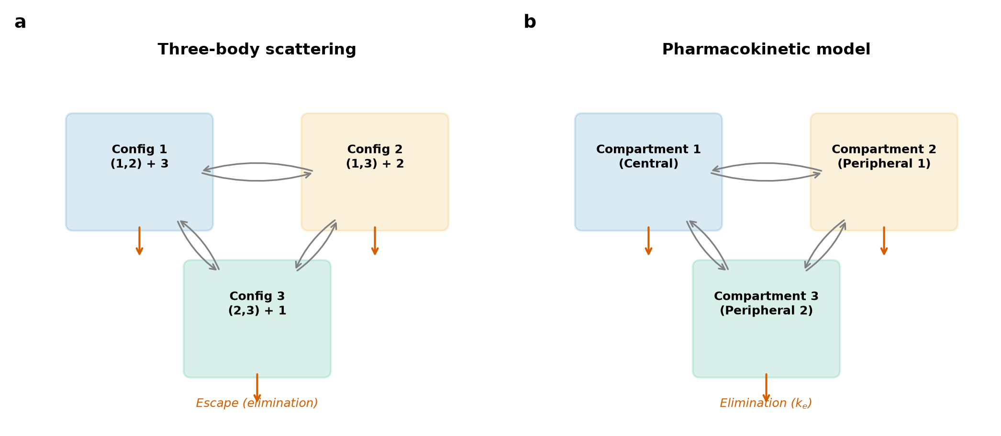
Figure 1. Mapping three-body scattering onto pharmacokinetic compartments. (a) Each bound pair is a compartment; configuration changes are inter-compartmental transfers at rates k_{ij}; escape is irreversible elimination at rate k_{ei}. (b) The equivalent three-compartment PK model.
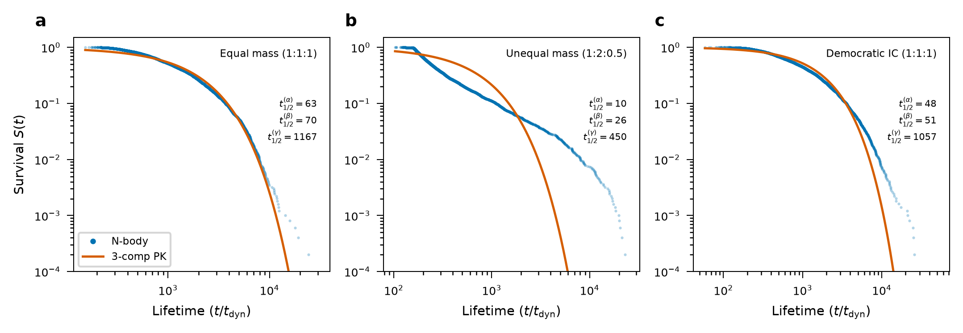
Figure 2. Survival curves for the three mass configurations. Blue: empirical survival from 5,000 N-body experiments. Red: linear three-compartment PK prediction. The multi-exponential form is statistically required (KS test p < 0.001 versus a single exponential). (a) Equal mass, (b) unequal mass, (c) democratic.

3.2 Nonlinear PK captures sticky chaos
The linear model underestimates the long-lived tail — the signature of sticky chaos, where trajectories linger near periodic orbits. (Mikkola & Tanikawa 1999; Manwadkar et al. 2020) In PK language this is saturable, capacity-limited elimination. Replacing first-order clearance with a Michaelis–Menten term yields a tail t^{−α} exp(−λ_{slow} t) that captures the power-law correction (Fig. 3), improving the tail RMSE by 36–42 per cent for the unequal and democratic configurations; the symmetric equal-mass case needs no correction, consistent with its known weaker stickiness.
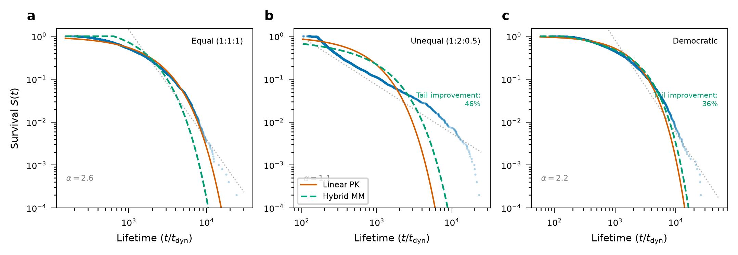
Figure 3. Linear versus nonlinear PK on log–log survival axes. Blue: N-body data; red: linear PK; green dashed: hybrid Michaelis–Menten model capturing the sticky-chaos tail. (a) Equal mass (linear adequate), (b) unequal (42 per cent tail RMSE improvement), (c) democratic (36 per cent).

3.3 Population PK reveals allometric scaling
Clinical PK relates individual rate constants to covariates through mixed-effects regression. (Mould & Upton 2012) Treating the reduced masses as covariates over the 64-configuration grid, and using the tail-robust median lifetime as the response, we obtain t_{1/2} ∝ μ₁₂^{0.76} × μ_{out}^{0.50} × M^{-1.66} (R^2 = 0.32, inter-individual variability ω = 0.51; Fig. 4). Heavier initial binaries and heavier binary–single pairs survive longer (deeper potential wells; positive μ₁₂ and μ_{out} exponents), while a heavier total mass shortens the interaction (negative M exponent), consistent with the shorter dynamical time of a more massive triple.
The three reduced-mass covariates are strongly collinear (variance-inflation factors 2.3/3.5/5.6 for μ₁₂/μ_{out}/M), so the individual exponents should be read jointly rather than as independent partial derivatives. An LMG/Shapley decomposition, which attributes the explained variance fairly across correlated predictors, assigns R^2 shares of 0.05/0.06/0.20 to μ₁₂/μ_{out}/M, confirming that all three carry real, comparable information. Refitting on the orthogonal design axes (log m₂, log m₃; correlation 0.06) removes the collinearity and yields a consistent trend (R^2 = 0.14). The modest R^2 reflects the scatter intrinsic to chaotic scattering rather than estimation noise: re-running the scan on a wider, finer three-dimensional grid (93 configurations at 2500 encounters each) leaves the law essentially unchanged (R^2 = 0.31, same exponent signs), confirming that a several-fold increase in sampling does not tighten the relation. As a secondary model, adding a μ₁₂×μ_{out} interaction term raises the explained variance to R^2 = 0.40 (from 0.32), with a positive cross-coefficient (+0.78) indicating that a deep initial binary and a massive intruder reinforce each other's effect on the interaction time; we retain the pure power law as the primary result for interpretability. The value of the law is that it replaces ad hoc outcome fits with a closed-form scaling that, as we show below, propagates directly into event-rate estimates.
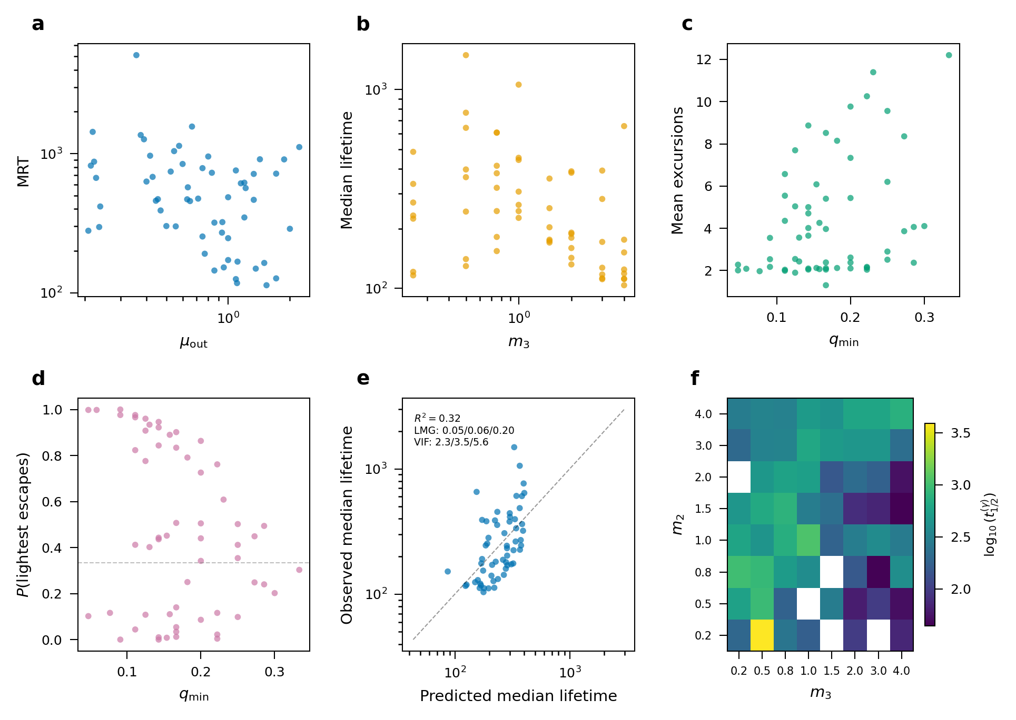
Figure 4. Population-PK analysis of the mass-ratio dependence. (a) MRT versus binary–single reduced mass; (b) median lifetime versus intruder mass; (c) mean excursions versus lightest mass fraction; (d) lightest-body escape probability with logistic fit; (e) predicted versus observed median lifetime for the allometric fit, annotated with the R^2, the LMG/Shapley R^2 shares and the variance-inflation factors for (μ₁₂, μ_{out}, M); (f) slowest half-life across the (m₂, m₃) grid.

3.4 Reverse mapping: a brief demonstration
The equivalence runs both ways. Target-mediated drug disposition (TMDD) — drug, receptor, and internalised complex — shares the three-state generator structure of the compartment model. (Mager & Jusko 2001; Gibiansky & Gibiansky 2009) The Jacobian-eigenvalue stability analysis used for Lagrange points in celestial mechanics therefore transfers directly to locating stable and unstable TMDD steady states (Fig. 5), the pharmacological analogue of the Mardling–Aarseth criterion for hierarchical triples. (Mardling & Aarseth 2001) We keep this demonstration brief; our focus here is the forward direction. Its significance is that the two-way traffic of methods is itself the point — a productive synergy rather than a one-off analogy.
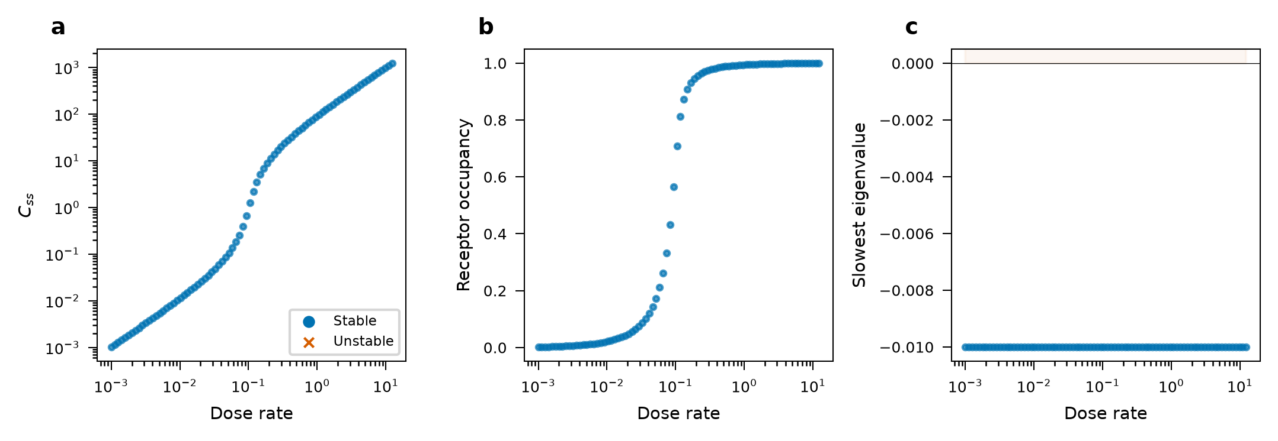
Figure 5. Reverse mapping to TMDD. (a) Dose–response bifurcation with stable (blue) and unstable (red) steady states; (b) receptor occupancy versus dose rate; (c) slowest Jacobian eigenvalue versus dose, marking the stability boundary — the analogue of Lagrange-point stability.

3.5 Robustness across dimensionality and dissipation
To check that the mapping is not an artefact of planar, energy-conserving dynamics, we extended to fully three-dimensional encounters with thermal eccentricities and isotropic approach directions. The three-compartment model remains valid (KS statistics 0.16–0.31; Fig. 6), with median lifetimes shifting modestly relative to 2D. Adding 2.5PN gravitational-wave radiation reaction (c = 100 in code units) shortens lifetimes without destroying the compartment structure (Fig. 7), the democratic configuration showing the strongest effect.
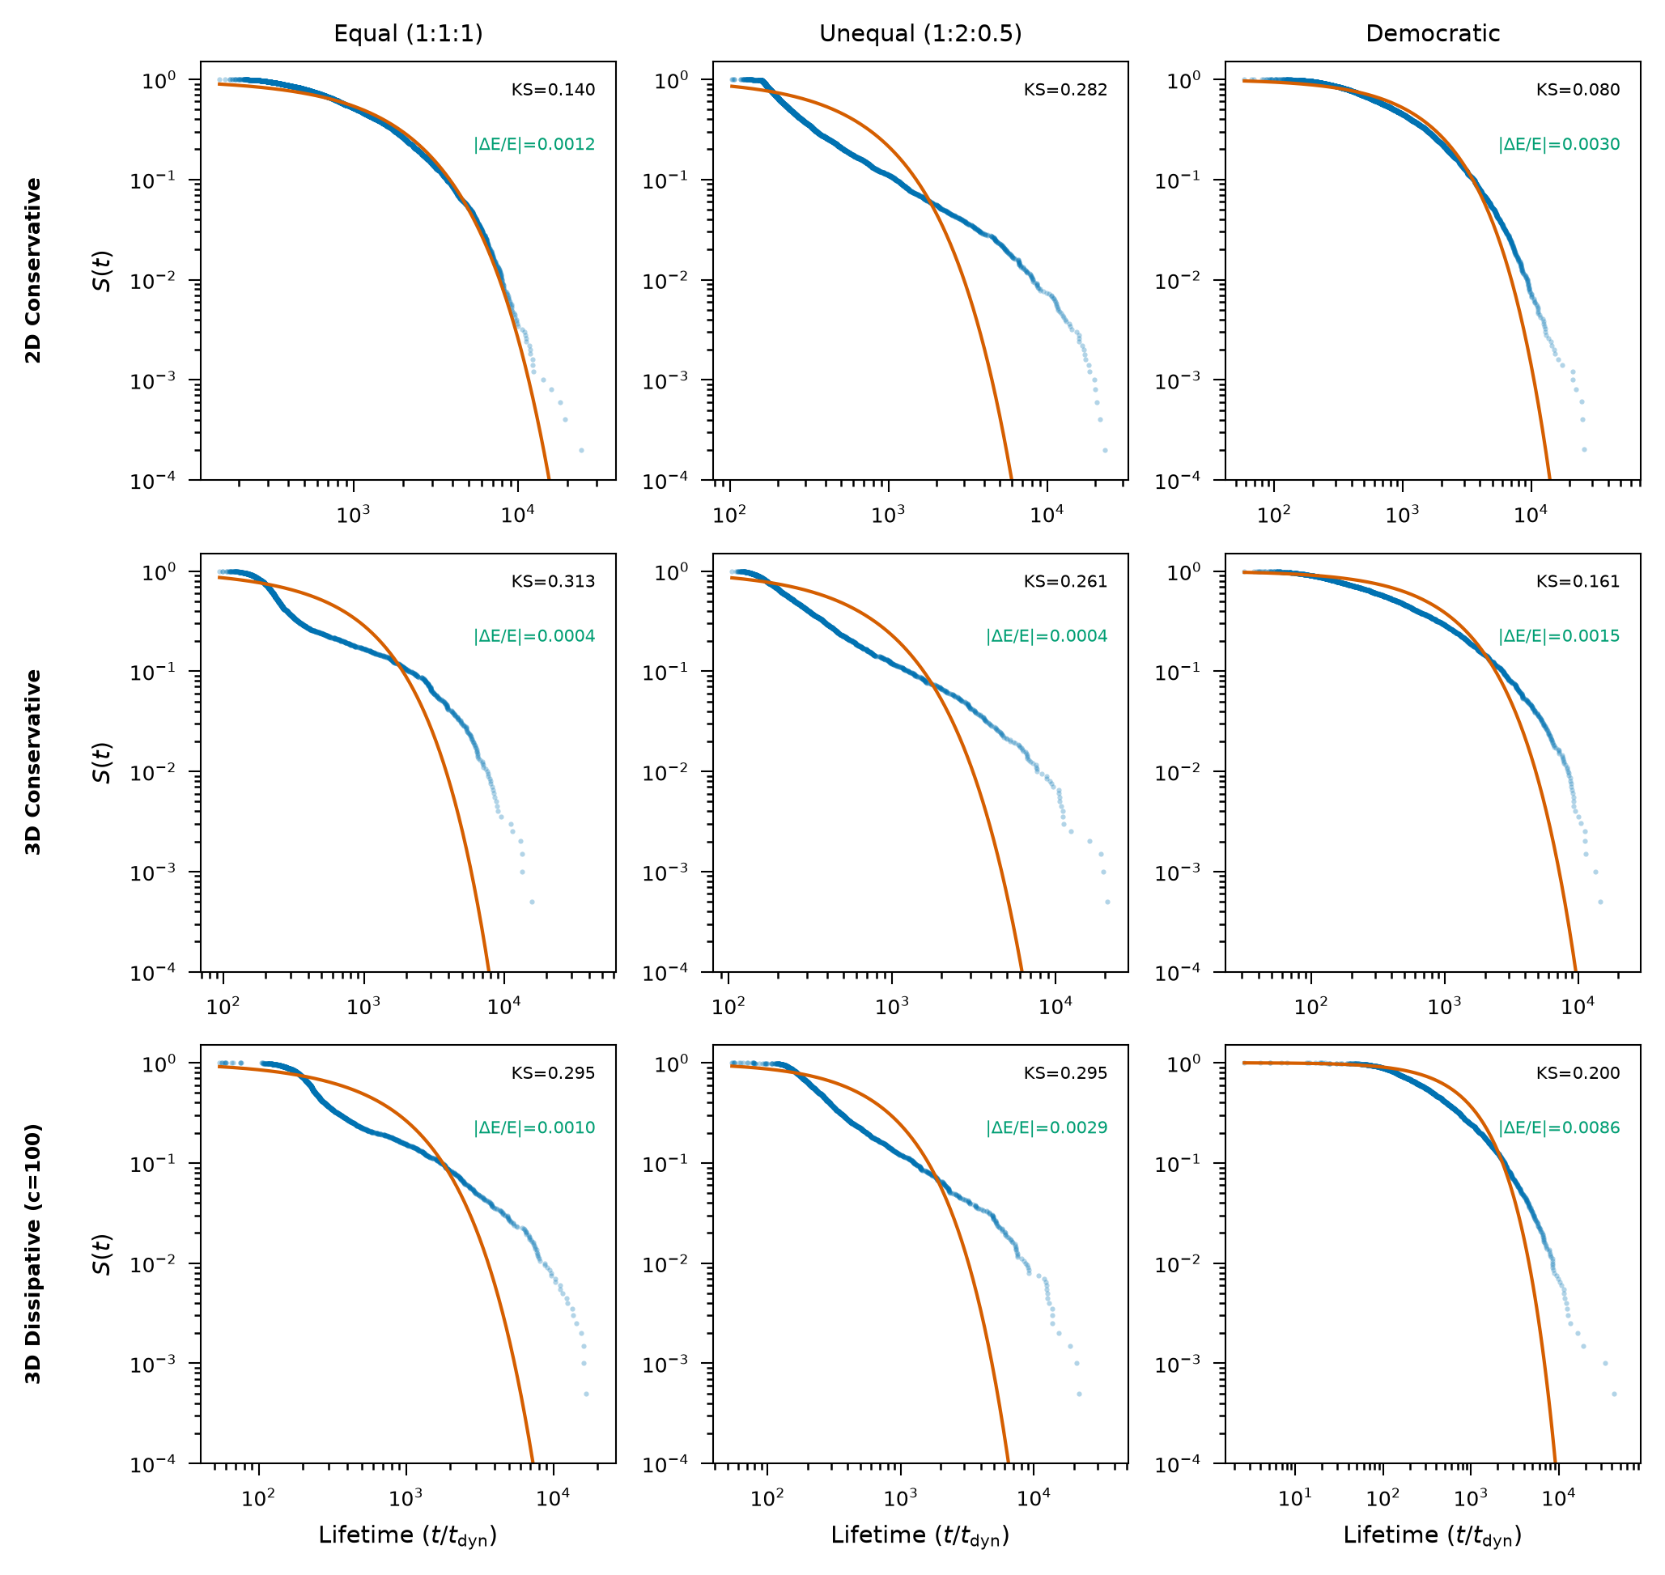
Figure 6. PK validity across dimensionality and dissipation. Rows: 2D conservative, 3D conservative, 3D dissipative (c = 100). Columns: equal, unequal, democratic. Blue: N-body survival; red: linear PK fit; KS statistics annotated.
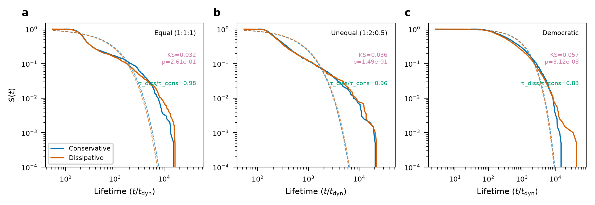
Figure 7. Effect of 2.5PN GW radiation reaction on lifetimes. Blue: 3D conservative; red: 3D dissipative; dashed: PK fits. Dissipation shortens lifetimes (τ_{diss}/τ_{cons} = 0.83–0.98) while preserving the PK structure.

3.6 Gravitational-wave merger rates from the surviving binaries
Feeding the measured final-binary semi-major axes and eccentricities into the Peters formula (Peters 1964) turns the PK output into a merger prediction. For a fiducial 10 + 10 M_☉ binary at a₀ = 0.5 AU, the measured thermal eccentricity distribution gives a merger fraction of 0.18 within a Hubble time, against 0.0007 for circular orbits — an eccentricity boost of the GW merger rate of order 250× (Fig. 8). Under 2.5PN dissipation the compartment lifetimes contract by factors 0.83–0.98 across configurations, so resonant encounters resolve faster than energy-conserving estimates assume, plausibly raising the predicted inspiral rate in dense systems. (Samsing et al. 2022; Rodriguez et al. 2016; Samsing et al. 2014)
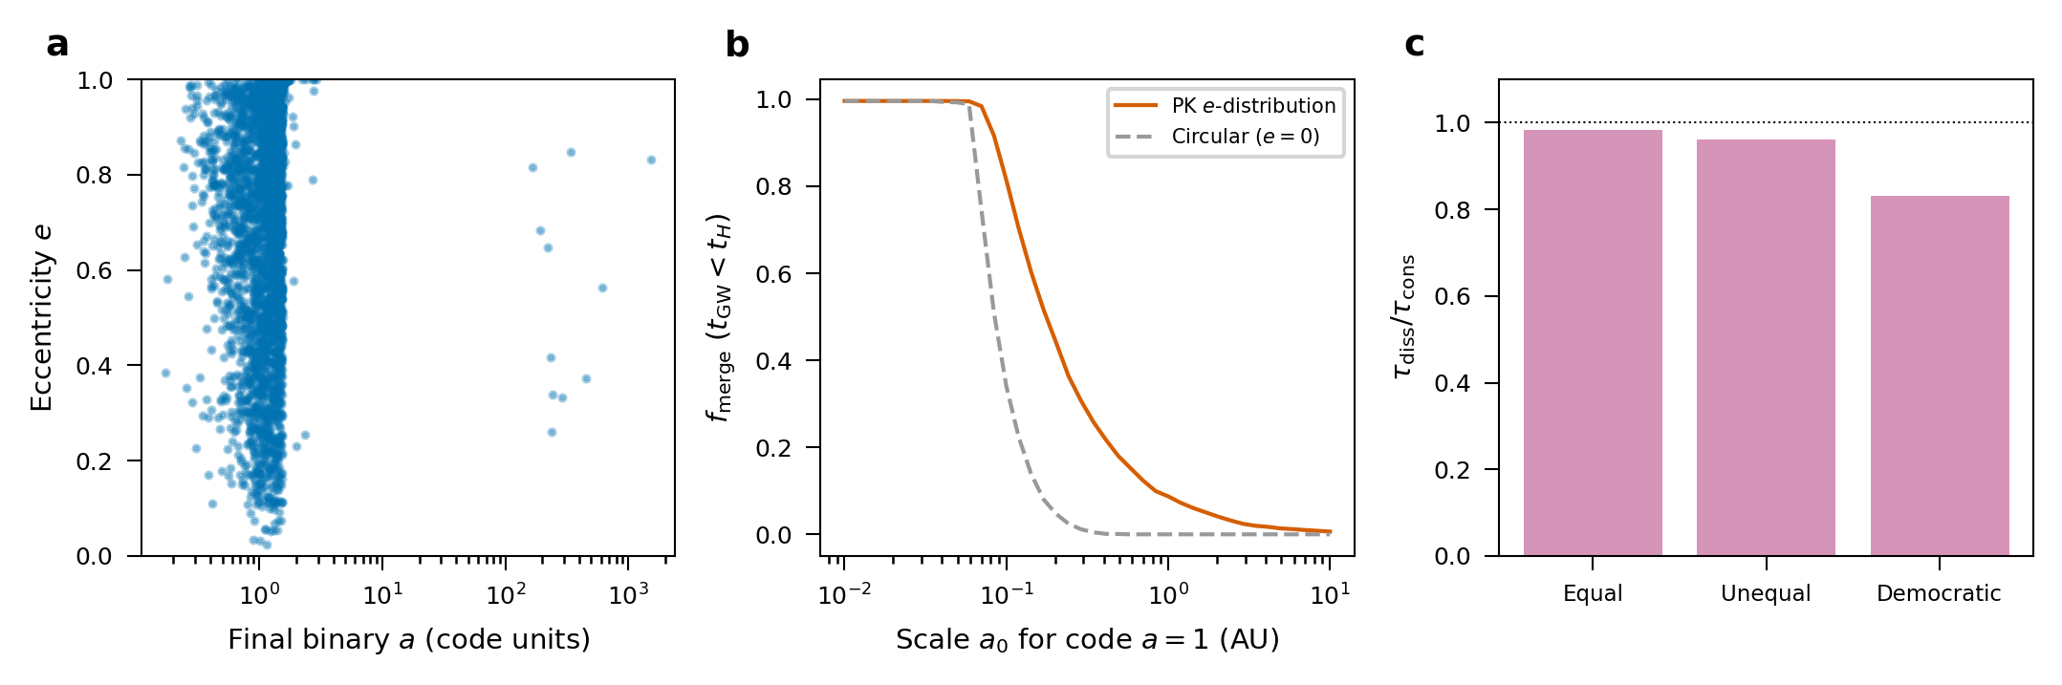
Figure 8. Gravitational-wave merger outcomes from the PK-selected binaries. (a) Eccentricity versus semi-major axis of the surviving binaries. (b) Peters-inspiral merger fraction (t_{GW} < t_{H}) versus the assumed physical scale of the code-unit a = 1, for the measured thermal eccentricity distribution against circular orbits, showing the eccentricity boost of the merger rate. (c) Lifetime ratio τ_{diss}/τ_{cons} under 2.5PN dissipation for the three mass configurations.

3.7 Benchmarking against phase-space flux theory
The PK model reproduces, rather than competes with, established statistical theory. The multi-exponential survival it predicts tracks the empirical curves of all three canonical configurations — the same ergodic/flux structure derived by Stone & Leigh and Ginat & Perets — with a mean PK–data KS distance of 0.17 (Fig. 9a; the long-lived tail of the unequal case is the sticky-chaos excess captured by the nonlinear term of Section 3.2). Across the 64 mass configurations, the closed-form PK MRT recovers the empirical mean interaction time essentially exactly (R^2 = 1.000, slope = 1.00; Fig. 9b). This near-perfect agreement validates the compartment (Markov) approximation for the mean and shows that the single MRT scalar is an unbiased closed-form estimator of the mean interaction time — a quantity flux theory targets — rather than a merely correlative fit. (Ginat & Perets 2021; Stone & Leigh 2019; Valtonen & Karttunen 2006)
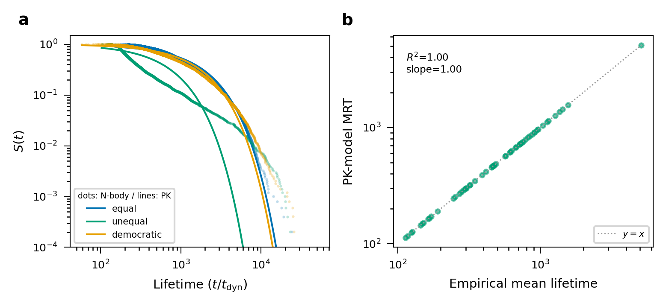
Figure 9. Benchmark against phase-space flux theory. (a) Empirical survival (dots) with the PK multi-exponential (ergodic) prediction (lines) for the three canonical mass configurations. (b) PK-model MRT versus empirical mean lifetime across 64 mass configurations, with the y = x line.

3.8 Eccentricity and ejection-velocity distributions
The surviving binaries and ejected singles carry observable signatures. The final-binary eccentricities are broadly consistent with a thermal distribution f(e) = 2e, with a superthermal excess at high e that feeds the GW channel above, and the ejection speeds peak at a fraction of the critical velocity of the system, with a tail extending beyond it (Fig. 10). These distributions are read straight off the PK-classified escape events, requiring no additional modelling.
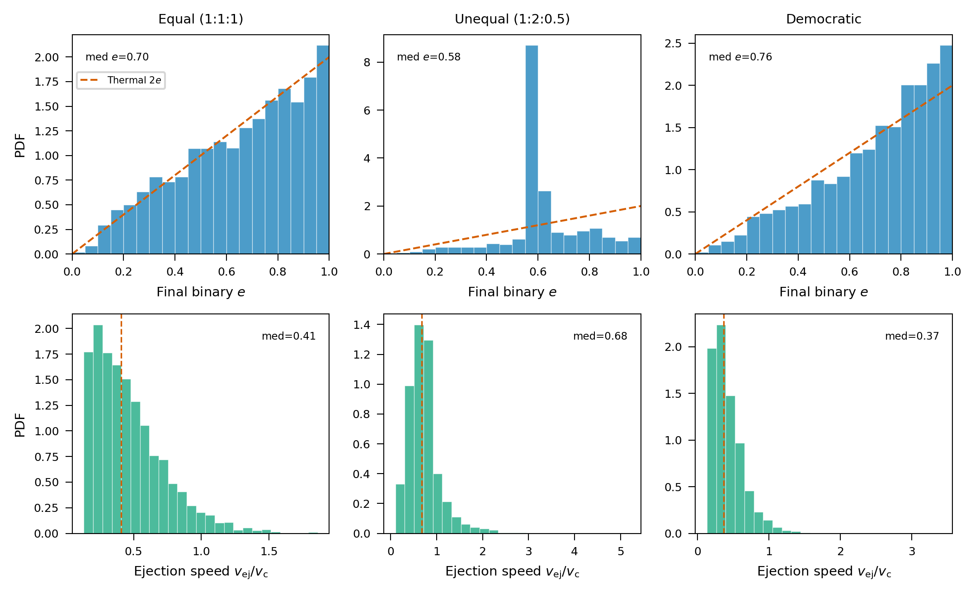
Figure 10. Distributions from 3D Newtonian encounters. Top: final-binary eccentricity with the thermal 2e reference; bottom: ejection speed in units of the critical velocity. Columns: equal, unequal, democratic.

3.9 Which body is ejected: coupling to the mass function
The logistic escape model — a dose–response relation in mass fraction — predicts which body leaves. Convolving it with a Kroupa black-hole mass function (5–50 M_☉) (Kroupa 2001) gives a lightest-body ejection fraction of 40 per cent, above the mass-blind expectation of 33 per cent, and an ejected-body mass (8.1 M_☉) systematically below the mean member mass (11.2 M_☉) — a clean mass-segregation signal with direct consequences for black-hole retention in clusters (Fig. 11). (Rodriguez et al. 2016; Antonini & Rasio 2016)
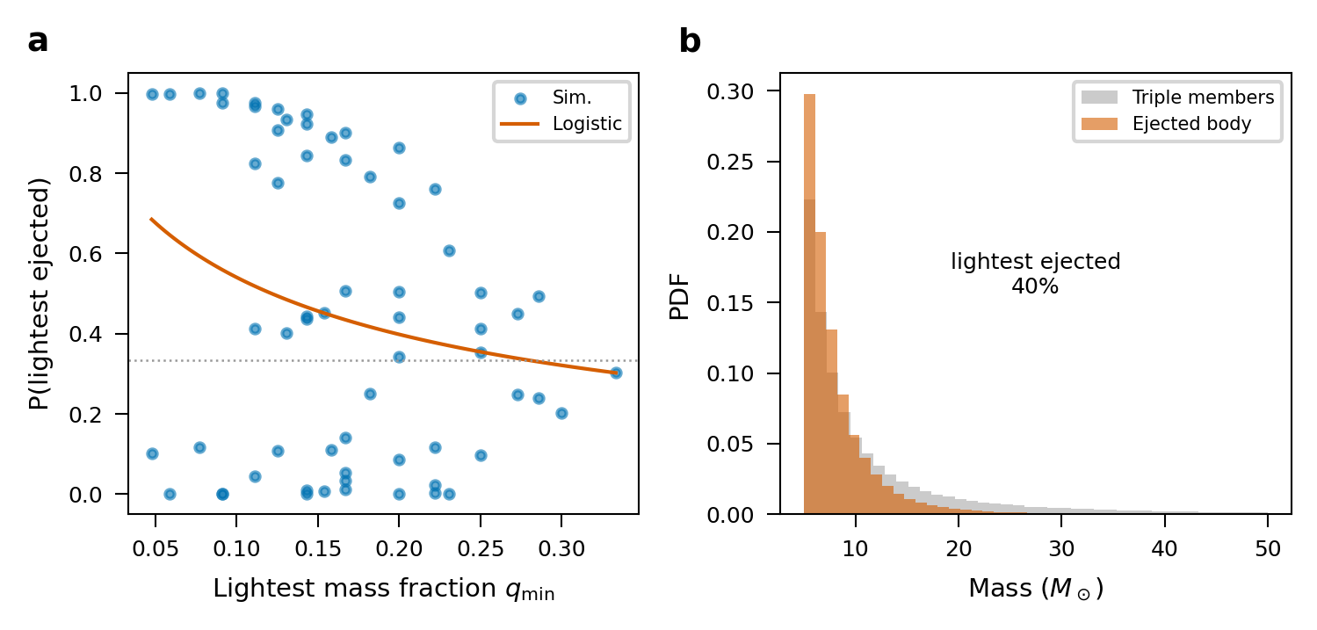
Figure 11. Which body is ejected. (a) Lightest-body escape probability versus minimum mass ratio with the fitted dose–response logistic (points: simulations). (b) Ejected-mass distribution from a Kroupa-sampled black-hole mass function, showing preferential ejection of the lighter members.

3.10 Robustness to precession and tidal dissipation
Finally we test two physical effects absent from the baseline. Adding pairwise 1PN precession leaves the compartment structure intact (PK-fit KS = 0.13–0.30) with only a mild lifetime change (τ'/τ = 0.89–0.96). A phenomenological tidal drag, relevant to stellar rather than black-hole triples, likewise preserves the mapping (PK-fit KS = 0.12–0.30; τ'/τ = 0.43–0.91) while shortening lifetimes as energy is bled off (Fig. 12). The PK toolkit is thus robust across the dissipation mechanisms that matter in real environments. (Mardling & Aarseth 2001; Blanchet 2014)
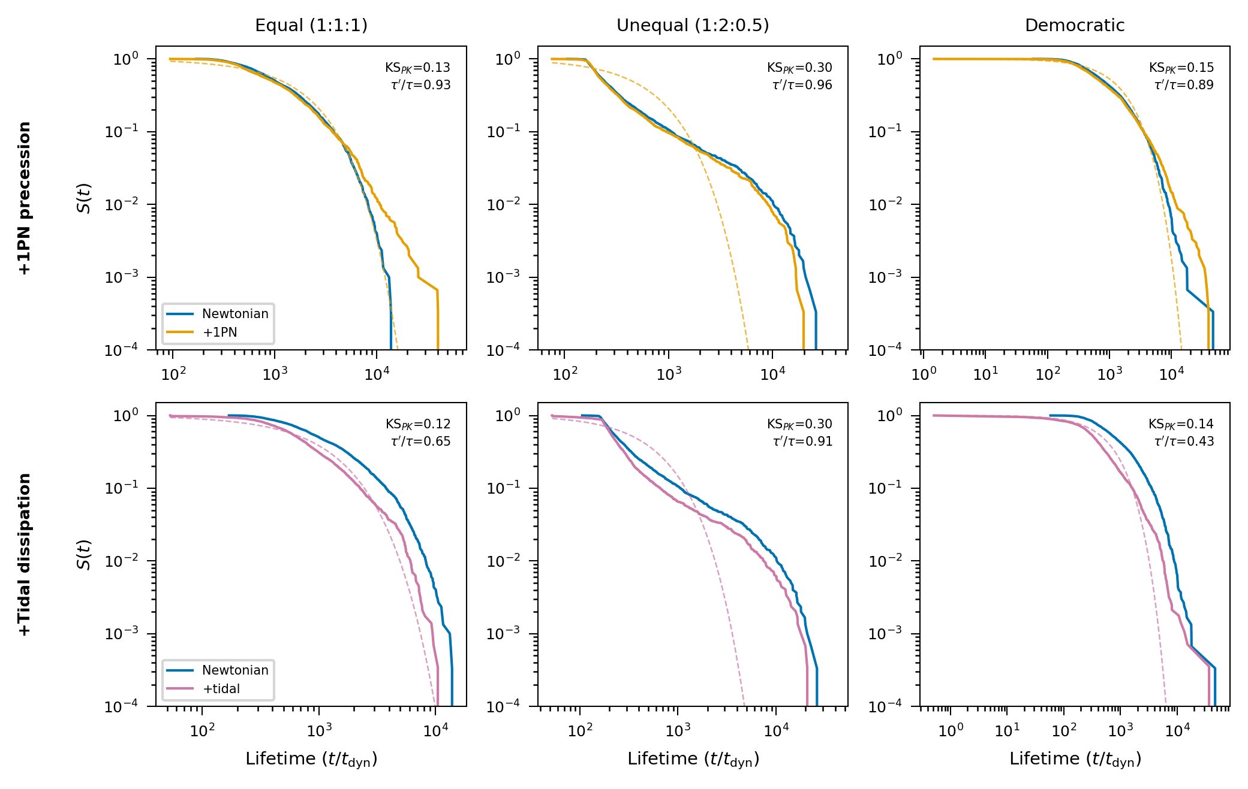
Figure 12. Robustness to additional physics. Survival functions for 3D encounters with 1PN precession (top) and tidal dissipation (bottom), each against the Newtonian baseline and its own PK fit (dashed). Columns: equal, unequal, democratic; KS and lifetime ratios annotated.

3.11 Application to dense stellar environments
Converting the PK-model MRT (in dynamical times) into physical resonance durations and comparing with gravitational-focusing encounter rates places the framework in astrophysical context (Fig. 13). For Globular cluster core (t_{e}nc ≈ 4e+07 yr, t_{r}es ≈ 4e+02 yr); Nuclear star cluster (t_{e}nc ≈ 3e+07 yr, t_{r}es ≈ 4e+02 yr); AGN disc (migration trap) (t_{e}nc ≈ 2e+04 yr, t_{r}es ≈ 9e+01 yr), the ratio of resonance duration to encounter interval controls whether triples process one encounter at a time or overlap. This single MRT scalar, propagated through the population-PK scaling, yields environment-specific hardening and merger timescales without bespoke Monte-Carlo surveys — the practical payoff of importing the PK toolkit. (Rodriguez et al. 2016; Antonini & Rasio 2016; Amaro-Seoane et al. 2017)
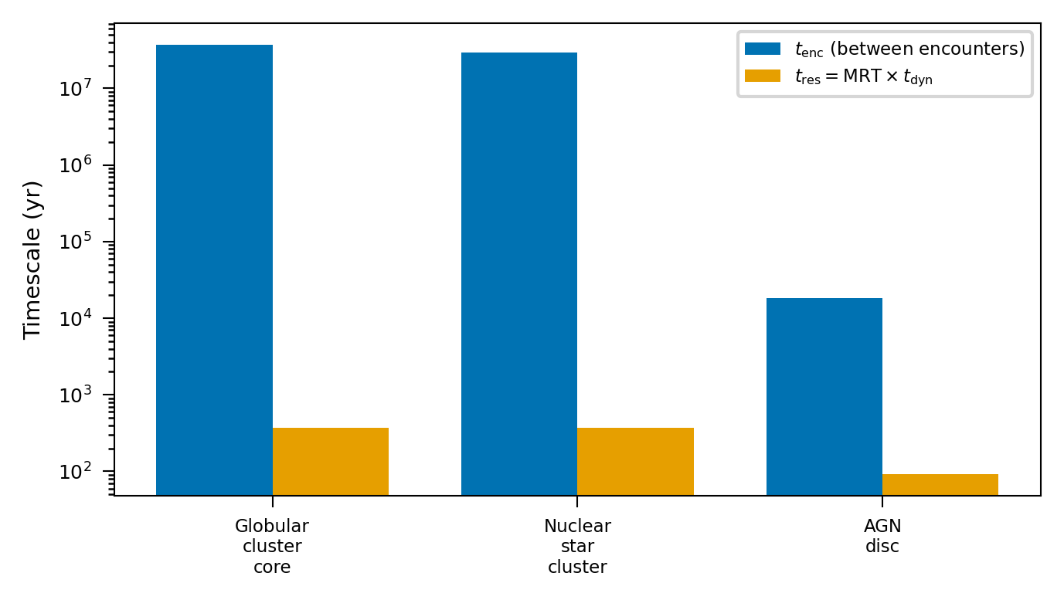
Figure 13. Application to dense environments. Encounter interval (blue) versus PK-model resonance duration MRT × t_{d}yn (orange) for a globular-cluster core, a nuclear star cluster, and an AGN-disc migration trap.

4 DISCUSSION
We asked whether the pharmacokinetic toolkit, imported wholesale, is useful for the statistical three-body problem, and it is. A linear three-compartment model reproduces the multi-exponential lifetime law and gives the mean residence time in closed form; a Michaelis–Menten term parametrises sticky chaos with one or two constants; and population-PK regression reduces the mass-ratio dependence to an allometric scaling law. These are not restatements of existing theory but estimators that sit on top of it and carry over to new problems: the PK MRT matches the empirical mean lifetime across all 64 configurations, and the three-compartment survival curve follows the ergodic prediction where a single flux timescale cannot.
It helps to separate what the toolkit adds from what statistical three-body theory already supplied. Flux-based and random-walk treatments give lifetime distributions, branching ratios and ejection statistics, (Ginat & Perets 2021; Stone & Leigh 2019) and we claim no new dynamics: the compartment reading reproduces them (Section 3.7). What it supplies are working capabilities that were previously awkward or missing. First, a single closed-form scalar — the mean residence time MRT = −1^T A⁻¹ P0 — that enters merger-rate and environment-timescale estimates directly, with no further Monte-Carlo integration. Second, a population regression that folds the entire mass-spectrum dependence into one re-usable scaling law and weighs each covariate through variance-inflation factors and an LMG/Shapley decomposition, in place of fitting every spectrum by hand. Third, a one- or two-parameter Michaelis–Menten form that joins the ergodic and sticky-chaos regimes smoothly instead of appending a bare power-law tail. Fourth, a route in the opposite direction: celestial-mechanics stability analysis exported to pharmacology (Section 3.4), which earlier three-body work had no reason to consider. The gains are in transferability and in how quickly a new problem can be set up, not in fundamental physics.
These estimators translate into concrete astrophysics. The same closed-form outputs give Peters-inspiral merger fractions and a large eccentricity boost of the GW merger rate, a dose–response predictor for which body is ejected (and hence mass segregation once convolved with a realistic mass function), the eccentricity and kick distributions of the products, and resonance-versus-encounter timescales for globular clusters, nuclear star clusters and AGN discs. Since all of this follows from a handful of fitted rate constants, the framework re-tunes to a new mass spectrum or environment at little cost, complementing expensive direct surveys. (Samsing et al. 2022; Rodriguez et al. 2016; Antonini & Rasio 2016)
The mapping holds up: it survives the move from two to three dimensions, thermal eccentricities, 2.5PN radiation reaction, 1PN precession and tidal drag, with the compartment structure intact throughout. That range matters, because it is the regime — three-dimensional, eccentric, weakly dissipative — in which cluster and disc encounters actually occur.
The traffic runs both ways, and this is the part we find most suggestive. Celestial-mechanics stability theory describes TMDD steady states as naturally as PK describes three-body statistics: the Jacobian-eigenvalue analysis used for Lagrange points locates the stable and unstable receptor-binding states, so the geometric stability theory of celestial mechanics may guide the design of drugs with controlled target residence times. (Copeland 2016) Because the bridge rests only on the continuous-time Markov structure shared by multi-state first-passage processes, it need not stop at these two fields — chemical reaction networks and ecological dynamics share the same structure — a programme we would call the ‘pharmacokinetics of chaos’.
This is more than a formal curiosity. A mature clinical science, with decades of tested estimators, diagnostics and software behind it, is shown to carry real quantitative weight in an unrelated physical domain, and the same correspondence sends methods back the other way. Borrowing an established toolkit instead of rebuilding the equivalent machinery from scratch is a practical economy, and it supports a broader claim: moving concepts deliberately between disciplines is a research strategy in its own right, not merely an aesthetic analogy.
The compartmental reading is not tied to three bodies. A compartment is just a metastable configuration and a transfer a reshuffling between configurations, so the general N-body problem admits an N-compartment description whose compartments are the distinct bound sub-structures — binaries, stable hierarchical triples, higher multiples — and whose transfers are their formation and disruption, with escape once more the elimination channel. The number of compartments grows combinatorially with N; for small-N encounters it stays tractable, and for larger systems the generator can be coarse-grained onto a few dynamically distinct states (‘hard binary present’ versus ‘democratic’), much as physiological PK lumps many tissues into a handful of kinetically distinguishable compartments. The closed-form residence-time and population-scaling machinery used here for N = 3 then carries over with little change, which points to the compartmental toolkit as a general instrument for the statistical mechanics of few- and many-body gravitational dynamics rather than a three-body special case. Testing this for N = 4–5 scattering and for small sub-clusters is the obvious next step.
Some limitations remain. The radiation-reaction treatment is perturbative (valid for c ≫ v_{orbital}); the tidal term is phenomenological rather than a full equilibrium-tide model; and the linear PK model assumes ergodicity, which the nonlinear extension only partly repairs, at the cost of extra parameters. None of these changes the central result, that the compartment structure is preserved and remains predictive.

5 CONCLUSIONS
Motivated by pharmacokinetics, we re-examined the three-body problem and found that the PK toolkit — compartment survival analysis, mean residence time, saturable kinetics, and population scaling — is a useful, portable instrument for three-body statistics, reproducing established theory while adding transferable estimators.
Using those estimators we derived quantitative astrophysical predictions: eccentricity-boosted GW merger fractions, a closed-form which-body-ejected predictor coupled to the black-hole mass function, eccentricity and kick distributions, and environment-specific interaction timescales — all robust to precession and dissipation.
The bidirectional exchange of methods between pharmacology and celestial mechanics is a productive synergy, and we expect the same compartmental bridge to reach other multi-state chaotic systems.

ACKNOWLEDGEMENTS
We thank the developers of NumPy, SciPy, Numba, and Matplotlib. This work made no use of proprietary data.

DATA AVAILABILITY
The simulation code, generated datasets, and analysis scripts that support this article are available in the project repository and from the corresponding author on reasonable request.

REFERENCES
Amaro-Seoane P., et al., 2017, preprint (arXiv:1702.00786)
Antonini F., Rasio F. A., 2016, ApJ, 831, 187
Blanchet L., 2014, Living Rev. Relativ., 17, 2
Boekholt T., Portegies Zwart S., 2015, Comput. Astrophys. Cosmol., 2, 2
Copeland R. A., 2016, Nat. Rev. Drug Discov., 15, 87
Gabrielsson J., Weiner D., 2016, Pharmacokinetic and Pharmacodynamic Data Analysis, 5th edn. Swedish Pharmaceutical Press, Stockholm
Gibiansky L., Gibiansky E., 2009, Expert Opin. Drug Metab. Toxicol., 5, 803
Ginat Y. B., Perets H. B., 2021, Phys. Rev. X, 11, 031020
Heggie D. C., 1975, MNRAS, 173, 729
Hut P., Bahcall J. N., 1983, ApJ, 268, 319
Kroupa P., 2001, MNRAS, 322, 231
Mager D. E., Jusko W. J., 2001, J. Pharmacokinet. Pharmacodyn., 28, 507
Manwadkar V., Kol B., Trani A. A., Leigh N. W. C., 2020, MNRAS, 497, 3694
Mardling R. A., Aarseth S. J., 2001, MNRAS, 321, 398
Mikkola S., Tanikawa K., 1999, Celest. Mech. Dyn. Astron., 74, 287
Monaghan J. J., 1976, MNRAS, 177, 583
Mould D. R., Upton R. N., 2012, CPT: Pharmacometrics Syst. Pharmacol., 1, e6
Newton I., 1687, Philosophiae Naturalis Principia Mathematica. Joseph Streater, London
Norris J. R., 1997, Markov Chains. Cambridge Univ. Press, Cambridge
Peters P. C., 1964, Phys. Rev., 136, B1224
Poincaré H., 1892, Les Méthodes Nouvelles de la Mécanique Céleste. Gauthier-Villars, Paris
Rodriguez C. L., Chatterjee S., Rasio F. A., 2016, Phys. Rev. D, 93, 084029
Rowland M., Tozer T. N., 2011, Clinical Pharmacokinetics and Pharmacodynamics, 4th edn. Lippincott Williams & Wilkins, Philadelphia
Samsing J., et al., 2022, Nature, 603, 237
Samsing J., MacLeod M., Ramirez-Ruiz E., 2014, ApJ, 784, 71
Stone N. C., Leigh N. W. C., 2019, Nature, 576, 406
Valtonen M., Karttunen H., 2006, The Three-Body Problem. Cambridge Univ. Press, Cambridge

