Association between the EU desflurane phase-out and secondary market vaporizer prices: an observational time-series analysis

Onishi Tatsuki¹, Tatsuyoshi Ikenoue^{1,2}
¹Data Science and AI Innovation Research Promotion Center, Shiga University
²Department of Public Health, Faculty of Medicine, University of Miyazaki

Corresponding author: Onishi Tatsuki; Data Science and AI Innovation Research Promotion Center, Shiga University; 1-1-1, Bamba, Hikone, Shiga, 522-8522, Japan; Telephone: +81-749-27-1023; E-mail: bougtoir@gmail.com

Abstract word count: ~299 (max 300)
Number of references: 22
Number of tables: 2 (+1 supplementary)
Number of figures: 6

Keywords: anesthetic vaporizer, desflurane, environmental regulation, F-gas, secondary market, EU regulation, equipment management, capital asset lifecycle

Abstract
Background: The European Union restricted desflurane—the volatile anesthetic with the highest commonly reported 100-year global warming potential (GWP100 ≈ 2540 CO₂ equivalents)—for routine use from 1 January 2026 under Regulation (EU) 2024/573, with exemptions for clinically necessary cases. Whether this targeted environmental regulation was associated with collateral economic effects on non-targeted anesthetic equipment markets has not been examined. We investigated whether the EU desflurane regulation was associated with changes in secondary market prices of anesthetic vaporizers, and whether any such changes were agent-specific or extended to non-regulated agents (sevoflurane, isoflurane).
Methods: We conducted a cross-sectional time-series analysis of completed eBay sales of desflurane, sevoflurane, and isoflurane vaporizers over three years (March 2023 to March 2026), spanning the full EU regulatory timeline. Temporal trends were assessed using Spearman rank correlation and Kendall τ across ordered regulatory phases. Pre-/post-ban comparison used the Mann–Whitney U test with Cohen’s d effect size. Sensitivity analyses included bootstrap resampling (10,000 iterations), post-hoc power simulation under observed lognormal parameters, and a comparative interrupted time-series (CITS) model of monthly median prices with sevoflurane and isoflurane as controls.
Results: 1033 completed sales were analyzed (158 desflurane, 321 sevoflurane, 554 isoflurane). Desflurane vaporizer prices declined (Spearman ρ=-0.28, P<0.001; Kendall τ=-0.12, P=0.049), with a 31% decline pre- to post-restriction (Cohen’s d=-0.47). Sevoflurane showed no trend. Isoflurane reached nominal significance in Spearman (ρ=-0.09, P=0.044) and Kendall τ (τ=-0.07, P=0.025) tests, but the quarterly median trend was not significant; these isolated P values, with small effect sizes, are interpreted cautiously.
Conclusions: Desflurane vaporizer prices on eBay were associated with an agent-specific decline; non-regulated agents remained comparatively stable. These observational findings are consistent with, but do not prove, an effect of the EU desflurane phase-out and should be interpreted as hypothesis-generating given the single-platform design, unmeasured confounders, small post-restriction sample, and multiple trend tests.

Introduction
Environmental regulation of healthcare products is accelerating. The European Union restricted desflurane—the volatile anesthetic with the highest commonly reported 100-year global warming potential (GWP100 ≈ 2540 CO₂ equivalents)^{1,2,3–5}—for routine use from 1 January 2026 under Regulation (EU) 2024/573, while permitting documented clinical exceptions.² The choice of GWP metric and time horizon remains debated for short-lived halogenated anesthetics such as desflurane (atmospheric lifetime ≈ 14 years), because GWP100 may not reflect their instantaneous radiative forcing or steady-state atmospheric concentrations.⁶ Desflurane also has recognized pharmacokinetic advantages, including faster emergence and extubation than sevoflurane in selected surgical populations.⁷ The American Society of Anesthesiologists has recommended deactivation of central nitrous oxide piping on environmental grounds.⁸ NHS England and NHS Scotland have independently decommissioned desflurane.^{9,10} Each of these measures targets a specific agent or delivery system, yet whether such targeted restrictions are associated with collateral economic effects on non-targeted equipment markets has not been empirically examined.
The EU desflurane restriction provides an opportunity to address this question as a natural experiment. First, only a single agent is targeted for routine use; sevoflurane (GWP ≈ 130) and isoflurane (GWP ≈ 510)^{11,12} remain in unrestricted use and serve as natural controls. Second, the regulatory process advanced through clearly dated milestones — European Commission proposal (April 2022), European Parliament plenary vote (March 2023), trilogue provisional agreement (October 2023), formal adoption (February 2024), and the 2026 restriction on routine use (January 2026) — enabling time-series analysis across successive phases. Third, anesthetic vaporizers are agent-specific capital assets with typical lifespans of 10–15 years, so the economic consequences of regulation may be reflected in secondary market values.
Previous studies have addressed the financial rationale for discontinuing desflurane,¹³ the clinical and policy implications of decommissioning programs,^{14,15} the effectiveness of vaporizer removal at the institutional level,¹⁶ and the cost savings from reduced volatile anesthetic consumption.^{17,18} The secondary market for pre-owned medical equipment has been characterized for other device categories.¹⁹ However, to our knowledge, no study has examined whether environmental regulation of a single anesthetic agent is associated with targeted secondary-market effects or whether it destabilizes the broader equipment market.
We hypothesized that (1) the EU desflurane regulation would be associated with a progressive decline in secondary market prices of desflurane vaporizers, and (2) this decline would be agent-specific—sevoflurane and isoflurane vaporizer prices would remain stable—suggesting that any market-level changes were concentrated in the regulated agent.

Materials and Methods

Ethics
Ethical approval was not required for this study. The study analyzed publicly available, anonymized completed sale data from an online marketplace (eBay). No individual-level, patient, or human participant data were collected.

Reporting guidelines
This study is reported in accordance with the Strengthening the Reporting of Observational Studies in Epidemiology (STROBE) guidelines for cross-sectional studies.²⁰ The completed STROBE checklist is provided as supplementary material.

Study design and data source
We conducted a cross-sectional time-series analysis of anesthetic vaporizer prices using completed (sold) listings on eBay (www.ebay.com). Data were retrieved using Terapeak, eBay’s official product research tool integrated within eBay Seller Hub. Terapeak provides access to up to three years of historical completed sale data, including item titles, sale prices, sale dates, and quantities sold. Data were collected in March 2026, covering the period from 28 March 2023 to 24 March 2026.
Although the three-year window reflects the maximum retrievable period within Terapeak, this timeframe is analytically meaningful: it begins shortly after the European Parliament plenary vote approving the revised F-gas Regulation (March 2023) and captures the full legislative trajectory from the European Commission’s original proposal (April 2022) through to the post-ban period, encompassing all key regulatory milestones. Because Terapeak’s three-year window ends at the data extraction date (March 2026), the post-restriction observation period is limited to approximately three months after the 1 January 2026 effective date (n=17 desflurane transactions); a longer follow-up would require either prospective data collection or a later extraction, neither of which was possible here. We used a single marketplace (eBay) rather than integrating data from multiple platforms to avoid the risk of counting cross-listed items more than once.

Eligibility criteria
We searched Terapeak for completed sales using the search terms “desflurane vaporizer,” “sevoflurane vaporizer,” and “isoflurane vaporizer” with a three-year date range filter. Inclusion criteria were: (1) completed (sold) listings; (2) standalone anesthetic vaporizer units; and (3) valid sale price and date. Exclusion criteria were: (1) non-vaporizer items (keyed fillers, bottle adapters, accessories, pour-fill adapters, anti-spill caps); (2) veterinary-specific anesthesia systems or machines (rather than standalone vaporizers); (3) lot listings containing multiple heterogeneous items; and (4) listings with missing or implausible price data.

Variables
The primary outcome was sale price in US dollars. For each listing, we recorded: item title, sale price (USD), sale date, and quantity sold. The primary exposure variable was the regulatory period, classified relative to key milestones in the EU F-gas Regulation timeline. The primary comparison used 1 January 2026 (the desflurane prohibition effective date) as the cutpoint. A secondary multi-period classification divided the study period into four phases: post-proposal (after EC proposal, April 2022), post-agreement (after trilogue, October 2023), post-adoption (after formal adoption, February 2024), and post-ban (after 1 January 2026). These ordered phases were used for trend analysis.

Statistical analysis
The primary analysis was a time-series trend assessment using Spearman rank correlation between sale date and price for each agent type separately. This was complemented by Kendall τ, computed between the ordered regulatory phase (1–5) and sale price, to test whether prices changed progressively across successive milestones. These trend tests, applied to each agent type independently, allowed direct comparison of temporal patterns between the regulated agent (desflurane) and the unregulated comparators (sevoflurane, isoflurane). Quarterly median prices were also assessed using Spearman correlation to evaluate the trend at an aggregated level.
The pre-/post-ban comparison (Mann–Whitney U test and Welch’s t-test) was conducted as a secondary, exploratory analysis. Given the small post-ban sample size (n=17 for desflurane), this comparison has limited statistical power, and its results should be interpreted with caution. Effect sizes were estimated using Cohen’s d with 95% confidence intervals. To test whether the magnitude of the pre-/post-ban price change differed between agent types, pairwise z-tests for independent Cohen’s d values were performed using the large-sample variance approximation.
Because trend tests (Spearman, Kendall τ, and quarterly Spearman) were applied to each of three agent types, the probability of nominally significant P values arising under the null is inflated. We did not apply a formal family-wise multiple-testing correction; instead, P values were interpreted alongside effect magnitude, direction, and consistency across tests. For isoflurane, both Spearman (P=0.044) and Kendall τ (P=0.025) tests reached nominal significance at the transaction level, but the quarterly median trend was not significant and effects were small; these P values were therefore interpreted cautiously and not considered evidence of a true trend.
Sensitivity analyses were performed to assess robustness and to address causal interpretation. First, we used bootstrap resampling (10,000 iterations) of the pre- and post-ban samples to derive non-parametric 95% confidence intervals for the difference in mean and median prices and to obtain bootstrap P values for the Mann–Whitney U and Welch tests. Second, we estimated post-hoc statistical power for the pre-/post-ban Mann–Whitney U test and Welch t-test by simulating 10,000 datasets from lognormal distributions parameterized by the observed pre- and post-ban means and standard deviations. Third, we fitted a comparative interrupted time-series (CITS) model to monthly median prices, with sevoflurane and isoflurane as concurrent controls, to estimate any desflurane-specific level or slope change at the 2026 restriction. A difference-in-differences (DiD) model on log-transformed individual transaction prices was also fitted as a further sensitivity check.
Descriptive statistics included mean, standard deviation (SD), median, interquartile range (IQR), and range for each agent type and regulatory period. The Kruskal–Wallis test was used for multi-period comparisons across regulatory phases. LOWESS (locally weighted scatterplot smoothing) trend lines were fitted to visualize price trajectories. Analyses were performed using Python 3.12 with pandas 2.2, scipy 1.14, and statsmodels 0.14. Statistical significance was set at P < 0.05 (two-sided). No a priori sample size calculation was performed, as this study aimed to capture all available transactions within the Terapeak data window.

Results
A total of 1033 completed eBay sales of anesthetic vaporizers were identified and included in the analysis after applying exclusion criteria: 158 desflurane, 321 sevoflurane, and 554 isoflurane vaporizers. The study period spanned from 28 March 2023 to 24 March 2026 (three years). Desflurane vaporizers were predominantly Datex-Ohmeda/GE Tec 6 Plus and Dräger D-Vapor models; sevoflurane vaporizers included Dräger Vapor 2000, Penlon Sigma Delta, and Tec 7 models; isoflurane vaporizers included Ohmeda Tec 3, Tec 5, Tec 7, and Dräger Vapor 2000 models (Fig. 1).

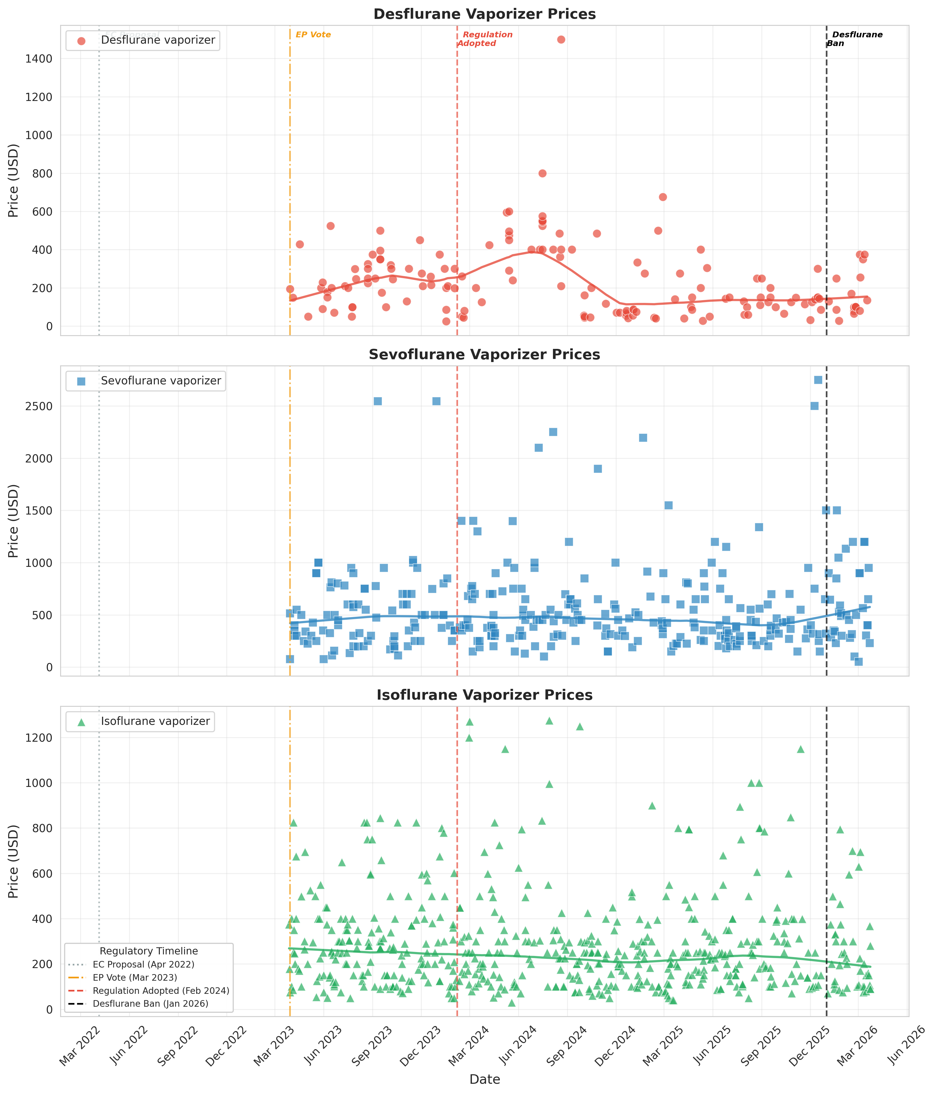
Fig. 1. Time series of eBay completed sale prices for desflurane (red), sevoflurane (blue), and isoflurane (green) vaporizers over three years (March 2023 to March 2026). Vertical dashed lines indicate key EU regulatory milestones. Curved lines represent LOWESS trend estimates (fraction = 0.3). Data source: eBay Terapeak.

Table 1. Time-series trend analysis of vaporizer prices by agent type. Spearman rank correlation tests monotonic association between sale date and price; Kendall τ tests association between ordered regulatory phase and price.
Agent | Spearman ρ | P value | Kendall τ | P value | Quarterly ρ | P value
Desflurane | -0.277 | <0.001 | -0.121 | 0.049 | -0.601 | 0.039
Sevoflurane | 0.010 | 0.862 | 0.039 | 0.365 | -0.092 | 0.777
Isoflurane | -0.086 | 0.044 | -0.074 | 0.025 | -0.321 | 0.285
Note: The Spearman and Kendall τ tests for isoflurane reached nominal significance (P=0.044 and P=0.025, respectively), but effect sizes were small and the quarterly median trend was not significant; this is therefore not interpreted as a clinically meaningful temporal trend.

Table 2. Pre- and post-ban vaporizer prices by agent type with between-agent effect size comparison. Values are mean ± SD in US dollars.
Panel A. Descriptive statistics and within-agent effect sizes (pre- vs post-ban)
Agent | n (pre/post) | Pre-ban mean ± SD | Post-ban mean ± SD | % change | Cohen’s d | 95% CI
Desflurane | 141/17 | $238 ± 195 | $164 ± 113 | -31.4% | -0.47 | -0.97 to 0.04
Sevoflurane | 287/34 | $545 ± 415 | $612 ± 365 | +12.3% | 0.17 | -0.18 to 0.53
Isoflurane | 510/44 | $287 ± 215 | $255 ± 191 | -11.2% | -0.16 | -0.47 to 0.15

Panel B. Between-agent comparison of effect sizes (z-test for independent Cohen’s d)
Comparison | Δd | SE | z | P value
Desflurane vs Sevoflurane | -0.64 | 0.316 | -2.03 | 0.043
Desflurane vs Isoflurane | -0.31 | 0.302 | -1.03 | 0.303
Sevoflurane vs Isoflurane | 0.33 | 0.240 | 1.37 | 0.171
Within-agent P values (Mann–Whitney U): Desflurane U P=0.148, t P=0.027; Sevoflurane U P=0.150, t P=0.326; Isoflurane U P=0.184, t P=0.297.

Sensitivity: Bootstrap 95% CI for the desflurane pre-/post-ban mean difference: US$-135 to US$-11; median difference: US$-124 to US$50. Post-hoc power (lognormal simulation, n=141/17): Mann–Whitney U 28.4%, Welch t 58.1%.

Desflurane vaporizer prices showed a statistically significant downward trend over the three-year study period (primary analysis). Spearman rank correlation demonstrated a significant negative monotonic association between sale date and price (ρ=-0.28, P<0.001). Kendall τ analysis confirmed that prices decreased across successive regulatory phases (τ=-0.12, P=0.049) (Fig. 2). At the aggregated level, quarterly median prices also showed a significant downward trend (ρ=-0.60, P=0.039) (Table 1; Fig. 3).

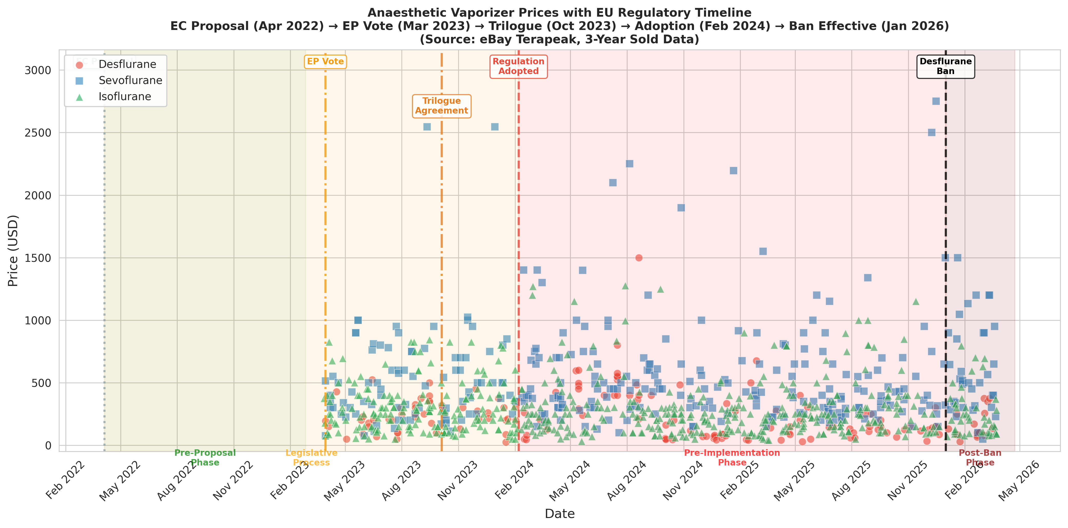
Fig. 2. Anesthetic vaporizer prices mapped against the EU regulatory timeline. Shaded regions indicate regulatory phases. Data source: eBay Terapeak.

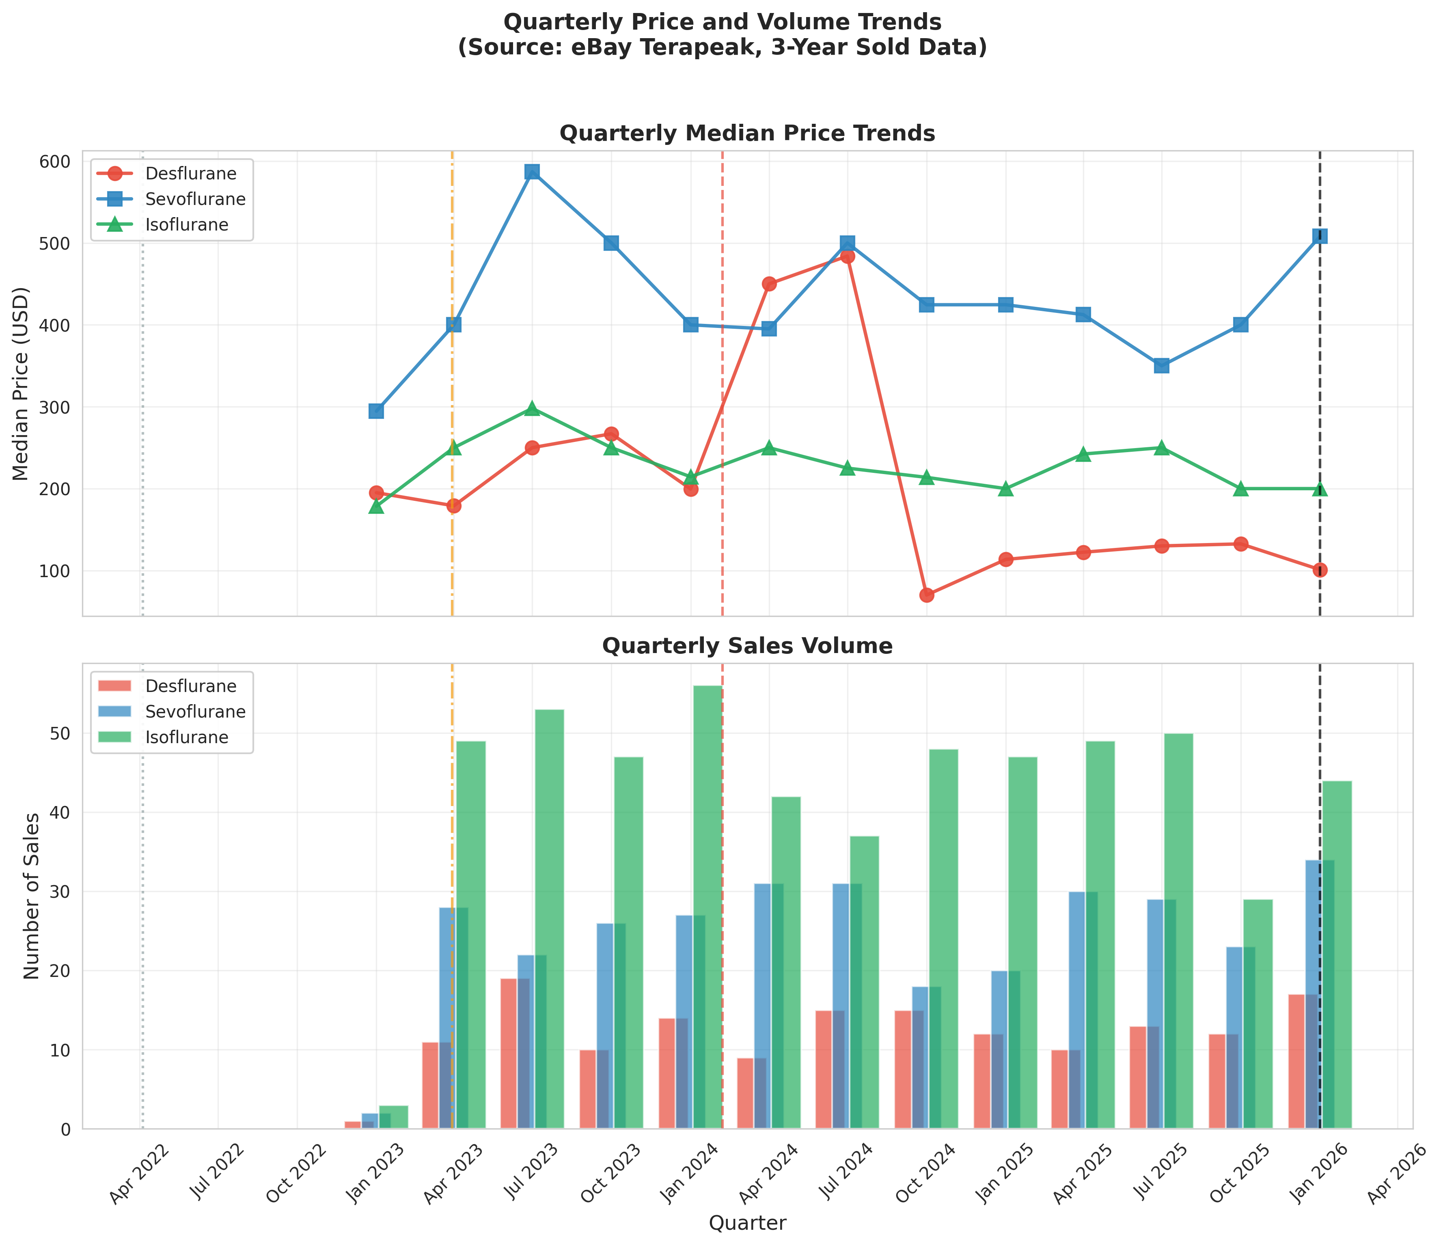
Fig. 3. Quarterly median price trends (upper panel) and sales volume (lower panel). Data source: eBay Terapeak.

In the exploratory pre-/post-ban comparison, the post-ban mean price (US$164 ± 113) was 31% lower than the pre-ban mean (US$238 ± 195). This difference was statistically significant on Welch’s t-test (P=0.027) but did not reach significance on the Mann–Whitney U test (P=0.148), likely reflecting the small post-ban sample (n=17). The effect size was medium (Cohen’s d=-0.47) (Table 2, Panel A; Fig. 4).

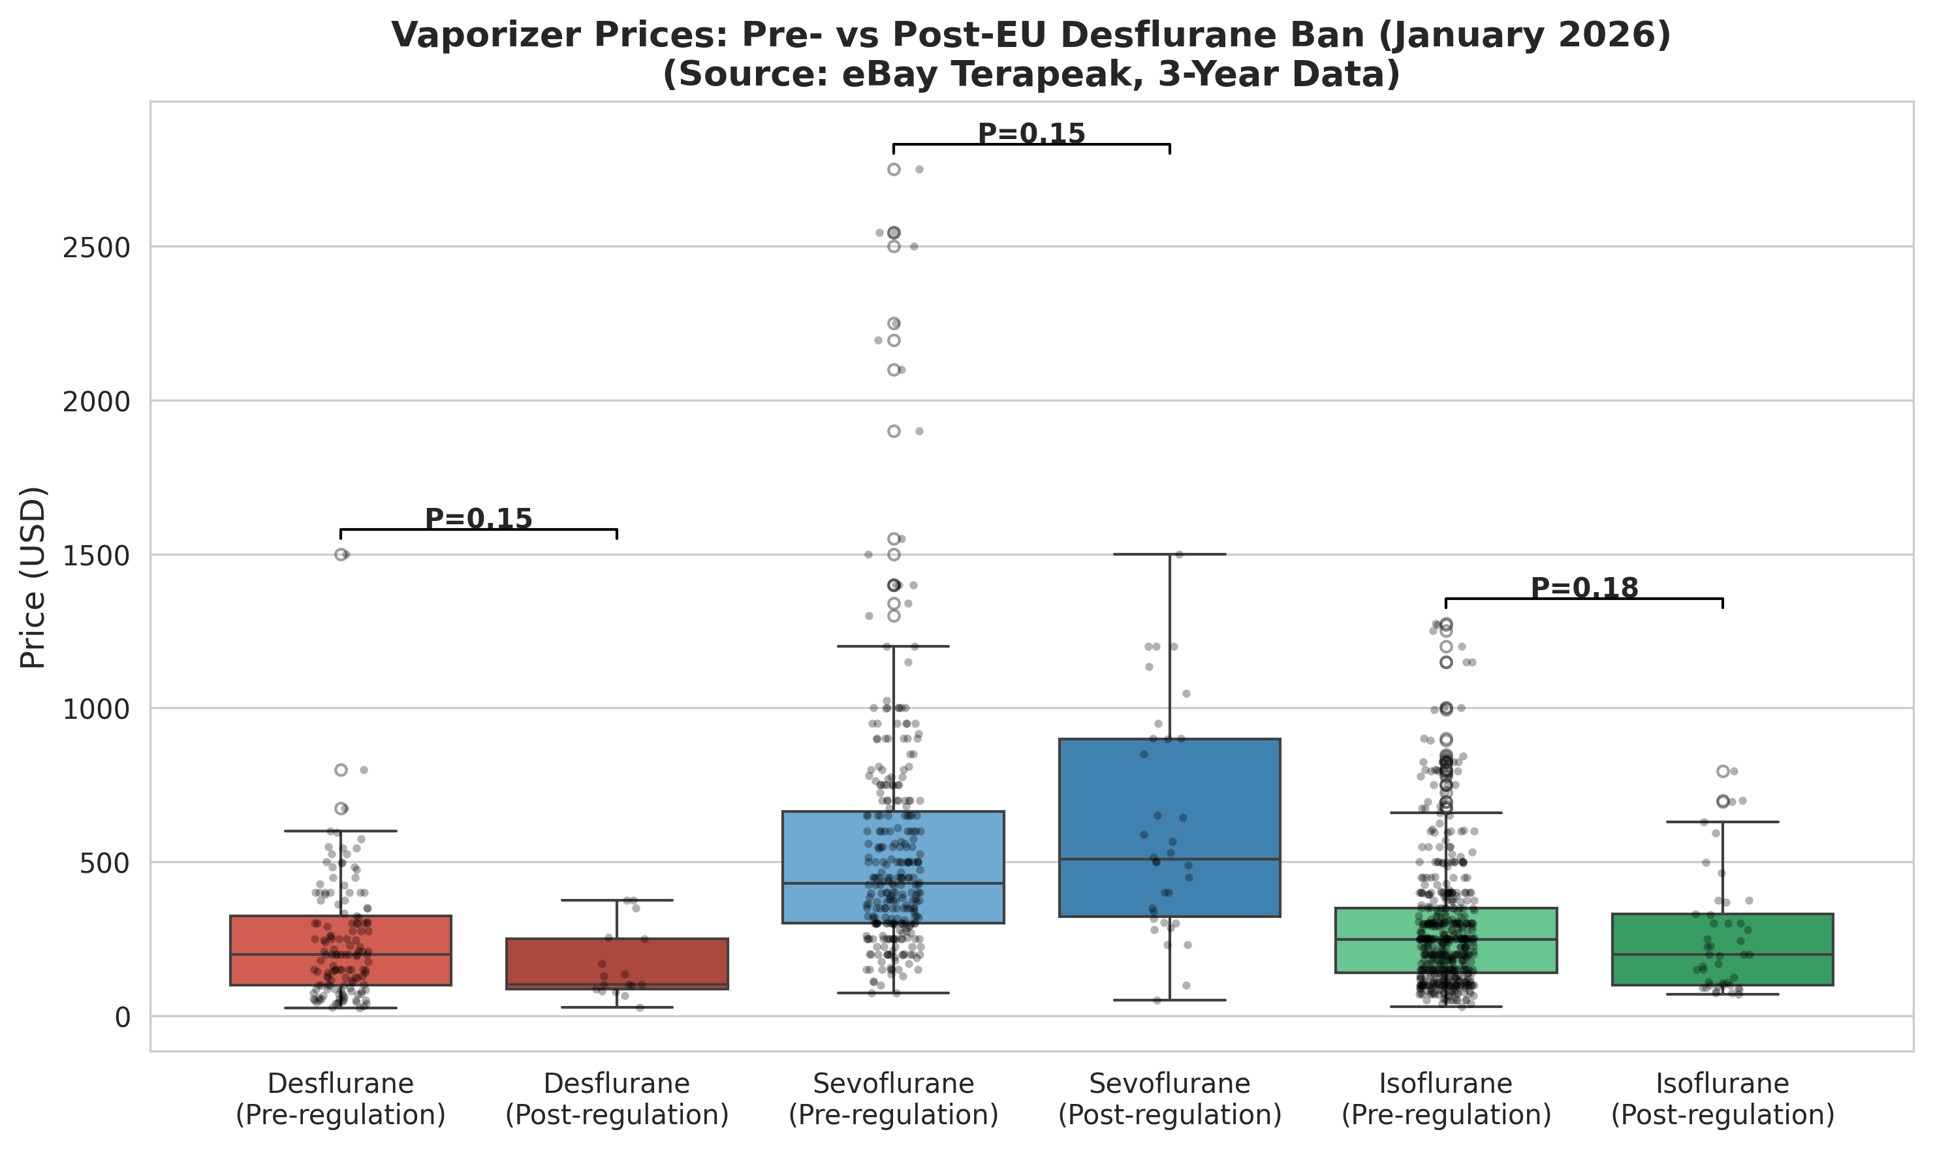
Fig. 4. Box plot comparison of vaporizer prices before and after the EU desflurane ban (1 January 2026). Individual data points are shown as jittered dots. Data source: eBay Terapeak.

In contrast, sevoflurane vaporizer prices showed no significant temporal trend (Spearman ρ=0.01, P=0.862; Kendall τ=0.04, P=0.365). Pre-/post-ban comparison showed a non-significant 12% increase (P=0.150, Mann–Whitney U) (Fig. 5).

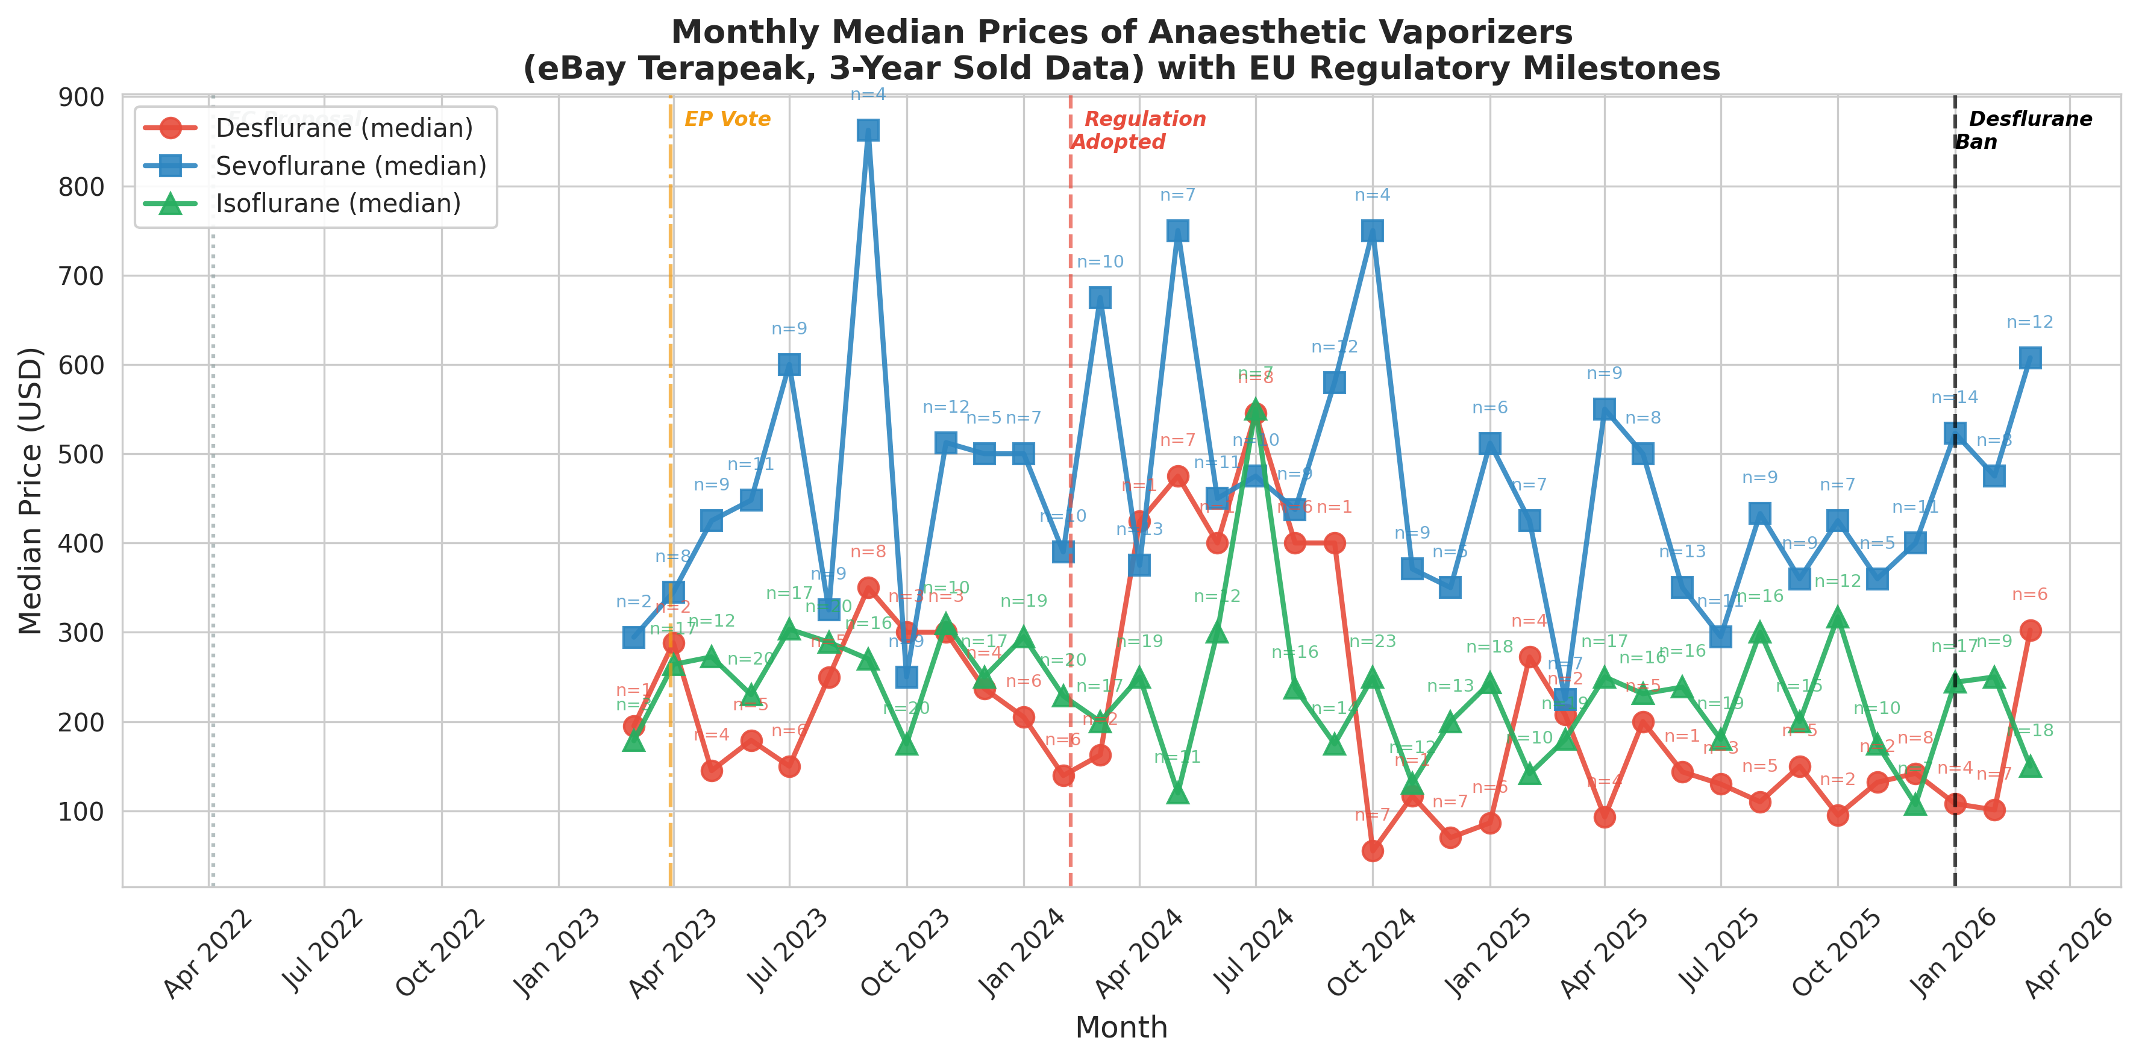
Fig. 5. Monthly median prices of anesthetic vaporizers on eBay. Annotations indicate the number of transactions per month (n). Data source: eBay Terapeak.

Isoflurane vaporizer prices were similarly stable. Spearman (ρ=-0.09, P=0.044) and Kendall τ (τ=-0.07, P=0.025) tests reached nominal significance at the transaction level, but the quarterly median trend was not significant (ρ=-0.32, P=0.285) and effect sizes were small. These isolated P values are expected under multiple testing and do not indicate a consistent directional trend. The pre-/post-ban comparison showed a non-significant 11% decline (P=0.184, Mann–Whitney U) (Fig. 6).

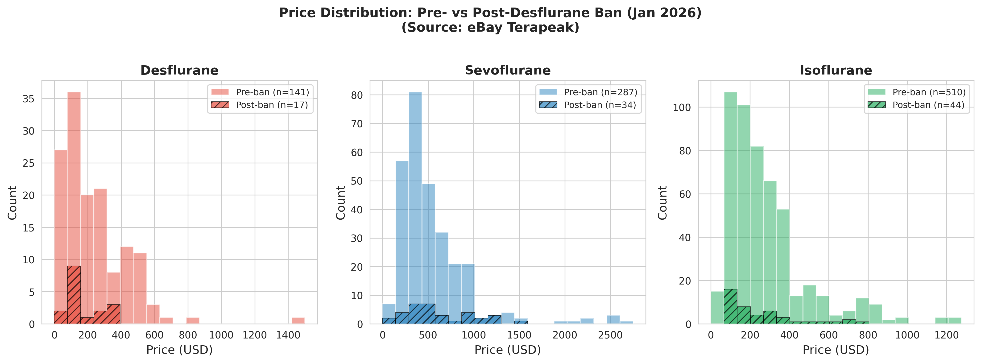
Fig. 6. Price distribution histograms for each vaporizer type, comparing pre-ban (solid fill) and post-ban (hatched) periods. Data source: eBay Terapeak.

Between-agent comparison tested whether the magnitude of pre-/post-ban price change differed across agent types (Table 2, Panel B). The effect size for desflurane (d=-0.47; 95% CI -0.97 to 0.04) was significantly larger than that for sevoflurane (d=0.17; 95% CI -0.18 to 0.53; Δd=-0.64, z=-2.03, P=0.043). The difference relative to isoflurane (d=-0.16; 95% CI -0.47 to 0.15) did not reach statistical significance (Δd=-0.31, z=-1.03, P=0.303).
Sensitivity analyses with control series were consistent with the primary time-series findings. In a comparative interrupted time-series model of monthly median prices, desflurane showed a desflurane-specific level decline at the restriction (log-price coefficient=-0.88, P<0.001) and a post-restriction slope difference (coefficient=0.45, P<0.001), whereas isoflurane did not (level-change P=0.602). In a transaction-level difference-in-differences model the desflurane post-restriction coefficient was not significant (log-price coefficient=0.018, P=0.946), partly because a significant pre-existing trend difference was present (P=0.001), violating the parallel-trend assumption. These models support agent-specificity but do not establish causality.
In a supplementary cross-sectional analysis of 120 current eBay asking prices (Table S1; active listings, 27 March 2026), desflurane vaporizers had the lowest median asking price (US$178), approximately one-seventh that of sevoflurane (US$1277) and one-third that of isoflurane (US$556; Kruskal–Wallis H=66.0, P<0.001). The desflurane asking–sold price spread (43%) was substantially narrower than for sevoflurane (184%) or isoflurane (178%), suggesting that sellers have already adjusted their price expectations to reflect post-regulation market conditions.

Discussion
This observational study provides the first empirical evidence that environmental regulation of a single anesthetic agent is associated with agent-specific effects on the secondary equipment market. Using three years of eBay completed sale data and complementary statistical approaches, we found that desflurane vaporizer prices declined progressively over the study period. Sevoflurane and isoflurane vaporizer prices remained comparatively stable throughout—despite being traded on the same marketplace and subject to the same macroeconomic conditions. The convergence of evidence from Spearman rank correlation, Kendall τ, and the between-agent effect size comparison (P=0.043) suggests a progressive and agent-specific desflurane price pattern. However, the single-platform, observational design precludes causal inference; the observed association may be partly or wholly attributable to concurrent secular trends.
The transaction-level difference-in-differences (DiD) model did not detect a significant desflurane post-restriction coefficient (coefficient=0.018, P=0.946). This null result should not be interpreted as evidence of no effect. Instead, the DiD parallel-trend assumption was violated (P=0.001 for the pre-restriction trend difference), indicating that desflurane prices were already diverging from controls before 1 January 2026. Because the regulation was proposed in 2022 and adopted in 2024, market participants may have anticipated the 2026 effective date; the DiD violation is consistent with a gradual, anticipation-driven decline rather than a discrete shock. The DiD and CITS results are best interpreted as sensitivity, not causal, analyses.
We did not family-wise correct trend tests across three agents. For isoflurane, Spearman (P=0.044) and Kendall τ (P=0.025) tests were nominally significant at the transaction level, but the quarterly median trend was not significant and effect sizes were small; these isolated P values are expected by chance and are not interpreted as a true trend. The desflurane finding is supported by consistency across Spearman, Kendall τ, and quarterly median analyses.
The stability of non-regulated agent prices is noteworthy, but it does not demonstrate that the EU regulation caused the desflurane decline. Several alternative explanations should be considered. NHS England and NHS Scotland decommissioned desflurane before the EU restriction took effect, so part of the price decline may reflect UK policy signals rather than EU regulation. A concurrent shift toward total intravenous anesthesia (TIVA) and the growing use of low-flow anesthesia and end-tidal control technologies reduce volatile anesthetic consumption generally, but should affect all agents rather than desflurane alone. Equipment-specific factors—age, model year, service history, cosmetic condition, and calibration certificates—are major determinants of vaporizer pricing and could produce compositional changes that mimic a regulatory effect. Macroeconomic trends and institutional stock reallocation—whereby facilities redistributed existing non-desflurane vaporizers internally rather than purchasing on the secondary market—may also have dampened market effects. The comparators (sevoflurane and isoflurane) are not perfect counterfactuals, but their stability on the same marketplace weakens broad-market explanations.
Generalizability is also limited. eBay is a global consumer-to-consumer and small-business marketplace; transactions by large hospital systems are more likely to occur on specialized business-to-business platforms (e.g., DOTmed, Bimedis) or through private dealer networks, which we could not study. Because eBay does not disclose buyer or seller location, we could not determine whether observed transactions involved EU participants; if a substantial share were outside the EU, the price decline could represent a global reassessment of desflurane’s long-term viability rather than a response confined to EU jurisdiction. Finally, the sample of post-restriction transactions was small, and the bootstrap median-difference confidence interval for desflurane included zero, underscoring the uncertainty of the pre-/post comparison.
To our knowledge, no previous study has examined the secondary market impact of environmental regulation on anesthetic equipment. Lehmann et al.¹⁶ demonstrated that combining education with physical removal of desflurane vaporizers reduced desflurane-attributable CO₂ equivalent emissions by 86%, but their study measured drug consumption rather than equipment resale values. Meyer¹³ and Mohammed and Metta¹⁵ articulated the global and financial rationale for desflurane discontinuation, while Moonesinghe¹⁴ discussed the broader implications of decommissioning programs, but none examined downstream effects on the secondary equipment market. Our findings are consistent with the broader literature on environment-related stranded assets,²¹ where anticipated regulatory restrictions are associated with anticipatory declines in asset values. The clinical and environmental trade-offs of restricting desflurane—including its pharmacokinetic advantages, the contested suitability of GWP100 for short-lived anesthetics, and the risk of reducing anesthetic diversity amid recurring propofol and sevoflurane shortages— underscore the need for cautious, evidence-based policy and for market studies that do not rely on a single sales channel.^{6,7,22}
The timing of the price decline may have practical implications. A substantial proportion of the depreciation appears to have occurred before the 2026 restriction took effect, during the legislative process itself. Because NHS England and NHS Scotland had already announced decommissioning, the pre-2026 pattern may partly reflect UK policy signals rather than EU law alone. For anesthesia departments, this observation suggests that early planning for equipment transition—rather than waiting for formal prohibition—may improve cost recovery on the secondary market, although this inference is observational and cannot be translated directly to all jurisdictions.
Strengths of this study include the use of actual completed sale prices (rather than asking prices), a three-year observation window spanning both the legislative process and restriction implementation, the use of multiple complementary statistical approaches (Spearman correlation, Kendall τ trend test, pre-/post-ban comparison, bootstrap resampling, post-hoc power estimation, and CITS/DiD sensitivity analyses), the availability of natural comparator groups (sevoflurane and isoflurane), and the use of a standardized data source (eBay Terapeak). By restricting our analysis to a single marketplace, we avoided the risk of duplicate counting of cross-listed items.
This study has several important limitations. First, this is an observational study of secondary market data; no causal inference can be drawn. The association between regulatory milestones and price changes may be confounded by unmeasured factors, including changes in clinical practice patterns (e.g., increasing use of total intravenous anesthesia), technological evolution of anesthesia delivery systems (e.g., low-flow and end-tidal control systems), NHS decommissioning announcements that pre-dated the 2026 EU restriction, or broader macroeconomic conditions. Second, eBay represents only one segment of the secondary medical equipment market. Prices on specialized platforms (e.g., DOTmed, Bimedis) or private dealer networks may behave differently, and our findings may not generalize to those channels. Third, we could not control for equipment age, model year, service history, cosmetic condition, or the presence of manufacturer calibration certificates—factors that substantially influence vaporizer pricing and could create compositional effects. Fourth, the post-restriction period (January–March 2026) comprised only 17 desflurane, 34 sevoflurane, and 44 isoflurane transactions. This small sample reflects the Terapeak three-year window ending at data collection in March 2026, which constrains the post-restriction follow-up to approximately three months after the 1 January 2026 effective date and precludes extending the window without prospective data collection or a later extraction. Bootstrap resampling and post-hoc power simulation confirmed that the desflurane Mann–Whitney U test had low power (approximately 28%) and that the median-difference confidence interval included zero; the Welch t-test was more powerful (approximately 58%) and the mean-difference confidence interval excluded zero. Although the time-series trend analyses (which use all data points) suggest a progressive decline, the pre-/post-ban comparison should be considered exploratory. Fifth, eBay is a global marketplace; we could not distinguish between EU and non-EU buyers or sellers, nor could we assess whether sellers were institutions disposing of regulated equipment or private resellers. Finally, the three-year observation period does not extend to the pre-proposal period (before April 2022), limiting our ability to establish a true baseline unaffected by regulatory signals. The DiD and CITS models support agent-specificity but do not satisfy the assumptions required for causal identification; they should be interpreted as sensitivity, not confirmatory, analyses. Additionally, multiple trend tests across three agents inflate the chance of a nominally significant P value; isolated P values near 0.05 (e.g., isoflurane Spearman P=0.044) are interpreted cautiously and in the context of effect size and consistency across tests.
Looking ahead, environmental pressures are likely to prompt further regulatory interventions in anesthesia and healthcare more broadly. Nitrous oxide, for example, is already subject to emerging regulatory and institutional restrictions on environmental grounds.⁸ Our findings provide preliminary, hypothesis-generating evidence that the EU desflurane restriction on routine use—the first mandatory, agent-specific environmental restriction in anesthesia—was associated with targeted secondary-market price patterns without observable destabilization of the wider equipment market. Future studies with larger post-restriction samples, multiple marketplaces, geographic transaction data, and controlled comparisons will be needed to confirm these findings and to determine whether they generalize to other regulatory contexts.

Conclusion
In this observational study, desflurane vaporizer prices on eBay showed a progressive, agent-specific decline during the EU regulatory process, while sevoflurane and isoflurane prices remained comparatively stable. These findings are consistent with the hypothesis that the EU desflurane phase-out was associated with targeted secondary-market effects, but they do not prove causation. They should be interpreted as hypothesis-generating, given the single-platform design, the inability to identify EU-specific transactions, the small post-restriction sample, and the possibility of unmeasured confounders such as NHS decommissioning and secular clinical trends.

CRediT authorship contribution statement
O.T.: Conceptualization, Methodology, Software, Formal analysis, Writing - original draft, Writing - review & editing
T.I.: Writing - original draft, Writing - review & editing

Disclosure statement
The authors declare that they have no known competing financial interests or personal relationships that could have appeared to influence the work reported in this paper.

Ethical statement
Ethical approval was not required for this study, which analyzed publicly available completed sale data from eBay. No individual-level or patient data were collected.

Funding
This research did not receive any specific grant from funding agencies in the public, commercial, or not-for-profit sectors.

Data availability
The datasets generated during this study are available from the corresponding author on reasonable request. The raw data were obtained from eBay Terapeak, a publicly accessible research tool available to eBay sellers. Analysis code is available at https://github.com/bougtoir/vaporizer-price-study.

Declaration of competing interest
The authors declare that they have no known competing financial interests or personal relationships that could have appeared to influence the work reported in this paper.

Acknowledgments
None.

Declaration of Generative Artificial Intelligence (AI) in Scientific Writing
During the preparation of this work the author used Devin (devin.ai) in order to format the text and choose words that suited the tone, and to help writing codes. After using this tool/service, the author reviewed and edited the content as needed and takes full responsibility for the content of the published article.

References
¹ Varughese S, Ahmed R. Environmental and occupational considerations of anesthesia: a narrative review and update. Anesth Analg. 2021;133:826–35.
² Regulation (EU) 2024/573 of the European Parliament and of the Council of 7 February 2024 on fluorinated greenhouse gases. Official Journal of the European Union. 2024;L 2024/573.
³ Sherman J, Le C, Lamers V, et al. Life cycle greenhouse gas emissions of anesthetic drugs. Anesth Analg. 2012;114:1086–90.
⁴ Hendrickx JFA, Nielsen OJ, De Hert S, et al. The science behind banning desflurane: a narrative review. Eur J Anaesthesiol. 2022;39:818–24.
⁵ White SM, Shelton CL, Gelb AW, et al. Principles of environmentally-sustainable anaesthesia: a global consensus statement from the World Federation of Societies of Anaesthesiologists. Anaesthesia. 2022;77:201–12.
⁶ Sulbaek Andersen MP, Nielsen OJ, Sherman JD. Assessing the potential climate impact of anaesthetic gases. Lancet Planet Health. 2023;7(7):e622–e629. doi:10.1016/S2542-5196(23)00084-0.
⁷ Hariyanto H, Widiastuti M, Pandrya CO, et al. Comparison of desflurane and sevoflurane as maintenance inhalational anaesthetic agents for adult patients undergoing neurosurgeries: a systematic review and meta-analysis of randomised trials. Indian J Anaesth. 2025;69(1):65–77. doi:10.4103/ija.ija_1215_24.
⁸ American Society of Anesthesiologists Committee on Environmental Health. Statement on deactivating central piped nitrous oxide to mitigate avoidable health care pollution. Schaumburg, IL: ASA, 2024.
⁹ McGain F, Muret J, Guen CL, et al. Environmental sustainability in anaesthesia and critical care. Br J Anaesth. 2020;125:680–92.
¹⁰ NHS England. Decommissioning of desflurane in the NHS. 2023.
¹¹ Sulbaek Andersen MP, Sander SP, Nielsen OJ, et al. Inhalation anaesthetics and climate change. Br J Anaesth. 2010;105:760–6.
¹² Ryan SM, Nielsen CJ. Global warming potential of inhaled anesthetics: application to clinical use. Anesth Analg. 2010;111:92–8.
¹³ Meyer MJ. Desflurane should des-appear: global and financial rationale. Anesth Analg. 2020;131:1317–22.
¹⁴ Moonesinghe SR. Desflurane decommissioning: more than meets the eye. Anaesthesia. 2024;79:237–41.
¹⁵ Mohammed A, Metta H. Is it time to bid adieu to desflurane? J Anaesthesiol Clin Pharmacol. 2025;41:211–2.
¹⁶ Lehmann H, Werning J, Baschnegger H, et al. Minimising the usage of desflurane only by education and removal of the vaporisers – a before-and-after-trial. BMC Anesthesiol. 2025;25:108.
¹⁷ Feldman JM, Lo C, Hendrickx J. Estimating the impact of carbon dioxide absorbent performance differences on absorbent cost during low-flow anesthesia. Anesth Analg. 2020;130(2):374–81. doi:10.1213/ANE.0000000000004059.
¹⁸ Beard J, Kennedy R, Philip J, et al. Environmental and economic impacts of end-tidal control of volatile anesthetics: a scoping review and analysis. Open Anesthesiol J. 2025;19:e25896458355905.
¹⁹ Shukla S, Kalaiselvan V, Raghuvanshi RS. How to improve regulatory practices for refurbished medical devices. Bull World Health Organ. 2023;101:412–7.
²⁰ von Elm E, Altman DG, Egger M, et al. The Strengthening the Reporting of Observational Studies in Epidemiology (STROBE) statement: guidelines for reporting observational studies. BMJ. 2007;335:806–8.
²¹ Shimbar A. Environment-related stranded assets: what does the market think about the impact of collective climate action on the value of fossil fuel stocks? Energy Econ. 2021;103:105579.
²² Kranke P, Kleinberg R, Meybohm P, et al. Anesthetic diversity: a pillar of healthcare system resilience and a strategic imperative in an era of uncertainty. Anaesthesiologie. 2026. doi:10.1007/s00101-025-01639-x.

Supplementary material
[Table S1: Current eBay asking prices — uploaded as separate file]

