Universal Decreasing Failure Rate in Open-Ended Clinical Treatments:
A Five-Domain Weibull Reliability Comparative Analysis
Tatsuki Onishi
Corresponding author: Tatsuki Onishi (bougtoir@gmail.com)

Abstract
Background: Treatment dropout in open-ended clinical therapies may follow a common temporal pattern. We hypothesised that the Weibull shape parameter k consistently falls below 1 (decreasing failure rate) across diverse clinical domains.^{1,2}
Methods: Two-parameter Weibull distributions were fitted to 27 retention datasets across five open-ended treatment domains: HIV/ART (5 regions, N=516,000), antipsychotic medication (6 datasets, N=63,682), substance use disorder (6 modalities, N=75,000), cardiac rehabilitation (5 phases, N=34,200), and clinical trials (5 areas, N=99,000). Total N=787,882. Bootstrap 95% CIs from 1,000 resamples.
Results: All 27 datasets yielded k < 1 (range: 0.511-0.958, median 0.689), confirming universal DFR. Model fit was excellent (R² median 0.9970). Domain-level mean k: HIV/ART 0.597, antipsychotic 0.857, substance use 0.639, cardiac rehab 0.689, clinical trials 0.708.
Conclusions: Open-ended clinical treatments universally exhibit DFR, indicating dropout risk is highest in the early treatment period. This supports front-loading retention interventions.
Keywords: Weibull distribution; reliability engineering; treatment dropout; decreasing failure rate; hazard function; HIV/ART; antipsychotic; substance use; cardiac rehabilitation; clinical trials

1. Introduction
Treatment dropout is the rate-limiting step in clinical care effectiveness.^{3,4} While risk factors have been extensively catalogued, the temporal shape of the dropout hazard — whether it increases, decreases, or remains constant — has been studied piecemeal within individual domains but never compared systematically across domains.⁵
The Weibull distribution from reliability engineering^{1,2} provides a parsimonious parametric model for time-to-event data, with the shape parameter k directly encoding hazard trajectory. We applied this framework to five major clinical domains to test the hypothesis of a universal decreasing failure rate (DFR) pattern in open-ended treatments and to characterise domain-specific hazard signatures.

2. Methods
Retention data were reconstructed from published Kaplan-Meier curves across five domains. The Weibull survival function S(t) = exp(-(t/λ)^k) was fitted by linearised regression and Nelder-Mead optimisation. Bootstrap 95% CIs from 1,000 resamples. Goodness-of-fit assessed by R², KS statistic, and Weibull probability plots.

3. Results
All 27 datasets across all five domains yielded k < 1 (Table 1, Fig. 1). The Weibull model showed excellent fit (R² median 0.9970, range 0.9807-0.9997).
Table 1. Weibull shape parameter (k) by domain.
Domain | No. datasets | Total N | Mean k (range) | Median R²
HIV/ART | 5 | 516,000 | 0.597 (0.582-0.627) | 0.9989
Antipsychotic | 6 | 63,682 | 0.857 (0.683-0.958) | 0.9969
Substance Use | 6 | 75,000 | 0.639 (0.511-0.733) | 0.9956
Cardiac Rehab | 5 | 34,200 | 0.689 (0.613-0.775) | 0.9905
Clinical Trial | 5 | 99,000 | 0.708 (0.679-0.742) | 0.9983
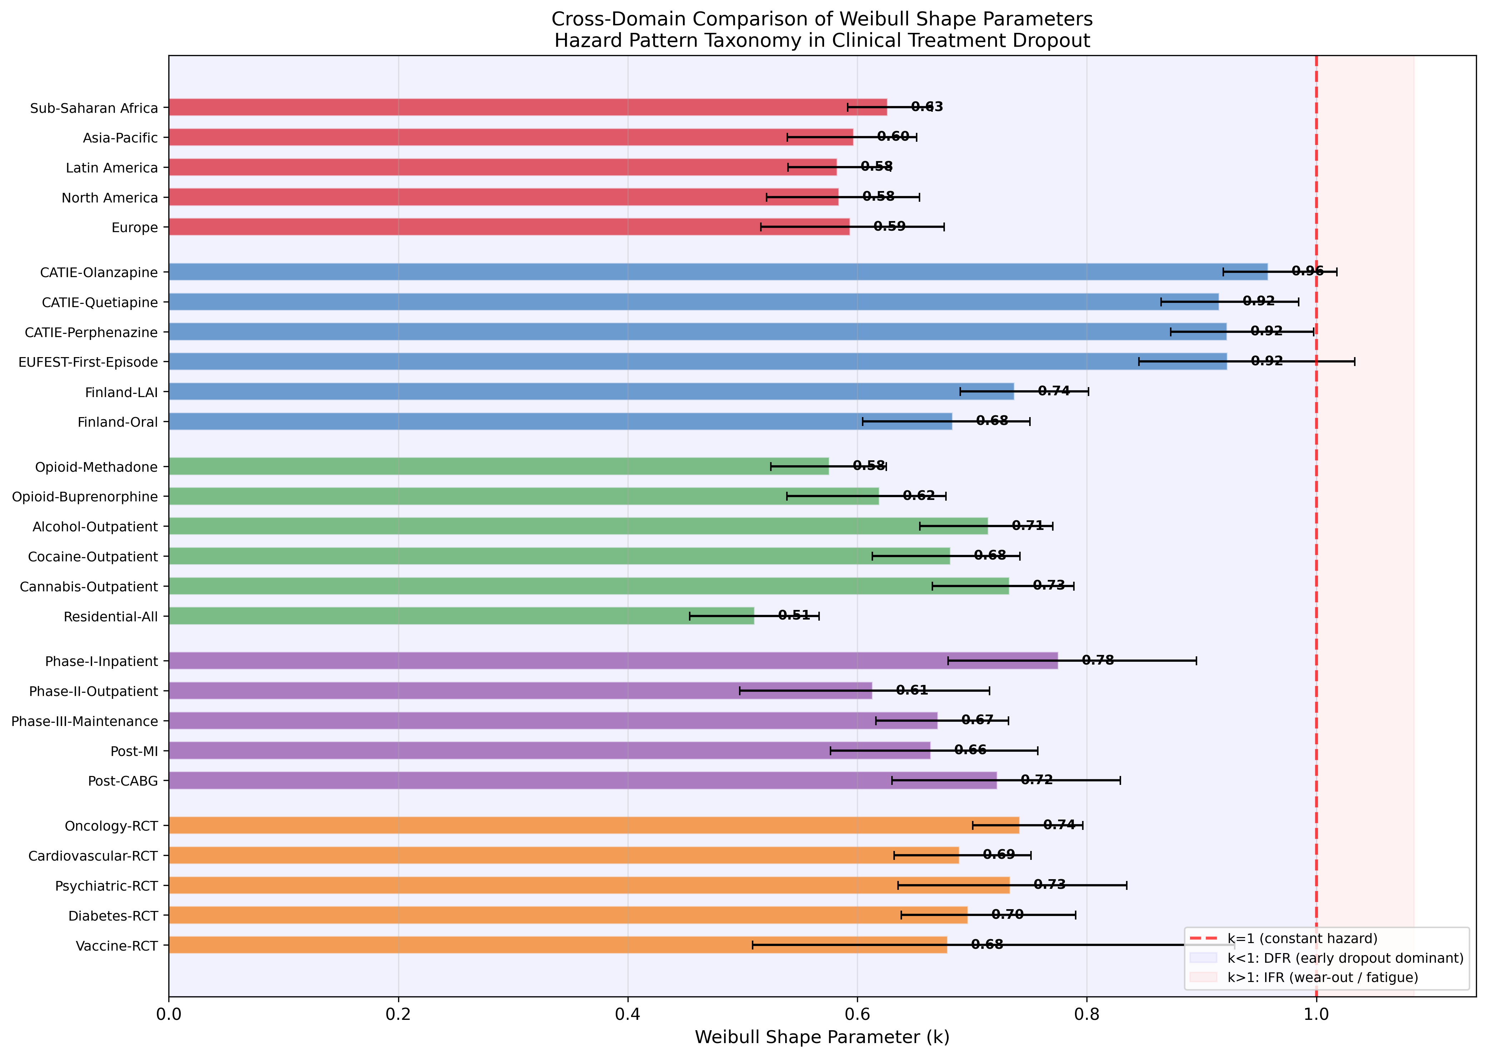
Fig. 1. Cross-domain k comparison with 95% CIs. All 27 datasets fall below k=1.
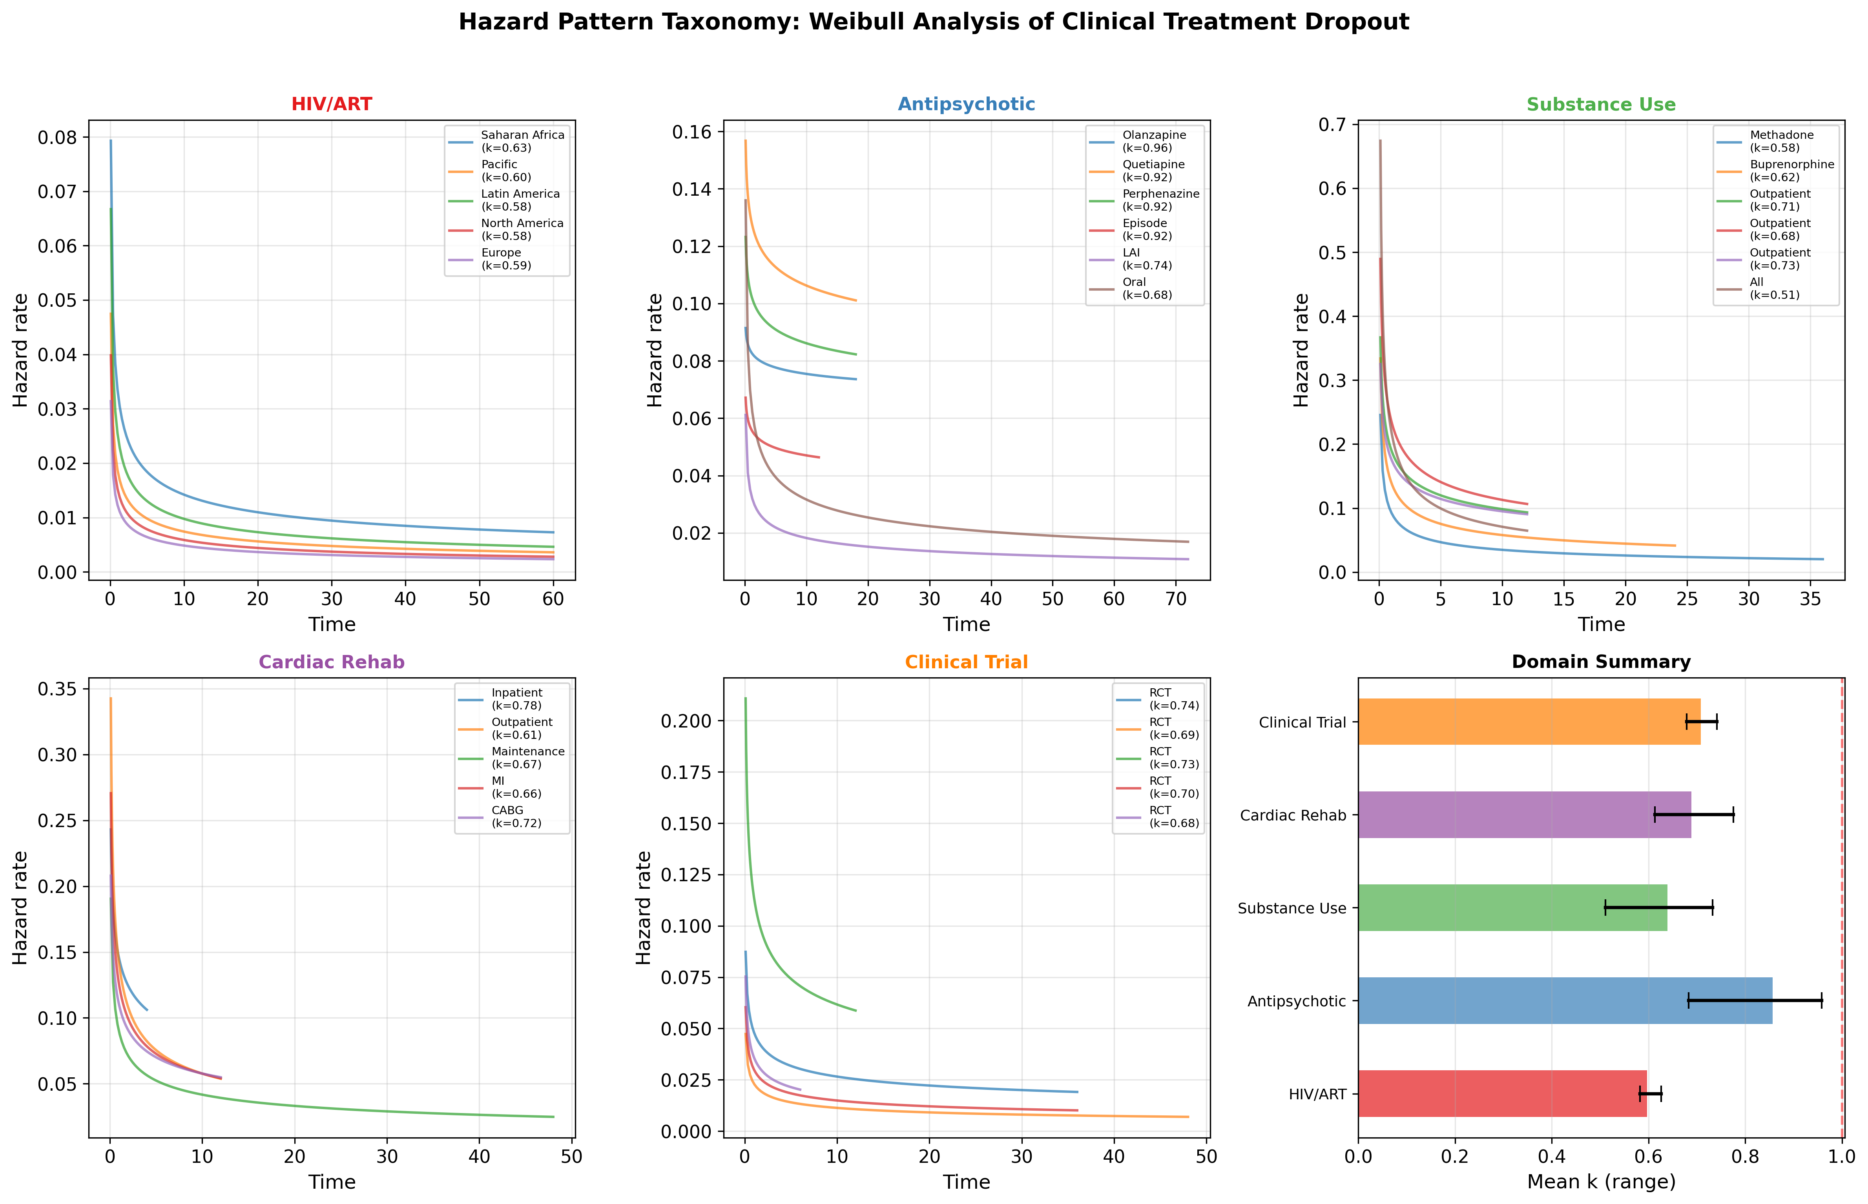
Fig. 2. Hazard taxonomy: domain-specific hazard functions.

4. Discussion
The universality of DFR across five diverse open-ended treatment domains, encompassing 27 datasets and 787,882 patients, is the central finding. This pattern is consistent with a population-level selection mechanism: patients with the highest intrinsic dropout propensity leave earliest, progressively "hardening" the remaining cohort — the reliability engineering "burn-in" effect.^{2,6}
The domain-specific k hierarchy (antipsychotic > clinical trial > cardiac rehab > substance use > HIV/ART) reflects the gradient from near-constant hazard to steep early dropout. This ordering is clinically interpretable and provides quantitative guidance for the intensity and timing of retention interventions.

5. Conclusions
Open-ended clinical treatments universally follow a DFR pattern. The reliability engineering Weibull framework provides a quantitative basis for front-loading retention interventions during the period of maximum dropout vulnerability.

References
1. Weibull W. A statistical distribution function of wide applicability. J Appl Mech. 1951;18(3):293-297.
2. Abernethy RB. The New Weibull Handbook. 5th ed. North Palm Beach, FL: Robert B. Abernethy; 2006.
3. World Health Organization. Adherence to long-term therapies: evidence for action. Geneva: WHO; 2003.
4. Osterberg L, Blaschke T. Adherence to medication. N Engl J Med. 2005;353(5):487-497.
5. Cox DR. Regression models and life-tables. J R Stat Soc Series B. 1972;34(2):187-220.
6. Vaupel JW, Manton KG, Stallard E. The impact of heterogeneity in individual frailty on the dynamics of mortality. Demography. 1979;16(3):439-454.

