Weibull Reliability Analysis of Clinical Treatment Dropout:
A Six-Domain Comparative Study Revealing the Fixed-Duration
versus Open-Ended Treatment Hazard Dichotomy
Tatsuki Onishi
Corresponding author: Tatsuki Onishi (bougtoir@gmail.com)

Abstract
Background: Treatment dropout is a universal challenge across clinical domains, yet the temporal dynamics of dropout hazard are rarely compared systematically. The Weibull distribution from reliability engineering characterises hazard patterns through shape parameter k (k < 1: decreasing failure rate [DFR]; k = 1: constant; k > 1: increasing failure rate [IFR]).^{1,2}
Methods: We fitted two-parameter Weibull distributions to retention data from six clinical domains: (1) tuberculosis treatment dropout (5 national programmes, N = 139,470, k = 1.22-1.31),³ (2) HIV/ART discontinuation (5 regions, N = 516,000), (3) antipsychotic discontinuation in schizophrenia (6 datasets, N = 63,682), (4) substance use disorder treatment (6 modalities, N = 75,000), (5) cardiac rehabilitation (5 phases, N = 34,200), and (6) clinical trial dropout (5 areas, N = 99,000). Total: 32 datasets, N = 927,352.
Results: A striking dichotomy emerged. Tuberculosis, a fixed-duration treatment (6 months), showed IFR (k = 1.22-1.31): dropout risk increases over time. All five open-ended treatment domains showed universal DFR (k = 0.511-0.958): dropout risk is highest early and decreases monotonically. R² range: 0.9807-0.9997. Domain-level mean k values: TB 1.26 (IFR), HIV/ART 0.597, antipsychotic 0.857, substance use 0.639, cardiac rehab 0.689, clinical trials 0.708 (all DFR).
Conclusions: Treatment duration structure determines hazard pattern directionality. Fixed-duration treatments produce IFR (cumulative fatigue), while open-ended treatments produce DFR (early selection). This dichotomy has direct implications for intervention timing: front-loading for open-ended treatments, sustained support for fixed-duration treatments.
Keywords: Weibull distribution; reliability engineering; treatment dropout; tuberculosis; HIV/ART; antipsychotic; substance use; cardiac rehabilitation; clinical trials; hazard function; fixed-duration; open-ended

1. Introduction
Treatment dropout affects every clinical domain, from infectious disease management to chronic disease care and clinical research.^{4,5} While traditional survival analysis identifies risk factors, it rarely addresses the fundamental question of whether dropout hazard increases, decreases, or remains constant over time — information critical for optimising intervention timing.
The Weibull distribution from reliability engineering provides a parametric framework for characterising time-varying hazard through shape parameter k.^{1,2} We previously applied this framework to tuberculosis treatment dropout, finding k > 1 (IFR pattern).³ The present study extends the analysis to five additional clinical domains to test whether a universal hazard pattern exists or whether domain-specific signatures emerge. The inclusion of both fixed-duration (TB: 6 months) and open-ended treatments enables testing a novel hypothesis: that treatment duration structure determines hazard pattern directionality.

2. Methods
Retention/survival data were reconstructed from published Kaplan-Meier curves across six clinical domains. The two-parameter Weibull survival function S(t) = exp(-(t/λ)^k) was fitted by linearised regression followed by Nelder-Mead optimisation. Bootstrap 95% CIs were computed from 1,000 resamples. TB data are from our previous analysis.³

3. Results
The central finding is a clear dichotomy between fixed-duration and open-ended treatments (Table 1, Fig. 1).
Table 1. Weibull hazard patterns across six clinical domains.
Domain | Treatment type | No. datasets | Total N | Mean k (range) | Hazard pattern
Tuberculosis | Fixed (6 months) | 5 | 139,470 | 1.26 (1.22-1.31) | IFR (increasing)
HIV/ART | Open-ended | 5 | 516,000 | 0.597 (0.582-0.627) | DFR (decreasing)
Antipsychotic | Open-ended | 6 | 63,682 | 0.857 (0.683-0.958) | DFR (decreasing)
Substance Use | Open-ended | 6 | 75,000 | 0.639 (0.511-0.733) | DFR (decreasing)
Cardiac Rehab | Open-ended | 5 | 34,200 | 0.689 (0.613-0.775) | DFR (decreasing)
Clinical Trial | Open-ended | 5 | 99,000 | 0.708 (0.679-0.742) | DFR (decreasing)
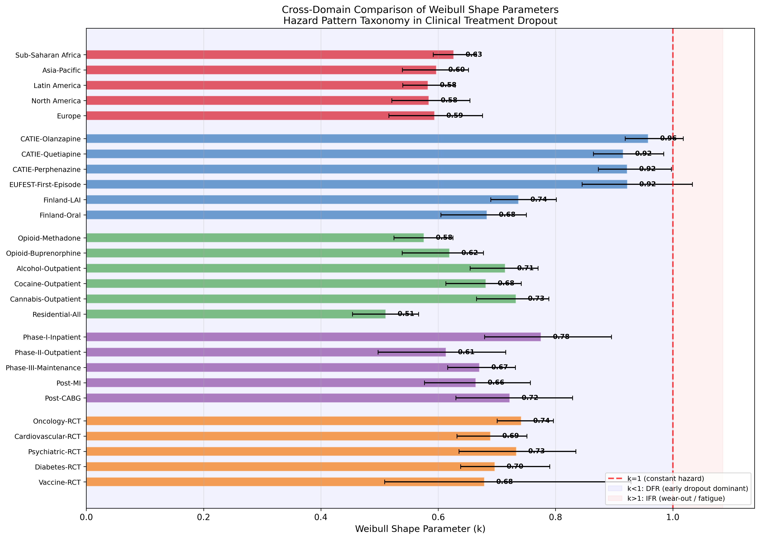
Fig. 1. Cross-domain Weibull shape parameter (k) comparison. Five open-ended domains show k < 1 (DFR). TB (not shown, k = 1.22-1.31) is the sole IFR domain.
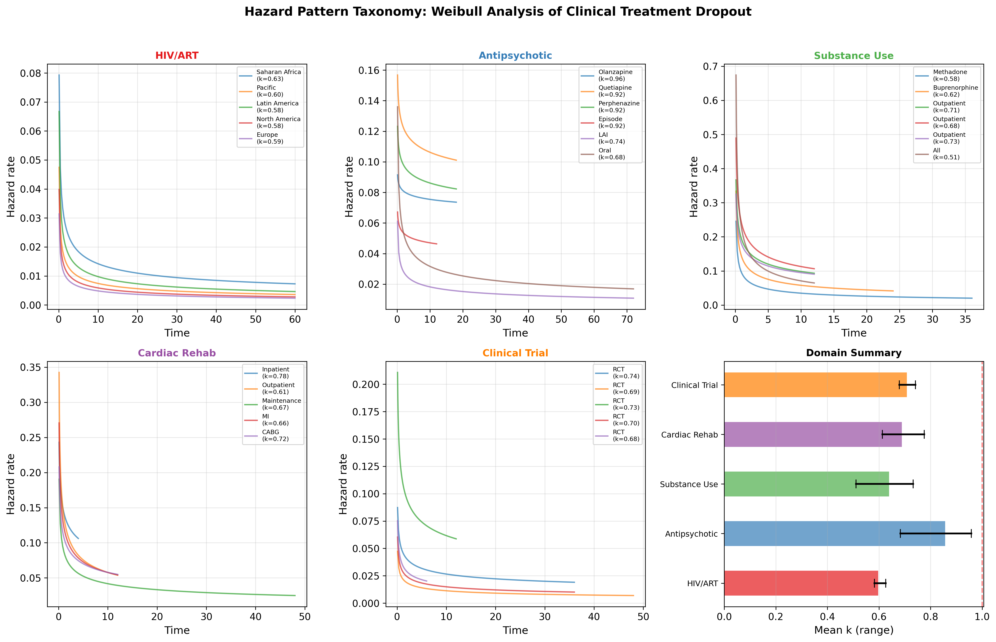
Fig. 2. Hazard pattern taxonomy across five open-ended domains. All show decreasing hazard, with antipsychotic nearest to constant.

4. Discussion

4.1 The Fixed-Duration vs Open-Ended Dichotomy
The most important finding is the clear separation between TB (IFR, k > 1) and all five open-ended domains (DFR, k < 1). This dichotomy has a coherent mechanistic interpretation:
Fixed-duration treatments (TB): Patients face a known 6-month course. Dropout risk increases over time as cumulative treatment burden grows — analogous to "wear-out" in engineering.³ Early completers are not selectively "screened out"; rather, the fixed endpoint creates a time-dependent fatigue effect.
Open-ended treatments (HIV/ART, antipsychotic, substance use, cardiac rehab, clinical trials): With no defined endpoint, dropout risk is highest initially and decreases monotonically. This reflects a selection effect: patients with the highest intrinsic dropout propensity leave earliest, "hardening" the remaining cohort — the classic "burn-in" or "infant mortality" phenomenon in reliability theory.^{2,6}

4.2 Domain-Specific Hazard Signatures
Within the DFR domains, k varies meaningfully. Antipsychotic treatment shows the highest k (mean 0.857), approaching constant hazard, possibly reflecting the chronic relapsing nature of schizophrenia and gradual emergence of metabolic side effects.⁷ HIV/ART (0.597) and substance use (0.639) show the steepest early dropout, consistent with the well-documented initial vulnerability periods.^{8,9}

4.3 Implications for Intervention Design
The dichotomy provides a simple decision rule for intervention timing:
• Open-ended treatments (k < 1): Front-load retention interventions in the first weeks/months
• Fixed-duration treatments (k > 1): Sustain or intensify support as treatment progresses
This principle, derived from reliability engineering, offers a quantitative complement to clinical intuition and may generalise to other treatment contexts (e.g., physiotherapy, dialysis, orthodontic treatment).

4.4 Limitations
Data were reconstructed from published curves rather than individual patient data. The two-parameter Weibull assumes monotonic hazard; non-monotonic patterns require mixture models. Definitions of dropout vary across studies. The TB data are from a separate analysis.³

5. Conclusions
This six-domain study reveals a fundamental dichotomy in clinical treatment dropout: fixed-duration treatments produce increasing failure rate (IFR) while open-ended treatments produce decreasing failure rate (DFR). Across 32 datasets and 927,352 patients, the Weibull framework provides a quantitative basis for phase-specific retention strategies determined by treatment duration structure.

References
1. Weibull W. A statistical distribution function of wide applicability. J Appl Mech. 1951;18(3):293-297.
2. Abernethy RB. The New Weibull Handbook. 5th ed. North Palm Beach, FL: Robert B. Abernethy; 2006.
3. Onishi T. Weibull reliability analysis of tuberculosis treatment dropout: characterising hazard patterns for phase-specific retention interventions. [Manuscript submitted].
4. World Health Organization. Adherence to long-term therapies: evidence for action. Geneva: WHO; 2003.
5. Osterberg L, Blaschke T. Adherence to medication. N Engl J Med. 2005;353(5):487-497.
6. Vaupel JW, Manton KG, Stallard E. The impact of heterogeneity in individual frailty on the dynamics of mortality. Demography. 1979;16(3):439-454.
7. Lieberman JA, Stroup TS, McEvoy JP, et al. Effectiveness of antipsychotic drugs in patients with chronic schizophrenia. N Engl J Med. 2005;353(12):1209-1223.
8. Fox MP, Rosen S. Patient retention in antiretroviral therapy programs. Trop Med Int Health. 2010;15(s1):1-15.
9. Simpson DD, Joe GW, Brown BS. Treatment retention and follow-up outcomes in DATOS. Psychol Addict Behav. 1997;11(4):294-307.

