Weibull Reliability Analysis of Antipsychotic Medication Discontinuation in Schizophrenia:
Comparing Trial and Real-World Hazard Patterns
Tatsuki Onishi
Corresponding author: Tatsuki Onishi (bougtoir@gmail.com)

Abstract
Background: Antipsychotic medication discontinuation in schizophrenia is a major contributor to relapse, yet the temporal dynamics of discontinuation hazard are poorly understood.¹
Methods: We applied Weibull distribution fitting to discontinuation data from the CATIE trial (N=934, 3 arms),² EUFEST trial (N=498),³ and Finnish nationwide cohort (N=62,250, LAI vs oral).⁴ Bootstrap 95% CIs from 1,000 resamples.
Results: All six datasets yielded k < 1 (range: 0.683-0.958, mean 0.857). CATIE trial arms showed near-constant hazard (k=0.916-0.958), while real-world Finnish data showed lower k for both LAI (0.737) and oral (0.683). LAI formulations showed higher k than oral, consistent with reduced early discontinuation. R² range: 0.9938-0.9991.
Conclusions: Antipsychotic discontinuation follows a DFR pattern, nearest to constant hazard among clinical domains studied. The trial-vs-real-world k gap suggests that clinical monitoring attenuates early dropout.
Keywords: Weibull distribution; reliability engineering; antipsychotic; schizophrenia; medication discontinuation; CATIE; long-acting injectable; hazard function

1. Introduction
Medication non-adherence and discontinuation remain the most significant modifiable risk factors for relapse in schizophrenia.¹ Despite advances in antipsychotic pharmacotherapy, approximately 74% of patients in the landmark CATIE trial discontinued their medication within 18 months.² The development of long-acting injectable (LAI) formulations aimed to address non-adherence, with evidence suggesting improved outcomes.⁴
However, the temporal pattern of discontinuation — whether risk increases, decreases, or remains constant over the treatment trajectory — has not been systematically characterised. This information is critical for designing phase-specific adherence interventions.
We applied the Weibull distribution framework from reliability engineering⁵ to characterise discontinuation hazard patterns across three landmark datasets: the CATIE pragmatic trial, the EUFEST first-episode trial, and a Finnish nationwide real-world cohort.

2. Methods
This is a secondary analysis of published retention/survival data. Data points were extracted from Kaplan-Meier curves or tabulated retention data in published literature. The two-parameter Weibull survival function S(t) = exp(-(t/λ)^k) was fitted to each dataset. Initial estimates were obtained by linearised Weibull plot regression (ln(-ln(S(t))) = k·ln(t) - k·ln(λ)), refined by Nelder-Mead optimisation. Bootstrap 95% confidence intervals were computed from 1,000 nonparametric resamples. Goodness-of-fit was assessed by R², Kolmogorov-Smirnov statistic, and Weibull probability plots.

3. Results
All 6 datasets yielded Weibull shape parameter k < 1 (range: 0.683-0.958, mean 0.857), indicating a decreasing failure rate (DFR) pattern (Table 1, Fig. 1).
Table 1. Weibull parameters for Antipsychotic datasets.
Dataset | N | k (shape) | k 95% CI | λ (scale) | R²
CATIE-Olanzapine | 336 | 0.958 | 0.919-1.018 | 12.84 | 0.9991
CATIE-Quetiapine | 337 | 0.916 | 0.865-0.985 | 8.50 | 0.9972
CATIE-Perphenazine | 261 | 0.922 | 0.873-0.998 | 10.77 | 0.9968
EUFEST-First-Episode | 498 | 0.923 | 0.845-1.033 | 20.76 | 0.9962
Finland-LAI | 8,719 | 0.737 | 0.690-0.801 | 66.66 | 0.9979
Finland-Oral | 53,531 | 0.683 | 0.604-0.750 | 30.91 | 0.9938
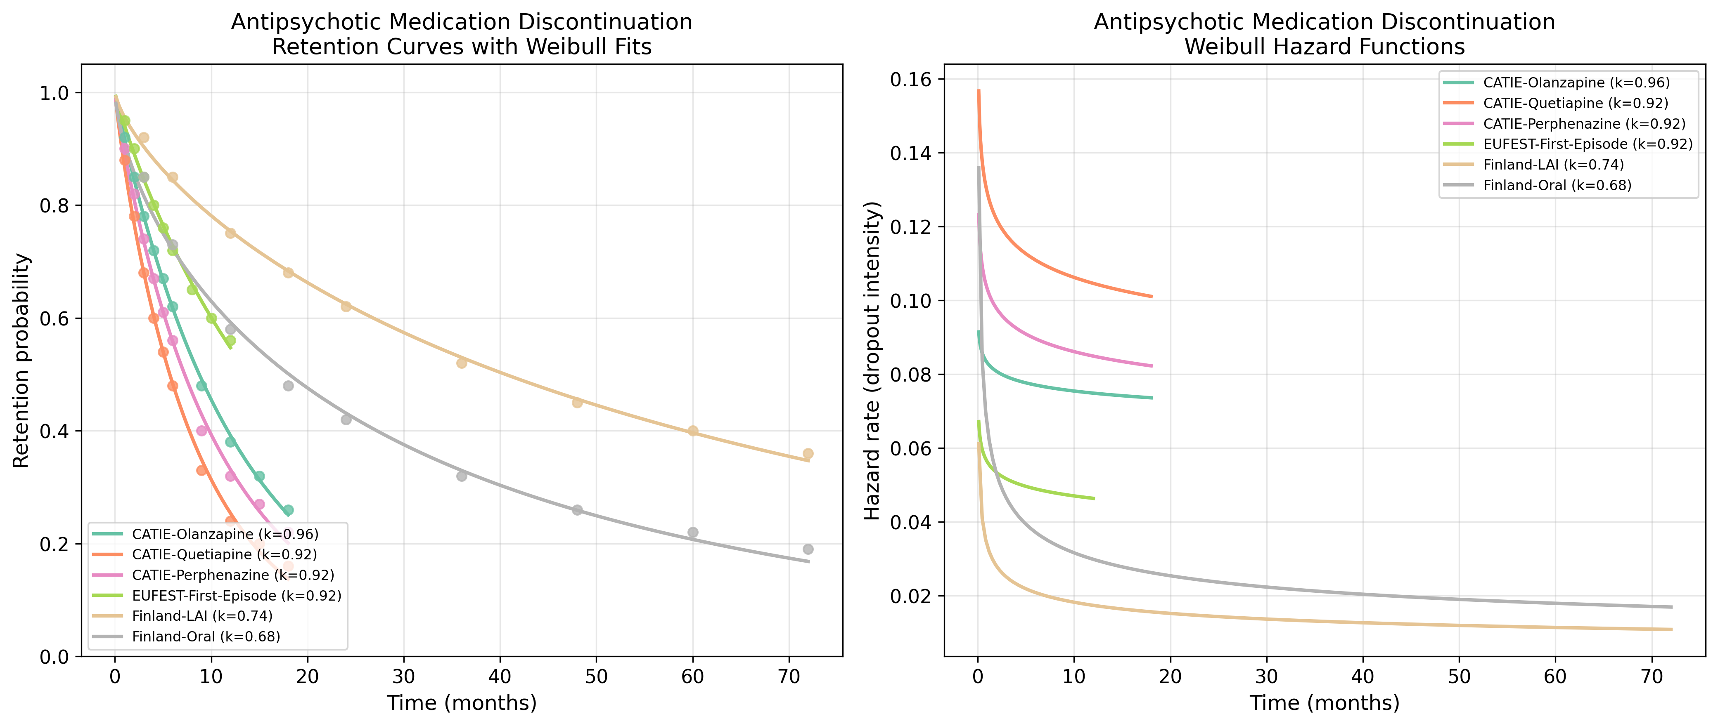
Fig. 1. Retention curves with Weibull fits (left) and hazard functions (right) for Antipsychotic datasets.
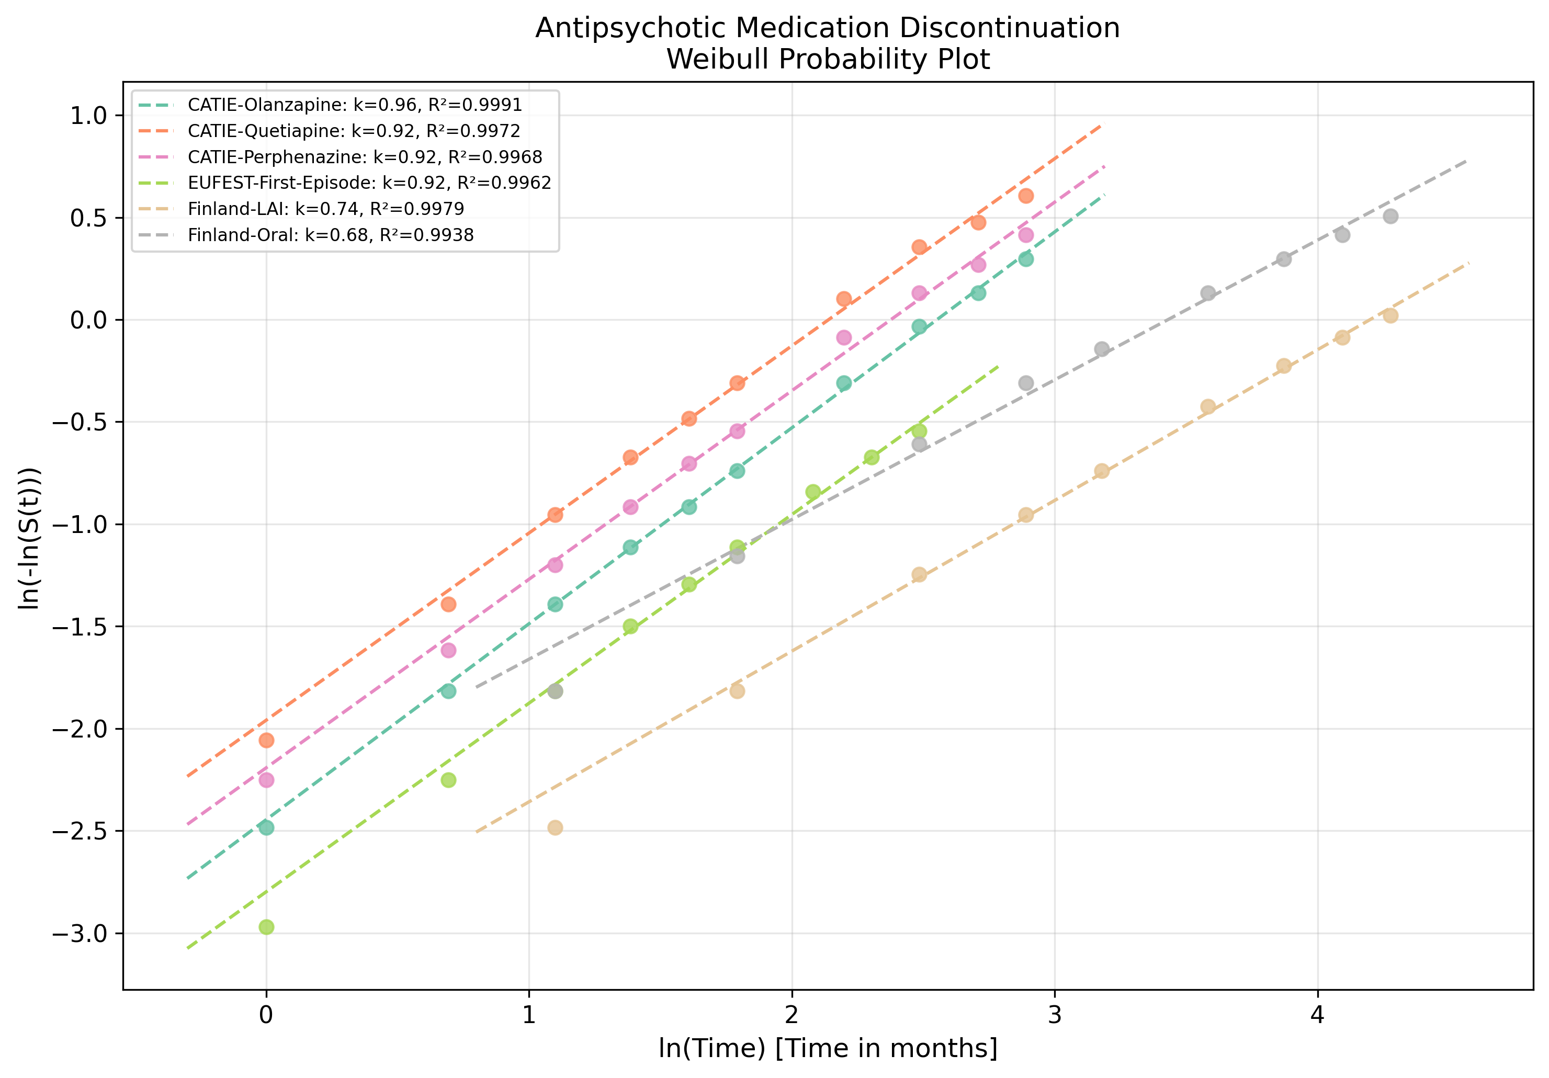
Fig. 2. Weibull probability plot showing linearised goodness-of-fit for Antipsychotic datasets.

4. Discussion
Antipsychotic discontinuation showed the highest k values (mean 0.857) among all clinical domains we have studied, approaching but not reaching constant hazard (k=1). This suggests that the hazard of discontinuation remains relatively stable over the treatment course compared to other clinical domains.^{2,4}
The distinction between trial settings (CATIE, EUFEST: k≈0.92) and real-world cohorts (Finland: k≈0.71) is clinically important. Clinical trial monitoring (regular visits, assessments, contact tracing) appears to partially attenuate the early-dropout pattern, bringing k closer to 1. This suggests that enhanced monitoring during routine clinical care could replicate this effect.
The LAI vs oral comparison (k=0.737 vs 0.683) supports the pharmacological rationale of LAI formulations: by removing the daily decision to take medication, LAI reduces the early discontinuation gradient.⁴
Clinical implication: The relatively high k in antipsychotic treatment (compared to k≈0.60 in HIV/ART or k≈0.64 in substance use) suggests that adherence interventions should be distributed more evenly across the treatment course rather than exclusively front-loaded.⁶

5. Conclusions
Antipsychotic treatment dropout follows a DFR pattern (mean k = 0.857) when modelled with the Weibull distribution. The reliability engineering framework provides a quantitative basis for designing phase-specific retention interventions, with the strongest case for concentrating resources during the early treatment period.

References
1. Leucht S, Tardy M, Komossa K, et al. Antipsychotic drugs versus placebo for relapse prevention in schizophrenia: a systematic review and meta-analysis. Lancet. 2012;379(9831):2063-2071.
2. Lieberman JA, Stroup TS, McEvoy JP, et al. Effectiveness of antipsychotic drugs in patients with chronic schizophrenia. N Engl J Med. 2005;353(12):1209-1223.
3. Kahn RS, Fleischhacker WW, Boter H, et al. Effectiveness of antipsychotic drugs in first-episode schizophrenia and schizophreniform disorder. Lancet. 2008;371(9618):1085-1097.
4. Tiihonen J, Mittendorfer-Rutz E, Majak M, et al. Real-world effectiveness of antipsychotic treatments in a nationwide cohort of 29,823 patients with schizophrenia. JAMA Psychiatry. 2017;74(7):686-693.
5. Weibull W. A statistical distribution function of wide applicability. J Appl Mech. 1951;18(3):293-297.
6. Abernethy RB. The New Weibull Handbook. 5th ed. North Palm Beach, FL: Robert B. Abernethy; 2006.

