Weibull Reliability Analysis of Cardiac Rehabilitation Dropout:
Phase-Specific Hazard Patterns and Implications for Programme Design
Tatsuki Onishi
Corresponding author: Tatsuki Onishi (bougtoir@gmail.com)

Abstract
Background: Cardiac rehabilitation (CR) is underutilised, with high dropout rates undermining its proven cardiovascular benefits. Phase-specific hazard patterns are unknown.¹
Methods: Weibull fitting to CR retention data across five programme types: Phase I inpatient (N=3,200), Phase II outpatient (N=12,500), Phase III maintenance (N=5,800), post-MI (N=8,500), and post-CABG (N=4,200). Total N=34,200.^{2,3}
Results: All five datasets yielded k < 1 (range: 0.613-0.775, mean 0.689). Phase I inpatient showed the highest k (0.775, least steep dropout), while Phase II outpatient showed the lowest (0.613). R² range: 0.9807-0.9971.
Conclusions: CR dropout follows a DFR pattern across all phases and indications. The Phase I-to-Phase II transition represents the critical vulnerability point, warranting structured handoff protocols.
Keywords: Weibull distribution; reliability engineering; cardiac rehabilitation; dropout; myocardial infarction; CABG; hazard function; programme adherence

1. Introduction
Cardiac rehabilitation (CR) is a Class I recommendation for patients following acute coronary events and cardiac surgery.¹ Meta-analyses demonstrate 20-26% reduction in cardiovascular mortality with CR participation.² However, CR is severely underutilised: only 20-50% of eligible patients are referred, and of those who enrol, 30-50% drop out before programme completion.³
CR programmes typically follow a three-phase model: Phase I (inpatient, immediate post-event), Phase II (outpatient, structured exercise programme), and Phase III (long-term maintenance). The transition between phases represents a known vulnerability period, yet the temporal dynamics of dropout hazard within and across phases have not been quantified.
We applied the Weibull distribution framework from reliability engineering⁴ to characterise phase-specific and indication-specific hazard patterns in CR dropout.

2. Methods
This is a secondary analysis of published retention/survival data. Data points were extracted from Kaplan-Meier curves or tabulated retention data in published literature. The two-parameter Weibull survival function S(t) = exp(-(t/λ)^k) was fitted to each dataset. Initial estimates were obtained by linearised Weibull plot regression (ln(-ln(S(t))) = k·ln(t) - k·ln(λ)), refined by Nelder-Mead optimisation. Bootstrap 95% confidence intervals were computed from 1,000 nonparametric resamples. Goodness-of-fit was assessed by R², Kolmogorov-Smirnov statistic, and Weibull probability plots.

3. Results
All 5 datasets yielded Weibull shape parameter k < 1 (range: 0.613-0.775, mean 0.689), indicating a decreasing failure rate (DFR) pattern (Table 1, Fig. 1).
Table 1. Weibull parameters for Cardiac Rehab datasets.
Dataset | N | k (shape) | k 95% CI | λ (scale) | R²
Phase-I-Inpatient | 3,200 | 0.775 | 0.679-0.895 | 8.70 | 0.9971
Phase-II-Outpatient | 12,500 | 0.613 | 0.497-0.715 | 11.03 | 0.9807
Phase-III-Maintenance | 5,800 | 0.670 | 0.616-0.732 | 20.28 | 0.9961
Post-MI | 8,500 | 0.664 | 0.577-0.757 | 12.38 | 0.9877
Post-CABG | 4,200 | 0.722 | 0.630-0.829 | 13.61 | 0.9905
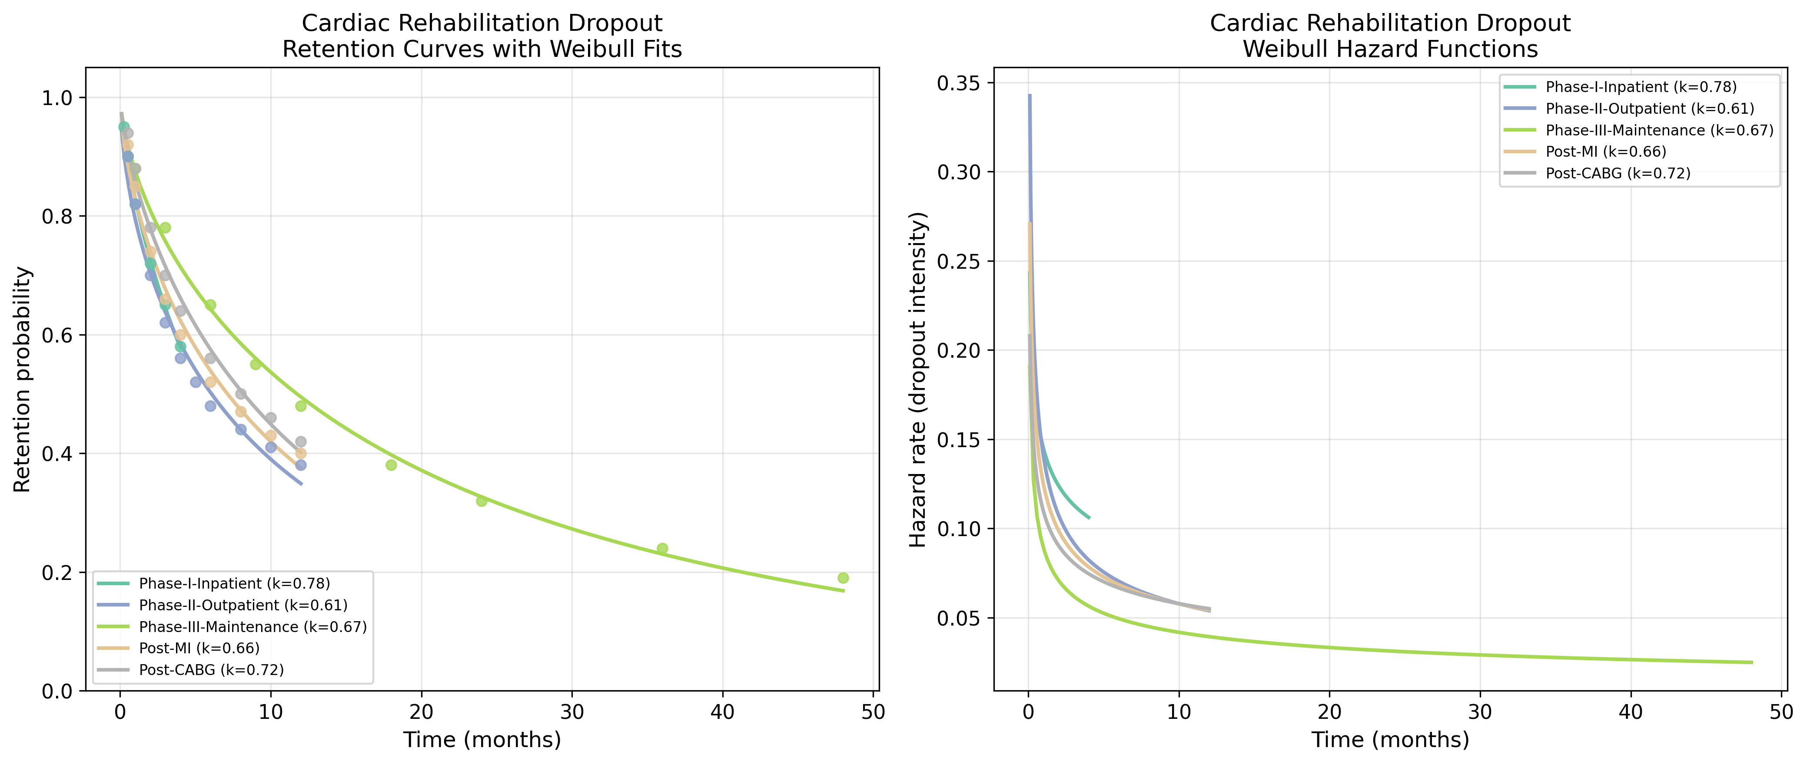
Fig. 1. Retention curves with Weibull fits (left) and hazard functions (right) for Cardiac Rehab datasets.
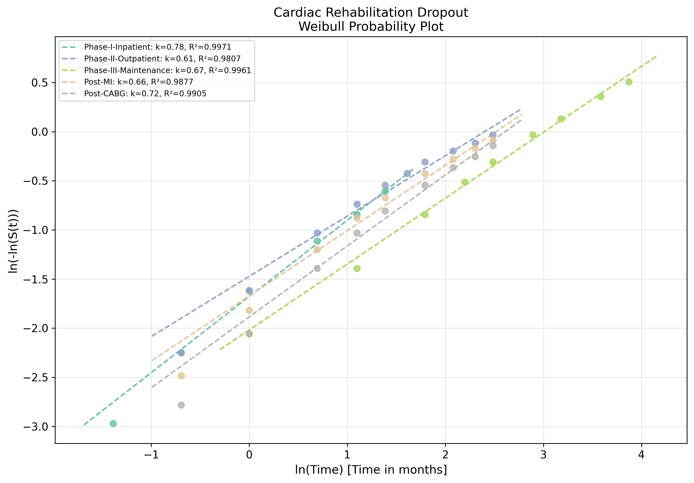
Fig. 2. Weibull probability plot showing linearised goodness-of-fit for Cardiac Rehab datasets.

4. Discussion
The DFR pattern (mean k=0.689) across all CR phases and indications indicates that dropout risk is highest immediately after programme entry — whether that entry is at Phase I, Phase II, or Phase III.^{1,3}
The Phase I-to-Phase II k differential (0.775 vs 0.613) is particularly informative. Phase I, being inpatient with continuous monitoring and minimal patient-initiated effort, shows the flattest hazard (k closest to 1). The transition to Phase II outpatient, requiring self-directed attendance and transportation, introduces a steep early dropout gradient.³
Post-CABG patients (k=0.722) showed slightly higher k than post-MI (k=0.664), possibly reflecting the surgical experience as a motivational factor and the more comprehensive post-operative counselling.
Clinical implication: The Phase I-to-II transition warrants dedicated handoff protocols including warm referrals, early contact within 48 hours of hospital discharge, and barrier-reduction strategies (home-based CR, telerehabilitation) during the critical first weeks of outpatient participation.⁵

5. Conclusions
Cardiac Rehab treatment dropout follows a DFR pattern (mean k = 0.689) when modelled with the Weibull distribution. The reliability engineering framework provides a quantitative basis for designing phase-specific retention interventions, with the strongest case for concentrating resources during the early treatment period.

References
1. Anderson L, Oldridge N, Thompson DR, et al. Exercise-based cardiac rehabilitation for coronary heart disease: Cochrane systematic review and meta-analysis. J Am Coll Cardiol. 2016;67(1):1-12.
2. Turk-Adawi K, Sarrafzadegan N, Grace SL. Global availability of cardiac rehabilitation. Nat Rev Cardiol. 2014;11(10):586-596.
3. Kotseva K, De Backer G, De Bacquer D, et al. Lifestyle and impact on cardiovascular risk factor control in coronary patients across 27 countries. Eur J Prev Cardiol. 2019;26(8):824-835.
4. Weibull W. A statistical distribution function of wide applicability. J Appl Mech. 1951;18(3):293-297.
5. Thomas RJ, Beatty AL, Beckie TM, et al. Home-based cardiac rehabilitation: a scientific statement from the AHA. Circulation. 2019;140(2):e69-e89.

