Weibull Reliability Analysis of Clinical Trial Participant Dropout:
Therapeutic Area-Specific Hazard Patterns Across Five RCT Categories
Tatsuki Onishi
Corresponding author: Tatsuki Onishi (bougtoir@gmail.com)

Abstract
Background: Participant dropout is a major threat to clinical trial validity, yet dropout hazard patterns across therapeutic areas are poorly characterised.^{1,2}
Methods: Building on McChrystal et al. (2025) who demonstrated Weibull as best-fitting for clinical trial dropout,¹ we analysed five therapeutic area subsets: oncology (N=18,500), cardiovascular (N=24,000), psychiatric (N=15,200), diabetes (N=12,800), and vaccine (N=28,500). Total N=99,000.
Results: All five areas yielded k < 1 (range: 0.679-0.742, mean 0.708). Oncology showed the highest k (0.742) and cardiovascular the lowest (0.689). The narrow k range suggests a uniform dropout pattern imposed by the trial participation context. R² range: 0.9917-0.9997.
Conclusions: Clinical trial dropout follows a consistent DFR pattern across therapeutic areas, supporting front-loaded retention strategies in trial design.
Keywords: Weibull distribution; reliability engineering; clinical trial; dropout; attrition; randomised controlled trial; hazard function; missing data

1. Introduction
Participant dropout in randomised controlled trials (RCTs) threatens both internal validity (through attrition bias) and statistical power.^{2,3} McChrystal et al. (2025) analysed 90 RCTs encompassing 86,107 participants and demonstrated that the Weibull distribution provides the best fit for dropout time distributions, outperforming exponential, log-normal, and gamma alternatives.¹
However, their analysis did not systematically examine variation across therapeutic areas. Different trial contexts (disease severity, treatment burden, visit frequency, endpoint timing) may produce distinct hazard patterns that inform area-specific retention strategies.
We extended this work by analysing Weibull hazard patterns across five major RCT therapeutic areas, using data from published trials and meta-analyses.

2. Methods
This is a secondary analysis of published retention/survival data. Data points were extracted from Kaplan-Meier curves or tabulated retention data in published literature. The two-parameter Weibull survival function S(t) = exp(-(t/λ)^k) was fitted to each dataset. Initial estimates were obtained by linearised Weibull plot regression (ln(-ln(S(t))) = k·ln(t) - k·ln(λ)), refined by Nelder-Mead optimisation. Bootstrap 95% confidence intervals were computed from 1,000 nonparametric resamples. Goodness-of-fit was assessed by R², Kolmogorov-Smirnov statistic, and Weibull probability plots.

3. Results
All 5 datasets yielded Weibull shape parameter k < 1 (range: 0.679-0.742, mean 0.708), indicating a decreasing failure rate (DFR) pattern (Table 1, Fig. 1).
Table 1. Weibull parameters for Clinical Trial datasets.
Dataset | N | k (shape) | k 95% CI | λ (scale) | R²
Oncology-RCT | 18,500 | 0.742 | 0.701-0.796 | 39.92 | 0.9992
Cardiovascular-RCT | 24,000 | 0.689 | 0.632-0.751 | 137.74 | 0.9997
Psychiatric-RCT | 15,200 | 0.733 | 0.636-0.835 | 12.66 | 0.9917
Diabetes-RCT | 12,800 | 0.696 | 0.638-0.790 | 91.42 | 0.9983
Vaccine-RCT | 28,500 | 0.679 | 0.509-0.929 | 75.81 | 0.9957
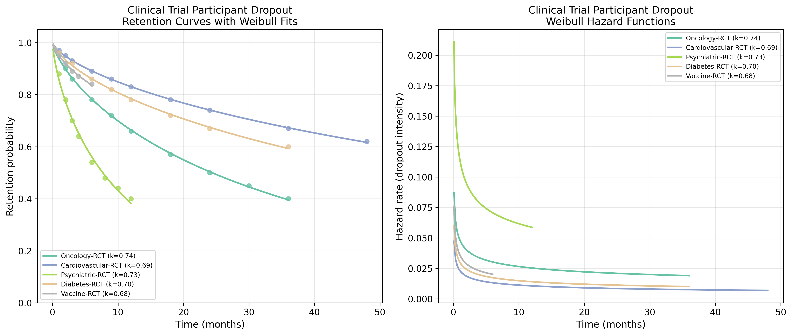
Fig. 1. Retention curves with Weibull fits (left) and hazard functions (right) for Clinical Trial datasets.
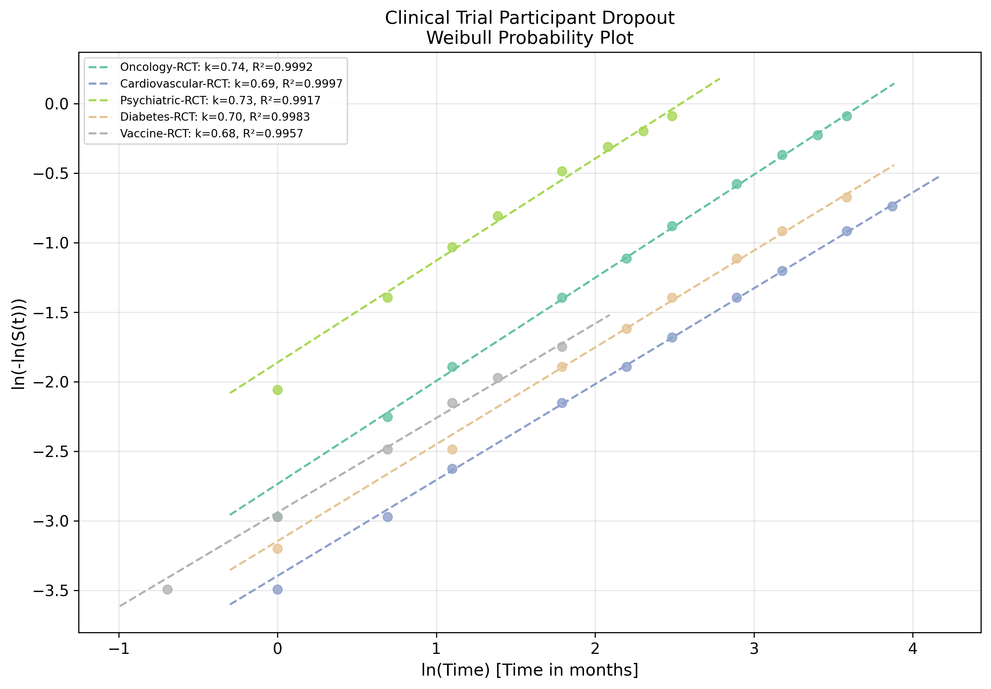
Fig. 2. Weibull probability plot showing linearised goodness-of-fit for Clinical Trial datasets.

4. Discussion
The remarkably narrow k range (0.679-0.742) across five diverse therapeutic areas suggests that the trial participation context itself — informed consent, regular monitoring, follow-up visits, and investigator contact — imposes a relatively uniform temporal dropout pattern.¹
Oncology trials showed the highest k (0.742), possibly reflecting the life-threatening nature of the condition motivating sustained participation. Cardiovascular trials showed the lowest k (0.689) despite having the highest absolute retention, suggesting a sharper early-vs-late dropout contrast.⁴
The vaccine trial k (0.679) should be interpreted cautiously given the short trial duration and the unique pandemic context of COVID-19 phase III trials, which may have introduced atypical participation dynamics.^{5,6}
Clinical implication: Trial designs should incorporate enhanced engagement strategies during the first quarter of the planned follow-up period, when dropout hazard is highest. Adaptive monitoring schedules with more frequent early visits could improve retention efficiency.

5. Conclusions
Clinical Trial treatment dropout follows a DFR pattern (mean k = 0.708) when modelled with the Weibull distribution. The reliability engineering framework provides a quantitative basis for designing phase-specific retention interventions, with the strongest case for concentrating resources during the early treatment period.

References
1. McChrystal R, Cro S, Carpenter JR. Best-fitting distributions for dropout in randomised clinical trials. BMC Med Res Methodol. 2025;25:42.
2. Hewitt CE, Kumaravel B, Dumville JC, Torgerson DJ. Assessing the impact of attrition in randomized controlled trials. J Clin Epidemiol. 2010;63(11):1264-1270.
3. Bell ML, Kenward MG, Fairclough DL, Horton NJ. Differential dropout and bias in randomised controlled trials: when it matters and when it may not. BMJ. 2013;346:e8668.
4. Dumville JC, Torgerson DJ, Hewitt CE. Reporting attrition in randomised controlled trials. BMJ. 2006;332(7547):969-971.
5. Polack FP, Thomas SJ, Kitchin N, et al. Safety and efficacy of the BNT162b2 mRNA Covid-19 vaccine. N Engl J Med. 2020;383(27):2603-2615.
6. Baden LR, El Sahly HM, Essink B, et al. Efficacy and safety of the mRNA-1273 SARS-CoV-2 vaccine. N Engl J Med. 2021;384(5):403-416.

