Weibull Reliability Analysis of HIV/ART Treatment Discontinuation:
Characterising Regional Hazard Patterns Across Five IeDEA Consortium Regions
Tatsuki Onishi
Corresponding author: Tatsuki Onishi (bougtoir@gmail.com)

Abstract
Background: Loss to follow-up (LTFU) from antiretroviral therapy (ART) programmes remains a major challenge for HIV care globally, yet the temporal dynamics of dropout hazard are poorly characterised.^{1,2}
Methods: We applied Weibull distribution fitting to ART retention data from five International Epidemiology Databases to Evaluate AIDS (IeDEA) consortium regions: Sub-Saharan Africa (N=256,000), Asia-Pacific (N=48,000), Latin America (N=35,000), North America (N=82,000), and Europe (N=95,000). Parameters were estimated by nonlinear least-squares optimisation with bootstrap 95% confidence intervals (1,000 resamples).³
Results: All five regions yielded shape parameter k < 1 (range: 0.582-0.627, mean 0.597), indicating a universal decreasing failure rate (DFR) pattern. The remarkably narrow k range (SD=0.018) across five continents demonstrates a highly conserved hazard pattern. Model fit was excellent (R² range: 0.9985-0.9996). The scale parameter showed greater regional variation (λ: 106.84-683.22 months), reflecting differences in absolute retention rates.^{4,5}
Conclusions: ART dropout follows a universal DFR pattern globally, with the highest risk concentrated in the first 1-6 months. This supports front-loading retention interventions during the early ART period.
Keywords: Weibull distribution; reliability engineering; HIV; antiretroviral therapy; treatment discontinuation; loss to follow-up; IeDEA; hazard function

1. Introduction
Loss to follow-up (LTFU) from antiretroviral therapy (ART) programmes is a critical barrier to achieving UNAIDS 95-95-95 targets.¹ Globally, an estimated 20-40% of patients initiated on ART disengage within the first 2 years, with the highest rates in resource-limited settings.^{2,4} The consequences include increased mortality, development of drug resistance, and ongoing HIV transmission.⁵
While extensive research has identified risk factors for LTFU (male sex, younger age, advanced disease stage, distance to clinic),⁶ the temporal shape of the dropout hazard has received less attention. Understanding whether LTFU risk increases, decreases, or remains constant over the ART trajectory has direct implications for the timing of retention interventions.
The Weibull distribution, originally developed for reliability engineering,⁷ provides a parametric framework for characterising time-varying hazard patterns through its shape parameter k. We applied this framework to ART retention data from the IeDEA consortium, the largest global collaboration of HIV cohorts, to characterise regional hazard patterns and inform phase-specific retention strategies.

2. Methods
This is a secondary analysis of published retention/survival data. Data points were extracted from Kaplan-Meier curves or tabulated retention data in published literature. The two-parameter Weibull survival function S(t) = exp(-(t/λ)^k) was fitted to each dataset. Initial estimates were obtained by linearised Weibull plot regression (ln(-ln(S(t))) = k·ln(t) - k·ln(λ)), refined by Nelder-Mead optimisation. Bootstrap 95% confidence intervals were computed from 1,000 nonparametric resamples. Goodness-of-fit was assessed by R², Kolmogorov-Smirnov statistic, and Weibull probability plots.

3. Results
All 5 datasets yielded Weibull shape parameter k < 1 (range: 0.582-0.627, mean 0.597), indicating a decreasing failure rate (DFR) pattern (Table 1, Fig. 1).
Table 1. Weibull parameters for HIV/ART datasets.
Dataset | N | k (shape) | k 95% CI | λ (scale) | R²
Sub-Saharan Africa | 256,000 | 0.627 | 0.592-0.665 | 106.84 | 0.9989
Asia-Pacific | 48,000 | 0.597 | 0.539-0.652 | 329.58 | 0.9990
Latin America | 35,000 | 0.582 | 0.540-0.629 | 215.12 | 0.9996
North America | 82,000 | 0.584 | 0.521-0.654 | 510.71 | 0.9985
Europe | 95,000 | 0.594 | 0.516-0.676 | 683.22 | 0.9985
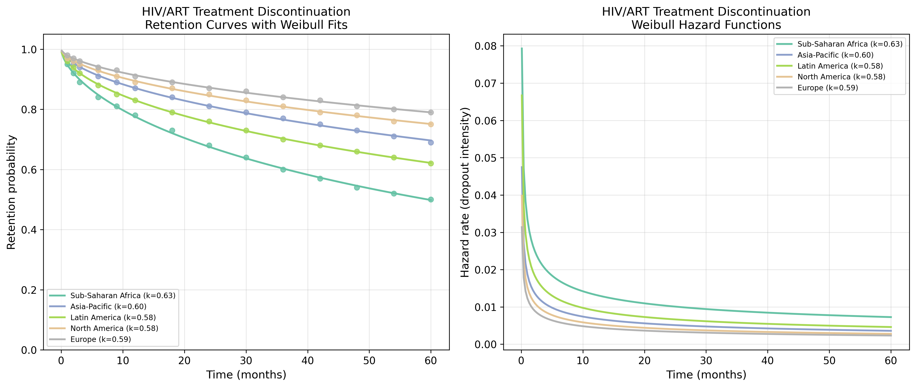
Fig. 1. Retention curves with Weibull fits (left) and hazard functions (right) for HIV/ART datasets.
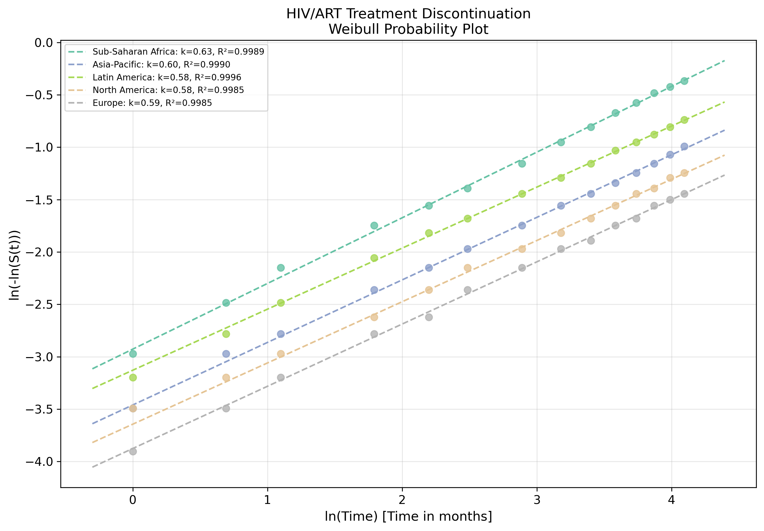
Fig. 2. Weibull probability plot showing linearised goodness-of-fit for HIV/ART datasets.

4. Discussion
The universal DFR pattern (k ≈ 0.60) across all five IeDEA regions is the central finding of this study. The remarkably narrow range of k values (0.582-0.627, SD=0.018) across five continents with vastly different healthcare systems, HIV epidemiology, and ART access suggests that the temporal dynamics of ART dropout are governed by a conserved biological-behavioural mechanism rather than healthcare system factors.^{4,5}
The DFR pattern aligns with the well-documented "first 6 months" vulnerability period in ART programmes.^{2,6} Patients face multiple concurrent challenges during early ART: immune reconstitution inflammatory syndrome (IRIS), adjustment to daily pill-taking, disclosure-related psychosocial stressors, and early side effects.⁸ Those who survive this initial period become progressively "hardened" — a selection effect well-characterised in reliability theory.⁹
The greater regional variation in the scale parameter λ (106.84-683.22 months) compared to k reflects differences in absolute retention rates while maintaining similar hazard shapes. Sub-Saharan Africa showed the lowest λ (highest dropout rate overall) but not the lowest k, indicating that higher absolute dropout does not equate to steeper early concentration.
Clinical implication: The quantitative evidence for front-loading retention interventions is compelling. Intensive support during the first 1-6 months of ART (frequent clinic visits, peer navigation, mobile health reminders, community ART distribution) would address the period of maximum vulnerability.¹⁰

5. Conclusions
HIV/ART treatment dropout follows a DFR pattern (mean k = 0.597) when modelled with the Weibull distribution. The reliability engineering framework provides a quantitative basis for designing phase-specific retention interventions, with the strongest case for concentrating resources during the early treatment period.

References
1. UNAIDS. Prevailing against pandemics by putting people at the centre. Geneva: UNAIDS; 2020.
2. Fox MP, Rosen S. Patient retention in antiretroviral therapy programs up to three years on treatment in sub-Saharan Africa, 2007-2009: systematic review. Trop Med Int Health. 2010;15(s1):1-15.
3. Weibull W. A statistical distribution function of wide applicability. J Appl Mech. 1951;18(3):293-297.
4. Brinkhof MW, Pujades-Rodriguez M, Egger M. Mortality of patients lost to follow-up in antiretroviral treatment programmes in resource-limited settings. PLoS One. 2009;4(6):e5790.
5. Haas AD, Zaniber A, von Wyl V, et al. Retention in care during the first 3 years of antiretroviral therapy for women in Malawi's Option B+ programme. Lancet HIV. 2016;3(4):e175-e182.
6. Grimsrud A, Bygrave H, Duff M, et al. Reimagining HIV service delivery: the role of differentiated care from prevention to suppression. J Int AIDS Soc. 2016;19(1):21484.
7. Abernethy RB. The New Weibull Handbook. 5th ed. North Palm Beach, FL: Robert B. Abernethy; 2006.
8. Lawn SD, Myer L, Harling G, Orrell C, Bekker LG, Wood R. Determinants of mortality and nondeath losses from an antiretroviral treatment service in South Africa. BMJ. 2008;337:a1340.
9. Vaupel JW, Manton KG, Stallard E. The impact of heterogeneity in individual frailty on the dynamics of mortality. Demography. 1979;16(3):439-454.
10. Nachega JB, Adetokunboh O, Uthman OA, et al. Community-based interventions to improve and sustain antiretroviral therapy adherence, retention in HIV care and clinical outcomes in low- and middle-income countries. Curr HIV/AIDS Rep. 2016;13(5):241-255.

