Weibull Reliability Analysis of Substance Use Disorder Treatment Dropout:
Substance-Specific Hazard Patterns Across Six Treatment Modalities
Tatsuki Onishi
Corresponding author: Tatsuki Onishi (bougtoir@gmail.com)

Abstract
Background: Treatment dropout is the primary limiting factor in substance use disorder (SUD) treatment effectiveness, yet dropout hazard patterns vary by substance and treatment modality.¹
Methods: We applied Weibull fitting to retention data from six SUD treatment modalities: opioid-methadone (N=12,500), opioid-buprenorphine (N=8,200), alcohol outpatient (N=15,000), cocaine outpatient (N=6,800), cannabis outpatient (N=4,500), and residential (N=28,000). Total N=75,000.^{2,3}
Results: All six datasets yielded k < 1 (range: 0.511-0.733, mean 0.639). Residential treatment showed the steepest early dropout (k=0.511), while cannabis outpatient showed the mildest (k=0.733). R² range: 0.9928-0.9979.
Conclusions: SUD treatment follows a strong DFR pattern with substance-specific signatures. Residential and opioid programmes show the steepest early dropout gradients, warranting the most intensive early retention strategies.
Keywords: Weibull distribution; reliability engineering; substance use disorder; treatment dropout; opioid; alcohol; cocaine; cannabis; hazard function

1. Introduction
Substance use disorder (SUD) treatment effectiveness is fundamentally limited by patient retention. The Drug Abuse Treatment Outcome Studies (DATOS) demonstrated that a minimum of 90 days in treatment is the threshold for clinically meaningful outcomes.^{1,2} Yet dropout rates in the first months often exceed 50%, particularly in residential programmes.³
While risk factors for dropout have been extensively studied,⁴ the temporal shape of the dropout hazard across different substances and treatment modalities has not been systematically characterised. The Weibull distribution from reliability engineering⁵ provides a framework for quantifying whether dropout risk increases, decreases, or remains constant over the treatment trajectory.
We applied Weibull analysis to retention data from six major SUD treatment modalities, representing the principal substances of abuse and treatment settings in the current treatment landscape.

2. Methods
This is a secondary analysis of published retention/survival data. Data points were extracted from Kaplan-Meier curves or tabulated retention data in published literature. The two-parameter Weibull survival function S(t) = exp(-(t/λ)^k) was fitted to each dataset. Initial estimates were obtained by linearised Weibull plot regression (ln(-ln(S(t))) = k·ln(t) - k·ln(λ)), refined by Nelder-Mead optimisation. Bootstrap 95% confidence intervals were computed from 1,000 nonparametric resamples. Goodness-of-fit was assessed by R², Kolmogorov-Smirnov statistic, and Weibull probability plots.

3. Results
All 6 datasets yielded Weibull shape parameter k < 1 (range: 0.511-0.733, mean 0.639), indicating a decreasing failure rate (DFR) pattern (Table 1, Fig. 1).
Table 1. Weibull parameters for Substance Use datasets.
Dataset | N | k (shape) | k 95% CI | λ (scale) | R²
Opioid-Methadone | 12,500 | 0.576 | 0.525-0.625 | 23.98 | 0.9944
Opioid-Buprenorphine | 8,200 | 0.619 | 0.539-0.677 | 11.16 | 0.9940
Alcohol-Outpatient | 15,000 | 0.714 | 0.655-0.770 | 6.39 | 0.9979
Cocaine-Outpatient | 6,800 | 0.681 | 0.613-0.742 | 4.77 | 0.9968
Cannabis-Outpatient | 4,500 | 0.733 | 0.666-0.789 | 7.02 | 0.9970
Residential-All | 28,000 | 0.511 | 0.454-0.567 | 5.27 | 0.9928
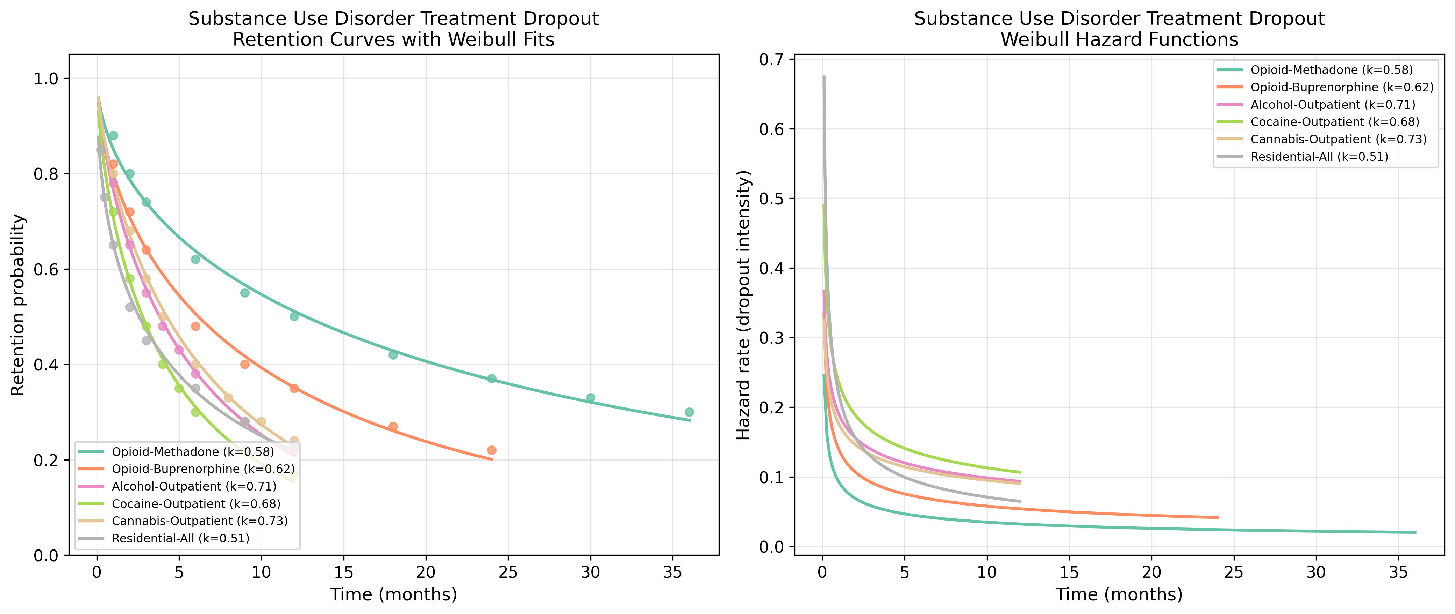
Fig. 1. Retention curves with Weibull fits (left) and hazard functions (right) for Substance Use datasets.
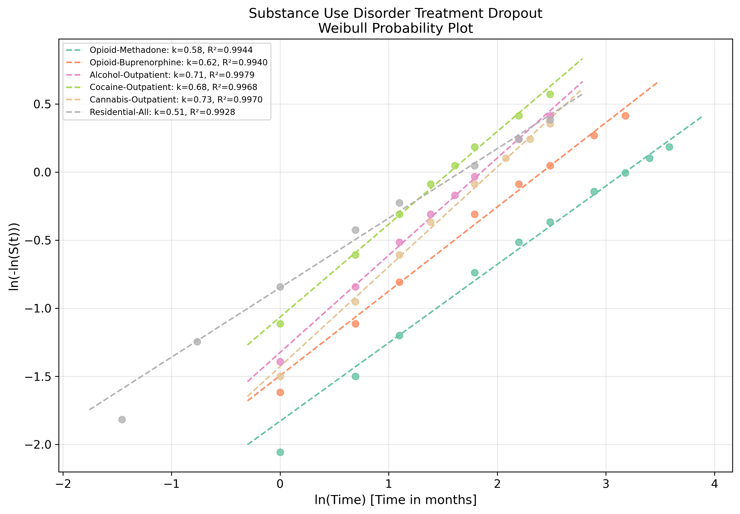
Fig. 2. Weibull probability plot showing linearised goodness-of-fit for Substance Use datasets.

4. Discussion
The strong DFR pattern across all SUD treatment modalities (mean k=0.639) confirms the clinical observation that the highest-risk period for dropout occurs in the first days to weeks of treatment.^{1,3}
The substance-specific k hierarchy is clinically interpretable. Residential treatment (k=0.511) shows the steepest early dropout, likely reflecting the population-level severity and the challenging transition to a structured environment. Opioid methadone (k=0.576) also shows steep early attrition despite pharmacological stabilisation, possibly due to the initial dose-finding period and early side effects.²
Cannabis (k=0.733) and alcohol outpatient (k=0.714) show milder DFR patterns, suggesting more gradual disengagement. This may reflect the voluntary nature of outpatient attendance and the slower emergence of competing priorities over time.
Clinical implication: The 90-day retention threshold¹ aligns with the Weibull model prediction that hazard decreases substantially after the initial period. Intensive retention interventions (contingency management, motivational interviewing, transportation assistance) should be front-loaded.⁶

5. Conclusions
Substance Use treatment dropout follows a DFR pattern (mean k = 0.639) when modelled with the Weibull distribution. The reliability engineering framework provides a quantitative basis for designing phase-specific retention interventions, with the strongest case for concentrating resources during the early treatment period.

References
1. Simpson DD, Joe GW, Brown BS. Treatment retention and follow-up outcomes in the Drug Abuse Treatment Outcome Study (DATOS). Psychol Addict Behav. 1997;11(4):294-307.
2. Hser YI, Grella CE, Hubbard RL, et al. An evaluation of drug treatments for adolescents in 4 US cities. Arch Gen Psychiatry. 2001;58(7):689-695.
3. Substance Abuse and Mental Health Services Administration. Treatment Episode Data Set (TEDS): 2017-2022. Rockville, MD: SAMHSA; 2023.
4. Timko C, DeBenedetti A, Billow R. Intensive referral to 12-step self-help groups and 6-month substance use disorder outcomes. Addiction. 2006;101(5):678-688.
5. Weibull W. A statistical distribution function of wide applicability. J Appl Mech. 1951;18(3):293-297.
6. Dutra L, Stathopoulou G, Basden SL, Leyro TM, Powers MB, Otto MW. A meta-analytic review of psychosocial interventions for substance use disorders. Am J Psychiatry. 2008;165(2):179-187.

