Reproducibly digitizable dropout curves are scarce and their hazard shapes heterogeneous: a scoping search and Weibull analysis of loss to follow-up in tuberculosis and HIV treatment
Original Research Article
Abstract
Objectives Loss to follow-up (LTFU) undermines tuberculosis (TB) and HIV treatment, yet support is rarely targeted to *when* patients disengage. The clinical question is whether dropout is homogeneous enough for its timing to be inferred from the diagnosis. We asked whether the hazard shape is consistent within and across diseases, and how often it is reported in a reproducibly usable form.
Methods A reproducible Europe PMC search (open-access TB/HIV reports mentioning a time-to-event curve; 7594 records, 2026-07-17) required a single, digitizable dropout curve (Kaplan–Meier or competing-risk cumulative incidence), not a final proportion. Eligible curves were digitized and fitted with a Weibull model F(t)=1−exp(−(t/λ)^k); the shape k (k>1 increasing-failure-rate [IFR]; k<1 decreasing-failure-rate [DFR]) was bootstrapped and compared with exponential and log-normal fits by the Akaike information criterion (AIC).
Results Despite 7594 records, only 7 infectious-disease curves from 6 studies qualified: two TB cohorts (Ethiopia, China) and five HIV/ART curves (Ethiopia, Maputo [2 curves], Malawi, Gambella); most reported only a final proportion. The shape parameter ranged k=0.44–1.86 (4 IFR, 3 DFR) and diverged within diseases: the two TB cohorts fell on opposite sides of k=1, and the HIV/ART cohorts likewise split.
Conclusions Reproducibly usable, time-resolved dropout curves are scarce, and where they exist the hazard shape is heterogeneous within both TB and HIV. Support timing therefore cannot be assumed from the disease label but must be located empirically, which also makes an intervention's effect verifiable. The core barrier is a reporting gap: time-to-LTFU curves or individual patient data must be published routinely.
Keywords Tuberculosis; HIV; Loss to follow-up; Retention in care; Scoping search; Treatment adherence; Weibull; Hazard function; Survival analysis; Reporting
Background
LTFU interrupts treatment for both TB and HIV, promoting acquired drug resistance, onward transmission and avoidable death¹. Two things are already established. First, the determinants of treatment interruption are multilevel and strongly context-dependent, differing by health system, case mix and social setting². Second, interventions intended to keep patients in care — community-based, behavioural and digital approaches — show inconsistent, setting-specific effectiveness, so no single strategy has proved universally transferable³. In practice, retention support is still frequently delivered as generic encouragement, chosen because it seems reasonable rather than because it is matched to when patients actually leave. Adopting a package simply because it ‘looks good’ also forfeits the chance to check whether it acts at the point in treatment where dropout actually happens.
What has been missing is a *quantitative* description of the phenomenon that plausibly underlies this: whether patients across settings even disengage on the same time-course. Programmatic reports usually give a single cumulative LTFU proportion, which hides *when* during treatment patients leave. This raises the clinical question at the centre of this study: is dropout homogeneous enough that the timing of retention support can be inferred from the diagnosis, or must the hazard shape be measured in each setting? The hazard shape carries direct operational meaning: an increasing hazard (k>1) argues for intensified support later in treatment, a decreasing hazard (k<1) for front-loading it in the earliest weeks. Making, and later verifying, such timing decisions requires the shape to be recoverable from the published evidence in the first place. We therefore treated this as a scoping question with a deliberately unusual eligibility criterion — that a study make dropout *visible over time* in a reproducibly digitizable curve, not merely as a final proportion — and asked two things: how often is dropout timing reported in that usable form, and, where it is, is the Weibull hazard shape consistent within a disease and between diseases? To our knowledge no prior review has used reproducible visualization of dropout timing as its inclusion criterion.
Methods
Search and eligibility. We queried Europe PMC (open-access TB/HIV LTFU or retention reports mentioning a Kaplan–Meier, survival or cumulative-incidence curve) on 2026-07-17, which identified 7594 records; the exact query and a record sample are saved in the repository and regenerated by scripts/search_scoping.py. Our eligibility criterion was pragmatic: a report had to present a *time-resolved* treatment-dropout or retention curve as a single, cleanly separable, digitizable line (Kaplan–Meier survivor or competing-risk cumulative incidence), not only a final cumulative LTFU proportion. Full dual-reviewer screening of every record was beyond the scope of this short study; we screened the identified literature pragmatically against this criterion and note that the overwhelming majority of LTFU reports present only a final proportion and were therefore ineligible. Eligible infectious-disease curves were carried forward; one non-infectious antipsychotic curve was retained separately as a methodological contrast, outside the infectious-disease scope.
Data and analysis. We used only real, published curves. TB data were the competing-risk LTFU cumulative incidence at Ambo General Hospital, Ethiopia⁴, and the all-patient time-to-LTFU Kaplan–Meier (KM) curve from a 5-year Chinese cohort⁵. HIV/ART retention curves were an ART time-to-LTFU KM from southwest Ethiopia⁶, the After- and Before-Test-and-Treat retention curves from a Maputo (Mozambique) cohort⁷, the pre-intervention remaining-in-care curve from a Malawian case-management study⁸, and the overall KM for youth living with HIV transitioning to adult care in Gambella, Ethiopia⁹. As a non-infectious methodological contrast we added an antipsychotic time-to-discontinuation curve¹⁰. Curves were digitized from the published figures by an in-house pixel extractor with axis calibration read from the figure tick marks (values taken from curve pixels, not entered by hand); the original figure images and digitized coordinates are in the public repository. For each dataset we fitted the Weibull cumulative-incidence model F(t)=1−exp(−(t/λ)^k) by nonlinear least squares, obtained a bootstrap 95% confidence interval (CI) for k, and compared the fit with exponential (k=1) and log-normal models by the Akaike information criterion (AIC). The shape parameter k is unit-free, so mixed follow-up units (months, days) do not affect the cross-study comparison of shape. Data, code and a one-command build that regenerates every reported number, Table 1 and Figure 1 are openly available (Availability of data and materials); no value is hard-coded.
Results
Yield of the search. Although the search identified 7594 open-access records, reproducibly digitizable, time-resolved dropout curves were rare: only 7 infectious-disease curves from 6 studies met the eligibility criterion (two TB and five HIV/ART curves; the 7 curves exceed the 6 studies because the Maputo study contributed two curves, its After- and Before-Test-and-Treat cohorts). The dominant reason for ineligibility was that reports gave only a final cumulative LTFU proportion, with no curve from which the timing of dropout could be recovered. This scarcity is itself a principal finding: the data needed to time retention support are, at present, seldom published in a usable form.
Fitted parameters for the eligible curves are shown in Table 1 and the fits are overlaid on the digitized data in Figure 1. Among the 7 infectious-disease curves the shape parameter spanned k=0.44 to k=1.86, with 4 increasing-hazard (IFR) and 3 decreasing-hazard (DFR). Crucially, the split occurred within diseases, not only between them. The two TB cohorts fell on opposite sides of k=1 (Ethiopia IFR, k=1.68 (95% CI 1.29–1.95); China DFR, k=0.44 (95% CI 0.43–0.50)). The five HIV/ART cohorts did the same: the two Maputo cohorts (k=1.39 (95% CI 1.34–1.46) and k=1.34 (95% CI 1.29–1.41)) and the Gambella youth cohort (k=1.86 (95% CI 1.73–2.18)) were increasing-hazard, whereas the southwest-Ethiopia ART cohort (k=0.63 (95% CI 0.54–0.73)) and the Malawi pre-intervention cohort (k=0.78 (95% CI 0.64–0.91)) were decreasing-hazard. The non-infectious antipsychotic contrast was also decreasing-hazard (k=0.49 (95% CI 0.42–0.57)). No single characteristic shape described even a single disease, and the AIC preferred a non-exponential (Weibull or log-normal) shape over a constant hazard for every curve.
Table 1. Weibull fits to the digitized treatment-dropout curves (seven eligible infectious-disease curves plus one non-infectious antipsychotic contrast; source of truth: results/weibull_fits.csv; all values regenerated by the released code).
Dataset (source) | k (95% CI) | λ | R² | Hazard pattern
TB-Ethiopia — PMC10290796 Fig.1a (competing-risk CIF, 6 mo) | 1.68 (1.29–1.95) | 21.5 | 0.978 | IFR (k>1)
TB-China — PMC10167013 Fig.3 (All-TB KM retention, 12 mo) | 0.44 (0.43–0.50) | 957.3 | 0.920 | DFR (k<1)
ART/HIV-Ethiopia — PMC12953970 Fig.1A (retention KM, months) | 0.63 (0.54–0.73) | 228.3 | 0.926 | DFR (k<1)
HIV-Maputo-ATT — PMC13037074 Fig.3 (ATT retention KM, 0-80 mo) | 1.39 (1.34–1.46) | 69.3 | 0.995 | IFR (k>1)
HIV-Maputo-BTT — PMC13037074 Fig.3 (BTT retention KM, 0-80 mo) | 1.34 (1.29–1.41) | 44.7 | 0.995 | IFR (k>1)
HIV-Malawi-pre — PMC13191892 Fig.1 (pre-intervention care KM, 0-12 mo) | 0.78 (0.64–0.91) | 35.8 | 0.928 | DFR (k<1)
HIV-Gambella — PMC12903592 Fig.2 (overall LTFU KM, 12-48 mo) | 1.86 (1.73–2.18) | 114.2 | 0.974 | IFR (k>1)
Antipsychotic — PMC12437960 (time-to-discontinuation KM, days) | 0.49 (0.42–0.57) | 104.8 | 0.958 | DFR (k<1)

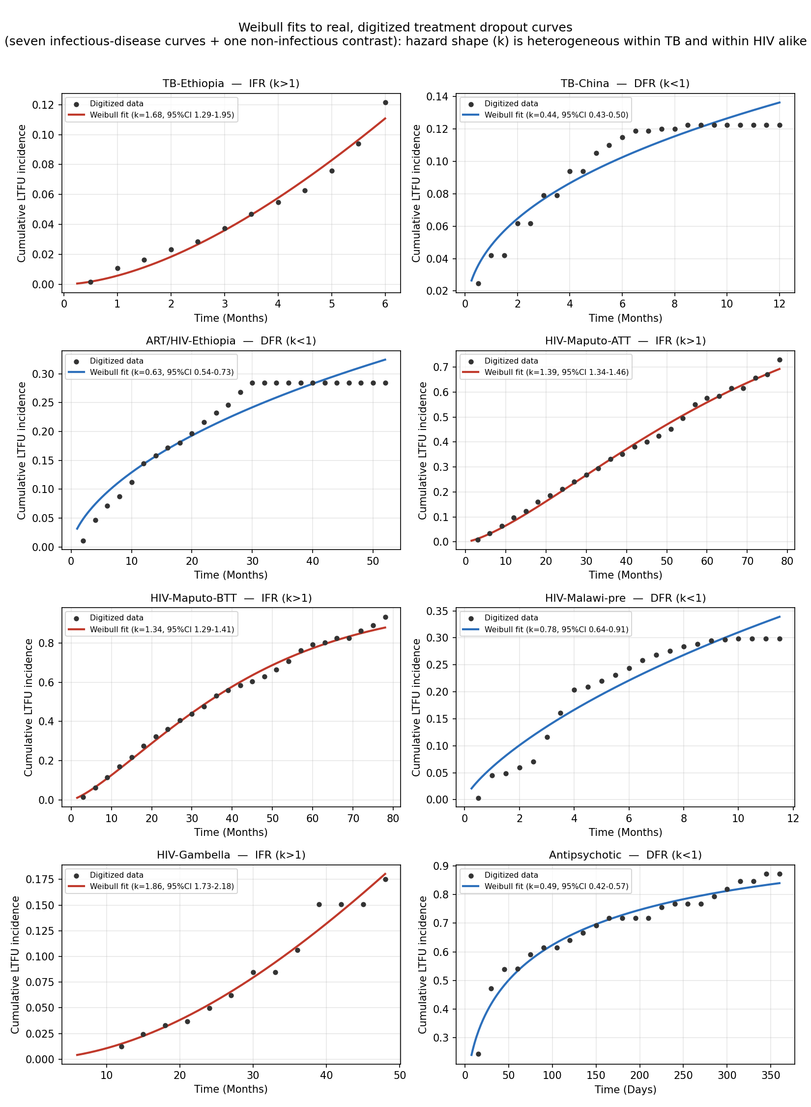
Figure 1. Weibull cumulative-incidence fits (red = increasing hazard, blue = decreasing hazard) to digitized dropout curves (points) for the seven eligible infectious-disease cohorts (two TB, five HIV/ART) plus a non-infectious antipsychotic contrast. Both the two TB cohorts and the HIV/ART cohorts split between IFR and DFR, so the hazard shape is heterogeneous within each disease.
Discussion
The clinical question posed at the outset was whether dropout is homogeneous enough for the timing of retention support to be inferred from the diagnosis. Our results answer it in the negative. Across the eligible curves the Weibull hazard shape was heterogeneous not only between diseases but within them: both the two TB cohorts and the HIV/ART cohorts fell on opposite sides of k=1, so there was no characteristic ‘TB shape’ or ‘HIV shape’ and the direction of the dropout hazard varied from cohort to cohort within the same disease. Dropout is therefore not homogeneous enough to read the timing of support off the diagnostic label: retention is not simply a matter of exhorting patients to try harder, and *when* to strengthen support cannot be assumed from the diagnosis. This gives a concrete, quantitative mechanism for the already-established observations that treatment-interruption determinants are context-dependent² and that retention interventions do not transfer cleanly between settings³.
The practical consequence follows directly. Because the hazard shape encodes *when* patients disengage, it maps onto the timing of adherence support: a front-loaded (DFR) setting argues for concentrating counselling, financial or social support in the earliest weeks, whereas a late-accelerating (IFR) setting argues for sustained or intensified support later in treatment. A package optimized for one shape will be mistimed in the other — a concrete reason why globally standardized adherence interventions have shown inconsistent effects³. This reframes retention design as a measurement problem before it is an intervention problem: choosing a support package because it seems sensible, without first locating a setting's dropout hazard shape, risks both mistiming the support and losing the ability to tell whether it worked, because an effect concentrated in the wrong phase of treatment can be invisible against the actual dropout dynamics. Estimating the shape first gives a pre-specified, falsifiable target — shift the hazard at the phase where dropout concentrates — against which an intervention can be evaluated; the Weibull cumulative-incidence model used here is a compact, reproducible way to obtain that shape from a single published curve.
Beyond answering the question, why the shapes diverge is worth considering even though it lies beyond what these data can establish. We cannot explain the divergence, and we do not claim to. It is confounded with different outcome definitions (competing-risk cumulative incidence vs all-patient KM), case mix, programme context and unequal observation windows, and it rests on digitized aggregate curves rather than individual patient data. One candidate worth stating explicitly is the age structure of disease onset: TB in China is increasingly concentrated in the elderly¹¹, whereas high-burden sub-Saharan settings such as Ethiopia are dominated by young adults, and age was itself a significant risk factor for LTFU in the Ethiopian TB cohort⁴. If the age-at-onset distribution governs competing mortality, comorbidity and the reasons patients disengage, it could plausibly determine whether the LTFU hazard rises or falls over the course of treatment. We stress that this is a hypothesis, not a result: our curves are aggregate and not age-stratified, so neither an age-at-onset distribution nor an age-by-LTFU-timing interaction can be fitted here without inventing data. Testing it would require age-stratified time-to-LTFU curves or individual patient data.
Finally, this scarcity has an equity dimension that is central to the message of this study. Sustainable care in settings with constrained health resources and limited access depends on planning retention support and then verifying that it works; both require the timing of dropout to be recorded and reported, not just its final total. Yet despite the very large global burden of tuberculosis¹, we could recover a reproducibly usable time-to-LTFU curve for only 2 TB cohorts — from China and Ethiopia — with no such curve available (or openly published) for the many other high-incidence settings, which differ in health system, case mix and programme context. A hazard shape measured in one country cannot simply be transplanted to another, so the near-absence of comparable curves elsewhere means most programmes currently have no local basis on which to time support or to test whether an intervention worked. Building and openly sharing time-resolved dropout data across many more regions — for TB and for HIV alike — is therefore not merely a research convenience but a prerequisite for evidence-based, sustainable retention care where the need is greatest.
Limitations
This is a pragmatic scoping study, not a fully registered dual-reviewer scoping review: the search was limited to open-access, English-language Europe PMC records mentioning a time-to-event curve, and screening against the eligibility criterion was performed pragmatically rather than by independent duplicate assessment, so the count of eligible curves is a lower bound and some eligible curves in other databases or languages will have been missed. Only seven time-resolved infectious-disease dropout curves met our bar, so the shape analysis is small and hypothesis-generating rather than confirmatory, and it cannot yet establish a shape for any disease. Estimates come from digitized aggregate curves, not individual patient data; the Ethiopian TB estimate is a competing-risk *subdistribution*-hazard shape; the Gambella HIV curve is plotted from an analysis time of one year, so its shape describes only the observed window; the antipsychotic cohort is small (n≈42), illustrative and outside the infectious-disease setting; and terminal KM steps and plateaus reflect administrative censoring. Different outcome definitions and follow-up windows across sources further limit direct comparison of the fitted scale parameters, although the shape parameter k is unit-free.
Conclusions
Across the treatment cohorts that publish a time-resolved LTFU curve, the Weibull hazard shape is heterogeneous within TB and within HIV alike: cohorts of the same disease fell on opposite sides of a constant hazard. When patients disengage therefore cannot be inferred from the diagnosis or from intuition, and retention support should be timed to each setting's empirically measured dropout hazard shape — which also makes its effect verifiable. Because the openly available evidence is still too sparse to fix these shapes, routine reporting of time-to-LTFU curves, and ideally individual patient data with harmonized LTFU definitions, is needed so that dropout patterns and the interventions matched to them can be established and tested.
Declarations
Ethics approval and consent to participate Not applicable. This study is a secondary analysis of aggregate, already-published, de-identified survival curves and involved no new human participants or individual-level data.
Consent for publication Not applicable.
Clinical trial number Not applicable.
Availability of data and materials All source figures, digitized CSV datasets, analysis code and a one-command build that regenerates every reported number, Table 1 and Figure 1 are openly available in the project repository. No result is hard-coded; every value is reproduced from the source data by the released code.
Competing interests The authors declare that they have no competing interests.
Funding This study received no specific funding.
Authors' contributions The author(s) conceived the study, digitized the source curves, implemented the analysis and wrote the manuscript. All authors read and approved the final manuscript.
Acknowledgements Not applicable.
References
1. World Health Organization. Global Tuberculosis Report 2024. Geneva: WHO; 2024.
2. Tsibiyane M, Faye LM, Ndayi K, Sineke N, Tyeshani L, Faleni M, et al. Multilevel determinants of tuberculosis treatment interruption in rural South Africa: insights from primary healthcare nurses. Int J Environ Res Public Health. 2026;23(5):598. doi:10.3390/ijerph23050598.
3. Kedthongma W, Usaprom S, Phakdeekul W. Community-based interventions to improve tuberculosis treatment outcomes: a meta-analysis. MethodsX. 2026;16:103893. doi:10.1016/j.mex.2026.103893.
4. Fufa DB, Diriba TA, Dame KT, Debusho LK. Competing risk models to evaluate the factors for time to loss to follow-up among tuberculosis patients at Ambo General Hospital. Arch Public Health. 2023;81:113. doi:10.1186/s13690-023-01130-2.
5. Jiang Y, Chen J, Ying M, Liu L, Li M, Lu S, et al. Factors associated with loss to follow-up before and after treatment initiation among patients with tuberculosis: a 5-year observation in China. Front Med. 2023;10:1136094. doi:10.3389/fmed.2023.1136094.
6. Daba O, Tsegaye D, Reshad M. Incidence and predictors of loss to follow-up among ART patients on follow-up at public health facilities in Southwest Ethiopia: a time-to-event analysis. J Int Assoc Provid AIDS Care. 2026;25:23259582261426232. doi:10.1177/23259582261426232.
7. Mateus A, Waldman EA. Retention and predictors of loss-to-follow-up among patients on antiretroviral therapy in the Test-and-Treat Era: evidence from a retrospective cohort study in Maputo, Mozambique. BMC Infect Dis. 2026;26:667. doi:10.1186/s12879-026-12949-9.
8. Makonokaya L, Dunga S, Kalitera L, Chamanga R, Msuku L, Golowa C, et al. Retention in HIV care before and after implementation of a case management program in Malawi. BMC Public Health. 2026;26:1615. doi:10.1186/s12889-026-27295-3.
9. Dorgi A, Tunje A, Shimbre MS, Belete AG, Guyo TG, Bodicha BB, et al. Incidence and predictors of loss to follow-up among youth living with HIV transitioning to adult care in Gambella, Southwest Ethiopia. BMC Infect Dis. 2026;26:336. doi:10.1186/s12879-026-12596-0.
10. Salas Aranda P, Garcia Cerdan C, Martin Gomez C, Lorenzo Romo C, Turrion Gomez M, Isidoro Garcia M, et al. Time to discontinuation in routine clinical practice of the initially prescribed antipsychotic treatment in patients with first-episode psychosis. Eur Psychiatry. 2025;68(Suppl):PMC12437960.
11. Yu Y, Xian S, Yang D, Mu L, Han Y, Luo W, et al. Temporal trends in tuberculosis incidence among the aging population in Southwest China: a retrospective study. BMC Geriatr. 2026;26:373. doi:10.1186/s12877-026-07373-2.

