Methods

Statistical Analysis
Continuous variables were described as mean ± standard deviation (SD) or median with interquartile range (IQR), depending on the distribution. Categorical variables were expressed as frequencies and percentages. The Shapiro–Wilk test was used to evaluate the normality of continuous variables.
Univariate comparisons between groups were performed using the Mann–Whitney U test for continuous variables and the chi-squared test for categorical variables. Spearman rank correlation coefficients were calculated to assess monotonic associations between continuous predictors and estimated blood loss (EBL). The Kruskal–Wallis test was used for comparisons across three or more groups.
To identify independent predictors of EBL, multivariable linear regression was performed using log-transformed EBL as the dependent variable. Coefficients were back-transformed and expressed as percentage changes in EBL with 95% confidence intervals (CIs). Multivariable logistic regression was used to identify independent risk factors for two binary outcomes: (1) intraoperative transfusion and (2) massive hemorrhage, defined as EBL ≥ 1500 mL. Results were expressed as odds ratios (ORs) with 95% CIs. The following covariates were included in all multivariable models: age, body mass index (BMI), gestational age, emergency vs. elective surgery, prior cesarean delivery, hypertensive disorders of pregnancy (HDP), placenta previa or low-lying placenta, epidural anesthesia, and surgical duration. The number of intraoperative hypotension episodes was additionally included in the linear regression model for EBL.
Model discrimination was evaluated using the area under the receiver operating characteristic curve (AUC). Temporal trends in blood loss, transfusion rate, and massive hemorrhage rate were assessed using Pearson correlation with year and compared between the early (2014–2018) and late (2019–2024) periods using the Mann–Whitney U test for continuous outcomes and the chi-squared test for proportions.
All tests were two-sided, and P < 0.05 was considered statistically significant. Statistical analyses were performed using Python 3.12 with SciPy 1.17, statsmodels 0.14, and scikit-learn 1.8.

Results

Patient Characteristics
A total of 3,113 singleton cesarean sections were identified during the study period (2014-2024). After excluding 158 cases (130 for general anesthesia, 10 for systolic blood pressure < 90 mmHg at admission, 5 for triplet pregnancy, 3 for intrauterine fetal death, 3 for vaginal delivery or forceps delivery, 3 for cardiac arrest or death, and 4 for other reasons including incomplete records), {n_final:,} patients were included in the final analysis (Table 1).
The mean patient age was 33.4 ± 5.2 years. The median gestational age was 38.0 weeks (IQR: 37.0–38.6). Emergency cesarean sections accounted for 45.9% (n = 1,357) of the cohort.
Table 1. Patient characteristics
Variable | n | Mean ± SD or n (%) | Median [IQR] | Range
Age (years) | 2955 | 33.4 ± 5.2 | 34.0 [30.0-37.0] | 17.0–50.0
BMI (kg/m²) | 2865 | 26.1 ± 13.2 | 24.8 [22.5-27.8] | 14.9–463.5
Gestational age (weeks) | 2892 | 37.2 ± 3.1 | 38.0 [37.0-38.6] | 22.6–42.1
Surgical duration (min) | 2955 | 50.3 ± 14.9 | 47.0 [40.0-57.0] | 5.0–163.0
Anesthesia duration (min) | 2955 | 67.1 ± 17.9 | 64.0 [55.0-76.0] | 0.0–196.0
Estimated blood loss (mL) | 2904 | 753.0 ± 458.6 | 650.0 [450.0-930.0] | 50.0–5500.0
Intravenous fluid (mL) | 2894 | 1046.3 ± 406.7 | 1000.0 [750.0-1250.0] | 100.0–4400.0
Hypotension episodes | 2896 | 2.0 ± 4.0 | 1.0 [0.0-2.0] | 0.0–60.0
Oxytocin (U) | 2897 | 11.3 ± 5.9 | 10.0 [5.0-15.0] | 0.0–50.0
Emergency CS: 0 | 1598 | 1598 (54.1%)
Emergency CS: 1 | 1357 | 1357 (45.9%)
ASA-PS: 1.0 | 1079 | 1079 (37.2%)
ASA-PS: 2.0 | 1708 | 1708 (59.0%)
ASA-PS: 3.0 | 110 | 110 (3.8%)
Prior cesarean: 0 | 1589 | 1589 (54.8%)
Prior cesarean: 1 | 1308 | 1308 (45.2%)
Hypertensive disorders of pregnancy: 0 | 2643 | 2643 (91.3%)
Hypertensive disorders of pregnancy: 1 | 251 | 251 (8.7%)
Placenta previa/low-lying placenta: 0 | 2693 | 2693 (91.1%)
Placenta previa/low-lying placenta: 1 | 262 | 262 (8.9%)
Epidural anesthesia: 0.0 | 1974 | 1974 (68.1%)
Epidural anesthesia: 1.0 | 923 | 923 (31.9%)
Continuous vasopressor infusion: 0.0 | 2642 | 2642 (91.2%)
Continuous vasopressor infusion: 1.0 | 255 | 255 (8.8%)
Intraoperative antiemetic: 0.0 | 2349 | 2349 (81.1%)
Intraoperative antiemetic: 1.0 | 548 | 548 (18.9%)
Transfusion: 0 | 2827 | 2827 (95.7%)
Transfusion: 1 | 128 | 128 (4.3%)
Massive hemorrhage (>=1500 mL): 0 | 2719 | 2719 (93.6%)
Massive hemorrhage (>=1500 mL): 1 | 185 | 185 (6.4%)

Estimated Blood Loss
Blood loss data were available for 2,904 patients (98.3%). The mean EBL was 753 ± 459 mL, with a median of 650 mL (IQR: 450–930 mL; range: 50–5500 mL). The distribution was right-skewed (Fig. 1A).

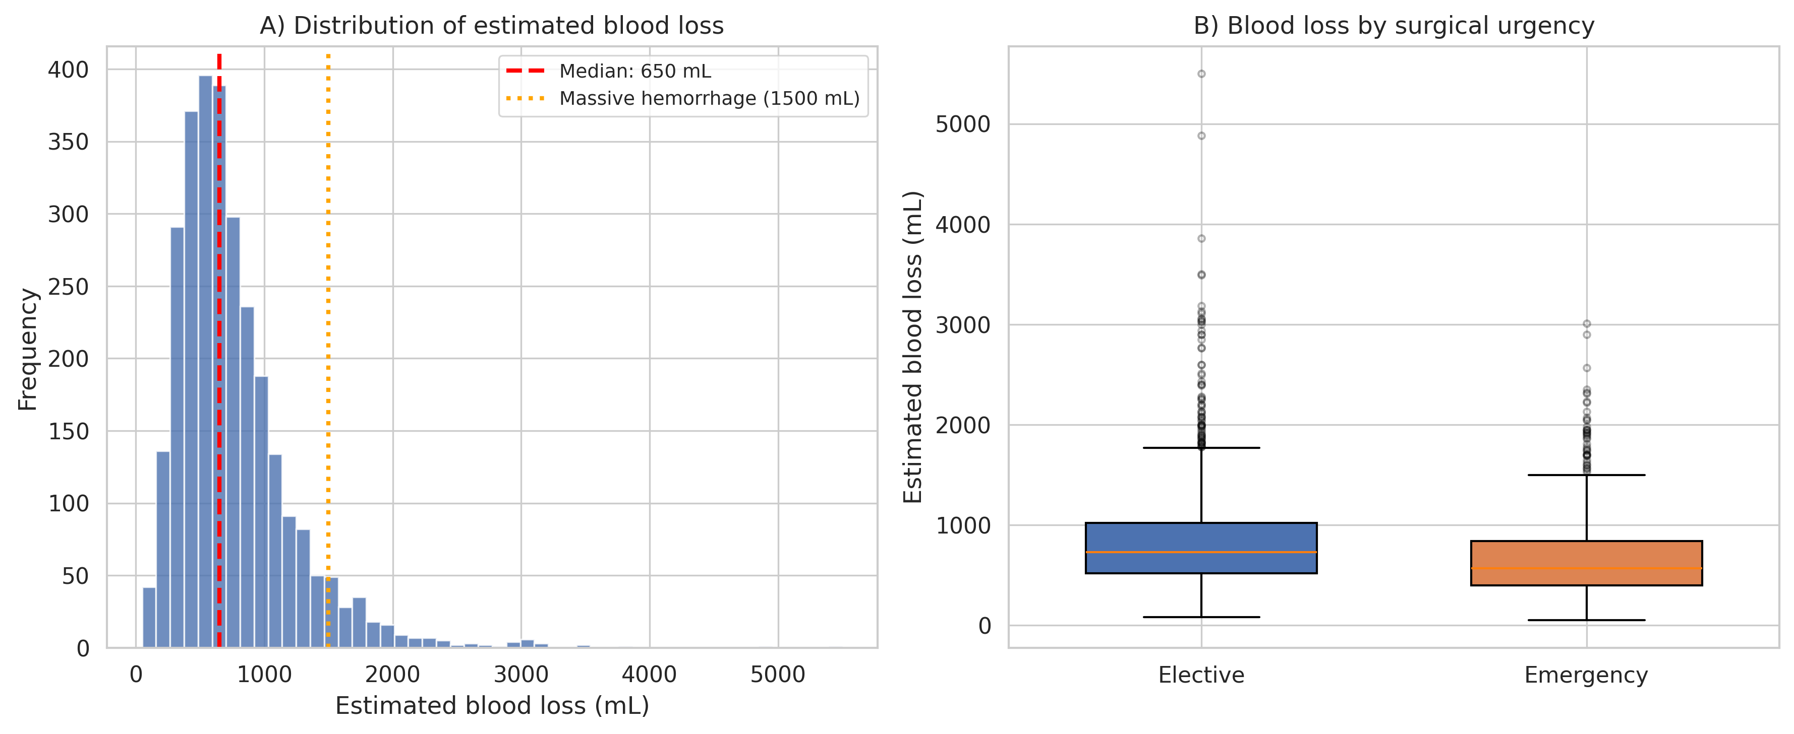
Figure 1. Distribution of estimated blood loss during cesarean section. (A) Histogram with median (dashed red) and massive hemorrhage threshold (dotted orange, 1500 mL). (B) Box plots by surgical urgency.

Elective cesarean sections had significantly higher median EBL compared with emergency cases (730 mL vs. 570 mL; P < 0.001) (Fig. 1B). Patients with placenta previa or low-lying placenta had substantially higher median EBL (1188 mL vs. 621 mL; P < 0.001). Epidural anesthesia was associated with higher median EBL (730 mL vs. 620 mL; P < 0.001). No significant difference was observed between patients with and without prior cesarean delivery (P = 0.95) (Fig. 5).

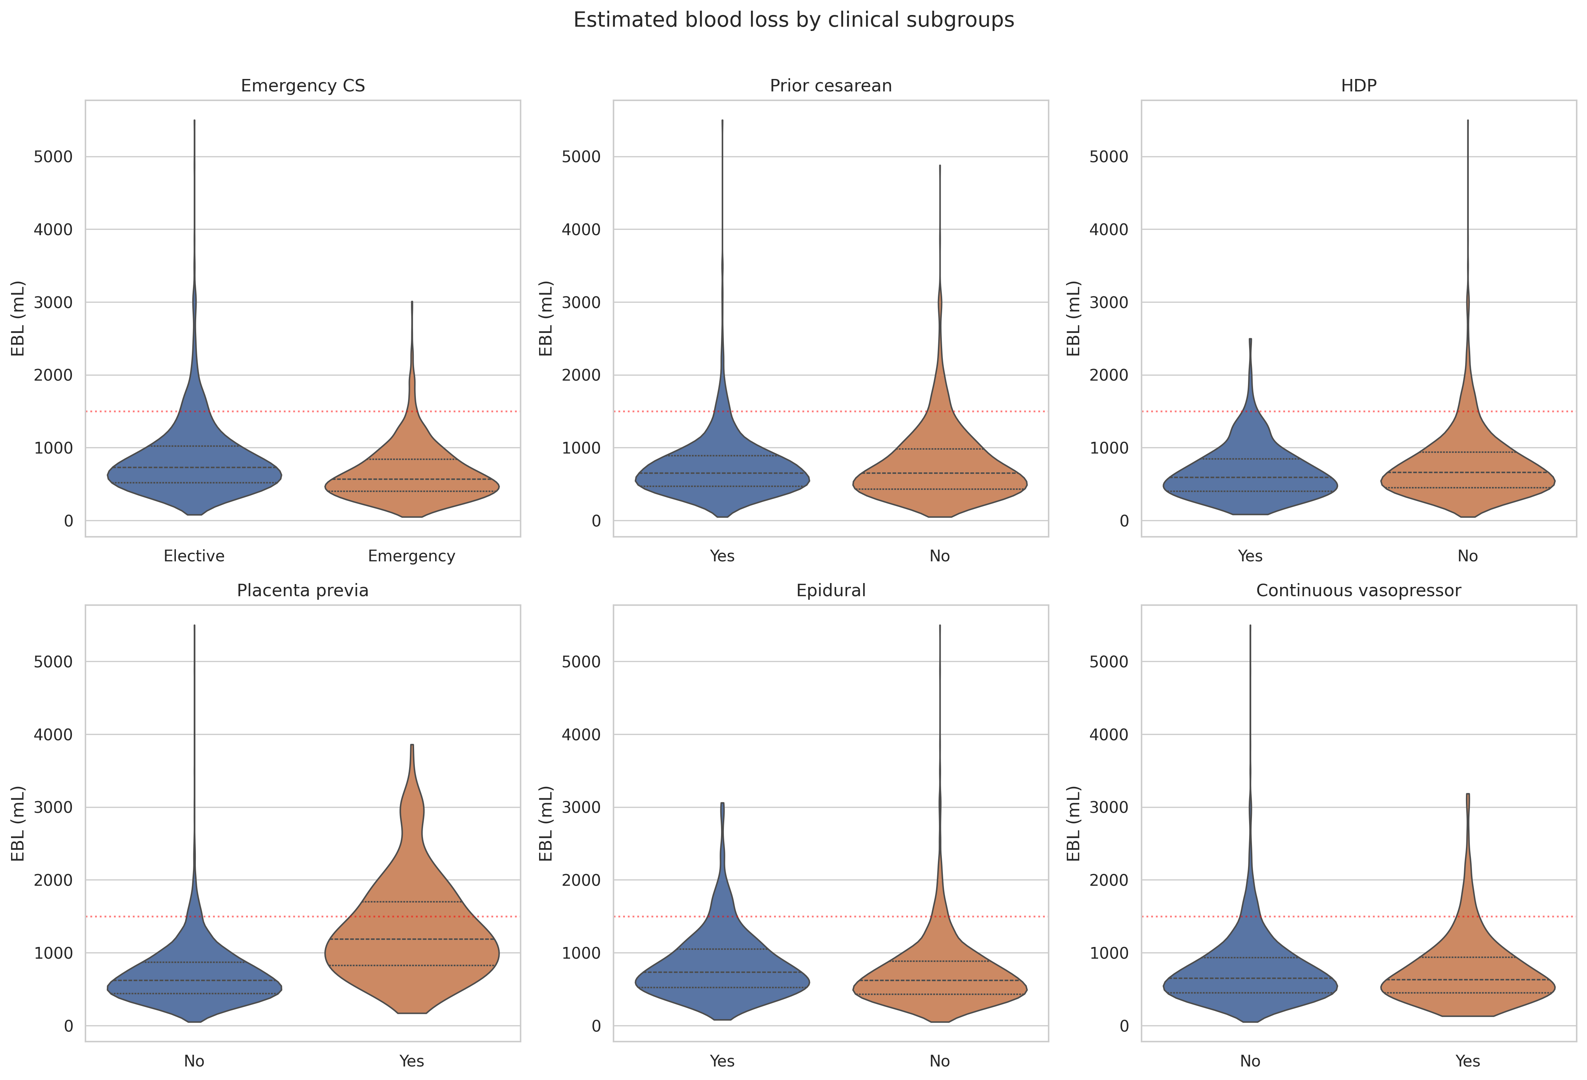
Figure 5. Estimated blood loss by clinical subgroups (violin plots). Red dotted line indicates the massive hemorrhage threshold (1500 mL). Horizontal lines within violins represent the median and interquartile range.

Multivariable Analysis of Blood Loss
In multivariable linear regression (n = 2,855; adjusted R² = 0.204), the following factors were independently associated with increased EBL: placenta previa or low-lying placenta (increased EBL by 71.8%; P < 0.001); surgical duration (increased EBL by 0.8%; P < 0.001); emergency cesarean section (decreased EBL by 17.3%; P < 0.001); epidural anesthesia (increased EBL by 15.7%; P < 0.001); number of hypotension episodes (increased EBL by 1.4%; P < 0.001); age (increased EBL by 0.9%; P < 0.001); prior cesarean delivery (decreased EBL by 8.9%; P < 0.001). Gestational age, bmi, hypertensive disorders of pregnancy were not significantly associated with EBL.
Table 2 and Figure 3 show the full regression results.
Table 2. Multivariable linear regression: Factors associated with estimated blood loss (log-transformed)
Variable | % Change in EBL | 95% CI | P-value
placenta previa or low-lying placenta | 71.8% | 60.3 to 84.1 | P < 0.001
surgical duration | 0.8% | 0.6 to 0.9 | P < 0.001
emergency cesarean section | -17.3% | -21.1 to -13.4 | P < 0.001
epidural anesthesia | 15.7% | 11.0 to 20.5 | P < 0.001
number of hypotension episodes | 1.4% | 0.9 to 1.9 | P < 0.001
age | 0.9% | 0.6 to 1.3 | P < 0.001
prior cesarean delivery | -8.9% | -13.0 to -4.7 | P < 0.001
gestational age | 0.4% | -0.3 to 1.0 | P = 0.270
BMI | 0.1% | -0.1 to 0.2 | P = 0.484
hypertensive disorders of pregnancy | 1.8% | -5.0 to 9.1 | P = 0.611

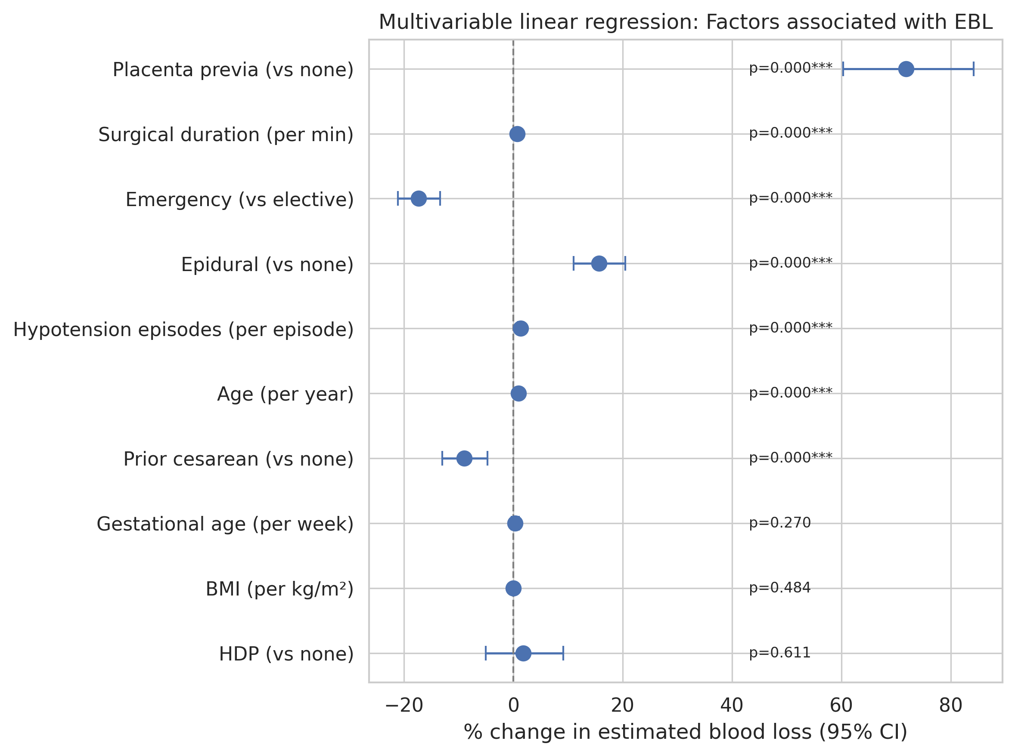
Figure 3. Forest plot showing the percentage change in estimated blood loss and 95% confidence intervals from multivariable linear regression (log-transformed EBL).

Transfusion
Intraoperative transfusion was administered in 128 patients (4.3%). Patients who received transfusion were older (median 35 vs. 34 years; P < 0.001), had earlier gestational age (median 37.1 vs. 38.1 weeks; P < 0.001), received more intravenous fluids (median 1425 vs. 990 mL; P < 0.001), and had higher oxytocin doses (median 15 vs. 10 U; P < 0.001) (Table 1).
Multivariable logistic regression (n = 2,858; 126 events) identified placenta previa as the strongest independent risk factor for transfusion (OR 88.14 (95% CI: 47.47–163.65); P < 0.001). Additional significant predictors included surgical duration (OR 1.03 (95% CI: 1.01–1.04); P < 0.001), age (OR 1.07 (95% CI: 1.02–1.12); P = 0.007), epidural anesthesia (OR 1.81 (95% CI: 1.12–2.92); P = 0.016). The model achieved excellent discrimination (AUC = 0.946) (Fig. 6A).
Table 3. Multivariable logistic regression: Factors associated with intraoperative transfusion
Variable | Odds Ratio | 95% CI | P-value
placenta previa or low-lying placenta | 88.14 | 47.47–163.65 | P < 0.001
surgical duration | 1.03 | 1.01–1.04 | P < 0.001
age | 1.07 | 1.02–1.12 | P = 0.007
epidural anesthesia | 1.81 | 1.12–2.92 | P = 0.016
prior cesarean delivery | 0.66 | 0.36–1.22 | P = 0.185
emergency cesarean section | 0.68 | 0.37–1.24 | P = 0.205
hypertensive disorders of pregnancy | 0.26 | 0.03–2.26 | P = 0.222
gestational age | 0.96 | 0.87–1.08 | P = 0.513
BMI | 1.00 | 0.99–1.02 | P = 0.662

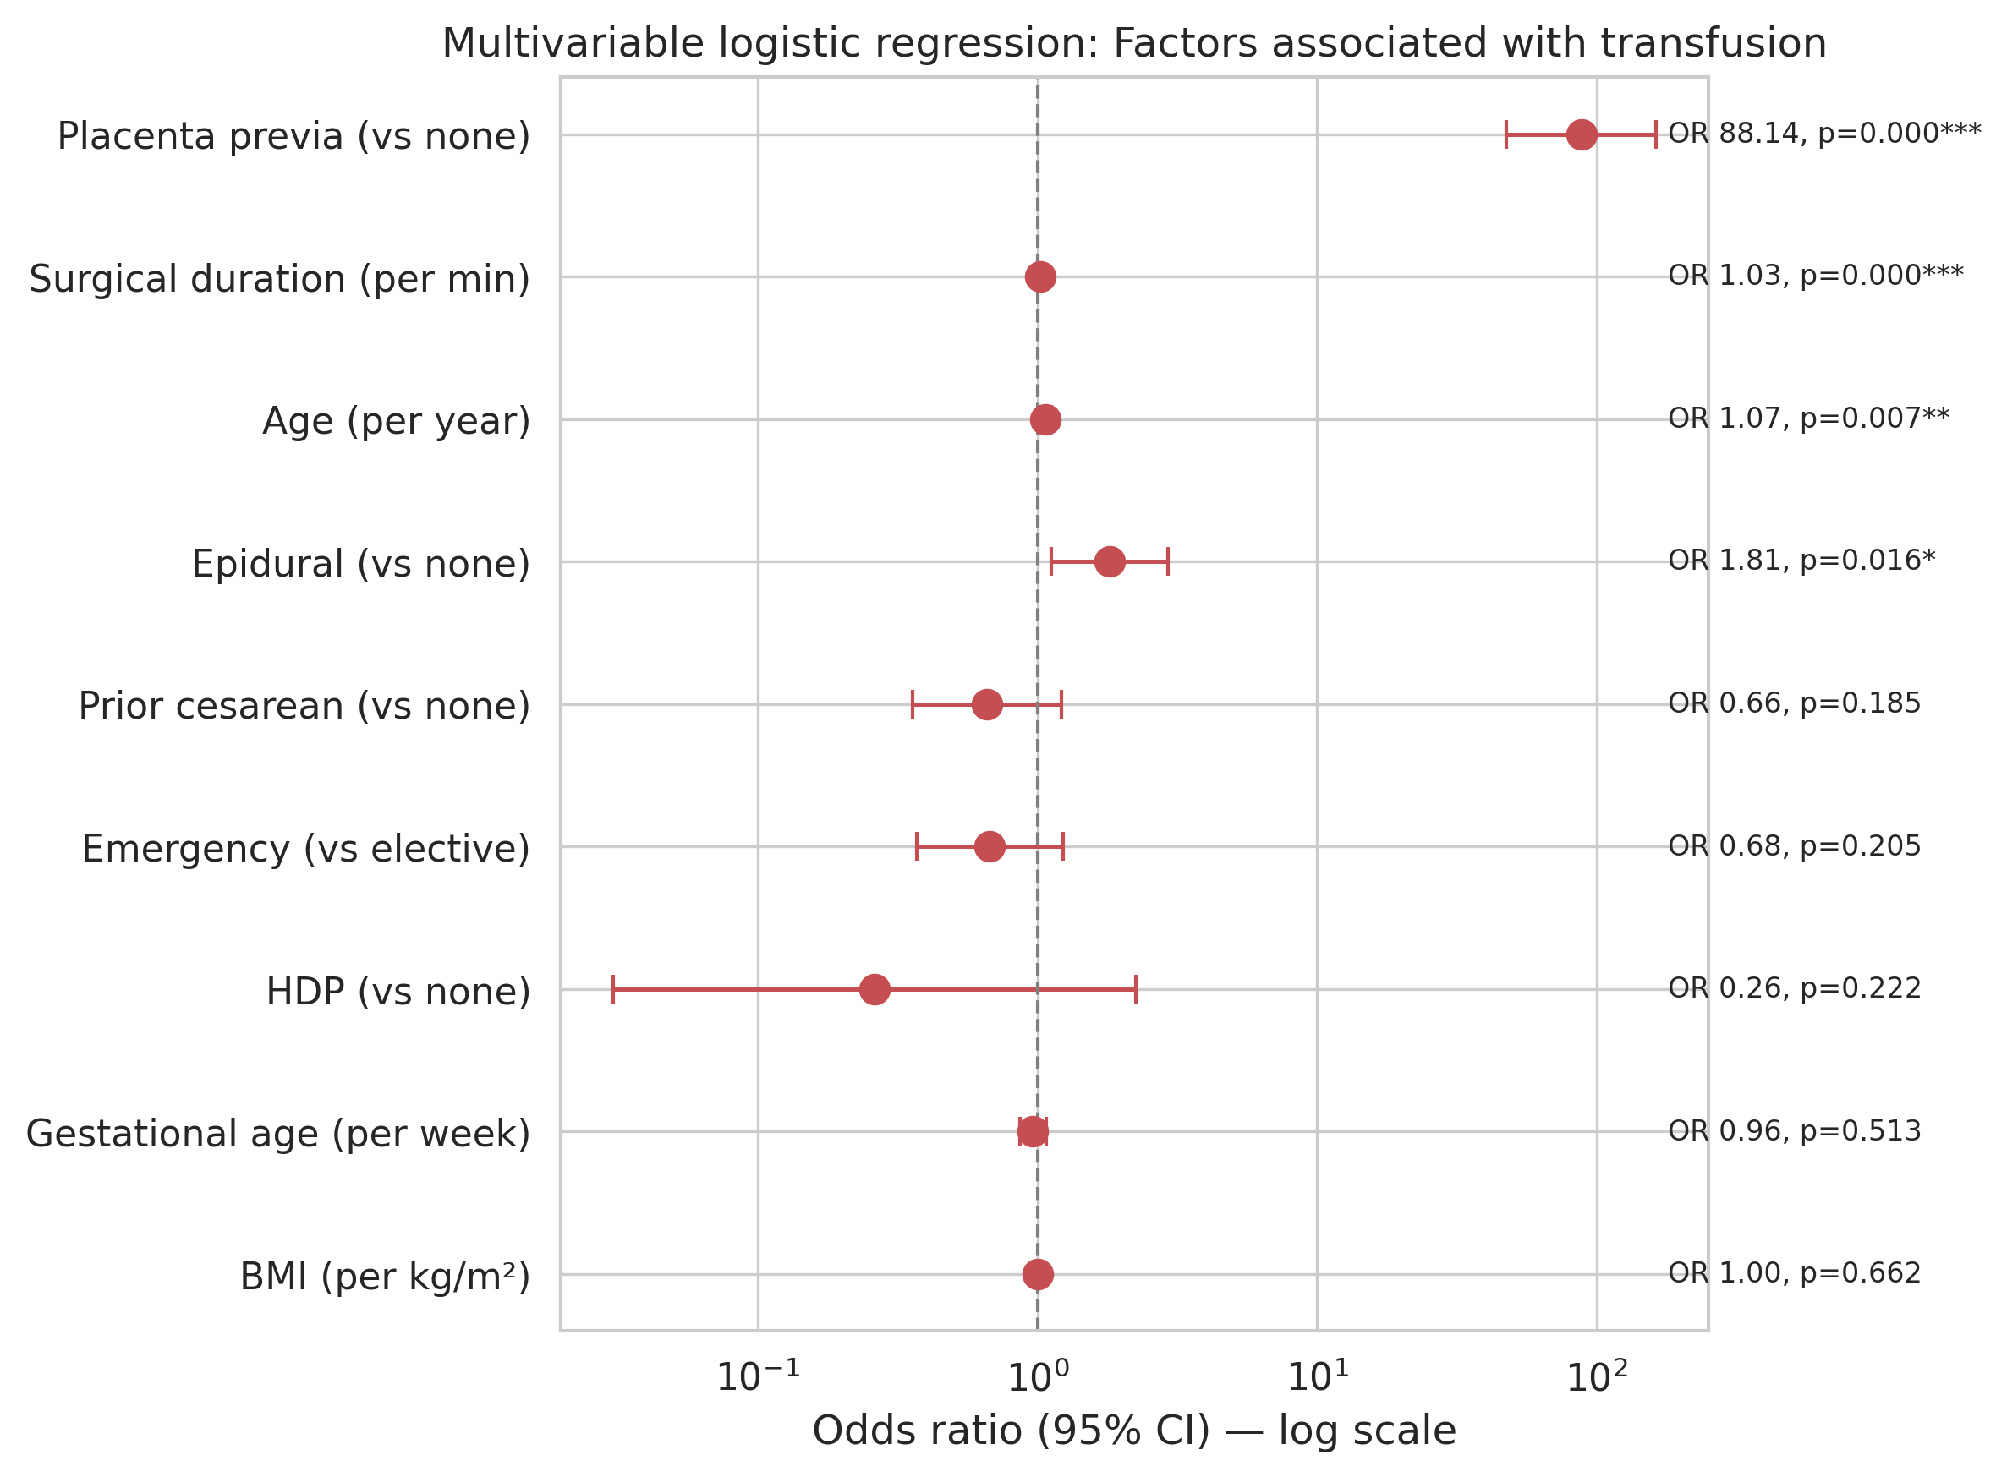
Figure 4. Forest plot showing odds ratios and 95% confidence intervals from multivariable logistic regression for intraoperative transfusion (log scale).

Massive Hemorrhage
Massive hemorrhage (EBL ≥ 1500 mL) occurred in 185 patients (6.4%). In multivariable logistic regression (n = 2,856; 183 events), the strongest independent risk factor was placenta previa (OR 9.15 (95% CI: 6.13–13.66); P < 0.001). surgical duration was a risk factor (OR 1.05 (95% CI: 1.04–1.06); P < 0.001). emergency cesarean section was a protective factor (OR 0.43 (95% CI: 0.28–0.67); P < 0.001). prior cesarean delivery was a protective factor (OR 0.50 (95% CI: 0.33–0.75); P < 0.001). epidural anesthesia was a risk factor (OR 1.71 (95% CI: 1.20–2.44); P = 0.003). Model discrimination was good (AUC = 0.820) (Fig. 6B).
Table 4. Multivariable logistic regression: Factors associated with massive hemorrhage (EBL ≥ 1500 mL)
Variable | Odds Ratio | 95% CI | P-value
placenta previa or low-lying placenta | 9.15 | 6.13–13.66 | P < 0.001
surgical duration | 1.05 | 1.04–1.06 | P < 0.001
emergency cesarean section | 0.43 | 0.28–0.67 | P < 0.001
prior cesarean delivery | 0.50 | 0.33–0.75 | P < 0.001
epidural anesthesia | 1.71 | 1.20–2.44 | P = 0.003
age | 1.03 | 1.00–1.07 | P = 0.052
gestational age | 0.94 | 0.88–1.00 | P = 0.058
hypertensive disorders of pregnancy | 0.80 | 0.35–1.83 | P = 0.602
BMI | 1.00 | 0.99–1.01 | P = 0.817

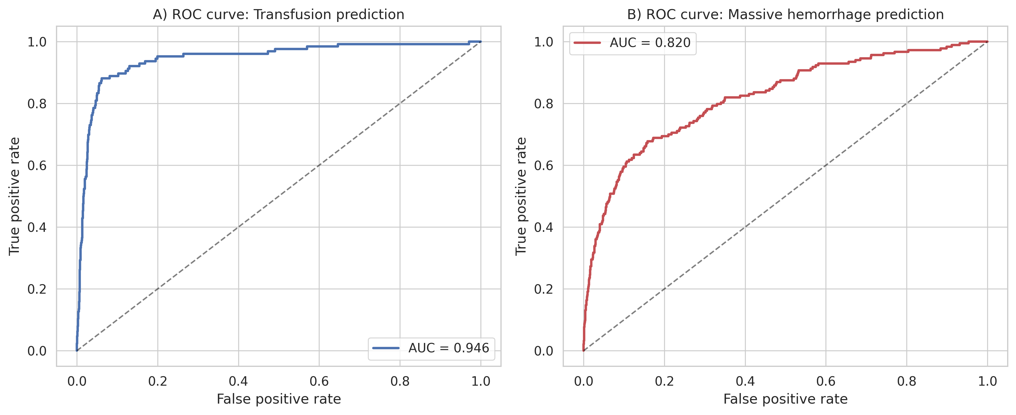
Figure 6. Receiver operating characteristic (ROC) curves for the multivariable logistic regression models. (A) Transfusion prediction. (B) Massive hemorrhage (≥1500 mL) prediction.

Temporal Trends
Significant temporal improvements were observed over the study period (Fig. 2). Median EBL decreased from 765 mL in 2014 to 560 mL in 2024 (Pearson r = −0.893; P < 0.001). The transfusion rate declined from 6.1% in 2014 to 1.4% in 2024 (r = −0.733; P = 0.010), and the massive hemorrhage rate declined from 9.2% in 2014 to 2.8% in 2024 (r = −0.742; P = 0.009).
When comparing the early (2014–2018; n = 1,468) and late (2019–2024; n = 1,487) periods, median EBL was significantly lower in the late period (620 vs. 700 mL; P < 0.001). The transfusion rate (2.6% vs. 6.1%; P < 0.001) and massive hemorrhage rate (5.1% vs. 7.4%; P = 0.012) were also significantly lower in the late period.

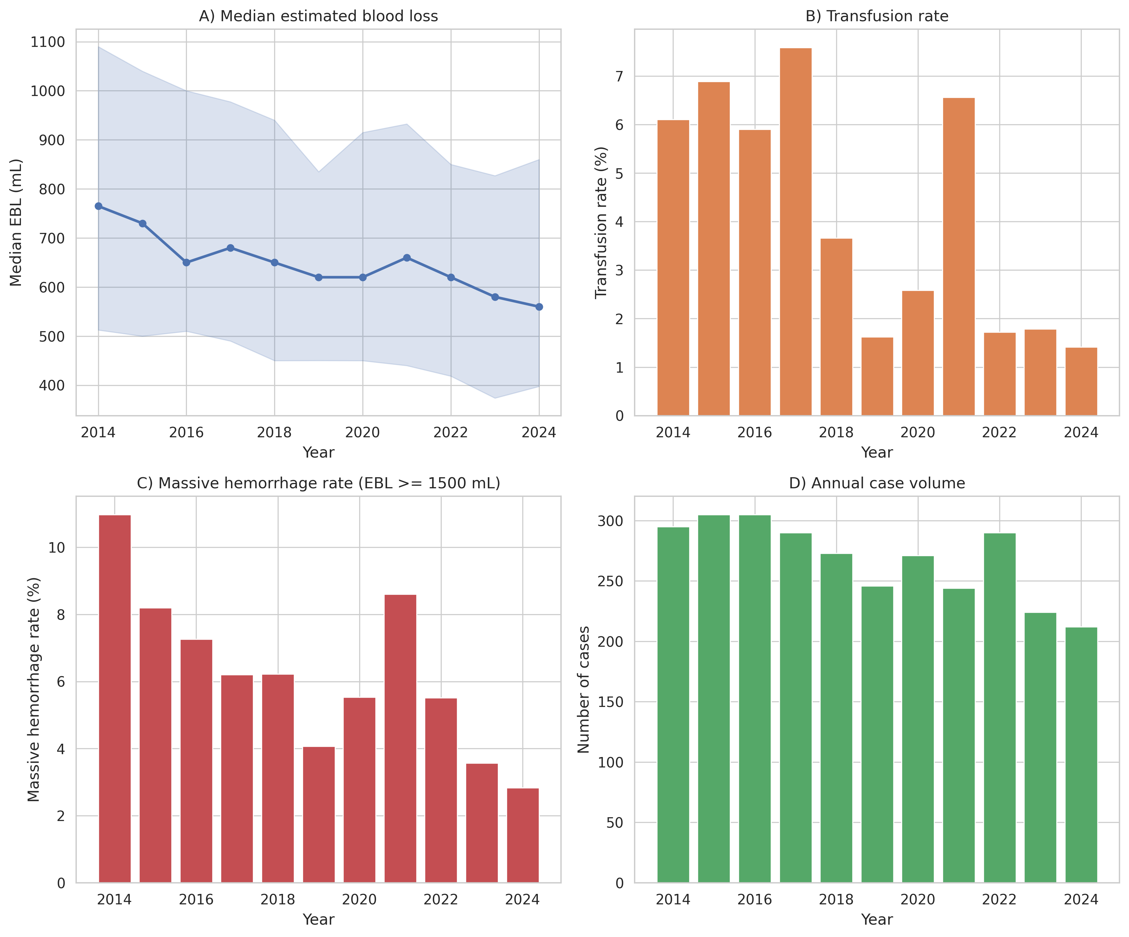
Figure 2. Temporal trends in cesarean section outcomes (2014–2024). (A) Median estimated blood loss with IQR shading. (B) Transfusion rate. (C) Massive hemorrhage rate. (D) Annual case volume.

