Descriptive Statistics: Twin Cesarean Section Cohort
Analysis date: 2026-05-29
Study period: 2014-04-01 to 2024-10-23
Cohort: twin pregnancies undergoing cesarean section under spinal anesthesia
N (raw): 366 → N (analysis): 342 (after exclusions and pre-anesthesia antiemetic removal)

Patient Flow
A total of 366 twin cesarean sections were identified. General anesthesia (2), Pre-anesthesia SBP < 90 mmHg (1), Intrauterine fetal death (9), Vanishing twin (3), No anesthesia data available (1), were excluded (20 total). An additional 4 patients who received antiemetics before anesthesia induction were excluded per protocol. The final analysis cohort comprised 342 twin cesarean sections.

Table 1. Patient Characteristics — Continuous Variables
Variable | n | Mean ± SD | Median [IQR] | Min | Max
Age (years) | 342 | 32.0 ± 4.8 | 32.0 [29.0–35.0] | 19.0 | 45.0
BMI (kg/m²) | 341 | 25.7 ± 4.0 | 25.3 [22.8–28.0] | 17.1 | 43.9
Gestational age (weeks) | 342 | 36.2 ± 2.2 | 37.0 [36.1–37.3] | 23.9 | 38.3
Surgery time (min) | 342 | 45.6 ± 11.0 | 44.0 [38.0–51.0] | 23.0 | 102.0
Anesthesia time (min) | 342 | 60.1 ± 12.7 | 58.0 [51.0–67.8] | 34.0 | 119.0
Estimated blood loss (mL) | 342 | 1380.2 ± 727.6 | 1195.0 [922.5–1670.0] | 130.0 | 5450.0
Infusion volume (mL) | 342 | 1080.1 ± 405.3 | 1050.0 [800.0–1300.0] | 300.0 | 2700.0
Hypotensive episodes (count) | 342 | 1.4 ± 2.4 | 0.0 [0.0–2.0] | 0.0 | 18.0
Intrathecal bupivacaine (mg) | 333 | 10.7 ± 1.3 | 10.0 [10.0–11.0] | 3.0 | 25.0
Intrathecal fentanyl (μg) | 334 | 18.5 ± 6.7 | 20.0 [15.0–20.0] | 0.0 | 50.0
Intrathecal morphine (mg) | 335 | 0.1 ± 0.1 | 0.1 [0.0–0.1] | 0.0 | 0.2
Ephedrine (mg) | 342 | 2.1 ± 5.0 | 0.0 [0.0–0.0] | 0.0 | 28.0
Phenylephrine (mg) | 341 | 0.2 ± 0.2 | 0.1 [0.0–0.3] | 0.0 | 1.9

Table 2. Patient Characteristics — Categorical Variables
Variable | n/N (%) | 95% CI | Missing
Emergency CS | 121/342 (35.4%) | 30.5–40.6% | 0
Prior CS | 40/342 (11.7%) | 8.7–15.5% | 0
Hypertensive disorders of pregnancy | 33/342 (9.6%) | 7.0–13.2% | 0
Preoperative steroid (≤1 week) | 25/342 (7.3%) | 5.0–10.6% | 0
Epidural anesthesia | 105/342 (30.7%) | 26.1–35.8% | 0
Continuous vasopressor infusion | 33/342 (9.6%) | 7.0–13.2% | 0
Hypotension (SBP < 90 mmHg) | 151/342 (44.2%) | 39.0–49.5% | 0
Uterine exteriorization | 73/74 (98.6%) | 92.7–99.8% | 268
BMI ≥ 35 kg/m² | 5/341 (1.5%) | 0.6–3.4% | 1
Preoperative antiemetic (≤24 h) | 1/341 (0.3%) | 0.1–1.6% | 1

Figure 1. Distribution of Key Variables
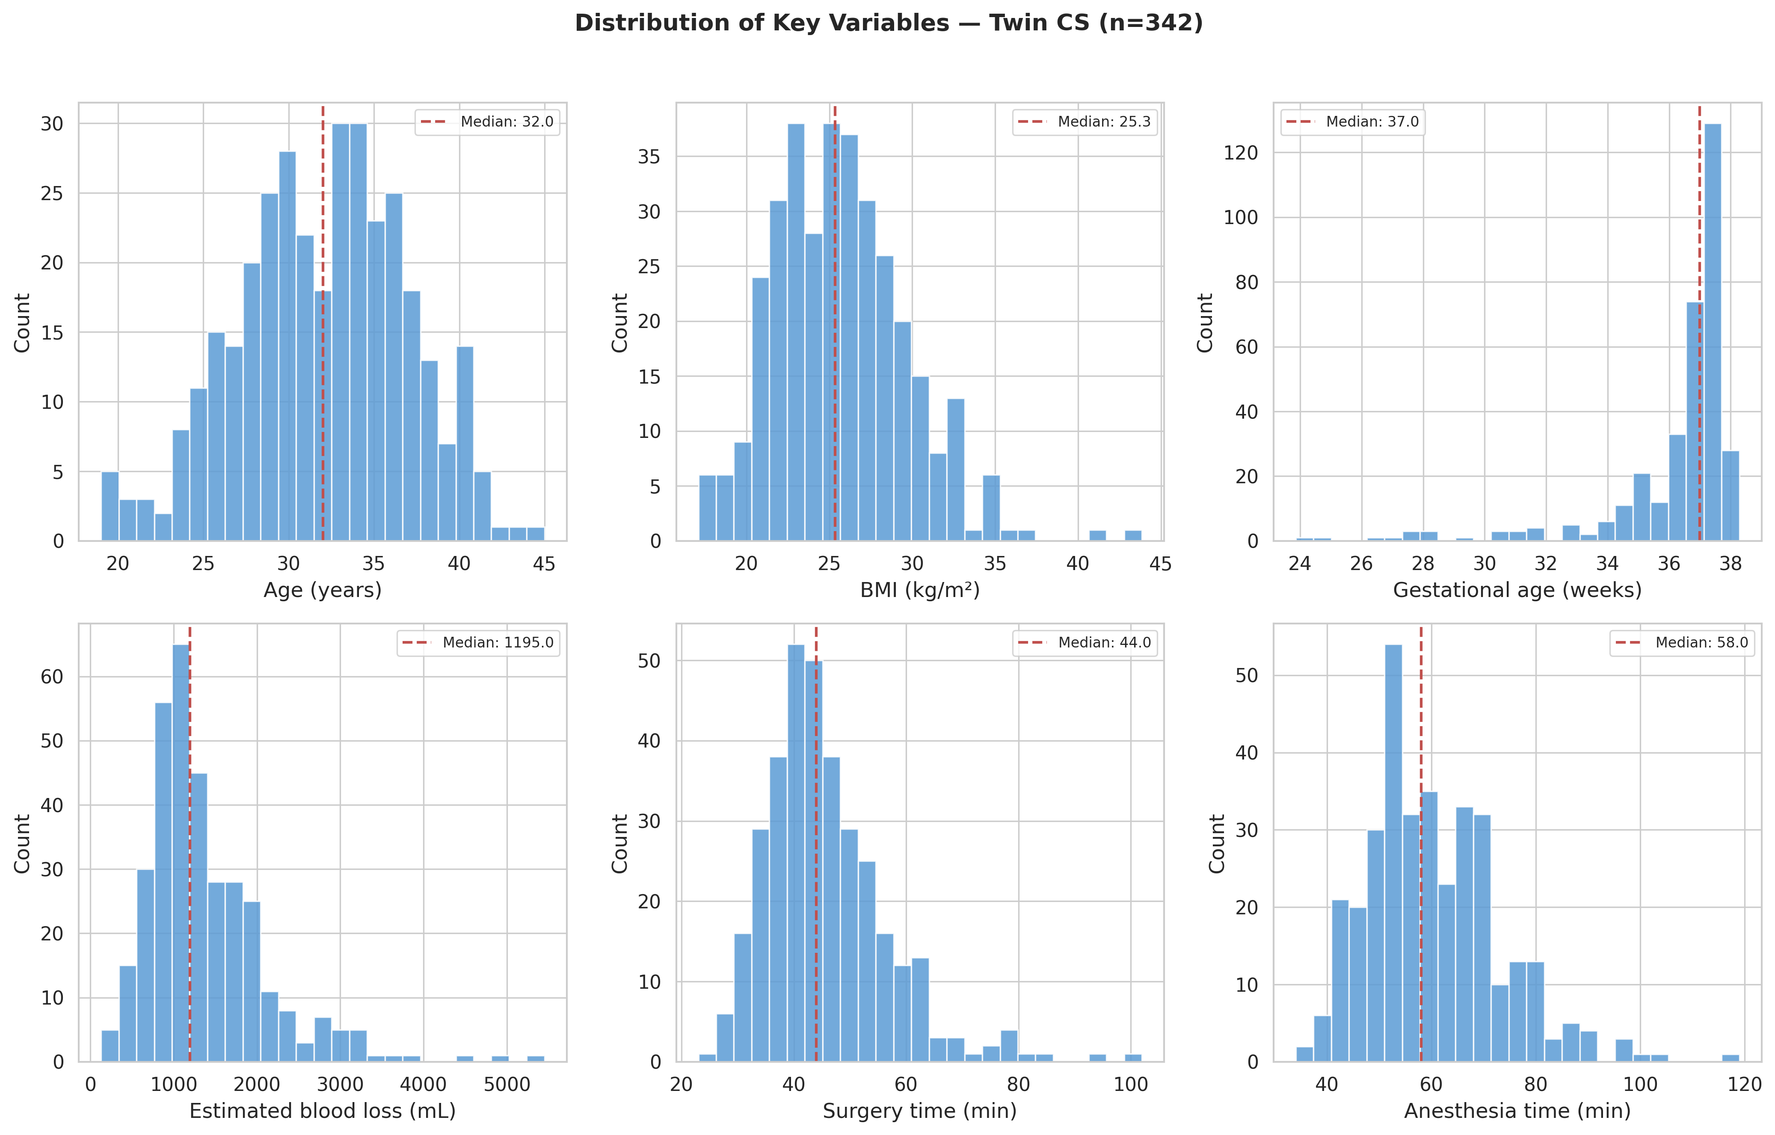
Figure 1. Distribution of age, BMI, gestational age, blood loss, surgery time, and anesthesia time in the twin CS cohort (n=342). Red dashed lines indicate median values.

Table 3. IONV Outcomes
Outcome | Events/N | Rate (%) | 95% CI
Primary: any IONV (anesthesia→exit) | 58/342 | 17.0 | 13.4–21.3%
Secondary: IONV before delivery only | 5/342 | 1.5 | 0.6–3.4%
Post-delivery IONV only | 54/342 | 15.8 | 12.3–20.0%
5-HT3 antagonist use (Definition E) | 8/342 | 2.3 | 1.2–4.5%

Figure 2. IONV Outcome Rates
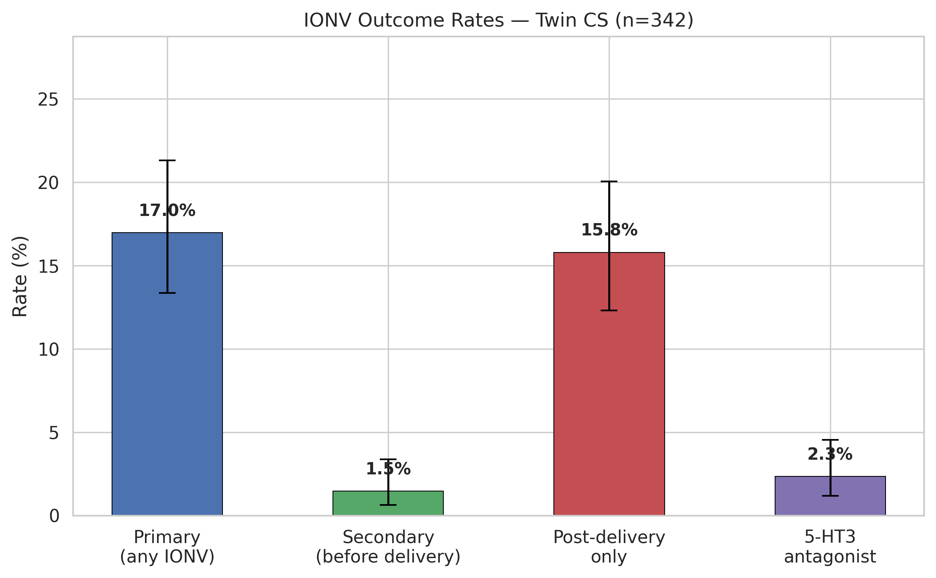
Figure 2. IONV outcome rates with 95% Wilson confidence intervals in twin CS (n=342).

Table 4. Antiemetic Drug Usage
Drug | n (%) | Median dose | Dose IQR
Metoclopramide | 38 (11.1%) | 10.0 | 10.0–10.0
Droperidol | 14 (4.1%) | 0.8 | 0.8–1.2
Ondansetron | 7 (2.0%) | 4.0 | 4.0–4.0
Granisetron | 1 (0.3%) | 3.0 | 3.0–3.0
Prochlorperazine (Novamin) | 4 (1.2%) | 5.0 | 5.0–5.0
Hydroxyzine (Atarax-P) | 3 (0.9%) | 25.0 | 25.0–25.0
Dexamethasone | 0 (0.0%) | – | –

Figure 3. Antiemetic Drug Usage
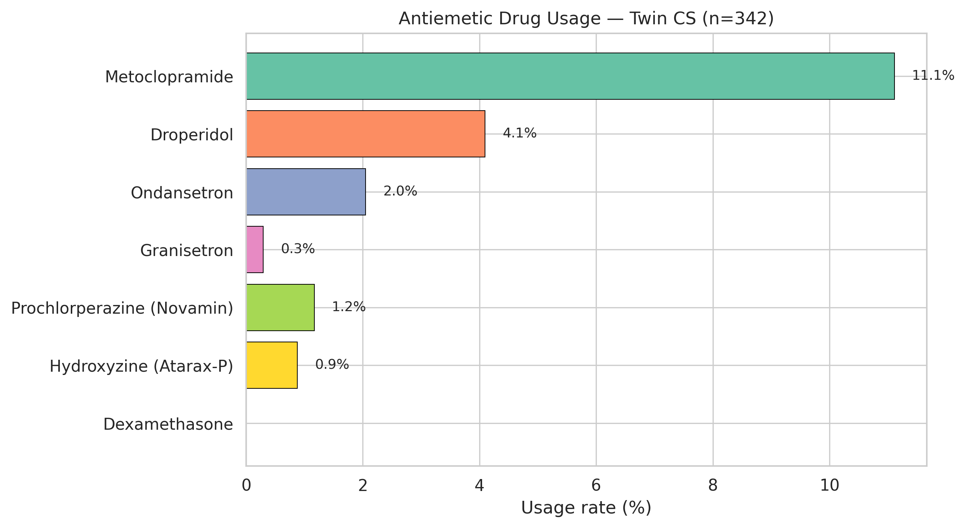
Figure 3. Frequency of individual antiemetic drug usage in twin CS (n=342).

Table 5. Emergency vs Elective Subgroup
Subgroup | n | Age median [IQR] | BMI median [IQR] | GA (weeks) median [IQR] | Blood loss (mL) median [IQR] | Surgery time (min) median [IQR] | Anesthesia time (min) median [IQR] | IONV primary n (%) | IONV secondary n (%)
Emergency | 121 | 32.0 [28.0–36.0] | 25.0 [22.1–27.9] | 35.4 [34.1–36.6] | 1150.0 [880.0–1860.0] | 43.0 [38.0–51.0] | 57.0 [50.0–67.0] | 27 (22.3%) | 1 (0.8%)
Elective | 221 | 32.0 [29.0–35.0] | 25.5 [23.1–28.2] | 37.3 [37.0–37.4] | 1220.0 [940.0–1625.0] | 44.0 [39.0–51.0] | 59.0 [51.0–68.0] | 31 (14.0%) | 4 (1.8%)

Figure 4. Blood Loss by Emergency Status
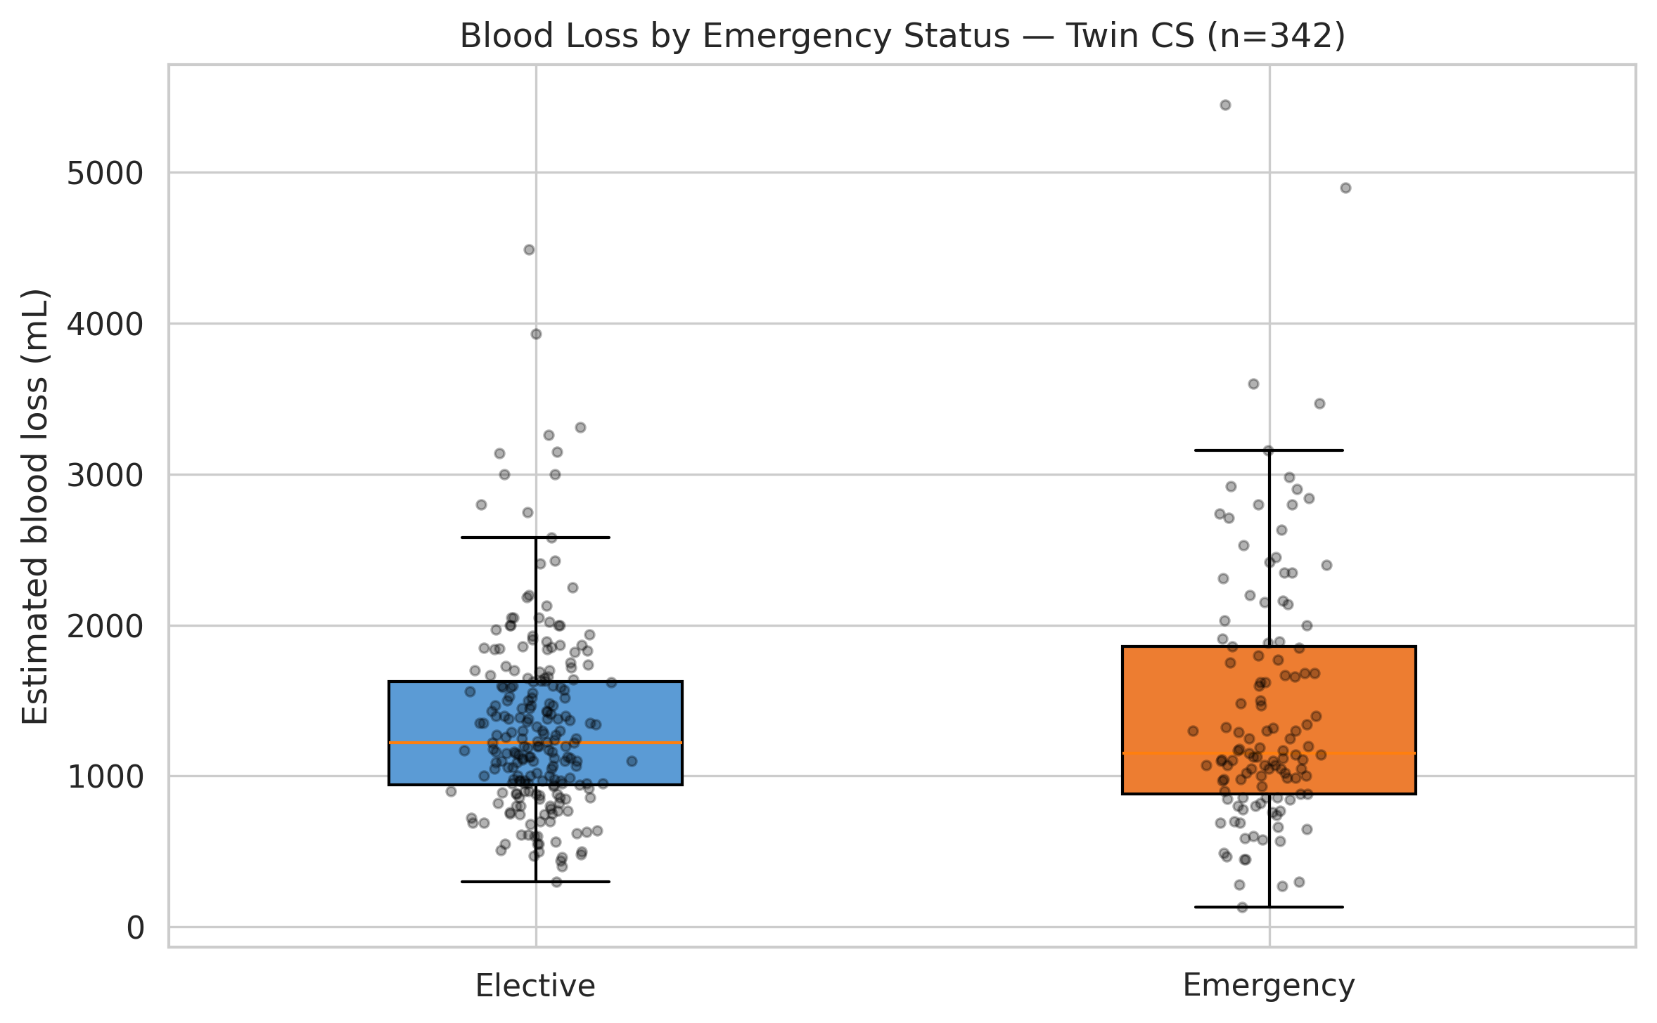
Figure 4. Estimated blood loss distribution in emergency vs elective twin CS (n=342). Individual data points shown with jitter.

Figure 5. Temporal Trends
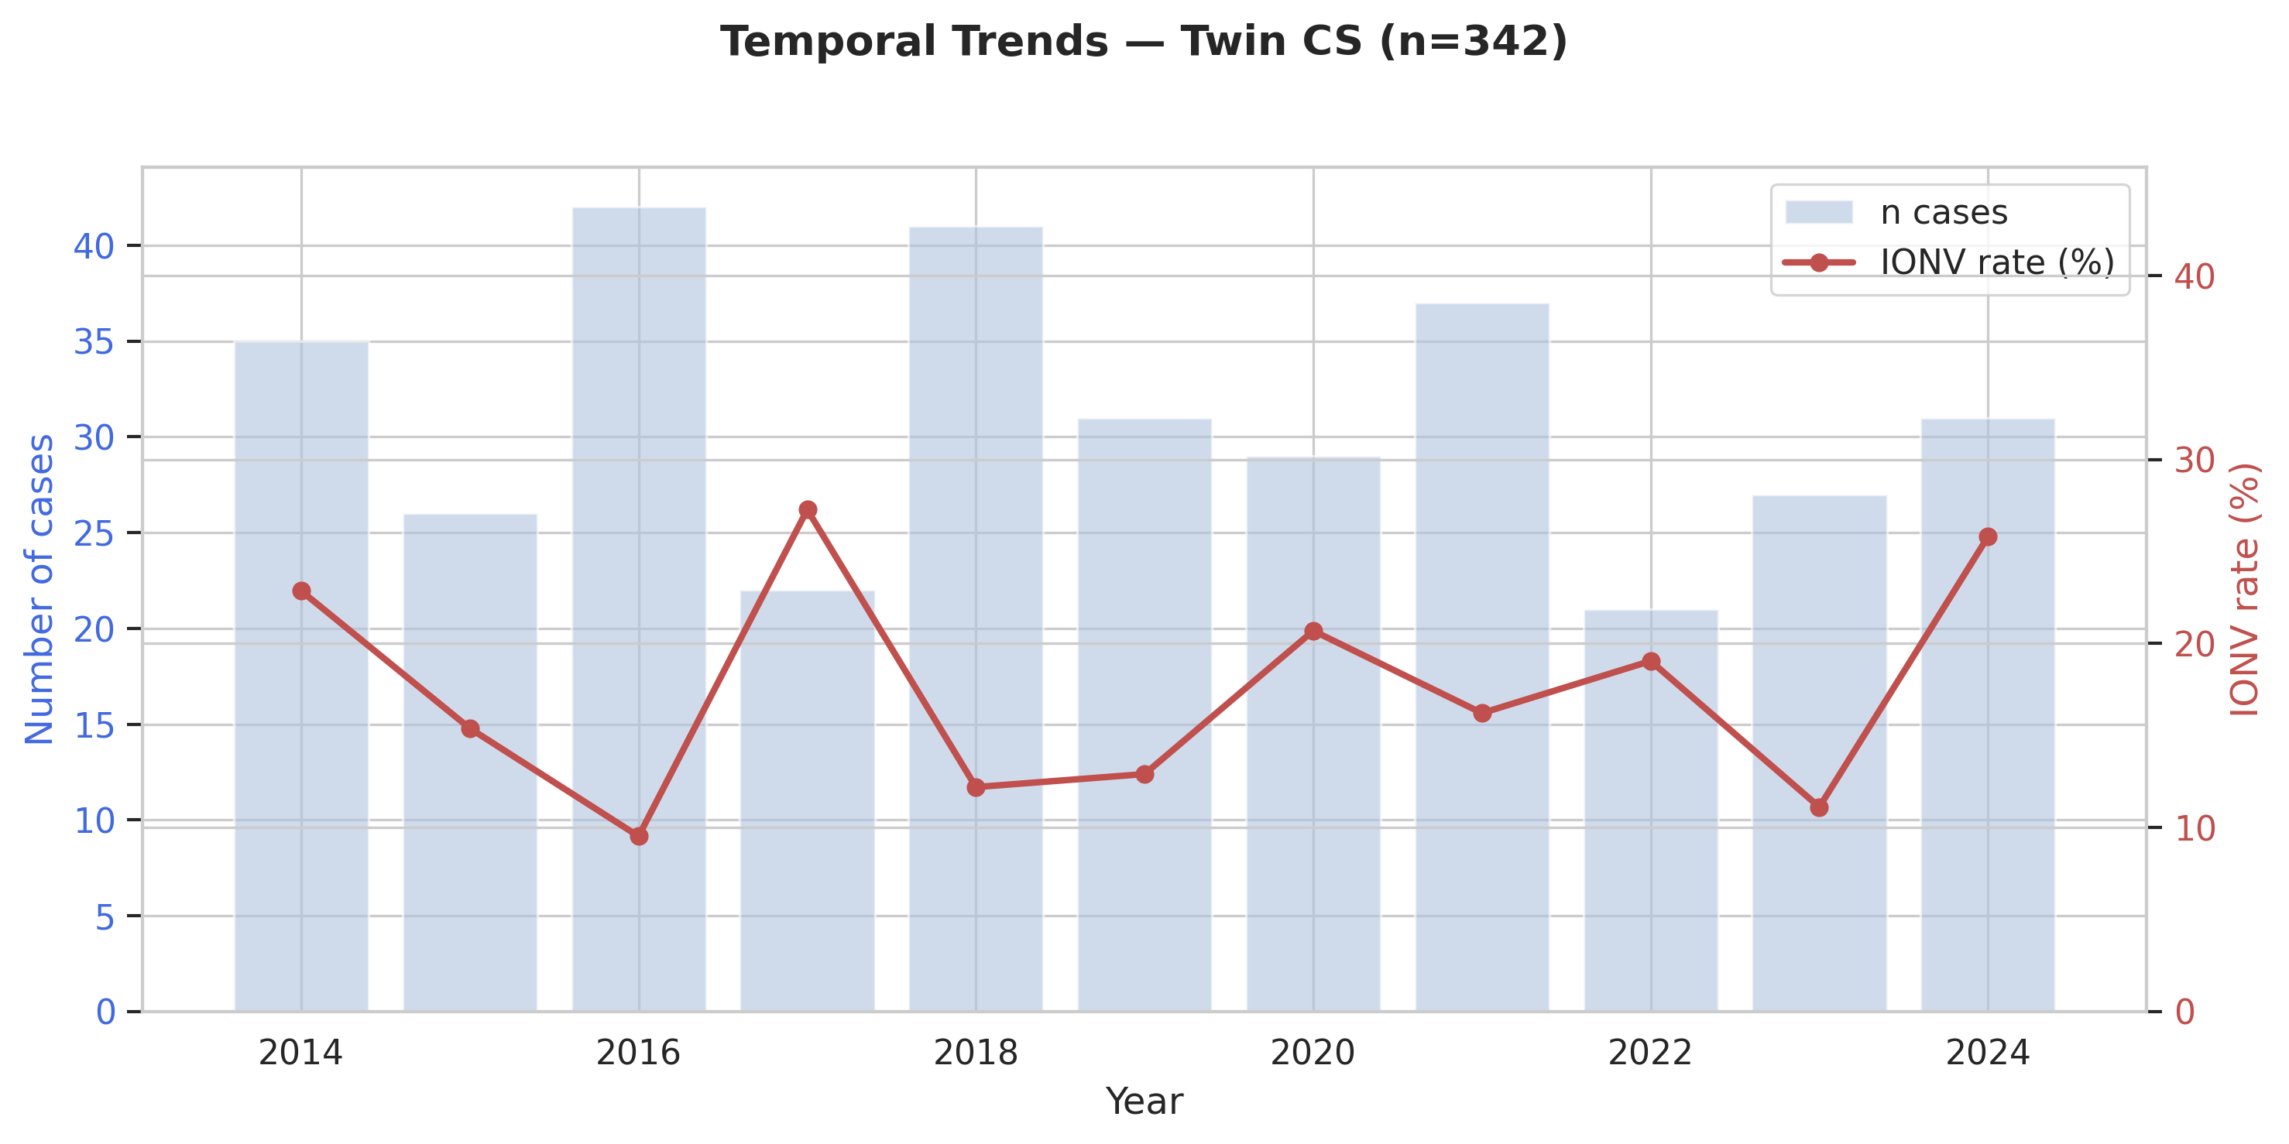
Figure 5. Annual case volume and IONV rates in twin CS (n=342).

Table 6. Yearly Trends
Year | n | IONV primary n (%) | EBL median (mL) | 5-HT3 n (%)
2014 | 35 | 8 (22.9%) | 1240 | 0 (0.0%)
2015 | 26 | 4 (15.4%) | 1340 | 0 (0.0%)
2016 | 42 | 4 (9.5%) | 1385 | 0 (0.0%)
2017 | 22 | 6 (27.3%) | 1210 | 0 (0.0%)
2018 | 41 | 5 (12.2%) | 1300 | 0 (0.0%)
2019 | 31 | 4 (12.9%) | 1140 | 0 (0.0%)
2020 | 29 | 6 (20.7%) | 1200 | 0 (0.0%)
2021 | 37 | 6 (16.2%) | 1120 | 0 (0.0%)
2022 | 21 | 4 (19.0%) | 1050 | 0 (0.0%)
2023 | 27 | 3 (11.1%) | 1150 | 1 (3.7%)
2024 | 31 | 8 (25.8%) | 1150 | 7 (22.6%)

