Methods

Study Design and Setting
This retrospective, single-center, observational study was conducted at Juntendo University Shizuoka Hospital, Japan, using medical records from April 1, 2014, to October 23, 2024. The study was approved by the institutional review board and conducted in accordance with the Declaration of Helsinki (2013 revision) and the Japanese Ethical Guidelines for Medical and Biological Research Involving Human Subjects (2021). Informed consent was waived via an opt-out mechanism.

Participants
We included women aged ≥18 years who underwent cesarean section under regional anesthesia (spinal, epidural, or combined spinal-epidural). Exclusion criteria were: general anesthesia, cardiac arrest in the operating room, pre-anesthesia systolic blood pressure <90 mmHg, intrauterine fetal death, vanishing twin, and triplet pregnancy.

Outcome Measures
Because this was a retrospective study and nausea and vomiting could not be directly ascertained from medical records, intraoperative antiemetic use was employed as a surrogate marker for IONV.^{2,3} The primary outcome was antiemetic use during the period from anesthesia induction to delivery or from delivery to operating room exit (i.e., any intraoperative antiemetic use). The secondary outcome was antiemetic use from anesthesia induction to delivery only. Antiemetics included ondansetron, granisetron, metoclopramide, droperidol, prochlorperazine (Novamin), hydroxyzine (Atarax-P), and dexamethasone.
Patients who received antiemetics before anesthesia induction (during the admission-to-anesthesia period) were excluded from the outcome analysis, as pre-anesthesia antiemetic administration was considered likely prophylactic.¹²⁻¹⁴

Statistical Analysis
Continuous variables were summarized as median [interquartile range] and compared using the Mann-Whitney U test. Categorical variables were summarized as n (%) and compared using the chi-square test or Fisher's exact test where expected cell counts were <5.
Multivariable logistic regression was performed to evaluate the association between twin pregnancy and IONV, adjusting for known risk factors: age, body mass index (BMI), gestational age, emergency cesarean section, prior cesarean section, hypertensive disorders of pregnancy (HDP), epidural anesthesia, surgery time, and intraoperative hypotension (systolic blood pressure <90 mmHg).^{7,8} Uterine exteriorization was not included in the model because of excessive missing data (available in only approximately 20% of the cohort). Results are presented as odds ratios (OR) with 95% confidence intervals (CI). A two-sided P < 0.05 was considered statistically significant. All analyses were performed using Python 3.12 with statsmodels 0.14, scipy 1.14, and scikit-learn 1.6.

Sensitivity Analyses
Six sensitivity analyses were performed using alternative IONV definitions to assess the robustness of the primary finding. Definition C restricted IONV to the post-delivery phase only (antiemetic use after delivery but not before). Definition D identified severe IONV, defined as use of two or more different antiemetic drugs. Definition E used a drug-specific approach, counting only 5-HT3 receptor antagonists (ondansetron or granisetron) as IONV markers. Definition F excluded patients whose only antiemetic was dexamethasone (frequently used prophylactically). Definition G treated the number of antiemetic drugs used as a count outcome and applied Poisson regression to estimate incidence rate ratios (IRR). Definition H stratified the primary analysis by the presence or absence of intraoperative hypotension, to assess whether the twin–IONV association differed by hypotension status.
For definitions with sparse events (events-per-variable ratio <5), a reduced model with six covariates (twin, age, BMI, gestational age, emergency, and hypotension) was used to ensure model convergence.

Results

Study Population
A total of 3,479 women who underwent cesarean section during the study period were identified (3,113 singleton and 366 twin pregnancies). After applying exclusion criteria, 3,243 patients remained (3,479 total; 6 excluded for general anesthesia, 13 for intrauterine fetal death, 3 for vanishing twin, 5 for triplet pregnancy, 4 for pre-anesthesia hypotension, and 58 for unavailable anesthesia data). An additional 55 patients who received pre-anesthesia antiemetics were excluded from the outcome analysis, yielding a final analysis cohort of 3,188 patients (2,846 singleton, 342 twin) (Fig. 1).

Patient Characteristics (Table 1)
Baseline patient characteristics are summarized in Table 1. Compared with the singleton group, the twin group had significantly lower age (32.0 vs 34.0 years, P < 0.001), lower gestational age (37.0 vs 38.0 weeks, P < 0.001), fewer emergency cesarean sections (35.4% vs 46.8%, P < 0.001), fewer prior cesarean sections (11.7% vs 45.0%, P < 0.001), lower hypotension incidence (44.2% vs 52.8%, P = 0.003), and higher blood loss (1195 vs 650 mL, P < 0.001). BMI, epidural use, HDP, and preoperative steroid use did not differ significantly between groups.
Variable | Singleton | Twin | P-value
Age (years) | 34.0 [30.0–37.0] | 32.0 [29.0–35.0] | < 0.001
BMI (kg/m²) | 24.8 [22.5–27.8] | 25.3 [22.8–28.0] | 0.183
Gestational age (weeks) | 38.0 [37.0–38.6] | 37.0 [36.1–37.3] | < 0.001
Surgery time (min) | 47.0 [40.0–57.0] | 44.0 [38.0–51.0] | < 0.001
Anesthesia time (min) | 64.0 [55.0–76.0] | 58.0 [51.0–67.8] | < 0.001
Estimated blood loss (mL) | 650.0 [450.0–930.0] | 1195.0 [922.5–1670.0] | < 0.001
Infusion volume (mL) | 1000.0 [750.0–1250.0] | 1050.0 [800.0–1300.0] | 0.054
Hypotensive episodes (count) | 1.0 [0.0–2.0] | 0.0 [0.0–2.0] | 0.002
Intrathecal bupivacaine (mg) | 10.0 [10.0–11.0] | 10.0 [10.0–11.0] | 0.178
Intrathecal fentanyl (μg) | 20.0 [20.0–25.0] | 20.0 [15.0–20.0] | 0.182
Emergency CS | 1331/2846 (46.8%) | 121/342 (35.4%) | < 0.001
Prior CS | 1280/2846 (45.0%) | 40/342 (11.7%) | < 0.001
Hypertensive disorders of pregnancy | 284/2846 (10.0%) | 33/342 (9.6%) | 0.847
Preoperative steroid (≤1 week) | 207/2839 (7.3%) | 25/342 (7.3%) | 0.990
Epidural anesthesia | 912/2846 (32.0%) | 105/342 (30.7%) | 0.615
Continuous vasopressor infusion | 253/2846 (8.9%) | 33/342 (9.6%) | 0.642
Hypotension (SBP < 90 mmHg) | 1502/2845 (52.8%) | 151/342 (44.2%) | 0.003
Uterine exteriorization | 563/607 (92.8%) | 73/74 (98.6%) | 0.077
BMI ≥ 35 kg/m² | 114/2815 (4.0%) | 5/341 (1.5%) | 0.018

IONV Outcomes
The primary outcome (any intraoperative antiemetic use) occurred in 504 of 2,846 singleton patients (17.7%) and 58 of 342 twin patients (17.0%), with no significant difference between groups (P = 0.731) (Table 2, Fig. 1). The secondary outcome (antiemetic use before delivery) was similarly not significantly different: 54 (1.9%) in singletons vs 5 (1.5%) in twins (P = 0.572). Post-delivery antiemetic use rates were also comparable (16.0% vs 15.8%, P = 0.938).

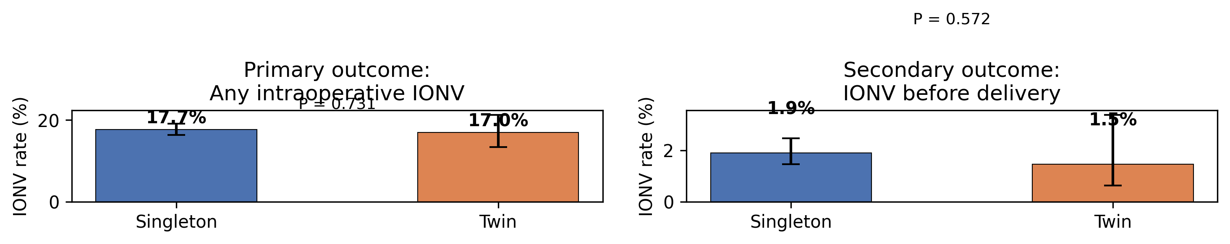
Figure 1. IONV rates by group.
Outcome | Singleton | Twin | P-value
Primary: any IONV (anesthesia→exit) | 504/2846 (17.7%) | 58/342 (17.0%) | 0.731
Secondary: IONV before delivery | 54/2846 (1.9%) | 5/342 (1.5%) | 0.572
Post-delivery IONV only | 454/2846 (16.0%) | 54/342 (15.8%) | 0.938

Antiemetic Drug Usage (Table 3)
The most commonly used antiemetic was metoclopramide (12.3% in singletons, 11.1% in twins), followed by droperidol (4.0% and 4.1%, respectively) (Table 3). Ondansetron use was significantly higher in twins (2.0% vs 0.9%, P = 0.041). Other antiemetic agents did not differ significantly between groups.
Drug | Singleton | Twin | P-value
Metoclopramide | 349 (12.3%) | 38 (11.1%) | 0.538
Droperidol | 114 (4.0%) | 14 (4.1%) | 0.938
Ondansetron | 25 (0.9%) | 7 (2.0%) | 0.075
Granisetron | 0 (0.0%) | 1 (0.3%) | 0.107
Prochlorperazine (Novamin) | 30 (1.1%) | 4 (1.2%) | 0.780
Hydroxyzine (Atarax-P) | 16 (0.6%) | 3 (0.9%) | 0.449
Dexamethasone | 2 (0.1%) | 0 (0.0%) | 1.000

Multivariable Logistic Regression
In multivariable logistic regression (n = 3,153; 556 events), twin pregnancy was not independently associated with IONV (adjusted OR 0.92, 95% CI 0.67–1.27; P = 0.624) (Fig. 2, Table 4). Factors significantly associated with IONV were epidural anesthesia (OR 1.66, 95% CI 1.36–2.01; P < 0.001), longer surgery time (OR 1.01 per minute, 95% CI 1.01–1.02; P < 0.001), and prior cesarean section (OR 0.77, 95% CI 0.62–0.96; P = 0.021; protective).

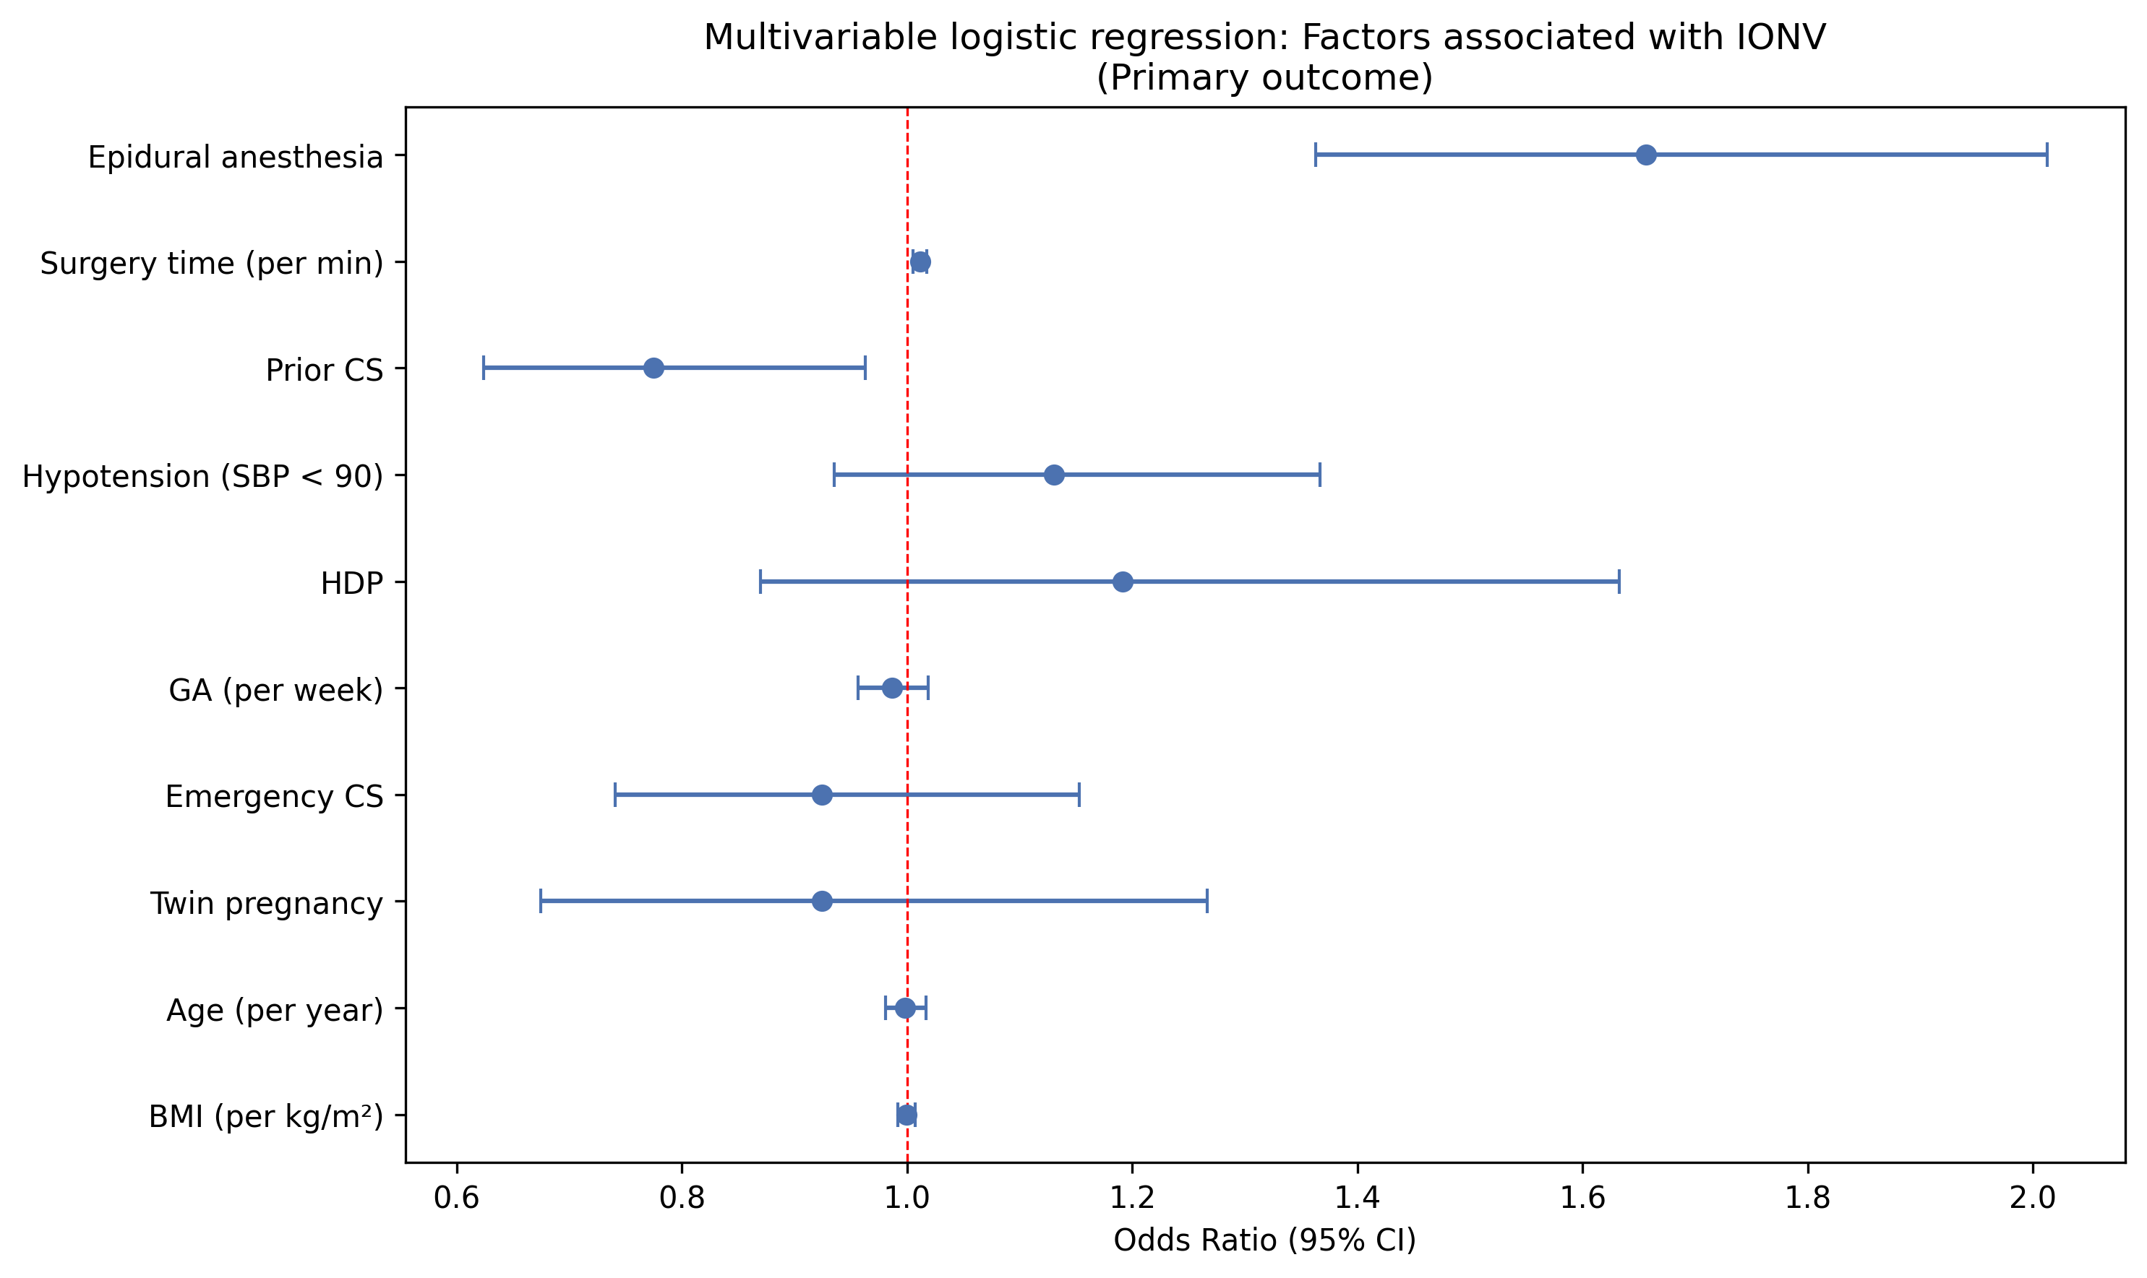
Figure 2. Forest plot: multivariable logistic regression for IONV (primary outcome).
Variable | OR | 95% CI lower | 95% CI upper | P-value
twin | 0.92 | 0.67 | 1.27 | 0.624
年齢(歳) | 1.00 | 0.98 | 1.02 | 0.873
BMI | 1.00 | 0.99 | 1.01 | 0.922
GA_weeks | 0.99 | 0.96 | 1.02 | 0.419
emergency | 0.92 | 0.74 | 1.15 | 0.486
prior_cs | 0.77 | 0.62 | 0.96 | 0.021
HDP | 1.19 | 0.87 | 1.63 | 0.275
epidural | 1.66 | 1.36 | 2.01 | < 0.001
手術時間_min | 1.01 | 1.01 | 1.02 | < 0.001
hypotension | 1.13 | 0.94 | 1.37 | 0.204
For the secondary outcome (IONV before delivery; n = 3,153, 58 events), twin pregnancy was likewise not significantly associated (adjusted OR 0.82, 95% CI 0.31–2.15; P = 0.683) (Fig. 3, Table 5).

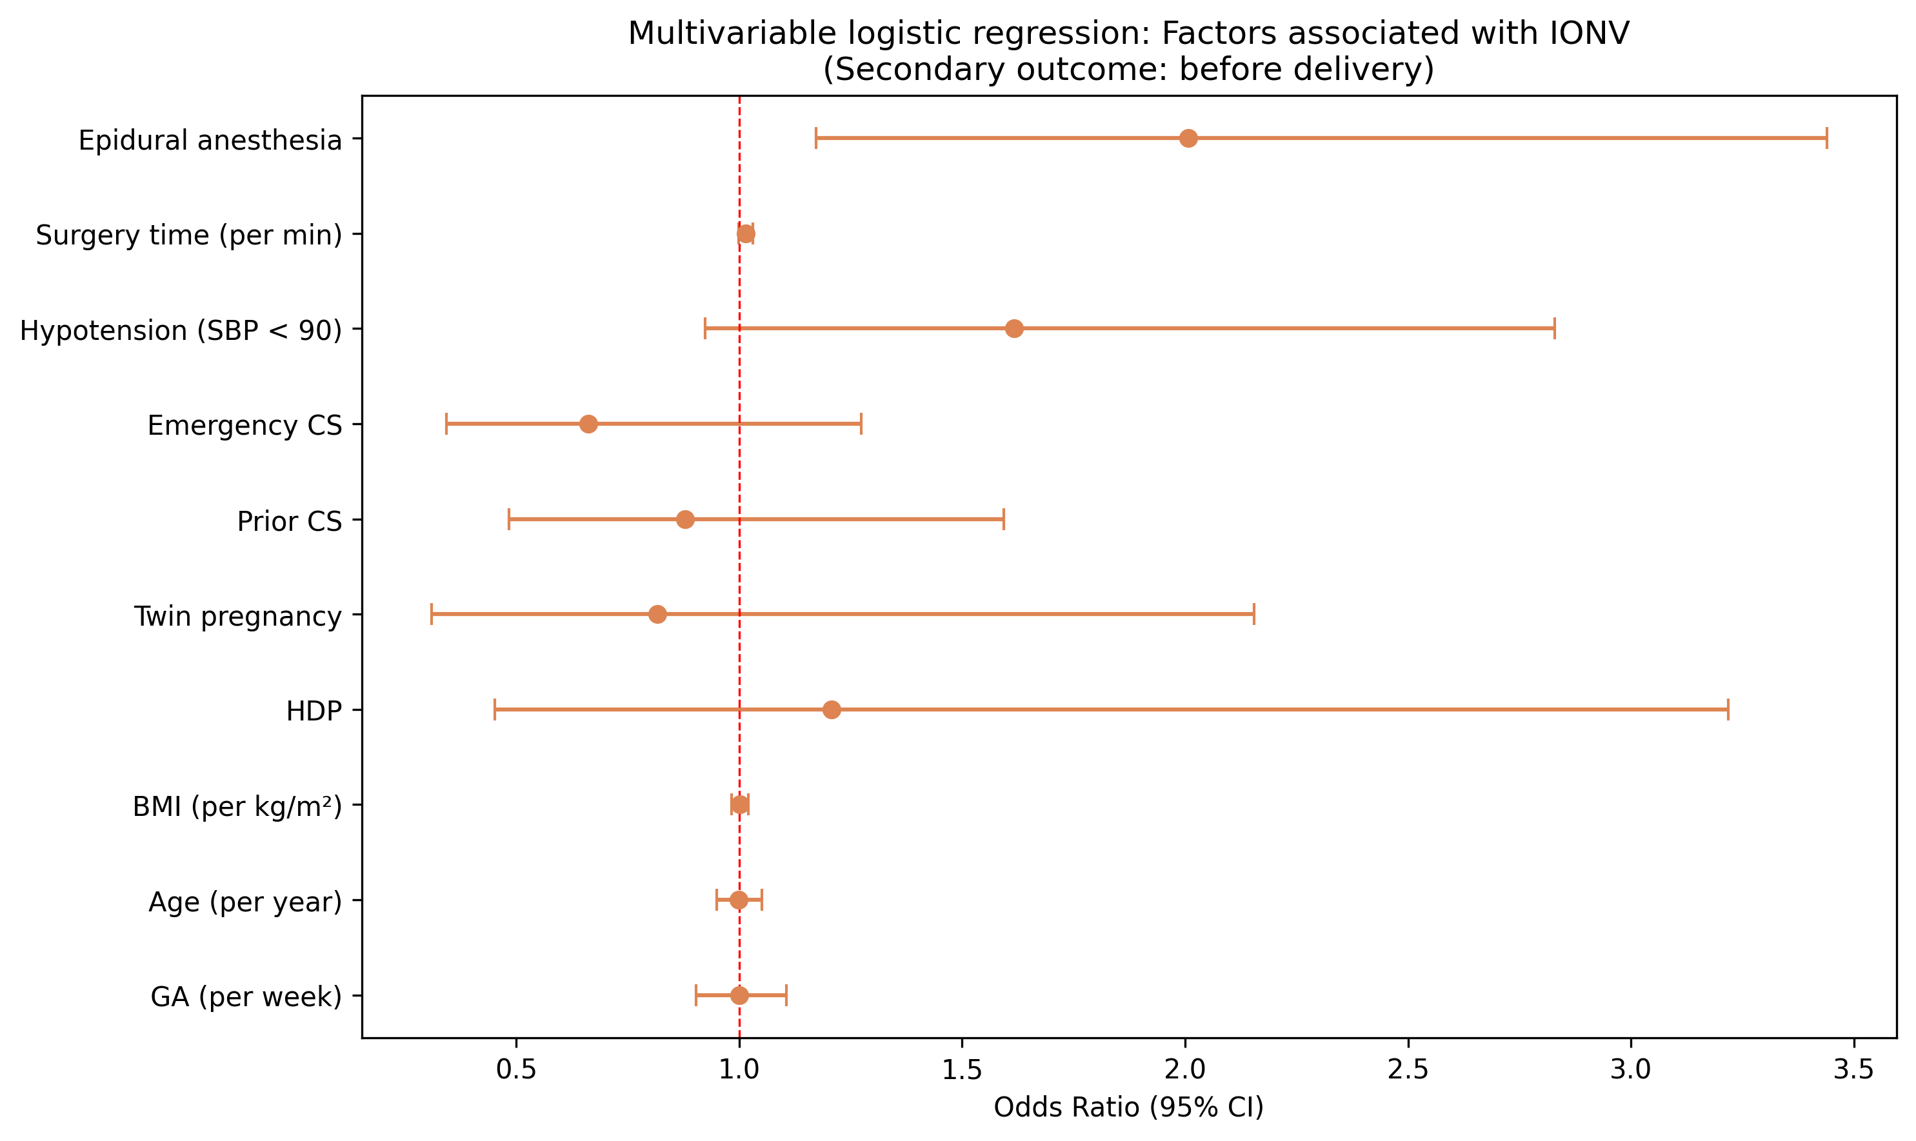
Figure 3. Forest plot: multivariable logistic regression for IONV (secondary outcome).

IONV Timing Distribution
The majority of IONV events occurred in the post-delivery phase (delivery to operating room exit), with comparable rates between singletons (16.0%) and twins (15.8%) (Fig. 4). IONV during the anesthesia-to-delivery phase was infrequent in both groups (1.9% vs 1.5%).

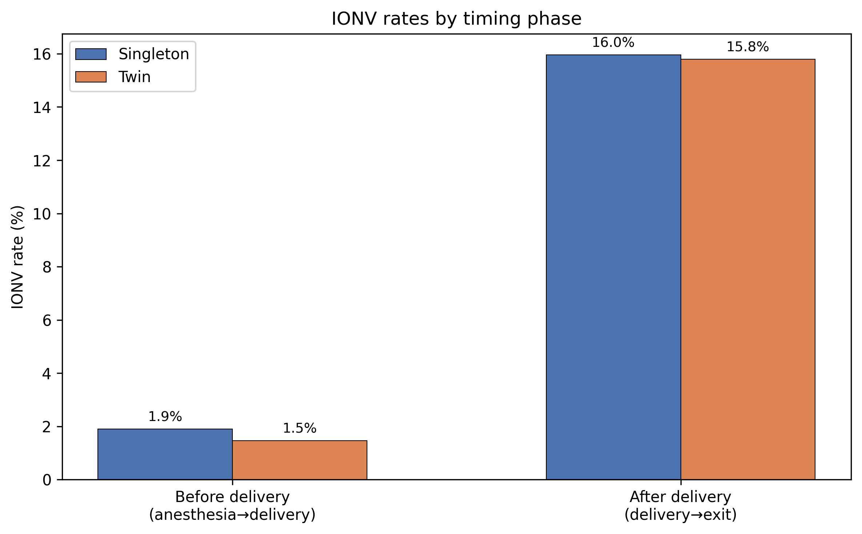
Figure 4. IONV rates by timing phase.

Temporal Trends
Temporal trends of IONV rates are shown in Figure 5. IONV rates remained relatively stable over the study period in both groups, without a clear upward or downward trend.

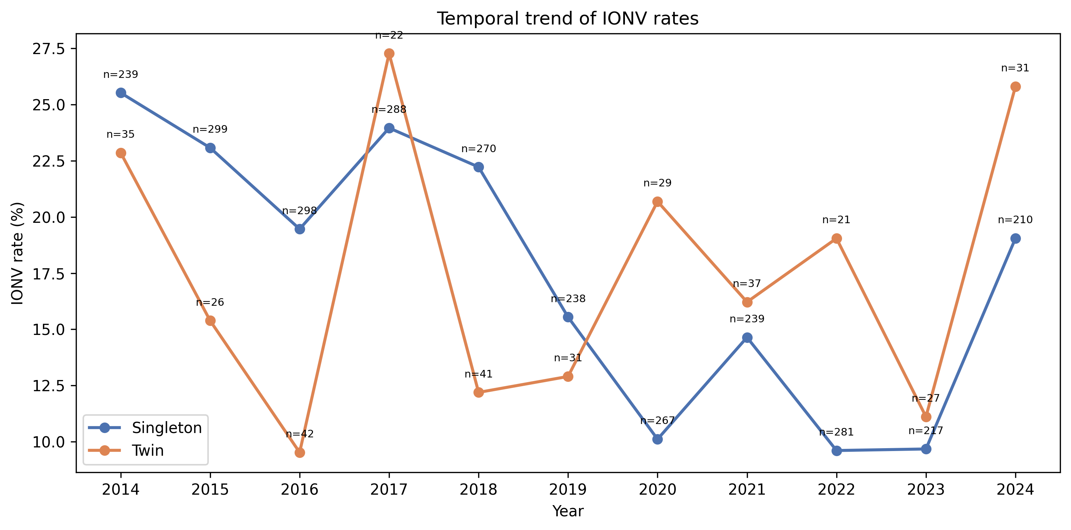
Figure 5. Temporal trend of IONV rates by year.

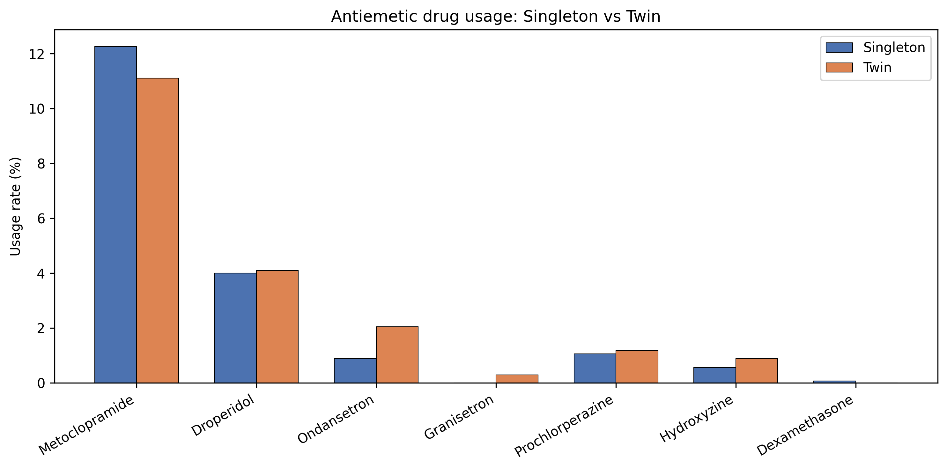
Figure 6. Antiemetic drug usage comparison: Singleton vs Twin.

Sensitivity Analyses
IONV rates according to alternative definitions are shown in Figure 7 and Table 6. With the primary definition (A), IONV rates were comparable between singletons (17.7%) and twins (17.0%). Most alternative definitions yielded similar non-significant differences. However, when IONV was defined by 5-HT3 antagonist use only (Definition E), twins had a significantly higher rate (2.3% vs 0.9%, P = 0.020).

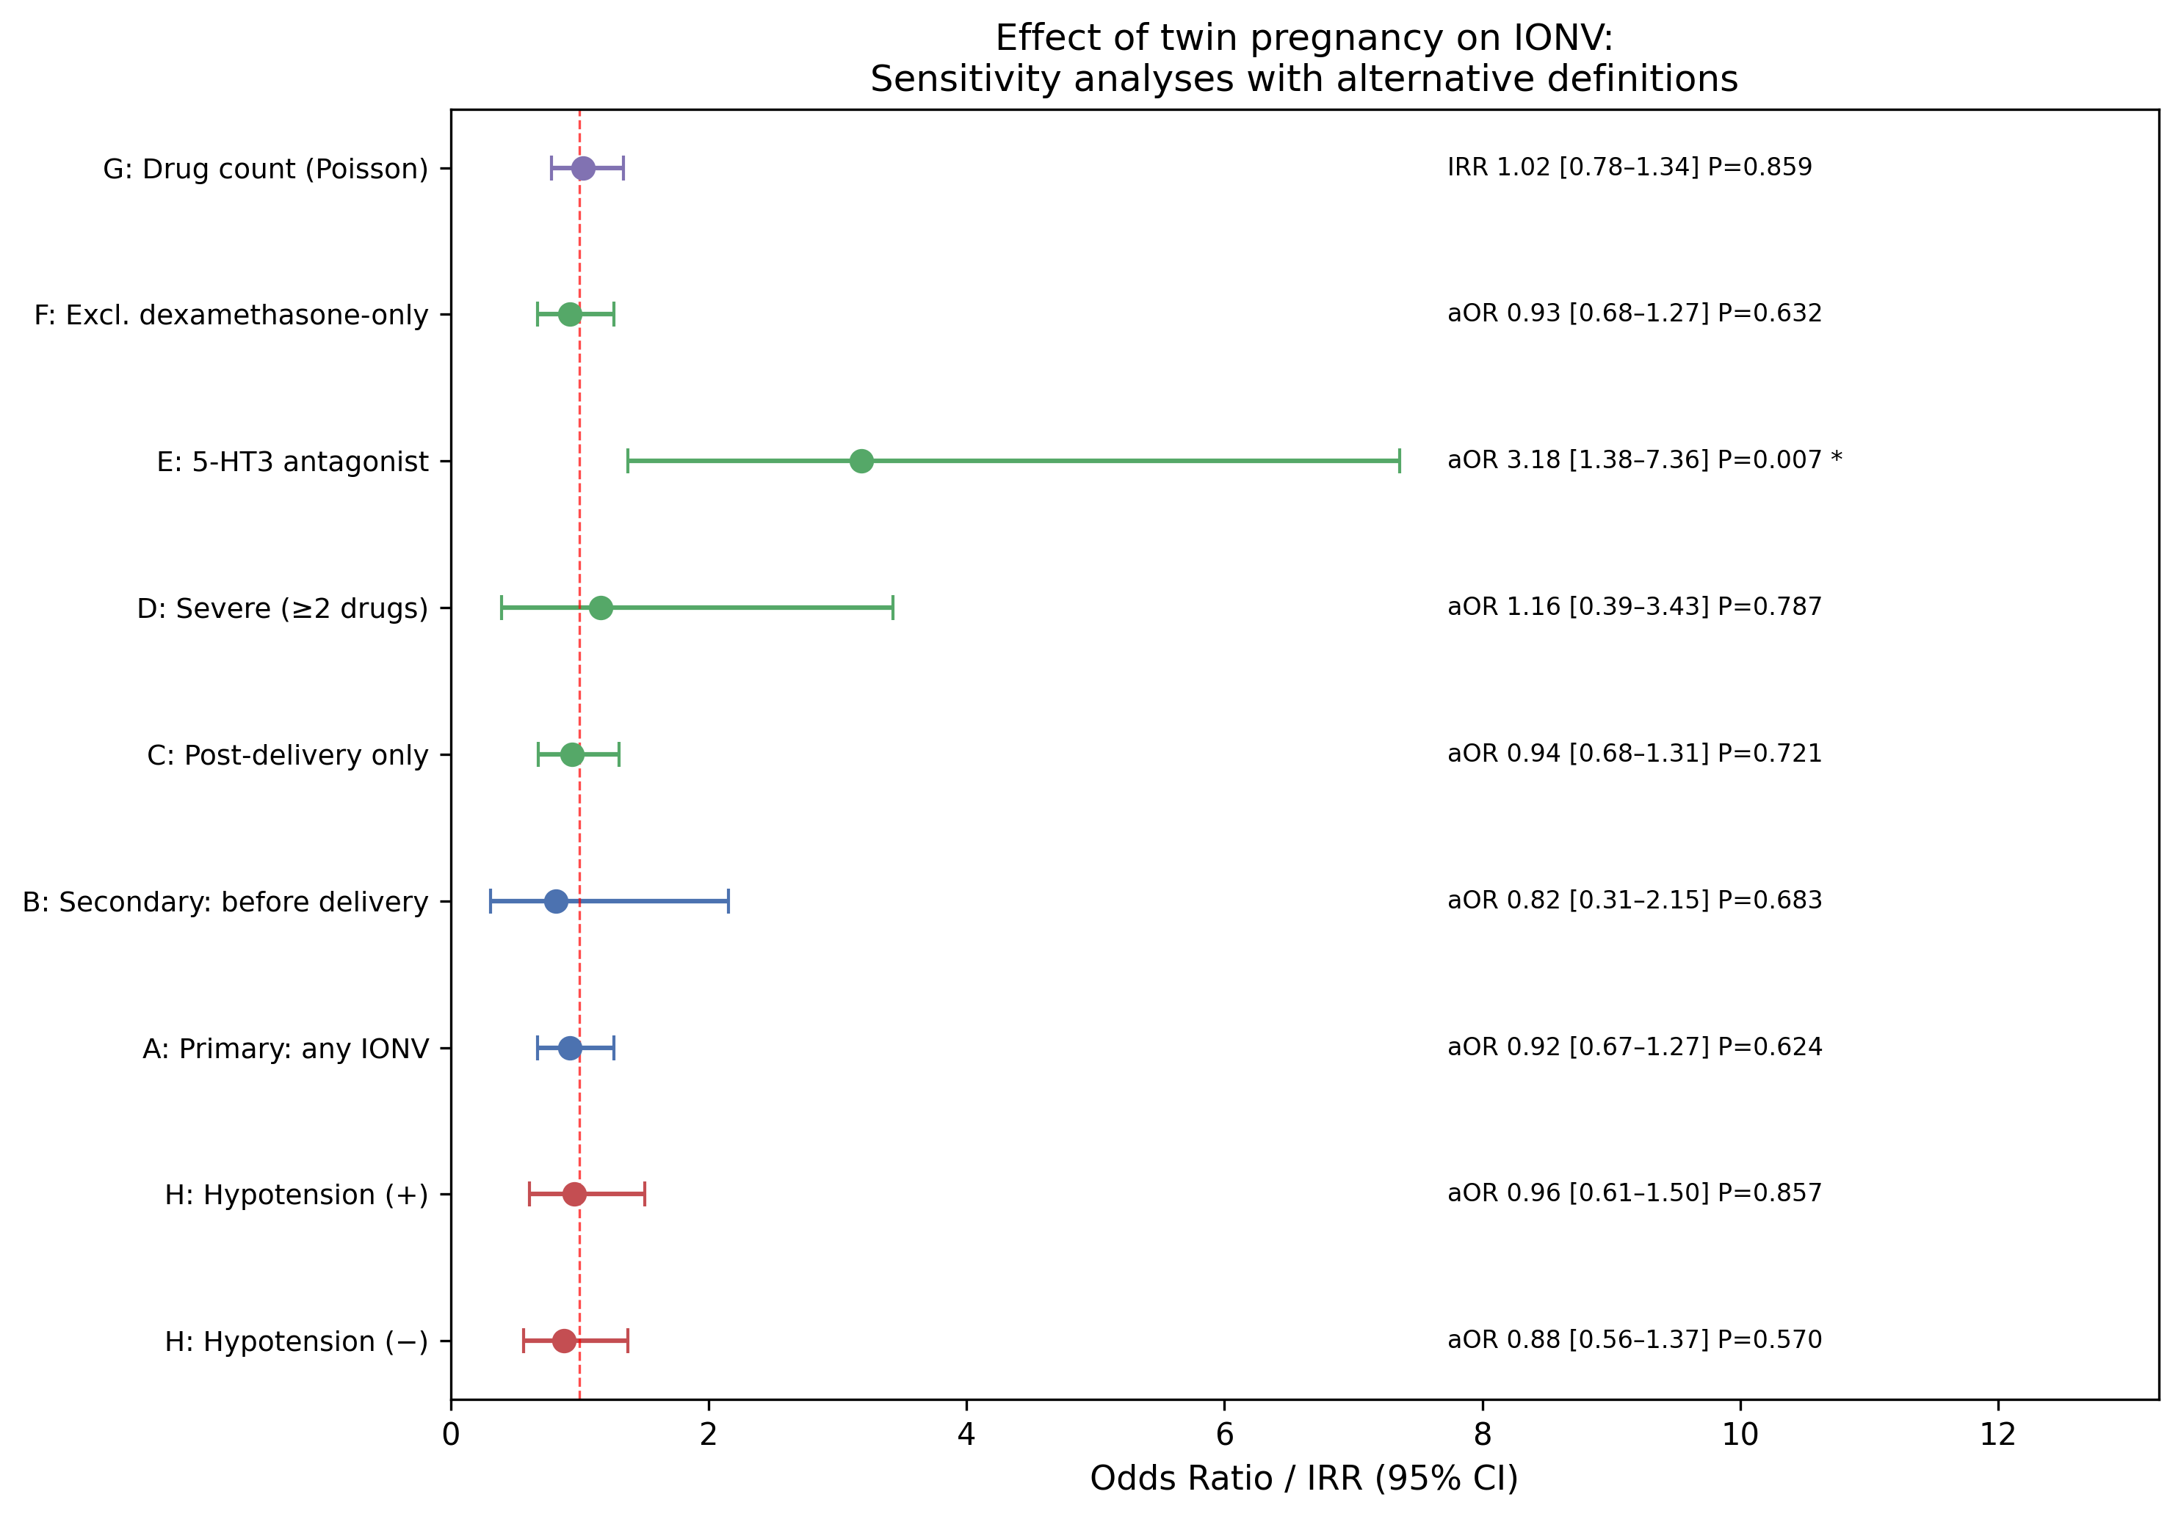
Figure 7. Forest plot: Effect of twin pregnancy on IONV across alternative definitions. Definitions A–F: adjusted odds ratios from multivariable logistic regression. Definition G: incidence rate ratio from Poisson regression. Definition H: stratified by hypotension status.
Definition | Label | n | Events | Twin aOR/IRR [95% CI] | P-value
A | Primary: any IONV | 3153 | 556 | 0.92 [0.67–1.27] | 0.624
B | Secondary: before delivery | 3153 | 58 | 0.82 [0.31–2.15] | 0.683
C | Post-delivery only | 3153 | 498 | 0.94 [0.68–1.31] | 0.721
D | Severe (≥2 drugs) | 3153 | 35 | 1.16 [0.39–3.43] | 0.787
E | 5-HT3 antagonist | 3153 | 33 | 3.18 [1.38–7.36] | 0.007
F | Excl. dexamethasone-only | 3153 | 555 | 0.93 [0.68–1.27] | 0.632
G | Drug count (Poisson) | 3153 | 597 | 1.02 [0.78–1.34] | 0.859
Table 6. Sensitivity analyses: twin pregnancy and IONV across alternative definitions.

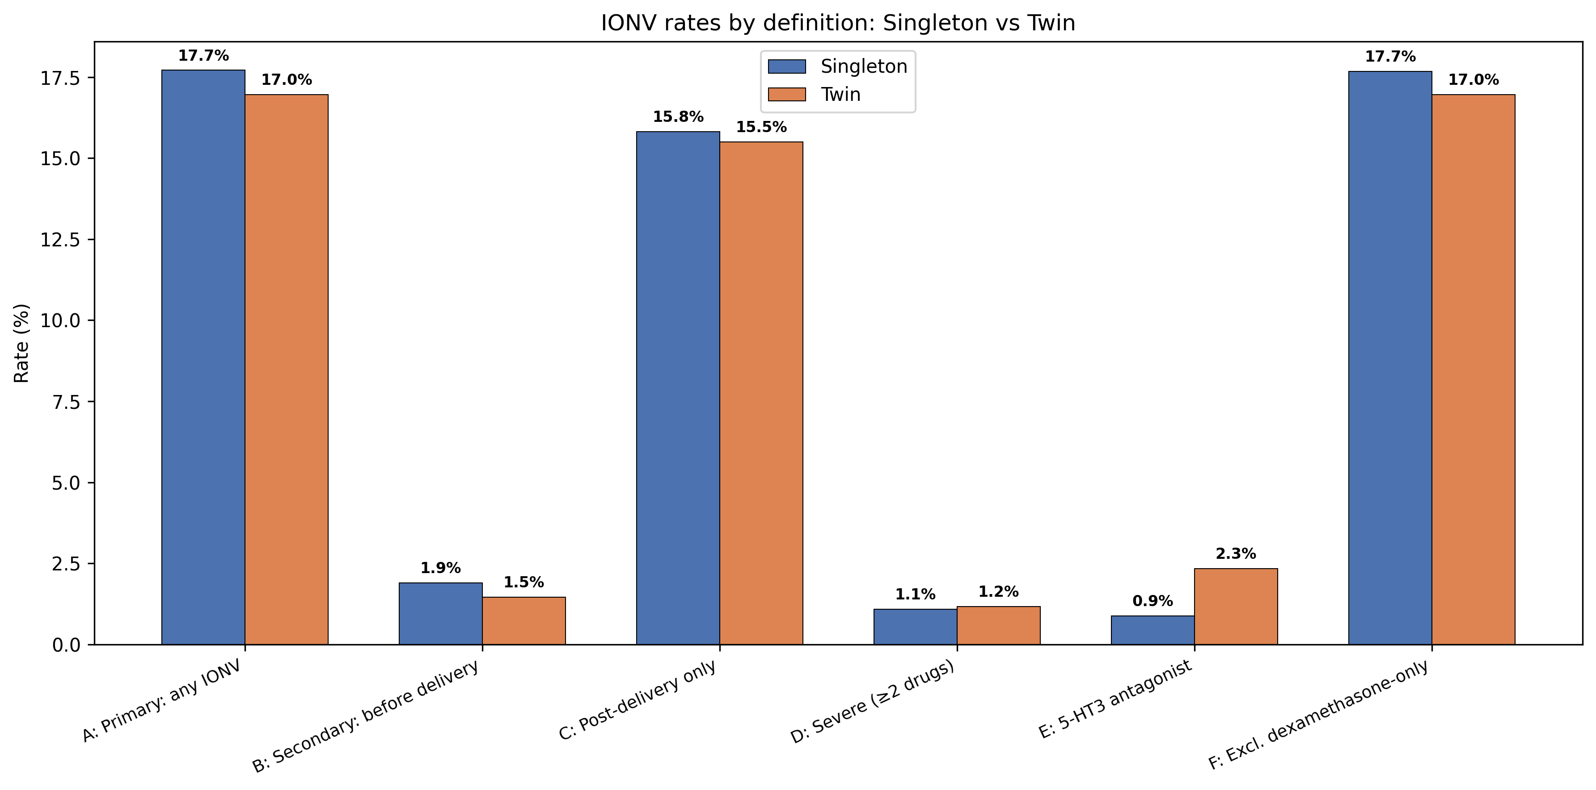
Figure 8. IONV rates by definition: Singleton vs Twin.
In multivariable logistic regression, twin pregnancy was not significantly associated with IONV under most alternative definitions (Table 6, Fig. 7).
A notable exception was Definition E (5-HT3 antagonist use), where twin pregnancy was associated with significantly higher 5-HT3 antagonist use (adjusted OR 3.18, 95% CI 1.38–7.36; P = 0.007; reduced model with 6 covariates due to sparse events, 33 events). This suggests that while overall antiemetic use is similar, twins may have a different pattern of antiemetic prescribing, with more frequent use of serotonin receptor antagonists.
In Poisson regression (Definition G), the antiemetic drug count did not differ significantly between groups (twin IRR 1.02, 95% CI 0.78–1.34; P = 0.859).

Hypotension-Stratified Analysis (Definition H)
In the hypotension-present subgroup (n = 1638), IONV rates were 18.8% (singleton) vs 18.5% (twin), with twin aOR 0.96 (95% CI 0.61–1.50; P = 0.857). In the hypotension-absent subgroup (n = 1515), rates were 16.5% vs 15.7%, with twin aOR 0.88 (95% CI 0.56–1.37; P = 0.570). Neither stratum showed a significant association between twin pregnancy and IONV, indicating that the null finding was consistent regardless of hypotension status (Fig. 9).

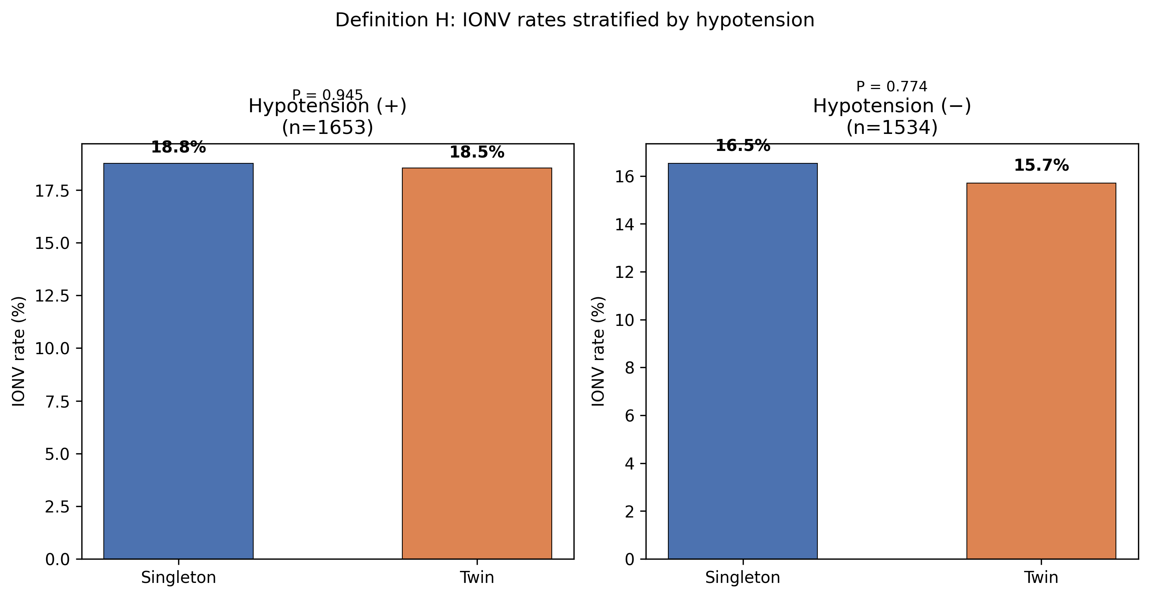
Figure 9. IONV rates stratified by intraoperative hypotension.

