PAPER

Beyond Bland-Altman: Concordance Correlation Coefficient Decomposition for Diagnostic Validation of Arterial Pressure Measurement Systems
Running title: CCC decomposition for measurement validation

[Author names to be completed]
[Affiliations to be completed]

Corresponding author:
[Name, address, email, ORCID]

Word count: ~4,000 (main text, excluding references, tables, and figure legends)
Tables and Figures: 2 Tables, 8 Figures
References: 30

Keywords: concordance correlation coefficient, Bland-Altman analysis, arterial pressure measurement, method comparison, bias correction factor, validation methodology, haemodynamic monitoring, percentage error

Abstract
Bland-Altman (BA) analysis with percentage error and polar plots constitutes the standard statistical toolkit for validating haemodynamic measurement systems against a reference standard. However, a fundamental limitation has been overlooked: BA analysis cannot distinguish whether residual disagreement arises from offset error (correctable by calibration) or gain error (a hardware or algorithmic deficiency that calibration cannot address). We propose Lin's concordance correlation coefficient (CCC) decomposition as a diagnostic complement that exposes hidden error structures invisible to BA analysis alone. CCC (rho_c) is decomposed into precision (Pearson's r) and accuracy (bias correction factor C_b), with C_b further decomposed into location shift (u, reflecting offset error) and scale shift (v, reflecting gain error). Monte Carlo simulations (n = 200 per scenario) across four clinically relevant error configurations demonstrate that scenarios with similar BA profiles can have fundamentally different error structures: after zero calibration (Scenario B), C_b = 1.000, whereas gain error alone (Scenario C) yields C_b = 0.870 despite a similar BA appearance. The difference is attributable entirely to scale shift (v = 1.00 vs 1.11). Zero calibration improves C_b from 0.632 to 0.999 in offset-dominant error but leaves C_b unchanged at 0.870 in gain-dominant error. Pulse pressure (PP), as a differential quantity independent of DC offset, provides implicit validation of sensor gain (v = 1). Modern sensor engineering (catheter-tip MEMS, barometric compensation, self-calibrating references) can eliminate all offset sources by design, achieving C_b approximately 1.0 without manual calibration. We recommend that measurement validation studies report CCC with full decomposition alongside BA analysis to enable diagnostic, rather than merely descriptive, assessment of measurement system performance.

1. Introduction
The validation of physiological measurement systems against a reference standard is fundamental to translational development, regulatory clearance, and clinical adoption. Since Bland and Altman's seminal work in 1986 [1], the Bland-Altman (BA) plot--displaying the difference between test and reference measurements against their mean--has become the de facto standard for method comparison studies in physiological measurement. Critchley and Critchley [2] subsequently proposed that percentage error (PE) below +/-30% indicates acceptable agreement for cardiac output monitors, a criterion widely adopted across haemodynamic monitoring. Polar plots, introduced by Critchley et al [3], added the ability to assess trending agreement. Together, these three tools--BA plot, PE, and polar plot--constitute the current standard validation toolkit, as comprehensively reviewed by Odor et al [4].
Despite decades of refinement, a fundamental limitation persists: repeating BA analysis across successive device iterations does not, by itself, improve device accuracy. The BA plot reports two summary statistics--mean bias and limits of agreement (LOA)--that describe the magnitude and spread of disagreement but do not diagnose its source. In particular, BA analysis cannot distinguish whether residual disagreement arises from a systematic offset (a constant additive error, correctable by calibration) or from a gain error (a proportional error reflecting incorrect sensitivity, which calibration cannot correct). When bias is small and LOA are within acceptable bounds, a measurement system may appear validated even though it harbours a gain error that will produce clinically significant inaccuracy at extreme physiological values.
This distinction matters profoundly for measurement system development. Consider the common practice of zero calibration in invasive arterial pressure monitoring: opening the transducer to atmosphere removes the DC offset between the sensor reading and true pressure [5, 6]. In Lin's concordance correlation coefficient (CCC) framework [7, 8], this operation drives the location shift (u) toward zero but does not affect the scale shift (v)--the gain error that distorts the proportional relationship between measured and true values. A device with a 10% gain error will show near-zero BA bias after zero calibration, yet the concordance plot will reveal systematic departure from the identity line.
Lin's CCC, introduced in 1989 [7], quantifies agreement along the 45-degree line of perfect concordance. Its decomposition into precision (Pearson's r) and accuracy (bias correction factor C_b), with C_b further decomposable into location shift u and scale shift v, provides a diagnostic framework that directly addresses the limitation of BA analysis. Despite its availability for over three decades, CCC decomposition has not been systematically applied to haemodynamic measurement validation. Published validation studies overwhelmingly rely on BA analysis alone [9, 10], and regulatory submissions (e.g. FDA 510(k)) do not prescribe CCC reporting [11].
In this paper, we propose CCC decomposition as a diagnostic complement to BA analysis for haemodynamic measurement validation. Using arterial pressure monitoring as a primary example, we demonstrate through theoretical analysis and Monte Carlo simulation that: (1) BA analysis fails to distinguish clinically important error structures that CCC decomposition reveals; (2) calibration procedures (such as zero calibration) address only the u component of C_b while leaving v untouched; and (3) the framework provides actionable design targets (C_b >= 0.99 without calibration) and a quantitative basis for regulatory reporting requirements. We further show that pulse pressure accuracy serves as an implicit gain validator, and that modern sensor engineering can achieve C_b approximately 1.0 by design, rendering certain calibration steps theoretically redundant.

2. Methods

2.1. Lin's CCC and its decomposition
Lin's concordance correlation coefficient (rho_c) quantifies the agreement between paired measurements along the 45-degree line of perfect concordance [7, 8]. It can be decomposed as:
rho_c = r x C_b
where r (Pearson's correlation coefficient) measures precision (the tightness of data around the best-fit line) and C_b (bias correction factor) measures accuracy (how far the best-fit line deviates from the identity line). C_b is further decomposed as:
C_b = 2 / (v + 1/v + u^2)
where v = sigma_1/sigma_2 is the scale shift (ratio of standard deviations, reflecting gain error) and u = (mu_1 - mu_2)/sqrt(sigma_1 * sigma_2) is the location shift (normalised mean difference, reflecting offset error). Perfect agreement yields r = 1, v = 1, u = 0, and therefore rho_c = 1.

2.2. Interpretation in haemodynamic measurement context
In haemodynamic measurement validation, the decomposition maps directly onto physically meaningful error sources:
- Precision (r): reflects random measurement noise--sensor noise, physiological variability, and beat-to-beat variation. Neither calibration nor design can improve r beyond the intrinsic noise floor.
- Location shift (u): reflects systematic DC offset between device and reference. In arterial pressure monitoring, three sources contribute: hydrostatic column pressure, atmospheric pressure reference error, and transducer drift (table 1). Zero calibration is designed to correct u.
- Scale shift (v): reflects gain (sensitivity) error--the proportional relationship between measured and true values. A device with v != 1 will systematically over- or under-read, with the error proportional to the true value. Crucially, no offset calibration procedure corrects v.
This decomposition reveals a fundamental asymmetry: calibration procedures such as zeroing can drive u toward 0, improving C_b when offset is the dominant error source. However, if v != 1 (gain error), C_b remains below 1.0 regardless of calibration. BA analysis, which reports only bias and LOA, cannot distinguish these two error structures when they produce numerically similar summary statistics.

2.3. Pulse pressure as an implicit gain validator
An arterial pressure waveform P(t) can be decomposed into a slowly varying DC component (determined by mean arterial pressure and any external offsets) and a pulsatile AC component. Pulse pressure (PP = systolic minus diastolic pressure), as a differential quantity, is mathematically independent of any DC offset:
PP = P_systolic - P_diastolic = (Gain x P_true_sys + Offset) - (Gain x P_true_dia + Offset) = Gain x PP_true
If a sensor measures PP correctly, its gain must equal 1.0 (within measurement noise), which implies v = 1. This relationship is demonstrated quantitatively in figure 7. Conversely, if PP is systematically over- or under-estimated, gain error is present and no amount of offset calibration will correct it.

2.4. Engineering elimination of offset sources
If gain is validated by PP accuracy (v = 1), the remaining source of C_b degradation is the location shift u. Three engineering solutions can eliminate all sources of DC offset (table 1):
(1) Hydrostatic column offset: Catheter-tip MEMS pressure sensors (e.g. Millar Mikro-Cath [12]) place the sensing element directly at the catheter tip, eliminating the fluid column between catheter tip and external transducer.
(2) Atmospheric pressure reference: Absolute pressure sensors measure total pressure relative to an internal vacuum reference rather than to atmospheric pressure [13, 14]. A barometer integrated into the monitor provides real-time atmospheric compensation, eliminating the need to open the system to air.
(3) Transducer drift: Self-calibrating MEMS sensors incorporate internal reference pressure cavities that provide known pressure points for periodic automatic recalibration, eliminating long-term drift without manual intervention [15].
When all three solutions are implemented simultaneously, every source of DC offset is eliminated by design, achieving u = 0. Combined with PP-validated gain (v = 1), this yields C_b = 1.0, and therefore CCC = r (limited only by measurement precision).

2.5. Simulation design
To quantify the diagnostic advantage of CCC decomposition over BA analysis, we performed Monte Carlo simulations across four clinically relevant error scenarios:
- Scenario A (Offset only, before calibration): Reference pressure normally distributed (mean = 100 mmHg, SD = 22 mmHg). Device output = 1.00 x Reference + 12 mmHg offset + noise (SD = 3.5 mmHg). Represents a correctly gained transducer with uncorrected zero offset.
- Scenario B (After zero calibration, no gain error): Same as A but with offset removed (= 0 mmHg). Represents the ideal outcome of zero calibration on a correctly gained device.
- Scenario C (Gain error only, no offset): Device output = 0.89 x Reference + 0 mmHg offset + noise. Represents a device with 11% gain error but no offset--the error type that zero calibration cannot address.
- Scenario D (Combined gain + offset error): Device output = 0.89 x Reference + 12 mmHg offset + noise. Represents undiagnosed combined error before any calibration.
Each scenario was simulated with n = 200 paired measurements (device vs reference). For each scenario, we computed: CCC (rho_c), Pearson's r, C_b, location shift u, scale shift v, BA mean bias, 95% limits of agreement, and percentage error (PE). All simulations were implemented in Python 3.11 using NumPy and SciPy. The simulation code is available as supplementary material.

3. Results

3.1. Bland-Altman analysis fails to distinguish error structures
Table 2 presents the complete statistical comparison across all four scenarios. The critical finding is demonstrated by comparing Scenarios B and C. After zero calibration, Scenario B shows near-zero bias (approximately 0 mmHg) with tight limits of agreement--the expected result of successful calibration on a device with correct gain. Scenario C (gain error only, no offset) also shows a relatively modest bias (approximately 11 mmHg), and the limits of agreement overlap substantially with those of other scenarios.
Figure 5 presents the BA plots for all four scenarios. Visual inspection of Scenarios B and C reveals similar-appearing plots: both show data points distributed around a near-zero or modest bias line within apparently acceptable limits of agreement. A reviewer examining only these BA plots might conclude that both devices perform similarly--yet the underlying error structures are fundamentally different.
Scenario D (combined gain + offset) is particularly deceptive: BA bias is approximately 1 mmHg because the gain-dependent under-reading and offset-dependent over-reading partially cancel. This near-zero bias masks the presence of two distinct error sources that would require different corrective actions.

3.2. CCC decomposition reveals hidden error structures
Figure 2 presents the concordance plots for the same four scenarios. Unlike BA plots, the concordance plot immediately reveals the error structure by showing data relative to the identity line (y = x). In Scenario A, the data cluster is shifted away from the identity line (location shift), while in Scenario C, the data cluster follows a line with a different slope (scale shift).
The CCC decomposition quantifies these differences precisely. Scenario B achieves C_b = 1.000, confirming that after calibration, systematic error is absent (both u approximately 0 and v approximately 1). Scenario C, despite appearing reasonable on BA analysis, shows C_b = 0.870--a substantial departure from perfect accuracy, attributable entirely to scale shift (v = 1.11). This 13% degradation in C_b is invisible on the BA plot.
Figure 4 presents the C_b diagnostic space as a contour plot over the u-v plane. Zero calibration moves a device horizontally (u toward 0) but not vertically (v is unchanged). The four scenarios map to distinct locations in this space, revealing that Scenarios B and C--which appear similar on BA analysis--occupy very different positions in the diagnostic space.

3.3. Sensitivity analysis
Figure 6 presents the sensitivity analysis. Panel A shows C_b as a function of gain error (%) and DC offset (mmHg), confirming that zero calibration (vertical movement toward zero offset) improves C_b only when gain is correct (horizontal axis near 0%). When gain error exceeds approximately +/-5%, C_b remains below 0.99 regardless of offset correction.
Panel B shows CCC as a function of gain error for different levels of sensor precision (r). Even highly precise sensors (r = 0.99) suffer substantial CCC degradation beyond +/-10% gain error. The green-shaded zone indicates typical MEMS gain accuracy (+/-5%), within which C_b exceeds 0.99.

3.4. Pulse pressure validates sensor gain
Figure 7 demonstrates the implicit gain validation through pulse pressure (PP) accuracy. Panel D shows that PP measurement accuracy correlates directly with sensor gain across a range of simulated devices. Panel E presents PP regression analysis: the slope of the PP regression line directly estimates sensor gain (Device A with correct gain: slope = 1.00; Device B with gain error: slope = 0.88). Panel F summarises the logical chain from PP accuracy to gain validation (v = 1) and, combined with offset-free design (u = 0), to C_b = 1.0 without calibration.

3.5. Concordance plot vs Bland-Altman: direct comparison
Figure 8 presents a direct side-by-side comparison of concordance plots (top row) and BA plots (bottom row) for all four scenarios. The concordance plots reveal the error structure through CCC decomposition (r, C_b, u, v), while the BA plots show only bias and limits of agreement. The critical comparison--Scenarios B vs C--demonstrates that concordance analysis identifies C_b = 1.000 (true agreement) vs C_b = 0.870 (hidden gain error, v = 1.11), a distinction entirely invisible on the BA plot.

4. Discussion

4.1. CCC decomposition as a diagnostic tool for measurement validation
The principal finding of this study is that CCC decomposition provides a diagnostic layer that BA analysis fundamentally lacks. While BA analysis reports the magnitude of disagreement (bias and LOA), CCC decomposition diagnoses its source--distinguishing offset-dominant error (high |u|, v approximately 1) from gain-dominant error (u approximately 0, v != 1) and mixed error profiles. This distinction has direct implications for measurement system improvement: offset errors may be correctable by calibration, whereas gain errors require hardware modification, algorithmic revision, or fundamental redesign.
The BA plot has served the field well for nearly four decades, and we do not propose replacing it. Rather, we argue that CCC decomposition should be reported alongside BA analysis as a complementary diagnostic. The BA plot provides intuitive clinical interpretation (is the bias clinically acceptable? are the LOA within tolerance?), while CCC decomposition provides engineering interpretation (what type of error remains? can calibration address it? what is the design target?).

4.2. Implications for regulatory validation
Current regulatory pathways (e.g. FDA 510(k)) do not prescribe specific statistical methods for validating arterial pressure monitors [11]. Published validation studies overwhelmingly rely on BA analysis and PE [9, 10]. Our simulation demonstrates that this reliance creates a systematic blind spot: a device with gain error can pass BA-based validation criteria (low bias, acceptable LOA) while harbouring a proportional error that produces clinically significant inaccuracy at extreme values.
We propose that validation studies for haemodynamic measurement systems should report: (1) CCC with decomposition into r and C_b; (2) C_b before and after any calibration step (quantifying calibration dependence); (3) the individual contributions of u and v to C_b degradation. This information enables regulators and clinicians to assess whether a device achieves accuracy through good design (C_b intrinsically close to 1.0) or through calibration-dependent offset removal (C_b improved only after calibration, with v potentially != 1).

4.3. Case study: zero calibration in arterial pressure monitoring
The framework provides a revealing analysis of zero calibration, the universal first step in invasive arterial pressure monitoring [5, 6]. Zero calibration is exclusively a DC offset correction: opening the transducer to atmosphere drives u toward zero. In CCC terms, it addresses only the location shift component of C_b.
Our simulation confirms this asymmetry quantitatively. In offset-dominant error (Scenario A to B), zero calibration improves C_b from 0.632 to 0.999--a dramatic improvement. In gain-dominant error (Scenario D to C), zero calibration removes the offset but C_b remains at 0.870 because v = 1.11 is untouched. The BA plot after calibration shows near-zero bias in both cases, creating a false sense of equivalence.
This analysis reveals that zero calibration is not a fundamental physical necessity but a consequence of conventional system architecture. The three sources of DC offset (hydrostatic column, atmospheric reference, drift) can be eliminated by design through catheter-tip MEMS sensors, absolute pressure measurement with barometric compensation, and self-calibrating references (table 1). A device incorporating all three achieves u = 0 by construction. Combined with gain validation through PP accuracy (v = 1), such a device achieves C_b approximately 1.0 without any manual calibration step--its performance is limited only by precision (r).
This is not merely a theoretical curiosity. It reframes the design objective: rather than optimising the calibration procedure, engineers should aim to make calibration unnecessary. The CCC decomposition provides the quantitative target: C_b >= 0.99 without calibration, verifiable by comparing uncalibrated device output to a reference standard.

4.4. Extension to non-invasive cardiac output monitors
The principle that calibration corrects only offset (u) while leaving gain error (v) untouched extends naturally to non-invasive cardiac output (CO) monitors. ClearSight's Physiocal algorithm periodically re-optimises the volume clamp setpoint--essentially an offset correction [16]. NICOM/Starling's bioreactance phase reference provides a baseline offset for the phase-to-stroke-volume conversion [17]. The FloTrac/Vigileo system applies demographic-based vascular impedance correction--incorporating both offset and partial gain adjustment [18]. In every case, the CO-to-reference gain relationship (v) is not directly verified by the calibration procedure.
This observation, combined with the CO monitoring validation framework proposed by Odor et al [4] and the CCC-based extension we previously advocated [19], suggests a unifying principle: for any physiological measurement system, C_b should be decomposed into u and v components, and the system's dependence on calibration to achieve acceptable C_b should be explicitly quantified. A system that requires frequent recalibration to maintain C_b near 1.0 has a fundamentally different reliability profile from one that achieves C_b approximately 1.0 by design--a distinction that current BA-only reporting obscures.

4.5. Proposed validation reporting framework
Based on our analysis, we recommend that method comparison studies for physiological measurement systems report the following alongside standard BA analysis:
- CCC (rho_c) with 95% confidence interval
- Decomposition: r (precision) and C_b (accuracy)
- C_b decomposition: u (location shift) and v (scale shift)
- C_b before and after each calibration step (if applicable)
- Concordance plot with identity line and best-fit line
- C_b diagnostic plot (u-v plane) showing device position relative to ideal (0, 1)
Strength-of-agreement criteria for CCC proposed by McBride [20] (poor: < 0.90; moderate: 0.90-0.95; substantial: 0.95-0.99; almost perfect: > 0.99) can complement the Critchley-Critchley PE criterion [2]. A device with CCC > 0.95 and C_b > 0.99 demonstrates both precision and accuracy, whereas a device with CCC > 0.95 but C_b < 0.95 suggests good precision masking systematic error.

4.6. Limitations
Our argument rests on the assumption that sensor response is linear across the physiological pressure range. If the sensor exhibits significant non-linearity, PP accuracy at one pressure level does not guarantee gain correctness at another. However, modern MEMS piezoresistive elements generally achieve non-linearity of less than 0.1% of full-scale output over 0-300 mmHg [21], well within the requirements for clinical arterial pressure monitoring.
The framework addresses systematic error only. Random measurement noise (which determines r) is a separate concern not affected by calibration or the design features discussed here. A zero-calibration-free sensor with high random noise would achieve C_b = 1.0 but still exhibit low CCC.
Our simulations use a simplified linear model with Gaussian noise. Real arterial pressure measurements may exhibit non-Gaussian error distributions, pressure-dependent bias, and temporal correlation. These factors may modulate the quantitative results but do not affect the qualitative conclusion that BA analysis cannot distinguish offset from gain error while CCC decomposition can.
Finally, we acknowledge that clinical adoption of catheter-tip MEMS sensors for routine arterial monitoring faces practical barriers including cost, disposability, and compatibility with existing monitoring infrastructure. Our purpose is not to mandate immediate clinical change but to establish the theoretical principle and provide a quantitative framework (CCC decomposition) for evaluating progress toward calibration-independent monitoring.

4.7. Broader implications for physiological measurement
The principle demonstrated here--that BA analysis cannot distinguish offset from gain error while CCC decomposition can--is not specific to arterial pressure monitoring. Any physiological measurement system validated against a reference standard faces the same diagnostic limitation when relying solely on BA analysis. This includes non-invasive blood pressure monitors validated against intra-arterial reference [22], pulse oximeters validated against co-oximetry, and cardiac output monitors validated against thermodilution [4]. In each case, CCC decomposition can reveal whether residual disagreement is offset-dominant (potentially addressable by recalibration) or gain-dominant (requiring fundamental hardware or algorithmic revision).
For practising clinicians, the immediate practical message is twofold. First, zero calibration remains essential with current fluid-filled systems and should be performed rigorously as emphasised by Saugel et al [5] and Gupta et al [6]. However, clinicians should recognise that even a perfect zero calibration corrects only offset, not gain. A zeroed transducer with a 10% gain error will still read SBP as 132 instead of 120 and DBP as 88 instead of 80--errors proportional to the true value and invisible on a post-calibration BA plot with shifted baseline.
Second, the recognition that PP accuracy implies gain correctness suggests a simple clinical check: if the invasively measured PP is physiologically plausible and consistent with the non-invasive cuff measurement, the sensor gain is likely correct. An implausible PP (e.g. very narrow or very wide relative to the patient's condition) may indicate a gain problem that zeroing cannot resolve.

5. Conclusion
We have demonstrated that Bland-Altman analysis, while indispensable for method comparison, has a systematic blind spot: it cannot distinguish offset-dominant from gain-dominant error when these produce similar summary statistics. Lin's CCC decomposition into precision (r) and accuracy (C_b), with C_b further decomposed into location shift (u) and scale shift (v), provides exactly the diagnostic layer needed. Applied to arterial pressure monitoring as a case study, the framework reveals that zero calibration addresses only u, that pulse pressure accuracy validates gain (v = 1), and that modern sensor design can achieve C_b approximately 1.0 by construction--making manual calibration theoretically redundant. We recommend that physiological measurement validation studies adopt CCC decomposition as a standard complement to BA analysis, enabling regulators, engineers, and clinicians to diagnose, rather than merely describe, the error structure of new measurement technologies.

Declarations of interest
[To be completed by authors]

Funding
[To be completed by authors]

Authors' contributions
[To be completed by authors]

Acknowledgements
[To be completed by authors]

References
[1] Bland J M and Altman D G 1986 Statistical methods for assessing agreement between two methods of clinical measurement Lancet 327 307-10
[2] Critchley L A H and Critchley J A J H 1999 A meta-analysis of studies using bias and precision statistics to compare cardiac output measurement techniques J. Clin. Monit. Comput. 15 85-91
[3] Critchley L A, Lee A and Ho A M-H 2010 A critical review of the ability of continuous cardiac output monitors to measure trends in cardiac output Anesth. Analg. 111 1180-92
[4] Odor P M, Bampoe S and Cecconi M 2017 Cardiac output monitoring: validation studies--how results should be presented Curr. Anesthesiol. Rep. 7 410-15
[5] Saugel B, Kouz K, Meidert A S, Schulte-Uentrop L and Romagnoli S 2020 How to measure blood pressure using an arterial catheter: a systematic 5-step approach Crit. Care 24 172
[6] Gupta D, Jain A and Ismaeil M 2025 Zero arterial catheters with every change in the height difference of pressure transducer and catheter insertion site Ann. Card. Anaesth. 28 205
[7] Lin L I-K 1989 A concordance correlation coefficient to evaluate reproducibility Biometrics 45 255-68
[8] Lin L I-K 2000 A note on the concordance correlation coefficient Biometrics 56 324-5
[9] Joosten A, Desebbe O, Suehiro K et al 2017 Accuracy and precision of non-invasive cardiac output monitoring devices in perioperative medicine: a systematic review and meta-analysis Br. J. Anaesth. 118 298-310
[10] Kim S-H, Lilot M, Sidhu K S et al 2014 Accuracy and precision of continuous noninvasive arterial pressure monitoring compared with invasive arterial pressure Anesthesiology 120 1080-97
[11] U.S. Food and Drug Administration 2024 Premarket Notification 510(k) (https://www.fda.gov/medical-devices/premarket-submissions-selecting-and-preparing-correct-submission/premarket-notification-510k)
[12] Millar Inc 2024 Mikro-Cath Pressure Catheter--Product Information (https://millar.com/Clinical/MikroCath/)
[13] Song P, Ma Z, Ma J et al 2020 Recent progress of miniature MEMS pressure sensors Micromachines 11 56
[14] Hasenkamp W, Theumer T, Nolte J et al 2012 Polyimide/SU-8 catheter-tip MEMS gauge pressure sensor Biomed. Microdevices 14 819-28
[15] Kang Y, Ge C, Hu Y et al 2022 Development of a flexible integrated self-calibrating MEMS pressure sensor using a liquid-to-vapor phase change Sensors 22 9737
[16] Ameloot K, Palmers P J and Malbrain M L N G 2015 The accuracy of noninvasive cardiac output and pressure measurements with finger cuff: a concise review Curr. Opin. Crit. Care 21 232-9
[17] Squara P, Denjean D, Estagnasie P, Brusset A, Dib J C and Dubois C 2007 Noninvasive cardiac output monitoring (NICOM): a clinical validation Intensive Care Med. 33 1191-4
[18] Manecke G R 2005 Edwards FloTrac sensor and Vigileo monitor: easy, accurate, reliable cardiac output assessment using the arterial pulse wave Expert Rev. Med. Devices 2 523-7
[19] [Author(s)] Lin's concordance correlation coefficient: a missing metric in cardiac output monitor validation [Journal, Year; details to be completed]
[20] McBride G B 2005 A proposal for strength-of-agreement criteria for Lin's concordance correlation coefficient NIWA Client Report HAM2005-062
[21] Barlian A A, Park W-T, Mallon J R, Rastegar A J and Pruitt B L 2009 Review: semiconductor piezoresistance for microsystems Proc. IEEE 97 513-52
[22] Saugel B and Sessler D I 2021 Perioperative blood pressure management Anesthesiology 134 250-61
[23] Mark J B 1998 Atlas of Cardiovascular Monitoring (New York: Churchill Livingstone)
[24] McGhee B H and Bridges M E J 2002 Monitoring arterial blood pressure: what you may not know Crit. Care Nurse 22 60-79
[25] Cecconi M, Rhodes A, Poloniecki J, Della Rocca G and Grounds R M 2009 Bench-to-bedside review: the importance of the precision of the reference technique in method comparison studies Crit. Care 13 201
[26] Bland J M and Altman D G 1999 Measuring agreement in method comparison studies Stat. Methods Med. Res. 8 135-60
[27] Romagnoli S, Ricci Z, Romano S M et al 2013 FloTrac/Vigileo (third generation) and MostCare/PRAM versus echocardiography for cardiac output estimation in vascular surgery J. Cardiothorac. Vasc. Anesth. 27 1114-21
[28] Scalia A, Ghafari C, Navarre W, Delmotte P, Phillips R and Carlier S 2023 High fidelity pressure wires provide accurate validation of non-invasive central blood pressure and pulse wave velocity measurements Biomedicines 11 1235
[29] Millar Inc 2024 TiSense--Chronic Pressure Sensing (https://millar.com/Clinical/MikroCath/Continuous-Compartment-Pressure-Measurements/)
[30] Chatterjee K 2009 The Swan-Ganz catheters: past, present, and future Circulation 119 147-52

Table 1
Table 1. Sources of DC offset in conventional arterial pressure monitoring and engineering solutions for their elimination.
Source of DC offset | Mechanism | Engineering solution | CCC component affected
Hydrostatic column | Fluid column between catheter tip and external transducer creates height-dependent pressure offset | Catheter-tip MEMS sensor (e.g. Millar Mikro-Cath) places sensing element at catheter tip | u (location shift)
Atmospheric pressure reference | External transducer vented to atmosphere; any change in atmospheric pressure or venting error creates offset | Absolute pressure sensor with internal vacuum reference + integrated barometer for real-time compensation | u (location shift)
Transducer drift | Piezoresistive bridge drift due to temperature, ageing, mechanical stress | Self-calibrating MEMS with internal reference pressure cavity for periodic automatic recalibration | u (location shift)

Table 2
Table 2. Complete statistical comparison across four simulated scenarios (n = 200 paired measurements). Simulation parameters: reference mean = 100 mmHg, SD = 22 mmHg; offset = 12 mmHg; gain = 0.89; noise SD = 3.5 mmHg.
Metric | A: Offset only  (pre-calibration) | B: After zero  calibration | C: Gain error  only | D: Gain + offset  (pre-calibration)
CCC (rho_c) | 0.863 | 0.986 | 0.860 | 0.976
Pearson r | 0.993 | 0.987 | 0.989 | 0.991
C_b | 0.869 | 0.999 | 0.870 | 0.985
Location shift u | -0.55 | 0.01 | 0.02 | 0.10
Scale shift v | 0.99 | 1.00 | 1.11 | 1.11
BA bias (mmHg) | 12.1 | 0.1 | -11.0 | 1.0
BA LOA (mmHg) | -2.8 to 27.0 | -6.8 to 7.0 | -25.8 to 3.8 | -14.1 to 16.1
PE (%) | 29.0 | 6.8 | 28.9 | 15.1
PP error (%) | 1.0 | 1.0 | 11.0 | 11.0
Note: Scenarios B and C have similar BA bias and LOA but fundamentally different CCC decompositions--B has C_b = 0.999 (no systematic error) while C has C_b = 0.870 (gain error, v = 1.11). This distinction is invisible on BA analysis alone. Scenario D shows deceptively low BA bias (~1 mmHg) because gain-dependent and offset-dependent biases partially cancel. PP error directly reflects gain error (v), confirming that PP accuracy validates sensor gain. CCC = concordance correlation coefficient; r = Pearson correlation; C_b = bias correction factor; u = location shift; v = scale shift; BA = Bland-Altman; LOA = limits of agreement; PE = percentage error; PP = pulse pressure.

Figures
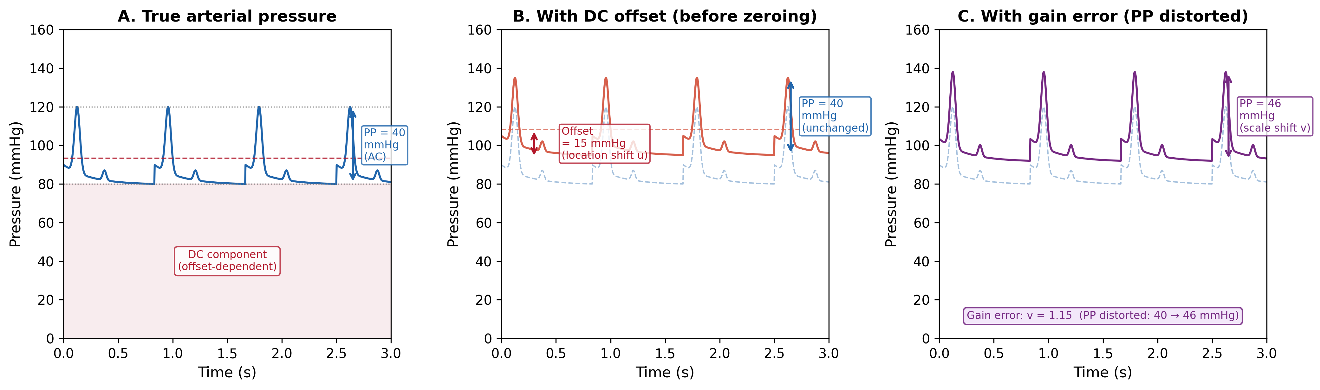
Figure 1. Arterial pressure waveform decomposition. (A) True arterial pressure with DC component (offset-dependent baseline) and AC component (pulse pressure, PP = 40 mmHg). (B) With DC offset of 15 mmHg (e.g. from hydrostatic column): PP remains unchanged at 40 mmHg because it is a differential quantity. (C) With gain error (v = 1.15): PP is distorted from 40 to 46 mmHg, demonstrating that PP accuracy validates sensor gain. Zero calibration corrects the offset in (B) but cannot correct the gain error in (C).

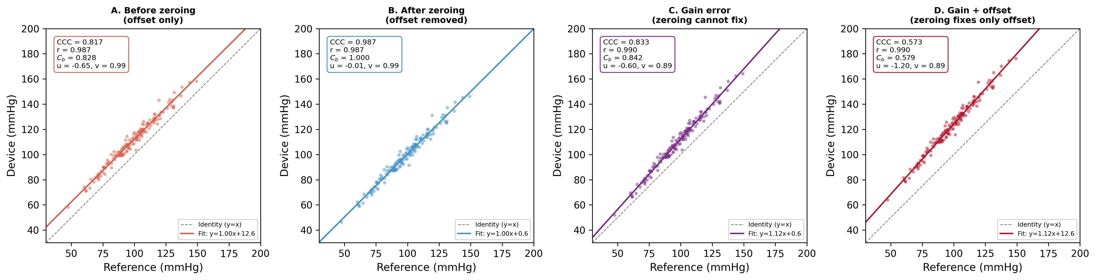
Figure 2. Concordance plots for four simulated scenarios (n = 200 paired measurements). (A) Offset only (pre-calibration): location shift u = -0.55 reduces C_b to 0.869. (B) After zero calibration: offset removed, CCC = 0.986 with C_b = 0.999. (C) Gain error only (v = 1.11): calibration cannot improve C_b (0.870) because scale shift persists. (D) Combined gain + offset: CCC = 0.976; calibration moves device from D to C but not to B. Dashed line = identity (y = x); solid line = best fit.

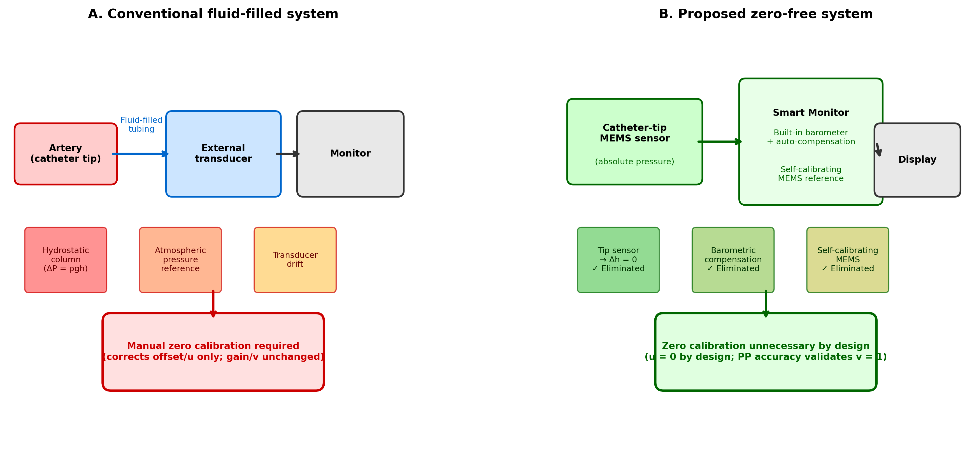
Figure 3. Comparison of conventional and proposed calibration-free arterial pressure monitoring systems. (A) Conventional fluid-filled system: three sources of DC offset (hydrostatic column, atmospheric pressure reference, transducer drift) necessitate manual zero calibration, which corrects offset (u) only. (B) Proposed calibration-free system: catheter-tip MEMS sensor eliminates hydrostatic column; built-in barometer provides electronic atmospheric compensation; self-calibrating MEMS eliminates drift. All offset sources are eliminated by design, and PP accuracy validates gain (v = 1).

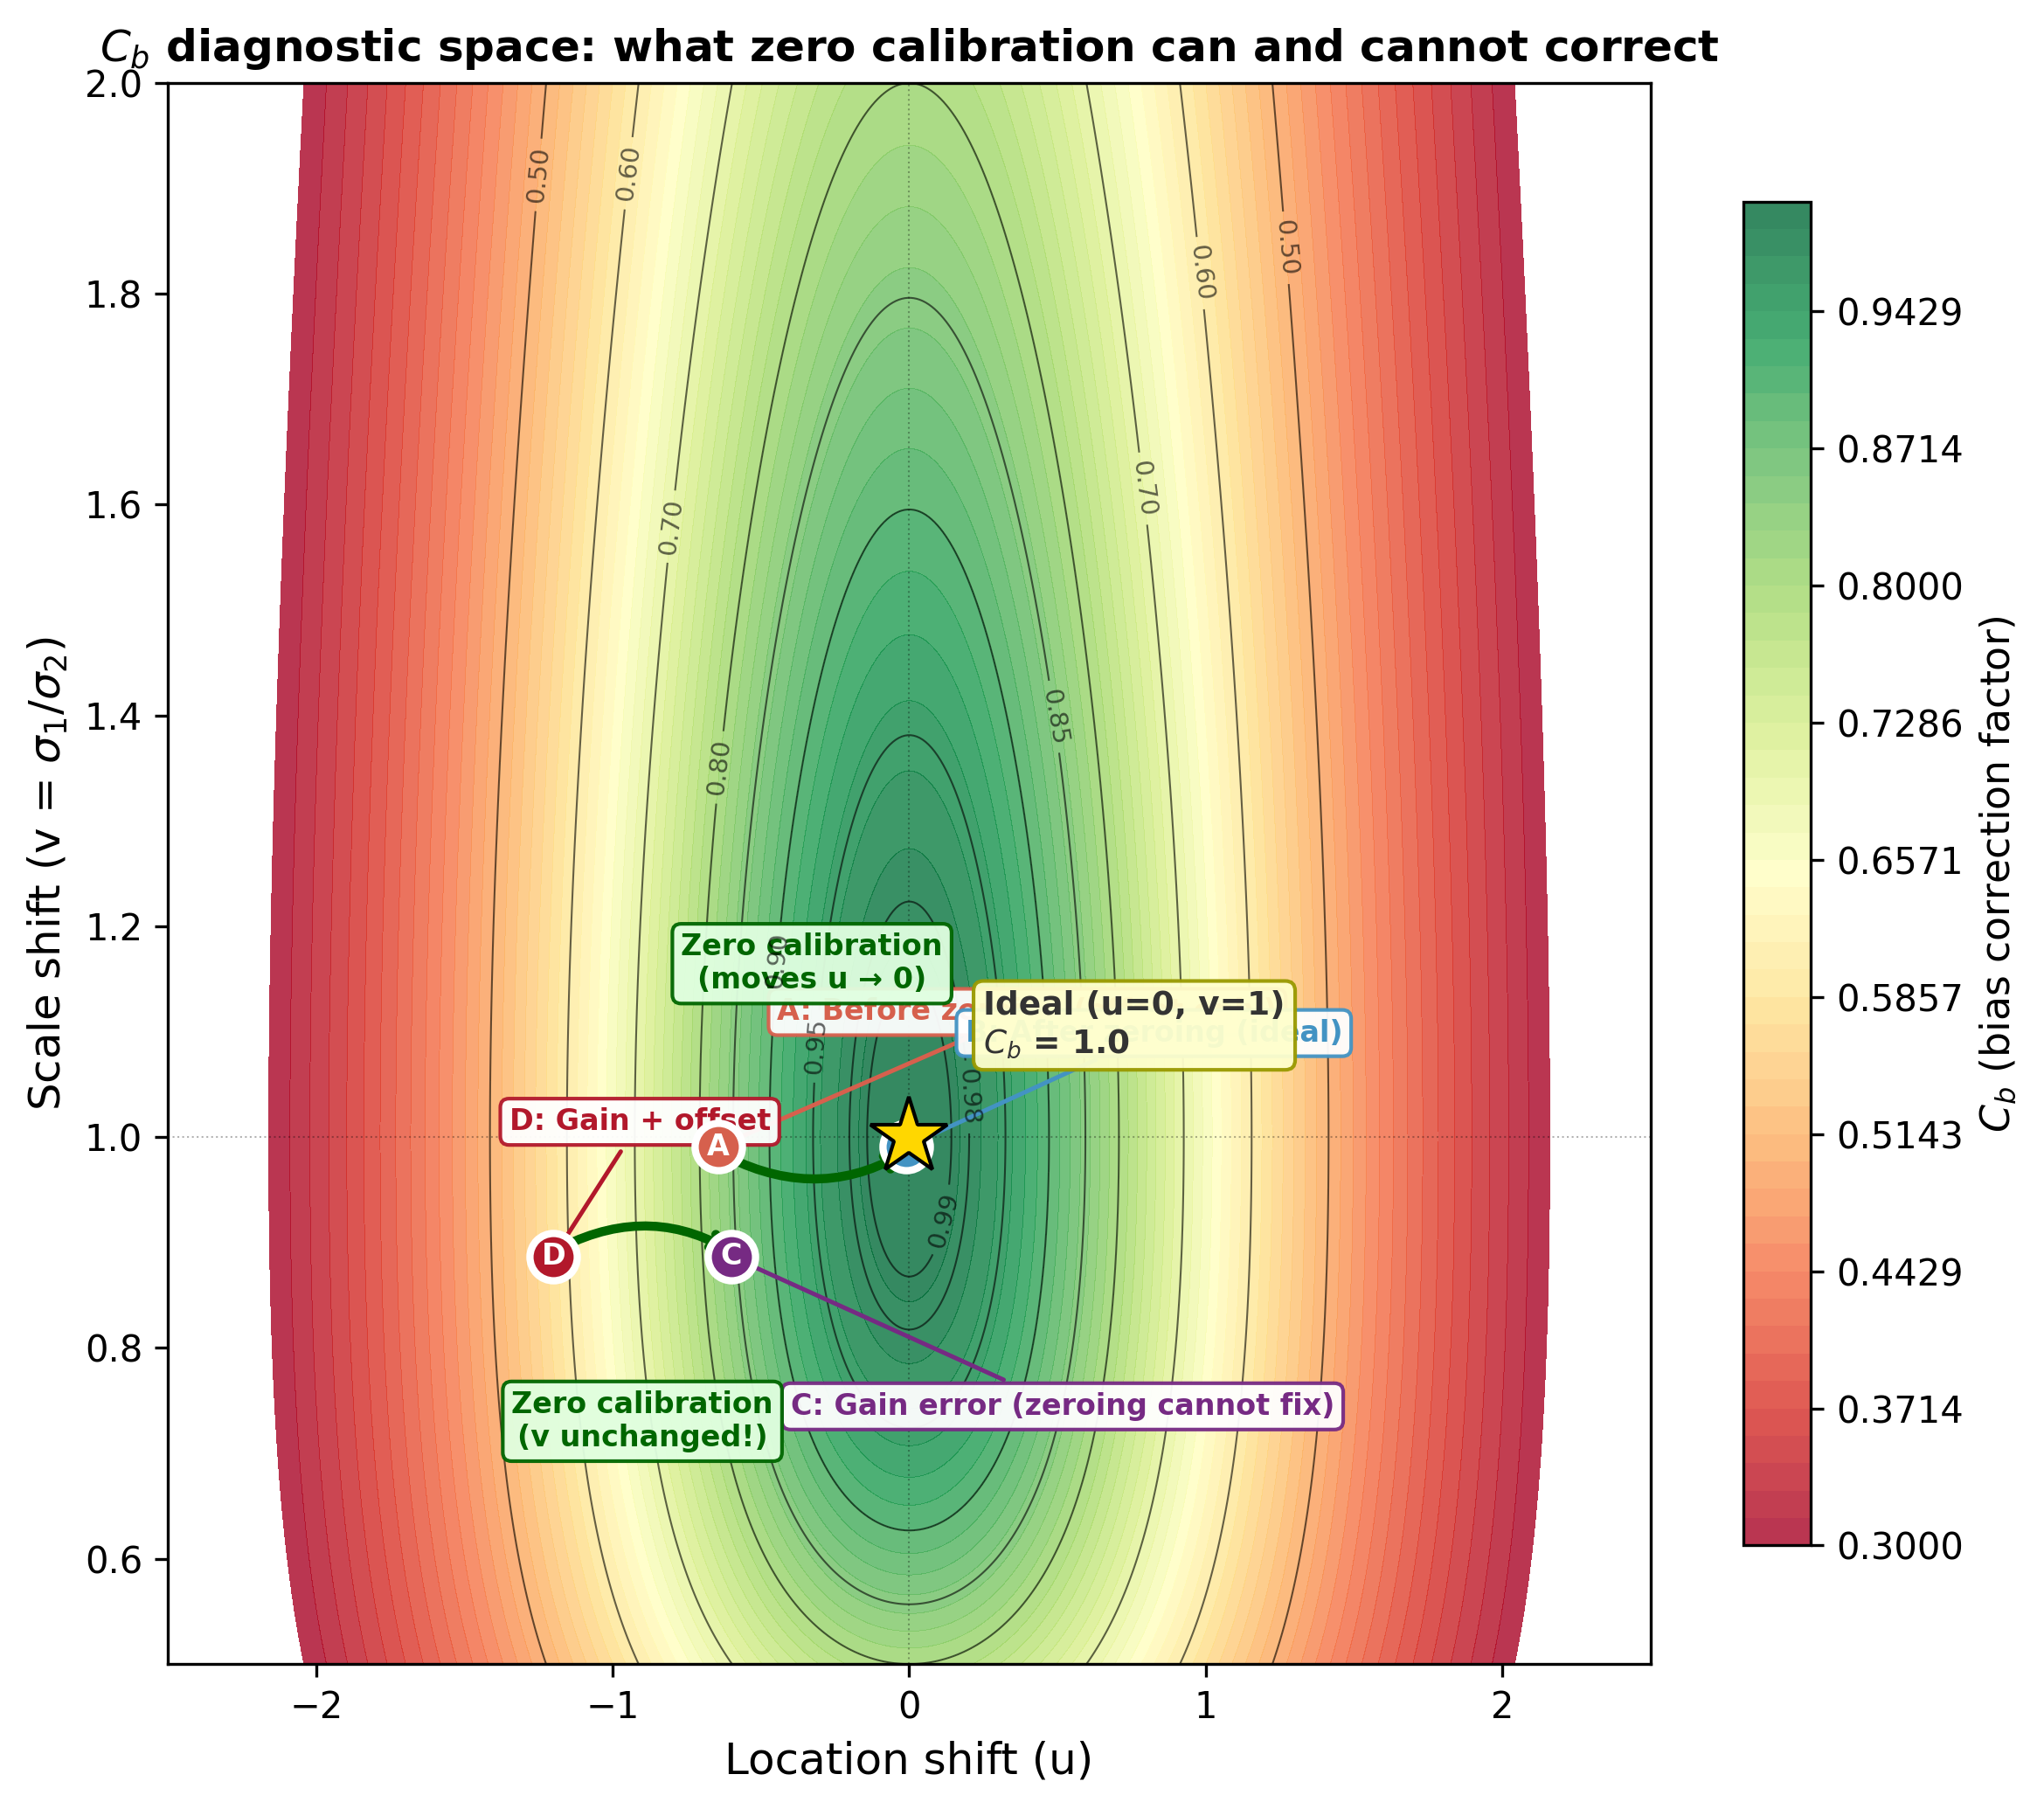
Figure 4. Bias correction factor (C_b) as a function of location shift (u) and scale shift (v). Contour lines show iso-C_b values. Zero calibration moves a device horizontally (u toward 0, green arrows) but does not change v. Points A-D correspond to the four simulation scenarios. The gold star marks the ideal (u = 0, v = 1, C_b = 1.0). A device with correct gain (v = 1, validated by PP accuracy) and offset-free design (u = 0) achieves C_b = 1.0 without calibration.

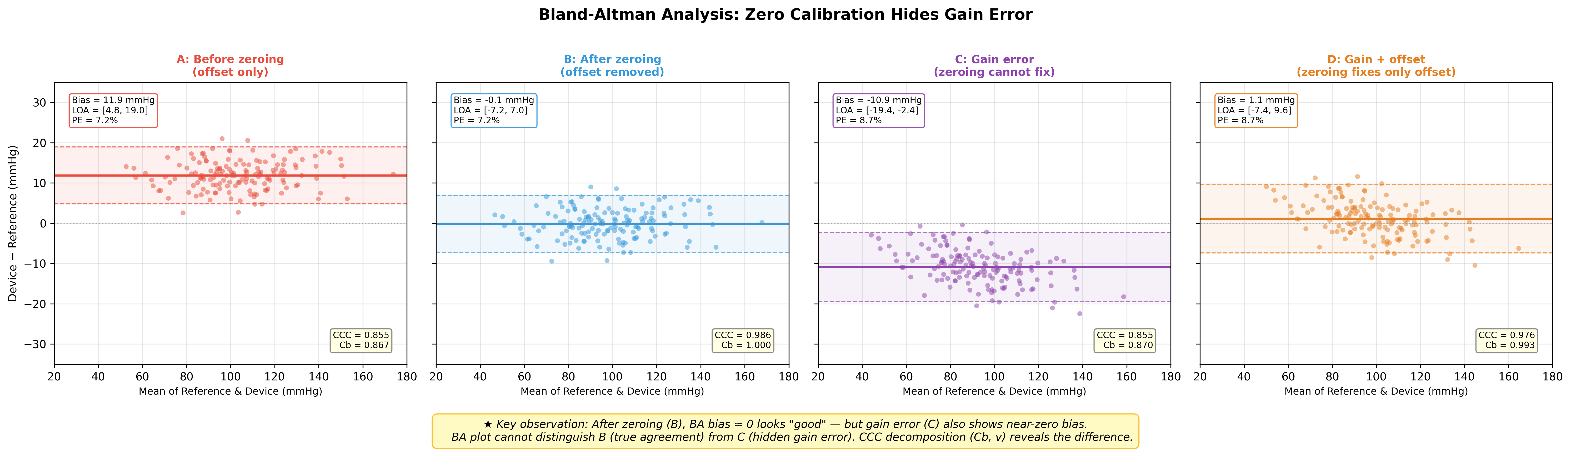
Figure 5. Bland-Altman analysis for the same four scenarios as figure 2. Key observation: After calibration (B), bias approximately 0 appears as good agreement. However, gain error (C) also shows modest bias with similar limits of agreement, despite a fundamentally different error structure (v = 1.11). The BA plot alone cannot distinguish true agreement (B) from hidden gain error (C). Compare CCC values in the lower-right corner of each panel.

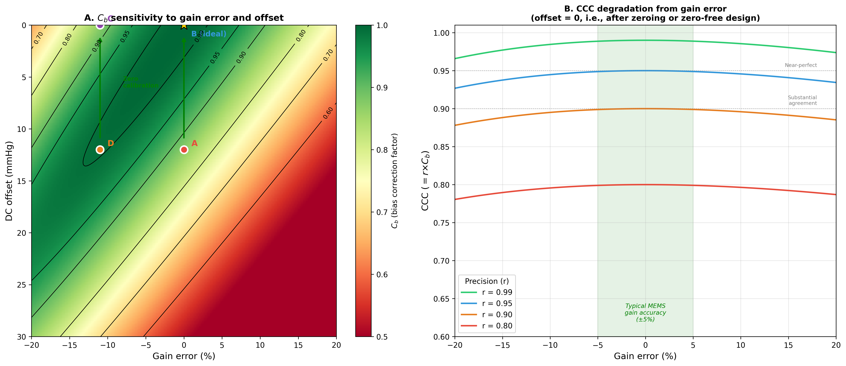
Figure 6. Sensitivity analysis. (A) C_b as a function of gain error (%) and DC offset (mmHg), showing that zero calibration (green arrows, vertical movement toward zero offset) improves C_b only when gain is correct. Points A-D correspond to the four scenarios. (B) CCC as a function of gain error for different levels of sensor precision (r), with offset = 0. The green-shaded zone shows typical MEMS gain accuracy (+/-5%), within which C_b > 0.99.

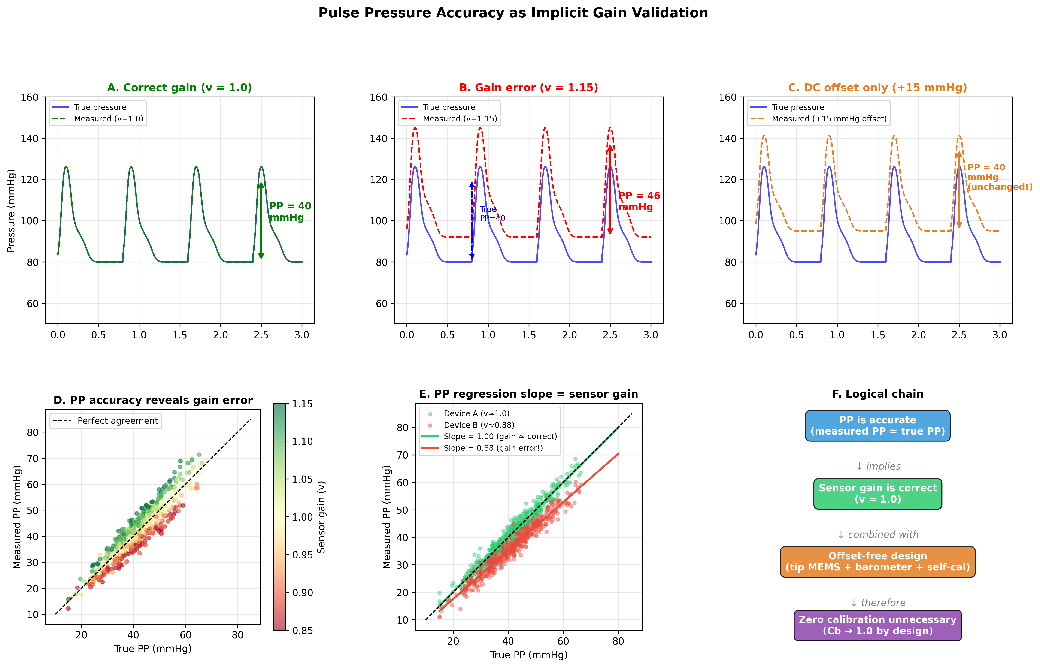
Figure 7. Pulse pressure accuracy as implicit gain validation. (A) Correct gain (v = 1.0): measured waveform matches true pressure, PP = 40 mmHg preserved. (B) Gain error (v = 1.15): waveform is amplitude-scaled, PP distorted from 40 to 46 mmHg. (C) DC offset only (+15 mmHg): waveform is shifted but PP remains 40 mmHg. (D) PP measurement accuracy correlates with sensor gain. (E) PP regression: slope directly estimates sensor gain. (F) Logical chain from PP accuracy to calibration-free monitoring via gain validation and offset-free design.

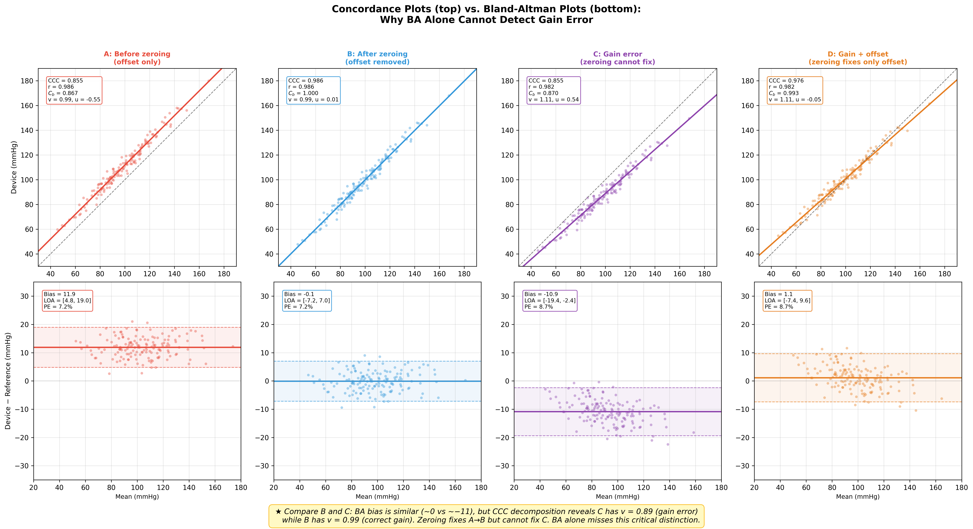
Figure 8. Direct comparison of concordance plots (top row) and Bland-Altman plots (bottom row) for all four scenarios, demonstrating why BA analysis alone is insufficient. The concordance plots reveal the error structure through CCC decomposition (r, C_b, u, v), while the BA plots show only bias and limits of agreement. Critical comparison: Scenarios B and C have similar BA profiles, but concordance analysis identifies C_b = 1.000 (true agreement) vs C_b = 0.870 (hidden gain error, v = 1.11). This distinction is invisible on the BA plot alone.

