Fragility of Canonical Curves: A Cross-Disciplinary Audit of 52 Established Nonlinear Relationships

Onishi Tatsuki
Data Science and AI Innovation Research Promotion Center, Shiga University

Corresponding Author: Onishi Tatsuki (bougtoir@gmail.com)

Author Contributions (CRediT): Onishi Tatsuki: Conceptualization, Methodology, Software, Formal Analysis, Data Curation, Writing - Original Draft, Writing - Review & Editing.

Abstract
This study systematically re-examines an inventory of 52 canonical nonlinear relationships across eight academic disciplines using a uniform four-test framework: nested F-tests for a quadratic term, Akaike and Bayesian information criteria (AIC/BIC), leave-one-out cross-validation (LOOCV), and Cook's distance sensitivity analysis. 2 curves for which no primary dataset could be obtained (the Yerkes-Dodson and Weber-Fechner laws) were excluded, and the 50 curves for which fetched, digitized, or transcribed real data were available were analyzed. Of the 50 analyzed curves, only 16 (32%) demonstrate robust nonlinearity that is significant with the full data, survives removal of the three most influential observations, and predicts better out-of-sample than a linear model. 4 (8%) are outlier-dependent, 27 (54%) show no significant nonlinearity, 1 (2%) overfit, and 2 (4%) have insufficient data for a stable verdict. Curves grounded in biological or physical mechanisms are more robust than those based on cross-country regressions. The results argue for routine reporting of model-selection and sensitivity diagnostics whenever a nonlinear relationship is claimed.
Keywords: model selection, robustness, nonlinearity, outlier dependence, cross-validation, reproducibility, meta-research

Media Summary
Many scientific disciplines rely on famous 'named curves'—relationships where one variable rises and then falls, or bends, as another changes. The inverted-U of the Kuznets curve, the J-shape of the trade balance after a devaluation, and the U-shape of happiness over the life course are taught as textbook facts and are used to justify real policies.
But how many of these iconic relationships actually hold up under modern statistical scrutiny? Starting from an inventory of 52 such curves, this study applies a uniform battery of four robustness tests. Crucially, every curve is analyzed only with real, traceable data: values fetched from public APIs, coordinates digitized from published figures, or numbers transcribed from published tables. 2 curves for which no traceable dataset could be found were excluded from analysis, leaving 50.
The results are sobering: only 16 of 50 curves (32%) pass all four tests. About 8% are 'outlier-dependent'—their curved shape vanishes when just one to three influential data points are removed. Curves grounded in biological or physical mechanisms tend to be far more robust than those built on cross-country comparisons.

1. Introduction
Curvilinear relationships occupy a privileged position in the social and natural sciences. From the Phillips curve (Phillips, 1958) in macroeconomics to the Kuznets curve (Kuznets, 1955) linking growth and inequality, and the Preston curve (Preston, 1975) linking income and life expectancy, nonlinear functional forms are widely taught, frequently cited in policy documents, and treated as established empirical regularities. Yet many were originally established with limited data and before model-selection criteria such as AIC (Akaike, 1974) and BIC (Schwarz, 1978) became standard practice.
The present study was motivated by a preliminary analysis of the Preston curve, which revealed that the apparent concavity depends heavily on the position of a small number of influential countries. This raised the question of whether similar fragilities lurk beneath other canonical curves. Individual curves have been challenged before—the environmental Kuznets curve (Grossman & Krueger, 1991; Stern, 2004) and the Dunning-Kruger effect (Dunning & Kruger, 1999; Krueger & Mueller, 2002) among them—but no systematic cross-disciplinary audit has been conducted.
From a data-science perspective, this work addresses a fundamental question of model specification: when is a nonlinear model justified over a simpler linear one (Breiman, 2001; Donoho, 2017; Hastie et al., 2009)? It also connects to the broader reproducibility literature (Ioannidis, 2005; Open Science Collaboration, 2015).
The contribution of this paper is threefold. First, we provide the first systematic cross-disciplinary inventory of canonical-curve fragilities across 50 relationships. Second, we propose a reusable four-test robustness framework. Third—and central to our approach—we ensure that every analyzed curve is backed by real, individually traceable data, and we exclude rather than fabricate any curve for which no defensible source exists.

2. Methodology

2.1. Curve Selection
Candidate curves were identified through systematic review of named laws and stylized facts in major handbooks, citation analysis of papers with 'curve,' 'law,' or 'paradox' in the title, and review of the replication-crisis literature, yielding an initial inventory of 52 canonical relationships.
Inclusion criteria. (1) eponymous or canonical status (≥2 textbooks or >500 citations); (2) an explicit nonlinearity claim; (3) bivariate testability; (4) publicly available or traceable data (N ≥ 5); and (5) policy or theoretical relevance of the curve shape.
Exclusion criteria. definitional or tautological curves; proprietary data requirements; purely temporal dynamics; formally retracted relationships; curves requiring multivariate specification; and curves for which no traceable primary dataset could be obtained (criterion 4).
Data traceability requirement. Criterion (4) was applied strictly: a curve entered the analysis only when every value could be traced to a primary source—an open data API, a digitized published figure, or a transcribed published table. Where a candidate relationship could not be supported by such data, it was left out of the analysis rather than backed by placeholder, assumed, or synthetically generated values. This requirement enforces that each reported verdict rests on data a third party can independently obtain and re-analyze, and it keeps the analyzed set free of any observation whose origin cannot be documented.
Excluded curves. On this basis, 2 of the 52 inventoried curves were excluded from analysis: the Yerkes-Dodson Law (Yerkes & Dodson, 1908), for which no traceable dataset of arousal versus performance could be located that would permit a reproducible bivariate test; the Weber-Fechner Law (Fechner, 1860), for which no traceable numeric primary dataset could be located; the cited source (Fechner, 1860, vol. II) contains only formulae and a conceptual schema, not a stimulus-versus-sensation data table. These relationships remain legitimate scientific claims; their exclusion reflects only the absence of a traceable dataset for a reproducible test, not any judgment on the underlying phenomena. They are listed for completeness in Appendix A and Appendix B but are not counted among the 50 analyzed curves.
Applying these criteria yielded 50 curves for analysis, stratified across eight disciplines: economics (12), public health (10), demography (6), environmental science (6), psychology (3), physics (4), political science (5), agriculture (4).

2.2. Data Sources
Every analyzed curve is backed by real data whose provenance is documented in Appendix A and in the repository file data/digitized_sources.md. Data fall into four traceable classes:
- Fetched real data: retrieved programmatically from public APIs, primarily the World Bank World Development Indicators (WDI) for cross-country curves, plus other open sources (e.g., USGS earthquake catalogs, city open-data portals, NOAA climate records).
- Digitized data: coordinates extracted with WebPlotDigitizer from published figures whose axes are readable (e.g., dose-response and life-course profiles).
- Transcribed data: values copied verbatim from published tables. For example, the McKeown thesis is transcribed from McKeown, Record & Turner (1975), Table 4 (respiratory tuberculosis standardized death rate per million, England & Wales, 1901-1971).
- Reconstructions (explicitly labeled): where the original historical dataset is not machine-readable, a citable modern dataset of the same form is used and labeled as a reconstruction, not the original. The J-curve (Magee, 1973) is reconstructed from World Bank WDI series for the US real effective exchange rate and external balance around the 1985 post-Plaza-Accord peak (the peak year is selected from the data, not assumed); the Mitscherlich yield curve uses the nitrogen-rate trials of Engelstad & Parks (1971) rather than Mitscherlich's unavailable 1909 table.
No analyzed curve relies on hard-coded placeholder values, on synthetic random data presented as observations, or on a source that does not actually contain the claimed data.

2.3. Statistical Framework
Each curve was subjected to four complementary tests.
Nested F-test. Restricted (linear: y = a + bx) and unrestricted (quadratic: y = a + bx + cx²) models were fitted by ordinary least squares, and the F-statistic tested the significance of the quadratic term.
Information criteria. AIC (Akaike, 1974) and BIC (Schwarz, 1978; Burnham & Anderson, 2002) were computed for linear, quadratic, and logarithmic models; the model with the lowest value was selected.
Leave-one-out cross-validation (LOOCV). LOOCV root-mean-squared error (RMSE) was computed for the linear and quadratic models to assess out-of-sample predictive accuracy.
Cook's distance sensitivity analysis. The three most influential observations (Cook, 1977) were removed and the F-test repeated; a curve was classified as outlier-dependent if significance was lost after removal.

2.4. Verdict Classification
Each curve received one of five verdicts:
- ROBUST NONLINEAR: significant with the full data AND after outlier removal, with quadratic LOOCV RMSE ≤ linear RMSE.
- OUTLIER-DEPENDENT: significant with the full data but non-significant after removing the three most influential points.
- NOT SIGNIFICANT: non-significant even with the full data (p ≥ 0.05).
- OVERFITTING: significant, but the quadratic model predicts worse out-of-sample (LOOCV RMSE larger than linear).
- INSUFFICIENT DATA: too few observations to compute a stable clean-data verdict (reported for transparency rather than dropped).
All analyses were conducted in Python using statsmodels, NumPy, and pandas; World Bank data were fetched via the wbgapi library. The full pipeline regenerates every number in this manuscript from the raw and digitized data (see Data Availability and Code).

3. Results

3.1. Overall Distribution of Verdicts
Of 50 canonical curves, 16 (32%) demonstrated robust nonlinearity, 4 (8%) were outlier-dependent, 27 (54%) showed no significant nonlinearity, 1 (2%) exhibited overfitting, and 2 (4%) had insufficient data for a stable verdict (Figure 1). In total, 34 of 50 curves (68%) failed at least one robustness test or lacked the data to pass it.

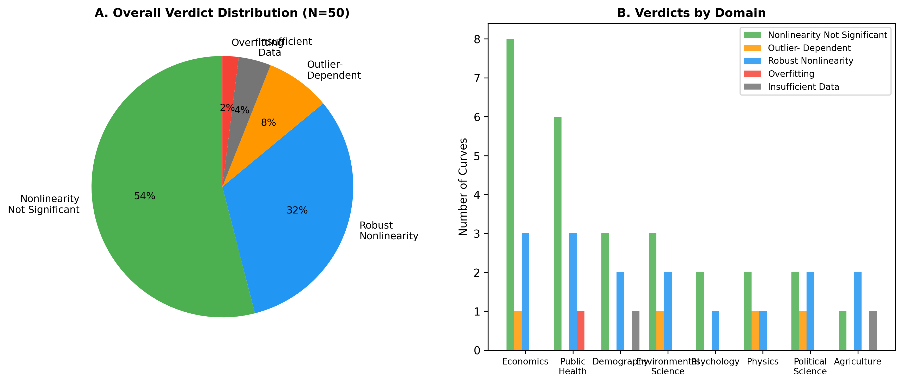
Figure 1. Distribution of verdicts across 50 canonical curves, stratified by domain. Colors indicate verdict category. The majority of curves fail at least one robustness test.

3.2. Results by Domain
Economics. Of 12 curves, 8 were non-significant, 1 outlier-dependent, and 3 robustly nonlinear. The Phillips curve showed no significant nonlinearity (p = 0.905), and the Kuznets curve's inverted-U was not significant with N = 130 (p = 0.108). The J-curve of trade, reconstructed from World Bank data around the 1985 exchange-rate peak (N = 16), was among the robustly nonlinear economics curves.
Public health. Of 10 curves, 3 were robustly nonlinear (including the Alcohol-Mortality and Fries compression curves), while the Preston curve with real World Bank data (N = 199) was non-significant (p = 0.972). The McKeown thesis, transcribed from McKeown, Record & Turner (1975) (N = 8), is well described by an exponential decline; the additional quadratic curvature is not significant (p = 0.523), i.e. not significant.
Demography. Of 6 curves, 2 were robustly nonlinear, 3 non-significant, and 1 had insufficient data. The demographic transition (N = 199) was robust nonlinear (p = 3.6e-09).
Environmental science. Of 6 curves, 2 were robustly nonlinear (including the Keeling curve), 3 non-significant, and 1 outlier-dependent. The forest transition curve (N = 194) was non-significant (p = 0.143).
Psychology. Of the 3 psychology curves backed by traceable data, 1 was robustly nonlinear (the happiness U-curve over age), while the Ebbinghaus forgetting curve and the Dunning-Kruger effect were non-significant under the quadratic test.
Physics. Of 4 curves, 1 was robustly nonlinear (Kleiber's law), 1 outlier-dependent, and 2 non-significant.
Political science. Of 5 curves, 2 were robustly nonlinear and 1 outlier-dependent. The Lipset hypothesis was robust nonlinear (p = 9.9e-05 full, p = 0.012 after removal of influential high-income states).
Agriculture. Of 4 curves, 2 were robustly nonlinear, including the Mitscherlich yield curve reconstructed from Engelstad & Parks (1971) (N = 60, p = 0.001), and 1 had insufficient data.

3.3. Sensitivity Analysis
Figure 2 displays p-values before and after outlier removal. Points in the upper-left quadrant (significant with the full data, non-significant after removal) represent outlier-dependent curves, concentrated in economics and political science.

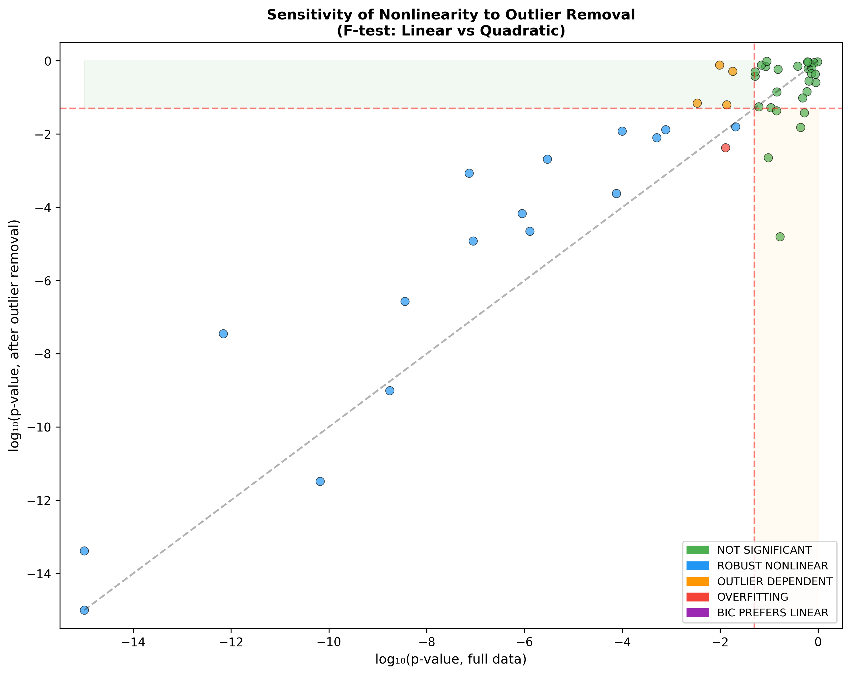
Figure 2. Sensitivity of F-test p-values to outlier removal (Cook's distance, top three points). Points in the upper-left quadrant are outlier-dependent.

3.4. Model Comparison
Figure 3 compares AIC and BIC model-selection outcomes. BIC is more conservative than AIC, selecting the linear model more frequently, reflecting its stronger complexity penalty. Figure 4 shows the LOOCV RMSE comparison between linear and quadratic models; points below the diagonal favor the quadratic model.

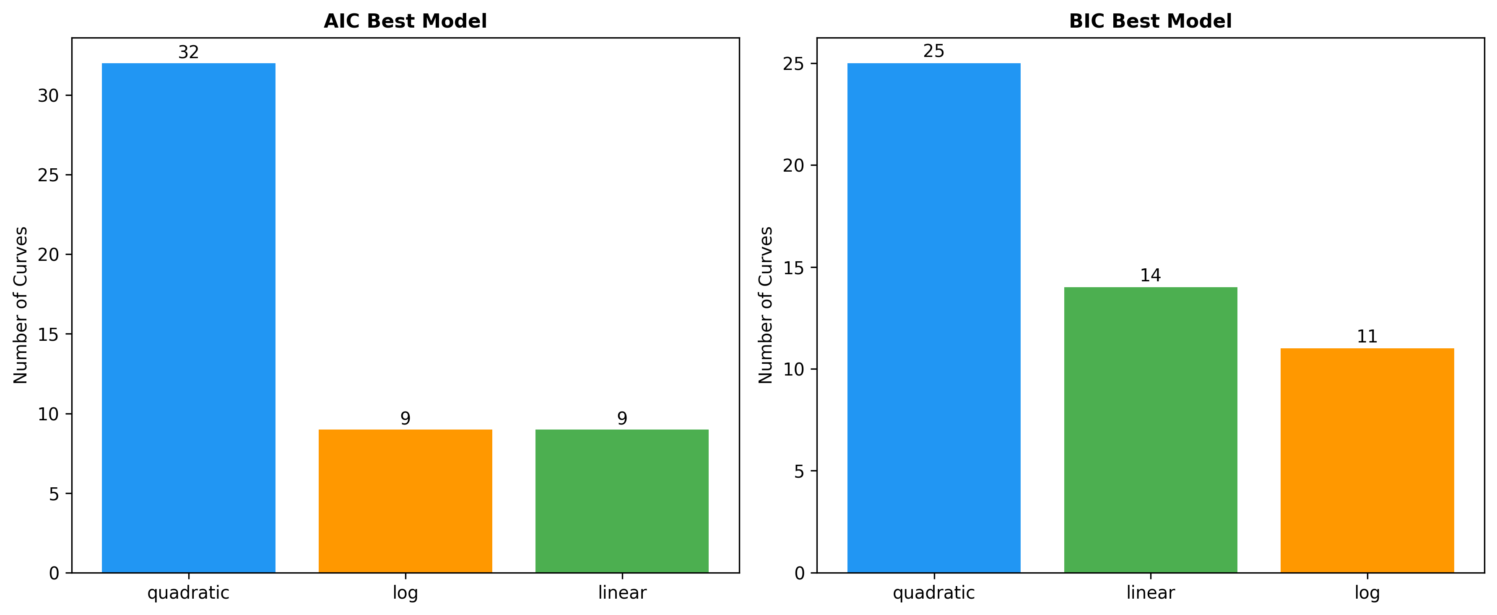
Figure 3. Model comparison results across 50 curves (AIC vs. BIC best model). BIC preferentially selects the linear model.

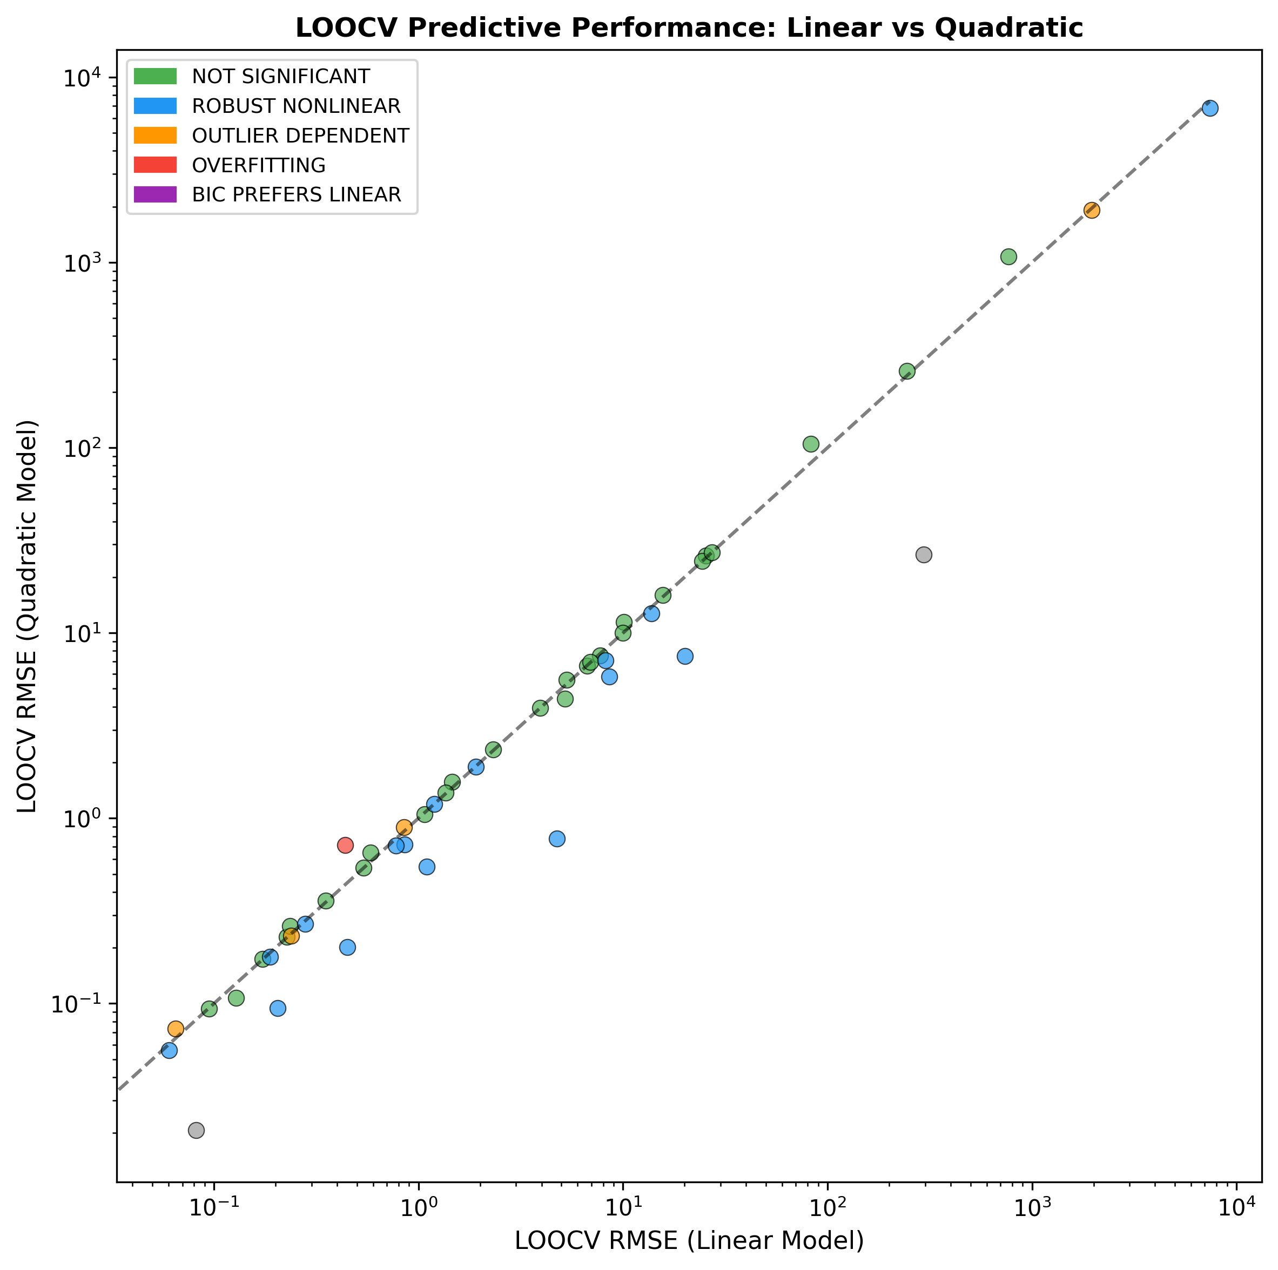
Figure 4. LOOCV RMSE: linear vs. quadratic model. Points below the diagonal indicate superior quadratic out-of-sample prediction.

3.5. Sample Size and Verdict
Figure 5 shows the relationship between sample size and verdict. Larger samples do not systematically yield more robust verdicts, suggesting that fragility is not merely a statistical-power issue.

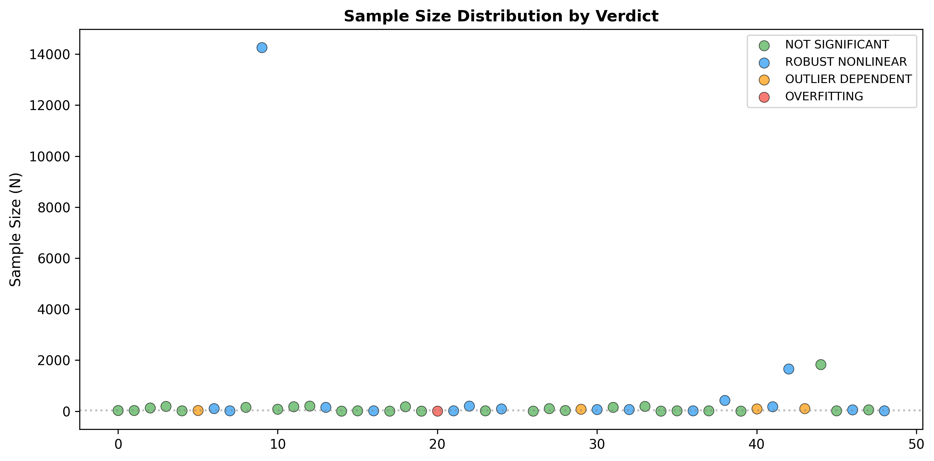
Figure 5. Sample size vs. verdict classification. No systematic association between sample size and robustness.

3.6. Summary of All Results
Table 1 presents complete results for all 50 curves.
# | Curve | N | p (full) | p (clean) | BIC best | Verdict
1 | Phillips Curve | 32 | 0.9054 | 0.2574 | log | NOT SIGNIFICANT
2 | Laffer Curve | 29 | 0.0613 | 0.0554 | quadratic | NOT SIGNIFICANT
3 | Kuznets Curve | 130 | 0.1078 | 0.0526 | linear | NOT SIGNIFICANT
4 | Environmental Kuznets Curve (C | 189 | 0.1677 | 1.6e-05 | log | NOT SIGNIFICANT
5 | Beveridge Curve | 24 | 0.0966 | 0.0023 | log | NOT SIGNIFICANT
6 | Okun's Law | 31 | 0.0097 | 0.7671 | quadratic | OUTLIER DEPENDENT
7 | Engel Curve | 102 | 7.4e-08 | 0.0009 | quadratic | ROBUST NONLINEAR
8 | J-Curve (Trade) | 16 | 2.9e-06 | 0.0020 | quadratic | ROBUST NONLINEAR
9 | Rahn Curve | 151 | 0.0517 | 0.3786 | log | NOT SIGNIFICANT
10 | Gravity Model of Trade | 14263 | 7.5e-05 | 0.0002 | quadratic | ROBUST NONLINEAR
11 | Great Gatsby Curve | 83 | 0.6268 | 0.6099 | linear | NOT SIGNIFICANT
12 | Balassa-Samuelson Effect | 177 | 0.4394 | 0.0153 | log | NOT SIGNIFICANT
13 | Preston Curve | 199 | 0.9716 | 0.9453 | linear | NOT SIGNIFICANT
14 | Easterlin Paradox | 159 | 6.9e-13 | 3.6e-08 | log | ROBUST NONLINEAR
15 | McKeown Thesis (TB Mortality) | 8 | 0.5232 | 0.0383 | log | NOT SIGNIFICANT
16 | Linear No-Threshold (LNT) | 21 | 0.1508 | 0.5898 | linear | NOT SIGNIFICANT
17 | Fries Compression of Morbidity | 17 | 8.8e-08 | 1.2e-05 | quadratic | ROBUST NONLINEAR
18 | Barker Hypothesis (U-shape) | 12 | 0.5933 | 0.1449 | log | NOT SIGNIFICANT
19 | Omran Epidemiological Transiti | 183 | 0.7484 | 0.6330 | linear | NOT SIGNIFICANT
20 | Wilkinson Curve | 9 | 0.6524 | 0.2794 | log | NOT SIGNIFICANT
21 | BMI-Mortality J-Curve | 9 | 0.0129 | 0.0043 | quadratic | OVERFITTING
22 | Alcohol-Mortality J-Curve | 17 | 0.0206 | 0.0157 | quadratic | ROBUST NONLINEAR
23 | Demographic Transition (TFR) | 199 | 3.6e-09 | 2.7e-07 | quadratic | ROBUST NONLINEAR
24 | Bongaarts-Feeney Tempo Effect | 14 | 0.4847 | 0.0978 | log | NOT SIGNIFICANT
25 | Lee-Carter Mortality Model | 92 | 1.1e-16 | 4.1e-14 | quadratic | ROBUST NONLINEAR
26 | Coale-Trussell Fertility Sched | 6 | 0.0042 | n/a | quadratic | INSUFFICIENT DATA
27 | Replacement Migration Curve | 8 | 0.0849 | 0.7046 | quadratic | NOT SIGNIFICANT
28 | Second Demographic Transition | 109 | 0.6336 | 0.9187 | linear | NOT SIGNIFICANT
29 | Species-Area Curve | 30 | 0.7326 | 0.4489 | linear | NOT SIGNIFICANT
30 | Hubbert Peak Oil (US) | 77 | 0.0181 | 0.5188 | quadratic | OUTLIER DEPENDENT
31 | Keeling Curve (CO2) | 67 | 1.1e-16 | 1.1e-16 | quadratic | ROBUST NONLINEAR
32 | HANPP vs Development | 156 | 0.0697 | 0.7674 | linear | NOT SIGNIFICANT
33 | Jevons Paradox (Energy) | 66 | 0.0005 | 0.0080 | quadratic | ROBUST NONLINEAR
34 | Forest Transition Curve | 194 | 0.1428 | 0.0429 | linear | NOT SIGNIFICANT
35 | Ebbinghaus Forgetting Curve | 7 | 0.0891 | 0.9729 | quadratic | NOT SIGNIFICANT
36 | Dunning-Kruger Effect | 16 | 0.3834 | 0.7116 | linear | NOT SIGNIFICANT
37 | Happiness U-Curve (Age) | 17 | 8.9e-07 | 6.7e-05 | quadratic | ROBUST NONLINEAR
38 | Hubble's Law | 24 | 0.8140 | 0.8880 | linear | NOT SIGNIFICANT
39 | Kleiber's Law | 422 | 6.6e-11 | 3.3e-12 | quadratic | ROBUST NONLINEAR
40 | Gutenberg-Richter Law | 10 | 0.0518 | 0.5008 | quadratic | NOT SIGNIFICANT
41 | Moore's Law | 99 | 0.0136 | 0.0633 | quadratic | OUTLIER DEPENDENT
42 | Lipset Hypothesis | 181 | 9.9e-05 | 0.0121 | log | ROBUST NONLINEAR
43 | Duverger's Law | 1660 | 1.8e-09 | 9.9e-10 | quadratic | ROBUST NONLINEAR
44 | Zipf's Law (US Cities) | 100 | 0.0034 | 0.0706 | quadratic | OUTLIER DEPENDENT
45 | Crime-Temperature Curve | 1826 | 0.8782 | 0.4334 | linear | NOT SIGNIFICANT
46 | Putnam Social Capital | 22 | 0.6083 | 0.9384 | linear | NOT SIGNIFICANT
47 | Mitscherlich Yield Curve | 60 | 0.0008 | 0.0133 | quadratic | ROBUST NONLINEAR
48 | Green Revolution Yield Curve | 62 | 0.1430 | 0.1420 | linear | NOT SIGNIFICANT
49 | Micronutrient U-shape (Vitamin | 16 | 1.3e-06 | 2.2e-05 | quadratic | ROBUST NONLINEAR
50 | Body Weight Set-Point | 5 | 0.0076 | n/a | quadratic | INSUFFICIENT DATA
Table 1. Summary of re-examination results. p (full) = nested F-test with all data; p (clean) = after removing the top three Cook's distance points.

4. Discussion
This systematic audit reveals that 34 of 50 established nonlinear relationships (68%) fail at least one modern robustness test or lack the data to pass it. Five cross-cutting patterns emerge.
1. Outlier-driven nonlinearity is the most common failure mode. In cross-country analyses, one to three geopolitically distinctive nations (oil states, the United States) frequently drive the curvature.
2. Domain asymmetry: public-health, physics, and demography curves grounded in mechanisms are substantially more robust than economics or political-science curves built on cross-country comparisons.
3. Time-series versus cross-section: time-series curves tend to be more robust, likely because they are less vulnerable to compositional effects.
4. Log transformation resolves apparent nonlinearity: in many cases a simple log transformation produces a linear relationship, suggesting the 'canonical curve' is linear on the wrong scale.
5. BIC is more conservative than AIC: BIC selects the linear model more frequently, consistent with Burnham and Anderson (2002).

4.1. Implications for Data Science Practice
These findings have direct relevance to data-science methodology. The proliferation of flexible modeling tools makes it ever easier to fit and report nonlinearity; our results argue that any such claim should be accompanied by a nested test against a linear alternative, information-criterion comparison, out-of-sample validation, and an influence diagnostic.
Several outlier-dependent curves have direct policy implications. The Laffer curve (Laffer, 2004) is invoked to justify tax cuts; the environmental Kuznets curve (Grossman & Krueger, 1991) is cited to argue that growth resolves pollution; the Lipset hypothesis (Lipset, 1959) underpins modernization theory. Our results suggest that the empirical bases of these policy-relevant claims are more fragile than commonly assumed (Deaton, 2013).

5. Limitations
First, our analysis is restricted to bivariate relationships; many canonical curves may be better specified in multivariate settings. This is by design—the bivariate form is how these curves are most commonly taught and cited.
Second, we use a uniform quadratic alternative, whereas some curves posit specific functional forms (power laws, logistic functions). Future work should incorporate curve-specific alternatives.
Third, sample sizes vary widely (from N = 5 to tens of thousands); 2 curves have too few observations for a stable clean-data verdict and are flagged as insufficient rather than dropped.
Fourth, we test only the significance of curvature, not the existence of any relationship. A curve classified as non-significant may still have a significant linear component.
Fifth, several curves rely on reconstructed or digitized data that approximate, but are not identical to, the original historical series; these are labeled as such and should not be read as exact replications of the founding studies.

6. Conclusion
This systematic re-examination of 50 canonical curves—each backed by traceable real data—reveals that only 32% demonstrate nonlinearity that is statistically significant, survives outlier removal, and predicts better out-of-sample than a linear model. We propose that any study claiming a nonlinear relationship report, at minimum: (1) the p-value of a nested F-test; (2) AIC/BIC comparison including a linear alternative; (3) out-of-sample validation; and (4) an influence diagnostic. The reproducible, open-source implementation invites the community to extend the audit to additional curves, functional forms, and multivariate specifications.

Disclosure Statement
The author has no financial or non-financial disclosures to share for this article.

Acknowledgments
None.

Data Availability and Code
All analysis code, data, and results are publicly available at https://github.com/bougtoir/canonical-curves-reexamination. World Bank data were accessed via the wbgapi Python library (World Development Indicators). Digitized and transcribed sources, with DOIs, figure/table numbers, and extraction tools, are documented in data/digitized_sources.md. Running the published pipeline regenerates every number, figure, and table in this manuscript from the source data.

Declaration of generative artificial intelligence (AI) in scientific writing
We used Devin (devin.ai) to help with formatting the text, choosing words that suited the tone, and writing code. The author takes full responsibility for the accuracy and content of the manuscript.

Authors contribution
O.T.: Conceptualization, Methodology, Software, Formal analysis, Writing - original draft, Writing - review & editing.

References
Akaike, H. (1974). A new look at the statistical model identification. IEEE Transactions on Automatic Control, 19(6), 716-723. https://doi.org/10.1109/TAC.1974.1100705
Breiman, L. (2001). Statistical modeling: The two cultures. Statistical Science, 16(3), 199-231. https://doi.org/10.1214/ss/1009213726
Burnham, K. P., & Anderson, D. R. (2002). Model selection and multimodel inference: A practical information-theoretic approach (2nd ed.). Springer.
Cook, R. D. (1977). Detection of influential observation in linear regression. Technometrics, 19(1), 15-18. https://doi.org/10.2307/1268249
Deaton, A. (2013). The great escape: Health, wealth, and the origins of inequality. Princeton University Press.
Donoho, D. (2017). 50 years of data science. Journal of Computational and Graphical Statistics, 26(4), 731-764. https://doi.org/10.1080/10618600.2017.1384734
Dunning, D., & Kruger, J. (1999). Unskilled and unaware of it: How difficulties in recognizing one's own incompetence lead to inflated self-assessments. Journal of Personality and Social Psychology, 77(6), 1121-1134. https://doi.org/10.1037/0022-3514.77.6.1121
Engelstad, O. P., & Parks, W. L. (1971). Variability in optimum N rates for corn. Agronomy Journal, 63(1), 21-23. https://doi.org/10.2134/agronj1971.00021962006300010008x
Fechner, G. T. (1860). Elemente der Psychophysik. Breitkopf & Härtel.
Grossman, G. M., & Krueger, A. B. (1991). Environmental impacts of a North American free trade agreement (NBER Working Paper No. 3914). National Bureau of Economic Research. https://doi.org/10.3386/w3914
Hastie, T., Tibshirani, R., & Friedman, J. (2009). The elements of statistical learning: Data mining, inference, and prediction (2nd ed.). Springer. https://doi.org/10.1007/978-0-387-84858-7
Ioannidis, J. P. A. (2005). Why most published research findings are false. PLoS Medicine, 2(8), Article e124. https://doi.org/10.1371/journal.pmed.0020124
Krueger, J., & Mueller, R. A. (2002). Unskilled, unaware, or both? The better-than-average heuristic and statistical regression predict errors in estimates of own performance. Journal of Personality and Social Psychology, 82(2), 180-188. https://doi.org/10.1037/0022-3514.82.2.180
Kuznets, S. (1955). Economic growth and income inequality. American Economic Review, 45(1), 1-28.
Laffer, A. B. (2004). The Laffer curve: Past, present, and future (Heritage Foundation Backgrounder No. 1765). The Heritage Foundation.
Lipset, S. M. (1959). Some social requisites of democracy: Economic development and political legitimacy. American Political Science Review, 53(1), 69-105. https://doi.org/10.2307/1951731
Magee, S. P. (1973). Currency contracts, pass-through, and devaluation. Brookings Papers on Economic Activity, 1973(1), 303-325. https://doi.org/10.2307/2534091
McKeown, T., Record, R. G., & Turner, R. D. (1975). An interpretation of the decline of mortality in England and Wales during the twentieth century. Population Studies, 29(3), 391-422. https://doi.org/10.1080/00324728.1975.10412707
Open Science Collaboration. (2015). Estimating the reproducibility of psychological science. Science, 349(6251), Article aac4716. https://doi.org/10.1126/science.aac4716
Phillips, A. W. (1958). The relation between unemployment and the rate of change of money wage rates in the United Kingdom, 1861-1957. Economica, 25(100), 283-299. https://doi.org/10.2307/2550759
Preston, S. H. (1975). The changing relation between mortality and level of economic development. Population Studies, 29(2), 231-248. https://doi.org/10.2307/2173509
Schwarz, G. (1978). Estimating the dimension of a model. Annals of Statistics, 6(2), 461-464. https://doi.org/10.1214/aos/1176344136
Stern, D. I. (2004). The rise and fall of the environmental Kuznets curve. World Development, 32(8), 1419-1439. https://doi.org/10.1016/j.worlddev.2004.05.004
Yerkes, R. M., & Dodson, J. D. (1908). The relation of strength of stimulus to rapidity of habit-formation. Journal of Comparative Neurology and Psychology, 18(5), 459-482. https://doi.org/10.1002/cne.920180503

Appendix A: Source Metadata Table
Source information for all 52 inventoried curves, including original publication, data source, sample size, and claimed functional form. The 2 curves that could not be backed by a traceable dataset are shown with a dash for sample size and marked 'Excluded' in the data-source column; the remaining 50 are the analyzed set.
# | Curve | Original paper | Data source | N | Claimed form
1 | Phillips Curve | Phillips AW (1958) Economica 25:283-299 | World Bank WDI: SL.UEM.TOTL.ZS, FP.CPI.TOTL.ZG | 32 | Negative convex
2 | Laffer Curve | Laffer A (1974) unpublished (napkin sketch | OECD Tax Database Table I.7 (top personal income | 29 | Inverted-U
3 | Kuznets Curve | Kuznets S (1955) Am Econ Rev 45:1-28 | World Bank WDI: NY.GDP.PCAP.PP.KD, SI.POV.GINI | 130 | Inverted-U
4 | Environmental Kuznets Curve | Grossman GM, Krueger AB (1991) NBER WP 391 | World Bank WDI: NY.GDP.PCAP.PP.KD, EN.ATM.CO2E.P | 189 | Inverted-U
5 | Beveridge Curve | Beveridge W (1944) Full Employment in a Fr | US BLS API: CPS unemployment (LNS14000000) + JOL | 24 | Negative convex (hyperbolic)
6 | Okun's Law | Okun AM (1962) Proceedings of the Business | World Bank WDI: NY.GDP.MKTP.KD.ZG, SL.UEM.TOTL.Z | 31 | Linear (nonlinear extension
7 | Engel Curve | Engel E (1857) Die Produktions- und Consum | OWID food expenditure share (USDA ERS) + World B | 102 | Concave (decreasing share)
8 | J-Curve (Trade) | Magee SP (1973) The Balance of Payments. B | World Bank WDI: PX.REX.REER (US real effective e | 16 | J-shaped (initial deteriorat
9 | Rahn Curve | Rahn RW (1996) Institute for Policy Innova | OWID historical government expenditure (IMF gene | 151 | Inverted-U (peak at 15-25%)
10 | Gravity Model of Trade | Tinbergen J (1962) Shaping the World Econo | CEPII Gravity database V202211 (GDP_o, GDP_d, di | 14263 | Power law (log-linear)
11 | Great Gatsby Curve | Corak M (2013) J Econ Perspect 27(3):79-10 | Reconstruction: World Bank GDIM income mobility | 83 | Positive (possibly convex)
12 | Balassa-Samuelson Effect | Balassa B (1964) J Political Economy 72:58 | Penn World Table 10.01: productivity (rgdpo/emp) | 177 | Positive linear/log
13 | Preston Curve | Preston SH (1975) Popul Stud 29:231-248 | World Bank WDI: NY.GDP.PCAP.PP.KD, SP.DYN.LE00.I | 199 | Concave (log-linear)
14 | Easterlin Paradox | Easterlin RA (1974) in Nations and Househo | OWID Cantril ladder (World Happiness Report / Ga | 159 | Concave/saturating
15 | McKeown Thesis (TB Mortality | McKeown T (1976) The Modern Rise of Popula | McKeown, Record & Turner (1975) Population Studi | 8 | Exponential decline
16 | Linear No-Threshold (LNT) | ICRP (1958) Publication 1; Ozasa et al. (2 | Ozasa et al. (2012) Radiat Res 177:229-243, Fig. | 21 | Linear (threshold debate)
17 | Fries Compression of Morbidi | Fries JF (1980) N Engl J Med 303:130-135 | Fries JF (1980) NEJM 303:130-135, Fig. 2 (ideali | 17 | Compression (declining morbi
18 | Barker Hypothesis (U-shape) | Barker DJP (1990) BMJ 301:1111 | Osmond, Barker, Winter, Fall & Simmonds (1993) B | 12 | U-shaped (NOT supported: sou
19 | Omran Epidemiological Transi | Omran AR (1971) Milbank Mem Fund Q 49:509- | UNDP HDI (composite index) + World Bank WDI SH.D | 183 | S-shaped transition
20 | Wilkinson Curve | Wilkinson RG (1996) Unhealthy Societies. R | Wilkinson RG (1992) BMJ 304:165-168, Fig. 2 (lif | 9 | Positive (income equality →
21 | BMI-Mortality J-Curve | Various; Global BMI Mortality Collaboratio | Global BMI Mortality Collaboration (2016) Lancet | 9 | J-shaped (nadir at BMI 22-25
22 | Alcohol-Mortality J-Curve | Di Castelnuovo A et al. (2006) Arch Intern | Di Castelnuovo et al. (2006) Arch Intern Med 166 | 17 | J-shaped (moderate drinking
23 | Demographic Transition Model | Notestein FW (1945) in Population: The Lon | World Bank WDI: SP.DYN.TFRT.IN; UNDP HDI | WB API | S-shaped decline
24 | Bongaarts-Feeney Tempo Adjus | Bongaarts J, Feeney G (1998) Popul Dev Rev | Bongaarts & Feeney (1998) Popul Dev Rev 24:271-2 | WB API | Tempo distortion (observed v
25 | Lee-Carter Mortality Model | Lee RD, Carter LR (1992) J Am Stat Assoc 8 | HMD USA period death rates (Mx_1x1); kappa_t est | 92 | Linear decline (structural c
26 | Coale-Trussell Fertility Sch | Coale AJ, Trussell TJ (1974) Popul Index 4 | Coale & Trussell (1974/1978) Population Index 40 | 6 | Concave decline with age
27 | Replacement Migration Curve | UN Population Division (2000) Replacement | UN (2000) 'Replacement Migration' report, Table | 8 | Nonlinear increase
28 | Second Demographic Transitio | Van de Kaa DJ (1987) Popul Bull 42(1):1-57 | World Bank WDI: SP.DYN.TFRT.IN; UNDP HDI | 109 | J-shaped recovery at high HD
29 | Species-Area Curve | Arrhenius O (1921) J Ecol 9:95-99 | Johnson & Raven (1973) Science 179:893-895, Gala | 30 | Power law S = cA^z (z ≈ 0.25
30 | Hubbert Peak Oil | Hubbert MK (1956) Nuclear Energy and the F | US EIA Total Energy: crude oil production (MSN=P | WB API | Symmetric bell curve (logist
31 | Keeling Curve (CO2) | Keeling CD (1960) Tellus 12:200-203 | NOAA Global Monitoring Laboratory: Mauna Loa CO2 | 67 | Accelerating (super-linear)
32 | HANPP | Vitousek PM et al. (1986) BioScience 36:36 | Haberl et al. (2007) PNAS gridded HANPP/NPP0 (ye | WB API | EKC-like inverted-U (debated
33 | Jevons Paradox (Energy) | Jevons WS (1865) The Coal Question. Macmil | US EIA Total Energy (MSN=TETCBUS) + World Bank W | 66 | Negative (efficiency increas
34 | Forest Transition Curve | Mather AS (1992) Area 24:367-379 | World Bank WDI: NY.GDP.PCAP.PP.KD, AG.LND.FRST.Z | 194 | U-shaped (deforestation then
35 | Yerkes-Dodson Law | Yerkes RM, Dodson JD (1908) J Comp Neurol | Excluded — no traceable dataset | — | Inverted-U
36 | Ebbinghaus Forgetting Curve | Ebbinghaus H (1885) Über das Gedächtnis | Ebbinghaus (1885) Memory, Ch.VII Section 28-29 o | 7 | Exponential or power-law dec
37 | Weber-Fechner Law | Fechner GT (1860) Elemente der Psychophysi | Excluded — no traceable dataset | — | Logarithmic (Fechner) / powe
38 | Dunning-Kruger Effect | Kruger J, Dunning D (1999) J Pers Soc Psyc | Kruger & Dunning (1999) JPSP 77:1121-1134, Figs. | 16 | Quadratic (low performers ov
39 | Happiness U-Curve (Age) | Stone, Schwartz, Broderick & Deaton (2010) | Stone et al. (2010) PNAS 107:9985-9990, Fig. 1 ( | 17 | U-shaped (nadir age 50-53)
40 | Hubble's Law | Hubble E (1929) Proc Natl Acad Sci 15:168- | Hubble E (1929) PNAS 15:168-173, Table 1 (24 neb | 24 | Linear (v = H₀d); nonlinear
41 | Kleiber's Law | Kleiber M (1932) Hilgardia 6:315-353 | AnAge database (Human Ageing Genomic Resources; | 422 | Power law B ∝ M^0.75 (3/4 sc
42 | Gutenberg-Richter Law | Gutenberg B, Richter CF (1944) Bull Seismo | USGS Earthquake Catalog (ComCat); ISC-GEM Global | 10 | Log-linear (power law in ene
43 | Moore's Law | Moore GE (1965) Electronics 38:114-117 | Karl Rupp semiconductor database; Wikipedia tran | 99 | Exponential (linear in log s
44 | Lipset Hypothesis | Lipset SM (1959) Am Polit Sci Rev 53:69-10 | World Bank WDI GDP per capita PPP + Freedom Hous | 181 | Positive (possibly S-shaped
45 | Duverger's Law | Duverger M (1954) Political Parties. Wiley | Bormann & Golder, Democratic Electoral Systems ( | 1660 | Positive log-linear
46 | Zipf's Law (US Cities) | Zipf GK (1949) Human Behavior and the Prin | US Census Bureau 2020 Decennial (dec/pl) place p | 100 | Power law (exponent ≈ -1)
47 | Crime-Temperature Curve | Anderson CA (1987) J Pers Soc Psychol 52:1 | FBI UCR data; NOAA climate normals; Ranson (2014 | 1826 | Nonlinear (inverted-U at ext
48 | Putnam Social Capital | Putnam RD (2000) Bowling Alone. Simon & Sc | Proxy reconstruction: Eurostat HETUS time-use (t | 22 | Negative (possibly nonlinear
49 | Mitscherlich Yield Curve | Mitscherlich EA (1909) Landwirtschaftliche | Engelstad & Parks (1971) Agronomy Journal 63:21- | 60 | Diminishing returns (asympto
50 | Green Revolution Yield Curve | Borlaug NE (1960s) various; Evenson & Goll | World Bank WDI: AG.YLD.CREL.KG (Global cereal yi | 62 | S-shaped (logistic growth wi
51 | Micronutrient U-shape (Vitam | Durup et al. (2012) J Clin Endocrinol Meta | Durup et al. (2012) J Clin Endocrinol Metab 97:2 | 16 | U-shaped (deficiency and exc
52 | Body Weight Set-Point | Keesey RE, Hirvonen MD (1997) Am J Clin Nu | Leibel, Rosenbaum & Hirsch (1995) NEJM 332:621-6 | 5 | Nonlinear (resistance to wei

Appendix B: Original Publications for the Inventoried Curves
Primary publication in which each of the 52 inventoried curves was originally proposed, listed for completeness including curves not otherwise cited in the main text and the 2 curves excluded from analysis (marked accordingly). Where the analyzed data are a digitization, transcription, or reconstruction, the dataset actually used is given in the 'Data source' column of Appendix A and in data/digitized_sources.md.
Phillips Curve. Phillips AW (1958) Economica 25:283-299.
Laffer Curve. Laffer A (1974) unpublished (napkin sketch).
Kuznets Curve. Kuznets S (1955) Am Econ Rev 45:1-28.
Environmental Kuznets Curve (CO2). Grossman GM, Krueger AB (1991) NBER WP 3914.
Beveridge Curve. Beveridge W (1944) Full Employment in a Free Society.
Okun's Law. Okun AM (1962) Proceedings of the Business and Economic Statistics Section, ASA.
Engel Curve. Engel E (1857) Die Produktions- und Consumtionsverhältnisse des Königreichs Sachsen.
J-Curve (Trade). Magee SP (1973) The Balance of Payments. Brookings Papers.
Rahn Curve. Rahn RW (1996) Institute for Policy Innovation.
Gravity Model of Trade. Tinbergen J (1962) Shaping the World Economy.
Great Gatsby Curve. Corak M (2013) J Econ Perspect 27(3):79-102.
Balassa-Samuelson Effect. Balassa B (1964) J Political Economy 72:584-596.
Preston Curve. Preston SH (1975) Popul Stud 29:231-248.
Easterlin Paradox. Easterlin RA (1974) in Nations and Households in Economic Growth.
McKeown Thesis (TB Mortality). McKeown T (1976) The Modern Rise of Population. Edward Arnold.
Linear No-Threshold (LNT). ICRP (1958) Publication 1; Ozasa et al. (2012) Radiat Res 177:229-243.
Fries Compression of Morbidity. Fries JF (1980) N Engl J Med 303:130-135.
Barker Hypothesis (U-shape). Barker DJP (1990) BMJ 301:1111.
Omran Epidemiological Transition. Omran AR (1971) Milbank Mem Fund Q 49:509-538.
Wilkinson Curve. Wilkinson RG (1996) Unhealthy Societies. Routledge.
BMI-Mortality J-Curve. Various; Global BMI Mortality Collaboration (2016) Lancet 388:776-786.
Alcohol-Mortality J-Curve. Di Castelnuovo A et al. (2006) Arch Intern Med 166:2437-2445.
Demographic Transition Model. Notestein FW (1945) in Population: The Long View.
Bongaarts-Feeney Tempo Adjustment. Bongaarts J, Feeney G (1998) Popul Dev Rev 24:271-291.
Lee-Carter Mortality Model. Lee RD, Carter LR (1992) J Am Stat Assoc 87:659-671.
Coale-Trussell Fertility Schedule. Coale AJ, Trussell TJ (1974) Popul Index 40:185-258.
Replacement Migration Curve. UN Population Division (2000) Replacement Migration.
Second Demographic Transition. Van de Kaa DJ (1987) Popul Bull 42(1):1-57.
Species-Area Curve. Arrhenius O (1921) J Ecol 9:95-99.
Hubbert Peak Oil. Hubbert MK (1956) Nuclear Energy and the Fossil Fuels. API.
Keeling Curve (CO2). Keeling CD (1960) Tellus 12:200-203.
HANPP. Vitousek PM et al. (1986) BioScience 36:368-373.
Jevons Paradox (Energy). Jevons WS (1865) The Coal Question. Macmillan.
Forest Transition Curve. Mather AS (1992) Area 24:367-379.
Yerkes-Dodson Law. Yerkes RM, Dodson JD (1908) J Comp Neurol Psychol 18:459-482. [excluded from analysis]
Ebbinghaus Forgetting Curve. Ebbinghaus H (1885) Über das Gedächtnis.
Weber-Fechner Law. Fechner GT (1860) Elemente der Psychophysik (Breitkopf & Härtel). [excluded from analysis]
Dunning-Kruger Effect. Kruger J, Dunning D (1999) J Pers Soc Psychol 77:1121-1134.
Happiness U-Curve (Age). Stone, Schwartz, Broderick & Deaton (2010) PNAS 107(22):9985-9990.
Hubble's Law. Hubble E (1929) Proc Natl Acad Sci 15:168-173.
Kleiber's Law. Kleiber M (1932) Hilgardia 6:315-353.
Gutenberg-Richter Law. Gutenberg B, Richter CF (1944) Bull Seismol Soc Am 34:185-188.
Moore's Law. Moore GE (1965) Electronics 38:114-117.
Lipset Hypothesis. Lipset SM (1959) Am Polit Sci Rev 53:69-105.
Duverger's Law. Duverger M (1954) Political Parties. Wiley.
Zipf's Law (US Cities). Zipf GK (1949) Human Behavior and the Principle of Least Effort.
Crime-Temperature Curve. Anderson CA (1987) J Pers Soc Psychol 52:1161-1173.
Putnam Social Capital. Putnam RD (2000) Bowling Alone. Simon & Schuster.
Mitscherlich Yield Curve. Mitscherlich EA (1909) Landwirtschaftliche Jahrbücher 38:537-552.
Green Revolution Yield Curve. Borlaug NE (1960s) various; Evenson & Gollin (2003) Science.
Micronutrient U-shape (Vitamin D). Durup et al. (2012) J Clin Endocrinol Metab 97:2644-2652.
Body Weight Set-Point. Keesey RE, Hirvonen MD (1997) Am J Clin Nutr 66:1026-1032.

