When the Curve Is Not There: Evaluating Policies Justified by Canonical Relationships, with Evidence from the Fukushima Evacuation and the Kansas Tax Experiment
Abstract
Policy is often justified by a curve rather than by a measured effect: a linear dose-response relationship that makes any exposure worth avoiding, or a revenue curve that promises tax cuts will pay for themselves. This paper asks how well such canonical relationships hold up in public data, and what happened when governments acted on two of them. We first re-test 50 textbook nonlinear relationships against current public data with a pre-specified decision tree; 68% do not survive standard tests of nonlinearity, outlier removal, and out-of-sample fit, a share that moves only between 60% and 74% across thresholds. We then evaluate two policies that invoked relationships whose empirical support is weak precisely where the policy applied. For the evacuation orders issued after the 2011 Fukushima Daiichi accident, justified through the linear no-threshold model, municipal vital statistics for 2005-2019 show excess deaths concentrated in 2011 (about 936 above expectation in the ten evacuated municipalities, of which 732 were direct disaster deaths) and no persistent excess afterwards; the 2012-2019 crude death rate in evacuated municipalities was 8% below the difference-in-differences counterfactual (permutation p = 0.001), a pattern we attribute mainly to how deaths of long-term evacuees are recorded rather than to a health benefit. For the 2012 Kansas income-tax cuts, justified through the Laffer curve, synthetic-control estimates show individual income-tax revenue per capita 27% below the counterfactual in 2013-2017 (permutation p = 0.03) with no detectable gain in output or employment. Neither policy delivered the outcome its curve promised. We argue that canonical relationships should be treated as hypotheses to be tested in the specific policy setting, not as settled evidence, and we show how routine robustness checks can do that before the policy is adopted.
Keywords: policy evaluation; synthetic control; difference-in-differences; linear no-threshold; Laffer curve; Fukushima; Kansas; robustness

Introduction
Many policies rest on a shape rather than on a number. The linear no-threshold (LNT) model holds that cancer risk rises in proportion to radiation dose with no safe level, so protective action is warranted at any exposure above background (ICRP, 2007). The Laffer curve holds that revenue first rises and then falls with the tax rate, so a state on the wrong side of the peak can cut taxes and collect more (Wanniski, 1978; Laffer, 2004). Both underpinned the two episodes we study: the protracted evacuation orders around the Fukushima Daiichi plant after March 2011, whose 20 mSv reference level comes from LNT-based protection standards, and the Kansas income-tax reductions enacted in 2012, designed with the Laffer curve's originator as adviser and defended on the argument that growth would replace the lost revenue. Both curves also belong to a wider family of textbook relationships - the Phillips curve, the Kuznets curve, the Preston curve, the environmental Kuznets curve, and dozens more - that are taught as established facts and cited in policy debate as if they had been measured with the precision of a physical constant.
This paper makes two connected arguments. The first is descriptive: when canonical nonlinear relationships are re-estimated on current public data with standard diagnostics, most of them are not robust. The second is evaluative: when policies are justified by such relationships, the outcomes the curve predicts often fail to appear, while the costs of the policy do. We do not claim that the underlying theories are false. Sample sizes are sometimes small, proxies imperfect, and aggregation coarse. Our claim is narrower and, we think, more useful for policy analysis: the empirical support for these relationships is weaker than their status suggests, and that weakness is a reason to test the relationship in the specific setting before committing resources on the strength of it (Cartwright & Hardie, 2012).
We proceed in two steps. Section 2 re-tests 50 canonical curves drawn from economics, public health, demography, environmental science, psychology, physics, political science, and agriculture, using a single pre-specified decision tree and reporting how the verdicts change with the thresholds. This step is deliberately brief; its role is to show that the two cases we then study are not isolated. Sections 3 and 4 present the two policy evaluations. The Fukushima evacuation is the main case because the policy was explicitly justified by a dose-response model, because its costs were borne in lives, and because municipal vital statistics allow a difference-in-differences and synthetic-control design that, to our knowledge, has not been applied to all-cause mortality in the evacuated municipalities over the eight years that followed the acute phase. The Kansas tax cuts are the secondary case: their fiscal outcome is already well documented (Rickman & Wang, 2018), which lets us check that the same methods recover a known answer before we lean on them for the harder case. Section 5 discusses what the results do and do not show, and Section 6 draws implications for how canonical relationships should enter policy analysis.

Canonical Curves in Public Data

Design
We assembled 52 canonical nonlinear relationships from standard textbooks and review articles; 2 (the Yerkes-Dodson law and the Weber-Fechner law) had no traceable primary dataset and were dropped, leaving 50 for analysis. For each curve we located a public dataset that matches the variables in the original claim, documented its source, and fitted a linear and a quadratic model in the variables as originally specified (logged where the canonical form is log-linear). Each curve receives one of five verdicts from a fixed decision tree (Figure 1): the quadratic term is tested with a nested F-test at level alpha; if significant, the k most influential observations by Cook's distance (Cook, 1977) are removed and the test repeated; if nonlinearity survives, leave-one-out cross-validated root-mean-squared error must favour the quadratic model; and the Bayesian information criterion must not prefer the linear model (Burnham & Anderson, 2004). Curves with fewer than eight observations after removal are labelled insufficient. The default is alpha = 0.05 and k = 3; because these choices are arbitrary, we report every verdict over alpha in {0.01, 0.05, 0.10} and k in {1, ..., 5}.
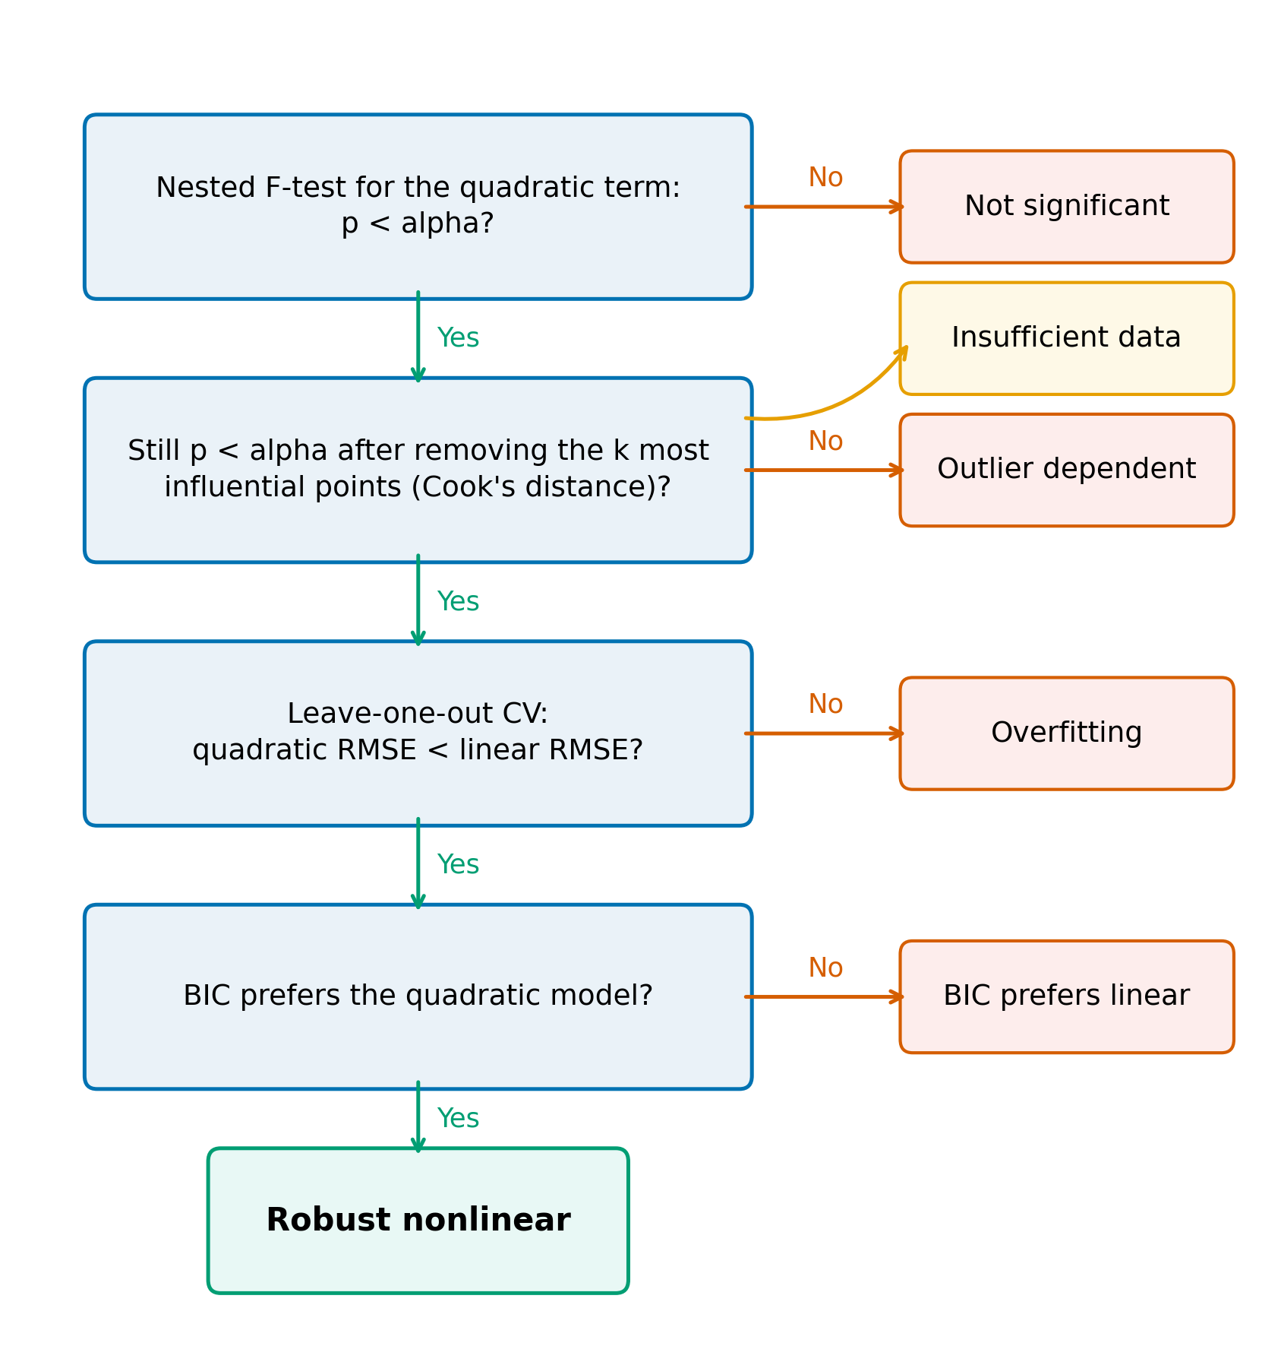
Figure 1. Decision tree used to classify each canonical curve. Each curve is fitted with linear and quadratic models; the verdict depends on the nested F-test at level alpha, the same test after removing the k most influential observations by Cook's distance, leave-one-out cross-validated prediction error, and the Bayesian information criterion. Default alpha = 0.05, k = 3.

Findings
At the default thresholds, 34 of 50 curves (68%) are not robustly nonlinear: 27 show no significant curvature in the full sample, 4 lose it when the most influential points are removed, 1 fit worse out of sample than a straight line, and 2 have too few observations to test (Table 1). The share that is not robust ranges from 60% to 74% across the threshold grid (Figure 2); no reasonable choice of alpha or k brings it below half. The two curves that motivate our policy cases illustrate two different ways in which a canonical relationship can be weakly supported. The Laffer curve, estimated on top statutory personal income-tax rates and total tax revenue for 29 OECD countries, shows no significant curvature at all (quadratic-term p = 0.06): in the range of rates actually observed, revenue rises with the rate and there is no detectable peak. The LNT relationship, estimated on 21 dose-response points from the Life Span Study of atomic-bomb survivors (Ozasa et al., 2012), is consistent with a straight line (p = 0.15), which is what the model asserts; but only 6 of those points lie below 0.1 Gy, and in that region a linear, a threshold, and a curvilinear response fit equally well. The shape the model asserts is supported where doses are high and untested where protective policy operates, a limitation long recognised in radiation epidemiology (Brenner et al., 2003); LNT is adopted in protection standards as a prudent assumption, not as a measured curve (ICRP, 2007).
Table 1. Verdicts for 50 canonical curves at the default thresholds (alpha = 0.05, k = 3), by field.
Category | Robust nonlinear | Not significant | Outlier dependent | Overfitting | Insufficient data | Total
Agriculture | 2 | 1 | 0 | 0 | 1 | 4
Demography | 2 | 3 | 0 | 0 | 1 | 6
Economics | 3 | 8 | 1 | 0 | 0 | 12
Environmental Science | 2 | 3 | 1 | 0 | 0 | 6
Physics | 1 | 2 | 1 | 0 | 0 | 4
Political Science | 2 | 2 | 1 | 0 | 0 | 5
Psychology | 1 | 2 | 0 | 0 | 0 | 3
Public Health | 3 | 6 | 0 | 1 | 0 | 10
Total | 16 | 27 | 4 | 1 | 2 | 50
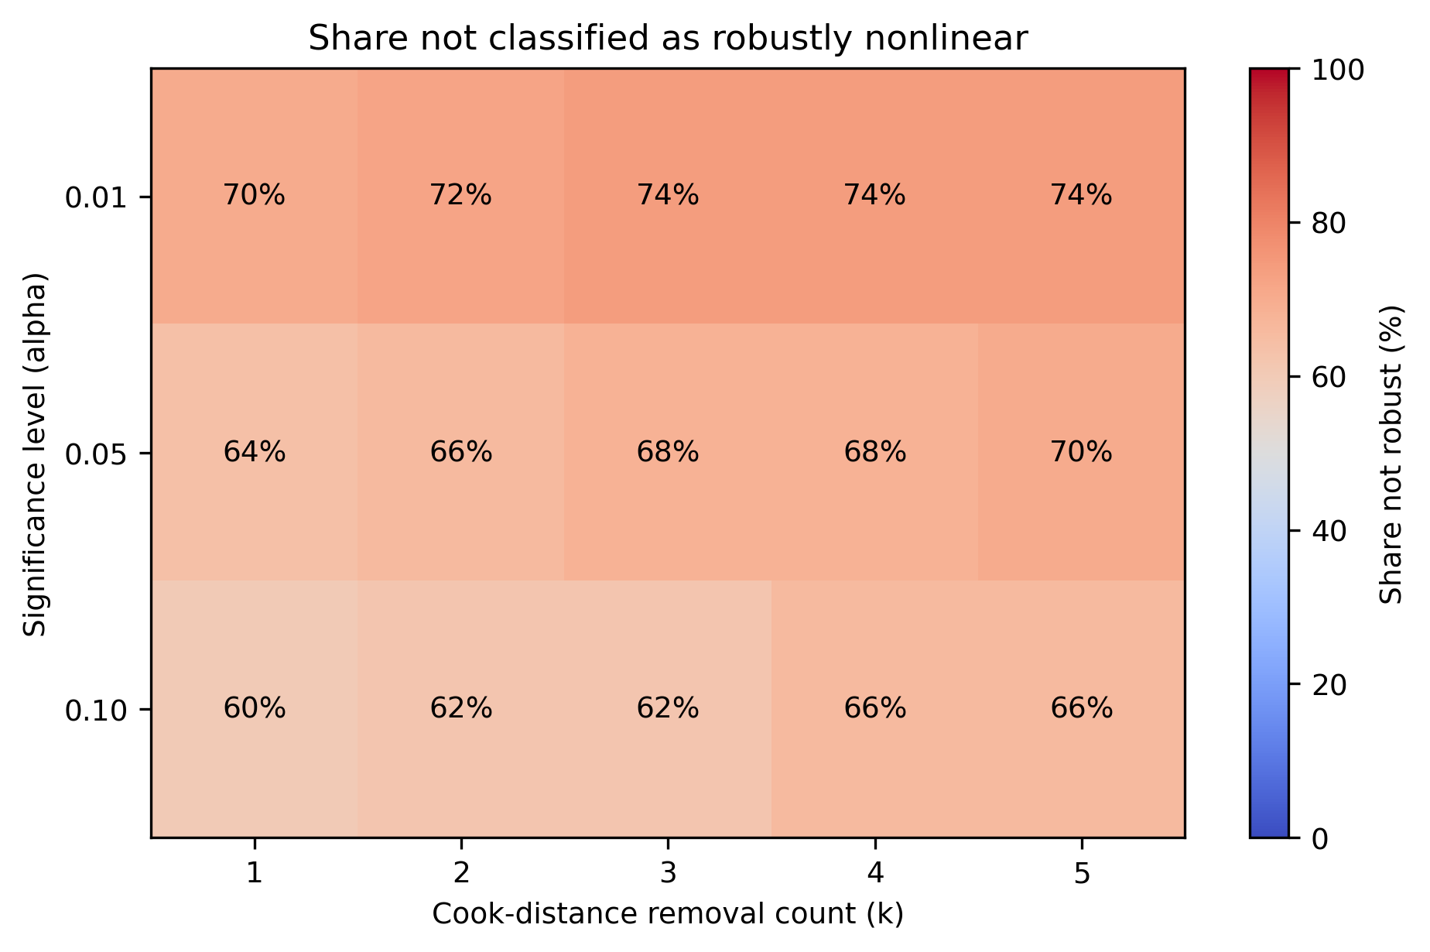
Figure 2. Share of the 50 canonical curves not classified as robustly nonlinear, by significance level alpha and number of influential observations removed k. The default cell (alpha = 0.05, k = 3) gives 68%.
We stress what this exercise does not show. A non-significant quadratic term in a small aggregate dataset is not evidence that a relationship is absent, and several curves in the robust group (the Keeling curve, Kleiber's law) are physical regularities of a different character from the social-science curves that dominate the list. The point is that the empirical footing of these relationships varies enormously, in a way that their common label of canonical conceals, and that a policy analyst has no way of knowing which kind of curve is being invoked without checking.

The Fukushima Evacuation and the Linear No-Threshold Model

Policy background
After the accident of 11 March 2011, the Japanese government ordered evacuation within 20 km of the plant (the restricted area), designated additional municipalities to the northwest where projected first-year doses exceeded 20 mSv as deliberate evacuation areas, and asked residents of a 20-30 km ring to prepare for evacuation. The 20 mSv per year reference level is the lower bound of the 20-100 mSv band that ICRP Publication 103 recommends for emergency exposure situations, itself derived from LNT risk coefficients (ICRP, 2007). Roughly 160,000 residents of the affected municipalities were displaced; many remained displaced for years, and orders for parts of the area were not lifted until the 2020s. The health costs of protracted evacuation for the elderly were recognised early: mortality among evacuated nursing-home residents rose sharply in the months after relocation (Yasumura et al., 2013; Nomura et al., 2013), and later analyses concluded that, for this group, the risk from relocation exceeded the radiation risk avoided (Murakami et al., 2015; Hasegawa et al., 2015). Population-level projections of radiation harm from the release, by contrast, were small: the best estimate of worldwide excess cancer deaths was 130 (range 15-1,100) (ten Hoeve & Jacobson, 2012), and both the WHO and UNSCEAR assessments concluded that no discernible increase in radiation-related health effects was expected in the general population (WHO, 2013; UNSCEAR, 2014). The same authors estimated that the evacuation itself prevented 28 radiation-related deaths (range 3-245) (ten Hoeve & Jacobson, 2012). These projections are themselves LNT-based, so they represent what the model itself says the evacuation could have averted.
Two features of this setting matter for the design. First, the evacuation orders coincided with the earthquake and tsunami, which killed residents of coastal municipalities whether or not they were later evacuated, so a comparison of evacuated and non-evacuated municipalities in 2011 confounds the two. We therefore separate 2011 from the years that follow and decompose the 2011 spike using official counts of direct disaster deaths. Second, the population at risk is defined by registration rather than by residence: evacuees who kept their registration in the home municipality remain in the denominator, and their deaths are in principle attributed to the home municipality. Whether that attribution is complete in practice is a question we return to when interpreting the post-2011 estimates.

Data
We built a municipality-year panel for all 307 municipalities in Fukushima and the seven surrounding prefectures (Miyagi, Iwate, Yamagata, Ibaraki, Tochigi, Gunma, Niigata) for 2005-2022. Deaths come from the Vital Statistics municipal tables; population denominators come from the Basic Resident Register counts published by the Ministry of Internal Affairs and Communications, which record residents by registered address and therefore continue to count evacuees who kept their registration in the home municipality. Age structure comes from the 2010 Population Census. Municipal mergers are handled by aggregating predecessor units into the successor municipality; because several mergers were completed during 2005, that year is used only descriptively and estimation starts in 2006. The resident-register series switched from Japanese nationals to all residents in 2013; we report a specification that uses a constant-scope series as a robustness check. Treatment status follows the official evacuation-order designations. The main treated group (T1) is the 10 municipalities with any territory in the restricted or deliberate evacuation areas; a subset (T1w, 4 municipalities) was evacuated in its entirety; a separate group (T2, 2 municipalities) was in the emergency evacuation preparation area only. Because the tsunami killed residents of coastal municipalities regardless of evacuation status, control municipalities whose 2011 deaths exceeded 1.2 times their 2006-2010 mean are excluded, leaving 191 controls with complete 2005-2019 data. Of the 307 municipalities and wards that exist in 2019, 47 are dropped because a population or death count is missing in at least one year or because the unit cannot be followed under a single code over the whole period; the drops are concentrated in Miyagi (15) and Niigata (12) (Appendix Table A1 lists them by prefecture and reason). Direct disaster deaths by municipality are taken from the Fukushima Prefecture damage report (Fukushima Prefecture, 2014), and certified disaster-related deaths from the Reconstruction Agency (Reconstruction Agency, 2026).

Empirical strategy
The outcome is the log crude death rate, ln(CDR), where CDR is deaths per 1,000 registered residents. The main estimator is a two-way fixed-effects difference-in-differences model,
$$ln(CDR_it) = {alpha}_{i} + {gamma}_{t} + beta D_it + {epsilon}_{it}$$
where D_it equals one for treated municipalities from 2012 onwards, ${alpha}_{i}$ and ${gamma}_{t}$ are municipality and year effects, and ${epsilon}_{it}$ is the error. The coefficient $beta$ is the average post-2011 treatment effect on log mortality; 2011 is excluded from the estimation sample because it mixes the direct disaster with the first months of evacuation, and is analysed separately below. An event-study version replaces bD_it with year-specific coefficients relative to 2010, which we use to inspect pre-trends. We report eight specifications for T1: controls drawn from all eight prefectures or from Fukushima only, observations unweighted or weighted by 2010 population, and with or without an interaction of the 2010 share aged 65 and over with year effects. The unweighted, Fukushima-only specification is the preferred one, because Fukushima controls share the prefecture-level shocks of the accident (evacuee inflows, reconstruction spending) and because weighting would let the largest treated city, Minamisoma, dominate a group of ten. With ten treated clusters, cluster-robust standard errors are unreliable (Bertrand et al., 2004; Cameron et al., 2008; Conley & Taber, 2011), so inference is by permutation: we re-assign treatment to 1000 random sets of control municipalities of the same size and report the share of placebo effects at least as large in absolute value as the estimate. The same permutation distribution provides a pre-trend test based on the sum of squared 2006-2009 event-study coefficients. As a second design we estimate a synthetic control (Abadie et al., 2010; Abadie, 2021) for the pooled T1 series and for each treated municipality, with donors restricted to Fukushima controls whose 2010 share aged 65 and over lies within 10 percentage points of the treated unit; with only five pre-treatment years and 25 donors the pre-period fit is exact, so we report a cross-fit (weights from 2006-2008, error in 2009-2010) as the honest measure of fit and treat the synthetic-control results as secondary.
The 2011 spike is decomposed as follows. Expected 2011 deaths for each treated municipality are its 2011 registered population times its 2010 death rate, scaled by the ratio of pooled control death rates in 2011 to 2010; excess deaths are observed minus expected; and residual excess is excess minus the officially counted direct disaster deaths. The residual is an upper bound on deaths attributable to the acute phase of evacuation within the calendar year, because some indirect deaths would also have occurred without the evacuation orders.

Results
Figure 3 shows pooled crude death rates. Before 2011 the evacuated municipalities track the Fukushima controls; in 2011 the T1 rate jumps by about 51%; from 2012 it falls below the control trend and stays there. Event-study coefficients (Figure 4) show no systematic pre-trend in the preferred specification (permutation p for the joint pre-period test = 0.314), a 2011 coefficient of 0.191 log points, and negative coefficients in every year from 2012 to 2019.
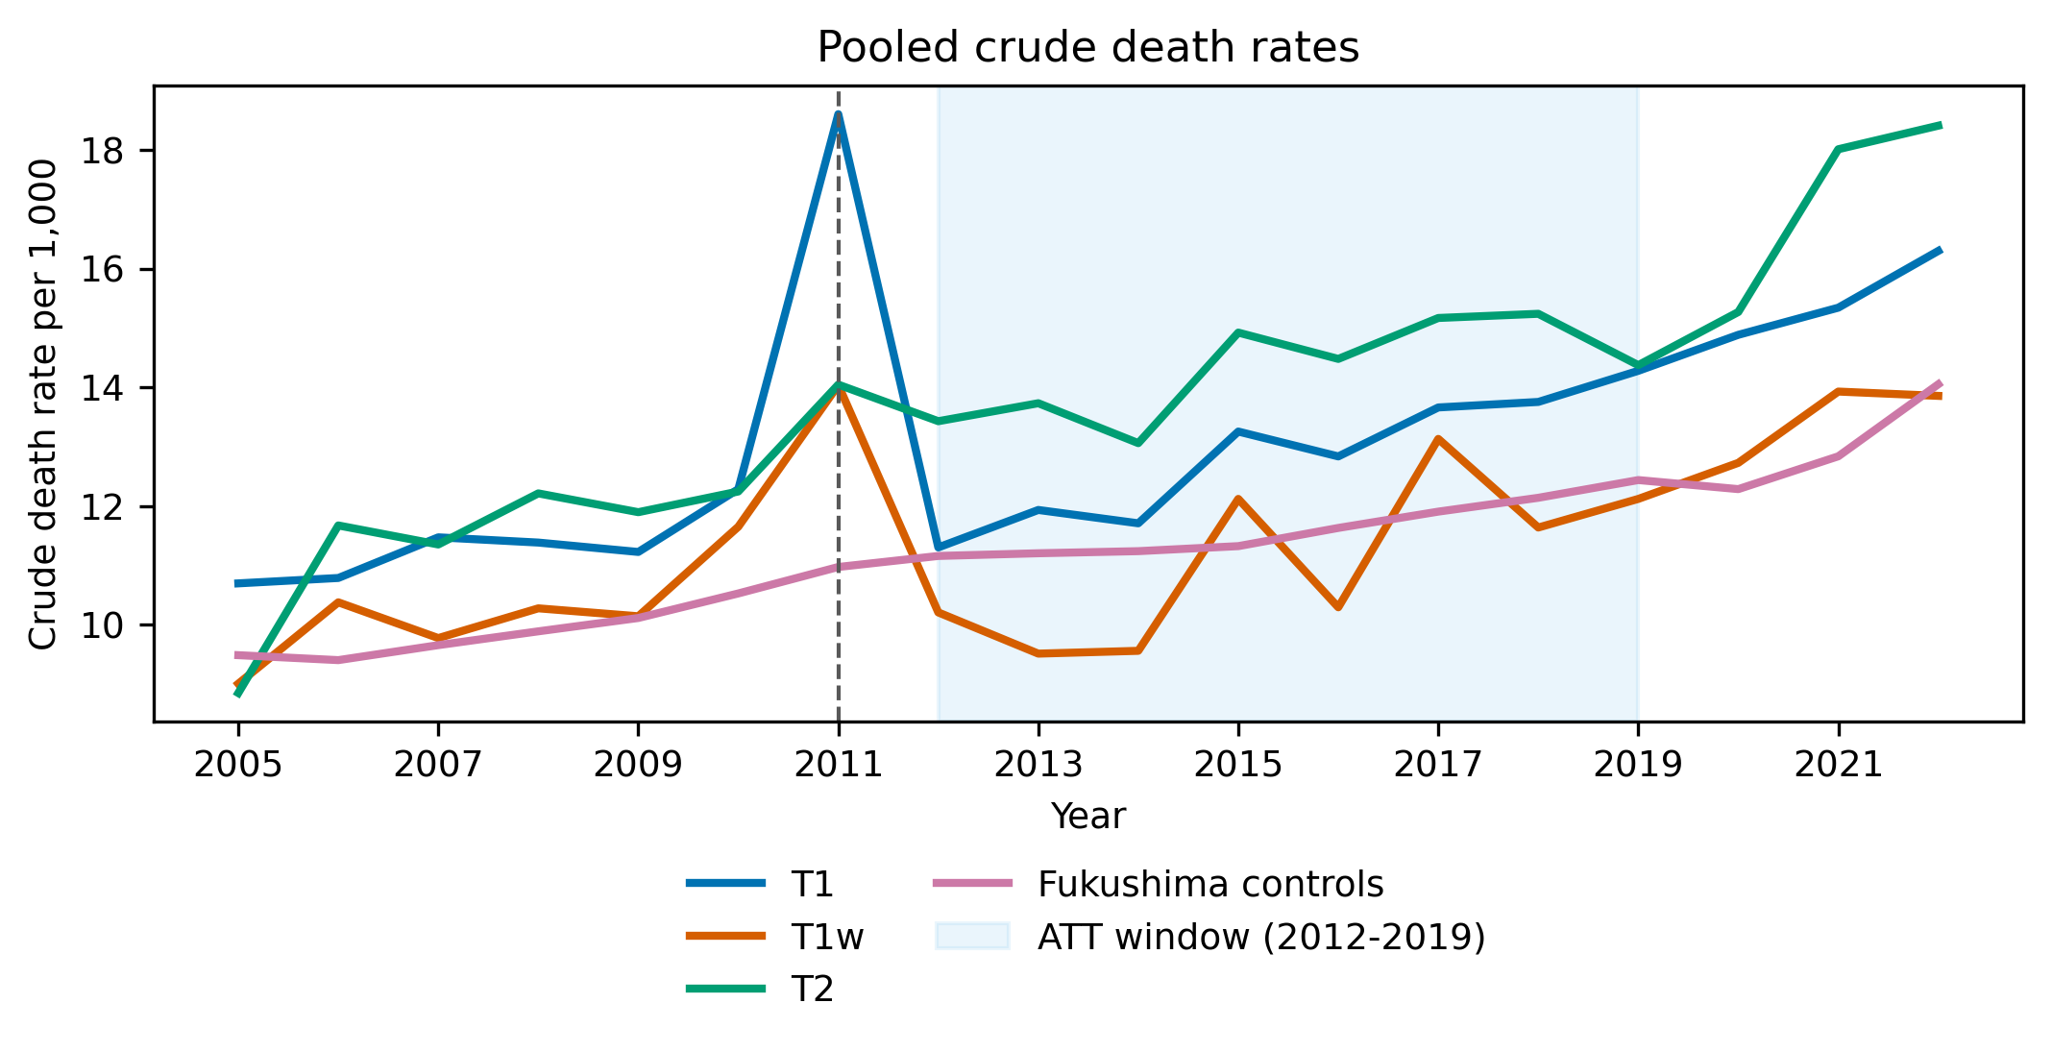
Figure 3. Crude death rate per 1,000 registered residents, 2005-2022, for municipalities in the restricted or deliberate evacuation areas (T1), the subset evacuated in full (T1w), the emergency evacuation preparation area (T2), and Fukushima control municipalities. Deaths from Vital Statistics; population from the Basic Resident Register. Shaded years (2020-2022) are outside the estimation sample.
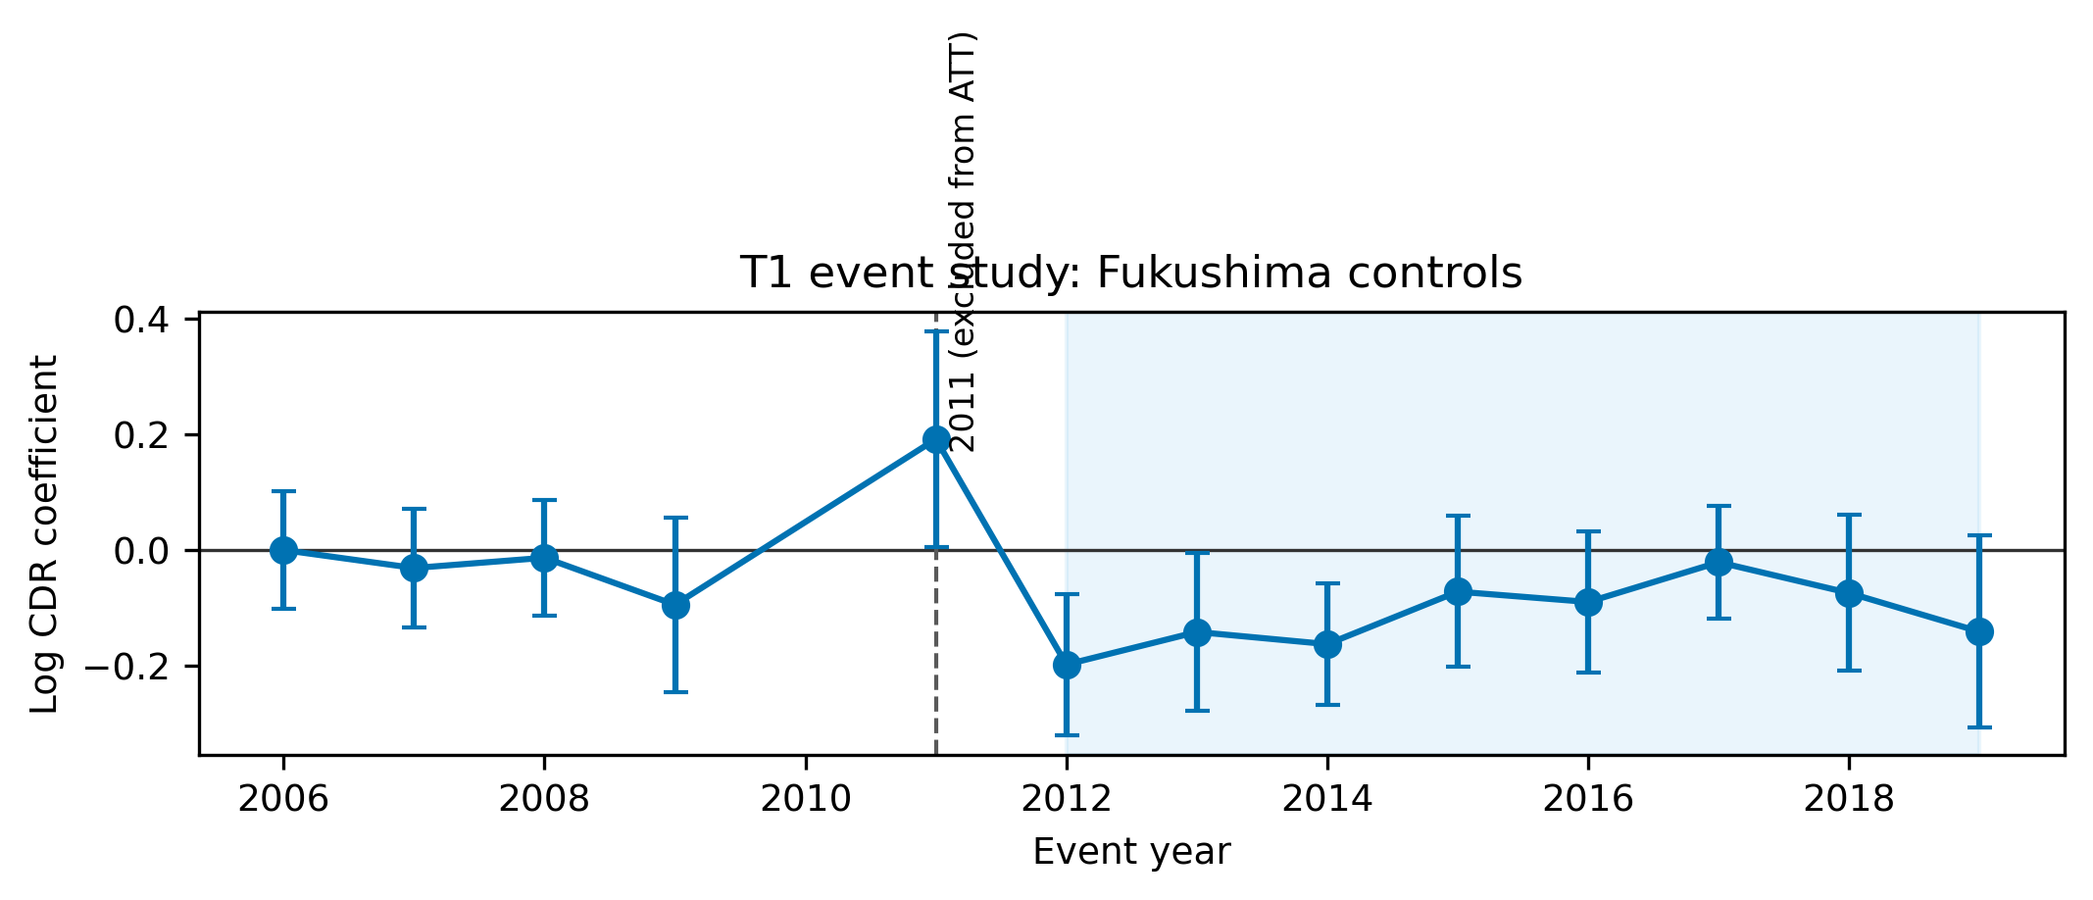
Figure 4. Event-study estimates of the effect of evacuation orders on log crude death rate, T1 municipalities versus Fukushima controls, unweighted, reference year 2010. Points are coefficients; bars are 95% confidence intervals from municipality-clustered standard errors, shown for reference only; inference in the text uses permutation.
Table 2 reports the difference-in-differences estimates. In the preferred specification the 2012-2019 log death rate in T1 municipalities is -0.085 (permutation p = 0.001), that is, about 8% below the counterfactual. The estimate is negative and of similar size in all eight T1 specifications (range -0.085 to -0.057), larger in magnitude for the wholly evacuated municipalities (T1w: -0.129, p = < 0.001), and close to zero with permutation p above 0.421 in every specification for the preparation-area group (T2), whose residents were largely not displaced. Pre-trend permutation p-values exceed 0.05 in all specifications except the unweighted all-prefecture T1 models (0.035), where the 2009 coefficient is negative. Restricting the resident-register series to a constant scope changes the T1 estimate to -0.067. The pooled synthetic control gives a 2012-2019 mean gap of -0.060 log points (permutation p = 0.077; cross-fit RMSPE 0.045), and 8 of the 10 municipality-level synthetic controls have negative post-period gaps (Appendix Table A2).
Table 2. Difference-in-differences estimates of the effect of evacuation orders on log crude death rate, 2012-2019 versus 2006-2010, 2011 excluded. Permutation p-values from 1000 random re-assignments of treatment among control municipalities; pre-trend p from the same distribution of the sum of squared 2006-2009 event-study coefficients. Excess deaths are implied by the estimate applied to observed deaths.
Group | Controls | Weighting | Age control | ATT (log points) | Permutation p | Pre-trend p | Implied deaths 2012-2019
T1 | All prefectures | Weighted | No | -0.057 | 0.002 | 0.268 | -877
T1 | All prefectures | Weighted | Yes | -0.066 | < 0.001 | 0.335 | -1,018
T1 | All prefectures | Unweighted | No | -0.072 | 0.002 | 0.039 | -1,123
T1 | All prefectures | Unweighted | Yes | -0.072 | < 0.001 | 0.035 | -1,109
T1 | Fukushima only | Weighted | No | -0.085 | < 0.001 | 0.847 | -1,333
T1 | Fukushima only | Weighted | Yes | -0.083 | < 0.001 | 0.863 | -1,291
T1 | Fukushima only | Unweighted | No | -0.085 | 0.001 | 0.314 | -1,322
T1 | Fukushima only | Unweighted | Yes | -0.079 | 0.005 | 0.275 | -1,224
T1w | All prefectures | Unweighted | No | -0.116 | 0.003 | 0.170 | -405
T1w | Fukushima only | Unweighted | No | -0.129 | < 0.001 | 0.498 | -451
T2 | All prefectures | Unweighted | No | -0.022 | 0.581 | 0.829 | -93
T2 | Fukushima only | Unweighted | No | -0.034 | 0.421 | 0.932 | -146
The 2011 decomposition (Figure 5, Table 3) puts the acute-phase burden in perspective. The ten T1 municipalities recorded 2,996 deaths in 2011 against 2,060 expected, an excess of 936. Officially counted direct disaster deaths in these municipalities number 732, 78% of the excess and concentrated in the coastal towns of Minamisoma and Namie. The residual, 204 deaths, is our upper bound on evacuation-related mortality recorded in the home municipalities during 2011. Over 2012-2019 the preferred estimate implies 1,322 fewer deaths than the counterfactual, about 165 per year. Prefecture-wide, the Reconstruction Agency has certified 2350 disaster-related deaths in Fukushima as of February 13, 2026, an administrative count based on family applications that is not confined to the evacuated municipalities and is not directly comparable to our estimates.
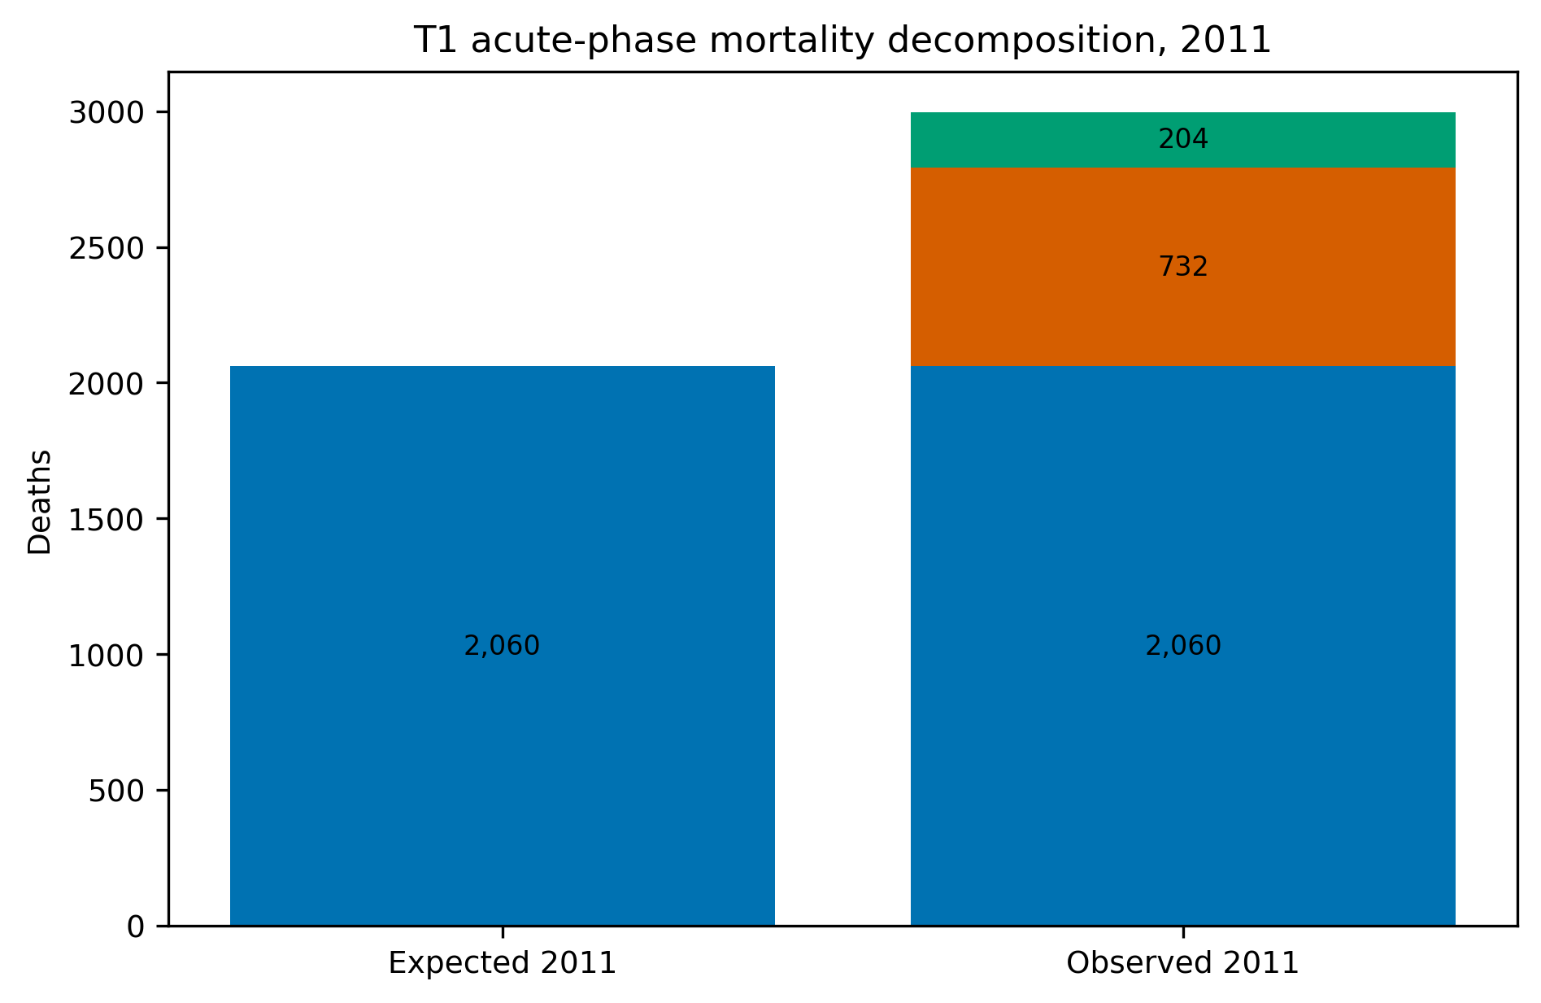
Figure 5. Decomposition of 2011 deaths in evacuated municipalities into expected deaths, direct disaster deaths, and residual excess. Expected deaths are 2011 population times the 2010 death rate, scaled by the change in the pooled control death rate. Direct deaths from the Fukushima Prefecture damage report.
Table 3. Measured and projected mortality associated with the Fukushima Daiichi accident. Measured quantities are from this paper's estimates or official counts; projected quantities are LNT-based assessments, quoted from the cited source.
Quantity | Value | Scope | Type | Source
T1 observed deaths 2011 | 2,996 | T1 municipalities | Measured | This study
T1 expected deaths 2011 | 2,060 | T1 municipalities | Measured | This study
T1 excess deaths 2011 | 936 | T1 municipalities | Measured | This study
Of which direct disaster deaths | 732 | T1 municipalities | Measured | Fukushima Prefecture, 2014
T1 residual excess deaths 2011 | 204 | T1 municipalities | Measured | This study
T1 implied difference 2012-2019 (recorded) | -1,322 | T1 municipalities | Measured | This study
Certified disaster-related deaths, Fukushima Prefecture | 2,350 | Fukushima prefecture | Measured | Reconstruction Agency, 2026
Projected worldwide cancer deaths from the release | 130 (15-1,100) | Worldwide | Projected (LNT-based) | ten Hoeve & Jacobson, 2012
Evacuation-avoided radiological mortalities | 28 (3-245) | Worldwide | Projected (LNT-based) | ten Hoeve & Jacobson, 2012
Lifetime-risk relative increases in the most affected areas | leukaemia up to 7%; breast up to 6%; all solid cancers up to 4%; thyroid up to 70% | Most affected areas | Projected (LNT-based) | WHO, 2013
WHO conclusion outside Japan | no discernible increase | Outside Japan | Projected (LNT-based) | WHO, 2013
Collective effective dose | 18 / 36 / 48 thousand man-Sv (first year / ten years / lifetime) | Japanese population | Projected (LNT-based) | UNSCEAR, 2014
UNSCEAR conclusion | no discernible increase expected | Exposed population | Projected (LNT-based) | UNSCEAR, 2014

The Kansas Tax Cuts and the Laffer Curve

Policy background
In May 2012 Kansas enacted Senate Substitute for House Bill 2117, which cut the top individual income-tax rate from 6.45% to 4.9%, collapsed the brackets, and exempted pass-through business income from taxation (Kansas Legislature, 2012), with further scheduled reductions enacted in 2013. Arthur Laffer advised the governor on the plan, and the argument that growth would offset the revenue loss was central to its public defence (Rothschild, 2012). The legislature reversed most of the cuts in June 2017 over the governor's veto. The Kansas episode has been studied as a natural experiment (Rickman & Wang, 2018) and its fiscal outcome is not in serious dispute, which is why we use it here to calibrate the methods. Kansas is also a reminder that a state economy has shocks of its own: the aircraft industry around Wichita, farm incomes exposed to commodity prices, and oil and gas extraction all moved over 2013-2017 for reasons unrelated to the tax code. The synthetic-control design addresses this by weighting donor states to match the pre-2013 path of each outcome, and we check the result against a pool that excludes states with contemporaneous income-tax reforms and against a pool that does not.

Data and strategy
We assembled a panel of the 50 states and the District of Columbia for 1997-2023 from the Federal Reserve Bank of St. Louis FRED database (real and nominal GDP, population, nonfarm employment, unemployment) and the Census Bureau's Annual Survey of State Government Tax Collections (total taxes and individual income taxes), deflated to 2012 dollars with the CPI. Outcomes are log real GDP per capita, log nonfarm employment, log real total tax revenue per capita, and log real individual income-tax revenue per capita. The synthetic control for Kansas is fitted on 1997-2012 with nonnegative weights summing to one; the main donor pool excludes 16 states that either enacted large income-tax changes in the same window or levy no broad-based income tax, leaving 33 donors, and an all-state pool is reported as a check. Inference is by placebo-in-space permutation of the ratio of post- to pre-treatment root-mean-squared prediction error (Abadie et al., 2010). We also report an in-time placebo with a pseudo-treatment in 2005, leave-one-donor-out estimates, and difference-in-differences event studies against the four neighbouring states (Nebraska, Missouri, Colorado, Iowa) and against the main pool. The main post-period is 2013-2017; 2018-2019 are shown to cover the reversal, and 2020 onwards is descriptive only.

Results
Figure 6 and Table 4 summarise the results. Real individual income-tax revenue per capita fell 27% below its synthetic counterpart on average over 2013-2017 (permutation p = 0.03; 26% with the all-state pool), a gap that widened from 91 to 422 dollars per resident between 2013 and 2016 and cumulates to about 4.6 billion 2012 dollars over five years. Total tax revenue per capita was 3.0% below the counterfactual (p = 0.18), reflecting the sales-tax increases enacted to offset the shortfall. Real GDP per capita (+1.5%, p = 0.71) and employment (-1.3%, p = 0.47) show no detectable departure from the counterfactual; the in-time placebo produces gaps of 0.006 to 0.056 log points for these outcomes, so effects of the size observed for output and employment are within the range the method produces when nothing happened, while the income-tax gap is several times larger than its placebo. Leave-one-out estimates for the income-tax outcome lie between -0.322 and -0.291. The neighbour-state event studies (Appendix Figure A1) agree in sign and show no pre-trend in the income-tax series.
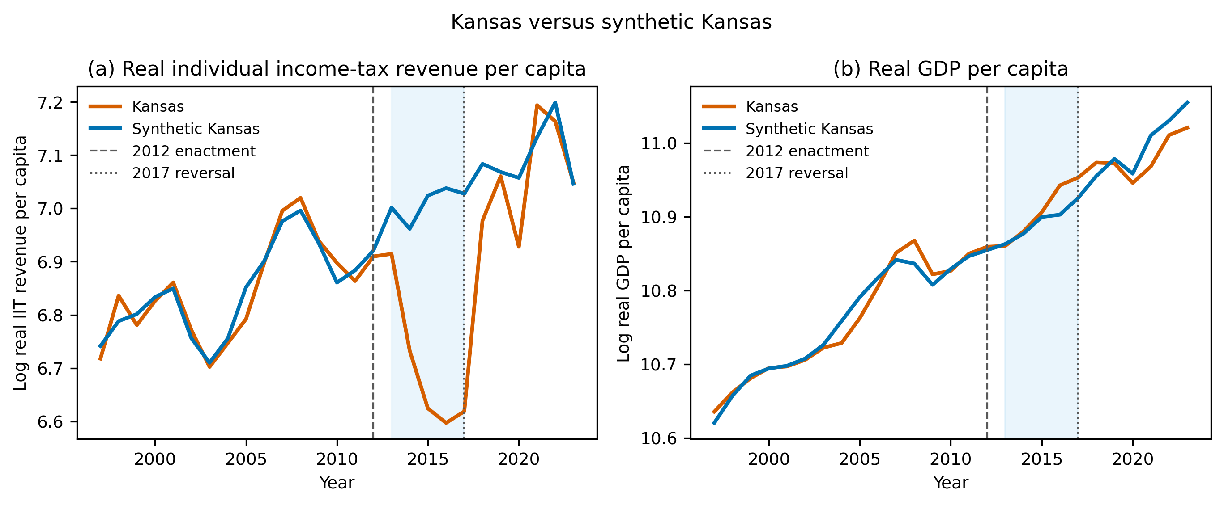
Figure 6. Kansas versus synthetic Kansas, main donor pool: log real individual income-tax revenue per capita (left) and log real GDP per capita (right), 1997-2019. Vertical lines mark the 2012 enactment and the 2017 reversal. Synthetic series are convex combinations of 33 donor states fitted on 1997-2012.
Table 4. Synthetic-control estimates for Kansas, 2013-2017 mean gap relative to synthetic Kansas. Permutation p is the rank of the Kansas post/pre RMSPE ratio among all donors. In-time placebo assigns a pseudo-treatment in 2005 and reports the 2005-2012 mean gap.
Outcome | Pool | Mean gap | Gap (%) | Permutation p | Pre-RMSPE | donors | in-time placebo | LOO range
Real GDP per capita | Main | 0.015 | +1.5% | 0.71 | 0.015 | 33 | 0.056 | 0.009 to 0.029
Real GDP per capita | All states | -0.004 | -0.4% | 0.49 | 0.007 | 50 | 0.056 | -
Nonfarm employment | Main | -0.013 | -1.3% | 0.47 | 0.004 | 33 | 0.006 | -0.014 to -0.001
Nonfarm employment | All states | -0.001 | -0.1% | 0.96 | 0.003 | 50 | 0.006 | -
Real total tax revenue per capita | Main | -0.031 | -3.0% | 0.18 | 0.013 | 32 | 0.075 | -0.039 to -0.028
Real total tax revenue per capita | All states | 0.030 | +3.1% | 0.12 | 0.010 | 49 | 0.075 | -
Real individual income-tax revenue per capita | Main | -0.313 | -26.9% | 0.03 | 0.025 | 32 | 0.103 | -0.322 to -0.291
Real individual income-tax revenue per capita | All states | -0.301 | -26.0% | 0.02 | 0.019 | 42 | 0.103 | -

Discussion

What the two cases show
In neither case did the outcome the curve promised materialise. Kansas cut income taxes and collected substantially less income tax, with no visible growth dividend within five years, which is the result the existing literature reports and which our methods recover. The Fukushima case is more complicated and we want to be careful about what it does and does not show. The mortality cost of the evacuation that is visible in municipal vital statistics is concentrated in 2011: several hundred deaths above expectation beyond those directly caused by the earthquake and tsunami, consistent with the cohort evidence on evacuated nursing-home residents. Over 2012-2019 we find no persistent excess; instead, recorded death rates in the evacuated municipalities run 6-14% below the counterfactual across the T1 and T1w specifications.
We do not read the post-2011 deficit as a health benefit of evacuation. Three mechanisms could produce it, and the data cannot cleanly separate them. First, mortality displacement: the 2011 excess brought forward deaths of frail residents who would otherwise have died in the following years. This alone cannot explain the whole deficit, which cumulates to more than the 2011 residual excess. Second, recording: vital statistics attribute a death to the address on the death notification, and long-term evacuees who died in institutions elsewhere may have been recorded there even while they remained on the home municipality's resident register, which would depress the numerator relative to the denominator. Third, selective de-registration: residents who moved their registration to the host municipality were removed from both numerator and denominator, and if those who left the register were older or frailer than those who stayed, the remaining registered population is healthier than the pre-accident one. The second and third mechanisms are measurement artefacts of protracted displacement, and the fact that the deficit is largest in the wholly evacuated municipalities, where displacement was total, and absent in the preparation-area municipalities, where it was brief, points in their direction. The methodological lesson is that municipal vital statistics can measure the acute mortality cost of an evacuation but not its chronic cost; the latter requires individual follow-up of the displaced population.
Against these costs stands the benefit the LNT model predicts the evacuation averted. The published LNT-based projections for the entire release put worldwide excess cancer deaths at 130 (range 15-1,100), and the WHO and UNSCEAR assessments, which assume LNT, concluded that no increase would be discernible in the exposed population (Table 3). The acute-phase residual we measure in ten municipalities, 204 deaths, exceeds the model's own best estimate of the deaths the evacuation prevented (28) and is of the same order as its estimate of the cancer deaths the entire release will eventually cause worldwide (130). It is also a count of recorded deaths rather than a projection. We do not conclude that the evacuation was wrong: the decision was taken under uncertainty about how the release would evolve, and the short-range evacuation in the first days is not what our estimates speak to. Our point concerns the protracted orders that followed, which were tied to a 20 mSv reference level whose empirical basis, as Section 2 shows, is an extrapolation into a dose range where the data used to support it cannot distinguish a linear response from a threshold. A policy that displaces tens of thousands of people for years on the strength of such a relationship deserves an explicit comparison of projected harm avoided against measured harm caused; that comparison was not made at the time and, when made retrospectively, does not favour the policy as implemented.

Implications for policy analysis
The two cases differ in almost every respect - country, outcome, unit of analysis, the direction of the error - and that is the point. What they share is a decision that treated the shape of a relationship as settled when the evidence for that shape, in the range where the decision operated, was thin. The audit in Section 2 suggests this is the normal condition of canonical curves rather than an unlucky pair. The practical question is what an analyst can do about it before a policy is adopted, rather than years afterwards.
The decision tree we used for the audit is a reasonable template. Its four steps ask whether the curvature is statistically distinguishable from a straight line in data from the relevant population, whether that finding depends on a handful of observations, whether the curved model predicts better out of sample, and whether a penalised criterion still prefers it. None of these steps is novel; their value is in being applied to the specific relationship a policy invokes, at the specific range of the explanatory variable where the policy will operate. For LNT the relevant range is below 0.1 Gy, where the audit finds 6 data points and no power to discriminate functional forms; for the Laffer curve it is the neighbourhood of a 6.45% state top rate, far below any rate at which the cross-country data show revenue turning down. A second, complementary step is to write down what the policy would cost if the curve were flat: a revenue loss equal to the static estimate in the Kansas case, and the mortality risk of relocating a population with a high share of elderly residents in the Fukushima case. Both quantities were knowable at the time, and both turned out to be the dominant term.
The methodological contribution is narrower but, we hope, transferable. Municipal vital statistics with permutation inference can measure the acute mortality cost of a mass evacuation and can rule out a large persistent excess in the registered population, but they cannot measure the chronic cost of protracted displacement, because displacement itself changes who is counted where. Evaluations of future evacuations, or of other policies that move people, should plan for individual-level follow-up of the displaced from the outset rather than rely on place-based statistics.

Limitations
The audit in Section 2 uses one dataset per curve and a single quadratic alternative; a curve could be robustly nonlinear in a form we did not fit, and several datasets are small. The Fukushima design has ten treated units, so inference rests on permutation rather than asymptotics and the power to detect a modest persistent excess is limited; the complete-case sample drops 47 of 307 municipalities, mainly where resident-register counts are unavailable for 2005-2010, and the tsunami exclusion rule conditions on a 2011 outcome, which we accept in order to keep the direct disaster out of the control group. The Kansas synthetic control has a pre-treatment fit of 0.025 log points for the income-tax outcome and an in-time placebo gap of 0.103 for the same outcome, so the point estimate should be read with a margin of roughly that size. Finally, two cases cannot establish that policies justified by canonical curves fail in general; they establish that two prominent ones did, and Section 2 gives reason to expect they are not alone.

Conclusion
Canonical curves are efficient ways to teach and to argue, and they will continue to enter policy debate. What we argue against is treating them as evidence. Most of the relationships we re-tested are not robust in public data, and the two policies we evaluated in detail delivered their costs without their promised benefits. The remedy is not exotic. Before a curve is used to justify a policy, the analyst can ask whether the relationship holds in data from the relevant population, whether it survives the removal of a few influential observations, whether a straight line predicts as well out of sample, and what the policy would cost if the curve turned out to be flat. Those checks take days, not years, and they would have flagged both cases studied here.

Notes
Artificial-intelligence assistance. An AI coding assistant (Devin, Cognition AI) was used to write and debug the data-acquisition, analysis, and document-generation code, and to draft and edit the manuscript text under the author's direction. All data sources, analytical choices, results, and interpretations were specified and verified by the author, who takes full responsibility for the content.

Data Availability Statement
All data used in this paper are public. The raw downloads, the scripts that reproduce every number, table, and figure from them, and the generated results are deposited in a public repository; the link is provided on the title page and will appear here on publication.

References
Abadie, A. (2021). Using synthetic controls: Feasibility, data requirements, and methodological aspects. Journal of Economic Literature, 59(2), 391-425. https://doi.org/10.1257/jel.20191450
Abadie, A., Diamond, A., & Hainmueller, J. (2010). Synthetic control methods for comparative case studies: Estimating the effect of California's tobacco control program. Journal of the American Statistical Association, 105(490), 493-505. https://doi.org/10.1198/jasa.2009.ap08746
Bertrand, M., Duflo, E., & Mullainathan, S. (2004). How much should we trust differences-in-differences estimates? Quarterly Journal of Economics, 119(1), 249-275. https://doi.org/10.1162/003355304772839588
Brenner, D. J., Doll, R., Goodhead, D. T., Hall, E. J., Land, C. E., Little, J. B., Lubin, J. H., Preston, D. L., Preston, R. J., Puskin, J. S., Ron, E., Sachs, R. K., Samet, J. M., Setlow, R. B., & Zaider, M. (2003). Cancer risks attributable to low doses of ionizing radiation: Assessing what we really know. Proceedings of the National Academy of Sciences, 100(24), 13761-13766. https://doi.org/10.1073/pnas.2235592100
Burnham, K. P., & Anderson, D. R. (2004). Multimodel inference: Understanding AIC and BIC in model selection. Sociological Methods & Research, 33(2), 261-304. https://doi.org/10.1177/0049124104268644
Cameron, A. C., Gelbach, J. B., & Miller, D. L. (2008). Bootstrap-based improvements for inference with clustered errors. Review of Economics and Statistics, 90(3), 414-427. https://doi.org/10.1162/rest.90.3.414
Cartwright, N., & Hardie, J. (2012). Evidence-based policy: A practical guide to doing it better. Oxford University Press.
Conley, T. G., & Taber, C. R. (2011). Inference with "difference in differences" with a small number of policy changes. Review of Economics and Statistics, 93(1), 113-125. https://doi.org/10.1162/REST_a_00049
Cook, R. D. (1977). Detection of influential observation in linear regression. Technometrics, 19(1), 15-18. https://doi.org/10.1080/00401706.1977.10489493
Fukushima Prefecture. (2014). Heisei 23 Tohoku Chiho Taiheiyo-oki Jishin ni yoru Higai Jokyo Sokuho (No. 1260) [Damage situation bulletin on the 2011 Tohoku Pacific Coast earthquake, No. 1260]. https://www.pref.fukushima.lg.jp/uploaded/attachment/422314.pdf
Hasegawa, A., Tanigawa, K., Ohtsuru, A., Yabe, H., Maeda, M., Shigemura, J., Ohira, T., Tominaga, T., Akashi, M., Hirohashi, N., Ishikawa, T., Kamiya, K., Shibuya, K., Yamashita, S., & Chhem, R. K. (2015). Health effects of radiation and other health problems in the aftermath of nuclear accidents, with an emphasis on Fukushima. The Lancet, 386(9992), 479-488. https://doi.org/10.1016/S0140-6736(15)61106-0
ICRP. (2007). The 2007 recommendations of the International Commission on Radiological Protection. ICRP Publication 103. Annals of the ICRP, 37(2-4). https://doi.org/10.1016/j.icrp.2007.10.003
Kansas Legislature. (2012). House Bill No. 2117, enrolled. 2012 Session Laws of Kansas, Chapter 135. https://kslegislature.org/li_2012/b2011_12/measures/documents/hb2117_enrolled.pdf
Laffer, A. B. (2004). The Laffer curve: Past, present, and future (Backgrounder No. 1765). The Heritage Foundation.
Murakami, M., Ono, K., Tsubokura, M., Nomura, S., Oikawa, T., Oka, T., Kami, M., & Oki, T. (2015). Was the risk from nursing-home evacuation after the Fukushima accident higher than the radiation risk? PLoS ONE, 10(9), e0137906. https://doi.org/10.1371/journal.pone.0137906
Nomura, S., Gilmour, S., Tsubokura, M., Yoneoka, D., Sugimoto, A., Oikawa, T., Kami, M., & Shibuya, K. (2013). Mortality risk amongst nursing home residents evacuated after the Fukushima nuclear accident: A retrospective cohort study. PLoS ONE, 8(3), e60192. https://doi.org/10.1371/journal.pone.0060192
Ozasa, K., Shimizu, Y., Suyama, A., Kasagi, F., Soda, M., Grant, E. J., Sakata, R., Sugiyama, H., & Kodama, K. (2012). Studies of the mortality of atomic bomb survivors, Report 14, 1950-2003: An overview of cancer and noncancer diseases. Radiation Research, 177(3), 229-243. https://doi.org/10.1667/RR2629.1
Reconstruction Agency. (2026). Number of disaster-related deaths from the Great East Japan Earthquake [in Japanese]. https://www.reconstruction.go.jp/files/user/topics/main-cat2/sub-cat2-6/20260213_kanrenshi.pdf
Rickman, D. S., & Wang, H. (2018). Two tales of two U.S. states: Regional fiscal austerity and economic performance. Regional Science and Urban Economics, 68, 46-55. https://doi.org/10.1016/j.regsciurbeco.2017.10.008
Rothschild, S. (2012, January 19). Consultant Laffer praises Brownback's tax plan. Lawrence Journal-World. https://www2.ljworld.com/news/2012/jan/19/consultant-laffer-touts-brownbacks-tax-plan/
UNSCEAR. (2014). Sources, effects and risks of ionizing radiation: UNSCEAR 2013 report to the General Assembly, Volume I, Scientific Annex A. United Nations. https://www.unscear.org/unscear/uploads/documents/unscear-reports/UNSCEAR_2013_Report_Vol.I.pdf
WHO. (2013). Health risk assessment from the nuclear accident after the 2011 Great East Japan earthquake and tsunami, based on a preliminary dose estimation. World Health Organization. ISBN 9789241505130. https://iris.who.int/server/api/core/bitstreams/3cc74066-fdcf-46ed-8e94-e2c7bc6e7eae/content
Wanniski, J. (1978). Taxes, revenues, and the "Laffer curve". The Public Interest, 50, 3-16.
Yasumura, S., Goto, A., Yamazaki, S., & Reich, M. R. (2013). Excess mortality among relocated institutionalized elderly after the Fukushima nuclear disaster. Public Health, 127(2), 186-188. https://doi.org/10.1016/j.puhe.2012.10.019
ten Hoeve, J. E., & Jacobson, M. Z. (2012). Worldwide health effects of the Fukushima Daiichi nuclear accident. Energy & Environmental Science, 5(9), 8743-8757. https://doi.org/10.1039/c2ee22019a

