Functional-Form Dependence in Evidence-Based Policymaking: Mapping Canonical Relationships and Two Policy Demonstrations
Abstract
Evidence-based policymaking often relies not only on whether two variables are associated, but also on the assumed shape of their relationship. Thresholds, turning points, diminishing returns, and monotonic risk functions can determine whether a policy is adopted, how intensive it is, and which consequences count as acceptable. We define functional-form dependence as a condition in which a policy's justification, expected benefit, threshold, direction, or intensity materially depends on a relationship shape that is insufficiently identified over the policy-relevant range. We develop a decision-facing appraisal framework that separates association, shape identification, range validity, decision dependence, consequence asymmetry, and reversibility. A cross-domain mapping exercise then applies one transparent quadratic diagnostic to 50 canonical relationships. Under this deliberately common diagnostic, 34 of 50 relationship-dataset pairs (68%) did not meet the study's criteria for robust nonlinear identification, with a sensitivity range of 60-74%. Two contrasting demonstrations then examine policies linked to assumed shapes: post-Fukushima evacuation under low-dose radiation-risk assumptions and the Kansas tax reform associated with claims about tax-rate and revenue or growth responses. Neither demonstration identifies a single correct policy. Instead, each shows why policy appraisal should test the specific shape and range on which a decision depends, compare plausible alternatives, and account for asymmetric consequences. The proposed appraisal complements causal evaluation by making model-form conditionality explicit before policy commitments become difficult to reverse.
Keywords: evidence-based policymaking; functional form; model uncertainty; policy appraisal; robust policy design

Introduction
Many policy arguments depend on the shape of an empirical relationship. A threshold can trigger regulation, a U-shaped curve can identify an optimal interior level, diminishing returns can determine spending priorities, and a monotonic dose-response function can justify action even where direct evidence is sparse. These are stronger claims than the claim that two variables are associated. They specify how an outcome changes across values of an exposure, including where the direction, slope, or curvature changes. When a policy uses that shape to select a threshold, intensity, target group, or expected benefit, the functional form becomes part of the policy's evidentiary infrastructure.
The evidence-based policy literature has long shown that evidence does not enter policy as a neutral input. Its meaning is shaped by institutions, problem frames, values, and practices of use (Head, 2008; Wesselink et al., 2014; Capano & Malandrino, 2022). Technical evidence can also narrow attention or be used beyond the conditions under which it is informative (Parkhurst, 2016). Models add a further layer: acceptance depends not only on technical properties but also on supporting infrastructure and organizational conditions (Kolkman et al., 2016). Yet appraisal often concentrates on the credibility of an estimate or causal design while leaving a prior question implicit: is the relationship shape needed by the decision actually identified where the policy will operate? This omission can reinforce established policy frames even when appraisal reveals a mismatch between objectives and consequences (Dunlop, 2010).
Model uncertainty is the broader category. Functional-form uncertainty concerns the shape of a relationship, including thresholds, turning points, curvature, and extrapolation, while model-form uncertainty can also encompass other choices about the mathematical structure used to represent a process (Draper, 1995). Functional-form dependence is the decision-level condition in which that shape uncertainty materially changes a recommended action, threshold, expected benefit, or policy intensity. External-validity and transportability concerns ask whether evidence carries across populations, periods, institutions, and exposure ranges (Cartwright & Hardie, 2012). Extrapolation concerns the use of a relationship outside observed support. Functional-form sensitivity also appears in causal methods when identifying assumptions depend on outcome transformations (Roth & Sant'Anna, 2023). The policy problem examined here arises when one of these uncertainties reaches the decision rule: a materially different plausible shape would imply a different action, threshold, expected benefit, or distribution of consequences.
Canonical relationships are especially consequential because they compress a multi-stage argument into a familiar picture. An inverted U suggests an optimum; a threshold suggests a boundary between acceptable and unacceptable exposure; a monotone curve suggests that more or less of an instrument will move an outcome in a predictable direction. The picture can therefore travel farther than the data, design, and scope conditions from which it originated. Once embedded in guidance, cost-benefit analysis, forecasting, or public communication, the curve may function as a decision premise even when its location, curvature, or relevant range was not estimated for the population facing the policy.
The resulting problem cannot be resolved by asking only whether an estimate is statistically significant or a model fits historical observations. Significance addresses sampling uncertainty conditional on a specification; fit summarizes performance over observed data; neither establishes that the assumed shape is the one on which a decision may safely rely. Conversely, shape uncertainty need not invalidate action. If all credible shapes recommend the same action over the policy-relevant range, the decision is robust even though the scientific model remains uncertain. The policy question is therefore comparative: which shape alternatives remain plausible, and do they imply materially different actions or distributions of harm?
We use functional-form dependence in this decision-facing sense: it occurs when the justification, expected benefit, threshold, direction, or intensity of a policy materially depends on an assumed relationship shape whose form is insufficiently identified over the range relevant to the policy decision. This definition does not require the assumed curve to be false. Nor does it imply that every policy should wait for definitive estimation. It identifies a condition that should change appraisal: analysts should expose the shape assumption, evaluate it over the relevant range, and examine decisions under plausible alternatives rather than presenting a single curve as settled evidence.
Five questions operationalize the concept. First, is the relationship's shape identified over the policy-relevant range, rather than merely somewhere in the data? Second, would a plausible alternative shape change the recommended action? Third, are the consequences of acting under a wrong shape asymmetric across groups or outcomes? Fourth, is the relationship transported across population, period, institutional setting, and exposure range? Fifth, can the policy be reversed cheaply, staged, piloted, or adapted as evidence accumulates? These questions connect evidentiary appraisal to robust policy design, which values performance across uncertain conditions rather than optimization under one favored model (Lempert & Collins, 2007; Capano & Woo, 2017).
The article makes four contributions. Conceptually, it separates evidence for an association from evidence for the shape required by a policy. Empirically, it maps functional-form identification across a non-probability sample of canonical relationships using a common transparent diagnostic. Analytically, it uses two contrasting demonstrations - Fukushima evacuation and Kansas tax reform - to show how risk and fiscal policies can depend on shapes at different stages of the policy process. Practically, it proposes a decision-facing appraisal framework that combines shape identification, decision sensitivity, consequence asymmetry, transportability, and reversibility. The mapping exercise motivates the problem; the demonstrations clarify its policy significance.
The proposed concept is an organizing contribution rather than a claim that functional-form sensitivity is newly discovered. Econometrics, risk analysis, model-uncertainty research, and robust decision approaches already examine parts of the problem. Functional-form dependence links those parts to the policy argument itself. It asks when a disputed shape is not merely a technical modeling choice but a load-bearing premise connecting evidence to authority, resource allocation, exposure limits, or the scale and timing of intervention. That shift makes it possible to distinguish scientific uncertainty that is decision-irrelevant from uncertainty that should change policy design.

Analytical framework and methods

From association to decision dependence
The decision-facing appraisal framework distinguishes linked layers from empirical association through policy commitment. Association existence asks whether an exposure and outcome covary. Functional-form identification asks which shapes remain compatible with the evidence. Policy-relevant-range identification asks whether those shapes are distinguished within the values to which the policy applies. Decision dependence asks whether choosing among those shapes changes the policy recommendation. Consequence asymmetry asks who bears the losses if the chosen shape is wrong. Transportability and reversibility determine how much confidence and commitment the decision requires. A relationship may be real while its turning point is unidentified; its turning point may be identified in one population but not transportable; or uncertainty may remain substantial but matter little because the same reversible action performs adequately under all plausible shapes.
Association existence and shape identification are separated because evidence can be strong at one layer and weak at another. A randomized or quasi-experimental contrast may establish that a policy instrument changed an outcome between two observed levels while leaving the response between, below, or above those levels unknown. A large observational sample may estimate a smooth curve precisely while leaving confounding unresolved. A mechanistic model may justify monotonicity while providing little information about the slope at low exposure. Treating these claims as interchangeable encourages evidence from one layer to be used as if it identified the others.
The policy-relevant range is the subset of values that the contemplated action can reasonably produce or regulate. It should be specified from the decision problem before model comparison, not selected after viewing where a preferred curve fits best. The range may be defined by an exposure standard, a feasible tax-rate change, a program dosage, or the characteristics of eligible populations. Uncertainty outside that interval can be immaterial, while uncertainty within a narrow interval can be decisive. This local emphasis also prevents abundant data at irrelevant values from creating false confidence about a sparsely supported policy margin.
Decision dependence requires an explicit bridge from model output to action. Let the candidate set include shapes that remain scientifically credible after diagnostic testing and substantive review. The policy is functionally dependent when applying the stated decision rule to that set yields materially different thresholds, target groups, intervention intensities, rankings, or expected net benefits. Materiality is therefore contextual rather than a universal statistical cutoff. A small change can matter near a legal boundary or when many people are affected; a statistically large difference can be irrelevant if every model supports the same staged action.
Consequence asymmetry and reversibility turn diagnosis into policy design. A false negative and a false positive need not impose comparable losses, and those losses may fall on different groups. Analysts can characterize plausible consequences, but the weights attached to mortality, displacement, revenue, distribution, rights, or institutional trust are normative and should not be hidden inside a single fitted curve. Reversibility changes the value of immediate precision: a pilot with monitoring and a stopping rule can tolerate more uncertainty than an irreversible relocation, infrastructure commitment, or statutory entitlement.
This layered view treats model form as a policy variable rather than only a statistical nuisance. It complements, rather than substitutes for, causal identification. A well-identified causal effect at one exposure contrast does not necessarily identify a full response function. Conversely, a well-fitted curve does not establish that movement along it is causal. Policy appraisal requires both kinds of discipline when a decision depends on the response shape.
The framework consequently differs from asking which model is globally best. A model can dominate on an information criterion and still be unsuitable for a policy that operates near an uncertain turning point. Model averaging can improve prediction yet conceal that alternative components imply different actions. Scenario analysis can display alternatives without explaining which assumptions generate them. Functional-form appraisal uses these tools but evaluates them against a decision-facing standard: the credible model set, the relevant range, the action rule, the distribution of error costs, and the option to learn after implementation.
Figure 1 summarizes the decision-facing appraisal framework. The sections that follow demonstrate different parts of this architecture: the cross-domain mapping examines shape identification under a common diagnostic, Fukushima shows how low-dose extrapolation interacts with asymmetric competing risks, and Kansas shows why a theoretically possible curve does not identify a policy's local position, slope, or dynamic response. The cases are substantively heterogeneous but expose the same policy-analytic issue: a recommendation can depend on a more specific response shape than the available evidence establishes over the range where the policy operates.
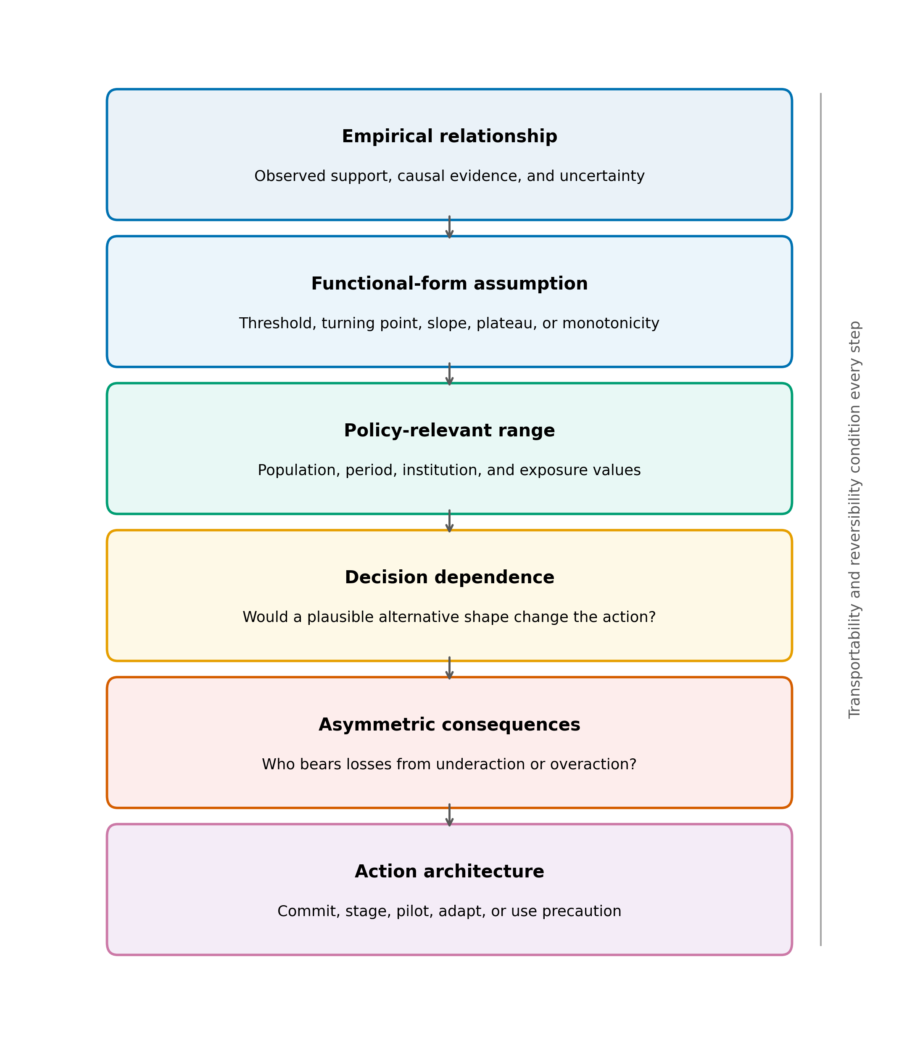
Figure 1. Decision-facing appraisal framework for functional-form dependence. The framework links the empirical relationship and assumed shape to the policy-relevant range, decision sensitivity, asymmetric consequences, and an action architecture that can include commitment, staging, adaptation, or precaution.

Cross-domain mapping exercise
We assembled an inventory of 52 named relationships commonly presented as nonlinear curves across economics, psychology, public health, biology, environmental science, management, and related fields. Two relationships were excluded because a reproducible dataset suitable for the common diagnostic could not be obtained, leaving 50. The unit is a relationship-dataset pair, not an independent study or a meta-analytic effect. The sample is purposive and non-probability based. It therefore cannot estimate the prevalence of invalid theories, failed replications, or policy dependence in any scientific population. Its role is to show that fragile shape identification can recur across domains and therefore warrants explicit policy appraisal.
Each relationship was evaluated against a linear baseline using the same quadratic alternative. A relationship was classified as robustly nonlinear only if the quadratic term passed a nested F-test at alpha = 0.05, remained significant after removal of the 3 observations with the largest Cook's distance, improved leave-one-out cross-validation root mean squared error, and was preferred by the Bayesian information criterion (Cook, 1977; Burnham & Anderson, 2004). An evidence item could instead be classified as not significant, outlier dependent, overfitting, insufficient data after influence removal, or BIC-preferred linear. Figure 2 shows the implemented decision sequence. This screen tests one simple nonlinear claim; failure does not establish linearity or rule out thresholds, splines, piecewise functions, interactions, or mechanistic alternatives.
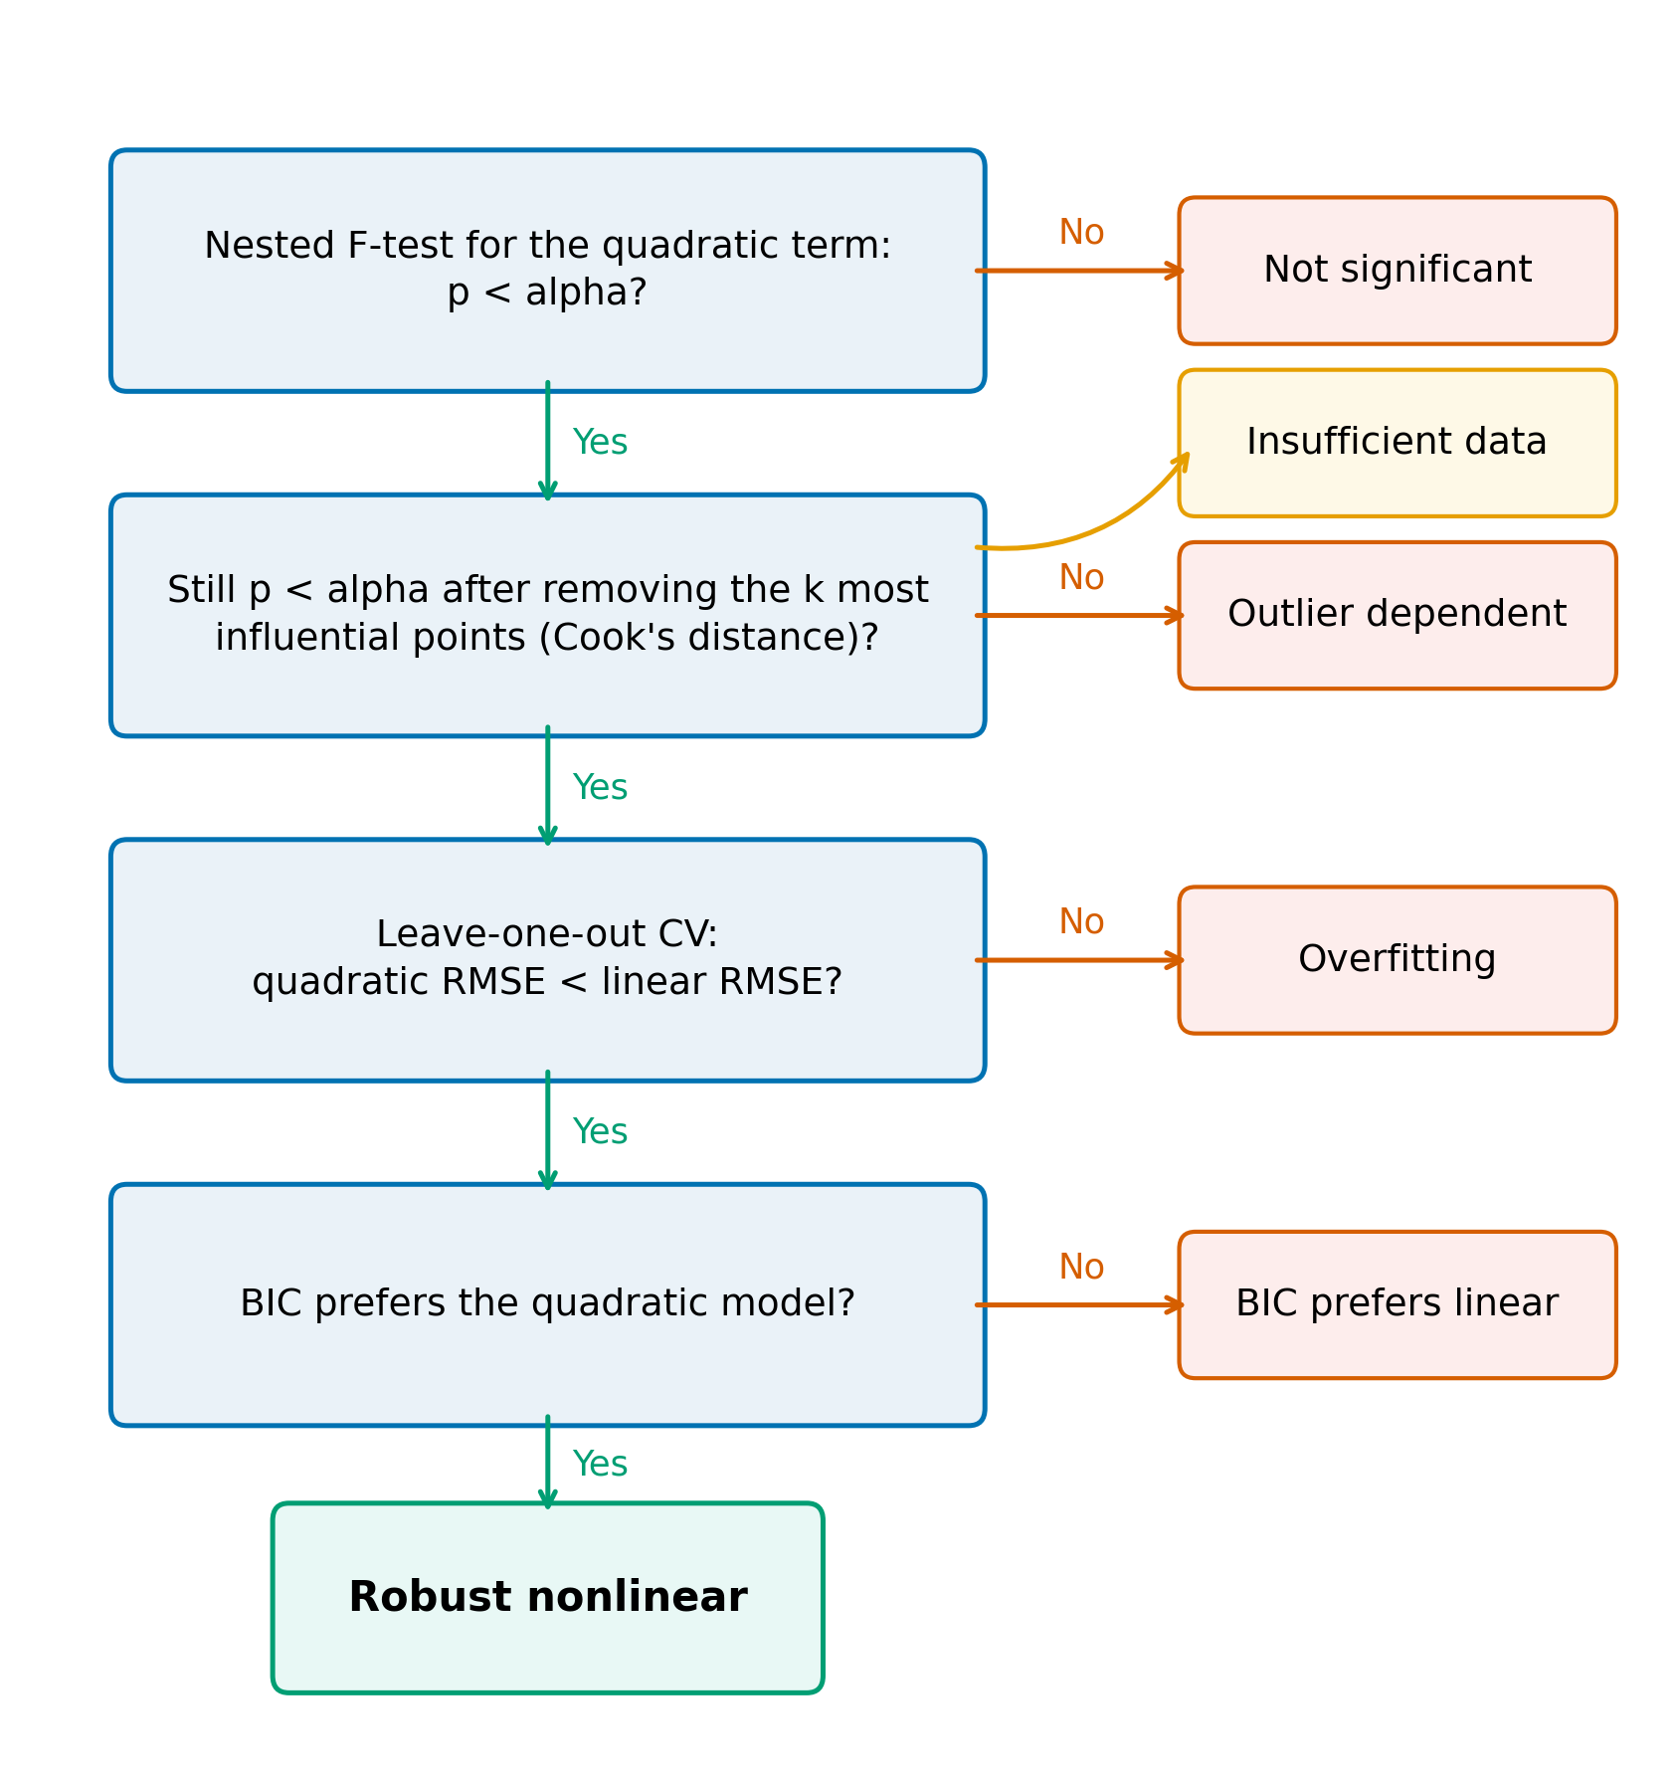
Figure 2. Diagnostic used in the cross-domain mapping exercise. Green paths continue toward robust nonlinear classification; orange paths indicate the first unmet criterion. Insufficient data is assigned when influence removal leaves too few observations for the nested comparison.
The common specification is intentionally austere. It makes the classification rule inspectable and limits domain-specific researcher discretion, but it also places unlike datasets on a shared statistical screen. Sample sizes, measurement quality, design strength, and substantive mechanisms differ across entries. We therefore preserve the diagnostic category rather than collapse all failures into a claim that a relationship is absent. Not significant indicates inadequate evidence for the tested curvature; outlier dependent indicates sensitivity to a small number of influential observations; overfitting indicates weaker out-of-sample performance; insufficient data indicates that the diagnostic could not support the classification after influence removal.
We varied alpha over {0.01, 0.05, 0.10} and the number of influential observations removed over k = {1, ..., 5}. These sensitivity checks reveal how much the mapping depends on reasonable analyst choices. The original data, fitted models, diagnostics, and classification outputs are retained for each relationship.
This exercise is consequently neither a replication count nor a ranking of fields. The underlying canonical claims were formulated at different times and may have been refined, bounded, or abandoned in later work. Some datasets are teaching or historical evidence rather than the strongest available study. The value of the map is diagnostic: it illustrates cases in which a recognizable nonlinear narrative outruns what a particular evidence base identifies. Policy use requires the next step of locating the decision, the relevant range, and the consequences of choosing among credible shapes.

Policy demonstrations and inferential scope
The two demonstrations were selected because both policy debates invoked a canonical shape, both involved consequential and partly irreversible choices, and both permit transparent post-policy analysis using public data. They are substantively heterogeneous and contrasting rather than representative cases, selected to expose the same decision-level dependence in different settings. Fukushima concerns a risk function used under emergency conditions, where errors can distribute health risks across radiation exposure, evacuation, displacement, and disrupted care. Kansas concerns a fiscal response function, where claims about revenue recovery and growth can affect budgets and public services. The analyses do not identify a universally correct radiation model or tax rate. They examine what can and cannot be learned when policy claims depend on assumed shapes.
The cases are not offered as proof that a single curve mechanically caused either policy. Emergency evacuation and tax legislation reflect legal authority, political commitments, administrative capacity, values, and multiple streams of evidence. The demonstrations instead isolate a load-bearing empirical proposition within each policy rationale and ask how observed outcomes bear on it. This limited claim is important: identifying functional-form dependence does not require a monocausal account of policymaking, only that the assumed shape changes the justification, expected benefit, or scale of action.
For Fukushima, annual municipal deaths and resident-register populations were assembled for 307 municipalities from the Japanese government's official-statistics portal (Ministry of Health, Labour and Welfare, 2021; Ministry of Internal Affairs and Communications, 2021). The primary treatment group (T1) contains 10 municipalities subject to mandatory evacuation orders, with approximately 160,000 residents in 2010. Municipalities with tsunami inundation exceeding 1.2% were excluded to reduce direct-tsunami confounding; missing-data exclusions are reported in Appendix Table A1. We estimated two-way fixed-effects differences in log crude death rates, with municipality and year effects, excluding 2011 from the post-period average:
$$ln(CDR_it) = {alpha}_{i} + {gamma}_{t} + beta D_it + {epsilon}_{it}$$
The preferred comparison uses unweighted T1 municipalities and Fukushima municipal controls for 2012-2019. Robustness checks vary control pools, population weighting, age controls, treatment definitions, permutation inference, and synthetic controls (Abadie et al., 2010, 2015; Abadie, 2021). The fixed-effects event-study design follows standard cautions about serial correlation and dynamic treatment patterns (Autor, 2003; Bertrand et al., 2004). The estimand is a difference in deaths recorded in municipal vital statistics relative to a counterfactual trend. It is not a direct estimate of evacuation-caused mortality. Resident registration, migration, deaths recorded outside the municipality, demographic composition, and selective return can affect both numerator and denominator. The 2011 decomposition separately compares observed and trend-expected deaths and direct disaster deaths. Appendix Table A2 reports unit-level synthetic-control results.
The Fukushima interpretation also separates distinct risk quantities. Low-dose radiation policy often uses linear no-threshold or related dose-response assumptions to project population risks at doses where direct epidemiological identification is difficult (ICRP, 2007). Evacuation thresholds translate those risk assumptions into action, but evacuation can produce other harms. Measured municipal deaths, certified disaster-related deaths, and projected radiological deaths are not interchangeable estimands. We place them side by side only to show differences in scope, construction, and decision relevance.
For Kansas, we constructed a state-year panel for 1997-2012 and later years, then estimated synthetic controls for real gross domestic product per capita, nonfarm employment, real total tax revenue per capita, and real individual income-tax revenue per capita. The main donor pool excludes states with large contemporaneous rate changes or without broad individual income taxes, leaving 33 donors; an all-state pool provides a second specification. Permutation tests, leave-one-donor-out checks, in-time placebos, and neighboring-state event studies assess sensitivity. State-specific aircraft, agriculture, and oil shocks remain plausible confounders.
The relevant functional-form distinction is between the general Laffer-curve proposition and claims made for the Kansas reform (Laffer, 2004; Kansas Legislature, 2012; Rothschild, 2012). A revenue-maximizing tax rate may exist in principle without Kansas beginning above it, and a local behavioral response does not imply that a large tax cut will recover its static revenue loss through growth. The demonstration therefore evaluates the observed reform against its synthetic counterfactual; it does not test the universal existence of a Laffer curve.
The Kansas estimands are post-reform gaps between Kansas and weighted donor states, conditional on pre-reform fit and the chosen donor restrictions. They combine the tax changes with other Kansas-specific events that occur after treatment and cannot establish the contribution of every statutory provision. The individual income-tax result is nevertheless directly relevant to the policy-facing claim that behavioral growth would offset a substantial part of the static revenue loss. GDP and employment outcomes provide a separate check on the growth channel; they should not be used to infer that all distributional, service, or long-run effects were absent.

Results

Mapping functional-form identification across canonical relationships
At the default thresholds, 34 of 50 relationship-dataset pairs (68%) were not classified as robustly nonlinear. The largest category was not significant (27); 4 were outlier dependent, 1 failed predictive comparison, and 2 became insufficient after influence removal. Sixteen passed all criteria. Across the study's alpha and influence-removal grid, the share not classified as robustly nonlinear ranged from 60% to 74% (Figure 3). Table 1 reports categories by field.
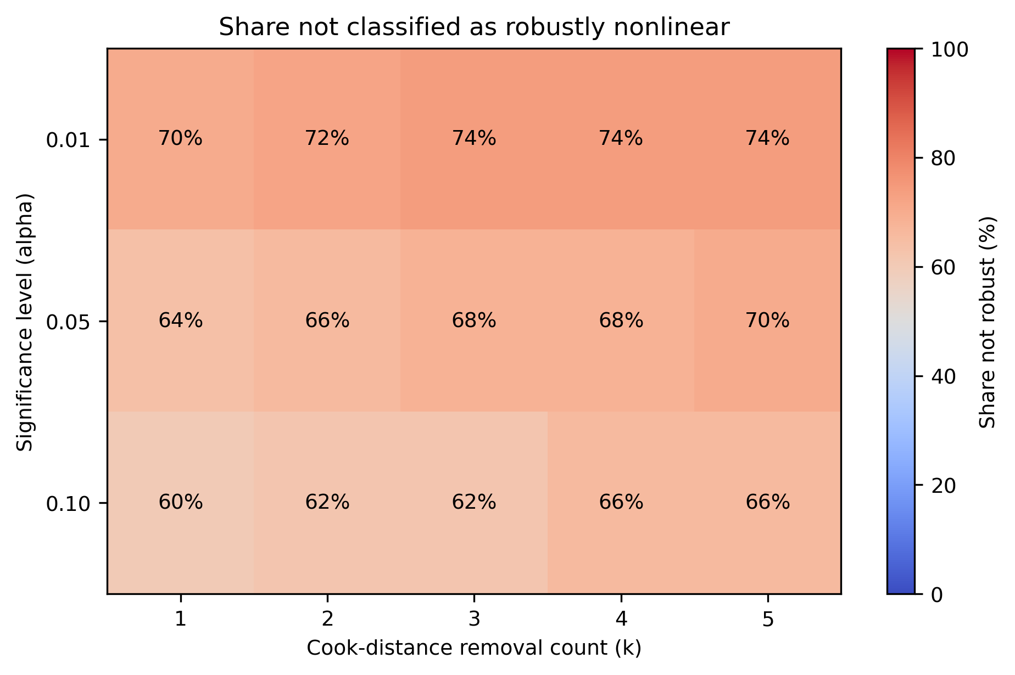
Figure 3. Share of 50 relationship-dataset pairs not classified as robustly nonlinear across significance levels and Cook-distance removal counts. Cell labels report percentages; the color scale spans 0-100%.
Table 1. Cross-domain mapping classifications by category. Counts describe the purposive relationship-dataset inventory and are not prevalence estimates for scientific theories or literatures.
Category | Robust nonlinear | Not significant | Outlier dependent | Overfitting | Insufficient data | Total
Agriculture | 2 | 1 | 0 | 0 | 1 | 4
Demography | 2 | 3 | 0 | 0 | 1 | 6
Economics | 3 | 8 | 1 | 0 | 0 | 12
Environmental Science | 2 | 3 | 1 | 0 | 0 | 6
Physics | 1 | 2 | 1 | 0 | 0 | 4
Political Science | 2 | 2 | 1 | 0 | 0 | 5
Psychology | 1 | 2 | 0 | 0 | 0 | 3
Public Health | 3 | 6 | 0 | 1 | 0 | 10
Total | 16 | 27 | 4 | 1 | 2 | 50
These classifications should be read as a map of shape identification under a common diagnostic, not a verdict on whether each underlying theory is true. A quadratic can miss a genuine nonlinear mechanism, and small datasets can fail a screen despite meaningful curvature. Conversely, a quadratic that passes does not establish causality or transportability. Across the mapped relationship-dataset pairs, several familiar schematic forms were more specific than could be established by the common diagnostic over the observed data range. For the Laffer dataset, the quadratic term had p = 0.06 with n = 29; for the low-dose radiation dataset, it had p = 0.15 with n = 21, including 6 observations below 0.1 Gy. These two items motivate, but do not resolve, the policy demonstrations.
The category pattern is more informative than the aggregate share alone. Most non-passing items did not provide strong evidence for the tested curvature, whereas a smaller group changed classification after influence or predictive checks. These are different evidentiary problems and call for different responses. Weak curvature evidence may justify presenting several shapes; influence dependence calls for scrutiny of measurement and scope; poor prediction cautions against using in-sample fit to forecast policy effects; insufficient support may justify targeted data collection. The map thus directs attention toward the assumption that carries the decision rather than issuing a uniform rejection.

Fukushima: policy dependence on an assumed risk function
Figure 4 plots pooled crude death rates. T1 municipalities show a sharp 2011 increase and a lower recorded rate than the Fukushima control group in much of the 2012-2019 estimation window. The preferred difference-in-differences estimate is -0.085 log points, corresponding to approximately 8% fewer recorded deaths than the counterfactual trend (permutation p 0.001; pre-trend p 0.314). Across T1 specifications, estimates range from -0.085 to -0.057 log points. Table 2 reports the specification grid, and Figure 5 shows the preferred event study.
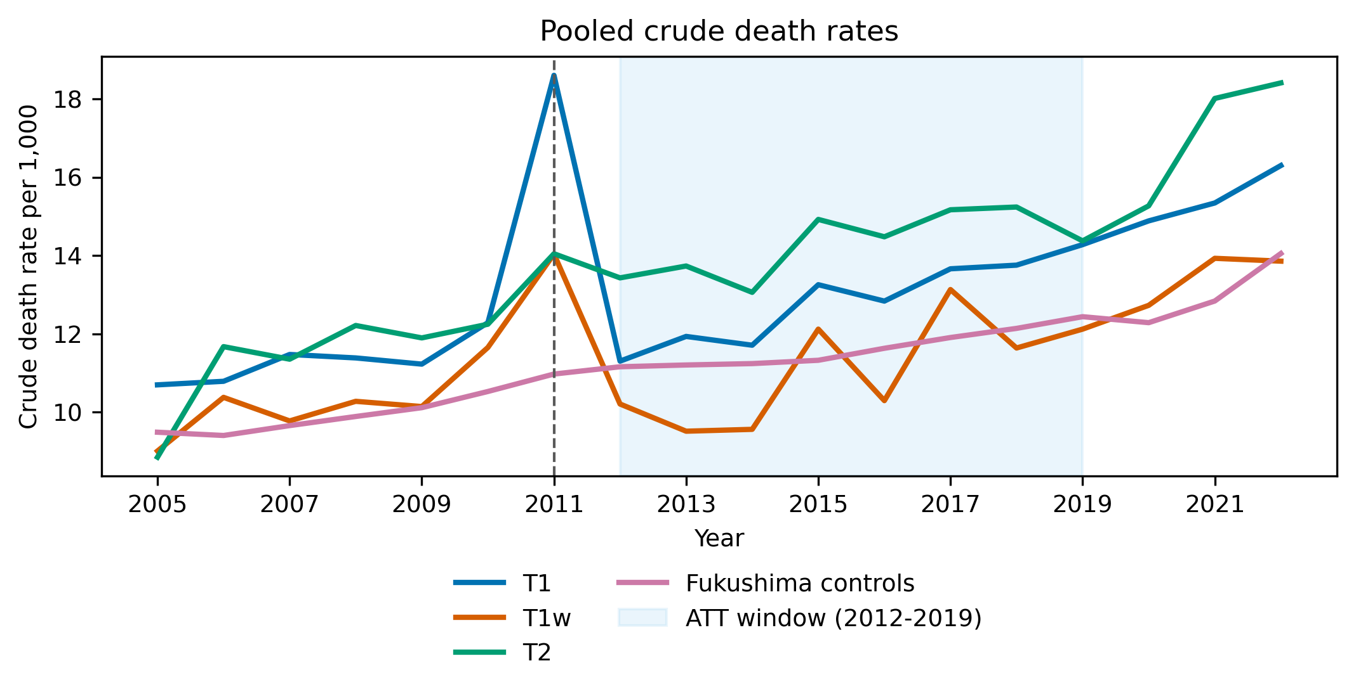
Figure 4. Pooled crude death rates in Fukushima treatment and control groups. T1 contains 10 mandatory-evacuation municipalities; T1w is the restricted complete-evacuation group; T2 contains comparison municipalities subject to other evacuation-related classifications. The shaded region is the 2012-2019 average-treatment-effect window.
Table 2. Fukushima difference-in-differences estimates. ATT is the 2012-2019 average difference in log crude death rates; 2011 is excluded. Permutation p values use 1000 assignments. Implied deaths are descriptive transformations of recorded municipal deaths and are not causal death counts.
Group | Controls | Weighting | Age control | ATT (log points) | Permutation p | Pre-trend p | Implied deaths 2012-2019
T1 | All prefectures | Weighted | No | -0.057 | 0.002 | 0.268 | -877
T1 | All prefectures | Weighted | Yes | -0.066 | < 0.001 | 0.335 | -1,018
T1 | All prefectures | Unweighted | No | -0.072 | 0.002 | 0.039 | -1,123
T1 | All prefectures | Unweighted | Yes | -0.072 | < 0.001 | 0.035 | -1,109
T1 | Fukushima only | Weighted | No | -0.085 | < 0.001 | 0.847 | -1,333
T1 | Fukushima only | Weighted | Yes | -0.083 | < 0.001 | 0.863 | -1,291
T1 | Fukushima only | Unweighted | No | -0.085 | 0.001 | 0.314 | -1,322
T1 | Fukushima only | Unweighted | Yes | -0.079 | 0.005 | 0.275 | -1,224
T1w | All prefectures | Unweighted | No | -0.116 | 0.003 | 0.170 | -405
T1w | Fukushima only | Unweighted | No | -0.129 | < 0.001 | 0.498 | -451
T2 | All prefectures | Unweighted | No | -0.022 | 0.581 | 0.829 | -93
T2 | Fukushima only | Unweighted | No | -0.034 | 0.421 | 0.932 | -146
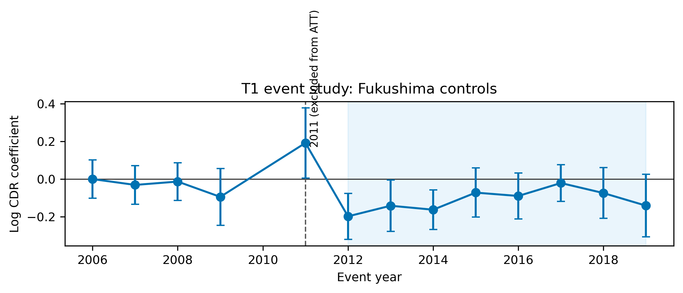
Figure 5. Preferred T1 event-study estimates using unweighted Fukushima municipal controls. Points are year-specific coefficients relative to the omitted reference year; bars are 95% confidence intervals. The acute disaster year 2011 is shown but excluded from the 2012-2019 average-treatment-effect window.
The negative post-2011 coefficient is not evidence that evacuation improved health. It is consistent with mechanisms that change who remains registered or where deaths are recorded, including displacement, selective return, and population composition. It also illustrates why a single observed outcome can be misleading when the policy reshapes the population at risk. Synthetic-control and treatment-scope checks produce the same broad warning but do not eliminate these interpretive limits.
This measurement problem is itself part of functional-form appraisal. Evacuation changes residence, service access, household composition, and the location where events are registered. The observed municipal mortality series therefore does not trace a stable population through exposure levels. A policy comparison that treated the post-evacuation curve as a biological dose-response function would confound the response of individuals with changes in who remains in the dataset. The relevant evidence architecture must distinguish exposure models, population movement, health outcomes, and administrative recording before those components are combined in a decision model.
The 2011 decomposition is different. T1 municipalities recorded 2,996 deaths against 2,060 expected from their pre-disaster trend, an excess of 936. Direct disaster deaths account for 732, leaving a residual of 204 (Figure 6). The residual cannot be assigned wholly to evacuation: emergency disruption, indirect disaster effects, measurement, and model error are also possible. Certified disaster-related deaths for Fukushima Prefecture total 2350 as of February 13, 2026, but that prefecture-wide administrative measure differs from the T1 municipal decomposition (Fukushima Prefecture, 2014; Reconstruction Agency, 2026).
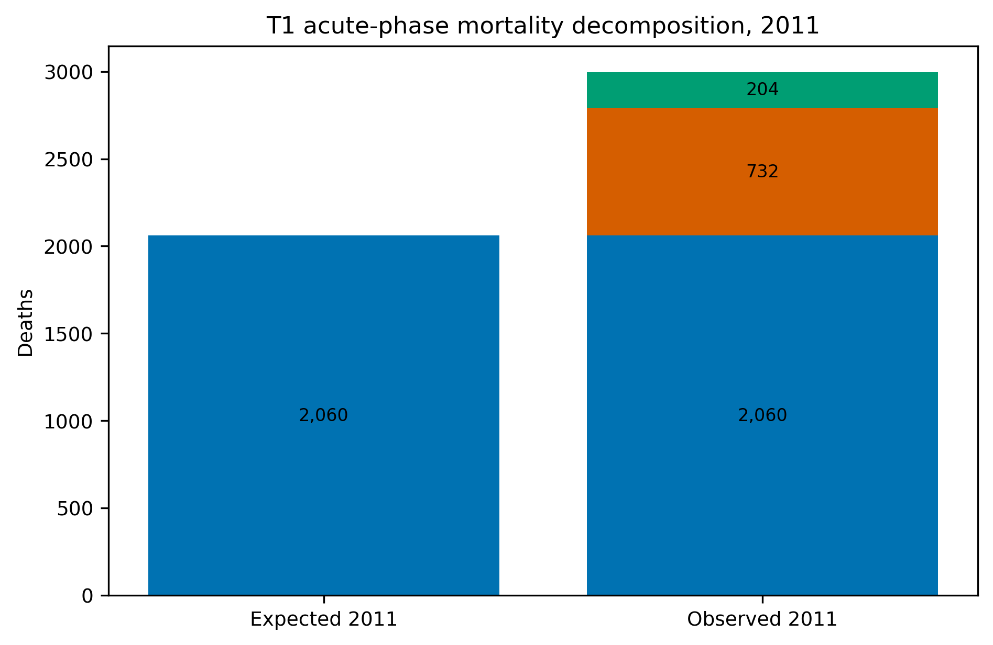
Figure 6. T1 acute-phase mortality decomposition for 2011. Expected deaths are projected from the pre-disaster municipal trend; direct disaster deaths are reported by Fukushima Prefecture; residual excess is the arithmetic difference and is not assigned to a single cause.
Table 3 places these measured quantities beside published radiological projections. Ten Hoeve and Jacobson (2012) projected a best estimate of 130 worldwide cancer deaths from the release, with a range of 15-1,100; their model attributed a best estimate of 28 averted radiological deaths to evacuation, with a range of 3-245. WHO (2013) and UNSCEAR (2014) report other modeled risk quantities and scopes. The comparison does not add these figures or treat them as commensurate. It shows that an evacuation decision can be highly sensitive to the assumed low-dose response while its consequences extend to outcomes that the radiation-risk curve does not represent.
Table 3. Fukushima measured mortality quantities and published radiological-risk projections. Rows differ in population, geography, time horizon, measurement, and model basis and must not be added or interpreted as commensurate estimands.
Quantity | Value | Scope | Type | Source
T1 observed deaths 2011 | 2,996 | T1 municipalities | Measured | This study
T1 expected deaths 2011 | 2,060 | T1 municipalities | Measured | This study
T1 excess deaths 2011 | 936 | T1 municipalities | Measured | This study
Of which direct disaster deaths | 732 | T1 municipalities | Measured | Fukushima Prefecture, 2014
T1 residual excess deaths 2011 | 204 | T1 municipalities | Measured | This study
T1 implied difference 2012-2019 (recorded) | -1,322 | T1 municipalities | Measured | This study
Certified disaster-related deaths, Fukushima Prefecture | 2,350 | Fukushima prefecture | Measured | Reconstruction Agency, 2026
Projected worldwide cancer deaths from the release | 130 (15-1,100) | Worldwide | Projected (LNT-based) | ten Hoeve & Jacobson, 2012
Evacuation-avoided radiological mortalities | 28 (3-245) | Worldwide | Projected (LNT-based) | ten Hoeve & Jacobson, 2012
Lifetime-risk relative increases in the most affected areas | leukaemia up to 7%; breast up to 6%; all solid cancers up to 4%; thyroid up to 70% | Most affected areas | Projected (LNT-based) | WHO, 2013
WHO conclusion outside Japan | no discernible increase | Outside Japan | Projected (LNT-based) | WHO, 2013
Collective effective dose | 18 / 36 / 48 thousand man-Sv (first year / ten years / lifetime) | Japanese population | Projected (LNT-based) | UNSCEAR, 2014
UNSCEAR conclusion | no discernible increase expected | Exposed population | Projected (LNT-based) | UNSCEAR, 2014
The demonstration therefore supports a calibrated conclusion. It does not show that the linear no-threshold model is false, that the evacuation was definitively wrong, or that non-evacuation would have been superior. It shows that the decision combined uncertain low-dose extrapolation with asymmetric and partly irreversible consequences. A functional-form appraisal would have required policy performance to be examined under multiple dose-response assumptions and would have treated evacuation design, duration, exceptions, staged return, and support for vulnerable residents as adjustable policy variables.
The case also illustrates why robust design can be more useful than a binary choice between accepting and rejecting a risk model. Zoning, assisted voluntary relocation, exemptions for medically fragile residents, transport and continuity of care, time-limited orders, exposure monitoring, and staged return can perform differently across plausible risk functions. Evaluating that portfolio would not remove ethical conflict or uncertainty, but it would prevent a single low-dose curve from determining every dimension of the intervention.

Kansas: policy dependence on an assumed fiscal response function
Figure 7 compares Kansas with synthetic Kansas. After the 2012 reform, real individual income-tax revenue per capita averaged approximately 27% below the main synthetic counterfactual (permutation p = 0.03); the all-state donor pool implies 26%. The estimated gap increased from about $91 per capita in 2013 to $422 in 2016, with a cumulative counterfactual gap of approximately $4.6 billion in 2012 dollars. Real total tax revenue was 3.0% lower (p = 0.18).
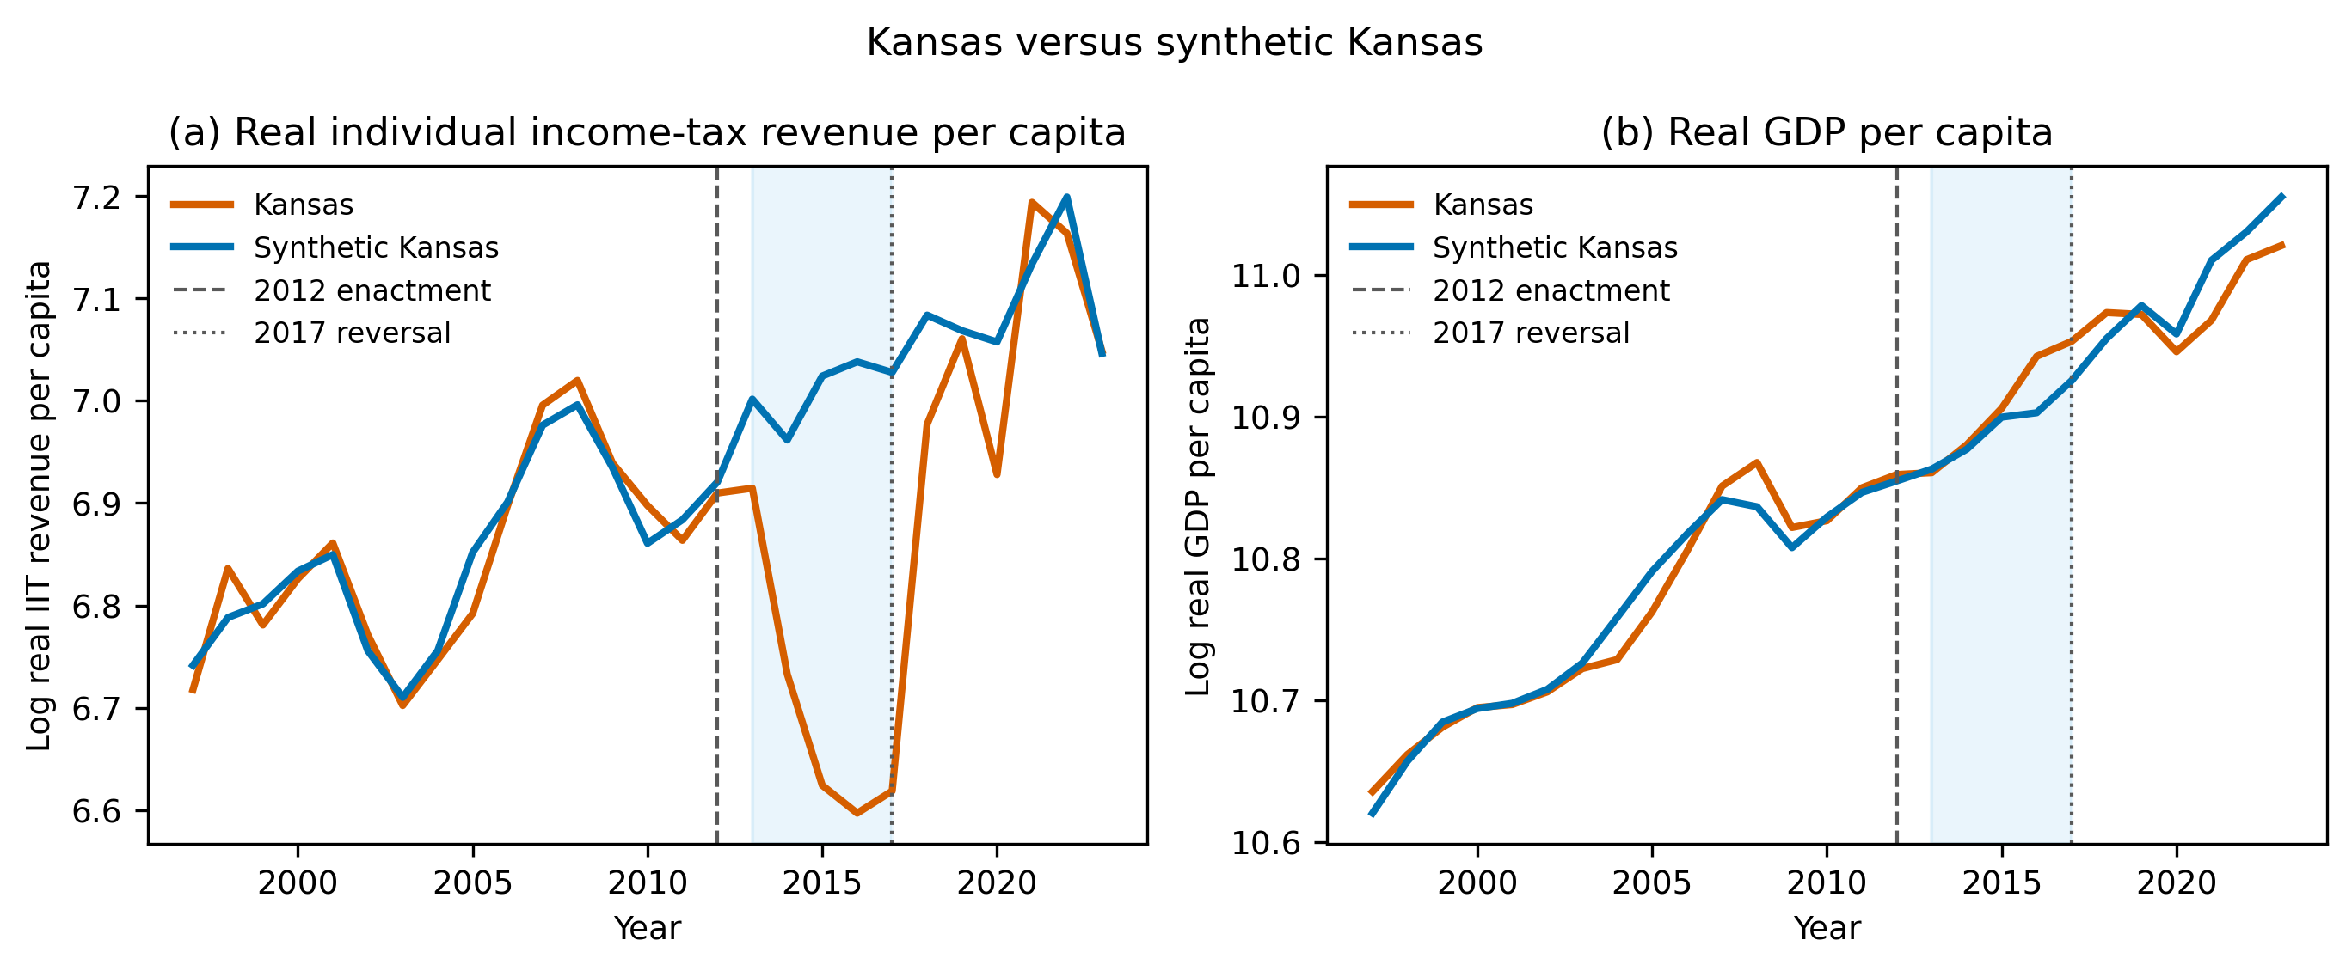
Figure 7. Kansas and synthetic Kansas, 1997-2019. Panel (a) reports log real individual income-tax revenue per capita; panel (b) reports log real GDP per capita. Synthetic controls use the main 33-state donor pool. Shading marks 2013-2017, between implementation and legislative reversal.
The corresponding post-reform gaps were +1.5% for real GDP per capita (p = 0.71) and -1.3% for employment (p = 0.47). Table 4 reports both donor pools, pre-period fit, in-time placebos, and leave-one-donor-out ranges. The individual income-tax estimate is stable across leave-one-donor-out checks (-0.322 to -0.291 log points) and has pre-period RMSPE 0.025. These comparisons do not eliminate state-specific shocks, especially in aircraft manufacturing, agriculture, and energy.
Table 4. Kansas synthetic-control estimates by outcome and donor pool. Mean gaps cover 2013-2017. Permutation p values compare Kansas with donor-state placebo gaps; LOO denotes leave-one-donor-out sensitivity.
Outcome | Pool | Mean gap | Gap (%) | Permutation p | Pre-RMSPE | donors | in-time placebo | LOO range
Real GDP per capita | Main | 0.015 | +1.5% | 0.71 | 0.015 | 33 | 0.056 | 0.009 to 0.029
Real GDP per capita | All states | -0.004 | -0.4% | 0.49 | 0.007 | 50 | 0.056 | -
Nonfarm employment | Main | -0.013 | -1.3% | 0.47 | 0.004 | 33 | 0.006 | -0.014 to -0.001
Nonfarm employment | All states | -0.001 | -0.1% | 0.96 | 0.003 | 50 | 0.006 | -
Real total tax revenue per capita | Main | -0.031 | -3.0% | 0.18 | 0.013 | 32 | 0.075 | -0.039 to -0.028
Real total tax revenue per capita | All states | 0.030 | +3.1% | 0.12 | 0.010 | 49 | 0.075 | -
Real individual income-tax revenue per capita | Main | -0.313 | -26.9% | 0.03 | 0.025 | 32 | 0.103 | -0.322 to -0.291
Real individual income-tax revenue per capita | All states | -0.301 | -26.0% | 0.02 | 0.019 | 42 | 0.103 | -
The result is not a universal rejection of the Laffer curve. It is a failure to observe a macroeconomic response large enough, within this period and design, to offset the reform's revenue loss. The functional-form issue lies in moving from a general possibility of a revenue maximum to a claim about Kansas's initial position, the local slope over a large policy change, and the timing and magnitude of dynamic growth. Those are separate empirical propositions. Treating the schematic curve as sufficient evidence compressed them into one policy claim.
A decision-facing appraisal would have separated at least four quantities: the static mechanical revenue loss, the behavioral response of taxable income, the effect of the reform on broader economic activity, and the timing with which any growth returns to the tax base. Each quantity can have a different functional form and lag structure. Budget safeguards, staged rate changes, automatic review triggers, and sunset clauses could then be evaluated against scenarios in which the growth response is early, delayed, small, or concentrated outside the taxed base. The point is not that gradualism is always optimal, but that reversibility and monitoring have value when the fiscal response curve is uncertain.

Discussion

Principal finding: association is not shape
The central finding is conceptual and practical. Evidence that two variables are associated does not by itself identify the functional form required for a policy decision. Across the mapped relationship-dataset pairs, classification under the common screen often depended on significance thresholds, influential observations, predictive comparison, or limited data. The policy demonstrations show why that distinction matters: a dose-response assumption can influence an emergency threshold, while a tax-response assumption can support a large fiscal change. In neither setting does uncertainty disappear merely because the curve has a recognized name.
This argument is not a demand for model-free policy. All appraisal uses models, and emergency decisions often must be made before evidence is complete. The relevant standard is conditional transparency: identify which shape the recommendation needs, show the range where it is supported, compare plausible alternatives, and state whether the action changes. Model uncertainty becomes policy risk when alternatives imply materially different decisions or consequences.
This distinction also qualifies common evidence hierarchies. A design that is credible for estimating an average contrast does not automatically rank highly for identifying a threshold, optimum, or tail response. The evidentiary question must match the policy claim. If the decision needs the sign of an average effect, a local contrast may be sufficient. If it needs a turning point or a projection far beyond observed support, the same study may provide only indirect evidence. Appraisal systems should therefore record not only study quality but which feature of the response function the design can identify.
Named curves can obscure this matching problem because they provide a portable vocabulary for officials, experts, advocates, and the public. Portability is valuable, but it can detach the image from its provenance. A useful accountability practice is to maintain an assumption ledger: the dataset and design supporting the shape, the range actually observed, transformations used, influential cases, competing forms considered, and the part of the decision that changes if the shape changes. Such documentation makes disagreement traceable without requiring every decision maker to reproduce the underlying analysis.

Policy-relevant range and transportability
Functional-form identification must be local to the decision. Global fit can hide weak support near a threshold or turning point, and dense observations in one range cannot validate extrapolation into another. The relevant support should be reported alongside the policy range, including which populations and periods identify the slope or curvature. Where evidence is transported, analysts should state which causal mechanisms and institutional conditions are assumed to remain stable. This extends the familiar concern with external validity from average effects to the shape of the response function.
The Fukushima case makes range validity especially salient because low-dose risk projections necessarily rely on assumptions where direct signal is weak. The Kansas case makes local policy position salient because the existence of a revenue maximum says little about whether a particular state is above or below it. In both cases, the policy-relevant claim is narrower and more demanding than the canonical relationship's general plausibility.
Transportability should be decomposed rather than treated as a single yes-or-no judgment. Population transport asks whether effect modifiers and vulnerability differ; temporal transport asks whether technology, behavior, or baseline risk changed; institutional transport asks whether implementation and incentives are comparable; range transport asks whether the relevant values are represented. A claim can transport on some dimensions and fail on another. Recording these dimensions separately clarifies whether uncertainty should alter the model, the target population, the implementation plan, or the strength of commitment.
Policies can also change the process used to learn the curve. Evacuation alters where people live and where health events are observed; tax reform changes reporting, avoidance, investment timing, and the composition of the tax base. Post-policy data are therefore not passive observations of the pre-policy relationship. Monitoring plans should anticipate these feedbacks and preserve measures capable of distinguishing substantive response from selection, adaptation, and administrative reclassification.

Functional-form dependence as policy risk
The seriousness of functional-form dependence depends on consequences, not only statistical uncertainty. A wrong shape may be tolerable when a policy is cheap, reversible, and produces similar outcomes across plausible models. It is more concerning when action is large, irreversible, distributionally uneven, or likely to create path dependence. Consequence asymmetry also cuts in both directions. Underreaction and overreaction may harm different groups, on different time horizons, through outcomes measured in different units. Appraisal should not allow one modeled outcome to eclipse harms omitted from the response function.
This view connects evidence use to policy design. Robustness is not simply a property of a coefficient; it is a property of an action across uncertain states of the world. Staged implementation, pilots, adaptive thresholds, sunset clauses, monitoring triggers, and support for exposed groups can reduce the cost of being wrong. Policy appraisal should therefore ask not only which curve fits best, but which feasible policy remains acceptable if the curve differs.
Four recurring forms of decision dependence deserve separate attention. Threshold dependence arises when small changes in a fitted boundary switch legal or administrative status. Turning-point dependence arises when policy assumes that an instrument lies on one side of an optimum. Extrapolation dependence arises when benefits or harms are projected into ranges with little direct support. Aggregation dependence arises when a population-level curve masks heterogeneous responses that matter for targeting or equity. The appropriate safeguard differs: buffer zones for thresholds, local identification around optima, scenario bounds for extrapolation, and subgroup or distributional analysis for aggregation.
Robustness and resilience remain distinct. Robustness asks whether an action performs acceptably across the uncertainties considered at appraisal. Resilience concerns the capacity of a policy system to detect surprises, absorb disruption, and reorganize after implementation (Capano & Woo, 2017). A policy can be robust to several response shapes yet brittle to an omitted outcome, or initially non-robust yet governed by institutions capable of rapid correction. Functional-form appraisal should therefore inform both ex ante choice and the ex post capacity to learn.

Applying the decision-facing appraisal framework
Figure 1 introduced the decision-facing appraisal framework before the empirical demonstrations. Analysts first specify the empirical relationship and the functional-form assumption embedded in the policy claim. They then delimit the policy-relevant range and test whether alternative shapes change the decision. Next they map consequences, including asymmetries and outcomes outside the focal curve. Finally, they choose an action architecture: commitment may be justified when the form is well identified and alternatives converge, while staging, adaptation, or precaution may be preferable when decisions diverge and consequences are asymmetric.
The decision-facing appraisal framework can be implemented without a large new modeling exercise. A minimum appraisal can display the observed support, compare a small set of theoretically plausible forms, report the induced policy recommendation under each, and explain which consequences are excluded. Sensitivity auditing is most useful when it follows the decision logic rather than varying parameters indiscriminately (Saltelli et al., 2020). Where disagreement concerns values rather than evidence, the appraisal should preserve that distinction instead of presenting technical uncertainty as the sole source of conflict.
A fuller appraisal can be organized as a decision table. Rows represent credible functional forms or bounded scenarios; columns report the implied threshold or policy intensity, affected population, expected benefits, omitted outcomes, and distribution of losses if the scenario is wrong. A final column records whether the action can be paused, reversed, or revised and what evidence would trigger that change. The purpose is not to assign spurious probabilities to every model but to reveal whether the recommendation is stable and where learning has the highest decision value.
The candidate model set should be theoretically and empirically disciplined. Including arbitrary curves can manufacture indecision; considering only the incumbent specification can manufacture confidence. Analysts should justify alternatives using mechanism, prior evidence, diagnostics, and known sources of extrapolation. Where the set remains contested, results can be reported under nested assumptions so that decision makers can see which conclusion requires which restriction. This is more informative than a single preferred estimate accompanied by a generic statement that results are robust.
Institutional responsibility should be assigned for updating the appraisal. A monitoring indicator without a named decision, review date, and authority to act does not create adaptation. For high-consequence policies, the record should identify who maintains the data, who reassesses the functional form, which stakeholders review asymmetric consequences, and what procedural threshold permits revision. These governance details matter because model assumptions can persist through organizational routines after their empirical basis has changed.

Limitations
The mapping exercise is deliberately bounded. The inventory is not a probability sample, relationship-dataset pairs are not independent studies, and the common quadratic alternative cannot represent every scientifically plausible form. Several datasets are small, classifications depend on methodological judgments, and a single dataset cannot adjudicate a literature. The mapping therefore does not estimate how often canonical theories are false. Its sensitivity analysis shows that the headline share varies, although the broader pattern persists.
The policy demonstrations also have important limits. The Fukushima analysis uses municipal vital statistics affected by displacement, registration, demographic change, and location of death. The resident-register denominator changes from Japanese residents through 2012 to total residents from 2013; year effects absorb a common level change, but differential foreign-resident composition may remain. The tsunami-inundation exclusion and treatment boundary are also design choices rather than randomized assignment. The analysis cannot attribute the full 2011 residual or the post-2011 difference to evacuation, nor can it estimate the unobserved health outcomes under a non-evacuation policy. The Kansas synthetic control cannot fully separate the tax reform from contemporaneous state-specific sectoral shocks; the neighboring-state event studies in Appendix Figure A1 are supplementary rather than definitive. Neither case isolates the causal effect of believing a curve.
The article also stops short of a welfare analysis that places all case outcomes on a common scale. That omission is deliberate because monetizing or aggregating mortality, displacement, service loss, revenue, growth, and distribution would introduce additional functional forms and normative weights. The framework can structure such an analysis, but it cannot remove the need for transparent value judgments. Future applications should examine how stakeholder participation changes the candidate consequence set and the definition of material decision change.
Finally, the decision-facing appraisal framework does not supply a universal rule for choosing among uncertain models. Decisions may still differ because of risk tolerance, equity weights, time horizons, or institutional responsibilities. Its value is diagnostic: it makes explicit when a named relationship is carrying more of the policy argument than the evidence over the relevant range can support.

Conclusion
Evidence-based policymaking should distinguish evidence for the existence of an association from evidence for the specific shape needed to justify a decision. Functional-form dependence identifies cases in which an insufficiently identified or transported shape determines a policy's threshold, direction, intensity, or expected benefit. The decision-facing appraisal framework does not imply automatic inaction. It requires analysts to expose the assumption, test the policy-relevant range, compare decisions under plausible alternatives, examine asymmetric consequences, and design policies that can learn or adapt where uncertainty remains. Before a canonical relationship is used to justify consequential policy, both the association and the decision-relevant shape should be validated.

Data availability
All data used in the analyses are from public sources. Archived source files, acquisition metadata, processed datasets, analysis code, machine-readable results, and document-generation code will be supplied to reviewers through an anonymized archive. The public repository URL is provided to the editor in the title-page materials and will be added to the manuscript after double-anonymous review. The archive README records the commands required to reproduce the analyses and submission files.

Artificial intelligence assistance
An AI coding assistant (Devin, Cognition AI) was used to assist with data-acquisition, analysis, and document-generation code and with manuscript drafting and editing under the author's direction. The author specified the research questions and analytical choices, verified the data sources and results, evaluated all interpretations, and takes full responsibility for the manuscript.

References
Abadie, A. (2021). Using synthetic controls: Feasibility, data requirements, and methodological aspects. Journal of Economic Literature, 59(2), 391-425. https://doi.org/10.1257/jel.20191450
Abadie, A., Diamond, A., & Hainmueller, J. (2010). Synthetic control methods for comparative case studies: Estimating the effect of California's tobacco control program. Journal of the American Statistical Association, 105(490), 493-505. https://doi.org/10.1198/jasa.2009.ap08746
Abadie, A., Diamond, A., & Hainmueller, J. (2015). Comparative politics and the synthetic control method. American Journal of Political Science, 59(2), 495-510. https://doi.org/10.1111/ajps.12116
Autor, D. H. (2003). Outsourcing at will: The contribution of unjust dismissal doctrine to the growth of employment outsourcing. Journal of Labor Economics, 21(1), 1-42. https://doi.org/10.1086/344122
Bertrand, M., Duflo, E., & Mullainathan, S. (2004). How much should we trust differences-in-differences estimates? Quarterly Journal of Economics, 119(1), 249-275. https://doi.org/10.1162/003355304772839588
Burnham, K. P., & Anderson, D. R. (2004). Multimodel inference: Understanding AIC and BIC in model selection. Sociological Methods & Research, 33(2), 261-304. https://doi.org/10.1177/0049124104268644
Capano, G., & Malandrino, A. (2022). Mapping the use of knowledge in policymaking: Barriers and facilitators from a subjectivist perspective (1990-2020). Policy Sciences, 55(3), 399-428. https://doi.org/10.1007/s11077-022-09468-0
Capano, G., & Woo, J. J. (2017). Resilience and robustness in policy design: A critical appraisal. Policy Sciences, 50(3), 399-426. https://doi.org/10.1007/s11077-016-9273-x
Cartwright, N., & Hardie, J. (2012). Evidence-based policy: A practical guide to doing it better. Oxford University Press.
Cook, R. D. (1977). Detection of influential observation in linear regression. Technometrics, 19(1), 15-18. https://doi.org/10.1080/00401706.1977.10489493
Draper, D. (1995). Assessment and propagation of model uncertainty. Journal of the Royal Statistical Society: Series B, 57(1), 45-70. https://doi.org/10.1111/j.2517-6161.1995.tb02015.x
Dunlop, C. A. (2010). The temporal dimension of knowledge and the limits of policy appraisal: Biofuels policy in the UK. Policy Sciences, 43(4), 343-363. https://doi.org/10.1007/s11077-009-9101-7
Fukushima Prefecture. (2014). Higashinihon daishinsai ni yoru higai jokyo sokuhou (dai 1260-ho) [Preliminary report on damage caused by the Great East Japan Earthquake (Report No. 1260)]. https://www.pref.fukushima.lg.jp/uploaded/attachment/422314.pdf
Head, B. W. (2008). Three lenses of evidence-based policy. Australian Journal of Public Administration, 67(1), 1-11. https://doi.org/10.1111/j.1467-8500.2007.00564.x
International Commission on Radiological Protection. (2007). The 2007 recommendations of the International Commission on Radiological Protection. ICRP Publication 103. Annals of the ICRP, 37(2-4). https://doi.org/10.1016/j.icrp.2007.10.003
Kansas Legislature. (2012). House Bill 2117, enrolled. https://www.kslegislature.gov/li_2012/b2011_12/measures/documents/hb2117_enrolled.pdf
Kolkman, D. A., Campo, P., Balke-Visser, T., & Gilbert, N. (2016). How to build models for government: Criteria driving model acceptance in policymaking. Policy Sciences, 49(4), 489-504. https://doi.org/10.1007/s11077-016-9250-4
Laffer, A. B. (2004). The Laffer curve: Past, present, and future. Heritage Foundation Backgrounder, 1765, 1-16. https://www.heritage.org/taxes/report/the-laffer-curve-past-present-and-future
Lempert, R. J., & Collins, M. T. (2007). Managing the risk of uncertain threshold responses: Comparison of robust, optimum, and precautionary approaches. Risk Analysis, 27(4), 1009-1026. https://doi.org/10.1111/j.1539-6924.2007.00940.x
Ministry of Health, Labour and Welfare. (2021). Vital statistics of Japan [Data set]. Portal Site of Official Statistics of Japan. https://www.e-stat.go.jp/en/stat-search/database?page=1&toukei=00450011
Ministry of Internal Affairs and Communications. (2021). Population, demographics, and household counts based on the Basic Resident Registration [Data set]. Portal Site of Official Statistics of Japan. https://www.e-stat.go.jp/en/stat-search/files?toukei=00200241
Parkhurst, J. O. (2016). Appeals to evidence for the resolution of wicked problems: The origins and mechanisms of evidentiary bias. Policy Sciences, 49(4), 373-393. https://doi.org/10.1007/s11077-016-9263-z
Reconstruction Agency. (2026). Higashinihon daishinsai ni okeru shinsai-kanrenshi no shisha-su [Number of disaster-related deaths in the Great East Japan Earthquake] (as of February 13, 2026). https://www.reconstruction.go.jp/files/user/topics/main-cat2/sub-cat2-6/20260213_kanrenshi.pdf
Roth, J., & Sant'Anna, P. H. C. (2023). When is parallel trends sensitive to functional form? Econometrica, 91(2), 737-747. https://doi.org/10.3982/ECTA19402
Rothschild, S. (2012, January 19). Consultant Laffer praises Brownback's tax plan. Lawrence Journal-World. https://www2.ljworld.com/news/2012/jan/19/consultant-laffer-touts-brownbacks-tax-plan/
Saltelli, A., Bammer, G., Bruno, I., Charters, E., Di Fiore, M., Didier, E., Espeland, W. N., Kay, J., Lo Piano, S., Mayo, D., Pielke, R., Portaluri, T., Porter, T. M., Puy, A., Rafols, I., Ravetz, J. R., Reinert, E., Sarewitz, D., Stark, P. B., Stirling, A., van der Sluijs, J., & Vineis, P. (2020). Five ways to ensure that models serve society: A manifesto. Nature, 582(7813), 482-484. https://doi.org/10.1038/d41586-020-01812-9
United Nations Scientific Committee on the Effects of Atomic Radiation. (2014). Sources, effects and risks of ionizing radiation: UNSCEAR 2013 report, Volume I, Scientific Annex A. United Nations. https://www.unscear.org/unscear/uploads/documents/unscear-reports/UNSCEAR_2013_Report_Vol.I.pdf
Wesselink, A., Colebatch, H., & Pearce, W. (2014). Evidence and policy: Discourses, meanings and practices. Policy Sciences, 47(4), 339-344. https://doi.org/10.1007/s11077-014-9209-2
World Health Organization. (2013). Health risk assessment from the nuclear accident after the 2011 Great East Japan Earthquake and Tsunami, based on a preliminary dose estimation. World Health Organization. https://iris.who.int/handle/10665/78218
ten Hoeve, J. E., & Jacobson, M. Z. (2012). Worldwide health effects of the Fukushima Daiichi nuclear accident. Energy & Environmental Science, 5(9), 8743-8757. https://doi.org/10.1039/C2EE22019A

