Online supplement: additional analyses, robustness results, and exclusions
Supplement Figure S1. Diagnostic used in the cross-domain mapping exercise. Green paths continue toward robust nonlinear classification; orange paths indicate the first unmet criterion. Insufficient data is assigned when influence removal leaves too few observations for the nested comparison.
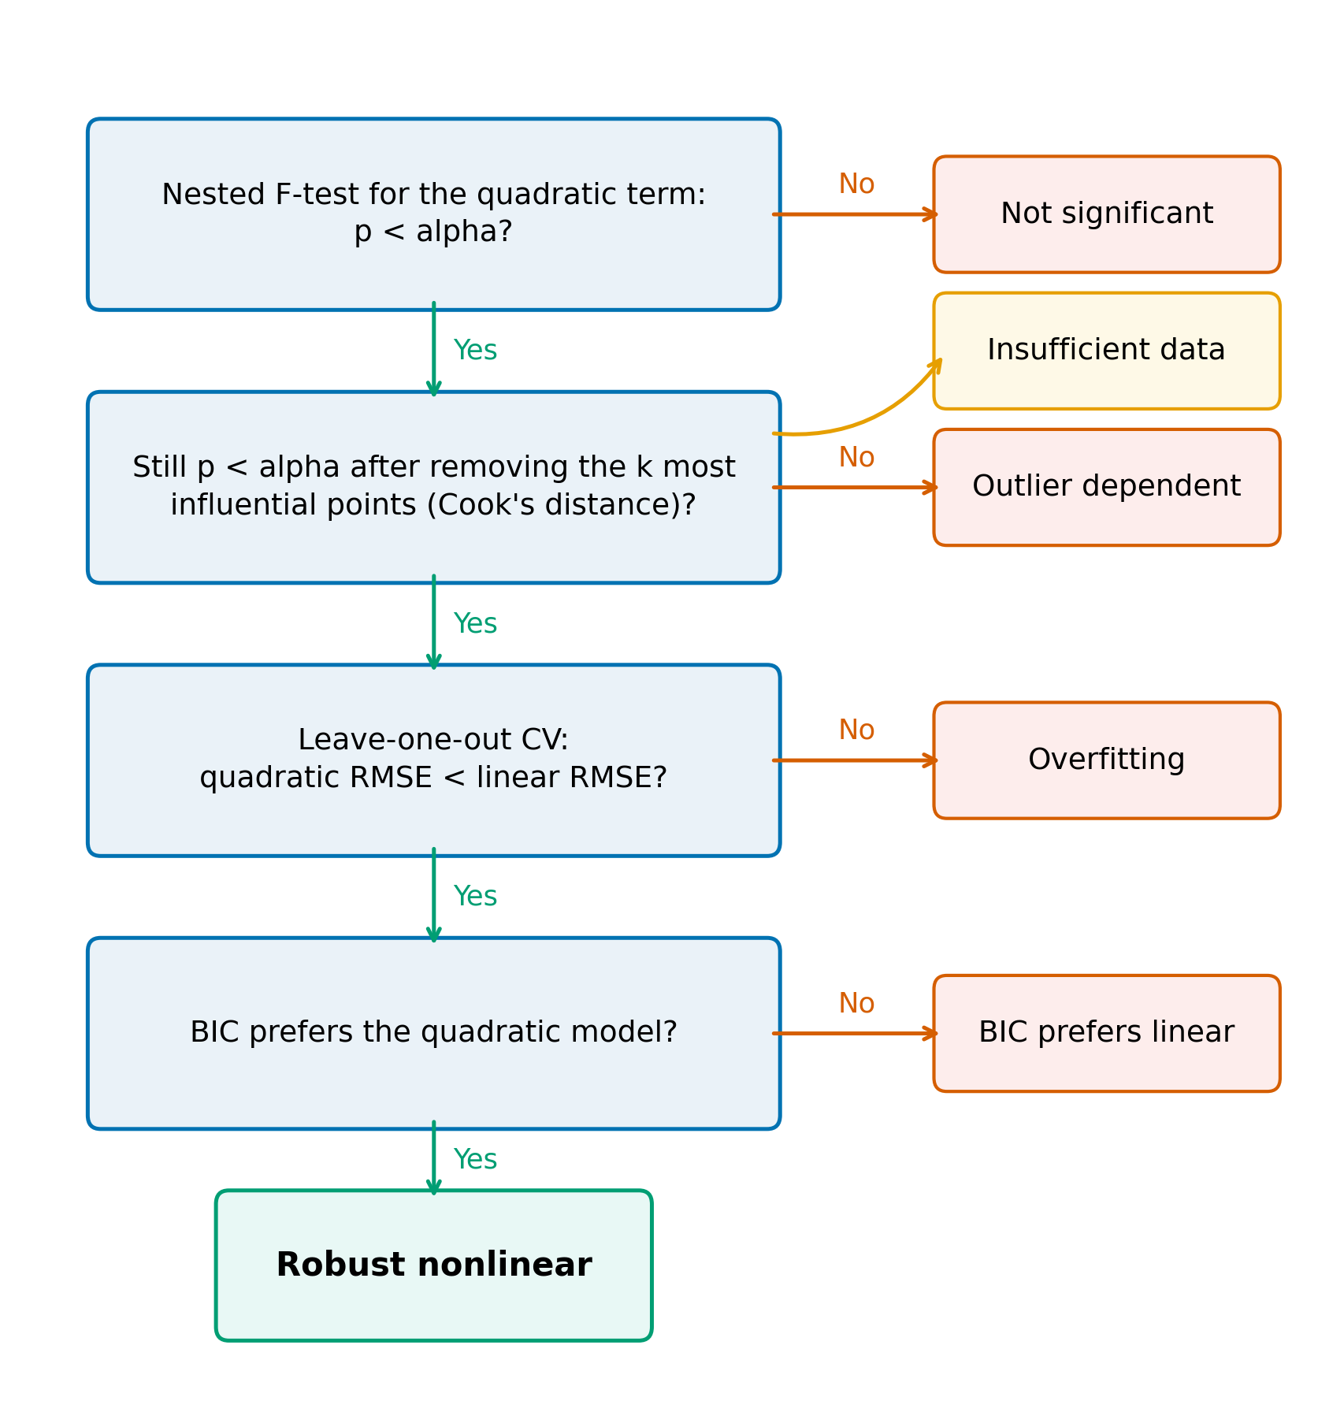
Supplement Figure S3. Preferred T1 event-study estimates using unweighted Fukushima municipal controls. Points are year-specific coefficients relative to the omitted reference year; bars are 95% confidence intervals. The acute disaster year 2011 is shown but excluded from the 2012-2019 average-treatment-effect window.
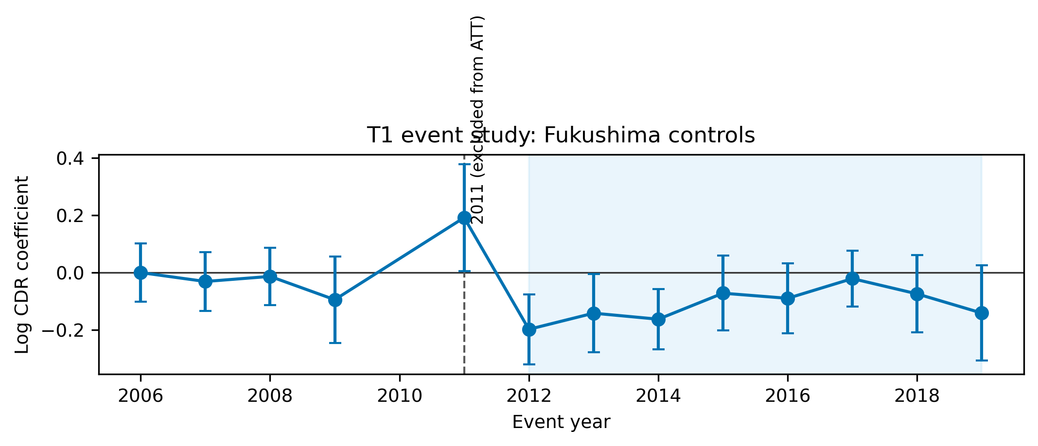
Supplement Figure S4. T1 acute-phase mortality decomposition for 2011. Expected deaths are projected from the pre-disaster municipal trend; direct disaster deaths are reported by Fukushima Prefecture; residual excess is the arithmetic difference and is not assigned to a single cause.
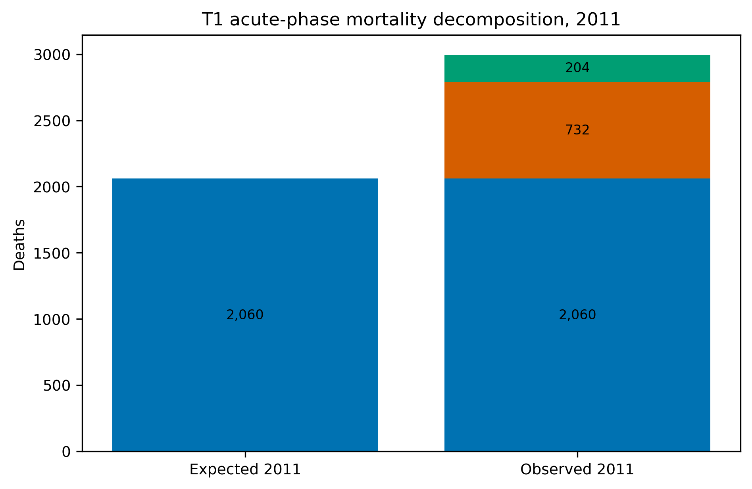
Supplement Figure S2. Kansas neighbouring-state difference-in-differences event studies for real GDP per capita, employment, total tax revenue, and individual income-tax revenue. Coefficients are relative to 2012; bars are 95% confidence intervals.
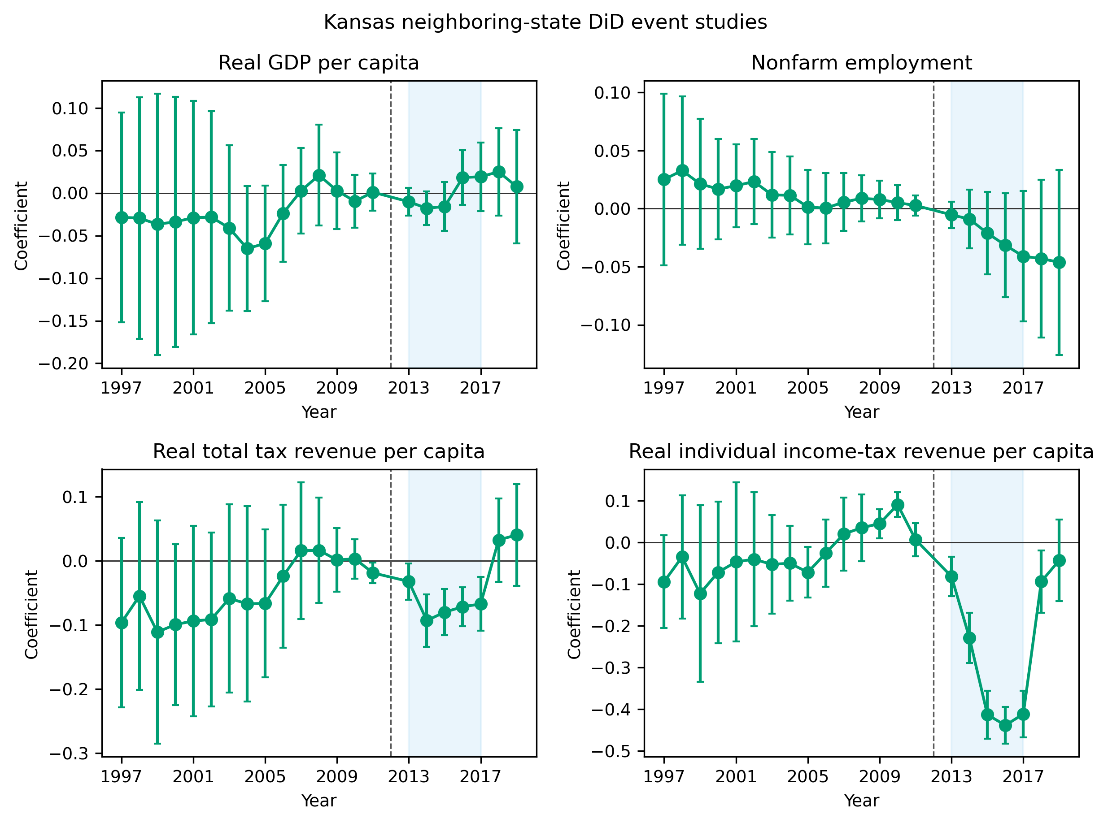
Supplement Table S3. Fukushima difference-in-differences estimates. ATT is the 2012-2019 average difference in log crude death rates; 2011 is excluded. Permutation p values use 1000 assignments. Implied deaths are descriptive transformations of recorded municipal deaths and are not causal death counts.
Group | Controls | Weighting | Age control | ATT (log points) | Permutation p | Pre-trend p | Implied deaths 2012-2019
T1 | All prefectures | Weighted | No | -0.057 | 0.002 | 0.268 | -877
T1 | All prefectures | Weighted | Yes | -0.066 | < 0.001 | 0.335 | -1,018
T1 | All prefectures | Unweighted | No | -0.072 | 0.002 | 0.039 | -1,123
T1 | All prefectures | Unweighted | Yes | -0.072 | < 0.001 | 0.035 | -1,109
T1 | Fukushima only | Weighted | No | -0.085 | < 0.001 | 0.847 | -1,333
T1 | Fukushima only | Weighted | Yes | -0.083 | < 0.001 | 0.863 | -1,291
T1 | Fukushima only | Unweighted | No | -0.085 | 0.001 | 0.314 | -1,322
T1 | Fukushima only | Unweighted | Yes | -0.079 | 0.005 | 0.275 | -1,224
T1w | All prefectures | Unweighted | No | -0.116 | 0.003 | 0.170 | -405
T1w | Fukushima only | Unweighted | No | -0.129 | < 0.001 | 0.498 | -451
T2 | All prefectures | Unweighted | No | -0.022 | 0.581 | 0.829 | -93
T2 | Fukushima only | Unweighted | No | -0.034 | 0.421 | 0.932 | -146
Supplement Table S4. Fukushima measured mortality quantities and published radiological-risk projections. Rows differ in population, geography, time horizon, measurement, and model basis and must not be added or interpreted as commensurate estimands.
Quantity | Value | Scope | Type | Source
T1 observed deaths 2011 | 2,996 | T1 municipalities | Measured | This study
T1 expected deaths 2011 | 2,060 | T1 municipalities | Measured | This study
T1 excess deaths 2011 | 936 | T1 municipalities | Measured | This study
Of which direct disaster deaths | 732 | T1 municipalities | Measured | Fukushima Prefecture, 2014
T1 residual excess deaths 2011 | 204 | T1 municipalities | Measured | This study
T1 implied difference 2012-2019 (recorded) | -1,322 | T1 municipalities | Measured | This study
Certified disaster-related deaths, Fukushima Prefecture | 2,350 | Fukushima prefecture | Measured | Reconstruction Agency, 2026
Projected worldwide cancer deaths from the release | 130 (15-1,100) | Worldwide | Projected (LNT-based) | ten Hoeve & Jacobson, 2012
Evacuation-avoided radiological mortalities | 28 (3-245) | Worldwide | Projected (LNT-based) | ten Hoeve & Jacobson, 2012
Lifetime-risk relative increases in the most affected areas | leukaemia up to 7%; breast up to 6%; all solid cancers up to 4%; thyroid up to 70% | Most affected areas | Projected (LNT-based) | WHO, 2013
WHO conclusion outside Japan | no discernible increase | Outside Japan | Projected (LNT-based) | WHO, 2013
Collective effective dose | 18 / 36 / 48 thousand man-Sv (first year / ten years / lifetime) | Japanese population | Projected (LNT-based) | UNSCEAR, 2014
UNSCEAR conclusion | no discernible increase expected | Exposed population | Projected (LNT-based) | UNSCEAR, 2014
Supplement Table S5. Kansas synthetic-control estimates by outcome and donor pool. Mean gaps cover 2013-2017. Permutation p values compare Kansas with donor-state placebo gaps; LOO denotes leave-one-donor-out sensitivity.
Outcome | Pool | Mean gap | Gap (%) | Permutation p | Pre-RMSPE | donors | in-time placebo | LOO range
Real GDP per capita | Main | 0.015 | +1.5% | 0.71 | 0.015 | 33 | 0.056 | 0.009 to 0.029
Real GDP per capita | All states | -0.004 | -0.4% | 0.49 | 0.007 | 50 | 0.056 | -
Nonfarm employment | Main | -0.013 | -1.3% | 0.47 | 0.004 | 33 | 0.006 | -0.014 to -0.001
Nonfarm employment | All states | -0.001 | -0.1% | 0.96 | 0.003 | 50 | 0.006 | -
Real total tax revenue per capita | Main | -0.031 | -3.0% | 0.18 | 0.013 | 32 | 0.075 | -0.039 to -0.028
Real total tax revenue per capita | All states | 0.030 | +3.1% | 0.12 | 0.010 | 49 | 0.075 | -
Real individual income-tax revenue per capita | Main | -0.313 | -26.9% | 0.03 | 0.025 | 32 | 0.103 | -0.322 to -0.291
Real individual income-tax revenue per capita | All states | -0.301 | -26.0% | 0.02 | 0.019 | 42 | 0.103 | -
Supplement Table S1. Municipalities excluded from the Fukushima panel because of missing mortality or population observations. Exclusions are determined before outcome estimation.
Prefecture | Municipality | Reason | Years missing
Iwate | Hachimantai | Population missing in at least one year 2005-2019 | 2005
Iwate | Oshu | Unit not observed under a single code 2005-2019 | 2005
Iwate | Takizawa | Unit not observed under a single code 2005-2019 | 2005,2006,2007,2008,2009,2010,2011,2012,2013
Iwate | Nishiwaga | Population missing in at least one year 2005-2019 | 2005
Iwate | Hirono | Unit not observed under a single code 2005-2019 | 2005
Miyagi | Aoba Ward, Sendai | Population missing in at least one year 2005-2019 | 2006,2007,2008,2009,2010
Miyagi | Miyagino Ward, Sendai | Population missing in at least one year 2005-2019 | 2005,2006,2007,2008,2009,2010
Miyagi | Wakabayashi Ward, Sendai | Population missing in at least one year 2005-2019 | 2005,2006,2007,2008,2009,2010
Miyagi | Taihaku Ward, Sendai | Population missing in at least one year 2005-2019 | 2005,2006,2007,2008,2009,2010
Miyagi | Izumi Ward, Sendai | Population missing in at least one year 2005-2019 | 2005,2006,2007,2008,2009,2010
Miyagi | Shiogama | Population missing in at least one year 2005-2019 | 2006,2007
Miyagi | Tome | Population missing in at least one year 2005-2019 | 2005
Miyagi | Kurihara | Population missing in at least one year 2005-2019 | 2005
Miyagi | Higashimatsushima | Population missing in at least one year 2005-2019 | 2005
Miyagi | Osaki | Unit not observed under a single code 2005-2019 | 2005
Miyagi | Tomiya | Unit not observed under a single code 2005-2019 | 2005,2006,2007,2008,2009,2010,2011,2012,2013,2014,2015,2016
Miyagi | Shichikashuku | Population missing in at least one year 2005-2019 | 2007,2008,2009,2010,2011,2012,2013,2014,2015,2016,2017
Miyagi | Shichigahama | Population missing in at least one year 2005-2019 | 2007,2008,2009,2010,2011,2012,2013,2014,2015,2016,2017
Miyagi | Misato | Unit not observed under a single code 2005-2019 | 2005
Miyagi | Minamisanriku | Population missing in at least one year 2005-2019 | 2005
Yamagata | Shonai | Population missing in at least one year 2005-2019 | 2005
Fukushima | Motomiya | Population missing in at least one year 2005-2019 | 2006
Ibaraki | Kasumigaura | Population missing in at least one year 2005-2019 | 2006
Ibaraki | Sakuragawa | Population missing in at least one year 2005-2019 | 2005
Ibaraki | Kamisu | Population missing in at least one year 2005-2019 | 2005
Ibaraki | Namegata | Population missing in at least one year 2005-2019 | 2005
Ibaraki | Hokota | Population missing in at least one year 2005-2019 | 2005
Ibaraki | Tsukubamirai | Unit not observed under a single code 2005-2019 | 2005,2006
Ibaraki | Omitama | Unit not observed under a single code 2005-2019 | 2005
Tochigi | Nasukarasuyama | Population missing in at least one year 2005-2019 | 2005
Tochigi | Shimotsuke | Unit not observed under a single code 2005-2019 | 2005
Tochigi | Nakagawa | Population missing in at least one year 2005-2019 | 2005
Gunma | Midori | Unit not observed under a single code 2005-2019 | 2005
Gunma | Higashiazuma | Unit not observed under a single code 2005-2019 | 2005
Gunma | Minakami | Population missing in at least one year 2005-2019 | 2005
Niigata | Kita Ward, Niigata | Unit not observed under a single code 2005-2019 | 2005,2006,2007,2008,2009,2010
Niigata | Higashi Ward, Niigata | Unit not observed under a single code 2005-2019 | 2005,2006,2007,2008,2009,2010
Niigata | Chuo Ward, Niigata | Unit not observed under a single code 2005-2019 | 2005,2006,2007,2008,2009,2010
Niigata | Konan Ward, Niigata | Unit not observed under a single code 2005-2019 | 2005,2006,2007,2008,2009,2010
Niigata | Akiha Ward, Niigata | Unit not observed under a single code 2005-2019 | 2005,2006,2007,2008,2009,2010
Niigata | Minami Ward, Niigata | Unit not observed under a single code 2005-2019 | 2005,2006,2007,2008,2009,2010
Niigata | Nishi Ward, Niigata | Unit not observed under a single code 2005-2019 | 2005,2006,2007,2008,2009,2010
Niigata | Nishikan Ward, Niigata | Unit not observed under a single code 2005-2019 | 2005,2006,2007,2008,2009,2010
Niigata | Myoko | Population missing in at least one year 2005-2019 | 2005
Niigata | Tainai | Population missing in at least one year 2005-2019 | 2005
Niigata | Seiro | Population missing in at least one year 2005-2019 | 2006
Niigata | Aga | Population missing in at least one year 2005-2019 | 2005
Supplement Table S2. Unit-level Fukushima synthetic-control results for T1 municipalities. Mean gaps cover 2012-2019; permutation p values compare treated and placebo-unit gaps.
Municipality | Donors | Pre-RMSPE | Post-RMSPE | Mean gap 2012-2019 | Permutation p
Minamisoma | 7 | 0.029 | 0.184 | -0.011 | 0.25
Kawamata | 23 | 0.01 | 0.082 | 0.055 | 0.333
Naraha | 20 | 0.088 | 0.204 | -0.128 | 0.714
Tomioka | 13 | 0.059 | 0.164 | -0.152 | 0.5
Kawauchi | 13 | 0.044 | 0.148 | 0.083 | 0.5
Okuma | 15 | 0.144 | 0.304 | -0.268 | 0.562
Futaba | 20 | 0.049 | 0.257 | -0.191 | 0.286
Namie | 18 | 0.004 | 0.18 | -0.098 | 0.263
Katsurao | 5 | 0.183 | 0.249 | -0.137 | 0.833
Iitate | 22 | 0.017 | 0.118 | -0.027 | 0.304

