When Evidence Is Not Specific Enough for Policy: Functional-Form Dependence in Evidence-Based Decision-Making
Abstract
Introduction: Evidence-based policy is usually appraised in terms of whether research is credible, relevant, and used. Yet many decisions require something more specific than an association: a threshold, a local slope, a turning point, or an extrapolated response. This article asks how evidence adequate for establishing an association can become inadequate when translated into a decision requiring a more specific functional form. Methods/Data: A purposive mapping of 50 named nonlinear relationships was screened with one transparent diagnostic, and two public-data applications follow the translation chain: post-Fukushima evacuation (10 evacuated municipalities) and the 2012 Kansas tax reform. Analytic plan: Each application reconstructs how evidence was interpreted into a policy-relevant shape, identifies the functional feature the decision required, and assesses whether evidence identified that feature in the policy-relevant range, using difference-in-differences and synthetic-control analyses. Results: 34 of 50 pairs failed the study's robust-nonlinear criteria, and in both applications the required functional feature was identified less securely than the policy assumed. Conclusion/Implications: Functional-form dependence names this evidence-to-policy mismatch; an appraisal checklist is derived for policymakers, practitioners, and knowledge brokers.
Keywords: evidence use; functional form; evidence-based policymaking; uncertainty

Background
Evidence-based policy is most often appraised in terms of whether research is credible, relevant to the decision at hand, and actually used. Yet many policy decisions require something more specific than a claim that one variable affects another. An evacuation order requires a statement about how harm declines with exposure. A tax reform is defended on how revenue and activity respond to rates. In each case, the decision needs a particular feature of an empirical relationship - a threshold, a local slope, a turning point, a curvature, or an extrapolated segment - to hold over the range where the policy operates.
A study can therefore be rigorous for what it directly estimates while remaining insufficient for the use made of it. A credible estimate of an average difference, an association, or a local effect does not by itself identify the shape a decision needs. This article calls the resulting condition functional-form dependence: a policy recommendation materially depends on a threshold, slope, turning point, curvature, or extrapolated response that is less securely identified than the policy use of that evidence assumes. Functional-form uncertainty is a component of model uncertainty about relationship shape (Draper, 1995; Morgan and Henrion, 1990); functional-form dependence is the evidence-use condition in which that uncertainty enters the policy decision rule.
The problem sits within, rather than outside, the evidence-use literature. Research on evidence-informed policymaking stresses that evidence is filtered through institutions, routines, and professional practices that can privilege a familiar picture over a fragile empirical claim (Cairney, 2016; Parkhurst, 2016; Boswell, 2009). Reviews of barriers to research use emphasise relevance, accessibility, timing, and contested interpretations of what counts as evidence (Oliver et al., 2014; Nutley et al., 2007), while work on transportability asks when findings established in one setting can support inferences about another (Cartwright and Hardie, 2012). Less attended to is a distinct level of mismatch: not whether evidence exists or is used, but whether the decision demands more decision-relevant specificity from the evidence than the evidence can deliver - what might be called an evidence-specificity gap.
This article asks: how can evidence that is adequate for establishing an association become inadequate when translated into a policy decision requiring a more specific functional form, and under what conditions does that gap become consequential for policy design? It answers empirically in two stages. First, a purposive mapping applies one transparent nonlinear diagnostic to 50 named canonical relationships across fields, showing that familiar scientific relationships may be used at a level of functional-form specificity that exceeds what a common diagnostic can establish. Second, two deliberately dissimilar policy applications - post-Fukushima evacuation and the 2012 Kansas tax reform - follow the translation chain from evidence to assumed shape to decision to consequences, in settings that share no dataset, institution, or evidentiary tradition. Figure 1 summarises the analytical sequence.
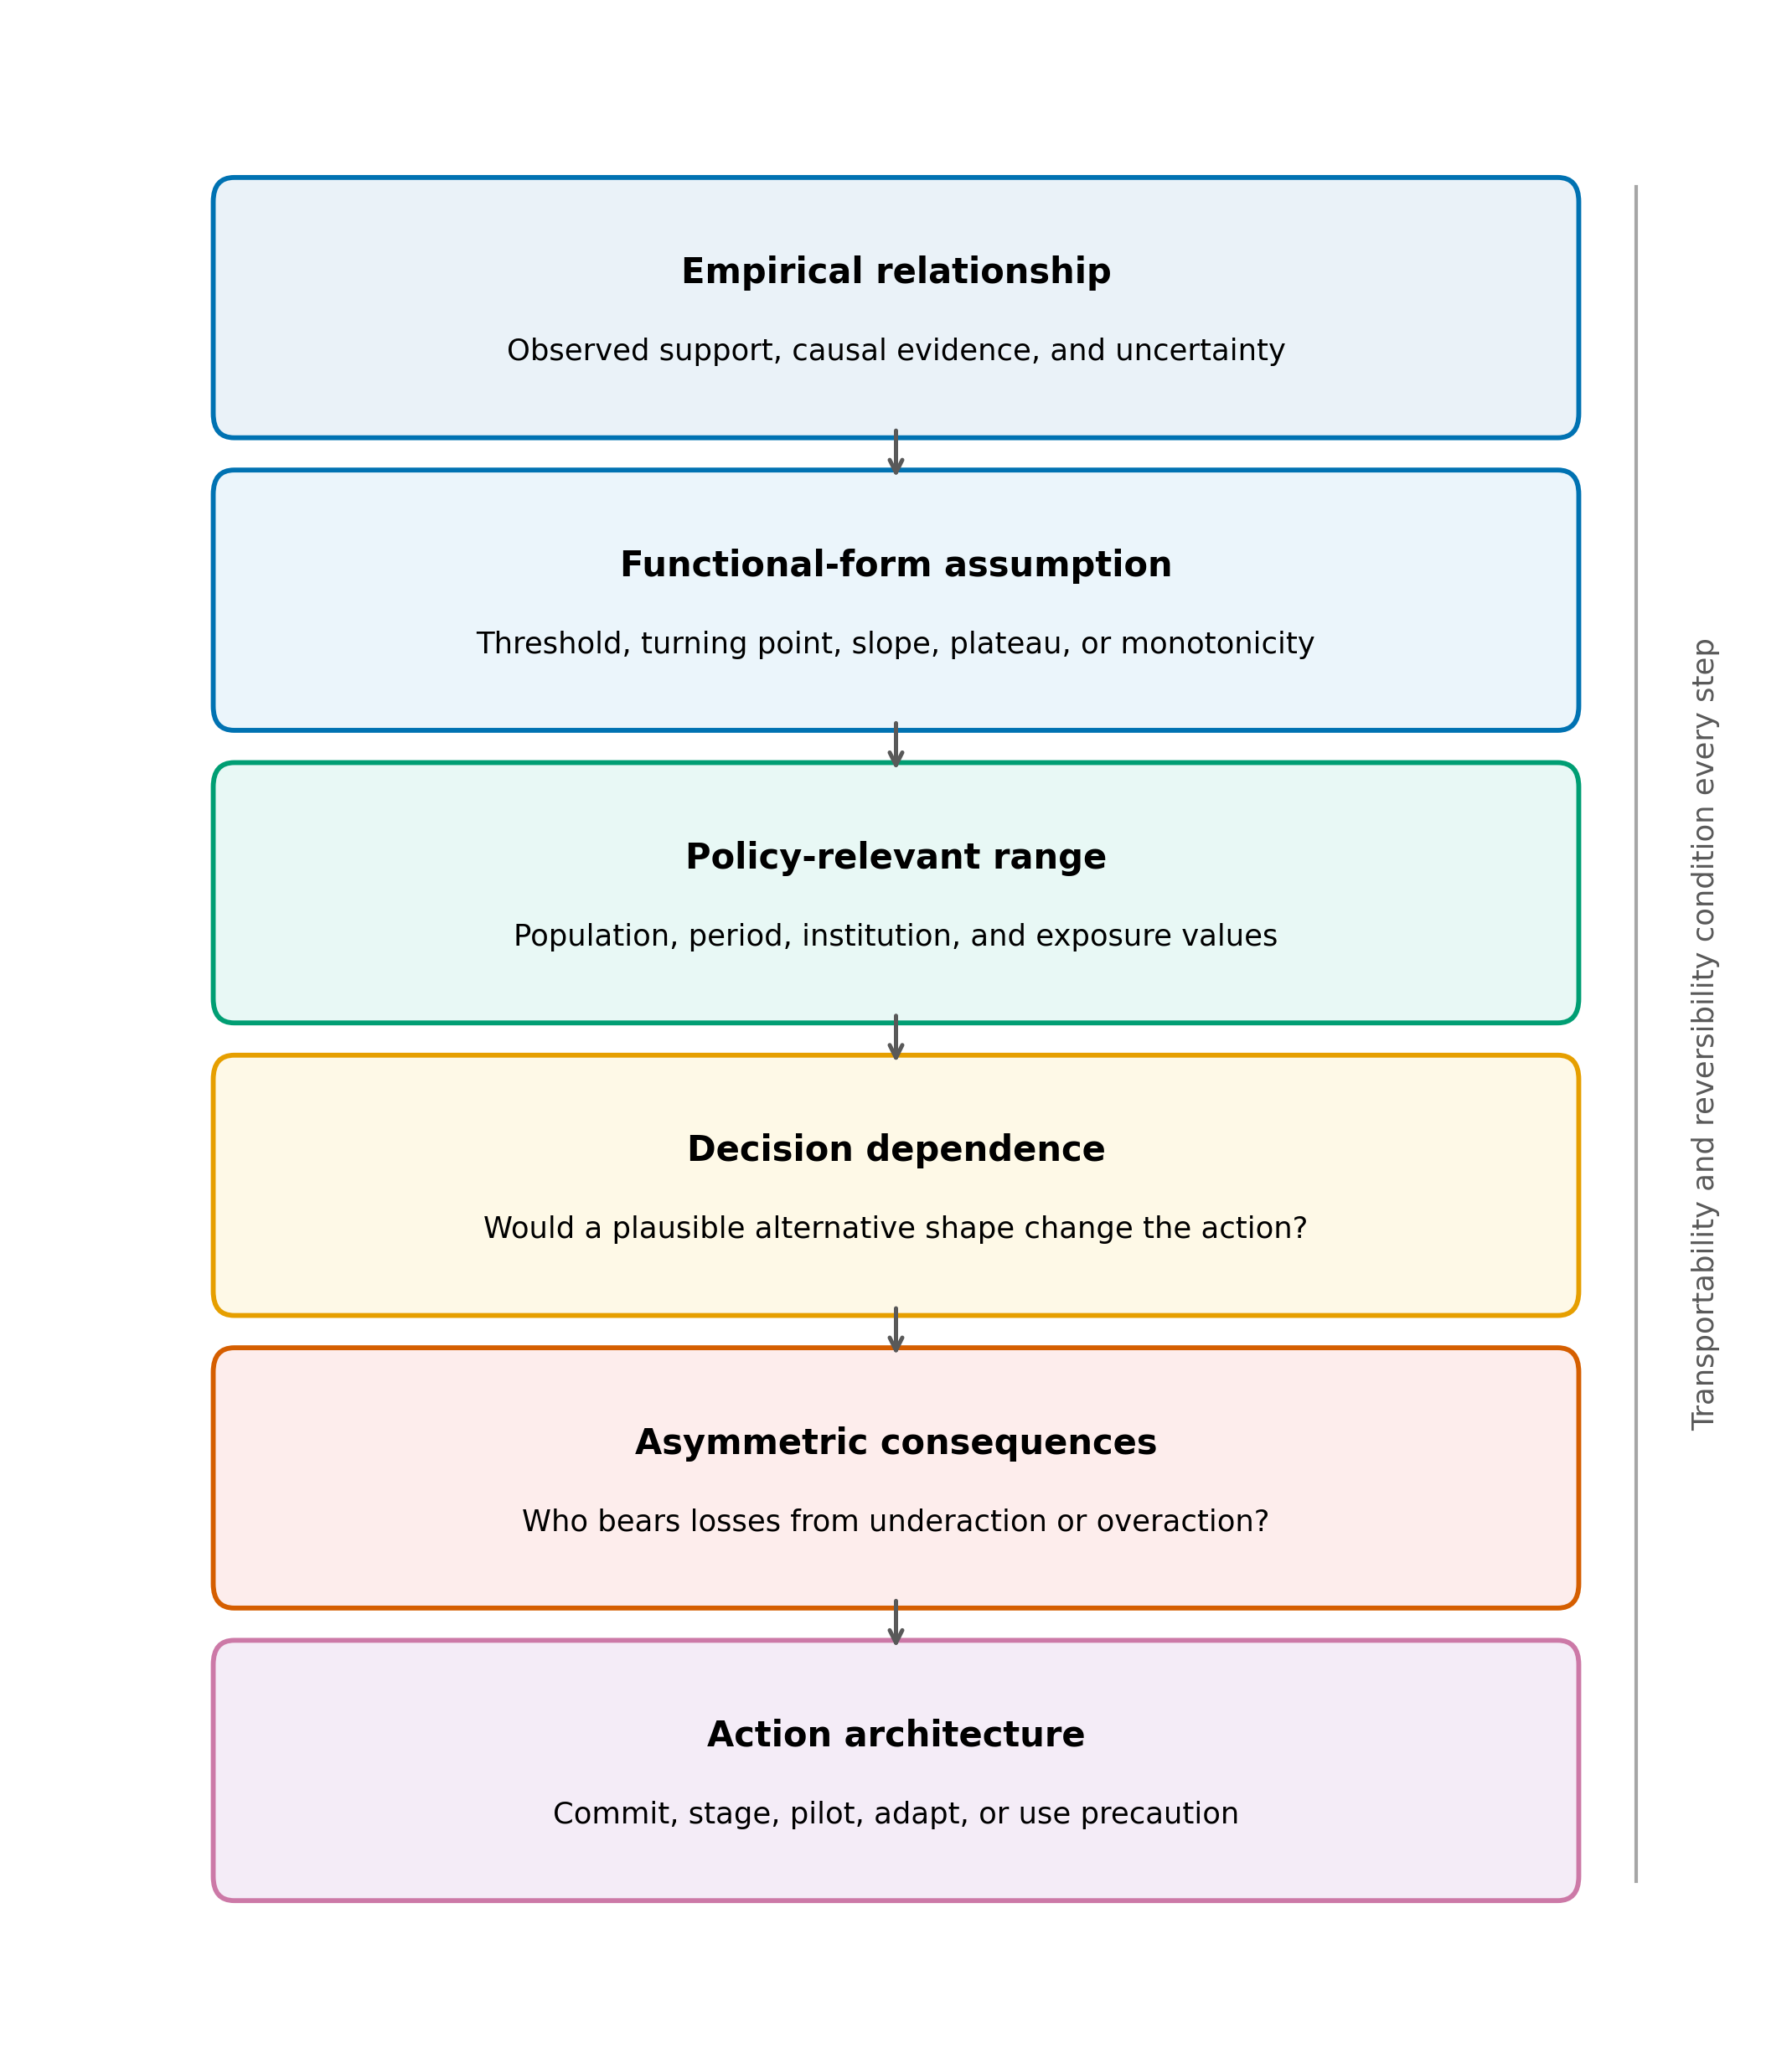
Figure 1. Evidence-to-policy appraisal sequence for functional-form dependence. The same analytical sequence is applied to both applications: the empirical relationship, the assumed functional form, the policy-relevant range, decision dependence, asymmetric consequences, and the action architecture. Transportability and reversibility condition every step.
The article makes three contributions. It identifies a specific evidence-to-policy mismatch that is distinct from the more studied problems of credibility, relevance, and uptake. It demonstrates the mismatch empirically across two unrelated policy domains, which is evidence that the problem is not an artefact of one field. And it derives a practical appraisal checklist for policymakers, practitioners, and knowledge brokers to use before uncertain functional form becomes embedded in policy.

Methods

Study design
The study is a cross-domain evidence-use analysis with two policy applications. The unit of analysis is the translation chain connecting an empirical relationship to a policy decision: the evidence available, the functional feature the decision required, the interpretation that bridged them, and the consequences that lay outside the original relationship. Fukushima and Kansas were selected because they maximise substantive contrast - different sectors, scientific traditions, institutional environments, temporal dynamics, and consequences of error - while exposing the same evidence-use problem. Finding the problem in two such different settings supports the claim that it is domain-general; the design does not support prevalence estimation, causal inference about all policies that use nonlinear models, or statistical generalisation.
To establish that the problem class extends beyond the applications, a purposive inventory of 52 named nonlinear relationships was screened with one common diagnostic; two pairs lacking a reproducible dataset were excluded, leaving 50. Each relationship-dataset pair was evaluated against a linear baseline with a quadratic alternative, requiring a nested F-test at alpha = 0.05, robustness to removal of the 3 most influential observations, leave-one-out predictive improvement, and BIC preference (Cook, 1977; Burnham and Anderson, 2004). Supplement Figure S1 shows the decision sequence.

Data in the applications
For Fukushima, annual municipal deaths and resident-register populations were assembled for 307 municipalities from the Japanese government's official-statistics portal (Ministry of Health, Labour and Welfare, 2021; Ministry of Internal Affairs and Communications, 2021). The primary treatment group (T1) contains 10 municipalities subject to mandatory evacuation orders, with approximately 160,000 residents in 2010; municipalities with tsunami inundation exceeding 1.2% were excluded to reduce direct-tsunami confounding; missing-data exclusions are reported in Supplement Table S1. Two-way fixed-effects differences in log crude death rates were estimated for 2012-2019, with robustness across control pools, weighting, treatment definitions, permutation inference, and synthetic controls (Abadie et al., 2010, 2015; Abadie, 2021; Bertrand et al., 2004); unit-level synthetic-control results are reported in Supplement Table S2.
For Kansas, a state-year panel covering 1997-2012 and later years supports synthetic-control estimates of real GDP per capita, nonfarm employment, real total tax revenue per capita, and real individual income-tax revenue per capita. The main donor pool excludes states with large contemporaneous rate changes or without broad income taxes, leaving 33 donors; permutation tests, leave-one-donor-out checks, in-time placebos, and neighbouring-state event studies assess sensitivity (Supplement Figure S2).
The preferred specification estimates two-way fixed-effects differences in log crude death rates, with municipality and year effects, excluding 2011 from the post-period average:
$$ln(CDR_it) = {alpha}_{i} + {gamma}_{t} + beta D_it + {epsilon}_{it}$$
Neither analysis claims to identify a universally correct radiation model or tax schedule, and neither treats a curve as the sole cause of policy. Emergency evacuation and tax legislation reflect legal authority, political commitments, and multiple streams of evidence; the analysis isolates the functional-form proposition each decision depended on.

Findings

Mapping the evidence-specificity problem
Under the default criteria, 34 of 50 relationship-dataset pairs (68%) did not meet the criteria for robust nonlinear identification; the share ranged from 60% to 74% across the alpha and influence-removal grid (Figure 2). Table 1 reports categories by field. For the Laffer dataset the quadratic term had p = 0.06 (n = 29); for the low-dose radiation dataset p = 0.15 (n = 21), with 6 observations below 0.1 Gy.
These results are a diagnostic map, not a replication-failure rate: the mapping is purposive, estimates no prevalence, and does not falsify any underlying theory. Their evidential function here is different: they show that familiar scientific relationships - the kind that circulate in policy debates as established pictures - may be used at a level of functional-form specificity that exceeds what a single transparent diagnostic can establish. The mapping thereby quantifies an evidence-specificity gap that the two applications then examine in the settings where it became decision-relevant.
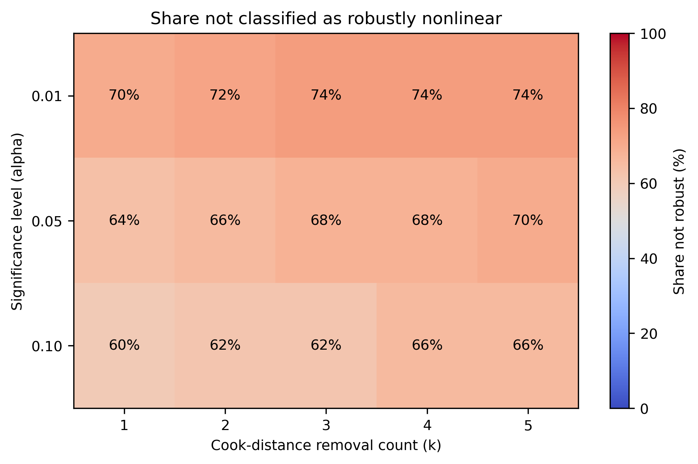
Figure 2. Share of 50 relationship-dataset pairs not classified as robustly nonlinear across significance levels and Cook-distance removal counts. Cell labels report percentages; the colour scale spans 0-100%.
Table 1. Cross-domain mapping classifications by category. Counts describe the purposive relationship-dataset inventory and are not prevalence estimates for scientific theories or literatures.
Category | Robust nonlinear | Not significant | Outlier dependent | Overfitting | Insufficient data | Total
Agriculture | 2 | 1 | 0 | 0 | 1 | 4
Demography | 2 | 3 | 0 | 0 | 1 | 6
Economics | 3 | 8 | 1 | 0 | 0 | 12
Environmental Science | 2 | 3 | 1 | 0 | 0 | 6
Physics | 1 | 2 | 1 | 0 | 0 | 4
Political Science | 2 | 2 | 1 | 0 | 0 | 5
Psychology | 1 | 2 | 0 | 0 | 0 | 3
Public Health | 3 | 6 | 0 | 1 | 0 | 10
Total | 16 | 27 | 4 | 1 | 2 | 50

Fukushima: translating low-dose evidence into policy
After the March 2011 Fukushima Daiichi accident, Japanese authorities ordered mandatory evacuations affecting roughly 160,000 residents. The translation chain runs from radiation-protection evidence, through low-dose dose-response assumptions - linear no-threshold and related projections of population risk at doses where direct epidemiological identification is difficult (ICRP, 2007) - to evacuation thresholds and orders, and onward to consequences that the dose-response curve does not represent: displacement, mortality risk among vulnerable groups, and disrupted care.
The decision required the slope of the dose-response function in the low-dose range: whether incremental exposure below the well-observed range carries proportional risk justifying broad and sustained evacuation. This is an extrapolation problem - the feature mattered precisely where direct evidence is weakest. Plausible alternative low-dose shapes - linear, threshold, hormetic, supralinear - imply materially different optimal evacuation scope, duration, and priority, so the decision was decision-sensitive to a feature the evidence could not sharply identify: functional-form dependence in its clearest form.
Figure 3 plots pooled crude death rates. T1 municipalities show a sharp 2011 increase and a lower recorded rate than Fukushima controls through much of 2012-2019; the preferred difference-in-differences estimate is -0.085 log points, approximately 8% fewer recorded deaths than the counterfactual trend (permutation p 0.001; pre-trend p 0.314). Supplement Table S3 reports the specification grid and Supplement Figure S3 the preferred event study.
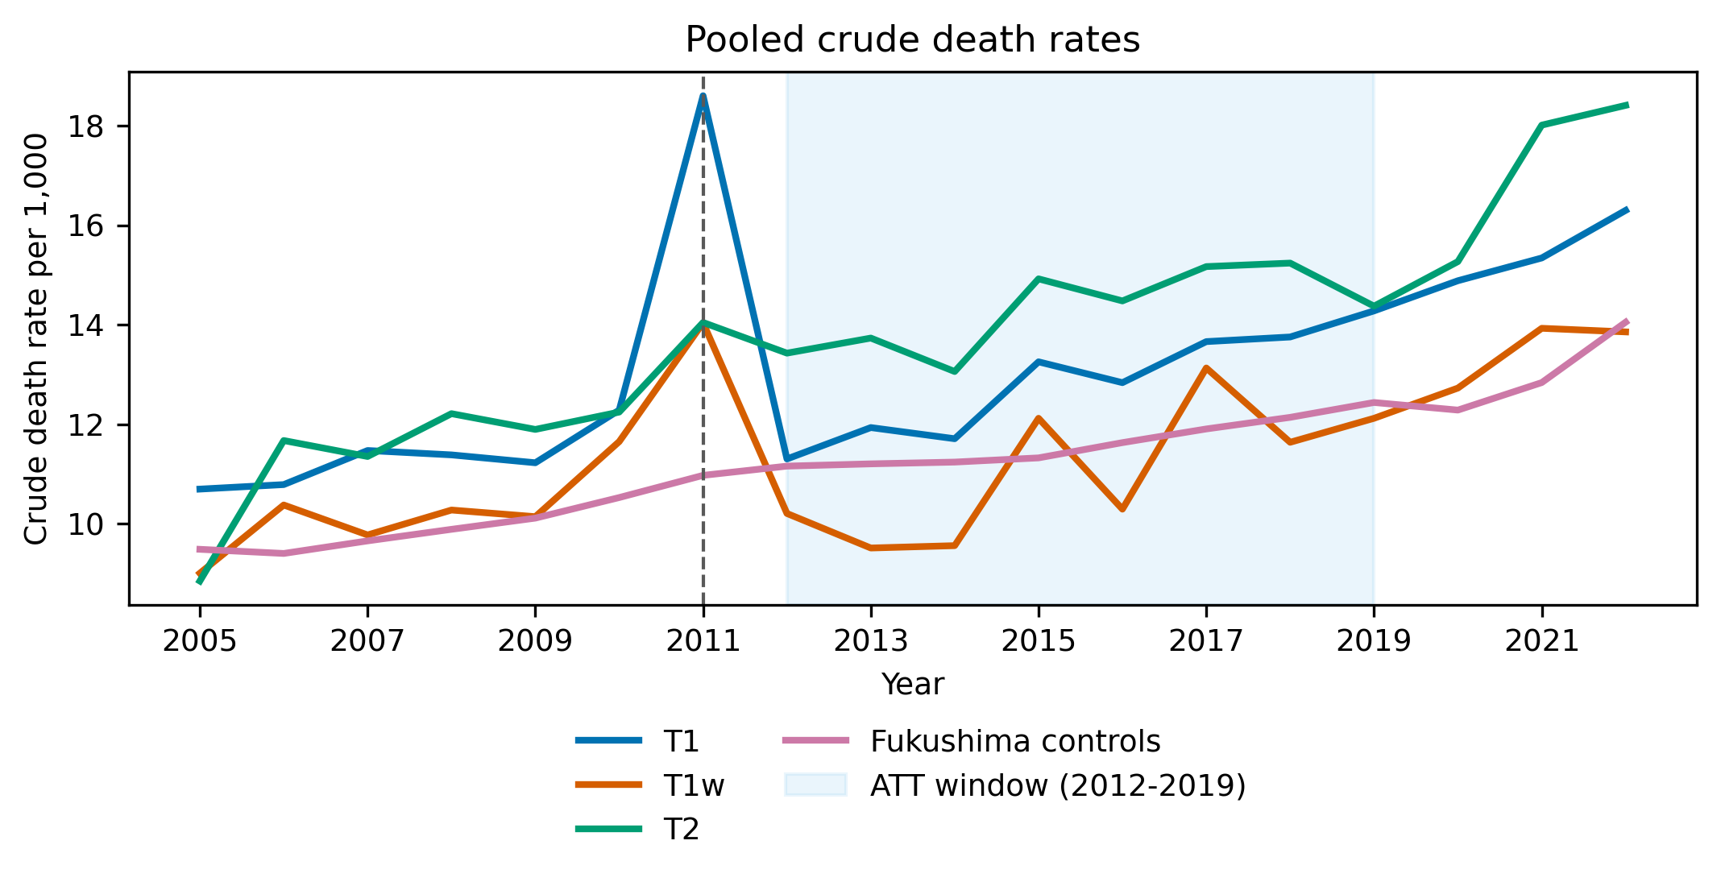
Figure 3. Pooled crude death rates in Fukushima treatment and control groups. T1 contains 10 mandatory-evacuation municipalities; T1w is the restricted complete-evacuation group; T2 contains comparison municipalities subject to other evacuation-related classifications. The shaded region is the 2012-2019 average-treatment-effect window.
The negative post-2011 coefficient is not evidence that evacuation improved health. Displacement, selective return, registration practice, and population composition change who remains in the series and where deaths are recorded - the post-evacuation curve does not trace a stable population through exposure levels. The 2011 decomposition is more informative: T1 municipalities recorded 2,996 deaths against 2,060 trend-expected, an excess of 936; direct disaster deaths account for 732, leaving a residual of 204 (Supplement Figure S4) that cannot be wholly assigned to evacuation. Certified disaster-related deaths for Fukushima Prefecture total 2350 as of February 13, 2026 (Reconstruction Agency, 2026; Fukushima Prefecture, 2014). Supplement Table S4 places measured quantities beside published radiological projections - for example, ten Hoeve and Jacobson's (2012) best estimate of 130 worldwide cancer deaths (range 15-1,100) with 28 averted by evacuation (range 3-245), alongside WHO (2013) and UNSCEAR (2014) quantities that differ in scope and construction.
The evidence-to-policy lesson is that evidence about radiation risk was translated into policy at a level of functional specificity and consequence coverage that the underlying dose-response evidence alone could not supply. Error costs were asymmetric on both sides and partly irreversible, yet the appraisal space was not binary: zoning, assisted voluntary relocation, exemptions for medically fragile residents, continuity of care, time-limited orders, exposure monitoring, and staged return are adjustable design variables that perform differently across plausible risk functions. The case does not show that the linear no-threshold model is false, that evacuation was definitively wrong, or that non-evacuation outcomes are observed; it shows functional-form uncertainty under extrapolation combined with high consequence asymmetry and limited reversibility.

Kansas: translating fiscal-response evidence into policy
In 2012 Kansas enacted large income-tax cuts. The justification invoked the Laffer curve - the proposition that revenue eventually declines as rates rise past a maximum (Laffer, 2004) - and assumed, under expectations about tax-rate-revenue and growth responses, that behavioural and growth responses would recover much of the static revenue loss (Kansas Legislature, 2012; Rothschild, 2012). The translation chain runs from economic theory and cross-jurisdiction evidence, through an assumed fiscal-response shape, to a claim about Kansas's local position on that shape, to legislation, and to observed fiscal and economic outcomes.
The decision required the state's local position on the revenue response, the local slope, and the timing and magnitude of any dynamic feedback - features that the existence of a Laffer-type relationship does not identify. Evidence that such a curve can exist does not locate Kansas on it, and the mapping exercise found the curve's quadratic shape statistically fragile even in its canonical dataset (p = 0.06).
Figure 4 compares Kansas with synthetic Kansas. After the reform, real individual income-tax revenue per capita averaged about 27% below the main synthetic counterfactual (permutation p = 0.03); the all-state pool implies 26%. The gap grew from roughly $91 per capita in 2013 to $422 in 2016, a cumulative counterfactual gap near $4.6 billion in 2012 dollars. Real total tax revenue was 3.0% lower (p = 0.18); post-reform gaps were +1.5% for real GDP per capita (p = 0.71) and -1.3% for employment (p = 0.47). Supplement Table S5 reports donor pools, pre-period fit, in-time placebos, and leave-one-donor-out ranges (-0.322 to -0.291 log points; pre-RMSPE 0.025), and Supplement Figure S2 the neighbouring-state event studies.
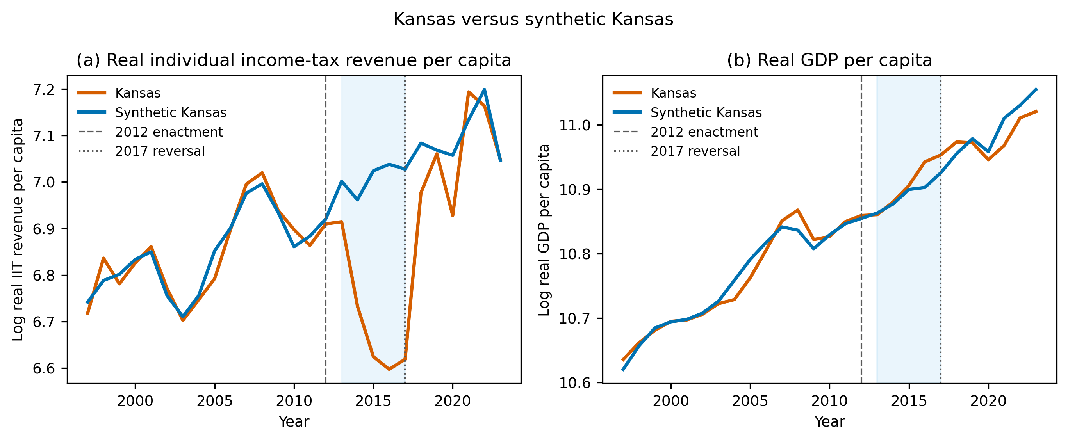
Figure 4. Kansas and synthetic Kansas, 1997-2019. Panel (a) reports log real individual income-tax revenue per capita; panel (b) reports log GDP per capita. Synthetic controls use the main 33-state donor pool. Shading marks 2013-2017, between implementation and legislative reversal.
The result is not a universal rejection of the Laffer curve, nor does Kansas disprove supply-side economics. Within this period and design, no macroeconomic response large enough to offset the revenue loss is observed. The evidence-use lesson is that a theoretically possible response shape was translated into a decision-relevant claim about local position and slope that the available evidence did not identify. Unlike Fukushima, however, the setting was comparatively reversible and observable: statutory changes are revisable, outcomes are visible on budget timescales, and staged rate changes, automatic review triggers, and sunset clauses were feasible learning architectures. Kansas's 2017 partial repeal illustrates correction after observation.

Cross-case synthesis: when evidence specificity matters
Both applications required decision-relevant knowledge of relationship shape that exceeded what the available evidence established. In each, a named canonical relationship supplied content - an evacuation threshold, an expected revenue recovery - that the evidence over the relevant range did not deliver. The evidence-use mechanism is the same even though the applications share no dataset, institution, or political context.
The applications differ in the conditions that determine whether the specificity gap becomes consequential (Table 2). Fukushima's uncertainty was extrapolative - the required feature lay below the observed dose range - whereas Kansas's concerned local position and dynamic response within a theoretically possible curve. Fukushima combined severe, two-sided consequence asymmetry with limited reversibility; Kansas carried primarily fiscal costs with far greater reversibility and rapid observability. Three interpretive findings follow, stated as generalisations rather than statistically tested hypotheses: functional-form uncertainty becomes policy-critical when plausible alternative shapes imply materially different actions - decision sensitivity, not statistical significance, is the threshold; the decision cost of functional-form uncertainty rises when consequences are asymmetric and commitments are difficult to reverse; and where policies are reversible and outcomes observable on useful timescales, adaptive implementation can partially substitute for ex ante shape certainty (Lempert and Collins, 2007; Walker et al., 2013).
Table 2. Cross-case synthesis of the two applications across the evidence-to-policy dimensions. The applications are not statistically comparable.
Dimension | Fukushima | Kansas
Policy domain | Health and radiation protection | Fiscal policy
Canonical relationship | Dose-response | Tax rate-revenue
Decision-relevant feature | Low-dose slope and extrapolation | Local slope and turning point
Central uncertainty | Extrapolation below the observed range | Unknown position and behavioral response
Principal downside of error | Health and displacement harms | Revenue and growth effects
Reversibility | Relatively limited | Comparatively greater
Functional-form dependence | High if action changes under alternative plausible shapes | High if expected fiscal response depends on local curve geometry

Discussion

Principal finding
The principal finding is that the specificity required by policy can exceed the specificity supported by evidence. This is an evidence-use problem in its own right, distinct from the better-studied problems of whether research is produced, credible, relevant, or taken up at all: evidence can be produced, credible, and used, and still be asked to support a more specific empirical claim than it identifies.

Why study quality is not enough
Appraisal practices concentrated on the quality or credibility of a study can miss the mismatch entirely. A rigorous causal estimate can fail to identify a shape, a threshold, a turning point, or behaviour outside the observed range, and functional form can matter even inside strong causal designs (Roth and Sant'Anna, 2023). Evidence hierarchies rank designs by internal validity; they say little about whether the feature a decision requires was ever estimated.

Relevance and transportability
Evidence may be credible yet insufficiently relevant to the policy-relevant range or context (Cartwright and Hardie, 2012). In Fukushima the gap was extrapolative - epidemiological strength at higher doses could not specify the low-dose slope. In Kansas it was locational - cross-jurisdiction and theoretical evidence could not place the state on the curve. Decomposing transportability by population, period, institution, and range makes these different gaps visible instead of a single judgement about whether evidence applies.

How evidence changes in translation
Named scientific relationships travel well: a curve summarises a multi-step argument in one portable picture. The applications show how that portability inflates claims - a relationship that evidences an association in the literature is rehearsed in policy reasoning as a threshold, a slope at a particular point, or an expected dynamic response, each a stronger claim than the source evidence licensed. The translation step is where specificity is gained on paper and lost in warrant.

Implications for policymakers and practitioners
Before evidence is used to justify policy, seven questions make the specificity gap visible: (1) what exactly does the evidence establish; (2) what specific functional feature does the policy require; (3) is that feature identified in the policy-relevant range; (4) is the evidence transportable to the target setting; (5) would plausible alternative shapes change the decision; (6) what are the consequences of acting on the wrong shape; and (7) can the policy be staged, monitored, or reversed? The checklist is an evidence-use tool, not a universal theory; its function is to keep the level of claim matched to the level of identification.

Implications for researchers
Researchers can make the specificity gap legible by distinguishing, in their reporting, between what the data identify, what model assumptions add, and what policy users may infer. Where a named relationship is likely to be translated into a decision, stating which features are identified in which ranges - and which are assumed - is itself an evidence-use contribution.

Implications for knowledge brokers
Intermediaries between research and policy are positioned to surface exactly this class of uncertainty (Ward et al., 2009). Brokers can ask the checklist questions on behalf of evidence users, flag extrapolation and shape dependence in summaries, and resist compressing multi-step arguments into the named curve that travels best.

Limitations
The design has clear limits. Two purposively selected applications cannot support statistical generalisation; the reconstruction is retrospective; the two empirical designs are heterogeneous; and policymakers' actual information sets are not fully observed, so the analysis isolates the functional-form proposition each decision depended on rather than the whole of each rationale. The 50-relationship mapping is purposive and estimates no prevalence. Fukushima's municipal mortality is affected by displacement, registration, demographic change, and recording location, and non-evacuation outcomes are unobserved. Kansas's synthetic control cannot fully separate the reform from contemporaneous state-specific shocks. The analysis also stops short of a welfare analysis placing all consequences on a common scale.

Conclusion
The gap between evidence and policy is not only about whether research is used; it is also about whether policy asks the evidence to support a more specific empirical claim than the evidence can identify. Functional-form dependence names that mismatch, and the mapping and applications show it appearing across unrelated domains. The governing principle for evidence use follows directly. Where a decision requires specificity the evidence lacks, the honest response is to narrow the claim, stage the commitment, or build in the capacity to learn. Evidence should not be translated into a more specific policy claim than the underlying data can support.

Data availability
All data used in the analyses are from public sources. Archived source files, acquisition metadata, processed datasets, analysis code, machine-readable results, and document-generation code will be supplied to reviewers through an anonymised archive. The public repository URL is provided to the editor in the title-page materials and will be added to the manuscript after double-anonymous review. The archive README records the commands required to reproduce the analyses and submission files.

Artificial intelligence assistance
An AI coding assistant (Devin, Cognition AI) was used to assist with data-acquisition, analysis, and document-generation code and with manuscript drafting and editing under the author's direction. The author specified the research questions and analytical choices, verified the data sources and results, evaluated all interpretations, and takes full responsibility for the manuscript.

References
Abadie, A, 2021, Using synthetic controls: Feasibility, data requirements, and methodological aspects, Journal of Economic Literature 59, 2, 391-425, https://doi.org/10.1257/jel.20191450
Abadie, A, Diamond, A, and Hainmueller, J, 2010, Synthetic control methods for comparative case studies: Estimating the effect of California's tobacco control program, Journal of the American Statistical Association 105, 490, 493-505, https://doi.org/10.1198/jasa.2009.ap08746
Abadie, A, Diamond, A, and Hainmueller, J, 2015, Comparative politics and the synthetic control method, American Journal of Political Science 59, 2, 495-510, https://doi.org/10.1111/ajps.12116
Bertrand, M, Duflo, E, and Mullainathan, S, 2004, How much should we trust differences-in-differences estimates?, Quarterly Journal of Economics 119, 1, 249-275, https://doi.org/10.1162/003355304772839588
Boswell, C, 2009, The political uses of expert knowledge: Immigration policy and social research, Cambridge: Cambridge University Press
Burnham, K P, and Anderson, D R, 2004, Multimodel inference: Understanding AIC and BIC in model selection, Sociological Methods & Research 33, 2, 261-304, https://doi.org/10.1177/0049124104268644
Cairney, P, 2016, The politics of evidence-based policymaking, London: Palgrave Macmillan, https://doi.org/10.1057/978-1-137-51781-4
Cartwright, N, and Hardie, J, 2012, Evidence-based policy: A practical guide to doing it better, Oxford: Oxford University Press
Cook, R D, 1977, Detection of influential observation in linear regression, Technometrics 19, 1, 15-18, https://doi.org/10.1080/00401706.1977.10489493
Draper, D, 1995, Assessment and propagation of model uncertainty, Journal of the Royal Statistical Society: Series B 57, 1, 45-70, https://doi.org/10.1111/j.2517-6161.1995.tb02015.x
Fukushima Prefecture, 2014, Higashinihon daishinsai ni yoru higai jokyo sokuhou (dai 1260-ho) [Preliminary report on damage caused by the Great East Japan Earthquake (Report No. 1260)], https://www.pref.fukushima.lg.jp/uploaded/attachment/422314.pdf
International Commission on Radiological Protection, 2007, The 2007 recommendations of the International Commission on Radiological Protection, ICRP Publication 103, Annals of the ICRP 37, 2-4, https://doi.org/10.1016/j.icrp.2007.10.003
Kansas Legislature, 2012, House Bill 2117, enrolled, https://www.kslegislature.gov/li_2012/b2011_12/measures/documents/hb2117_enrolled.pdf
Laffer, A B, 2004, The Laffer curve: Past, present, and future, Heritage Foundation Backgrounder 1765, 1-16, https://www.heritage.org/taxes/report/the-laffer-curve-past-present-and-future
Lempert, R J, and Collins, M T, 2007, Managing the risk of uncertain threshold responses: Comparison of robust, optimum, and precautionary approaches, Risk Analysis 27, 4, 1009-1026, https://doi.org/10.1111/j.1539-6924.2007.00940.x
Ministry of Health, Labour and Welfare, 2021, Vital statistics of Japan [Data set], Portal Site of Official Statistics of Japan, https://www.e-stat.go.jp/en/stat-search/database?page=1&toukei=00450011
Ministry of Internal Affairs and Communications, 2021, Population, demographics, and household counts based on the Basic Resident Registration [Data set], Portal Site of Official Statistics of Japan, https://www.e-stat.go.jp/en/stat-search/files?toukei=00200241
Morgan, M G, and Henrion, M, 1990, Uncertainty: A guide to dealing with uncertainty in quantitative risk and policy analysis, Cambridge: Cambridge University Press
Nutley, S, Walter, I, and Davies, H T O, 2007, Using evidence: How research can inform public services, Bristol: Policy Press
Oliver, K, Innvar, S, Lorenc, T, Woodman, J, and Thomas, J, 2014, A systematic review of barriers to and facilitators of the use of evidence by policymakers, BMC Health Services Research 14, 2, https://doi.org/10.1186/1472-6963-14-2
Parkhurst, J O, 2016, Appeals to evidence for the resolution of wicked problems: The origins and mechanisms of evidentiary bias, Policy Sciences 49, 4, 373-393, https://doi.org/10.1007/s11077-016-9263-z
Reconstruction Agency, 2026, Higashinihon daishinsai ni okeru shinsai-kanrenshi no shisha-su [Number of disaster-related deaths in the Great East Japan Earthquake] (as of February 13, 2026), https://www.reconstruction.go.jp/files/user/topics/main-cat2/sub-cat2-6/20260213_kanrenshi.pdf
Roth, J, and Sant'Anna, P H C, 2023, When is parallel trends sensitive to functional form?, Econometrica 91, 2, 737-747, https://doi.org/10.3982/ECTA19402
Rothschild, S, 2012, Consultant Laffer praises Brownback's tax plan, Lawrence Journal-World, 19 January, https://www2.ljworld.com/news/2012/jan/19/consultant-laffer-touts-brownbacks-tax-plan/
United Nations Scientific Committee on the Effects of Atomic Radiation, 2014, Sources, effects and risks of ionizing radiation: UNSCEAR 2013 report, Volume I, Scientific Annex A, New York: United Nations, https://www.unscear.org/unscear/uploads/documents/unscear-reports/UNSCEAR_2013_Report_Vol.I.pdf
Walker, W E, Haasnoot, M, and Kwakkel, J H, 2013, Adapt or perish: A review of planning approaches for adaptation under deep uncertainty, Sustainability 5, 3, 955-979, https://doi.org/10.3390/su5030955
Ward, V, House, A, and Hamer, S, 2009, Knowledge brokering: The missing link in the evidence to action chain?, Evidence & Policy 5, 3, 267-279, https://doi.org/10.1332/174426409X463811
World Health Organization, 2013, Health risk assessment from the nuclear accident after the 2011 Great East Japan Earthquake and Tsunami, based on a preliminary dose estimation, Geneva: World Health Organization, https://iris.who.int/handle/10665/78218
ten Hoeve, J E, and Jacobson, M Z, 2012, Worldwide health effects of the Fukushima Daiichi nuclear accident, Energy & Environmental Science 5, 9, 8743-8757, https://doi.org/10.1039/C2EE22019A

