When Policy Depends on a Curve: Comparing Functional-Form Dependence in Fukushima Evacuation and Kansas Tax Reform
Abstract
Policies often depend on the shape of an empirical relationship, not merely on an association. I define functional-form dependence as reliance on a threshold, slope, turning point, or extrapolated response that is less securely identified than the policy assumes. A structured comparison of post-Fukushima evacuation and Kansas tax reform examines decision-relevant shape, uncertainty, transportability, consequence asymmetry, reversibility, and learning capacity. The cases share the same mechanism but differ in its policy significance. A purposive mapping of 50 canonical relationships provides background motivation. The comparison yields transferable lessons for policy appraisal under uncertain functional form.
Keywords: comparative policy analysis; functional form; lesson-drawing; policy appraisal; evidence-based policymaking; uncertainty

Introduction
Policy arguments routinely depend on the shape of an empirical relationship rather than on the existence of an association alone. An evacuation order depends on how risk declines with dose. A tax cut is defended on how revenue and activity respond to rates. In each case, the policy requires a particular feature of the underlying curve - a threshold, a local slope, a turning point, or an extrapolated segment - to hold over the range where the policy operates.
This creates what this article calls functional-form dependence: the condition in which a policy's justification, expected benefit, threshold, direction, or intensity materially depends on a relationship shape that is insufficiently identified over the policy-relevant range. Functional-form uncertainty is a form of model uncertainty about relationship shape (Draper, 1995; Morgan & Henrion, 1990); functional-form dependence is the decision-level condition in which that uncertainty changes what should be done.
Existing discussions of model uncertainty, evidence use, and policy appraisal do not always show how such uncertainty changes policy choice under different institutional and consequence structures (Weimer & Vining, 2017; Walker et al., 2013). Evidence enters policy through institutions and routines that can privilege a familiar picture over a fragile empirical claim (Cairney, 2016; Parkhurst, 2016; Boswell, 2009). What remains underdeveloped is a comparative account: when does the same kind of evidentiary gap become decision-critical in one policy setting and manageable in another?
The comparative puzzle is therefore: why does the same basic evidence problem - a decision that leans on an incompletely identified relationship shape - create different decision risks in different policy settings? Answering it requires cases that share the mechanism but differ on the conditions that could plausibly moderate it.
This article compares post-Fukushima evacuation, justified under low-dose radiation-risk assumptions, with the Kansas tax reform of 2012, defended under assumptions about tax-rate-revenue and growth responses. The two policies are deliberately dissimilar - different sectors, scientific traditions, institutional environments, temporal dynamics, and consequences of error - yet both committed resources and authority on functional-form assumptions whose decision-relevant features were incompletely identified. This maximum-contrast selection follows the logic of comparing unlike systems to identify which features of a phenomenon are general and which are context-dependent (Przeworski & Teune, 1970).
The comparison is organized around common dimensions: the policy-dependent relationship, the decision-relevant functional feature, the location and type of uncertainty, decision sensitivity, transportability of evidence, consequence asymmetry, reversibility, and the opportunity for iterative learning. Figure 1 summarizes the shared analytical sequence with each case mapped onto the same dimensions.
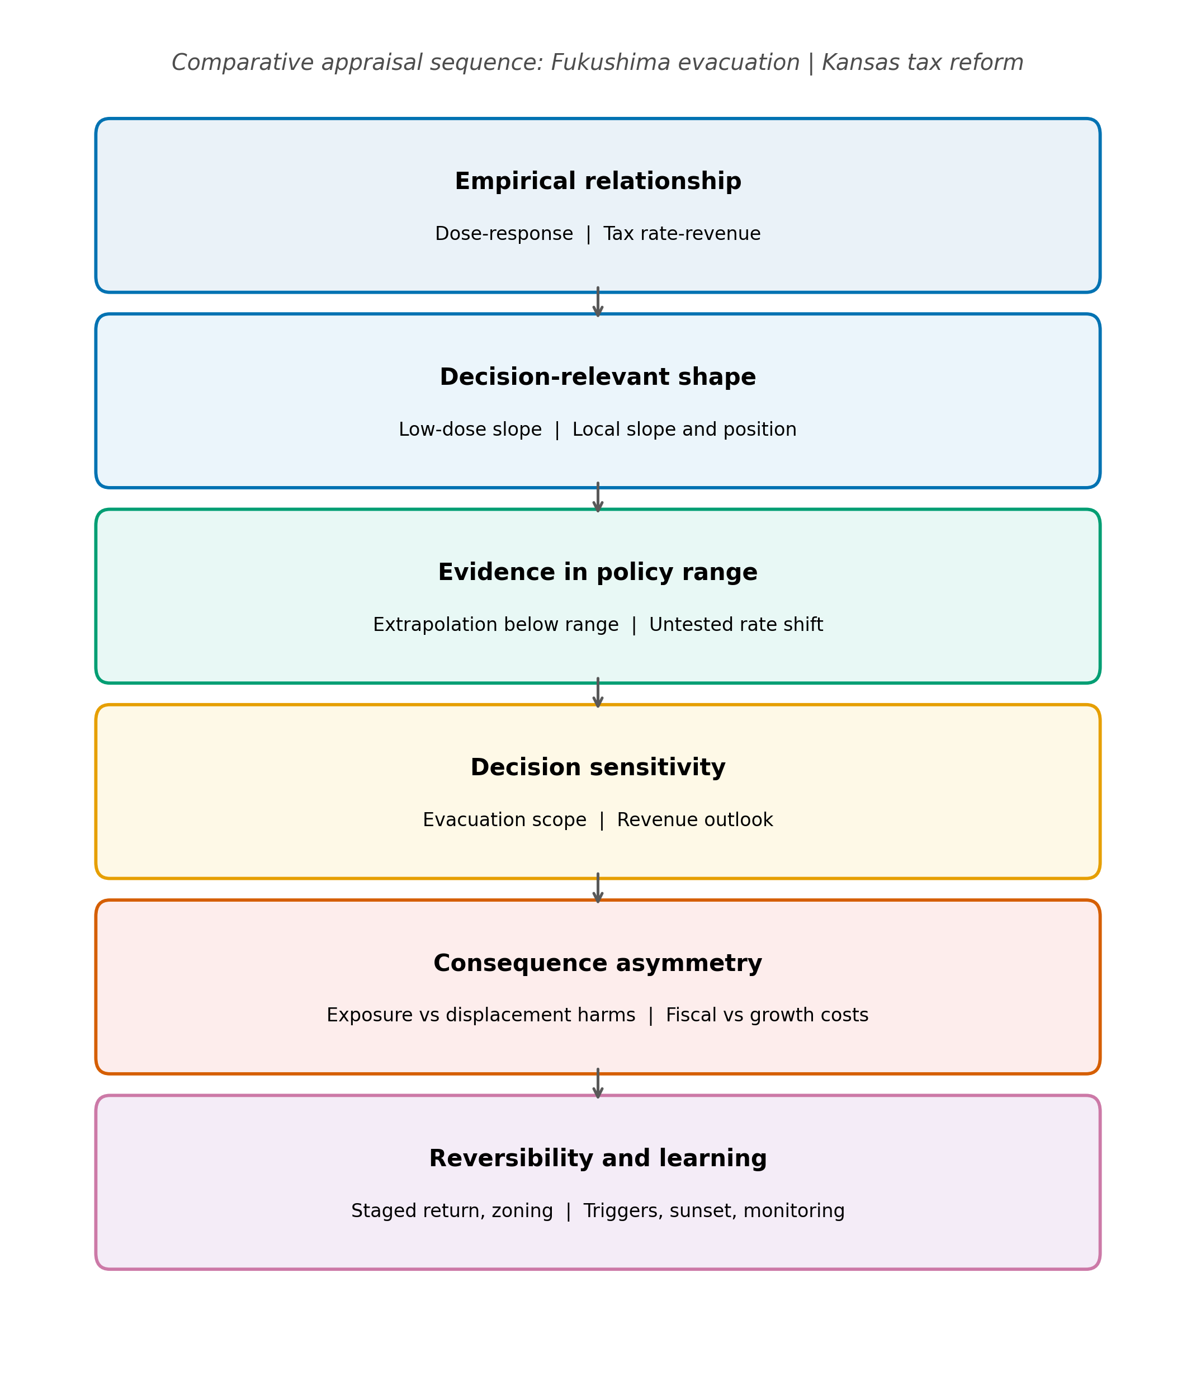
Figure 1. Comparative appraisal sequence for functional-form dependence. The same analytical sequence is applied to both cases: the empirical relationship, the decision-relevant shape, evidence in the policy range, decision sensitivity, consequence asymmetry, and reversibility and learning. Fukushima entries appear before the vertical bar; Kansas entries after it.
A purposive mapping of 50 canonical relationships supplies background motivation: the gap between association, empirical shape, and policy-relevant functional form is not unique to either case. The mapping is not the comparative core and is used only to establish that the problem class is broad.
The article makes three contributions. Conceptually, it defines functional-form dependence as a decision-level manifestation of model-form uncertainty. Comparatively, it identifies the shared mechanism and the context-dependent moderators across two highly dissimilar policies, in the structured and focused tradition of comparative case analysis (George & Bennett, 2005). Practically, it derives comparative propositions and lesson-drawing for policy appraisal under uncertain functional form, in the tradition JCPA has long cultivated (Rose, 1991; Bennett & Howlett, 1992; Dolowitz & Marsh, 2000).

Comparative research design

Case selection
Fukushima and Kansas were selected for maximum substantive contrast combined with a common analytical mechanism. They differ sharply in policy sector (radiation protection versus fiscal policy), institutional environment (emergency disaster governance versus legislative budget politics), scientific tradition (radiation epidemiology versus public economics), temporal dynamics, and the consequences of error. They nonetheless expose the same decision-level mechanism: in both, policy commitment depended on functional-form assumptions whose decision-relevant features were incompletely identified by the evidence available at the time.
This design permits three things: identification of a recurring mechanism across heterogeneous contexts; examination of how consequence asymmetry and reversibility modify the importance of shape uncertainty; and comparative lesson-drawing about appraisal practice. It does not permit prevalence estimation, causal inference about all policies that use nonlinear models, or statistical generalization from N = 2. The cases are contrasting instrumental cases, not a representative sample (George & Bennett, 2005).

Units and common comparative dimensions
The unit of comparison is the policy decision, not the country, program, or dataset. In each case, the analysis isolates the load-bearing empirical proposition within the policy rationale and asks how the decision depended on a specific functional feature of that relationship. Both cases are examined under the same eight dimensions: (1) the policy-dependent relationship; (2) the decision-relevant functional feature; (3) the location of functional-form uncertainty; (4) decision sensitivity - whether materially different plausible shapes imply materially different choices; (5) transportability of the available evidence to the relevant population, setting, range, and period; (6) consequence asymmetry - the relative harms of acting on a wrong form versus failing to act on a right one; (7) reversibility of the intervention; and (8) the learning architecture available to the policy - whether it could have been piloted, staged, updated, monitored, or adapted.
The comparison is structured and focused rather than statistical: the same questions are asked of each case, and the answers are coded qualitatively into a common comparative table presented in the comparative findings. No numerical comparability is claimed between the cases' estimates; the shared object is the dependence structure between evidence and decision.

Evidence in each case
For Fukushima, annual municipal deaths and resident-register populations were assembled for 307 municipalities from the Japanese government's official-statistics portal (Ministry of Health, Labour and Welfare, 2021; Ministry of Internal Affairs and Communications, 2021). The primary treatment group (T1) contains 10 municipalities subject to mandatory evacuation orders, with approximately 160,000 residents in 2010; municipalities with tsunami inundation exceeding 1.2% were excluded to reduce direct-tsunami confounding; missing-data exclusions are reported in Appendix Table A1. Two-way fixed-effects differences in log crude death rates were estimated for 2012-2019, with robustness across control pools, weighting, treatment definitions, permutation inference, and synthetic controls (Abadie et al., 2010, 2015; Abadie, 2021; Bertrand et al., 2004); unit-level synthetic-control results are reported in Appendix Table A2.
For Kansas, a state-year panel covering 1997-2012 and later years supports synthetic-control estimates of real GDP per capita, nonfarm employment, real total tax revenue per capita, and real individual income-tax revenue per capita. The main donor pool excludes states with large contemporaneous rate changes or without broad income taxes, leaving 33 donors; permutation tests, leave-one-donor-out checks, in-time placebos, and neighboring-state event studies assess sensitivity (Appendix Figure A1).
Neither analysis claims to identify a universally correct radiation model or tax schedule, and neither treats a curve as the sole cause of policy. Emergency evacuation and tax legislation reflect legal authority, political commitments, and multiple streams of evidence; the design isolates the functional-form proposition each decision depended on.

Background: cross-domain mapping
To establish that the problem class extends beyond these cases, a purposive inventory of 52 named nonlinear relationships was screened with one common diagnostic; two pairs lacking a reproducible dataset were excluded, leaving 50. Each relationship-dataset pair was evaluated against a linear baseline with a quadratic alternative, requiring a nested F-test at alpha = 0.05, robustness to removal of the 3 most influential observations, leave-one-out predictive improvement, and BIC preference (Cook, 1977; Burnham & Anderson, 2004). Figure 2 shows the decision sequence.
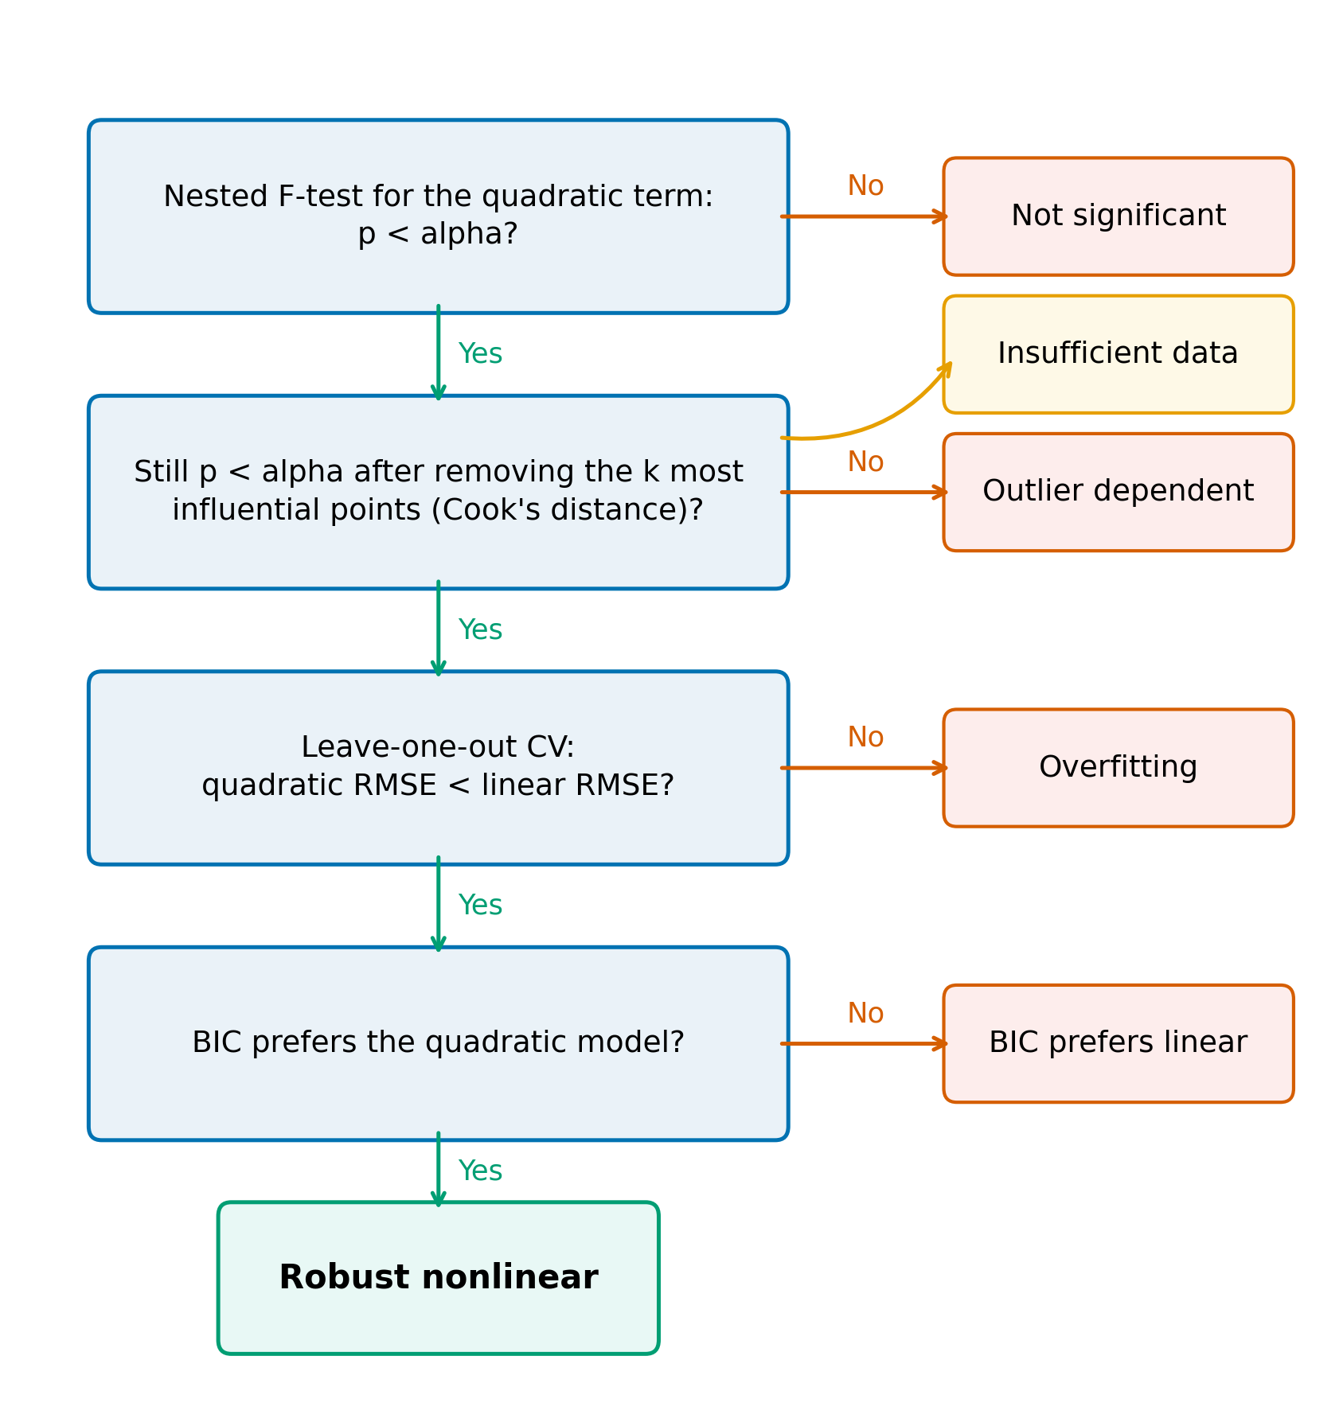
Figure 2. Diagnostic used in the cross-domain mapping exercise. Green paths continue toward robust nonlinear classification; orange paths indicate the first unmet criterion. Insufficient data is assigned when influence removal leaves too few observations for the nested comparison.
Under the default criteria, 34 of 50 pairs (68%) did not meet the criteria for robust nonlinear identification; the share ranged from 60% to 74% across the alpha and influence-removal grid (Figure 3). Table 1 reports categories by field. For the Laffer dataset the quadratic term had p = 0.06 (n = 29); for the low-dose radiation dataset p = 0.15 (n = 21), with 6 observations below 0.1 Gy. These results are a diagnostic map, not a replication-failure rate: the mapping is purposive, estimates no prevalence, and does not falsify any underlying theory.
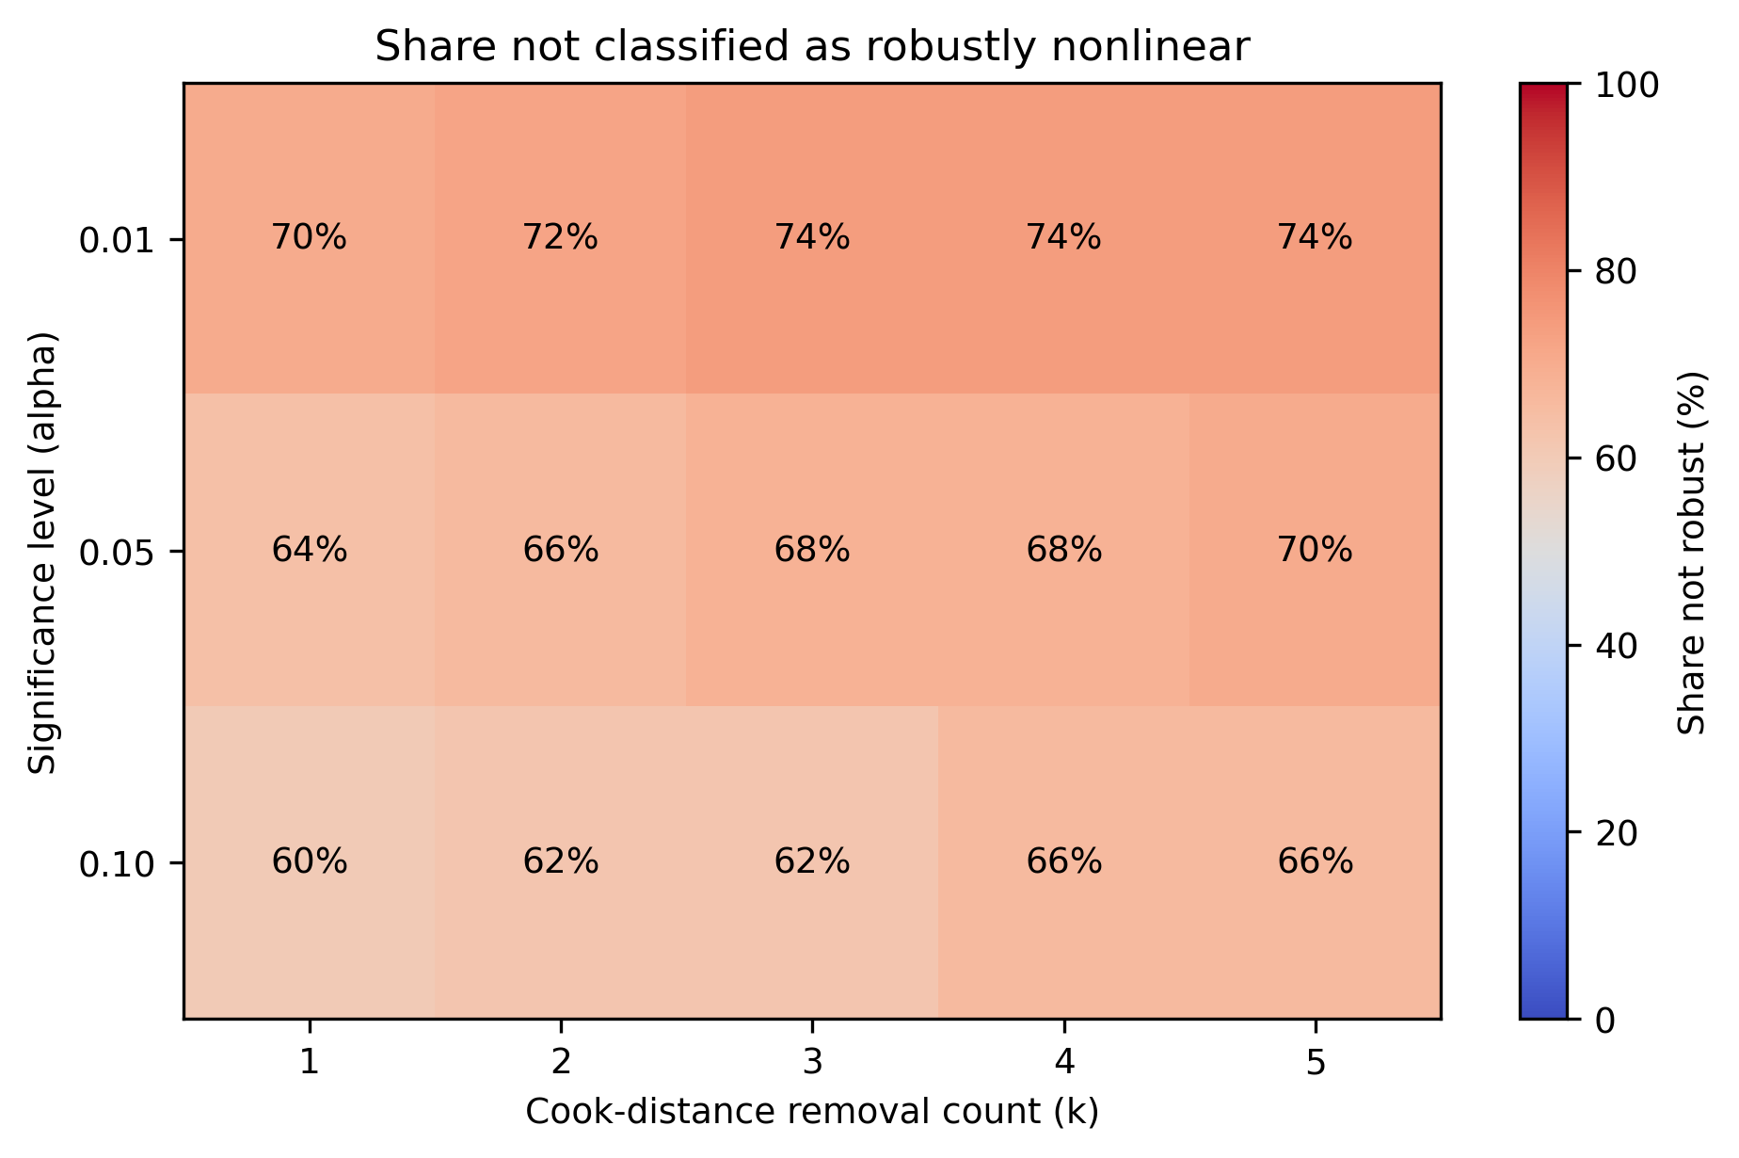
Figure 3. Share of 50 relationship-dataset pairs not classified as robustly nonlinear across significance levels and Cook-distance removal counts. Cell labels report percentages; the color scale spans 0-100%.
Table 1. Cross-domain mapping classifications by category. Counts describe the purposive relationship-dataset inventory and are not prevalence estimates for scientific theories or literatures.
Category | Robust nonlinear | Not significant | Outlier dependent | Overfitting | Insufficient data | Total
Agriculture | 2 | 1 | 0 | 0 | 1 | 4
Demography | 2 | 3 | 0 | 0 | 1 | 6
Economics | 3 | 8 | 1 | 0 | 0 | 12
Environmental Science | 2 | 3 | 1 | 0 | 0 | 6
Physics | 1 | 2 | 1 | 0 | 0 | 4
Political Science | 2 | 2 | 1 | 0 | 0 | 5
Psychology | 1 | 2 | 0 | 0 | 0 | 3
Public Health | 3 | 6 | 0 | 1 | 0 | 10
Total | 16 | 27 | 4 | 1 | 2 | 50

Case 1: Fukushima evacuation and the low-dose risk function

Policy problem and decision
After the March 2011 Fukushima Daiichi accident, Japanese authorities ordered mandatory evacuations affecting roughly 160,000 residents. The decision traded modeled radiation risk against immediate and continuing harms of displacement under emergency conditions.

Assumed empirical relationship
Radiation protection defaults to linear no-threshold and related dose-response assumptions that project population risks at doses where direct epidemiological identification is difficult (ICRP, 2007). Evacuation thresholds translate those risk assumptions into action.

Decision-relevant functional feature
The decision required the slope of the dose-response function in the low-dose range: whether incremental exposure below the well-observed range carries proportional risk justifying broad and sustained evacuation. This is an extrapolation problem - the feature mattered precisely where direct evidence is weakest.

Evidence in the relevant range
The preferred specification estimates two-way fixed-effects differences in log crude death rates, with municipality and year effects, excluding 2011 from the post-period average:
$$ln(CDR_it) = {alpha}_{i} + {gamma}_{t} + beta D_it + {epsilon}_{it}$$
Figure 4 plots pooled crude death rates. T1 municipalities show a sharp 2011 increase and a lower recorded rate than Fukushima controls through much of 2012-2019; the preferred difference-in-differences estimate is -0.085 log points, approximately 8% fewer recorded deaths than the counterfactual trend (permutation p 0.001; pre-trend p 0.314). Table 2 reports the specification grid and Figure 5 the preferred event study.
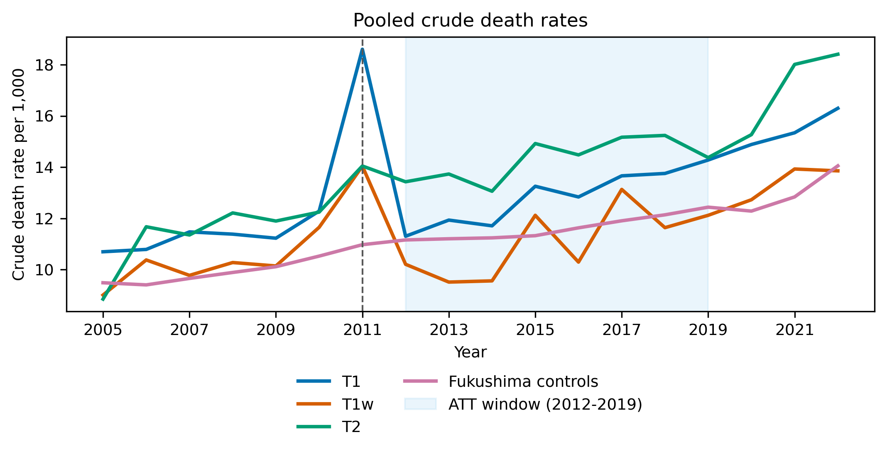
Figure 4. Pooled crude death rates in Fukushima treatment and control groups. T1 contains 10 mandatory-evacuation municipalities; T1w is the restricted complete-evacuation group; T2 contains comparison municipalities subject to other evacuation-related classifications. The shaded region is the 2012-2019 average-treatment-effect window.
Table 2. Fukushima difference-in-differences estimates. ATT is the 2012-2019 average difference in log crude death rates; 2011 is excluded. Permutation p values use 1000 assignments. Implied deaths are descriptive transformations of recorded municipal deaths and are not causal death counts.
Group | Controls | Weighting | Age control | ATT (log points) | Permutation p | Pre-trend p | Implied deaths 2012-2019
T1 | All prefectures | Weighted | No | -0.057 | 0.002 | 0.268 | -877
T1 | All prefectures | Weighted | Yes | -0.066 | < 0.001 | 0.335 | -1,018
T1 | All prefectures | Unweighted | No | -0.072 | 0.002 | 0.039 | -1,123
T1 | All prefectures | Unweighted | Yes | -0.072 | < 0.001 | 0.035 | -1,109
T1 | Fukushima only | Weighted | No | -0.085 | < 0.001 | 0.847 | -1,333
T1 | Fukushima only | Weighted | Yes | -0.083 | < 0.001 | 0.863 | -1,291
T1 | Fukushima only | Unweighted | No | -0.085 | 0.001 | 0.314 | -1,322
T1 | Fukushima only | Unweighted | Yes | -0.079 | 0.005 | 0.275 | -1,224
T1w | All prefectures | Unweighted | No | -0.116 | 0.003 | 0.170 | -405
T1w | Fukushima only | Unweighted | No | -0.129 | < 0.001 | 0.498 | -451
T2 | All prefectures | Unweighted | No | -0.022 | 0.581 | 0.829 | -93
T2 | Fukushima only | Unweighted | No | -0.034 | 0.421 | 0.932 | -146
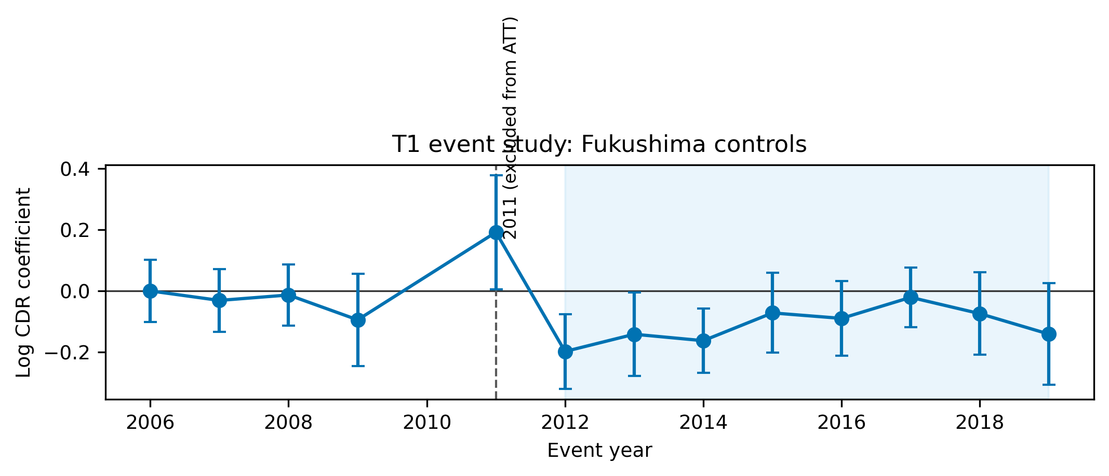
Figure 5. Preferred T1 event-study estimates using unweighted Fukushima municipal controls. Points are year-specific coefficients relative to the omitted reference year; bars are 95% confidence intervals. The acute disaster year 2011 is shown but excluded from the 2012-2019 average-treatment-effect window.
The negative post-2011 coefficient is not evidence that evacuation improved health. Displacement, selective return, registration practice, and population composition change who remains in the series and where deaths are recorded - the post-evacuation curve does not trace a stable population through exposure levels. The 2011 decomposition is more informative: T1 municipalities recorded 2,996 deaths against 2,060 trend-expected, an excess of 936; direct disaster deaths account for 732, leaving a residual of 204 (Figure 6) that cannot be wholly assigned to evacuation. Certified disaster-related deaths for Fukushima Prefecture total 2350 as of February 13, 2026 (Reconstruction Agency, 2026; Fukushima Prefecture, 2014).
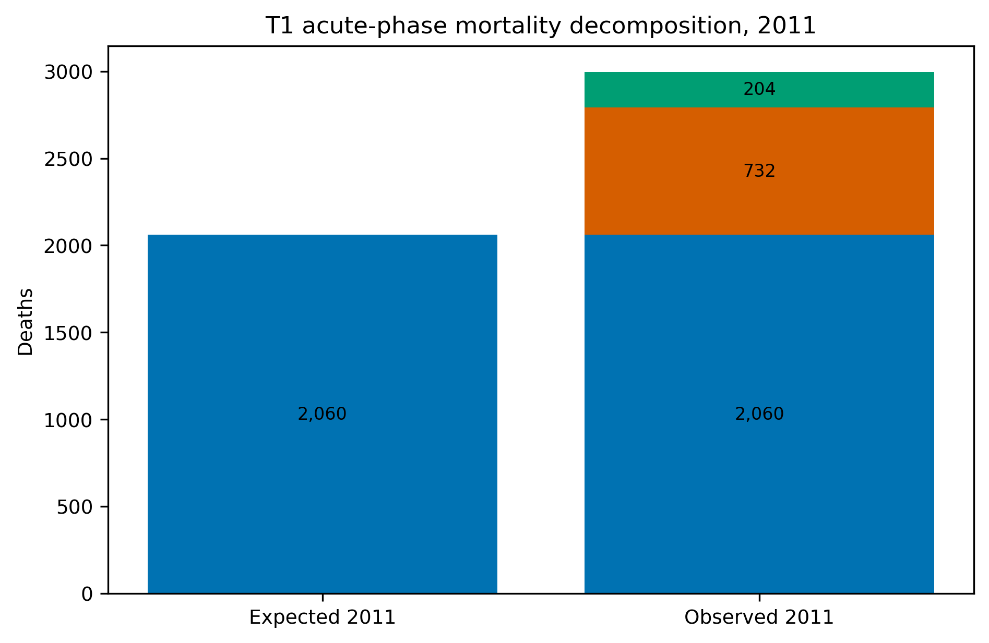
Figure 6. T1 acute-phase mortality decomposition for 2011. Expected deaths are projected from the pre-disaster municipal trend; direct disaster deaths are reported by Fukushima Prefecture; residual excess is the arithmetic difference and is not assigned to a single cause.
Table 3 places measured quantities beside published radiological projections - for example, Ten Hoeve and Jacobson's (2012) best estimate of 130 worldwide cancer deaths (range 15-1,100) with 28 averted by evacuation (range 3-245), alongside WHO (2013) and UNSCEAR (2014) quantities that differ in scope and construction. These estimands are not commensurate; juxtaposing them shows that the evacuation decision was highly sensitive to an assumed low-dose response while its consequences extended to outcomes the curve does not represent.
Table 3. Fukushima measured mortality quantities and published radiological-risk projections. Rows differ in population, geography, time horizon, measurement, and model basis and must not be added or interpreted as commensurate estimands.
Quantity | Value | Scope | Type | Source
T1 observed deaths 2011 | 2,996 | T1 municipalities | Measured | This study
T1 expected deaths 2011 | 2,060 | T1 municipalities | Measured | This study
T1 excess deaths 2011 | 936 | T1 municipalities | Measured | This study
Of which direct disaster deaths | 732 | T1 municipalities | Measured | Fukushima Prefecture, 2014
T1 residual excess deaths 2011 | 204 | T1 municipalities | Measured | This study
T1 implied difference 2012-2019 (recorded) | -1,322 | T1 municipalities | Measured | This study
Certified disaster-related deaths, Fukushima Prefecture | 2,350 | Fukushima prefecture | Measured | Reconstruction Agency, 2026
Projected worldwide cancer deaths from the release | 130 (15-1,100) | Worldwide | Projected (LNT-based) | ten Hoeve & Jacobson, 2012
Evacuation-avoided radiological mortalities | 28 (3-245) | Worldwide | Projected (LNT-based) | ten Hoeve & Jacobson, 2012
Lifetime-risk relative increases in the most affected areas | leukaemia up to 7%; breast up to 6%; all solid cancers up to 4%; thyroid up to 70% | Most affected areas | Projected (LNT-based) | WHO, 2013
WHO conclusion outside Japan | no discernible increase | Outside Japan | Projected (LNT-based) | WHO, 2013
Collective effective dose | 18 / 36 / 48 thousand man-Sv (first year / ten years / lifetime) | Japanese population | Projected (LNT-based) | UNSCEAR, 2014
UNSCEAR conclusion | no discernible increase expected | Exposed population | Projected (LNT-based) | UNSCEAR, 2014

Decision sensitivity
Plausible alternative low-dose shapes - linear, threshold, hormetic, supralinear - imply materially different optimal evacuation scope, duration, and priority. The policy was therefore decision-sensitive to a feature the evidence could not sharply identify: functional-form dependence in its clearest form.

Consequence asymmetry
Error costs are asymmetric on both sides. Acting on an overstated low-dose slope imposes displacement, mortality risk among vulnerable groups, and disrupted care; failing to act on a real slope imposes exposure harms. These harms fall on identifiable groups and are measured in different units, so no single fitted curve can settle the trade-off.

Reversibility and learning
Reversibility was limited: displacement and institutional disruption are partly irreversible, and mid-crisis learning architecture was thin. Yet the appraisal space was not binary. Zoning, assisted voluntary relocation, exemptions for medically fragile residents, continuity of care, time-limited orders, exposure monitoring, and staged return are adjustable design variables that perform differently across plausible risk functions. The case does not show that LNT is false, that evacuation was definitively wrong, or that non-evacuation outcomes are observed; it shows functional-form uncertainty under extrapolation combined with high consequence asymmetry and limited reversibility.

Case 2: Kansas tax reform and the fiscal response function

Policy problem and decision
In 2012 Kansas enacted large income-tax cuts justified partly by claims that behavioral and growth responses would recover much of the static revenue loss (Kansas Legislature, 2012; Rothschild, 2012).

Assumed empirical relationship
The justification invoked the Laffer curve - the proposition that revenue eventually declines as rates rise past a maximum (Laffer, 2004). The policy-relevant claim was not that such a curve exists, but that Kansas's position, the local slope, and the dynamic growth response would make the reform close to self-financing.

Decision-relevant functional feature
The decision required the state's local position and the local slope of the revenue response, plus the timing and magnitude of any dynamic feedback - features that curve existence alone does not identify.

Evidence in the relevant range
Figure 7 compares Kansas with synthetic Kansas. After the reform, real individual income-tax revenue per capita averaged about 27% below the main synthetic counterfactual (permutation p = 0.03); the all-state pool implies 26%. The gap grew from roughly $91 per capita in 2013 to $422 in 2016, a cumulative counterfactual gap near $4.6 billion in 2012 dollars. Real total tax revenue was 3.0% lower (p = 0.18); post-reform gaps were +1.5% for real GDP per capita (p = 0.71) and -1.3% for employment (p = 0.47). Table 4 reports donor pools, pre-period fit, in-time placebos, and leave-one-donor-out ranges (-0.322 to -0.291 log points; pre-RMSPE 0.025).
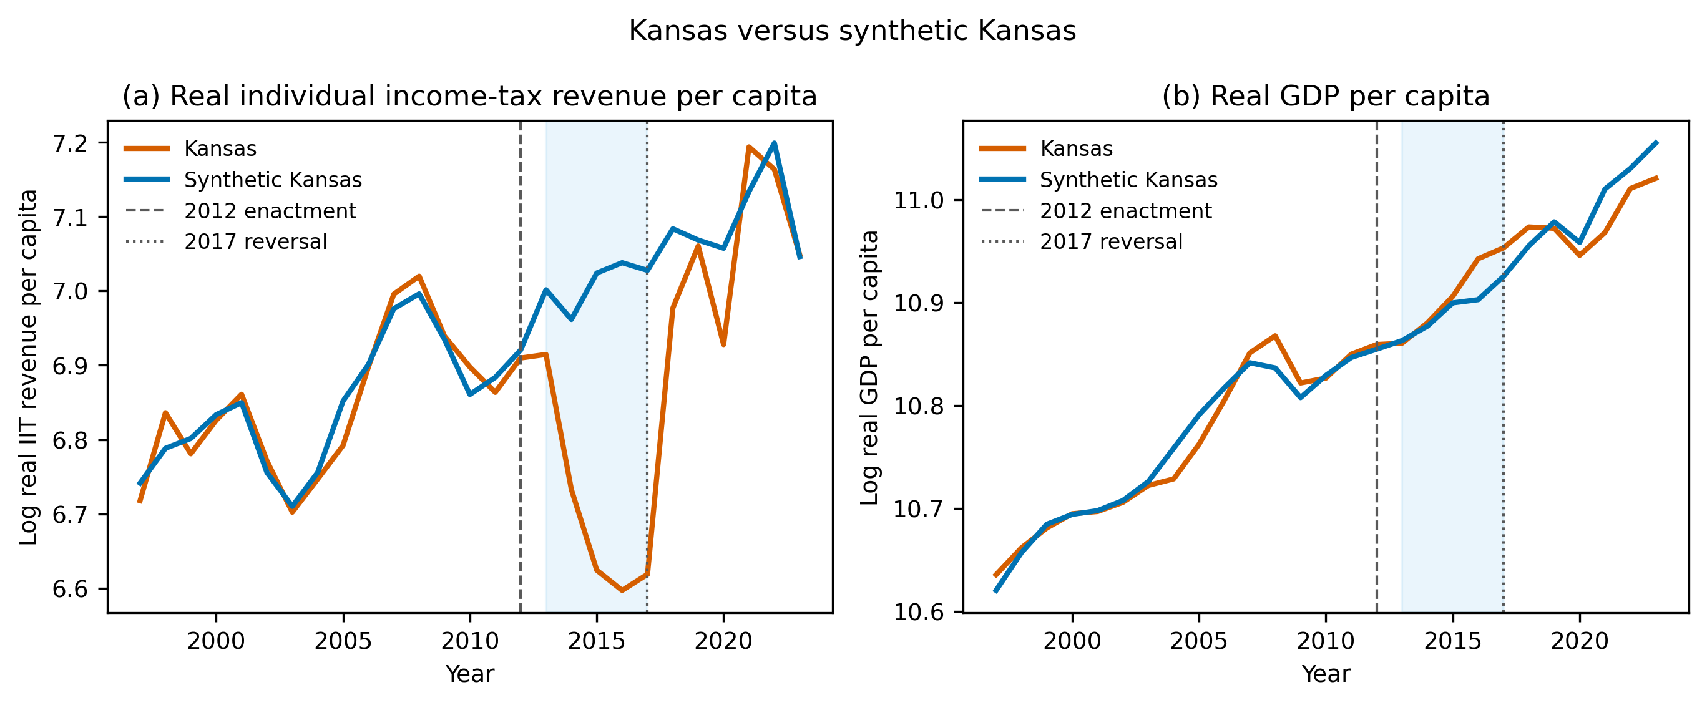
Figure 7. Kansas and synthetic Kansas, 1997-2019. Panel (a) reports log real individual income-tax revenue per capita; panel (b) reports log GDP per capita. Synthetic controls use the main 33-state donor pool. Shading marks 2013-2017, between implementation and legislative reversal.
Table 4. Kansas synthetic-control estimates by outcome and donor pool. Mean gaps cover 2013-2017. Permutation p values compare Kansas with donor-state placebo gaps; LOO denotes leave-one-donor-out sensitivity.
Outcome | Pool | Mean gap | Gap (%) | Permutation p | Pre-RMSPE | donors | in-time placebo | LOO range
Real GDP per capita | Main | 0.015 | +1.5% | 0.71 | 0.015 | 33 | 0.056 | 0.009 to 0.029
Real GDP per capita | All states | -0.004 | -0.4% | 0.49 | 0.007 | 50 | 0.056 | -
Nonfarm employment | Main | -0.013 | -1.3% | 0.47 | 0.004 | 33 | 0.006 | -0.014 to -0.001
Nonfarm employment | All states | -0.001 | -0.1% | 0.96 | 0.003 | 50 | 0.006 | -
Real total tax revenue per capita | Main | -0.031 | -3.0% | 0.18 | 0.013 | 32 | 0.075 | -0.039 to -0.028
Real total tax revenue per capita | All states | 0.030 | +3.1% | 0.12 | 0.010 | 49 | 0.075 | -
Real individual income-tax revenue per capita | Main | -0.313 | -26.9% | 0.03 | 0.025 | 32 | 0.103 | -0.322 to -0.291
Real individual income-tax revenue per capita | All states | -0.301 | -26.0% | 0.02 | 0.019 | 42 | 0.103 | -
The result is not a universal rejection of the Laffer curve, nor does Kansas disprove supply-side economics. Within this period and design, no macroeconomic response large enough to offset the revenue loss is observed. A decision-facing appraisal would have separated the static revenue loss, the taxable-income response, the activity effect, and the timing of any return to the base.

Decision sensitivity
Plausible local slopes and growth paths imply materially different budget trajectories; the reform was decision-sensitive to unverified response geometry.

Consequence asymmetry
Error costs were primarily fiscal - revenue loss and compressed services - and asymmetric against optimistic assumptions, but less severe in kind than irreversible health harms.

Reversibility and learning
Reversibility was comparatively greater: statutory changes are revisable, outcomes are observable on budget timescales, and staged rate changes, automatic review triggers, and sunset clauses were feasible learning architectures. Kansas's 2017 partial repeal illustrates correction after observation. The case shows functional-form uncertainty about local position and response geometry in a setting with comparatively greater reversibility and ongoing observability.

Comparative findings

A common mechanism
Both cases required decision-relevant knowledge of relationship shape that exceeded what the available evidence clearly established. In each, a named canonical relationship supplied content - an evacuation threshold, an expected revenue recovery - that the evidence over the relevant range did not deliver. The mechanism is identical even though the cases share no dataset, institution, or political context.

Where the cases diverge
The cases differ on nearly every moderating dimension (Table 5). Fukushima's uncertainty was extrapolative - the relevant feature lay below the observed dose range - whereas Kansas's was about local position and dynamic response within a theoretically possible curve. Fukushima combined severe, two-sided consequence asymmetry with limited reversibility; Kansas carried primarily fiscal costs with far greater reversibility and rapid observability. These differences predict the different decision architectures each case called for.
Table 5. Comparative summary of the two cases across the common dimensions. The cases are not statistically comparable; the final column states the comparative lesson each contrast supports.
Comparative dimension | Fukushima evacuation | Kansas tax reform | Comparative lesson
Policy domain | Radiation protection; emergency public health | Fiscal and economic policy | The mechanism is domain-general: a named curve can carry a decision in any sector.
Policy objective | Reduce population radiation exposure | Raise growth while recovering revenue | Both objectives required a specific shape, not just an association.
Canonical relationship | Low-dose radiation dose-response | Tax rate-revenue and growth response | Named curves compress multi-step arguments into portable pictures.
Decision-relevant feature | Low-dose slope below observed doses | Local position, slope, and dynamic response | Each decision needed one feature of the curve, not the curve as a whole.
Type of uncertainty | Extrapolation below the observed range | Local-position and response-geometry uncertainty | Different uncertainty locations produce different appraisal priorities.
Extrapolation burden | High; few observations below 0.1 Gy | Moderate; within-state history but untested rate cut | Extrapolation burden predicts how far evidence can carry a decision.
Transportability | Atomic-bomb and occupational evidence to municipal exposure | Cross-state and theoretical evidence to one state's response | Transport gaps differ in kind; decompose them by population, period, and institution.
Decision sensitivity | Evacuation scope and duration change under plausible dose-response shapes | Revenue outlook changes under plausible local slopes and growth paths | In both, plausible alternative shapes imply materially different policies.
Cost of wrong action | Displacement, mortality risk, care disruption | Revenue loss and service compression | Error costs fall on identifiable groups, not on the model.
Cost of inaction | Residual radiation exposure | Foregone growth stimulus claim | Asymmetry must be weighed in both directions, not one.
Consequence asymmetry | Severe on both sides; competing harms | Primarily fiscal; distribution across budgets | Higher asymmetry raises the decision value of shape certainty.
Reversibility | Limited; displacement and health effects partly irreversible | Comparatively greater; statutes revised in 2017 | Reversible settings can substitute adaptive design for ex ante certainty.
Time to observe outcomes | Years; health endpoints partly latent | Years; fiscal outcomes observable quickly | Observability on policy timescales enables learning architectures.
Learning opportunity | Zoning, staged return, exemptions possible but hard mid-crisis | Staged cuts, triggers, sunset clauses readily available | Where learning is feasible, adaptive implementation hedges shape uncertainty.
Preferred decision architecture | Staged, revisable protection with asymmetric-harm safeguards | Staged implementation with triggers and monitoring | Architecture should match the joint uncertainty-consequence-reversibility configuration.

Comparative propositions
The comparison supports three analytical propositions, stated as interpretive generalizations rather than statistically tested hypotheses. Proposition 1: functional-form uncertainty becomes policy-critical when plausible alternative shapes imply materially different actions - decision sensitivity, not statistical significance, is the threshold. Proposition 2: the decision cost of functional-form uncertainty increases when consequences are asymmetric and commitments are difficult to reverse. Proposition 3: where policies are reversible and outcomes observable on useful timescales, adaptive implementation can partially substitute for ex ante functional-form certainty (Lempert & Collins, 2007; Walker et al., 2013).

Lesson-drawing
Comparative policy analysis distinguishes what can travel from what cannot (Rose, 1991; Dolowitz & Marsh, 2000). One lesson is transferable across domains: before acting on a named empirical relationship, identify the exact functional feature the decision requires and test whether it is identified in the relevant range. A second lesson is context-dependent: how much shape uncertainty can be tolerated depends on consequence asymmetry, reversibility, transportability, observational feedback, and institutional capacity to update. Non-transferable elements include numerical thresholds, effect sizes, sector-specific causal mechanisms, and institutional details - transporting those would repeat the functional-form error the article diagnoses.

Discussion

Principal comparative finding
The principal finding is comparative, not only conceptual: the policy significance of uncertain functional form depends not only on how poorly the curve is identified but on how that uncertainty interacts with decision sensitivity, consequence asymmetry, reversibility, transportability, and opportunities for learning. Finding the same mechanism across maximum-contrast cases indicates that functional-form dependence is a general appraisal problem rather than an artifact of one policy field.

What comparison adds
A single case could show that shape uncertainty mattered; it could not show which conditions make it matter more. Comparison reveals that identical evidentiary weakness produces different decision risks: in Fukushima it argued for staged, revisable protection with safeguards for asymmetric harms, while in Kansas it argued for staged implementation with triggers and monitoring. The comparative design thereby converts a cautionary observation into an appraisal variable - the joint configuration of uncertainty and decision structure - that comparative policy research can examine across further settings.

Implications for comparative policy analysis
The framework complements causal identification and evidence hierarchies: a credible average contrast need not identify the feature the decision requires, and functional form can matter even inside causal designs (Roth & Sant'Anna, 2023). For comparative policy analysis, the study suggests treating the relationship between evidence structure and decision architecture as itself a dimension of comparison - alongside the more familiar comparisons of instruments, institutions, and outcomes (Howlett, 2019; Hall, 1993; Freeman, 2006).

Limitations
The design has clear limits. Two purposively selected cases cannot support statistical generalization; the reconstruction is retrospective; the two empirical designs are heterogeneous; and policymakers' actual information sets are not fully observed. The 50-relationship mapping is purposive and estimates no prevalence. Fukushima's municipal mortality is affected by displacement, registration, demographic change, and recording location, and non-evacuation outcomes are unobserved. Kansas's synthetic control cannot fully separate the reform from contemporaneous state-specific shocks. The analysis also stops short of a welfare analysis placing all consequences on a common scale, which would introduce further functional forms and normative weights.

Conclusion
Comparing Fukushima and Kansas shows that functional-form dependence is one mechanism with different policy implications under different configurations of uncertainty, consequence asymmetry, reversibility, transportability, and learning capacity. The comparative lesson for policy appraisal is to expose the decision-relevant shape, test decisions under plausible alternatives, and match the action architecture to the cost of being wrong - before commitments become difficult to reverse.

Data availability
All data used in the analyses are from public sources. Archived source files, acquisition metadata, processed datasets, analysis code, machine-readable results, and document-generation code will be supplied to reviewers through an anonymized archive. The public repository URL is provided to the editor in the title-page materials and will be added to the manuscript after double-anonymous review. The archive README records the commands required to reproduce the analyses and submission files.

Artificial intelligence assistance
An AI coding assistant (Devin, Cognition AI) was used to assist with data-acquisition, analysis, and document-generation code and with manuscript drafting and editing under the author's direction. The author specified the research questions and analytical choices, verified the data sources and results, evaluated all interpretations, and takes full responsibility for the manuscript.

References
Abadie, A. (2021). Using synthetic controls: Feasibility, data requirements, and methodological aspects. Journal of Economic Literature, 59(2), 391-425. https://doi.org/10.1257/jel.20191450
Abadie, A., Diamond, A., & Hainmueller, J. (2010). Synthetic control methods for comparative case studies: Estimating the effect of California's tobacco control program. Journal of the American Statistical Association, 105(490), 493-505. https://doi.org/10.1198/jasa.2009.ap08746
Abadie, A., Diamond, A., & Hainmueller, J. (2015). Comparative politics and the synthetic control method. American Journal of Political Science, 59(2), 495-510. https://doi.org/10.1111/ajps.12116
Bennett, C. J., & Howlett, M. (1992). The lessons of learning: Reconciling theories of policy learning and policy change. Policy Sciences, 25(3), 275-294. https://doi.org/10.1007/BF00138786
Bertrand, M., Duflo, E., & Mullainathan, S. (2004). How much should we trust differences-in-differences estimates? Quarterly Journal of Economics, 119(1), 249-275. https://doi.org/10.1162/003355304772839588
Boswell, C. (2009). The political uses of expert knowledge: Immigration policy and social research. Cambridge University Press.
Burnham, K. P., & Anderson, D. R. (2004). Multimodel inference: Understanding AIC and BIC in model selection. Sociological Methods & Research, 33(2), 261-304. https://doi.org/10.1177/0049124104268644
Cairney, P. (2016). The politics of evidence-based policymaking. Palgrave Macmillan. https://doi.org/10.1057/978-1-137-51781-4
Cook, R. D. (1977). Detection of influential observation in linear regression. Technometrics, 19(1), 15-18. https://doi.org/10.1080/00401706.1977.10489493
Dolowitz, D. P., & Marsh, D. (2000). Learning from abroad: The role of policy transfer in contemporary policy-making. Governance, 13(1), 5-24. https://doi.org/10.1111/0952-1895.00121
Draper, D. (1995). Assessment and propagation of model uncertainty. Journal of the Royal Statistical Society: Series B, 57(1), 45-70. https://doi.org/10.1111/j.2517-6161.1995.tb02015.x
Freeman, R. (2006). Learning in public policy. In M. Moran, M. Rein, & R. E. Goodin (Eds.), The Oxford handbook of public policy (pp. 367-388). Oxford University Press.
Fukushima Prefecture. (2014). Higashinihon daishinsai ni yoru higai jokyo sokuhou (dai 1260-ho) [Preliminary report on damage caused by the Great East Japan Earthquake (Report No. 1260)]. https://www.pref.fukushima.lg.jp/uploaded/attachment/422314.pdf
George, A. L., & Bennett, A. (2005). Case studies and theory development in the social sciences. MIT Press.
Hall, P. A. (1993). Policy paradigms, social learning, and the state: The case of economic policymaking in Britain. Comparative Politics, 25(3), 275-296. https://doi.org/10.2307/422246
Howlett, M. (2019). Designing public policies: Principles and instruments (2nd ed.). Routledge. https://doi.org/10.4324/9781315232003
International Commission on Radiological Protection. (2007). The 2007 recommendations of the International Commission on Radiological Protection. ICRP Publication 103. Annals of the ICRP, 37(2-4). https://doi.org/10.1016/j.icrp.2007.10.003
Kansas Legislature. (2012). House Bill 2117, enrolled. https://www.kslegislature.gov/li_2012/b2011_12/measures/documents/hb2117_enrolled.pdf
Laffer, A. B. (2004). The Laffer curve: Past, present, and future. Heritage Foundation Backgrounder, 1765, 1-16. https://www.heritage.org/taxes/report/the-laffer-curve-past-present-and-future
Lempert, R. J., & Collins, M. T. (2007). Managing the risk of uncertain threshold responses: Comparison of robust, optimum, and precautionary approaches. Risk Analysis, 27(4), 1009-1026. https://doi.org/10.1111/j.1539-6924.2007.00940.x
Ministry of Health, Labour and Welfare. (2021). Vital statistics of Japan [Data set]. Portal Site of Official Statistics of Japan. https://www.e-stat.go.jp/en/stat-search/database?page=1&toukei=00450011
Ministry of Internal Affairs and Communications. (2021). Population, demographics, and household counts based on the Basic Resident Registration [Data set]. Portal Site of Official Statistics of Japan. https://www.e-stat.go.jp/en/stat-search/files?toukei=00200241
Morgan, M. G., & Henrion, M. (1990). Uncertainty: A guide to dealing with uncertainty in quantitative risk and policy analysis. Cambridge University Press.
Parkhurst, J. O. (2016). Appeals to evidence for the resolution of wicked problems: The origins and mechanisms of evidentiary bias. Policy Sciences, 49(4), 373-393. https://doi.org/10.1007/s11077-016-9263-z
Przeworski, A., & Teune, H. (1970). The logic of comparative social inquiry. Wiley.
Reconstruction Agency. (2026). Higashinihon daishinsai ni okeru shinsai-kanrenshi no shisha-su [Number of disaster-related deaths in the Great East Japan Earthquake] (as of February 13, 2026). https://www.reconstruction.go.jp/files/user/topics/main-cat2/sub-cat2-6/20260213_kanrenshi.pdf
Rose, R. (1991). What is lesson-drawing? Journal of Public Policy, 11(1), 3-30. https://doi.org/10.1017/S0143814X00004918
Roth, J., & Sant'Anna, P. H. C. (2023). When is parallel trends sensitive to functional form? Econometrica, 91(2), 737-747. https://doi.org/10.3982/ECTA19402
Rothschild, S. (2012, January 19). Consultant Laffer praises Brownback's tax plan. Lawrence Journal-World. https://www2.ljworld.com/news/2012/jan/19/consultant-laffer-touts-brownbacks-tax-plan/
United Nations Scientific Committee on the Effects of Atomic Radiation. (2014). Sources, effects and risks of ionizing radiation: UNSCEAR 2013 report, Volume I, Scientific Annex A. United Nations. https://www.unscear.org/unscear/uploads/documents/unscear-reports/UNSCEAR_2013_Report_Vol.I.pdf
Walker, W. E., Haasnoot, M., & Kwakkel, J. H. (2013). Adapt or perish: A review of planning approaches for adaptation under deep uncertainty. Sustainability, 5(3), 955-979. https://doi.org/10.3390/su5030955
Weimer, D. L., & Vining, A. R. (2017). Policy analysis: Concepts and practice (6th ed.). Routledge.
World Health Organization. (2013). Health risk assessment from the nuclear accident after the 2011 Great East Japan Earthquake and Tsunami, based on a preliminary dose estimation. World Health Organization. https://iris.who.int/handle/10665/78218
ten Hoeve, J. E., & Jacobson, M. Z. (2012). Worldwide health effects of the Fukushima Daiichi nuclear accident. Energy & Environmental Science, 5(9), 8743-8757. https://doi.org/10.1039/C2EE22019A

Appendix: Supplementary municipality exclusions and robustness analyses
Appendix Table A1. Municipalities excluded from the Fukushima panel because of missing mortality or population observations. Exclusions are determined before outcome estimation.
Prefecture | Municipality | Reason | Years missing
Iwate | Hachimantai | Population missing in at least one year 2005-2019 | 2005
Iwate | Oshu | Unit not observed under a single code 2005-2019 | 2005
Iwate | Takizawa | Unit not observed under a single code 2005-2019 | 2005,2006,2007,2008,2009,2010,2011,2012,2013
Iwate | Nishiwaga | Population missing in at least one year 2005-2019 | 2005
Iwate | Hirono | Unit not observed under a single code 2005-2019 | 2005
Miyagi | Aoba Ward, Sendai | Population missing in at least one year 2005-2019 | 2006,2007,2008,2009,2010
Miyagi | Miyagino Ward, Sendai | Population missing in at least one year 2005-2019 | 2005,2006,2007,2008,2009,2010
Miyagi | Wakabayashi Ward, Sendai | Population missing in at least one year 2005-2019 | 2005,2006,2007,2008,2009,2010
Miyagi | Taihaku Ward, Sendai | Population missing in at least one year 2005-2019 | 2005,2006,2007,2008,2009,2010
Miyagi | Izumi Ward, Sendai | Population missing in at least one year 2005-2019 | 2005,2006,2007,2008,2009,2010
Miyagi | Shiogama | Population missing in at least one year 2005-2019 | 2006,2007
Miyagi | Tome | Population missing in at least one year 2005-2019 | 2005
Miyagi | Kurihara | Population missing in at least one year 2005-2019 | 2005
Miyagi | Higashimatsushima | Population missing in at least one year 2005-2019 | 2005
Miyagi | Osaki | Unit not observed under a single code 2005-2019 | 2005
Miyagi | Tomiya | Unit not observed under a single code 2005-2019 | 2005,2006,2007,2008,2009,2010,2011,2012,2013,2014,2015,2016
Miyagi | Shichikashuku | Population missing in at least one year 2005-2019 | 2007,2008,2009,2010,2011,2012,2013,2014,2015,2016,2017
Miyagi | Shichigahama | Population missing in at least one year 2005-2019 | 2007,2008,2009,2010,2011,2012,2013,2014,2015,2016,2017
Miyagi | Misato | Unit not observed under a single code 2005-2019 | 2005
Miyagi | Minamisanriku | Population missing in at least one year 2005-2019 | 2005
Yamagata | Shonai | Population missing in at least one year 2005-2019 | 2005
Fukushima | Motomiya | Population missing in at least one year 2005-2019 | 2006
Ibaraki | Kasumigaura | Population missing in at least one year 2005-2019 | 2006
Ibaraki | Sakuragawa | Population missing in at least one year 2005-2019 | 2005
Ibaraki | Kamisu | Population missing in at least one year 2005-2019 | 2005
Ibaraki | Namegata | Population missing in at least one year 2005-2019 | 2005
Ibaraki | Hokota | Population missing in at least one year 2005-2019 | 2005
Ibaraki | Tsukubamirai | Unit not observed under a single code 2005-2019 | 2005,2006
Ibaraki | Omitama | Unit not observed under a single code 2005-2019 | 2005
Tochigi | Nasukarasuyama | Population missing in at least one year 2005-2019 | 2005
Tochigi | Shimotsuke | Unit not observed under a single code 2005-2019 | 2005
Tochigi | Nakagawa | Population missing in at least one year 2005-2019 | 2005
Gunma | Midori | Unit not observed under a single code 2005-2019 | 2005
Gunma | Higashiazuma | Unit not observed under a single code 2005-2019 | 2005
Gunma | Minakami | Population missing in at least one year 2005-2019 | 2005
Niigata | Kita Ward, Niigata | Unit not observed under a single code 2005-2019 | 2005,2006,2007,2008,2009,2010
Niigata | Higashi Ward, Niigata | Unit not observed under a single code 2005-2019 | 2005,2006,2007,2008,2009,2010
Niigata | Chuo Ward, Niigata | Unit not observed under a single code 2005-2019 | 2005,2006,2007,2008,2009,2010
Niigata | Konan Ward, Niigata | Unit not observed under a single code 2005-2019 | 2005,2006,2007,2008,2009,2010
Niigata | Akiha Ward, Niigata | Unit not observed under a single code 2005-2019 | 2005,2006,2007,2008,2009,2010
Niigata | Minami Ward, Niigata | Unit not observed under a single code 2005-2019 | 2005,2006,2007,2008,2009,2010
Niigata | Nishi Ward, Niigata | Unit not observed under a single code 2005-2019 | 2005,2006,2007,2008,2009,2010
Niigata | Nishikan Ward, Niigata | Unit not observed under a single code 2005-2019 | 2005,2006,2007,2008,2009,2010
Niigata | Myoko | Population missing in at least one year 2005-2019 | 2005
Niigata | Tainai | Population missing in at least one year 2005-2019 | 2005
Niigata | Seiro | Population missing in at least one year 2005-2019 | 2006
Niigata | Aga | Population missing in at least one year 2005-2019 | 2005
Appendix Table A2. Unit-level Fukushima synthetic-control results for T1 municipalities. Mean gaps cover 2012-2019; permutation p values compare treated and placebo-unit gaps.
Municipality | Donors | Pre-RMSPE | Post-RMSPE | Mean gap 2012-2019 | Permutation p
Minamisoma | 7 | 0.029 | 0.184 | -0.011 | 0.25
Kawamata | 23 | 0.01 | 0.082 | 0.055 | 0.333
Naraha | 20 | 0.088 | 0.204 | -0.128 | 0.714
Tomioka | 13 | 0.059 | 0.164 | -0.152 | 0.5
Kawauchi | 13 | 0.044 | 0.148 | 0.083 | 0.5
Okuma | 15 | 0.144 | 0.304 | -0.268 | 0.562
Futaba | 20 | 0.049 | 0.257 | -0.191 | 0.286
Namie | 18 | 0.004 | 0.18 | -0.098 | 0.263
Katsurao | 5 | 0.183 | 0.249 | -0.137 | 0.833
Iitate | 22 | 0.017 | 0.118 | -0.027 | 0.304
Appendix Figure A1. Kansas neighboring-state difference-in-differences event studies for real GDP per capita, employment, total tax revenue, and individual income-tax revenue. Coefficients are relative to 2012; bars are 95% confidence intervals.
