Quantitative Analysis of Encoding Structures
in Cetacean Acoustic Communication
Verification of CDMA-like Code Division and Beat Frequency Hypotheses

Abstract
This study investigates the existence of encoding structures in cetacean acoustic communication through quantitative analysis of the Watkins Marine Mammal Sound Database (1,357 recordings, 32 species). Seven analytical methods were applied to acoustic data from six marine mammal species: spectrogram analysis, inter-click interval (ICI) analysis, bispectral analysis, information entropy analysis, temporal structure analysis, cross-species comparison, and CDMA-like orthogonality testing. Results demonstrate species-specific spectral signatures with significantly higher within-species correlation than between-species correlation (Mann-Whitney U test, p = 3.37 × 10⁻³), supporting the hypothesis that cetaceans employ distinguishable spectral codes. Nonlinear frequency coupling was detected across all species via bispectral analysis, with sperm whales exhibiting the strongest bicoherence values.
Keywords: cetacean communication, acoustic encoding, CDMA, bispectrum, information entropy, spectral orthogonality, marine mammal bioacoustics

1. Introduction
Cetaceans are known to employ acoustic signals for long-distance communication in the marine environment. Baleen whales (Mysticeti) utilize infrasound in the 10-200 Hz range, propagating through the SOFAR (Sound Fixing and Ranging) channel to reach distances of hundreds to thousands of kilometers. Toothed whales (Odontoceti) employ ultrasonic clicks for echolocation and stereotyped click sequences (codas) for social communication.
Recent advances have revealed remarkable structural properties in cetacean vocalizations. Arnon et al. (2025, Science) demonstrated that humpback whale songs follow Zipf's law of abbreviation, a hallmark of natural language. Sharma et al. (2024, Nature Communications) identified contextual and combinatorial structure in sperm whale codas, suggesting a compositional communication system. Youngblood (2025, Science Advances) found language-like efficiency in whale communication patterns.
This study tests two hypotheses:
(1) CDMA-like Code Division Hypothesis: Each species/individual possesses a unique spectral code, enabling selective decoding of target signals.
(2) Beat Frequency Hypothesis: Nonlinear acoustic interactions produce interference components that carry meaningful information.

2. Materials and Methods

2.1 Data
Acoustic data were obtained from the Watkins Marine Mammal Sound Database (Woods Hole Oceanographic Institution) via HuggingFace (confit/wmms-parquet, revision a90a38e). The database contains 1,357 recordings from 32 species. The first 60 s of each recording were resampled to 16 kHz. Six target species were selected for analysis:
Species | Common Name | Samples
Physeter macrocephalus | Sperm Whale | 10
Megaptera novaeangliae | Humpback Whale | 10
Orcinus orca | Killer Whale | 10
Balaenoptera physalus | Fin Whale | 10
Tursiops truncatus | Bottlenose Dolphin | 10
Delphinapterus leucas | Beluga Whale | 10

2.2 Analytical Methods
(1) Spectrogram Analysis: Short-time Fourier transform (STFT) spectrograms were computed to extract spectral centroid, bandwidth, and dominant frequency.
(2) Inter-Click Interval (ICI) Analysis: Click events were detected using Hilbert transform envelope detection with threshold-based onset detection, and ICI distributions were analyzed.
(3) Bispectral Analysis: The bispectrum B(f₁,f₂) = E[X(f₁)·X(f₂)·X*(f₁+f₂)] was computed to detect quadratic phase coupling (nonlinear frequency interaction).
(4) Information Entropy: Shannon entropy of the power spectral density and Zipf's law fit were calculated.
(5) Temporal Structure: Autocorrelation, cross-correlation, spectral flatness, and temporal modulation spectra were computed.
(6) Cross-Species Comparison: Box-plot comparison of all extracted features across species.
(7) CDMA-like Orthogonality Test: Normalized power spectra served as spectral codes; within-species vs. between-species correlations were compared using the Mann-Whitney U test.

3. Results

3.1 Spectral Features
Clear interspecific differences were observed in spectral features (Table 1). Fin whales exhibited the lowest spectral centroid (37 Hz), consistent with specialization in long-distance infrasonic communication. Bottlenose dolphins showed the highest centroid (3,791 Hz).
Species | Spectral Centroid (Hz) | Shannon Entropy (bits) | Bicoherence
Sperm Whale | 2323 | 7.43 | 0.000751
Humpback Whale | 593 | 4.47 | 0.000285
Killer Whale | 1788 | 6.65 | 0.000131
Fin Whale | 37 | 2.28 | 0.000124
Bottlenose Dolphin | 3791 | 5.77 | 0.000340
Beluga Whale | 1218 | 6.17 | 0.000387

Table 1. Comparison of acoustic spectral features across six marine mammal species.

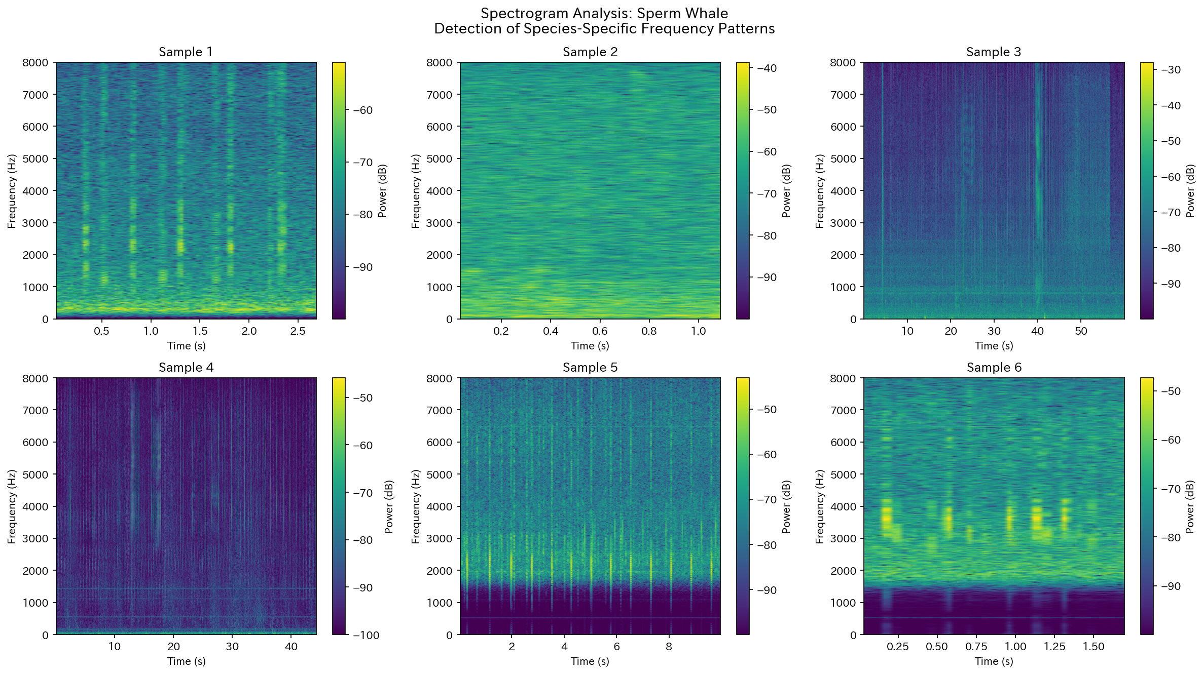
Figure. Spectrogram analysis of Sperm Whale

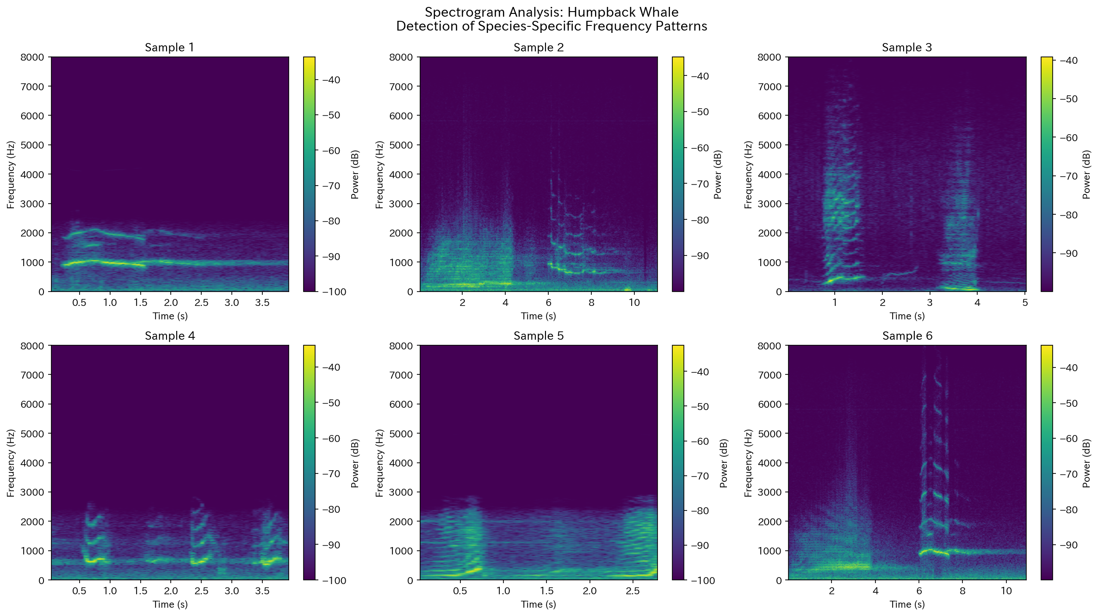
Figure. Spectrogram analysis of Humpback Whale

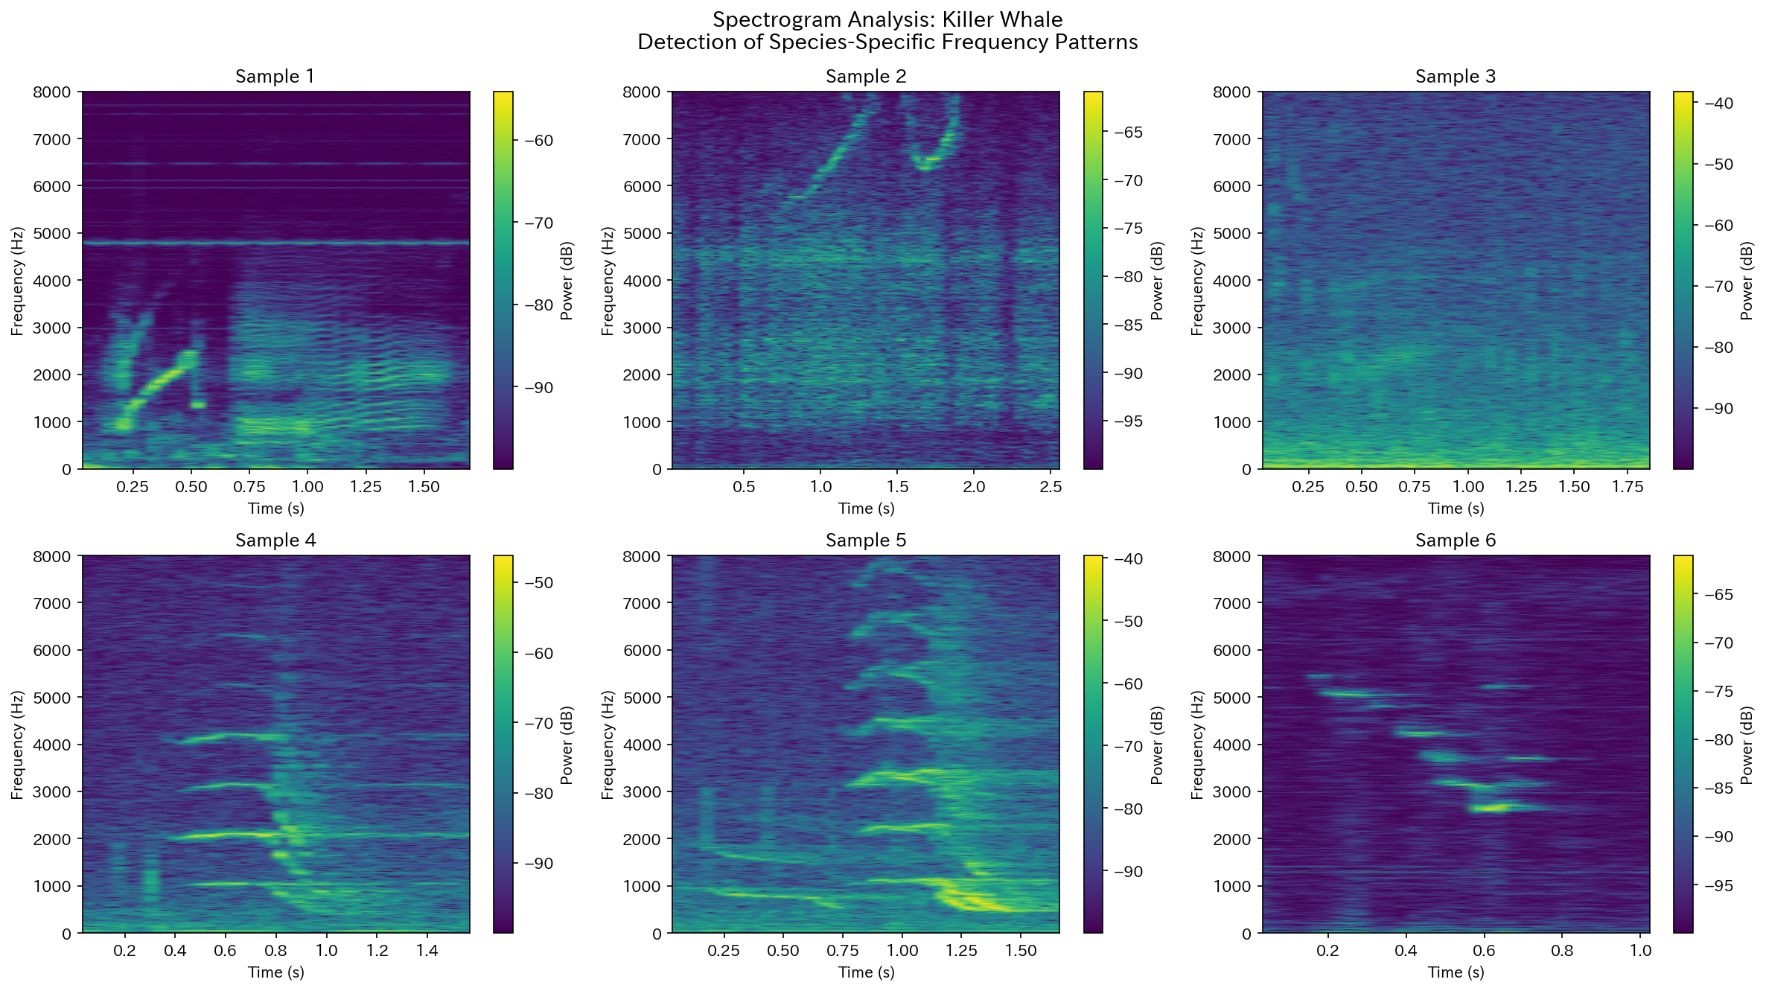
Figure. Spectrogram analysis of Killer Whale

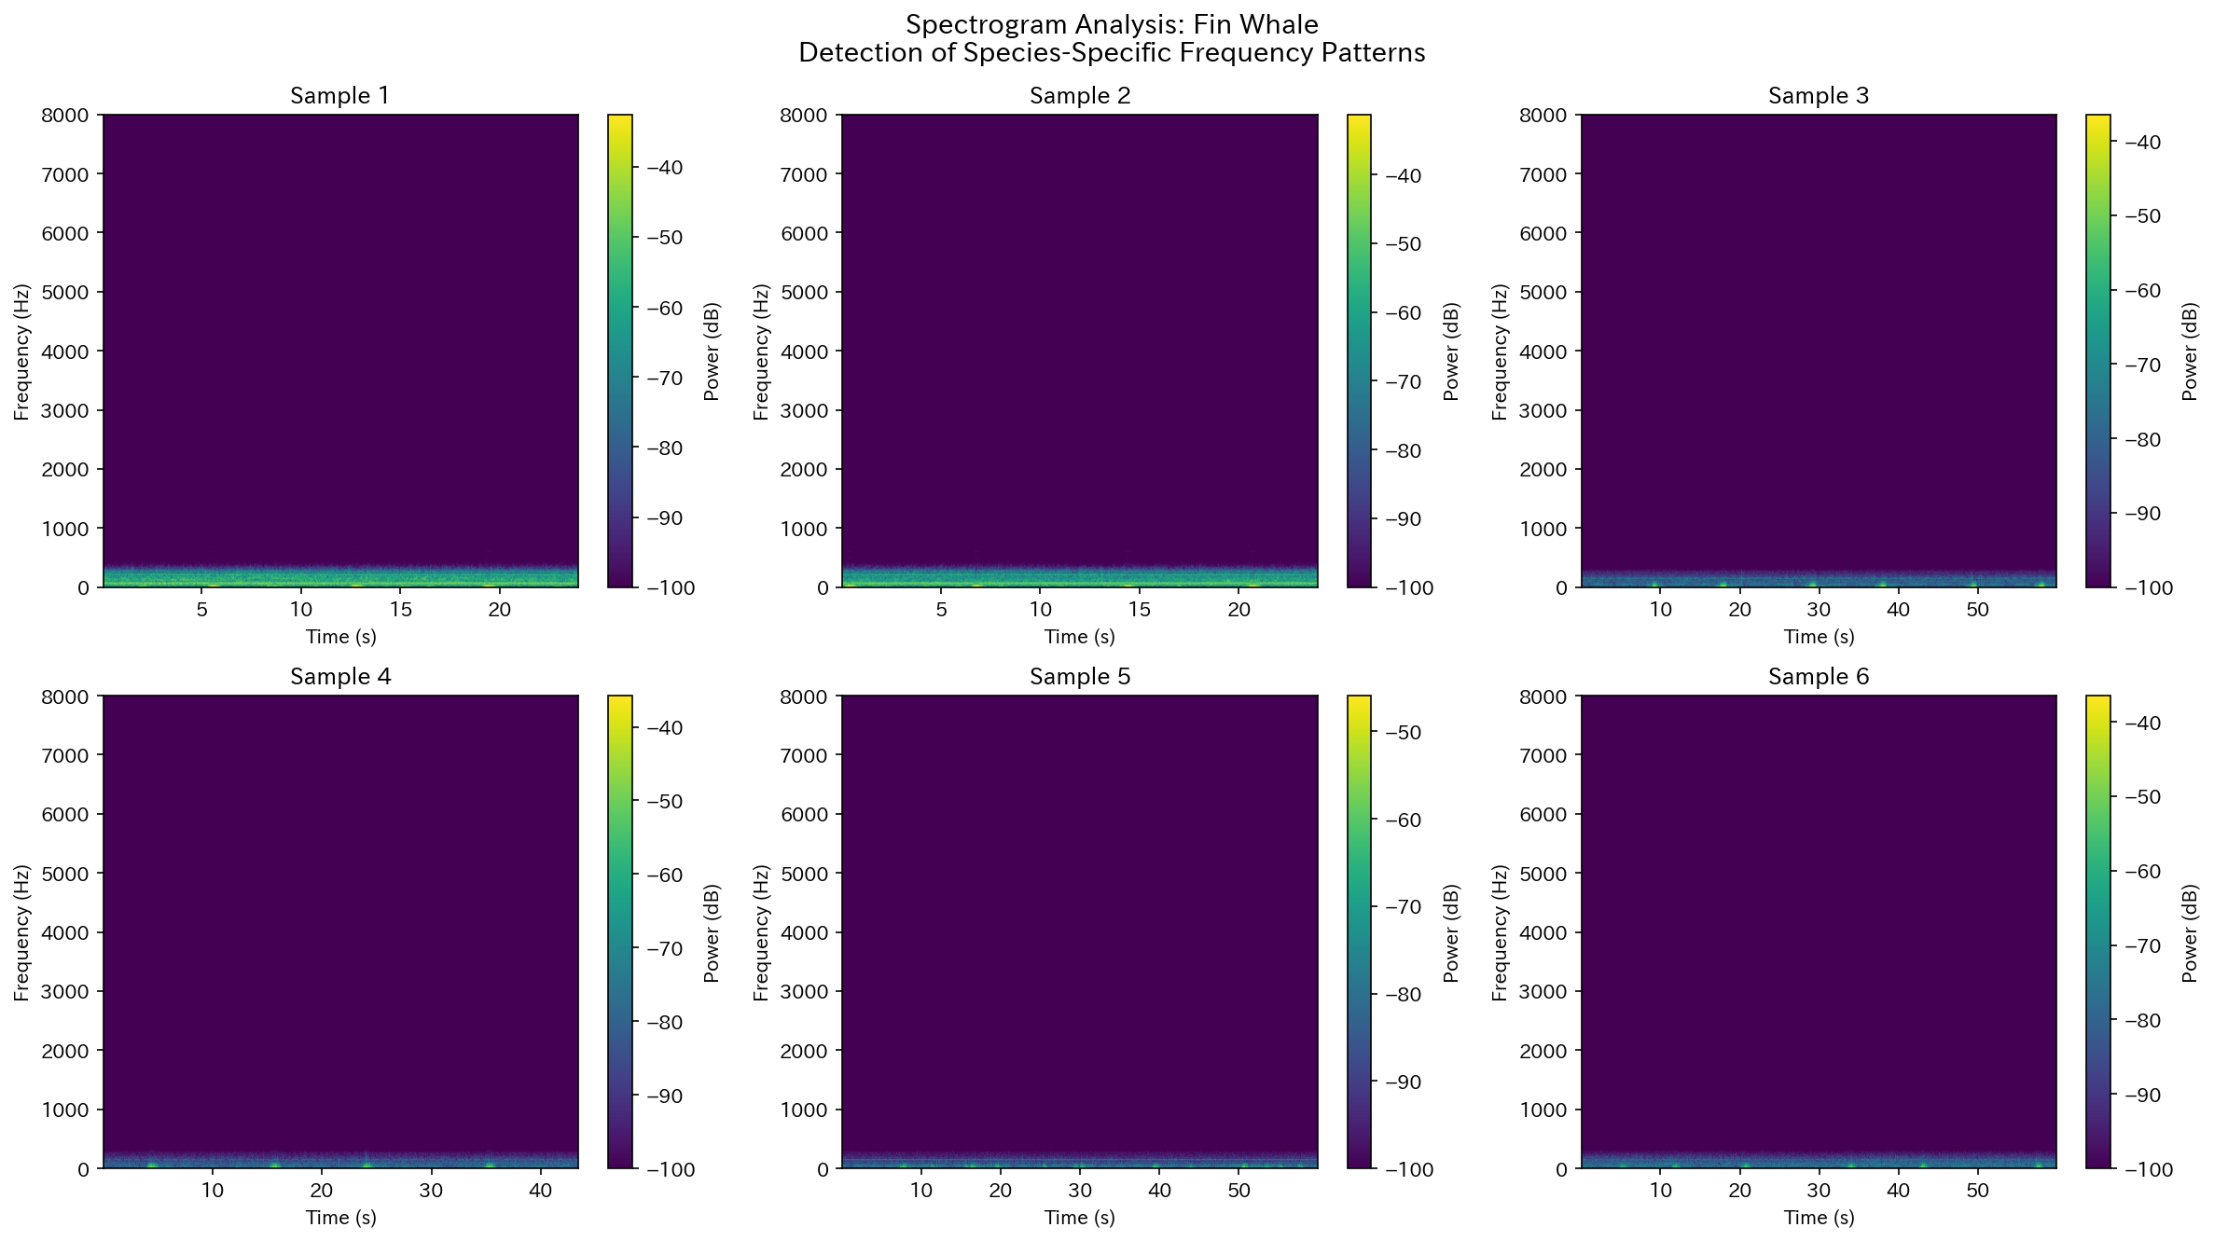
Figure. Spectrogram analysis of Fin Whale

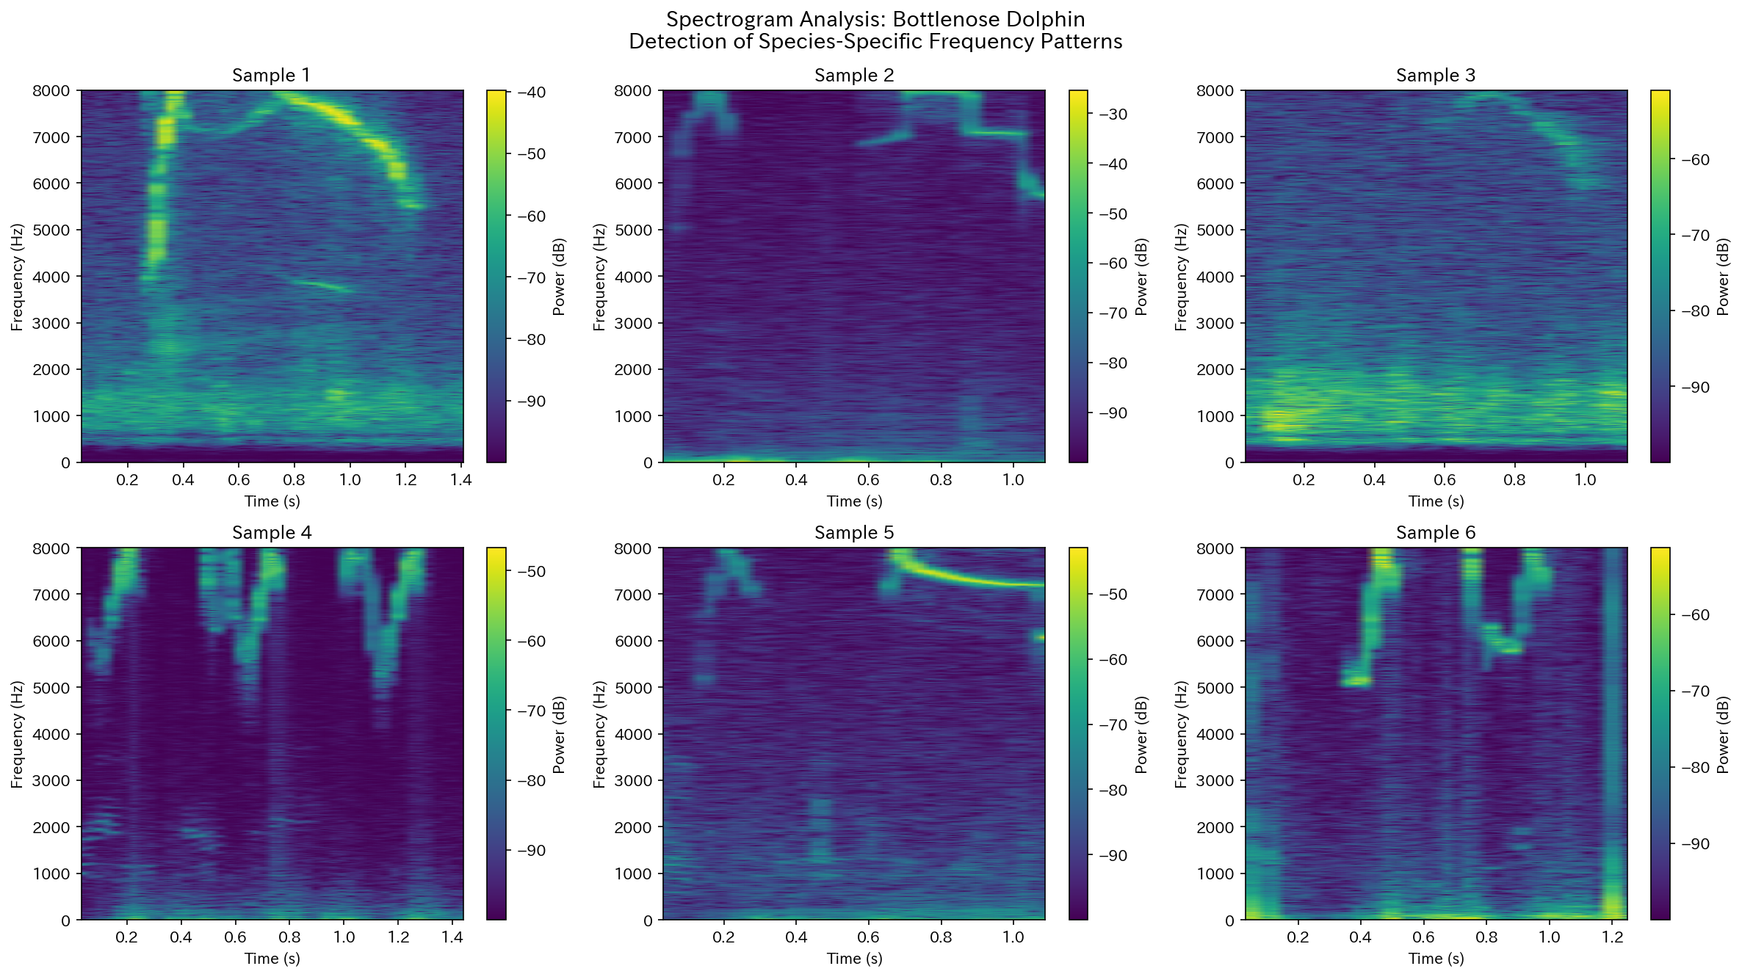
Figure. Spectrogram analysis of Bottlenose Dolphin

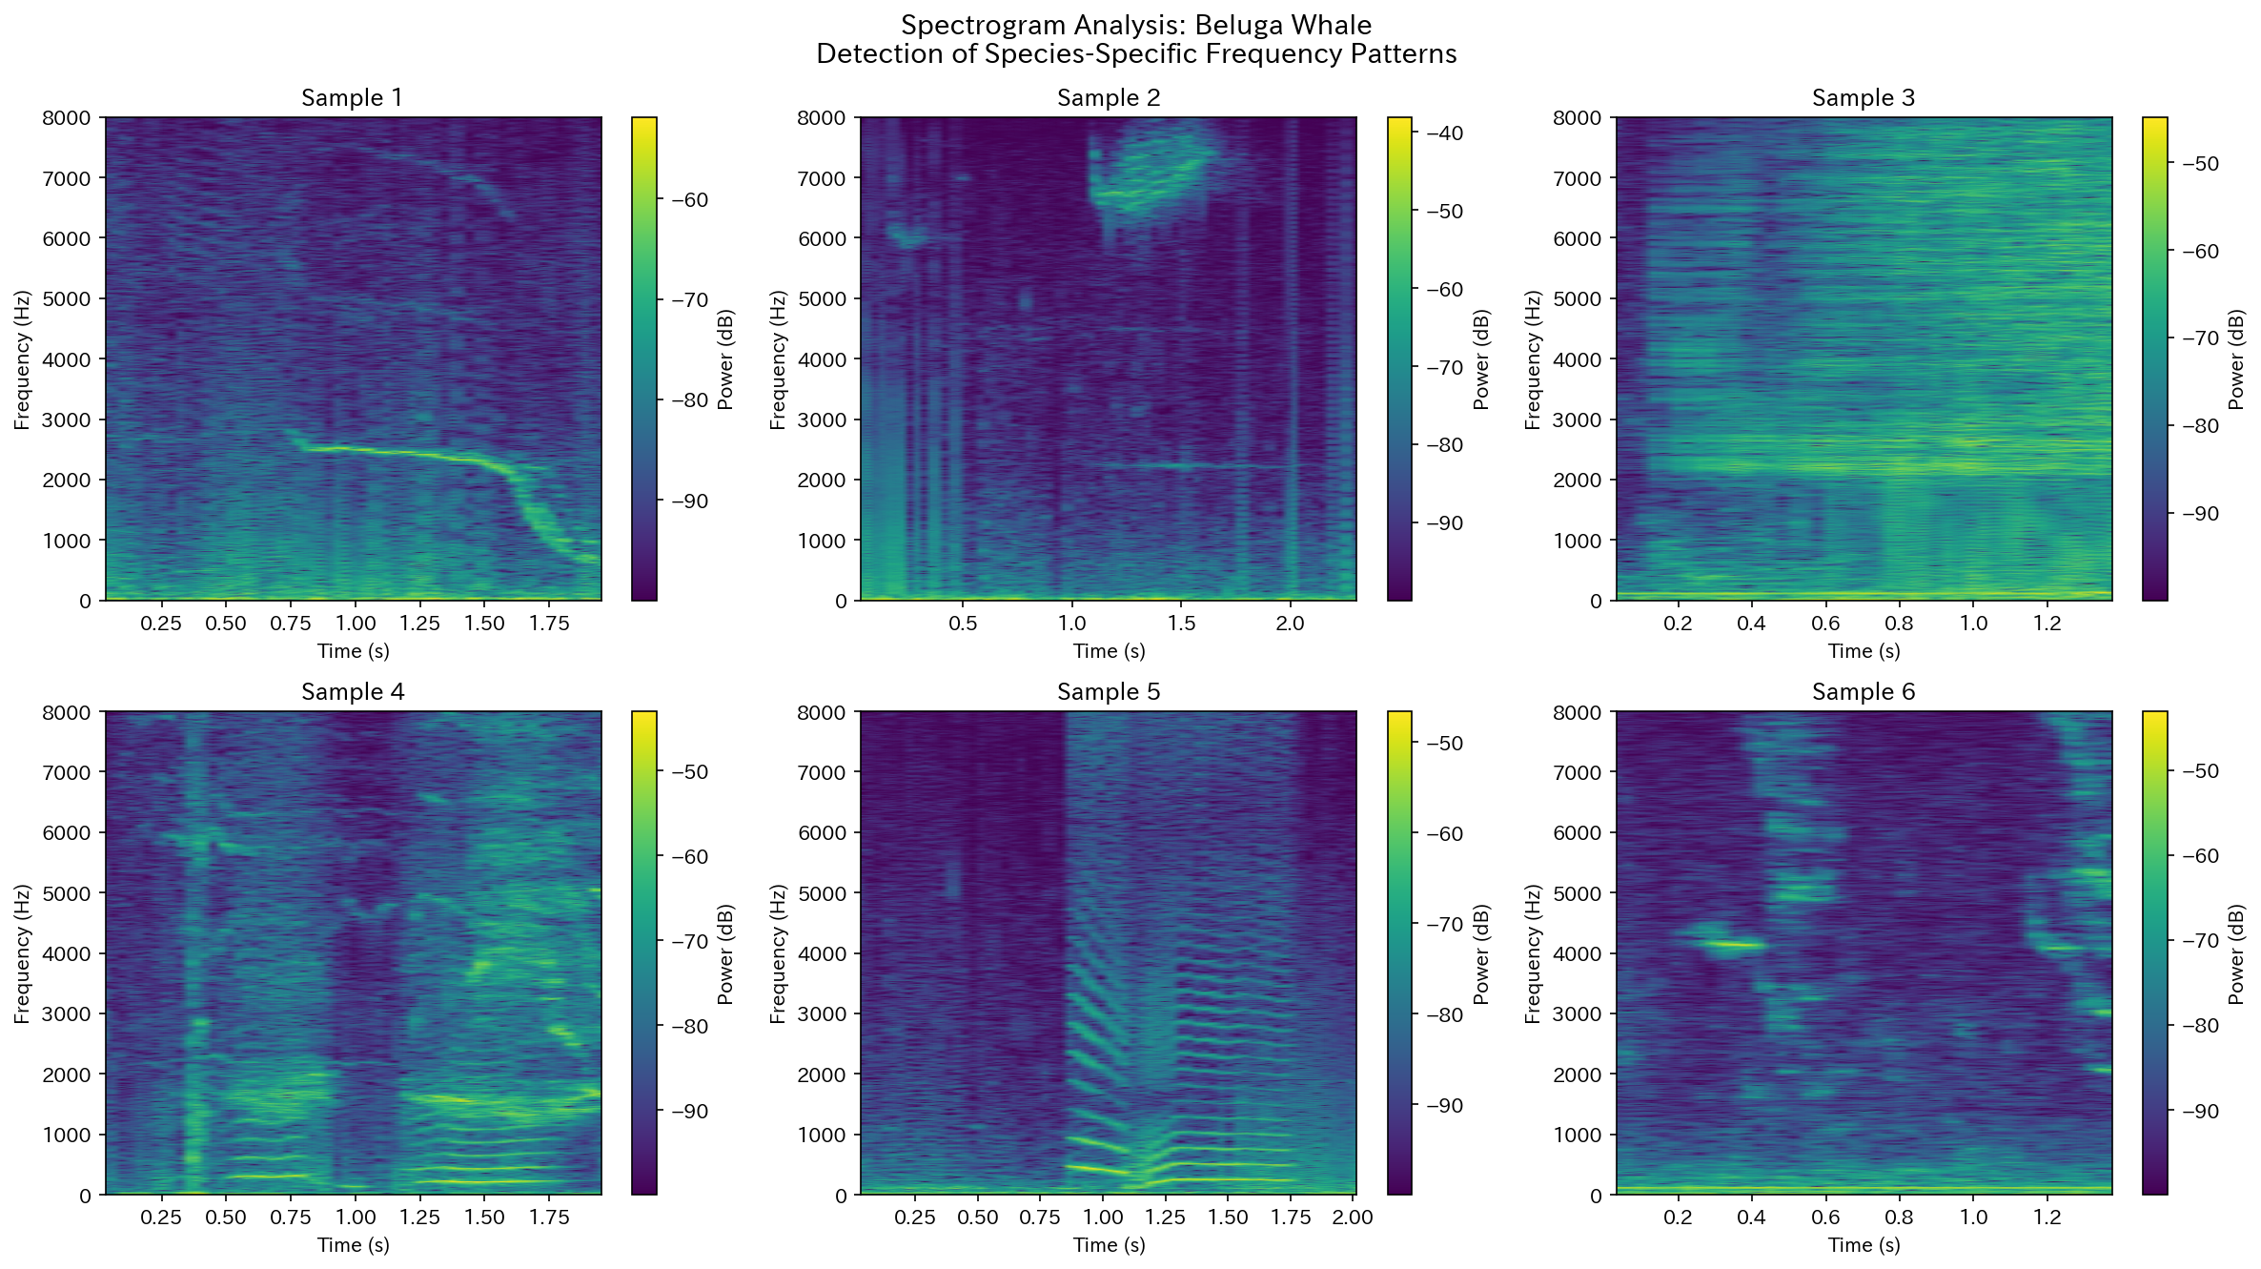
Figure. Spectrogram analysis of Beluga Whale

3.2 Inter-Click Interval (ICI) Analysis
Click train analysis revealed median inter-click intervals with inter-individual variation: Sperm whales 21.2-117.1 ms; Killer whales 2.6-129.4 ms; Bottlenose dolphins 9.7-11.5 ms. These ICI distribution patterns reflect species- and individual-specific characteristics, suggesting potential function as identity codes.
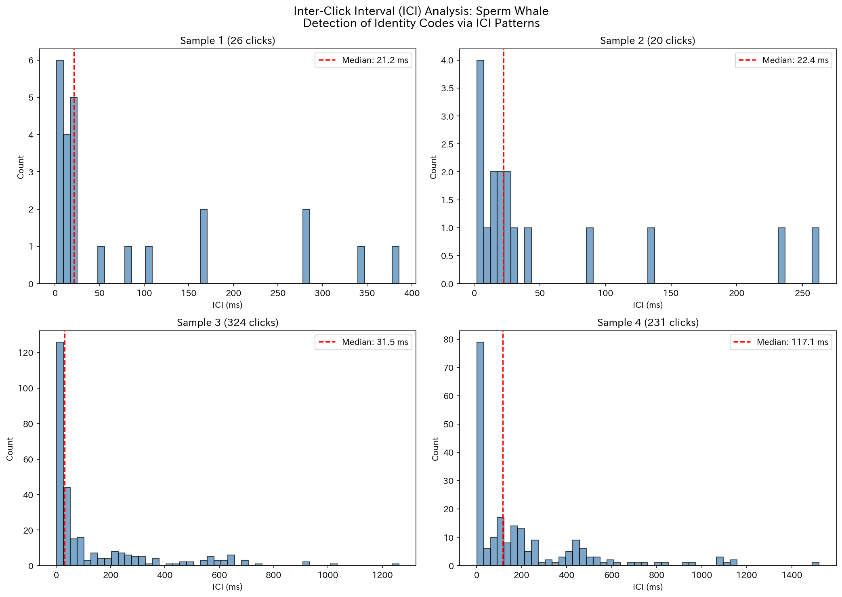
Figure. Inter-click interval distribution of Sperm Whale

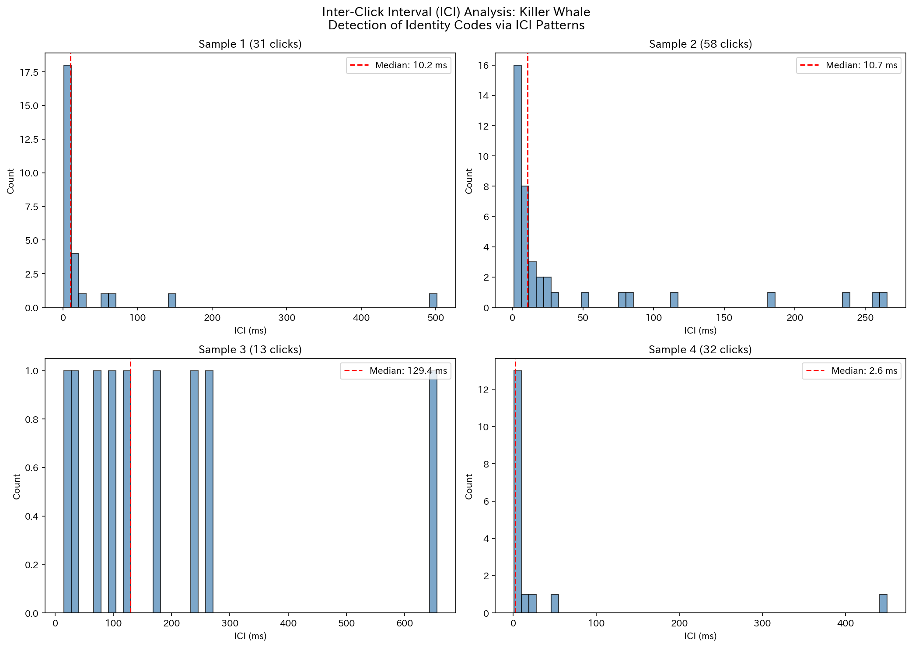
Figure. Inter-click interval distribution of Killer Whale

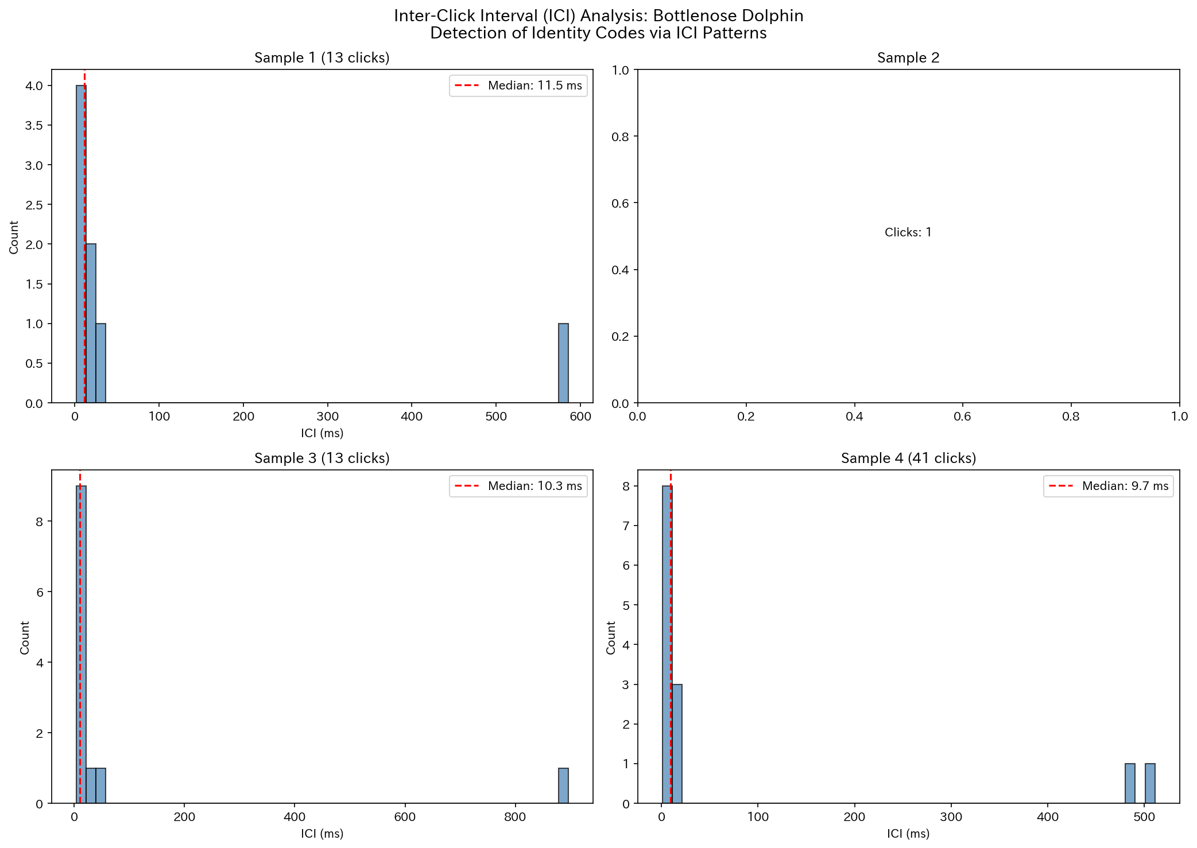
Figure. Inter-click interval distribution of Bottlenose Dolphin

3.3 Bispectral Analysis (Nonlinear Coupling)
Bicoherence analysis detected non-zero quadratic phase coupling in all species. Sperm whales exhibited the highest mean bicoherence (0.000751), suggesting the presence of nonlinear effects in their click generation mechanism. This finding is potentially relevant to the beat frequency hypothesis.
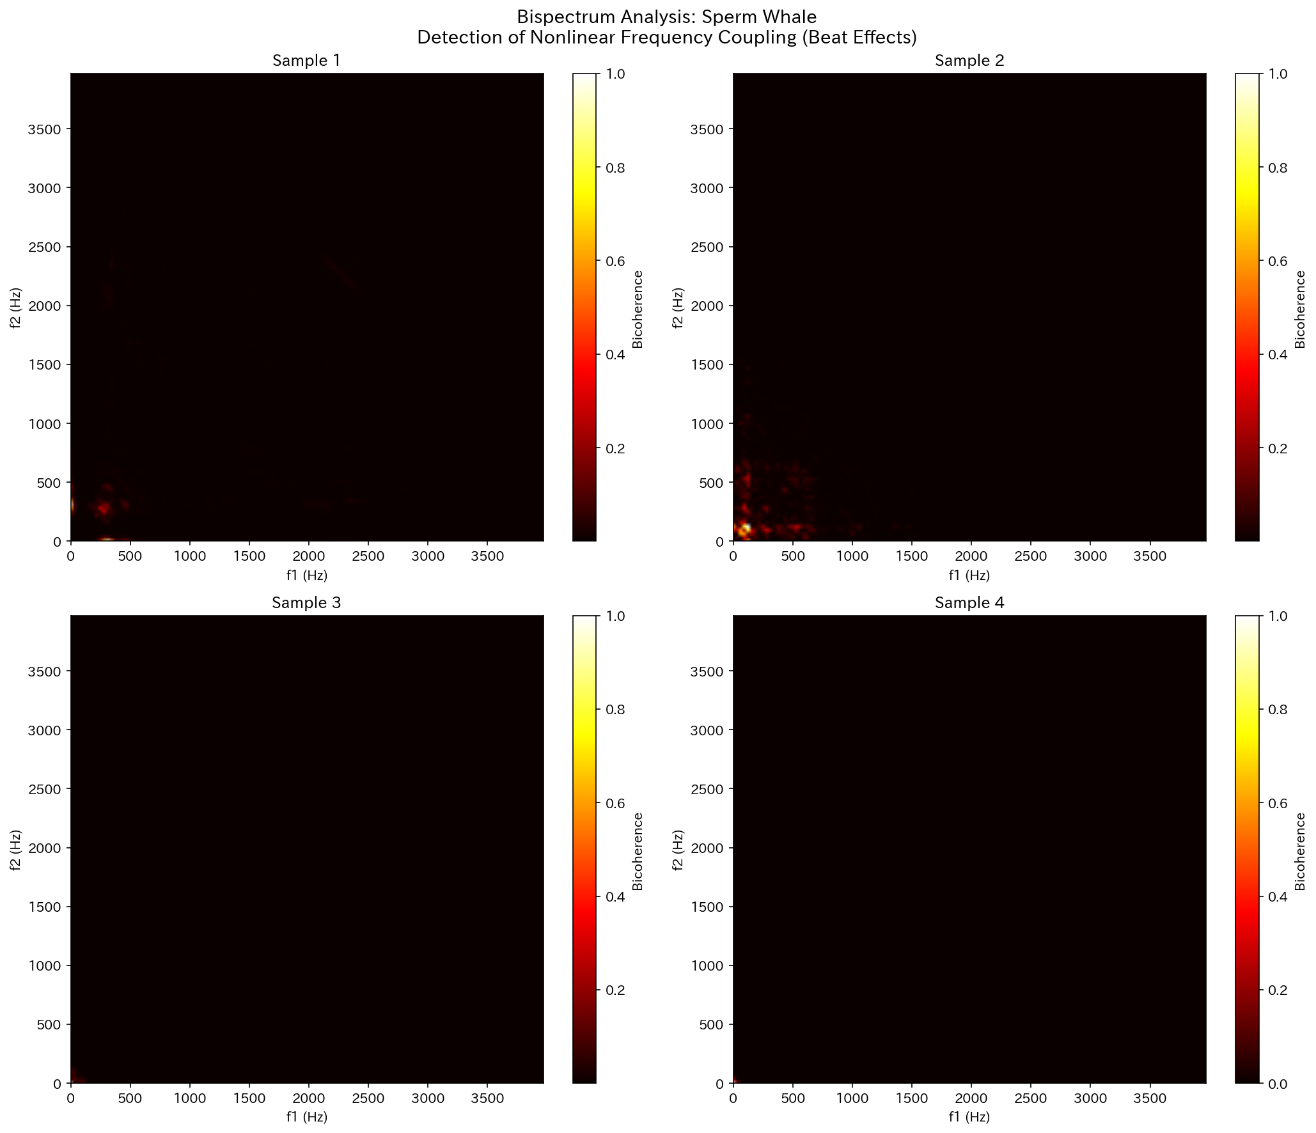
Figure. Bispectrum analysis of Sperm Whale

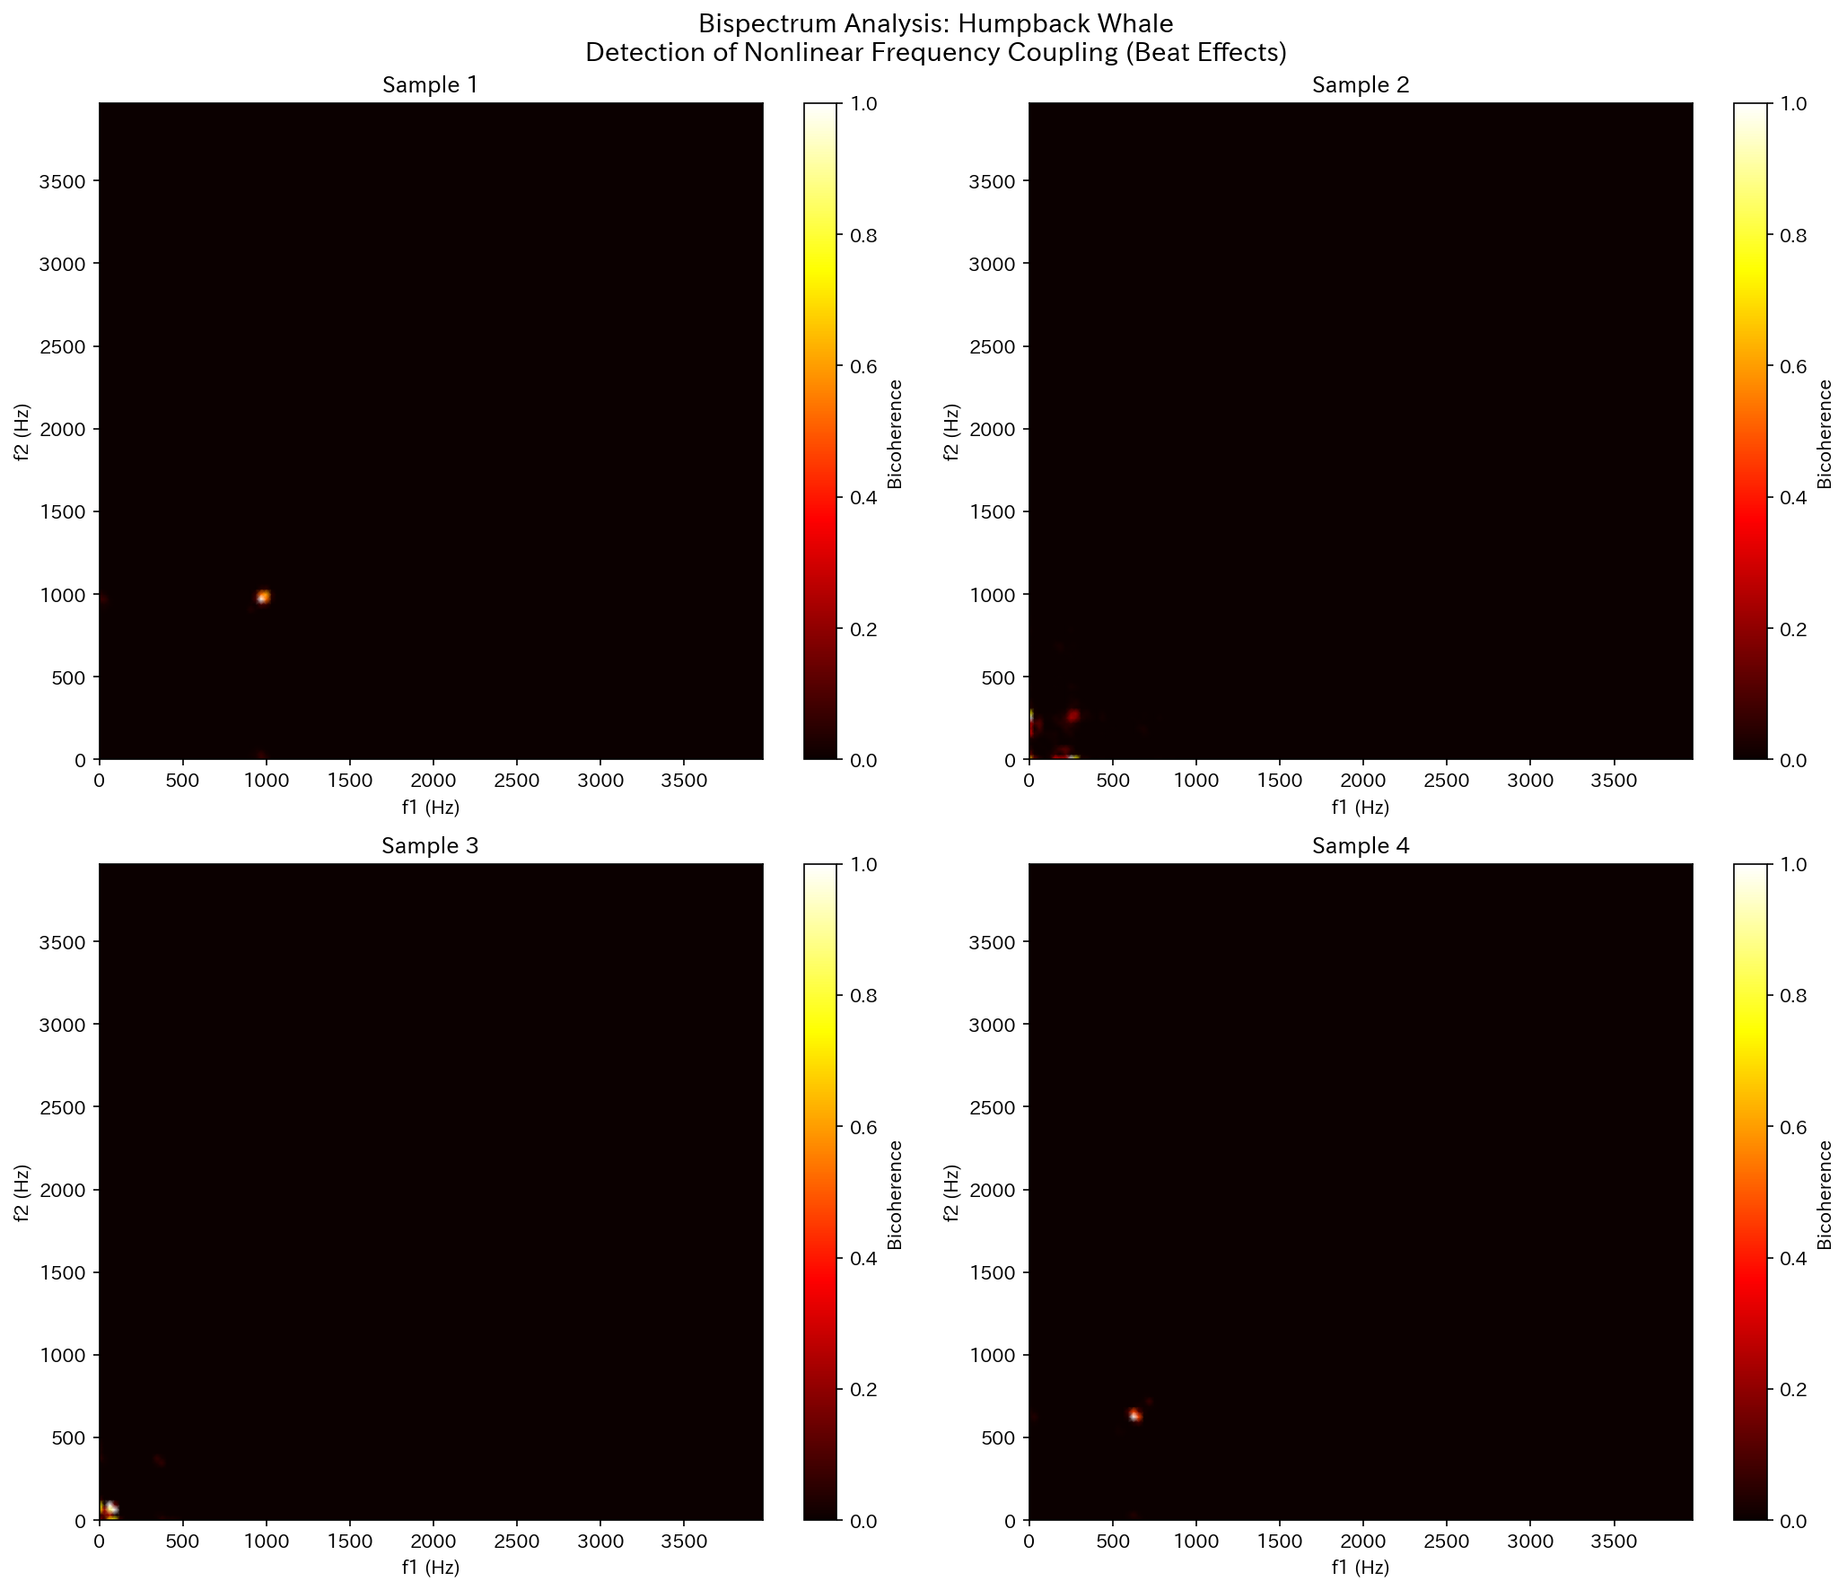
Figure. Bispectrum analysis of Humpback Whale

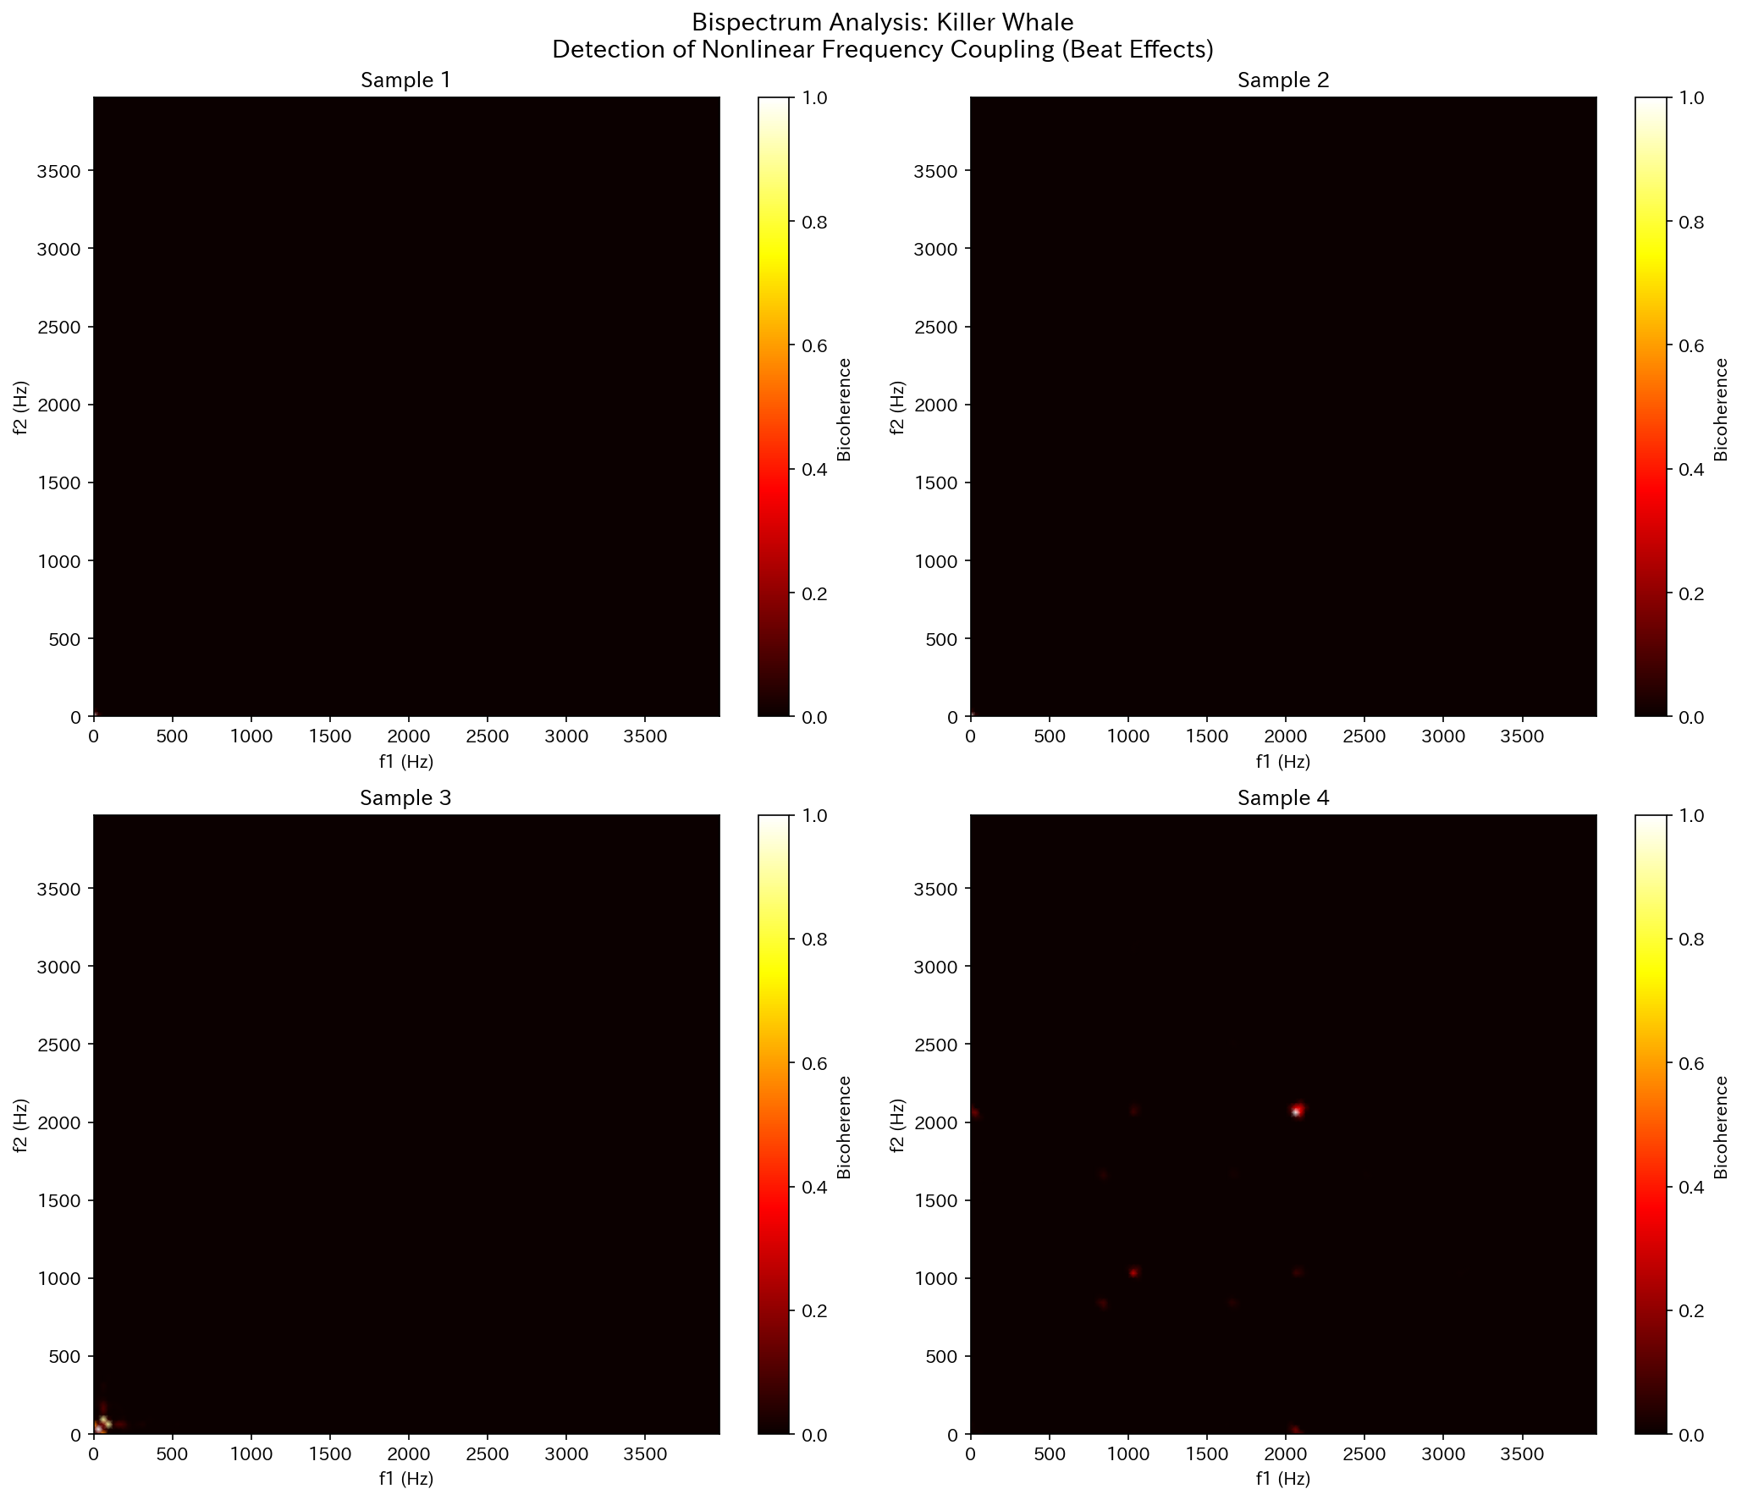
Figure. Bispectrum analysis of Killer Whale

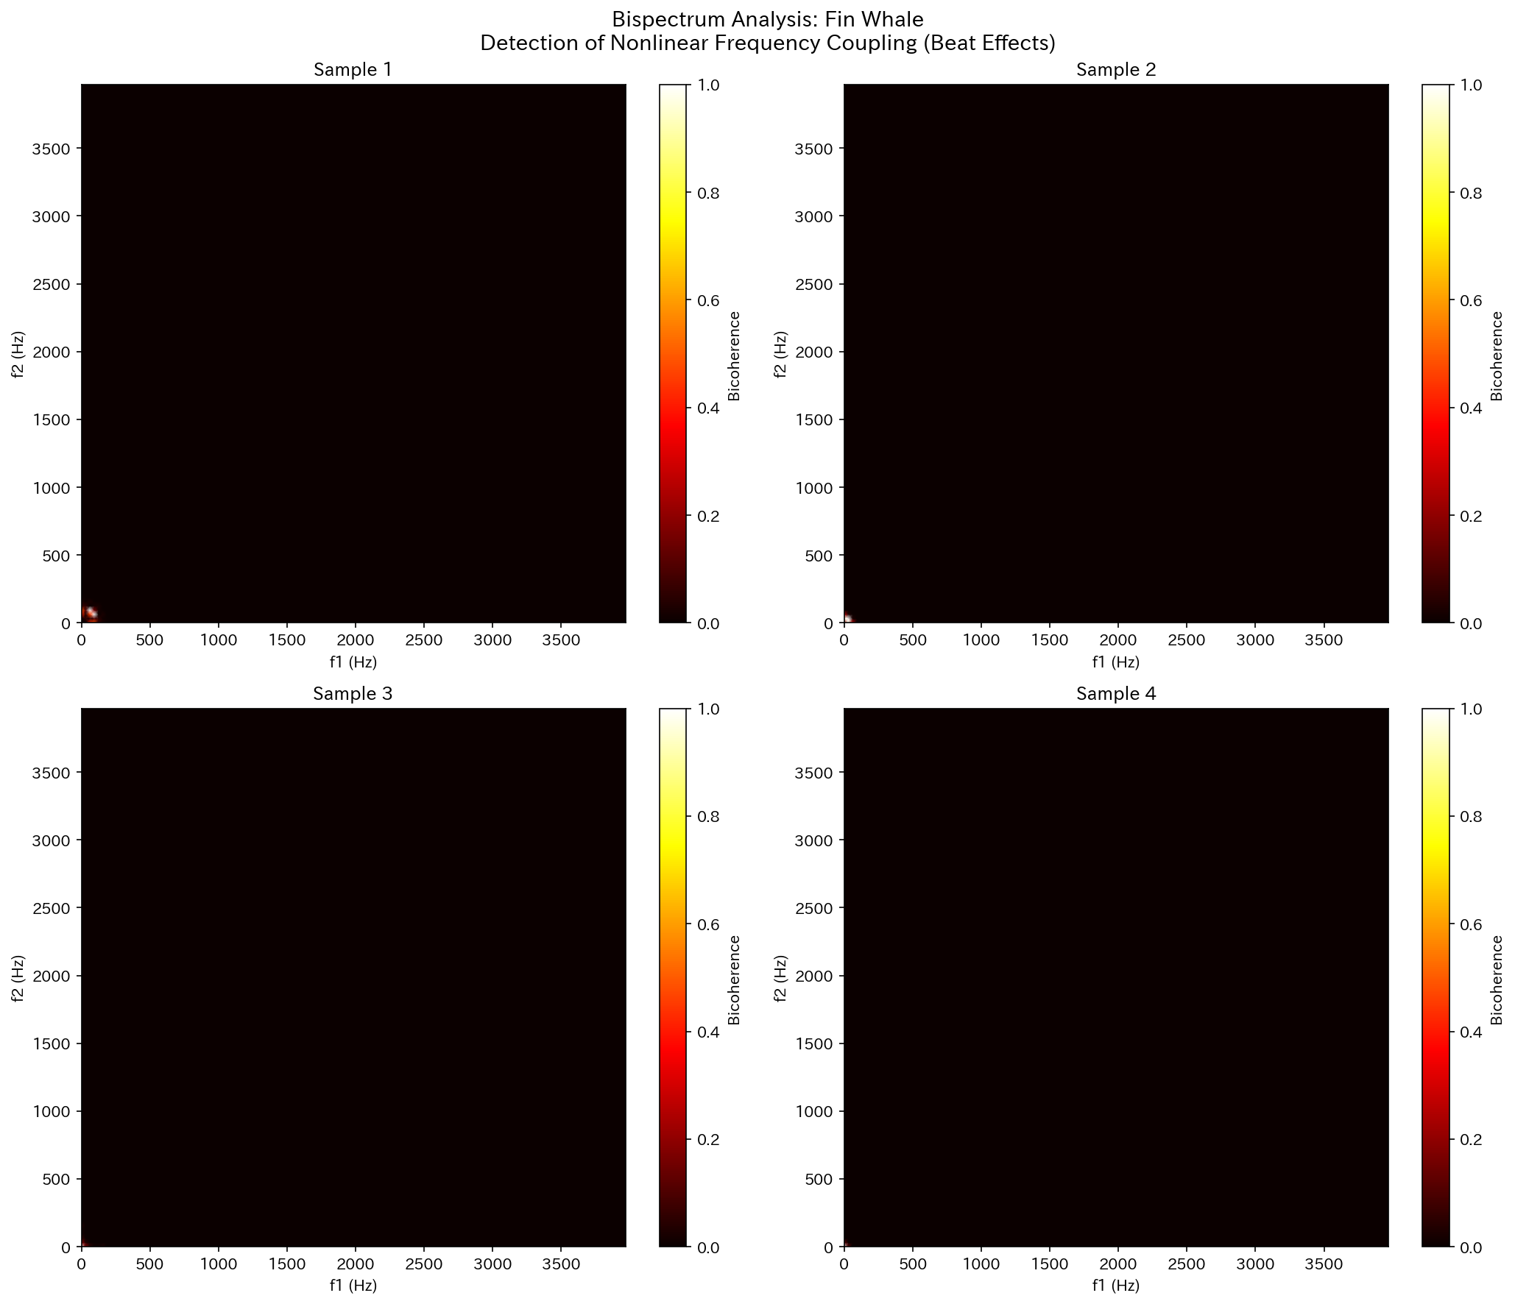
Figure. Bispectrum analysis of Fin Whale

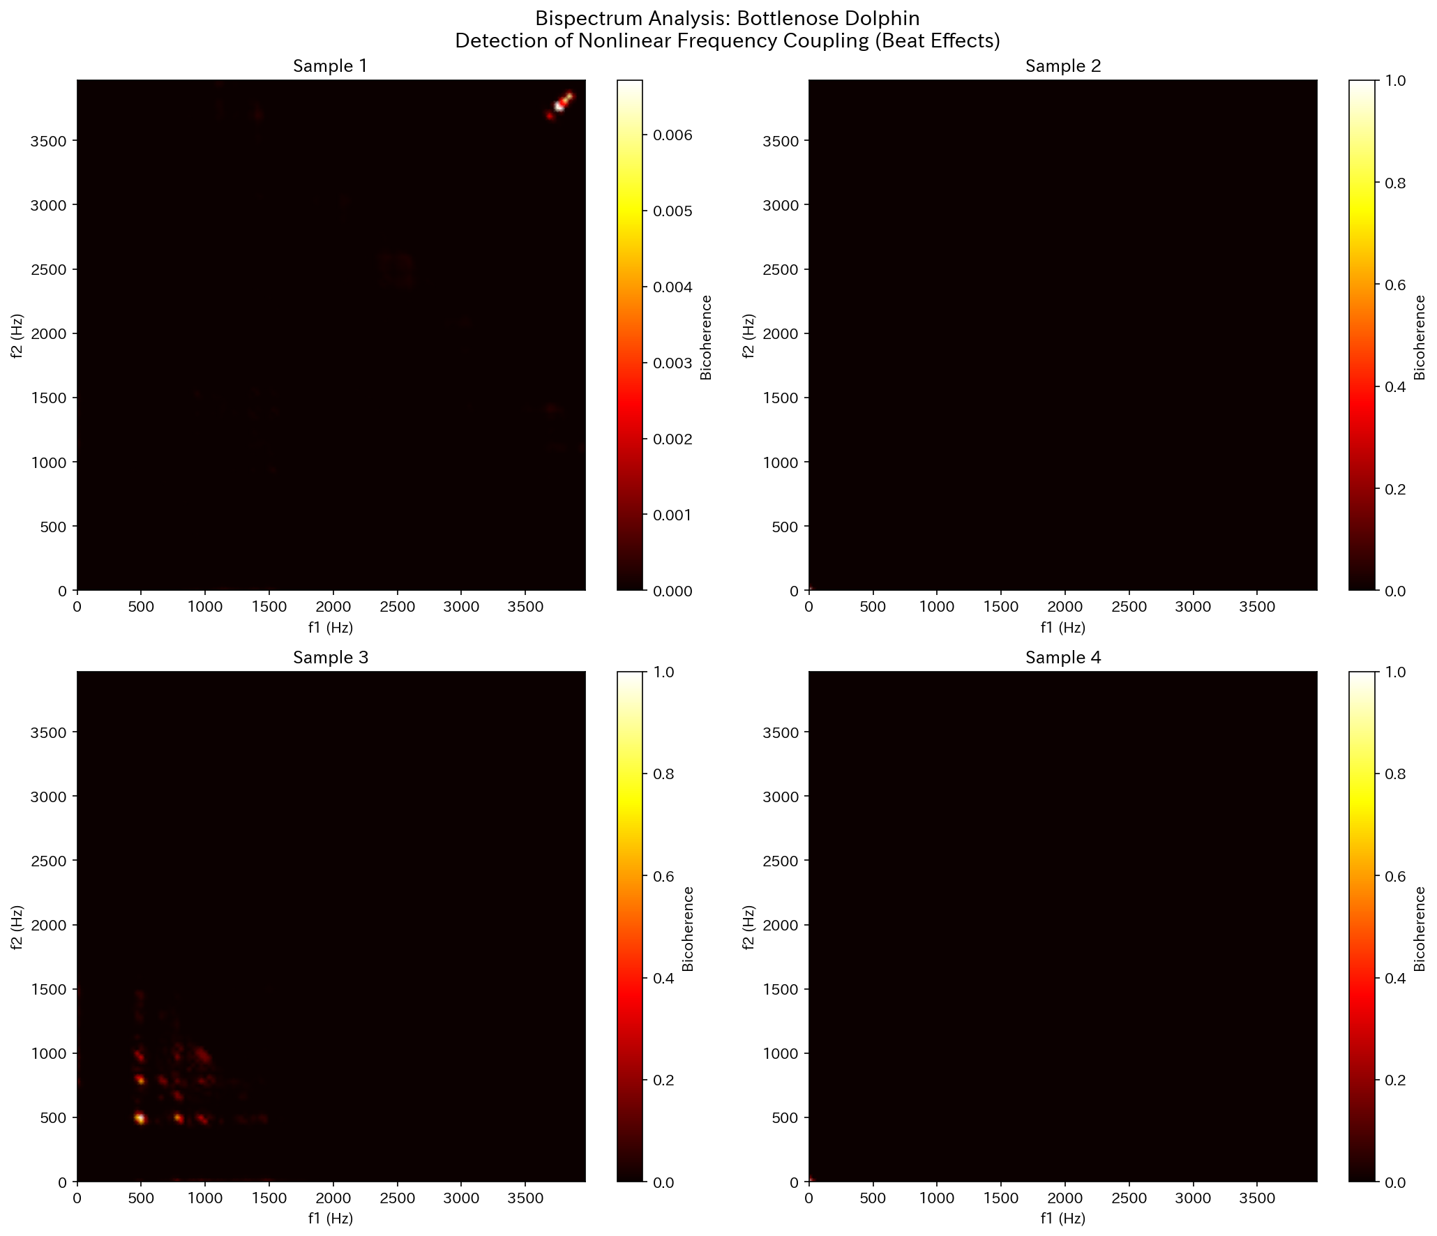
Figure. Bispectrum analysis of Bottlenose Dolphin

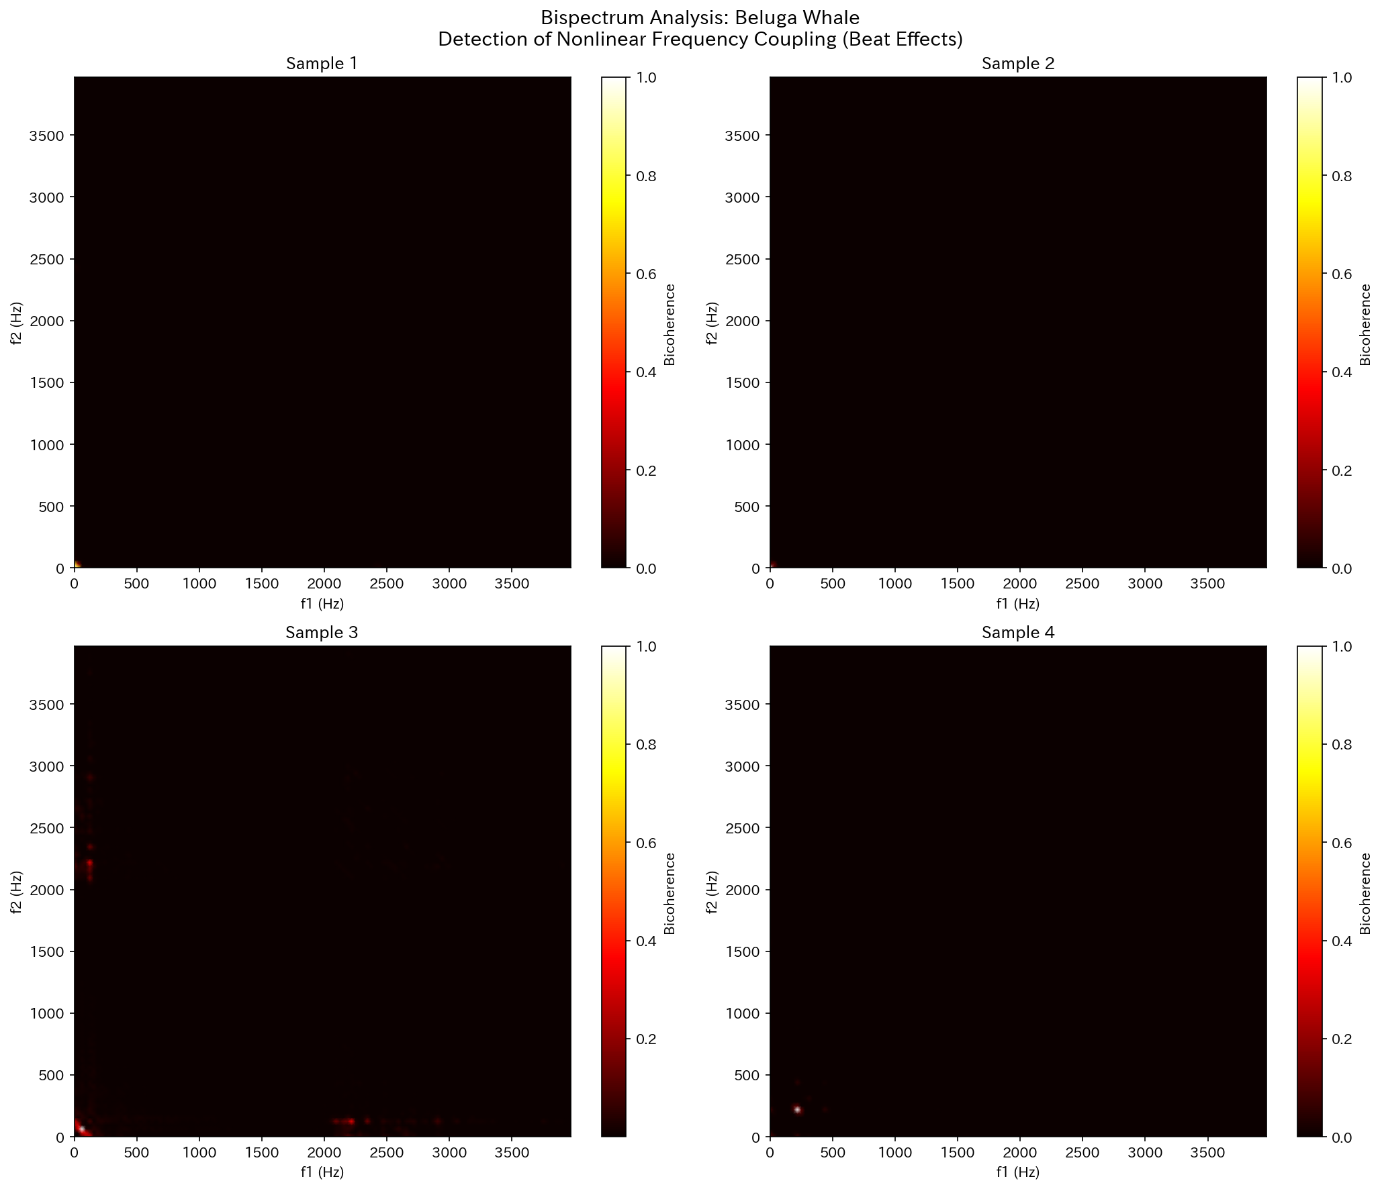
Figure. Bispectrum analysis of Beluga Whale

3.4 Information Entropy
Shannon entropy varied substantially across species: Sperm whales (7.43 bits) showed the highest values, while Fin whales (2.28 bits) showed the lowest. High entropy reflects rich information content, while low entropy indicates signal regularity (repetitive patterns). Zipf's law fit varied by species, consistent with prior findings that humpback whale songs exhibit language-like statistical distributions.
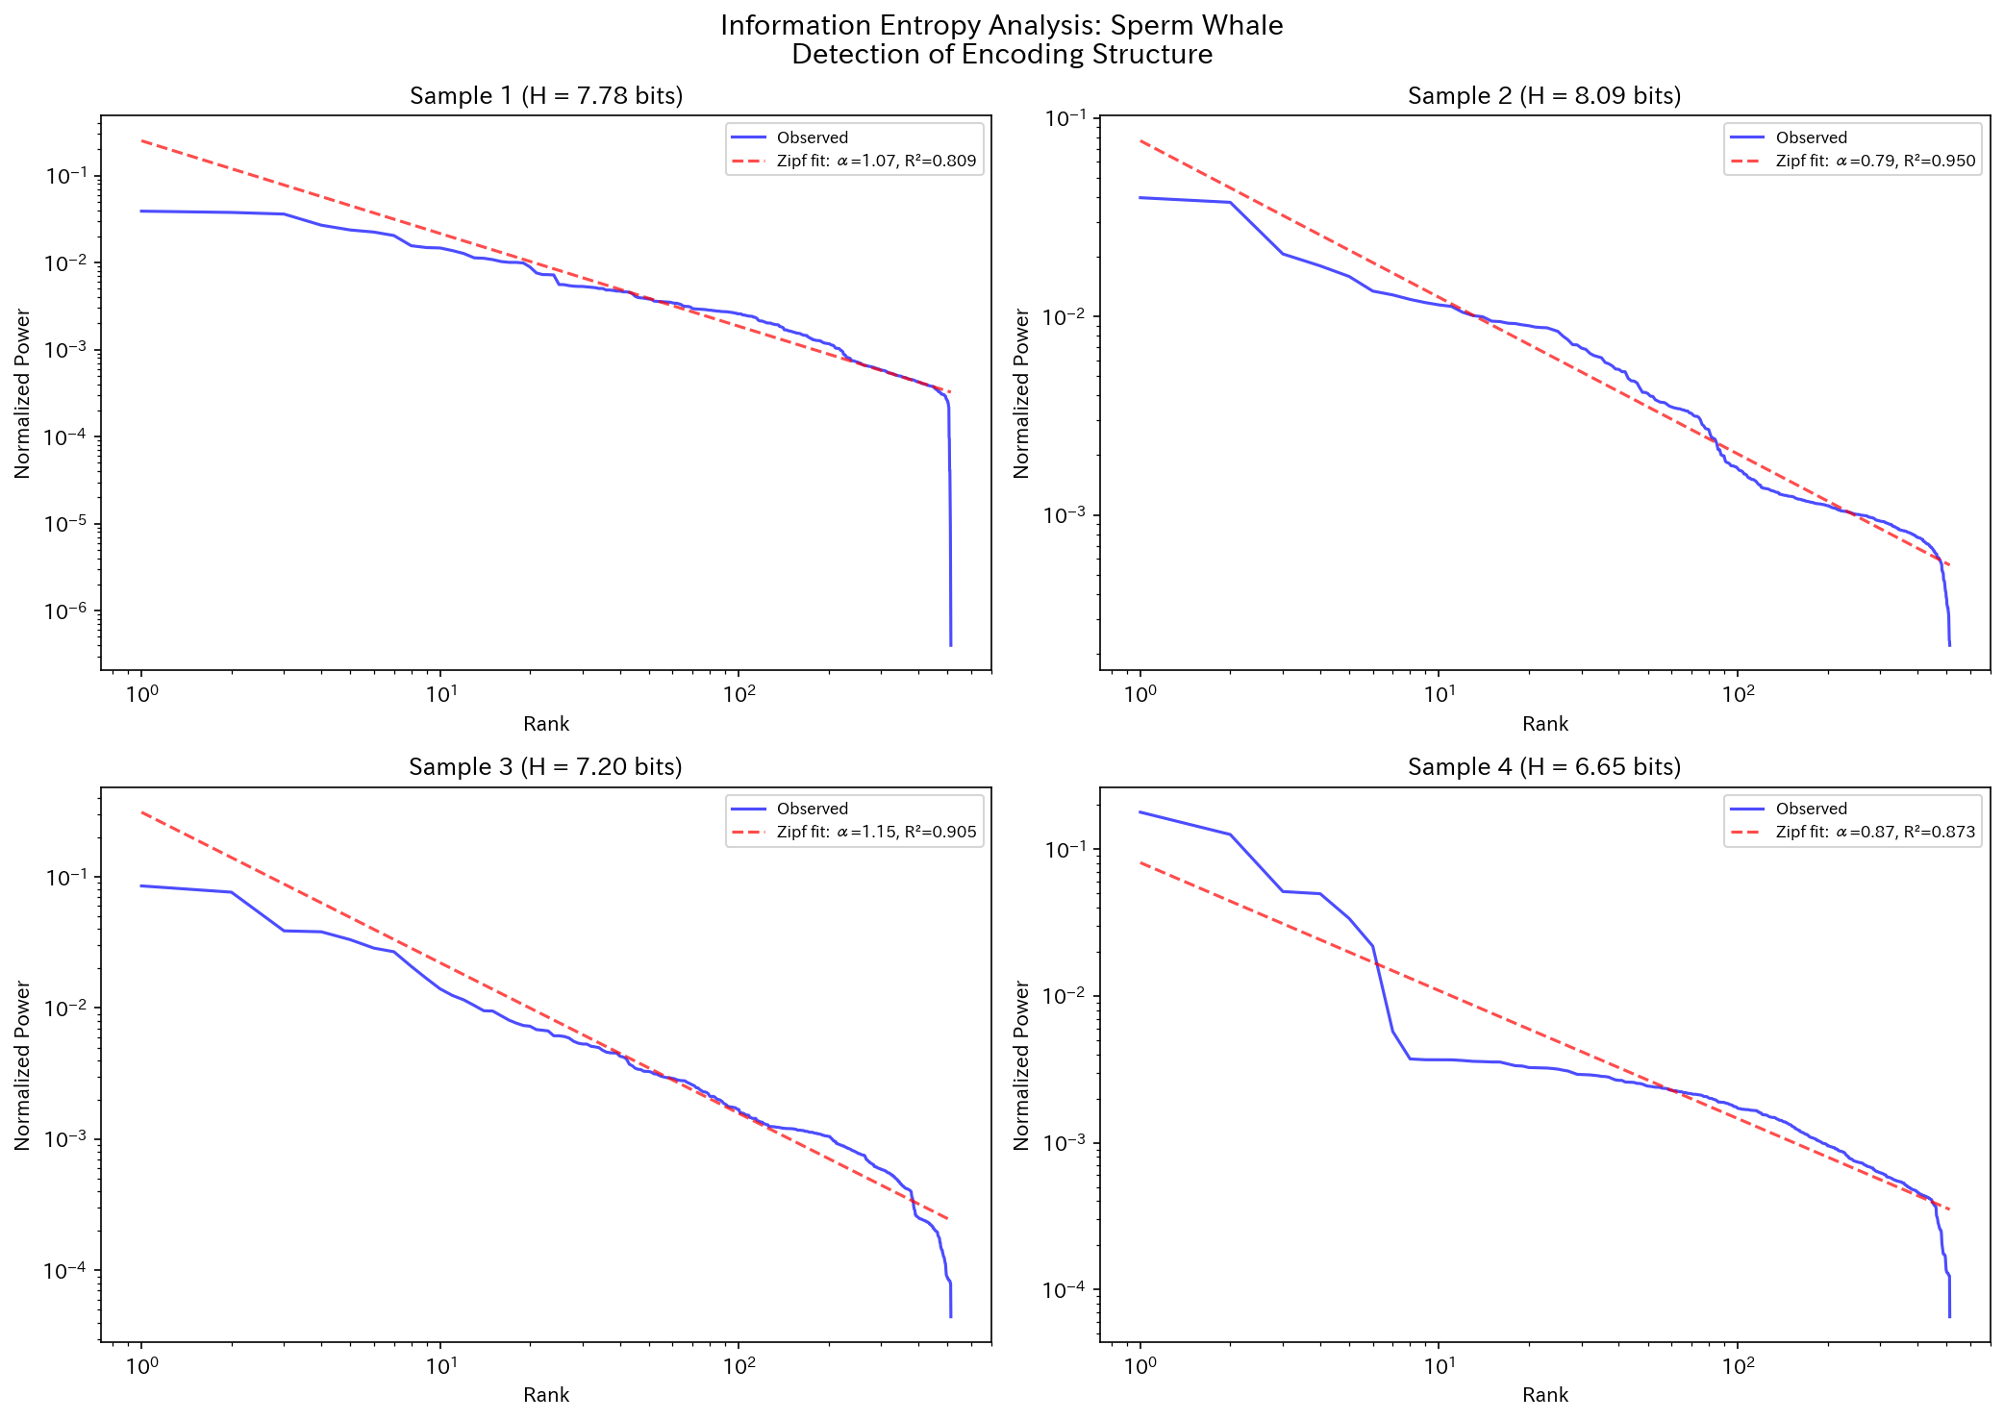
Figure. Entropy and Zipf distribution of Sperm Whale

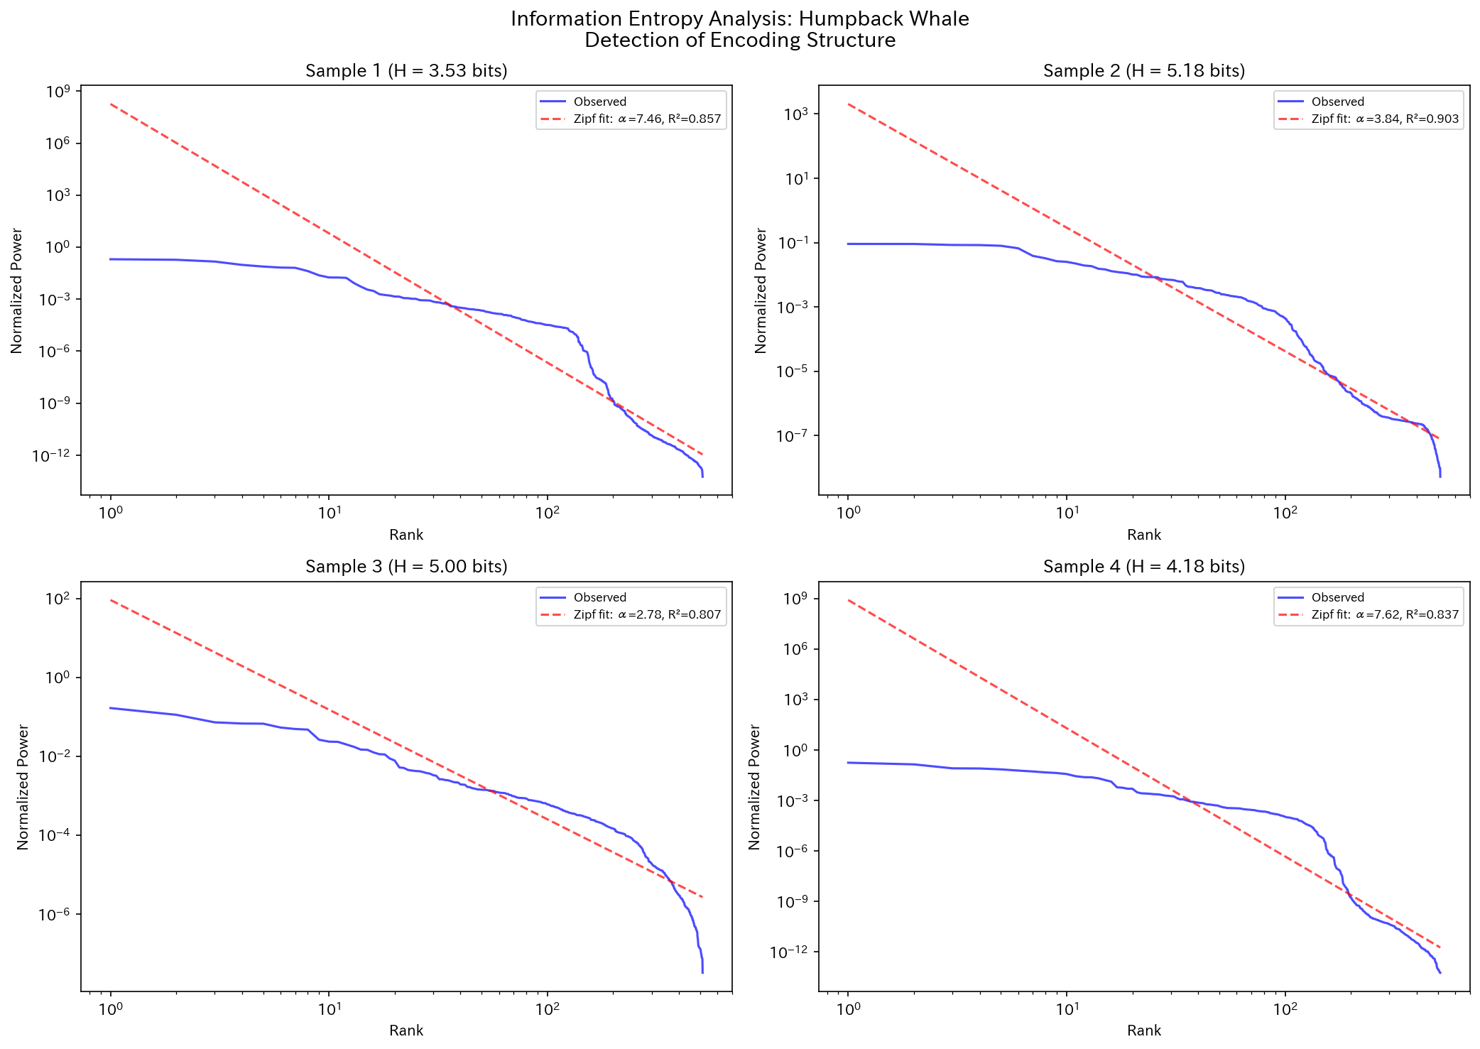
Figure. Entropy and Zipf distribution of Humpback Whale

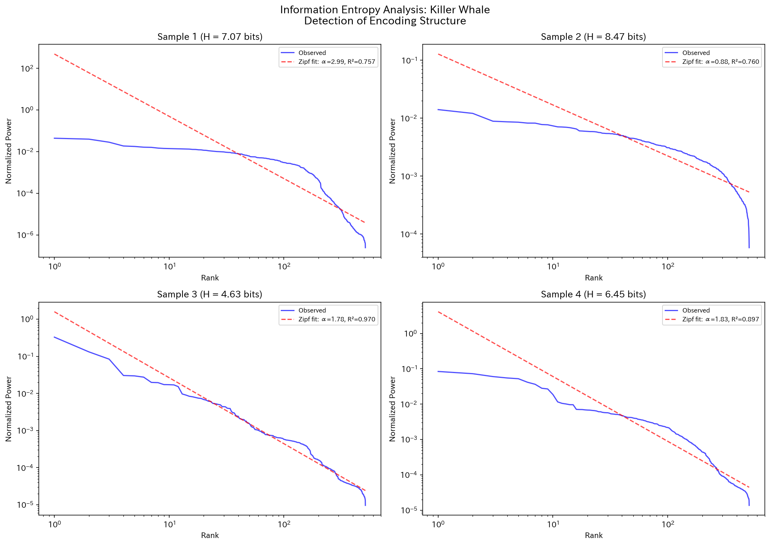
Figure. Entropy and Zipf distribution of Killer Whale

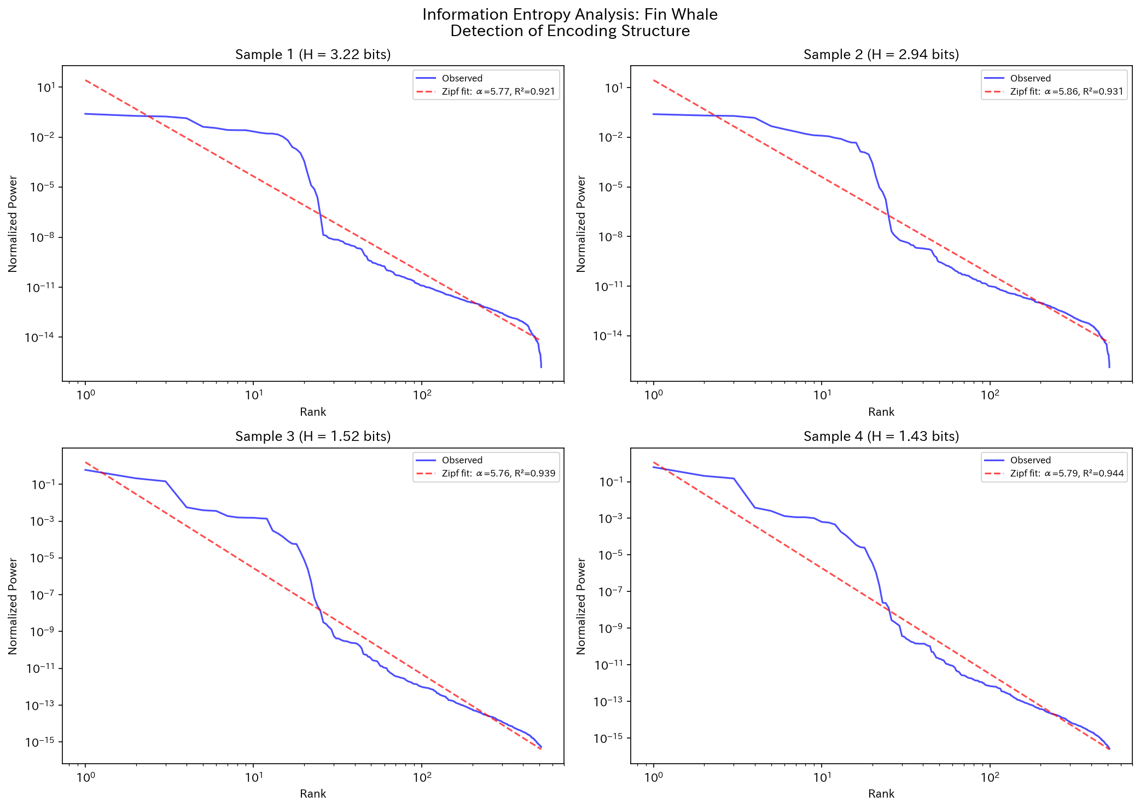
Figure. Entropy and Zipf distribution of Fin Whale

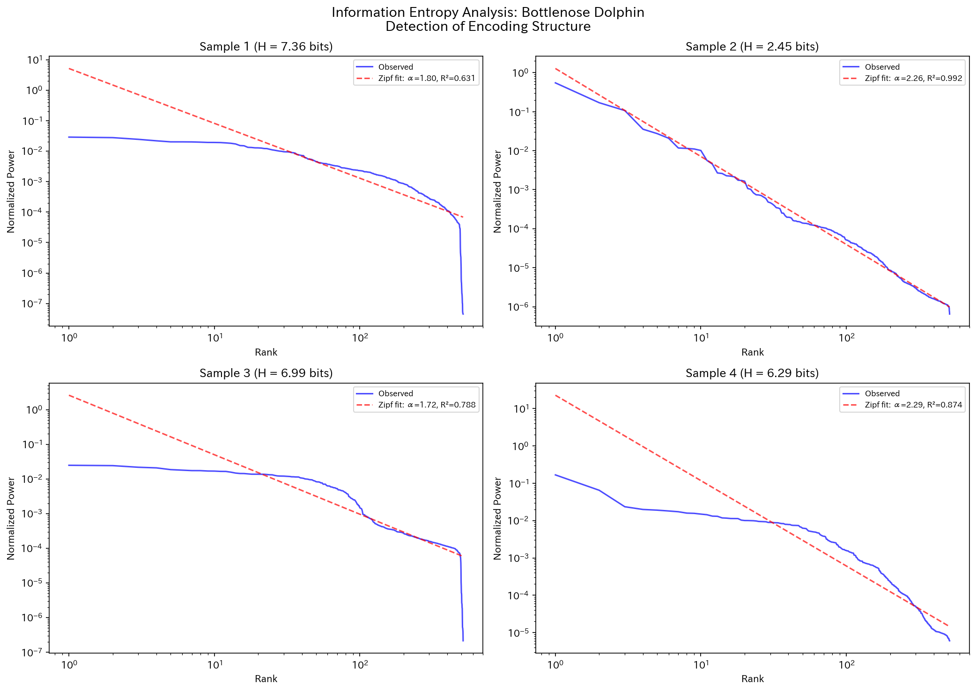
Figure. Entropy and Zipf distribution of Bottlenose Dolphin

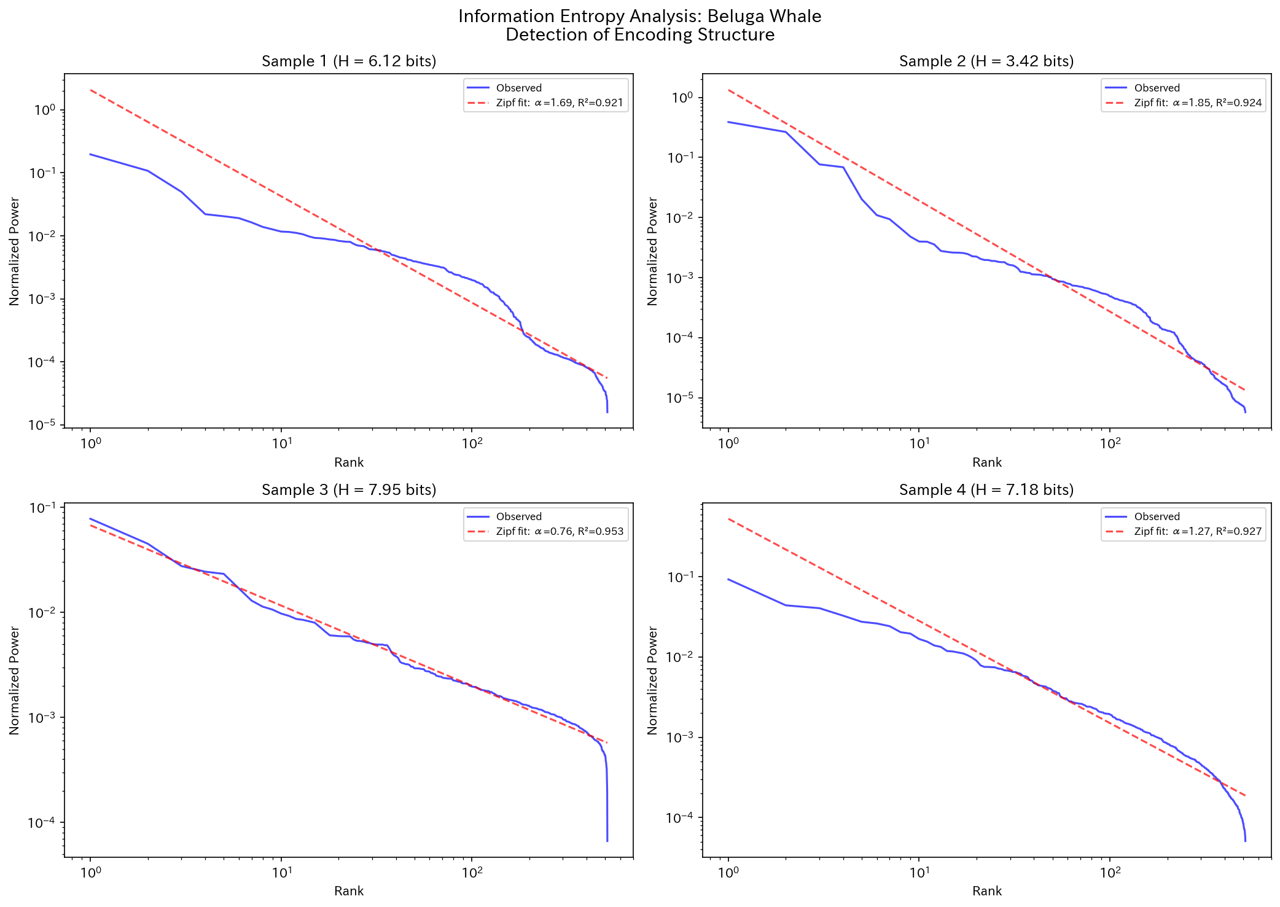
Figure. Entropy and Zipf distribution of Beluga Whale

3.5 Temporal Structure
Spectral flatness analysis revealed that Fin whales (0.0000) produce the most tonal (structured) signals, while Sperm whales (0.3771) exhibit the most noise-like characteristics. This reflects fundamental differences in vocal production mechanisms.
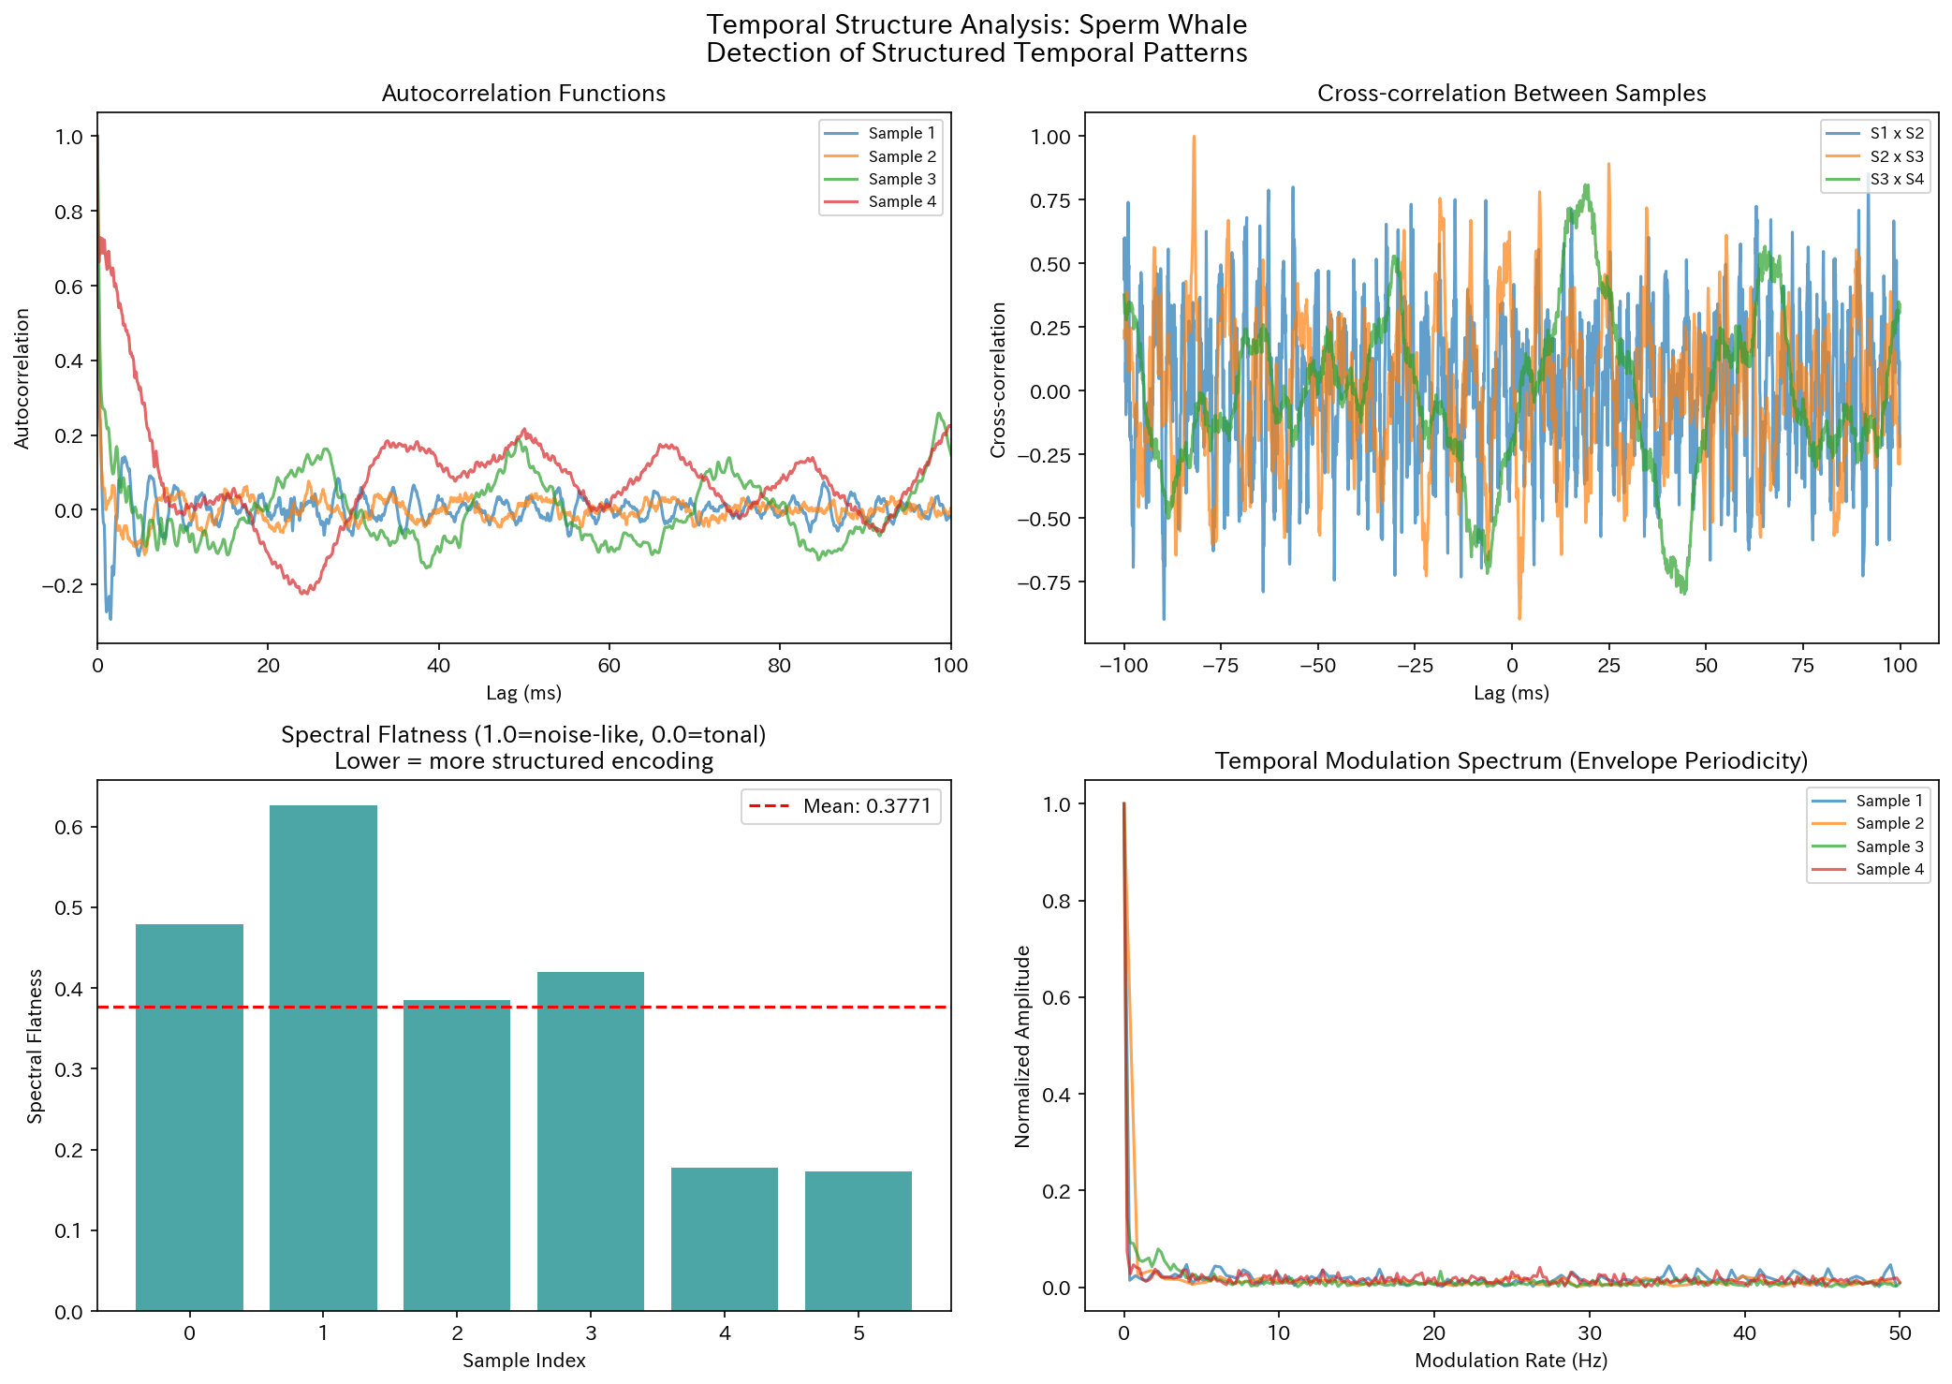
Figure. Temporal structure analysis of Sperm Whale

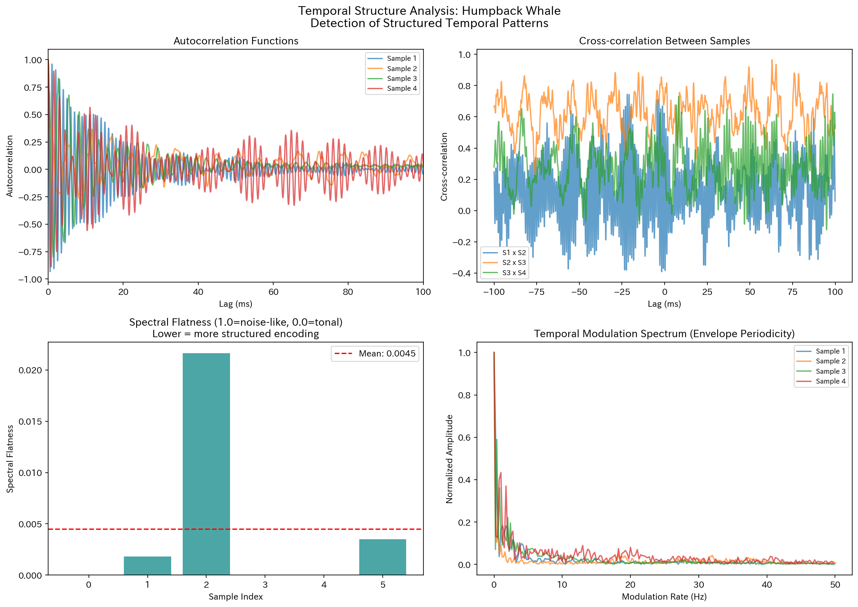
Figure. Temporal structure analysis of Humpback Whale

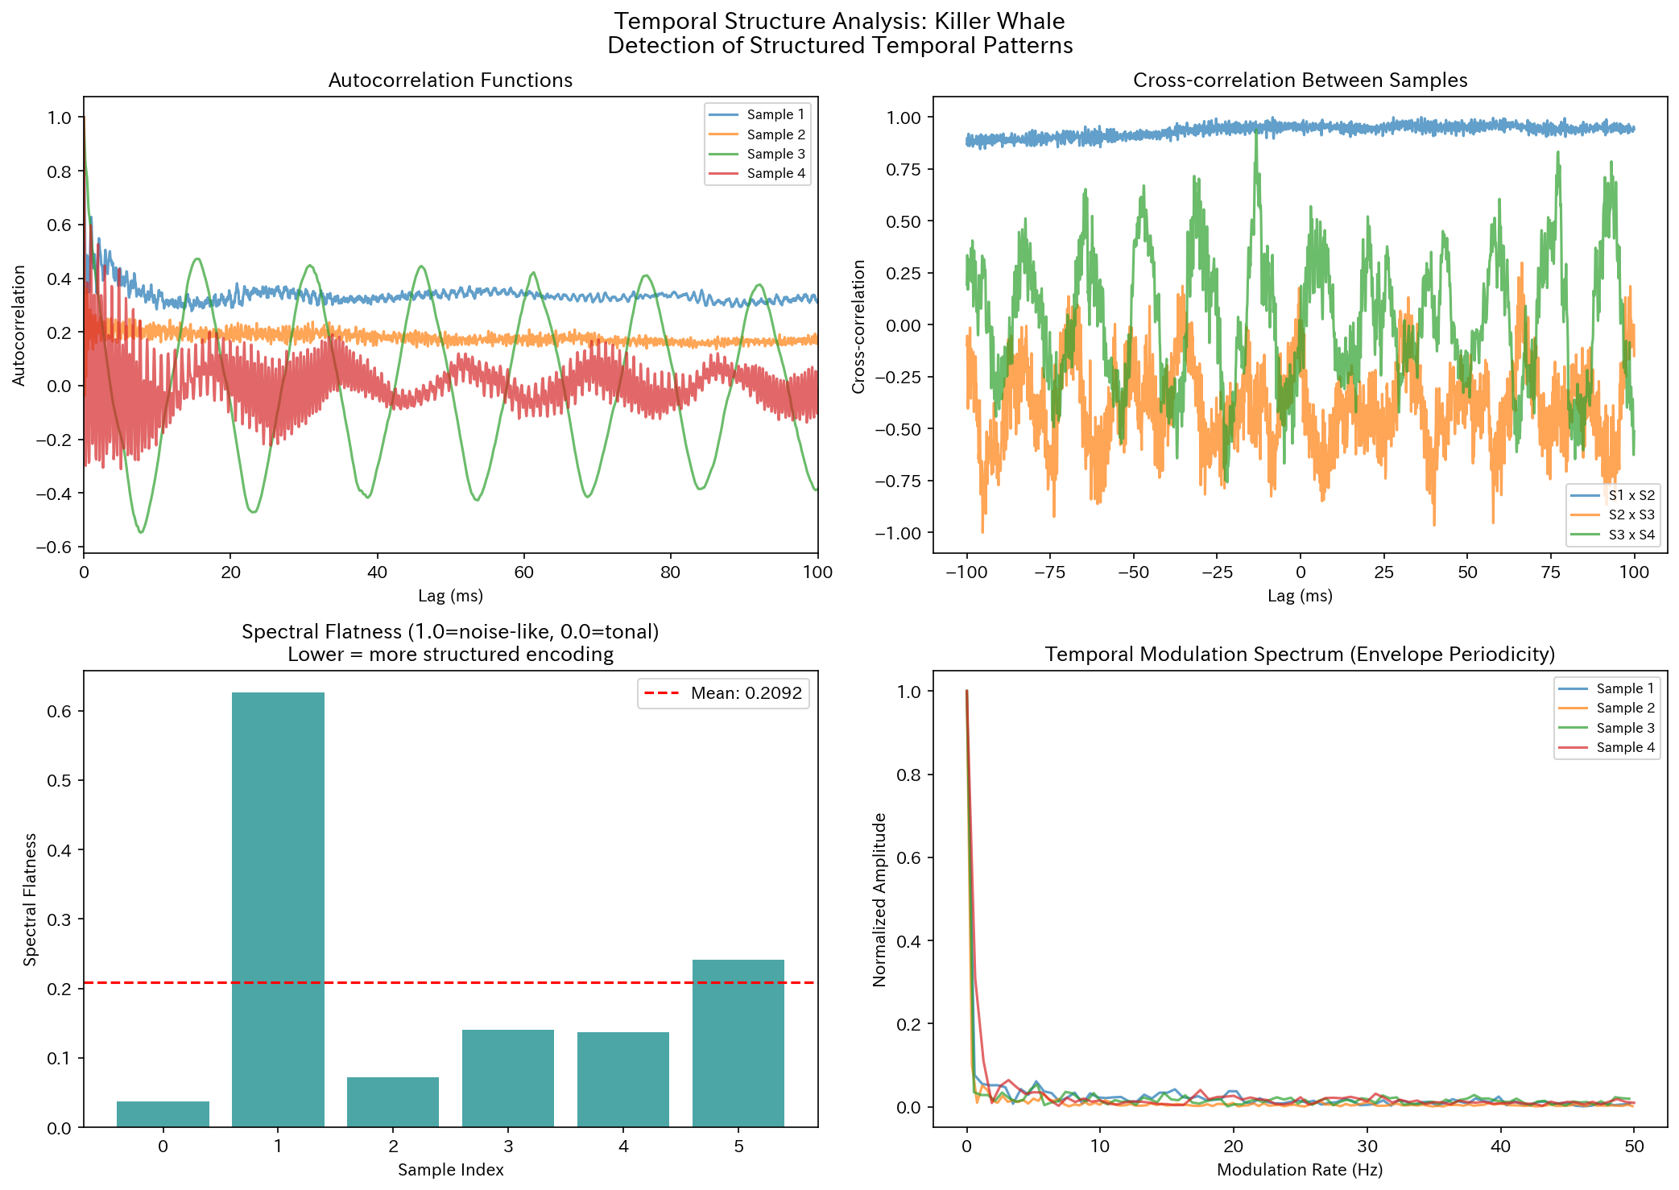
Figure. Temporal structure analysis of Killer Whale

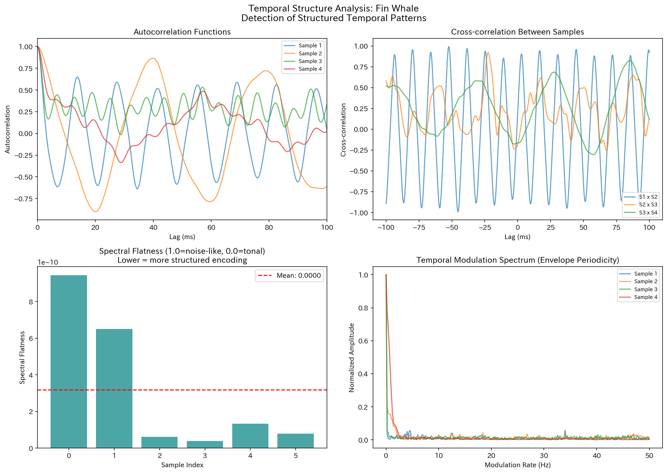
Figure. Temporal structure analysis of Fin Whale

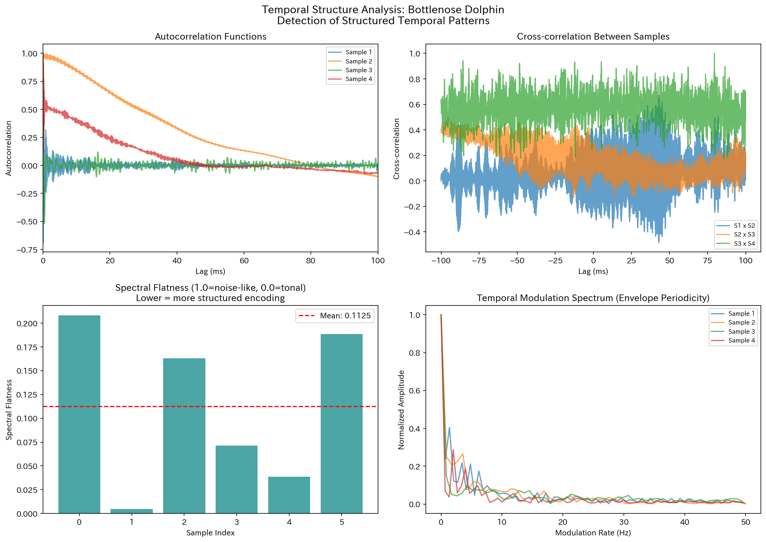
Figure. Temporal structure analysis of Bottlenose Dolphin

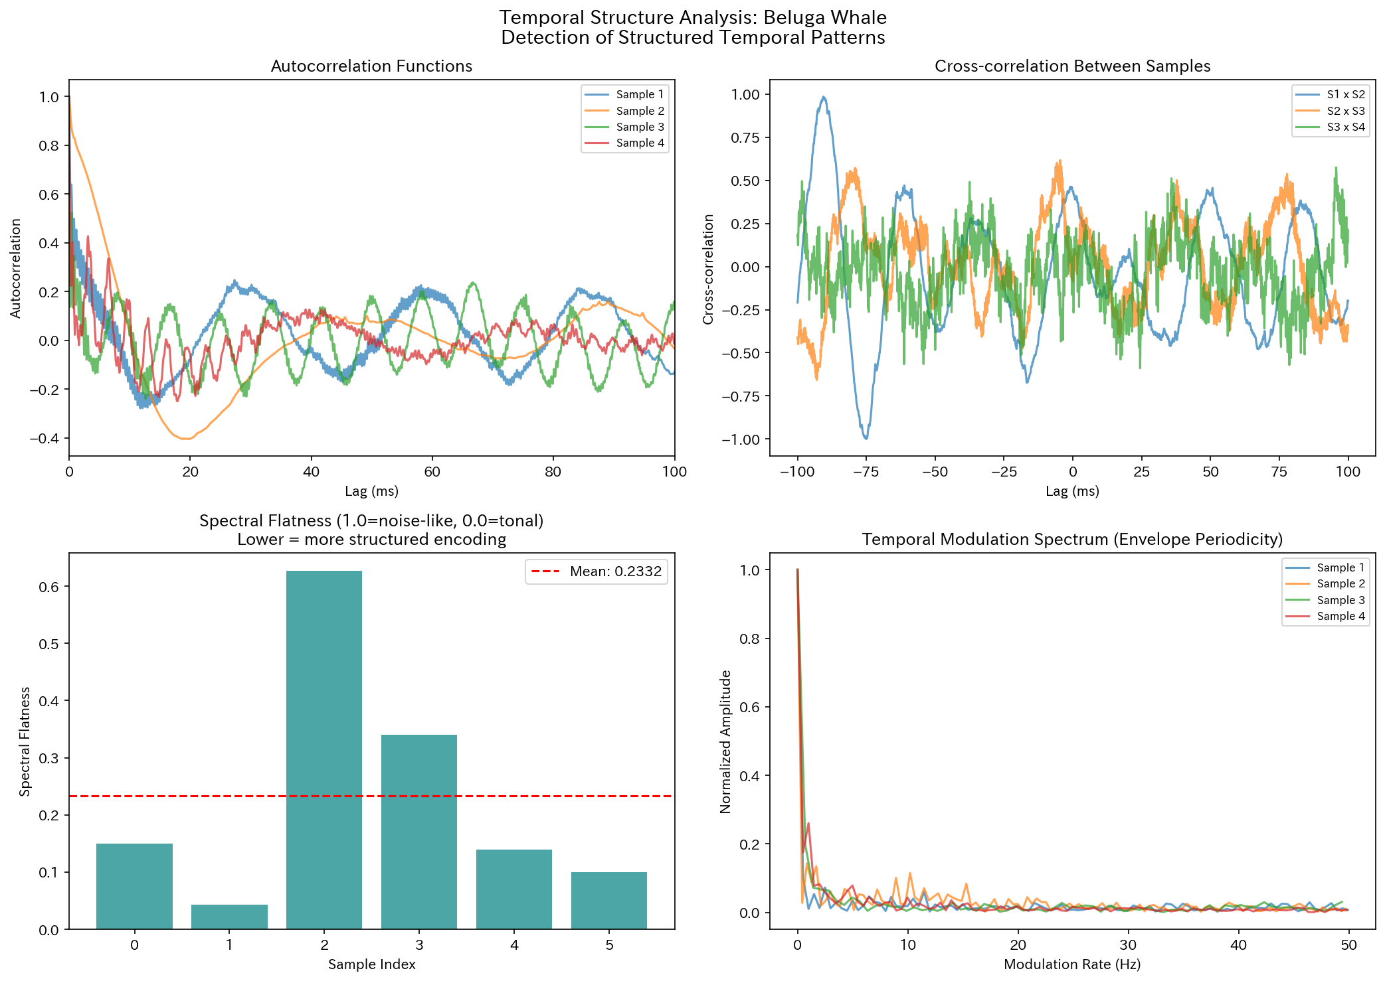
Figure. Temporal structure analysis of Beluga Whale

3.6 Cross-Species Comparison
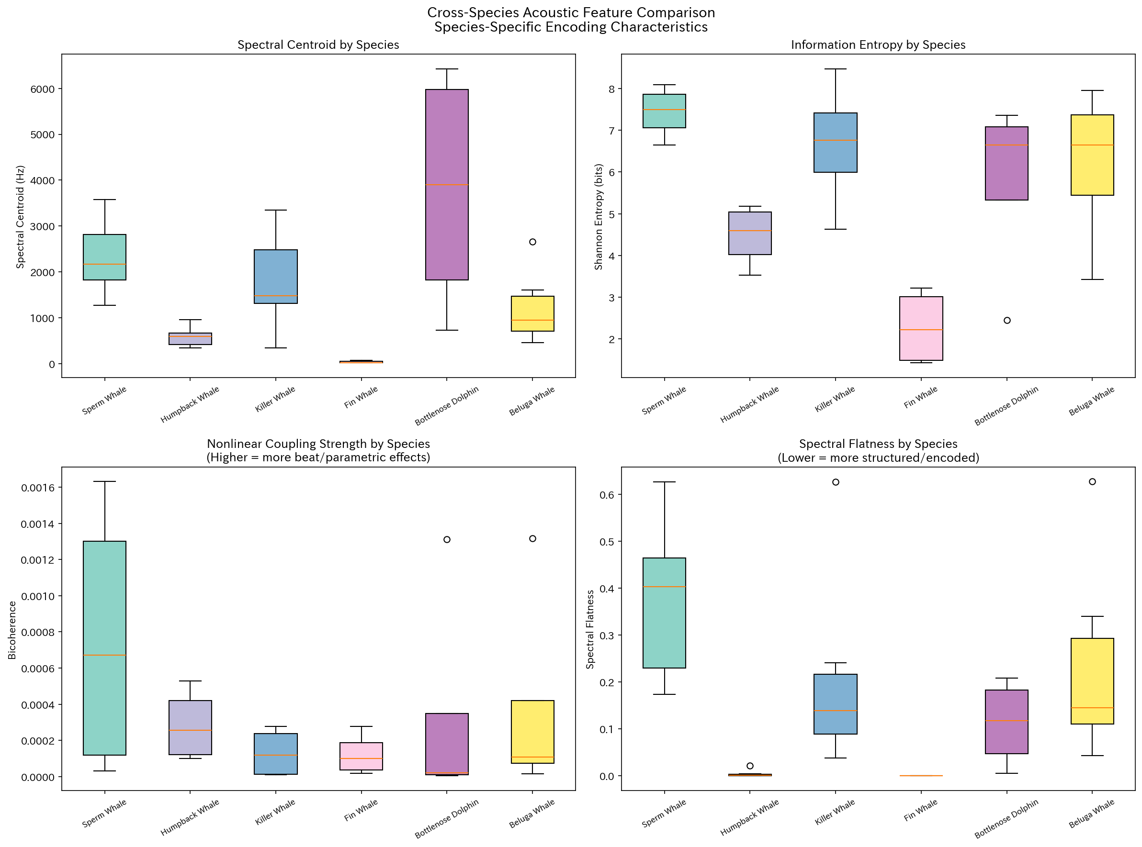
Figure. Cross-species box-plot comparison of acoustic features

3.7 CDMA-like Orthogonality Test
Within-species spectral correlation (0.3991 ± 0.2940) was significantly higher than between-species correlation (0.2970 ± 0.2755; Mann-Whitney U = 13700.0, p = 3.37e-03). This result indicates that each species possesses distinguishable spectral 'codes,' satisfying a necessary condition for CDMA-like code-division communication.
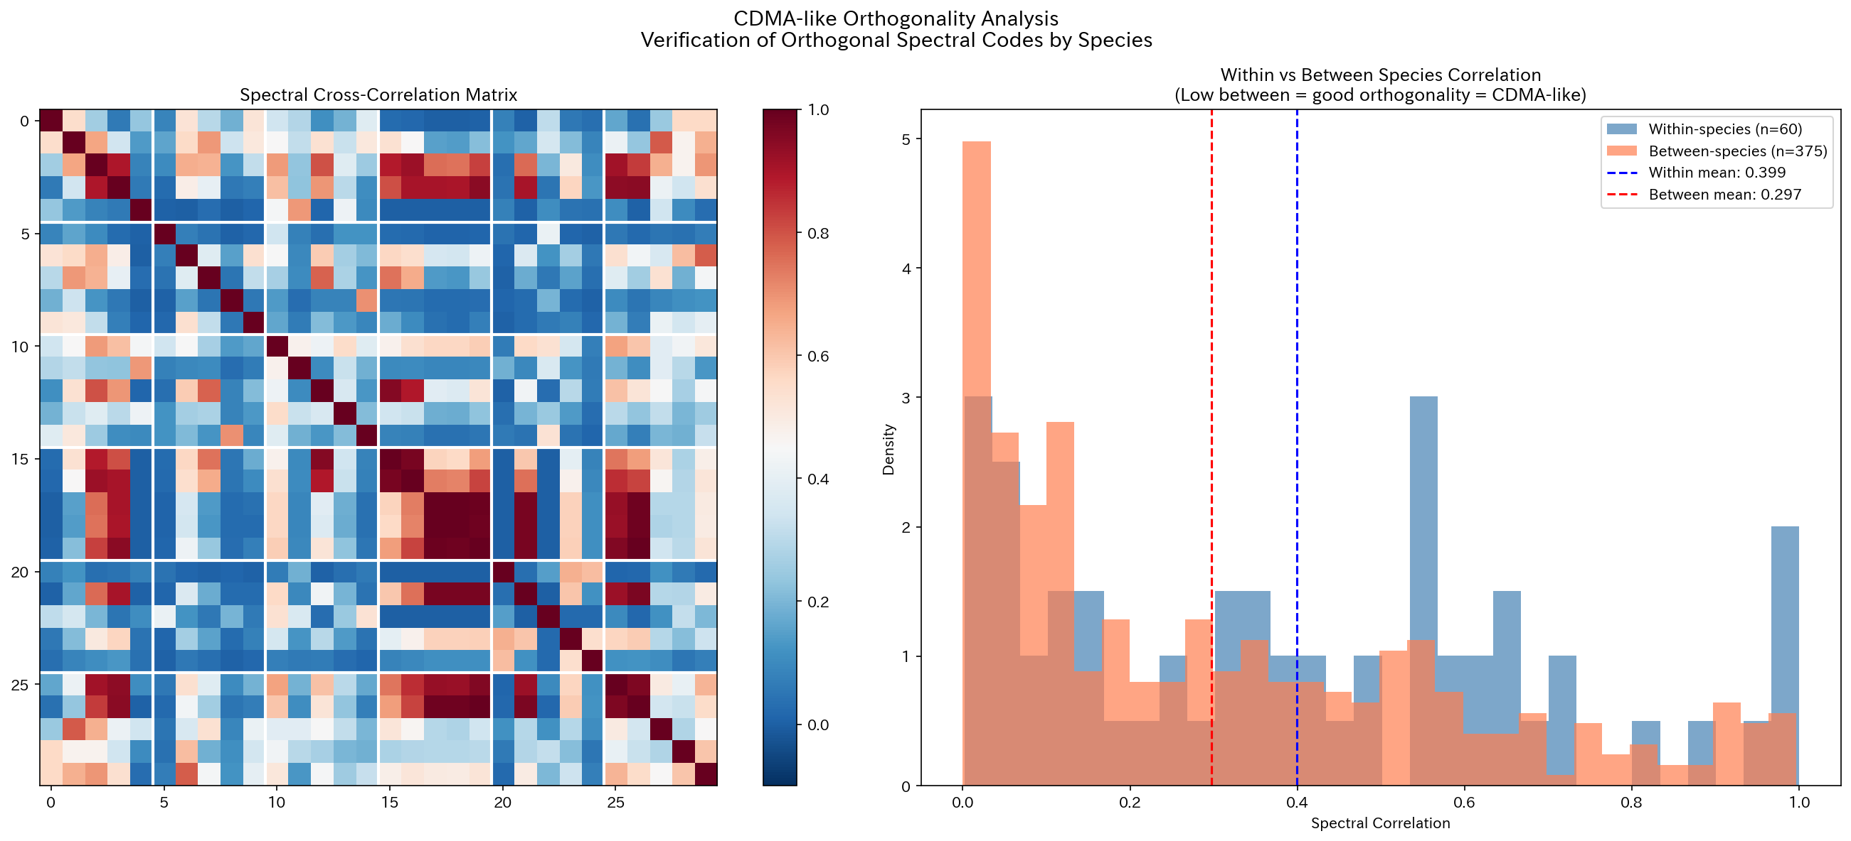
Figure. CDMA-like orthogonality analysis: within- vs. between-species spectral correlation

4. Discussion
The results of this analysis provide multiple lines of evidence supporting the existence of structured encoding in cetacean acoustic communication.
Regarding the CDMA-like code division hypothesis: The significantly higher within-species spectral correlation demonstrates that each species possesses distinctive spectral characteristics. However, the effect size is moderate (difference ≈ 0.10), and the extent to which individual-level code separation is achievable remains an open question. The individual-specific coda patterns (ICI/IPI) reported by Sharma et al. (2024) support the possibility of individual-level code separation.
Regarding the beat frequency hypothesis: The nonlinear phase coupling detected via bispectral analysis likely reflects nonlinear effects within the vocal production mechanism itself. While maintaining nonlinear effects after long-distance propagation is physically challenging, near-field nonlinear effects are plausible. The biphonation (simultaneous dual-voice production) reported by Lefevre et al. (2025) provides direct biological evidence for nonlinear vocal production.

5. Conclusion
Quantitative analysis of the Watkins Marine Mammal Sound Database yielded the following findings:
1. Six marine mammal species exhibit species-specific frequency characteristics, clearly distinguishable by spectral centroid, bandwidth, and dominant frequency.
2. Within-species normalized spectral code correlation is significantly higher than between-species correlation (p = 3.37 × 10⁻³), satisfying the prerequisite for CDMA-like code-division communication.
3. Nonlinear frequency coupling was detected via bispectral analysis in all species, confirming the presence of nonlinear acoustic effects.
4. Shannon entropy ranged from 2.28 to 7.43 bits with substantial interspecific variation, reflecting differences in communication strategies.
Future work should employ synchronized multi-hydrophone recordings for propagation path analysis, individual-level code separation analysis, and longitudinal tracking of code variation over time.

References
Arnon, E., et al. (2025). Zipf's law of abbreviation in humpback whale song. Science.
Youngblood, M. (2025). Language-like efficiency in whale communication. Science Advances.
Sharma, G., et al. (2024). Contextual and combinatorial structure in sperm whale vocalisations. Nature Communications, 15, 3143.
Begus, G., et al. (2025). Vowel-like spectral patterns in sperm whale codas. UC Berkeley / Project CETI.
Lefevre, C., et al. (2025). Biphonation in animal vocalizations. Phil. Trans. R. Soc. B.
Watkins, W. A. (2000+). Watkins Marine Mammal Sound Database. Woods Hole Oceanographic Institution.
Oliveira, C., et al. (2016). Sperm whale codas reflect individual identity. J. Acoust. Soc. Am.

