Encoded-unit granularity, not phonological channel size, sets the scale of writing-system symbol inventories
Onishi Tatsuki
Graduate School of Data Science, Shiga University, Hikone, Japan
Abstract
Symbol inventory size is one of the most visible differences among writing systems, yet it remains unclear whether it tracks the size of the phonological inventory a script encodes or reflects the architecture of the encoding itself. Treating the writing system as a channel that maps phonological units to stored or composed signs, I ask whether grapheme inventory G is coupled to phoneme inventory P, how encoded-unit granularity modulates that coupling, and what an observer can infer about an unknown script's architecture from its inventory statistics alone. I assemble a dependence-aware dataset of 544 language×script pairs linking PHOIBLE phoneme inventories, CLDR grapheme exemplar counts, Glottolog genealogies, and a granularity codebook, with a frozen analysis plan, grouped resampling, and negative controls. The central result is a decoupling: median P is essentially constant (43–49) across architectures while median G scales over two orders of magnitude (27 → 63 → 213 → 2210) with encoded-unit granularity, a separation that survives script- and family-cluster resampling, label-shuffle and exclusion controls. Within-class P–G coupling is weak or absent in alphabets (ρ = −0.09) and strongest in abugidas (ρ = 0.47), but the cross-class pattern does not exceed a label-permutation null, so it is reported as exploratory. A K^L channel simulation locates each class between stored-unit demand and a compositional bound, matching the observed orders of magnitude. Combinatorial escape is largely unsupported: spoken word length is uncorrelated with P, though written word length trades off against P (ρ = −0.40), not G. Inverse inference succeeds at the level of encoded-unit granularity using directly observable inventory statistics alone (macro-F1 = 0.76 under family-grouped cross-validation), whereas finer architecture labels gain little beyond inventory size and the phonological inventory itself is not recoverable. Symbol-inventory scale appears to be set not by how many phonemes exist but by how large the encoded unit is and whether signs are stored or composed.
1. Introduction
Every writing system faces the same biophysical problem: a bounded set of visually discriminable, producible signs must cover a linguistic channel. Two factors could set the resulting inventory. The first is the demand side — how many encoded units the architecture chooses to mark. The second is the supply side — how many distinct signs human hands and eyes can maintain. Comparative work has documented that inventories span from ~26 letters to thousands of sinograms [1], [2], and simulation studies suggest character complexity is bounded by discriminability [3], [4]. What has not been quantified, under dependence-aware inference, is whether the size of the underlying phonological inventory leaves a trace on the size of the written inventory.
The naive expectation — phonographic systems should show G tracking P, since each phoneme invites a letter — produces a trivial paper ("alphabets have fewer characters than Chinese") if answered at the wrong level. The more informative question is architectural: the encoded-unit granularity, from phoneme to morpheme, determines how many units demand signs, and compositionality determines whether those signs are stored individually or built from primitives. I therefore test four propositions on a new linked dataset: (H1) G is coupled to P within phonographic architectures; (H2) small primitive inventories are compensated by longer coded forms (combinatorial escape); (H3) coupling decays with encoding distance from the channel; (H4) an observer given only symbol statistics can recover the latent architecture.
This channel framing follows a productive line of work showing that language's structural and channel-level properties are coupled in compensating ways [5]. The statistical difficulty is real: languages are genealogically and areally dependent, scripts are shared across dozens of languages, and inventory counts are heavy-tailed. Following recent calls for dependence-aware comparative inference [6], [7], all primary estimates use script- or family-cluster resampling, grouped cross-validation, permutation controls, and a frozen analysis plan. Negative and null results are reported by design.
2. Data
Unit of analysis is the language×script pair. The final dataset contains 544 pairs spanning 6 writing-system classes.
Phoneme inventory P is the largest PHOIBLE 2.0 segment inventory (consonants + vowels + tone-bearing segments) per ISO 639-3 code [8]. Taking the maximal inventory per language follows prior cross-linguistic practice [9] and avoids dialect-level noise; sensitivity to consonant-only inventories is reported in supplementary analyses.
Grapheme inventory G is the count of core exemplarCharacters in CLDR 46.1 [10] for the default script assigned to each language by CLDR likelySubtags, supplemented by seven curated pairs covering granularity cells that likelySubtags misses (e.g. Han-script languages lacking PHOIBLE records, Vai, N'Ko). Auxiliary exemplar counts (G_aux) are retained for sensitivity analyses. CLDR exemplars approximate, but do not equal, full grapheme inventories; for compositional scripts I additionally record the functional component inventory (e.g. Korean jamo) as a sensitivity variable.
Granularity is coded ordinally: 1 = phoneme/feature (alphabets, abjads, featural Hangul), 2 = CV-akshara (Brahmic abugidas, Ethiopic), 3 = syllable/mora (kana, Cherokee, Vai, Cans), 4 = morpheme-syllable (Han-derived and mixed systems). The codebook (code/script_type_codebook.csv) maps 114 scripts to a writing-system class and granularity and is released with the analysis code.
Dependence structure: Glottolog 5.0 top-level families [11] and ISO 15924 script codes define the resampling clusters. Combinatorial-escape outcomes use mean segment count per Swadesh gloss from ASJP [12] (spoken side, aggregated per ISO 639-3) and mean orthographic length of the 1000 most frequent wordforms from wordfreq [13] (written side; exact language-code matches only).
3. Methods
The analysis plan was frozen before full analysis (SAP_FROZEN.md, commit 6ef2860); amendments are logged in docs/PROTOCOL_AMENDMENTS.md. Primary analyses: (P1) class medians of G, P, and G/P with script-cluster bootstrap 95% CIs (B = 2000); (P2) within-class Spearman ρ(P, G) with family-cluster bootstrap CIs; (P3) a crossed mixed-effects model logG ~ logP × C(granularity) with variance components for script and family. Secondary analyses: (S1) regression of mean word length on G and P with family clustering; (S2) a K^L toy-channel simulation locating each class between a stored-unit bound and a compositional bound under noise; (S3) multinomial classifiers of ws_class and granularity from symbol statistics under leave-one-family-out and leave-one-script-out cross-validation, benchmarked against majority and G-only baselines. Negative controls (frozen): F1 within-stratum P permutation; F2 architecture-label shuffles applied to the coupling pattern and the granularity–G separation; F3 exclusion of Latin-, Han-derived, and single-language-script rows. All code and seeds are in the reproducibility bundle.
4. Results
4.1 Descriptive: the decoupling
Median P is remarkably flat across granularity classes — 45, 48, 43, and 49 for levels 1–4 respectively (Table 1) — consistent with phoneme inventories being bounded by production/perception constraints largely independent of writing [14]. Median G, by contrast, scales from 27 (granularity 1) through 63 (level 2) and 213 (level 3) to 2210 (level 4) — more than two orders of magnitude of variation associated with encoded-unit architecture rather than phonological inventory size (Figure 1). The median G/P ratio rises correspondingly from 0.63 to 45.1. This is the paper's central pattern: the symbol inventory answers "what size is the encoded unit," not "how large is the phoneme inventory."
Table 1. Class medians of G, P, and G/P with script-cluster bootstrap 95% CIs.
granularity | variable | n | scripts (n) | median | CI lo | CI hi
1 | G | 470 | 13 | 27 | 26 | 38
1 | P | 470 | 13 | 45 | 41 | 46
1 | G/P | 470 | 13 | 0.63 | 0.60 | 0.87
2 | G | 47 | 18 | 63 | 49.5 | 73
2 | P | 47 | 18 | 48 | 43 | 55
2 | G/P | 47 | 18 | 1.18 | 1 | 1.57
3 | G | 7 | 6 | 213 | 88 | 675
3 | P | 7 | 6 | 43 | 27.5 | 56
3 | G/P | 7 | 6 | 6.26 | 3.63 | 10.4
4 | G | 20 | 4 | 2210 | 2179 | 11172
4 | P | 20 | 4 | 48.5 | 48 | 49
4 | G/P | 20 | 4 | 45.1 | 45.1 | 232.8

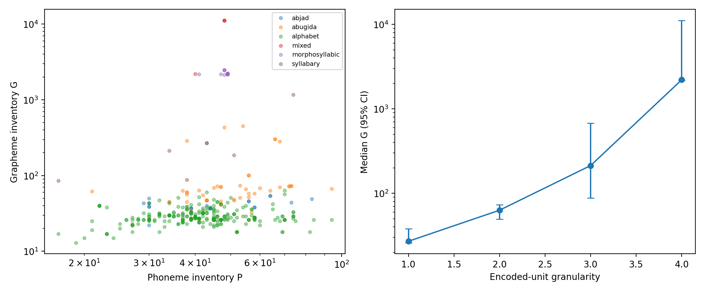
Figure 1. P vs G across writing-system classes with class medians.
4.2 Primary: within-class P–G coupling
Within-class coupling is non-monotonic and mostly weak (Table 2). Alphabets show no coupling (ρ = −0.09, family-cluster CI [−0.31, 0.49]). Abjads show a positive but imprecise coefficient (ρ = 0.31, CI [−0.73, 0.59]). Abugidas show the strongest coupling (ρ = 0.47, CI [0.10, 0.61], permutation p < 0.005) — consistent with akshara inventories growing where consonant–vowel combinatorics demand it. The morphosyllabic class shows essentially none (ρ = −0.01), as expected where signs encode morphemes. The crossed mixed model agrees: the logP main effect is null (β = 0.02, 95% CI [−0.05, 0.09]) and only the granularity-3 interaction reaches significance (Table 3).
Table 2. Within-class Spearman rho(P, G) with family-cluster bootstrap CIs.
class | n | families (n) | rho | p | CI lo | CI hi
abjad | 26 | 4 | 0.31 | 0.123 | -0.73 | 0.59
abugida | 47 | 7 | 0.47 | <0.001 | 0.10 | 0.61
alphabet | 444 | 27 | -0.09 | 0.061 | -0.31 | 0.49
morphosyllabic | 16 | 1 | -0.01 | 0.958
Note: family-cluster confidence intervals are not estimable for classes represented by a single language family.

Table 3. Crossed mixed-effects model logG ~ logP x C(granularity), fixed effects.
term | coef | CI lo | CI hi
Intercept | 3.48 | 3.12 | 3.84
C(gran)[T.2] | 0.20 | -0.72 | 1.13
C(gran)[T.3] | -4.04 | -7.30 | -0.77
C(gran)[T.4] | 3.31 | -3.00 | 9.62
logP | 0.02 | -0.05 | 0.09
logP:C(gran)[T.2] | 0.13 | -0.09 | 0.34
logP:C(gran)[T.3] | 1.57 | 0.70 | 2.45
logP:C(gran)[T.4] | 0.30 | -1.34 | 1.94

However, the F2 control requires honesty about what is confirmatory here. Under 200 shuffles of the architecture labels, the maximal within-class |ρ| reaches 0.56 at the 95th percentile of the null — the observed pattern (max 0.47, permutation p = 0.154) does not exceed it. The abugida coupling is robust in isolation; the cross-class ordering, H1 and H3 as framed, is not. I therefore report the coupling pattern as exploratory and H1/H3 as unsupported in their confirmatory form — the predicted coupling is absent precisely where the channel story is strongest (alphabets). What survives every control is the level shift: granularity's separation of G (Kruskal H = 190 vs null 95th percentile = 6.8, p = 0.005), robust to excluding Latin-script, Han-derived, and single-language-script rows (F3).
4.3 Mechanism: stored units vs composed signs
The K^L simulation makes the decoupling interpretable (Figure 2, Table 4). Each class's observed G is bracketed by two bounds: the stored-unit demand U it would need if every encoded unit required a distinct sign, and the compositional bound $⌈U^{1/L}⌉$ it would need if signs were built from K primitives at depth L. Alphabetic inventories undershoot their stored-unit demand (median 27 vs ~49): real alphabets do not mark every phoneme — polyphony, digraphs, and underdifferentiation are the rule, not the exception. Abugidas sit near their compositional bound (observed 63, compositional ~23, stored ~517): the akshara body is genuinely compositional — base glyphs plus vowel diacritics — so the stored inventory stays small even though the encoded-unit demand is hundreds of CV units. Syllabaries sit mid-range; morphosyllabic systems coincide with the stored-unit bound by construction, since morpheme signs admit little productive composition. Re-encoding the same phonologies at each granularity level shifts demand by orders of magnitude while P varies within ±50% inside a level (Table 5): granularity, not channel size, is the variable that locates inventory scale.
Table 4. Simulated stored-unit vs compositional bounds vs observed G.
granularity | n | obs. G median | stored bound (median) | compositional bound (median) | within bounds (frac)
1 | 470 | 27 | 49.4 | 50 | 0.86
2 | 47 | 63 | 517.0 | 23 | 1
3 | 7 | 213 | 485.2 | 8 | 1
4 | 20 | 2210 | 2223 | 7 | 0.85

Table 5. Counterfactual stored-unit demand by granularity.
re-encoded granularity | U median | U IQR | range
1 | 45 | [39.00, 45.00] | 17-94
2 | 462 | [317.00, 525.00] | 57-1715
3 | 638.4 | [440.00, 727.00] | 79-2387
4 | 2000 | not estimable | 2000-2000

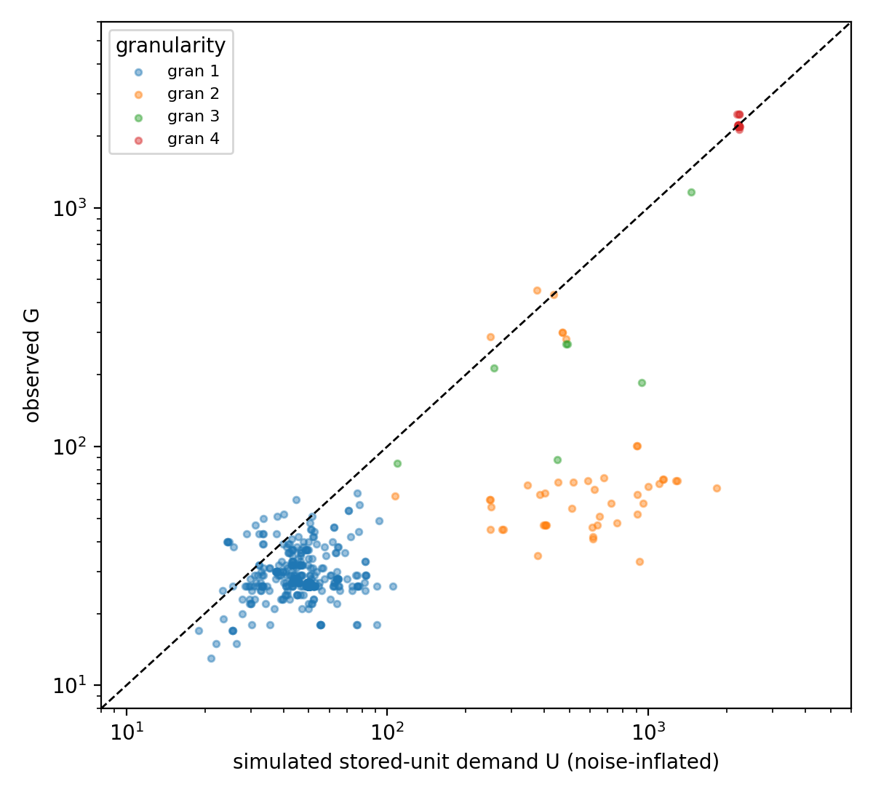
Figure 2. Observed G vs simulated stored-unit demand by granularity.
4.4 Combinatorial escape: mostly null
If small inventories are compensated by longer codes, spoken word length should fall as P rises. It does not: ρ(P, ASJP word length) = 0.01 over 526 pairs and −0.05 within alphabets (Table 6, Figure 3). The written side partially replicates the classic trade-off — ρ(P, mean orthographic word length) = −0.40 (family-bootstrap CI [−0.94, −0.11]; 287 wordfreq-matched pairs) — but ρ(G, word length) = +0.13 with a CI spanning zero: the compensation lives in phonological structure (more phonemes → shorter morphemes), not in the letter inventory per se. H2 is thus unsupported at the level the protocol predicted.
Table 6. Combinatorial escape: Spearman rho of inventory vs mean word length.
subset | n | rho(P, word len.) | p | 95% CI | rho(G, word len.) | p | 95% CI
all | 526 | 0.01 | 0.847 | [-0.23, 0.16] | 0.09 | 0.036 | [-0.31, 0.22]
abjad | 26 | -0.48 | 0.014 | [-0.58, 0.39] | -0.06 | 0.762 | [-0.61, 1.00]
abugida | 46 | 0.19 | 0.202 | [-0.25, 0.60] | 0.14 | 0.350 | [-0.23, 0.81]
alphabet | 427 | -0.05 | 0.337 | [-0.29, 0.15] | 0.09 | 0.078 | [-0.39, 0.30]
morphosyllabic | 16 | 0.53 | 0.035 | not estimable | -0.35 | 0.188 | not estimable
Note: p values are conventional Spearman test p values; 95% CIs are family-cluster bootstrap intervals. Because the confidence intervals account for genealogical clustering while the nominal p values do not, the two inferential summaries need not coincide. Cluster-aware confidence intervals are preferred for interpretation. Family-cluster confidence intervals are not estimable for classes represented by a single language family.

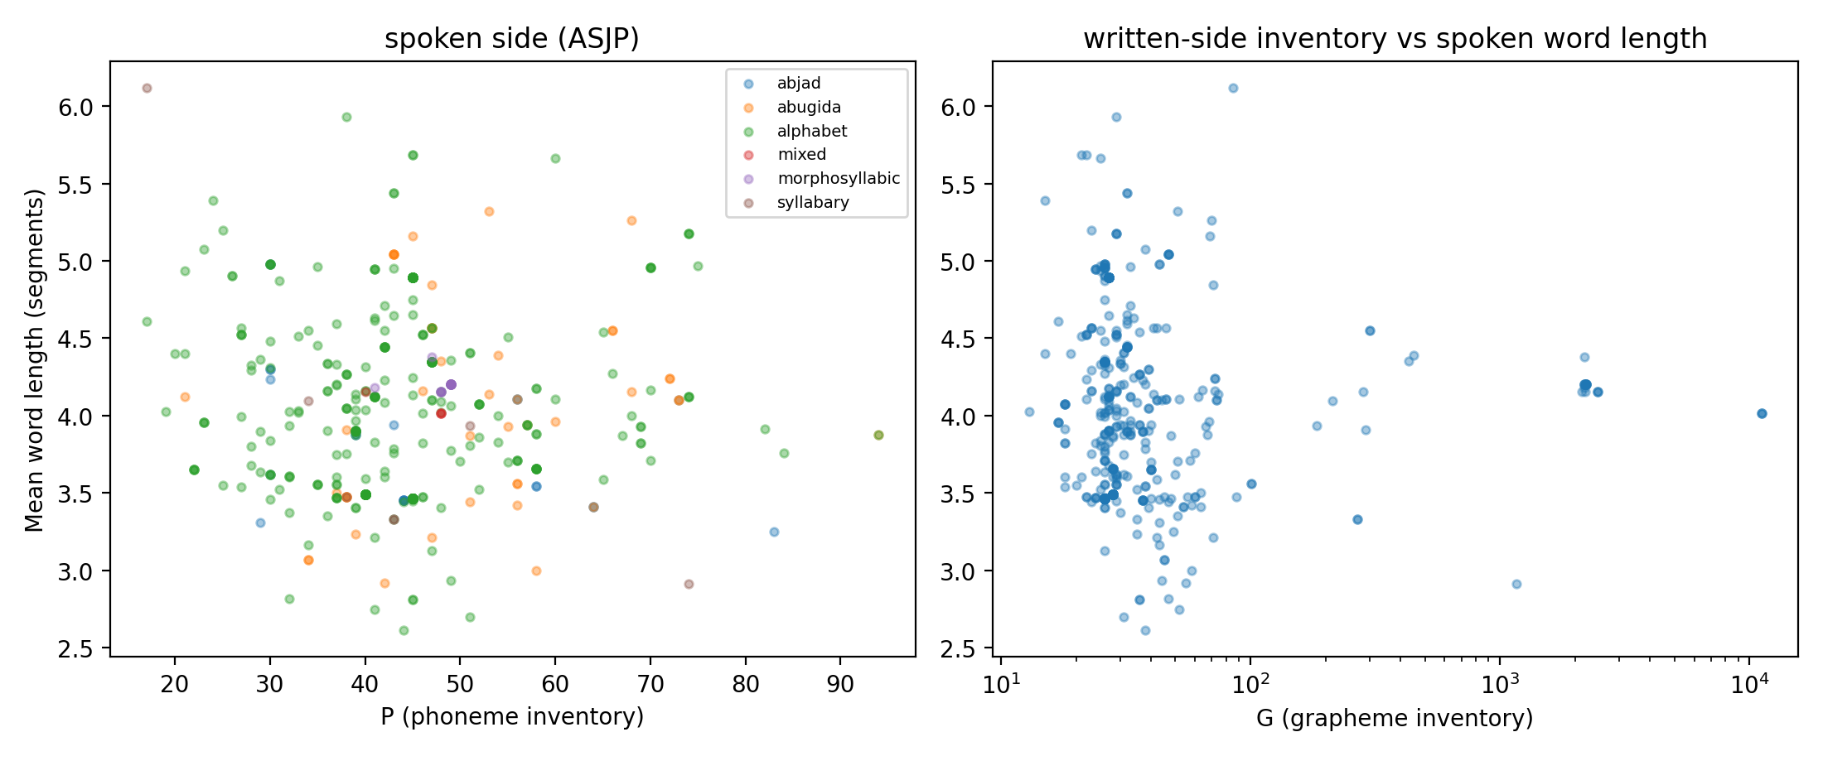
Figure 3. Spoken word length vs P and G (ASJP).
4.5 Inverse inference: granularity is recoverable from observable statistics; architecture labels barely
Two prediction tasks must be kept separate because they differ in what the observer is allowed to know.
Task 1 — granularity inference (the inverse problem proper). Using only directly observable symbol-inventory statistics — G and G_aux, with no phonological information of any kind — a random-forest classifier recovers encoded-unit granularity at macro-F1 = 0.76 under leave-one-family-out cross-validation and 0.64 under leave-one-script-out, against a majority baseline of 0.23 (Table 7). This addresses the inverse problem directly: the scale of the encoded unit leaves a detectable statistical footprint in inventory magnitude even when the underlying phonological inventory is entirely unknown.
Table 7. Inverse inference: macro-F1 under grouped cross-validation.
model | target | macro-F1 | SD
logreg_family | ws_class | 0.71 | 0.36
logreg_script | ws_class | 0.55 | 0.45
rf_family | ws_class | 0.63 | 0.38
rf_script | ws_class | 0.57 | 0.45
stump_G_family | ws_class | 0.71 | 0.35
stump_G_script | ws_class | 0.56 | 0.47
majority_family | ws_class | 0.18 | 0
rf_family | granularity | 0.76 | 0.34
rf_script | granularity | 0.64 | 0.44
majority | granularity | 0.23 | 0

Task 2 — writing-system-class inference (secondary). A richer classifier using additional variables — including the G/P ratio, which presupposes that P is already known — predicts conventional writing-system class at macro-F1 = 0.71 (symbol-statistics feature set, family-grouped). However, a decision stump on G alone reaches 0.71, and adding consonant/vowel counts does not improve on the symbol-only set (0.70 with the fuller feature set). Finer architecture labels therefore carry essentially no recoverable information beyond raw inventory magnitude. The underlying phonological inventory is likewise not recoverable: it is approximately constant across architectures and carries no signal to decode. Label-shuffled controls collapse to baseline by construction.
5. Discussion
The central empirical finding is a decoupling: across 544 language×script pairs, phoneme inventory size varies relatively little across writing-system architectures (median 43–49), while symbol inventory size changes by more than two orders of magnitude with encoded-unit granularity (median 27 → 2210). The naive expectation that phonological channel size determines written-inventory size — strongest for phonographic scripts — is not supported: alphabets show no coupling (ρ = −0.09), the cross-class coupling pattern does not exceed the label-permutation null, and the overall correlation is trivial (ρ = 0.09). The data instead locate inventory variation on the architectural side: what unit the script encodes, and whether its signs are stored or composed.
The architectural interpretation follows from the simulation bounds. A system encoding phonemes needs tens of stored units; one encoding CV frames needs hundreds unless it composes; one encoding morphemes is pushed into the thousands unless it manufactures surface forms from primitives — as Hangul's featural composition and Brahmic diacritic composition do. The weak alphabet coupling is then unsurprising: once a few dozen signs cover the channel, marginal phonemes no longer purchase marginal letters, and orthographies systematically undershoot their phoneme inventories. The stronger abugida coupling has the opposite logic: where the encoded unit is a CV frame, phonological combinatorics (C × V) maps almost mechanically into stored-unit demand, so P variation reaches G through the product of its parts rather than through P itself. The combinatorial-escape hypothesis fails on the spoken side and survives only as a phonological residue on the written surface: the inventory–length trade-off does not route through the letter inventory.
The inverse problem has a structured boundary. Directly observable inventory statistics retain information about the scale of the encoded unit — granularity is recoverable at macro-F1 = 0.76 from G and G_aux alone — but finer architecture labels gain little beyond raw inventory size, and the underlying phonological inventory is not recoverable at all. That boundary is itself the informative answer to the inverse question: an unfamiliar symbolic system's inventory magnitude constrains the likely granularity of its encoded unit, conditional on storage-versus-composition assumptions, but does not reveal the elementary inventory that generated it. Generalized cautiously, a large inventory in an unfamiliar symbolic system should not be read directly as evidence of semantic encoding; it constrains granularity first.
The biophysical framing requires calibration. Human production, perception, visual discrimination, motor execution, and learnability plausibly constrain the number of reusable primitive contrasts [3], [4], but the present analysis does not estimate a universal upper bound on phoneme, grapheme, or sign inventories. What it does show is comparative: phonological inventory size varies little across architectures while graphemic inventory size changes by orders of magnitude with granularity. Biophysical limits are a plausible mechanism, supported by prior literature — the flatness of P and the bounded range of stored primitive inventories are consistent with that account — but they are interpretation, not a quantity estimated here.
Several null results deserve emphasis because they constrain the theory rather than weaken the paper. The naive P–G correlation (ρ = 0.09) that a dependence-naive analysis might have elevated to the main finding is trivial. The spoken-side inventory–length trade-off, a textbook expectation [15], does not generalize to this dataset; only its written-surface residue survives, routed through phonology rather than orthography. And the classifier comparison shows that sophistication buys nothing over a single threshold on G — a warning for inverse-inference work more broadly.
6. Limitations
G is measured by CLDR exemplar counts, which approximate but do not equal curated grapheme inventories; the divergence is largest for Han-derived and compositional scripts, where I rely on curated counts and the functional-inventory sensitivity variable. PHOIBLE's max-per-language convention biases P upward for dialect-rich languages. Granularity coding is ordinal and partly judgment-based; the codebook is released for scrutiny. Granularity-3 cells are thin (n = 7) and the morphosyllabic class is dominated by a few families, so within-class estimates there are descriptive. The stored-unit bound for granularity 4 is a proxy, not a morpheme count. CLDR coverage is itself a selection: unwritten or recently written languages are absent by construction, so the estimand is "systems that became standardized orthographies," not all conceivable systems.
7. Conclusion
Across 544 language×script pairs, phoneme inventory size remains comparatively stable across writing-system architectures, while symbol inventory size changes by more than two orders of magnitude with encoded-unit granularity. The expected P–G coupling is not supported in alphabets and does not survive confirmatory cross-class controls. Inventory scale is better characterized by what linguistic unit the script encodes and whether its signs are stored or composed. Directly observable inventory statistics retain information about encoded-unit granularity but little about the underlying phonological inventory — a boundary that defines both an architectural account of writing-system scale and an empirical limit on inverse inference from unfamiliar symbolic systems.
Declarations
The author declares no competing interests. All analysis code, the script-type codebook, curated data, and reproduction instructions are openly available in the linked repository; primary data are redistributed subject to their sources' licenses (PHOIBLE: CC-BY-SA; Glottolog: CC-BY; CLDR: Unicode license; ASJP: CC-BY).
References
1. Daniels PT. An Exploration of Writing. Sheffield: Equinox; 2018.
2. Sproat R. A Computational Theory of Writing Systems. Cambridge: Cambridge University Press; 2000.
3. Changizi MA, Shimojo S. Character complexity and redundancy in writing systems over human history. Proc R Soc B. 2005;272(1560):267-275.
4. Miton H, Morin O. Graphic complexity in writing systems. Cognition. 2021;214:104771. doi:10.1016/j.cognition.2021.104771
5. Coupe C, Oh YM, Dediu D, Pellegrino F. Different languages, similar encoding efficiency: comparable information rates across the human communicative niche. Sci Adv. 2019;5(9):eaaw2594. doi:10.1126/sciadv.aaw2594
6. Jaeger TF, Graff P, Croft W, Pontillo D. Mixed effect models for genetic and areal dependencies in linguistic typology. Linguist Typol. 2011;15(2):281-319.
7. Bickel B. Typology in the 21st century: major current developments. Linguist Typol. 2007;11(1):239-251.
8. Moran S, McCloy D, editors. PHOIBLE 2.0. Jena: Max Planck Institute for the Science of Human History; 2019. https://phoible.org
9. Moran S, Grossman E, Verkerk A. Investigating diachronic trends in phonological inventories using BDPROTO. Lang Resour Eval. 2021;55(1):79-103. doi:10.1007/s10579-019-09483-3
10. Unicode Consortium. Unicode Common Locale Data Repository (CLDR), version 46.1; 2024. https://cldr.unicode.org
11. Hammarstrom H, Forkel R, Haspelmath M, Bank S. Glottolog 5.0. Leipzig: Max Planck Institute for Evolutionary Anthropology; 2024. https://glottolog.org
12. Wichmann S, Holman EW, Brown CH. The ASJP Database (version 20). 2022. https://asjp.clld.org
13. Speer R. rspeer/wordfreq: v3.0 [software]. Zenodo; 2022. https://doi.org/10.5281/zenodo.7199437
14. Maddieson I. Patterns of Sounds. Cambridge: Cambridge University Press; 1984.
15. Fenk-Oczlon G, Fenk A. Complexity trade-offs between the subsystems of language. In: Miestamo M, Sinnemaki K, Karlsson F, editors. Language Complexity. Amsterdam: Benjamins; 2008. p. 43-65.

