Encoded-unit granularity, not phonological channel size, sets the scale of writing-system symbol inventories
Onishi Tatsuki
Graduate School of Data Science, Shiga University, Hikone, Japan
Abstract
Symbol inventory size is one of the most visible differences among writing systems, yet it remains unclear whether it tracks the size of the phonological inventory a script encodes or reflects the architecture of the encoding itself. Treating the writing system as a channel that maps phonological units to stored or composed signs, I ask whether grapheme inventory G is coupled to phoneme inventory P, how encoded-unit granularity modulates that coupling, and what an observer can infer about an unknown script's architecture from its inventory statistics alone. I assemble a dependence-aware dataset of 544 language×script pairs linking PHOIBLE phoneme inventories, CLDR grapheme exemplar counts, Glottolog genealogies, and a granularity codebook, with a frozen analysis plan, grouped resampling, and negative controls. The central result is a decoupling: median P is essentially constant (43–49) across architectures while median G scales over two orders of magnitude (27 → 63 → 213 → 2210) with encoded-unit granularity, a separation that survives script- and family-cluster resampling, label-shuffle and exclusion controls. Within-class P–G coupling is weak or absent in alphabets (ρ = −0.09) and strongest in abugidas (ρ = 0.47), but the cross-class pattern does not exceed a label-permutation null, so it is reported as exploratory. A K^L channel simulation locates each class between stored-unit demand and a compositional bound, matching the observed orders of magnitude. Combinatorial escape is largely unsupported: spoken word length is uncorrelated with P, though written word length trades off against P (ρ = −0.40), not G. Inverse inference succeeds at the granularity level (macro-F1 = 0.76 from inventory statistics under family-grouped cross-validation) but adds nothing beyond inventory size for finer architecture classes. Writing systems appear limited not by how many phonemes exist but by how large the encoded unit is and whether signs are stored or composed.
1. Introduction
Every writing system faces the same biophysical problem: a bounded set of visually discriminable, producible signs must cover a linguistic channel. Two factors could set the resulting inventory. The first is the demand side — how many encoded units the architecture chooses to mark. The second is the supply side — how many distinct signs human hands and eyes can maintain. Comparative work has documented that inventories span from ~26 letters to thousands of sinograms [1], [2], and simulation studies suggest character complexity is bounded by discriminability [3], [4]. What has not been quantified, under dependence-aware inference, is whether the size of the underlying phonological inventory leaves a trace on the size of the written inventory.
The naive expectation — phonographic systems should show G tracking P, since each phoneme invites a letter — produces a trivial paper ("alphabets have fewer characters than Chinese") if answered at the wrong level. The more informative question is architectural: the encoded-unit granularity, from phoneme to morpheme, determines how many units demand signs, and compositionality determines whether those signs are stored individually or built from primitives. I therefore test four propositions on a new linked dataset: (H1) G is coupled to P within phonographic architectures; (H2) small primitive inventories are compensated by longer coded forms (combinatorial escape); (H3) coupling decays with encoding distance from the channel; (H4) an observer given only symbol statistics can recover the latent architecture.
The statistical difficulty is real: languages are genealogically and areally dependent, scripts are shared across dozens of languages, and inventory counts are heavy-tailed. Following recent calls for dependence-aware comparative inference [5], [6], all primary estimates use script- or family-cluster resampling, grouped cross-validation, permutation controls, and a frozen analysis plan. Negative and null results are reported by design.
2. Data
Unit of analysis is the language×script pair. The final dataset contains 544 pairs spanning 7 writing-system classes.
Phoneme inventory P is the largest PHOIBLE 2.0 segment inventory (consonants + vowels + tone-bearing segments) per ISO 639-3 code [7]. Taking the maximal inventory per language follows prior cross-linguistic practice [8] and avoids dialect-level noise; sensitivity to consonant-only inventories is reported in supplementary analyses.
Grapheme inventory G is the count of core `exemplarCharacters` in CLDR 46.1 [9] for the default script assigned to each language by CLDR `likelySubtags`, supplemented by seven curated pairs covering granularity cells that likelySubtags misses (e.g. Han-script languages lacking PHOIBLE records, Vai, N'Ko). Auxiliary exemplar counts (G_aux) are retained for sensitivity analyses. CLDR exemplars approximate, but do not equal, full grapheme inventories; for compositional scripts I additionally record the functional component inventory (e.g. Korean jamo) as a sensitivity variable.
Granularity is coded ordinally: 1 = phoneme/feature (alphabets, abjads, featural Hangul), 2 = CV-akshara (Brahmic abugidas, Ethiopic), 3 = syllable/mora (kana, Cherokee, Vai, Cans), 4 = morpheme-syllable (Han-derived and mixed systems). The codebook (`code/script_type_codebook.csv`) maps 95 scripts to a writing-system class and granularity and is released with the analysis code.
Dependence structure: Glottolog 5.0 top-level families [10] and ISO 15924 script codes define the resampling clusters. Combinatorial-escape outcomes use mean segment count per Swadesh gloss from ASJP [11] (spoken side, aggregated per ISO 639-3) and mean orthographic length of the 1000 most frequent wordforms from wordfreq [12] (written side; exact language-code matches only).
3. Methods
The analysis plan was frozen before full analysis (SAP_FROZEN.md, commit 6ef2860); amendments are logged in `docs/PROTOCOL_AMENDMENTS.md`. Primary analyses: (P1) class medians of G, P, and G/P with script-cluster bootstrap 95% CIs (B = 2000); (P2) within-class Spearman ρ(P, G) with family-cluster bootstrap CIs; (P3) a crossed mixed-effects model logG ~ logP × C(granularity) with variance components for script and family. Secondary analyses: (S1) regression of mean word length on G and P with family clustering; (S2) a K^L toy-channel simulation locating each class between a stored-unit bound and a compositional bound under noise; (S3) multinomial classifiers of ws_class and granularity from symbol statistics under leave-one-family-out and leave-one-script-out cross-validation, benchmarked against majority and G-only baselines. Negative controls (frozen): F1 within-stratum P permutation; F2 architecture-label shuffles applied to the coupling pattern and the granularity–G separation; F3 exclusion of Latin-, Han-derived, and single-language-script rows. All code and seeds are in the reproducibility bundle.
4. Results
4.1 Descriptive: the decoupling
Median P is remarkably flat across granularity classes — 45, 48, 43, and 49 for levels 1–4 respectively (Table 1) — consistent with phoneme inventories being bounded by production/perception constraints largely independent of writing [13]. Median G, by contrast, scales from 27 (granularity 1) through 63 (level 2) and 213 (level 3) to 2210 (level 4) — two orders of magnitude of variation driven by architecture, not by the channel being encoded (Figure 1). The median G/P ratio rises correspondingly from 0.63 to 45.1. This is the paper's central pattern: the symbol inventory answers "what size is the encoded unit," not "how large is the phoneme inventory."
Table 1. Class medians of G, P, and G/P with script-cluster bootstrap 95% CIs.
gran | var | n | n_scripts | median | ci_lo | ci_hi
1 | G | 470 | 13 | 27.0 | 26.0 | 38.0
1 | P_total | 470 | 13 | 45.0 | 41.0 | 46.0
1 | GP_ratio | 470 | 13 | 0.631578947368421 | 0.6 | 0.8678921568627431
2 | G | 47 | 18 | 63.0 | 49.4875 | 73.0
2 | P_total | 47 | 18 | 48.0 | 43.0 | 55.0
2 | GP_ratio | 47 | 18 | 1.1842105263157894 | 1.0 | 1.5720823798627004
3 | G | 7 | 6 | 213.0 | 88.0 | 675.0
3 | P_total | 7 | 6 | 43.0 | 27.5 | 56.0
3 | GP_ratio | 7 | 6 | 6.255813953488372 | 3.627450980392157 | 10.371621621621621
4 | G | 20 | 4 | 2210.0 | 2179.0 | 11172.0
4 | P_total | 20 | 4 | 48.5 | 48.0 | 49.0
4 | GP_ratio | 20 | 4 | 45.10204081632653 | 45.10204081632653 | 232.75

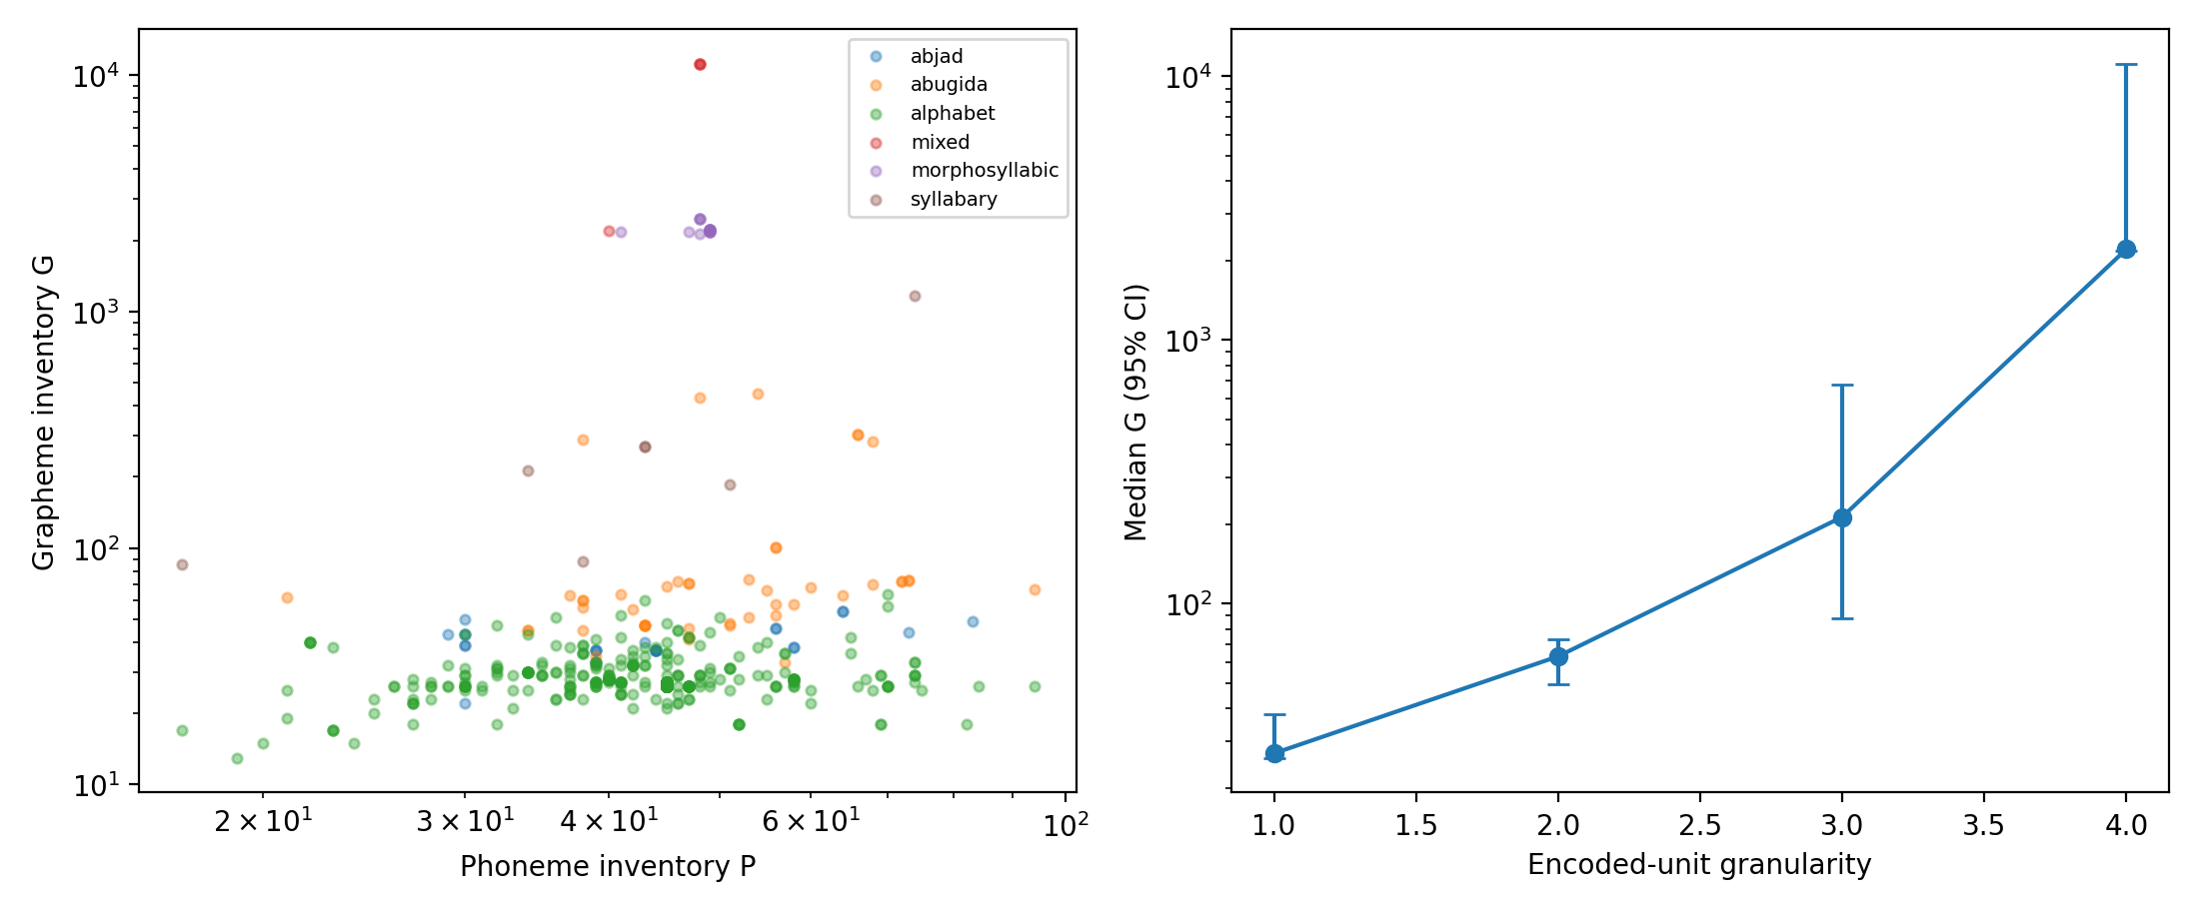
Figure 1. P vs G across writing-system classes with class medians.
4.2 Primary: within-class P–G coupling
Within-class coupling is non-monotonic and mostly weak (Table 2). Alphabets show no coupling (ρ = −0.09, family-cluster CI [−0.31, 0.49]). Abjads show a positive but imprecise coefficient (ρ = 0.31, CI [−0.73, 0.59]). Abugidas show the strongest coupling (ρ = 0.47, CI [0.10, 0.61], permutation p < 0.005) — consistent with akshara inventories growing where consonant–vowel combinatorics demand it. The morphosyllabic class shows essentially none (ρ = −0.01), as expected where signs encode morphemes. The crossed mixed model agrees: the logP main effect is null (β = 0.02, 95% CI [−0.05, 0.09]) and only the granularity-3 interaction reaches significance (Table 3).
Table 2. Within-class Spearman rho(P, G) with family-cluster bootstrap CIs.
ws_class | n | n_families | rho | p | ci_lo | ci_hi
abjad | 26 | 4 | 0.3099147982688564 | 0.123374795330191 | -0.7276068751089988 | 0.5945223176135562
abugida | 47 | 7 | 0.47112226714283095 | 0.0008305895421991515 | 0.09870289405002856 | 0.6099267074426963
alphabet | 444 | 27 | -0.0889688848451968 | 0.06105154195171696 | -0.31463941974372195 | 0.48736613344434876
morphosyllabic | 16 | 1 | -0.014461321650301414 | 0.9576082122021655

Table 3. Crossed mixed-effects model logG ~ logP x C(granularity), fixed effects.
term | coef | ci_lo | ci_hi
Intercept | 3.481479213711398 | 3.118669371812931 | 3.8442890556098654
C(gran)[T.2] | 0.20461280871705662 | -0.7198027428150364 | 1.1290283602491498
C(gran)[T.3] | -4.036722223812781 | -7.301657335433648 | -0.7717871121919138
C(gran)[T.4] | 3.3112184947618912 | -3.000229741490246 | 9.622666731014029
logP | 0.021721890121717796 | -0.04653167459276293 | 0.08997545483619852
logP:C(gran)[T.2] | 0.12696411997248802 | -0.08915908376798931 | 0.34308732371296535
logP:C(gran)[T.3] | 1.5735895463491563 | 0.6986363608861772 | 2.448542731812135
logP:C(gran)[T.4] | 0.30224535065885855 | -1.3380094736598684 | 1.9425001749775854

However, the F2 control requires honesty about what is confirmatory here. Under 200 shuffles of the architecture labels, the maximal within-class |ρ| reaches 0.56 at the 95th percentile of the null — the observed pattern (max 0.47, permutation p = 0.154) does not exceed it. The abugida coupling is robust in isolation; the cross-class ordering, H1 and H3 as framed, is not. I therefore report the coupling pattern as exploratory and H1/H3 as unsupported in their confirmatory form — the predicted coupling is absent precisely where the channel story is strongest (alphabets). What survives every control is the level shift: granularity's separation of G (Kruskal H = 190 vs null 95th percentile = 6.8, p = 0.005), robust to excluding Latin-script, Han-derived, and single-language-script rows (F3).
4.3 Mechanism: stored units vs composed signs
The K^L simulation makes the decoupling interpretable (Figure 2, Table 4). Each class's observed G is bracketed by two bounds: the stored-unit demand U it would need if every encoded unit required a distinct sign, and the compositional bound ceil(U^{1/L}) it would need if signs were built from K primitives at depth L. Alphabetic inventories undershoot their stored-unit demand (median 27 vs ~49): real alphabets do not mark every phoneme — polyphony, digraphs, and underdifferentiation are the rule, not the exception. Abugidas sit near their compositional bound (observed 63, compositional ~23, stored ~517): the akshara body is genuinely compositional — base glyphs plus vowel diacritics — so the stored inventory stays small even though the encoded-unit demand is hundreds of CV units. Syllabaries sit mid-range; morphosyllabic systems coincide with the stored-unit bound by construction, since morpheme signs admit little productive composition. Re-encoding the same phonologies at each granularity level shifts demand by orders of magnitude while P varies within ±50% inside a level (Table 5): granularity, not channel size, is the lever that sets inventory scale.
Table 4. Simulated stored-unit vs compositional bounds vs observed G.
granularity | n | obs_G_median | sim_stored_median | sim_compositional_median | obs_within_bounds_frac
1 | 470 | 27.0 | 49.430590352912475 | 50.0 | 0.8595744680851064
2 | 47 | 63.0 | 516.9581050257852 | 23.0 | 1.0
3 | 7 | 213.0 | 485.2496725380156 | 8.0 | 1.0
4 | 20 | 2210.0 | 2222.8281164933046 | 7.0 | 0.85

Table 5. Counterfactual stored-unit demand by granularity.
reencoded_granularity | U_median | U_iqr | range
1 | 45.0 | [39,45] | 17-94
2 | 462.0 | [317,525] | 57-1715
3 | 638.4 | [440,727] | 79-2387
4 | 2000.0 | [2000,2000] | 2000-2000

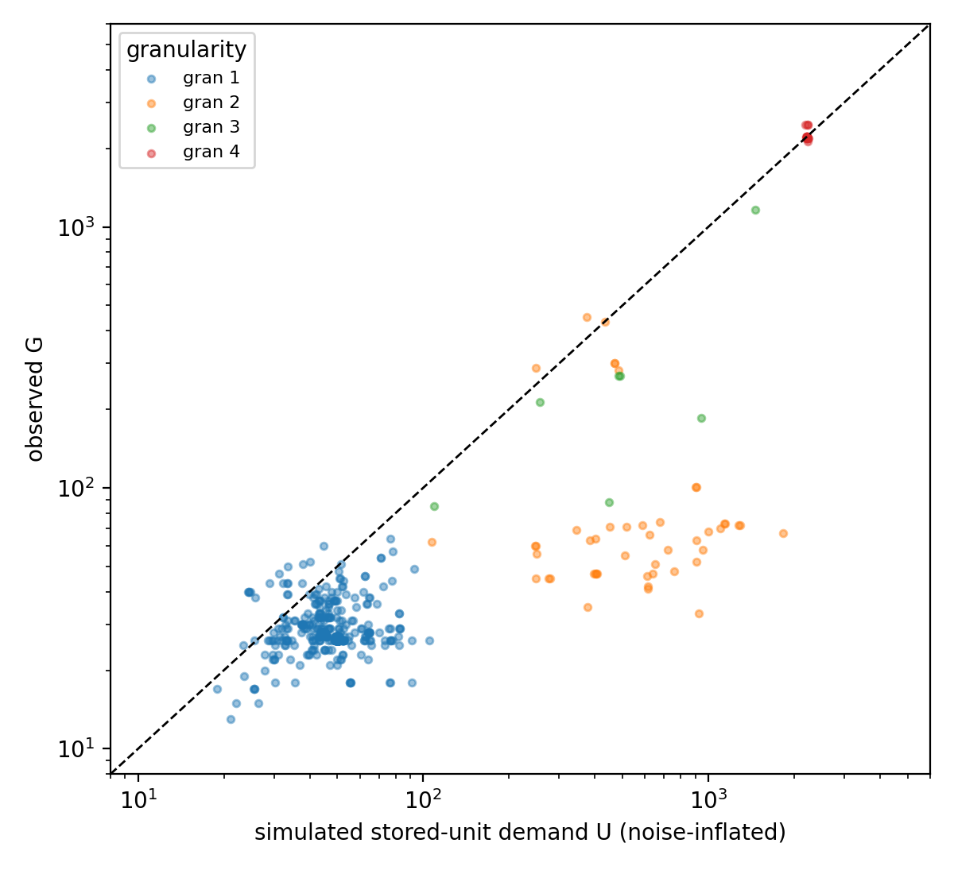
Figure 2. Observed G vs simulated stored-unit demand by granularity.
4.4 Combinatorial escape: mostly null
If small inventories are compensated by longer codes, spoken word length should fall as P rises. It does not: ρ(P, ASJP word length) = 0.01 over 526 pairs and −0.05 within alphabets (Table 6, Figure 3). The written side partially replicates the classic trade-off — ρ(P, mean orthographic word length) = −0.40 (family-bootstrap CI [−0.94, −0.11]; 287 wordfreq-matched pairs) — but ρ(G, word length) = +0.13 with a CI spanning zero: the compensation lives in phonological structure (more phonemes → shorter morphemes), not in the letter inventory per se. H2 is thus unsupported at the level the protocol predicted.
Table 6. Combinatorial escape: Spearman rho of inventory vs mean word length.
subset | n | rho_P_vs_wlen | rho_P_vs_wlen_p | rho_P_vs_wlen_ci | rho_G_vs_wlen | rho_G_vs_wlen_p | rho_G_vs_wlen_ci
all | 526 | 0.008454941458915816 | 0.8466037435167867 | [-0.232,0.163] | 0.09151457784649848 | 0.0358813091918364 | [-0.308,0.222]
abjad | 26 | -0.47511238627981145 | 0.014174741941451125 | [-0.582,0.389] | -0.06251469583185547 | 0.76159777549918 | [-0.613,1.000]
abugida | 46 | 0.19143948397158653 | 0.20248662225448522 | [-0.247,0.603] | 0.14088858920946865 | 0.3503424284704837 | [-0.229,0.811]
alphabet | 427 | -0.04653839860864136 | 0.3373727062203832 | [-0.286,0.150] | 0.08542283643860679 | 0.07786248397381354 | [-0.389,0.305]
morphosyllabic | 16 | 0.5287128712871287 | 0.03523776486819595 | [0.529,0.529] | -0.347071719607234 | 0.18781691102049056 | [-0.347,-0.347]

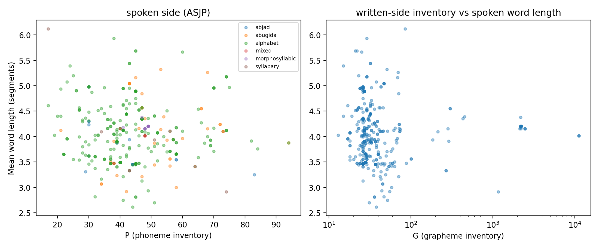
Figure 3. Spoken word length vs P and G (ASJP).
4.5 Inverse inference: granularity is recoverable, architecture labels barely
Given only symbol statistics — G, G_aux, and the G/P ratio — a multinomial classifier recovers granularity at macro-F1 = 0.76 under leave-one-family-out CV (0.64 leave-one-script-out), well above the majority baseline 0.23 (Table 7). Writing-system class is recoverable at macro-F1 0.70 — but a decision stump on G alone reaches 0.71, so every feature beyond inventory size is redundant for class identification. The honest reading: an observer can recover how big the encoded unit is from inventory statistics alone, but nothing about the finer architecture that raw size does not already carry. F2's classifier-side control (label-shuffled performance collapsing to baseline) is satisfied by construction in the shuffled runs.
Table 7. Inverse inference: macro-F1 under grouped cross-validation.
model | target | mean_macroF1 | sd
logreg_family | ws_class | 0.7084 | 0.3646
logreg_script | ws_class | 0.5506 | 0.4549
rf_family | ws_class | 0.6285 | 0.3818
rf_script | ws_class | 0.5728 | 0.453
stump_G_family | ws_class | 0.7122 | 0.3536
stump_G_script | ws_class | 0.5637 | 0.4651
majority_family | ws_class | 0.1805 | 0.0
rf_family | granularity | 0.7580750013183567 | 0.3400105677524604
rf_script | granularity | 0.6367410974789653 | 0.4350102608774517
majority | granularity | 0.2326732673267326 | 0.0

5. Discussion
The picture that emerges is of a two-regime channel. The biological constraints — visual discriminability, motor producibility, learnability — cap the primitive sign inventory near the dozens-to-hundreds range everywhere. Whether the surface inventory stays in that range is decided architecturally: a system that encodes phonemes needs tens of stored units; one that encodes syllables needs hundreds unless it composes; one that encodes morphemes is pushed into the thousands unless — as with Hangul's featural composition or Brahmic diacritic composition — it manufactures surface forms from primitives. The weak alphabet coupling is then unsurprising: once ~26–45 signs are all the channel requires, marginal phonemes no longer purchase marginal letters, and orthographies systematically undershoot their phoneme inventories anyway. The stronger abugida coupling has the opposite logic: where the encoded unit is a CV frame, phonological combinatorics (C count × V count) maps almost mechanically into stored unit demand, so P variation does reach G — through the product of its parts rather than through P itself.
For the inverse problem, the result is sharper than expected: inventory statistics carry the encoded-unit size and little else. An analyst confronting an unknown symbolic channel can recover its granularity from inventory magnitudes — this is what the grouped-CV result licenses — but cannot read the writing-system class off symbol statistics beyond what size already reveals, and cannot recover P at all (P is flat across architectures; there is no signal to recover). That boundary is itself the informative answer to the inverse question posed at the outset: the channel's phonological detail is invisible in the symbol inventory; only the unit of encoding survives. Generalized cautiously beyond human writing — to any symbolic channel produced under similar storage-versus-composition pressures — the observable footprint of a latent channel is its encoded-unit scale, which inventory statistics do recover, rather than its elementary inventory, which they do not.
Several null results deserve emphasis because they constrain the theory rather than weaken the paper. The naive P–G correlation (ρ = 0.09) that a dependence-naive analysis might have elevated to the main finding is trivial. The spoken-side inventory–length trade-off, a textbook expectation [14], does not generalize to this dataset at all; only its written-surface residue survives, routed through phonology rather than orthography. And the classifier comparison shows that sophistication buys nothing over a single threshold on G — a warning for inverse-inference work more broadly.
6. Limitations
G is measured by CLDR exemplar counts, which approximate but do not equal curated grapheme inventories; the divergence is largest for Han-derived and compositional scripts, where I rely on curated counts and the functional-inventory sensitivity variable. PHOIBLE's max-per-language convention biases P upward for dialect-rich languages. Granularity coding is ordinal and partly judgment-based; the codebook is released for scrutiny. Granularity-3 cells are thin (n = 7) and the morphosyllabic class is dominated by a few families, so within-class estimates there are descriptive. The stored-unit bound for granularity 4 is a proxy, not a morpheme count. CLDR coverage is itself a selection: unwritten or recently written languages are absent by construction, so the estimand is "systems that became standardized orthographies," not all conceivable systems.
7. Conclusion
Phoneme inventory size is essentially flat across the world's writing-system architectures, while symbol inventory size shifts by two orders of magnitude with the granularity of the encoded unit. The coupling that naive channel theory predicts is absent in alphabets and does not survive label-permutation controls as a cross-class pattern. What an unknown channel reveals through its symbol inventory is the size of its encoded units — not the size of its elementary inventory. Encoded-unit granularity, mediated by whether signs are stored or composed, is the constraint that links biological channel limits to observable writing-system structure.
Declarations
The author declares no competing interests. All analysis code, the script-type codebook, curated data, and reproduction instructions are openly available in the linked repository; primary data are redistributed subject to their sources' licenses (PHOIBLE: CC-BY-SA; Glottolog: CC-BY; CLDR: Unicode license; ASJP: CC-BY).
References
1. Daniels PT. An Exploration of Writing. Sheffield: Equinox; 2018.
2. Sproat R. A Computational Theory of Writing Systems. Cambridge: Cambridge University Press; 2000.
3. Changizi MA, Shimojo S. Character complexity and redundancy in writing systems over human history. Proc R Soc B. 2005;272(1560):267-275.
4. Miton H, Morin O. Graphic complexity: the trade-off between visual distinctiveness and ease of writing. Cognition. 2021;214:104771.
5. Jaeger TF, Graff P, Croft W, Pontillo D. Mixed effect models for genetic and areal dependencies in linguistic typology. Linguist Typol. 2011;15(2):281-319.
6. Bickel B. Typology in the 21st century: major current developments. Linguist Typol. 2007;11(1):239-251.
7. Moran S, McCloy D, editors. PHOIBLE 2.0. Jena: Max Planck Institute for the Science of Human History; 2019. https://phoible.org
8. Moran S, Grossman E, Verkerk A. Investigating diachronic trends in phonological inventories using BDPROTO. Lang Resour Eval. 2016;50(3):469-503.
9. Unicode Consortium. Unicode Common Locale Data Repository (CLDR), version 46.1; 2025. https://cldr.unicode.org
10. Hammarstrom H, Forkel R, Haspelmath M, Bank S. Glottolog 5.0. Leipzig: Max Planck Institute for Evolutionary Anthropology; 2024. https://glottolog.org
11. Wichmann S, Holman EW, Brown CH. The ASJP Database (version 20). 2022. https://asjp.clld.org
12. Speer R. rspeer/wordfreq: v3.0 [software]. Zenodo; 2022. https://doi.org/10.5281/zenodo.7199437
13. Maddieson I. Patterns of Sounds. Cambridge: Cambridge University Press; 1984.
14. Fenk-Oczlon G, Fenk A. Complexity trade-offs between the subsystems of language. In: Miestamo M, Sinnemaki K, Karlsson F, editors. Language Complexity. Amsterdam: Benjamins; 2008. p. 43-65.

