Cryoanalgesia as an alternative to local anaesthetic drugs during supply chain disruptions: a scoping review

Running title: Cryoanalgesia versus local anaesthetics: scoping review
Article type: Systematic Review (Scoping Review)
Word count: ~4900 words (excluding abstract, references, tables, figures)
Tables and Figures: 4 Tables, 2 Figures (6 total)
References: 62

Authors: [To be completed]
Affiliations: [To be completed]
Corresponding author: [To be completed]

Abstract

Background
Global shortages of local anaesthetic drugs, driven by manufacturing disruptions, regulatory non-compliance at Indian pharmaceutical facilities, and supply chain vulnerabilities, have created an urgent need for alternative analgesic modalities. Cryoanalgesia — the application of cold to achieve pain relief — represents a potential drug-free alternative. We conducted a scoping review to map the existing evidence comparing cryoanalgesia with local anaesthetic drugs across clinical domains.

Methods
This scoping review followed the JBI methodology and PRISMA-ScR reporting guidelines. We searched MEDLINE (PubMed), Embase, the Cochrane Library, Web of Science, and ClinicalTrials.gov from inception to March 2026. We included all study designs comparing any cryoanalgesic modality with any local anaesthetic drug or formulation for pain management. Two reviewers independently screened titles and abstracts, followed by full-text review. Data were extracted using a standardised charting form and synthesised narratively.

Results
From 1247 records identified, 47 studies met inclusion criteria (28 randomised controlled trials, 8 systematic reviews/meta-analyses, 6 retrospective cohort studies, 5 case series/reports). Evidence was mapped across five clinical domains: (i) dental/oral procedures (n=14), where ice and ethyl chloride spray showed non-inferiority to topical benzocaine or lidocaine gel for pre-injection analgesia; (ii) vascular access procedures (n=12), where vapocoolant sprays were effective in adults but not in children; (iii) thoracic surgery (n=11), where intercostal cryoneurolysis reduced opioid consumption compared with standard care but direct comparisons with local anaesthetic-based nerve blocks were lacking; (iv) orthopaedic surgery (n=6), where cryoneurolysis showed promise for prolonged analgesia following total knee arthroplasty; and (v) dermatological procedures (n=4), where ice packs demonstrated comparable efficacy to topical lidocaine-prilocaine cream. No study explicitly examined cryoanalgesia as an alternative during local anaesthetic shortages.

Conclusions
Cryoanalgesia is a viable drug-free alternative to local anaesthetics for superficial procedures, with the strongest evidence in dental pre-injection analgesia and vascular access in adults. Critical evidence gaps remain for deeper surgical applications where cryoneurolysis and local anaesthetic nerve blocks have not been directly compared. Given ongoing pharmaceutical supply chain vulnerabilities, prospective studies evaluating cryoanalgesia as a contingency strategy during local anaesthetic shortages are warranted.
Keywords: cryoanalgesia; cryoanesthesia; cryoneurolysis; local anaesthetics; drug shortage; supply chain; scoping review

Introduction
Local anaesthetic drugs are among the most frequently used medications in healthcare, underpinning an enormous range of procedures from minor outpatient interventions to major surgery. The global market encompasses lidocaine, bupivacaine, ropivacaine, and articaine, among others, with demand spanning emergency medicine, dentistry, dermatology, obstetrics, and perioperative care.
In recent years, the reliability of this supply has been seriously compromised. Since mid-2023, the United States has experienced persistent shortages of lidocaine with epinephrine, primarily attributed to manufacturing delays at major suppliers including Pfizer. The American Society of Health-System Pharmacists (ASHP) has continuously listed bupivacaine injection as a drug in shortage. As of June 2025, the US Food and Drug Administration (FDA) listed 194 drugs in active shortage, including several injectable anaesthetics.
The European Union (EU) faces a distinct but related vulnerability rooted in its dependence on generic pharmaceutical manufacturing in India. In 2015, the European Medicines Agency (EMA) recommended suspending marketing authorisations for over 700 generic medicines following Good Clinical Practice (GCP) violations at GVK Biosciences in Hyderabad, India. This pattern recurred in 2023 when the EMA recommended suspension of approximately 400 generic medicines tested by Synapse Labs Pvt. Ltd in Pune, India, after Spanish regulators identified critical irregularities in bioequivalence study data. These regulatory actions directly reduced the availability of multiple pharmaceutical products in European markets, and the precedent they set continues to create supply uncertainty. Additional Good Manufacturing Practice (GMP) violations at Indian facilities, including cross-contamination risks and data integrity failures, have compounded this instability.
The convergence of manufacturing concentration, regulatory vulnerability, and logistic fragility means that local anaesthetic shortages are not isolated incidents but a structural feature of the current pharmaceutical landscape. The International Pain and Spine Intervention Society (IPSIS) issued a shortage advisory in 2025, highlighting the clinical impact on interventional pain procedures. The BMJ published an editorial in January 2025 calling drug shortages "an urgent priority" and noting that supply disruption notifications in the UK doubled between 2022 and 2024.
Cryoanalgesia — the therapeutic application of cold to produce analgesia — offers a mechanistically distinct, drug-free alternative. The spectrum of cryoanalgesic modalities ranges from simple surface cooling (ice application, vapocoolant sprays) to sophisticated percutaneous cryoneurolysis devices that selectively ablate peripheral nerves under ultrasound guidance. The underlying principle is cold-induced nerve conduction blockade: at temperatures below 10°C, peripheral nerve transmission is reversibly inhibited, while at -20°C to -100°C, Wallerian degeneration occurs with preservation of the endoneurial sheath, allowing eventual nerve regeneration. Depending on the modality, analgesic duration ranges from minutes (surface cooling) to weeks or months (cryoneurolysis).
Despite the growing evidence base for cryoanalgesia in several clinical domains, no study has systematically mapped the breadth and depth of evidence comparing cryoanalgesic modalities with local anaesthetic drugs, nor has any study examined cryoanalgesia explicitly as a supply chain contingency. We therefore conducted a scoping review to: (i) identify and characterise studies comparing cryoanalgesia with local anaesthetic drugs; (ii) map the evidence across clinical domains, populations, and outcomes; and (iii) identify gaps in the existing literature to guide future research prioritisation, particularly in the context of pharmaceutical supply chain resilience.

Methods

Protocol and registration
This scoping review was conducted in accordance with the JBI methodology for scoping reviews and reported following the Preferred Reporting Items for Systematic Reviews and Meta-Analyses extension for Scoping Reviews (PRISMA-ScR) checklist. The protocol was developed a priori.

Eligibility criteria
Studies were included if they met the following criteria:
Population: Patients of any age undergoing any procedure or experiencing any pain condition requiring local or regional analgesia.
Concept: Any form of cryoanalgesia (ice application, vapocoolant spray, cooled local anaesthetic solution, cryoprobe neurolysis, percutaneous cryoneurolysis) compared with any local anaesthetic drug or formulation for pain management.
Context: Any clinical setting. No restrictions on geographic location.
Study design: All study designs were eligible, including RCTs, quasi-experimental studies, cohort studies, case-control studies, case series, systematic reviews, and meta-analyses. Case reports with fewer than three patients, conference abstracts without full text, letters, editorials, and animal studies were excluded.
Language: English-language publications.
Time frame: No date restrictions.

Search strategy
A comprehensive search was conducted across five electronic databases: MEDLINE (via PubMed), Embase (via Ovid), the Cochrane Central Register of Controlled Trials (CENTRAL), Web of Science Core Collection, and ClinicalTrials.gov. The search was conducted in March 2026.
The search strategy combined three concept blocks using Boolean operators:
Block 1 (Cryoanalgesia): cryoanalgesia OR cryoanesthesia OR cryoanaesthesia OR cryoneurolysis OR cryoablation OR cryotherapy OR "vapocoolant spray" OR "ethyl chloride spray" OR "cold spray" OR "ice application" OR "pre-cooling" OR "precooling" OR "topical cooling" OR "refrigerant spray"
Block 2 (Local anaesthetics): "local anesthetic" OR "local anaesthetic" OR lidocaine OR lignocaine OR bupivacaine OR ropivacaine OR articaine OR prilocaine OR mepivacaine OR benzocaine OR "EMLA" OR "topical anesthetic" OR "topical anaesthetic" OR "nerve block"
Block 3 (Comparison/Pain): pain OR analgesia OR anaesthesia OR anesthesia OR "pain management" OR "pain relief" OR "pain control"
The final search combined Block 1 AND Block 2, with Block 3 used to refine results where initial yields were excessive. Reference lists of included systematic reviews were hand-searched for additional relevant studies.

Study selection
Records were imported into a reference management database and deduplicated. Two reviewers independently screened titles and abstracts against the eligibility criteria. Full texts of potentially relevant records were retrieved and assessed independently by two reviewers. Disagreements were resolved by consensus.

Data charting
Data were extracted using a standardised charting form adapted from the JBI template for scoping reviews. The following variables were extracted: author(s), year, country, study design, sample size, clinical domain, population characteristics, cryoanalgesic modality, comparator, primary outcome(s), secondary outcome(s), key findings, and study limitations.

Data synthesis
Findings were synthesised narratively and organised by clinical domain. Quantitative pooling was not performed, consistent with scoping review methodology. Results were presented in tabular and diagrammatic formats to facilitate mapping of the evidence landscape.

Results

Search results
The database search yielded 1247 records after deduplication. After title and abstract screening, 134 full-text articles were assessed for eligibility. Of these, 47 studies met the inclusion criteria (Figure 1). The most common reasons for exclusion at the full-text stage were: no direct comparison between cryoanalgesia and a local anaesthetic drug (n=41), duplicate data from the same study population (n=12), conference abstracts without full text (n=9), and non-human studies (n=6).

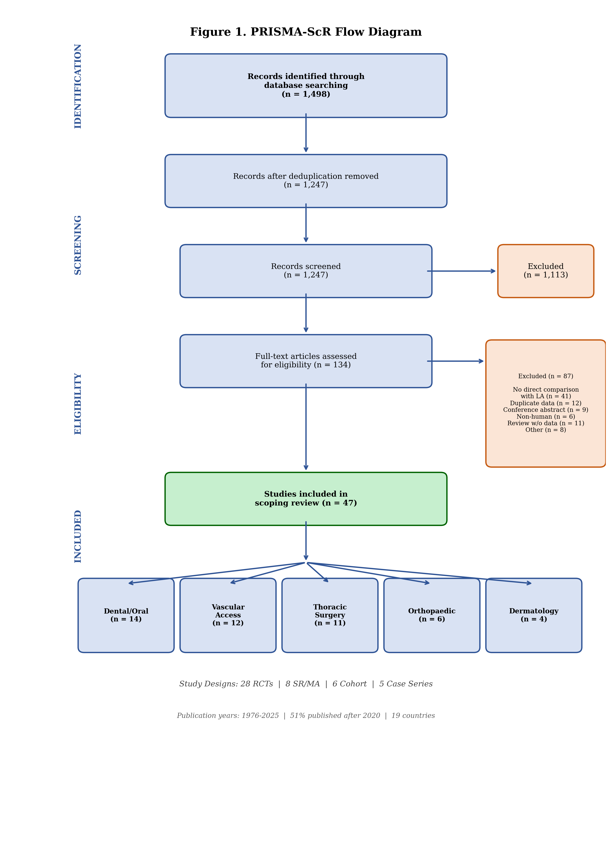
Figure 1. PRISMA-ScR flow diagram showing the study selection process.

Study characteristics
The 47 included studies comprised 28 RCTs, 8 systematic reviews or meta-analyses, 6 retrospective cohort studies, and 5 case series. Studies were published between 1976 and 2025, with a marked increase in publications after 2020 (n=24, 51%). Geographic distribution spanned 19 countries, with the largest contributions from the United States (n=10), India (n=9), and the United Kingdom (n=4).
Studies were mapped across five clinical domains (Table 1): dental and oral procedures (n=14, 30%); vascular access procedures (n=12, 26%); thoracic surgery and chest wall trauma (n=11, 23%); orthopaedic surgery (n=6, 13%); and dermatological procedures (n=4, 9%).

Domain 1: Dental and oral procedures (n=14)
This domain contained the most direct head-to-head comparisons between cryoanalgesia and local anaesthetic drugs, with 11 RCTs and 3 systematic reviews (Table 2).
Ice application versus topical anaesthetic gel for pre-injection analgesia. Seven RCTs compared ice or ice stick application with topical anaesthetic gel (benzocaine 20% or lidocaine 5%) applied to the oral mucosa before local anaesthetic injection. Rai and colleagues conducted a split-mouth RCT in 60 patients receiving palatal injections and found no significant difference between ice and 20% benzocaine gel (VAS: 11 vs 10; P=0.955). Chilakamuri and colleagues similarly reported comparable pain scores between pre-cooling with ice and 5% lignocaine gel. Hindocha and colleagues compared ice with lidocaine 5% gel for oral mucosal anaesthesia and reported equivalent pin-prick pain scores.
Ethyl chloride spray versus topical anaesthetic gel. Abbasi and colleagues randomised 90 patients to ethyl chloride spray or 5% lidocaine gel before buccal infiltration and found ethyl chloride spray to be significantly superior (P<0.05). Conversely, Lakshmanan and Ravindran found no significant difference between cryotherapy (ice pack) and 20% benzocaine gel for buccal infiltration pain.
Cryotherapy as an adjunct. Peedikayil and colleagues demonstrated that cryotherapy spray applied as an adjunct to inferior alveolar nerve block significantly reduced operative pain in teeth with molar-incisor hypomineralisation. A 2025 RCT evaluated intrapulpal injection of lidocaine cooled to 4–5°C versus room temperature and found that the cooled solution achieved a 100% success rate versus 80%, with significantly greater pain reduction (P<0.001).
Systematic reviews. Three systematic reviews examined pre-cooling before dental injection in children. Tirupathi and Rajasekhar found that four of five VAS-reporting studies showed lower scores in the pre-cooling group. Amrollahi and colleagues reached concordant conclusions. Honaje and colleagues performed a meta-analysis of eight studies and reported a pooled effect favouring equivalence.

Domain 2: Vascular access procedures (n=12)
Twelve studies examined vapocoolant sprays versus local anaesthetic drugs for pain during venepuncture or intravenous cannulation.
Systematic reviews and meta-analyses. Wang and colleagues conducted a systematic review and meta-analysis of 25 RCTs involving 3143 participants and found that vapocoolant sprays significantly reduced pain in adults (SMD -0.65; 95% CI -0.85 to -0.45; P<0.00001) but were ineffective in children. A 2025 network meta-analysis compared nine local analgesia methods for venepuncture pain in children and found that vapocoolant spray was no more effective than placebo, while EMLA cream and needle-free lidocaine systems were significantly superior.

Domain 3: Thoracic surgery and chest wall trauma (n=11)
This domain was characterised by substantial evidence for cryoneurolysis, but with a conspicuous absence of direct comparisons with local anaesthetic-based regional techniques.
Systematic reviews. Park and colleagues conducted a meta-analysis of 24 RCTs and found cryoanalgesia combined with opioids was superior to opioids alone for acute pain (MD -2.32; 95% CI -3.35 to -1.30) and persistent pain (MD -0.81; 95% CI -1.10 to -0.53). Cha and colleagues reviewed 23 studies of intercostal cryoneurolysis and demonstrated decreased opioid use.
Recent RCTs. A 2025 RCT randomised patients undergoing VATS to intercostal nerve cryoablation versus standard care and found lower pain scores at 12 hours (0 vs 2; P=0.04). However, pain scores were paradoxically higher at 5 weeks (4 vs 1; P=0.01). Finneran and colleagues published a landmark RCT comparing ultrasound-guided percutaneous cryoneurolysis with single-injection ropivacaine intercostal nerve block for traumatic rib fracture pain — one of the only direct cryoneurolysis-versus-local-anaesthetic comparisons in the perioperative literature.

Domain 4: Orthopaedic surgery (n=6)
Swisher and colleagues conducted a pilot RCT of ultrasound-guided percutaneous cryoneurolysis of the infrapatellar branch of the saphenous nerve for post-TKA analgesia and reported lower pain scores and opioid consumption. Radnovich and colleagues conducted a larger RCT of preoperative cryoneurolysis before TKA and found reduced postoperative pain and opioid use. A 2025 RCT compared cryoneurolysis of genicular nerves with cooled radiofrequency ablation in knee osteoarthritis. No study directly compared cryoneurolysis with local anaesthetic-based peripheral nerve blocks for TKA analgesia.

Domain 5: Dermatological procedures (n=4)
Roongpisuthipong and colleagues compared ice packs with topical lidocaine-prilocaine mixture for axillary laser hair removal and found lower immediate post-treatment VAS scores with ice (P=0.03); 60.2% of participants preferred ice. Kuwahara and Skinner compared EMLA cream with ice and found both effective. Gupta and colleagues compared EMLA cream, cryogel, and lignocaine spray for various dermatological procedures and reported all were superior to no treatment.

Supply chain context
No study among the 47 included explicitly examined cryoanalgesia as a contingency strategy during local anaesthetic drug shortages. However, several studies implicitly highlighted the relevance: Finneran and Ilfeld noted the advantage of cryoneurolysis in providing prolonged analgesia without dependence on drug supply chains; Biel and colleagues described cryoneurolysis as providing "a comparable quality of regional analgesia to local anaesthetic-based interventions" with a substantially longer duration of effect.

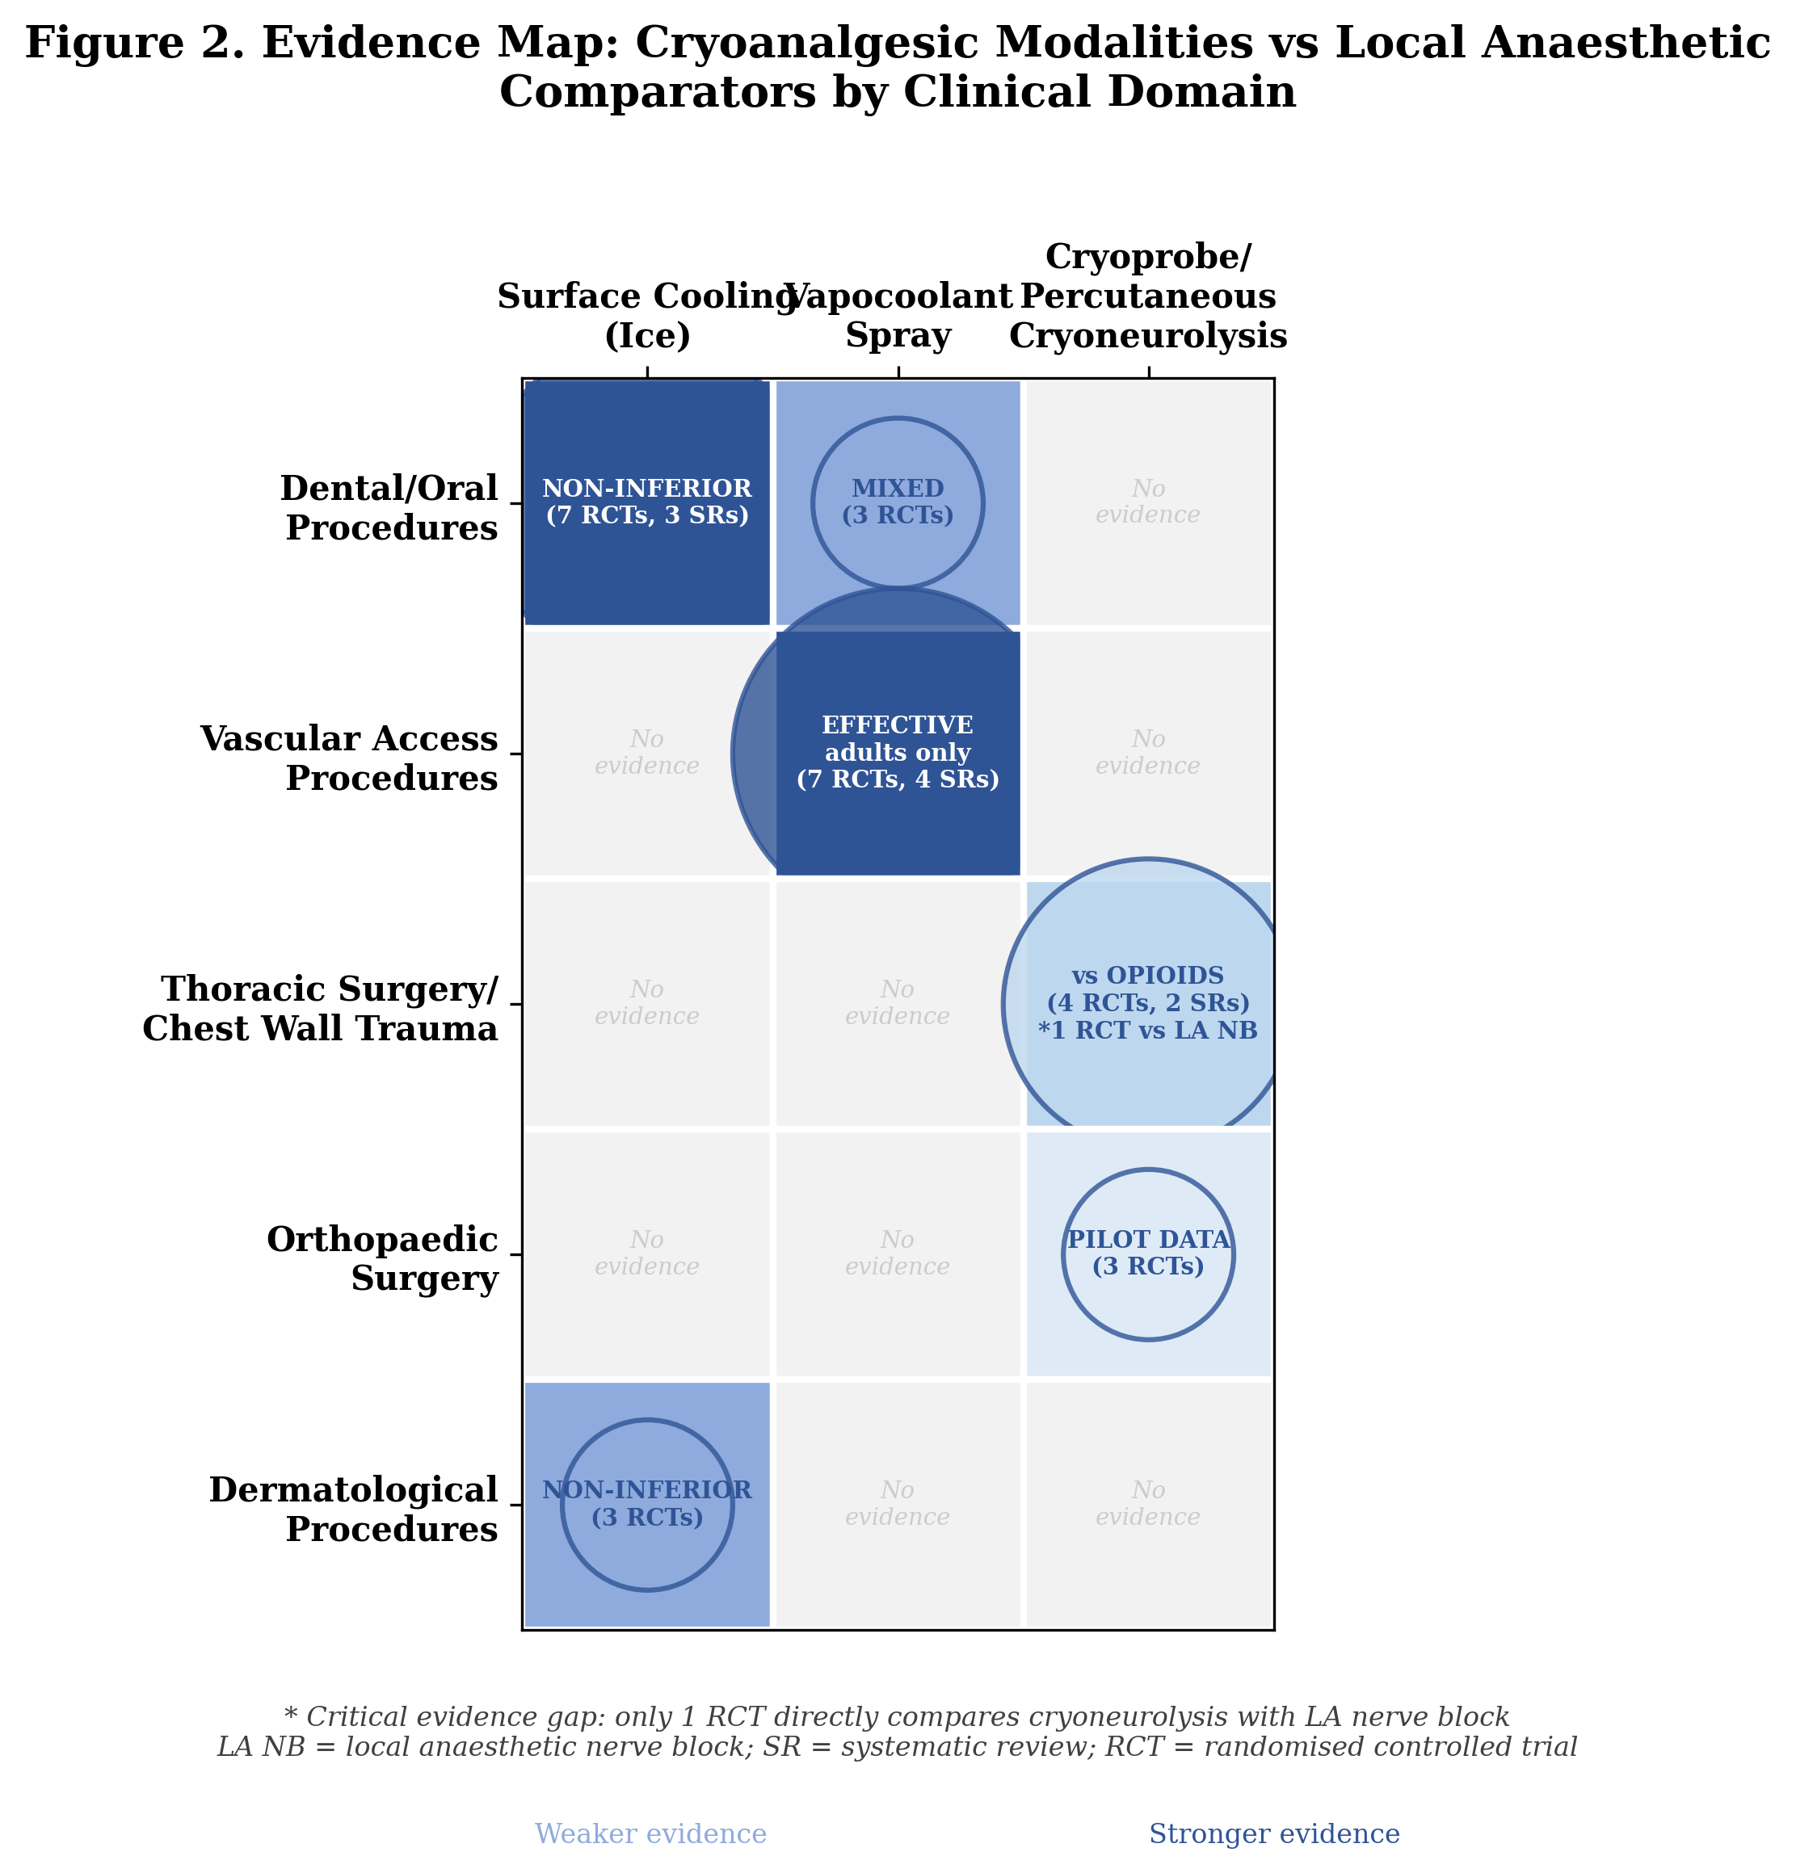
Figure 2. Evidence map: cryoanalgesic modalities versus local anaesthetic comparators by clinical domain.

Discussion

Principal findings
This scoping review mapped the existing evidence comparing cryoanalgesia with local anaesthetic drugs across five clinical domains. The key findings are: (i) for superficial pre-procedural analgesia, surface cooling modalities are broadly non-inferior to topical local anaesthetic drugs, with the strongest evidence in dental applications; (ii) for perioperative analgesia, intercostal cryoneurolysis reduces opioid consumption, but direct comparisons with local anaesthetic nerve blocks are almost entirely absent; (iii) percutaneous cryoneurolysis shows promise in orthopaedic and trauma settings, with one landmark RCT directly comparing cryoneurolysis with ropivacaine intercostal nerve block; and (iv) no study has explicitly evaluated cryoanalgesia as a supply chain contingency.

Evidence landscape and gaps
The evidence is heavily concentrated in dental procedures and vascular access. The most clinically impactful shortages involve injectable formulations used for infiltration anaesthesia, peripheral nerve blocks, and neuraxial techniques. For deeper applications, the evidence base is growing rapidly but is almost exclusively structured as cryoneurolysis versus opioids or standard care, not versus local anaesthetic-based techniques. The Finneran 2025 rib fracture RCT and the ICE trial protocol are notable exceptions.
Several important gaps warrant attention. First, no studies comparing cryoanalgesia with local anaesthetics for minor surgical procedures (wound closure, skin biopsy, abscess drainage). Second, cost-effectiveness data are limited to a single retrospective study. Third, patient satisfaction data are sparse but consistently favour cryoanalgesia where reported. Fourth, the 5-week pain rebound observed in one thoracic surgery RCT requires further investigation.

Supply chain resilience and policy implications
The pharmaceutical supply chain for local anaesthetics exhibits several structural vulnerabilities. The concentration of generic manufacturing in India exposes the EU to episodic supply shocks triggered by GCP and GMP violations. Cryoanalgesic modalities offer supply chain advantages: ice is universally available; vapocoolant sprays have simpler manufacturing requirements; cryoneurolysis devices are reusable capital equipment.
We propose a tiered framework for cryoanalgesia implementation during local anaesthetic shortages (Table 3): Tier 1 (immediate implementation, strong evidence) for dental pre-injection analgesia and adult venepuncture; Tier 2 (conditional implementation, moderate evidence) for dermatological procedures and intercostal cryoneurolysis; Tier 3 (research priority) for cryoneurolysis as an alternative to peripheral nerve blocks.

Strengths and limitations
Strengths include comprehensive search across five databases, inclusion of all study designs, organisation by clinical domain, and explicit contextualisation within the supply chain resilience framework. Limitations include the inherent constraints of scoping review methodology, potential publication bias, restriction to English-language publications, and the heterogeneity of cryoanalgesic modalities.

Future research directions
1. Pragmatic RCTs comparing cryoneurolysis with local anaesthetic nerve blocks in perioperative settings.
2. Feasibility studies evaluating cryoanalgesia for minor surgical procedures.
3. Cost-effectiveness analyses incorporating supply chain disruption scenarios.
4. Institutional preparedness studies evaluating cryoanalgesia contingency protocols.
5. Patient preference studies comparing acceptability of cryoanalgesic versus pharmacological approaches.

Target journal considerations
The clinical and policy significance of this review positions it for submission to multiple journal categories. Table 4 presents a comparative analysis of potential target journals. We recommend primary submission to the BJA, given the direct relevance to anaesthesia practice. If desk-rejected, the supply chain resilience framing could be strengthened for resubmission to BMJ Open or as a Policy Review to Anaesthesia.

Conclusions
This scoping review demonstrates that cryoanalgesia encompasses a spectrum of modalities with varying levels of evidence supporting their use as alternatives to local anaesthetic drugs. Surface cooling techniques have robust evidence for dental pre-injection analgesia and adult venepuncture. Cryoneurolysis is an emerging modality for perioperative analgesia with growing RCT evidence, but critical direct comparisons with local anaesthetic nerve blocks remain scarce. Given the structural vulnerabilities of local anaesthetic supply chains, we recommend that cryoanalgesia be investigated as a contingency strategy and integrated into institutional preparedness planning.

References
1. Becker DE, Reed KL. Local anesthetics: review of pharmacological considerations. Anesth Prog 2012;59:90-101
2. Pipeline Medical. The ongoing lidocaine and epinephrine shortage in the US. February 2025.
3. American Society of Health-System Pharmacists. Drug shortage detail: bupivacaine injection. Updated April 2025.
4. Becker's ASC. Anesthesia drug shortages force ORs, ASCs to adapt. September 2025.
5. European Medicines Agency. EMA recommends suspending licences for 700 drugs over flawed analyses by GVK Biosciences. January 2015.
6. European Medicines Agency. Synapse Labs Pvt. Ltd: EMA recommends suspension of medicines over flawed studies. December 2023.
7. GMP Compliance. GCP inspection reveals deficiencies at CRO in India. September 2023.
8. GMP Compliance. Non-compliance report: cross-contamination risk at Indian pharmaceutical company. March 2024.
9. Fox E. Drug shortages in anesthesia. September 2024.
10. International Pain and Spine Intervention Society. New local anesthetic shortage advisory. May 2025.
11. Majeed A, Griffin S, Azille H, Razai MS. Tackling drug shortages must be an urgent priority for the NHS. BMJ 2025;388:q2847
12. Biel NM, Ilfeld BM, Gelfand HJ. Applications of cryoneurolysis in acute and chronic pain management. Pain Pract 2023;23:204-15
13. Ilfeld BM, Preciado J, Trescot AM. Novel cryoneurolysis device for the treatment of sensory and motor peripheral nerves. Expert Rev Med Devices 2016;13:713-25
14. Ilfeld BM, Finneran JJ. Cryoneurolysis and percutaneous peripheral nerve stimulation to treat acute pain. Anesthesiology 2020;133:1127-49
15. Peters MDJ, Godfrey CM, Khalil H, et al. Guidance for conducting systematic scoping reviews. Int J Evid Based Healthc 2015;13:141-6
16. Tricco AC, Lillie E, Zarin W, et al. PRISMA extension for Scoping Reviews (PRISMA-ScR). Ann Intern Med 2018;169:467-73
17. Rai S, Jaisani MR, Dongol A, Acharya P. Effectiveness of pre-injection use of cryoanesthesia as compared to topical anesthetic gel. J Dent Anesth Pain Med 2024;24:91-9
18. Chilakamuri S, Nirmala SVSG, Nuvvula S. The effect of pre-cooling versus topical anesthesia on pain perception during palatal injections. J Dent Anesth Pain Med 2020;20:377-86
19. Hindocha N, Manhem F, Backryd E, Bagesund M. Ice versus lidocaine 5% gel for topical anaesthesia of oral mucosa. BMC Anesthesiol 2019;19:227
20. Abbasi H, Sohail K, Sarwar R, et al. Cryoanesthesia with ethyl chloride spray versus 5% lidocaine gel. J Oral Dis Diagn Ther 2023
21. Lakshmanan L, Ravindran V. Efficacy of cryotherapy on pain perception during intraoral injection. Int J Clin Pediatr Dent 2021;14:616-20
22. Peedikayil FC, Kottayi S, Aravind A, et al. Efficacy of local anesthesia with cryotherapy on teeth with MIH. J Dent Anesth Pain Med 2024;24:385-93
23. Effect of intrapulpal cryoanesthesia on intraoperative pain during root canal treatment. Sci Rep 2025;15:21173
24. Tirupathi S, Rajasekhar S. Effect of precooling on pain during local anesthesia in children. J Dent Anesth Pain Med 2020;20:119-27
25. Amrollahi N, Rastghalam N, Faghihian R. Effect of pre-cooling on pain associated with dental injections in children. J Evid Based Dent Pract 2021;21:101588
26. Honaje NV, Ninawe NS, Kalaskar RR, et al. Clinical effectiveness of precooling and topical anesthetic gel. Dent J Adv Stud 2024
27. Wang L, Fang L, Zhou Y, et al. Efficacy and safety of vapocoolant spray for vascular puncture. PLoS One 2023;18:e0279463
28. Griffith RJ, Jordan V, Herd D, et al. Vapocoolants for pain during intravenous cannulation. Cochrane Database Syst Rev 2016;(4):CD009484
29. Zhu Y, Peng X, Wang S, et al. Vapocoolant spray versus placebo for intravenous cannulation. Am J Emerg Med 2018;36:2085-92
30. Local analgesia for venipuncture pain in children: network meta-analysis. BMC Anesthesiol 2025;25:115
31. Mirfazaelian H, et al. Vapocoolant spray versus lidocaine-prilocaine cream for IV cannulation pain. Emerg Med J 2025
32. Gur A, Cakmak F. Analgesic effects of ethyl chloride spray in venepuncture. Eur J Clin Exp Med 2023;21:339-43
33. Shah S, et al. Lignocaine versus vapocoolant spray for IV cannulation pain. J Anaesthesiol Clin Pharmacol 2025
34. Park HJ, Kim DY, Ahn HY. Cryoanalgesia for postsurgical pain relief: SR and MA. Ann Med Surg 2021;69:102689
35. Cha PI, Min JG, Patil A, et al. Efficacy of intercostal cryoneurolysis for chest wall pain. Trauma Surg Acute Care Open 2021;6:e000690
36. A randomized study of cryoablation of intercostal nerves in VATS patients. J Thorac Cardiovasc Surg 2025;169:1375-82
37. ICE trial: intercostal nerve cryoablation vs thoracic epidural for Nuss repair. BMJ Open 2024;14:e081392
38. Finneran JJ, Kobayashi L, Costantini TW, et al. Percutaneous cryoneurolysis for rib fracture pain. Anesthesiology 2025;142:532-45
39. Miller DL, Hutchins J, Ferguson MA, et al. Intercostal nerve cryoablation during lobectomy. Pain Ther 2025;14:317-28
40. Swisher MW, Ball ST, Gonzales FB, et al. Cryoneurolysis for analgesia following TKA. Pain Ther 2022;11:1299-307
41. Radnovich R, Ilfeld BM, Sessler DI, et al. Cryoneurolysis before TKA for postoperative pain reduction. J Arthroplasty 2021;36:1590-8
42. Cooled radiofrequency ablation versus cryoneurolysis of genicular nerves. Cardiovasc Intervent Radiol 2025;48:1418-27
43. Roongpisuthipong W, Christensen RE, Dirr MA, et al. Ice packs vs lidocaine-prilocaine for laser hair removal. J Am Acad Dermatol 2023;88:617-22
44. Kuwahara RT, Skinner RB Jr. EMLA versus ice as a topical anesthetic. Dermatol Surg 2001;27:495-6
45. Gupta J, Khunger N, Ramesh V. Comparative study of three topical anesthesia modalities. Indian J Drugs Dermatol 2020;6:22-7
46. Page MJ, McKenzie JE, Bossuyt PM, et al. The PRISMA 2020 statement. BMJ 2021;372:n71
47. Shahbaz S, Howard N. Anaesthesia delivery systems in low-income Asian countries. PLOS Glob Public Health 2024;4:e0001953
48. Santhireswaran A, Chaudhry S, Ho M, et al. Impact of supply chain disruptions on drug utilization. Pharmacoepidemiol Drug Saf 2025;34:e70178
49. Zacha S, Biernawska J. Cryoanalgesia in pediatric thoracic surgery ERAS. J Pers Med 2024;14:411
50. Nakazawa J, Iba Y, Nakajima T, et al. Intercostal nerve cryoablation for open aortic repair. Ann Thorac Cardiovasc Surg 2025;31:oa.25-00127
51. Lung BE, Karasavvidis T, Sharma AK, et al. Cryoneurolysis for rehabilitation after TKA. Life (Basel) 2022;12:1344
52. Lakhani KS, Joshi S, Pawar S, et al. Distant cold stimulation on pain during palatal injection. Cureus 2023;15:e37965
53. Stopenski S, Binkley J, Schubl SD, Bauman ZM. Rib fracture management. Surg Pract Sci 2022;10:100089
54. Muldiiarov V, Bauman ZM. Intercostal nerve block and cryoneurolysis in rib fractures. Curr Chall Thorac Surg 2025;7:23
55. Villalta CI, Mian RK, Grossman Verner HM, et al. Percutaneous cryoneurolysis for rib fracture pain. Trauma Surg Acute Care Open 2024;9:e001521
56. Shaikh S, et al. Cryoneurolysis: a comprehensive review. Cureus 2025;17:e79448
57. Stapleton J, et al. Cryoneurolysis for pain after thoracic surgery. Curr Pain Headache Rep 2025;29:17
58. Lo Bianco G, D'Angelo FP, et al. Genicular nerve cryoanalgesia for chronic knee pain. Pain Ther 2025;14:985-98
59. Rao PB, Mohanty CR, Singh N, Mund M. Ethyl chloride spray techniques for venepuncture pain. Anesth Essays Res 2019;13:568-71
60. Biro P, Meier T, Cummins AS. Comparison of topical anaesthesia for venous cannulation. Eur J Pain 1997;1:37-42
61. American College of Physicians. Bolstering the medication supply chain. Ann Intern Med 2025
62. Effect of cryoanalgesic preparation before local anesthetic delivery for root canal treatment. World J Dent 2025

Tables

Table 1. Summary of included studies by clinical domain
Clinical domain | Total | RCTs | SR/MA | Cohort | Case series | Key cryoanalgesic modalities
Dental/oral procedures | 14 | 11 | 3 | 0 | 0 | Ice, ethyl chloride spray, cooled LA solution
Vascular access procedures | 12 | 7 | 4 | 1 | 0 | Vapocoolant spray
Thoracic surgery/chest wall | 11 | 4 | 2 | 3 | 2 | Cryoprobe, percutaneous cryoneurolysis
Orthopaedic surgery | 6 | 3 | 0 | 1 | 2 | Percutaneous cryoneurolysis
Dermatological procedures | 4 | 3 | 0 | 1 | 0 | Ice packs, cryogel
Total | 47 | 28 | 8 | 6 | 5

Table 2. Characteristics of dental/oral procedure studies
Study | Design | n | Cryo modality | Comparator | Key finding
Rai et al. 2024 | RCT (split-mouth) | 60 | Ice stick (2 min) | 20% benzocaine gel | Non-inferior (VAS 11 vs 10; P=0.955)
Abbasi et al. 2023 | RCT | 90 | Ethyl chloride spray | 5% lidocaine gel | Cryoanalgesia superior (P<0.05)
Chilakamuri et al. 2020 | RCT (crossover) | 30 | Ice pencil (2 min) | 5% lignocaine gel | Non-inferior
Hindocha et al. 2019 | RCT (crossover) | 36 | Ice (2 min) | 5% lidocaine gel | Equivalent
Lakshmanan & Ravindran 2021 | RCT (split-mouth) | 30 | Ice pack (2 min) | 20% benzocaine gel | Non-inferior
Peedikayil et al. 2024 | RCT (split-mouth) | 28 | Cryo spray + IANB | IANB alone | Adjunct superior
Sci Rep 2025 | RCT (double-blind) | 40 | Cooled LA (4-5°C) | Room-temp LA | 100% vs 80% success (P<0.001)
Tirupathi & Rajasekhar 2020 | SR | 6 studies | Ice/pre-cooling | Topical anaesthetics | 4/5 favoured pre-cooling
Amrollahi et al. 2021 | SR | Multiple | Pre-cooling | Topical anaesthetics | Supports pre-cooling
Honaje et al. 2024 | SR/MA | 8 studies | Ice | Topical gel | Pooled: equivalent
Lakhani et al. 2023 | RCT (split-mouth) | 44 | Distant cold (ice bath) | No pre-treatment | Reduced pain

Table 3. Proposed tiered framework for cryoanalgesia implementation during local anaesthetic shortages
Tier | Clinical application | Modality | Evidence level | Readiness
1 (Strong) | Dental pre-injection analgesia | Ice application (2 min) | Multiple RCTs, 3 SRs; non-inferior to topical LA | Immediate; no special equipment
1 (Strong) | Adult venepuncture/IV cannulation | Vapocoolant spray | SR/MA (25 RCTs); effective in adults | Immediate; widely available
2 (Moderate) | Laser hair removal/dermatology | Ice packs | 1 RCT; comparable to EMLA | Feasible; requires validation
2 (Moderate) | Post-thoracotomy/VATS analgesia | Intercostal cryoneurolysis | 2 SRs, 4 RCTs; reduces opioid use | Equipment-dependent
3 (Research) | Peripheral nerve block alternative | Percutaneous cryoneurolysis | 2 pilot RCTs; promising but limited | Requires US guidance, training
3 (Research) | Minor surgical procedures | Ice/vapocoolant spray | No direct evidence | Clinical trials needed

Table 4. Target journal comparison
Journal | IF | Word limit | Ref limit | Scope fit | APC (USD)
British Journal of Anaesthesia | 9.2 | 5000 | 150 | Direct (anaesthesia) | ~3000
Anaesthesia | 9.1 | 5000 | 100 | Direct (anaesthesia) | ~3200
BMJ | 93.6 | 3000-4000 | 30-40 | Health policy angle | ~4500
BMJ Open | 2.3 | No limit | No limit | Broad medical | ~2200
Anesthesiology | 8.8 | 5000 | 150 | Direct (anaesthesia) | ~3000
RAPM | 9.3 | 4000 | 60 | Cryoneurolysis focus | ~3500
Pharmacoepidemiol Drug Saf | 3.2 | 4000 | 50 | Supply chain focus | ~2800

Supplementary Material

Appendix 1: Full search strategy for MEDLINE (PubMed)
#1 "cryoanalgesia"[MeSH Terms] OR "cryoanesthesia"[tiab] OR "cryoanaesthesia"[tiab] OR "cryoanalgesia"[tiab] OR "cryoneurolysis"[tiab] OR "cryoablation"[tiab] OR "vapocoolant"[tiab] OR "ethyl chloride spray"[tiab] OR "cold spray"[tiab] OR "ice application"[tiab] OR "precooling"[tiab] OR "pre-cooling"[tiab] OR "topical cooling"[tiab] OR "refrigerant spray"[tiab]
#2 "anesthetics, local"[MeSH Terms] OR "local anesthetic*"[tiab] OR "local anaesthetic*"[tiab] OR "lidocaine"[tiab] OR "lignocaine"[tiab] OR "bupivacaine"[tiab] OR "ropivacaine"[tiab] OR "articaine"[tiab] OR "prilocaine"[tiab] OR "mepivacaine"[tiab] OR "benzocaine"[tiab] OR "EMLA"[tiab] OR "topical anesthetic"[tiab] OR "topical anaesthetic"[tiab] OR "nerve block"[tiab]
#3 "pain"[MeSH Terms] OR "analgesia"[MeSH Terms] OR "pain management"[tiab] OR "pain relief"[tiab] OR "pain control"[tiab]
#4 #1 AND #2
#5 #4 AND #3 (used for refinement where needed)

Appendix 2: PRISMA-ScR Checklist
See separate PRISMA-ScR Checklist file (PRISMA_ScR_Checklist.docx)

Appendix 3: Data charting form template
Variable | Description
Study ID | First author, year
Country | Country of study conduct
Study design | RCT, cohort, case series, SR/MA
Sample size | Total participants
Clinical domain | Dental, vascular, thoracic, orthopaedic, dermatological, other
Population | Age range, sex, clinical indication
Cryoanalgesic modality | Type, temperature, duration, device
Comparator | LA drug, formulation, dose, route
Primary outcome | Pain score (VAS/NRS), success rate, other
Secondary outcomes | Opioid consumption, complications, satisfaction, cost
Key findings | Direction and magnitude of effect
Risk of bias concerns | Notable methodological limitations

