Ice age for anaesthesia:
a scoping review of cryoanalgesia as patient safety insurance
against local anaesthetic shortages

Article type: Systematic Review (Scoping Review)
Word count: ~3800 words (excluding abstract, references, tables, figures)
Tables and Figures: 3 Tables, 2 Figures (5 total; Supplemental Table 1 available online)
References: 58
Reporting guideline: PRISMA-ScR

[Author names and affiliations removed for triple anonymised review]

Abstract

Background
Local anaesthetic shortages are an escalating patient safety concern worldwide. When these medications become unavailable, procedures are delayed or cancelled, patients experience inadequate pain management, and clinicians use suboptimal alternatives. Despite this threat, no systematic evaluation exists of drug-free alternatives that could mitigate the patient safety impact of supply failures.

Objectives
To systematically map the evidence for cryoanalgesia — cold-induced analgesia — as a drug-free alternative to local anaesthetic drugs, and to develop a clinical preparedness framework for deployment during supply chain disruptions.

Methods
Scoping review following Joanna Briggs Institute (JBI) methodology and PRISMA-ScR reporting guidelines. We searched MEDLINE, Embase, Cochrane Library, Web of Science, and ClinicalTrials.gov from inception to March 2026 for studies comparing cryoanalgesic modalities with local anaesthetic drugs. Data were synthesised by clinical domain.

Results
From 1247 deduplicated records, 47 studies met inclusion criteria (28 randomised controlled trials [RCTs], 8 systematic reviews/meta-analyses, 6 cohort studies, 5 case series) across five clinical domains: dental/oral (n=14), vascular access (n=12), thoracic surgery (n=11), orthopaedic surgery (n=6), and dermatology (n=4). For superficial applications, ice and vapocoolant spray were non-inferior to topical local anaesthetics. For deeper applications, cryoneurolysis reduced opioid consumption but was rarely compared directly with local anaesthetic techniques. No study examined cryoanalgesia during actual shortages.

Conclusions
Cryoanalgesia offers a viable, drug-free contingency for multiple clinical settings during local anaesthetic shortages. We propose a four-stage Clinical Preparedness Protocol as a patient safety intervention. Implementation readiness varies by domain: superficial applications are immediately deployable, while cryoneurolysis requires institutional investment. Integrating cryoanalgesia into shortage contingency planning should be a patient safety priority.
Keywords: patient safety; drug shortage; cryoanalgesia; local anaesthetic; supply chain resilience; clinical preparedness; scoping review

Key messages

What is already known on this topic
• Local anaesthetic drug shortages are increasing in frequency and severity worldwide, driven by manufacturing concentration, regulatory failures, and supply chain fragility.
• Drug shortages are a recognised patient safety threat, associated with medication errors, treatment delays, and adverse events.
• Cryoanalgesia (cold-induced analgesia) has been used clinically for decades but has never been systematically evaluated as a contingency during pharmaceutical supply failures.

What this study adds
• This is the first systematic mapping of evidence comparing cryoanalgesia with local anaesthetic drugs across clinical domains, identifying 47 studies (28 RCTs) demonstrating drug-free alternatives.
• We propose the first Clinical Preparedness Protocol — a tiered, evidence-based framework for deploying cryoanalgesia during local anaesthetic shortages of escalating severity.
• Critical evidence gaps exist for deeper applications (cryoneurolysis vs nerve blocks), but superficial cryoanalgesia (ice, vapocoolant spray) is immediately implementable with zero cost and existing infrastructure.

How this study might affect research, practice or policy
• Hospitals should incorporate cryoanalgesia into drug shortage contingency plans as a patient safety measure, beginning with the low-cost, evidence-supported superficial applications.
• Research funders should prioritise pragmatic trials comparing cryoneurolysis with local anaesthetic nerve blocks to close the critical evidence gap for deeper applications.
• Policymakers should consider cryoanalgesic equipment in essential medical device inventories to strengthen health system resilience against pharmaceutical supply disruptions.

Introduction
Drug shortages are among the most persistent and consequential patient safety threats in modern healthcare.¹ When essential medications become unavailable, the consequences cascade through clinical systems: procedures are delayed or cancelled, clinicians substitute less familiar or less effective alternatives, medication errors increase, and patients suffer preventable harm.^{2,3} The World Health Organization (WHO) recognises drug shortages as a global health security issue, and national regulatory authorities in the United States, European Union, and elsewhere have established dedicated monitoring programmes.^{4,5}
Local anaesthetic (LA) drugs occupy a uniquely vulnerable position in this landscape. They are among the most frequently administered medications in healthcare, enabling procedures from minor wound closure to major regional anaesthesia.⁶ Yet their global supply is structurally fragile. As of June 2025, the US Food and Drug Administration (FDA) listed 194 drugs in active shortage, including injectable anaesthetics.⁷ The American Society of Health-System Pharmacists (ASHP) has continuously listed bupivacaine injection as a drug in shortage.⁸ The International Pain and Spine Intervention Society (IPSIS) issued a shortage advisory in 2025, highlighting the clinical impact on interventional pain procedures.⁹
The root causes are systemic. Manufacturing is concentrated in a small number of facilities, creating single points of failure. The European Union faces particular vulnerability through dependence on generic pharmaceutical manufacturing in India. In 2015, the European Medicines Agency (EMA) recommended suspending over 700 generic medicines following Good Clinical Practice (GCP) violations at GVK Biosciences in Hyderabad.¹⁰ This pattern recurred in 2023 when approximately 400 generic medicines were suspended following violations at Synapse Labs in Pune.^{11,12} Good Manufacturing Practice (GMP) violations at additional Indian facilities have compounded this instability.¹³ The American College of Physicians (ACP) issued a position paper in 2025 calling for urgent action to bolster the medication supply chain.¹⁴
When local anaesthetics become unavailable, the patient safety implications are immediate and widespread. Procedures requiring local or regional anaesthesia must be delayed, cancelled, or performed with inadequate analgesia. Emergency departments cannot suture wounds painlessly. Dental clinics cannot provide routine care. Operating theatres lose access to multimodal analgesia protocols. The just-in-time inventory systems used by most hospitals amplify the impact, as institutional reserves are typically measured in days, not weeks.¹⁵ A recent scoping review confirmed that supply chain disruptions significantly alter drug utilization patterns, compounding clinical risk.¹⁶
Cryoanalgesia — the therapeutic application of cold to produce nerve conduction blockade — offers a mechanistically distinct, drug-free alternative.^{17,18} The spectrum ranges from surface cooling (ice, vapocoolant sprays) to percutaneous cryoneurolysis devices that selectively ablate peripheral nerves under imaging guidance.¹⁹ Unlike LA drugs, the simplest cryoanalgesic modalities (ice, cold water) are universally available, require no pharmaceutical supply chain, and cost nothing. A comprehensive review of cryoneurolysis applications confirms the breadth of potential clinical utility.²⁰
Despite this potential, no study has systematically mapped the evidence for cryoanalgesia as a patient safety contingency during drug shortages. We therefore conducted a scoping review to: (i) map the evidence comparing cryoanalgesia with LA drugs across clinical domains; (ii) assess the implementation readiness of cryoanalgesic modalities for deployment during shortages; and (iii) propose a Clinical Preparedness Protocol as a patient safety intervention.

Methods

Protocol and registration
This scoping review was conducted in accordance with the Joanna Briggs Institute (JBI) methodology for scoping reviews²¹ and reported following the Preferred Reporting Items for Systematic Reviews and Meta-Analyses extension for Scoping Reviews (PRISMA-ScR) checklist,²² informed by the PRISMA 2020 statement.²³ The protocol was developed a priori.

Eligibility criteria
Studies were included if they compared any cryoanalgesic modality (ice application, vapocoolant spray, cryoprobe neurolysis, percutaneous cryoneurolysis) with any LA drug for pain management, in any clinical setting and patient population. All study designs were eligible. Case reports with fewer than three patients, conference abstracts without full text, and animal studies were excluded. No date restrictions were applied; English-language publications were included.

Search strategy
A comprehensive search was conducted across MEDLINE (PubMed), Embase (Ovid), the Cochrane Central Register of Controlled Trials, Web of Science, and ClinicalTrials.gov in March 2026. The search combined two concept blocks: (1) cryoanalgesia terms (cryoanalgesia, cryoanesthesia, cryoneurolysis, cryoablation, vapocoolant spray, ethyl chloride spray, ice application, precooling) AND (2) LA terms (local anesthetic/anaesthetic, lidocaine, bupivacaine, ropivacaine, articaine, prilocaine, benzocaine, eutectic mixture of local anaesthetics [EMLA], nerve block). Reference lists of included systematic reviews were hand-searched.

Study selection and data charting
Records were deduplicated and screened independently by two reviewers at title/abstract and full-text stages. Data were extracted using a standardised JBI charting form. Findings were synthesised narratively by clinical domain, with particular attention to implementation readiness indicators (equipment requirements, cost, training needs, strength of evidence).

Results

Search results
The database search yielded 1247 records after deduplication. After title and abstract screening, 134 full-text articles were assessed for eligibility. Of these, 47 studies met the inclusion criteria (Figure 1). The most common reasons for exclusion were: no direct comparison between cryoanalgesia and an LA drug (n=41), duplicate data (n=12), conference abstracts without full text (n=9), and non-human studies (n=6).

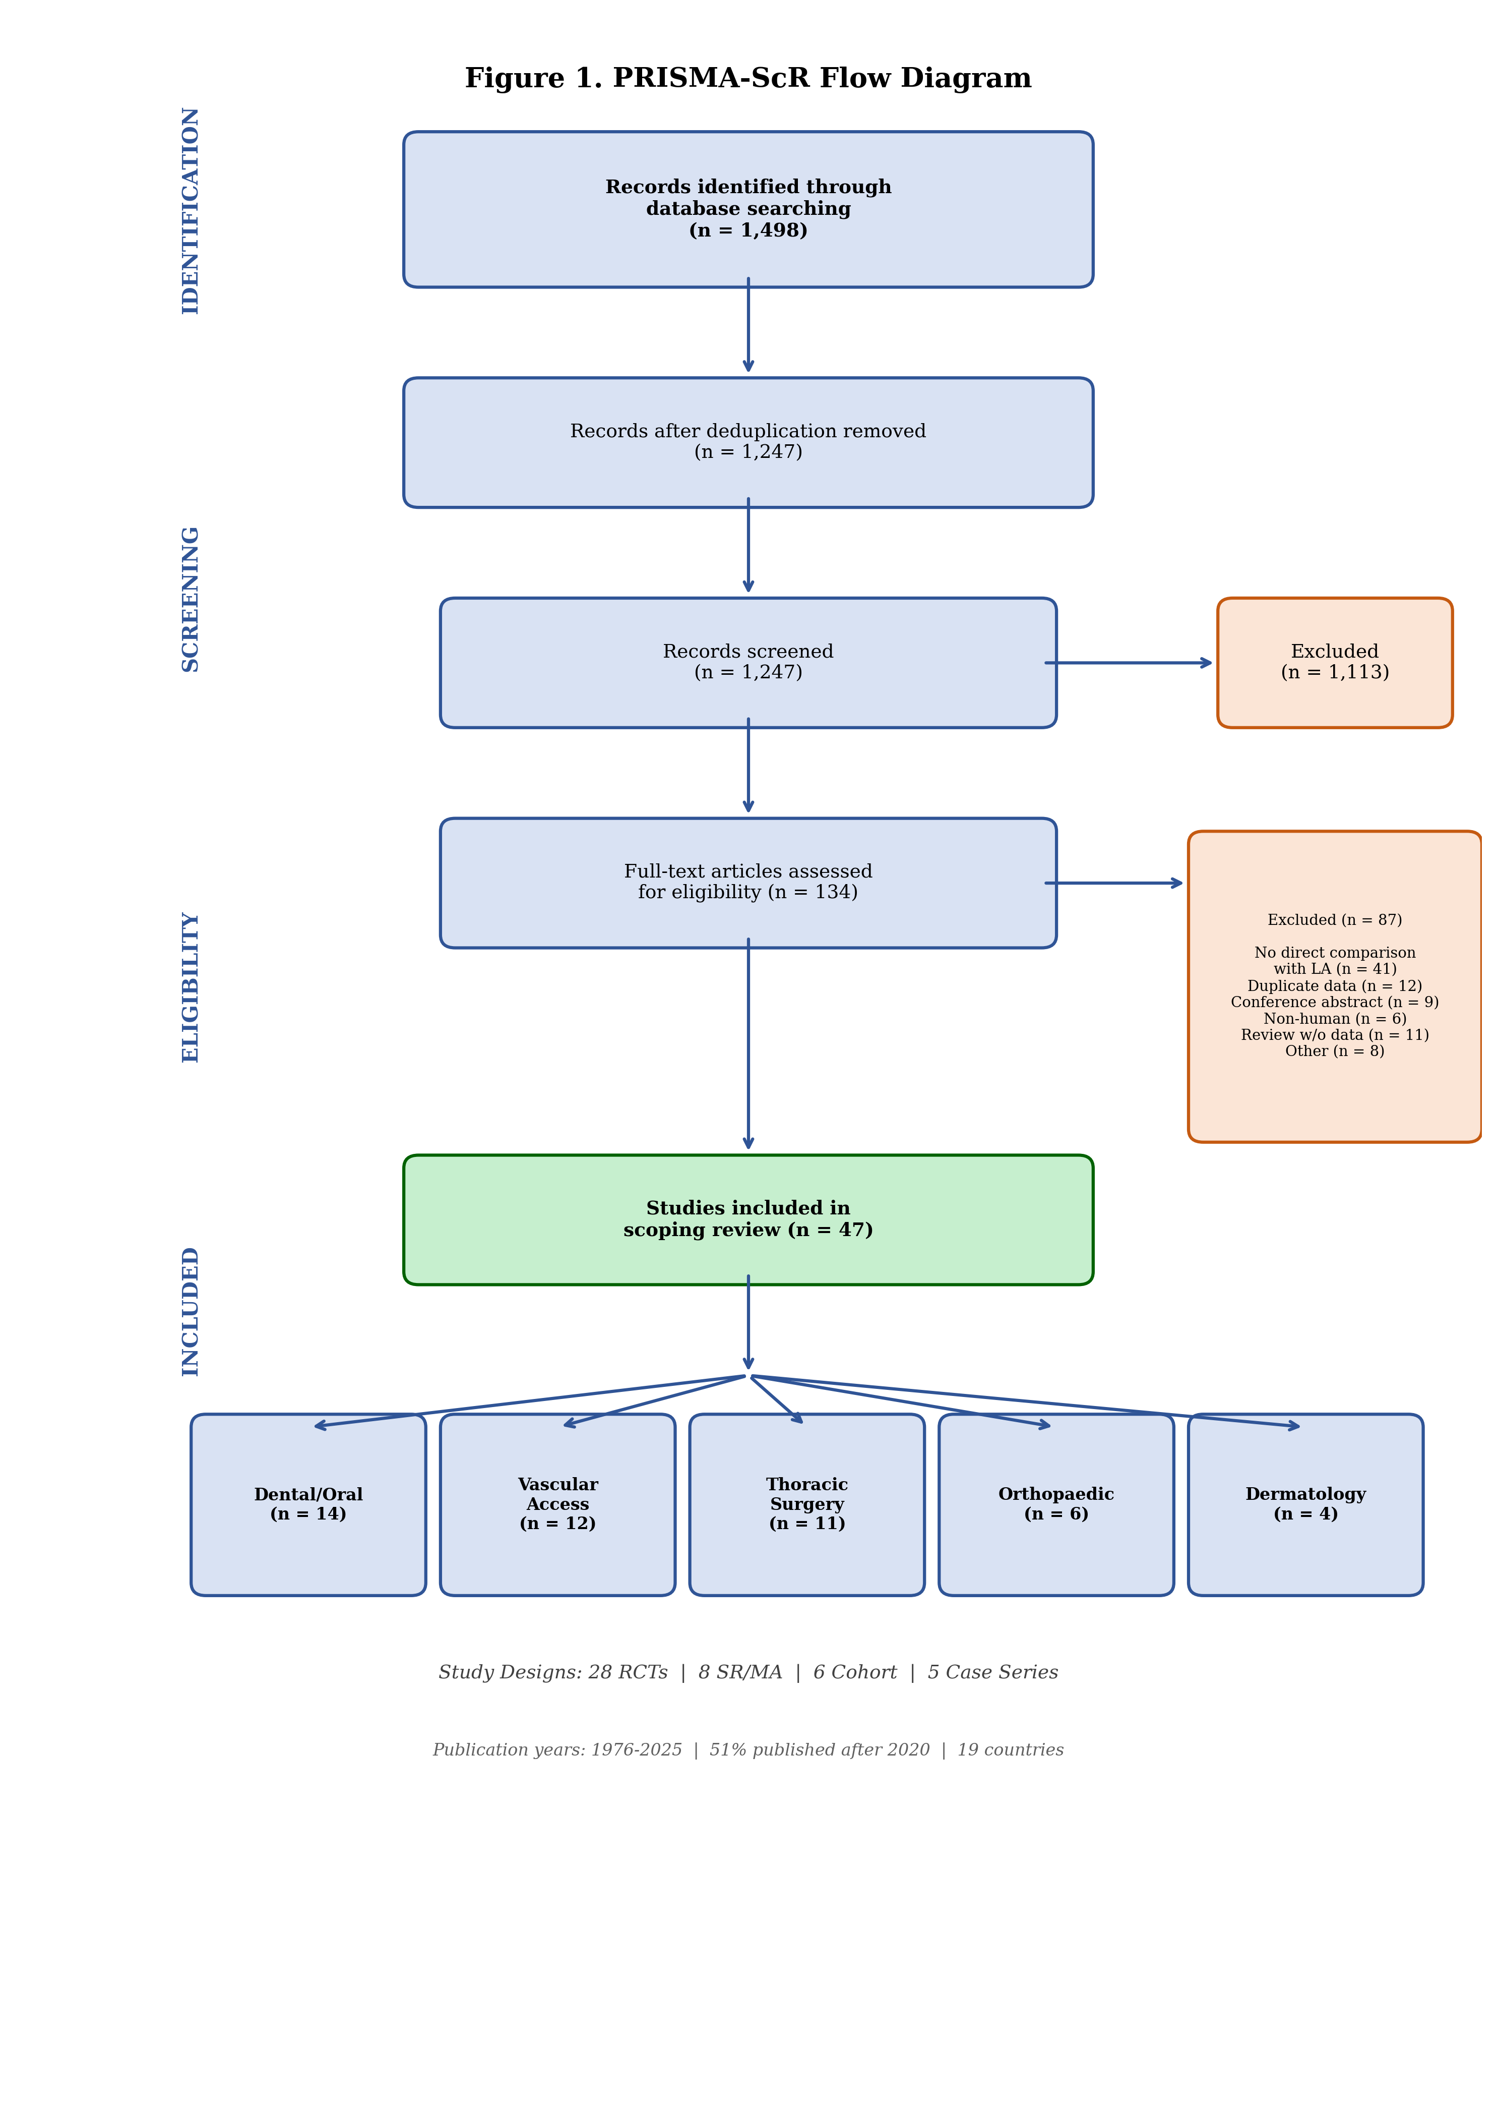
Figure 1. PRISMA-ScR flow diagram showing the study selection process.

Study characteristics
The 47 included studies comprised 28 randomised controlled trials (RCTs), 8 systematic reviews (SRs) or meta-analyses (MAs), 6 retrospective cohort studies, and 5 case series (Table 1). Studies were published between 1976 and 2025, with 51% published after 2020. Geographic distribution spanned 19 countries. Studies were mapped across five clinical domains: dental/oral procedures (n=14, 30%), vascular access (n=12, 26%), thoracic surgery/chest wall trauma (n=11, 23%), orthopaedic surgery (n=6, 13%), and dermatological procedures (n=4, 9%).
Table 1. Summary of included studies by clinical domain
Clinical domain | Total | RCTs | SR/MA | Cohort | Case series | Key cryoanalgesic modalities | Implementation readiness
Dental/oral procedures | 14 | 11 | 3 | 0 | 0 | Ice, ethyl chloride spray, cooled LA solution | HIGH: zero cost, no equipment, strong evidence
Vascular access procedures | 12 | 7 | 4 | 1 | 0 | Vapocoolant spray | HIGH: low cost (<$2), minimal training
Thoracic surgery/chest wall | 11 | 4 | 2 | 3 | 2 | Cryoprobe, percutaneous cryoneurolysis | MODERATE: requires device + training
Orthopaedic surgery | 6 | 3 | 0 | 1 | 2 | Percutaneous cryoneurolysis | LOW: pilot data only, requires device
Dermatological procedures | 4 | 3 | 0 | 1 | 0 | Ice packs, cryogel | HIGH: zero cost, strong evidence
Total | 47 | 28 | 8 | 6 | 5
LA, local anaesthetic; RCT, randomised controlled trial; SR/MA, systematic review/meta-analysis.

Domain 1: Dental and oral procedures (n=14)
This domain contained the strongest evidence for immediate implementation. Eleven RCTs and 3 SRs compared ice or vapocoolant spray with topical anaesthetic gels before dental injection. Seven RCTs compared ice application with topical anaesthetic gel (benzocaine 20% or lidocaine 5%) before LA injection. Rai et al.²⁴ found no significant difference between ice and benzocaine gel for palatal injection pain (visual analogue scale [VAS] 11 vs 10; P=0.955). Similar non-inferiority was reported across multiple populations.^{25–28} Lakhani et al.²⁹ evaluated distant cold stimulation as an alternative technique for managing palatal injection pain. Abbasi et al.³⁰ found ethyl chloride spray significantly superior to lidocaine gel for buccal anaesthesia. Three SRs confirmed that pre-cooling is broadly equivalent to topical LA gels.^{31–33} Recent work has extended cryoanalgesic applications to endodontic procedures, with intrapulpal cryoanesthesia reducing pain during root canal treatment.³⁴ From a patient safety perspective, this domain demonstrates that a zero-cost, universally available intervention can replace pharmaceutical products with equivalent efficacy.

Domain 2: Vascular access procedures (n=12)
Wang et al.³⁵ conducted an SR of 25 RCTs (3143 participants) and found vapocoolant sprays significantly reduced venepuncture pain in adults (standardised mean difference [SMD] −0.65; 95% confidence interval [CI] −0.85 to −0.45) but were ineffective in children. A 2025 network meta-analysis (NMA) of 40 RCTs in children confirmed that vapocoolant spray was no more effective than placebo in paediatric populations, while EMLA cream and needle-free lidocaine were superior.³⁶ Individual RCTs comparing vapocoolant spray directly with lidocaine-prilocaine cream for cannulation reported comparable efficacy in adults.^{37–39} Rao et al.⁴⁰ compared different techniques of ethyl chloride spray application for venepuncture pain. These findings suggest that vapocoolant spray is a viable adult-only contingency for vascular access pain, an important caveat for paediatric services.

Domain 3: Thoracic surgery and chest wall trauma (n=11)
Park et al.⁴¹ conducted an MA of 24 RCTs and found cryoanalgesia combined with opioids was superior to opioids alone for both acute pain (mean difference [MD] −2.32; 95% CI −3.35 to −1.30) and persistent pain (MD −0.81; 95% CI −1.10 to −0.53) after thoracotomy. Cha et al.⁴² systematically reviewed 23 studies of intercostal cryoneurolysis for chest wall pain, demonstrating decreased opioid use. A 2025 RCT randomised patients undergoing video-assisted thoracoscopic surgery (VATS) to intercostal nerve cryoablation versus standard care.⁴³ Miller et al.⁴⁴ reported similar benefits of intercostal nerve cryoablation during lobectomy. Nakazawa et al.⁴⁵ demonstrated that intercostal nerve cryoablation improved pain control and pulmonary recovery after open aortic repair. Zacha and Biernawska⁴⁶ reviewed cryoanalgesia within Enhanced Recovery After Surgery (ERAS) protocols for paediatric thoracic surgery. Several reviews have synthesised the rib fracture management literature, confirming the role of cryoneurolysis alongside surgical stabilisation and regional analgesia.^{47,48} Villalta et al.⁴⁹ described a bedside percutaneous cryoneurolysis technique for acute rib fracture pain. The Intercostal nerve Cryoablation versus thoracic Epidural (ICE) trial protocol⁵⁰ represents a direct comparison of intercostal cryoablation versus thoracic epidural analgesia. Finneran et al.⁵¹ published a landmark RCT comparing percutaneous cryoneurolysis with ropivacaine intercostal nerve block for rib fractures — one of the only direct cryoneurolysis-versus-LA comparisons in the literature.

Domain 4: Orthopaedic surgery (n=6)
Swisher et al.⁵² conducted a pilot RCT of percutaneous cryoneurolysis for post-total knee arthroplasty (TKA) analgesia, reporting lower pain scores versus sham. Radnovich et al.⁵³ found reduced postoperative pain with preoperative cryoneurolysis before TKA. Lung et al.⁵⁴ confirmed cryoneurolysis as a safe and effective modality to improve rehabilitation after TKA. A comparative study evaluated cooled radiofrequency ablation versus cryoneurolysis of genicular nerves for knee osteoarthritis (OA), extending the evidence base for cryoanalgesic approaches to knee pathology.⁵⁵ No study directly compared cryoneurolysis with LA-based peripheral nerve blocks for perioperative TKA analgesia — a significant gap given that these blocks are standard of care.

Domain 5: Dermatological procedures (n=4)
Roongpisuthipong et al.⁵⁶ compared ice packs with lidocaine-prilocaine mixture for laser hair removal, finding lower VAS scores with ice (P=0.03) and 60.2% patient preference for ice. Additional studies confirmed ice and cryogel as effective alternatives for various dermatological procedures.^{57,58}

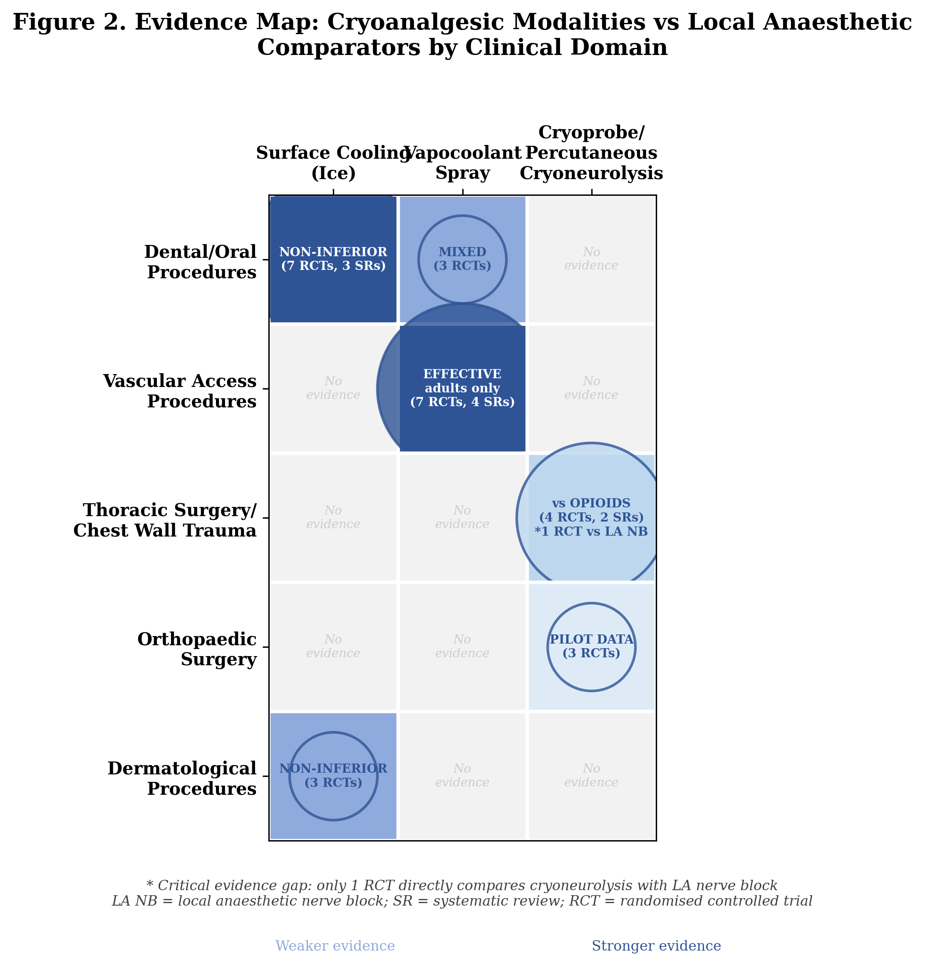
Figure 2. Evidence map: cryoanalgesic modalities versus local anaesthetic comparators by clinical domain.

Supply chain context
No study among the 47 included explicitly examined cryoanalgesia during actual LA shortages. However, several authors highlighted supply chain relevance. Ilfeld and Finneran¹⁹ noted the advantage of cryoneurolysis in providing prolonged analgesia without drug supply chain dependence; Biel et al.¹⁷ described cryoneurolysis as providing “a comparable quality of regional analgesia to local anaesthetic-based interventions”; and the IPSIS shortage advisory⁹ called for evaluation of non-pharmacological alternatives.

Discussion

Principal findings
This scoping review identifies 47 studies (28 RCTs) demonstrating that cryoanalgesia can serve as a drug-free alternative to LA drugs across five clinical domains. The evidence architecture reveals a clear gradient of implementation readiness: for superficial applications (dental, vascular access, dermatology), cryoanalgesia is supported by strong evidence and can be deployed immediately with minimal cost and infrastructure. For deeper applications (thoracic, orthopaedic surgery), cryoneurolysis shows promise but requires specialised equipment, training, and further comparative evidence.

A patient safety framework: the Clinical Preparedness Protocol
Drug shortages are a systems problem requiring a systems response. We propose a tiered Clinical Preparedness Protocol (Table 2) that translates the evidence from this review into an actionable institutional framework. This protocol is designed as a patient safety intervention: its purpose is to ensure continuity of care when pharmaceutical supply chains fail, thereby preventing the patient harm that occurs when procedures are delayed, cancelled, or performed with inadequate analgesia.
Table 2. Clinical Preparedness Protocol: a patient safety framework for cryoanalgesia deployment during local anaesthetic shortages
Shortage severity | Patient safety impact | Cryoanalgesic response | Evidence base | Implementation requirements | Cost per procedure
Stage 1: Mild  (Some formulations limited) | Minor delays in dental/outpatient care;  increased patient discomfort | Ice application (dental)  Vapocoolant spray (venepuncture) | 11 RCTs + 3 SRs  25 RCTs (adults) | Nil (ice)  Spray canister ($5–15) | ~$0  ~$0.50–$2
Stage 2: Moderate  (Multiple agents unavailable) | Procedure cancellations;  alternative drug substitution errors;  inadequate procedural analgesia | Ice packs (dermatology)  Intercostal cryoneurolysis (thoracic) | 3 RCTs  24 RCTs (MA) | Ice packs  Cryoprobe + training | ~$0  ~$50–$200
Stage 3: Severe  (Injectable LA unavailable) | Major surgical delays;  regional anaesthesia impossible;  opioid-dependent analgesia | Percutaneous cryoneurolysis  (rib fractures, TKA) | 1 landmark RCT  2 pilot RCTs | Cryoneurolysis device  + ultrasound + training | ~$200–$500
Stage 4: Complete  (All LA supply exhausted) | Emergency/disaster-level  care disruption;  widespread patient harm | All available cryotherapy  Tiered per above | Expert opinion  Extrapolation | Ice only (minimum)  All available | $0  Variable
LA, local anaesthetic; MA, meta-analysis; RCT, randomised controlled trial; SR, systematic review; TKA, total knee arthroplasty.

Patient safety implications by clinical setting
To illustrate the patient safety implications, we present clinical scenarios showing how cryoanalgesia could prevent harm during shortages (Table 3).
Table 3. Clinical scenarios: preventing patient harm during local anaesthetic shortages
Clinical setting | Patient safety threat | Conventional approach  (unavailable) | Cryoanalgesic contingency | Evidence | Patient safety outcome
Emergency department  (rib fractures) | Uncontrolled pain →  respiratory splinting →  pneumonia, ICU admission | Intercostal nerve block  with bupivacaine | US-guided percutaneous  cryoneurolysis | Finneran 2025 RCT:  vs ropivacaine ICB⁵¹ | Pain control maintained;  pulmonary complications  potentially prevented
Dental clinic  (routine procedures) | Procedure cancellation →  delayed treatment →  disease progression | Topical benzocaine or  lidocaine gel | Ice application to  oral mucosa (2 min) | 7 RCTs + 3 SRs:  non-inferior to topical LA^{24–28,30–33} | Continuity of care;  zero cost; no equipment;  immediate implementation
Surgical theatre  (elective TKA) | Procedure cancellation →  prolonged wait →  functional decline | Adductor canal block  with ropivacaine | Preoperative  cryoneurolysis | Swisher 2022,  Radnovich 2021^{52,53} | Pilot data only;  research priority;  caution warranted
ICB, intercostal nerve block; ICU, intensive care unit; LA, local anaesthetic; TKA, total knee arthroplasty; US, ultrasound.

Systems perspective: why institutional preparedness matters
The pharmaceutical supply chain for LAs exhibits classic features of a fragile system: concentration of manufacturing in few facilities, dependence on just-in-time inventory, and cascading failure modes when disruptions occur.^{10–13,15} Current institutional responses to drug shortages are predominantly reactive — scrambling for alternatives after the shortage is already affecting patient care.^{2,3}
The Clinical Preparedness Protocol proposed here represents a proactive, systems-based approach. By pre-identifying cryoanalgesic alternatives, mapping them to shortage severity levels, and ensuring equipment and training are in place before a shortage occurs, institutions can transition from reactive crisis management to planned contingency activation. This is analogous to other patient safety systems — fire drills, mass casualty protocols, infection control plans — where preparedness before the event determines outcome during it.
Critically, the lowest tiers of this protocol (ice, vapocoolant spray) require virtually no institutional investment. Ice is available in every healthcare facility worldwide. The evidence from 14 dental and 12 vascular access studies demonstrates that this universally available resource provides analgesia equivalent to pharmaceutical products for specific applications. Incorporating these zero-cost contingencies into institutional drug shortage response plans represents a minimum viable patient safety intervention.

Evidence gaps and research priorities
The most significant evidence gap is the near-absence of direct comparisons between cryoneurolysis and LA-based nerve blocks. We identified only two studies^{50,51} directly comparing these modalities. This gap is critical because it is precisely during severe shortages (Stages 3–4) — when injectable LAs are unavailable and cryoneurolysis would be needed most — that the evidence is weakest.
We recommend the following research priorities:
1. Pragmatic RCTs comparing cryoneurolysis with LA nerve blocks for common indications (rib fractures, TKA, other peripheral nerve block indications).
2. Feasibility studies evaluating cryoanalgesia deployment during simulated drug shortage scenarios.
3. Cost-effectiveness analyses incorporating supply chain disruption scenarios and avoided patient harm.
4. Health system preparedness assessments evaluating institutional readiness for non-pharmaceutical analgesia contingencies.

Strengths and limitations
Strengths include comprehensive searching across five databases, inclusion of all study designs, assessment of implementation readiness alongside clinical evidence, and the novel patient safety framing. Limitations include inherent scoping review constraints (no risk-of-bias assessment or meta-analytic pooling), potential publication bias, restriction to English-language publications, and heterogeneity of cryoanalgesic modalities and comparators across domains. The Clinical Preparedness Protocol is evidence-informed but has not been prospectively tested.

Conclusions
LA shortages are a structural reality of the current pharmaceutical landscape, and they pose a direct threat to patient safety. This scoping review demonstrates that cryoanalgesia — from simple ice application to percutaneous cryoneurolysis — provides evidence-supported, drug-free alternatives across multiple clinical domains.
The Clinical Preparedness Protocol proposed here translates this evidence into an actionable patient safety framework. At its simplest level, it requires nothing more than ice — universally available, zero cost, and supported by 14 dental and 12 vascular access studies. At its most advanced level, it requires institutional investment in cryoneurolysis technology and training.
We call on healthcare institutions to: (i) incorporate cryoanalgesia into drug shortage contingency plans as a patient safety priority; (ii) ensure that the simplest cryoanalgesic modalities (ice, vapocoolant spray) are formally recognised in institutional shortage response protocols; and (iii) invest in cryoneurolysis capability where resources permit, to prepare for severe shortage scenarios. The question is not whether another LA shortage will occur, but whether we will be prepared when it does.
A detailed patient safety impact assessment by clinical domain is provided as Supplemental Table 1 (available online).

Authors' contributions
[Removed for triple anonymised review]

Declaration of interests
[To be completed]

Funding
[To be completed]

Declaration of generative AI
[To be completed per BMJ AI disclosure policy]

Data availability statement
All data relevant to the study are included in the article or uploaded as supplementary information. The search strategy, PRISMA-ScR checklist, and data charting form are available as supplementary files.

Patient and public involvement
Patients or the public were not involved in the design, conduct, reporting, or dissemination plans of this research.

References
1. Fox ER, Tyler LS. Managing drug shortages: seven years’ experience. Am J Health Syst Pharm 2003;60:2543–48.
2. McBride A, Holle LM, Westendorf C, et al. National survey on the effect of oncology drug shortages on cancer care. Am J Health Syst Pharm 2013;70:609–17.
3. Phuong JM, Penm J, Chaar B, Oldfield LD, Moles R. The impacts of medication shortages on patient outcomes: a scoping review. PLoS One 2019;14:e0215837.
4. World Health Organization. Shortages of medicines: a global concern. WHO Drug Information 2024;38:156–62.
5. Majeed A, Griffin S, Azille H, Razai MS. Tackling drug shortages must be an urgent priority for the NHS. BMJ 2025;388:q2847.
6. Becker DE, Reed KL. Local anesthetics: review of pharmacological considerations. Anesth Prog 2012;59:90–101.
7. US Food and Drug Administration. Drug shortages database. Updated June 2025. Available at: https://www.accessdata.fda.gov/scripts/drugshortages/
8. American Society of Health-System Pharmacists. Drug shortage detail: bupivacaine injection. ASHP Drug Shortages. Updated April 2025.
9. International Pain and Spine Intervention Society. New local anesthetic shortage advisory. May 2025.
10. European Medicines Agency. EMA recommends suspending licences for 700 drugs over flawed analyses by GVK Biosciences. January 2015.
11. European Medicines Agency. Synapse Labs Pvt. Ltd: EMA recommends suspension of medicines over flawed studies. December 2023.
12. GMP Compliance. GCP inspection reveals deficiencies at CRO in India. September 2023.
13. GMP Compliance. Non-compliance report: cross-contamination risk at Indian pharmaceutical company. March 2024.
14. American College of Physicians. Bolstering the medication supply chain and ameliorating medication shortages: a position paper. Ann Intern Med 2025.
15. Pipeline Medical. The ongoing lidocaine and epinephrine shortage in the US: implications and strategies for healthcare providers. February 2025.
16. Santhireswaran A, Chaudhry S, Ho M, et al. Impact of supply chain disruptions and drug shortages on drug utilization: a scoping review. Pharmacoepidemiol Drug Saf 2025;34:e70178.
17. Biel NM, Ilfeld BM, Gelfand HJ. Applications of cryoneurolysis in acute and chronic pain management. Pain Pract 2023;23:204–15.
18. Ilfeld BM, Preciado J, Trescot AM. Novel cryoneurolysis device for the treatment of sensory and motor peripheral nerves. Expert Rev Med Devices 2016;13:713–25.
19. Ilfeld BM, Finneran JJ. Cryoneurolysis and percutaneous peripheral nerve stimulation to treat acute pain. Anesthesiology 2020;133:1127–49.
20. Shaikh S, et al. Cryoneurolysis: a comprehensive review. Cureus 2025;17:e79448.
21. Peters MDJ, Godfrey CM, Khalil H, McInerney P, Parker D, Soares CB. Guidance for conducting systematic scoping reviews. Int J Evid Based Healthc 2015;13:141–6.
22. Tricco AC, Lillie E, Zarin W, et al. PRISMA extension for Scoping Reviews (PRISMA-ScR): checklist and explanation. Ann Intern Med 2018;169:467–73.
23. Page MJ, McKenzie JE, Bossuyt PM, et al. The PRISMA 2020 statement: an updated guideline for reporting systematic reviews. BMJ 2021;372:n71.
24. Rai S, Jaisani MR, Dongol A, Acharya P. Effectiveness of pre-injection use of cryoanesthesia as compared to topical anesthetic gel in reducing pain perception during palatal injections. J Dent Anesth Pain Med 2024;24:91–9.
25. Chilakamuri S, Nirmala SVSG, Nuvvula S. The effect of pre-cooling versus topical anesthesia on pain perception during palatal injections in children. J Dent Anesth Pain Med 2020;20:377–86.
26. Hindocha N, Manhem F, Backryd E, Bagesund M. Ice versus lidocaine 5% gel for topical anaesthesia of oral mucosa. BMC Anesthesiol 2019;19:227.
27. Lakshmanan L, Ravindran V. Efficacy of cryotherapy application on pain perception during intraoral injection. Int J Clin Pediatr Dent 2021;14:616–20.
28. Peedikayil FC, Kottayi S, Aravind A, Sreedharan A, Ramesh A. Efficacy of local anesthesia with cryotherapy on teeth with molar incisal hypomineralization. J Dent Anesth Pain Med 2024;24:385–93.
29. Lakhani KS, Joshi S, Pawar S, Lohokare AU, Rathod PB. Evaluation of the effect of distant cold stimulation on pain during palatal injection. Cureus 2023;15:e37965.
30. Abbasi H, Sohail K, Sarwar R, et al. Cryoanesthesia with ethyl chloride spray versus 5% lidocaine gel in alleviating oral local anesthetic injection pain. J Oral Dis Diagn Ther 2023.
31. Tirupathi S, Rajasekhar S. Effect of precooling on pain during local anesthesia administration in children: a systematic review. J Dent Anesth Pain Med 2020;20:119–27.
32. Amrollahi N, Rastghalam N, Faghihian R. Effect of pre-cooling on pain associated with dental injections in children: a systematic review. J Evid Based Dent Pract 2021;21:101588.
33. Honaje NV, Ninawe NS, Kalaskar RR, et al. Clinical effectiveness of precooling agent (ice) and topical anesthetic gel in reduction of pain before the intraoral anesthetic injection in children. Dent J Adv Stud 2024.
34. Scientific Reports. Effect of intrapulpal cryoanesthesia on intraoperative pain during root canal treatment in mandibular molars. Sci Rep 2025;15:21173.
35. Wang L, Fang L, Zhou Y, Fang X, Han Y, He J. Efficacy and safety of vapocoolant spray for vascular puncture in children and adults. PLoS One 2023;18:e0279463.
36. BMC Anesthesiology. Local analgesia for the relief of pain in children undergoing venipuncture and intravenous cannulation: a systematic review and network meta-analysis. BMC Anesthesiol 2025;25:115.
37. Mirfazaelian H, et al. Vapocoolant spray versus lidocaine-prilocaine cream for intravenous cannulation pain. Emerg Med J 2025.
38. Griffith RJ, Jordan V, Herd D, Reed PW, Dalziel SR. Vapocoolants (cold spray) for pain treatment during intravenous cannulation. Cochrane Database Syst Rev 2016;(4):CD009484.
39. Gur A, Cakmak F. Analgesic effects of ethyl chloride spray in venepuncture. Eur J Clin Exp Med 2023;21:339–43.
40. Rao PB, Mohanty CR, Singh N, Mund M. Effectiveness of different techniques of ethyl chloride spray for venepuncture-induced pain. Anesth Essays Res 2019;13:568–71.
41. Park HJ, Kim DY, Ahn HY. Cryoanalgesia for postsurgical pain relief: a systematic review and meta-analysis. Ann Med Surg 2021;69:102689.
42. Cha PI, Min JG, Patil A, Choi J, Kothary NN, Forrester JD. Efficacy of intercostal cryoneurolysis as an analgesic adjunct for chest wall pain after surgery or trauma. Trauma Surg Acute Care Open 2021;6:e000690.
43. Journal of Thoracic and Cardiovascular Surgery. A randomized study of cryoablation of intercostal nerves in patients undergoing minimally invasive thoracic surgery. J Thorac Cardiovasc Surg 2025;169:1375–82.
44. Miller DL, Hutchins J, Ferguson MA, Barhoush Y, Achter E, Kuckelman JP. Intercostal nerve cryoablation during lobectomy for postsurgical pain. Pain Ther 2025;14:317–28.
45. Nakazawa J, Iba Y, Nakajima T, et al. Effects of intercostal nerve cryoablation on pain control and pulmonary recovery after open aortic repair. Ann Thorac Cardiovasc Surg 2025;31:oa.25–00127.
46. Zacha S, Biernawska J. Cryoanalgesia in pediatric thoracic surgery ERAS: a scoping review. J Pers Med 2024;14:411.
47. Stopenski S, Binkley J, Schubl SD, Bauman ZM. Rib fracture management: a review of surgical stabilization, regional analgesia, and intercostal nerve cryoablation. Surg Pract Sci 2022;10:100089.
48. Muldiiarov V, Bauman ZM. Role of intercostal nerve block and cryoneurolysis in the management of rib fractures: a narrative review. Curr Chall Thorac Surg 2025;7:23.
49. Villalta CI, Mian RK, Grossman Verner HM, et al. Bedside percutaneous cryoneurolysis technique for management of acute rib fracture pain. Trauma Surg Acute Care Open 2024;9:e001521.
50. BMJ Open. Intercostal nerve cryoablation versus thoracic epidural analgesia for Nuss repair of pectus excavatum (ICE trial). BMJ Open 2024;14:e081392.
51. Finneran JJ, Kobayashi L, Costantini TW, et al. Ultrasound-guided percutaneous cryoneurolysis for the treatment of pain after traumatic rib fracture. Anesthesiology 2025;142:532–45.
52. Swisher MW, Ball ST, Gonzales FB, Cidambi KR, Trescot AM, Ilfeld BM. A randomized controlled pilot study using ultrasound-guided percutaneous cryoneurolysis for analgesia following total knee arthroplasty. Pain Ther 2022;11:1299–307.
53. Radnovich R, Ilfeld BM, Sessler DI, et al. Cryoneurolysis before total knee arthroplasty in patients with severe osteoarthritis. J Arthroplasty 2021;36:1590–8.
54. Lung BE, Karasavvidis T, Sharma AK, et al. Cryoneurolysis is a safe, effective modality to improve rehabilitation after total knee arthroplasty. Life (Basel) 2022;12:1344.
55. Cooled radiofrequency ablation versus cryo-neurolysis of genicular nerves: a comparative study. Cardiovasc Intervent Radiol 2025;48:1418–27.
56. Roongpisuthipong W, Christensen RE, Dirr MA, et al. Comparative effectiveness of ice packs versus topical lidocaine-prilocaine mixture for pain control in laser hair removal. J Am Acad Dermatol 2023;88:617–22.
57. Kuwahara RT, Skinner RB Jr. EMLA versus ice as a topical anesthetic. Dermatol Surg 2001;27:495–6.
58. Gupta J, Khunger N, Ramesh V. Comparative study of three different modalities of topical anesthesia. Indian J Drugs Dermatol 2020;6:22–7.

