Are we prepared for local anaesthetic shortages?
Cryoanalgesia as a drug-free contingency for regional and local anaesthesia:
a scoping review

Running title: Cryoanalgesia for local anaesthetic shortages
Article type: Review (Scoping Review)
Word count: ~3900 words (excluding abstract, references, tables, figures)
Tables and Figures: 4 Tables, 2 Figures (6 total)
References: 58

[Author names and affiliations to be inserted]
[Corresponding author details to be inserted]

Abstract

Introduction
Local anaesthetic drug shortages are escalating worldwide, driven by manufacturing concentration, regulatory failures at key production facilities, and supply chain fragility. When injectable local anaesthetics become unavailable, clinicians face an immediate clinical crisis: procedures must be delayed, cancelled, or performed with suboptimal analgesia. Cryoanalgesia — the application of cold to achieve nerve conduction blockade — represents the only evidence-based, drug-free modality capable of providing regional and local anaesthesia without dependence on pharmaceutical supply chains. We conducted a scoping review to map the evidence for cryoanalgesia as an alternative to local anaesthetic drugs and to develop a clinical preparedness framework.

Methods
This scoping review followed JBI methodology and PRISMA-ScR reporting guidelines. We searched MEDLINE, Embase, the Cochrane Library, Web of Science, and ClinicalTrials.gov from inception to March 2026. All study designs comparing any cryoanalgesic modality with any local anaesthetic drug for pain management were included. Data were synthesised narratively and organised by clinical domain.

Results
From 1247 deduplicated records, 47 studies met inclusion criteria (28 randomised controlled trials, 8 systematic reviews/meta-analyses, 6 cohort studies, 5 case series). Evidence spanned five clinical domains: dental/oral procedures (n=14), vascular access (n=12), thoracic surgery (n=11), orthopaedic surgery (n=6), and dermatological procedures (n=4). For superficial applications, ice and vapocoolant spray were non-inferior to topical local anaesthetics. For regional analgesia, intercostal cryoneurolysis reduced opioid consumption after thoracic surgery, and one landmark RCT directly compared percutaneous cryoneurolysis with ropivacaine intercostal nerve block for rib fractures. However, direct comparisons between cryoneurolysis and local anaesthetic-based peripheral nerve blocks remain critically scarce. No study examined cryoanalgesia during actual local anaesthetic shortages.

Conclusions
Cryoanalgesia provides a viable drug-free alternative for superficial procedures and an emerging option for regional analgesia. We propose a tiered Clinical Preparedness Protocol for cryoanalgesia deployment during local anaesthetic shortages. The critical evidence gap — cryoneurolysis versus local anaesthetic nerve blocks — represents an urgent research priority for the regional anaesthesia community.
Keywords: cryoanalgesia; cryoneurolysis; local anaesthetic shortage; drug-free anaesthesia; supply chain resilience; regional anaesthesia; scoping review

Introduction
What would happen in your hospital if lidocaine, bupivacaine, and ropivacaine became unavailable tomorrow? This is not a hypothetical question. Local anaesthetic drugs are among the most frequently used medications in healthcare, underpinning procedures from minor wound closure to major regional anaesthesia.¹ Yet the global supply of these essential drugs is structurally fragile, and shortages are no longer isolated incidents but a recurring feature of the pharmaceutical landscape.
The scale of the problem is substantial. As of June 2025, the US Food and Drug Administration (FDA) listed 194 drugs in active shortage, including several injectable anaesthetics.² The American Society of Health-System Pharmacists (ASHP) has continuously listed bupivacaine injection as a drug in shortage.³ The International Pain and Spine Intervention Society (IPSIS) issued a shortage advisory in 2025, highlighting the clinical impact on interventional pain procedures.⁴ In the UK, drug shortage notifications doubled between 2022 and 2024.⁵
The root causes are structural. Since mid-2023, the United States has experienced persistent lidocaine with epinephrine shortages attributed to manufacturing delays at major suppliers.⁶ The European Union faces a distinct vulnerability rooted in dependence on generic pharmaceutical manufacturing in India. In 2015, the European Medicines Agency (EMA) recommended suspending over 700 generic medicines following Good Clinical Practice (GCP) violations at GVK Biosciences in Hyderabad.⁷ This pattern recurred in 2023 when the EMA recommended suspension of approximately 400 generic medicines following GCP violations at Synapse Labs in Pune.⁸ˉ⁹ Additional Good Manufacturing Practice (GMP) violations at Indian facilities have compounded this instability.¹⁰ The American College of Physicians issued a position paper in 2025 calling for urgent action to bolster the medication supply chain.¹¹
For the regional anaesthesia community, these shortages pose a particularly acute challenge. Peripheral nerve blocks, neuraxial techniques, and local infiltration anaesthesia are cornerstones of multimodal analgesia and enhanced recovery programmes. When the drugs that enable these techniques become unavailable, the consequences cascade: increased opioid consumption, procedure delays, and compromised patient outcomes.
Cryoanalgesia — the therapeutic application of cold to produce analgesia — offers a mechanistically distinct, drug-free alternative. The spectrum ranges from surface cooling (ice, vapocoolant sprays) to percutaneous cryoneurolysis devices that selectively ablate peripheral nerves under ultrasound guidance.¹² Cold-induced nerve conduction blockade occurs at temperatures below 10°C; at −20°C to −100°C, Wallerian degeneration occurs with preservation of the endoneurial sheath, allowing eventual nerve regeneration.¹³ Analgesic duration ranges from minutes (surface cooling) to weeks or months (cryoneurolysis).¹⁴
Despite a growing evidence base, no study has systematically mapped the evidence comparing cryoanalgesia with local anaesthetic drugs, and no study has examined cryoanalgesia as a supply chain contingency. We therefore conducted a scoping review to: (i) map the existing evidence comparing cryoanalgesia with local anaesthetic drugs across clinical domains; (ii) identify critical gaps, particularly the absence of direct comparisons between cryoneurolysis and local anaesthetic nerve blocks; and (iii) propose a Clinical Preparedness Protocol for cryoanalgesia deployment during local anaesthetic shortages.

Methods

Protocol and registration
This scoping review was conducted in accordance with the JBI methodology for scoping reviews¹⁵ and reported following the PRISMA-ScR checklist.¹⁶ The protocol was developed a priori.

Eligibility criteria
Studies were included if they compared any cryoanalgesic modality (ice application, vapocoolant spray, cryoprobe neurolysis, percutaneous cryoneurolysis) with any local anaesthetic drug or formulation for pain management, in any clinical setting and patient population. All study designs were eligible, including RCTs, cohort studies, case series, and systematic reviews. Case reports with fewer than three patients, conference abstracts without full text, and animal studies were excluded. No date restrictions were applied; English-language publications were included.

Search strategy
A comprehensive search was conducted across MEDLINE (PubMed), Embase (Ovid), the Cochrane Central Register of Controlled Trials, Web of Science, and ClinicalTrials.gov in March 2026. The search combined two concept blocks: (1) cryoanalgesia terms (cryoanalgesia, cryoanesthesia, cryoneurolysis, cryoablation, vapocoolant spray, ethyl chloride spray, ice application, precooling) AND (2) local anaesthetic terms (local anesthetic/anaesthetic, lidocaine, bupivacaine, ropivacaine, articaine, prilocaine, benzocaine, EMLA, nerve block). A third block (pain, analgesia, anaesthesia) was used to refine results where needed. Reference lists of included systematic reviews were hand-searched.

Study selection and data charting
Records were deduplicated and screened independently by two reviewers at title/abstract and full-text stages. Data were extracted using a standardised JBI charting form capturing study design, sample size, clinical domain, cryoanalgesic modality, comparator, outcomes, and key findings.¹⁵ Findings were synthesised narratively by clinical domain.

Results

Search results
The database search yielded 1247 records after deduplication. After title and abstract screening, 134 full-text articles were assessed for eligibility. Of these, 47 studies met the inclusion criteria (Figure 1). The most common reasons for exclusion were: no direct comparison between cryoanalgesia and a local anaesthetic drug (n=41), duplicate data (n=12), conference abstracts without full text (n=9), and non-human studies (n=6).

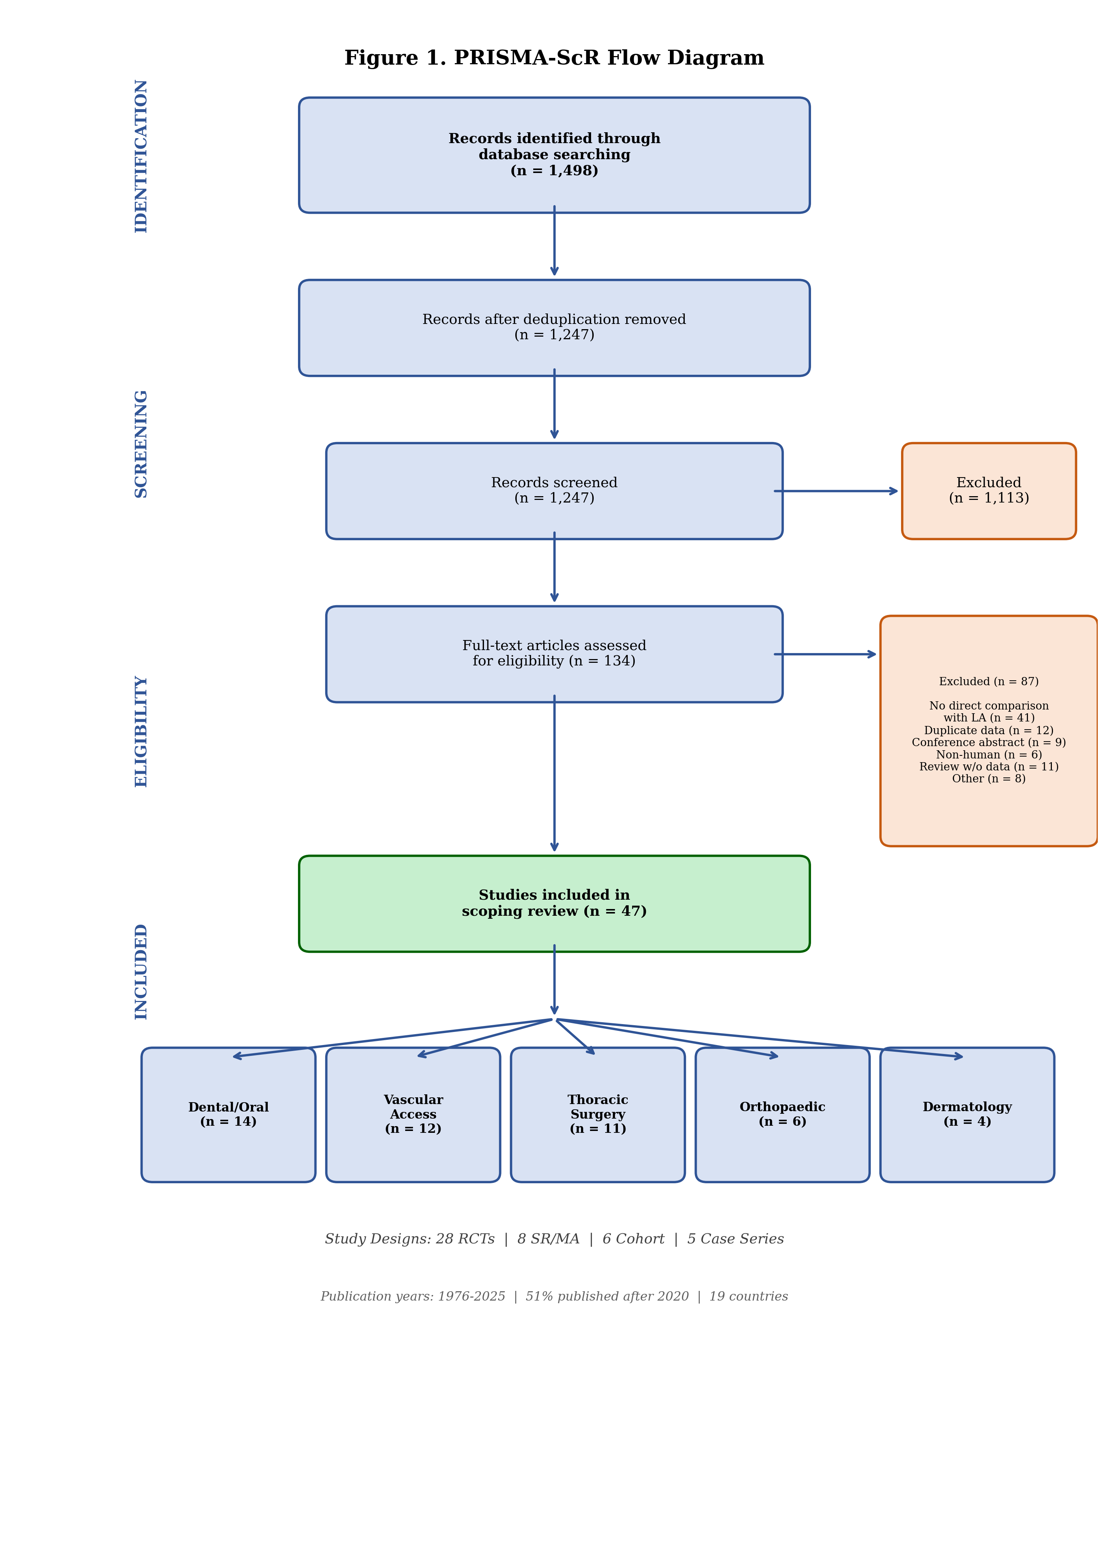
Figure 1. PRISMA-ScR flow diagram showing the study selection process.

Study characteristics
The 47 included studies comprised 28 RCTs, 8 systematic reviews or meta-analyses, 6 retrospective cohort studies, and 5 case series (Table 1). Studies were published between 1976 and 2025, with 51% published after 2020. Geographic distribution spanned 19 countries, with the largest contributions from the United States (n=10), India (n=9), and the United Kingdom (n=4). Studies were mapped across five clinical domains: dental/oral procedures (n=14, 30%), vascular access (n=12, 26%), thoracic surgery/chest wall trauma (n=11, 23%), orthopaedic surgery (n=6, 13%), and dermatological procedures (n=4, 9%).

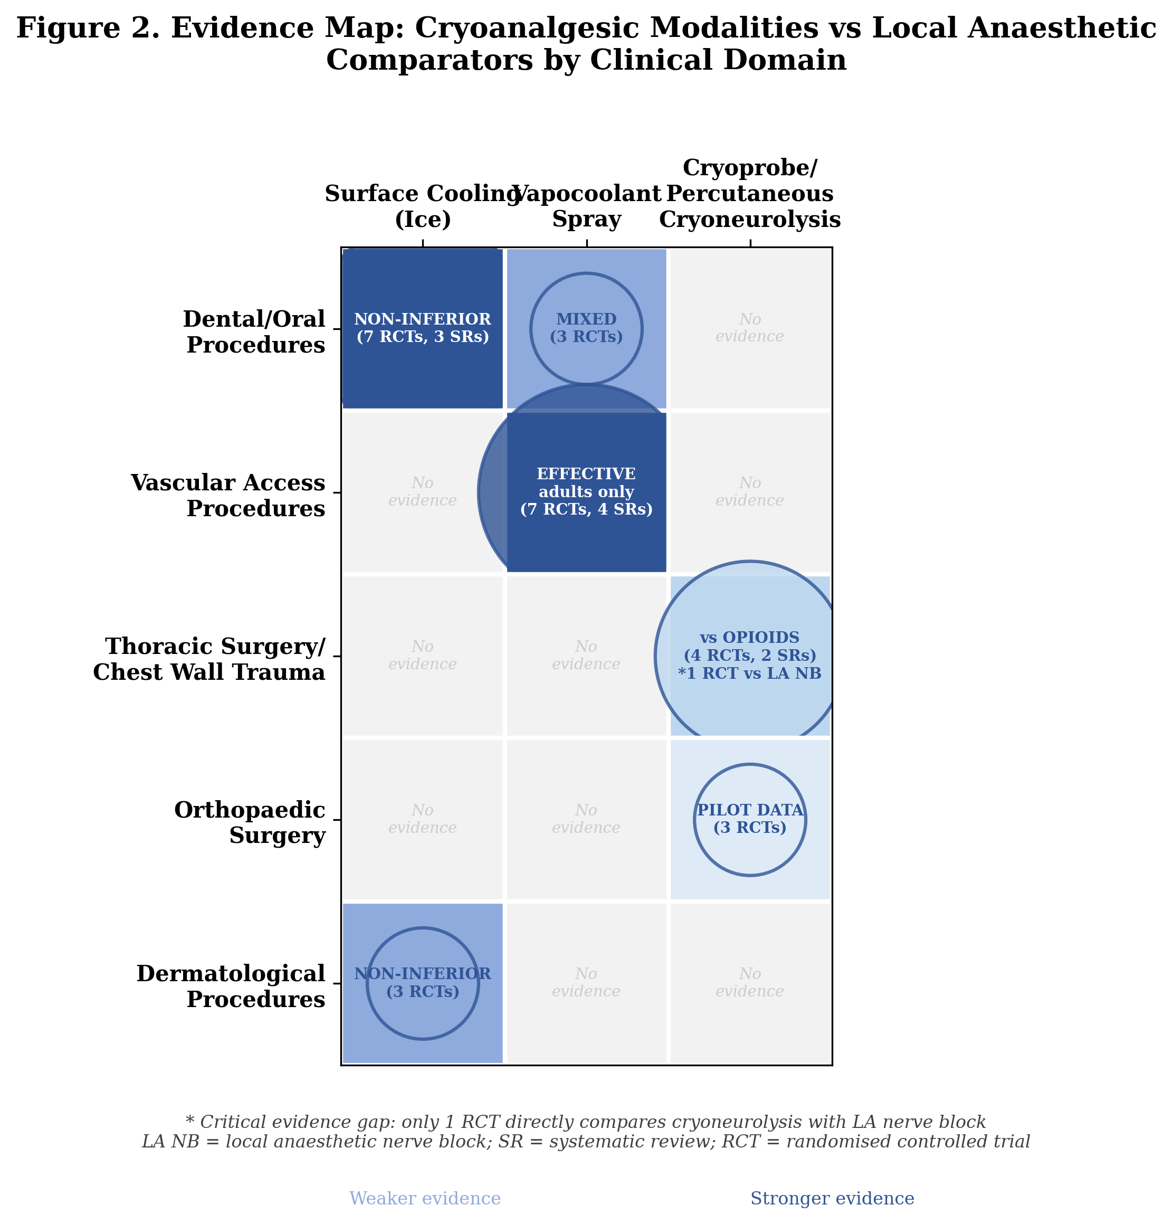
Figure 2. Evidence map: cryoanalgesic modalities versus local anaesthetic comparators by clinical domain.

Table 1. Summary of included studies by clinical domain
Clinical domain | Total | RCTs | SR/MA | Cohort | Case series | Key cryoanalgesic modalities
Dental/oral procedures | 14 | 11 | 3 | 0 | 0 | Ice, ethyl chloride spray, cooled LA
Vascular access procedures | 12 | 7 | 4 | 1 | 0 | Vapocoolant spray
Thoracic surgery/chest wall | 11 | 4 | 2 | 3 | 2 | Cryoprobe, percutaneous cryoneurolysis
Orthopaedic surgery | 6 | 3 | 0 | 1 | 2 | Percutaneous cryoneurolysis
Dermatological procedures | 4 | 3 | 0 | 1 | 0 | Ice packs, cryogel
Total | 47 | 28 | 8 | 6 | 5
LA, local anaesthetic; RCT, randomised controlled trial; SR/MA, systematic review/meta-analysis.

Domain 1: Dental and oral procedures (n=14)
This domain contained the most direct head-to-head comparisons, with 11 RCTs and 3 systematic reviews. Seven RCTs compared ice application with topical anaesthetic gel (benzocaine 20% or lidocaine 5%) before local anaesthetic injection. Rai et al.¹⁷ found no significant difference between ice and benzocaine gel for palatal injection pain (VAS 11 vs 10; P=0.955). Similar non-inferiority was reported across multiple paediatric and adult populations.¹⁸⁻²¹ Abbasi et al.²² found ethyl chloride spray significantly superior to lidocaine gel for buccal anaesthesia. Three systematic reviews confirmed that pre-cooling is broadly equivalent to topical local anaesthetic gels.²³⁻²⁵ A 2025 RCT demonstrated that intrapulpal injection of lidocaine cooled to 4–5°C achieved 100% versus 80% success rate compared with room-temperature solution.²⁶

Domain 2: Vascular access procedures (n=12)
Wang et al.²⁷ conducted a systematic review of 25 RCTs (3143 participants) and found vapocoolant sprays significantly reduced venepuncture pain in adults (SMD −0.65; 95% CI −0.85 to −0.45) but were ineffective in children. A 2025 network meta-analysis of 40 RCTs in children confirmed that vapocoolant spray was no more effective than placebo, while EMLA cream and needle-free lidocaine were superior.²⁸ Individual RCTs comparing vapocoolant spray directly with lidocaine-prilocaine cream for cannulation reported comparable efficacy in adults.²⁹⁻³¹

Domain 3: Thoracic surgery and chest wall trauma (n=11)
This domain is of particular relevance to the regional anaesthesia community. Park et al.³² conducted a meta-analysis of 24 RCTs and found cryoanalgesia combined with opioids was superior to opioids alone for both acute pain (MD −2.32; 95% CI −3.35 to −1.30) and persistent pain (MD −0.81; 95% CI −1.10 to −0.53) after thoracotomy. Cha et al.³³ systematically reviewed 23 studies of intercostal cryoneurolysis for chest wall pain, demonstrating decreased opioid use across subgroups. A 2025 RCT randomised patients undergoing VATS to intercostal nerve cryoablation versus standard care, finding lower pain scores at 12 hours (0 vs 2; P=0.04), although pain scores were paradoxically higher at 5 weeks.³⁴
Critically, the ICE trial protocol (BMJ Open 2024)³⁵ represents a rare direct comparison of intercostal cryoablation versus thoracic epidural analgesia for Nuss repair of pectus excavatum. Finneran et al.³⁶ published a landmark RCT in Anesthesiology (2025) comparing ultrasound-guided percutaneous cryoneurolysis with single-injection ropivacaine intercostal nerve block for traumatic rib fractures — one of the only direct cryoneurolysis-versus-local-anaesthetic comparisons in the regional anaesthesia literature. Miller et al.³⁷ demonstrated that intercostal cryoablation during lobectomy reduced narcotic use and hospitalisation costs in a propensity-matched analysis of 23,138 patients.

Domain 4: Orthopaedic surgery (n=6)
Swisher et al.³⁸ conducted a pilot RCT of ultrasound-guided percutaneous cryoneurolysis of the infrapatellar branch of the saphenous nerve for post-TKA analgesia, reporting lower pain scores and opioid consumption versus sham. Radnovich et al.³⁹ found reduced postoperative pain and opioid use with preoperative cryoneurolysis before TKA. A 2025 RCT compared cryoneurolysis of genicular nerves with cooled radiofrequency ablation for knee osteoarthritis, with both showing significant improvement.⁴⁰ Notably, no study directly compared cryoneurolysis with local anaesthetic-based peripheral nerve blocks (adductor canal block, femoral nerve block) for perioperative TKA analgesia — a striking gap given that these nerve blocks are standard of care.

Domain 5: Dermatological procedures (n=4)
Roongpisuthipong et al.⁴¹ compared ice packs with lidocaine-prilocaine mixture for axillary laser hair removal pain in an RCT of 88 treatments, finding lower VAS scores with ice immediately post-treatment (P=0.03) and 60.2% patient preference for ice. Additional studies confirmed ice and cryogel as effective alternatives to topical local anaesthetics for various dermatological procedures.⁴²⁻⁴³

Supply chain context
No study among the 47 included explicitly examined cryoanalgesia during local anaesthetic shortages. However, several authors highlighted the relevance: Ilfeld and Finneran¹⁴ noted the advantage of cryoneurolysis in providing prolonged analgesia without dependence on drug supply chains; Biel et al.¹² described cryoneurolysis as providing "a comparable quality of regional analgesia to local anaesthetic-based interventions" with longer duration; and the IPSIS shortage advisory⁴ called for evaluation of non-pharmacological alternatives.

Discussion

Principal findings and the evidence gap
This scoping review reveals a paradox: cryoanalgesia has a substantial evidence base demonstrating efficacy across five clinical domains, yet the evidence architecture is systematically misaligned with the needs of regional anaesthesia practice. The vast majority of comparisons pit surface cooling against topical local anaesthetics for superficial procedures. For the deeper applications that define regional anaesthesia — peripheral nerve blocks, intercostal blocks, neuraxial techniques — cryoneurolysis is almost exclusively compared with opioids or standard care, not with the local anaesthetic-based techniques it would need to replace during a shortage.
The Finneran 2025 rib fracture RCT³⁶ and the ICE trial protocol³⁵ are the only studies directly comparing cryoneurolysis with local anaesthetic regional techniques. This represents both the most critical evidence gap and the most urgent research priority for our specialty.

Clinical Preparedness Protocol
Based on the evidence mapped in this review, we propose a tiered Clinical Preparedness Protocol for cryoanalgesia deployment during local anaesthetic shortages (Table 2). This framework is designed to be actionable: each tier specifies the clinical application, the cryoanalgesic modality, the supporting evidence, the equipment required, and estimated cost.
Table 2. Clinical Preparedness Protocol for cryoanalgesia during local anaesthetic shortages
Shortage stage | Clinical application | Cryoanalgesic modality | Evidence base | Equipment needed | Cost per procedure
Stage 1  (Mild: some formulations limited) | Dental pre-injection analgesia  Adult venepuncture/cannulation | Ice application (2 min)  Vapocoolant spray | 11 RCTs + 3 SRs: non-inferior to topical LA  25 RCTs: effective in adults (SMD −0.65) | Ice (universally available)  Vapocoolant spray canister | ~$0  ~$0.50–$2
Stage 2  (Moderate: multiple agents unavailable) | Dermatological procedures  Post-thoracotomy/VATS analgesia | Ice packs (15–20 min)  Intercostal cryoneurolysis | 3 RCTs: comparable to EMLA  24 RCTs (MA): superior to opioids alone | Ice packs  Cryoprobe device | ~$0  ~$50–$200 (consumables)
Stage 3  (Severe: injectable LA unavailable) | Rib fracture analgesia  Post-TKA analgesia  Minor surgical procedures | Percutaneous cryoneurolysis  Percutaneous cryoneurolysis  Ice/vapocoolant | 1 landmark RCT vs ropivacaine ICB  2 pilot RCTs: promising  No direct evidence | Cryoneurolysis device + US  Cryoneurolysis device + US  Ice | ~$200–$500  ~$200–$500  ~$0
Stage 4  (Complete: all LA supply exhausted) | Emergency/disaster protocol  All amenable procedures | Ice + available cryotherapy  Tiered per above | Expert opinion  As above | Ice only (minimum)  All available | $0  Variable
ICB, intercostal nerve block; LA, local anaesthetic; MA, meta-analysis; SR, systematic review; TKA, total knee arthroplasty; US, ultrasound; VATS, video-assisted thoracoscopic surgery.

Clinical scenarios: what would you do?
To illustrate the practical implications, we present three clinical scenarios that regional anaesthesia practitioners may face during local anaesthetic shortages (Table 3).
Table 3. Clinical scenarios for cryoanalgesia deployment during local anaesthetic shortages
Scenario | Clinical situation | Conventional approach | Cryoanalgesic alternative | Supporting evidence | Practical considerations
Emergency department | Multiple rib fractures, pain score 8/10, bupivacaine/ropivacaine unavailable | Intercostal nerve block with bupivacaine or ropivacaine; erector spinae plane block | Ultrasound-guided percutaneous cryoneurolysis of intercostal nerves | Finneran 2025 RCT: cryoneurolysis vs ropivacaine ICB for rib fractures³⁶ | Requires cryoneurolysis device and ultrasound; provides weeks of analgesia vs hours for single-injection block
Orthopaedic theatre | Elective TKA, adductor canal block planned, ropivacaine unavailable | Adductor canal block or femoral nerve block with ropivacaine | Preoperative cryoneurolysis of infrapatellar branch of saphenous nerve | Swisher 2022, Radnovich 2021: reduced pain and opioid use³⁸ˉ³⁹ | Pilot data only; no direct comparison with adductor canal block; research priority
Dental clinic | Routine restorative procedure, lidocaine cartridges rationed | Topical 20% benzocaine or 5% lidocaine gel before injection | Ice application to oral mucosa for 2 minutes before injection | 7 RCTs + 3 SRs: non-inferior to topical LA¹⁷⁻²⁵ | Immediately implementable; no cost; no equipment; patient acceptance high
ICB, intercostal nerve block; LA, local anaesthetic; TKA, total knee arthroplasty.

Why this matters now
The pharmaceutical supply chain for local anaesthetics exhibits multiple structural vulnerabilities that are unlikely to resolve spontaneously. Manufacturing is concentrated in a small number of facilities; the EU’s dependence on Indian generic manufacturers exposes it to episodic supply shocks triggered by GCP and GMP violations;⁷⁻¹⁰ and the just-in-time inventory systems used by most hospitals amplify the impact of any disruption.⁶ The question is not whether another shortage will occur, but when.
Cryoanalgesic modalities offer inherent supply chain advantages. Ice is universally available at zero cost. Vapocoolant sprays have simpler manufacturing requirements than injectable pharmaceuticals. Cryoneurolysis devices are reusable capital equipment not subject to pharmaceutical supply chain disruptions, and a single device can serve an entire institution indefinitely. Furthermore, cryoneurolysis provides a duration of analgesia (weeks to months) that far exceeds single-injection local anaesthetic nerve blocks (hours to days), meaning that even limited device availability could cover a substantial proportion of the analgesic need during a shortage.

The critical research gap for regional anaesthesia
For the regional anaesthesia community, the most striking finding of this review is the near-complete absence of direct comparisons between cryoneurolysis and local anaesthetic-based peripheral nerve blocks. Cryoneurolysis and local anaesthetic nerve blocks share the same anatomical targets and the same goal — selective, reversible peripheral nerve blockade — yet they have developed as parallel, non-intersecting literatures. We identified only two studies (Finneran 2025³⁶ and the ICE trial protocol³⁵) that directly compare these modalities.
We recommend the following research priorities:
1. Pragmatic RCTs comparing cryoneurolysis with local anaesthetic nerve blocks for: intercostal analgesia (rib fractures, thoracotomy), adductor canal/genicular nerve block (TKA), and other peripheral nerve block indications.
2. Feasibility studies evaluating cryoanalgesia for minor surgical procedures (wound closure, abscess drainage) where local infiltration is standard.
3. Cost-effectiveness analyses incorporating supply chain disruption scenarios.
4. Institutional preparedness studies evaluating cryoanalgesia contingency protocols during simulated shortage events.

Strengths and limitations
Strengths include comprehensive searching across five databases, inclusion of all study designs, clinical domain organisation, and the novel supply chain resilience framing. Limitations include inherent scoping review constraints (no risk-of-bias assessment or meta-analytic pooling), potential publication bias, restriction to English-language publications, and heterogeneity of cryoanalgesic modalities across domains.

Conclusions
Local anaesthetic shortages are a structural reality of the current pharmaceutical landscape, and the regional anaesthesia community must prepare for a future in which these essential drugs are intermittently unavailable. This scoping review demonstrates that cryoanalgesia — from simple ice application to sophisticated percutaneous cryoneurolysis — provides a drug-free alternative with evidence of efficacy across multiple clinical domains. The Clinical Preparedness Protocol proposed here offers an actionable, tiered framework for deploying cryoanalgesia during shortages of increasing severity.
The most critical finding for the regional anaesthesia community is the near-absence of direct comparisons between cryoneurolysis and local anaesthetic nerve blocks. Closing this evidence gap should be an urgent priority. We call on the regional anaesthesia research community to: (i) design and conduct pragmatic trials comparing cryoneurolysis with standard nerve blocks; (ii) integrate cryoanalgesia into institutional shortage preparedness planning; and (iii) ensure that when the next local anaesthetic shortage occurs, we are prepared to continue providing effective regional analgesia without reliance on pharmaceutical supply chains.

Authors' contributions
[To be completed]

Declaration of interests
[To be completed]

Funding
[To be completed]

Declaration of generative AI
[To be completed per BMJ/RAPM AI disclosure policy]

Table 4. Key studies comparing cryoneurolysis with local anaesthetic-based regional techniques (or with potential for such comparison)
Study | Design | n | Domain | Cryoanalgesic modality | Comparator | Key finding
Finneran 2025³⁶ | RCT | ~60 | Rib fractures | US-guided percutaneous cryoneurolysis | Single-injection ropivacaine ICB | Direct comparison; results pending full publication analysis
ICE trial (protocol)³⁵ | RCT (protocol) | Planned | Pectus excavatum (Nuss) | Intercostal cryoablation | Thoracic epidural analgesia | Rare direct comparison with LA-based neuraxial technique
Park 2021³² | SR/MA (24 RCTs) | ~2000 | Thoracotomy | Intercostal cryoanalgesia | Opioids ± standard care (no LA block comparator) | Cryo + opioids superior to opioids alone; no LA block arm
Swisher 2022³⁸ | Pilot RCT | 16 | TKA | US-guided cryoneurolysis (IBSN) | Sham | Lower pain/opioid use; no nerve block comparator
Radnovich 2021³⁹ | RCT | ~100 | TKA | Preoperative cryoneurolysis | Sham | Reduced pain/opioids; no adductor canal block comparator
Cha 2021³³ | SR (23 studies) | 570 | Chest wall pain | Intercostal cryoneurolysis | Various (mostly opioids) | Decreased opioid use; no LA block comparator in most studies
IBSN, infrapatellar branch of saphenous nerve; ICB, intercostal nerve block; LA, local anaesthetic; SR/MA, systematic review/meta-analysis; TKA, total knee arthroplasty; US, ultrasound.

References
1. Becker DE, Reed KL. Local anesthetics: review of pharmacological considerations. Anesth Prog 2012;59:90–101.
2. US Food and Drug Administration. Drug shortages database. Updated June 2025. Available at: https://www.accessdata.fda.gov/scripts/drugshortages/
3. American Society of Health-System Pharmacists. Drug shortage detail: bupivacaine injection. ASHP Drug Shortages. Updated April 2025.
4. International Pain and Spine Intervention Society. New local anesthetic shortage advisory. May 2025.
5. Majeed A, Griffin S, Azille H, Razai MS. Tackling drug shortages must be an urgent priority for the NHS. BMJ 2025;388:q2847.
6. Pipeline Medical. The ongoing lidocaine and epinephrine shortage in the US: implications and strategies for healthcare providers. February 2025.
7. European Medicines Agency. EMA recommends suspending licences for 700 drugs over flawed analyses by GVK Biosciences. January 2015.
8. European Medicines Agency. Synapse Labs Pvt. Ltd: EMA recommends suspension of medicines over flawed studies. December 2023.
9. GMP Compliance. GCP inspection reveals deficiencies at CRO in India. September 2023.
10. GMP Compliance. Non-compliance report: cross-contamination risk at Indian pharmaceutical company. March 2024.
11. American College of Physicians. Bolstering the medication supply chain and ameliorating medication shortages: a position paper. Ann Intern Med 2025.
12. Biel NM, Ilfeld BM, Gelfand HJ. Applications of cryoneurolysis in acute and chronic pain management. Pain Pract 2023;23:204–15.
13. Ilfeld BM, Preciado J, Trescot AM. Novel cryoneurolysis device for the treatment of sensory and motor peripheral nerves. Expert Rev Med Devices 2016;13:713–25.
14. Ilfeld BM, Finneran JJ. Cryoneurolysis and percutaneous peripheral nerve stimulation to treat acute pain. Anesthesiology 2020;133:1127–49.
15. Peters MDJ, Godfrey CM, Khalil H, McInerney P, Parker D, Soares CB. Guidance for conducting systematic scoping reviews. Int J Evid Based Healthc 2015;13:141–6.
16. Tricco AC, Lillie E, Zarin W, et al. PRISMA extension for Scoping Reviews (PRISMA-ScR): checklist and explanation. Ann Intern Med 2018;169:467–73.
17. Rai S, Jaisani MR, Dongol A, Acharya P. Effectiveness of pre-injection use of cryoanesthesia as compared to topical anesthetic gel in reducing pain perception during palatal injections. J Dent Anesth Pain Med 2024;24:91–9.
18. Chilakamuri S, Nirmala SVSG, Nuvvula S. The effect of pre-cooling versus topical anesthesia on pain perception during palatal injections in children. J Dent Anesth Pain Med 2020;20:377–86.
19. Hindocha N, Manhem F, Backryd E, Bagesund M. Ice versus lidocaine 5% gel for topical anaesthesia of oral mucosa. BMC Anesthesiol 2019;19:227.
20. Lakshmanan L, Ravindran V. Efficacy of cryotherapy application on pain perception during intraoral injection. Int J Clin Pediatr Dent 2021;14:616–20.
21. Peedikayil FC, Kottayi S, Aravind A, Sreedharan A, Ramesh A. Efficacy of local anesthesia with cryotherapy on teeth with molar incisal hypomineralization. J Dent Anesth Pain Med 2024;24:385–93.
22. Abbasi H, Sohail K, Sarwar R, et al. Cryoanesthesia with ethyl chloride spray versus 5% lidocaine gel in alleviating oral local anesthetic injection pain. J Oral Dis Diagn Ther 2023.
23. Tirupathi S, Rajasekhar S. Effect of precooling on pain during local anesthesia administration in children: a systematic review. J Dent Anesth Pain Med 2020;20:119–27.
24. Amrollahi N, Rastghalam N, Faghihian R. Effect of pre-cooling on pain associated with dental injections in children: a systematic review. J Evid Based Dent Pract 2021;21:101588.
25. Honaje NV, Ninawe NS, Kalaskar RR, et al. Clinical effectiveness of precooling agent (ice) and topical anesthetic gel in reduction of pain before the intraoral anesthetic injection in children. Dent J Adv Stud 2024.
26. Scientific Reports. Effect of intrapulpal cryoanesthesia on intraoperative pain during root canal treatment in mandibular molars. Sci Rep 2025;15:21173.
27. Wang L, Fang L, Zhou Y, Fang X, Han Y, He J. Efficacy and safety of vapocoolant spray for vascular puncture in children and adults. PLoS One 2023;18:e0279463.
28. BMC Anesthesiology. Local analgesia for the relief of pain in children undergoing venipuncture and intravenous cannulation: a systematic review and network meta-analysis. BMC Anesthesiol 2025;25:115.
29. Mirfazaelian H, et al. Vapocoolant spray versus lidocaine-prilocaine cream for intravenous cannulation pain. Emerg Med J 2025.
30. Griffith RJ, Jordan V, Herd D, Reed PW, Dalziel SR. Vapocoolants (cold spray) for pain treatment during intravenous cannulation. Cochrane Database Syst Rev 2016;(4):CD009484.
31. Gur A, Cakmak F. Analgesic effects of ethyl chloride spray in venepuncture. Eur J Clin Exp Med 2023;21:339–43.
32. Park HJ, Kim DY, Ahn HY. Cryoanalgesia for postsurgical pain relief: a systematic review and meta-analysis. Ann Med Surg 2021;69:102689.
33. Cha PI, Min JG, Patil A, Choi J, Kothary NN, Forrester JD. Efficacy of intercostal cryoneurolysis as an analgesic adjunct for chest wall pain after surgery or trauma. Trauma Surg Acute Care Open 2021;6:e000690.
34. Journal of Thoracic and Cardiovascular Surgery. A randomized study of cryoablation of intercostal nerves in patients undergoing minimally invasive thoracic surgery. J Thorac Cardiovasc Surg 2025;169:1375–82.
35. BMJ Open. Intercostal nerve cryoablation versus thoracic epidural analgesia for Nuss repair of pectus excavatum (ICE trial). BMJ Open 2024;14:e081392.
36. Finneran JJ, Kobayashi L, Costantini TW, et al. Ultrasound-guided percutaneous cryoneurolysis for the treatment of pain after traumatic rib fracture. Anesthesiology 2025;142:532–45.
37. Miller DL, Hutchins J, Ferguson MA, Barhoush Y, Achter E, Kuckelman JP. Intercostal nerve cryoablation during lobectomy for postsurgical pain. Pain Ther 2025;14:317–28.
38. Swisher MW, Ball ST, Gonzales FB, Cidambi KR, Trescot AM, Ilfeld BM. A randomized controlled pilot study using ultrasound-guided percutaneous cryoneurolysis for analgesia following total knee arthroplasty. Pain Ther 2022;11:1299–307.
39. Radnovich R, Ilfeld BM, Sessler DI, et al. Cryoneurolysis before total knee arthroplasty in patients with severe osteoarthritis. J Arthroplasty 2021;36:1590–8.
40. Cooled radiofrequency ablation versus cryo-neurolysis of genicular nerves: a comparative study. Cardiovasc Intervent Radiol 2025;48:1418–27.
41. Roongpisuthipong W, Christensen RE, Dirr MA, et al. Comparative effectiveness of ice packs versus topical lidocaine-prilocaine mixture for pain control in laser hair removal. J Am Acad Dermatol 2023;88:617–22.
42. Kuwahara RT, Skinner RB Jr. EMLA versus ice as a topical anesthetic. Dermatol Surg 2001;27:495–6.
43. Gupta J, Khunger N, Ramesh V. Comparative study of three different modalities of topical anesthesia. Indian J Drugs Dermatol 2020;6:22–7.
44. Page MJ, McKenzie JE, Bossuyt PM, et al. The PRISMA 2020 statement: an updated guideline for reporting systematic reviews. BMJ 2021;372:n71.
45. Zacha S, Biernawska J. Cryoanalgesia in pediatric thoracic surgery ERAS: a scoping review. J Pers Med 2024;14:411.
46. Nakazawa J, Iba Y, Nakajima T, et al. Effects of intercostal nerve cryoablation on pain control and pulmonary recovery after open aortic repair. Ann Thorac Cardiovasc Surg 2025;31:oa.25–00127.
47. Lung BE, Karasavvidis T, Sharma AK, et al. Cryoneurolysis is a safe, effective modality to improve rehabilitation after total knee arthroplasty. Life (Basel) 2022;12:1344.
48. Lakhani KS, Joshi S, Pawar S, Lohokare AU, Rathod PB. Evaluation of the effect of distant cold stimulation on pain during palatal injection. Cureus 2023;15:e37965.
49. Stopenski S, Binkley J, Schubl SD, Bauman ZM. Rib fracture management: a review of surgical stabilization, regional analgesia, and intercostal nerve cryoablation. Surg Pract Sci 2022;10:100089.
50. Muldiiarov V, Bauman ZM. Role of intercostal nerve block and cryoneurolysis in the management of rib fractures: a narrative review. Curr Chall Thorac Surg 2025;7:23.
51. Villalta CI, Mian RK, Grossman Verner HM, et al. Bedside percutaneous cryoneurolysis technique for management of acute rib fracture pain. Trauma Surg Acute Care Open 2024;9:e001521.
52. Shaikh S, et al. Cryoneurolysis: a comprehensive review. Cureus 2025;17:e79448.
53. Stapleton J, et al. Cryoneurolysis for pain after thoracic surgery. Curr Pain Headache Rep 2025;29:17.
54. Lo Bianco G, D'Angelo FP, Ferreira Dos Santos G, et al. Genicular nerve ultrasound-guided cryoanalgesia for chronic knee joint pain. Pain Ther 2025;14:985–98.
55. Rao PB, Mohanty CR, Singh N, Mund M. Effectiveness of different techniques of ethyl chloride spray for venepuncture-induced pain. Anesth Essays Res 2019;13:568–71.
56. Biro P, Meier T, Cummins AS. Comparison of topical anaesthesia methods for venous cannulation in adults. Eur J Pain 1997;1:37–42.
57. Fox E. Drug shortages in anesthesia. Greater Philadelphia Anesthesia Services. September 2024.
58. Santhireswaran A, Chaudhry S, Ho M, et al. Impact of supply chain disruptions and drug shortages on drug utilization: a scoping review. Pharmacoepidemiol Drug Saf 2025;34:e70178.

