Identifiability of spatial relations under geodetic datum and reference-frame loss
Tatsuki Onishi
[Affiliation to be confirmed]
Correspondence: bougtoir@gmail.com
Original Research Article — Journal of Geodesy

Abstract
Geodetic coordinates are interpretable only through a datum or reference frame, its realization, and epoch. We ask which spatial relations remain identifiable when that metadata is lost, a question distinct from estimating coordinates in a free network. For centered three-dimensional configurations with known metric scale, complete labeled Euclidean chord distances leave a residual O(3) invariance group. An independently interpreted directed axis reduces this to O(2), a physically recoverable chiral witness reduces it to SO(2), and an independently recoverable directed meridian removes the residual rotation. Thus an axis alone does not select signed relative longitude, and a stored orientation bit is sufficient only if its physical interpretation is independently recoverable. We test this hierarchy with seeded distance-geometry simulations, generic incomplete random frameworks, WGS84–GRS80 sensitivity, and an ITRF2020 satellite-laser-ranging demonstration. For 16-point random frameworks, the first tested edge-retention probability with observed full-local-rigidity frequency at least 0.95 was 0.6, where the estimated frequency was 0.996; this does not establish global rigidity. Changing WGS84 to GRS80 altered synthetic chord distances by at most 0.000225 m without changing directional classifications. In the ITRF2020 network, linear propagation from 2015.0 to 2025.0 changed pairwise chord distances by a maximum of 0.691 m and a median of 0.091 m. The framework identifies which archival claims are invariant, which require physical anchors, and which must remain explicitly ambiguous.
Keywords: geodetic datum; reference frame; identifiability; distance geometry; rigidity; epoch

1 Introduction
A geodetic coordinate tuple is not a physical location by itself. Its interpretation depends on a coordinate reference system, datum or reference-frame realization, coordinate epoch, and coordinate operations (ISO 2019; Petit and Luzum 2010). Terrestrial reference frames realize origin, scale, orientation, and time evolution from observations and conventions (Altamimi et al. 2002, 2023). Numeric coordinates and trajectory models remain epoch- and model-dependent (Bevis and Brown 2014), yet can outlive the metadata, station realization, software, or object identifiers needed to interpret them.
Datum defects, rank-deficient normal equations, free-network adjustment, inner constraints, and minimum constraints are established geodetic topics (Papo 1985; Sillard and Boucher 2001; Kotsakis 2012, 2013; Kotsakis and Chatzinikos 2017). Coordinate-invariant network models clarify which parameters are non-estimable before a datum is imposed (Chatzinikos and Dermanis 2017), while no-net-rotation and station-selection choices affect realized frames (Altamimi et al. 2003; Glaser et al. 2015; Zajdel et al. 2019).
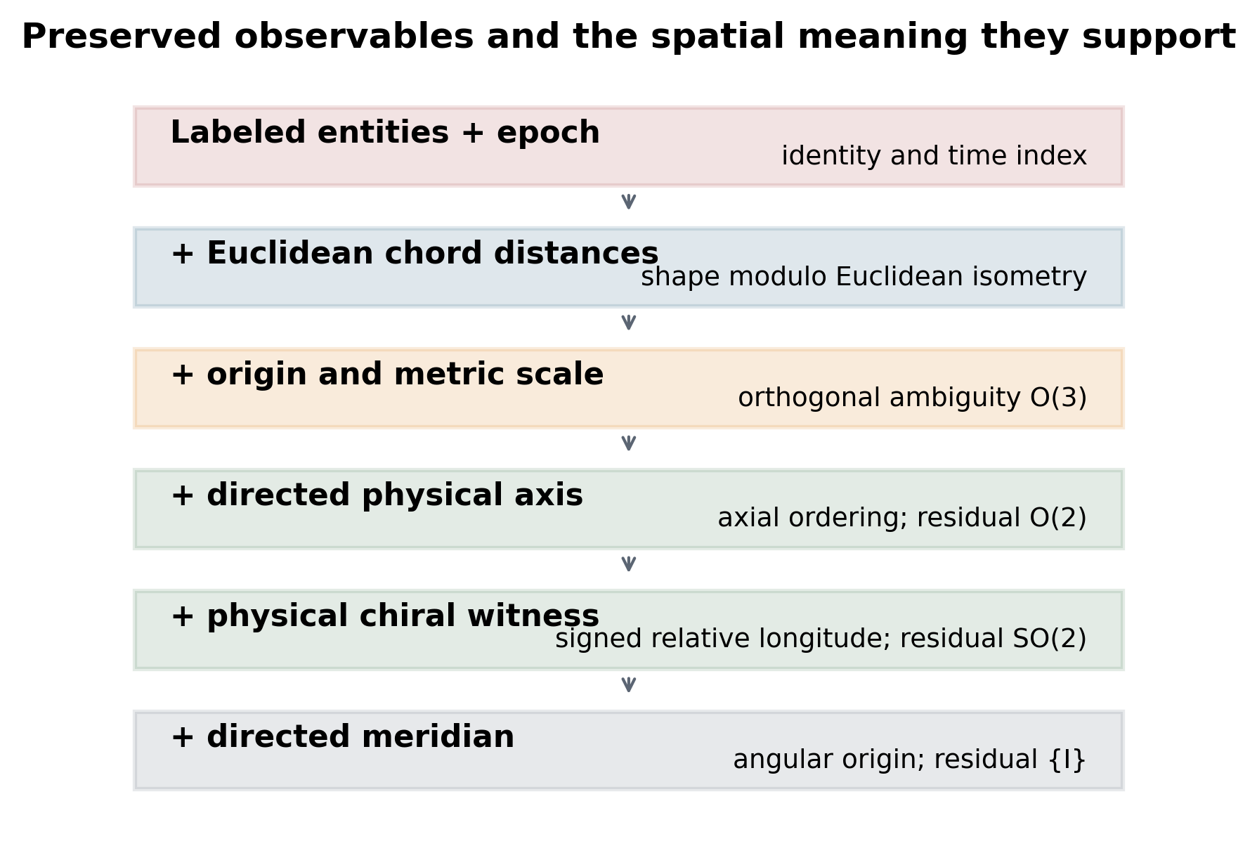
Fig. 1 Preserved observables and the spatial meaning they support. Each layer adds information not recoverable from the preceding layer under the stated Euclidean model.
Our question begins after that operational setting has failed: given only selected archived observables, which relational claims remain identifiable, and what residual invariance group remains? We focus on labeled Euclidean chord distances, axial ordering, signed relative longitude, and absolute angular origin. Fig. 1 separates the information layers. This is a sufficiency audit for archival observables, not a new datum-adjustment method.
The contribution is threefold: a corrected residual-invariance hierarchy that separates axis, physical chirality, and meridian information; explicit definitions and degeneracy states for directional relations; and a reproducible analysis of incomplete-network local rigidity, ellipsoid sensitivity, and epoch dependence in an ITRF2020 example. The synthetic reflection and corruption experiments serve as theorem validation rather than as empirical discoveries.

2 Geodetic observables and terminology
We follow IERS usage: a terrestrial reference system is the theoretical specification, whereas a terrestrial reference frame is its realization by coordinates and motions of physical points (Petit and Luzum 2010; Altamimi et al. 2023). A datum, coordinate reference system, and coordinate operation are metadata needed to interpret coordinate values, but none is identical to the physical relation being archived. An ellipsoid such as GRS80 specifies shape and gravity-related constants, not a complete time-evolving frame (Moritz 2000).
The theoretical distance is d_ij = ||x_i - x_j||_2 in a three-dimensional Euclidean embedding: a chord distance, not a surface geodesic on a sphere or ellipsoid. Surface-geodesic distance defines a different distance-geometry problem and is outside the present theorems.
For a nonzero directed axis s and nonzero point x measured from a specified origin, define generic axial latitude as phi_s(x) = asin[(s·x)/(||s||||x||)]. This becomes geocentric latitude only when the origin and directed axis have the corresponding terrestrial interpretation. It is not geodetic latitude, which uses the ellipsoid normal; astronomical latitude, which uses the local gravity direction; or magnetic latitude, which uses a magnetic-field model. We use north/south only when the directed axis has an independently defined physical interpretation.
For projections a_perp and b_perp onto the plane normal to s, define signed relative longitude by atan2[s·(b_perp × a_perp), a_perp·b_perp] on the principal branch (-pi, pi]. The relation is pairwise and is not a globally transitive total order. It is reported as undefined for axis projections and exact or near projected antipodes; same-meridian pairs are explicit ties. Branch-cut proximity is therefore a conditioning issue, not hidden by a forced east/west label.
We represent an archived relation event as E = {I, t_obs, t_ref, G, O, C, M, U, P}. I stores entity identifiers and identity hypotheses; t_obs and t_ref are observation and reference epochs; G is relational geometry; O contains origin and directed-axis information; C is a physically interpretable chiral witness; M is a directed meridian or equivalent angular anchor; U is uncertainty; and P records provenance and model assumptions. Entity identity and epoch recoverability are independent of geometric precision.

3 Identifiability theory
Let X = [x_1, ..., x_n]^T be labeled points in R^3 and let D contain d_ij = ||x_i - x_j||. Double centering of squared distances gives B = -1/2 J(D∘D)J, where J = I - 11^T/n. An eigendecomposition of B recovers centered coordinates whenever D is Euclidean. For a generic rank-three configuration, any other realization with the same D is XQ + 1c^T for orthogonal Q and translation c. If physical units are not stored, a scale factor is also free (Dokmanić et al. 2015; Liberti et al. 2014).
For a retained observable map F, we call the transformations Q for which F(QX) = F(X) the residual invariance group of those observables. This is an observational equivalence group, not the pointwise stabilizer of a generic realized configuration.
Proposition 1 (metric identifiability). For a generic complete labeled Euclidean distance matrix of embedding dimension three, the realization is unique only modulo translation and an element of O(3). Proof sketch: double centering determines the centered Gram matrix. Any rank-three factorization of that Gram matrix differs by an orthogonal factor. Because O(3) contains both proper and improper transformations, distance data do not select chirality.
After translation is removed and metric scale is known, the residual invariance group is O(3). Requiring an independently interpreted directed axis s leaves an O(2) residual invariance group because axial reflections remain. A physically recoverable chiral witness selects the proper branch and leaves SO(2), the rotations about s. An independently recoverable directed meridian removes that final rotation. Fig. 2 and Table 1 summarize the chain O(3) -> O(2) -> SO(2) -> {I}.
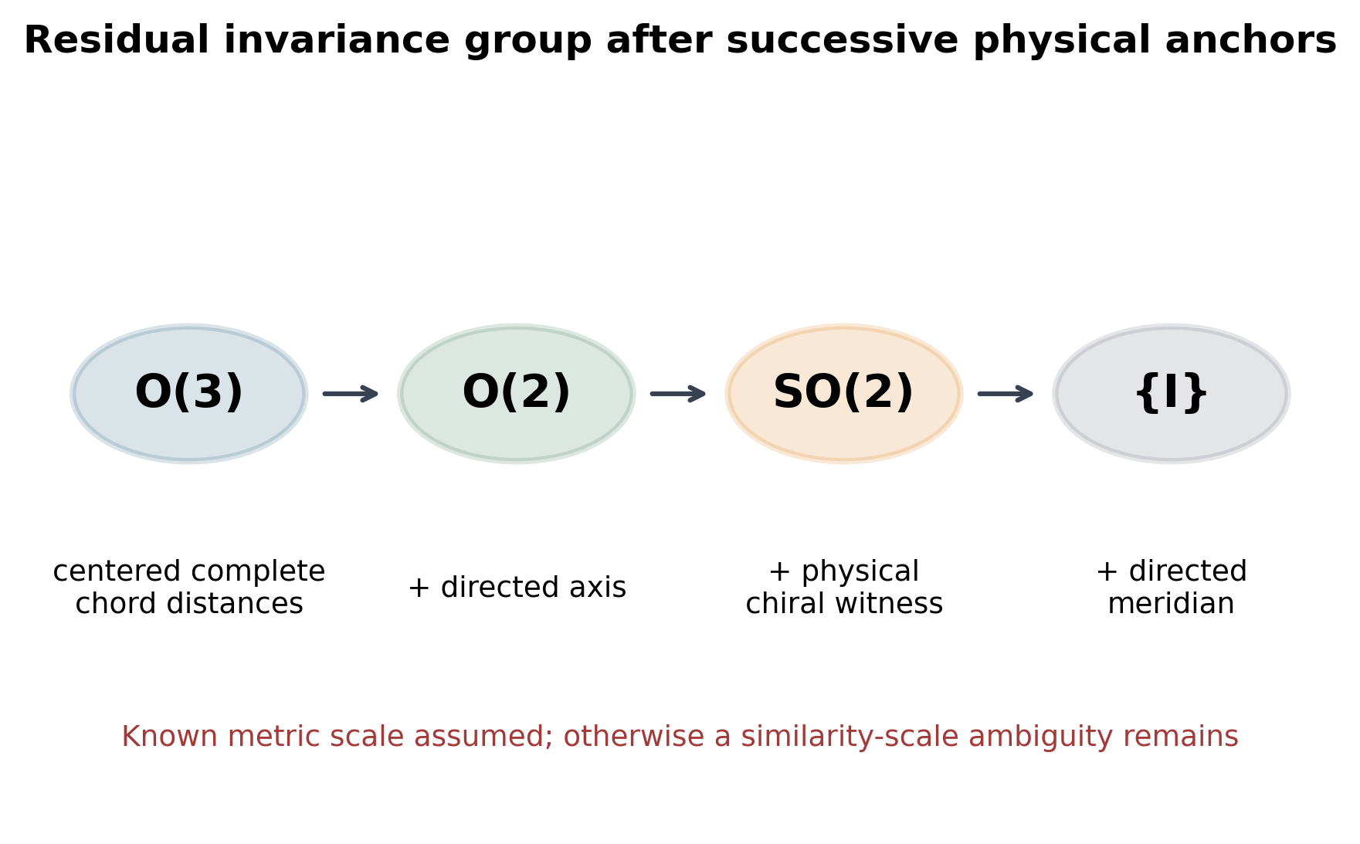
Fig. 2 Residual invariance group after successive physical anchors. Complete centered Euclidean chord distances leave O(3); a directed axis leaves O(2); an independently recoverable physical chiral witness leaves SO(2); and a directed meridian removes the final axial rotation.
Table 1 Information hierarchy and residual ambiguity under a rigid model.
Model | Stored Information | Identifiable Quantities | Remaining Ambiguity
M0 | labeled entities only | entity identity only | unconstrained geometry
M1 | + selected chord distances | recorded edge lengths | graph-dependent
M2 | + locally rigid distance graph with known metric scale | local Euclidean shape | Euclidean isometry E(3); possibly discrete noncongruent embeddings
M3 | + complete labeled Euclidean chord-distance matrix | global Euclidean shape for a generic full-dimensional configuration | translation and O(3)
M4 | + fixed origin or centered coordinates | origin-referenced shape | O(3)
M5 | + independently interpreted directed axis | axial latitude ordering | residual invariance group O(2)
M6 | + physically recoverable chiral witness | signed relative longitude away from degeneracies | proper axial rotations SO(2)
M7 | + independently recoverable directed meridian | absolute angular origin about the axis | identity
Metadata | + observation epoch, entity continuity, units, and model provenance | time-indexed physical interpretation | model and measurement uncertainty remain
Proposition 2 (axial-order invariance). Let Q be any orthogonal transformation applied jointly to centered points and directed axis. Because (Qs)·(Qx) = s·x and norms are preserved, axial latitude and its pairwise ordering are invariant under both proper and improper transformations. The directed sense is essential: replacing s by -s exchanges the ordering.
Proposition 3 (chirality dependence). Under the same joint orthogonal transformation, the scalar triple product defining the sine term is multiplied by det(Q), whereas the cosine term is unchanged. Signed relative longitude is therefore invariant under SO(3) and reverses under an axial reflection in O(3)\SO(3), as illustrated in Fig. 3. An algebraic orientation label resolves this ambiguity only if the physical interpretation of the label is independently recoverable; a coordinate-handedness convention alone is not a physical witness.
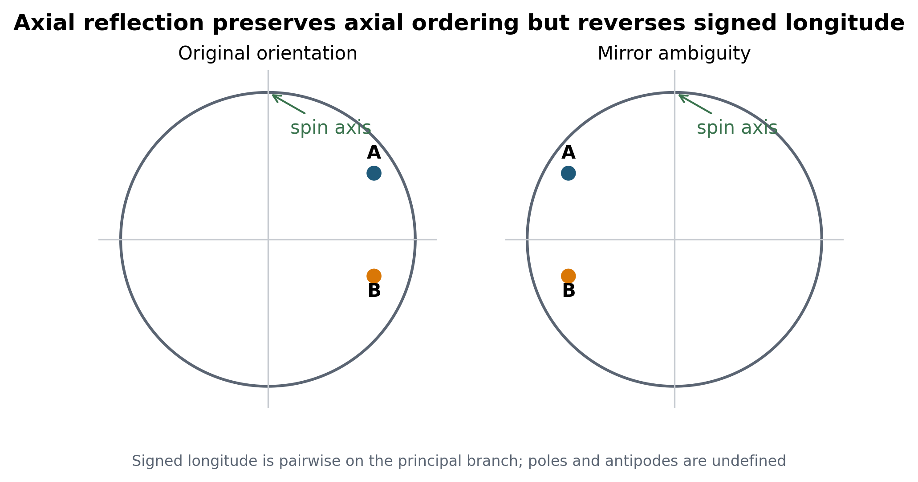
Fig. 3 Directional asymmetry under axial reflection. Generic axial-latitude ordering is preserved, whereas signed relative longitude reverses. The longitude relation is pairwise on the principal branch and is undefined at axis and projected-antipode degeneracies.
Proposition 4 (meridian necessity). With origin, directed axis, and physical chirality fixed, every proper rotation about s preserves distances, axial ordering, and signed relative longitudes. These observables cannot identify an absolute angular origin. A directed meridian or equivalent oriented external direction at the relevant epoch is required. Without physical chirality, axis plus meridian still leaves the reflection fixing both.
These statements concern identifiability, not necessarily stable estimation. Identifiability asks whether two admissible states can produce exactly the same retained information; conditioning asks how strongly noise in that information changes an estimate. A nearly coplanar oriented simplex may formally encode chirality while being numerically fragile. The archive must therefore store uncertainty and quality indicators for anchors rather than only a categorical claim that an anchor exists.
For incomplete distance graphs, local rigidity of a generic three-dimensional framework requires rigidity-matrix rank 3n - 6 (Asimow and Roth 1978, 1979). This rank condition removes the six infinitesimal Euclidean gauge motions but does not establish global rigidity or exclude disconnected noncongruent realizations. It is therefore used here as a limited network-identifiability diagnostic.

4 Materials and methods
The synthetic benchmark samples 24 points on a WGS84-shaped ellipsoid, forms the complete distance matrix, and reconstructs a three-dimensional configuration by classical multidimensional scaling. Proper and reflection-permitting Procrustes fits are computed independently from the same unaligned reconstruction using the determinant constraint of Kabsch (1976, 1978).
250 random proper rotations and axial reflections validate the directional invariance claims. 4000 Monte Carlo trials per condition perturb the axis and corrupt an algebraic orientation label; these are symmetry sanity checks, not models of physical witness survival. Wilson intervals quantify finite-simulation uncertainty. The frame taxonomy in Table 2 distinguishes the physical meaning and failure modes of candidate anchors.

Table 2 Reference-frame classes, physical anchors, and principal failure modes.
Frame | Physical Anchor | Preserving Transformations | Temporal Durability | Principal Failure Mode | North South Support | East West Support
Terrestrial reference frame | realized station coordinates and velocities | time-dependent Euclidean/Helmert mapping | high for modern epochs | network/model discontinuity | yes | yes
Celestial reference frame | extragalactic source directions | celestial rotations | high | source structure and realization change | with Earth orientation | with Earth orientation
Spin-axis frame | directed angular-momentum/rotation axis | rotation about axis and axial reflection | medium | polar motion and true polar wander | yes | only with physical chirality
Plate-fixed frame | rigid plate model | plate Euler rotation | medium | deformation and plate reorganization | model-dependent | model-dependent
Paleomagnetic frame | remanent field direction under field assumptions | axial rotations | geological | remagnetization and GAD violations | paleolatitude | not from paleomagnetism alone
Hotspot/mantle frame | hotspot tracks or mantle structures | model-specific plate rotations | geological | mantle motion and sparse anchors | model-dependent | model-dependent
Relative tectonic network | distances/rotations among blocks | network gauge transformations | geological | topology loss and deformation | only with axial anchor | only with orientation anchor
Hybrid redundant frame | independent geometric, axial, and physical anchors | intersection of preserved symmetries | highest conditional robustness | correlated anchor failure | yes | yes

The incomplete-network experiment draws generic points from a continuous three-dimensional distribution for n = 6, 8, 10, 12, 16. Every possible edge is retained independently with probability in {0.1, 0.2, 0.3, 0.4, 0.5, 0.6, 0.7, 0.8, 0.9, 1.0}, with 2000 point-and-graph trials per cell. We calculate the numerical rigidity-matrix rank, full-local-rigidity frequency, Wilson interval, and excess nullity after the six Euclidean gauge modes. Table 3 reports the first tested edge-retention probabilities with observed local-rigidity frequencies at or above 0.50 and 0.95; it is a seeded phase diagram, not a universal threshold.
Table 3 First tested edge-retention probabilities with observed local-rigidity frequencies at or above 0.50 and 0.95 in the seeded generic-random-framework experiment; these are not universal thresholds.
N Points | First Tested Edge Probability At Or Above 50Pct | First Tested Edge Probability At Or Above 95Pct | Complete Graph Local Rigidity Probability
6 | 0.8 | 1.0 | 1.0
8 | 0.7 | 0.9 | 1.0
10 | 0.6 | 0.7 | 1.0
12 | 0.5 | 0.7 | 1.0
16 | 0.4 | 0.6 | 1.0
Ellipsoid sensitivity compares WGS84 with GRS80 using identical seeded geodetic latitudes and longitudes. We report coordinate and chord-distance differences and agreement of axial-order and signed-longitude classifications. This isolates dependence on the reference ellipsoid from the group-theoretic claims.
For a realized geodetic demonstration, we parse the official ITRF2020 SLR station file at reference epoch 2015.0 (Altamimi et al. 2023). Stations with maximum Cartesian coordinate standard uncertainty no greater than 0.02 m are divided into longitude bins; the best station in each occupied bin is selected and supplemented from remaining eligible stations to obtain 16 sites. Positions are linearly propagated to 2025.0 using published velocities. This propagation is an epoch-sensitivity demonstration, not a complete nonlinear station-motion model.
Epoch sensitivity can be written schematically as x(t) = x(t_ref) + v(t - t_ref) + d(t), where v is a secular velocity and d contains discontinuities, seasonal signals, postseismic deformation, and other nonlinear terms. Dropping t_ref or the motion model makes a coordinate internally incomplete. Our 10-year linear calculation retains only the secular term so that the role of epoch is visible without conflating it with a station-specific geophysical model.
All reported numerical values are loaded from the generated result registry rather than copied into the document builder. Calculations use seed 20260924. Raw-input checksums, acquisition metadata, result traceability, code, tests, editable tables, and editable figure slides accompany the submission.

5 Results
The incomplete-network analysis produced a size-dependent transition in local rigidity (Fig. 4). For n = 16, full local rigidity occurred in 0.947 of trials at edge-retention probability 0.5 (95% Wilson interval 0.936–0.956) and 0.996 at 0.6. The latter 95% Wilson interval was 0.992–0.998. The first tested probability with an observed frequency at least 0.95 was therefore 0.6. Smaller frameworks required higher tested retention probabilities (Table 3). These frequencies characterize the configured random framework ensemble and do not imply global rigidity.
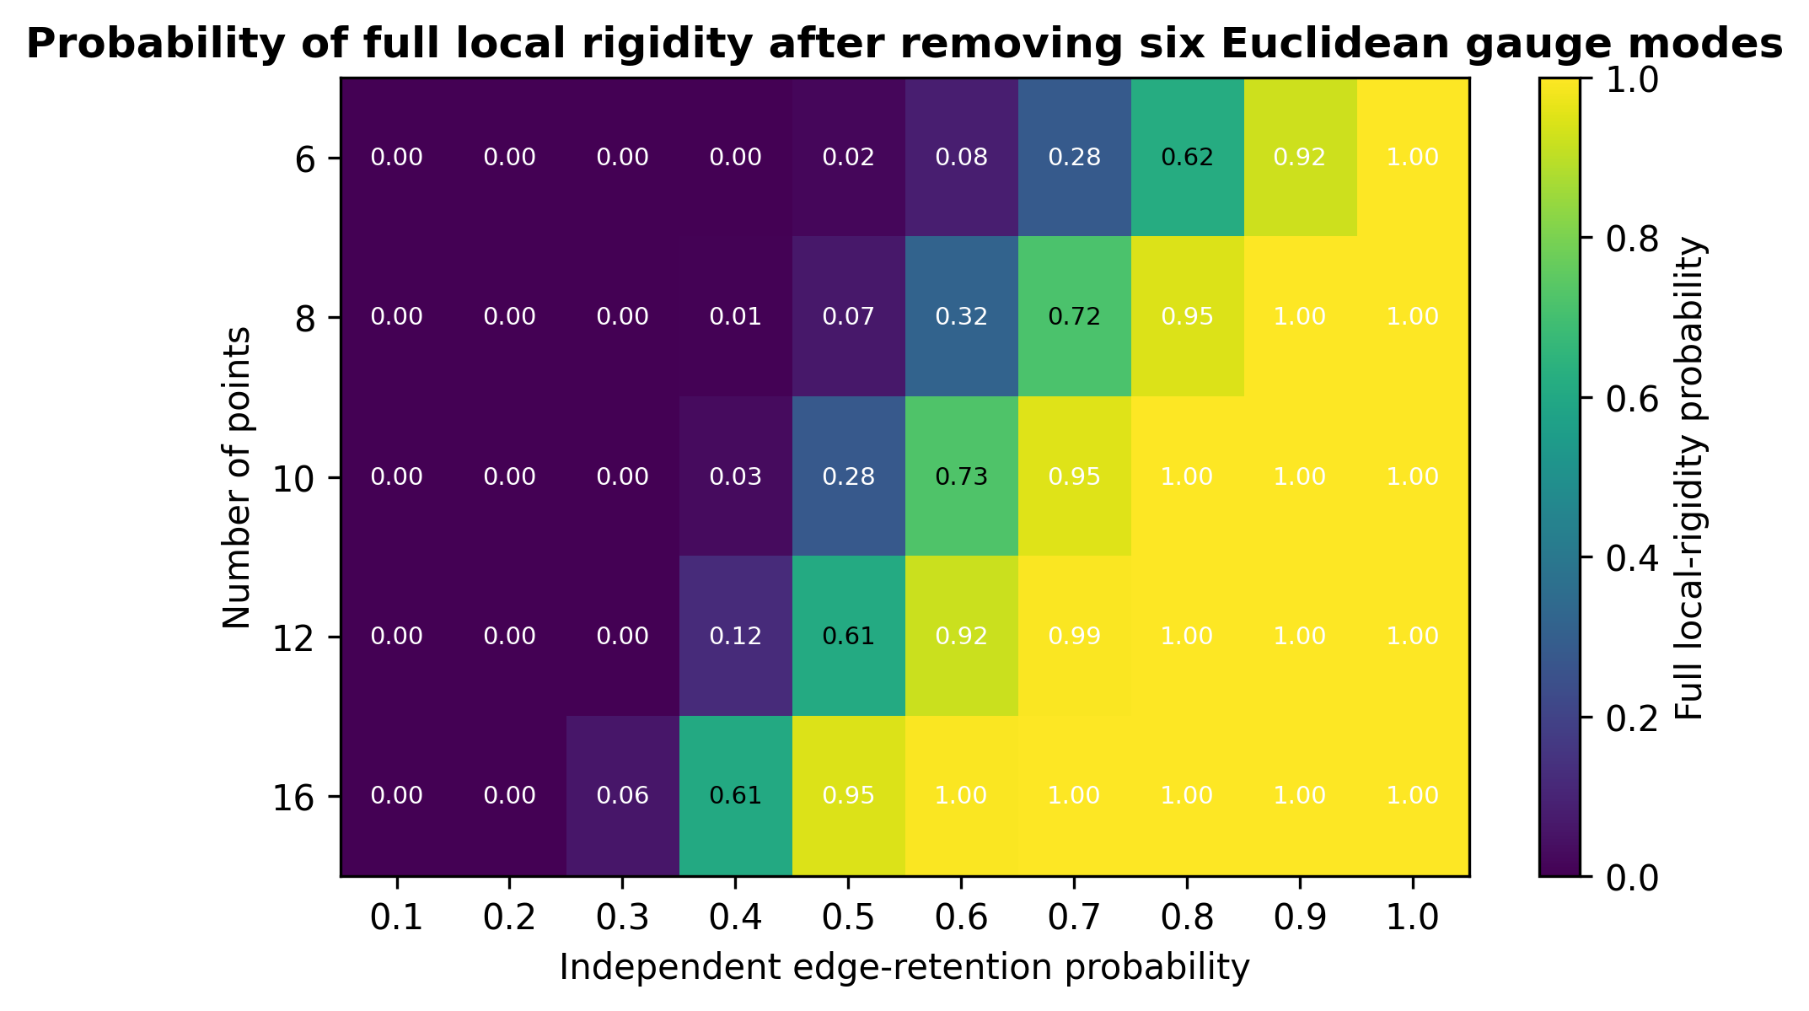
Fig. 4 Probability of full local rigidity for generic three-dimensional random frameworks. Each cell summarizes 2000 independently sampled point-and-edge realizations after the six infinitesimal Euclidean gauge modes are removed. The result concerns local rigidity, not global uniqueness.
Replacing WGS84 by GRS80 changed synthetic coordinates by at most 0.000121 m and Euclidean chord distances by at most 0.000225 m. Both axial-order and signed-longitude classifications agreed for all tested pairs. The sensitivity values are reported in Supplementary Table S1.
The complete distance matrix reconstructed the synthetic configuration with a reflection-permitting RMSE of 2.97e-09 m. For the seeded realization, constraining the alignment to a proper rotation exposed an RMSE of 6.136 million m, demonstrating that a numerically exact metric recovery need not recover handed orientation.
Across random proper rotations, north/south and east/west sign accuracies were both 1.000. Under axial reflection, north/south accuracy remained 1.000, whereas east/west agreement was 0.000. These validation results are shown in Supplementary Fig. S1.
The Monte Carlo sanity check separated axis noise from algebraic orientation-label corruption. At zero axis noise and label-corruption probabilities of 0.1 and 0.4, north/south accuracy remained 1.000; east/west accuracy decreased to 0.895 (95% Wilson interval 0.885–0.904) and 0.602 (95% Wilson interval 0.587–0.617), respectively (Supplementary Fig. S2).
The ITRF2020 demonstration selected 16 SLR stations (Fig. 5). Distance reconstruction again had negligible reflection-permitting RMSE (3.61e-09 m). A computational reflection preserved all axial-order signs and reversed all nondegenerate signed-longitude signs; it is a symmetry test, not a physically valid ITRF realization. From 2015.0 to 2025.0, the maximum absolute pairwise-distance change was 0.691 m and the median was 0.091 m.
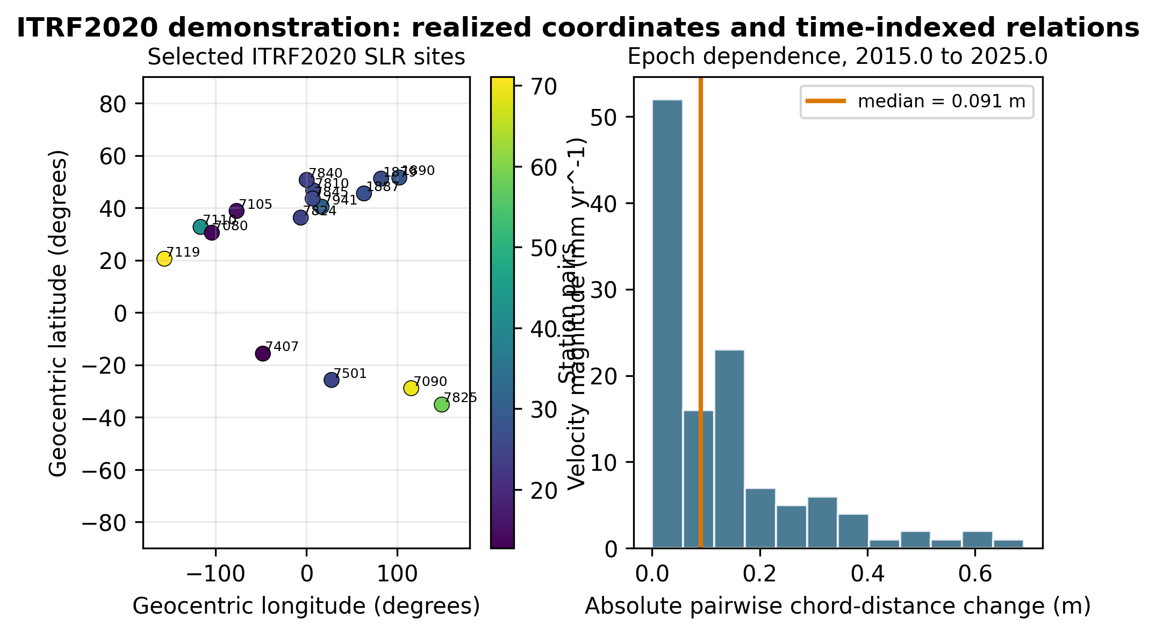
Fig. 5 ITRF2020 demonstration. The left panel shows the selected SLR sites and published velocity magnitudes. The right panel shows absolute pairwise Euclidean chord-distance changes after linear propagation from epoch 2015.0 to 2025.0; this is an epoch-sensitivity calculation, not a reflected physical realization.

6 Discussion
Why not simply store latitude, longitude, height, epoch, and the reference frame? That is the correct operational answer when the coordinate metadata, realization, transformation models, and software remain available. It is not equivalent to preserving the relation under metadata loss. Coordinates encode a chosen representation; distances encode frame-free metric information; a directed axis and physical chirality encode orientation; and redundant physical anchors provide independently testable recovery paths. Storing both coordinates and relational invariants is therefore not duplication: it permits detection of corruption, convention loss, or misapplied transformations.
The residual-invariance hierarchy complements, rather than replaces, free-network adjustment. Datum constraints choose or realize a coordinate representation within a gauge class; the present audit asks which claims are shared by every member of that class. Helmert alignment, minimum constraints, NNT/NNR conditions, and CRS metadata remain essential for operational coordinates, but they do not retroactively create a lost physical chiral witness or meridian anchor.
A plate-reconstruction model is likewise insufficient by itself. A model represents an interpretation conditioned on plate circuits, Euler rotations, paleomagnetic assumptions, hotspot or mantle anchors, and a particular absolute-longitude strategy. The model may become unavailable or superseded, and its parameters do not replace the underlying observations, uncertainty, provenance, or entity mapping. Global plate frames seek coherence among such constraints (Torsvik et al. 2008), but geological longitude remains more model-dependent than paleolatitude (Torsvik et al. 2012; Torsvik and Cocks 2019). The appropriate archival response is to store model version and outputs together with constraints and uncertainty, not to label paleolongitude categorically impossible.
The hierarchy shows why additional anchors should be independent. Multiple coordinates derived from the same frame operation are correlated copies, not redundant physical evidence. A hybrid archive should combine labeled distances, physical chirality, directed-axis evidence, epoch/time-scale metadata, and provenance whose failure modes are not identical.
Reference-frame durability is consequently relation-specific. A terrestrial frame is precise for modern crust-fixed coordinates but depends on maintained stations and motion models. A celestial frame offers inertial orientation but requires Earth-orientation links for terrestrial directions. A spin-axis frame supports axial ordering but not a meridian. Plate-fixed, paleomagnetic, hotspot, and mantle frames extend to geological time only through additional physical assumptions. Calling any one of these frames 'permanent' without naming the preserved relation hides the actual invariance class.
A machine-readable implementation of E should preserve values, units, coordinate and time scales, identifier namespaces, covariance or samples, source checksums, model versions, and explicit statements of which symmetries remain unresolved. Reconstruction software should emit both an estimate and an ambiguity descriptor—for example, 'unique up to axial reflection'—so later users cannot mistake a chosen convention for recovered evidence.
Entity identity is a separate inverse problem. A perfect frame cannot decide whether a historical name denotes a monument, a moving plate, a city footprint, or a semantic region. Candidate mappings and their probabilities belong in I and U, and spatial reconstruction should be conditional on them.

7 Limitations
The formal results assume labeled points, a Euclidean embedding, a known metric scale, a recoverable origin for axial projection, and generic nondegenerate configurations. Real archives may contain incomplete distance graphs, deformation, topological change, scale loss, and correlated anchor errors. Surface-geodesic and non-Euclidean distance models require separate theorems. Local rigidity rank neither proves global uniqueness nor solves graph completion and identity inference.
The ITRF example demonstrates symmetry and epoch sensitivity in a modern realized network. It does not validate million-year station propagation, plate reconstructions, paleomagnetic field models, or mantle frames. Linear station velocities over ten years are used only to make the epoch dependence directly auditable.
A meridian or chiral witness can be physically defined in several ways, but recoverability, independence, uncertainty, and deformation must be assessed for each application. Paleolongitude remains model-dependent, and neither the hierarchy nor the ITRF demonstration validates a particular deep-time reconstruction mechanism.

8 Conclusions
Preserving historical direction requires more than preserving coordinates or distances. Complete distances preserve metric shape up to orthogonal gauge freedom. A directed physical axis supports axial ordering, a recoverable physical chiral witness supports signed relative longitude, and a directed meridian supports absolute angular origin. Epoch, entity identity, metric scale, uncertainty, and provenance are independent requirements.
A practical archive should therefore retain the original coordinate representation and frame metadata, relational invariants, orientation anchors, explicit epochs, uncertainty, and provenance. The correct output when information is missing is an ambiguity class or probability—not an unjustified unique reconstruction.

Declarations

Funding
[To be completed locally before submission.]

Competing interests
[To be completed locally before submission.]

Author contributions
Tatsuki Onishi: Conceptualization, methodology, validation, formal analysis, investigation, data curation, writing—original draft, writing—review and editing, visualization, supervision, and project administration.

Data availability
The persisted ITRF2020 SLR source file, its checksum ledger, the processed station selection, simulation configurations, and generated numerical results are available in the public repository at https://github.com/bougtoir/deep-time-reference-systems. The authoritative ITRF source is https://itrf.ign.fr/ftp/pub/itrf/itrf2020/ITRF2020_SLR.SSC.txt.

Code availability
The complete reproducible Python analysis and document-generation pipeline, pinned configuration, tests, and reproducibility archive are available at https://github.com/bougtoir/deep-time-reference-systems.

Ethics approval
Not applicable. The study uses synthetic geometry and public geodetic station products and involves no human participants or animals.

Generative AI disclosure
During preparation of this work, the author used the Devin web service by Cognition (no user-visible version identifier; used 24–25 September 2026). Prompts requested targeted literature-metadata verification, Python implementation and checking, deterministic simulation replication, figure/table/document generation, numerical reconciliation, and language revision. The tool assisted with those tasks but did not supply empirical source data or generate experimental images; all numerical results and display items were regenerated by the disclosed code from persisted inputs and configurations. The author reviewed and verified the code, outputs, references, figures, and text, made the scientific and editorial decisions, and takes full responsibility for the content.

References
Altamimi Z, Sillard P, Boucher C (2002) ITRF2000: a new release of the International Terrestrial Reference Frame for earth science applications. Journal of Geophysical Research: Solid Earth 107(B10):ETG 2-1–ETG 2-19. https://doi.org/10.1029/2001JB000561
Altamimi Z, Sillard P, Boucher C (2003) The impact of a no-net-rotation condition on ITRF2000. Geophysical Research Letters 30(2):1064. https://doi.org/10.1029/2002GL016279
Altamimi Z, Rebischung P, Collilieux X, Métivier L, Chanard K (2023) ITRF2020: an augmented reference frame refining the modeling of nonlinear station motions. Journal of Geodesy 97:47. https://doi.org/10.1007/s00190-023-01738-w
Asimow L, Roth B (1978) The rigidity of graphs. Transactions of the American Mathematical Society 245:279–289. https://doi.org/10.1090/S0002-9947-1978-0511410-9
Asimow L, Roth B (1979) The rigidity of graphs, II. Journal of Mathematical Analysis and Applications 68:171–190. https://doi.org/10.1016/0022-247X(79)90108-2
Bevis M, Brown A (2014) Trajectory models and reference frames for crustal motion geodesy. Journal of Geodesy 88:283–311. https://doi.org/10.1007/s00190-013-0685-5
Chatzinikos M, Dermanis A (2017) A coordinate-invariant model for deforming geodetic networks: understanding rank deficiencies, non-estimability of parameters, and the effect of the choice of minimal constraints. Journal of Geodesy 91:375–396. https://doi.org/10.1007/s00190-016-0970-1
Dokmanić I, Parhizkar R, Ranieri J, Vetterli M (2015) Euclidean distance matrices: essential theory, algorithms, and applications. IEEE Signal Processing Magazine 32(6):12–30. https://doi.org/10.1109/MSP.2015.2398954
Glaser S, Fritsche M, Sośnica K et al (2015) A consistent combination of GNSS and SLR with minimum constraints. Journal of Geodesy 89:1165–1180. https://doi.org/10.1007/s00190-015-0842-0
International Organization for Standardization (2019) ISO 19111:2019 Geographic information—Referencing by coordinates. ISO, Geneva. https://www.iso.org/standard/74039.html
Kabsch W (1976) A solution for the best rotation to relate two sets of vectors. Acta Crystallographica Section A 32:922–923. https://doi.org/10.1107/S0567739476001873
Kabsch W (1978) A discussion of the solution for the best rotation to relate two sets of vectors. Acta Crystallographica Section A 34:827–828. https://doi.org/10.1107/S0567739478001680
Kotsakis C (2012) Reference frame stability and nonlinear distortion in minimum-constrained network adjustment. Journal of Geodesy 86:755–774. https://doi.org/10.1007/s00190-012-0555-6
Kotsakis C (2013) Generalized inner constraints for geodetic network densification problems. Journal of Geodesy 87:661–673. https://doi.org/10.1007/s00190-013-0637-0
Kotsakis C, Chatzinikos M (2017) Rank defect analysis and the realization of proper singularity in normal equations of geodetic networks. Journal of Geodesy 91:627–652. https://doi.org/10.1007/s00190-016-0989-3
Liberti L, Lavor C, Maculan N, Mucherino A (2014) Euclidean distance geometry and applications. SIAM Review 56(1):3–69. https://doi.org/10.1137/120875909
Moritz H (2000) Geodetic Reference System 1980. Journal of Geodesy 74:128–133. https://doi.org/10.1007/s001900050278
Papo HB (1985) Extended free net adjustment constraints. Bulletin Géodésique 59:378–390. https://doi.org/10.1007/BF02521070
Petit G, Luzum B (eds) (2010) IERS Conventions (2010). IERS Technical Note 36. https://iers-conventions.obspm.fr/content/tn36.pdf
Sillard P, Boucher C (2001) A review of algebraic constraints in terrestrial reference frame datum definition. Journal of Geodesy 75:63–73. https://doi.org/10.1007/S001900100166
Torsvik TH, Müller RD, Van der Voo R, Steinberger B, Gaina C (2008) Global plate motion frames: toward a unified model. Reviews of Geophysics 46:RG3004. https://doi.org/10.1029/2007RG000227
Torsvik TH, Van der Voo R, Preeden U et al (2012) Phanerozoic polar wander, palaeogeography and dynamics. Earth-Science Reviews 114:325–368. https://doi.org/10.1016/j.earscirev.2012.06.007
Torsvik TH, Cocks LRM (2019) The integration of palaeomagnetism, the geological record and mantle tomography in the location of ancient continents. Geological Magazine 156:242–260. https://doi.org/10.1017/S001675681700098X
Zajdel R, Sośnica K, Drożdżewski M, Bury G, Strugarek D (2019) Impact of network constraining on the terrestrial reference frame realization based on SLR observations to LAGEOS. Journal of Geodesy 93:2293–2313. https://doi.org/10.1007/s00190-019-01307-0

