Supplementary information
Identifiability of spatial relations under geodetic datum and reference-frame loss

S1 Formal assumptions and degeneracies
The distance result assumes a labeled Euclidean distance matrix of embedding dimension at most three. Sparse graphs may admit flexes or multiple discrete realizations. Repeated points, collinear or coplanar simplices, axis-pole locations, and projected antipodes are treated as degeneracies rather than forced directional classifications.
Generic axial ordering requires an origin and a directed axis. An undirected axis leaves its labels exchangeable. Signed relative longitude requires a physically recoverable chiral witness; absolute angular origin requires an additional directed meridian. A stored orientation bit without recoverable physical meaning does not remove the reflection ambiguity.

S2 Computational algorithms
Classical multidimensional scaling uses the three largest positive eigenpairs of the double-centered squared-distance matrix. Procrustes alignment uses a singular-value decomposition and explicitly constrains the determinant when reflection is forbidden. Direction signs are evaluated from normalized axial projections and a two-argument arctangent on the principal branch. The rigidity analysis uses numerical rank of the three-dimensional rigidity matrix with an SVD tolerance scaled by matrix dimensions and machine precision.

S3 Reproducibility configuration
seed: 20260924
synthetic:
n_points: 24
n_frame_trials: 250
monte_carlo_trials: 4000
ellipsoid:
name: WGS84
semi_major_axis_m: 6378137.0
inverse_flattening: 298.257223563
ellipsoid_sensitivity:
name: GRS80
semi_major_axis_m: 6378137.0
inverse_flattening: 298.257222101
anchor_corruption_probabilities: [0.0, 0.01, 0.05, 0.1, 0.2, 0.4]
angular_noise_degrees: [0.0, 0.01, 0.05, 0.1, 0.25, 0.5]
rigidity:
n_points: [6, 8, 10, 12, 16]
edge_probabilities: [0.1, 0.2, 0.3, 0.4, 0.5, 0.6, 0.7, 0.8, 0.9, 1.0]
trials: 2000
seed_offset: 1000
real_data:
source: data/raw/itrf2020/ITRF2020_SLR.SSC.txt
reference_epoch: 2015.0
comparison_epoch: 2025.0
max_coordinate_sigma_m: 0.02
n_sites: 16

S4 ITRF2020 selected stations
Table 1 Selected ITRF2020 SLR stations and epochs.
Domes | Site Name | Technique Id | Latitude Degrees | Longitude Degrees | Reference Epoch | Comparison Epoch
40445M004 | MAUI | 7119 | 20.579588011218565 | -156.25692679418262 | 2015.0 | 2025.0
40497M001 | Monument Peak | 7110 | 32.716542819713 | -116.4226784499638 | 2015.0 | 2025.0
40442M006 | FORT DAVIS | 7080 | 30.5117098111711 | -104.01519959418388 | 2015.0 | 2025.0
40451M105 | Washington | 7105 | 38.83248993117698 | -76.8276968652703 | 2015.0 | 2025.0
48081S001 | Campus Universi | 7407 | -15.67269811883136 | -47.86529338063169 | 2015.0 | 2025.0
13402S007 | SAN FERNANDO | 7824 | 36.28149367442857 | -6.20530671391078 | 2015.0 | 2025.0
14001S007 | Zimmerwald | 7810 | 46.68520770658857 | 7.465224516900016 | 2015.0 | 2025.0
30302M003 | Hartebeesthoek | 7501 | -25.73887838935569 | 27.686177286269704 | 2015.0 | 2025.0
25603S001 | Baikonur Cosmod | 1887 | 45.51259179864986 | 63.34241682566955 | 2015.0 | 2025.0
12372S001 | Altay | 1879 | 51.15604735269942 | 82.17729836577405 | 2015.0 | 2025.0
12338S004 | Badary | 1890 | 51.58283480322939 | 102.23536268348586 | 2015.0 | 2025.0
50107M001 | Yarragadee | 7090 | -28.883434983501672 | 115.346753302934 | 2015.0 | 2025.0
50119S003 | Mount Stromlo | 7825 | -35.13482884193121 | 149.0098822886652 | 2015.0 | 2025.0
12734S008 | Matera | 7941 | 40.4585779422104 | 16.7046145471105 | 2015.0 | 2025.0
13212S001 | Herstmonceux Ca | 7840 | 50.67885528360768 | 0.3361285649584317 | 2015.0 | 2025.0
10002S002 | Grasse (OCA) | 7845 | 43.56246101585594 | 6.921576461282378 | 2015.0 | 2025.0

S5 Incomplete-network and ellipsoid sensitivity
Table S1 WGS84–GRS80 sensitivity for the seeded point set.
Metric | Value | Unit
ellipsoid_maximum_coordinate_difference_m | 0.0001210656051966 | m
ellipsoid_median_coordinate_difference_m | 0.0001025915363387 | m
ellipsoid_maximum_chord_distance_difference_m | 0.0002250224351882 | m
ellipsoid_median_chord_distance_difference_m | 4.020938649773598e-05 | m
ellipsoid_axial_ordering_agreement | 1.0 | proportion
ellipsoid_signed_longitude_agreement | 1.0 | proportion

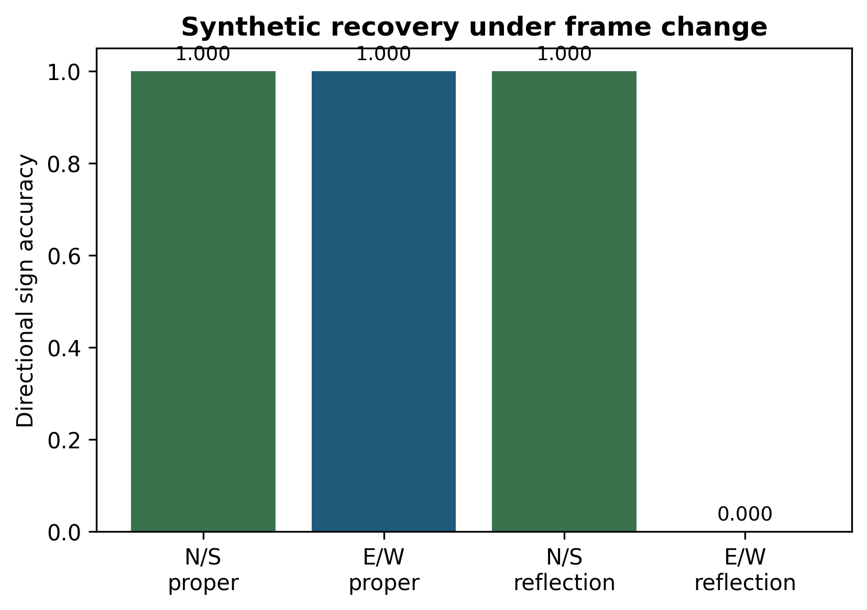
Supplementary Fig. S1 Synthetic theorem-validation benchmark. Proper rotations preserve both tested directional signs; axial reflection preserves axial ordering and reverses signed longitude.
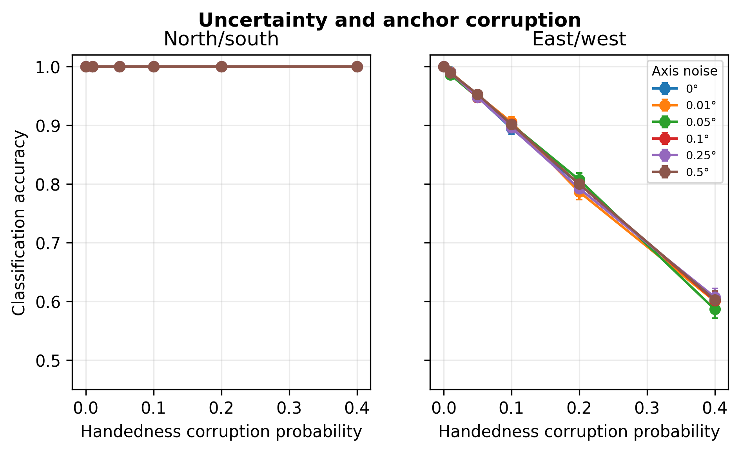
Supplementary Fig. S2 Seeded axis-noise and algebraic-orientation-corruption experiment. The curves are conditional simulation checks and are not estimates of physical anchor survival.

S6 Numerical result registry
Table S2 Machine-generated values used in the manuscript.
Metric | Value | Source | Unit
synthetic_number_of_points | 24.0 | synthetic_benchmark | proportion_or_m
synthetic_frame_trials | 250.0 | synthetic_benchmark | proportion_or_m
synthetic_monte_carlo_trials_per_condition | 4000.0 | synthetic_benchmark | proportion_or_m
distance_reconstruction_rmse_allow_reflection_m | 2.970170222267324e-09 | synthetic_benchmark | proportion_or_m
distance_reconstruction_rmse_proper_only_m | 6136173.251345326 | synthetic_benchmark | proportion_or_m
proper_rotation_north_south_accuracy | 1.0 | synthetic_benchmark | proportion_or_m
proper_rotation_east_west_accuracy | 1.0 | synthetic_benchmark | proportion_or_m
reflection_north_south_accuracy | 1.0 | synthetic_benchmark | proportion_or_m
reflection_east_west_accuracy | 0.0 | synthetic_benchmark | proportion_or_m
n_selected_sites | 16.0 | itrf2020_demonstration | count
maximum_coordinate_standard_uncertainty_m | 0.02 | itrf2020_demonstration | m
distance_reconstruction_rmse_m | 3.613275939091764e-09 | itrf2020_demonstration | m
axial_reflection_north_south_accuracy | 1.0 | itrf2020_demonstration | proportion
axial_reflection_east_west_accuracy | 0.0 | itrf2020_demonstration | proportion
maximum_pairwise_distance_change_m | 0.6906252605840564 | itrf2020_demonstration | m
median_pairwise_distance_change_m | 0.0907241012901067 | itrf2020_demonstration | m
reference_epoch | 2015.0 | itrf2020_demonstration | decimal_year
comparison_epoch | 2025.0 | itrf2020_demonstration | decimal_year
random_seed | 20260924.0 | configuration | integer
ellipsoid_maximum_coordinate_difference_m | 0.0001210656051966 | ellipsoid_sensitivity | m
ellipsoid_median_coordinate_difference_m | 0.0001025915363387 | ellipsoid_sensitivity | m
ellipsoid_maximum_chord_distance_difference_m | 0.0002250224351882 | ellipsoid_sensitivity | m
ellipsoid_median_chord_distance_difference_m | 4.020938649773598e-05 | ellipsoid_sensitivity | m
ellipsoid_axial_ordering_agreement | 1.0 | ellipsoid_sensitivity | proportion
ellipsoid_signed_longitude_agreement | 1.0 | ellipsoid_sensitivity | proportion
rigidity_largest_network_n_points | 16.0 | rigidity_phase_diagram | count
rigidity_trials_per_cell | 2000.0 | rigidity_phase_diagram | count
rigidity_95pct_threshold_edge_probability | 0.6 | rigidity_phase_diagram | probability
rigidity_probability_at_95pct_threshold | 0.996 | rigidity_phase_diagram | proportion
rigidity_95pct_threshold_95ci_lower | 0.992126535703962 | rigidity_phase_diagram | proportion
rigidity_95pct_threshold_95ci_upper | 0.9979717533930348 | rigidity_phase_diagram | proportion
rigidity_edge_probability_before_95pct_threshold | 0.5 | rigidity_phase_diagram | probability
rigidity_probability_before_95pct_threshold | 0.9465 | rigidity_phase_diagram | proportion
rigidity_probability_before_95pct_threshold_95ci_lower | 0.935754264314357 | rigidity_phase_diagram | proportion
rigidity_probability_before_95pct_threshold_95ci_upper | 0.955533812463484 | rigidity_phase_diagram | proportion
north_south_accuracy_at_0.1_chirality_corruption | 1.0 | uncertainty_benchmark | proportion
east_west_accuracy_at_0.1_chirality_corruption | 0.895 | uncertainty_benchmark | proportion
east_west_accuracy_at_0.1_chirality_corruption_95ci_lower | 0.8851180041126476 | uncertainty_benchmark | proportion
east_west_accuracy_at_0.1_chirality_corruption_95ci_upper | 0.9041240356884884 | uncertainty_benchmark | proportion
north_south_accuracy_at_0.4_chirality_corruption | 1.0 | uncertainty_benchmark | proportion
east_west_accuracy_at_0.4_chirality_corruption | 0.60225 | uncertainty_benchmark | proportion
east_west_accuracy_at_0.4_chirality_corruption_95ci_lower | 0.5869914415518415 | uncertainty_benchmark | proportion
east_west_accuracy_at_0.4_chirality_corruption_95ci_upper | 0.6173123522954146 | uncertainty_benchmark | proportion

S7 Test coverage
The automated suite covers rigid-transform distance invariance, independent proper and reflection-permitting alignment, simplex chirality, local ENU basis orthonormality, proper-rotation direction invariance, axial-reflection direction asymmetry, branch wrapping, same-meridian ties, pole and exact/near-antipode degeneracies, rigidity rank, ITRF parsing and site count, configuration-dependent epoch labels, nondefault uncertainty grids, and seeded reproducibility.

S8 Interpretation of main numerical values
The proper-only mirror ambiguity is 6.136 million m for the seeded point set. This value characterizes the selected configuration and is not a universal Earth-scale constant.
The local-rigidity frequencies are Monte Carlo summaries for independently sampled generic points and Bernoulli edge retention. They do not establish global rigidity, geodetic network optimality, or a universal density threshold.

