Recoverability-aware records for spatial relations under incomplete reference-frame metadata
Tatsuki Onishi
[Affiliation to be confirmed]
Correspondence: bougtoir@gmail.com
Methodology — Earth Science Informatics

Abstract
Coordinates are interpretable only with their coordinate reference system, frame realization, epoch and transformation; when this metadata is lost or silently corrupted, software still returns a unique answer. I present a versioned, machine-readable record for time-indexed spatial relations, a validator and a decoder that report, per task, whether a relation is unique, unique up to a residual group, set-valued, probabilistic, non-identifiable or invalid. The record stores coordinates with complete metadata, labelled distances, origin, axis, chirality and meridian anchors whose evidence type is explicit, uncertainty and SHA-256 provenance. I benchmarked six representations on 16 ITRF2020 satellite-laser-ranging stations, 16 intact, loss and corruption scenarios and random field deletion. The baseline carries complete metadata and a coordinate fixity checksum, and its redundant variant repairs fields missing from either copy. With intact metadata both recovered every task. Under a silent handedness flip the baseline gave false certainty on 0.274 of task items, and on 0.415 when values from the wrong epoch were exported with a re-issued checksum; the proposed record gave none, but in the latter case it returned 0.391 of items as set-valued, whereas a coordinate-free relations-and-anchors record recovered all. Under independent field deletion no proposed record produced false certainty (95% upper bound 0.006); the redundant baseline did so in at most 0.018 of records but retained equal or greater coverage at every rate. A chirality witness that is a digital copy failed exactly like a missing witness. The contribution is safety under specified metadata loss, not superiority with complete metadata.
Keywords: coordinate reference system metadata; data provenance; uncertainty; identifiability; geodetic reference frame; data validation

1 Introduction
A coordinate tuple is not a location by itself. Its meaning depends on a coordinate reference system (CRS), a datum or reference-frame realization, a coordinate epoch and the coordinate operations applied to it (ISO 2019; Petit and Luzum 2010). Terrestrial reference frames such as ITRF2020 realize origin, scale, orientation and time evolution from observations (Altamimi et al. 2023), and station positions are epoch-dependent (Bevis and Brown 2014). In data systems the numeric values routinely outlive this context: sidecar files are dropped in format conversion, axis-order conventions are misread, epochs are left implicit and provenance is not updated when values are edited.
The usual informatics answer is complete metadata: ISO 19111 and its OGC abstract specification define dynamic CRSs, coordinate epochs and point-motion operations, and PROJJSON serializes them (ISO 2019; OGC 2019; PROJ 2023). When that metadata is present and correct it is sufficient, and I show this explicitly. The failure addressed here is different: when metadata is missing or silently wrong, a consumer that reads coordinates still returns a single, precise-looking answer. Nothing in the data tells it that a signed east–west relation or an absolute longitude has become non-identifiable.
This paper contributes (i) a versioned JSON record for time-indexed spatial relations that stores, alongside coordinates and complete reference-system metadata, frame-free relational evidence and independent physical anchors whose evidence type is explicit; (ii) a validator and a decoder that return a per-task recoverability state instead of coercing ambiguity into one coordinate; and (iii) a reproducible benchmark against a strong coordinate-plus-metadata baseline under specified loss and corruption modes, with ablations, calibration and cost. The mathematics in Sect. 3 is used as a foundation and is not claimed as new.

2 Related work
Standards. ISO 19111 and OGC Topic 2 model CRSs, datum ensembles, dynamic frames, coordinate epochs and transformations (ISO 2019; OGC 2019); PROJJSON encodes them (PROJ 2023). ISO 19115-1 and ISO 19157-1 describe lineage and positional accuracy (ISO 2014, 2023). W3C PROV-O and OWL-Time express provenance and temporal entities (W3C 2013, 2022), GeoSPARQL 1.1 standardizes topological relations and their querying (OGC 2024; Car and Homburg 2022), and OAIS defines preservation of representation information (CCSDS 2024). These specify how to describe a CRS or lineage; none returns a machine-readable statement of which relations remain identifiable when parts of that description are lost.
Earth science informatics. Provenance tracing (Barkstrom 2010; Tilmes et al. 2010), common data models (Nativi et al. 2008), spatio-temporal knowledge representation (Galton 2009), regridding architectures (Shippert and Gaustad 2017), decentralized metadata management (Fugazza et al. 2021) and semantic interoperability (Lakani et al. 2026) address description and exchange. Uncertainty propagation in GIS and model chains (Heuvelink et al. 1989; Bastin et al. 2013), FAIR principles (Wilkinson et al. 2016), persistent identifiers (Klump and Huber 2017) and geospatial knowledge graphs (Hogan et al. 2022; Janowicz et al. 2022) complement them. Qualitative spatial reasoning formalizes topology and orientation relations (Egenhofer and Franzosa 1991; Freksa 1992) but assumes a shared orientation frame. Plate-reconstruction software makes deep-time frames explicit through models (Müller et al. 2018).
Geodesy and geometry. Datum defects, free-network adjustment and minimum constraints are mature topics (Sillard and Boucher 2001; Kotsakis and Chatzinikos 2017; Chatzinikos and Dermanis 2017). Distance geometry and Procrustes alignment give recovery up to Euclidean motions (Kabsch 1976; Liberti et al. 2014; Dokmanić et al. 2015), and rigidity theory characterizes incomplete distance graphs (Asimow and Roth 1978). The present work reuses these results to define what a data record must carry and what a consumer may claim.

3 Foundations: observables and residual invariance
Let $X={[x_{1},…,x_{n}]}^{T}$ be labelled points in $ℝ^{3}$ with chord distances $d_{ij}=‖x_{i}−x_{j}‖$. Double centring, $B=−\frac{1}{2} J(D∘D)J$ with $J=I−11^{T}/n$, recovers a configuration unique up to translation and an orthogonal transformation (Dokmanić et al. 2015). An independent origin removes translation, a directed axis $s$ leaves $O(2)$, a physically recoverable chiral witness leaves $SO(2)$ and a directed meridian leaves the identity (Fig. 1). Axial latitude $ϕ_{s}(x)=arcsin\frac{s·x}{‖s‖ ‖x‖}$ is invariant under the whole group, whereas the signed relative longitude $atan2[s·(b_{⟂}×a_{⟂}), a_{⟂}·b_{⟂}]$ on $−π<λ≤π$ is multiplied in sign by $det(Q)$. Table 1 lists the resulting task-level identifiability.
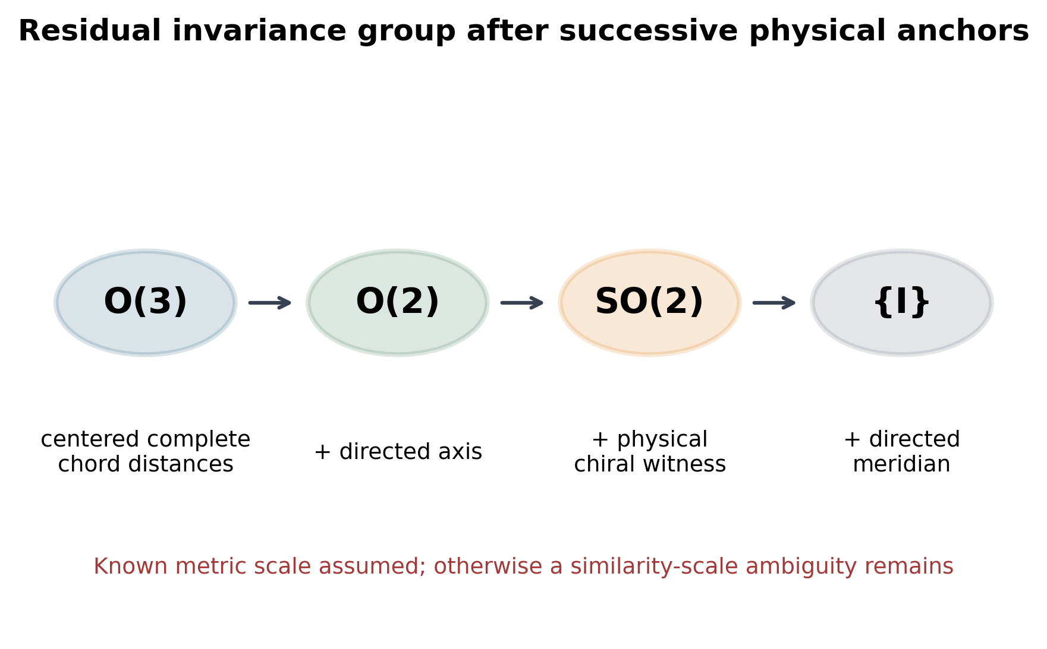
Fig. 1 Residual invariance group of the retained observables after successive independent physical anchors (known results; Sect. 3). Complete centred chord distances leave O(3); a directed axis leaves O(2); an independently recoverable chiral witness leaves SO(2); a directed meridian removes the final rotation. Metric scale is assumed known.
Table 1 Task-level identifiability under successive independent anchors (rigid model, known scale).
Model | Stored information | Identifiable quantities | Remaining ambiguity
M0 | labeled entities only | entity identity only | unconstrained geometry
M1 | + selected chord distances | recorded edge lengths | graph-dependent
M2 | + locally rigid distance graph with known metric scale | local Euclidean shape | Euclidean isometry E(3); possibly discrete noncongruent embeddings
M3 | + complete labeled Euclidean chord-distance matrix | global Euclidean shape for a generic full-dimensional configuration | translation and O(3)
M4 | + fixed origin or centered coordinates | origin-referenced shape | O(3)
M5 | + independently interpreted directed axis | axial latitude ordering | residual invariance group O(2)
M6 | + physically recoverable chiral witness | signed relative longitude away from degeneracies | proper axial rotations SO(2)
M7 | + independently recoverable directed meridian | absolute angular origin about the axis | identity
Metadata | + observation epoch, entity continuity, units, and model provenance | time-indexed physical interpretation | model and measurement uncertainty remain
Two consequences shape the data model. First, a stored orientation bit or a second copy of the CRS is not independent evidence: if it is recomputed from the same corrupted values it agrees with them. The record therefore labels each anchor as independent physical evidence, a digital copy or a conventional definition. Second, identifiability is task-specific: distances can be unique while signed longitude is unique only up to $O(2)$, so a single record-level quality flag is insufficient.

4 Method: the recoverability-aware relation record
Record model. A record (schema dtrs-relation-record, version 1.1.0) contains entities, optional coordinates and velocities, a reference-system block, labelled relations with epoch and rates, anchors, uncertainty, provenance and a declared recoverability block (Fig. 2; Table 2). Hashes of the coordinate and relation components are computed at export, so they detect alteration after export but not errors committed before the hash was issued; the declared residual group and per-task states are recomputed by the validator and a stale declaration is an error.
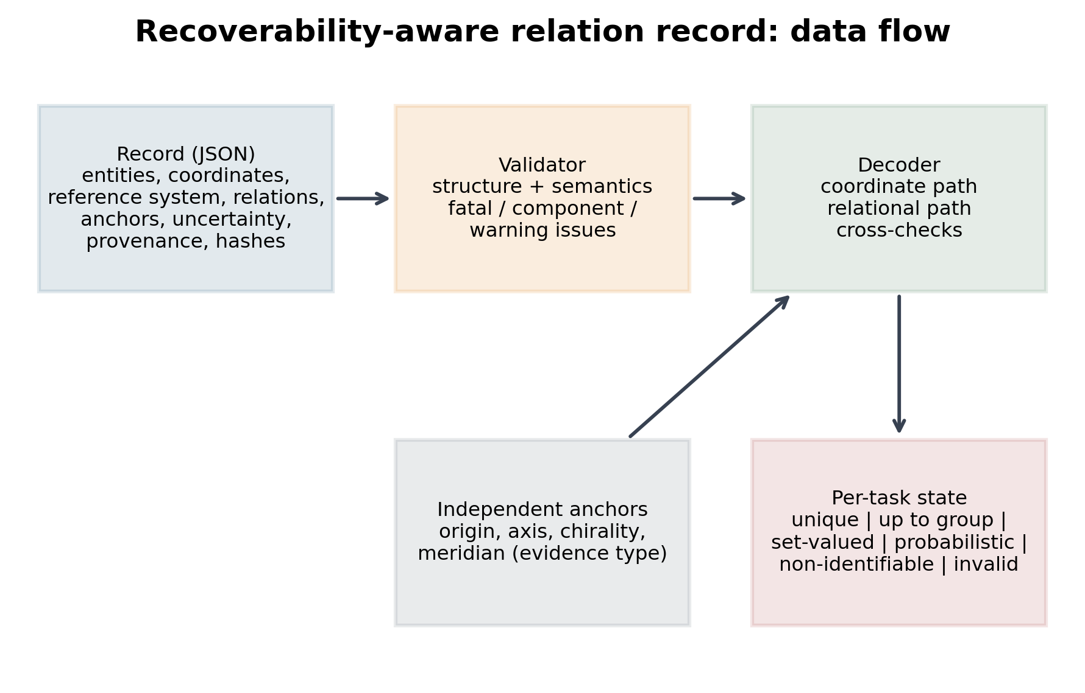
Fig. 2 Data flow of the recoverability-aware relation record. The validator rejects structurally invalid records and flags invalid components; the decoder combines a coordinate path and a relational path, cross-checks them against anchors, uncertainty and provenance hashes, and emits a per-task recoverability state.
Table 2 Components of the relation record (schema version 1.1.0) and their role in recovery.
Field | Content | Role in recovery
entities | Identifier, label, namespace; collisions are reported | Entity identity (T6)
coordinates | Values, optional velocities, unit | Original representation; precise answers when metadata are intact
reference_system | CRS id, axes, unit, frame, coordinate and frame epochs, transformation | Interprets coordinates (ISO 19111 / PROJJSON role)
relations | Labelled chord distances, rates, epoch, completeness | Frame-free metric evidence (T1, T5); rigidity check
anchors.origin | Geocentric radii with evidence type | Removes translation; enables axial projection
anchors.axis | Axial latitudes with standard uncertainty | Reduces O(3) to O(2); N/S ordering (T2)
anchors.chirality | Oriented entity triple, sign, evidence type | Reduces O(2) to SO(2) only if independent physical evidence (T3)
anchors.meridian | Entity and longitude of the directed meridian | Reduces SO(2) to identity (T4)
uncertainty | Coordinate and distance standard uncertainty, coverage factor | Consistency tolerances; probabilistic states
provenance | Source ids and SHA-256, software version, coordinate and relation hashes | Detects stale or edited components
declared_recoverability | Residual group and per-task state computed at export | Machine-readable ambiguity class; stale declarations rejected
Validation. The validator checks the JSON structure against the schema and then semantic constraints: identifier collisions, array lengths, degenerate or non-orthogonal axes, relation edges referring to absent entities, collinear or out-of-range chirality triples, invalid meridian entities, provenance hash mismatches and stale declarations. Issues are fatal (record unusable), component (one anchor or path unusable) or warnings.
Decoding. Six states are defined: unique; unique up to a named group; set-valued (conflicting candidates retained); probabilistic (with a probability); non-identifiable; and invalid record. The decoder evaluates a coordinate path only when the reference system is usable and the coordinate hash verifies, and a relational path by classical multidimensional scaling of the distances augmented by origin radii, followed by axis fitting, chirality selection and meridian rotation when the corresponding anchors are valid. The paths are cross-checked: distances are compared at the stated coverage factor, and coordinate-derived latitudes and chirality are compared with independent anchors. A disagreement withdraws the coordinate path for orientation tasks or yields a set-valued distance; a missing anchor yields the corresponding residual group. North–south ordering from noisy axis anchors is reported as probabilistic when the sign probability is below 0.975. The step-by-step algorithm is given in Online Resource 1 (Sect. S2).
Implementation. The schema, validator, decoders and benchmark are a Python package (dtrs.records) with a JSON Schema export, worked examples for every representation and damaged-record examples (Online Resource 2). Unit tests cover schema validity, intact recovery, refusal to claim orientation from relations alone, group-valued states, invalid-witness detection and the baseline comparisons. The full pipeline is executed by make reproduce.
Use of AI tools. The Devin web service (Cognition) was used in September and November 2026 to assist with Python implementation, test writing, simulation execution, document generation and language revision. It did not supply source data. All numerical values are regenerated by the disclosed code from persisted inputs; the author reviewed the code, outputs, references and text and is responsible for the content.

5 Testing
Data. The official ITRF2020 SLR station solution was persisted with its checksum (Altamimi et al. 2023). Stations with maximum coordinate standard uncertainty no greater than 0.02 m were binned by longitude to select 16 sites (Fig. 3; Online Resource 1, Table S1). Reference epoch 2015.0 and comparison epoch 2025.0 were used with published linear velocities.
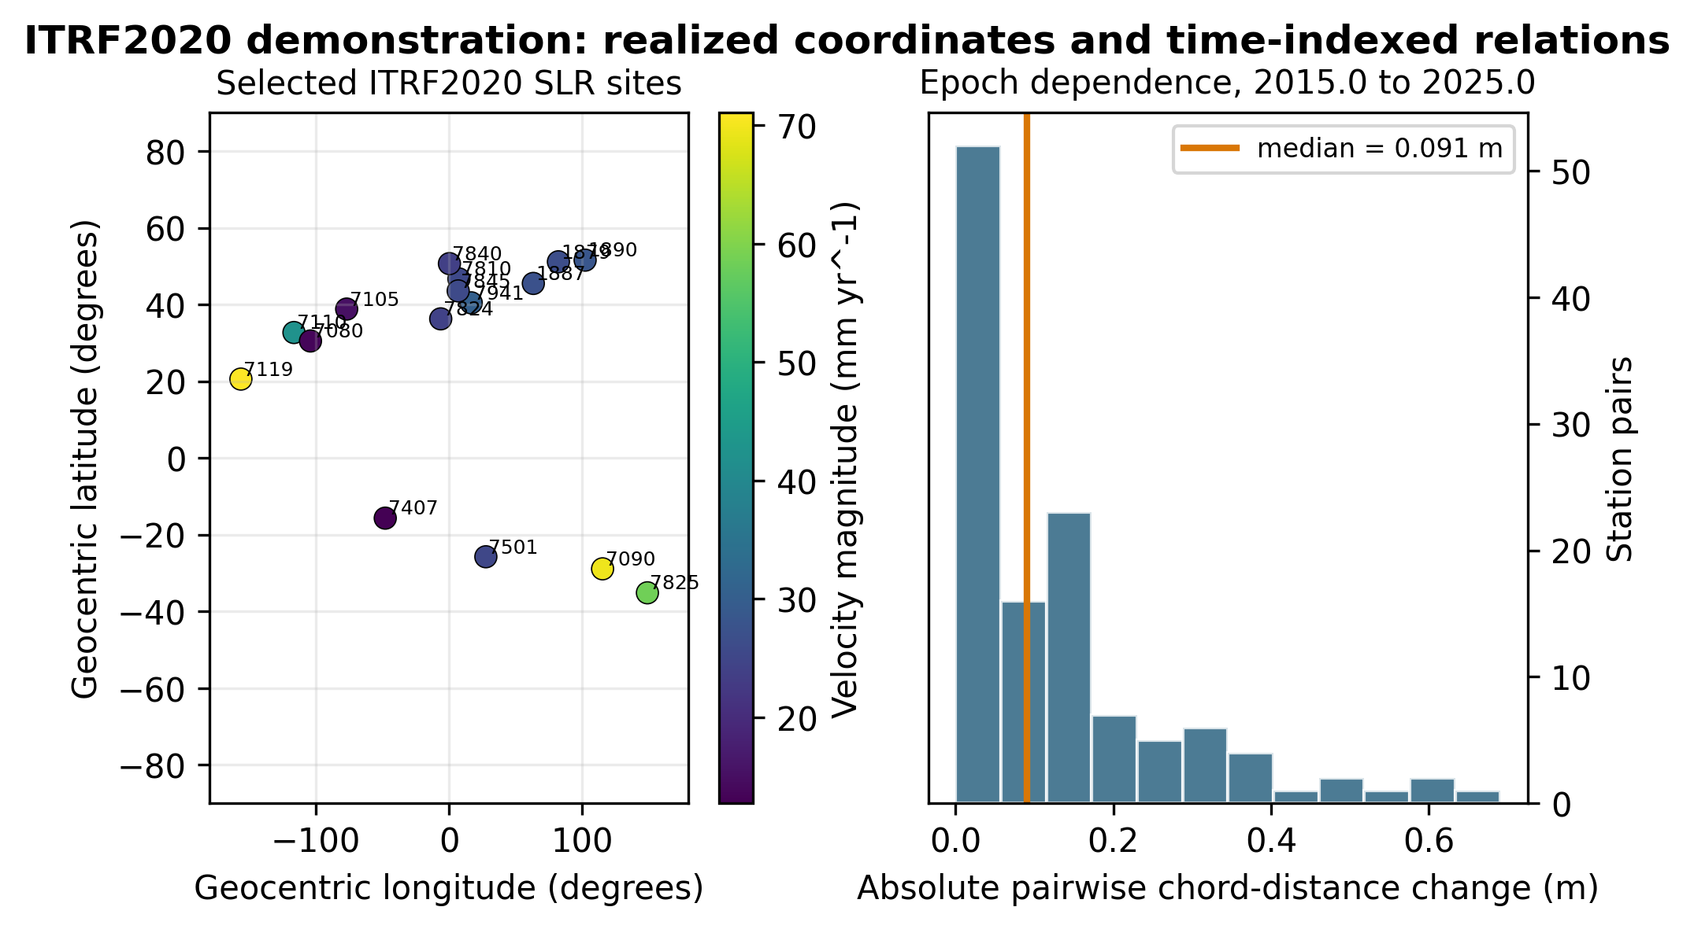
Fig. 3 ITRF2020 test network. Left: the 16 selected SLR stations and published velocity magnitudes. Right: absolute pairwise chord-distance changes after linear propagation from 2015.0 to 2025.0.
Representations and tasks. Representation A stores coordinates only; B adds complete CRS, axis, unit, frame and epoch metadata, velocities and a SHA-256 fixity checksum of the coordinate values, and is the strong baseline; its decoder rejects the record when the checksum fails. BR adds a redundant metadata copy, reconciled over the union of keys so that a field missing from either copy is repaired from the other and a contradiction is an error, and a digital chirality bit; C stores labelled distances and rates only; D adds origin, axis, chirality and meridian anchors; E combines B and D with uncertainty and provenance. Tasks are metric distance (T1), north–south ordering (T2), signed east–west relation (T3), absolute longitude (T4) and distance at the comparison epoch (T5) for all pairs and sites; entity identity (T6) is evaluated through identifier collisions. An answer is correct when distances agree within 0.01 m, signs agree, or longitude agrees within 1e-05 degrees.
Metrics. Each answer is classified as correct unique, false certainty (a unique answer that is wrong), honest ambiguity (group-valued, set-valued or probabilistic), non-identifiable or flagged invalid. Coverage is the correct-unique proportion. Record-level false certainty under random loss is summarized with Wilson intervals.
Scenarios. The 16 deterministic scenarios cover loss of the CRS block under three storage conventions, loss of the CRS identifier with parameters retained, loss of the coordinate epoch, a silent left-handed export in which all digitally derived fields are recomputed after the error, a correctly labelled axis swap, an identifier collision, absent and invalid chirality witnesses, joint loss of CRS and witness, coordinates replaced by values at the comparison epoch without updating hashes, the same error committed before the hashes were issued, an unflagged 0.05 m error at three sites, and sparse relations (edge retention 0.5) with the CRS lost (Table 3). Random loss deletes each of fourteen metadata fields independently (MCAR) or the whole metadata block, including its copy, as a correlated failure. Ablations remove one component of E at a time or replace the physical chirality witness by a digital copy. Calibration perturbs axis anchors with Gaussian noise of 0.01, 0.03 and 0.1 rad.
Table 3 Deterministic scenario outcomes for the strong baseline B, its redundant variant BR, the proposed record E and the coordinate-free record D (proportions of task items; 'flagged invalid' means the fixity checksum or validator rejected the record).
Scenario | B false certainty | B correct unique | BR false certainty | BR correct unique | E false certainty | E correct unique | E honest ambiguity | B flagged invalid | D correct unique
S0 intact | 0.0 | 1.0 | 0.0 | 1.0 | 0.0 | 1.0 | 0.0 | 0.0 | 1.0
S1a CRS block lost (standard) | 0.0 | 0.0 | 0.0 | 1.0 | 0.0 | 1.0 | 0.0 | 0.0 | 1.0
S1b CRS block lost (left-handed) | 0.0 | 0.0 | 0.0 | 1.0 | 0.0 | 1.0 | 0.0 | 0.0 | 1.0
S1c CRS block lost (rotated) | 0.0 | 0.0 | 0.0 | 1.0 | 0.0 | 1.0 | 0.0 | 0.0 | 1.0
S2 CRS id lost, parameters kept | 0.0 | 1.0 | 0.0 | 1.0 | 0.0 | 1.0 | 0.0 | 0.0 | 1.0
S3 coordinate epoch lost | 0.0 | 0.516 | 0.0 | 0.516 | 0.0 | 1.0 | 0.0 | 0.0 | 1.0
S4 silent handedness flip | 0.274 | 0.726 | 0.274 | 0.726 | 0.0 | 1.0 | 0.0 | 0.0 | 1.0
S5 labelled axis swap | 0.0 | 1.0 | 0.0 | 1.0 | 0.0 | 1.0 | 0.0 | 0.0 | 1.0
S6 identifier collision | 0.0 | 0.762 | 0.0 | 0.762 | 0.0 | 0.762 | 0.123 | 0.0 | 0.762
S7 chiral witness absent | 0.0 | 1.0 | 0.0 | 1.0 | 0.0 | 1.0 | 0.0 | 0.0 | 0.726
S8 chiral witness invalid | 0.0 | 1.0 | 0.0 | 1.0 | 0.0 | 1.0 | 0.0 | 0.0 | 0.726
S9 CRS and witness lost | 0.0 | 0.0 | 0.0 | 1.0 | 0.0 | 0.726 | 0.274 | 0.0 | 0.726
S10 epoch-mislabelled values | 0.0 | 0.0 | 0.0 | 0.0 | 0.0 | 1.0 | 0.0 | 1.0 | 1.0
S11 unflagged 5 cm error | 0.137 | 0.863 | 0.137 | 0.863 | 0.0 | 0.875 | 0.125 | 0.0 | 1.0
S12 sparse relations, CRS lost | 0.0 | 0.0 | 0.0 | 1.0 | 0.0 | 0.234 | 0.0 | 0.0 | 0.234
S13 epoch mislabel, hash re-issued | 0.415 | 0.585 | 0.415 | 0.585 | 0.0 | 0.609 | 0.391 | 0.0 | 1.0
Geometric foundations. The frozen geometric experiments are retained as checks of the decoder's foundations: complete-distance reconstruction with and without reflection, direction invariance under proper and improper transformations, WGS84–GRS80 sensitivity, and the local rigidity of random three-dimensional frameworks for n = 6, 8, 10, 12, 16 and edge-retention probabilities {0.1, 0.2, 0.3, 0.4, 0.5, 0.6, 0.7, 0.8, 0.9, 1.0} with 2000 trials per cell (Table 4). All calculations use seed 20260924; the record benchmark uses seed 20263924. Direction asymmetry, the rigidity phase diagram, the synthetic benchmark and anchor sensitivity are shown in Online Resource 1 (Figs. S1–S4), with ellipsoid sensitivity, the reference-frame taxonomy and the full numerical registry in Tables S2–S4.
Table 4 Seeded local-rigidity transition summary for generic random frameworks: first tested edge-retention probabilities with full-rigidity frequencies at or above 0.50 and 0.95; these are not universal thresholds.
N points | First tested edge probability at or above 50pct | First tested edge probability at or above 95pct | Complete graph local rigidity probability
6 | 0.8 | 1.0 | 1.0
8 | 0.7 | 0.9 | 1.0
10 | 0.6 | 0.7 | 1.0
12 | 0.5 | 0.7 | 1.0
16 | 0.4 | 0.6 | 1.0

6 Results
Intact metadata. B and E recovered every task (correct-unique 1.000 and 1.000); there is no gain from the proposed record when metadata are complete and correct (Fig. 4). Representation A gave false certainty on 0.208 of items even when intact, because it cannot propagate distances to another epoch. C was correct on 0.484 of items and returned non-identifiable for every orientation task, as required.
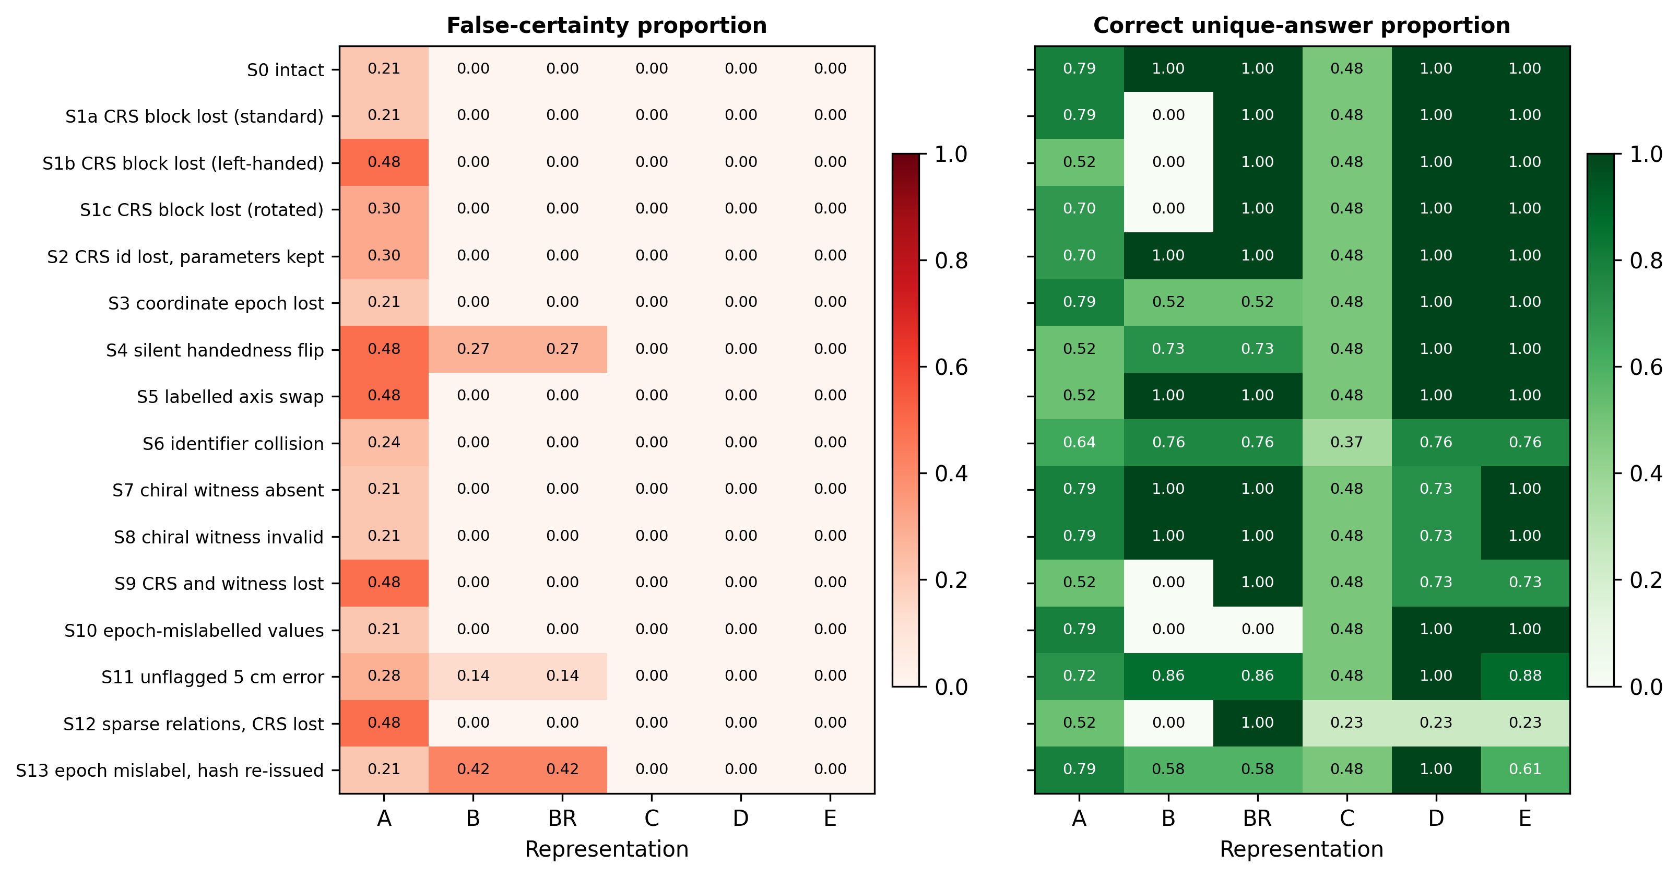
Fig. 4 Outcome of each deterministic loss or corruption scenario for representations A (coordinates only), B (coordinates and complete metadata), BR (B with a redundant metadata copy and digital chirality bit), C (relations only), D (relations and physical anchors) and E (proposed hybrid). Each cell is the proportion of 496 task items.
Silent corruption. Under the silent left-handed export B and BR gave false certainty on 0.274 of items, all in the east–west and longitude tasks, because the redundant copy and digital bit were recomputed from the corrupted values. E detected the contradiction with its independent chirality and axis anchors and recovered 1.000 of items from the relational path. When epoch-mislabelled values were written after the hashes had been issued, B and BR rejected the record through their fixity checksum (1.000 flagged invalid) and E fell back to the relational path. When the same error was committed before the hashes were issued, the checksum verified and B gave false certainty on 0.415 of items; E gave none but returned 0.391 as set-valued because its coordinates contradicted its relations, whereas D was correct on 1.000. Carrying coordinates therefore costs coverage when they are wrong in a way no hash can reveal. With an unflagged coordinate error B gave false certainty on 0.137; E reported 0.125 of items as set-valued and none falsely, whereas D, which has no coordinates to conflict with, was correct on 1.000.
Explicit loss. When the CRS block was deleted, B became non-identifiable on 1.000 of items without error, BR recovered through its copy, and E recovered 1.000 through the relational path. When the chirality witness was also lost, E returned the east–west and longitude tasks as unique up to a group (0.274 of items). An identifier collision was handled identically by B, D and E (set-valued 0.123), so it is not an advantage of the proposal. Sparse relations reduced E's coverage to 0.234, with the remainder non-identifiable.
Random loss. Under independent field deletion B produced at least one false answer in 0.015–0.057 of records, when transformation parameters were lost while the axis labels remained (Fig. 5); BR, which repairs the primary from its copy, did so in 0.000–0.018, only when both copies had lost them. No E record produced false certainty at any rate (95% upper bound 0.006). Coverage favoured repaired redundancy at every rate: at rate 0.1 BR retained 0.962 and E 0.908, at rate 0.5 0.534 and 0.290; D, which has no coordinates to withdraw, retained 0.459 at rate 0.5. Under correlated block loss E kept coverage 1.000 at rate 0.5, B and BR 0.513.
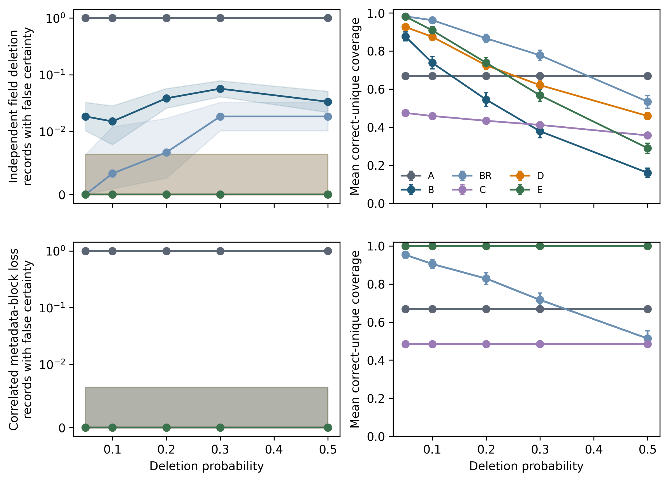
Fig. 5 Random metadata loss. Rows: independent deletion of individual fields and correlated loss of the whole metadata block. Left: proportion of records with at least one false-certainty answer with 95% Wilson intervals (symmetric-log axis). Right: mean correct-unique coverage with 95% intervals. 200 replicates per convention, three storage conventions. Where fewer lines are visible, series coincide.
Ablation and calibration. Over all scenarios the full record had false certainty 0.0000; removing relations raised it to 0.0345, removing the chirality witness to 0.0171, and replacing the physical witness by a digital copy to 0.0171 (Fig. 6). Probabilistic north–south states had Brier scores of 0.0049, 0.0168 and 0.0666 at the three noise levels, and unique claims were wrong in at most 0.0028 of items.
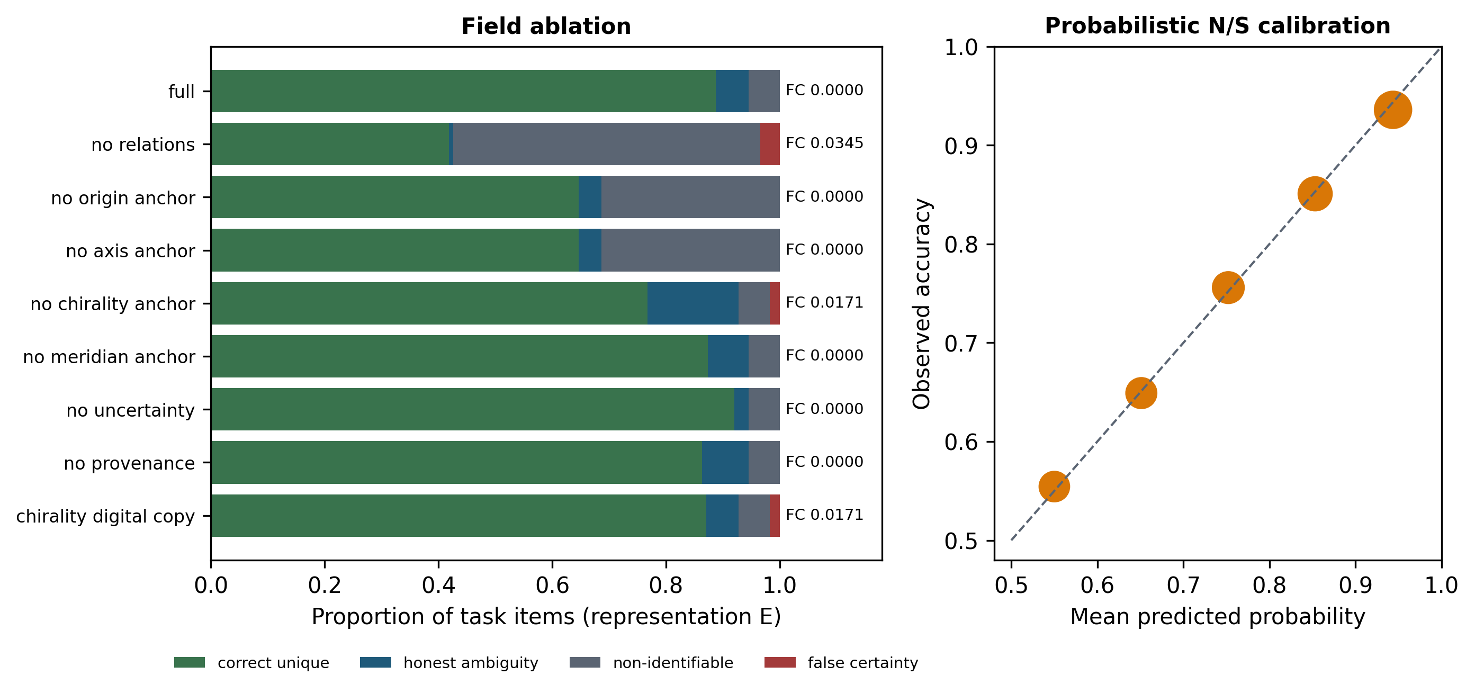
Fig. 6 Left: field ablation of representation E aggregated over all deterministic scenarios; numbers give the false-certainty proportion. Right: reliability of probabilistic north/south states under noisy axis anchors; marker area scales with the number of items per bin.
Cost. The E record for the test network occupied 8773 bytes of compact JSON, 3.67 times representation A and 2.72 times B; median decoding time was 2.7 ms.
Geometric checks. Complete distances reconstructed the synthetic configuration with reflection-permitting RMSE 4e-09 m, whereas a proper-only alignment left 6.136 million m. Replacing WGS84 by GRS80 changed chord distances by at most 0.000225 m without changing any directional classification. For 16-point frameworks full local rigidity occurred in 0.9465 of trials at edge retention 0.5 (95% interval 0.9358–0.9555) and 0.996 at 0.6 (0.9921–0.9980). In the ITRF2020 network the maximum and median pairwise distance changes over the ten-year interval were 0.691 m and 0.091 m, so distance relations are epoch-specific at the centimetre level.

7 Discussion
Complete CRS metadata is the right operational answer and remains so: the benchmark shows no advantage of the proposed record when it is intact. The record is useful when the metadata cannot be trusted or has been partly lost, which is the normal condition of long-lived and repeatedly converted data. Its safety comes from three design choices that existing metadata standards do not combine: per-task recoverability states, frame-free relational evidence cross-checked against coordinates, and an explicit distinction between independent physical anchors and digital copies.
The ablations make the last point quantitative. A second copy of the CRS or a stored chirality bit increases coverage under independent deletion but fails together with the values under common-mode corruption, and a fixity checksum detects alteration after export but not an error committed before it. A strong baseline that reconciles its copies and verifies a checksum removes most, but not all, of the false certainty that a naive consumer shows; the remaining advantage of the proposed record is the absence of false certainty, paid for in coverage. That advantage comes from the relations, anchors and conflict checks, not from the coordinates: profile D, the same record without coordinates, also gave no false certainty in any scenario and was correct more often than E when coordinates were wrong (unflagged error: 1.000 versus 0.875), whereas E kept coverage when the chirality witness was absent (1.000 versus 0.726). Carrying coordinates is therefore a coverage choice that an archive can make per dataset, not a safety mechanism. Redundancy therefore has to be designed around independent failure modes, a point that applies equally to plate-reconstruction outputs whose frames are model choices (Müller et al. 2018).
The states map naturally onto existing vocabularies: the declared recoverability block can be expressed as a PROV-O derivation with a data-quality result in the sense of ISO 19157-1, and the relations as GeoSPARQL-style statements with OWL-Time epochs. I did not implement these mappings; the JSON Schema is the normative form in this version.

8 Limitations
The benchmark uses one realized network of 16 stations and synthetic corruption; the scenarios are specified failure modes, not a sample of real data incidents, so the proportions are conditional on them. The Euclidean chord model, known metric scale, linear velocities and generic configurations are assumed; deformation, nonlinear station motion, surface-geodesic distances and identity inference beyond collision detection are not treated. In the benchmark the anchors are computed from the true configuration and their independence is a stipulation of each scenario (the corruption does not reach them); the results test how the decoder uses independent evidence, not whether such evidence is available in practice. The axis anchor stores geocentric latitudes and is therefore a second, differently failing encoding of the coordinates rather than a new observation. Independent physical anchors are assumed to exist and to be correctly labelled; the record can describe but not create them. A digital chirality bit is never treated as a recovered physical handedness anchor. The relational path needs complete or rigid distance graphs, and coverage falls with sparsity.

9 Conclusions
A recoverability-aware record that keeps coordinates with full metadata, labelled relations, independent anchors, uncertainty and provenance, together with a validator and decoder that report per-task states, removed false certainty in every specified loss and corruption scenario tested while matching the strong baseline when metadata were intact. It costs storage, coverage relative to repaired redundancy under independent deletion, and coverage relative to a coordinate-free record when coordinates are wrong before export. The schema, code, data and benchmark are openly available for reuse and extension.

Statements and Declarations

Funding
[To be completed locally before submission.]

Competing interests
[To be completed locally before submission.]

Ethics approval
Not applicable; no human participants or animals were involved.

Consent to participate
Not applicable.

Consent for publication
Not applicable.

Data availability
The persisted ITRF2020 SLR source file, its checksum ledger, the processed station selection, the record schema and examples, simulation and benchmark configurations, and generated numerical results are available in the public repository at https://github.com/bougtoir/deep-time-reference-systems. The authoritative ITRF source is https://itrf.ign.fr/ftp/pub/itrf/itrf2020/ITRF2020_SLR.SSC.txt.

Code availability
The complete reproducible Python analysis and document-generation pipeline, pinned configuration, tests, and reproducibility archive are available at https://github.com/bougtoir/deep-time-reference-systems.

Author contributions
Tatsuki Onishi: Conceptualization, methodology, validation, formal analysis, investigation, data curation, writing—original draft, writing—review and editing, visualization, supervision, and project administration.

Generative AI disclosure
During preparation of this work, the author used the Devin web service by Cognition (no user-visible version identifier; used in September and November 2026). Prompts requested targeted literature-metadata verification, Python implementation and checking, deterministic simulation replication, figure/table/document generation, numerical reconciliation, and language revision. The tool assisted with those tasks but did not supply empirical source data or generate experimental images; all numerical results and display items were regenerated by the disclosed code from persisted inputs and configurations. The author reviewed and verified the code, outputs, references, figures, and text, made the scientific and editorial decisions, and takes full responsibility for the content.

References
Altamimi Z, Rebischung P, Collilieux X, Métivier L, Chanard K (2023) ITRF2020: an augmented reference frame refining the modeling of nonlinear station motions. J Geod 97:47. https://doi.org/10.1007/s00190-023-01738-w
Asimow L, Roth B (1978) The rigidity of graphs. Trans Am Math Soc 245:279–289. https://doi.org/10.1090/S0002-9947-1978-0511410-9
Barkstrom BR (2010) A mathematical framework for earth science data provenance tracing. Earth Sci Inform 3:167–196. https://doi.org/10.1007/s12145-010-0057-0
Bastin L, Cornford D, Jones R, Heuvelink GBM, Pebesma E, Stasch C, Nativi S, Mazzetti P, Williams M (2013) Managing uncertainty in integrated environmental modelling: the UncertWeb framework. Environ Model Softw 39:116–134. https://doi.org/10.1016/j.envsoft.2012.02.008
Bevis M, Brown A (2014) Trajectory models and reference frames for crustal motion geodesy. J Geod 88:283–311. https://doi.org/10.1007/s00190-013-0685-5
Car NJ, Homburg T (2022) GeoSPARQL 1.1: motivations, details and applications of the decadal update to the most important geospatial LOD standard. ISPRS Int J Geo-Inf 11:117. https://doi.org/10.3390/ijgi11020117
CCSDS (2024) Reference model for an Open Archival Information System (OAIS). CCSDS 650.0-M-3, Magenta Book. Consultative Committee for Space Data Systems, Washington DC. https://public.ccsds.org/Pubs/650x0m3.pdf
Chatzinikos M, Dermanis A (2017) A coordinate-invariant model for deforming geodetic networks: understanding rank deficiencies, non-estimability of parameters, and the effect of the choice of minimal constraints. J Geod 91:375–396. https://doi.org/10.1007/s00190-016-0970-1
Dokmanić I, Parhizkar R, Ranieri J, Vetterli M (2015) Euclidean distance matrices: essential theory, algorithms, and applications. IEEE Signal Process Mag 32(6):12–30. https://doi.org/10.1109/MSP.2015.2398954
Egenhofer MJ, Franzosa RD (1991) Point-set topological spatial relations. Int J Geogr Inf Syst 5:161–174. https://doi.org/10.1080/02693799108927841
Freksa C (1992) Using orientation information for qualitative spatial reasoning. In: Frank AU, Campari I, Formentini U (eds) Theories and methods of spatio-temporal reasoning in geographic space. Lecture Notes in Computer Science 639. Springer, Berlin, pp 162–178. https://doi.org/10.1007/3-540-55966-3_10
Fugazza C, Tagliolato Acquaviva d’Aragona P, Oggioni A, Carrara P (2021) Decentralized geospatial metadata management. Earth Sci Inform 14:1579–1596. https://doi.org/10.1007/s12145-020-00559-1
Galton A (2009) Spatial and temporal knowledge representation. Earth Sci Inform 2:169–187. https://doi.org/10.1007/s12145-009-0027-6
Heuvelink GBM, Burrough PA, Stein A (1989) Propagation of errors in spatial modelling with GIS. Int J Geogr Inf Syst 3:303–322. https://doi.org/10.1080/02693798908941518
Hogan A, Blomqvist E, Cochez M et al (2022) Knowledge graphs. ACM Comput Surv 54(4):71. https://doi.org/10.1145/3447772
ISO (2014) ISO 19115-1:2014 Geographic information—Metadata—Part 1: Fundamentals. International Organization for Standardization, Geneva. https://www.iso.org/standard/53798.html
ISO (2019) ISO 19111:2019 Geographic information—Referencing by coordinates. International Organization for Standardization, Geneva. https://www.iso.org/standard/74039.html
ISO (2023) ISO 19157-1:2023 Geographic information—Data quality—Part 1: General requirements. International Organization for Standardization, Geneva. https://www.iso.org/standard/78900.html
Janowicz K, Hitzler P, Li W et al (2022) Know, know where, KnowWhereGraph: a densely connected, cross-domain knowledge graph and geo-enrichment service stack for applications in environmental intelligence. AI Mag 43:30–39. https://doi.org/10.1002/aaai.12043
Kabsch W (1976) A solution for the best rotation to relate two sets of vectors. Acta Crystallogr A 32:922–923. https://doi.org/10.1107/S0567739476001873
Klump J, Huber R (2017) 20 years of persistent identifiers—which systems are here to stay? Data Sci J 16:9. https://doi.org/10.5334/dsj-2017-009
Kotsakis C, Chatzinikos M (2017) Rank defect analysis and the realization of proper singularity in normal equations of geodetic networks. J Geod 91:627–652. https://doi.org/10.1007/s00190-016-0989-3
Lakani E, Louge T, Karray MH (2026) Geoscience semantic interoperability: systematic review of semantic resources. Earth Sci Inform 19:111. https://doi.org/10.1007/s12145-026-02159-x
Liberti L, Lavor C, Maculan N, Mucherino A (2014) Euclidean distance geometry and applications. SIAM Rev 56:3–69. https://doi.org/10.1137/120875909
Müller RD, Cannon J, Qin X et al (2018) GPlates: building a virtual Earth through deep time. Geochem Geophys Geosyst 19:2243–2261. https://doi.org/10.1029/2018GC007584
Nativi S, Caron J, Domenico B, Bigagli L (2008) Unidata’s Common Data Model mapping to the ISO 19123 data model. Earth Sci Inform 1:59–78. https://doi.org/10.1007/s12145-008-0011-6
OGC (2019) Topic 2—Referencing by coordinates. OGC Abstract Specification 18-005r5. Open Geospatial Consortium. https://docs.ogc.org/as/18-005r5/18-005r5.html
OGC (2024) OGC GeoSPARQL—a geographic query language for RDF data, version 1.1. OGC 22-047r1. Open Geospatial Consortium. https://docs.ogc.org/is/22-047r1/22-047r1.html
Petit G, Luzum B (eds) (2010) IERS Conventions (2010). IERS Technical Note 36. Verlag des Bundesamts für Kartographie und Geodäsie, Frankfurt am Main. https://iers-conventions.obspm.fr/content/tn36.pdf
PROJ (2023) PROJJSON specification. PROJ contributors. https://proj.org/en/latest/specifications/projjson.html
Shippert T, Gaustad K (2017) An architecture for consolidating multidimensional time-series data onto a common coordinate grid. Earth Sci Inform 10:247–256. https://doi.org/10.1007/s12145-016-0285-z
Sillard P, Boucher C (2001) A review of algebraic constraints in terrestrial reference frame datum definition. J Geod 75:63–73. https://doi.org/10.1007/s001900100166
Tilmes C, Yesha Y, Halem M (2010) Tracking provenance of earth science data. Earth Sci Inform 3:59–65. https://doi.org/10.1007/s12145-010-0046-3
W3C (2013) PROV-O: the PROV ontology. W3C Recommendation 30 April 2013. https://www.w3.org/TR/prov-o/
W3C (2022) Time ontology in OWL. W3C Candidate Recommendation Draft 15 November 2022. https://www.w3.org/TR/owl-time/
Wilkinson MD, Dumontier M, Aalbersberg IJ et al (2016) The FAIR Guiding Principles for scientific data management and stewardship. Sci Data 3:160018. https://doi.org/10.1038/sdata.2016.18

