Two pathways, many clocks: a commentary on Itao (2026)
Tatsuki Onishi
Affiliation to be completed. Corresponding author: Tatsuki Onishi (email to be completed).

Abstract
Itao (2026) reports two universal demographic-transition pathways: a conserved λe₀ before and a conserved λexp(e₀/17) after a mid-twentieth-century change point. Using the same public data, we ask whether this is a placeless law or partly an artefact of aligning asynchronous national transitions on a common calendar, and whether it holds at sub-national scales. Country-specific onsets span 1828–2013 (IQR 58 years). Event-time alignment reduces between-country λ variance by a factor of 3.4, but tightens only the first conserved quantity. Within countries, regional λ at matched e₀ differs as much as the cross-national variation of the second pathway. The two pathways are a timing-locked regularity plus heterogeneous convergence rather than a single universal constant.
Keywords: demographic transition; fertility; life expectancy; universality; sub-national heterogeneity; event-time alignment

A cross-disciplinary claim
The search for law-like regularities in human populations has a long history (Notestein, 1945; Kirk, 1996). Itao (2026) contributes a striking recent example: plotting λ against life expectancy at birth e₀ for 186 countries, the paper reports that national trajectories are organised by two conserved quantities, λe₀ before and λexp(e₀/17) after a change point near the mid-twentieth century. Importing statistical-physics search for conserved quantities into demography is a valuable cross-disciplinary move, and the household model linking the shift to returns to schooling (Galor, 2011) gives a plausible mechanism. We take the two-regime description as a starting point and ask how far the regularity survives when timing and spatial scale are treated more carefully.

Asynchronous transitions, not a global turning point
If the reported change point were a genuine world-historical moment, most countries should transition near it. They do not. Using Coale's (1973) onset definition—the first irreversible decline in a smoothed λ series—country-specific onsets range from 1828 to 2013, an inter-quartile range of 58 years; only 6% begin within a decade of 1950 (Figure 1A). A pooled calendar split is sharply estimated at 1966 (95% CI 1946–1969), consistent with Itao (2026), but this narrowness is an aggregation artefact: it summarises asynchronous national transitions rather than a synchronised global event (Bongaarts & Watkins, 1996; Reher, 2004).

Event alignment sharpens the first pathway only
If transitions are asynchronous, a placeless law should look clearer when each country is read on its own clock. Re-aligning trajectories on each country's onset reduces the between-country standard deviation of λ from 10.9 to 5.9 births per 1,000 in the ±25-year window—a 3.4-fold reduction in variance (Figure 1B). Under alignment, the first conserved quantity, λe₀, tightens from CV = 0.27 to 0.17, a timing-locked regularity that calendar-time pooling partly obscures. The second quantity, λexp(e₀/17), does not improve (CV = 0.30 versus 0.31; Figure 1C). The two pathways are asymmetric: the pre-transition process has a conservation-like structure once timing is modelled, whereas the post-transition regime remains a loose, heterogeneous convergence.
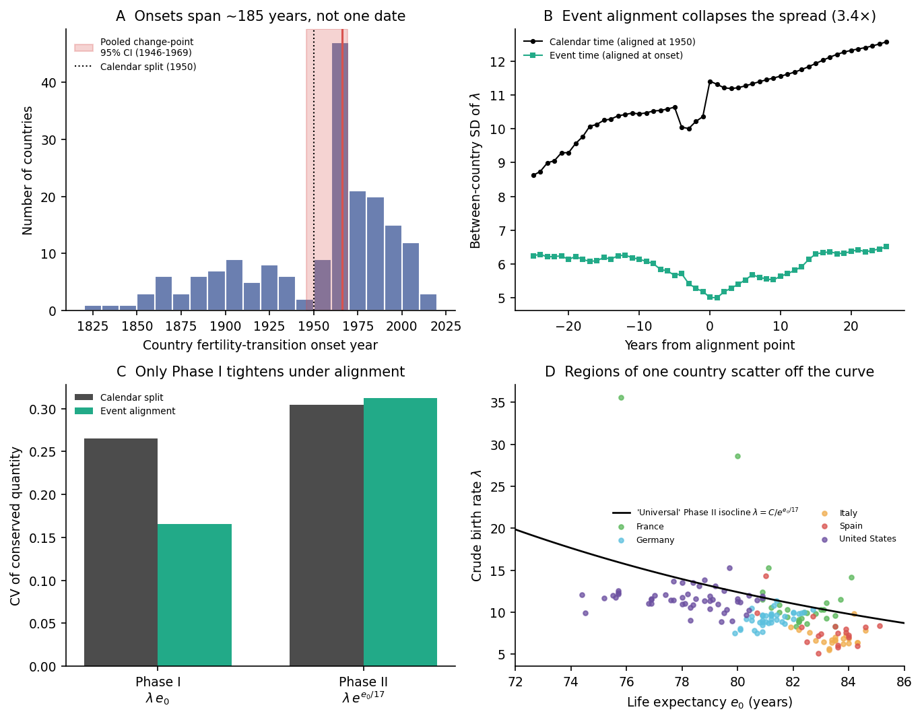
Figure 1. (A) Fertility-transition onsets span 185 years; the shaded band is the 95% CI for the pooled calendar change point. (B) Event-time alignment (each country at its own onset) reduces the between-country SD of λ by a factor of 3.4. (C) Alignment lowers the CV of the first conserved quantity (λe₀) but not the second (λexp(e₀/17)). (D) Within five decentralised states, regions at nearly identical e₀ scatter off the single 'universal' Phase II isocline, so the country-level curve does not carry to sub-national scales.

No single curve describes within-country variation
A genuinely placeless law should also hold below the national level. Region-level data for 156 regions of five decentralised states (Eurostat, 2024; National Center for Health Statistics, 2022; U.S. Census Bureau, 2020) show that regions of the same country at matched e₀ differ substantially in λ (Figure 1D). The within-country CV of λ among regions within a three-year e₀ band ranges from 0.10 to 0.36 (median 0.14), comparable to the cross-national Phase II CV (0.31). In Spain, regional λ in 2019 spans 5.1–14.3 births per 1,000 despite an e₀ spread of only 4.4 years. Longitudinal sub-populations from the Human Mortality Database (2024) likewise diverge: East and West Germany follow different λ–e₀ paths, with a mean matched-e₀ gap of 2.5 births per 1,000 (27% of the mean).

Conclusion
None of this overturns the regularity Itao (2026) documents. It does relocate it. The first pathway is a timing-locked mortality–fertility co-movement that becomes sharper once each country is read on its own clock. The second pathway is better understood as heterogeneous convergence toward low fertility than as a single universal constant. Event-time alignment and hierarchical modelling are natural complements to the statistical-physics approach, pushing the same reasoning down to the within-country scales where policy operates.

Acknowledgements
The author thanks Kenji Itao for making the original analysis and data openly available.

Financial Support
This research received no specific grant.

Conflicts of Interest
The author declares none.

References
Bongaarts, J., & Watkins, S. C. (1996). Social interactions and contemporary fertility transitions. Population and Development Review, 22(4), 639–682.
Coale, A. J. (1973). The demographic transition reconsidered. In International Population Conference, Liège 1973 (Vol. 1, pp. 53–72). IUSSP.
Eurostat. (2024). Regional demographic statistics [Data set]. https://ec.europa.eu/eurostat/web/regions/data/database
Galor, O. (2011). Unified growth theory. Princeton University Press.
Human Mortality Database. (2024). University of California, Berkeley, and Max Planck Institute for Demographic Research. https://www.mortality.org
Itao, K. (2026). Two universal pathways in demographic transition. Evolutionary Human Sciences. https://doi.org/10.1017/ehs.2026.10054
Kirk, D. (1996). Demographic transition theory. Population Studies, 50(3), 361–387.
National Center for Health Statistics. (2022). U.S. state life expectancy by sex, 2019 [Data set]. Centers for Disease Control and Prevention. https://data.cdc.gov
Notestein, F. W. (1945). Population—the long view. In T. W. Schultz (Ed.), Food for the world (pp. 36–57). University of Chicago Press.
Reher, D. S. (2004). The demographic transition revisited as a global process. Population, Space and Place, 10(1), 19–41.
U.S. Census Bureau. (2020). Population estimates program (PEP): Components of change [Data set]. https://www.census.gov/programs-surveys/popest.html

