Two pathways, many clocks: extending demographic-transition universality to event time and within-country scales
Tatsuki Onishi
Affiliation to be completed. Corresponding author: Tatsuki Onishi (email to be completed).

Abstract
Itao (2026) reports that demographic transitions follow two universal pathways: a conserved product λ×e₀ before a mid-twentieth-century change point and a conserved λ×exp(e₀/17) afterwards, where λ is the crude birth rate and e₀ life expectancy at birth. This statistical-physics reading of demography—seeking conserved quantities behind a global regularity—is a valuable cross-disciplinary contribution, and we build on it. Using the same public data, we ask how far the regularity extends: whether it reflects a placeless law or is partly shaped by aligning asynchronous national transitions on a common calendar, and whether it carries to sub-national scales. Country-specific fertility onsets span 1828–2013 (inter-quartile range 58 years); only 6% of countries begin within a decade of 1950. Re-aligning each country at its own onset collapses the between-country dispersion of λ by a factor of 3.4, but tightens only the first conserved quantity, not the second. Within single countries, regions at nearly identical e₀ differ in λ by as much as the cross-national variation of that second pathway. We read the two pathways as a timing-locked mortality–fertility regularity plus heterogeneous post-transition convergence rather than a single placeless constant, and offer event-time alignment and hierarchical modelling as complements that sharpen, rather than overturn, Itao's framework.
Keywords: demographic transition; fertility; life expectancy; universality; sub-national heterogeneity; event-time alignment

A striking claim of universality
A recurring ambition in the quantitative study of human populations is to find law-like regularities that hold across societies (Notestein, 1945; Kirk, 1996). Itao (2026) offers a bold instance. Plotting the crude birth rate λ against period life expectancy at birth e₀ for 186 countries, the paper reports that the world's trajectories are organised by two conserved quantities: an early regime in which λ×e₀ is approximately constant, and a later regime in which λ×exp(e₀/17) is approximately constant, with a single change point placed near the mid-twentieth century. The two regimes are interpreted as universal 'pathways' shared by all countries, and are linked through a household model of the trade-off between the number of children and investment in their education to a shift in the returns to schooling (Galor, 2011). Importing the statistical-physics search for conserved quantities and phase-like regimes into demography is precisely the kind of cross-disciplinary move that can expose structure other framings miss, and it motivates the closer look we take here.
We reproduce the qualitative structure of this result from the same public source (Gapminder, 2023). Fitting the paper's family of forms and searching for the single calendar split that maximises the pooled coefficient of determination, the explained variance rises from R² = 0.48 for one regime to 0.60 for two, with a best split at 1966. This closely echoes Itao (2026), and we take the two-regime description as a well-established starting point. Our question is a complementary one: how far the fit reflects a placeless law versus the shared calendar on which asynchronous national histories are viewed, and how it behaves when the same logic is pushed to finer temporal and spatial scales.

Data and methods
We use the national crude birth rate and period life expectancy series compiled by Gapminder (2023), the same primary source as the target paper, giving 39,960 country-year observations for 186 countries over 1800–2015. Following Itao (2026), we fit through-origin isoclines λ = C/e₀ᵖ (power laws) and λ = C/exp(e₀/c) (exponentials) and locate the single calendar split that maximises the pooled R² by exhaustive search; a country bootstrap (2,000 replicates, resampling countries) gives its confidence interval. Each country's fertility onset is the last year its five-year-smoothed λ sits within 10% of its own pre-transition maximum before an irreversible decline (Coale, 1973); event time is calendar year minus this onset. Conserved-quantity dispersion is measured within the paper's own fitting windows (e₀ > 40 for the first quantity, e₀ > 60 for the second). Sub-national λ and e₀ are matched by region and year. All code and derived tables are public (see Research Transparency and Reproducibility); no value in this article is hand-entered.

What a universal law would predict
A genuinely universal, placeless relationship between λ and e₀ makes two predictions that pooled calendar-time plots cannot test. First, because transitions began at very different dates, aligning each country not on the calendar but on its own transition onset should not degrade—and should, if anything, sharpen—the collapse of trajectories onto a common curve. Second, the law should hold at any level of aggregation: regions within a country, observed in the same year at essentially the same e₀, should share the same λ. We test both.

The mid-century change point summarises asynchronous transitions
Estimating each country's fertility-transition onset—the year after which the smoothed crude birth rate stays irreversibly below its pre-transition plateau (Coale, 1973)—yields onsets from 1828 to 2013, a range of 185 years, with an inter-quartile range of 58 years (Figure 1). Only 6% of countries begin their transition within ten years of 1950; 27% began before 1930 and 37% after 1970. The pooled change point is nonetheless sharply estimated (1966; bootstrap 95% CI 1946–1969, an interval that comfortably includes the mid-century date Itao (2026) adopts, so our split is consistent with, not a correction to, the original). The narrowness is nonetheless revealing: it shows that pooling manufactures a crisp global 'moment of transition' that almost no individual country experiences near that date. A single calendar change point is thus most naturally read as a summary of many asynchronous national transitions rather than a moment at which the world turned a corner together (Bongaarts & Watkins, 1996; Reher, 2004; Figure 1).
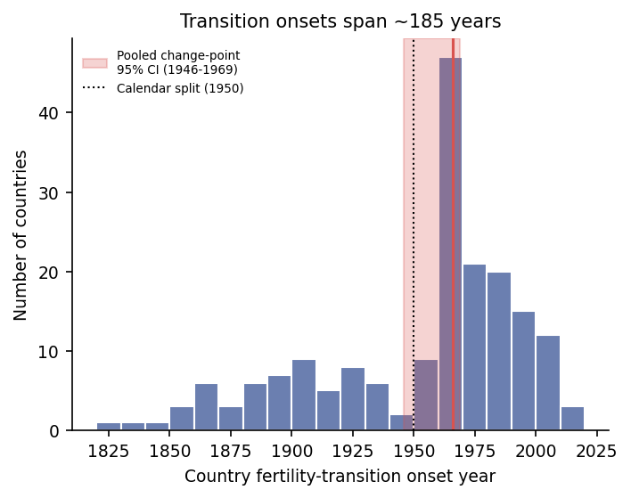
Figure 1. Country-specific fertility-transition onsets span roughly 185 years (1828–2013). The shaded band is the bootstrap 95% confidence interval (1946–1969) of the single pooled calendar change point; the dotted line marks 1950.

Event alignment collapses the spread—but only for the first pathway
If national transitions are asynchronous, re-expressing each trajectory in event time (years since its own onset) should concentrate them. It does. Within ±25 years of the alignment point, the mean between-country standard deviation of λ falls from 10.9 births per 1,000 in calendar time to 5.9 in event time—a 3.4-fold reduction in variance (Figure 2). Much of the scatter that the paper's two-regime fit accommodates is therefore timing, not a property of the λ–e₀ relationship itself.
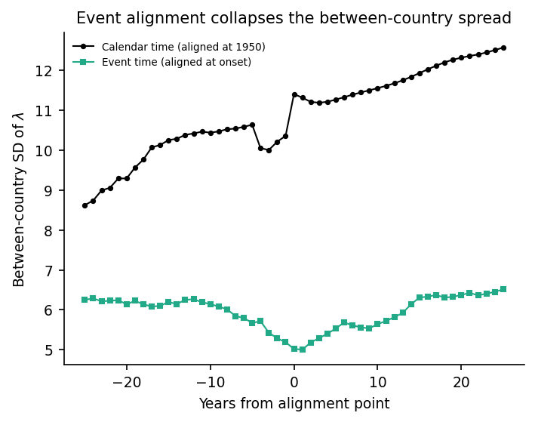
Figure 2. Between-country standard deviation of the crude birth rate around the alignment point, in calendar time (aligned at 1950) versus event time (aligned at each country's onset). Event alignment reduces the variance 3.4-fold.
Crucially, alignment does not rehabilitate both pathways equally. Recomputing the two conserved quantities within the paper's own fitting windows, event alignment lowers the coefficient of variation of the first quantity λ×e₀ from 0.27 (calendar) to 0.17—a genuine, timing-locked regularity that the calendar view actually obscures. But the second quantity λ×exp(e₀/17) does not tighten at all (0.30 calendar versus 0.31 event; Figure 3). The two 'universal pathways' are thus asymmetric: the pre-transition co-movement of fertility and mortality behaves like a conserved quantity once timing is removed, whereas the post-transition regime is a loose, heterogeneous convergence that no single constant captures—consistent with the reversal of the fertility–development relationship at high income (Myrskylä et al., 2009).
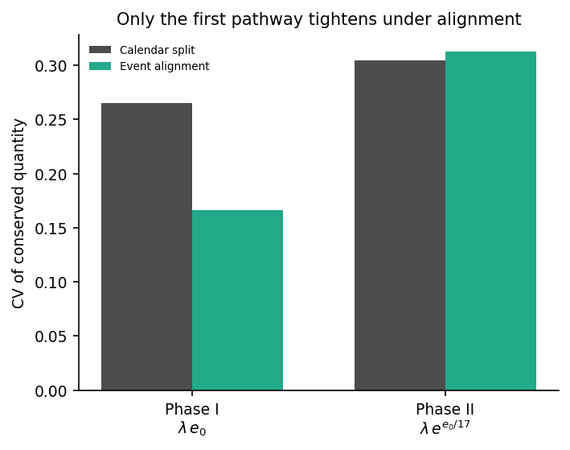
Figure 3. Coefficient of variation of the two conserved quantities within the paper's fitting windows, under the calendar split versus event alignment. Only the first pathway tightens.

A single curve does not yet describe within-country variation
A placeless law should also hold below the national level, and here the country-level regularity does not straightforwardly carry over—an open question that a country-level analysis necessarily leaves for later work. Using region-level life expectancy and crude birth rate for five decentralised states (156 regions in total; Eurostat, 2024; National Center for Health Statistics, 2022; U.S. Census Bureau, 2020), regions of the same country in the same year—at nearly identical e₀—differ substantially in λ (Figure 4). Among regions within a three-year e₀ band, the within-country coefficient of variation of λ ranges from 0.10 to 0.36 across countries (median 0.14). In Spain, regional λ in 2019 runs from 5.1 to 14.3 births per 1,000 despite an e₀ spread of only 4.4 years. This intra-national dispersion is of the same order as the cross-national variation of the second conserved quantity (0.31) that the paper treats as a universal signal. Whatever organises λ at a given e₀, it is not a single quantity shared by all populations.
Longitudinal sub-populations tell the same story. In the Human Mortality Database (2024), East and West Germany traced materially different λ–e₀ paths over their shared life-expectancy range (68–81 years): at matched e₀ their crude birth rates differed by 2.5 births per 1,000 on average (27% of the mean), reaching 5.0 at the widest—two populations of one nation that never shared a single curve.
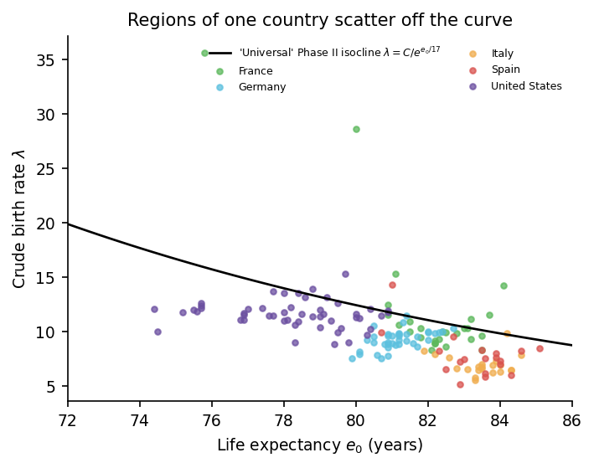
Figure 4. Region-level crude birth rate versus life expectancy (2019) for five decentralised states, against the national Phase II isocline λ = C/exp(e₀/17). Regions of one country scatter off the curve rather than lying on it.

Robustness
Both headline findings are robust to the exploratory onset definition. Varying the fertility-decline threshold (5–20%) and the smoothing window (3–9 years) over 16 combinations, the onset inter-quartile range stays between 51 and 66 years and the event-time variance reduction between 3.3- and 3.6-fold. The onset estimator is a descriptive device, not a claim about any single country's demographic history, and none of our conclusions depends on its exact tuning.
A stronger test of universality is whether stretching each country's time axis—not merely shifting it to the onset—collapses the trajectories onto a single curve (Figure 5). Rescaling event time by each country's transition duration (median 39 years, inter-quartile range 25–70; N = 180) does not: the between-country dispersion of λ at matched duration-normalised time is 7.5 births per 1,000, no smaller than the 6.3 obtained by onset alignment alone. The decline's shape is more nearly universal—once the amplitude is also normalised, the dispersion of the unit-scaled curves falls 3.3-fold—but that comparison discards the birth-rate level, which is exactly what a conserved quantity is supposed to fix. Decisively, no monotone time warp can touch the relationship in the (e₀, λ) plane the law is stated in: the between-country SD of λ at matched e₀ (6.9 births per 1,000) is invariant to any such rescaling. Time alignment thus sharpens the first pathway's timing, but does not by itself establish universality of level.
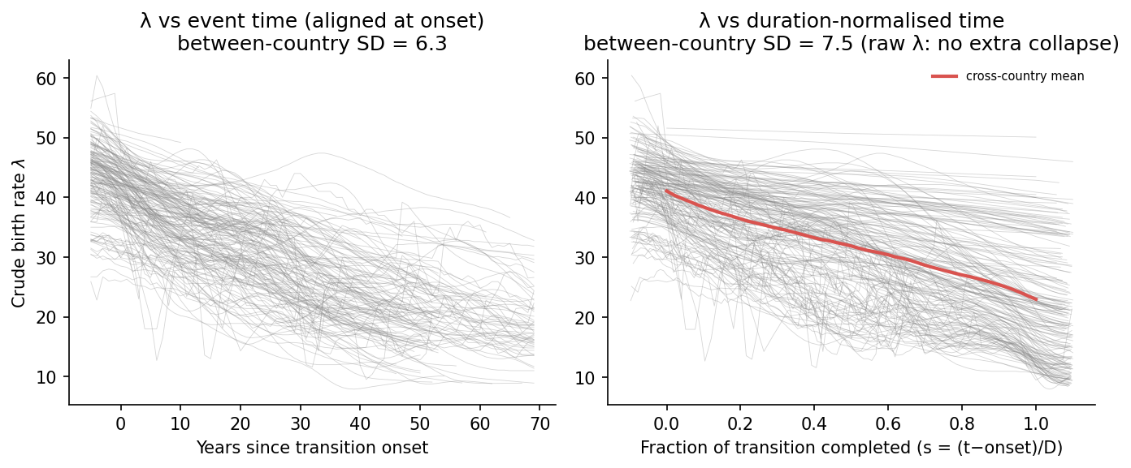
Figure 5. Crude birth rate against (left) years since each country's transition onset and (right) duration-normalised transition time s = (t−onset)/D. Rescaling the time axis does not shrink the raw between-country spread of λ beyond onset alignment; only the amplitude-normalised shape collapses, and the (e₀, λ) relationship is invariant to any monotone time warp.

Interpretation
None of this diminishes the regularity Itao (2026) documents; our aim is to build on it and locate it more precisely. The first pathway emerges, on this reading, as a real, timing-locked co-movement: as mortality falls, fertility follows in a way that is remarkably similar—indeed sharper than in calendar time—once each country is read on its own clock. The second 'pathway' is better described as incomplete, heterogeneous convergence toward low fertility, whose scatter—across countries and, importantly, within them—is larger than a single conserved constant would imply. We therefore offer three complementary refinements that extend, rather than overturn, the framework: analyse trajectories in event time alongside calendar time; model countries and regions as a hierarchy with partial pooling rather than a single pooled cloud; and read a common change point as a description of aggregated timing rather than a synchronised global event. Understood this way, the statistical-physics search for universality remains productive: it points to mechanism and shape once timing and level are accounted for, and its natural next step—which the mechanistic household model of Itao (2026) invites—is to carry the same reasoning down to the within-country scales where policy actually operates.

Acknowledgements
The author thanks Kenji Itao for making the original analysis and data openly available, which made this re-analysis possible.

Author Contributions
TO conceived the study, performed all analyses, and wrote the article.

Financial Support
This research received no specific grant from any funding agency, commercial or not-for-profit sectors.

Conflicts of Interest
The author declares none.

Research Transparency and Reproducibility
All data are public. Long-run national crude birth rate and life expectancy series are from Gapminder (https://www.gapminder.org/data/); sub-national data are from the Eurostat regional database (https://ec.europa.eu/eurostat/web/regions/data/database), the Human Mortality Database (https://www.mortality.org), the U.S. National Center for Health Statistics (https://data.cdc.gov) and the U.S. Census Bureau Population Estimates Program (https://www.census.gov/programs-surveys/popest.html). All analysis code and derived results that regenerate every number and figure in this article are available at https://github.com/bougtoir/demographic-transition-universality (release archived on acceptance).

References
Bongaarts, J., & Watkins, S. C. (1996). Social interactions and contemporary fertility transitions. Population and Development Review, 22(4), 639–682.
Coale, A. J. (1973). The demographic transition reconsidered. In International Population Conference, Liège 1973 (Vol. 1, pp. 53–72). IUSSP.
Eurostat. (2024). Regional demographic statistics [Data set]. https://ec.europa.eu/eurostat/web/regions/data/database
Galor, O. (2011). Unified growth theory. Princeton University Press.
Gapminder. (2023). Population, fertility and life expectancy data [Data set]. https://www.gapminder.org/data/
Human Mortality Database. (2024). University of California, Berkeley, and Max Planck Institute for Demographic Research. https://www.mortality.org
Itao, K. (2026). Two universal pathways in demographic transition. Evolutionary Human Sciences. https://doi.org/10.1017/ehs.2026.10054
Kirk, D. (1996). Demographic transition theory. Population Studies, 50(3), 361–387.
Myrskylä, M., Kohler, H.-P., & Billari, F. C. (2009). Advances in development reverse fertility declines. Nature, 460(7256), 741–743.
National Center for Health Statistics. (2022). U.S. state life expectancy by sex, 2019 [Data set]. Centers for Disease Control and Prevention. https://data.cdc.gov
Notestein, F. W. (1945). Population—the long view. In T. W. Schultz (Ed.), Food for the world (pp. 36–57). University of Chicago Press.
Reher, D. S. (2004). The demographic transition revisited as a global process. Population, Space and Place, 10(1), 19–41.
U.S. Census Bureau. (2020). Population estimates program (PEP): Components of change [Data set]. https://www.census.gov/programs-surveys/popest.html

