Supporting Information
Geographic distance decay in population-level Neanderthal and Denisovan segment profiles
Figure S1. Complete 66-population Neanderthal and Denisovan profile-similarity matrices.
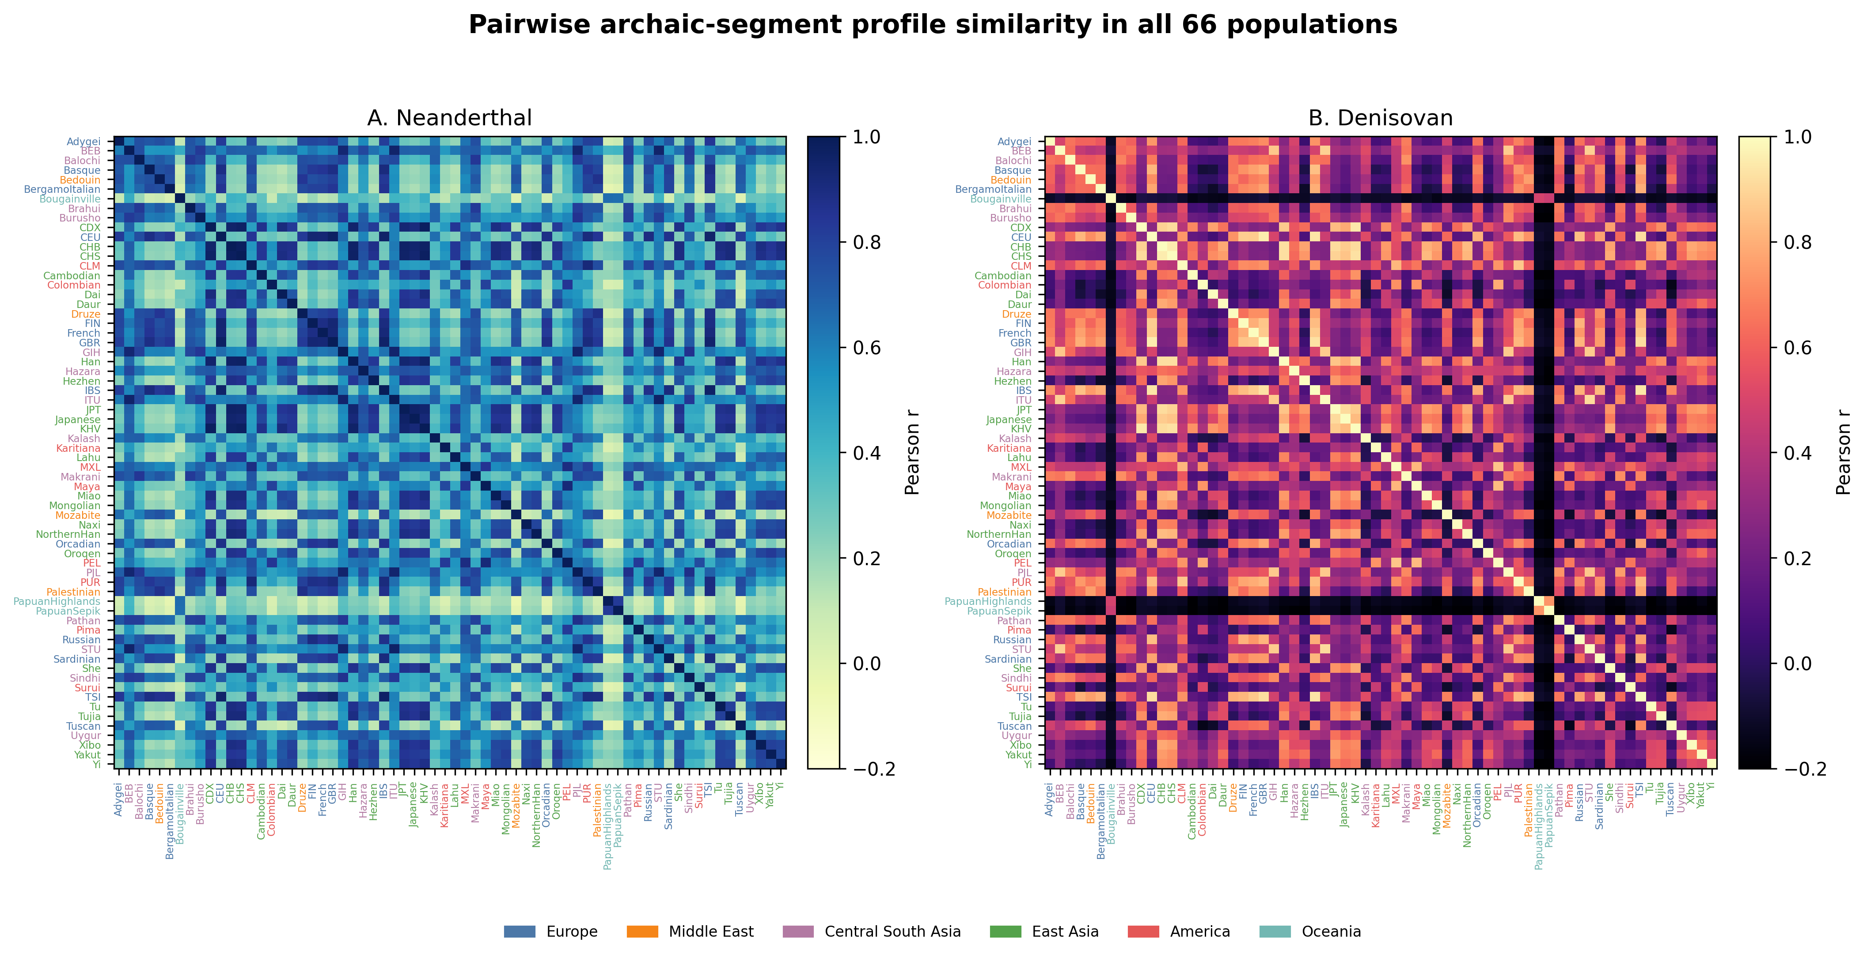

Figure S2. Descriptive geographic distance correlations at 250-kb, 500-kb, and 1-Mb window sizes; QAP results are tabulated in Supplementary Data.
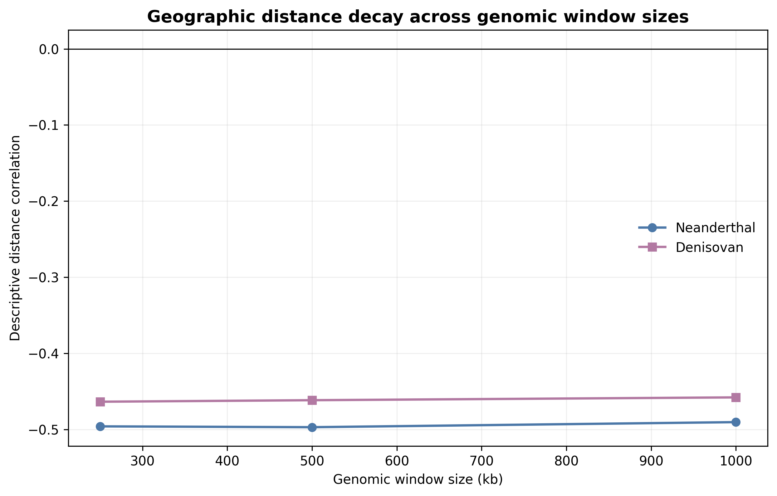

Supplementary Data Files
Supplementary Data 1: population_metadata.csv. Population, project, sample size, coordinates, continent assignment, and analysis inclusion.
Supplementary Data 2: pairwise_sharing_corrected.csv. Complete pairwise similarity, geographic, covariate, residual, permutation, and FDR results.
Supplementary Data 3: model_summary.csv. QAP coefficients, permutation P values, descriptive R-squared values, and population-deletion intervals.
Supplementary Data 4: sensitivity_analysis.csv and window_size_sensitivity.csv. Metric, population-subset, and window-size robustness summaries.

