Supplementary Information
A structural null for exceptional pairwise genomic similarity: archaic-segment sharing across 66 human populations
Contents: Supplementary Figures S1–S7, Supplementary Table S1, and descriptions of Supplementary Data 1–10 (provided in JHG_Supplementary_Data.zip). Reference numbers refer to the main-text reference list.

Supplementary Figure S1. Complete 66-population Neanderthal and Denisovan profile-similarity matrices.
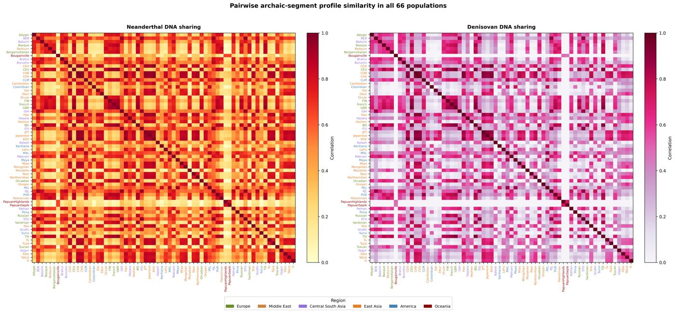

Supplementary Figure S2. Sensitivity of the descriptive Neanderthal distance correlation to exclusion of designated recently admixed populations.
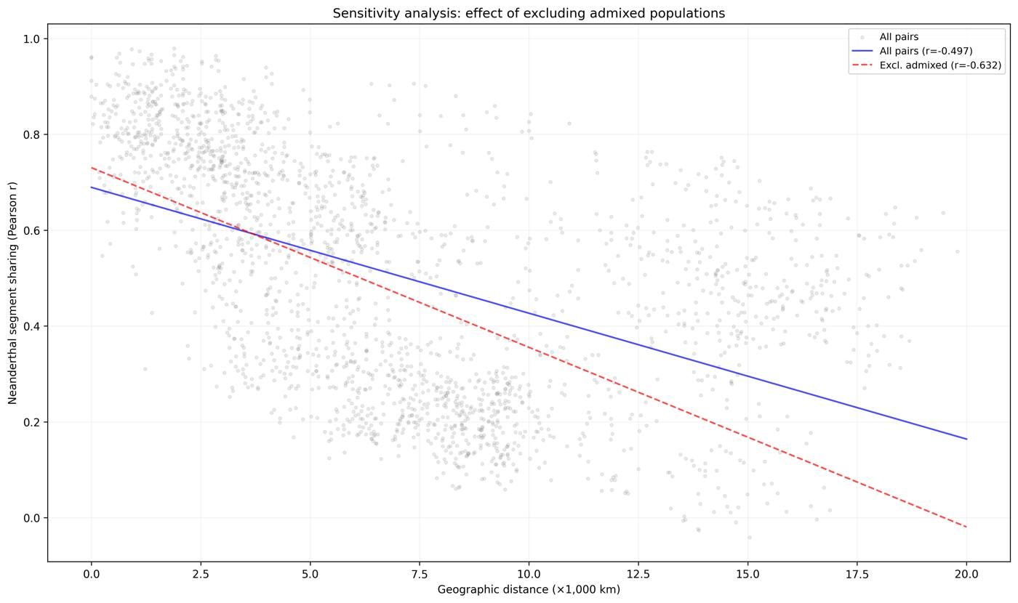

Supplementary Figure S3. Descriptive geographic distance correlations at 250-kb, 500-kb, and 1-Mb window sizes. QAP results are tabulated in Supplementary Data.
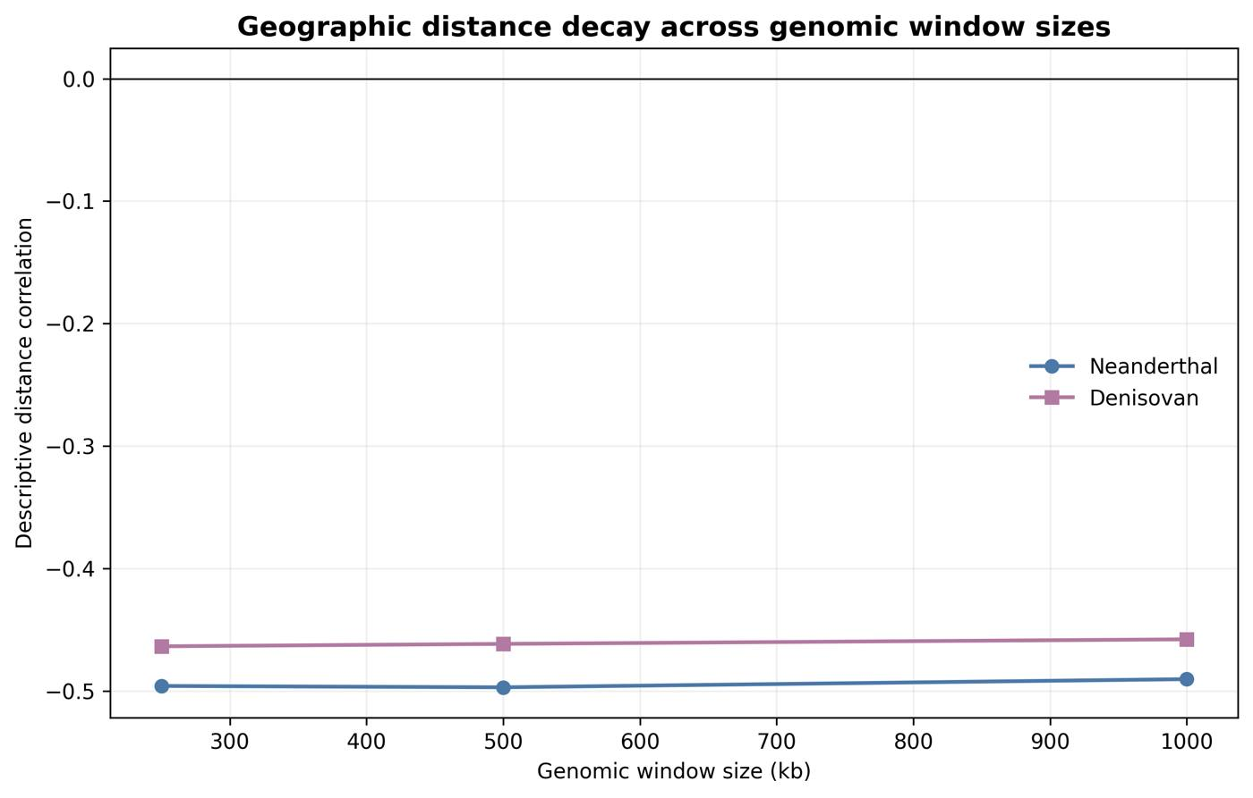

Supplementary Figure S4. Exploratory ABO-centered analysis preserving the historical grouped-bar and segment-map layout. Equal maximum-similarity ties are excluded from the displayed three-reference proportions and retained in Supplementary Data. The Pima segment overlaps ABO; the Maya segment is within the wider interval but does not overlap the gene. Counts are segments, not regional frequencies, and are not interpreted as a migration route.
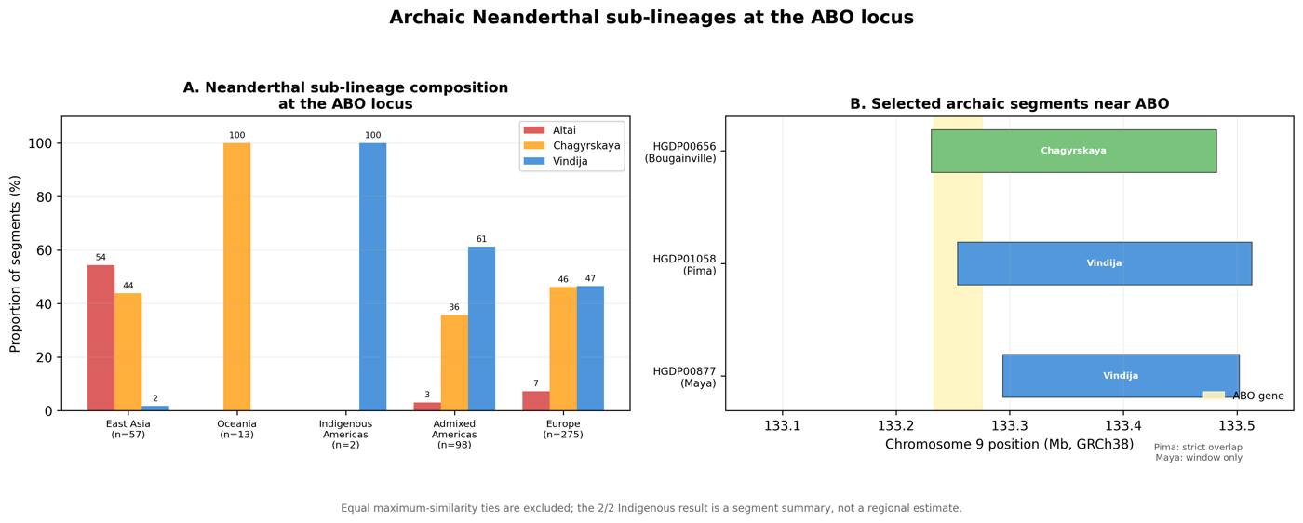

Supplementary Figure S5. O2 blood-group subtype-defining allele frequencies and ABO-window segment-carrier frequencies. The panels use different sources and are not an association analysis; proximity does not establish that the O2 allele is Neanderthal-derived.
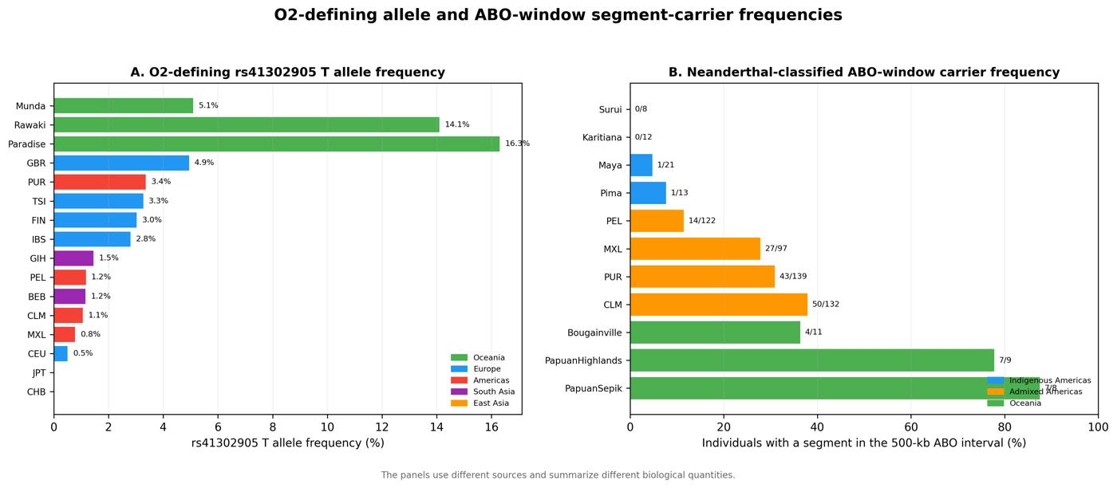

Supplementary Figure S6. Descriptive ancient and modern ABO-window summaries generated by different pipelines; no formal temporal comparison is made.
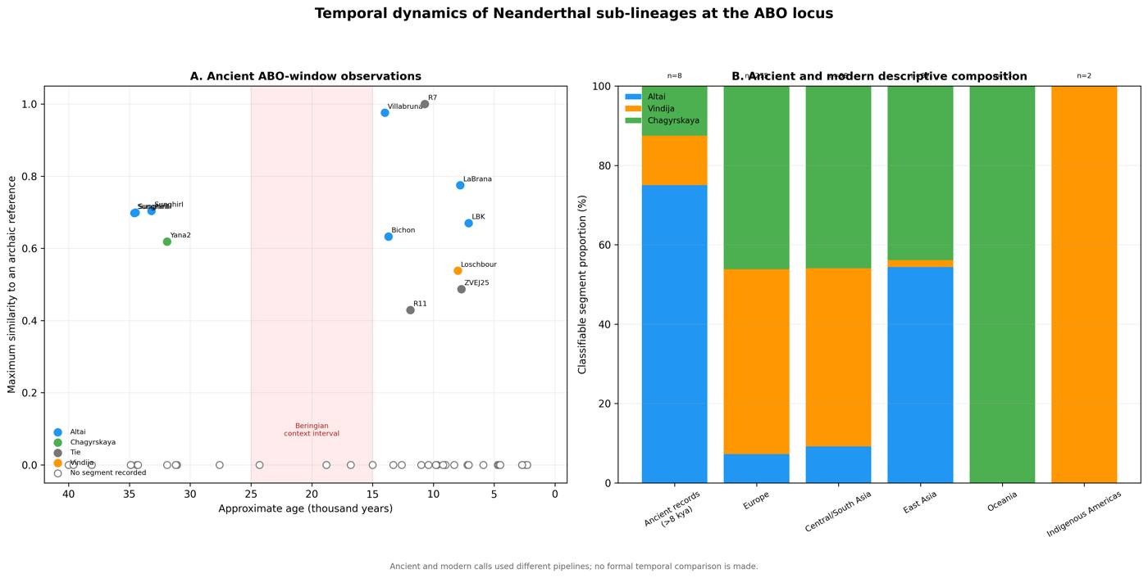

Supplementary Figure S7. Bivariate global context computed in this study. Circle area encodes the mean per-bin Neanderthal-segment coverage and colour encodes the mean per-bin Denisovan-segment coverage for each population, both from data/population_profiles_500kb.npz; coordinates are approximate sampling locations from data/population_metadata.csv. These descriptive summaries were not used in the pairwise statistical models.
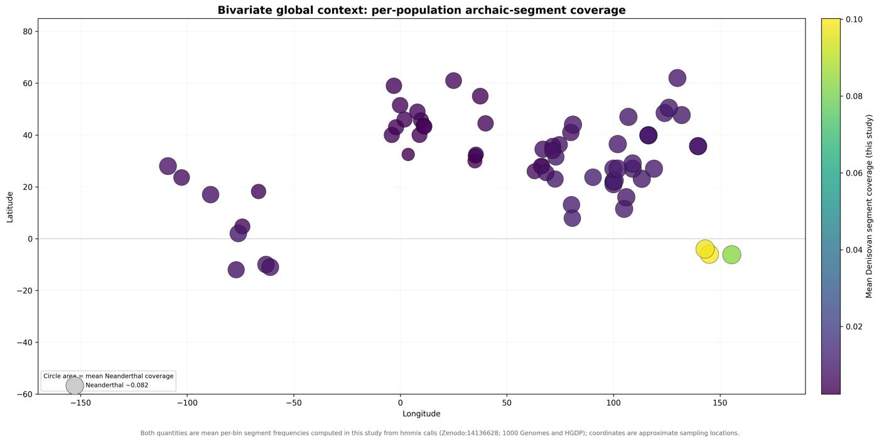

Table S1. Exploratory ABO-window Neanderthal-reference composition
Region | n | Altai % | Vindija % | Chagyrskaya %
East Asia | 57 | 54.4 | 1.8 | 43.9
Europe | 275 | 7.3 | 46.5 | 46.2
Indigenous Americas | 2 | 0.0 | 100.0 | 0.0
Admixed Americas | 98 | 3.1 | 61.2 | 35.7
Central/South Asia | 98 | 9.2 | 44.9 | 45.9
Middle East | 44 | 11.4 | 52.3 | 36.4
Oceania | 13 | 0.0 | 0.0 | 100.0
Note. Counts are classifiable segments, not individuals. Percentages use the three-reference denominator shown by n. Equal maximum-similarity ties are excluded from these percentages but retained in Supplementary Data. The 2/2 Indigenous American value is not a regional frequency estimate; only one segment overlaps ABO, and these counts are not interpreted as a migration route.

Supplementary Data 1–10
Supplementary Data 1: population_metadata.csv. Population, project of origin, sample size, representative latitude and longitude, continental assignment, recent-admixture flag, and inclusion status for each of the 66 analysed populations.
Supplementary Data 2: pairwise_sharing_corrected.csv. All 2 145 population pairs with Neanderthal and Denisovan profile similarity, great-circle distance, covariate indicators, fitted values, residual z scores, permutation P values, and Benjamini-Hochberg q values.
Supplementary Data 3: model_summary.csv. Quadratic assignment procedure coefficients for both ancestries, population-label permutation P values, descriptive R-squared values, and population-deletion intervals.
Supplementary Data 4: sensitivity_analysis.csv. Similarity-metric and population-subset robustness summaries, including the non-admixed subset of 1 891 pairs from 62 populations.
Supplementary Data 5: window_size_sensitivity.csv. Robustness of the population-wide geographic-distance association at 250-kb, 500-kb, and 1-Mb genomic window sizes, reporting for each ancestry the raw distance correlation, the quadratic assignment procedure distance coefficient, the two-sided permutation P value, the descriptive R-squared value, and the number of permutations.
Supplementary Data 6: profile_quality_checks.csv. Ancestry-level profile quality checks reporting the maximum observed population-window frequency, the number of bins exceeding one, and the number of non-zero population-window entries.
Supplementary Data 7: abo_focal_test.json. Prespecified ABO focal-window result: window coordinates, maximum standardised excess similarity, genome-wide percentile, empirical P value, and the number of usable windows for each ancestry.
Supplementary Data 8: ancient_abo_summary.csv. Ancient-individual summaries extracted from the published Neanderthal-segment catalogue for the ABO interval, giving for each of the 59 assessed ancient individuals the age, population, region, closest archaic reference, reference proportions, segment-detection status, and strict ABO gene overlap. These data were generated by a different pipeline from the present-day profiles, are used descriptively only in the Discussion, and are not compared statistically with the present-day data; no analysis result depends on this file.
Supplementary Data 9: ancient_abo_provenance.json. Provenance for the ancient ABO-interval summary, including the source publication and source data DOIs, the GRCh37/hg19 genome build, the ABO gene and window coordinates, the diagnostic-site and genetic-map settings, the source file names with their SHA-256 checksums, and the counts of ancient individuals assessed, with a detected segment, and with strict ABO overlap.
Supplementary Data 10: analysis_provenance.json. Provenance for the committed analysis, including the analysis release, the analysis code commit, the input file names with their SHA-256 checksums, the minimum segment probability and minimum population size, the genomic bin size, the frequency definition, and the final counts of individuals, populations, and population pairs.

