Population structure, not special connections: a dependence-aware baseline for archaic-segment sharing across 66 human populations
Original Article
ONISHI TATSUKI
Data Science and AI Innovation Research Promotion Center
Onishi Tatsuki, Data Science and AI Innovation Research Promotion Center; Email: bougtoir@gmail.com
Running title: A dependence-aware archaic-sharing baseline

Summary
Archaic-like segments near focal loci such as the ABO blood-group gene are often read as evidence of special population connections or migration routes, yet such readings are rarely tested against a genome-wide baseline that respects the dependence structure of pairwise data. We built a reproducible baseline for population-level archaic-segment sharing and used it as a well-powered negative test of exceptional-connection and focal-locus claims. High-confidence Neanderthal and Denisovan introgression calls from 3,134 individuals in 66 populations were summarised in 500-kilobase windows, and profile similarity was computed for 2,145 population pairs. Distance associations and pair-level outliers were assessed with population-label permutation tests and false-discovery-rate control. Profile similarity declined with geographic distance for Neanderthal (r=-0.497) and Denisovan (r=-0.462) segments, with partial distance correlations of -0.369 and -0.326 and permutation P values of 0.0001 and 0.0002. No non-admixed pair reached both a residual above two standard deviations and a false-discovery rate below 0.10, and a prespecified ABO-window scan showed no route-level signal. Population-level archaic-segment sharing reflects broad geographic structure but supports neither exceptional population pairs nor an ABO-mediated migration history, providing a reusable baseline for evaluating focal-locus archaic claims.
Keywords: ABO Blood-Group System; Gene Flow; Genetics, Population; Models, Statistical; Neanderthals

Introduction
Genomic comparisons established gene flow from Neanderthals (Homo neanderthalensis) and Denisovans into ancestors of present-day populations outside Africa (Green et al. 2010; Reich et al. 2010). The amount and genomic distribution of introgressed sequence vary among populations because of demographic history, drift, selection, and multiple introgression histories (Sankararaman et al. 2014; Sankararaman et al. 2016; Jacobs et al. 2019). These differences invite a recurring style of inference in which shared archaic segments, often at a focal locus such as the ABO blood-group gene, are read as evidence of a special connection between two populations or of a particular migration route (Calafell et al. 2008; Halverson and Bolnick 2008; Condemi et al. 2021).
Such claims are difficult to evaluate because pairwise profile similarity is dyadic: each of 66 populations appears in many pair rows, so the 2,145 pairs are not independent observations. Standard row-wise regressions, bootstraps, or response shuffles do not preserve this population-level dependence, and an apparently exceptional pair can arise from broad structure alone. What is generally missing is a genome-wide baseline that constructs population profiles reproducibly, tests distance and pair-level effects under a permutation scheme that respects the dependence structure, and applies explicit multiple-testing control. Quadratic assignment procedures (QAP) permute population labels on a complete matrix and provide exactly this kind of dependence-aware test (Krackhardt 1988; Dekker, Krackhardt, and Snijders 2007).
We build such a baseline and use it as a well-powered negative test of two recurring claims: that particular population pairs share an exceptional excess of archaic segments, and that a focal locus such as ABO marks a specific migration route. A clearly framed negative result under dependence-aware inference is itself informative, because it sets the genome-wide expectation that any positive focal-locus or special-connection claim must exceed. Using great-circle distance across 66 populations from the 1000 Genomes Project and Human Genome Diversity Project (HGDP), we test whether Neanderthal- and Denisovan-segment profile similarity declines with distance, whether any population pair is a false-discovery-rate-supported residual outlier, and whether a prespecified interval centered on the ABO blood-group locus, chosen because ABO has an unusually deep allelic history and has motivated founder-effect and archaic-background hypotheses (Segurel et al. 2012; Calafell et al. 2008; Halverson and Bolnick 2008; Condemi et al. 2021), shows anything beyond the genome-wide expectation. Robustness to alternative windows, similarity metrics, sample-size thresholds, datasets, co-located pairs, and regional omission is assessed throughout. The focal ABO analysis is prespecified as exploratory and is not used to infer a migration route.

Materials and Methods

Data sources and population inclusion
We analyzed publicly archived segment calls generated with hmmix, a hidden Markov model-based method that detects candidate archaic sequence without requiring an unadmixed modern outgroup (Skov et al. 2018). Segment files for the 1000 Genomes Project and Human Genome Diversity Project (HGDP) samples were obtained from Zenodo record 14136628. Source population definitions followed those resources (1000 Genomes Project Consortium 2015; Bergström et al. 2020). Secure Hash Algorithm 256 (SHA-256) checksums of both raw files are written to the analysis provenance record.
Segments with mean posterior probability below 0.8 were excluded. Populations with fewer than seven represented individuals were excluded, leaving 3,134 individuals in 66 populations. Source calls annotated as Neanderthal or Both entered the Neanderthal profile; calls annotated as Denisova or Both entered the Denisovan profile.

Population profiles and pairwise similarity
Autosomes were partitioned into 500-kilobase (kb) windows. Within each ancestry category, overlapping or fragmented source segments were collapsed so that each individual-haplotype-window contributed at most one presence. For each population and window, unique haplotype presences were divided by twice the number of represented individuals. A runtime validity check required every frequency to lie between 0 and 1.
For each population pair, Pearson correlation was calculated across the union of windows with a nonzero frequency in either population. Pairs required more than 100 union windows for Neanderthal and more than 50 for Denisovan profiles. The 66-population matrices contained 2,145 unique off-diagonal pairs. Correlations describe profile similarity and do not establish identity by descent. Spearman correlation and cosine similarity were calculated as metric sensitivities.
Population coordinates were consolidated in a versioned metadata table from source sampling locations or population centroids. Great-circle distance was calculated with the Haversine formula. Coordinate uncertainty and co-located population labels were assessed by excluding zero-distance pairs.

Dyadic regression and permutation inference
The primary expanded descriptive model regressed pairwise similarity on distance per 1,000 km, involvement of one of four designated recently admixed American populations: Puerto Ricans from Puerto Rico (PUR), Colombians from Medellín, Colombia (CLM), people with Mexican ancestry from Los Angeles, United States (MXL), or Peruvians from Lima, Peru (PEL). The model also included same-continent status and same-dataset status. These indicators are coarse sensitivity covariates, not individual ancestry estimates or causal controls. Distance-only models were also fit.
Coefficient P values used 9,999 quadratic assignment permutations. At each iteration, the response matrix was permuted by the same random population-label order on rows and columns, after which the model was refit. Two-sided P values were the proportion of permuted coefficient magnitudes at least as large as the observed magnitude, including a plus-one correction. Descriptive R-squared values quantify fit to the observed pair matrix and are not interpreted as independent observations or causal variance explained.
Population-deletion stability intervals were calculated by refitting the expanded model after removing every pair containing one population in turn and reporting the 2.5th and 97.5th percentiles of the resulting coefficients. These are sensitivity intervals rather than independent-sample confidence intervals.

Residual outliers and multiple testing
Outlier analysis was restricted to the complete matrix after removing PUR, CLM, MXL, and PEL. Similarity was modeled using distance, same-continent status, and same-dataset status. Positive residuals were standardized by the residual standard deviation. For every pair, a one-sided nominal P value was calculated from its own residual null distribution across 9,999 population-label permutations. Because pair residuals are dyadically dependent, this null was generated by the same joint row-and-column population-label permutation used for the coefficient tests rather than by row-wise resampling, following the rationale for multiple-regression quadratic assignment with dependent dyads (Dekker, Krackhardt, and Snijders 2007). The Benjamini-Hochberg procedure was applied jointly to all non-admixed pairs within each ancestry analysis to control the false discovery rate (FDR) (Benjamini and Hochberg 1995). A supported positive outlier required z>2 and q<0.10.

Robustness analyses
We repeated distance-only population-label tests for 250-kb, 500-kb, and 1-megabase (Mb) windows. At 500 kb, robustness summaries compared Pearson, Spearman, and cosine similarity; minimum population sizes of 7, 10, 15, and 20; the complete dataset, non-admixed populations, 1000 Genomes-only and HGDP-only subsets; exclusion of zero-distance pairs; and leave-one-continent-out subsets. Full-window Pearson correlation and presence-absence Jaccard similarity assessed sensitivity to the nonzero-window union. Sensitivity tests used 999 population-label permutations. No genome-wide callable mask was available in the source release, so mask-adjusted profiles could not be evaluated.

Secondary ABO-centered analysis
The ABO gene was defined on Genome Reference Consortium Human Build 38 (GRCh38) as chromosome 9 (chr9):133,233,278-133,276,024. We distinguished strict gene overlap from any overlap with a 500-kb interval spanning chr9:133.0-133.5 Mb. Population carrier frequencies used unique individuals in the numerator and all represented source individuals in the denominator.
For Neanderthal or Both segments in the interval, similarity counts to Altai, Vindija, and Chagyrskaya were compared; tied maxima remained ties. The Vindija reference is a high-coverage Neanderthal genome (Prüfer et al. 2017). The O2 blood-group subtype-defining rs41302905 T allele was summarized from Ensembl/1000 Genomes frequencies and published Solomon Islands frequencies (Ohashi et al. 2006). Ancient-window observations were extracted by a documented, reproducible script from the public Neanderthal-segment catalogue of Iasi et al. (2024), using the GRCh37 ABO interval that corresponds to the GRCh38 window analysed here; ancient and modern calls used different pipelines and were not directly compared statistically.

Ethical review, community engagement, and interpretation
This computational secondary analysis used de-identified public data and involved no recruitment, contact, biospecimen collection, or new individual-level phenotype inference. The author did not obtain a separate institutional review determination for this secondary analysis; approvals, consent, and data-access procedures were those reported by the source studies. This limitation is disclosed rather than treating public availability as equivalent to unrestricted ethical reuse.
No source community or stakeholder representatives participated in the design, analysis, interpretation, or dissemination of the present secondary study, and no direct community return-of-results process was conducted. Because the dataset includes Indigenous participants and the topic can affect narratives of ancestry and migration, analyses were interpreted in light of Indigenous data-governance guidance and the Collective Benefit, Authority to Control, Responsibility, and Ethics (CARE) Principles (Claw et al. 2018; Carroll et al. 2020). Population labels were retained only when needed for transparent source-data description; locus-level observations were not generalized to communities, and migration routes were not assigned from these data. The public article, code, and derived aggregate results are the current means of results availability. These disclosures are made in the interest of transparent ethical reporting for secondary genomic analyses.

Results

Data-validity correction
Collapsing fragmented segments at the individual-haplotype-window level removed duplicate contributions that could otherwise make a nominal frequency exceed 1. In the rebuilt profiles, the maximum frequency was 1.0 for both ancestry categories and no population-window frequency exceeded 1. The analysis retained 66 populations, 3,134 individuals, and 2,145 unique population pairs.

Geographic distance decay
Neanderthal profile similarity declined with distance (raw r=-0.497); the corresponding Denisovan correlation was -0.462. Partial distance correlations from the expanded descriptive models were -0.369 and -0.326. Distance-only R-squared values were 0.247 and 0.213; expanded-model values were 0.546 and 0.511. The QAP distance coefficients per 1,000 km were -0.01892 (P=0.0001) and -0.01918 (P=0.0002) (Figure 1).
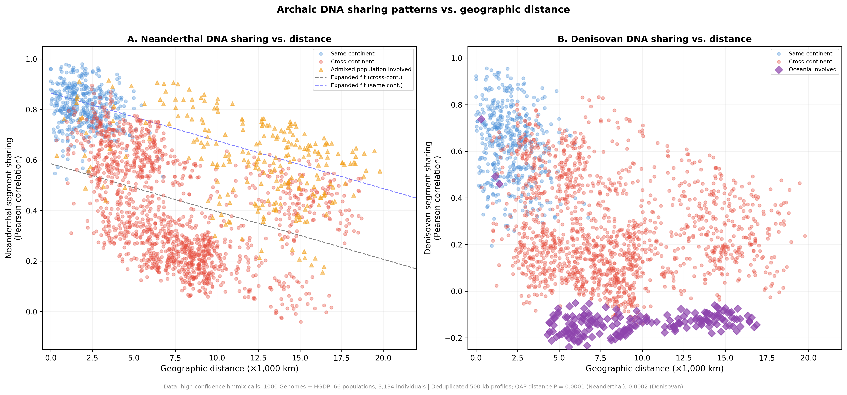
Figure 1. Archaic-segment profile similarity and geographic distance. Each point is a dependent population pair. Lines are descriptive distance-only fits; reported P values use population-label quadratic assignment permutations.

Population structure
The representative heat maps showed broad regional blocks and a stronger Oceanian contrast in the Denisovan profile (Figure 2). The complete 66-population heat map is provided as Figure S1.
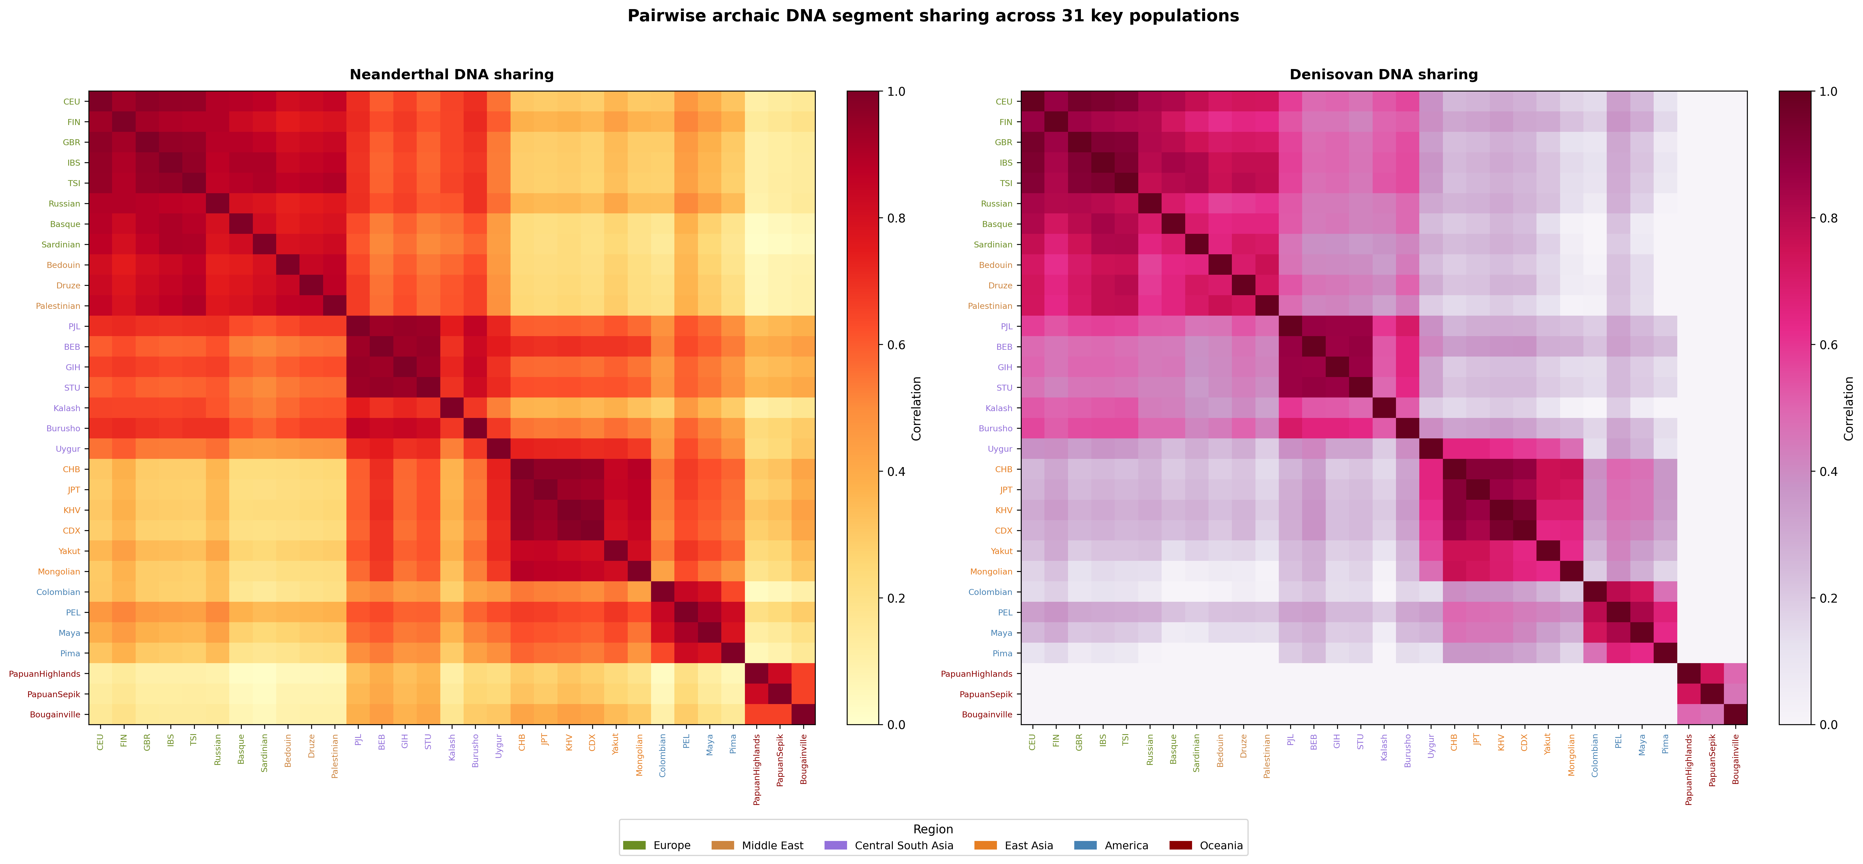
Figure 2. Pairwise archaic-segment profile similarity for 31 prespecified populations. The subset is displayed for legibility; all 66 populations were analyzed.

Robustness analyses
Negative distance correlations were examined across admixture exclusions, within-dataset subsets, minimum sample sizes, and regional omissions. Figure 3 shows the effect of excluding designated recently admixed populations, and Figure 4 shows window-size results at 250 kb, 500 kb, and 1 Mb. These analyses were treated as robustness checks rather than independent confirmatory tests.
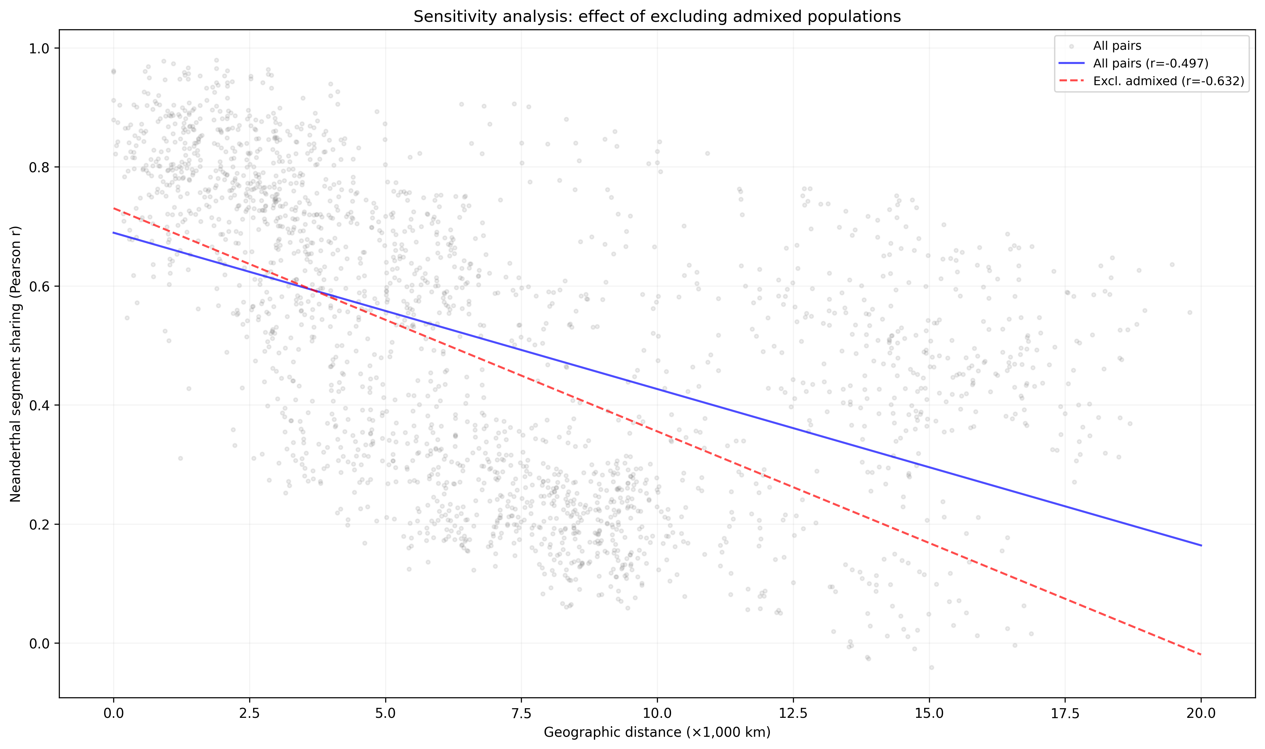
Figure 3. Sensitivity of the descriptive Neanderthal distance correlation to exclusion of designated recently admixed populations.
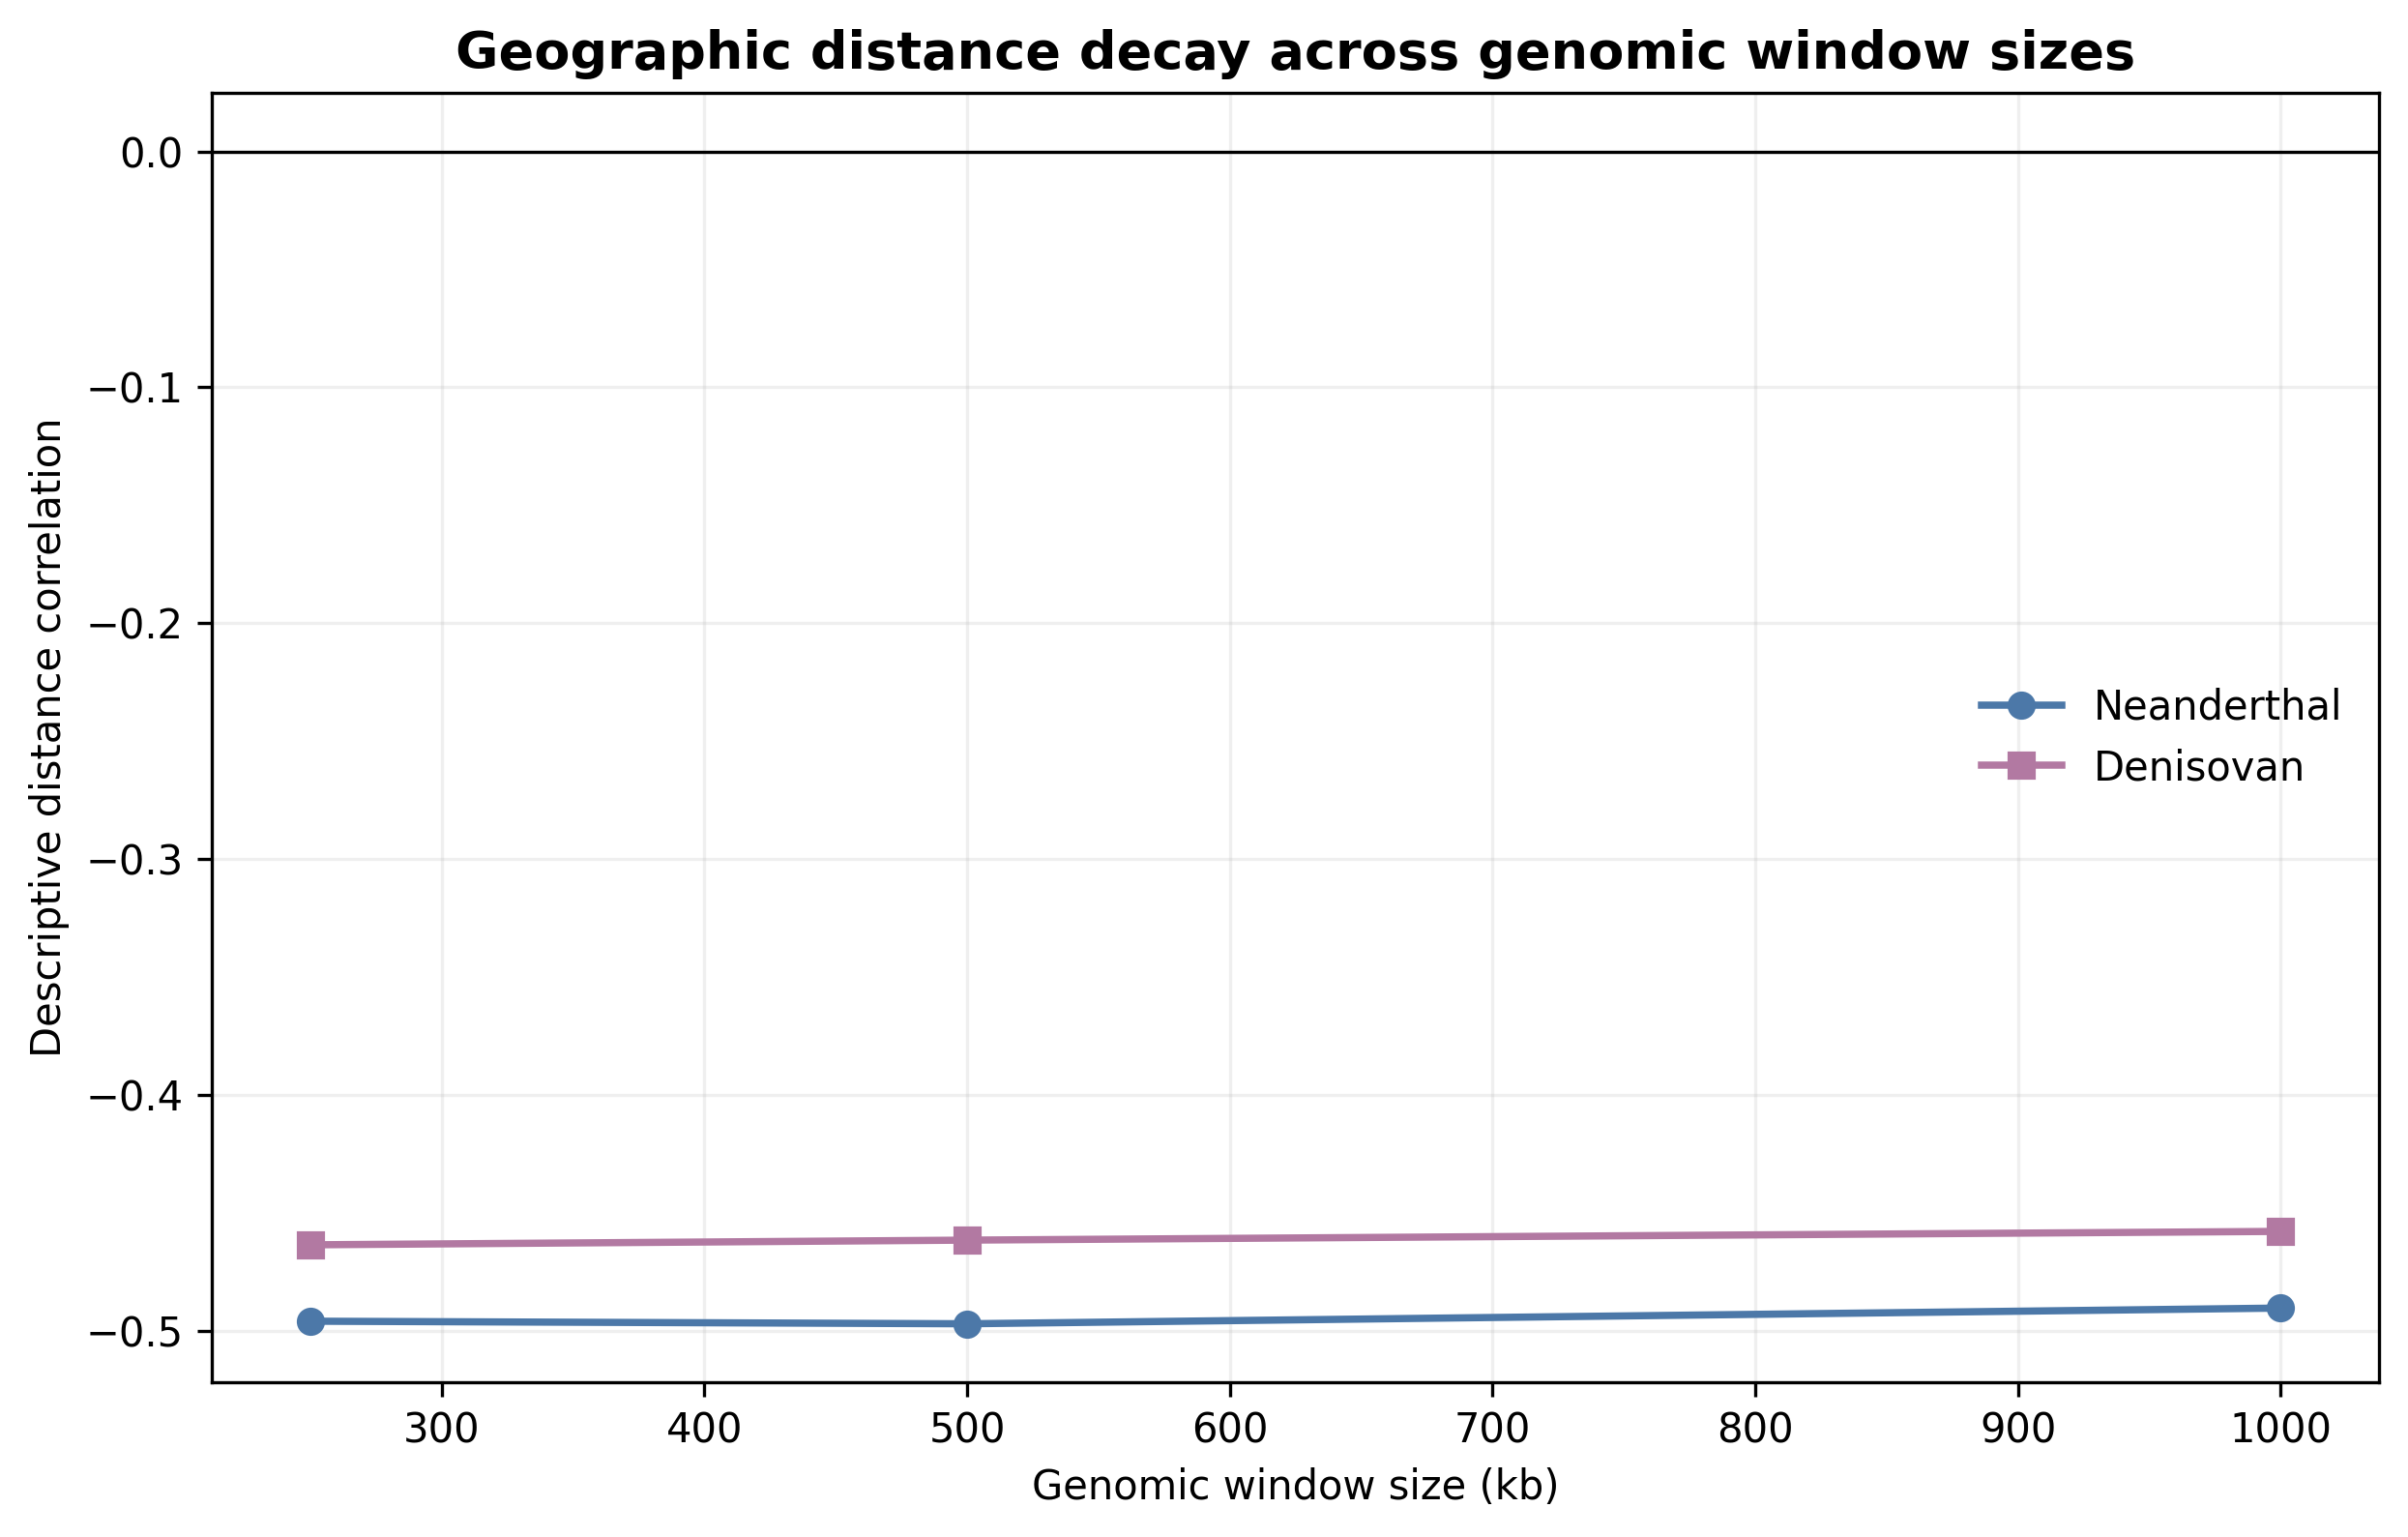
Figure 4. Descriptive geographic distance correlations at 250-kb, 500-kb, and 1-Mb window sizes. Quadratic assignment procedure results are tabulated in Supplementary Data.

Residual outlier testing
No non-admixed pair met both the positive-residual z>2 criterion and Benjamini-Hochberg q<0.10 for either ancestry category. Nominal residual ranks are retained in the full pairwise data table for auditability but are not interpreted as statistically supported population connections (Table 1).
Table 1. Positive-residual Neanderthal pairs after false discovery rate control
Population 1 | Population 2 | Region 1 | Region 2 | Distance (km) | Sharing (r) | z-score
No qualifying pair | — | — | — | — | — | No z>2 and q<0.10 result
Note. The prespecified family contains all non-admixed population pairs. No pair met both z>2 and Benjamini-Hochberg q<0.10; the Denisovan analysis likewise identified no qualifying pair. Complete nominal rankings and dependence-aware model results are provided in Supplementary Data.

Prespecified ABO-window check
As a prespecified focal-locus check, the 500-kb ABO-centered scan identified 834 Neanderthal or Both source segments, of which 129 overlapped the ABO gene and 247 were tied for maximum reference similarity. In the Indigenous American HGDP subset only two segments among 41 represented individuals fell in the interval. Consistent with the genome-wide result, this focal scan produced no route-level signal; exploratory segment-level compositions and counts are provided as Supplementary material (Figure S2; Table S1) and are not interpreted as regional proportions or migration routes.

Contextual displays
Several descriptive context panels are provided as supplementary figures because they do not derive from the pairwise analysis. The O2-defining allele and ABO-window carrier summaries use different sources and are displayed descriptively rather than as an association analysis (Figure S3). Ancient and modern ABO-window observations were produced by different pipelines and permit no formal temporal comparison (Figure S4). A bivariate global map summarising each population's mean Neanderthal and Denisovan segment coverage from the present profiles provides broad geographic context and was not used in the statistical models (Figure S5).

Discussion
After correction of the population-frequency construction, both Neanderthal and Denisovan profile similarities retained negative geographic associations. The result is therefore not an artifact of allowing fragmented segments to contribute repeatedly to the same haplotype-window. The revised estimates are used throughout the manuscript and submission materials.
The population-label permutation is central to interpretation. A dataset of 2,145 pairs does not contain 2,145 independent geographic comparisons because each of 66 populations appears repeatedly. QAP preserves the complete matrix while testing whether the observed distance coefficient is unusual under population relabeling (Krackhardt 1988; Dekker, Krackhardt, and Snijders 2007). The expanded-model R-squared values remain descriptive; coarse same-continent, recent-admixture, and dataset indicators should not be read as causal adjustment.
The distance-decay signal is compatible with broad serial demographic structure and the spatial patterning of introgressed sequence described in earlier work (Sankararaman et al. 2014; Sankararaman et al. 2016; Quilodran et al. 2023). It does not identify the timing, direction, or number of migration or introgression events. Population coordinates are approximations, and archaic-call similarity can also reflect callability, allele-frequency differences, linkage, selection, and reference-panel composition.
The absence of FDR-supported residual outliers constrains the strongest historical claims. A highly ranked pair cannot be promoted as evidence for a special connection when its pair-specific permutation result does not survive the declared testing family. This is especially important for admixed American populations, for which recent mixture can alter both inferred archaic profiles and geographic interpretations.
The ABO analysis illustrates the limits of a focal-locus narrative. ABO has deep allelic history, and selection can affect the persistence of introgressed sequence (Segurel et al. 2012; Petr et al. 2019). Nevertheless, an inferred segment in a 500-kb interval is not an ABO allele, closest-reference similarity is not a transmission path, and the O2-defining variant cannot be labeled Neanderthal-derived from proximity alone. The Pima and Maya observations are individual segment records, not population prevalence estimates.
Published Ancient North Eurasian and multiple-founder models provide broader contexts for First American ancestry (Raghavan et al. 2014; Skoglund et al. 2015), but they do not validate a route for either ABO-window segment. Such a claim would require independently sampled ancient genomes, a phased local genealogy, method-matched calling, and explicit community-engaged governance for any new Indigenous genomic analysis.
Limitations include modest sizes for several populations, sparse Denisovan calls outside Oceania, centroid-based distances, lack of a common callable mask, and correlation measures that do not distinguish identity by descent from identity by state. The dataset combines two projects, and same-dataset status only partially represents technical heterogeneity. Population-deletion and sensitivity analyses assess stability but cannot replace validation in independent modern and ancient data.
In conclusion, population-level archaic-segment profiles show a broad geographic distance-decay pattern under dependence-aware permutation tests, but the same analysis provides no support for an exceptional population pair, an ABO-mediated migration history, or a specific route through Beringia or island Southeast Asia. The contribution is therefore less a new signal than a reproducible, dependence-aware baseline: by combining frequency-constrained profile construction, population-label QAP inference, and explicit false-discovery-rate control, it offers a reusable negative control against which focal-locus and special-connection archaic claims can be judged.

Acknowledgements
The author acknowledges the participants, communities, and investigators whose contributions made the 1000 Genomes, HGDP, hmmix, and ancient-genome resources available. Public availability does not remove obligations of respectful reuse.
Funding: This research received no specific grant from any funding agency in the public, commercial, or not-for-profit sectors.

Data Availability
Analysis scripts, aggregate derived data, figures, and document-generation code are available at https://github.com/bougtoir/denisovan-archaic-dna-analysis and will be fixed as release ahg-submission-2026-07 before submission. The source hmmix segment calls are available from Zenodo record 14136628 (https://doi.org/10.5281/zenodo.14136628). The ancient ABO-window observations were derived from the public Neanderthal-segment catalogue of Iasi et al. (2024), archived at Dryad (https://doi.org/10.5061/dryad.zw3r228gg); O2 subtype-defining allele frequencies were obtained from the Ensembl Variation application programming interface and from Ohashi et al. (2006). Raw-file SHA-256 checksums and all analysis parameters are included in analysis_provenance.json and ancient_abo_provenance.json.

Conflict of Interest Statement
The author declares no conflict of interest.

Ethics Statement
This secondary computational analysis used de-identified public genomic data and involved no recruitment, participant contact, biospecimen collection, or new phenotype inference. No separate institutional review determination was obtained; approvals, consent, and access procedures were those reported by the source studies. No source community representatives participated in this secondary study, and no direct community return-of-results process occurred. Because Indigenous genomic records are included, results are reported only at the minimum level needed for auditability, are not generalized to communities, and are not used to assign migration routes. The public article, code, and aggregate derived results are the current means of results availability.

Author Contributions
Onishi Tatsuki: Conceptualization, methodology, formal analysis, visualization, writing—original draft, and writing—review and editing.

References
1000 Genomes Project Consortium. 2015. “A Global Reference for Human Genetic Variation.” Nature 526 (7571): 68–74. https://doi.org/10.1038/nature15393.
Benjamini, Yoav, and Yosef Hochberg. 1995. “Controlling the False Discovery Rate: A Practical and Powerful Approach to Multiple Testing.” Journal of the Royal Statistical Society: Series B 57 (1): 289–300. https://doi.org/10.1111/j.2517-6161.1995.tb02031.x.
Bergström, Anders, Shane A. McCarthy, Ruoyun Hui, et al. 2020. “Insights into Human Genetic Variation and Population History from 929 Diverse Genomes.” Science 367 (6484): eaay5012. https://doi.org/10.1126/science.aay5012.
Calafell, Francesc, Françoise Roubinet, Antonio Ramirez-Soriano, et al. 2008. “Evolutionary Dynamics of the Human ABO Gene.” Human Genetics 124 (2): 123–35. https://doi.org/10.1007/s00439-008-0530-8.
Carroll, Stephanie Russo, Ibrahim Garba, Oscar L. Figueroa-Rodríguez, et al. 2020. “The CARE Principles for Indigenous Data Governance.” Data Science Journal 19: 43. https://doi.org/10.5334/dsj-2020-043.
Claw, Katrina G., Dorothy Lippert, Jessica Bardill, et al. 2018. “A Framework for Enhancing Ethical Genomic Research with Indigenous Communities.” Nature Communications 9: 2957. https://doi.org/10.1038/s41467-018-05188-3.
Condemi, Silvana, Amandine Mazières, Pascal Faux, et al. 2021. “Blood Groups of Neandertals and Denisova Decrypted.” PLOS ONE 16 (7): e0254175. https://doi.org/10.1371/journal.pone.0254175.
Dekker, David, David Krackhardt, and Tom A. B. Snijders. 2007. “Sensitivity of MRQAP Tests to Collinearity and Autocorrelation Conditions.” Psychometrika 72: 563–81. https://doi.org/10.1007/s11336-007-9016-1.
Green, Richard E., Johannes Krause, Adrian W. Briggs, et al. 2010. “A Draft Sequence of the Neandertal Genome.” Science 328 (5979): 710–22. https://doi.org/10.1126/science.1188021.
Halverson, Melissa S., and Deborah A. Bolnick. 2008. “An Ancient DNA Test of a Founder Effect in Native American ABO Blood Group Frequencies.” American Journal of Physical Anthropology 137 (3): 342–47. https://doi.org/10.1002/ajpa.20887.
Iasi, Leonardo N. M., Manjusha Chintalapati, Laurits Skov, et al. 2024. “Neanderthal Ancestry through Time: Insights from Genomes of Ancient and Present-Day Humans.” Science 386 (6727): eadq3010. https://doi.org/10.1126/science.adq3010.
Jacobs, Guy S., Georgi Hudjashov, Lauri Saag, et al. 2019. “Multiple Deeply Divergent Denisovan Ancestries in Papuans.” Cell 177 (4): 1010–21.e32. https://doi.org/10.1016/j.cell.2019.02.035.
Krackhardt, David. 1988. “Predicting with Networks: Nonparametric Multiple Regression Analysis of Dyadic Data.” Social Networks 10 (4): 359–81. https://doi.org/10.1016/0378-8733(88)90004-4.
Ohashi, Jun, Izumi Naka, Ryosuke Kimura, et al. 2006. “Polymorphisms in the ABO Blood Group Gene in Three Populations in the New Georgia Group of the Solomon Islands.” Journal of Human Genetics 51 (5): 407–11. https://doi.org/10.1007/s10038-006-0375-8.
Petr, Martin, Svante Pääbo, Janet Kelso, and Benjamin Vernot. 2019. “Limits of Long-Term Selection against Neandertal Introgression.” Proceedings of the National Academy of Sciences 116 (5): 1639–44. https://doi.org/10.1073/pnas.1814338116.
Prüfer, Kay, Cesare de Filippo, Steffi Grote, et al. 2017. “A High-Coverage Neandertal Genome from Vindija Cave in Croatia.” Science 358 (6363): 655–58. https://doi.org/10.1126/science.aao1887.
Quilodran, Claudio S., Julie Rio, Athanasios Tsoupas, and Mathias Currat. 2023. “Past Human Expansions Shaped the Spatial Pattern of Neanderthal Ancestry.” Science Advances 9 (42): eadg9817. https://doi.org/10.1126/sciadv.adg9817.
Raghavan, Maanasa, Pontus Skoglund, Kelly E. Graf, et al. 2014. “Upper Palaeolithic Siberian Genome Reveals Dual Ancestry of Native Americans.” Nature 505 (7481): 87–91. https://doi.org/10.1038/nature12736.
Reich, David, Richard E. Green, Martin Kircher, et al. 2010. “Genetic History of an Archaic Hominin Group from Denisova Cave in Siberia.” Nature 468 (7327): 1053–60. https://doi.org/10.1038/nature09710.
Sankararaman, Sriram, Swapan Mallick, Michael Dannemann, et al. 2014. “The Genomic Landscape of Neanderthal Ancestry in Present-Day Humans.” Nature 507 (7492): 354–57. https://doi.org/10.1038/nature12961.
Sankararaman, Sriram, Swapan Mallick, Nick Patterson, and David Reich. 2016. “The Combined Landscape of Denisovan and Neanderthal Ancestry in Present-Day Humans.” Current Biology 26 (9): 1241–47. https://doi.org/10.1016/j.cub.2016.03.037.
Segurel, Laure, Emma E. Thompson, Timothée Flutre, et al. 2012. “The ABO Blood Group Is a Trans-Species Polymorphism in Primates.” Proceedings of the National Academy of Sciences 109 (45): 18493–98. https://doi.org/10.1073/pnas.1210603109.
Skoglund, Pontus, Swapan Mallick, Maria Cátira Bortolini, et al. 2015. “Genetic Evidence for Two Founding Populations of the Americas.” Nature 525 (7567): 104–8. https://doi.org/10.1038/nature14895.
Skov, Laurits, Ruoyun Hui, Vladimir Shchur, et al. 2018. “Detecting Archaic Introgression Using an Unadmixed Outgroup.” PLOS Genetics 14 (9): e1007641. https://doi.org/10.1371/journal.pgen.1007641.

