Supporting Information
Population structure, not special connections: a dependence-aware baseline for archaic-segment sharing across 66 human populations
Figure S1. Complete 66-population Neanderthal and Denisovan profile-similarity matrices.
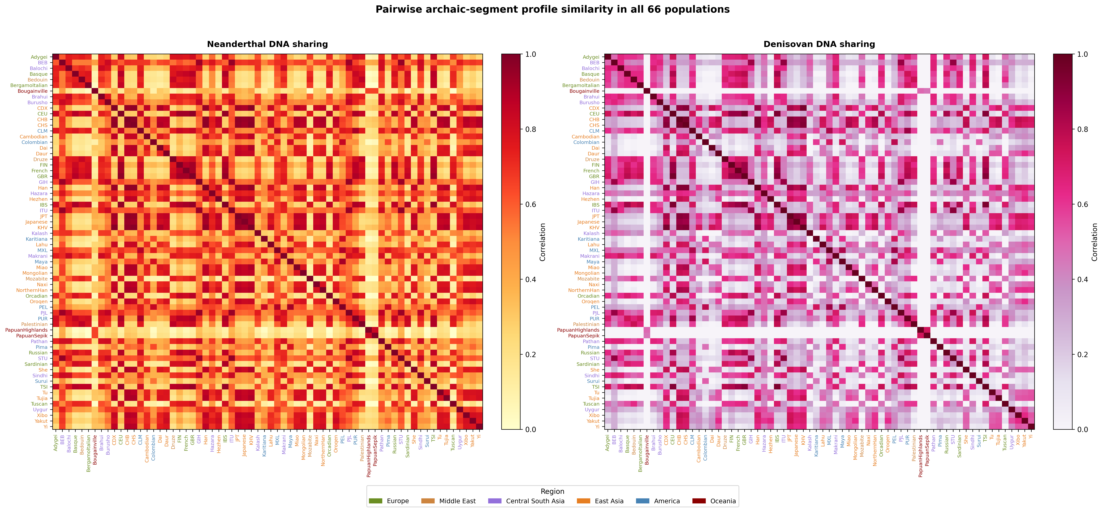

Figure S2. Exploratory ABO-centered analysis preserving the historical grouped-bar and segment-map layout. Equal maximum-similarity ties are excluded from the displayed three-reference proportions and retained in Supplementary Data. The Pima segment overlaps ABO; the Maya segment is within the wider interval but does not overlap the gene. Counts are segments, not regional frequencies, and are not interpreted as a migration route.
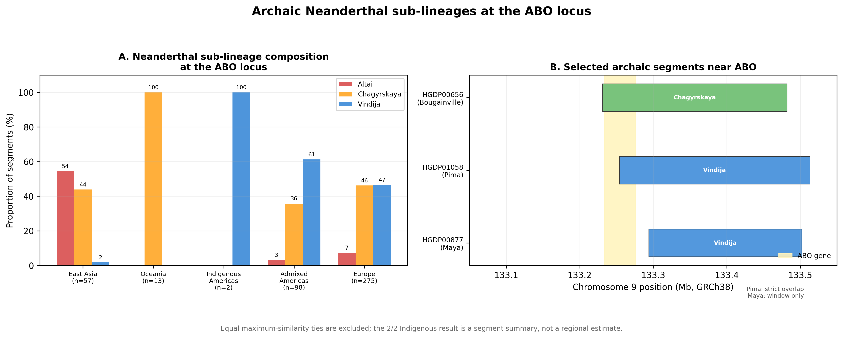

Figure S3. O2 blood-group subtype-defining allele frequencies and ABO-window segment-carrier frequencies. The panels use different sources and are not an association analysis; proximity does not establish that the O2 allele is Neanderthal-derived.
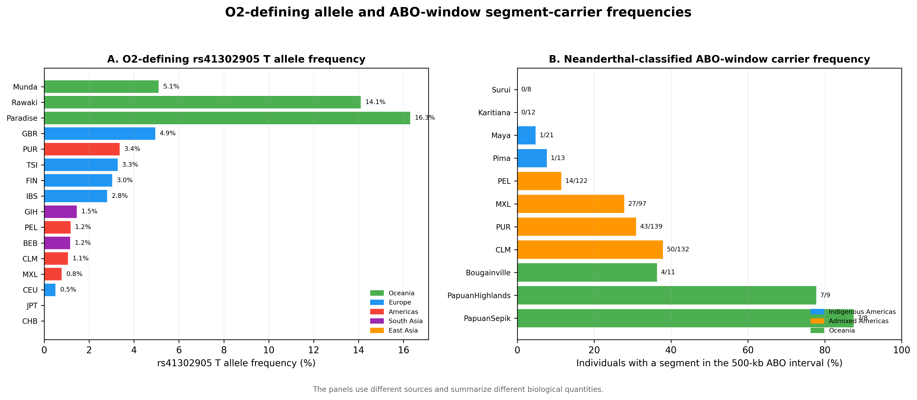

Figure S4. Descriptive ancient and modern ABO-window summaries generated by different pipelines; no formal temporal comparison is made.
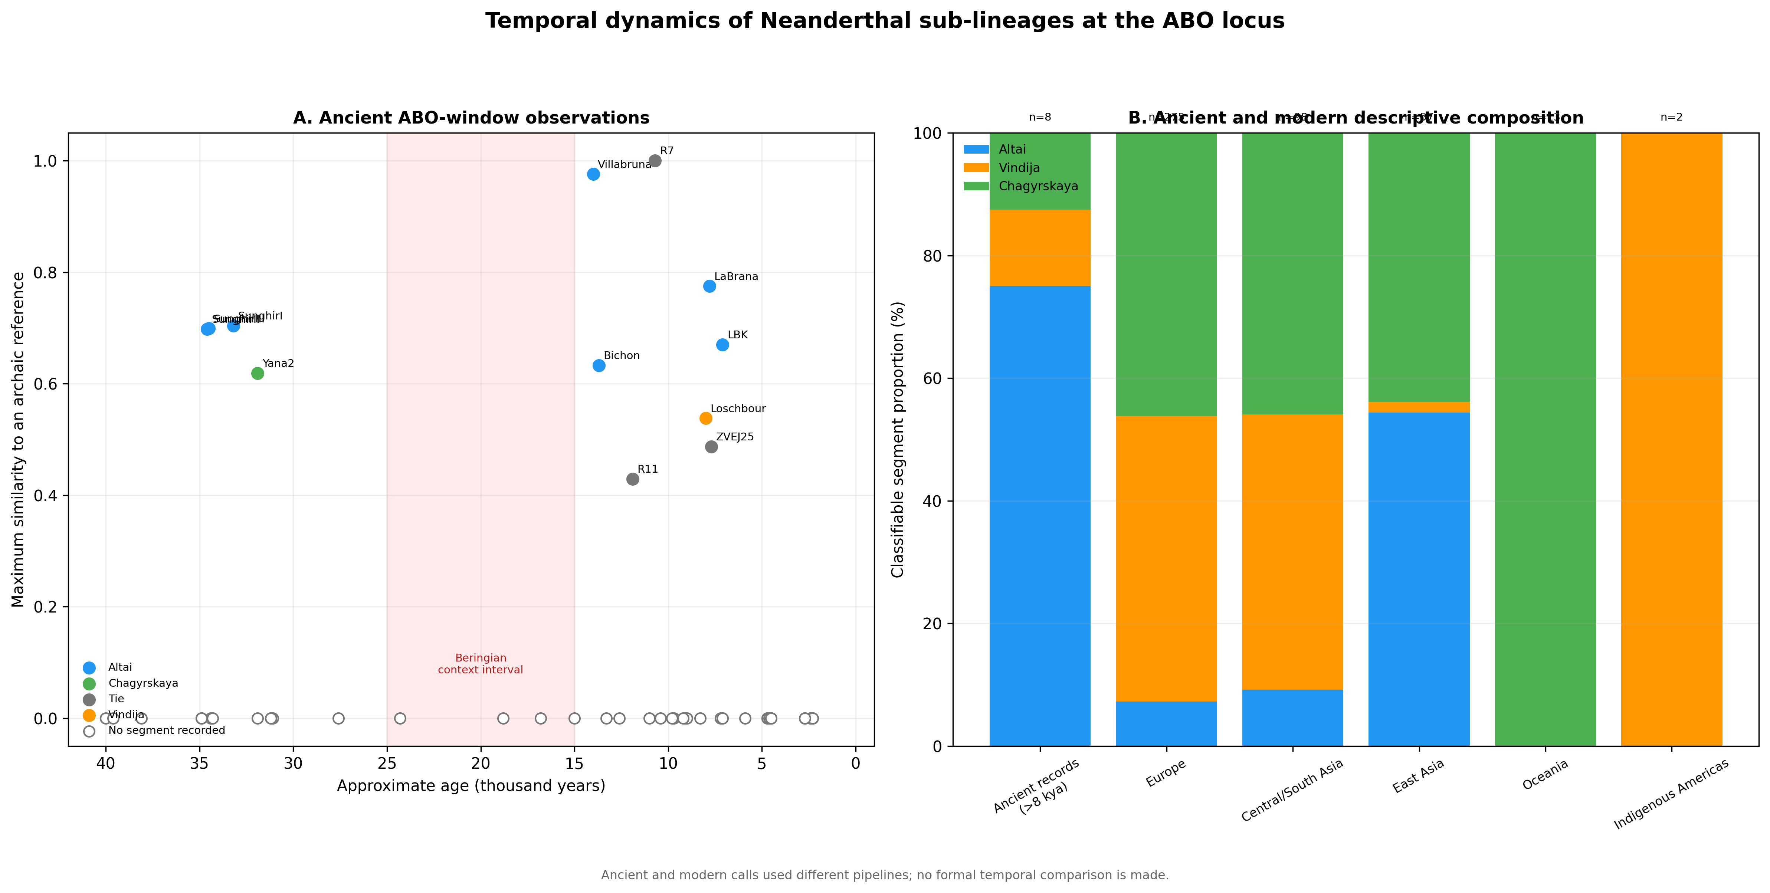

Figure S5. Bivariate global context computed in this study. Circle area encodes the mean per-bin Neanderthal-segment coverage and colour encodes the mean per-bin Denisovan-segment coverage for each population, both from data/population_profiles_500kb.npz; coordinates are approximate sampling locations from data/population_metadata.csv. These descriptive summaries were not used in the pairwise statistical models.
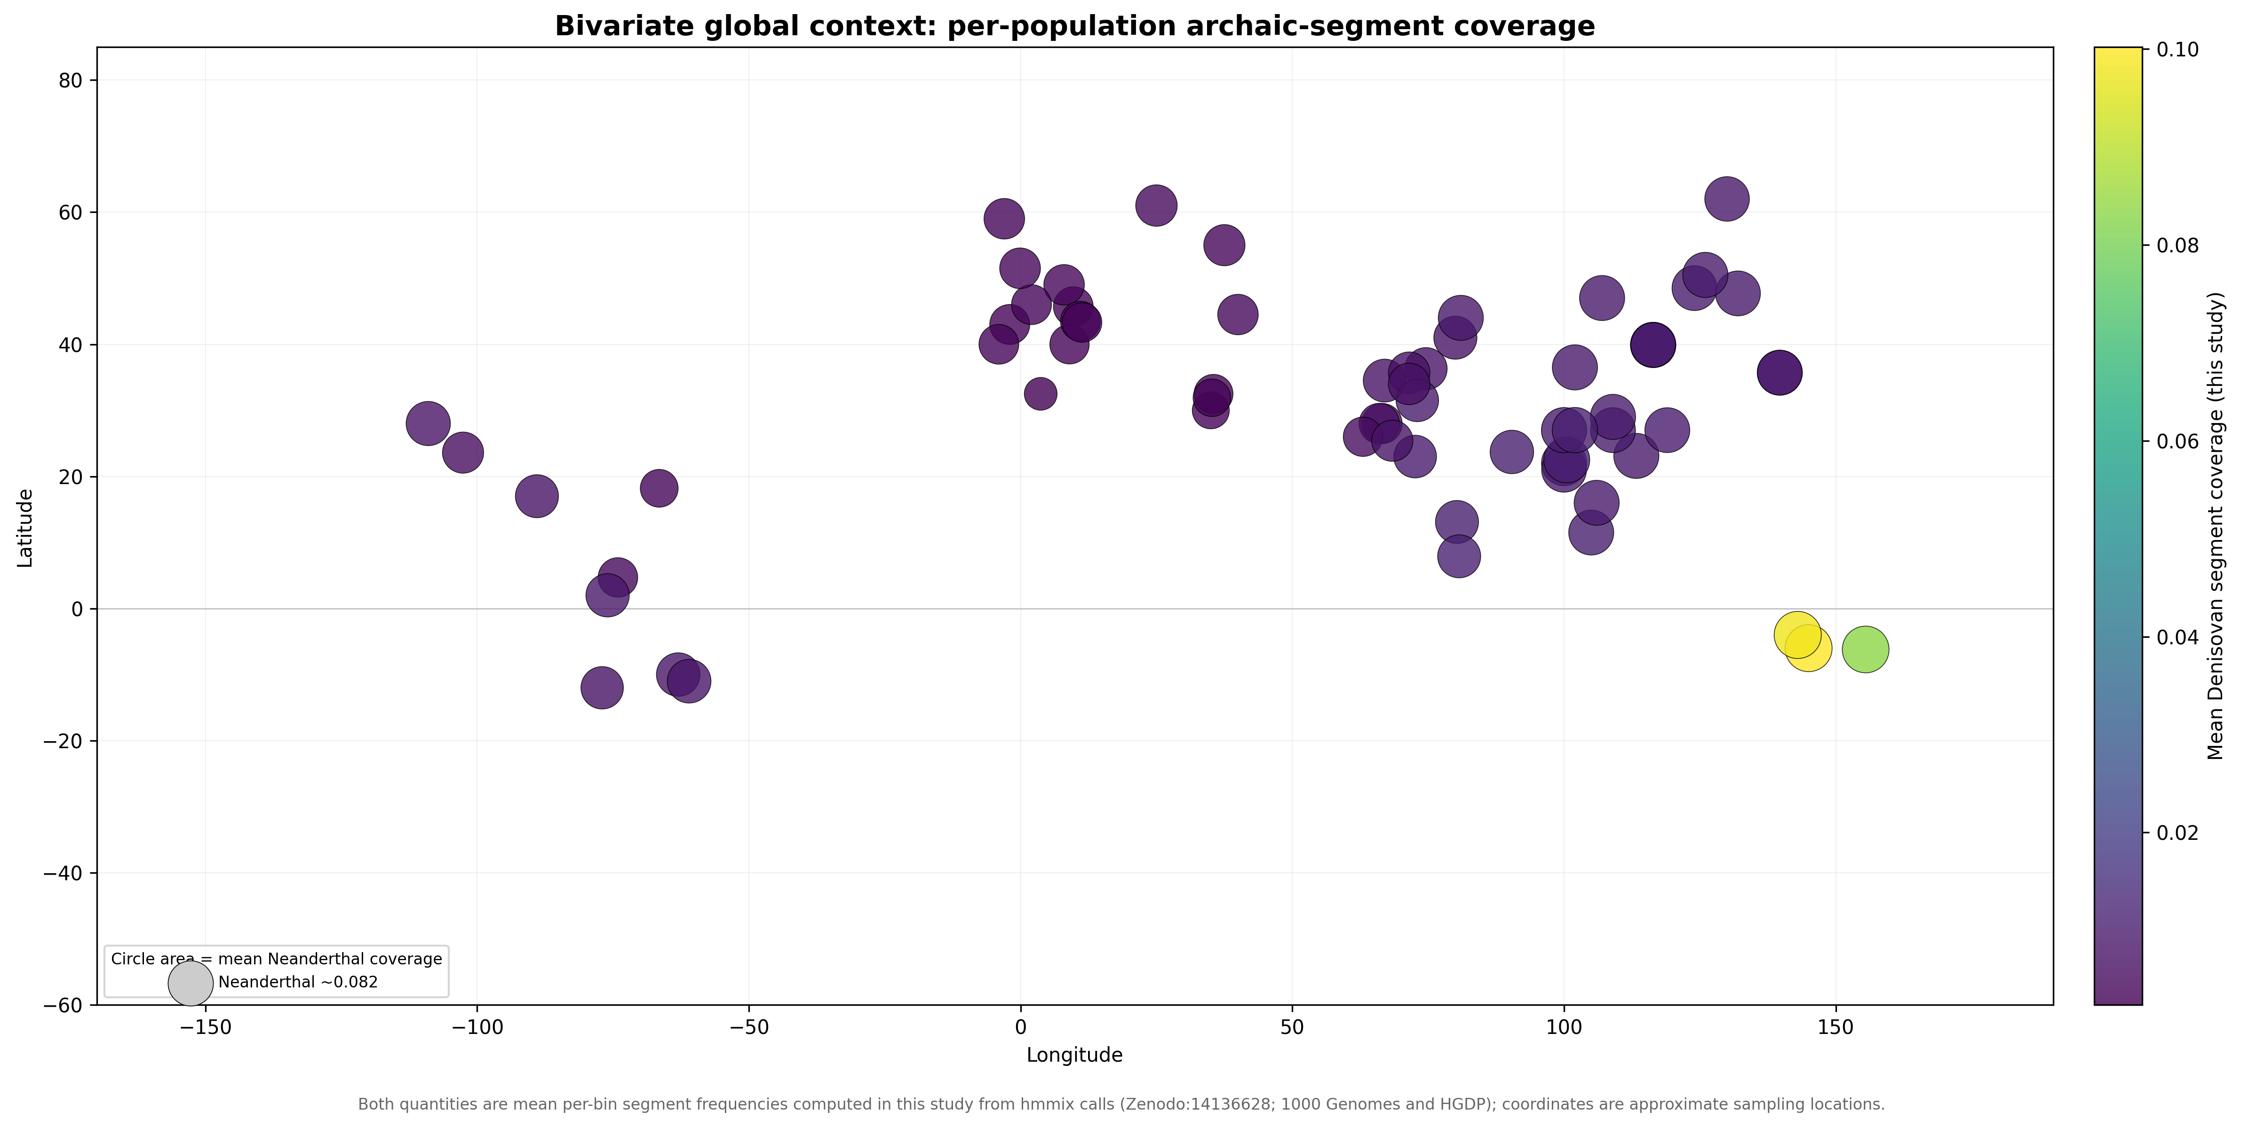

Table S1. Exploratory ABO-window Neanderthal-reference composition
Region | n | Altai % | Vindija % | Chagyrskaya %
East Asia | 57 | 54.4 | 1.8 | 43.9
Europe | 275 | 7.3 | 46.5 | 46.2
Indigenous Americas | 2 | 0.0 | 100.0 | 0.0
Admixed Americas | 98 | 3.1 | 61.2 | 35.7
Central/South Asia | 98 | 9.2 | 44.9 | 45.9
Middle East | 44 | 11.4 | 52.3 | 36.4
Oceania | 13 | 0.0 | 0.0 | 100.0
Note. Counts are classifiable segments, not individuals. Percentages use the three-reference denominator shown by n. Equal maximum-similarity ties are excluded from these percentages but retained in Supplementary Data. The 2/2 Indigenous American value is not a regional frequency estimate; only one segment overlaps ABO, and these counts are not interpreted as a migration route.

Supplementary Data Files
Supplementary Data 1: population_metadata.csv. Population, project, sample size, coordinates, continent assignment, and analysis inclusion.
Supplementary Data 2: pairwise_sharing_corrected.csv. Complete pairwise similarity, geographic, covariate, residual, permutation, and false discovery rate results.
Supplementary Data 3: model_summary.csv. Quadratic assignment procedure coefficients, permutation P values, descriptive R-squared values, and population-deletion intervals.
Supplementary Data 4: sensitivity_analysis.csv and window_size_sensitivity.csv. Metric, population-subset, and window-size robustness summaries.

