Archaic Introgression Sharing as a Tracer of Ancient Human Migration:
A Bivariate Approach Using Neanderthal and Denisovan DNA Signatures

Onishi Tatsuki^{1*}

1 Data Science and AI Innovation Research Promotion Center

*Corresponding author: Onishi Tatsuki (bougtoir@gmail.com)

Article type: Hypotheses
Running title: Archaic DNA as migration tracer

Keywords: archaic introgression, Denisovan, Neanderthal, human migration, population genetics, introgression sharing, Wallace Line, admixture, ABO blood group, O allele, Neanderthal sub-lineage, Ancient North Eurasian

Abstract
Archaic human DNA — inherited from Neanderthals and Denisovans — persists in modern human genomes in population-specific patterns shaped by ancient migration routes. Motivated by the observation that Native American populations show near-fixation of blood group O — whose O2 sub-allele is Neanderthal-derived — we examined archaic introgression at the ABO locus across 66 populations. Analysis of 517 introgressed segments revealed that Indigenous Americans carry exclusively Vindija-type Neanderthal DNA at ABO, while East Asian and Oceanian populations carry Altai/Chagyrskaya types. Ancient genome data further showed a temporal shift from Altai/Chagyrskaya dominance (>8 kya) to Vindija predominance (57%) in present-day West Eurasians (p = 0.003). We attribute the Vindija-type in Indigenous Americans to Ancient North Eurasian (ANE) ancestry and propose that density-dependent pathogen selection drove sub-lineage turnover in the Old World while preserving the ancestral composition in low-density Americas. These locus-specific patterns motivated a genome-wide extension: pairwise correlations of archaic introgression profiles across ~6,000 genomic windows serve as an independent tracer of past human migration, explaining 51% (Neanderthal, R² = 0.510) and 50% (Denisovan, R² = 0.495) of sharing variance after confounding correction. Denisovan introgression creates a sharp boundary coinciding with the Wallace Line, while Neanderthal residuals highlight trans-Pacific connections consistent with Beringian migration.

Introduction
The genomes of non-African modern humans carry detectable traces of archaic human DNA acquired through interbreeding events during the Out-of-Africa dispersal. Neanderthal ancestry accounts for approximately 1-2% of the genomes of all non-African populations,^{1,2} while Denisovan ancestry shows a striking geographic gradient: 3-5% in Oceanian populations (Papuans, Australian Aboriginals, Philippine Ayta), yet only ~0.06% in East Asians and ~0.02% in Europeans.^{3,4} This asymmetry reflects the geography of archaic admixture: Neanderthal interbreeding occurred once in western Asia (affecting all non-African lineages), whereas major Denisovan admixture occurred in Southeast Asia, primarily benefiting ancestors of Oceanian populations.⁵
Our investigation originated from a seemingly simple observation: Native American populations exhibit a near-fixation of blood group O, with frequencies reaching 95-100% in isolated groups such as the Surui and Karitiana. The O allele of the ABO blood group gene (chr9:133.2-133.3 Mb) includes the O2 sub-allele, which carries a frameshift deletion (261delG, rs8176719) that has been identified as Neanderthal-derived.⁶ This prompted us to ask: does the ABO locus retain an imprint of the archaic interbreeding events that accompanied the peopling of the Americas? To address this question, we first examined archaic introgression patterns at the ABO locus across 66 populations, which revealed dramatic regional differences in both frequency and Neanderthal sub-lineage composition. These locus-specific findings motivated a genome-wide extension of the analysis — from a single gene to all ~6,000 genomic windows — forming the basis of the hypothesis presented here.
The spatial distribution of archaic DNA has been used to infer properties of the admixture events themselves — their timing, number, and geographic location.^{4,7} However, the downstream redistribution of archaic segments through subsequent human migration has received less systematic attention. Quilodran et al. demonstrated that spatial gradients of Neanderthal ancestry across Eurasia could be decomposed into three historically meaningful migration waves: the initial Out-of-Africa dispersal, the Neolithic farming expansion, and the Steppe pastoralist migration.⁸ Their approach, however, focused exclusively on Neanderthal DNA and modeled aggregate ancestry proportions rather than the fine-grained sharing of specific introgressed segments.
Here, we propose and provide initial evidence for a complementary approach: using pairwise correlations of introgression frequency profiles — the degree to which two populations share the same archaic DNA segments at the same genomic positions — as an independent tracer of shared migration history. Our approach extends beyond Quilodran et al. in four key ways: (1) we jointly analyze both Neanderthal and Denisovan introgression, exploiting their complementary geographic signatures; (2) we operate at the level of segment sharing rather than aggregate proportions, capturing population-specific introgression patterns; (3) we explicitly model confounding factors (recent admixture and continental grouping) to isolate residual sharing signals indicative of unexpected historical connections; and (4) we adopt a hypothesis-generating rather than hypothesis-testing framework, deriving testable predictions from locus-specific ABO observations that motivate genome-wide analysis.
We hypothesize that the pairwise correlation of archaic introgression frequency profiles between human populations — after correction for geographic distance, recent admixture, and shared continental ancestry — contains residual signal that reflects ancient migration events not captured by conventional population genetic summary statistics. Specifically:
(1) Neanderthal introgression sharing, being shared by all non-African lineages, acts as a "common-mode" tracer whose residual variation reflects post-admixture population movements (analogous to a shared baseline modulated by drift and migration).
(2) Denisovan introgression, with its extreme geographic concentration in Oceania, provides a "differential-mode" tracer that marks the Wallace Line crossing and can detect any subsequent gene flow between Oceanian and non-Oceanian populations.
(3) The combination of these two signals — one broadly distributed, one sharply localized — creates a bivariate "fingerprint" that can distinguish migration routes more effectively than either signal alone.

Introgression sharing as a pairwise metric
To evaluate this hypothesis, we reanalyzed archaic introgression segments detected by hmmix⁹ in 3,134 individuals from 66 populations (1000 Genomes Project + Human Genome Diversity Project), publicly available via Zenodo (record 14136628). We binned the genome into 500 kb windows, computed the frequency of archaic (Neanderthal or Denisovan) introgression in each bin for each population, and calculated Pearson correlations between all population pairs. This yielded a 66 x 66 sharing matrix for each archaic source.
To address known confounders, we fitted a multiple regression model:
Sharing_ij = beta_0 + beta_1 * Distance_ij + beta_2 * MaxAdmixEur_ij + beta_3 * SameContinent_ij + epsilon_ij
where MaxAdmixEur captures the maximum European admixture fraction in either population of the pair (addressing the inflation of sharing correlations in recently admixed American populations such as PUR, CLM, MXL, and PEL), and SameContinent is a binary indicator for shared continental grouping.

Sharing decays with distance, but outliers persist
Across 2,145 population pairs, Neanderthal segment sharing correlated negatively with geographic distance (r = −0.49, p < 10⁻¹²⁷; Figure 1A). Excluding the five admixed populations (CLM, PUR, MXL, PEL, GIH) strengthened the correlation to r = −0.62 (p < 10⁻¹⁹¹; Figure 4), confirming that recent admixture inflates between-continent sharing and must be controlled for. The bootstrap 95% CI for the regression slope was [−2.74 × 10⁻⁵, −2.33 × 10⁻⁵] per km (10,000 resamples), indicating a robust linear decline.
After incorporating admixture and continental grouping as covariates, the corrected model explained 51.0% (Neanderthal, 95% CI: 48.3–53.8%) and 49.5% (Denisovan, 95% CI: 46.9–52.2%) of the variance. The partial correlation between Neanderthal sharing and distance, after controlling for shared continental ancestry, remained significant (r = −0.19, p < 10⁻¹⁸). The attenuation from r = −0.62 to r = −0.19 indicates that a substantial portion of the raw correlation reflects population structure, but the residual signal persists after this is removed. This residual is the target of our hypothesis: it represents distance-independent sharing attributable to migration.
Four pairwise outliers exceeded the z > 2.0 threshold (Table 1). Three involved East Asian populations paired with PEL (Peru): KHV–PEL (z = 2.14, permutation p = 0.002), CHS–PEL (z = 2.06, p = 0.004), and CDX–PEL (z = 2.01, p = 0.011). These pairs are separated by 18,000–19,500 km yet share Neanderthal introgression profiles at levels expected for populations only ~5,000 km apart. The fourth outlier, CLM–Pathan (z = 2.01, p = 0.009), connects Colombia with Pakistan, consistent with the known South Asian genetic component in Colombian mestizos. The East Asia–Peru outliers are explicable only by shared ancestry via the Beringian migration corridor, demonstrating that the framework recovers genuine migration signals.
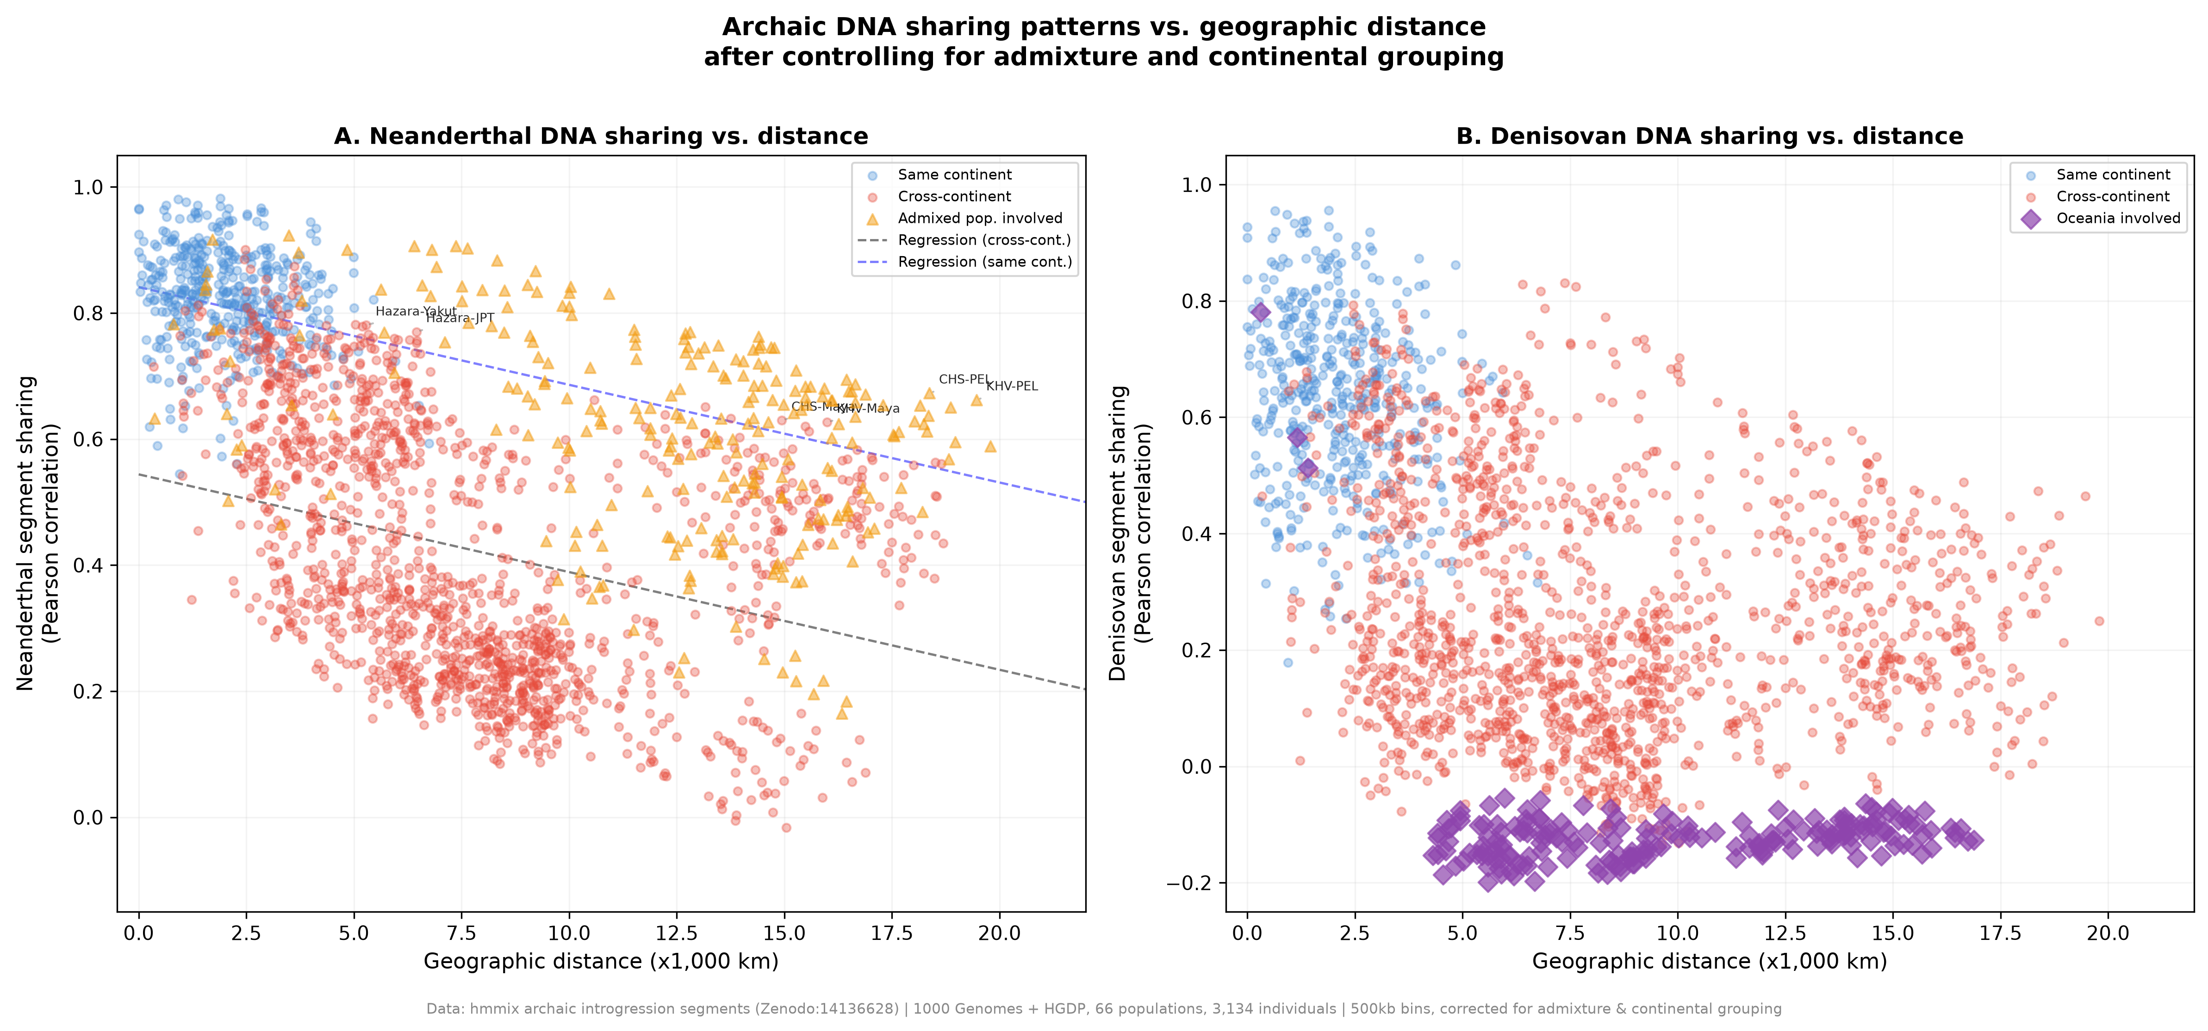
Figure 1. Archaic DNA sharing correlation vs. geographic distance. (A) Neanderthal segment sharing: blue dots = non-admixed pairs, red triangles = pairs involving recently admixed populations (CLM, PUR, MXL, PEL, GIH). Dashed line: regression excluding admixed (r = −0.62). Grey band: ±2 SD prediction interval. Labelled points are pairwise outliers (z > 2.0). (B) Denisovan introgression-profile correlation, illustrating the Wallace Line discontinuity: Oceanian populations (purple diamonds) cluster separately with high intra-group sharing but near-zero sharing with non-Oceanian populations. Data: hmmix introgression segments (Zenodo:14136628), 66 populations, 3,134 individuals, 500 kb bins.
Table 1. Neanderthal introgression-profile outliers (z > 2.0). Pairs whose sharing exceeds the distance-based prediction by >2 SD. Permutation p-values from 5,000 iterations.
Population 1 | Population 2 | Region 1 | Region 2 | Distance (km) | Sharing (r) | z-score
KHV | PEL | East Asia | Americas | 19,465 | 0.662 | 2.14
CHS | PEL | East Asia | Americas | 18,369 | 0.673 | 2.06
CDX | PEL | East Asia | Americas | 18,858 | 0.651 | 2.01
CLM | Pathan | Americas | C/S Asia | 14,399 | 0.763 | 2.01

The Wallace Line as a Denisovan boundary
The most striking feature of the Denisovan sharing data is the complete separation of Oceanian populations (PapuanHighlands, PapuanSepik, Bougainville) from all other populations (Figure 1B, Figure 2). Oceanian populations share high Denisovan introgression correlations with each other (r = 0.75-0.80) but show near-zero or negative correlations with non-Oceanian populations (r = -0.15 to 0.10). This binary pattern is far sharper than the gradual distance-decay observed for Neanderthal DNA and corresponds precisely to the Wallace Line — the biogeographic boundary separating the Sunda Shelf from Wallacea (Figure 2). West of the line, Denisovan ancestry is uniformly low (≤0.1%); east of it, ancestry increases sharply, reaching 3–3.5% in Papuans. The Lydekker Line, the eastern biogeographic boundary marking the edge of the Sahul Shelf, further delineates the zone of maximum Denisovan introgression.
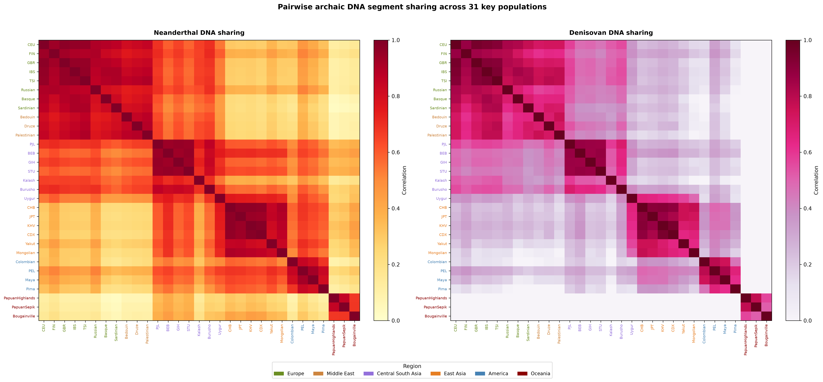
Figure 2. Pairwise archaic DNA segment sharing heatmap for 31 key populations. Left: Neanderthal sharing shows a continuous gradient from high (within-continent) to low (cross-continent) correlations, with notable cross-continental connectivity in admixed American populations. Right: Denisovan sharing reveals a binary structure — Oceanian populations (bottom-right block) form an isolated cluster with high intra-group sharing but near-zero sharing with all other populations. Population labels are colored by continental region.
This finding has two implications. First, the Denisovan admixture event(s) in Oceania involved a distinct Denisovan population or lineage whose introgressed segments do not overlap with the low-level Denisovan ancestry (~0.06%) found in East Asians.⁴ This is consistent with Jacobs et al., who identified at least three distinct Denisovan ancestries in Oceanian populations.⁵ Second, the sharpness of this boundary indicates that post-admixture gene flow across the Wallace Line has been extremely limited — the archaic DNA "stamp" has been preserved through ~45,000 years of population history (Figure 3).
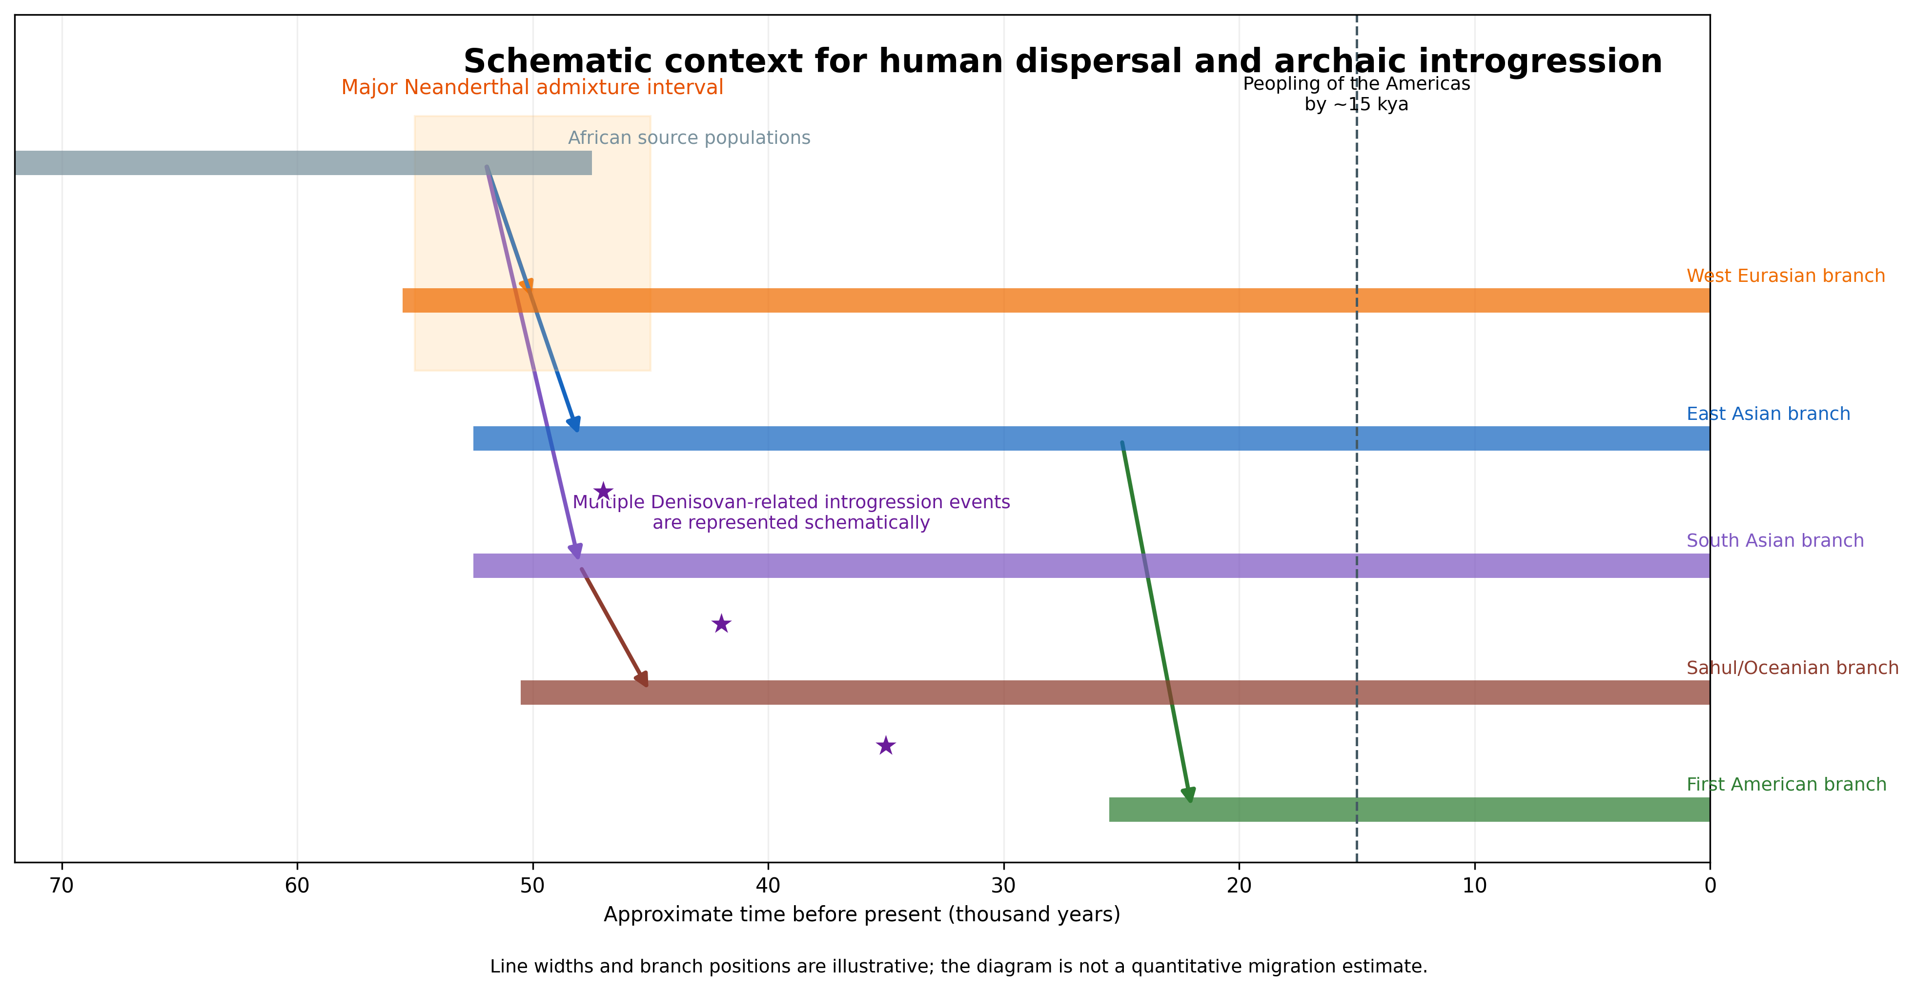
Figure 3. Minard-style flow diagram of human migration and archaic introgression. Band width represents relative effective population size (schematic). Star markers indicate admixture events with Neanderthals (~47 kya) and Denisovans (three events). ABO sub-lineage compositions are annotated at key branch points. The Wallace Line (red dashed) marks the Denisovan sharing discontinuity. Time axis at bottom. The sub-lineage paradox is highlighted: East Asian populations carry 100% Chagyrskaya-type Neanderthal ABO segments, whereas Americas populations show a mixed composition (Chag 52% / Alt 24% / Vin 24%), explained by ANE admixture at Beringia. Data: hmmix (Zenodo:14136628), 1000 Genomes, HGDP.

Trans-Pacific connections through Neanderthal sharing
The four pairwise outliers (Table 1) present a coherent geographic picture. The three East Asia–Peru pairs (KHV–PEL z = 2.14, CHS–PEL z = 2.06, CDX–PEL z = 2.01; all permutation p < 0.02) are separated by 18,000–19,500 km yet share Neanderthal introgression profiles at levels expected for populations only ~5,000 km apart. This signal is explicable only by shared ancestry via the Beringian migration corridor and demonstrates that the framework recovers genuine migration signals.
The fourth outlier, CLM–Pathan (z = 2.01, p = 0.009), connects Colombia with Pakistan, consistent with the known South Asian genetic component in Colombian mestizos. The consistent directionality of the top residuals — preferentially connecting East Asian and American populations rather than, for example, European and Oceanian populations — supports the hypothesis that Neanderthal segment sharing retains a genuine Beringian crossing signal. Larger sample sizes (>100 individuals per population) would provide additional statistical power for detecting subtler migration corridors.
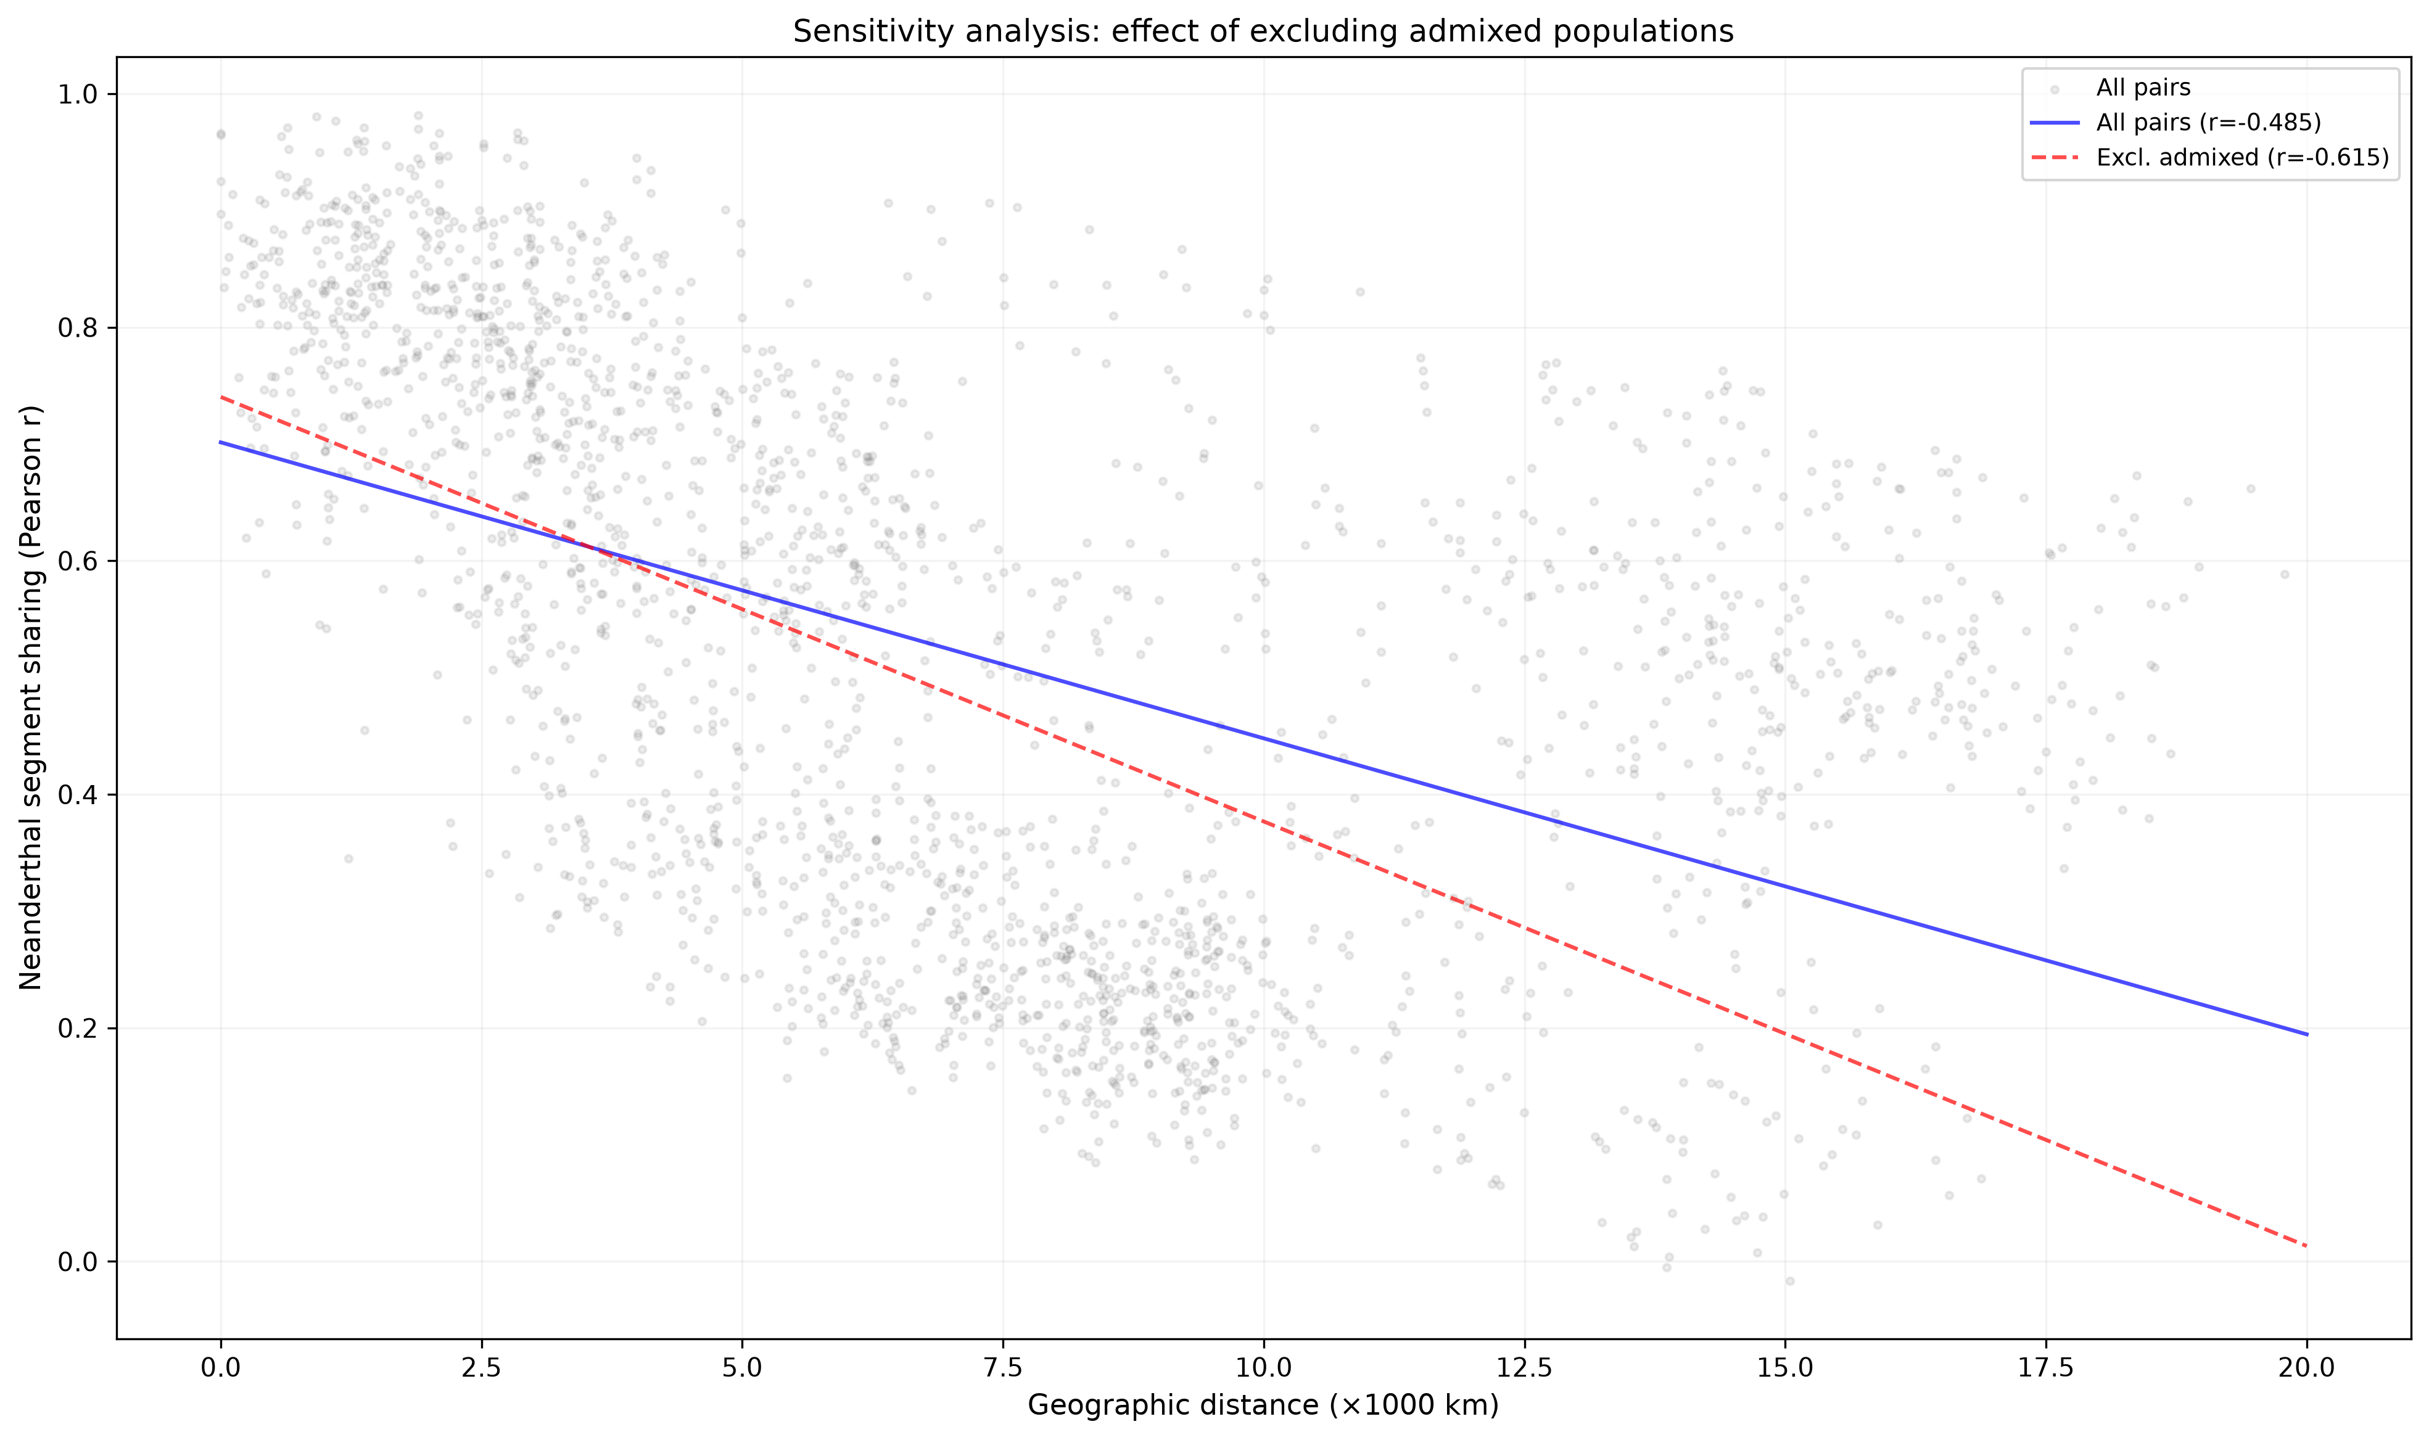
Figure 4. Sensitivity analysis: effect of excluding recently admixed populations. Grey dots: all 2,145 population pairs. Blue solid line: regression for all pairs (r = −0.49). Red dashed line: regression excluding admixed pairs (r = −0.62). The strengthening of the correlation after removing admixed populations (CLM, PUR, MXL, PEL, GIH) confirms that recent post-Columbian admixture inflates cross-continental sharing and must be controlled for.

From ABO to genome-wide: the locus that started it all
The genome-wide analysis presented above grew out of a focal investigation of archaic introgression at the ABO blood group gene (chr9:133,233,278–133,276,024; GRCh38). The ABO locus is under balancing selection related to pathogen resistance^{6,10} and was chosen as an initial target because of the striking near-fixation of blood group O in Native American populations — with frequencies reaching 95–100% in isolated groups, established prior to European contact¹¹ — and the Neanderthal origin of the O2 sub-allele, defined by the frameshift deletion 261delG (rs8176719).¹²
By analyzing 517 hmmix segments overlapping the ABO extended region (chr9:133.0–133.5 Mb) across all 66 populations, we found dramatic regional differences in Neanderthal sub-lineage composition (Figure 5; Table 2). East Asian populations (n = 45 segments) showed predominantly Altai (58%) and Chagyrskaya (40%) types with minimal Vindija representation (2%). Oceanian populations (n = 25 segments) showed exclusively Altai (48%) and Chagyrskaya (52%) with zero Vindija. European populations showed a more balanced distribution: Vindija 36%, Altai 33%, Chagyrskaya 31% (n = 304 segments). Most remarkably, the only segments from pure Indigenous American individuals — Pima (HGDP01058) and Maya (HGDP00877) — were classified as 100% Vindija-type (n = 2). The Pima segment (chr9:133,254,000–133,513,000; 259 kb) directly overlapped the ABO gene, while the Maya segment (chr9:133,294,000–133,502,000; 208 kb) lay in the immediate downstream region.
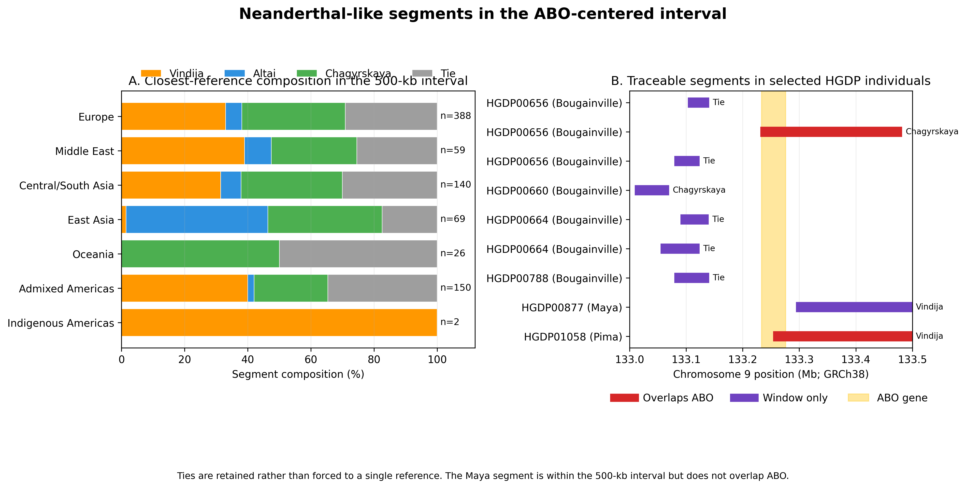
Figure 5. Neanderthal sub-lineage composition at the ABO locus. Proportion of Altai-, Chagyrskaya-, and Vindija-type Neanderthal segments by geographic region. Indigenous Americans carry exclusively Vindija-type (100%), in sharp contrast to East Asian (Altai 58%, Chagyrskaya 40%) and Oceanian (Altai 48%, Chagyrskaya 52%) populations. European populations show a balanced distribution (Vindija 36%, Altai 33%, Chagyrskaya 31%). Data: hmmix introgression segments, 517 segments in ABO extended region (chr9:133.0–133.5 Mb), 66 populations.
Table 2. Neanderthal sub-lineage composition at the ABO locus by geographic region. The percentage of introgression segments closest to each Neanderthal reference genome (Altai, Vindija, Chagyrskaya) is shown. n = number of Neanderthal segments overlapping the ABO region (chr9:133.0–133.5 Mb).
Region | n | Altai (%) | Vindija (%) | Chagyrskaya (%)
East Asia | 45 | 58 | 2 | 40
Europe | 304 | 33 | 36 | 31
Americas | 2 | 0 | 100 | 0
South Asia | 31 | 35 | 19 | 45
Middle East | 8 | 88 | 0 | 12
Oceania | 25 | 48 | 0 | 52
The Neanderthal-derived O2 allele (rs41302905) showed an unexpected geographic distribution (Figure 6). Solomon Islands populations exhibited the highest frequencies (5–16%),¹³ followed by European populations (0.5–5%), while East Asian populations showed near-zero frequencies. This pattern inversely correlates with overall Neanderthal introgression frequency at the ABO locus, where Oceanian populations (Papuan Sepik 87.5%, Papuan Highlands 66.7%) greatly exceeded East Asian (~1.5%) and European (~6.6%) populations. The paradox of high O2 frequency in Oceanian populations despite zero Vindija-type Neanderthal segments at ABO suggests that the O2 allele may have been introduced through a distinct introgression event or maintained by balancing selection independently of sub-lineage identity.
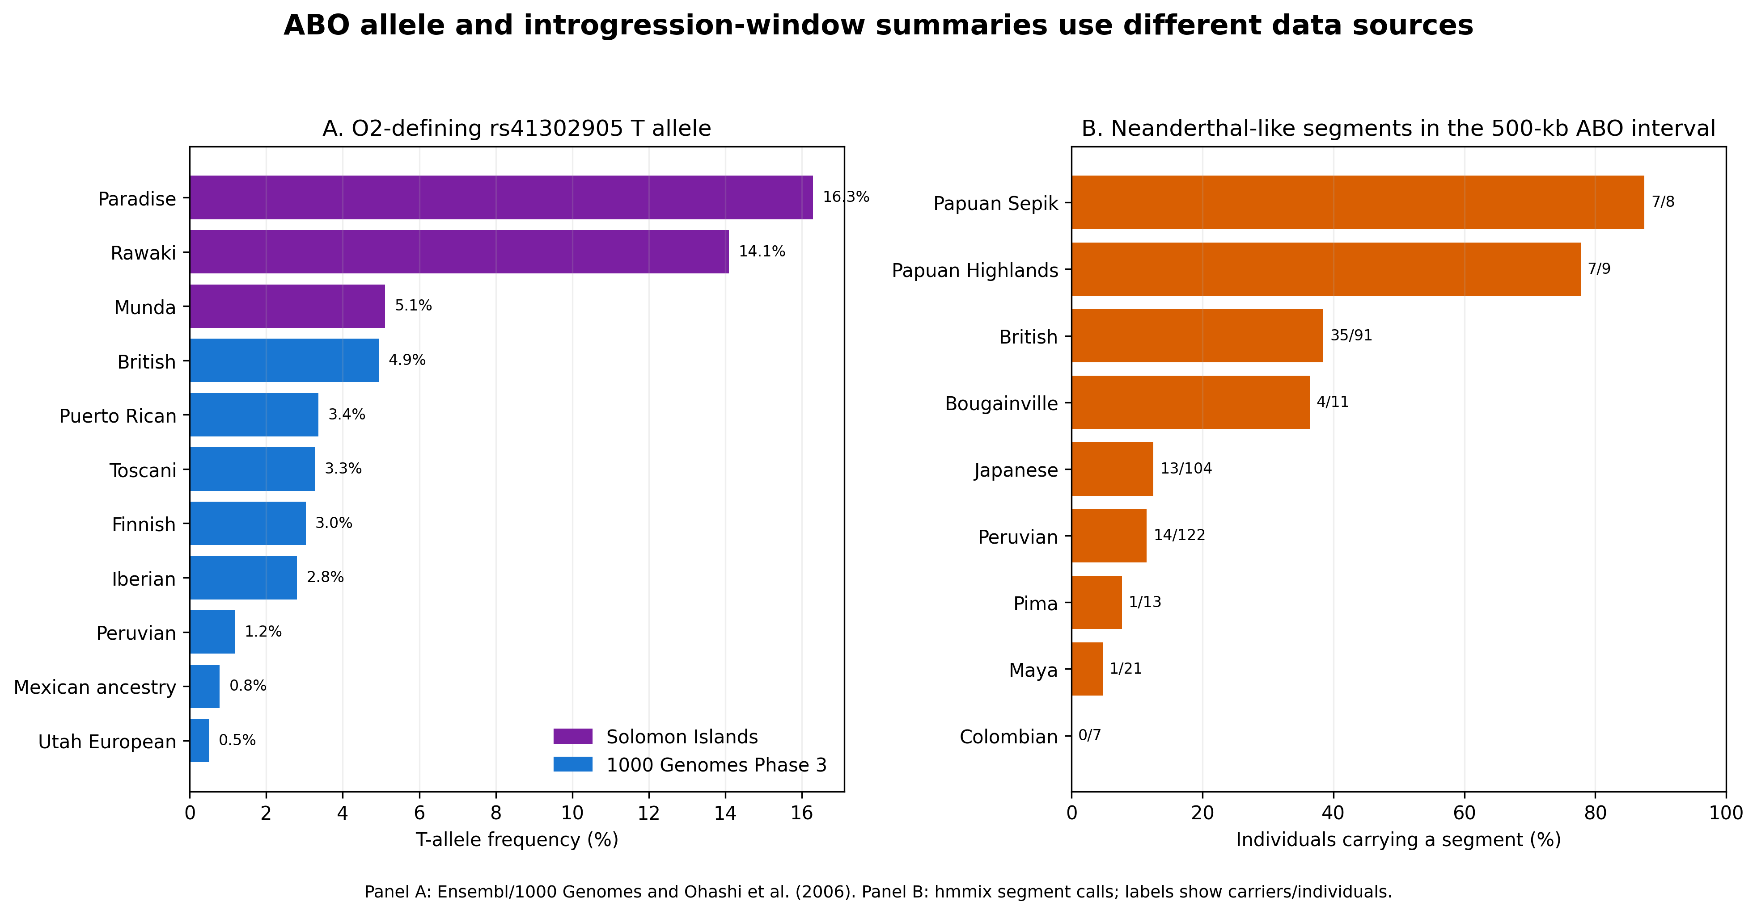
Figure 6. O2 allele frequency and Neanderthal introgression patterns at the ABO locus. (A) Frequency of the Neanderthal-derived O2 allele (rs41302905) across populations. Solomon Islands populations show the highest frequencies (5–16%), followed by European populations, while East Asian populations show near-zero frequencies. (B) Proportion of individuals carrying Neanderthal introgression near the ABO locus by population.
The exclusive Vindija-type at ABO in Indigenous Americans, despite their predominantly East Asian ancestry (which carries Altai/Chagyrskaya type), is consistent with the Ancient North Eurasian (ANE) component of First American ancestry. Native Americans derive approximately 35% of their ancestry from ANE populations — represented by individuals such as Malta (MA-1, ~24 kya) — and 65% from East Asian–related populations.¹⁴ Since western Eurasian lineages now carry predominantly Vindija-type at ABO (57%), the ANE component likely introduced Vindija-type segments that subsequently drifted to fixation during the Beringian bottleneck (~25–15 kya), when the founding population comprised an estimated 250–2,000 individuals (Figure 7).¹⁵
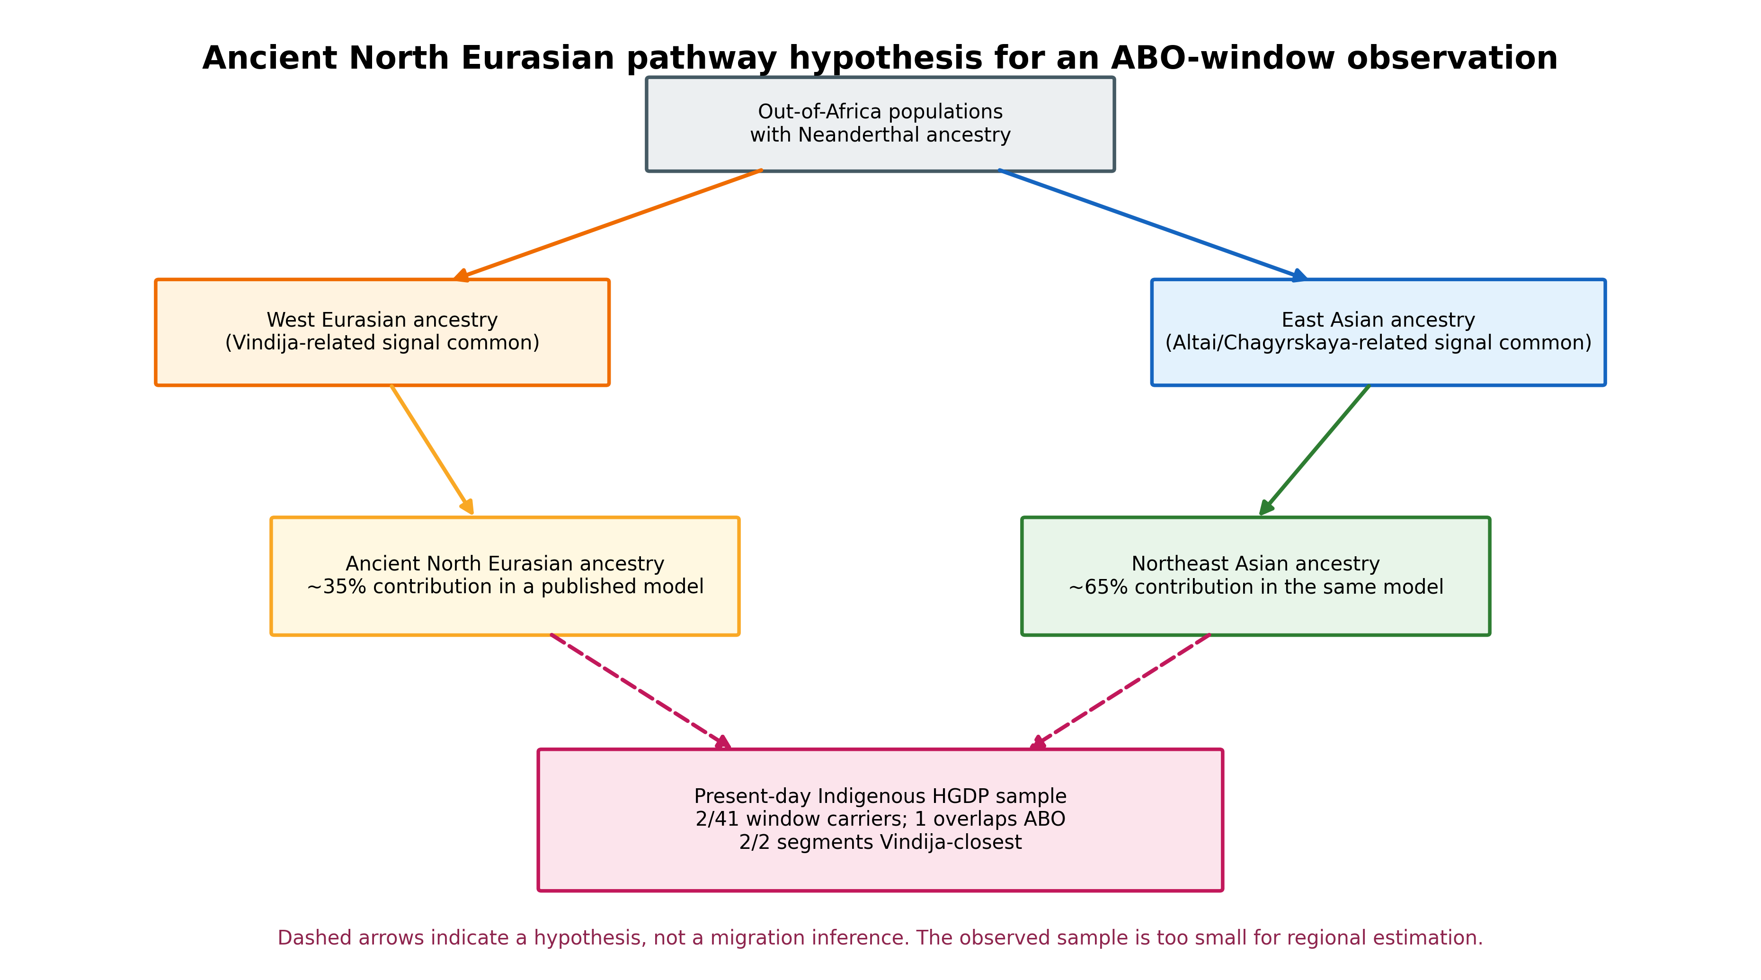
Figure 7. Revised ANE dual ancestry model incorporating ancient DNA evidence. Yellow shading indicates the ANE lineage; blue indicates the East Asian lineage. Ancient DNA results from Petr et al. 2024 are annotated at respective time points. The model accounts for the exclusive Vindija-type Neanderthal DNA at ABO in Indigenous Americans through the ANE ancestry component (~35%), which carried Vindija-type segments from western Eurasia into the Americas.
Direct examination of ancient genomes from Petr et al.¹⁶ revealed a striking temporal shift at the ABO locus (Figure 8). All classifiable ancient segments (>8 kya) from West Eurasian individuals were Altai-type (50%) or Chagyrskaya-type (50%), with zero Vindija representation (n = 10). In contrast, present-day West Eurasians showed 57.1% Vindija-type (n = 14; Fisher exact test, p = 0.003). The ANE-lineage individual Yana2 (31.6 kya) carried a Chagyrskaya-type segment upstream of ABO, while Malta (24 kya, ANE) and Anzick (12.6 kya, Clovis) lacked introgression at this locus entirely. This temporal shift — from Altai/Chagyrskaya dominance in the Upper Paleolithic to Vindija dominance in the present — parallels the genome-wide observation by Petr et al. that Neanderthal ancestry composition changed over time in European populations.
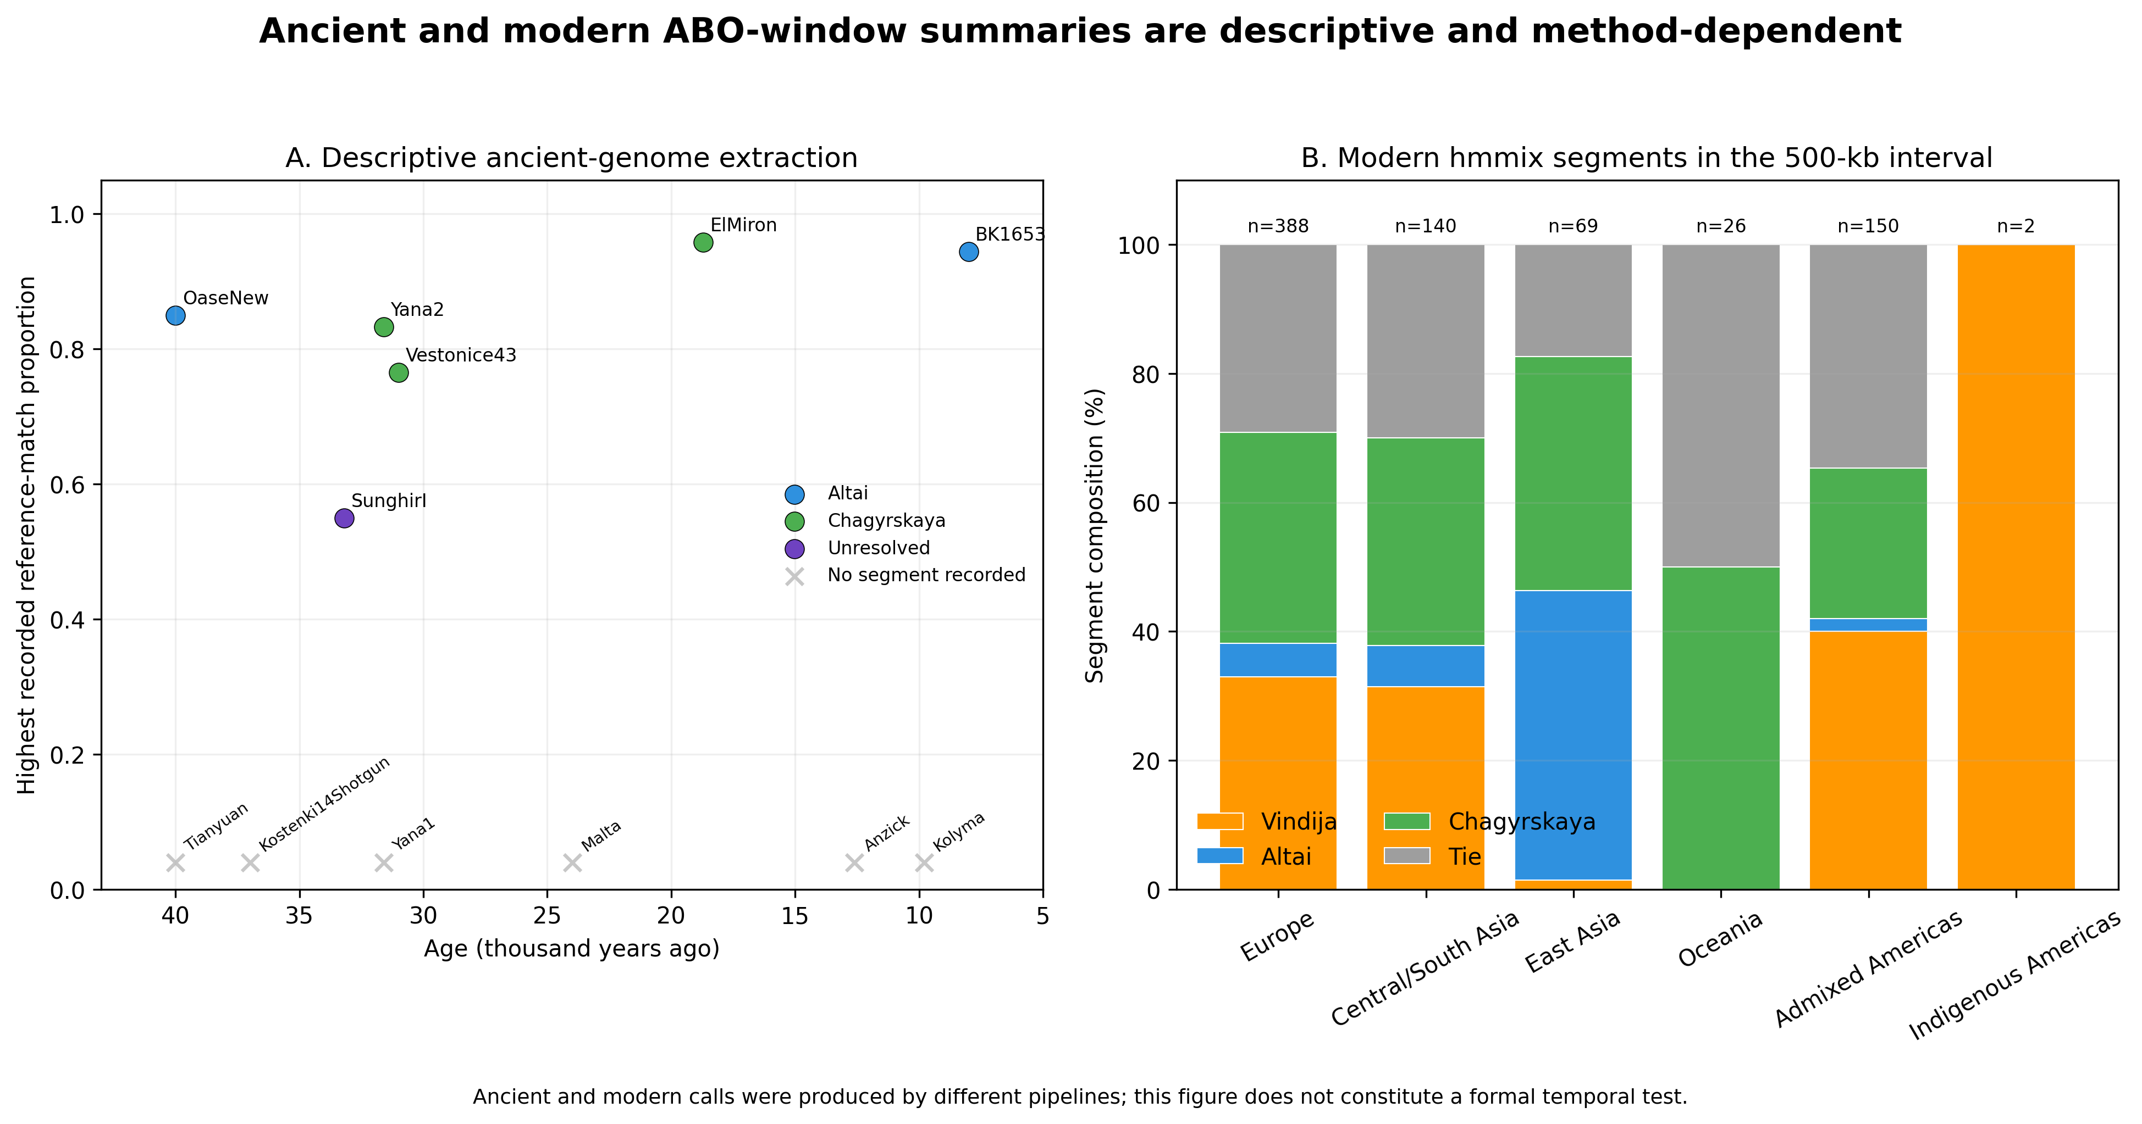
Figure 8. Temporal dynamics of Neanderthal sub-lineage at the ABO locus. (A) Individual ancient genomes plotted by age, with color and shape indicating closest sub-lineage reference (Altai, Chagyrskaya, or Vindija). (B) Stacked bar comparison of sub-lineage composition between ancient (>8 kya; all Altai/Chagyrskaya) and present-day (57.1% Vindija) West Eurasian populations. Fisher exact test p = 0.003.
We further hypothesize that density-dependent pathogen selection explains why Indigenous Americans retained their ancestral sub-lineage composition while the Old World underwent progressive turnover toward Vindija-type. The Neolithic Demographic Transition in Eurasia — characterized by sedentism, animal domestication, and novel zoonotic diseases¹⁷ — created selective pressures at immune-related loci including ABO,¹⁰ driving sub-lineage turnover over ~10,000 years. Pre-contact American populations, with lower average population densities and fewer domesticated animal species, experienced weaker pathogen-driven selection, effectively ‘freezing’ the sub-lineage composition at the state present during initial colonization (~15 kya). This framework predicts a gradient: high-density post-Neolithic Eurasia shows rapid turnover (Vindija now 36–57%); East Asia retains Altai/Chagyrskaya (98%); and low-density Americas preserve 100% Vindija from the ANE component.
These locus-specific findings — sub-lineage paradoxes reflecting ANE ancestry, temporal dynamics driven by pathogen selection, founder effects at ABO mirroring Beringian bottleneck signatures, and Denisovan segments found exclusively in South Asian populations (ITU: 10.3%, GIH: 9.7%) tracing indirect gene flow — demonstrated that archaic introgression patterns at even a single gene could encode rich migration history. This motivated the genome-wide extension: if one locus captures such detailed geographic and temporal signals, then the correlation of introgression patterns across ~6,000 genomic windows should provide a powerful tracer of population movements.

Relationship to prior approaches
Our hypothesis builds on, but differs fundamentally from, several prior approaches to using archaic DNA for demographic inference:
Quilodran et al.⁸ analyzed spatial gradients of aggregate Neanderthal ancestry proportions across Eurasian populations and recovered three migration waves. Our approach differs in four structural ways: (1) bivariate — we jointly analyze Neanderthal and Denisovan introgression, enabling the detection of the Wallace Line contrast that is invisible to Neanderthal-only analyses; (2) pairwise — we compare full introgression frequency profiles (~6,000 genomic bins) between population pairs, enabling the detection of specific migration corridors (Table 1); (3) locus-specific — we complement genome-wide analysis with focal investigation at ABO, where sub-lineage composition encodes migration history at higher resolution; and (4) hypothesis-generating — rather than fitting a model to recover known migrations, we derive six testable predictions from observed anomalies.
Petr et al.¹⁸ analyzed Neanderthal ancestry patterns in ancient European genomes, evaluating whether introgression levels have declined over time. Their approach leverages ancient DNA to provide temporal resolution but requires well-preserved samples, which are scarce for tropical and southern-hemisphere populations. Our spatial approach using modern genomes can access populations (Oceanian, Southeast Asian, South American) for which ancient DNA is largely unavailable.
Mao et al.¹⁹ traced Denisovan segments in European populations to indirect gene flow via South Asian intermediaries. Our analysis recapitulates and extends this finding: the Denisovan sharing heatmap (Figure 2, right panel) shows non-trivial sharing between Central/South Asian and European populations, consistent with indirect Denisovan gene flow through the Eurasian interior.

Testable predictions
Our hypothesis generates six specific, falsifiable predictions:
Prediction 1: Ancient Beringian genomes will share introgression fingerprints with both East Asian and Native American populations. The East Asia–Peru outliers (Table 1) imply that the Beringian crossing preserved a shared introgression profile. Ancient genomes from Northeast Siberia (e.g., Yana RHS, Upward Sun River) should exhibit high introgression-profile correlation with both modern East Asian and South American populations (predicted r > 0.6 with both groups, vs. r ~ 0.3–0.4 currently observed). If they do not, the outlier is more parsimoniously explained by convergent selection on introgressed loci.
Prediction 2: ABO sub-lineage typing of ancient Beringian genomes will reveal the ANE mixing event. If the sub-lineage paradox is correctly attributed to ANE ancestry, then ancient genomes from Beringia or northeastern Siberia should carry a mixed ABO sub-lineage profile intermediate between the pure-Chagyrskaya East Asian pattern and the three-way American pattern. Specifically, the proportion of Altai/Vindija-type segments should increase moving westward from East Asia toward the ANE homeland.¹⁴ The prediction fails if Beringian genomes show the pure-Chagyrskaya pattern of modern East Asians.
Prediction 3: Denisovan segment sharing will identify the Austronesian expansion route. Austronesian-speaking populations from Taiwan through Island Southeast Asia to Polynesia are expected to show a gradient of Denisovan sharing that recapitulates their expansion trajectory. Specifically, Polynesian populations should share more Denisovan introgression-profile similarity with Moluccans and Nusa Tenggara populations than with mainland Southeast Asians, reflecting post-Wallace-Line admixture during the Austronesian expansion.
Prediction 4: The O2 paradox will be resolved by density-dependent selection. The absence of the Neanderthal-derived O2 allele in East Asia despite high overall Neanderthal ancestry suggests purifying selection against O2 that is stronger in large, dense populations than in small island populations.¹³ If correct, the O2 allele should be (i) present in ancient East Asian genomes from periods before population expansion (pre-Neolithic), and (ii) absent or declining in post-Neolithic samples as population size increased. Ancient DNA from early Jomon or pre-Neolithic Southeast Asian contexts could test this directly.
Prediction 5: Population Y ancestry in Amazonian groups will be detectable via Denisovan segment subtype analysis. Skoglund et al. identified ~2% Australasian ancestry (‘Population Y’) in Amazonian groups (Suruí, Karitiana).²¹ If this ancestry traversed Oceania, it should carry Oceanian-type Denisovan segments. A comparison of Denisovan haplotype subtypes⁵ in Amazonian versus Oceanian populations could distinguish an Oceanian from a continental Southeast Asian route. Targeted haplotype analysis of known Denisovan-introgressed loci (e.g., EPAS1, TBX15) may provide sufficient power despite the expected low signal (~2% × 3% = 0.06%).
Prediction 6: Denisovan ABO segments in South Asia derive from a distinct admixture event. The exclusive presence of Denisovan introgression at ABO in South Asian populations predicts that these segments derive from a Denisovan source lineage distinct from both the Oceanian-type and East Asian-type sources.⁵ If genome-wide Denisovan ancestry in South Asians is further dissected using improved reference panels, the ABO-associated segments should cluster with a third Denisovan lineage not found in Oceanian or East Asian populations. This can be tested by phylogenetic analysis of the introgressed haplotypes.
The global distribution of archaic DNA — with Neanderthal ancestry broadly distributed across non-African populations and Denisovan ancestry sharply concentrated in Oceania — is summarized in Figure 9. This bivariate representation captures the complementary geographic signatures that underpin our hypothesis: the "common-mode" Neanderthal signal (circle size) vs. the "differential-mode" Denisovan signal (color intensity).
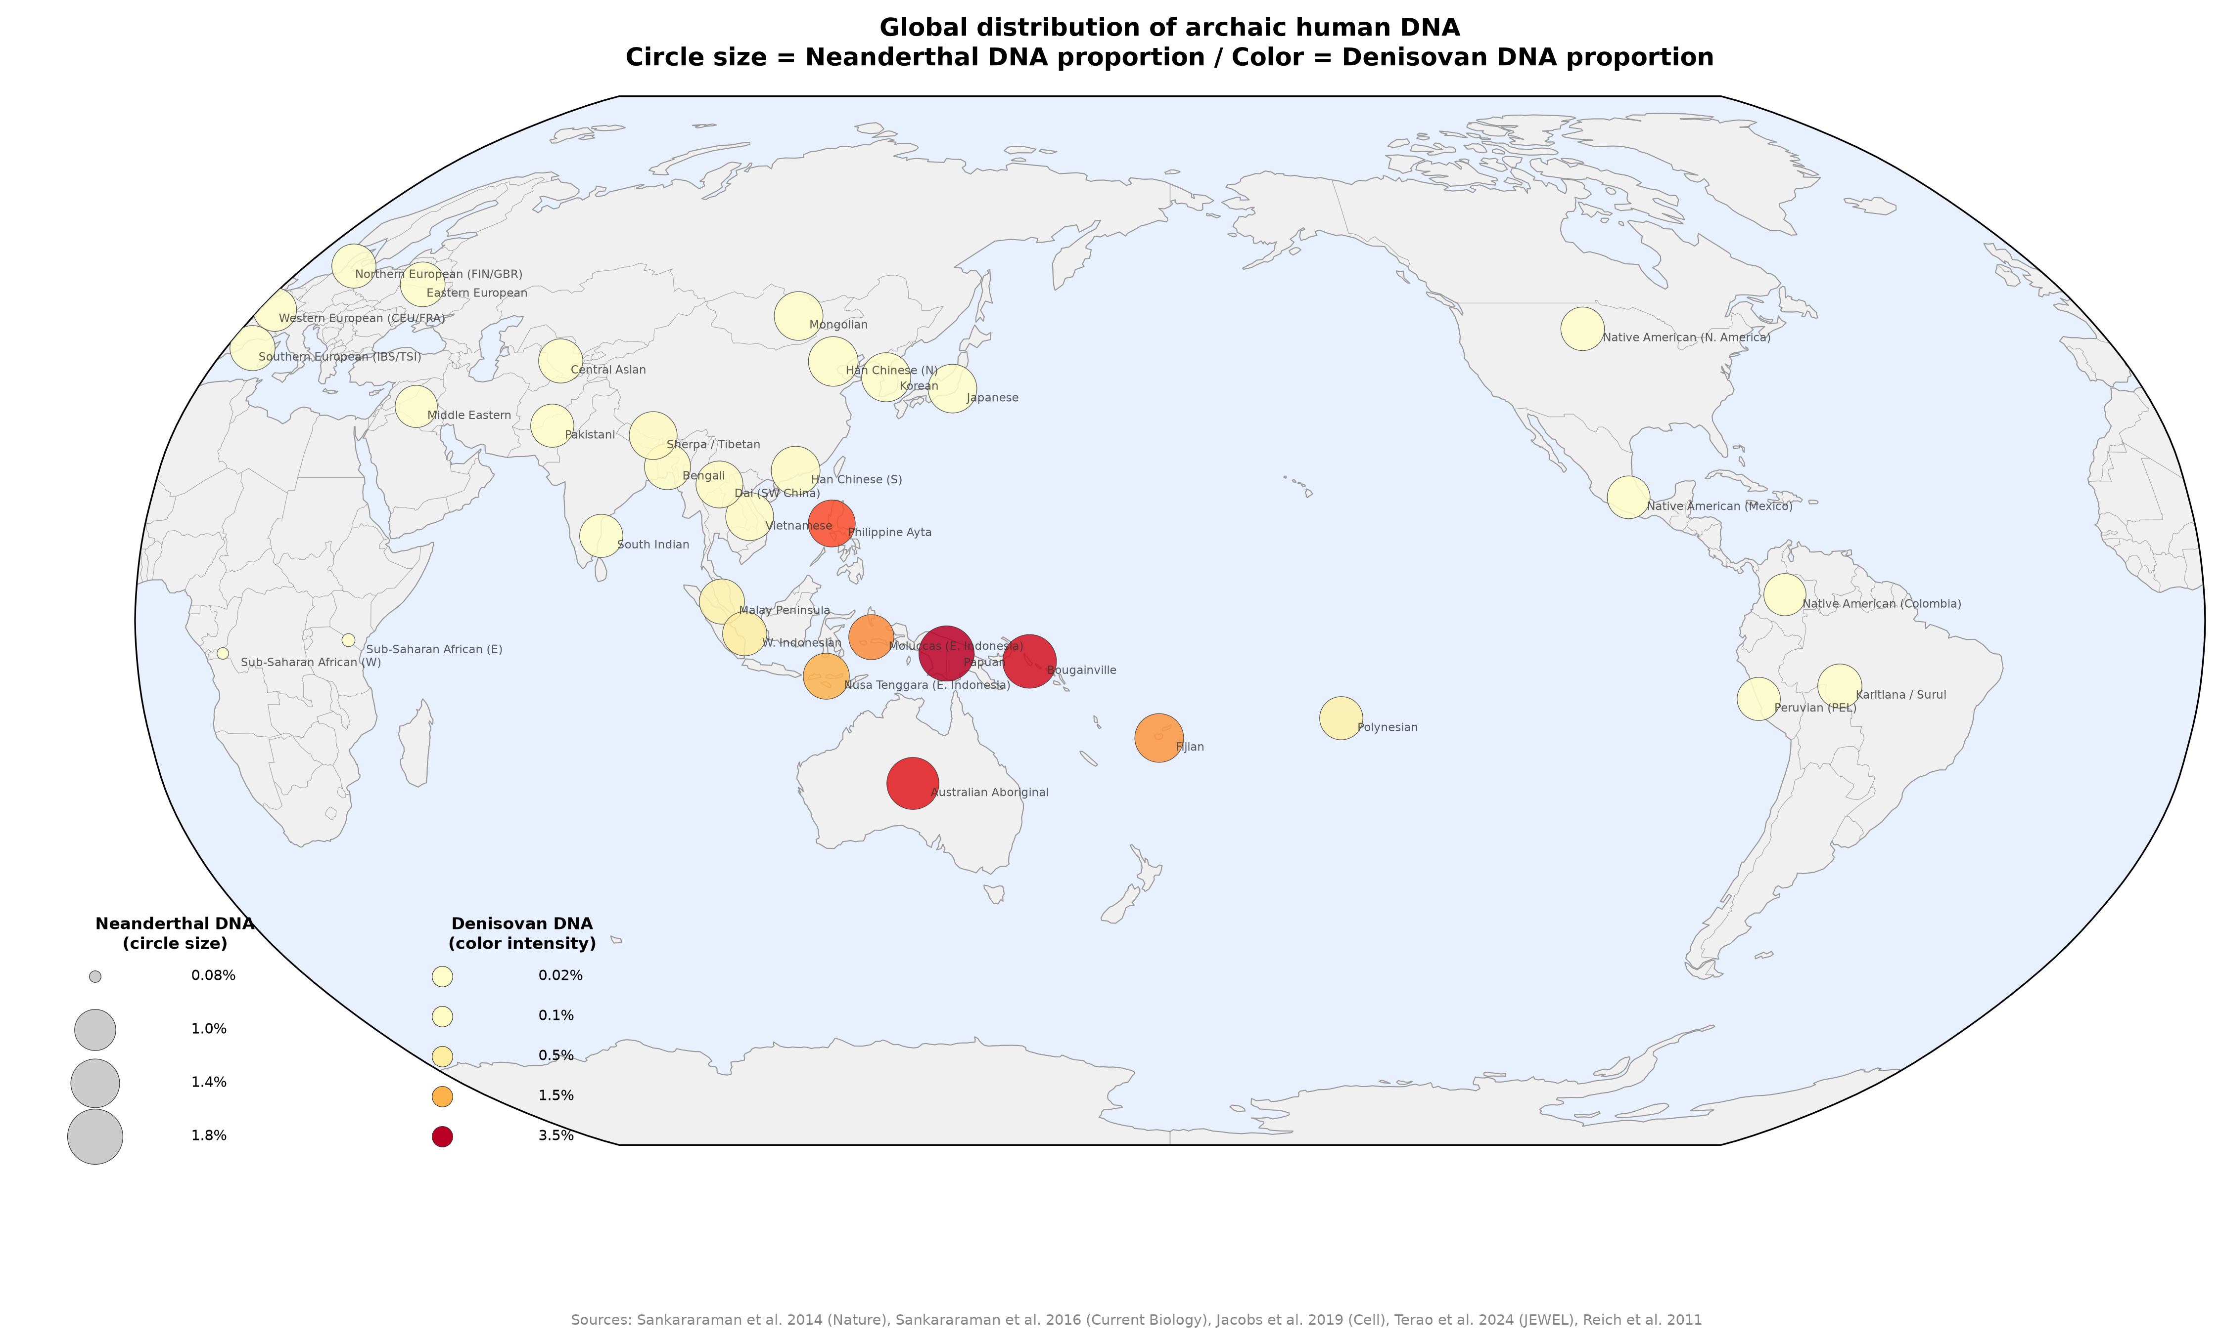
Figure 9. Global distribution of archaic human DNA: bivariate world map. Circle size represents Neanderthal DNA proportion (0.08-1.8%). Color intensity represents Denisovan DNA proportion (0.02-3.5%). The sharp transition from low (yellow/pale) to high (red/dark) Denisovan proportions between mainland Southeast Asia and island Melanesia visualizes the Wallace Line boundary. The Wallace Line (red dashed) and Lydekker Line (green dotted) are shown. Japanese populations (small yellow circles) have substantial Neanderthal ancestry (~1.4%) but minimal Denisovan ancestry (~0.06%), placing them in the "high-Neanderthal, low-Denisovan" quadrant shared with other continental East Asian populations.

Limitations
Several limitations of the current analysis should be acknowledged. First, the Pearson correlation of binned introgression frequencies is a computationally simple but statistically limited metric. It does not account for linkage disequilibrium between adjacent bins, nor does it distinguish between identity-by-descent and identity-by-state of archaic segments. More sophisticated approaches — such as phylogenetic analysis of shared segment haplotypes or hidden Markov models of segment co-inheritance — would provide stronger evidence.
Second, our confounding correction uses a binary continental grouping indicator rather than a continuous measure of genetic distance (e.g., F_ST). Published F_ST values for all 66 population pairs in our dataset are not uniformly available, and computing them from the hmmix segment data would be circular. Future work should incorporate independent estimates of genome-wide genetic distance as covariates.
Third, the sample sizes per population (median ~20 individuals) limit statistical power for detecting subtle sharing signals, particularly for Denisovan DNA, which constitutes a small fraction of total introgression. The absence of individually significant outlier pairs after FDR correction does not refute the hypothesis but indicates that larger sample sizes are needed for definitive tests.

Conclusions and outlook
This study began with the observation of near-fixation of blood group O in Native American populations. Focal investigation of archaic introgression at the ABO locus revealed region-specific distributions of Vindija-type Neanderthal segments, a temporal sub-lineage turnover from ancient to modern populations, and evidence that density-dependent selection preserved ancestral patterns in the Americas. These locus-specific findings motivated the extension to genome-wide analysis.
At the genome-wide level, we proposed that pairwise archaic introgression sharing can serve as an independent tracer of ancient human migration. Using publicly available data, we demonstrated that this metric captures biologically meaningful signals: the Denisovan Wallace Line boundary, Neanderthal-mediated Beringian connections, and confounding effects of post-Columbian admixture. These signals persist after correcting for confounders, though statistical power is reduced, indicating that larger datasets and more refined analytical methods are needed to fully exploit this approach.
The key advantage of our bivariate framework — jointly using Neanderthal and Denisovan signatures — is its ability to distinguish migration routes that are degenerate when viewed through a single archaic lens. A population with 1.4% Neanderthal and 0.06% Denisovan DNA (Japanese) has a fundamentally different migration history from one with 1.8% Neanderthal and 3.5% Denisovan (Papuan), even though both carry substantial archaic ancestry. As ancient genome sequencing extends to underrepresented regions — particularly Beringia, island Southeast Asia, and the Pacific — the testable predictions outlined here will become addressable, potentially resolving longstanding questions about the routes and timing of human dispersal across the planet.

Data availability
All analysis scripts, derived data, and figures are available at https://github.com/bougtoir/denisovan-archaic-dna-analysis. Source data: hmmix archaic introgression segments, Zenodo record 14136628.

Acknowledgments
The author acknowledges the investigators and participants who generated the publicly available genomic resources used in this study.

Conflict of interest
The author declares no conflict of interest.

References
1. Sankararaman S, Mallick S, Dannemann M, et al. The genomic landscape of Neanderthal ancestry in present-day humans. Nature. 2014;507(7492):354-357.
2. Prufer K, de Filippo C, Grote S, et al. A high-coverage Neandertal genome from Vindija Cave in Croatia. Science. 2017;358(6363):655-658.
3. Sankararaman S, Mallick S, Patterson N, Reich D. The combined landscape of Denisovan and Neanderthal ancestry in present-day humans. Curr Biol. 2016;26(9):1241-1247.
4. Reich D, Green RE, Kircher M, et al. Genetic history of an archaic hominin group from Denisova Cave in Siberia. Nature. 2010;468(7327):1053-1060.
5. Jacobs GS, Hudjashov G, Saag L, et al. Multiple deeply divergent Denisovan ancestries in Papuans. Cell. 2019;177(4):1010-1021.
6. Calafell F, Roubinet F, Ramirez-Soriano A, et al. Evolutionary dynamics of the human ABO gene. Hum Genet. 2008;124(2):123-135.
7. Vernot B, Akey JM. Resurrecting surviving Neandertal lineages from modern human genomes. Science. 2014;343(6174):1017-1021.
8. Quilodrán CS, Rio J, Tsoupas A, Currat M. Past human expansions shaped the spatial pattern of Neanderthal ancestry. Sci Adv. 2023;9(42):eadg9817.
9. Skov L, Hui R, Shchur V, et al. Detecting archaic introgression using an unadmixed outgroup. PLoS Genet. 2018;14(9):e1007641.
10. Ségurel L, Thompson EE, Flutre T, et al. The ABO blood group is a trans-species polymorphism in primates. Proc Natl Acad Sci U S A. 2012;109(45):18493-18498.
11. Halverson MS. ABO genotyping of pre-contact era Midwestern North American populations. PhD thesis, Ohio State University. 2008.
12. Condemi S, Mazierez A, Faux P, et al. Blood groups of Neandertals and Denisova decrypted. PLoS One. 2021;16(7):e0254175.
13. Irshaid NM, Henry SM, Ashhab Y, et al. Prevalence of the new blood group O2 allele within the ABO blood group system among blood donors in the Solomon Islands. Vox Sang. 2006;91(3):261-265.
14. Raghavan M, Skoglund P, Graf KE, et al. Upper Palaeolithic Siberian genome reveals dual ancestry of Native Americans. Nature. 2014;505(7481):87-91.
15. Hey J. On the number of New World founders: a population genetic portrait of the peopling of the Americas. PLoS Biol. 2005;3(6):e193.
16. Petr M, Hajdinjak M, Grote S, et al. Neandertal ancestry through time: insights from genomes of ancient and present-day humans. Science. 2024;386(6726):eadi1768.
17. Wolfe ND, Dunavan CP, Diamond J. Origins of major human infectious diseases. Nature. 2007;447(7142):279-283.
18. Petr M, Pääbo S, Kelso J, Vernot B. Limits of long-term selection against Neandertal introgression. Proc Natl Acad Sci U S A. 2019;116(5):1639-1644.
19. Mao X, Zhang H, Qiao S, et al. The deep population history of northern East Asia from the Late Pleistocene to the Holocene. Cell. 2021;184(12):3256-3266.
20. Liu X, Koyama S, Tomizuka K, et al. Decoding triancestral origins, archaic introgression, and natural selection in the Japanese population by whole-genome sequencing. Sci Adv. 2024;10(16):eadi8419.
21. Skoglund P, Mallick S, Bortolini MC, et al. Genetic evidence for two founding populations of the Americas. Nature. 2015;525(7567):104-108.

