Supporting Information
Population structure defines the null expectation for pairwise genomic similarity: archaic-segment sharing across 66 human populations
Figure S1. Complete 66-population Neanderthal and Denisovan profile-similarity matrices.
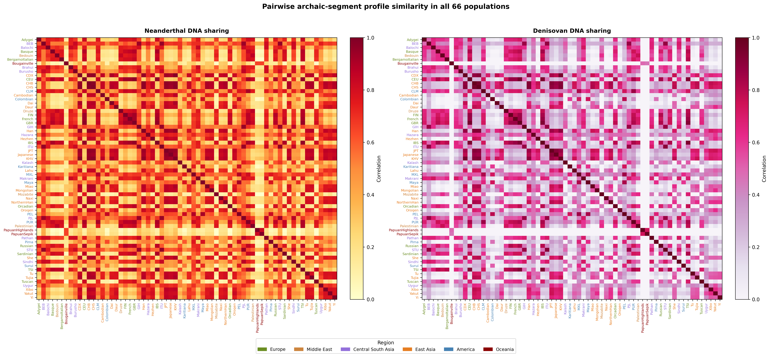

Figure S2. Sensitivity of the descriptive Neanderthal distance correlation to exclusion of designated recently admixed populations.
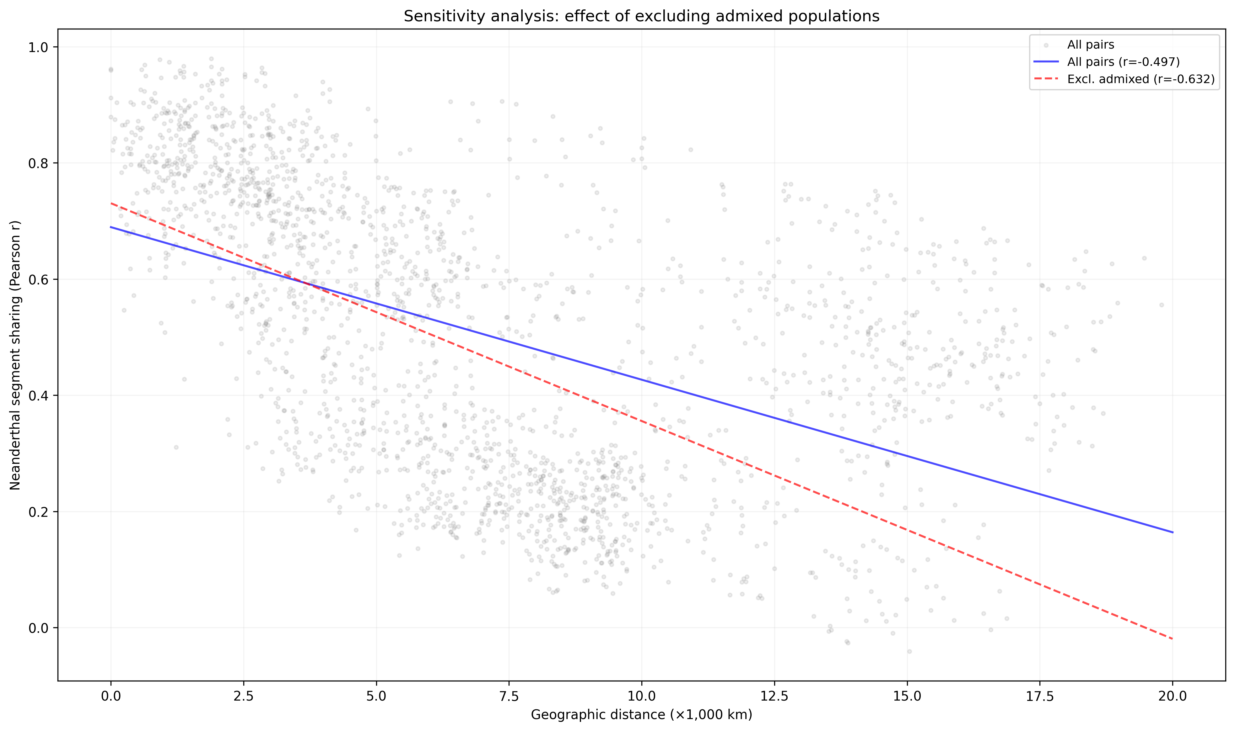

Figure S3. Descriptive geographic distance correlations at 250-kb, 500-kb, and 1-Mb window sizes. QAP results are tabulated in Supplementary Data.
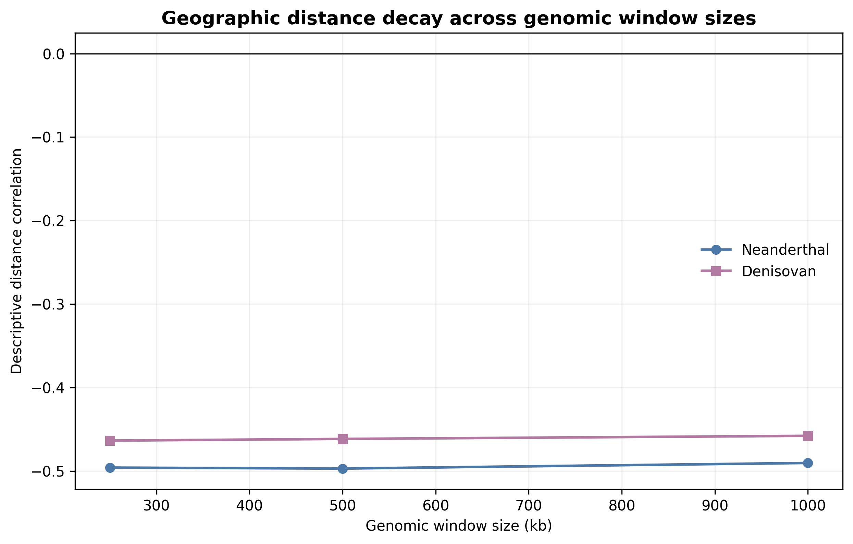

Figure S4. Exploratory ABO-centered analysis preserving the historical grouped-bar and segment-map layout. Equal maximum-similarity ties are excluded from the displayed three-reference proportions and retained in Supplementary Data. The Pima segment overlaps ABO; the Maya segment is within the wider interval but does not overlap the gene. Counts are segments, not regional frequencies, and are not interpreted as a migration route.
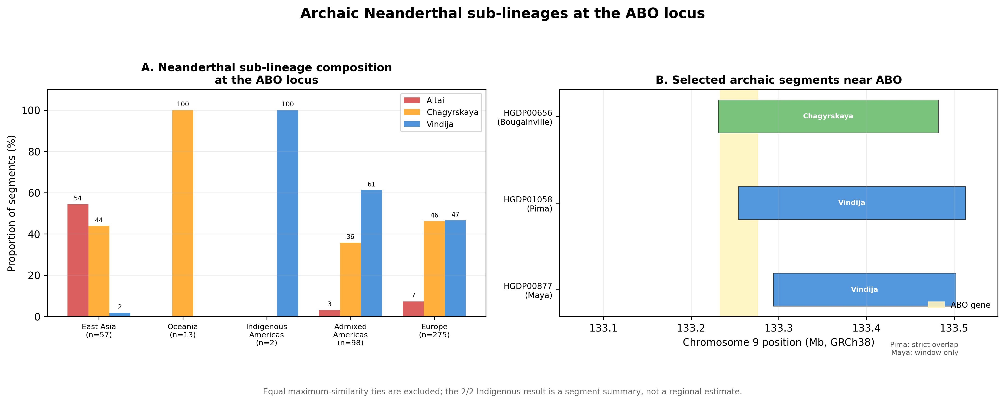

Figure S5. O2 blood-group subtype-defining allele frequencies and ABO-window segment-carrier frequencies. The panels use different sources and are not an association analysis; proximity does not establish that the O2 allele is Neanderthal-derived.
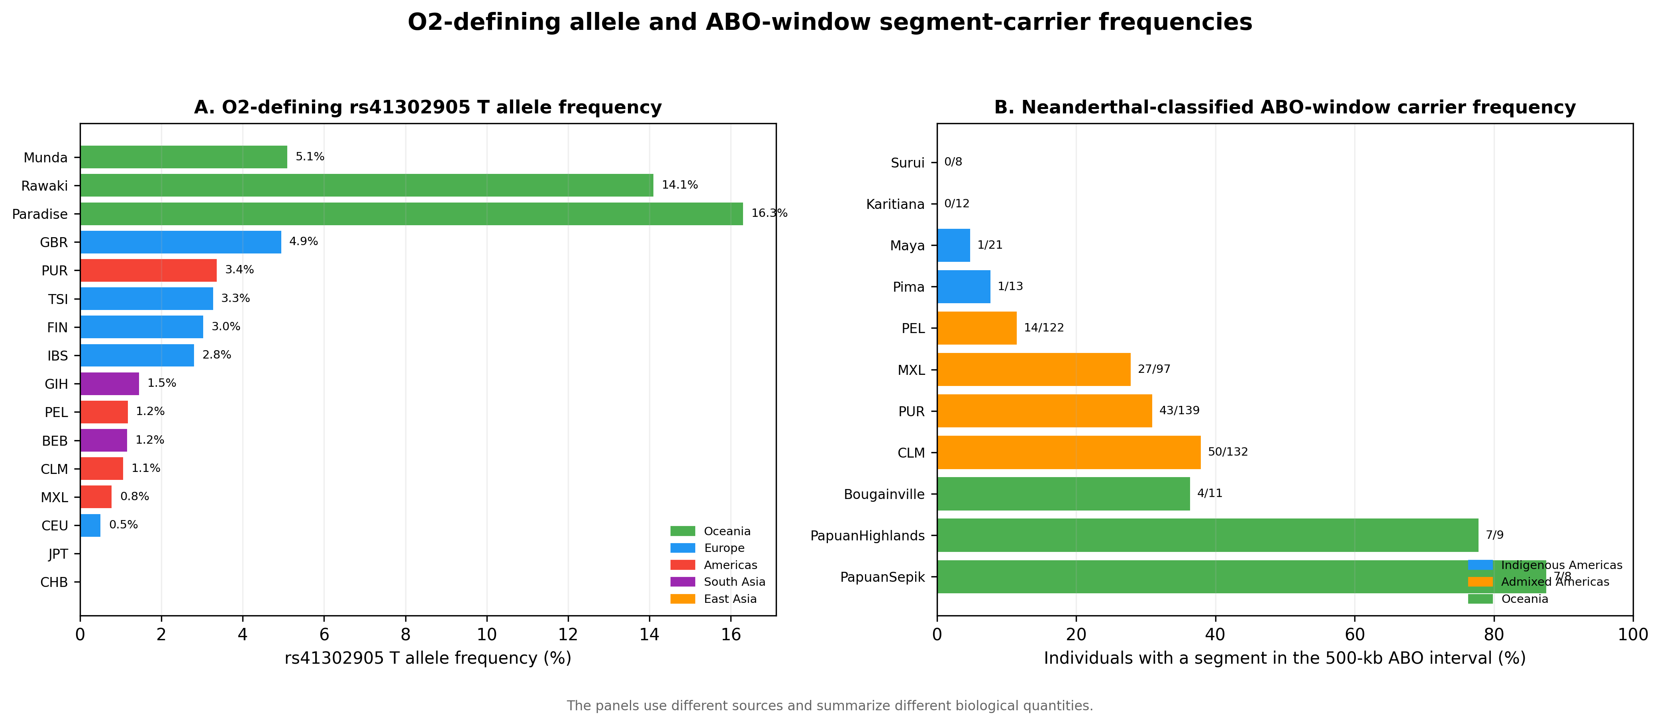

Figure S6. Descriptive ancient and modern ABO-window summaries generated by different pipelines; no formal temporal comparison is made.
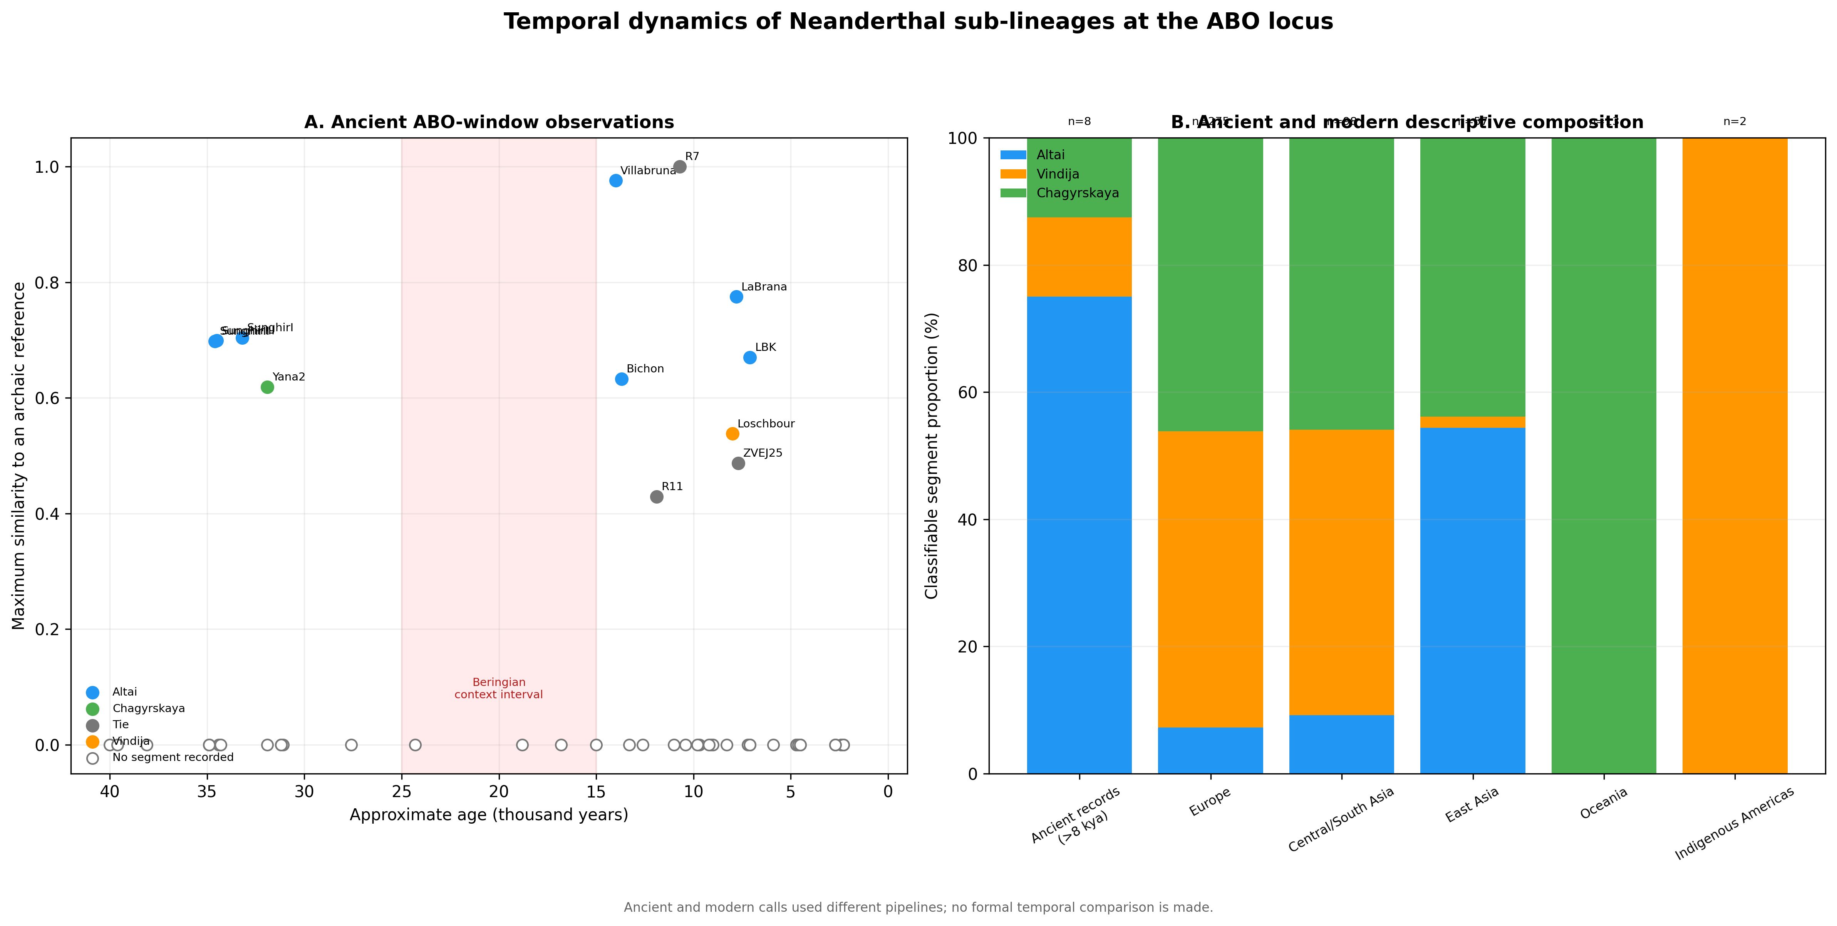

Figure S7. Bivariate global context computed in this study. Circle area encodes the mean per-bin Neanderthal-segment coverage and colour encodes the mean per-bin Denisovan-segment coverage for each population, both from data/population_profiles_500kb.npz; coordinates are approximate sampling locations from data/population_metadata.csv. These descriptive summaries were not used in the pairwise statistical models.
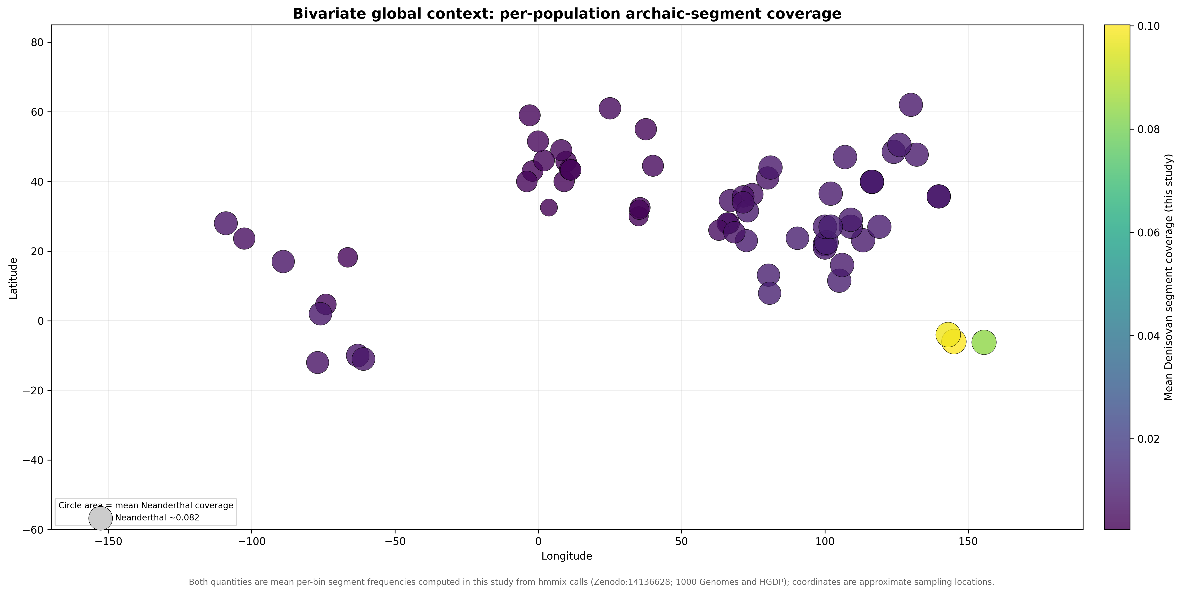

Table S1. Exploratory ABO-window Neanderthal-reference composition
Region | n | Altai % | Vindija % | Chagyrskaya %
East Asia | 57 | 54.4 | 1.8 | 43.9
Europe | 275 | 7.3 | 46.5 | 46.2
Indigenous Americas | 2 | 0.0 | 100.0 | 0.0
Admixed Americas | 98 | 3.1 | 61.2 | 35.7
Central/South Asia | 98 | 9.2 | 44.9 | 45.9
Middle East | 44 | 11.4 | 52.3 | 36.4
Oceania | 13 | 0.0 | 0.0 | 100.0
Note. Counts are classifiable segments, not individuals. Percentages use the three-reference denominator shown by n. Equal maximum-similarity ties are excluded from these percentages but retained in Supplementary Data. The 2/2 Indigenous American value is not a regional frequency estimate; only one segment overlaps ABO, and these counts are not interpreted as a migration route.

Supplementary File Inventory
The submission contains 5 main figures (Figures 1-5), 7 supplementary figures (Figures S1-S7), 1 main table (Table 1), 1 supplementary table (Table S1), and 10 machine-readable supplementary data files listed below.
Supplementary Data 1: population_metadata.csv. Population, project of origin, sample size, representative latitude and longitude, continental assignment, recent-admixture flag, and inclusion status for each of the 66 analysed populations.
Supplementary Data 2: pairwise_sharing_corrected.csv. All 2,145 population pairs with Neanderthal and Denisovan profile similarity, great-circle distance, covariate indicators, fitted values, residual z scores, permutation P values, and Benjamini-Hochberg q values.
Supplementary Data 3: model_summary.csv. Quadratic assignment procedure coefficients for both ancestries, population-label permutation P values, descriptive R-squared values, and population-deletion intervals.
Supplementary Data 4: sensitivity_analysis.csv. Similarity-metric and population-subset robustness summaries, including the non-admixed subset of 1,891 pairs from 62 populations.
Supplementary Data 5: window_size_sensitivity.csv. Robustness of the population-wide geographic-distance association at 250-kb, 500-kb, and 1-Mb genomic window sizes, reporting for each ancestry the raw distance correlation, the quadratic assignment procedure distance coefficient, the two-sided permutation P value, the descriptive R-squared value, and the number of permutations.
Supplementary Data 6: profile_quality_checks.csv. Ancestry-level profile quality checks reporting the maximum observed population-window frequency, the number of bins exceeding one, and the number of non-zero population-window entries.
Supplementary Data 7: abo_focal_test.json. Prespecified ABO focal-window result: window coordinates, maximum standardised excess similarity, genome-wide percentile, empirical P value, and the number of usable windows for each ancestry.
Supplementary Data 8: ancient_abo_summary.csv. Ancient-individual summaries extracted from the published Neanderthal-segment catalogue for the ABO interval, giving for each of the 59 assessed ancient individuals the age, population, region, closest archaic reference, reference proportions, segment-detection status, and strict ABO gene overlap. These data were generated by a different pipeline from the present-day profiles, are used descriptively only in the Discussion, and are not compared statistically with the present-day data; no analysis result depends on this file.
Supplementary Data 9: ancient_abo_provenance.json. Provenance for the ancient ABO-interval summary, including the source publication and source data DOIs, the GRCh37/hg19 genome build, the ABO gene and window coordinates, the diagnostic-site and genetic-map settings, the source file names with their SHA-256 checksums, and the counts of ancient individuals assessed, with a detected segment, and with strict ABO overlap.
Supplementary Data 10: analysis_provenance.json. Provenance for the committed analysis, including the analysis release, the analysis code commit, the input file names with their SHA-256 checksums, the minimum segment probability and minimum population size, the genomic bin size, the frequency definition, and the final counts of individuals, populations, and population pairs.
The ten files designated Supplementary Data 1-10 are the formal machine-readable supplementary files cited in the article. The accompanying data archive also contains additional derived intermediate and auxiliary files retained to support reproducibility and auditability: it holds 23 files in total under data/, of which the 13 not designated above are intermediate or auxiliary derived files, together with a README_DATA.md documentation file.
Supporting documents: MOLECULAR_ECOLOGY_SUPPORTING_INFORMATION.docx (this file, containing Figures S1-S7 and Table S1), Table_S1_abo_summary.docx (editable supplementary table), and tables_molecol/Table_S1.xlsx (spreadsheet version of Table S1).
Supplementary figure files: figures/Figure_S1 to figures/Figure_S7, each supplied as a 300-dpi PNG and a 300-dpi TIFF.

