Structural asymmetries distort guild-level beta-diversity contrasts
Blinded main text (double-anonymous).
*(blinded main text — double-anonymous review)*

Abstract
**Aim** — To quantify when guild-level beta-diversity contrasts recover genuine ecological differences and when they are generated, erased or exaggerated by structural properties of assemblage data.
**Location** — Simulated one- and two-dimensional landscapes; empirical case studies from the Morrison (western North America) and Nemegt (Mongolia) formations.
**Time period** — Late Jurassic to Late Cretaceous (empirical case studies); simulations are timeless.
**Major taxa studied** — Terrestrial vertebrate assemblages; herbivorous and predatory dinosaur guilds used as the empirical stress test.
**Methods** — Controlled assemblage simulations in which the generative guild contrast is zero by construction, manipulating regional pool size, dominance structure, taxonomic aggregation (species→genus pooling), temporal aggregation (eight slices → pooled bins) and sampling asymmetry, including a factorial interaction design; a 2-D lattice replication with distance-decay slope analysis tests geometric generality. Empirically, a sequential structural decomposition of a strong predator–herbivore turnover contrast in the Morrison Formation, plus an identical locked pipeline on Nemegt.
**Results** — Structural asymmetry alone generated false spatial differentiation: a four-taxon pool produced bias ≈ −0.17 (extreme two-taxon ≈ −0.41; replicated on a 2-D lattice: ≈ −0.21 / ≈ −0.47), and pool asymmetry also inflated the apparent distance-decay slope (≈0.028 vs ≈0.006). Temporal aggregation proved source-dependent: it erased the structurally generated component while amplifying explicit ecological contrasts approximately four-fold. In Morrison, a naive contrast of Δβ = −0.550 was progressively attenuated by structural controls (Δβ = −0.020 after dominant-taxon exclusion); Nemegt showed no such contrast (Δβ = +0.094, CI crossing zero).
**Main conclusions** — Guild-level beta-diversity contrasts should not be interpreted as differences in spatial connectivity, mobility or habitat breadth without explicit control for assemblage structure and temporal aggregation. Assemblage construction can create, erase or exaggerate apparent spatial ecological structure, and it distorts the spatial form of turnover, not only its mean.

Introduction
Beta diversity — the compositional variation of assemblages across space — is a foundational currency of macroecology and biogeography (Whittaker, 1960; Tuomisto, 2010; Anderson et al., 2011; Moreno & Rodríguez, 2010). Pairwise dissimilarity, multiple-site metrics and the decay of similarity with distance are used to infer connectivity, dispersal limitation, environmental filtering and biogeographic differentiation (Nekola & White, 1999; Soininen et al., 2007; Morlon et al., 2008; Baselga, 2010). Comparative studies increasingly apply these measures across taxonomic or functional groups — asking, for example, whether one guild is more spatially homogeneous than another — because such contrasts promise inference about group-specific spatial ecology (Heino et al., 2015). All of these applications are scale-dependent: turnover varies with the spatial grain and extent of the data (Wiens, 1989; Barton et al., 2013). When such measures are compared between guilds, clades or functional groups, the comparison carries an implicit assumption: that the two assemblages are structurally comparable — that differences in their regional pool size, dominance structure, taxonomic resolution, temporal span and sampling intensity do not themselves alter measured turnover.
In practice, however, guilds and assemblages differ routinely in exactly these properties. A predator guild and its prey guild typically differ in pool size; a dominant species can occupy most of the sampled sites while its comparison guild has none; one group may be identifiable to species while another is only resolvable to genus; one dataset may integrate a decade of sampling while another pools centuries; and the two sides may have been collected under different effort regimes. Each of these structural properties is individually known to affect diversity metrics. Measured beta diversity depends on the size and composition of the regional species pool (Kraft et al., 2011; Chase et al., 2011; Pärtel et al., 2011; Zobel, 2016), and comparisons across assemblages of unequal richness are a known source of scale-dependent distortion (Chase et al., 2018). Dominant species and the shape of the occupancy–frequency distribution can drive dissimilarity values regardless of underlying spatial processes (Lennon et al., 2004; McGeoch & Gaston, 2002; McGill et al., 2007; Hillebrand et al., 2008). The taxonomic grain at which data are recorded alters diversity patterns (Bertrand et al., 2006; Bevilacqua et al., 2009), temporal aggregation reshapes apparent community change (Olszewski, 1999; Korhonen et al., 2010; Blowes et al., 2019), and unequal sampling effort and incomplete detection bias comparisons when they are not standardized (Gotelli & Colwell, 2001; MacKenzie et al., 2002; Colwell et al., 2012; Chao et al., 2014). Because these mechanisms co-occur in real data and interact, treating them as independent additive corrections is itself an untested assumption. Each mechanism is established; what is missing is a quantitative account of how large their separate and joint effects on guild-level turnover contrasts can be.
This is not merely a fossil problem. Much of the biodiversity evidence now used in macroecology is historically aggregated: museum and herbarium collections, long-term monitoring compilations, archaeological faunas, pollen and sedimentary records are all assembled over uneven taxonomic, temporal and sampling structure (Shaffer et al., 1998; Graham et al., 2004; Pyke & Ehrlich, 2010; Lavoie, 2013). Palaeoecological assemblages are the extreme end of the same spectrum — they push every structural asymmetry further, with small and uneven taxon pools, strong dominance, coarse taxonomic resolution and temporal averaging over thousands to millions of years (Kidwell & Behrensmeyer, 1991; Olszewski, 1999; Behrensmeyer et al., 2000; Badgley, 2010; Smith & McGowan, 2007; Vilhena & Smith, 2013). If structural bias in guild-level turnover comparisons is consequential anywhere, it should be consequential there. The fossil record therefore serves as an informative stress test for a general inferential problem rather than a special case with its own rules (Uhen et al., 2013; Peters & McClennen, 2015).
What is missing from the literature is not awareness that these biases exist but their magnitudes under controlled conditions: how large can a structurally generated guild contrast become when no genuine ecological difference exists, and can assemblage structure distort not only mean dissimilarity but also the spatial form of turnover — the distance-decay relationship that underlies biogeographic inference? Answering these questions requires a known generative baseline, which empirical assemblages cannot provide; it requires simulation.
Here we combine (i) controlled simulations in which the generative guild contrast is zero by construction, on a one-dimensional spatial axis and, as a robustness check, a two-dimensional lattice; (ii) a factorial map identifying joint conditions that produce false differences and large distortions; (iii) an analysis of how structural asymmetry distorts distance-decay slopes, not just mean dissimilarity; and (iv) an empirical fossil stress test — dinosaur assemblages of the Late Jurassic Morrison Formation (Maidment et al., 2024) — in which an initially strong guild-level turnover contrast is decomposed stepwise under structural controls, with the Nemegt Formation as an external comparator. Our central equation is Δβ_observed ≠ Δβ_ecological whenever the compared guilds differ in assemblage structure (Fig. 1). Our objectives are to quantify the magnitude of structural bias under controlled conditions, to identify conditions causing false differentiation, lost differentiation and distortion of magnitude, to decompose the Morrison signal empirically, and to derive a practical diagnostic workflow for guild-level beta-diversity inference in structurally heterogeneous data.
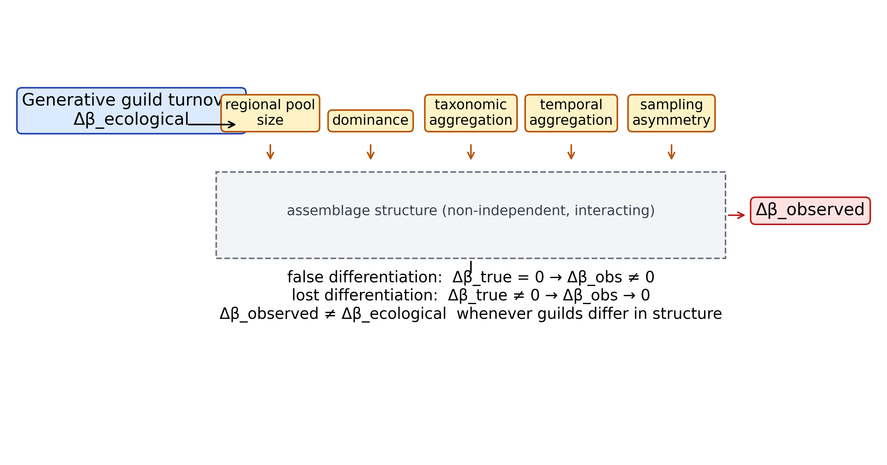
Figure 1. Conceptual framework. Generative guild turnover is filtered
through assemblage structure — regional pool size, dominance,
taxonomic and temporal aggregation, sampling asymmetry — before
Δβ_observed is measured; observed contrasts therefore need not equal
ecological contrasts.

Methods

Overview
We combine (i) controlled simulation of fossil guild assemblages, in which the generative turnover contrast is known, with (ii) a sequential empirical decomposition of a real guild-level beta-diversity contrast in the Upper Jurassic Morrison Formation, and (iii) a negative external comparator from the Nemegt Formation. All estimators, null models, seeds and output files are frozen and versioned; every number cited in the manuscript is traced in `results/manuscript_values.csv`.

Terminology and estimand
Throughout, beta diversity is measured between assemblages as the mean pairwise Jaccard dissimilarity computed on incidence matrices, equivalently one minus the mean pairwise Jaccard index (Legendre, 2014). The focal contrast is
$$Δβ = β_{P} − β_{H}$$
where β_P and β_H are mean pairwise Jaccard beta diversities of the predator and herbivore guilds. The estimand is the mean of pairwise dissimilarities, identical for the point estimate and the bootstrap distribution (collection resampling with replacement on incidence rows). Under a simulated scenario, bias is defined as
$$Bias = {Δβ}_{obs} − {Δβ}_{true}$$
Sign conventions: Δβ < 0 indicates predators are *more* spatially homogeneous than herbivores; Δβ > 0 indicates greater predator turnover. A lumping manipulation that lowers predator beta raises β_H − β_P and therefore produces Δβ < 0 (apparent predator continuity); we report lumping effects as B_lumping = β_species − β_genus of the manipulated guild and as Δβ shifts with explicit sign annotation.

Simulation design
Artificial fossil assemblages are generated on a 1-D spatial axis of N = 200 localities (analysis/sim_core.py). Each taxon occupies a contiguous range of width `breadth` (fraction of the axis) centred at a uniform random location; within its range it is recorded with probability `occ_p` per locality. Guild incidence matrices are built independently for herbivores (26 taxa) and predators from identical per-taxon parameters, so the two guilds share the same underlying spatial process — contiguous random ranges, equal occupancy probability — and Δβ_true = 0 in expectation; the guilds differ only in pool size. The simulator is deliberately one-dimensional (contiguous 1-D ranges): bias magnitudes are demonstrations of sufficiency, not calibrated estimates for real palaeolandscapes. The conceptual decomposition
$${Δβ}_{obs} = {Δβ}_{eco} + B_{γ} + B_{D} + B_{T} + B_{L} + B_{S} + ε$$
is a scaffold, not a fitted causal partition; the five terms can interact, which is why Simulation 6 is factorial. Default parameters: breadth = 0.45, occ_p = 0.35, N_H = 26, N_P = 12. All sweeps use 100–200 replicates per cell with frozen seeds (Table S1; full sweep outputs Table S2) (20260922–20260923).

Two-dimensional robustness and distance decay
A confirmatory simulator generates assemblages on a 40×40 square lattice: each taxon occupies a disc of radius 0.225·L centred at a uniform-random location, recording with occ_p = 0.35 per lattice cell (analysis/13_2d_robustness.py, seed 20260924, 100 replicates; Table S9). Beyond mean pairwise β, we compute distance-decay slopes as the linear regression slope of pairwise Jaccard dissimilarity on pairwise Euclidean distance (lattice units) per replicate and guild; slope comparisons report small-pool versus comparison-guild apparent decay under identical generative spatial processes.

Simulation 1 — gamma-diversity imbalance
Herbivore richness fixed at 26; predator richness swept 2–26. Δβ_true = 0 by construction. Output: mean Δβ_obs, 95% quantile interval, proportion of replicates with Δβ_obs < 0 and with |Δβ_obs| > 0.1 (false-contrast rate).

Simulation 2 — dominant taxon
One predator taxon is elevated to a dominant that occurs in proportion p_D of all localities, independent of range; p_D swept 0–0.9.

Simulation 3 — taxonomic lumping
k geographically partitioned species (disjoint sub-ranges, joint occupancy ~0.6) are collapsed into a single genus column. Bias is reported as β_species − β_genus for the predator guild and as the change in Δβ between species- and genus-level matrices.

Simulation 4 — temporal averaging, baseline arm (Delta_beta_true ~ 0)
Each taxon's occurrence pattern is re-drawn independently across 8 time slices; locality rows are then pooled into bins of 8, 4, 2, or 1 slice(s) (pooled presence = slice-wise OR). Guilds share identical per-taxon parameters, so the only nonzero contrast at the thinnest resolution is the structural pool-size term.

Simulation 4b — temporal averaging under nonzero true contrast
To quantify how temporal aggregation alters an explicitly imposed ecological contrast, we generated explicitly nonzero ecological contrasts by giving the two guilds different mean range breadths — a difference in underlying spatial ecology, not in assemblage structure: narrower ranges yield higher within-guild turnover. Three prospectively specified scenarios were run (herbivore breadth, predator breadth): weak (0.30, 0.45; target Delta_beta_true ~ -0.05), moderate (0.30, 0.70; ~ -0.10) and strong (0.15, 0.90; ~ -0.20). Pool sizes follow the baseline arm (N_H = 26, N_P = 12); aggregation uses the identical slice-wise-OR rule at 8, 4, 2 and 1 bins; 150 replicates, frozen seed 20260925 (Table S8) (analysis/21_temporal_false_negative.py). Attenuation is quantified as attenuation_fraction = 1 - |Delta_beta_pooled| / |Delta_beta_thin| on replicate means; negative values indicate amplification rather than attenuation.

Simulation 5 — asymmetric sampling
The spatial axis is divided into alternating 20-locality environment blocks; predator occurrences in environment A are retained with a sampling multiplier of 1–8× relative to environment B (truncated at 1).

Simulation 6 — factorial
Full grid of n_pred_taxa (2–26) × p_dominant (0–0.9) × n_lumped (1, 3, 6 partitioned species), 100 replicates per cell, to map false-difference (|Δβ_obs| > 0.1) and extreme-bias regions; the five bias terms are not assumed independent — the factorial design is the primary evidence on interaction.

Empirical worked example — Morrison Formation
Occurrence data derive from the Maidment et al. (2024) Dryad dataset (DOI 10.5061/dryad.6m905qg77; CC0), hashed with sha256 and listed in `metadata/sources.csv` (Text S2): 651 dinosaur occurrences, 239 collections, 38 resolved genera (locality map, Figure S3; guild and taxonomic mapping, Table S5). Guilds follow the published taxonomy; predators = theropod taxa, herbivores = ornithischian + sauropodomorph taxa. Analyses use the collection (assemblage) as the spatial unit, genus resolution, Jaccard metric, and a 999-replicate collection bootstrap (seed 20260920).
The sequential decomposition applies, in fixed order: 1. naive genus-level Δβ; 2. gamma-matched null (B = 10,000 replicates reassigning guild labels across genera while preserving pool sizes); 3. frequency-matched null (occupancy-frequency matched); 4. exclusion of the dominant predator (Allosaurus); 5. species-level resolution (Allosaurus split into named species; Table S10); 6. stratigraphic-duration + occurrence-count OLS on geographic extent (extent ~ duration + n_occurrences), reporting the Allosaurus residual and z-score; 7. an exploratory collection-covariate logistic model of Allosaurus presence (environment, lithology, collection type, count type), reported only as pseudo-R². The unpenalized fit showed quasi-separation (state coefficients ≈ 17, MLE non-convergence); an L2-penalized logistic refit (sklearn, C = 1, 0.1, 10) converged and is reported as a robustness check alongside it (Table S4; Figure S4). Both remain exploratory and carry no inferential weight.

External comparator — Nemegt Formation
Nemegt dinosaur occurrences were pulled from the Paleobiology Database (Paleodata API; collections filtered to Nemegt-bearing collections in Mongolia, Maastrichtian), with sha256 provenance: 319 dinosaur occurrences, 124 collections; body-fossil genus-resolved subset: 89 collections, predator 116 occurrences / 26 genera, herbivore 34 occurrences / 8 genera. The identical locked pipeline (Jaccard, collection level, genus, 999 bootstrap, seed 20260920) yields the comparator Δβ. The gamma-matched null degenerates here because herbivore gamma (8 genera) is smaller than predator gamma — Nemegt is used strictly as a comparator of opposite structure, not as a biological replication test (extended diagnostics: Table S6; Figure S5).

Independent evidence audit
A bounded literature scan (Text S1; stable isotopes, trackways, feeding traces, ontogenetic structure, palaeobiogeography) classifies each evidence class on a five-point scale from "supports exceptional mobility" to "contradictory"; the full classification is in INDEPENDENT_EVIDENCE_AUDIT.md.

Reproducibility
All random seeds are frozen; scripts under `methodological_beta_bias/analysis/` (01–13 plus figure/docx builders) regenerate every table and figure. `results/manuscript_values.csv` maps each cited number to its source script, output file, figure panel and manuscript location.

Results

Results 1 — Gamma-diversity imbalance alone creates strong apparent guild contrasts
With the generative guild contrast fixed at zero, reducing one guild's regional taxon pool generated substantial apparent turnover bias despite identical generative guild turnover: at a predator pool of 4 taxa (against 26 herbivore taxa — a realistic Morrison-like asymmetry) mean Δβ_obs was −0.170 (95% replicate interval −0.187, −0.157), and under the most extreme tested condition, a two-taxon pool, bias reached −0.412 (−0.443, −0.398) (Fig. 2a). A "false contrast" is defined here as |Δβ_obs| > 0.1 on the mean-pairwise Jaccard contrast (an operational magnitude threshold on the point estimate — not a CI or p-value criterion; replicate spread supplies the interval): the false-contrast rate was 100% at predator pools of both 2 and 4 taxa (200 replicates each, seed 20260922), and the all-negative-sign rate persisted through pools of 20. Threshold sensitivity is reported in the Supporting Information (Table S7): at pool 2 the rate remains 100% even at |Δβ| > 0.20, while at pool 4 it is 100% at 0.05 and 0.10 but 0% at 0.20, and at pools ≥12 it is 0% at every threshold — the 0.1 criterion is therefore an operational threshold whose sensitivity is characterised, not a universal benchmark. Only at equal pools (26 vs 26) did Δβ_obs centre on zero (−0.0001; −0.008, +0.008).
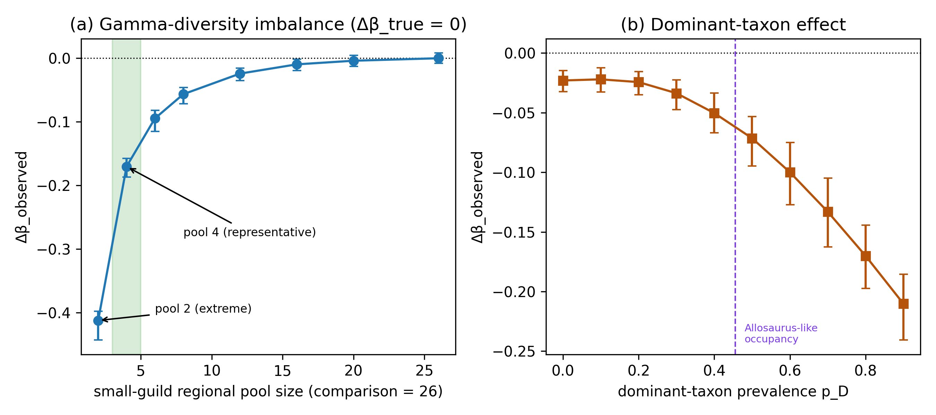
Figure 2. Structural asymmetry creates false differentiation
(Δβ_true = 0). (a) Δβ_obs vs small-guild regional pool size
(comparison guild = 26 taxa); four-taxon pool is the representative
case (−0.17) and the two-taxon pool the extreme tested condition
(−0.41); points are means over 200 replicates with 95% replicate
intervals. (b) Δβ_obs vs dominant-taxon prevalence p_D; negative
Δβ = apparent spatial continuity of the small/dominant-structured
guild. Frozen seed set 20260922.
A lightweight two-dimensional replication (40×40 lattice, disc-shaped ranges, identical pool asymmetry; 100 replicates, seed 20260924) reproduced the qualitative pattern: bias ≈ −0.21 at a four-taxon pool and ≈ −0.47 at the extreme two-taxon pool, confirming the phenomenon is not an artefact of one-dimensional range geometry. Pool asymmetry also inflated the small-pool guild's apparent distance-decay slope (≈0.028 lattice-units⁻¹ versus ≈0.006 for the comparison guild under identical generative spatial processes): the bias distorts the spatial form of turnover, not only its mean (Fig. 3).
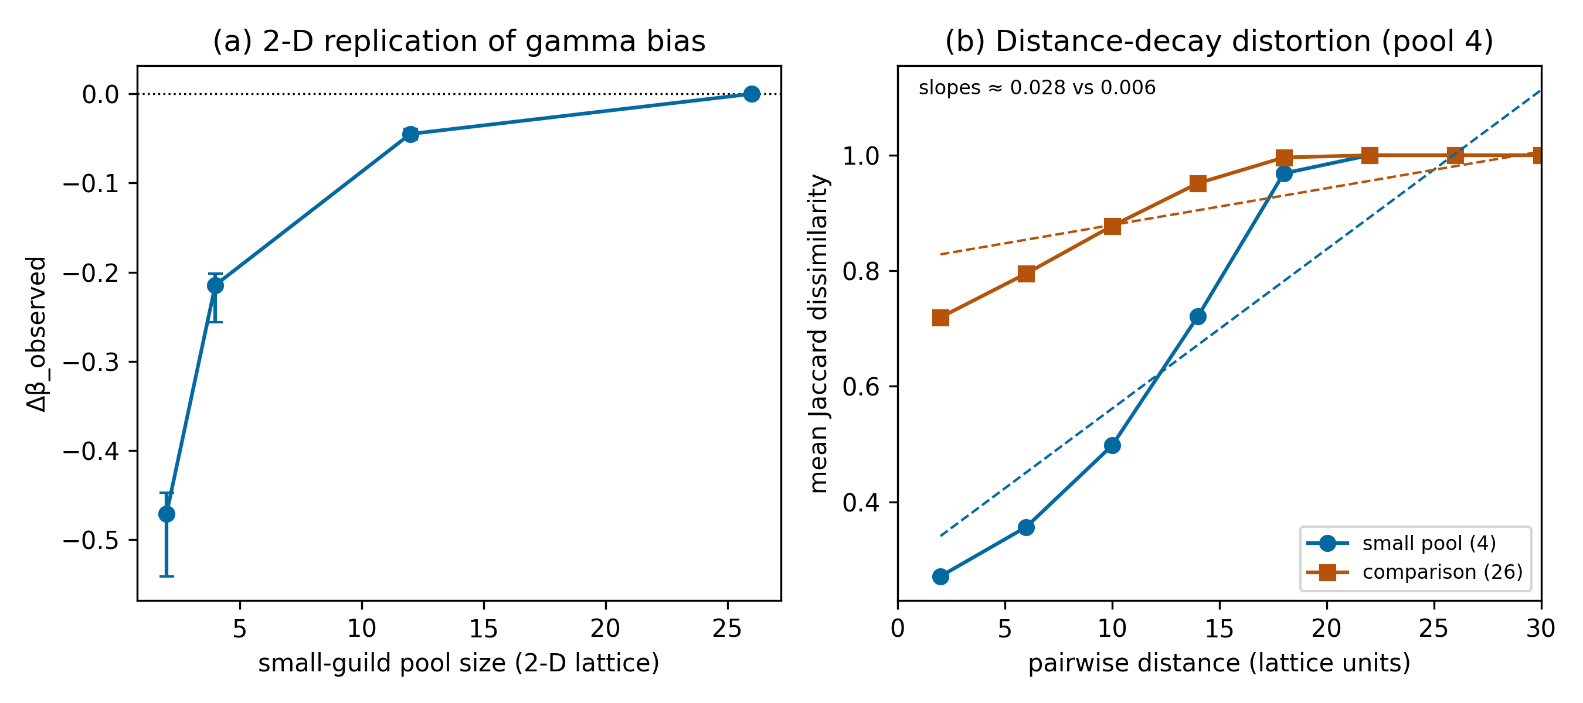
Figure 3. Two-dimensional robustness and distance-decay
distortion. (a) Δβ_obs under pool asymmetry on a 40×40 lattice with
disc-shaped ranges (pool 4: −0.21; pool 2: −0.47; 100 replicates,
seed 20260924), replicating the 1-D pattern. (b) Mean pairwise Jaccard
dissimilarity vs pairwise geographic distance (β(d)) for small-pool
vs comparison guilds; fitted decay slopes ≈0.028 vs ≈0.006 — the
bias inflates the apparent rate of spatial turnover, not just its
mean. Dependent variable: pairwise Jaccard; distance in lattice
units; slope sign positive = increasing dissimilarity with distance.

Results 2 — Dominance, taxonomic lumping, temporal averaging and sampling
**Dominant taxon.** A single dominant predator lowered Δβ_obs monotonically with its prevalence: bias ≈ −0.07 at p_D = 0.5 — the cell bracketing Allosaurus's observed 45.6% occupancy — and ≈ −0.21 at p_D = 0.9 (Fig. 2b).
**Taxonomic lumping.** We define B_lumping = β_species − β_genus of the manipulated guild; positive values mean genus pooling makes the guild appear *more* spatially continuous. Collapsing k geographically partitioned species into one genus produced B_lumping up to +0.099 at k = 6, shifting Δβ_obs from −0.001 (species-resolved) to −0.101 (genus-pooled; Fig. 4a) — i.e., lumping fabricated apparent predator continuity.
**Temporal averaging.** Temporal pooling had a *source-dependent* effect rather than a simple erasure. In the baseline arm, where the thin-slice contrast is purely structural (pool asymmetry only), pooling 8 thin time slices into one bin drove Δβ_obs from −0.031 to −0.001 (Fig. 4b; Figure S2) — the pool-driven apparent contrast was erased. Under explicitly nonzero ecological contrasts generated by range breadths, however, pooling *amplified* the contrast: thin-slice Δβ_true ≈ −0.05, −0.10 and −0.17 became −0.189, −0.393 and −0.701 under full pooling respectively (attenuation fractions −2.75, −3.07 and −3.07, i.e. amplification, not attenuation; Fig. 4b). Union pooling saturates the occupancy of already-widespread guild taxa, driving their per-bin beta toward zero disproportionately; the direction and magnitude of the distortion therefore depend on which feature differs between guilds, not simply on aggregation width.
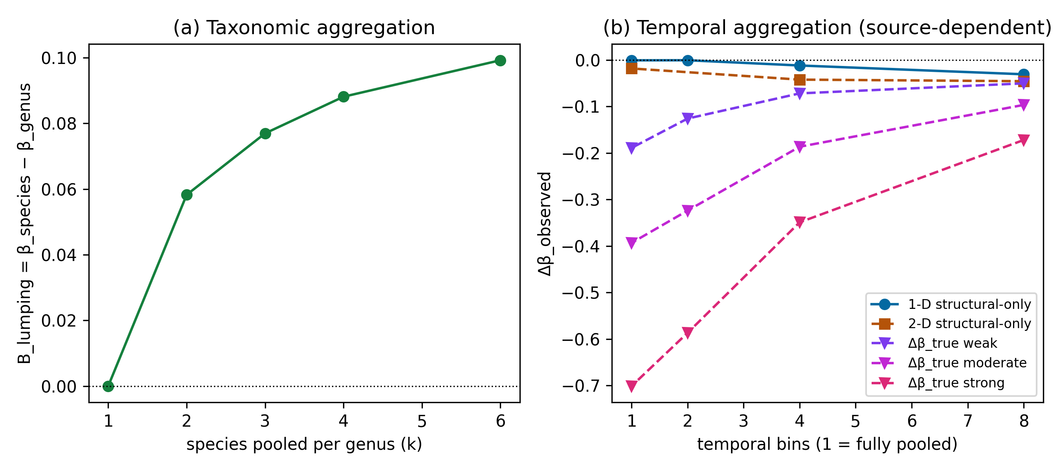
Figure 4. Taxonomic aggregation and temporal aggregation. (a) Pooling k geographically partitioned species into one genus adds
apparent continuity; B_lumping = β_species − β_genus (positive = more
continuity), up to +0.099 at k = 6. (b) Temporal pooling is
source-dependent, not simply attenuating: the pool-driven structural
baseline (−0.031) is erased to −0.001 under full pooling (2-D
confirmatory −0.045 → −0.018), whereas explicit ecological contrasts
generated by range breadths are amplified (Δβ_true ≈ −0.05, −0.10,
−0.17 → −0.19, −0.39, −0.70 at full pooling).
**Sampling asymmetry.** An 8-fold predator-sampling asymmetry between environmental blocks produced comparatively small bias under the parameter range examined (Δβ_obs between −0.024 and −0.023; Supporting Information, Table S3; Figure S1); we do not claim sampling bias is unimportant in general.

Results 3 — Factorial simulation: false-difference and extreme-bias regions
The five structural terms are not independent. In the factorial grid (n_pred_taxa × p_dominant × n_lumped), biases compound non-additively: the most extreme cell reached Bias = −0.91 and the false-difference rate (|Δβ_obs| > 0.1 under Δβ_true = 0) reached 100% in the low-gamma, high-dominance, high-lumping region (Fig. 5). Because interactions dominate the corner cases, no single-bias correction is sufficient.
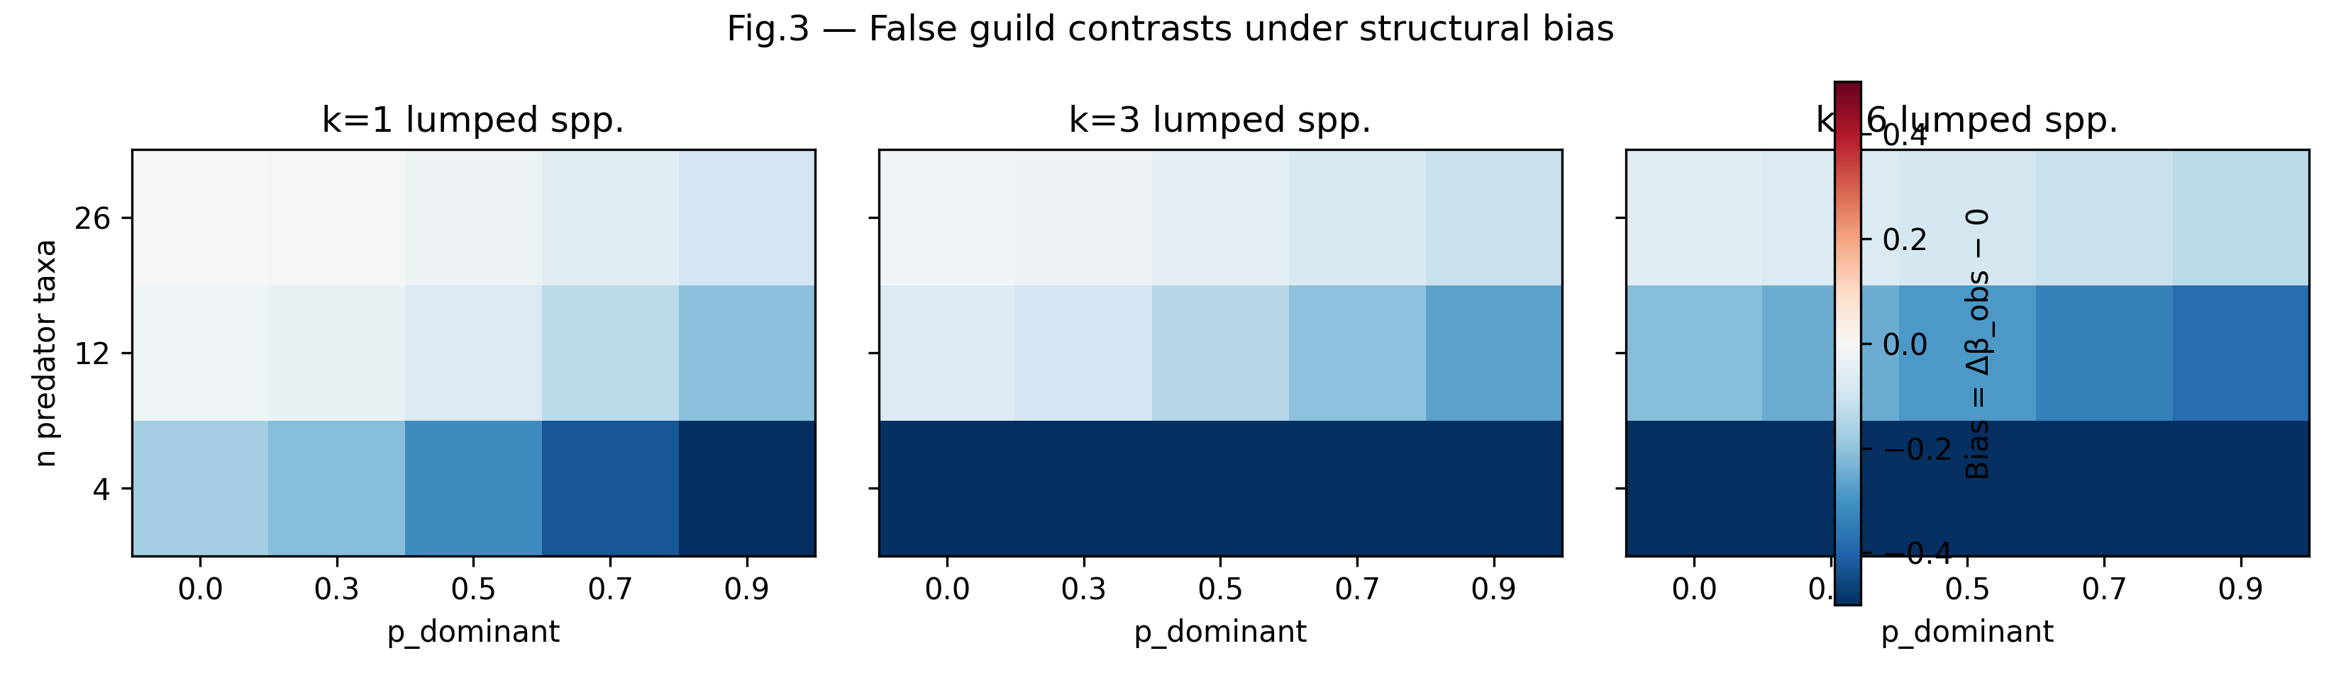
Figure 5. Factorial bias map. Bias = Δβ_obs − Δβ_true across
pool size × dominance, one panel per lumping level; false-difference and
extreme-bias regions occupy the low-gamma/high-dominance corner
(max |Bias| −0.91, 100% false-difference rate). The additive
decomposition is conceptual only; this map is the estimable summary.

Results 4 — Morrison worked example: the naive guild contrast
On the primary specification (collection assemblages, genus level, Jaccard), Morrison predators were much more spatially homogeneous than herbivores: Δβ = −0.550 (bootstrap 95% CI −0.630, −0.457). Read naively this would imply exceptional predator spatial continuity — exactly the class of signal Simulations 1–3 show can arise structurally.

Results 5 — Sequential empirical decomposition
Applying the diagnostic cascade (Fig. 6):
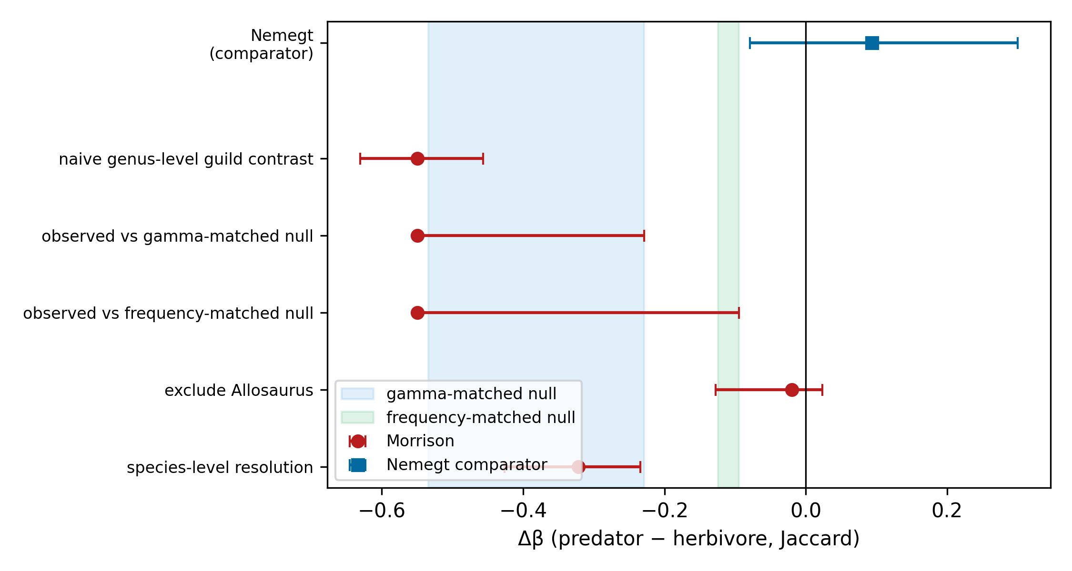
Figure 6. Empirical stress test (Morrison Formation). Sequential
attenuation: naive Δβ = −0.550 (−0.630, −0.457); gamma- and
frequency-matched null intervals shown shaded (distinct from
bootstrap CIs); dominant-taxon exclusion Δβ = −0.020; species
resolution Δβ = −0.322; dominant-taxon extent residual −36.6 km
(z = −0.16). Inset: Nemegt comparator Δβ = +0.094 (−0.079, +0.300).
If space is constrained, the Nemegt inset moves to Supporting
Information.
1. **Gamma-matched null.** Δβ = −0.550 was close to, but marginally more negative than, the lower bound of the pool-matched null interval (−0.534 to −0.229): unequal taxon pools account for much of the magnitude but do not by themselves generate a contrast as extreme as the observed one. 2. **Frequency-matched null.** The observed value is more negative than the frequency-matched null interval (−0.124 to −0.095): occupancy-frequency structure alone does not produce the signal. 3. **Dominant-taxon exclusion.** Removing Allosaurus collapses Δβ to −0.020 (−0.128, +0.024). 4. **Taxonomic resolution.** At species level Δβ attenuates to −0.322 (−0.426, −0.234), direction consistent with Simulation 3. 5. **Duration + sampling adjustment.** After regressing geographic extent on stratigraphic duration and occurrence count, Allosaurus's extent residual is −36.6 km (z = −0.16): not geographically exceptional for its sampling footprint. 6. **Preservation/collection model (exploratory).** The unpenalized model reached pseudo-R² = 0.46 but did not fully converge (quasi-separation; state coefficients ≈ 17). An L2-penalized logistic refit converged and yielded pseudo-R² = 0.34 — the same qualitative conclusion that collection covariates carry substantial presence structure. Both are retained as exploratory diagnostics only.

Results 6 — Nemegt comparator
Under the identical locked pipeline, Nemegt (herbivore gamma 8 < predator gamma 26 — the reverse asymmetry) yields Δβ = +0.094 (95% CI −0.079, +0.300): the Morrison direction is not reproduced. Nemegt functions here as a structural comparator showing the pattern is not a universal predator-guild phenomenon; extended Tarbosaurus diagnostics appear in the Supplementary Material.

Results 7 — Independent evidence audit
A bounded review of isotopic, ichnological and feeding-trace evidence identified nothing contradicting the methodological interpretation; the strongest independent evidence supports dietary generalism rather than exceptional mobility (Foster, 2015; Drumheller et al., 2020), and no direct test of Allosaurus movement was identified (Supplementary Material).

Discussion

Main conceptual result
Our simulations demonstrate that guild-level turnover contrasts are vulnerable in both directions, though not symmetrically. Under an imposed guild contrast of zero (Δβ_true = 0), structural asymmetry alone — unequal regional pools, dominance, taxonomic lumping — generated observed contrasts as large as |Δβ_obs| ≈ 0.17 for a realistic four-taxon pool and ≈ 0.41 under the most extreme two-taxon pool: a false-positive mechanism. Temporal aggregation acted differently. It erased the *structurally generated* component of a contrast (the pool-driven baseline decayed −0.031 → −0.001 under full pooling; 2-D: −0.045 → −0.018), yet *amplified* explicitly nonzero ecological contrasts generated by range breadths (thin-slice Δβ_true ≈ −0.05, −0.10 and −0.17 became −0.19, −0.39 and −0.70 after full pooling). Assemblage construction can thus create, erase or exaggerate apparent spatial structure, and the sign of the distortion depends on the source of the contrast rather than on the aggregation operation alone. These magnitudes are scenario-specific demonstrations of sufficiency, not universal constants, but the failure directions are qualitative properties of guild-level comparisons rather than artifacts of any single parameterization. They also differ in where they hide: false differentiation is invisible to naive replication — repeating the same contrast on structurally similar data reproduces the same bias — whereas a contrast inflated or erased by time averaging is invisible precisely because the pre-aggregation state is unobservable. A diagnostic workflow must therefore probe the contrast's provenance rather than searching only for spurious signal.

Gamma diversity
The largest single bias source was gamma-diversity imbalance. Richness effects on dissimilarity metrics are recognized (Kraft et al., 2011; Chase et al., 2011), but the magnitudes observed here — a four-taxon pool yielding a fully reproducible apparent contrast of −0.17 against a 26-taxon pool under Δβ_true = 0 — show that pool-size-matched nulls are not optional refinements but a minimal requirement. The qualitative result replicated across spatial geometries: on a 2-D lattice the same conditions produced −0.21 (pool 4) and −0.47 (pool 2), indicating the phenomenon is not an artifact of one-dimensional range geometry. Comparisons among guilds or regions with different pool structures remain vulnerable even after standard diversity partitioning (Chase et al., 2018).

Distance-decay distortion
A result of particular relevance to biogeographic inference is that structural asymmetry distorts the *shape* of turnover, not only its mean. In the 2-D simulations, the small-pool guild showed an inflated apparent distance-decay slope (≈0.028) relative to the comparison guild (≈0.006) under identical generative spatial processes. Distance decay is a core tool for diagnosing dispersal limitation and environmental filtering (Nekola & White, 1999; Soininen et al., 2007; Morlon et al., 2008); our result implies that guild or regional differences in pool size alone can mimic steeper turnover gradients, so decay comparisons require the same structural controls as mean dissimilarity. Practically, a reported difference in distance-decay slopes between groups may reflect differential sensitivity to pool size rather than differential dispersal; pool-matched or richness-standardized decay curves are the analogue of the matched-null requirement for mean Δβ.

Dominance and taxonomic aggregation
A single dominant taxon shifted Δβ by ≈−0.07 at realistic prevalence and ≈−0.21 at extreme dominance — consistent with the known sensitivity of assemblage dissimilarity to common species (Lennon et al., 2004; Hillebrand et al., 2008; McGeoch & Gaston, 2002; Avolio et al., 2019). Genus-level pooling of geographically differentiated species produced an apparent continuity shift of +0.099 (B_lumping = β_species − β_genus; positive = more apparent continuity), mirroring taxonomic-sufficiency effects documented for assemblage analyses (Bertrand et al., 2006; Bevilacqua et al., 2009; Lane et al., 2003). In the Morrison case, dominant-taxon exclusion and species-level resolution each collapsed or attenuated the naive contrast — an empirical illustration, not a general estimate. The two mechanisms are usefully distinguished: dominance changes which *sites* are occupied (fewer occupied sites than the pool implies, biasing β downward in the dominant guild), whereas lumping changes which *entities* are counted (multiple spatially segregated species fused into one widespread genus, erasing turnover at the finer taxonomic grain). Both inflate apparent spatial continuity but through different data construction paths, so the diagnostics differ: occupancy-frequency inspection for the former, resolution sensitivity for the latter.

Temporal aggregation
Time averaging is expected to homogenize assemblages (Kidwell & Behrensmeyer, 1991; Olszewski, 1999; Kowalewski, 1999; Tomašových & Kidwell, 2010). Our simulations qualify that expectation in an important way: the effect of temporal pooling depends on what generated the contrast. Where the pre-aggregation contrast was structural — the pool-asymmetry baseline of the Δβ_true = 0 arm — pooling erased it (−0.031 → −0.001). Where the contrast was ecological, generated by differing range breadths, pooling amplified it approximately four-fold (Δβ_true ≈ −0.05 → −0.19; ≈ −0.10 → −0.39; ≈ −0.17 → −0.70 under full pooling). Union pooling mechanically saturates the occupancy of already-widespread taxa, so the already-homogeneous guild is disproportionately flattened (mechanism in Text S3). Temporal aggregation is therefore neither a simple false-negative nor a false-positive mechanism: it is a bidirectional distortion whose direction is determined by the source of the underlying contrast. For empirical work the implication is conservative in the opposite direction from the usual assumption — a strong contrast surviving aggregation is not evidence of robustness, because aggregation can inflate as well as erase.

Sampling
An eight-fold sampling asymmetry produced comparatively small bias (≈−0.024) within the tested parameter range. We do not infer that sampling is unimportant — fossil databases are demonstrably sampling-structured (Smith & McGowan, 2007; Vilhena & Smith, 2013; Alroy, 2008) — only that under our parameterization its isolated effect was smaller than pool-size, dominance and lumping effects.

Empirical stress test
In the Morrison Formation, a naive predator–herbivore Δβ of −0.550 lay just beyond the lower bound of the gamma-matched null interval (−0.534), exceeded the frequency-matched null, and collapsed to −0.020 after exclusion of the single dominant taxon; species-level resolution gave −0.322, and the dominant taxon was not geographically exceptional after duration and occurrence adjustment (extent residual −36.6 km, z = −0.16). Collection covariates explained substantial presence structure (pseudo-R² 0.46 unpenalized, 0.34 under L2 penalization — exploratory, with an MLE convergence warning; the penalized fit reaches the same qualitative conclusion). The correct interpretation is not that the ecological account was disproven, but that structural explanations became sufficient — a biologically compelling narrative was no longer required. Nemegt, run through the identical locked pipeline, showed Δβ = +0.094 (−0.079, +0.300): the Morrison direction is not a universal predator-guild property.

Factorial interaction
Because gamma diversity, dominance, taxonomic resolution and sampling co-vary in real assemblages, the bias terms cannot be treated as independent additive corrections. The factorial simulation — the appropriate summary for applied inference — shows interactions large enough to generate extreme apparent contrasts (the extreme corner reached −0.91). This is why single-mechanism corrections under-protect: fixing only pool size leaves dominance and lumping free to generate a contrast; the diagnostic workflow must therefore be sequential and cross-checked rather than a single covariate adjustment.

General applicability
The mechanisms quantified here apply wherever comparisons are made between assemblages differing in pool size, dominance, taxonomic grain, temporal span or sampling structure — museum and herbarium records, multi-year monitoring compilations, archaeological faunas, and sedimentary records (Shaffer et al., 1998; Pyke & Ehrlich, 2010; Lavoie, 2013; Graham et al., 2004). These are conceptual analogues; direct tests in each domain are needed, and our magnitudes should not be transported quantitatively. The growing reliance on aggregated occurrence datasets for biodiversity-change inference (Blowes et al., 2019) makes this direction-dependence especially consequential: structurally generated contrasts are likely to be interpreted as ecological signal, and contrasts distorted by time averaging are untestable by construction — the pre-aggregation state is not observable. Among the candidate biases we isolated, the pool-size mechanism has the clearest parallel outside palaeontology — cross-guild and cross-region richness asymmetries are ubiquitous in modern occurrence data — whereas temporal averaging is most acute in archives that integrate time, and taxonomic lumping sits between the two wherever identification effort varies across groups.

Practical workflow
Before interpreting guild-level beta-diversity contrasts: (1) compare guild gamma diversity; (2) run pool-size-matched nulls; (3) inspect dominance and run leave-one-dominant-taxon analyses; (4) harmonize taxonomic resolution and test sensitivity across levels; (5) test temporal aggregation; (6) inspect sampling asymmetry and detection structure; (7) examine distance-decay slopes, not only mean dissimilarity; (8) map interactions across these factors; (9) only then infer ecological connectivity, mobility or filtering. The same discipline applies to non-fossil assemblage comparisons (Socolar et al., 2016). This sequence is summarised in Table 1.
**Table 1.** Diagnostic workflow for guild-level beta-diversity contrasts. Each row pairs a structural mechanism demonstrated in this study with the minimal diagnostic required before the observed contrast is interpreted ecologically.
Structural mechanism | Failure mode | Required diagnostic | Reference result
Unequal regional pool (gamma imbalance) | False differentiation | Pool-size-matched null | Simulation 1; Fig. 2a
Dominant taxon | False differentiation | Leave-one-dominant-taxon analysis | Simulation 2; Fig. 2b
Taxonomic lumping | False differentiation (apparent continuity) | Cross-resolution sensitivity test | Simulation 3; Fig. 4a
Temporal aggregation | Erasure of structural contrast; amplification of ecological contrast (source-dependent) | Re-analysis at the finest available temporal bins; do not treat aggregation survival as robustness | Simulation 4/4b; Fig. 4b
Asymmetric sampling | Attenuation or inflation (parameter-dependent) | Inspection of collection-effort structure | Simulation 5; Table S3
Distance-decay geometry | Distorted turnover shape | Decay-slope comparison under structural controls | Simulation 1 (2-D); Fig. 3b
Joint interactions | Extreme false differences, interaction regions | Factorial robustness map | Simulation 6; Fig. 5

Limitations
Our simulators use simplified ecology and synthetic guild construction; parameter ranges were chosen to bracket plausible assemblage structures but the reported magnitudes are not calibrated estimates for real landscapes. The bias mechanisms are non-independent — the factorial map, not the additive decomposition, is the appropriate summary. The 2-D replication improves but does not reproduce real landscape complexity. Morrison is one worked example and species-resolution analyses depend on identification completeness. Structural sufficiency is not causal attribution: demonstrating that a contrast *can* be generated structurally does not prove it *was*.

References
See bibliography.md (52 DOI-verified entries; reference_audit.csv).

References
Whittaker, R. H. (1960). Vegetation of the Siskiyou Mountains, Oregon and California *Ecological Monographs*. https://doi.org/10.2307/1948435
Tuomisto, Hanna (2010). A diversity of beta diversities: straightening up a concept gone awry. Part 2. Quantifying beta diversity and related phenomena *Ecography*. https://doi.org/10.1111/j.1600-0587.2009.06148.x
Moreno, Claudia E.; Rodríguez, Pilar (2010). A consistent terminology for quantifying species diversity? *Oecologia*. https://doi.org/10.1007/s00442-010-1591-7
Baselga, Andrés (2010). Partitioning the turnover and nestedness components of beta diversity *Global Ecology and Biogeography*. https://doi.org/10.1111/j.1466-8238.2009.00490.x
Baselga, Andrés (2012). The relationship between species replacement, dissimilarity derived from nestedness, and nestedness *Global Ecology and Biogeography*. https://doi.org/10.1111/j.1466-8238.2011.00756.x
Anderson, Marti J.; Crist, Thomas O.; Chase, Jonathan M.; Vellend, Mark; Inouye, Brian D.; Freestone, Amy L. (2011). Navigating the multiple meanings of β diversity: a roadmap for the practicing ecologist *Ecology Letters*. https://doi.org/10.1111/j.1461-0248.2010.01552.x
Legendre, Pierre (2014). Interpreting the replacement and richness difference components of beta diversity *Global Ecology and Biogeography*. https://doi.org/10.1111/geb.12207
Kraft, Nathan J. B.; Comita, Liza S.; Chase, Jonathan M.; Sanders, Nathan J.; Swenson, Nathan G.; Crist, Thomas O. (2011). Disentangling the Drivers of β Diversity Along Latitudinal and Elevational Gradients *Science*. https://doi.org/10.1126/science.1208584
Chase, Jonathan M.; Kraft, Nathan J. B.; Smith, Kevin G.; Vellend, Mark; Inouye, Brian D (2011). Using null models to disentangle variation in community dissimilarity from variation in α-diversity *Ecosphere*. https://doi.org/10.1890/es10-00117.1
Chase, Jonathan M.; McGill, Brian J.; McGlinn, Daniel J.; May, Felix; Blowes, Shane A.; Xiao, Xiao (2018). Embracing scale‐dependence to achieve a deeper understanding of biodiversity and its change across communities *Ecology Letters*. https://doi.org/10.1111/ele.13151
Nekola, Jeffrey C.; White, Peter S. (1999). The distance decay of similarity in biogeography and ecology *Journal of Biogeography*. https://doi.org/10.1046/j.1365-2699.1999.00305.x
Soininen, Janne; McDonald, Robert; Hillebrand, Helmut (2007). The distance decay of similarity in ecological communities *Ecography*. https://doi.org/10.1111/j.0906-7590.2007.04817.x
Morlon, Hélène; Chuyong, George; Condit, Richard; Hubbell, Stephen; Kenfack, David; Thomas, Duncan (2008). A general framework for the distance–decay of similarity in ecological communities *Ecology Letters*. https://doi.org/10.1111/j.1461-0248.2008.01202.x
Barton, Philip S.; Cunningham, Saul A.; Manning, Adrian D.; Gibb, Heloise; Lindenmayer, David B.; Didham, Raphael K. (2013). The spatial scaling of beta diversity *Global Ecology and Biogeography*. https://doi.org/10.1111/geb.12031
Wiens, J. A. (1989). Spatial Scaling in Ecology *Functional Ecology*. https://doi.org/10.2307/2389612
Avolio, Meghan L.; Carroll, Ian T.; Collins, Scott L.; Houseman, Gregory R.; Hallett, Lauren M.; Isbell, Forest (2019). A comprehensive approach to analyzing community dynamics using rank abundance curves *Ecosphere*. https://doi.org/10.1002/ecs2.2881
Lennon, Jack J.; Koleff, Patricia; Greenwood, Jeremy J. D.; Gaston, Kevin J. (2004). Contribution of rarity and commonness to patterns of species richness *Ecology Letters*. https://doi.org/10.1046/j.1461-0248.2004.00548.x
McGEOCH, MELODIE A.; GASTON, KEVIN J. (2002). Occupancy frequency distributions: patterns, artefacts and mechanisms *Biological Reviews*. https://doi.org/10.1017/s1464793101005887
Bertrand, Y.; Pleijel, F.; Rouse, G.W. (2006). Taxonomic surrogacy in biodiversity assessments, and the meaning of Linnaean ranks *Systematics and Biodiversity*. https://doi.org/10.1017/s1477200005001908
Bevilacqua, Stanislao; Fraschetti, Simonetta; Musco, Luigi; Terlizzi, Antonio (2009). Taxonomic sufficiency in the detection of natural and human-induced changes in marine assemblages: A comparison of habitats and taxonomic groups *Marine Pollution Bulletin*. https://doi.org/10.1016/j.marpolbul.2009.07.018
Olszewski, Thomas (1999). Taking advantage of time-averaging *Paleobiology*. https://doi.org/10.1017/s009483730002652x
Kidwell, Susan M.; Bosence, Daniel W. J. (1991). Taphonomy and Time-Averaging of Marine Shelly Faunas *Topics in Geobiology*. https://doi.org/10.1007/978-1-4899-5034-5_4
Tomašových, Adam; Kidwell, Susan M. (2010). Predicting the effects of increasing temporal scale on species composition, diversity, and rank-abundance distributions *Paleobiology*. https://doi.org/10.1666/08092.1
Blowes, Shane A.; Supp, Sarah R.; Antão, Laura H.; Bates, Amanda; Bruelheide, Helge; Chase, Jonathan M. (2019). The geography of biodiversity change in marine and terrestrial assemblages *Science*. https://doi.org/10.1126/science.aaw1620
Korhonen, Jenni J.; Soininen, Janne; Hillebrand, Helmut (2010). A quantitative analysis of temporal turnover in aquatic species assemblages across ecosystems *Ecology*. https://doi.org/10.1890/09-0392.1
Gotelli, Nicholas J.; Colwell, Robert K. (2001). Quantifying biodiversity: procedures and pitfalls in the measurement and comparison of species richness *Ecology Letters*. https://doi.org/10.1046/j.1461-0248.2001.00230.x
Chao, Anne; Gotelli, Nicholas J.; Hsieh, T. C.; Sander, Elizabeth L.; Ma, K. H.; Colwell, Robert K. (2014). Rarefaction and extrapolation with Hill numbers: a framework for sampling and estimation in species diversity studies *Ecological Monographs*. https://doi.org/10.1890/13-0133.1
MacKenzie, Darryl I.; Nichols, James D.; Lachman, Gideon B.; Droege, Sam; Andrew Royle, J.; Langtimm, Catherine A. (2002). ESTIMATING SITE OCCUPANCY RATES WHEN DETECTION PROBABILITIES ARE LESS THAN ONE *Ecology*. https://doi.org/10.1890/0012-9658(2002)083[2248:esorwd]2.0.co;2
Colwell, R. K.; Chao, A.; Gotelli, N. J.; Lin, S.-Y.; Mao, C. X.; Chazdon, R. L. (2012). Models and estimators linking individual-based and sample-based rarefaction, extrapolation and comparison of assemblages *Journal of Plant Ecology*. https://doi.org/10.1093/jpe/rtr044
Shaffer, H.Bradley; Fisher, Robert N; Davidson, Carlos (1998). The role of natural history collections in documenting species declines *Trends in Ecology &amp; Evolution*. https://doi.org/10.1016/s0169-5347(97)01177-4
Pyke, Graham H.; Ehrlich, Paul R. (2010). Biological collections and ecological/environmental research: a review, some observations and a look to the future *Biological Reviews*. https://doi.org/10.1111/j.1469-185x.2009.00098.x
Lavoie, Claude (2013). Biological collections in an ever changing world: Herbaria as tools for biogeographical and environmental studies *Perspectives in Plant Ecology, Evolution and Systematics*. https://doi.org/10.1016/j.ppees.2012.10.002
GRAHAM, C; FERRIER, S; HUETTMAN, F; MORITZ, C; PETERSON, A (2004). New developments in museum-based informatics and applications in biodiversity analysis *Trends in Ecology &amp; Evolution*. https://doi.org/10.1016/j.tree.2004.07.006
Maidment, Susannah (2024). Data and code for: Diversity through space and time in the Upper Jurassic Morrison Formation, western USA *Dryad (dataset)*. https://doi.org/10.5061/dryad.6m905qg77
Alroy, John (2008). Dynamics of origination and extinction in the marine fossil record *Proceedings of the National Academy of Sciences*. https://doi.org/10.1073/pnas.0802597105
Behrensmeyer, Anna K.; Kidwell, Susan M.; Gastaldo, Robert A. (2000). Taphonomy and paleobiology *Paleobiology*. https://doi.org/10.1666/0094-8373(2000)26[103:tap]2.0.co;2
Vilhena, Daril A.; Smith, Andrew B. (2013). Spatial Bias in the Marine Fossil Record *PLoS ONE*. https://doi.org/10.1371/journal.pone.0074470
Noto, Christopher R.; Grossman, Ari (2010). Broad-Scale Patterns of Late Jurassic Dinosaur Paleoecology *PLoS ONE*. https://doi.org/10.1371/journal.pone.0012553
Foster, John R. (2015). Theropod Dinosaur Ichnogenus<i>Hispanosauropus</i>Identified from the Morrison Formation (Upper Jurassic), Western North America *Ichnos*. https://doi.org/10.1080/10420940.2015.1059335
Drumheller, Stephanie K.; McHugh, Julia B.; Kane, Miriam; Riedel, Anja; D’Amore, Domenic C. (2020). High frequencies of theropod bite marks provide evidence for feeding, scavenging, and possible cannibalism in a stressed Late Jurassic ecosystem *PLOS ONE*. https://doi.org/10.1371/journal.pone.0233115
Kowalewski, Michal (1999). Time-averaging of fossil assemblages: taphonomy and temporal resolution *Taphonomy*. https://doi.org/10.1017/cbo9780511612381.006
Heino, Jani; Soininen, Janne; Alahuhta, Janne; Lappalainen, Jyrki; Virtanen, Risto (2015). A comparative analysis of metacommunity types in the freshwater realm *Ecology and Evolution*. https://doi.org/10.1002/ece3.1460
McGill, Brian J.; Etienne, Rampal S.; Gray, John S.; Alonso, David; Anderson, Marti J.; Benecha, Habtamu Kassa (2007). Species abundance distributions: moving beyond single prediction theories to integration within an ecological framework *Ecology Letters*. https://doi.org/10.1111/j.1461-0248.2007.01094.x
Socolar, Jacob B.; Gilroy, James J.; Kunin, William E.; Edwards, David P. (2016). How Should Beta-Diversity Inform Biodiversity Conservation? *Trends in Ecology &amp; Evolution*. https://doi.org/10.1016/j.tree.2015.11.005
Hillebrand, Helmut; Bennett, Danuta M.; Cadotte, Marc W. (2008). CONSEQUENCES OF DOMINANCE: A REVIEW OF EVENNESS EFFECTS ON LOCAL AND REGIONAL ECOSYSTEM PROCESSES *Ecology*. https://doi.org/10.1890/07-1053.1
Pärtel, Meelis; Szava-Kovats, Robert; Zobel, Martin (2011). Dark diversity: shedding light on absent species *Trends in Ecology &amp; Evolution*. https://doi.org/10.1016/j.tree.2010.12.004
Zobel, Martin (2016). The species pool concept as a framework for studying patterns of plant diversity *Journal of Vegetation Science*. https://doi.org/10.1111/jvs.12333
Uhen, Mark D.; Barnosky, Anthony D.; Bills, Brian; Blois, Jessica; Carrano, Matthew T.; Carrasco, Marc A. (2013). From card catalogs to computers: databases in vertebrate paleontology *Journal of Vertebrate Paleontology*. https://doi.org/10.1080/02724634.2012.716114
Peters, Shanan E.; McClennen, Michael (2015). The Paleobiology Database application programming interface *Paleobiology*. https://doi.org/10.1017/pab.2015.39
Badgley, Catherine (2010). Tectonics, topography, and mammalian diversity *Ecography*. https://doi.org/10.1111/j.1600-0587.2010.06282.x
Lane, Abigail; Benton, Michael J. (2003). Taxonomic Level as a Determinant of the Shape of the Phanerozoic Marine Biodiversity Curve *The American Naturalist*. https://doi.org/10.1086/377188
SMITH, ANDREW B.; McGOWAN, ALISTAIR J. (2007). THE SHAPE OF THE PHANEROZOIC MARINE PALAEODIVERSITY CURVE: HOW MUCH CAN BE PREDICTED FROM THE SEDIMENTARY ROCK RECORD OF WESTERN EUROPE? *Palaeontology*. https://doi.org/10.1111/j.1475-4983.2007.00693.x

