Assemblage structure distorts beta diversity and distance decay
Running title: Bias in spatial turnover inference
Article type: Research Article
Author: Tatsuki Onishi
Affiliation: [affiliation to be entered by the author at submission]
Corresponding author: Tatsuki Onishi, [full postal address, e-mail address and ORCID to be entered by the author at submission]

Abstract
Ecologists routinely compare beta diversity and distance decay among guilds, taxa, habitats or data sources and interpret the differences as evidence of dispersal limitation, connectivity, environmental filtering or habitat breadth. Such comparisons assume that the compared assemblages are structurally comparable, yet they often differ in regional pool size, dominance, taxonomic resolution, temporal aggregation and sampling. Each mechanism is individually known to affect diversity metrics; less is known about how large their separate and joint effects on guild-level contrasts can be. I used controlled one- and two-dimensional simulations with a fixed generative guild contrast to manipulate these properties singly and factorially, quantifying their effects on mean pairwise Jaccard dissimilarity and on distance-decay slopes. I then applied a sequential structural decomposition to a predator–herbivore turnover contrast in Late Jurassic Morrison Formation dinosaur assemblages, with the Nemegt Formation as a structural comparator. With no generative contrast, a four-taxon versus 26-taxon pool produced an apparent contrast of −0.17 (two-taxon pool: −0.41), and pool asymmetry steepened the apparent distance-decay slope (0.028 versus 0.006) under identical spatial processes. Temporal aggregation was source-dependent: full pooling erased a structural contrast (−0.031 to −0.001) but amplified imposed ecological contrasts 3.8- to 4.1-fold. Structural factors combined non-additively (combined bias −0.76 versus −0.28 expected from summed single-factor effects). In the Morrison Formation, a naive contrast of −0.550 (95% CI −0.630 to −0.457) attenuated to −0.020 after exclusion of the dominant predator; Nemegt showed no comparable contrast (+0.094; −0.079 to +0.300). These magnitudes are scenario-specific demonstrations of sufficiency, not universal constants. Structural comparability should be diagnosed, using pool-matched nulls and dominance, resolution and aggregation checks, before ecological meaning is assigned to beta-diversity or distance-decay contrasts.
Keywords: assemblage structure; beta diversity; community ecology; distance decay; spatial turnover; temporal aggregation

Introduction
Beta diversity, the variation in species composition among sites, and the distance decay of compositional similarity are among the most widely used descriptors of spatial ecological structure (Whittaker, 1960; Nekola & White, 1999; Soininen et al., 2007; Tuomisto, 2010; Anderson et al., 2011; Moreno & Rodríguez, 2010). Pairwise dissimilarities, multiple-site indices and decay slopes are routinely read as evidence of dispersal limitation, environmental filtering, connectivity or habitat breadth (Morlon et al., 2008; Baselga, 2010). Ecologists increasingly compare these quantities among guilds, taxonomic groups, habitats, regions or data sources, asking for example whether one guild is more spatially homogeneous than another, because such contrasts promise inference about group-specific spatial processes (Heino et al., 2015; Socolar et al., 2016). All of these applications are scale-dependent: turnover varies with the grain and extent of the data (Wiens, 1989; Sfenthourakis & Panitsa, 2012; Keil et al., 2012; Barton et al., 2013). Comparisons among groups carry a further, usually implicit, assumption: that the compared assemblages are structurally comparable, so that differences in regional pool size, dominance structure, taxonomic resolution, temporal span and sampling intensity do not themselves alter measured turnover.
In practice, compared assemblages differ in exactly these properties, often several at once. A predator guild and its prey guild typically differ in pool size; a dominant species can occupy most sampled sites in one guild while the comparison guild has no such taxon; one group may be identifiable to species while another is resolvable only to genus; one dataset may integrate a decade of sampling while another pools centuries; and the two sides may have been collected under different effort regimes. Each of these structural properties is individually known to affect diversity metrics. Measured beta diversity depends on the size and composition of the regional species pool (Kraft et al., 2011; Chase et al., 2011; Pärtel et al., 2011; Zobel, 2016), and comparisons across assemblages of unequal richness are a recognised source of scale-dependent distortion (Chase et al., 2018). Dominant species and the shape of the occupancy–frequency distribution can drive dissimilarity values regardless of the underlying spatial process (McGeoch & Gaston, 2002; Lennon et al., 2004; McGill et al., 2007; Hillebrand et al., 2008). The taxonomic grain at which data are recorded alters diversity patterns (Bertrand et al., 2006; Bevilacqua et al., 2009), temporal aggregation reshapes apparent community change (Olszewski, 1999; Korhonen et al., 2010; Blowes et al., 2019), and unequal sampling effort and incomplete detection bias comparisons that are not standardised (Gotelli & Colwell, 2001; MacKenzie et al., 2002; Colwell et al., 2012; Chao et al., 2014).
What is missing from the literature is not awareness that these biases exist but their magnitudes under controlled conditions. Several questions remain largely unquantified. How large an apparent guild-level contrast can structural asymmetry alone generate when no generative contrast exists? Does structural asymmetry alter the shape of distance decay as well as mean dissimilarity? How do the mechanisms behave when they co-occur, given that treating them as independent, additive corrections is itself an untested assumption? Can temporal aggregation move a measured contrast in different directions depending on what generated it? And, practically, what sequence of diagnostics should precede the ecological interpretation of a beta-diversity contrast? Answering these questions requires a known generative baseline, which empirical assemblages cannot provide; it requires simulation.
The problem is general. Much of the biodiversity evidence now used to infer spatial structure is historically aggregated: museum and herbarium collections, long-term monitoring compilations, multi-source databases, archaeological faunas and sedimentary records are all assembled over uneven taxonomic, temporal and sampling structure (Shaffer et al., 1998; Graham et al., 2004; Pyke & Ehrlich, 2010; Lavoie, 2013). Palaeoecological assemblages lie at the extreme end of this spectrum, with small and uneven taxon pools, strong dominance, coarse taxonomic resolution and temporal averaging over long intervals (Kidwell & Bosence, 1991; Olszewski, 1999; Behrensmeyer et al., 2000; Smith & McGowan, 2007; Badgley, 2010; Vilhena & Smith, 2013). If structural bias in guild-level comparisons is consequential anywhere, it should be consequential there, which makes fossil assemblages useful empirical stress tests for a general problem of ecological inference rather than a special case with its own rules (Stigall & Lieberman, 2006; Uhen et al., 2013; Peters & McClennen, 2016).
Here I combine (i) controlled simulations in which the generative guild contrast is fixed, on a one-dimensional spatial axis and, as a robustness check, a two-dimensional lattice; (ii) an analysis of how structural asymmetry alters distance-decay slopes as well as mean dissimilarity; (iii) a factorial design that maps how structural factors interact; and (iv) an empirical worked example in which an initially strong predator–herbivore turnover contrast in dinosaur assemblages of the Late Jurassic Morrison Formation (Maidment, 2024) is decomposed stepwise under structural diagnostics, with the Late Cretaceous Nemegt Formation as a structural comparator. The guiding relation is that the observed contrast need not equal the ecological contrast whenever the compared assemblages differ in structure (Fig. 1). The contribution is quantitative and integrative rather than the discovery of new bias mechanisms. My objectives were to quantify the magnitude of structural distortion under controlled conditions, to identify conditions that create, erase or exaggerate apparent differentiation, to decompose the Morrison contrast empirically, and to derive a practical diagnostic workflow for interpreting beta-diversity contrasts in structurally heterogeneous assemblage data.
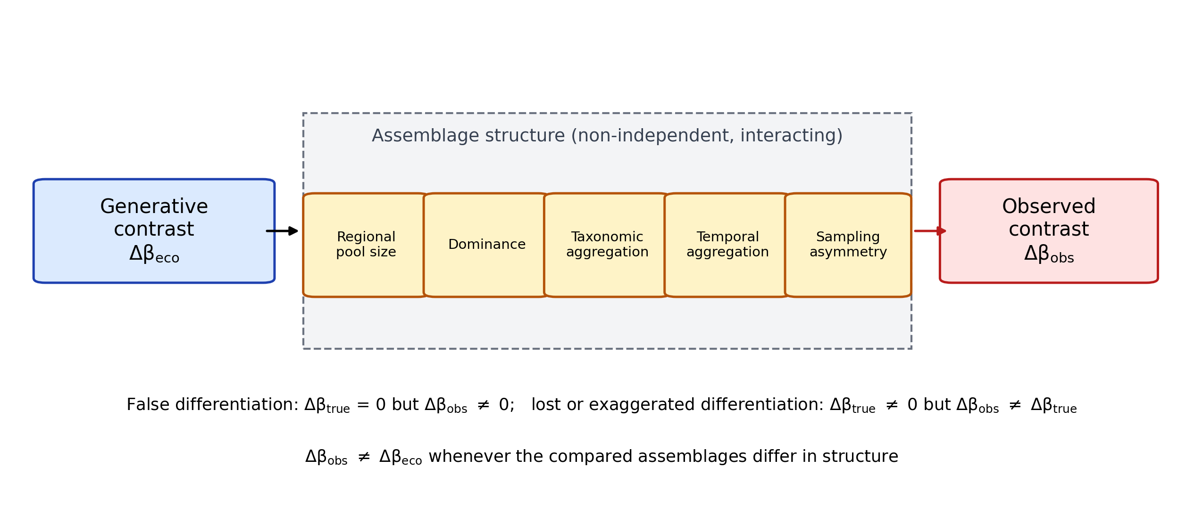
Figure 1. Conceptual framework. A generative (ecological) guild contrast, Δβ_{eco}, is filtered through assemblage structure (regional pool size, dominance, taxonomic aggregation, temporal aggregation and sampling asymmetry, which are non-independent and can interact) before the observed contrast, Δβ_{obs}, is measured. Structural differences can create a contrast where none exists (false differentiation) or alter the size of an existing contrast, so the observed contrast need not equal the ecological contrast when the compared assemblages differ in structure.

Materials and Methods

Overview
The study combines controlled simulations of guild assemblages, in which the generative turnover contrast is known, with a sequential empirical decomposition of a real guild-level contrast in the Morrison Formation and a structural comparator from the Nemegt Formation. All estimators, null models and random seeds are fixed in the analysis code; every number reported in this article is traced to its generating script and output file in a value-level registry (see Data Accessibility Statement).

Generative process, observed estimand and structural manipulation
Three elements are kept distinct throughout. The generative process is the simulation rule that places taxa in space; in the simulations both guilds are generated by the same per-taxon process unless a scenario explicitly imposes an ecological difference. The observed estimand is the guild contrast in mean pairwise dissimilarity computed from the resulting incidence matrices. A structural manipulation changes how the assemblage data are constructed (pool size, dominance, taxonomic resolution, temporal pooling or sampling) without changing the generative process. Beta diversity was measured as the mean pairwise Jaccard dissimilarity among sampling units, computed on incidence matrices (Legendre, 2014). The focal contrast is
$$Δβ = β_{P} − β_{H}$$
where β_{P} and β_{H} are the mean pairwise Jaccard dissimilarities of the predator and herbivore guilds. The same estimand is used for point estimates and bootstrap distributions. In each simulated scenario, the simulation-defined (generative) contrast Δβ_{true} is the contrast expected under the generative process alone; it equals zero by construction in every scenario except the imposed-contrast arm of the temporal-aggregation simulation. Bias is defined as
$$Bias = {Δβ}_{obs} − {Δβ}_{true}$$
Negative Δβ indicates that predators are more spatially homogeneous than herbivores. For taxonomic lumping, the effect on the manipulated guild is reported as
$$B_{lumping} = β_{species} − β_{genus}$$
so that positive values mean that genus pooling makes the guild appear more spatially continuous; its effect on Δβ is reported separately with explicit sign. The conceptual decomposition
$${Δβ}_{obs} = {Δβ}_{eco} + B_{γ} + B_{D} + B_{T} + B_{L} + B_{S} + ε$$
is used only as a scaffold for naming the structural terms (pool size, dominance, temporal aggregation, lumping and sampling), not as a fitted causal partition; because the terms can interact, interaction was examined with a factorial design (Simulation 6).

Simulation design
Assemblages were generated on a one-dimensional axis of 200 localities (analysis/sim_core.py). Each taxon occupies a contiguous range whose width is a fixed fraction of the axis (default 0.45), centred at a uniform random location, and is recorded with probability 0.35 at each locality within its range. Herbivore (26 taxa by default) and predator (12 taxa by default) incidence matrices are built independently from identical per-taxon parameters, so the two guilds share the same spatial process and differ only in the manipulated structural property. The simulator is deliberately simple: its outputs are demonstrations of sufficiency under specified conditions, not calibrated estimates for real landscapes. Each parameter cell was replicated 100–200 times with fixed seeds (seed set 20260922 for Simulations 1–5 and 20260923 for Simulation 6); the complete parameter and seed list is provided in the repository.
Simulation 1 (pool size) held herbivore richness at 26 taxa and varied predator richness from 2 to 26 (200 replicates per cell); Δβ_{true} = 0. Outputs were the mean Δβ_{obs}, its 95% replicate interval, the proportion of replicates with negative Δβ_{obs}, and the proportion exceeding an operational false-contrast threshold of 0.1 in absolute value. Sensitivity of the false-contrast rate to thresholds of 0.05, 0.10 and 0.20 was evaluated at pools of 2, 4, 12 and 26 taxa (200 replicates per cell). Simulation 2 (dominance) elevated one predator taxon to occur in a proportion p_{D} of all localities, independently of its range, with p_{D} varied from 0 to 0.9. Simulation 3 (taxonomic lumping) collapsed k geographically partitioned species (disjoint sub-ranges) into a single genus column, with k from 1 to 6. Simulation 4 (temporal aggregation, structural arm) redrew each taxon's occurrences independently in eight time slices and pooled locality rows into 8, 4, 2 or 1 temporal bins, with pooled presence defined as presence in any pooled slice (union pooling); because the guilds share per-taxon parameters, the only nonzero contrast at the finest resolution is the structural pool-size term. Simulation 5 (sampling asymmetry) divided the axis into alternating blocks of 20 localities and retained predator occurrences in one block type with a sampling multiplier of 1–8 relative to the other. Simulation 6 (factorial) crossed predator pool size (4, 12 or 26 taxa), dominant-taxon prevalence (p_{D} = 0, 0.3, 0.5, 0.7 or 0.9) and lumping (k = 1, 3 or 6 species pooled into one column), with 100 replicates per cell. When k equals or exceeds the pool size, the entire small guild is collapsed into a single column; such cells were retained but are identified as degenerate when reported.

Temporal aggregation under imposed ecological contrasts
To test how temporal aggregation acts on an explicitly ecological contrast, Simulation 4b gave the two guilds different mean range breadths, a difference in spatial ecology rather than in data construction (narrower ranges yield higher within-guild turnover). Three prospectively specified scenarios were run with herbivore and predator breadths of 0.30 and 0.45 (weak), 0.30 and 0.70 (moderate), and 0.15 and 0.90 (strong). Pool sizes followed the structural arm (26 and 12 taxa) and aggregation used the same union-pooling rule (150 replicates; seed 20260925; analysis/21_temporal_false_negative.py). Because the pool asymmetry is retained, each finest-resolution contrast combines the imposed ecological difference with the structural component quantified in Simulation 4. The change under pooling was summarised as the attenuation fraction
$$A = 1 − \frac{\left|{Δβ}_{pooled}\right|}{\left|{Δβ}_{thin}\right|}$$
computed on replicate means, where negative values indicate amplification rather than attenuation.

Two-dimensional replication and distance decay
A confirmatory simulator generated assemblages on a 40 × 40 lattice; each taxon occupied a disc of radius 0.225 times the lattice width centred at a uniform random location and was recorded with probability 0.35 per occupied cell (analysis/13_2d_robustness.py; 100 replicates; seed 20260924). In addition to mean pairwise dissimilarity, I computed distance-decay slopes as the ordinary least-squares slope of pairwise Jaccard dissimilarity on pairwise Euclidean distance (lattice units) for each replicate and guild, so that the apparent decay of a small-pool guild could be compared with that of the comparison guild under identical generative spatial processes. The same lattice was used for a structural-only temporal-aggregation check (8, 4 and 1 bins).

Empirical worked example: Morrison Formation
Occurrence data were taken from the Morrison Formation dataset of Maidment (2024), archived in Dryad under a CC0 waiver; Morrison dinosaur assemblages have a long history of palaeoecological interpretation (Noto & Grossman, 2010). The cleaned dinosaur subset comprises 651 occurrences in 239 collections and 38 resolved genera (26 herbivore and 12 predator genera). Guilds follow the published taxonomy: predators are theropods; herbivores are ornithischians and sauropodomorphs. Analyses used the collection as the sampling unit, genus resolution, the Jaccard metric and a 999-replicate collection bootstrap (analysis/07_morrison_empirical_decomposition.py; seed 20260924). The sequential decomposition applied, in fixed order: (1) the naive genus-level Δβ; (2) a gamma-matched null (10,000 replicates drawing herbivore genera to match the predator pool size); (3) a frequency-matched null (10,000 replicates matching the occupancy frequencies of predator genera); (4) exclusion of the dominant predator, Allosaurus; (5) species-level resolution, with Allosaurus split into its named species; (6) a regression of geographic extent on stratigraphic duration and occurrence count across genera, reporting the Allosaurus residual and z-score; and (7) an exploratory logistic model of Allosaurus presence on collection covariates (environment, lithology, member, state, systems tract and dinosaur richness), reported only as a pseudo-R². The unpenalised fit showed quasi-separation and did not fully converge, so an L2-penalised refit (regularisation strengths C = 0.1, 1 and 10) is reported alongside it; both are exploratory and carry no inferential weight.

Structural comparator: Nemegt Formation
Nemegt Formation dinosaur occurrences (Maastrichtian, Mongolia) were downloaded from the Paleobiology Database through its public API (Peters & McClennen, 2016), with download parameters and SHA-256 checksums recorded: 319 dinosaur occurrences in 124 collections. The body-fossil, genus-resolved subset used for analysis contained 89 collections, with 116 predator occurrences of 26 genera and 34 herbivore occurrences of 8 genera. The same locked specification (Jaccard, collection level, genus resolution, 999-replicate bootstrap; seed 20260920; analysis/11_nemegt_validation.py) yielded the comparator Δβ. Because the Nemegt herbivore pool is smaller than the predator pool, the gamma-matched null is undefined there, and Nemegt is used strictly as a comparator of reversed structure, not as a biological replication.

Independent evidence audit
A bounded literature audit classified independent evidence relevant to predator mobility in the Morrison Formation (isotopes, trackways, feeding traces, ontogenetic structure and palaeobiogeography) on a five-level scale from support for exceptional mobility to contradiction. The full classification is provided in the repository.

Statistical summaries and reproducibility
Simulation intervals are 2.5% and 97.5% quantiles across replicates; empirical intervals are bootstrap percentile intervals; null intervals are 2.5% and 97.5% quantiles of the null distributions and are reported separately from bootstrap intervals. No significance tests are used to make claims about the simulations, whose purpose is to quantify magnitudes. All analyses were run in Python (NumPy, pandas, SciPy, statsmodels and scikit-learn). The scripts under methodological_beta_bias/analysis/ regenerate every table, figure and registry value from the archived inputs.

Results

Pool-size imbalance alone creates strong apparent guild contrasts
With the generative guild contrast fixed at zero, reducing one guild's regional pool generated substantial apparent differentiation. At a predator pool of four taxa against 26 herbivore taxa, mean Δβ_{obs} was −0.170 (95% replicate interval −0.187 to −0.157); at the most extreme tested pool of two taxa it was −0.412 (−0.443 to −0.398) (Fig. 2a). Defining a false contrast operationally as an absolute Δβ_{obs} above 0.1 (a magnitude threshold on the replicate estimate, not a significance criterion), the false-contrast rate was 100% at pools of both 2 and 4 taxa. All replicates were negative up to a pool of 12 taxa, and 83.5% remained negative at a pool of 20. Only at equal pools (26 versus 26) did Δβ_{obs} centre on zero (−0.0001; −0.008 to +0.008). The false-contrast rate depended on the threshold (Table 1): at a pool of two taxa it remained 100% even at a threshold of 0.20, whereas at a pool of four taxa it was 100% at 0.05 and 0.10 but 0% at 0.20, and at pools of 12 or more it was 0% at every threshold. The 0.1 criterion is therefore an operational threshold whose sensitivity is characterised, not a universal benchmark.
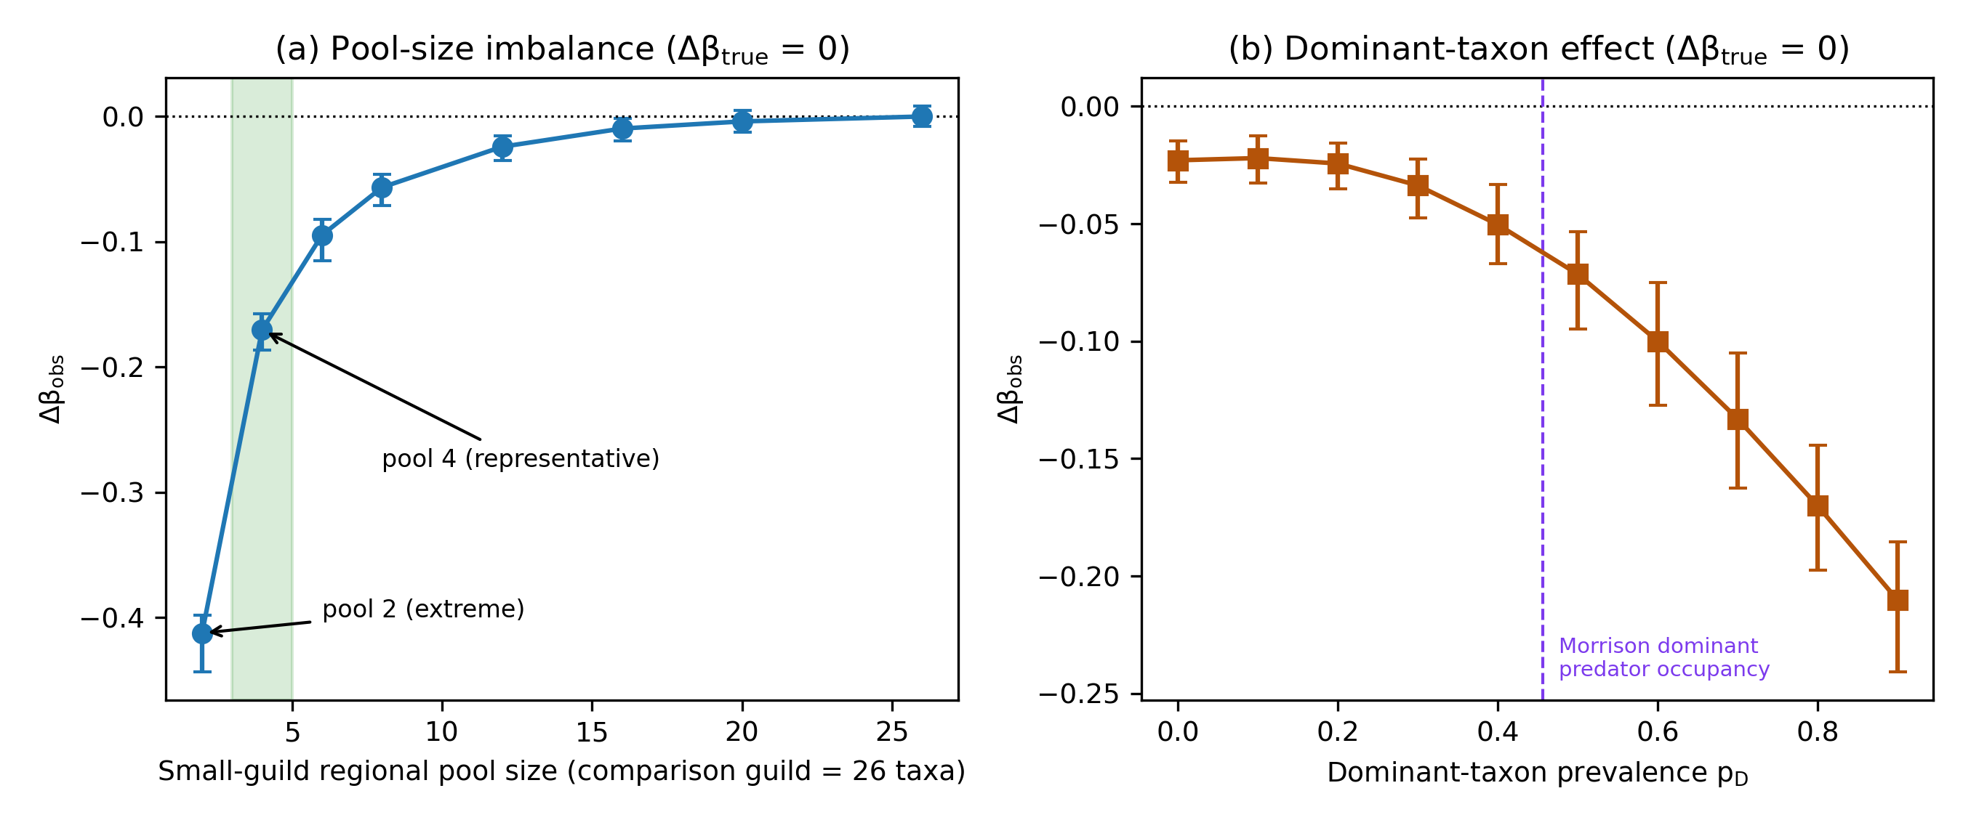
Figure 2. Structural asymmetry creates false differentiation when Δβ_{true} = 0. (a) Δβ_{obs} against the regional pool size of the smaller guild (comparison guild 26 taxa); the four-taxon pool is the representative case (−0.17) and the two-taxon pool the extreme tested condition (−0.41). (b) Δβ_{obs} against the prevalence p_{D} of a single dominant taxon; the dashed line marks the occupancy of the dominant Morrison predator (45.6% of collections). Negative Δβ indicates apparent spatial continuity of the smaller or dominance-structured guild. Points are means of 200 replicates with 95% replicate intervals (seed 20260922).
Table 1. False-contrast rate (proportion of replicates in which the absolute value of Δβ_{obs} exceeds the threshold) by small-guild pool size and threshold, with Δβ_{true} = 0; comparison guild 26 taxa; 200 replicates per cell (seed 20260922).
Small-guild pool size | Threshold 0.05 | Threshold 0.10 | Threshold 0.20
2 | 1.00 | 1.00 | 1.00
4 | 1.00 | 1.00 | 0.00
12 | 0.00 | 0.00 | 0.00
26 | 0.00 | 0.00 | 0.00
The two-dimensional replication reproduced the pattern: Δβ_{obs} was −0.21 at a four-taxon pool and −0.47 at a two-taxon pool (Fig. 3a), showing that the effect is not an artefact of one-dimensional range geometry. Pool asymmetry also changed the apparent spatial form of turnover. Under identical generative spatial processes, the fitted slope of pairwise Jaccard dissimilarity against geographic distance (positive values indicate dissimilarity increasing with distance, i.e. distance decay of similarity) for the four-taxon guild was 0.028 per lattice unit, compared with 0.006 for the 26-taxon comparison guild (Fig. 3b): the small-pool guild appeared to have much steeper distance decay, although both guilds were generated by the same spatial process.
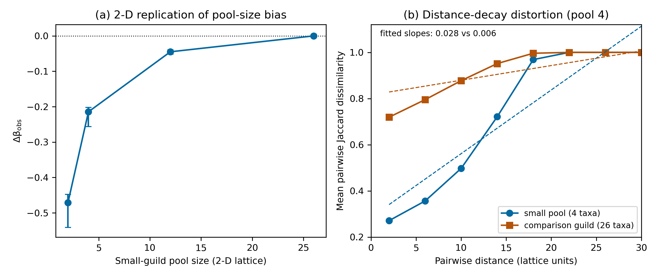
Figure 3. Two-dimensional replication and distance-decay distortion. (a) Δβ_{obs} under pool asymmetry on a 40 × 40 lattice with disc-shaped ranges (four-taxon pool −0.21; two-taxon pool −0.47; means and 95% replicate intervals of 100 replicates; seed 20260924). (b) Mean pairwise Jaccard dissimilarity against pairwise distance (lattice units) for the four-taxon and 26-taxon guilds generated by the same spatial process; dashed lines show the fitted linear decay slopes (0.028 versus 0.006 per lattice unit).

Dominance, taxonomic lumping, temporal aggregation and sampling
A single dominant predator lowered Δβ_{obs} monotonically as its prevalence increased (Fig. 2b): bias was approximately −0.07 at p_{D} = 0.5, the cell closest to the observed occupancy of the dominant Morrison predator (45.6% of collections), and −0.21 at p_{D} = 0.9.
Collapsing k geographically partitioned species into one genus column produced B_{lumping} up to +0.099 at k = 6, shifting Δβ_{obs} from −0.001 at species resolution to −0.101 after genus pooling (Fig. 4a). Taxonomic lumping thus fabricated apparent continuity in the lumped guild.
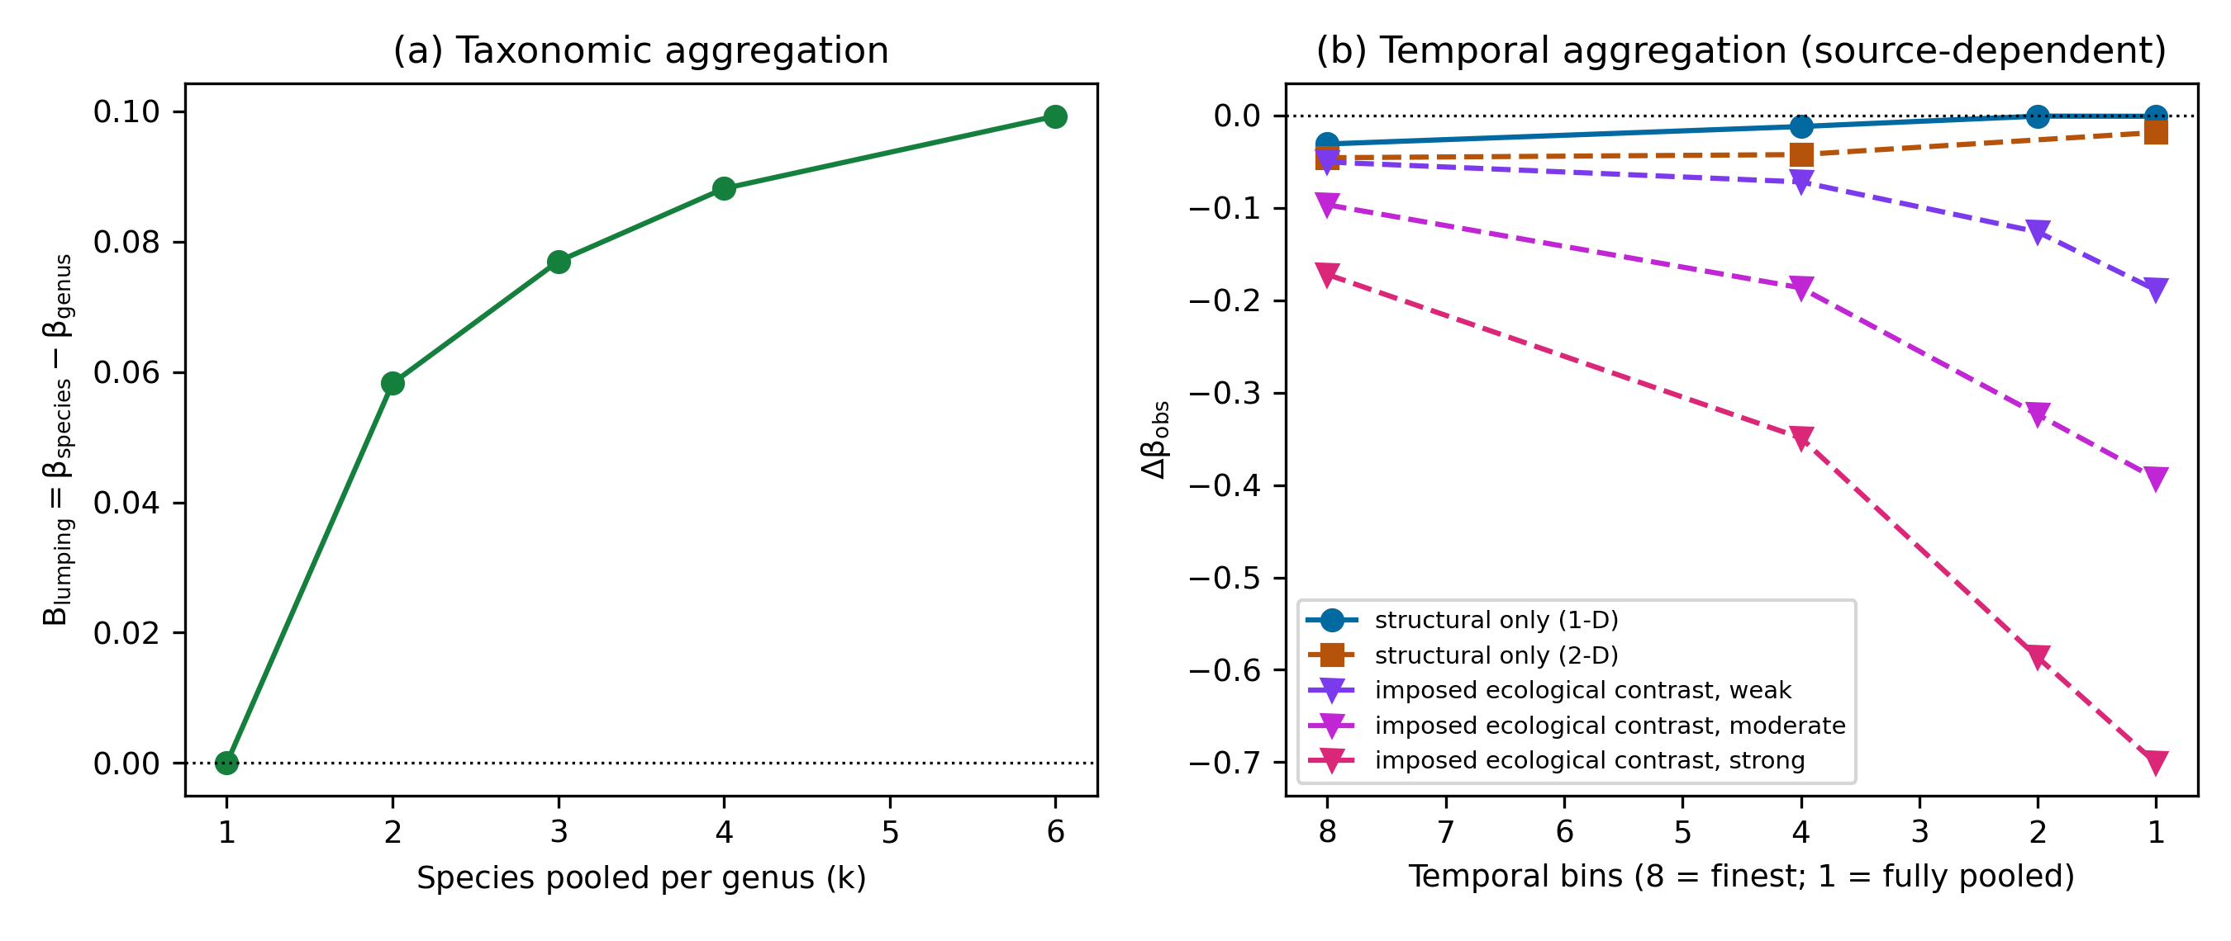
Figure 4. Taxonomic and temporal aggregation. (a) Pooling k geographically partitioned species into one genus column; B_{lumping} = β_{species} − β_{genus} (positive values indicate greater apparent continuity), reaching +0.099 at k = 6. (b) Δβ_{obs} against the number of temporal bins under union pooling (8 = finest resolution, 1 = fully pooled). Structural-only contrasts are erased by pooling (one-dimensional −0.031 to −0.001; two-dimensional −0.046 to −0.018), whereas contrasts that include an imposed difference in range breadth are amplified (−0.05, −0.10 and −0.17 become −0.19, −0.39 and −0.70 at full pooling).
Temporal aggregation had a source-dependent effect rather than a uniform one (Fig. 4b). In the structural arm, where the finest-resolution contrast arises only from pool asymmetry, pooling eight slices into one bin moved Δβ_{obs} from −0.031 to −0.001: the structurally generated contrast was erased. Under imposed ecological contrasts, pooling instead amplified the contrast. Finest-resolution contrasts of −0.05, −0.10 and −0.17 became −0.189, −0.393 and −0.701 under full pooling (attenuation fractions −2.75, −3.07 and −3.07, i.e. 3.8- to 4.1-fold amplification). Under union pooling, taxa that are already widespread approach full occupancy first, which drives the per-bin dissimilarity of the guild with broader ranges toward zero disproportionately. The direction of the distortion therefore depended on which feature differed between the guilds, not simply on the width of aggregation.
An eight-fold sampling asymmetry between environmental blocks produced comparatively small and stable bias under the parameter range examined (Table 2). This result is specific to the tested parameterisation and does not imply that sampling structure is generally unimportant.
Table 2. Apparent guild contrast Δβ_{obs} under predator-sampling asymmetry between alternating environmental blocks, with Δβ_{true} = 0 (pool sizes 26 and 12 taxa; 200 replicates per cell; seed 20260922).
Predator sampling multiplier (block A relative to block B) | Mean Δβ_{obs} | 95% replicate interval
1 | −0.024 | −0.040 to −0.010
2 | −0.023 | −0.038 to −0.008
4 | −0.024 | −0.045 to −0.007
8 | −0.024 | −0.041 to −0.008

Structural factors interact non-additively
In the factorial design, structural biases combined non-additively (Fig. 5). For a four-taxon pool with p_{D} = 0.9 and k = 3, the combined bias was −0.76, whereas the additive expectation was −0.28; the additive expectation is the pool-only bias (four-taxon pool, p_{D} = 0, k = 1) plus the dominance-only and lumping-only increments read from the 26-taxon row of the same grid (p_{D} = 0.9 and k = 3, respectively, each relative to p_{D} = 0, k = 1). This is a descriptive comparison of replicate means; no inferential interaction term was estimated. The false-difference rate (absolute Δβ_{obs} above 0.1 with Δβ_{true} = 0) reached 100% across the low-pool, high-dominance and high-lumping region. The largest bias, −0.91, occurred in the degenerate cells where k = 6 collapses the whole four-taxon guild into one column, so that its turnover is zero by construction and Δβ_{obs} equals the negative of the comparison guild's mean dissimilarity; the largest bias among non-degenerate cells was −0.76. Because these extreme-bias regions arise from combinations of factors, correcting any single factor in isolation did not remove the false difference.
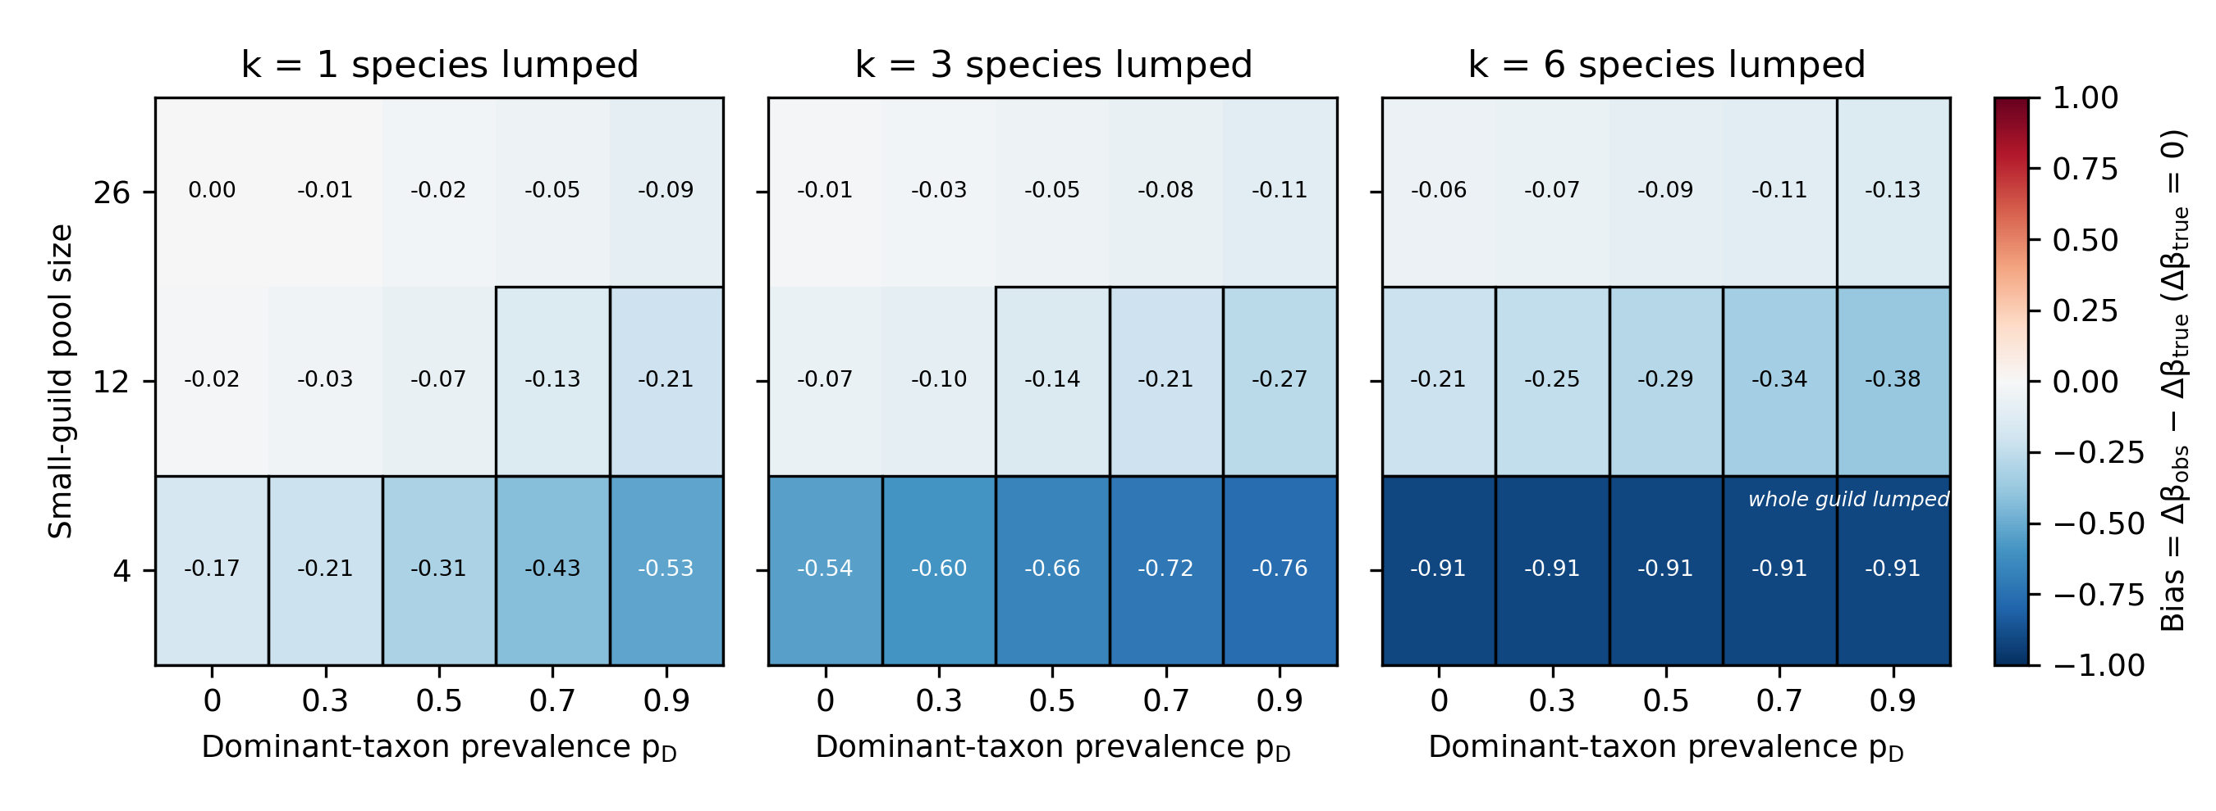
Figure 5. Factorial bias map with Δβ_{true} = 0. Bias = Δβ_{obs} − Δβ_{true} by small-guild pool size and dominant-taxon prevalence p_{D}, with one panel per lumping level k; cell labels give mean bias over 100 replicates (seed 20260923), and outlined cells have a false-difference rate (absolute Δβ_{obs} above 0.1) of at least 0.95. In the cells labelled "whole guild lumped" (pool 4, k = 6) the entire small guild is collapsed into one column, so its turnover is zero by construction and bias equals the negative of the comparison guild's mean dissimilarity (−0.91).

Morrison worked example: the naive guild contrast
On the primary specification (collection assemblages, genus level, Jaccard), Morrison predators were much more spatially homogeneous than herbivores: Δβ = −0.550 (bootstrap 95% CI −0.630 to −0.457). Read naively, this contrast would suggest exceptional spatial continuity of the predator guild, which is precisely the class of signal that Simulations 1–3 show can arise structurally.

Sequential structural decomposition
Applying the diagnostic sequence (Fig. 6): (1) the observed Δβ of −0.550 was close to, but marginally more negative than, the lower bound of the gamma-matched null interval (−0.534 to −0.229); unequal pool sizes account for much of the magnitude but do not by themselves generate a contrast as extreme as the observed one. (2) The observed value was more negative than the frequency-matched null interval (−0.124 to −0.095), so occupancy-frequency structure alone does not reproduce it. (3) As a dominance-sensitivity diagnostic (not as a preferred representation of the assemblage), excluding the dominant predator, Allosaurus, reduced the contrast to −0.020 (−0.128 to +0.024). (4) As a taxonomic-grain sensitivity analysis, at species resolution the contrast attenuated to −0.322 (−0.426 to −0.234), in the direction expected from Simulation 3. (5) After regressing geographic extent on stratigraphic duration and occurrence count, the Allosaurus extent residual was −36.6 km (z = −0.16); the genus is not geographically exceptional for its sampling footprint. (6) In the exploratory presence model, the unpenalised fit reached pseudo-R² = 0.46 but did not fully converge (quasi-separation; state coefficients 14.1 to 17.8); the L2-penalised refit converged with pseudo-R² = 0.34 (C = 1), supporting the same qualitative conclusion that collection covariates carry substantial presence structure.
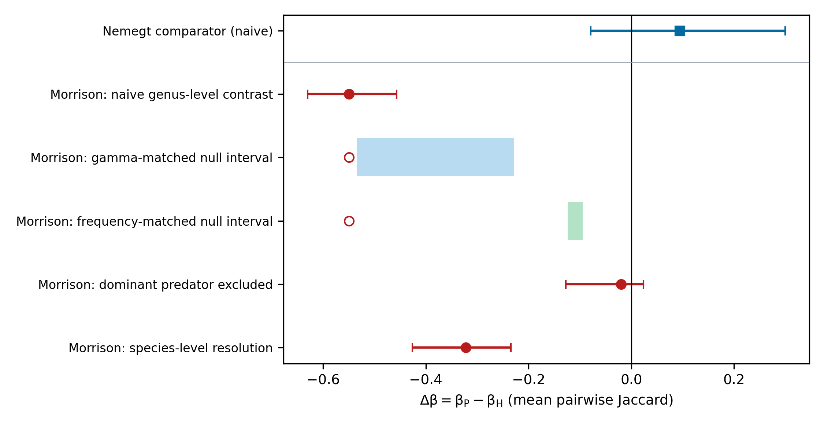
Figure 6. Sequential structural decomposition of the Morrison Formation guild contrast and the Nemegt comparator. Filled symbols show estimates with bootstrap 95% CIs (999 resamples of collections): Morrison naive genus-level contrast (−0.550), contrast after exclusion of the dominant predator (−0.020) and species-level contrast (−0.322); Nemegt naive contrast (+0.094). Shaded bands are null 95% intervals for the gamma-matched (−0.534 to −0.229) and frequency-matched (−0.124 to −0.095) nulls, with the observed naive contrast shown as an open circle; null intervals are distinct from bootstrap CIs.

Nemegt comparator
Under the same locked specification, the Nemegt Formation, where the herbivore pool (8 genera) is smaller than the predator pool (26 genera), yielded Δβ = +0.094 (95% CI −0.079 to +0.300) (Fig. 6). The Morrison direction is therefore not reproduced; Nemegt shows that the Morrison pattern is not a general property of predator guilds, without serving as a biological replication.

Independent evidence
The bounded evidence audit identified nothing that contradicts the structural interpretation. Trackway evidence for large Morrison theropods is consistent with wide distribution but not diagnostic of movement (Foster, 2015); feeding-trace evidence indicates a broad prey spectrum including scavenging (Drumheller et al., 2020), which bears on dietary generalism rather than mobility; and no direct test of Allosaurus movement was identified.

Discussion

Structural comparability before ecological interpretation
When are compared assemblages structurally comparable enough for a beta-diversity contrast to be read ecologically? The simulations show that guild-level contrasts are vulnerable in more than one direction. With no generative contrast, structural asymmetry alone (unequal pools, dominance and taxonomic lumping) generated apparent contrasts of −0.17 for a four-taxon pool and −0.41 for a two-taxon pool. Temporal aggregation behaved differently: it erased the structurally generated component of a contrast (−0.031 to −0.001 under full pooling; −0.046 to −0.018 on the lattice) but amplified imposed ecological contrasts. Assemblage construction can thus create, erase, exaggerate or reshape apparent spatial structure, and the sign of the distortion can depend on the source of the contrast rather than on the aggregation operation alone. None of the component mechanisms is new; what the simulations add is their magnitude under controlled conditions, their interaction, their effect on distance decay, and a demonstration of how they play out in a real dataset. The magnitudes are demonstrations of sufficiency under specified conditions, not constants to be transferred to other systems.

Pool size and distance decay
Pool-size imbalance was the largest single source of bias. Richness effects on dissimilarity metrics are recognised (Kraft et al., 2011; Chase et al., 2011), and Jaccard dissimilarity combines species replacement with richness difference (Baselga, 2010, 2012; Legendre, 2014). The magnitudes observed here, a fully reproducible apparent contrast of −0.17 from a four-taxon versus 26-taxon pool with no generative difference, indicate that pool-size-matched nulls are a minimal requirement rather than an optional refinement, and the result held on a two-dimensional lattice (−0.21 and −0.47). Comparisons among guilds or regions with different pool structures remain vulnerable even after standard diversity partitioning (Chase et al., 2018).
Structural asymmetry also changed the shape of turnover, not only its mean. On the lattice, the small-pool guild showed a steeper apparent distance-decay slope (0.028) than the comparison guild (0.006) under identical generative spatial processes. Distance decay is a core tool for diagnosing dispersal limitation and environmental filtering (Nekola & White, 1999; Soininen et al., 2007; Morlon et al., 2008). The result implies that differences in pool size alone can mimic differences in decay rate, so that a reported difference in decay slopes between groups may reflect differential sensitivity to pool size rather than differential dispersal. This does not mean that empirical differences in distance decay are generally artefacts; it means that decay comparisons need the same structural controls as comparisons of mean dissimilarity, for example pool-matched or richness-standardised decay curves.

Dominance and taxonomic aggregation
A single dominant taxon shifted Δβ by approximately −0.07 at moderate prevalence and −0.21 at high prevalence, consistent with the known sensitivity of dissimilarity to common species (McGeoch & Gaston, 2002; Lennon et al., 2004; Hillebrand et al., 2008; Avolio et al., 2019). Genus-level pooling of geographically differentiated species produced an apparent continuity shift of +0.099, mirroring taxonomic-sufficiency effects documented for assemblage analyses (Lane & Benton, 2003; Bertrand et al., 2006; Bevilacqua et al., 2009). The two mechanisms are usefully distinguished. Dominance changes which sites are occupied, whereas lumping changes which entities are counted, fusing several spatially segregated species into one widespread taxon. Both inflate apparent spatial continuity, but through different data-construction paths, so the diagnostics differ: occupancy–frequency inspection and leave-one-dominant analyses for the former, and cross-resolution sensitivity tests for the latter.

Temporal aggregation is source-dependent
Time averaging is generally expected to homogenise assemblages (Kidwell & Bosence, 1991; Olszewski, 1999; Martin, 1999; Tomašových & Kidwell, 2010). The simulations qualify this expectation for the union-pooling operator tested here. Where the finest-resolution contrast was structural, pooling erased it; where the contrast included an imposed difference in range breadth, pooling amplified it 3.8- to 4.1-fold (−0.05 to −0.19, −0.10 to −0.39 and −0.17 to −0.70). The mechanism is mechanical: with union pooling over k slices, a per-slice presence probability p becomes
$$p_{k} = 1 − {(1 − p)}^{k}$$
so taxa that are already widespread approach full occupancy first and the guild with broader ranges is flattened disproportionately. Temporal aggregation is therefore neither simply a false-negative nor simply a false-positive mechanism under this operator; its direction is set by the source of the underlying contrast. One practical implication is that a strong contrast surviving aggregation is not by itself evidence of robustness, because aggregation can inflate as well as erase. These conclusions are limited to union pooling; other aggregation rules (for example abundance-weighted or occupancy-thresholded pooling) were not tested.

Sampling
An eight-fold sampling asymmetry produced comparatively small bias (approximately −0.02, essentially unchanged from the symmetric case) within the tested parameter range. I do not infer that sampling is unimportant; occurrence databases, including fossil databases, are demonstrably sampling-structured (Smith & McGowan, 2007; Alroy, 2008; Vilhena & Smith, 2013). The result indicates only that, under this parameterisation, the isolated sampling effect was smaller than the pool-size, dominance and lumping effects.

Non-additive combined effects of structural factors
Because pool size, dominance, taxonomic resolution and sampling co-vary in real assemblages, the bias terms cannot be treated as independent additive corrections. In the factorial design, the combined bias was more than twice the additive expectation built from single-factor effects in the low-pool, high-dominance, intermediate-lumping region (−0.76 versus −0.28), and the extreme cells reached −0.91 when lumping collapsed the whole small guild into one taxon. The latter value is a boundary case, but it illustrates the endpoint of the non-additive combination: once structural features remove all turnover from one guild, the observed contrast reflects only the other guild. Correcting only pool size leaves dominance and lumping free to generate a contrast, so diagnostics should be sequential and cross-checked rather than a single covariate adjustment.

The Morrison worked example
In the Morrison Formation, a naive predator–herbivore Δβ of −0.550 lay close to, but marginally beyond, the lower bound of the gamma-matched null interval (−0.534), was more negative than the frequency-matched null, and collapsed to −0.020 after exclusion of the single dominant predator; species-level resolution gave −0.322, and the dominant predator was not geographically exceptional after adjustment for duration and occurrence count (extent residual −36.6 km, z = −0.16). Collection covariates explained substantial presence structure in exploratory models. The appropriate interpretation is not that an ecological account of the contrast has been disproven. Rather, after structural diagnostics a strong biological explanation is no longer required to account for the observed pattern, and biological interpretation becomes non-unique. Structural sufficiency is not causal attribution: the analysis does not show that Allosaurus was sedentary, non-migratory or otherwise behaviourally constrained, and it does not identify a unique causal mechanism. Nemegt, analysed with the same locked specification, showed Δβ = +0.094 (−0.079 to +0.300); the Morrison direction is not a universal predator-guild property.

General applicability
The mechanisms quantified here are relevant wherever assemblages that differ in pool size, dominance, taxonomic grain, temporal span or sampling structure are compared: museum and herbarium records, long-term monitoring compilations, multi-source biodiversity databases, archaeological faunas and palaeoecological records (Shaffer et al., 1998; Graham et al., 2004; Pyke & Ehrlich, 2010; Lavoie, 2013). The mechanisms are broadly relevant wherever assemblages differ structurally, although the magnitudes reported here are scenario-specific and should not be transported directly to other systems. Among the mechanisms examined, pool-size asymmetry has the clearest parallel outside palaeontology, because cross-guild and cross-region richness asymmetries are ubiquitous in contemporary occurrence data; temporal aggregation is most acute in archives that integrate time; and taxonomic lumping matters wherever identification effort differs among groups. The growing use of aggregated occurrence data for biodiversity-change inference (Blowes et al., 2019) makes the direction-dependence of these distortions especially consequential.

A practical workflow
Before a guild-level beta-diversity contrast is interpreted as evidence of dispersal limitation, connectivity, environmental filtering or habitat breadth, I suggest the following recommended diagnostic sequence, to be applied as far as the data allow rather than as a validated decision rule: (1) compare gamma diversity among the groups; (2) run pool-size-matched null models; (3) inspect occupancy and dominance and run leave-one-dominant analyses; (4) harmonise taxonomic resolution and test sensitivity across levels; (5) test the effect of temporal aggregation, analysing the finest available bins; (6) inspect sampling and detection structure; (7) compare distance-decay relationships under the same structural controls, not only mean dissimilarity; (8) examine combined effects of co-occurring structural factors; and (9) interpret the contrast as evidence of ecological connectivity, mobility, filtering or habitat breadth only to the extent that it survives the applicable checks. The same discipline applies to non-fossil assemblage comparisons (Socolar et al., 2016). The sequence, with the failure mode each step addresses, is summarised in Table 3.
Table 3. Recommended diagnostic sequence for guild-level beta-diversity contrasts. Each row pairs a structural mechanism examined in this study with a diagnostic recommended, where the data allow, before an observed contrast is interpreted ecologically; the sequence is not a validated decision rule.
Structural mechanism | Failure mode | Recommended diagnostic | Evidence in this study
Unequal regional pool (gamma imbalance) | False differentiation | Pool-size-matched null model | Simulation 1; Fig. 2a; Table 1
Dominant taxon | False differentiation | Occupancy inspection; leave-one-dominant analysis | Simulation 2; Fig. 2b
Taxonomic lumping | False differentiation (apparent continuity) | Cross-resolution sensitivity test | Simulation 3; Fig. 4a
Temporal aggregation | Erasure of a structural contrast; amplification of an ecological contrast (source-dependent) | Re-analysis at the finest available temporal bins; aggregation survival not treated as robustness | Simulations 4 and 4b; Fig. 4b
Asymmetric sampling | Small bias under the tested parameters; parameter-dependent in general | Inspection of collection-effort and detection structure | Simulation 5; Table 2
Distance-decay geometry | Distorted apparent decay slope | Decay-slope comparison under structural controls | Two-dimensional simulation; Fig. 3b
Joint structural factors | Non-additive combined bias; extreme false differences | Factorial or multi-factor robustness check | Simulation 6; Fig. 5

Limitations
The simulators use simplified ecology and synthetic guild construction; parameter ranges were chosen to bracket plausible assemblage structures, but the reported magnitudes are scenario-specific and are not calibrated estimates for real landscapes. The one- and two-dimensional geometries do not reconstruct real landscape heterogeneity. The mechanisms interact, so the factorial map rather than the additive scaffold is the appropriate summary. All contrasts were computed with incidence-based Jaccard dissimilarity; turnover-only or abundance-based metrics differ in their sensitivity to richness difference (Baselga, 2010; Legendre, 2014) and were not evaluated systematically. Temporal-aggregation results apply to union pooling only, and the small sampling effect applies only to the tested parameterisation. Fossil data carry taxonomic and temporal limitations, and the species-level Morrison analysis depends on identification completeness. Morrison is one worked empirical case, and Nemegt is a structural comparator, not a biological replication. Structural sufficiency does not establish causal attribution: showing that a contrast can be generated structurally does not prove that it was. Conclusions about other ecological domains require direct testing with data from those domains.

Conclusions
Assemblage structure can create, erase, exaggerate or reshape apparent spatial ecological structure, affecting both mean beta diversity and the form of distance decay. Beta-diversity contrasts should therefore not be interpreted biologically before the structural comparability of the compared assemblages has been evaluated; the workflow in Table 3 provides a practical order for doing so.

Author Contributions
Tatsuki Onishi: Conceptualization (lead); Methodology (lead); Software (lead); Formal analysis (lead); Investigation (lead); Data curation (lead); Visualization (lead); Writing – original draft (lead); Writing – review and editing (lead).

Acknowledgements
The author gratefully acknowledges Robert T. Bakker, whose writings on dinosaur palaeobiology first inspired the author's interest in dinosaurs during his school years. His pioneering use of ecological patterns to infer aspects of dinosaur biology provided a lasting intellectual influence and helped inspire the questions revisited here from the perspective of spatial and community ecology.

Funding
No external funding was received for this work.

Conflict of Interest Statement
The author declares no competing interests.

Ethics Statement
Ethics approval was not required; only publicly available occurrence data for non-human (fossil) organisms and simulated data were used. Consent to participate: not applicable. Consent for publication: not applicable.

Data Accessibility Statement
All occurrence data used in this study derive from publicly available sources: the Morrison Formation dataset of Maidment (2024), archived in Dryad at https://doi.org/10.5061/dryad.6m905qg77 (CC0), and occurrence records from the Paleobiology Database (https://paleobiodb.org/).
The complete simulation and analysis code, fixed random seeds, provenance records, processed analysis inputs and value-level numerical registry are publicly available at https://github.com/bougtoir/dinosaur-migration-foodweb. The repository contains the source-data registry with download parameters and SHA-256 checksums (metadata/sources.csv), the manuscript value registry (methodological_beta_bias/results/manuscript_values.csv), the independent-evidence audit (methodological_beta_bias/INDEPENDENT_EVIDENCE_AUDIT.md), the parameter and seed registry (methodological_beta_bias/results/parameter_seed_registry.csv), complete simulation outputs, the taxonomic reconciliation table, Morrison locality and taxon-distribution materials, species-resolution and presence-model diagnostics, extended Nemegt diagnostics, and the scripts required to reproduce the analyses and figures. Reproduction entry points are documented in the repository README and Makefile (make beta_bias).
For reviewer convenience, copies of metadata/sources.csv, methodological_beta_bias/results/manuscript_values.csv, and methodological_beta_bias/INDEPENDENT_EVIDENCE_AUDIT.md are also supplied with the submission as supplementary reviewer files. The versions in the public repository are the canonical versions.

Code Availability
The simulation code, generated datasets, analysis scripts, and reproducibility materials supporting this article are publicly available at https://github.com/bougtoir/dinosaur-migration-foodweb.

References
Alroy, J. (2008). Dynamics of origination and extinction in the marine fossil record. Proceedings of the National Academy of Sciences, 105, 11536–11542. https://doi.org/10.1073/pnas.0802597105
Anderson, M. J., Crist, T. O., Chase, J. M., Vellend, M., Inouye, B. D., Freestone, A. L., Sanders, N. J., Cornell, H. V., Comita, L. S., Davies, K. F., Harrison, S. P., Kraft, N. J. B., Stegen, J. C., & Swenson, N. G. (2011). Navigating the multiple meanings of β diversity: a roadmap for the practicing ecologist. Ecology Letters, 14(1), 19–28. https://doi.org/10.1111/j.1461-0248.2010.01552.x
Avolio, M. L., Carroll, I. T., Collins, S. L., Houseman, G. R., Hallett, L. M., Isbell, F., Koerner, S. E., Komatsu, K. J., Smith, M. D., & Wilcox, K. R. (2019). A comprehensive approach to analyzing community dynamics using rank abundance curves. Ecosphere, 10(10), e02881. https://doi.org/10.1002/ecs2.2881
Badgley, C. (2010). Tectonics, topography, and mammalian diversity. Ecography, 33(2), 220–231. https://doi.org/10.1111/j.1600-0587.2010.06282.x
Barton, P. S., Cunningham, S. A., Manning, A. D., Gibb, H., Lindenmayer, D. B., & Didham, R. K. (2013). The spatial scaling of beta diversity. Global Ecology and Biogeography, 22(6), 639–647. https://doi.org/10.1111/geb.12031
Baselga, A. (2010). Partitioning the turnover and nestedness components of beta diversity. Global Ecology and Biogeography, 19(1), 134–143. https://doi.org/10.1111/j.1466-8238.2009.00490.x
Baselga, A. (2012). The relationship between species replacement, dissimilarity derived from nestedness, and nestedness. Global Ecology and Biogeography, 21(12), 1223–1232. https://doi.org/10.1111/j.1466-8238.2011.00756.x
Behrensmeyer, A. K., Kidwell, S. M., & Gastaldo, R. A. (2000). Taphonomy and paleobiology. Paleobiology, 26(S4), 103–147. https://doi.org/10.1666/0094-8373(2000)26[103:tap]2.0.co;2
Bertrand, Y., Pleijel, F., & Rouse, G. W. (2006). Taxonomic surrogacy in biodiversity assessments, and the meaning of Linnaean ranks. Systematics and Biodiversity, 4(2), 149–159. https://doi.org/10.1017/s1477200005001908
Bevilacqua, S., Fraschetti, S., Musco, L., & Terlizzi, A. (2009). Taxonomic sufficiency in the detection of natural and human-induced changes in marine assemblages: A comparison of habitats and taxonomic groups. Marine Pollution Bulletin, 58(12), 1850–1859. https://doi.org/10.1016/j.marpolbul.2009.07.018
Blowes, S. A., Supp, S. R., Antão, L. H., Bates, A., Bruelheide, H., Chase, J. M., Moyes, F., Magurran, A., McGill, B., Myers-Smith, I. H., Winter, M., Bjorkman, A. D., Bowler, D. E., Byrnes, J. E. K., Gonzalez, A., Hines, J., Isbell, F., Jones, H. P., Navarro, L. M., Thompson, P. L., Vellend, M., Waldock, C., & Dornelas, M. (2019). The geography of biodiversity change in marine and terrestrial assemblages. Science, 366(6463), 339–345. https://doi.org/10.1126/science.aaw1620
Chao, A., Gotelli, N. J., Hsieh, T. C., Sander, E. L., Ma, K. H., Colwell, R. K., & Ellison, A. M. (2014). Rarefaction and extrapolation with Hill numbers: a framework for sampling and estimation in species diversity studies. Ecological Monographs, 84(1), 45–67. https://doi.org/10.1890/13-0133.1
Chase, J. M., Kraft, N. J. B., Smith, K. G., Vellend, M., & Inouye, B. D. (2011). Using null models to disentangle variation in community dissimilarity from variation in α-diversity. Ecosphere, 2(2), art24. https://doi.org/10.1890/es10-00117.1
Chase, J. M., McGill, B. J., McGlinn, D. J., May, F., Blowes, S. A., Xiao, X., Knight, T. M., Purschke, O., & Gotelli, N. J. (2018). Embracing scale-dependence to achieve a deeper understanding of biodiversity and its change across communities. Ecology Letters, 21(11), 1737–1751. https://doi.org/10.1111/ele.13151
Colwell, R. K., Chao, A., Gotelli, N. J., Lin, S. Y., Mao, C. X., Chazdon, R. L., & Longino, J. T. (2012). Models and estimators linking individual-based and sample-based rarefaction, extrapolation and comparison of assemblages. Journal of Plant Ecology, 5(1), 3–21. https://doi.org/10.1093/jpe/rtr044
Drumheller, S. K., McHugh, J. B., Kane, M., Riedel, A., & D’Amore, D. C. (2020). High frequencies of theropod bite marks provide evidence for feeding, scavenging, and possible cannibalism in a stressed Late Jurassic ecosystem. PLOS ONE, 15(5), e0233115. https://doi.org/10.1371/journal.pone.0233115
Foster, J. R. (2015). Theropod Dinosaur IchnogenusHispanosauropusIdentified from the Morrison Formation (Upper Jurassic), Western North America. Ichnos, 22(3-4), 183–191. https://doi.org/10.1080/10420940.2015.1059335
Gotelli, N. J., & Colwell, R. K. (2001). Quantifying biodiversity: procedures and pitfalls in the measurement and comparison of species richness. Ecology Letters, 4(4), 379–391. https://doi.org/10.1046/j.1461-0248.2001.00230.x
Graham, C., Ferrier, S., Huettman, F., Moritz, C., & Peterson, A. (2004). New developments in museum-based informatics and applications in biodiversity analysis. Trends in Ecology & Evolution, 19(9), 497–503. https://doi.org/10.1016/j.tree.2004.07.006
Heino, J., Soininen, J., Alahuhta, J., Lappalainen, J., & Virtanen, R. (2015). A comparative analysis of metacommunity types in the freshwater realm. Ecology and Evolution, 5(7), 1525–1537. https://doi.org/10.1002/ece3.1460
Hillebrand, H., Bennett, D. M., & Cadotte, M. W. (2008). Consequences of dominance: a review of evenness effects on local and regional ecosystem processes. Ecology, 89(6), 1510–1520. https://doi.org/10.1890/07-1053.1
Keil, P., Schweiger, O., Kühn, I., Kunin, W. E., Kuussaari, M., Settele, J., Henle, K., Brotons, L., Pe’er, G., Lengyel, S., Moustakas, A., Steinicke, H., & Storch, D. (2012). Patterns of beta diversity in Europe: the role of climate, land cover and distance across scales. Journal of Biogeography, 39(8), 1473–1486. https://doi.org/10.1111/j.1365-2699.2012.02701.x
Kidwell, S. M., & Bosence, D. W. J. (1991). Taphonomy and Time-Averaging of Marine Shelly Faunas. In Allison, P. A., & Briggs, D. E. G. (Eds.), Taphonomy (Topics in Geobiology) (pp. 115–209). Springer. https://doi.org/10.1007/978-1-4899-5034-5_4
Korhonen, J. J., Soininen, J., & Hillebrand, H. (2010). A quantitative analysis of temporal turnover in aquatic species assemblages across ecosystems. Ecology, 91(2), 508–517. https://doi.org/10.1890/09-0392.1
Kraft, N. J. B., Comita, L. S., Chase, J. M., Sanders, N. J., Swenson, N. G., Crist, T. O., Stegen, J. C., Vellend, M., Boyle, B., Anderson, M. J., Cornell, H. V., Davies, K. F., Freestone, A. L., Inouye, B. D., Harrison, S. P., & Myers, J. A. (2011). Disentangling the Drivers of β Diversity Along Latitudinal and Elevational Gradients. Science, 333(6050), 1755–1758. https://doi.org/10.1126/science.1208584
Lane, A., & Benton, M. J. (2003). Taxonomic Level as a Determinant of the Shape of the Phanerozoic Marine Biodiversity Curve. The American Naturalist, 162(3), 265–276. https://doi.org/10.1086/377188
Lavoie, C. (2013). Biological collections in an ever changing world: Herbaria as tools for biogeographical and environmental studies. Perspectives in Plant Ecology, Evolution and Systematics, 15(1), 68–76. https://doi.org/10.1016/j.ppees.2012.10.002
Legendre, P. (2014). Interpreting the replacement and richness difference components of beta diversity. Global Ecology and Biogeography, 23(11), 1324–1334. https://doi.org/10.1111/geb.12207
Lennon, J. J., Koleff, P., Greenwood, J. J. D., & Gaston, K. J. (2004). Contribution of rarity and commonness to patterns of species richness. Ecology Letters, 7(2), 81–87. https://doi.org/10.1046/j.1461-0248.2004.00548.x
MacKenzie, D. I., Nichols, J. D., Lachman, G. B., Droege, S., Andrew Royle, J., & Langtimm, C. A. (2002). Estimating site occupancy rates when detection probabilities are less than one. Ecology, 83(8), 2248–2255. https://doi.org/10.1890/0012-9658(2002)083[2248:esorwd]2.0.co;2
Maidment, S. (2024). Data and code for: Diversity through space and time in the Upper Jurassic Morrison Formation, western USA [Dataset]. Dryad. https://doi.org/10.5061/dryad.6m905qg77
Martin, R. E. (1999). Time-averaging of fossil assemblages: taphonomy and temporal resolution. In Taphonomy (pp. 186–234). Cambridge University Press. https://doi.org/10.1017/cbo9780511612381.006
McGeoch, M. A., & Gaston, K. J. (2002). Occupancy frequency distributions: patterns, artefacts and mechanisms. Biological Reviews, 77(3), 311–331. https://doi.org/10.1017/s1464793101005887
McGill, B. J., Etienne, R. S., Gray, J. S., Alonso, D., Anderson, M. J., Benecha, H. K., Dornelas, M., Enquist, B. J., Green, J. L., He, F., Hurlbert, A. H., Magurran, A. E., Marquet, P. A., Maurer, B. A., Ostling, A., Soykan, C. U., Ugland, K. I., & White, E. P. (2007). Species abundance distributions: moving beyond single prediction theories to integration within an ecological framework. Ecology Letters, 10(10), 995–1015. https://doi.org/10.1111/j.1461-0248.2007.01094.x
Moreno, C. E., & Rodríguez, P. (2010). A consistent terminology for quantifying species diversity? Oecologia, 163(2), 279–282. https://doi.org/10.1007/s00442-010-1591-7
Morlon, H., Chuyong, G., Condit, R., Hubbell, S., Kenfack, D., Thomas, D., Valencia, R., & Green, J. L. (2008). A general framework for the distance–decay of similarity in ecological communities. Ecology Letters, 11(9), 904–917. https://doi.org/10.1111/j.1461-0248.2008.01202.x
Nekola, J. C., & White, P. S. (1999). The distance decay of similarity in biogeography and ecology. Journal of Biogeography, 26(4), 867–878. https://doi.org/10.1046/j.1365-2699.1999.00305.x
Noto, C. R., & Grossman, A. (2010). Broad-Scale Patterns of Late Jurassic Dinosaur Paleoecology. PLoS ONE, 5(9), e12553. https://doi.org/10.1371/journal.pone.0012553
Olszewski, T. (1999). Taking advantage of time-averaging. Paleobiology, 25(2), 226–238. https://doi.org/10.1017/s009483730002652x
Pärtel, M., Szava-Kovats, R., & Zobel, M. (2011). Dark diversity: shedding light on absent species. Trends in Ecology & Evolution, 26(3), 124–128. https://doi.org/10.1016/j.tree.2010.12.004
Peters, S. E., & McClennen, M. (2016). The Paleobiology Database application programming interface. Paleobiology, 42(1), 1–7. https://doi.org/10.1017/pab.2015.39
Pyke, G. H., & Ehrlich, P. R. (2010). Biological collections and ecological/environmental research: a review, some observations and a look to the future. Biological Reviews, 85(2), 247–266. https://doi.org/10.1111/j.1469-185x.2009.00098.x
Sfenthourakis, S., & Panitsa, M. (2012). From plots to islands: species diversity at different scales. Journal of Biogeography, 39(4), 750–759. https://doi.org/10.1111/j.1365-2699.2011.02639.x
Shaffer, H. B., Fisher, R. N., & Davidson, C. (1998). The role of natural history collections in documenting species declines. Trends in Ecology & Evolution, 13(1), 27–30. https://doi.org/10.1016/s0169-5347(97)01177-4
Smith, A. B., & McGowan, A. J. (2007). The shape of the Phanerozoic marine palaeodiversity curve: how much can be predicted from the sedimentary rock record of Western Europe? Palaeontology, 50(4), 765–774. https://doi.org/10.1111/j.1475-4983.2007.00693.x
Socolar, J. B., Gilroy, J. J., Kunin, W. E., & Edwards, D. P. (2016). How Should Beta-Diversity Inform Biodiversity Conservation? Trends in Ecology & Evolution, 31(1), 67–80. https://doi.org/10.1016/j.tree.2015.11.005
Soininen, J., McDonald, R., & Hillebrand, H. (2007). The distance decay of similarity in ecological communities. Ecography, 30(1), 3–12. https://doi.org/10.1111/j.0906-7590.2007.04817.x
Stigall, A. L., & Lieberman, B. S. (2006). Quantitative palaeobiogeography: GIS, phylogenetic biogeographical analysis, and conservation insights. Journal of Biogeography, 33(12), 2051–2060. https://doi.org/10.1111/j.1365-2699.2006.01585.x
Tomašových, A., & Kidwell, S. M. (2010). Predicting the effects of increasing temporal scale on species composition, diversity, and rank-abundance distributions. Paleobiology, 36(4), 672–695. https://doi.org/10.1666/08092.1
Tuomisto, H. (2010). A diversity of beta diversities: straightening up a concept gone awry. Part 2. Quantifying beta diversity and related phenomena. Ecography, 33(1), 23–45. https://doi.org/10.1111/j.1600-0587.2009.06148.x
Uhen, M. D., Barnosky, A. D., Bills, B., Blois, J., Carrano, M. T., Carrasco, M. A., Erickson, G. M., Eronen, J. T., Fortelius, M., Graham, R. W., Grimm, E. C., O’Leary, M. A., Mast, A., Piel, W. H., Polly, P. D., & Säilä, L. K. (2013). From card catalogs to computers: databases in vertebrate paleontology. Journal of Vertebrate Paleontology, 33(1), 13–28. https://doi.org/10.1080/02724634.2012.716114
Vilhena, D. A., & Smith, A. B. (2013). Spatial Bias in the Marine Fossil Record. PLoS ONE, 8(10), e74470. https://doi.org/10.1371/journal.pone.0074470
Whittaker, R. H. (1960). Vegetation of the Siskiyou Mountains, Oregon and California. Ecological Monographs, 30(3), 279–338. https://doi.org/10.2307/1943563
Wiens, J. A. (1989). Spatial Scaling in Ecology. Functional Ecology, 3(4), 385. https://doi.org/10.2307/2389612
Zobel, M. (2016). The species pool concept as a framework for studying patterns of plant diversity. Journal of Vegetation Science, 27(1), 8–18. https://doi.org/10.1111/jvs.12333

