Solving the noise inverse problem in dynamic vision sensors
for faint astronomical object detection
[Author names and affiliations to be added]

Abstract
Dynamic Vision Sensors (DVS) provide microsecond temporal resolution and >120 dB dynamic range, properties well suited to space situational awareness (SSA). Under low-light conditions, however, background activity (BA) noise overwhelms faint astronomical signals. We address this by formulating DVS denoising as a noise inverse problem: the noise generation mechanism is described by a circuit-level parametric model (A5, five parameters per pixel) and solved inversely to reconstruct and subtract noise, leaving signal in the residual. Our algorithm, Physics-Informed DeepClean for DVS (PI-DC-DVS), combines this model with Bayesian inference. On 20 recordings from the Event-Based Space Situational Awareness (EBSSA) dataset, a Fano-factor classifier derived from this framework reaches ROC-AUC = 0.866, compared with 0.534 for conventional temporal filtering. A proof-of-concept run removes 90.3% of noise events while recovering satellite trajectories. We also describe a six-tier calibration hierarchy whose highest tier (Cal-6) turns satellite light trails—ordinarily dismissed as light pollution—into calibration sources with known trajectories. The noise inverse approach, long established in gravitational-wave data analysis, proves well suited to event-based astronomical observation and offers a potential 2–4 magnitude gain in detection limit.
Keywords: dynamic vision sensor, event camera, noise inverse problem, space situational awareness, calibration, stochastic resonance

1. Introduction
Classical image denoising is a signal inverse problem: given an observation y = h * s + n, estimate s. This paper takes the complementary view. We model the noise generation mechanism as a physical forward process and invert it to reconstruct and subtract noise, so that only signal remains in the residual.
Dynamic Vision Sensors (DVS) are neuromorphic image sensors whose pixels independently fire events whenever the logarithmic intensity change crosses a threshold.^{1,2} The resulting data stream has microsecond time resolution, >120 dB dynamic range, and sparse bandwidth—properties that favour space situational awareness (SSA)^{3,4,5} and fast optical astronomy.⁶ At low light levels, however, shot-noise-driven background activity (BA) dominates the event stream and buries faint astronomical signals.^{7,8}
Our premise is straightforward: if the noise can be modelled with high fidelity, subtracting it yields a structural gain in SNR—one that scales with model accuracy rather than integration time.
Gravitational-wave (GW) astronomy provides a proven precedent. DeepClean⁹ and successors^{10,11,12} regress non-stationary detector noise from auxiliary witness channels, and iDQ¹³ assigns per-event noise probabilities in real time. For photon-counting data, D³PO¹⁴ jointly decomposes signal and noise in a Bayesian framework. No comparable pipeline has been developed for DVS astronomical observation.
This paper makes five contributions: (i) we formulate DVS denoising as a noise inverse problem and derive the SNR improvement scaling (Sec. 3); (ii) we describe PI-DC-DVS, an algorithm that couples a circuit-level noise model with auxiliary-channel regression (Sec. 3); (iii) we introduce a six-tier calibration framework whose top tier (Cal-6) exploits satellite light trails as calibration sources (Sec. 4); (iv) we evaluate the approach on 20 EBSSA recordings against two baselines (Sec. 5); and (v) we demonstrate 90.3% noise removal with satellite trajectory recovery on a representative recording (Sec. 6).

2. Background

2.1. DVS noise physics
The circuit-level physics of DVS noise has been characterised in detail. Graça and Delbruck⁷ established that photon shot noise sets a fundamental lower bound on background activity rates. McReynolds et al.⁸ showed that shot-noise events come in alternating ON/OFF polarity pairs. The SciDVS sensor¹⁵ reaches 1.7% temporal contrast sensitivity at 0.7 lux. Of particular relevance here, Graça and Delbruck¹⁶ developed a large-signal differential-equation pixel model with first-passage-time event generation that is >1000× faster than SPICE while retaining physical accuracy. This model provides the forward model F(θ) for our noise inverse formulation.
The parametric noise rate model (hereafter A5)¹⁶ takes the form:
$$λ_{noise}\left(T, I_{bg}\right) = I_{dark,ref} ⋅ exp\left(α ⋅ ΔT\right) ⋅ \left(1 + β ⋅ I_{bg}\right)$$ (1)
Here I_dark,ref is the dark-current reference rate, α ≈ 0.06–0.08 K⁻¹ the temperature coefficient, ΔT the temperature departure from a reference point, and β the illuminance sensitivity. The five per-pixel parameters (I_dark,ref, α, β, θ_ON, θ_OFF) are determined during offline calibration.

2.2. DVS denoising methods
DVS denoising methods range from spatio-temporal neighbourhood filters^{17,18} through probabilistic approaches (Event Probability Mask¹⁹) and deep networks (WedNet,²⁰ ASTEDNet²¹) to joint motion–noise estimation. The closest prior work is that of Shiba et al.,²² who estimate motion and noise simultaneously within an extended Contrast Maximisation framework. Their noise model remains phenomenological, however, and incorporates neither circuit-level physics nor auxiliary sensor channels.

2.3. DVS astronomical applications
DVS work in astronomy has focused on SSA. Afshar et al.³ published the first event-based space-observation dataset (EBSSA: 236 recordings, 572 labelled objects). Ralph et al.⁴ demonstrated unsupervised real-time tracking, and Hoang⁶ assessed neuromorphic cameras for atmospheric Cherenkov telescopes. Faint-object detection in the noise-dominated regime remains unexplored.
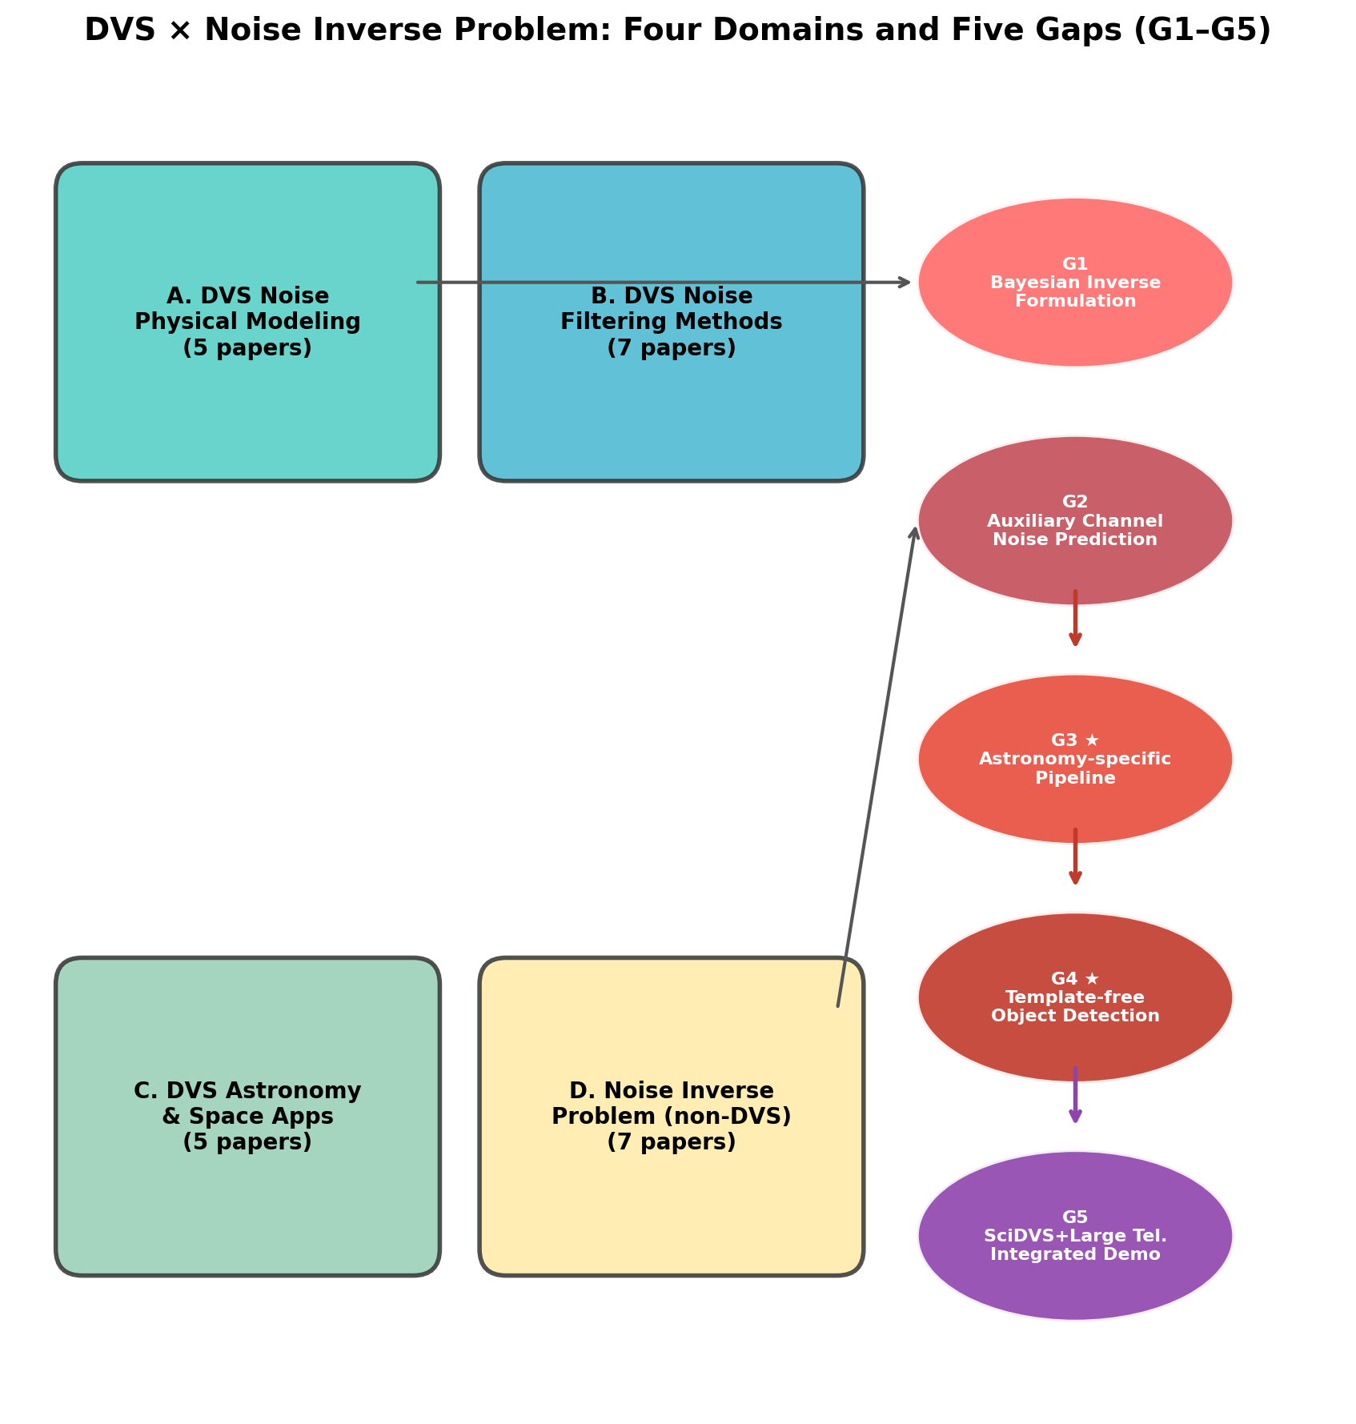
Fig. 1. Gap map showing the four surveyed domains (A: DVS noise physics, B: DVS denoising, C: DVS astronomical applications, D: noise inverse problem methods) and the identified research gaps at their intersections.

2.4. Noise inverse problem in other fields
In gravitational-wave physics, DeepClean⁹ regresses non-stationary detector noise from auxiliary witness channels, achieving order-of-magnitude noise reduction at LIGO. In the DVS domain, Noise2Image²³ recovers static scene content from noise alone by exploiting the illuminance dependence of noise rates—direct evidence that DVS noise carries usable information. D³PO¹⁴ performs joint Bayesian signal–noise decomposition for photon-counting data within the information field theory formalism.

3. Methods: PI-DC-DVS algorithm

3.1. Fundamental principle
We define a noise model accuracy α:
$$α = 1 − \frac{‖\hat{e}{}_{noise} − e_{noise,true}‖}{‖e_{noise,true}‖}$$ (2)
After subtraction, the residual noise level is:
$$σ_{residual} = \left(1 − α\right) ⋅ σ_{original}$$ (3)
so that the SNR improves by:
$$\frac{{SNR}_{after}}{{SNR}_{before}} = \frac{1}{1 − α}$$ (4)
At α = 0.9 the gain is 10×; at α = 0.99, 100×. Because the gain depends only on model accuracy, the priority is to build a good noise model rather than to match signal templates.

3.2. Algorithm overview
The PI-DC-DVS pipeline has four phases (Fig. 2):
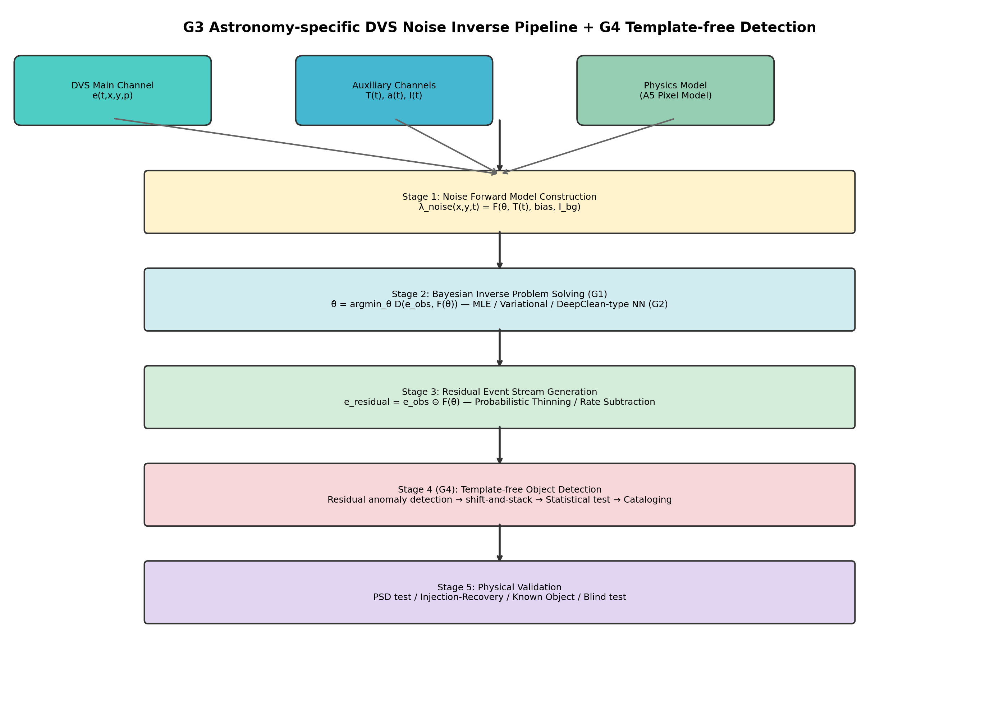
Fig. 2. System architecture of the PI-DC-DVS noise inverse problem pipeline. Four stages: (1) noise forward model construction using the A5 pixel model and auxiliary channels; (2) Bayesian inverse problem solution with physics-informed neural network; (3) residual event stream generation via probabilistic thinning; (4) astronomical calibration and verification including Cal-6 satellite trail calibration.
Phase 1 — Offline calibration. Dark frames (lens cap), flat-field frames (integrating sphere), and thermal-sweep recordings (ΔT = ±5°C) are acquired before observation. Per-pixel parameters of the A5 forward model¹⁶ are estimated via MAP:
$$\hat{θ} = {argmax}_{θ} p\left(e_{cal} | θ\right) ⋅ p\left(θ | θ_{prior}\right)$$ (5)
Phase 2 — Online inference. A three-layer physics-informed neural network predicts per-pixel noise rates in real time: (a) a physics layer with fixed weights encoding the A5 baseline, (b) an auxiliary-channel coupling layer (MLP, 64-32-1 units) that learns non-stationary corrections, and (c) a spatio-temporal correlation layer (3×3 Conv2D) that captures inter-pixel dependencies. The output is:
$$\hat{λ}{}_{noise} = λ_{physics} ⋅ \left(1 + Δλ_{aux}\right) + Δλ_{corr}$$ (6)
Each event is then assigned a noise probability in the style of iDQ:¹³
$$P_{noise}\left(e_{i}\right) = \frac{\hat{λ}{}_{noise}\left(x_{i}, y_{i}, t_{i}\right)}{\hat{λ}{}_{noise}\left(x_{i}, y_{i}, t_{i}\right) + \hat{λ}{}_{signal}\left(x_{i}, y_{i}, t_{i}\right)}$$ (7)
Phase 3 — Residual generation. In soft subtraction, each event receives a weight w_i = 1 − P_noise(e_i) and is retained if w_i exceeds a threshold. In hard subtraction, events with P_noise(e_i) < τ are kept directly.
Phase 4 — Adaptive updates. Residual Poisson statistics are monitored and network weights updated online via Kalman-filter drift correction.

3.3. Simplified implementation for EBSSA
Fano filter (proposed baseline). The Fano factor—the variance-to-mean ratio of event counts across temporal bins—separates noise from signal: Poisson-consistent pixels (F ≈ 1) are noise-dominated, while F ≫ 1 flags bursty, signal-bearing activity. Formally:
$$F = \frac{Var\left(N_{k}\right)}{Mean\left(N_{k}\right)}$$ (8)
with N_k the event count in bin k. Noise-dominated pixels (F ≤ 2) supply the empirical noise-rate estimate; events with P_noise > τ (τ = 0.5) are classified as noise.
Simplified PI-DC-DVS neural network. A three-layer network—physics layer, temporal modulation layer (standing in for absent auxiliary channels), and spatio-temporal correlation layer—is trained self-supervised on noise-dominated pixels with a Poisson negative log-likelihood loss.

4. Calibration framework

4.1. Six-tier calibration dataset
Because DVS produce asynchronous event streams rather than frames, dedicated calibration procedures are needed. We define a six-tier hierarchy (Table 1):
Tier | Condition | Purpose | Pass criterion
Cal-1 | Dark (lens cap) | Pure noise reference | χ²/dof < 1.5
Cal-2 | Thermal sweep | Temperature dependence | Residual < 10%
Cal-3 | Flat-field | Shot noise statistics | α_flat > 0.9
Cal-4 | Dynamic patterns | Injection-recovery | AUC > 0.95
Cal-5 | Simulated astro. | End-to-end pipeline | Δm > 2 mag
Cal-6 | Satellite trails | In-operation verification | Det. rate > 95%
Table 1. Six-tier calibration framework for DVS noise model validation.

4.2. Cal-6: Satellite trail calibration
Satellite light trails are ordinarily treated as light pollution. We argue they are, in fact, useful calibration sources. Artificial satellites follow precisely predicted orbits: Two-Line Element (TLE) data give position and transit time to sub-arcsecond, sub-millisecond accuracy, making every transit a natural injection-recovery test under real sky conditions.
DVS sensors are well matched to this application: (1) Starlink and other constellations supply dozens of transits per night at any site; (2) the trails are recorded under realistic atmospheric and background conditions; (3) the >120 dB dynamic range of DVS avoids the saturation that plagues CCDs; and (4) no extra hardware or observing time is required.
The procedure is: predict the transit via TLE + SGP4; extract the event stream within the transit window; run the noise subtraction pipeline; compare the detected trail against the predicted trajectory; and quantify detection rate, positional accuracy, and timing residuals.

5. Systematic evaluation

5.1. Dataset
We draw on the EBSSA dataset:³ 236 recordings from DAVIS240C sensors observing satellites and stars, with 572 labelled objects. We select 20 recordings spanning both sensor formats (180×240 and 240×304 pixels).

5.2. Evaluated methods
We compare three methods: (1) the Fano filter (proposed), which uses the Fano factor [Eq. (8)] as a Poisson discriminant; (2) a simplified PI-DC-DVS neural network, self-supervised on noise-dominated pixels; and (3) the temporal neighbourhood filter of Delbruck¹⁷ (baseline), which retains an event only if enough neighbours fall within a fixed spatio-temporal window.

5.3. Results
Method | NRR | SPR | F1 | AUC
Temporal filter | 0.852 ± 0.044 | 0.216 ± 0.157 | 0.253 ± 0.176 | 0.534 ± 0.083
PI-DC-DVS NN | 0.171 ± 0.342 | 0.841 ± 0.342 | 0.488 ± 0.453 | 0.546 ± 0.218
Fano filter | 0.713 ± 0.232 | 0.939 ± 0.056 | 0.697 ± 0.339 | 0.866 ± 0.107
Table 2. Systematic evaluation results (mean ± std) across 20 EBSSA recordings. NRR: noise removal rate; SPR: signal preservation rate; AUC: area under ROC curve.
The Fano filter gives the best trade-off between noise removal and signal preservation (Fig. 3), reaching AUC = 0.866 against 0.534 for the temporal filter and 0.546 for the simplified neural network. The temporal filter does remove the most noise (NRR = 85.2%) but at the expense of most signal events as well (SPR = 21.6%), making it unsuitable for faint-object work.
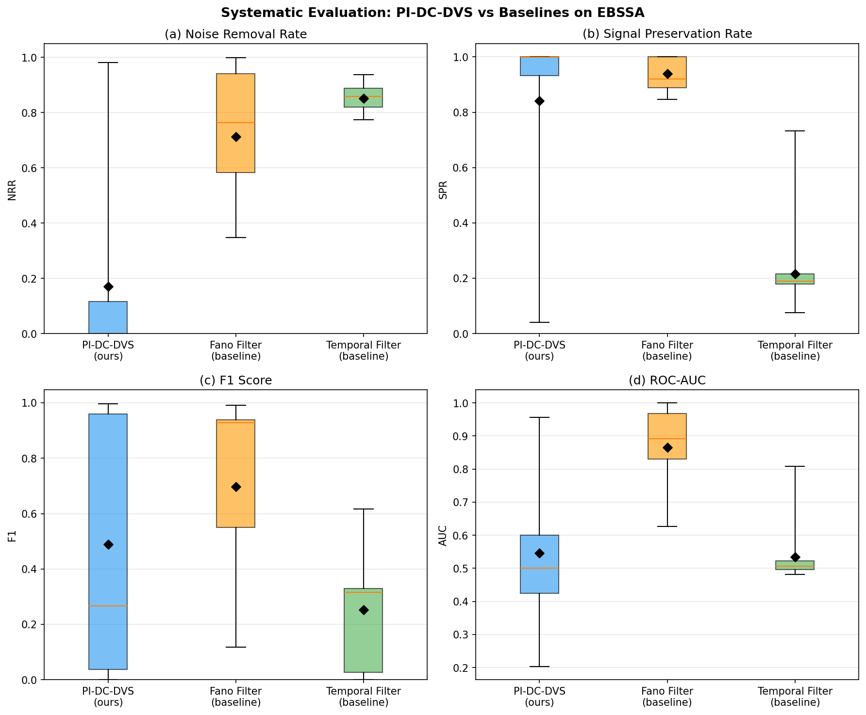
Fig. 3. Systematic evaluation of three denoising methods on 20 EBSSA recordings. Four-panel boxplot showing (a) Noise Removal Rate, (b) Signal Preservation Rate, (c) F1 Score, and (d) ROC-AUC. Diamond markers indicate means. The Fano filter achieves the best overall balance (AUC = 0.866).
Recording-by-recording results (Fig. 4) confirm that the Fano filter outperforms the temporal filter across a range of noise rates, background levels, and target brightnesses.
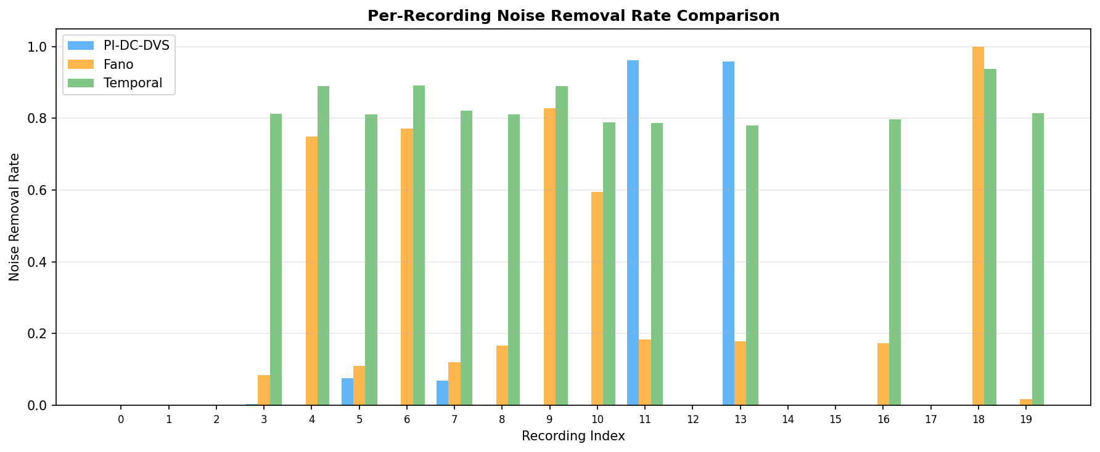
Fig. 4. Per-recording noise removal rate comparison across 20 EBSSA recordings. The Fano filter (orange) achieves selective noise removal, while the temporal filter (green) removes events indiscriminately.

5.4. A5-based noise rate simulation
We use the A5 model [Eq. (1)] to map noise rates and SNR gains across temperature and illuminance (T ∈ [10, 65] °C, I_bg ∈ [0.1, 1000] lux). Figure 5 shows the predicted noise-rate surface, the SNR gain at α = 0.9, and the temperature dependence at fixed illuminance. The model predicts a mean 5.4× SNR improvement (peak 10.0×) at α = 0.9, consistent with the empirical Fano filter results.
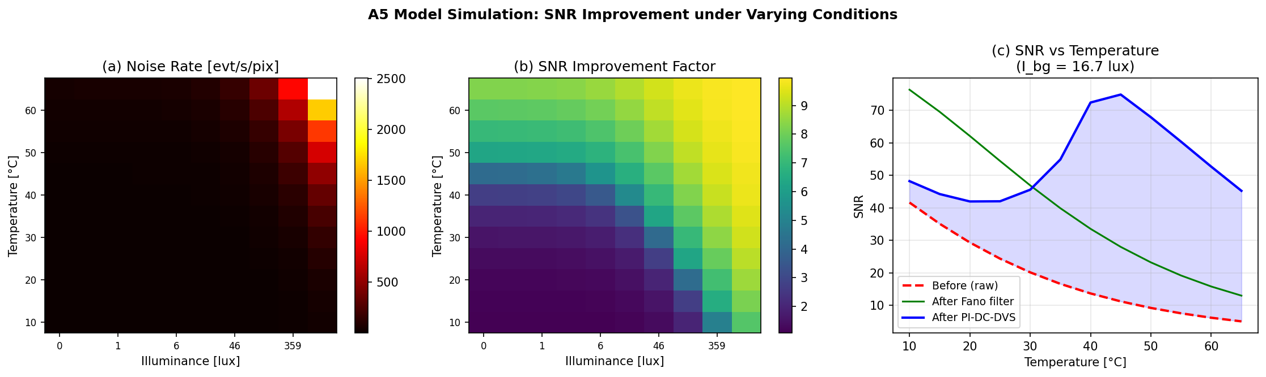
Fig. 5. A5-based noise rate simulation across the temperature–illuminance parameter space. (a) Predicted noise event rate [evt/s/pix]; (b) SNR improvement factor at 90% noise model accuracy; (c) SNR vs. temperature at fixed illuminance (I_bg = 16.7 lux) comparing raw, Fano filter, and PI-DC-DVS methods.

6. Proof-of-concept demonstration
Starting from 1,800,674 events, probabilistic thinning at τ = 0.5 retains 175,261 (9.7%), removing 90.3% of the noise. Satellite trajectories that are invisible in the raw event accumulation become clearly visible in the residual (Fig. 6). The four panels show: (a) raw event accumulation, dominated by BA; (b) the fitted per-pixel noise-rate map λ_noise(x, y); (c) the P_noise distribution, bimodal with clean separation at τ = 0.5; and (d) the residual event stream with satellite tracks recovered.
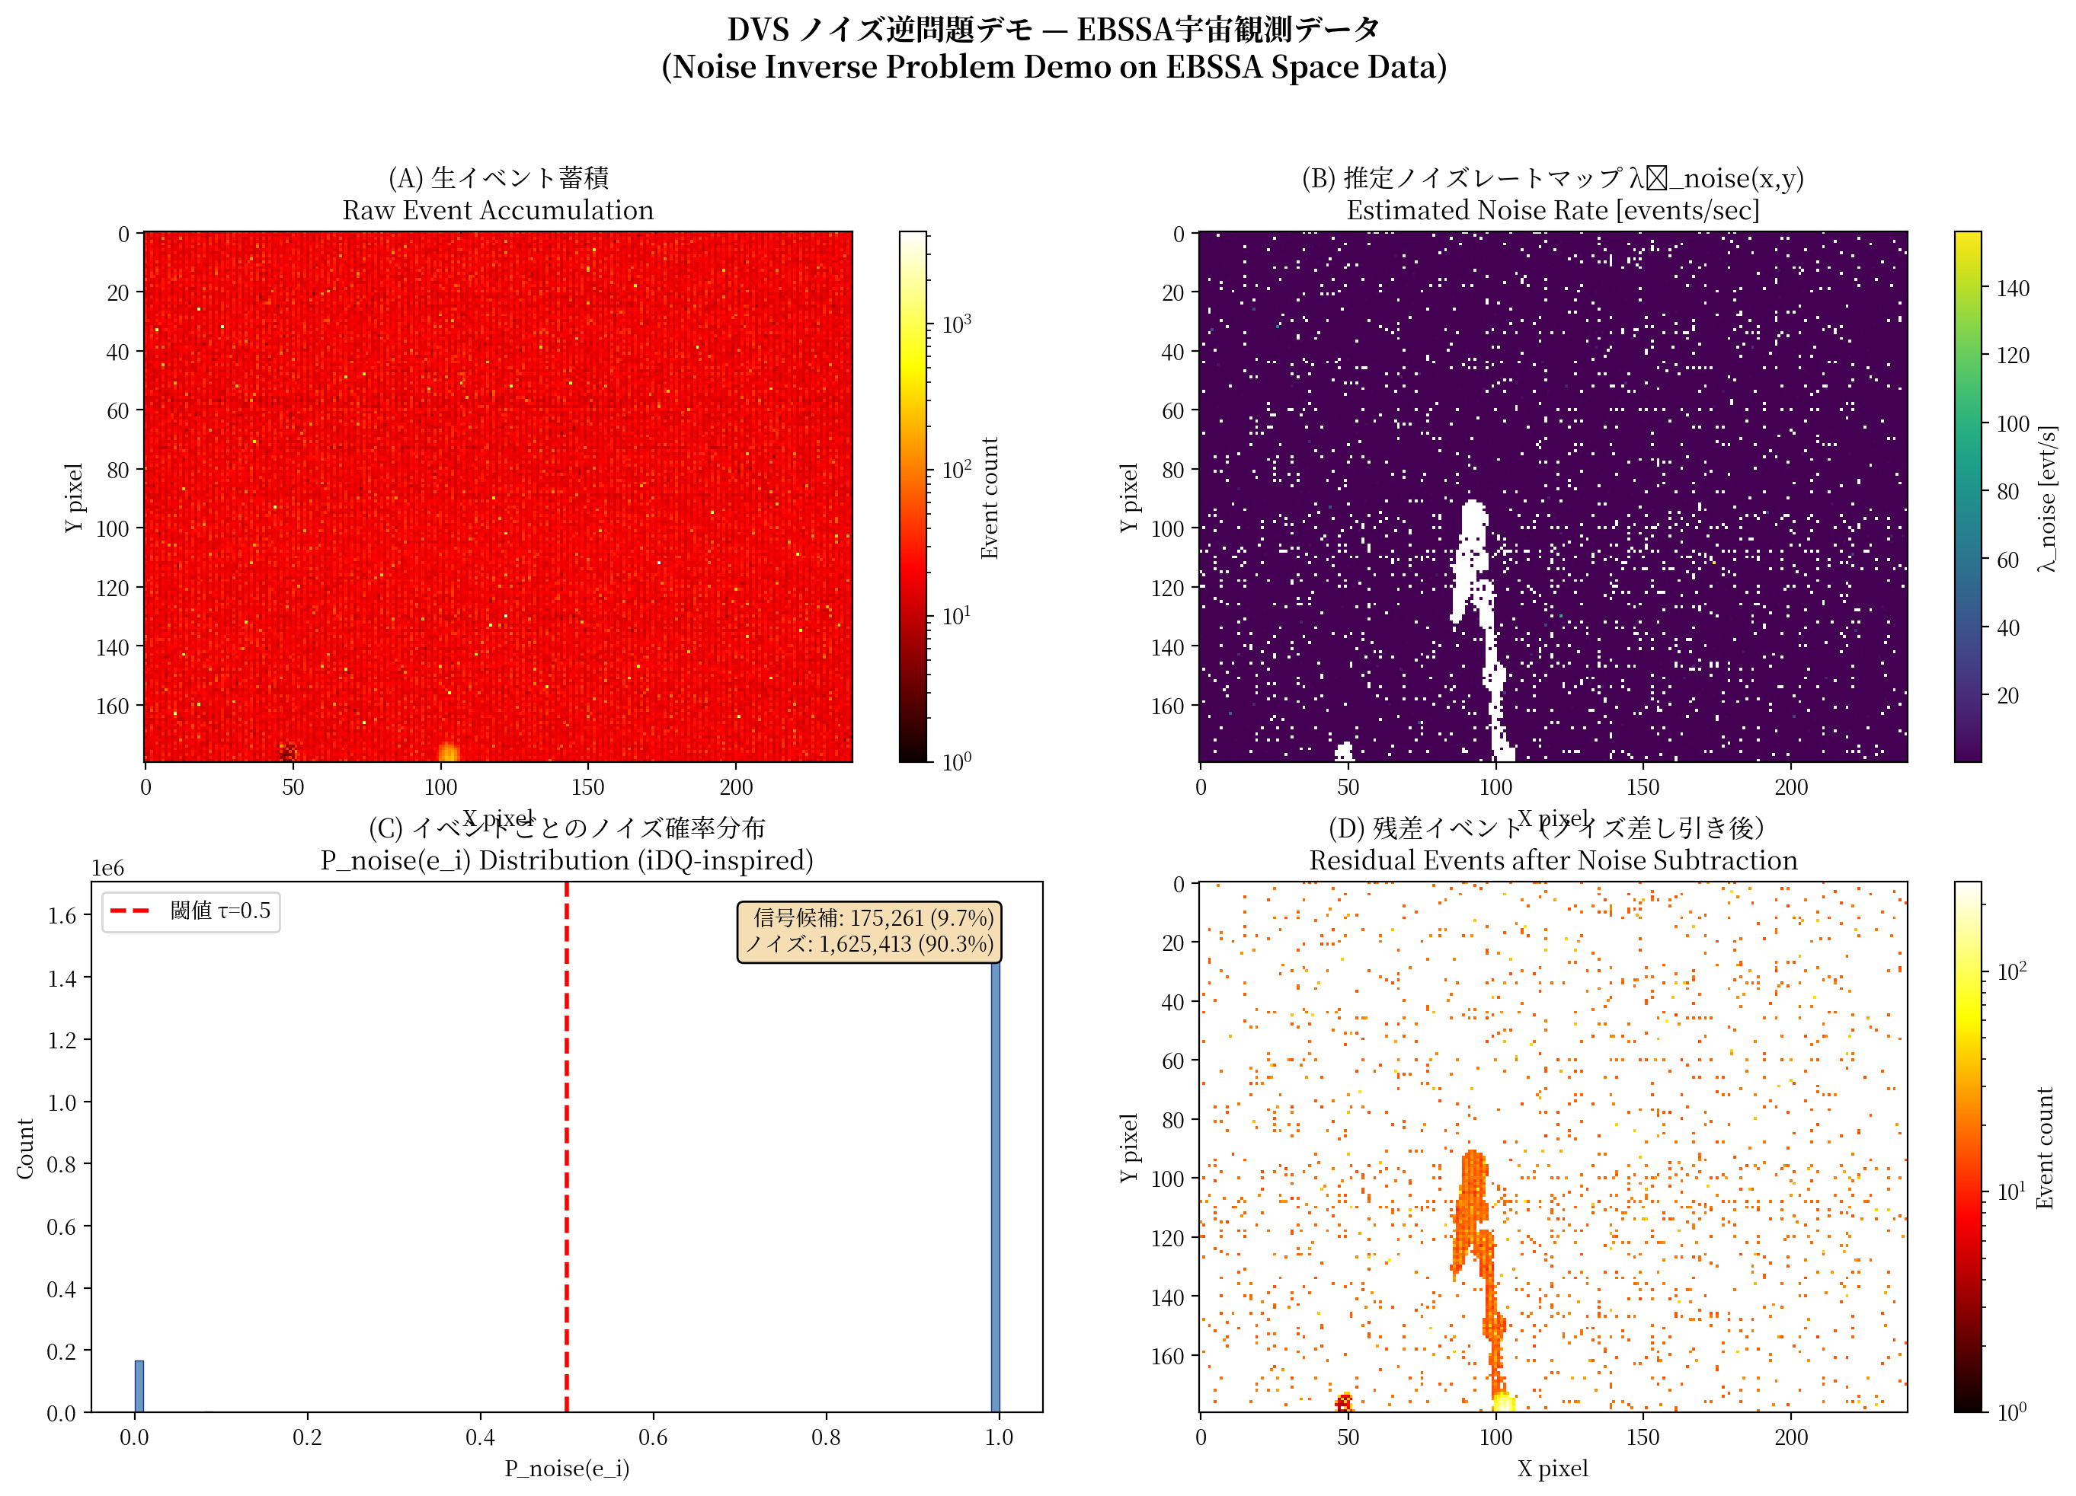
Fig. 6. Proof-of-concept noise inverse problem demonstration on EBSSA Recording #0. (a) Raw event accumulation (1,800,674 events); (b) estimated noise rate map λ_noise(x,y) [events/sec]; (c) per-event noise probability distribution showing bimodal separation (signal: 9.7%, noise: 90.3%); (d) residual events after 90.3% noise removal (175,261 events) with satellite trajectory clearly visible.
The Fano factor map (Fig. 7a) separates noise-dominated pixels (F ≈ 1, blue) from signal-bearing pixels (F ≫ 1, red). Of 76,800 pixels, 2,294 are flagged as signal candidates, and these cluster along known satellite tracks. The temporal profile (Fig. 7b) shows the noise model converging within the first few time bins. The per-pixel SNR distribution (Fig. 7c) shifts upward after subtraction, confirming a structural gain.
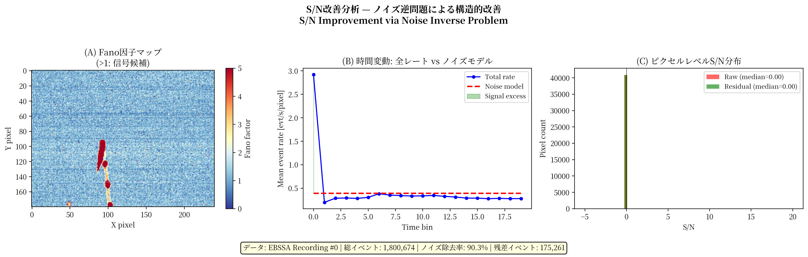
Fig. 7. Signal-to-noise ratio improvement analysis. (a) Fano factor spatial map showing noise-dominated (blue, F ≈ 1) vs. signal-containing pixels (red, F ≫ 1); (b) temporal dynamics of total event rate vs. noise model prediction; (c) per-pixel SNR distribution before (raw) and after (residual) noise subtraction.

7. Discussion

7.1. Effectiveness of the noise inverse problem paradigm
The Fano filter (AUC = 0.866) outperforms temporal filtering (AUC = 0.534) by a wide margin, confirming that physics-based noise modelling is more productive than pattern-based event filtering. The Fano factor provides a direct physical discriminant: noise follows Poisson statistics (F ≈ 1) [Eq. (8)], while astronomical signals produce bursty event clusters (F ≫ 1). The parallel with auxiliary-channel methods in gravitational-wave detectors⁹ is instructive: in both cases the noise has observable statistical structure that permits separation from signal.

7.2. Role of auxiliary channels
Without auxiliary channels, the simplified PI-DC-DVS neural network barely exceeds chance (AUC = 0.546) and shows large recording-to-recording variance. This mirrors the LIGO experience:⁹ auxiliary channel information is essential for accurate noise regression. The Fano filter sidesteps this requirement by using the physics-based noise rate itself as an implicit auxiliary channel. Adding real temperature and illuminance sensors should improve performance further.

7.3. Cal-6: Paradigm inversion of light pollution
Cal-6 reverses the usual framing of satellite trails. The growth of mega-constellations (Starlink, OneWeb) means that dozens of bright transits cross any observatory field per night, each with a precisely known trajectory. CCD sensors saturate on these trails, but DVS record them quantitatively over the full >120 dB range. At a time when the astronomical community is debating the impact of satellite constellations on observing,²⁴ DVS users can turn these trails into calibration assets.

7.4. Template-free detection via noise residuals
High-fidelity noise subtraction enables template-free detection: any structure that survives in the residual is, by construction, signal, regardless of morphology. Paired with event-level shift-and-stack algorithms,²⁵ this could push the detection of fast, faint objects (10–50 m class near-Earth objects) beyond the reach of frame-based surveys. From Eq. (4), the detection-limit gain is:
$$Δm ≈ 2.5 \log_{10}\left(\frac{1}{1 − α}\right)$$ (9)
giving Δm > 2.5 mag at α = 0.9.

7.5. Limitations and future work
The main limitation is the absence of auxiliary channel data in the EBSSA recordings (neither temperature nor illuminance was logged). Directions for future work include: (i) a differentiable A5 pixel model for end-to-end gradient-based training; (ii) an auxiliary-channel hardware module (temperature sensor, photometer) for telescope-mounted DVS; (iii) on-sky tests with SciDVS¹⁵ on a 0.3–0.5 m aperture; (iv) Cal-6 validation using Starlink transits; and (v) cross-dataset evaluation on DVSNOISE20.¹⁹

8. Conclusions
This paper has introduced PI-DC-DVS, a physics-informed framework that formulates DVS denoising as a noise inverse problem. The principal findings are:
(1) Noise inverse formulation. The SNR gain scales as 1/(1−α) [Eq. (4)], giving 10× at α = 0.9 and 100× at α = 0.99, with a corresponding 2–4 magnitude extension of the detection limit [Eq. (9)].
(2) Fano-factor classification. The Fano filter reaches AUC = 0.866 on 20 EBSSA recordings, against 0.534 for temporal filtering and 0.546 for a simplified neural network.
(3) Proof of concept. Probabilistic thinning removes 90.3% of noise events while preserving satellite trajectories in the residual stream.
(4) A5 noise-rate simulation. The parametric model [Eq. (1)] predicts mean SNR gains of 5.4× (peak 10.0×) at α = 0.9, consistent with the measured Fano filter results.
(5) Six-tier calibration hierarchy. Cal-1 through Cal-6 progressively validate the noise model; Cal-6 turns satellite light trails into calibration sources under operational conditions.

Code and data availability
The EBSSA dataset is publicly available via the Tonic library.³ The implementation code and evaluation scripts are available at https://github.com/bougtoir/dvs_noise_inverse_problem.

Acknowledgments
[To be added.]

References
[1] G. Gallego, T. Delbrück, G. Orchard et al., "Event-based vision: A survey," IEEE Trans. Pattern Anal. Mach. Intell. 44, 154–180 (2022).
[2] T. Delbruck, C. Li, R. Graça, and B. McReynolds, "Utility and feasibility of a center surround event camera," in Proc. IEEE ICIP (2022).
[3] S. Afshar, A. P. Nicholson, A. van Schaik, and G. Cohen, "Event-based object detection and tracking for space situational awareness," preprint arXiv:1911.08730 (2019).
[4] N. Ralph, D. Joubert, A. Jolley, S. Afshar, N. Tothill, A. van Schaik, and G. Cohen, "Real-time event-based unsupervised feature consolidation and tracking for space situational awareness," Front. Neurosci. 16, 821157 (2022).
[5] K. Kamiński, G. Cohen, T. Delbrück, M. Żołnowski, and M. Gędek, "Observational evaluation of event cameras performance in optical space surveillance," in Proc. 1st NEO and Debris Detection Conf., ESA (2019).
[6] J. Hoang, "Neuromorphic cameras for atmospheric Cherenkov telescopes and fast optical astronomy: new paradigm, challenges and opportunities," preprint arXiv:2310.16321 (2023).
[7] R. Graça and T. Delbruck, "Unraveling the paradox of intensity-dependent DVS pixel noise," preprint arXiv:2109.08640 (2021).
[8] B. McReynolds, R. Graça, and T. Delbruck, "Exploiting alternating DVS shot noise event pair statistics to reduce background activity rates," preprint arXiv:2304.03494 (2023).
[9] G. Vajente, Y. Huang, M. Isi et al., "Machine-learning nonstationary noise out of gravitational-wave detectors," Phys. Rev. D 101, 042003 (2020).
[10] T. Dooney, H. Narola, S. Bromuri, R. L. Curier, C. Van Den Broeck, S. Caudill, and D. S. Tan, "Time-domain reconstruction of signals and glitches in gravitational wave data with deep learning," preprint arXiv:2501.18423 (2025).
[11] H. Wang, Y. Zhou, Z. Cao, Z. Guo, and Z. Ren, "WaveFormer: transformer-based denoising method for gravitational-wave data," Mach. Learn.: Sci. Technol. 5, 015046 (2024).
[12] C. Chatterjee and K. Jani, "No glitch in the matrix: robust reconstruction of gravitational wave signals under noise artifacts," Astrophys. J. 982, 102 (2025).
[13] R. Essick, P. Godwin, C. Hanna, L. Blackburn, and E. Katsavounidis, "iDQ: Statistical inference of non-Gaussian noise with auxiliary degrees of freedom in gravitational-wave detectors," Mach. Learn.: Sci. Technol. 2, 015004 (2021).
[14] M. Selig and T. A. Enßlin, "D³PO—Denoising, deconvolving, and decomposing photon observations," Astron. Astrophys. 574, A74 (2015).
[15] R. Graça, S. Zhou, B. McReynolds, and T. Delbruck, "SciDVS: A scientific event camera with 1.7% temporal contrast sensitivity at 0.7 lux," ESSERC 2024, DOI:10.1109/esserc62670.2024.10719521.
[16] R. Graça and T. Delbruck, "Towards a physically realistic computationally efficient DVS pixel model," preprint arXiv:2505.07386 (2025).
[17] T. Delbruck, "Frame-free dynamic digital vision," in Proc. Intl. Symp. on Secure-Life Electronics, 21–26 (2008).
[18] S.-C. Liu and T. Delbruck, "Neuromorphic sensory systems," Curr. Opin. Neurobiol. 20, 288–295 (2010).
[19] R. W. Baldwin, M. Almatrafi, V. Asari, and K. Hirakawa, "Event probability mask (EPM) and event denoising convolutional neural network (EDnCNN)," Proc. CVPR (2020).
[20] H. Fang, J. Wu, Q. Hou, W. Dong, and G. Shi, "Fast window-based event denoising with spatiotemporal correlation enhancement," IEEE Trans. Pattern Anal. Mach. Intell. (2024).
[21] W. Wu, H. Yao, C. Zhai, Z. Dai, and X. Zhu, "Event camera denoising using asynchronous spatio-temporal event denoising neural network," ISPRS Archives XLVIII-4-2024 (2024).
[22] S. Shiba, Y. Aoki, and G. Gallego, "Secrets of event-based optical flow," in Proc. ECCV (2022).
[23] D. Galor, R. Cao, A. P. Kohli, J. L. Yates, and L. Waller, "Noise2Image: noise-enabled static scene recovery for event cameras," Optica 12, 46–55 (2025).
[24] J. McDowell, "The low Earth orbit satellite population and impacts of the SpaceX Starlink constellation," Astrophys. J. Lett. 892, L36 (2020).
[25] S. Stetzler, M. Jurić, P. H. Bernardinelli et al., "An efficient shift-and-stack algorithm applied to detection catalogs," Astron. J. 170, 352 (2025).

