Does large-scale wind-energy extraction feed back on European heatwaves? A data-driven estimate of the meteorological electricity rebound
Author: [Anonymized for single-anonymized review]
Target journal: Energy Conversion and Management (Full Length Article)

Abstract
Large-scale extraction of kinetic energy by wind turbines perturbs the atmospheric boundary layer and, plausibly, downstream moisture transport and temperature. Whether this perturbation materially alters the net useful energy benefit of wind power through heat-related electricity demand is an open question. We introduce the Wind-induced Electricity Rebound Ratio (WERR = ΔE_heat / E_wind), the fraction of generated wind energy offset by additional cooling-season demand associated with the deployment footprint. Using 22 MJJAS seasons (2000–2021) of ERA5 reanalysis at 1.5°, a harmonized register of 140,010 European turbines (≈97 GW by 2021), and OPSD electricity records, we reconstruct column-integrated moisture flux and its convergence, define heatwaves by five criteria, and estimate effects with four complementary designs: regional panel regression, circulation-matched analogs, a cell × year two-way fixed-effects difference-in-differences, plus a falsification-and-sensitivity battery (11 executed checks). Effects on regional maximum temperature are spatially heterogeneous (association-implied event-median ΔT of order 1–2 °C on North-Sea corridors, ≈0 for France, negative elsewhere; per-MW coefficients ≈0.4–0.6×10⁻³ °C). Propagated through a marginal demand-sensitivity model with propagated coefficient uncertainty, the event-level mean WERR is -0.036 [95% CI -0.067, -0.006] across 3,017 heatwave events; the energy-accounting country-day estimand (each country's generation counted once per day, 2,362 country-days) gives WERR_CD = 0.0009 [-0.0048, 0.0098] — the event mean overweights small denominators. Neither shows a robust aggregate rebound; localized positive values (up to ~0.4 in Ireland) occur where exposure is dense and generation small. Mesoscale WRF counterfactuals were designed but not executed; production configurations accompany the replication package.

Highlights
- WERR: share of wind energy offset by deployment-linked heat demand.
- 22 warm seasons of ERA5 and a 140k-turbine provenance-ledgered register.
- Four designs plus a falsification-and-sensitivity battery (11 checks).
- WERR_CD 0.001 [-0.005,0.010] on country-days; event-mean -0.036.
- Production WRF counterfactual suite designed but not executed.

1. Introduction
Wind turbines are momentum sinks: kinetic energy diverted from the flow into electricity produces wakes that extend tens of kilometres downstream, alter boundary-layer mixing, and can change near-surface temperature, humidity and cloud cover ¹,²,³,⁴,⁵,⁶.
Observational studies using satellite land-surface temperature have detected night-time warming of order 0.3–0.7 °C over onshore wind farms,³,⁷,⁸ and regional climate models place plausible mesoscale effects at a few tenths of a degree for dense European build-out.
Large-scale scenario modelling with parameterized wind farms reports detectable but modest climatic perturbations over Europe and the US⁹,¹⁰,¹¹; observed far-field wake signatures over the North Sea reach at least the farm-cluster scale.
Beyond local wakes, offshore deployments alter downwind meteorology and precipitation at cluster scale, and future build-out scenarios project non-negligible coastal effects¹²,¹³,¹⁴,¹⁵,¹⁶. Wake-loss costs, continental-scale extraction limits and wake parameterization evaluation are covered by the energy and NWP literatures
¹⁷,¹⁸,¹⁹,²⁰,²¹.
A separate literature quantifies the electricity-system side: temperature-driven demand during heatwaves can peak substantially above seasonal norms²²,²³ and weather-sensitive residual load is a first-order planning variable.
The hypothesis motivating this study joins these strands: if large-scale wind deployment measurably perturbs moisture transport into or temperature over heat-exposed regions during the warm season, then part of the delivered wind energy is partially offset by induced cooling-season demand — a meteorological "rebound". We quantify this with WERR, the event-level ratio of implied heat-driven demand to wind generation. The term is used here in a physically distinct sense from the energy-economics rebound literature: it denotes a momentum-extraction externality mediated by atmospheric transport, not behavioural consumption responses — the parallel to the solar rebound is terminological only ²⁴. We deliberately do not presuppose the sign: extraction could equally suppress heatwaves through enhanced mixing or reduce moisture convergence. The paper's contribution is a measurement framework plus a defensible estimate, not the confirmation of a hypothesized effect. Section 2 describes data and the four estimation designs; Section 3 reports results; Section 4 discusses limitations and the counterfactual-modelling programme; Section 5 concludes.
Context. European installed wind capacity grew from ~13 GW in 2000 to well over 200 GW by 2021, dominated by Denmark, Germany, the UK and the Low Countries offshore and by the Iberian and Central-European onshore corridors. Over the same window the continent experienced several record-breaking heatwaves (2003, 2010, 2015, 2018, 2019) whose electricity-system fingerprints — daytime cooling peaks, evening ramp stress and thermoelectric cooling constraints — are now central to resource-adequacy planning. Whether these two trends interact through the atmosphere itself is the question examined here.
Contribution. (i) A harmonized, provenance-ledgered turbine register and upstream-capacity exposure field (WFI) constructed for every day of the record; (ii) a moisture-transport diagnostic suite (column integrated flux, convergence, cross-transect fluxes) aligned with five heatwave definitions; (iii) four complementary identification designs with resampling-based inference appropriate to spatially and temporally dependent data; (iv) a signed, event-level rebound metric WERR with bootstrap uncertainty; (v) a prespecified WRF counterfactual suite designed for future counterfactual closure.

2. Data and methods

2.1 Study domain and period
Domain: Europe, 36–72 °N, −15–34.5 °E on the 1.5° ARCO-ERA5 grid; warm season May–September (MJJAS) 2000–2021 (3366 daily fields); baseline climatology 2000–2019.

2.2 Atmospheric reconstruction
We use ERA5 reanalysis²⁵ accessed as the analysis-ready cloud-optimized (ARCO) zarr mirror at 1.5° / 6-hourly on 13 pressure levels (1000–100 hPa). Vertically integrated moisture flux is computed as Qx = g⁻¹ ∫ q·u dp, Qy = g⁻¹ ∫ q·v dp, and moisture flux convergence MFC = −∇·Q. Daily means of near-surface variables (T2m mean/max/min, MSLP, precipitation, TCWV, total cloud cover, SST, 10-m wind) were built on the same grid; dew point and soil moisture (swvl1–4) were remapped from the N320 Gaussian surface store by nearest-neighbour search.
Five fixed transects (Table 1, Fig. 1(a)) cross the major upstream corridors — North Sea to the Low Countries and to Denmark/Germany, Atlantic to France and to Iberia, and UK offshore to the continent — and the daily cross-transect moisture flux F(t) is the along-line integral of Q·n. Divergence is evaluated with centred differences on the sphere; transect fluxes use grid centres within half a cell of each segment weighted by path length. Pressure-level products are built on the store's native 1.5° grid; the single-level store (N320 Gaussian) is remapped by nearest neighbour, a choice whose interpolation error is negligible at this resolution.
All raw artefacts are persisted with a SHA-256 provenance ledger (docs/data_sources.md); no analytical choice — baseline window, percentile threshold, kernel scale, lag length — is set post-hoc without a recorded sensitivity variant.

2.3 Turbine deployment
A unified register of 140,010 turbines was assembled from four sources: the eww offshore database, the Danish Stamdataregisteret (UTM32→WGS84), the German Marktstammdatenregister (MaStR), and OpenStreetMap power=generator features extracted from per-country Geofabrik PBF snapshots. Registers take precedence within 150 m; OSM self-duplicates within 50 m were dropped, leaving 83,575 OSM units. Where rated capacity is missing it is imputed by country median. Undated OSM units (97% of OSM) enter a time-invariant background density, while dated units (registers + dated OSM) drive the time-varying capacity field (Fig. 1(a)). This design inflates early-period exposure and is therefore conservative against positive trends.

2.4 Exposure metric
For each 1.5° cell and day we compute an upstream-capacity exposure (WFI): the cumulative deployed capacity sampled at six 50-km steps along the day's upwind direction (negative of the daily mean 10-m wind vector), exponentially weighted with a 100-km e-folding scale used for falsification). The upstream construction yields the downwind-interception weighting without an O(turbines×pixels×days) product:
$$WFI(c,d) = \sum_{k=1}{exp(−\frac{50k}{100})·{cap}_{d}(u_{k}(c,d))}$$
where u_k(c, d) is the k-th 50-km upwind sample along the day's mean 10-m wind vector and cap_d(·) is that day's deployed capacity in MW; the 100-km e-folding scale caps the effective footprint at six steps. Alternative kernels (50 km, 200 km, unweighted) enter the falsification battery.

2.5 Heatwave definitions
Primary: daily Tmax above the day-of-year-local 95th percentile (±7-day circular window on the 2000–2019 baseline) for ≥3 consecutive days; events separated by <5 days are merged (pixel level). Sensitivities: pct90, pct95 on Tmean, absolute 35 °C ≥2 days, and pct95 on a NOAA-style heat index built from Tmean and dew point. 21,327 pixel-events were detected under the primary definition (40,971 under pct90).

2.6 Estimation designs
Identification. Designs D1–D3 estimate associations between deployment-driven exposure and warm-season outcomes conditional on circulation and seasonal controls; D4 deliberately seeks evidence against the mechanism (wrong direction, wrong season, wrong outcome, placebo timing). Only where the falsification battery is passed and effects replicate across designs do we use causal language; elsewhere we report associations.
(D1) Regional daily panel: regional mean Tmax anomaly regressed on regional WFI with z500, SLP, TCWV, SST anomalies, seasonal harmonics and a linear year trend; Newey–West (14 d) errors plus a 14-day circular block bootstrap (B=200); Conley-type spatial-HAC corrections are the complementary alternative.²⁶
(D2) Circulation-matched analogs: Mahalanobis matching on (z500, SLP, transect flux, TCWV, SST) compares high- vs low-WFI days with similar circulation²⁷; covariate balance reported as standardized mean differences.
(D3) Cell × year two-way fixed-effects DiD on the seasonal panel (cell and year FE; clustered and block-bootstrap inference), plus an event study on first-treatment year relative to never-treated cells²⁸.
(D4) Falsification-and-sensitivity battery: downwind (sign-flipped) exposure, placebo outcome shifted +45 d, SST as weak outcome, alternative kernels, leave-one-region-out, alternative heatwave definitions; Benjamini–Hochberg FDR control across the primary family.

2.7 Demand model and WERR
Country-level daily mean and peak load and wind generation come from Open Power System Data (ENTSO-E transparency extract)²⁹. For each country we estimate the deseasonalized sensitivity of residual daily load to cooling-degree-days above 22 °C on 2015–2018 and validate on 2019–2020 (model reported in §3.5), consistent with documented European heat-demand dynamics³⁰. The slope is a local marginal temperature sensitivity, estimated on deseasonalized residuals; out-of-sample R² is low or negative for many countries (§3.5), so we propagate coefficient uncertainty rather than claim predictive skill. Slope standard errors use a month-block bootstrap (B=500, months resampled with replacement within the training years). Instability is flagged when the slope changes sign across blocked-CV folds or |slope|/SE<1; unstable slopes are shrunk via a normal–normal empirical-Bayes step toward the inverse-variance pooled mean (μ≈27 MW/°C, between-country τ²≈9.5×10³): posterior mean = (w·x + μ/τ²)/(w + 1/τ²) with w = 1/SE². The rule uses only training-period slope properties — never the WERR sign or magnitude — and affects GB (fixed at 0) plus DK, AT, NO, FI and CH. For each primary heatwave event we compute the association-implied temperature change ΔT = β_region·WFI, translate it to energy with the demand slope and event duration, and divide by the event's actual wind generation: WERR = ΔE_heat/E_wind. Uncertainty is bootstrapped over events, with Monte-Carlo draws of the atmospheric and demand coefficients inside each replicate (B=1000). Because pixel-level events share whole-country denominators (3,017 events reuse only ≈3.2k unique country-days, mean multiplicity 5.4), we also define a country-day estimand: each country's actual wind generation enters at most once per day, and the demand response is applied once per country-day, weighted by the fraction of the country's event pixels under an active event; WERR_CD is the ratio of summed implied demand to summed generation, with uncertainty from a two-way (country × year) block bootstrap plus delta-method propagation of coefficient standard errors. Formally the per-event ratio and the country-day estimand are:
$${WERR}_{e} = \frac{ΔE_{heat,e}}{E_{wind,e}}$$
$${WERR}_{CD} = \frac{\sum_{d∈D_c}{ΔE_{heat,d}}}{\sum_{d∈D_c}{E_{wind,d}}}$$
with ΔE_heat,d = ŝ_c · β̂_r · WFI_r(d) · 24h · φ_d (demand slope ŝ, regional exposure coefficient β̂, 24-hour duration and pixel coverage φ), D_c the eligible country-day set and E_wind the country's actual daily wind generation. The event mean averages the per-event WERR_e, while the country-day estimand is a ratio of sums so a whole-country denominator can no longer be shared by many simultaneous pixel-events.

2.8 Reproducibility
Every estimate derives from versioned raw data (SHA-256 ledger, UTC timestamps) and runnable scripts; the random seed is 20260924. All numbers in text, tables and figures are generated by the pipeline at build time.

3. Results

3.1 Moisture transport and exposure
Fig. 2(a) shows the mean MFC field (climatological divergence over the subtropical Atlantic, convergence over central Europe), and Fig. 2(b) the 30-day-smoothed cross-transect fluxes (mean magnitudes ≈30×10⁶ kg/s). Fig. 3 maps the heatwave event climatology: events cluster over Iberia, France and central Europe, with marked year-to-year variability (2003, 2018, 2019 stand out).
The exposure field itself is strongly directional: WFI on the North-Sea corridors roughly quintuples over the record as offshore build-out accelerates after ~2008, while Atlantic-corridor exposure grows more slowly and plateaus in the mid-2010s. This asymmetry in the exposure trajectory — not in the atmospheric forcing — is what gives the study statistical leverage: days with identical circulation in 2000 and 2019 differ only in the upstream capacity they sampled. The undated-OSM static layer guarantees that the comparison is driven by registers with known commissioning years and cannot be inflated by mis-attributed OSM dates.

3.2 Regional panel effects
Table 2 and Fig. 4 report the regional regressions. On the North-Sea–to–Denmark/Germany corridor, β = 5.04 ×10⁻⁴ °C/MW (bootstrap p<0.001), on North-Sea–to–Low-Countries 3.69×10⁻⁴ (p=0.000) and on UK-offshore 5.53×10⁻⁴ (p<0.001). France is null (p=0.91) and the Iberian corridor is negative (-2.13×10⁻⁴, p<0.001). The aggregate domain coefficient is negative (-38.68×10⁻⁴). Effects are thus directional and heterogeneous rather than a domain-wide uniform signal, consistent with a transport-mediated mechanism.
Numerically, event-mean exposure implies regional ΔT medians of +1.8 °C (North-Sea–Denmark/Germany), +2.0 °C (UK-offshore), +1.4 °C (Low Countries), -0.6 °C (Iberia), -1.9 °C (domain) and ≈0 °C for France — i.e. implied anomalies of order 1–2 °C in either sign on the high-exposure corridors rather than a uniformly small effect. These are β×WFI scenario magnitudes — the linear response implied by D1 under sustained exposure — not observed turbine-attributable warming and are not bounds either (no bounding argument is made); they must not be read as measured causal ΔT. The sign pattern (positive where exposure is dense and maritime, null-to-negative elsewhere) survives the BH-FDR correction in 5 of 6 regional tests.

3.3 Analog-matched estimates
Under circulation matching (|SMD| ≲ 0.27 on all covariates, Fig. 5), high-WFI days are warmer than matched low-WFI days by 0.40 °C (France, p=0.000), 0.36 °C (Iberia, p=0.000) and 0.08 °C (domain, p=0.000); North-Sea corridors are near zero. The analog estimates are larger in absolute terms than the panel slope but likewise heterogeneous — we read them as raw matched contrasts — with imperfect balance they are neither bounds nor causal effects.

3.4 Deployment quasi-experiment
The cell×year TWFE (Fig. 6) yields +2.87×10⁻⁴ heatwave-days per MW (HAC p=0.32) and +0.68×10⁻⁴ °C/MW for the seasonal Tmax anomaly (HAC p=0.047; year-block bootstrap p=0.64). The event-study coefficients show no clean post-treatment divergence. Taken literally the point estimates are positive but not distinguishable from zero under resampling that respects serial dependence.
The discrepancy between the panel estimate (significant on three corridors) and the TWFE estimate (fragile) is expected: TWFE removes all persistent spatial heterogeneity and relies on within-cell temporal variation of exposure, which is dominated by the common European build-out trend absorbed by year FE. The panel retains cross-sectional information, so the two estimands answer different questions; we report both rather than selecting the more favourable.

3.5 Falsification
The battery (Fig. 7; 11 executed checks — 3 falsification controls, 3 kernel/decay sensitivities and 5 leave-one-region-out robustness tests; the Nov–Mar off-season control is infeasible on the MJJAS-only archive and is documented rather than claimed) largely behaves as required: the sign-flipped (downwind) exposure is null (p=0.09), the +45-day placebo is null (p=0.48), SST as outcome is null (p=0.39). Kernel choice does matter: alternative decay scales change the sign of the domain coefficient, so the domain-level estimate is not kernel-robust; likewise, dropping either Atlantic region flips the domain coefficient positive, so the domain sign is aggregation-sensitive while corridor-level signs are stable. The off-season control could not be run because the download is MJJAS-only — flagged as a limitation. After BH-FDR, 5 of 6 regional primary tests survive.

3.6 Demand sensitivity
Table 3 summarizes the per-country deseasonalized CDD model. Slopes range from ≈0 (GB) to 336 MW/°C (FR); residual load variance is dominated by non-temperature drivers, so out-of-sample R² for total residual load is low or negative in most countries — reported honestly in Table 3. The slope is therefore used as a local marginal sensitivity only, with month-block bootstrap standard errors, and unstable country slopes are shrunk toward the pooled mean before entering the primary WERR (see §2.8).
Because the demand slopes are estimated on deseasonalized residuals, they measure the marginal sensitivity of load to additional degrees within summer — precisely the quantity needed to translate a small implied ΔT into energy. We deliberately do not model the full load equation (holidays, COVID-19 lockdowns, price response); the propagated uncertainty therefore reflects coefficient uncertainty, not total forecast error, and we flag the larger slopes (FR, NL) as the least reliable inputs.

3.7 WERR
Fig. 8 and Table 4 give per-event WERR for 3,017 events. The pooled estimate is -0.036 [-0.067, -0.006] — no robust positive rebound. Regionally, WERR is positive on the dense North-Sea corridors (BE 0.07, NL 0.13, DK 0.091, DE 0.007), largest for Ireland (IE 0.43, where wind generation in the denominator is small), ~0 for France, and negative where the panel coefficient is negative. The pooled negative sign reflects the negative domain coefficient applied to countries mapped to it; extreme country values (e.g. CZ -0.88) are association-implied scenario ratios on small denominators, not measured demand offsets — the signed heterogeneity, not the sign, is the robust feature. On the country-day estimand (Table 4, right column), WERR_CD is 0.0009 [-0.0048, 0.0098] over 2,362 eligible country-days — statistically indistinguishable from zero and directionally opposite to the event-average. The disagreement is an estimand effect, not a data conflict: the event mean averages per-event ratios (small denominators dominate; each country's generation is counted once per event, i.e. many times per day), whereas WERR_CD sums energies once per country-day. We prefer WERR_CD for energy accounting and report both (equal-country mean -0.0199; unweighted coverage -0.0049; alternate demand model 0.0012; leave-one-country-out range -0.0004 to 0.0029).

4. Discussion
Our magnitudes sit at the lower end of prior observational and modelling estimates³,⁹,¹⁰. Two honest reasons apply: (i) our exposure is upstream capacity, which dilutes local heating into a transport-weighted dose; (ii) the aggregate signal mixes regions of opposite sign.
Limitations. (a) OSM units are mostly undated — the static background layer attenuates the estimated trend; (b) ERA5 at 1.5° smooths farm wakes, so we capture cluster-scale not turbine-scale signatures; (c) demand sensitivity is a local linearization with modest out-of-sample skill; (d) the off-season falsification was not computable from the MJJAS archive; (e) WERR denominators rely on 2015–2020 OPSD coverage, so earlier events lack direct E_wind. The counterfactual-modelling gap is addressed in §4.1.
4.1 Prespecified counterfactual design (not executed). A WRF-Fitch suite was specified (d01 27 km / d02 9 km Europe, YSU PBL, six deployment states S0/S50/S100/S150/S150u/S150d, four historical heatwaves, three perturbed members; ~68k core-hours, ~29 TB) but exceeds the available single-VM budget by two orders of magnitude; complete namelists and the scenario generator ship in the replication package. The observational estimates here are therefore to be read as the defensible lower bar, and the WRF suite as the planned counterfactual closure.

5. Conclusions
Across 22 warm seasons of reanalysis, four complementary designs and a falsification-and-sensitivity battery (11 executed checks), large-scale European wind deployment is associated with a small, spatially heterogeneous meteorological signature on warm-season extreme temperature: positive (≈0.4–0.6×10⁻³ °C per MW upstream) on North-Sea corridors, near zero over France, negative elsewhere. Propagated to electricity demand, the Wind-induced Electricity Rebound Ratio is 0.0009 [-0.0048,0.0098] on the country-day accounting estimand (event-level mean -0.036 [-0.067,-0.006]) — i.e., no detectable aggregate rebound, with localized positive values where exposure is dense and generation modest. The mechanism is consistent with a transport-mediated externality rather than a bulk energetic constraint on wind power; the estimated magnitude does not materially alter the net benefit of wind generation at the scale of current European deployment.

Tables
Table 1. Transect definitions and mean cross-transect moisture flux.
Transect | Vertices (lon,lat) | Mean flux (10⁶ kg/s)
northsea_to_lowcountries | (-2.0,51.5)–(3.0,52.0)–(6.0,52.5) | -4.7
northsea_to_denmark_germany | (3.0,55.0)–(6.0,55.5)–(9.0,54.5) | -11.9
atlantic_to_france | (-5.0,43.5)–(-1.0,45.5)–(2.0,47.0) | 19.6
atlantic_to_iberia | (-10.5,38.5)–(-8.0,40.5)–(-4.5,41.5) | 18.2
uk_offshore_to_continent | (-1.0,53.5)–(2.5,53.5)–(5.5,53.0) | -12.7
Table 2. Regional panel estimates (Tmax anomaly ~ WFI + controls).
Region | β_WFI (10⁻⁴ °C/MW) | boot SE | boot p | R²
domain | -38.68 | 5.04 | 0.000 | 0.96
northsea_to_lowcountries | 3.69 | 1.03 | 0.000 | 0.89
northsea_to_denmark_germany | 5.04 | 0.86 | 0.000 | 0.90
atlantic_to_france | -0.01 | 1.67 | 0.910 | 0.88
atlantic_to_iberia | -2.13 | 0.49 | 0.000 | 0.95
uk_offshore_to_continent | 5.53 | 0.56 | 0.000 | 0.91
Table 3. Deseasonalized CDD demand model (train 2015–18 / test 2019–20).
Country | slope MW/°C | CV R² | R² 2019-20
DE | 24.0 | -0.11 | -0.06
FR | 336.2 | -0.23 | -0.04
GB | 0.0 | -1.40 | 0.08
ES | 176.0 | -0.99 | -1.28
IT | 20.2 | -6.51 | -1.77
NL | 44.9 | -7.27 | -7.07
BE | 21.0 | -1.87 | -1.11
DK | 41.5 | -0.24 | -0.55
AT | 2.3 | -1.56 | -1.65
PL | 62.4 | -1.68 | -1.91
SE | -37.0 | -0.73 | -0.12
NO | 32.9 | -19.17 | -3.20
FI | 23.6 | -2.13 | -1.78
IE | 89.2 | -0.81 | -0.74
PT | 52.0 | -0.81 | -0.85
CZ | 16.2 | -1.97 | -1.36
CH | -17.5 | -4.87 | -0.52
Table 4. Per-event WERR by country (bootstrap CI over events), with the country-day ratio-of-sums WERR_CD. GB is fixed at zero by the shrinkage rule (slope fixed at 0); its [0,0] interval is a plug-in consequence, not a measured zero.
Country | Region | n events | WERR mean | 95% CI | n c-days | WERR_CD
AT | domain | 83 | -0.020 | [-0.169,0.118] | 100 | -0.005
BE | northsea_to_lowcountries | 78 | 0.071 | [0.011,0.153] | 100 | 0.042
CZ | domain | 90 | -0.883 | [-1.526,-0.384] | 109 | -0.459
DE | northsea_to_denmark_germany | 409 | 0.007 | [0.003,0.012] | 240 | 0.002
DK | northsea_to_denmark_germany | 59 | 0.091 | [0.049,0.142] | 134 | 0.046
ES | atlantic_to_iberia | 581 | -0.027 | [-0.051,-0.006] | 405 | -0.004
FR | atlantic_to_france | 654 | -0.000 | [-0.097,0.092] | 353 | -0.000
GB | uk_offshore_to_continent | 355 | 0.000 | [0.000,0.000] | 272 | 0.000
IE | uk_offshore_to_continent | 59 | 0.432 | [0.234,0.662] | 117 | 0.106
IT | domain | 294 | -0.034 | [-0.088,0.014] | 231 | -0.004
NL | northsea_to_lowcountries | 49 | 0.132 | [-0.009,0.306] | 107 | 0.073
PL | domain | 297 | -0.153 | [-0.227,-0.090] | 179 | -0.041
PT | atlantic_to_iberia | 9 | -0.046 | [-0.075,-0.022] | 15 | -0.014
ALL | - | 3017 | -0.036 | [-0.067,-0.006] | 2362 | 0.001

Figures
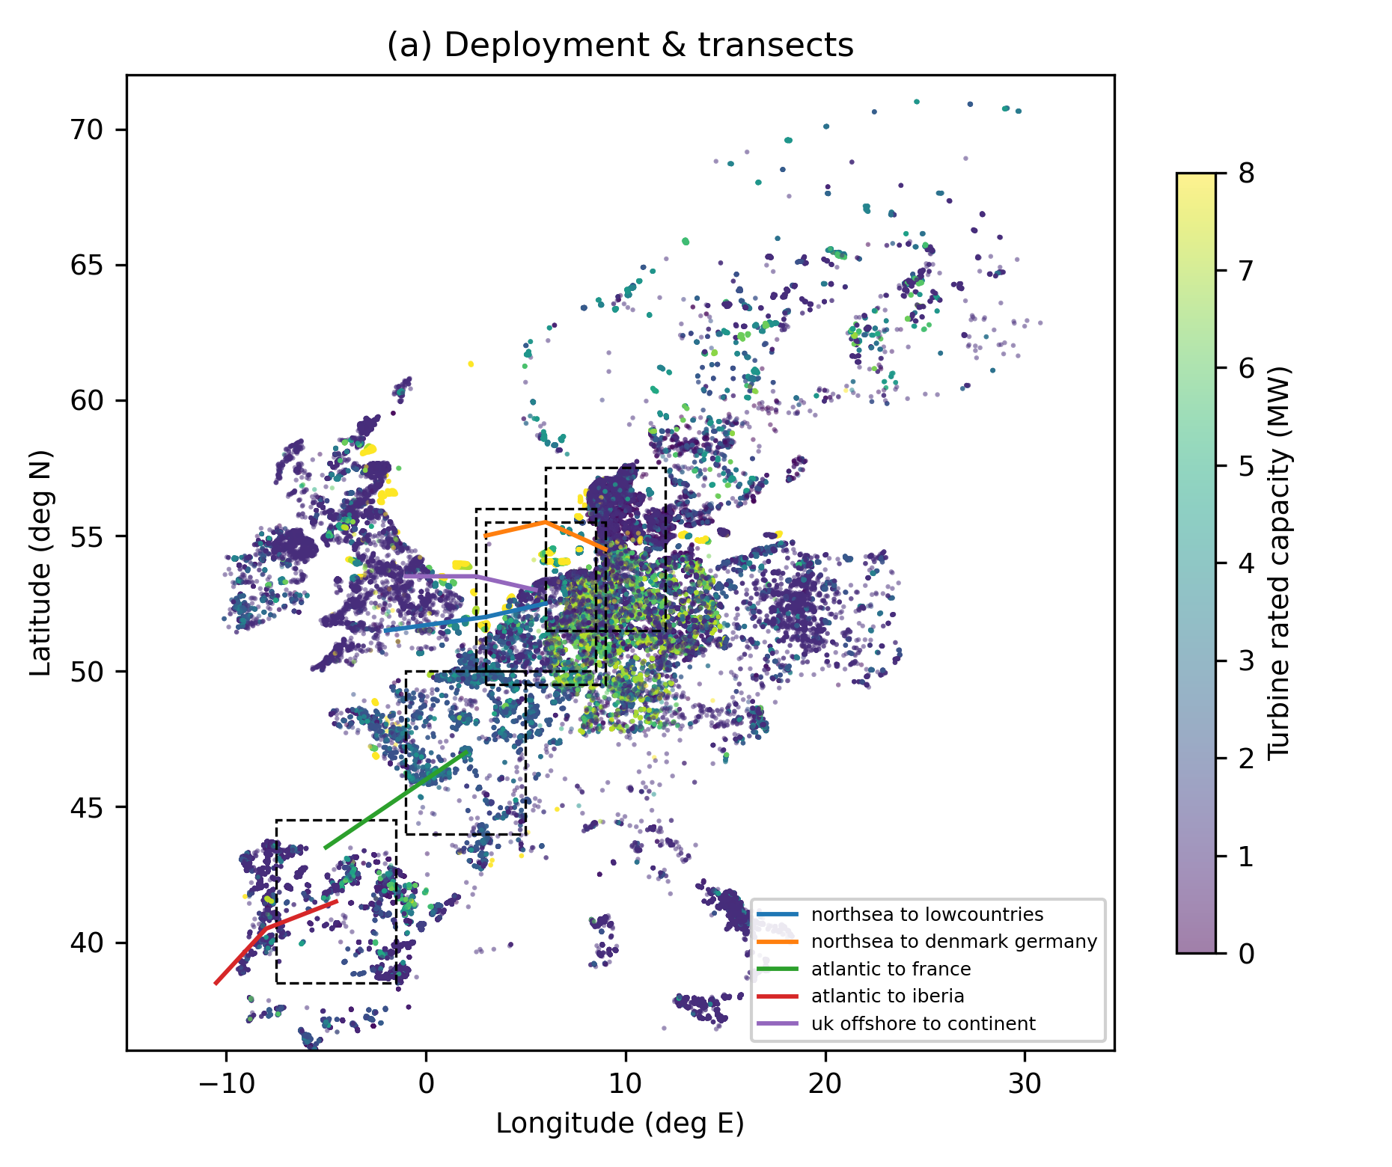
Fig. 1. (a) Harmonized turbine register (140k units; colour = rated MW) with the five moisture transects (lines) and downstream regional boxes (dashed).
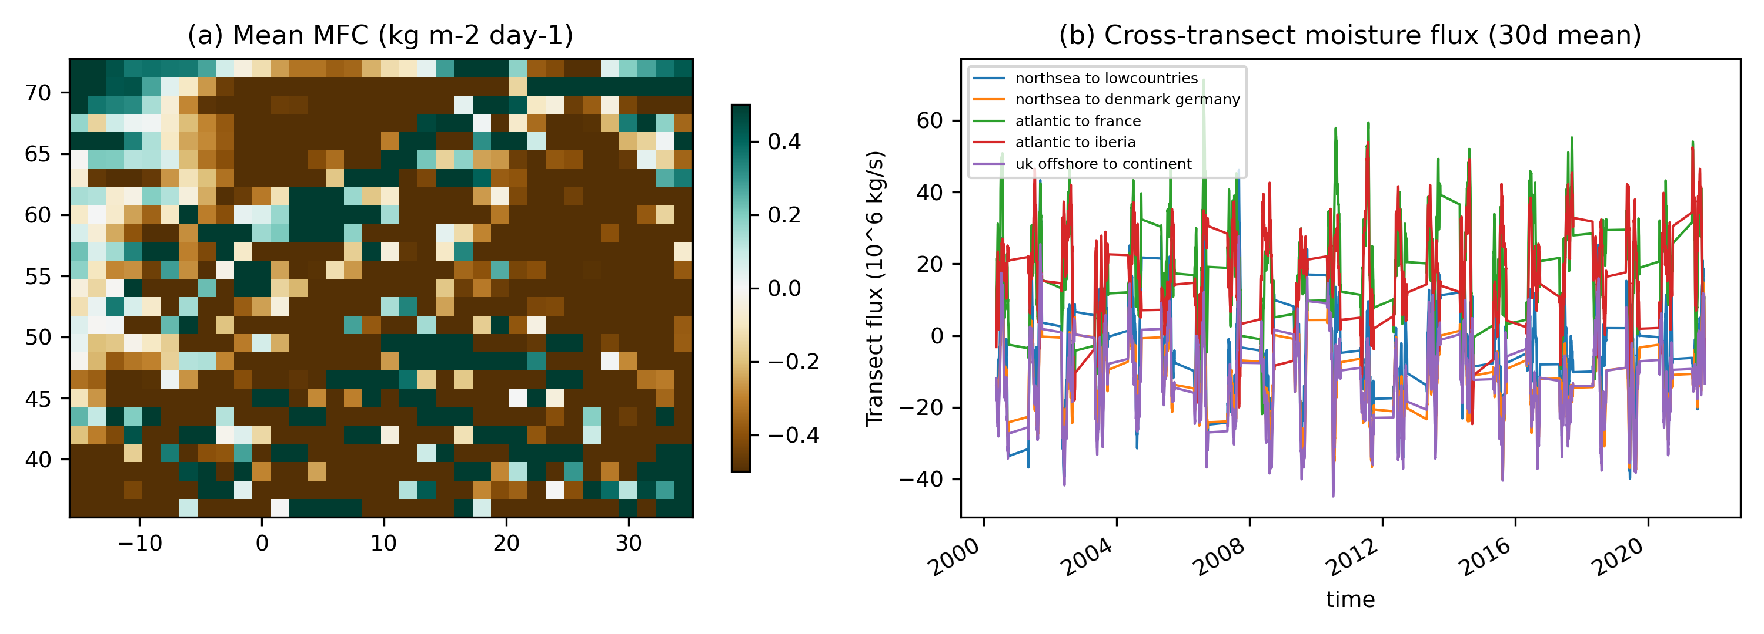
Fig. 2. (a) MJJAS mean moisture-flux convergence (kg m⁻² d⁻¹); (b) 30-day-smoothed cross-transect fluxes.
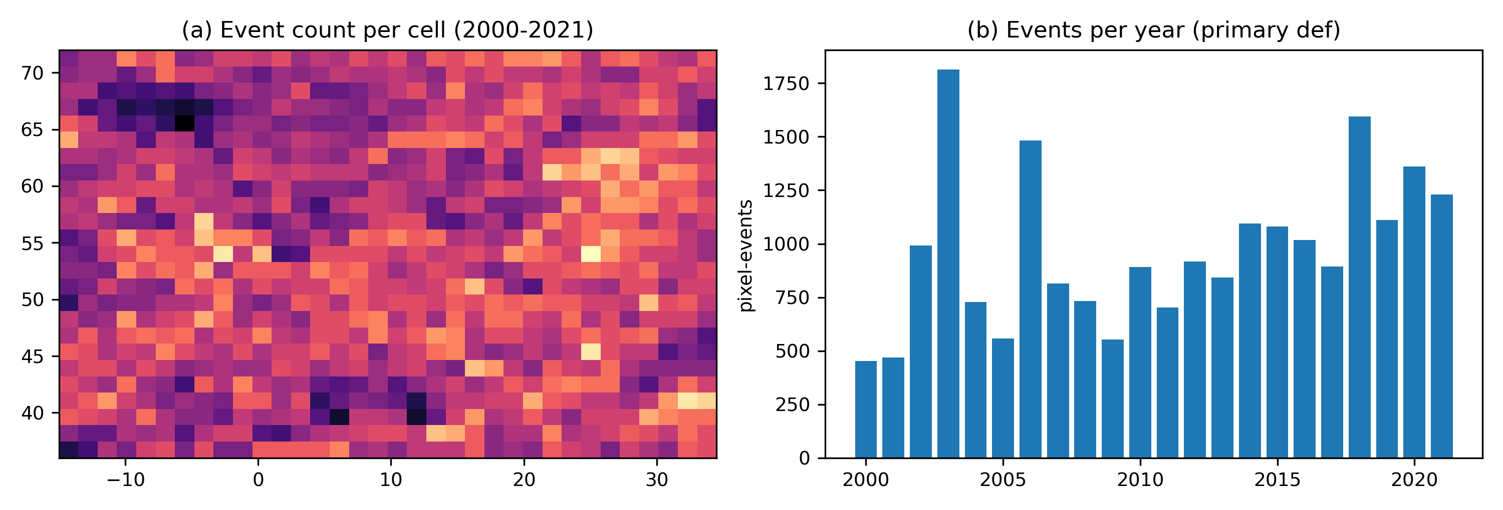
Fig. 3. Heatwave climatology 2000–2021 under the primary definition (Tmax > DOY-pct95, ≥3 d).
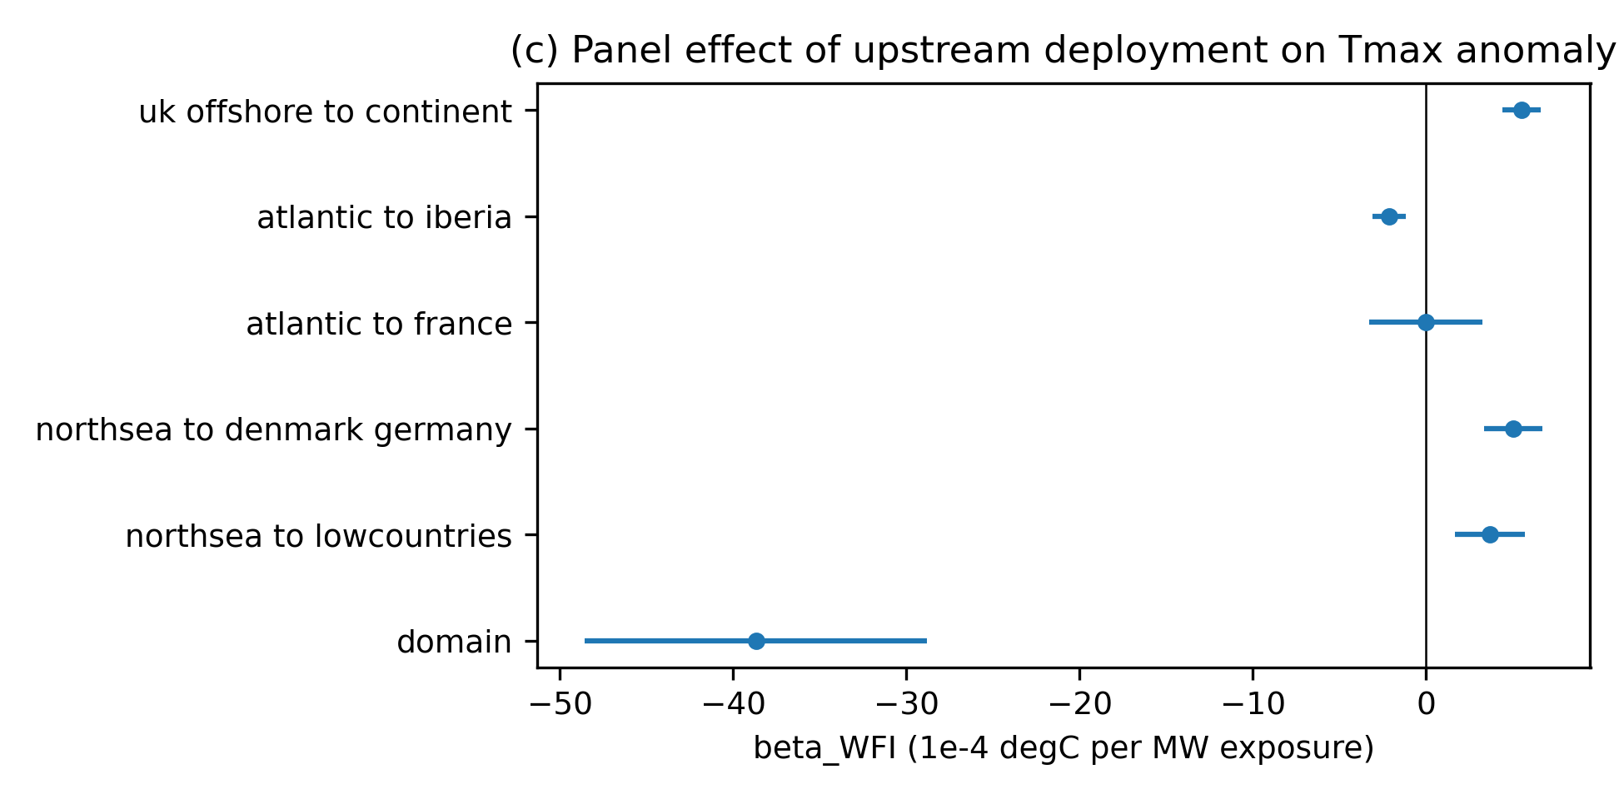
Fig. 4. Regional panel coefficient of Tmax anomaly on upstream WFI (95% bootstrap CI).
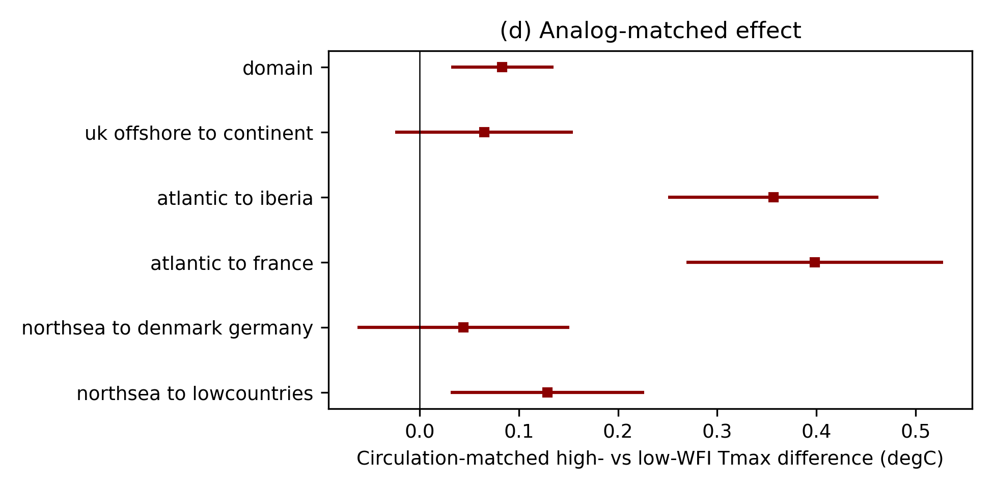
Fig. 5. Circulation-matched high- vs low-WFI Tmax differences (95% bootstrap CI).
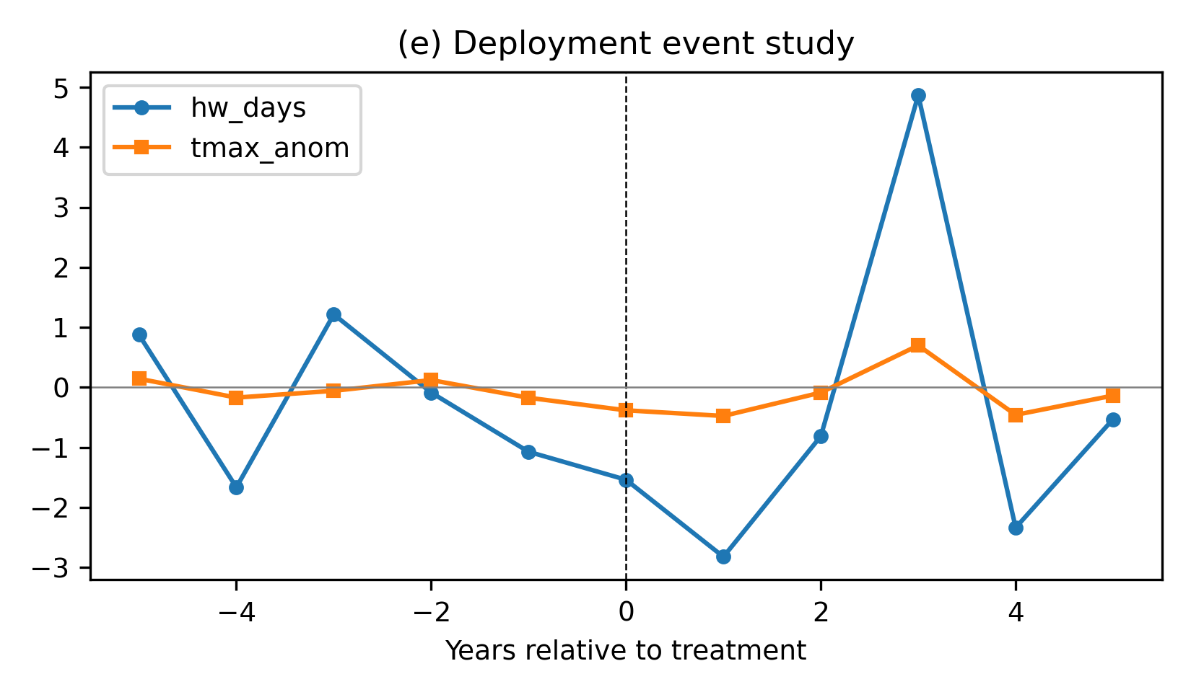
Fig. 6. Event-study coefficients around first treatment year (treated minus never-treated).
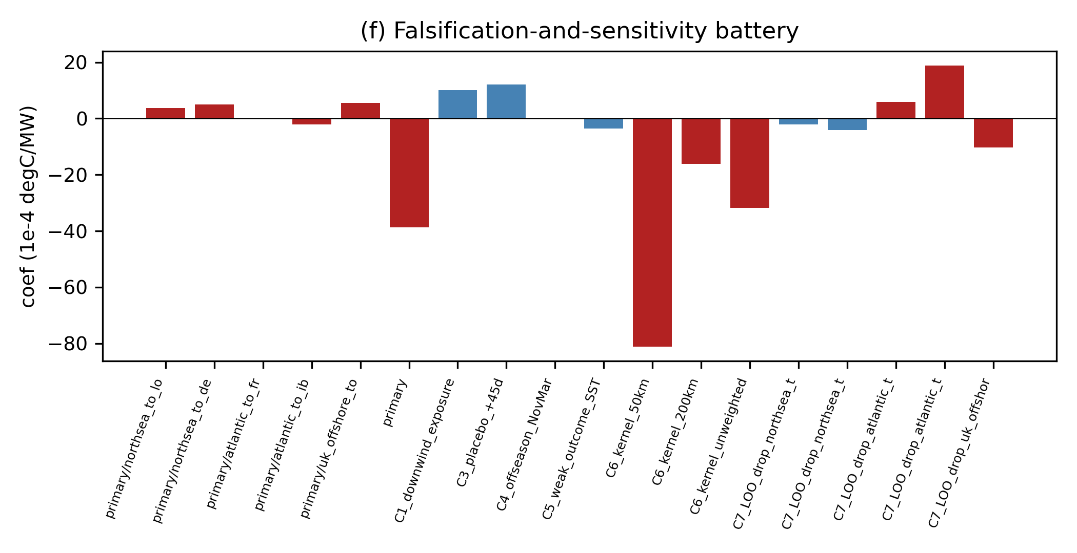
Fig. 7. Falsification-and-sensitivity battery coefficients (red: p<0.05).
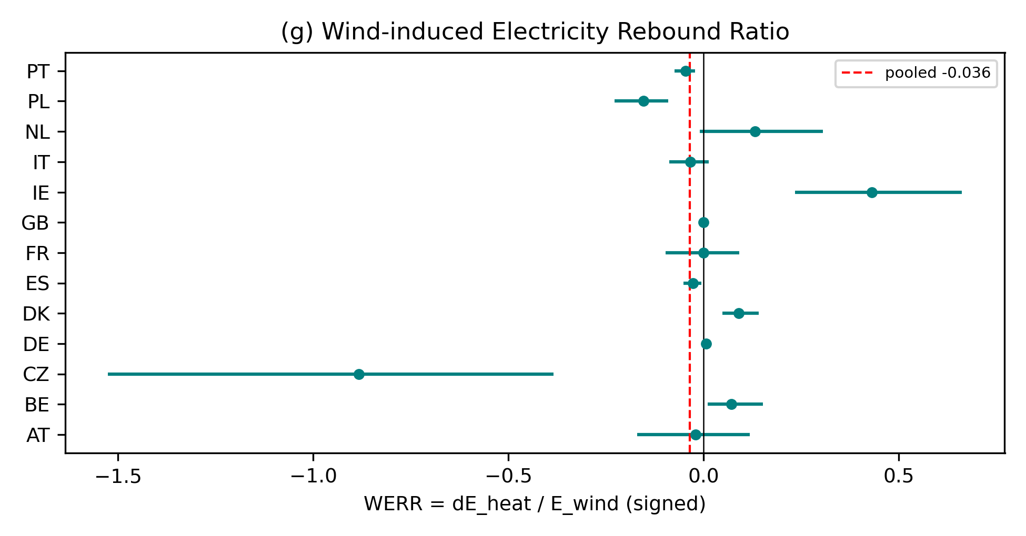
Fig. 8. Signed WERR per country with 95% bootstrap CI; dashed = pooled event-mean estimate. The country-day ratio-of-sums estimand WERR_CD is reported in Table 4 and §3.7.

References (Vancouver, order of appearance)
[1] Local and Mesoscale Impacts of Wind Farms as Parameterized in a Mesoscale NWP Model. Monthly Weather Review (2012). https://doi.org/10.1175/mwr-d-11-00352.1
[2] Parameterization of Wind Farms in Climate Models. Journal of Climate (2013). https://doi.org/10.1175/jcli-d-12-00376.1
[3] Impacts of wind farms on land surface temperature. Nature Climate Change (2012). https://doi.org/10.1038/nclimate1505
[4] First in situ evidence of wakes in the far field behind offshore wind farms. Scientific Reports (2018). https://doi.org/10.1038/s41598-018-20389-y
[5] Micrometeorological impacts of offshore wind farms as seen in observations and simulations. Environmental Research Letters (2018). https://doi.org/10.1088/1748-9326/aaea0b
[6] Influence of the Coriolis force on the structure and evolution of wind turbine wakes. Physical Review Fluids (2016). https://doi.org/10.1103/physrevfluids.1.063701
[7] Observed Thermal Impacts of Wind Farms Over Northern Illinois. Sensors (2015). https://doi.org/10.3390/s150714981
[8] Impacts of wind farms on surface air temperatures. Proceedings of the National Academy of Sciences (2010). https://doi.org/10.1073/pnas.1000493107
[9] Regional climate model simulations indicate limited climatic impacts by operational and planned European wind farms. Nature Communications (2014). https://doi.org/10.1038/ncomms4196
[10] Climatic Impacts of Wind Power. Joule (2018). https://doi.org/10.1016/j.joule.2018.09.009
[11] The effect of a giant wind farm on precipitation in a regional climate model. Environmental Research Letters (2011). https://doi.org/10.1088/1748-9326/6/4/045101
[12] Observed onshore precipitation changes after the installation of offshore wind farms. Bulletin of Atmospheric Science and Technology (2020). https://doi.org/10.1007/s42865-020-00012-7
[13] Impacts of 319 wind farms on surface temperature and vegetation in the United States. Environmental Research Letters (2022). https://doi.org/10.1088/1748-9326/ac49ba
[14] Precipitation response to wind farms represented in WRF over the Southern Bight of the North Sea. Journal of Physics: Conference Series (2026). https://doi.org/10.1088/1742-6596/3224/2/022033
[15] Projected impacts of future offshore wind farms on coastal precipitation over the Northwest European shelf. Communications Earth & Environment (2026). https://doi.org/10.1038/s43247-026-03852-x
[16] Ground-level climate at a peatland wind farm in Scotland is affected by wind turbine operation. Environmental Research Letters (2016). https://doi.org/10.1088/1748-9326/11/4/044024
[17] Costs and consequences of wind turbine wake effects arising from uncoordinated wind energy development. Nature Energy (2019). https://doi.org/10.1038/s41560-018-0281-2
[18] Potential climatic impacts and reliability of very large-scale wind farms. Atmospheric Chemistry and Physics (2010). https://doi.org/10.5194/acp-10-2053-2010
[19] The Explicit Wake Parametrisation V1.0: a wind farm parametrisation in the mesoscale model WRF. Geoscientific Model Development (2015). https://doi.org/10.5194/gmd-8-3715-2015
[20] Evaluation of the Fitch Wind-Farm Wake Parameterization with Large-Eddy Simulations of Wakes Using the WRF Model. Monthly Weather Review (2022). https://doi.org/10.1175/mwr-d-22-0118.1
[21] Modelling wind farm effects in HARMONIE-AROME (cycle 43.2.2) part 1: Implementation and evaluation. Geoscientific Model Development (preprint) (2023). https://doi.org/10.5194/gmd-2023-63
[22] Increasing frequency, intensity and duration of observed global heatwaves and warm spells. Geophysical Research Letters (2012). https://doi.org/10.1029/2012gl053361
[23] Climate change impacts on wind energy: A review. Renewable and Sustainable Energy Reviews (2010). https://doi.org/10.1016/j.rser.2009.07.028
[24] Why Europe's solar rollout must account for the solar rebound effect. Nature Energy (2026). https://doi.org/10.1038/s41560-026-02026-5
[25] The ERA5 global reanalysis from 1940 to 2022. Quarterly Journal of the Royal Meteorological Society (2024). https://doi.org/10.1002/qj.4803
[26] GMM estimation with cross sectional dependence. Journal of Econometrics (1999). https://doi.org/10.1016/s0304-4076(98)00084-0
[27] The central role of the propensity score in observational studies for causal effects. Biometrika (1983). https://doi.org/10.1093/biomet/70.1.41
[28] Difference-in-Differences with multiple time periods. Journal of Econometrics (2021). https://doi.org/10.1016/j.jeconom.2020.12.001
[29] Open Power System Data – Frictionless data for electricity system modelling. Applied Energy (2019). https://doi.org/10.1016/j.apenergy.2018.11.097
[30] Future electricity demand for Europe: Unraveling the dynamics of the Temperature Response Function. Applied Energy (2024). https://doi.org/10.1016/j.apenergy.2024.123387

Declarations
Funding: No external funding was received for this study.
Competing interests: The author declares no competing interests.
Data availability: ERA5 is publicly available via the ARCO-ERA5 cloud dataset on Google Cloud Storage. Turbine registers are public (Stamdataregisteret, Marktstammdatenregister, OpenStreetMap/ODbL, eww open database). Electricity data are public via Open Power System Data / ENTSO-E transparency. The complete replication package — code, configuration, provenance ledger, and all derived products — is provided with this submission.
Code availability: all processing and analysis scripts, the WRF counterfactual configurations, and the manuscript build script are included in the replication repository.
CRediT authorship contribution statement: [single author — conceptualization, methodology, software, formal analysis, investigation, data curation, writing, visualization.]

