Maximum hormonal action is not always optimal: interior optima in a previously validated glucose–insulin–glucagon model
Tatsuki Onishi
Affiliation: (to be completed)
Word count (abstract): 243
Keywords: glucose homeostasis; insulin; glucagon; mathematical model; dose-response; feedback; Braess paradox

Abstract
We tested whether maximal endocrine action equals optimal homeostasis in a previously validated 26-state glucose–insulin–glucagon model (revised Sorensen model; the Python port reproduced key upstream validation outputs). Ten interventions scaling insulin and glucagon signalling or secretion efficacy via a uniform u in [0,1] convention were swept across five challenges and scored with a composite homeostatic loss (hypo-/hyperglycaemic burden, variability, recovery, endocrine exposure) alongside Pareto analysis of the glycaemic axes. 4 of 50 intervention–challenge combinations showed strict interior optima (Type II, L(u) < L(0) and < L(1)). The clearest case is partial suppression of insulin secretion under IVGTT (u = 0.83; loss 234.42 → 55.89 vs 94.84 at u = 1): limiting the insulin excursion prevents reactive hypoglycaemia while retaining enough action to clear the load. All four optima were no worse than maximal modulation (u = 1) on the glycaemic-burden axes, and 2 of 4 lay on the Pareto frontier of glycaemic burden and variability; the optima were stable to grid and solver refinement, while classification showed the expected dependence on loss-function composition (per-case, 92 % — 11/12 — of weight perturbations preserved Type II/II* for each probed Type II case; pooled across all six probed cases the fraction was 46 %). Parallel optima appeared in insulin-resistant and insulin-deficient states and, exploratorily, in a minimal HPT-axis model. Maximal endocrine action can therefore be suboptimal in feedback-controlled systems — a Braess-like regime.

Keywords
glucose homeostasis; insulin; glucagon; mathematical model; dose-response; feedback; Braess paradox; homeostatic regulation

Introduction
Endocrine physiology is organised as a control problem: hormones act inside feedback loops, so the efficacy of a local signal — how strongly it acts on its target — and its whole-system utility — how well the closed loop holds homeostasis — are distinct quantities [1]. Stronger local action can recruit counter-regulation, so pushing a loop harder does not necessarily improve its performance [2]. The pancreatic islet is a compact example: insulin suppresses glucagon secretion while glucagon stimulates insulin secretion, a reciprocal or "paradoxical" arrangement that shapes both glucose clearance and the risk of overshoot [3,4,5].
Quantitative modelling has long supplied the language for such questions. The minimal-model tradition established that a few state variables suffice to quantify insulin sensitivity from IV glucose tolerance tests [6,7]. Whole-body physiology entered from Sorensen's original model [8] into revised Sorensen-type systems that resolve pancreatic insulin secretion, hepatic glucose production/utilisation and peripheral uptake [9], and modern simulators explicitly include glucagon secretion and action in the hypoglycaemic range [10]. These models make it possible to ask not only whether an intervention changes a hormone level but how it shifts the performance of the entire feedback system — including whether the relation between endocrine efficacy and homeostatic outcome has an interior optimum.
Non-monotonic dose–response is well documented elsewhere: hormetic U-shaped curves are a pharmacological staple [11], and non-monotonicity is common for natural hormones and endocrine-active agents [12]. Those observations concern the response of a target to exogenous exposure. The question here is structurally different: the intervention variable is a monotonic, continuous scaling of endogenous feedback efficacy, and the non-monotonicity emerges at the level of whole-system homeostatic utility — monotonic local modulation → feedback-controlled endocrine system → non-monotonic system performance. Whether maximum endocrine action is optimal at the whole-organism level has not, to our knowledge, been tested in a quantitative model.
In coupled networks, theory warns that maximal local capacity need not be globally optimal — most famously in Braess' paradox, where adding capacity to a traffic network degrades overall flow [13], and in its biological analogue where perturbation of a homeostatic network can produce paradoxical behaviour [14]. Here, we test the complementary hypothesis directly at the level of endocrine feedback: *there exist interventions whose effect on whole-body homeostatic performance has an interior optimum u in (0,1), i.e. moderate modulation outperforms both the unperturbed baseline and the maximal modulation.**
We formalise this in the revised Sorensen glucose–insulin–glucagon model [9] — a 26-state ODE system with explicit insulin and glucagon secretion, hepatic glucose production/utilisation and peripheral uptake — using a uniform modulation convention, a justified composite homeostatic loss, mandatory synthetic negative controls, and sensitivity analysis. We then ask whether the phenomenon generalises to a second axis, the hypothalamic–pituitary–thyroid (HPT) loop.

Materials and Methods

Model
The primary system is the revised Sorensen model of Panunzi et al. [9] (CC-BY), a previously validated model ported from the upstream reference implementation (MATLAB; iasi-cnr/A-Revised-Sorensen-Model, commit 1ad94954) to Python 3. The model integrates the IV-infusion variant (Sorensen) and the oral-absorption variant (BioSorSimo) into one 26-state system with a gastrointestinal transit chain, pancreatic insulin secretion (potentiator/inhibitor/labile pool), insulin-dependent peripheral glucose uptake (PGU) and hepatic glucose production/utilisation (HGP/HGU), and glucagon secretion and action on HGP with a 65-min delay cascade. Integration used LSODA (rtol = 1e-7, atol = 1e-9). The basal initial condition is the model's steady state (drift < 0.03 mg/dL over 630 min), and the port reproduced key upstream validation outputs on the OGTT dataset distributed with the model (Figure 1): insulin release rate matched the data closely (RMSE 21.4 mU/min, basal 18.9 vs 18.7), gut absorption reproduced (peak 824 vs 808 mg/min), and the glucose excursion shape matched (peak 132 vs 122 mg/dL) with a documented basal offset of 14 mg/dL reflecting the reference subject's lower fasting glucose.
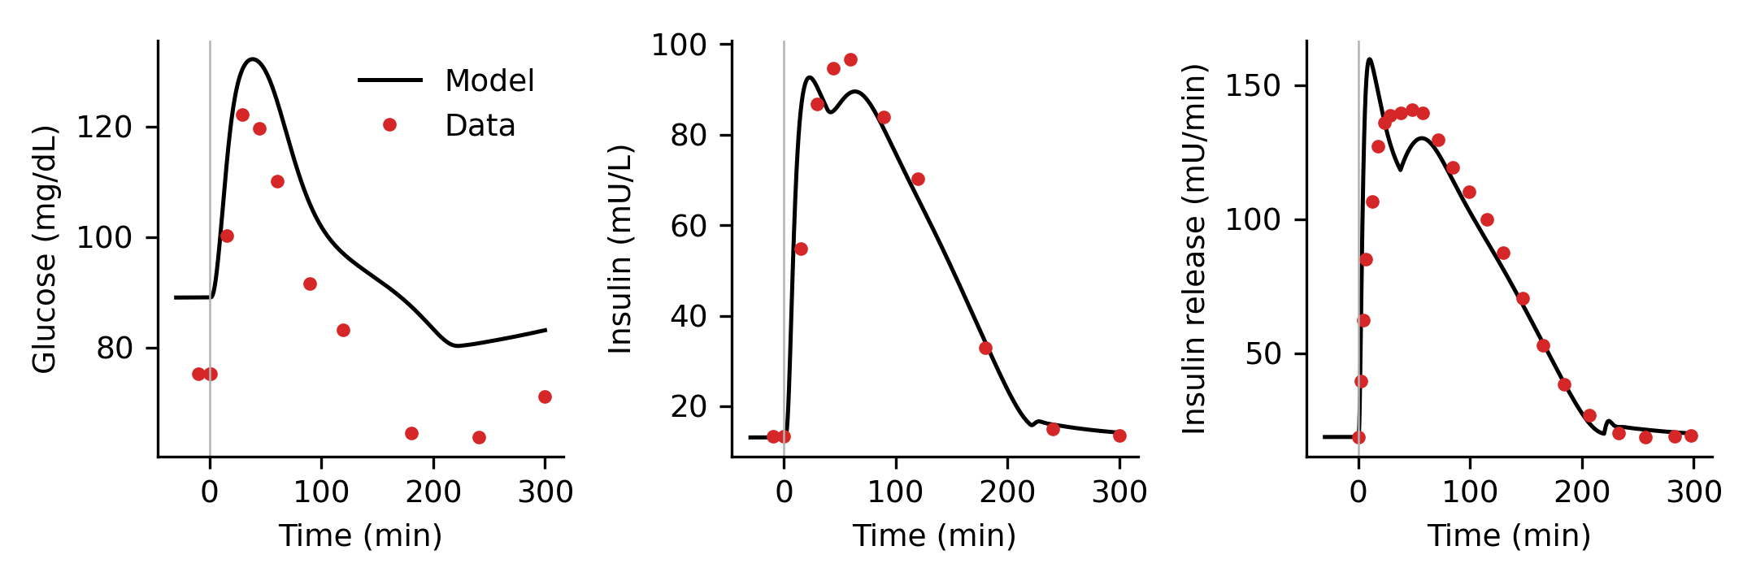

Intervention convention
Every intervention is parameterised by a single modulation fraction u ∈ [0,1]: u = 0 is baseline (multiplier 1) and u = 1 is the defined maximum (Figure 2). For signalling interventions the factor s(u) rescales the deviation of each hormone-action multiplier from neutral, M_eff = 1 + s(u)·(M − 1) (floor 0.05): s = 1 reproduces baseline exactly, s → 3 triples action efficacy, s → 0 abolishes it. Secretion interventions scale the secretion rate directly. Ten interventions were studied (Table 1): insulin signalling at peripheral, hepatic and global sites (potentiation and global inhibition), hepatic glucagon signalling (potentiation and inhibition), insulin secretion (potentiation and impairment) and glucagon secretion (potentiation and suppression).
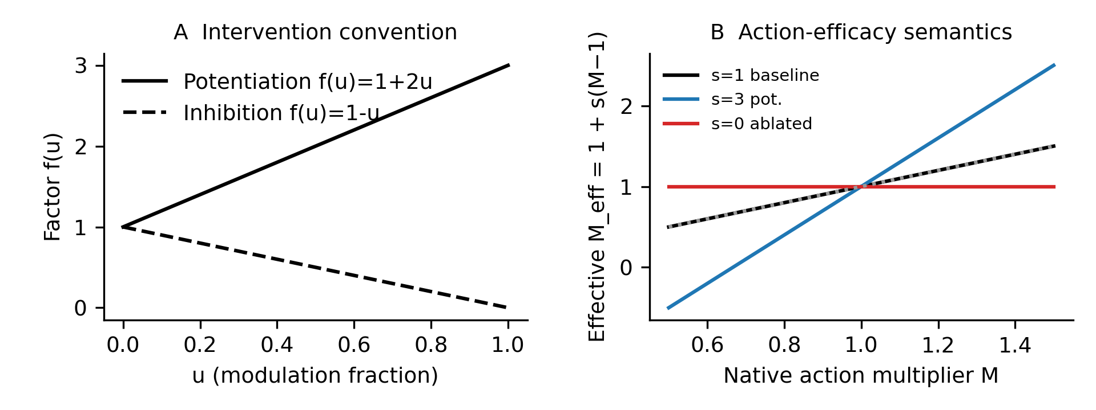

Challenges and endpoints
Five challenge protocols were simulated: prolonged fasting (600-min basal hold), IVGTT (0.5 g/kg over 3 min), OGTT (100 g oral), IVITT (0.04 U/kg insulin over 3 min) and continuous IV insulin infusion (CIVII, 0.25 mU/kg/min for 150 min). Solver outputs were interpolated onto a common 0.5-min grid before endpoint computation so that sample-based statistics (SD, successive differences) do not depend on LSODA's internal step sizes. Fifteen endpoints were computed per run on the post-challenge window: hypo-/hyperglycaemic burdens (thresholds 70 and 140 mg/dL), |G − 90| deviation, glucose AUC, SD and successive-difference RMSD, peak, nadir, recovery time, undershoot, and insulin/glucagon exposure. The composite loss L(u) — a scalar summary encoding one particular set of homeostatic priorities — is a weighted sum of normalised endpoints (weights and normalisation scales documented in the repository), emphasising hypoglycaemic burden most strongly. It is complemented by a weight-independent Pareto analysis on the glycaemic axes. Responses were classified: Type 0 (no benefit), Type I (monotone benefit, optimum at maximum), Type II (strict interior optimum beating both ends — the primary hypothesis), Type II* (interior optimum beating baseline but not the maximum) and Type III (plateau). u = 0.05 grid spacing was used with local refinement to 0.01 resolution around optima. Local refinement was used only to locate u*; classifications were always recomputed against the true u = 0 and u = 1 endpoints.

Controls and robustness
Mandatory negative controls verified the classifier cannot produce spurious interior optima: monotone and flat synthetic responders classify correctly, a planted U-shape is detected, and cubic-spline refinement is classification-stable (results/controls/). Robustness was assessed by ±2-fold perturbation and zeroing of each loss-term family, grid steps 0.10/0.05/0.025, solver rtol 1e-5/1e-7, and classification thresholds 1/2/5 %. Pareto fronts between hypoglycaemic and hyperglycaemic burden were extracted per case. Disease extensions rescanned all interventions under a T2DM-like state (insulin signalling efficacy halved) and a T1DM-like state (endogenous insulin secretion abolished; glucagon secretion remains simulated/manipulable). An exploratory 3-ODE HPT-axis model (TSH secretion with Hill feedback by T3, T4 and T3 pools) tested generality. All analyses regenerate via `python scripts/run_all.py`; 16 unit tests cover model integrity, the u = 0 identity, intervention semantics and the classifier.
Disease-state labels: the T2DM-like state halves insulin signalling efficacy at all sites; the T1DM-like state abolishes endogenous insulin secretion (glucagon secretion remains simulated and manipulable).

Results

Landscape of modulation responses
Figure 3 shows the composite loss L(u) for all 50 intervention–challenge combinations. Three regimes dominate. In the fasting state every intervention leaves L essentially unchanged until ablation destabilises homeostasis (Type 0/III). Under IVGTT and IVITT the insulin axis is strongly non-monotone; under the more physiological OGTT, suppression of glucagon secretion shows a shallow interior optimum while most glucagon-axis interventions are near-plateau.
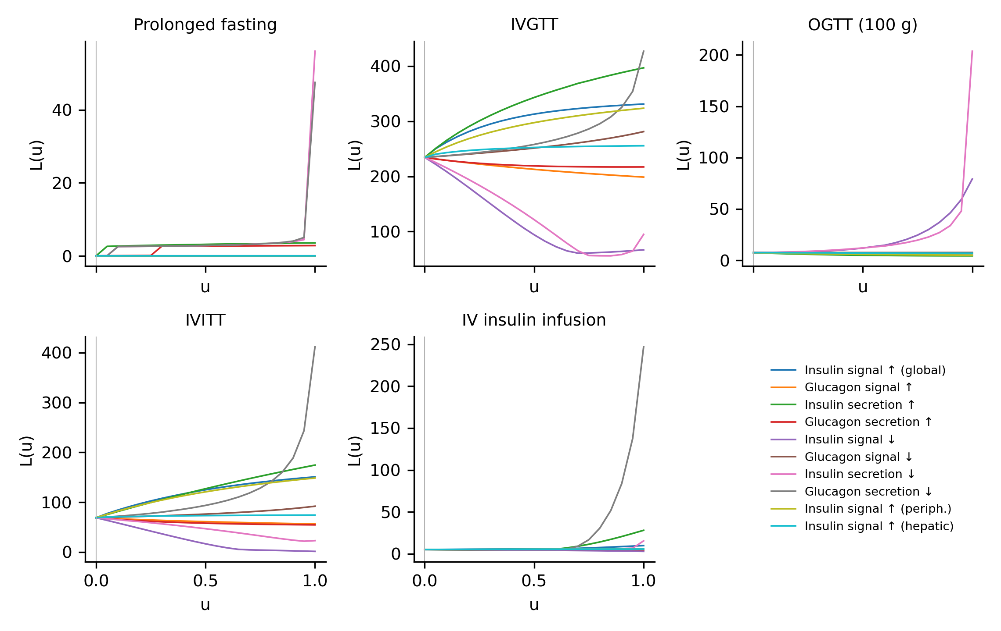
Strict interior optima (Type II) were found in 4 of 50 combinations (Table 2). The strongest result is partial suppression of insulin secretion under IVGTT: u* = 0.83, with L falling from 234.42 at baseline to 55.89, while full ablation (u = 1) gives 94.84 — worse than the optimum but still better than baseline, i.e. the dose-response has a genuine interior minimum (Figure 4A). Global inhibition of insulin action showed a parallel optimum at u* = 0.71 (L = 60.68). Under CIVII, modest potentiation of insulin secretion was optimal (u* = 0.51; L = 4.13 vs 28.06 at maximum), showing the phenomenon is not restricted to inhibitory interventions. Interior optima thus occur for insulin secretion, insulin signalling and glucagon secretion, in both directions of modulation, and across IV and continuous-infusion challenges (Table 2, Table 3).
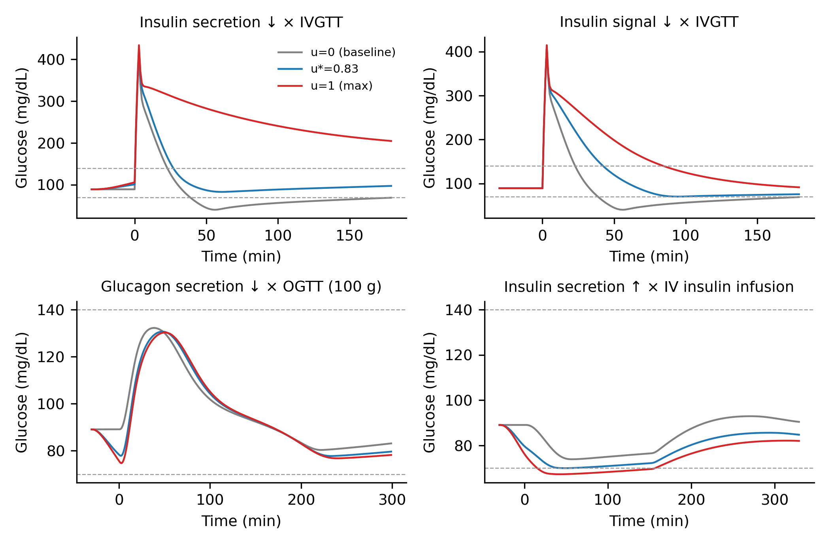

Weight-independent support: Pareto analysis
Because the composite loss is one scalarisation of homeostatic performance, each Type II case was also assessed on the glycaemic axes without weights (Figure 5, Table 3). All four optima are no worse than maximal modulation u = 1 on the glycaemic-burden axes — three strictly dominate u = 1 there, the OGTT case shows equal glycaemic burdens — and 2 of 4 optima lie on the Pareto frontier (no other u is better on every glycaemic axis). Versus baseline, the IVGTT optimum is a genuine trade-off rather than universal dominance: the reactive-hypoglycaemia burden falls from 1760.30 to 0.00 mg/dL·min while hyperglycaemic burden rises modestly (2155.80 → 2809.70). The shallow OGTT glucagon-suppression optimum is endpoint-dependent: on the glycaemic axes it is not Pareto-undominated — its interior minimum reflects reduced glycaemic variability and endocrine exposure rather than a difference in glycaemic burden (hypo and hyper burden are zero at u = 0, u* and u = 1). Individual endpoints for each case are given in Table 3.
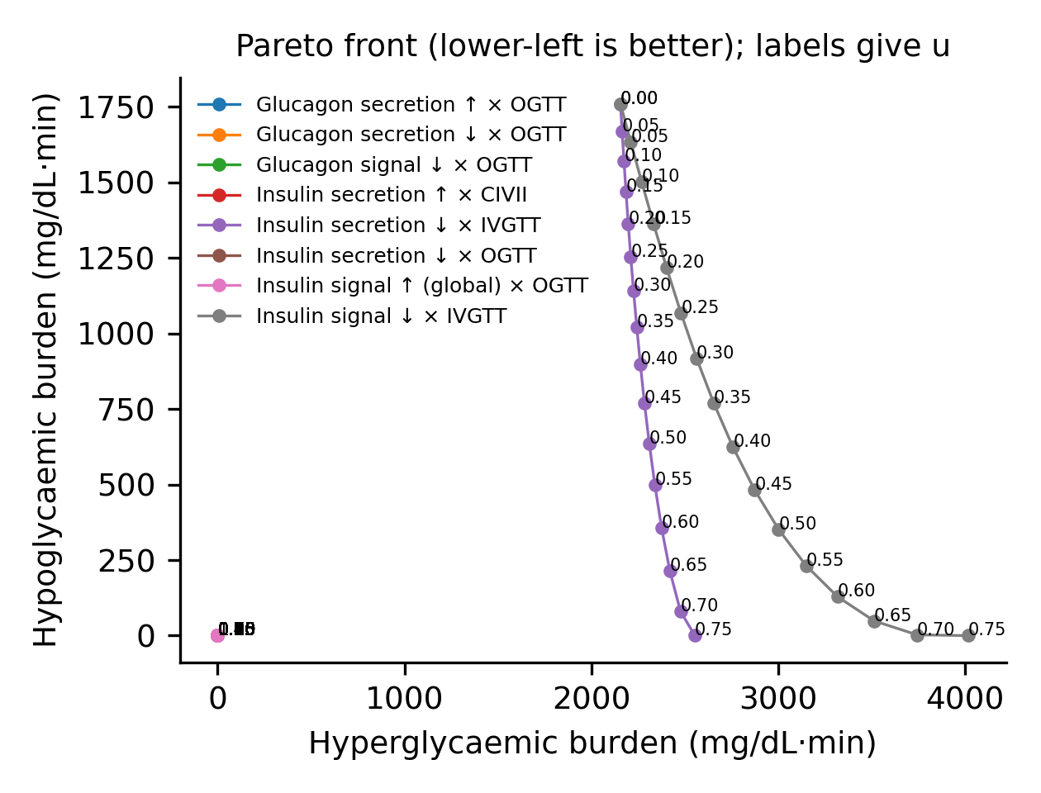

Mechanism of the IVGTT optimum
The IVGTT interior optimum arises from the trade-off between the insulin excursion needed to clear the load and the reactive hypoglycaemia it produces. At baseline the 0.5 g/kg bolus drives a secretion spike (peak 1349 mU/L) followed by a nadir of 40 mg/dL; at u* the insulin peak is roughly a quarter as high (298 mU/L), the nadir rises to 77 mg/dL, and peak glucose increases only modestly (Figure 6). At u = 1, secretion is abolished, hypoglycaemia disappears but glucose never returns to target — the optimum interior point balances both failure modes. Under OGTT, partial glucagon secretion suppression shows a shallow interior optimum (u* = 0.88; L = 6.57 vs 6.76 at u = 1), driven mainly by reduced glycaemic variability, consistent with the islet's paradoxical feedback design [3].
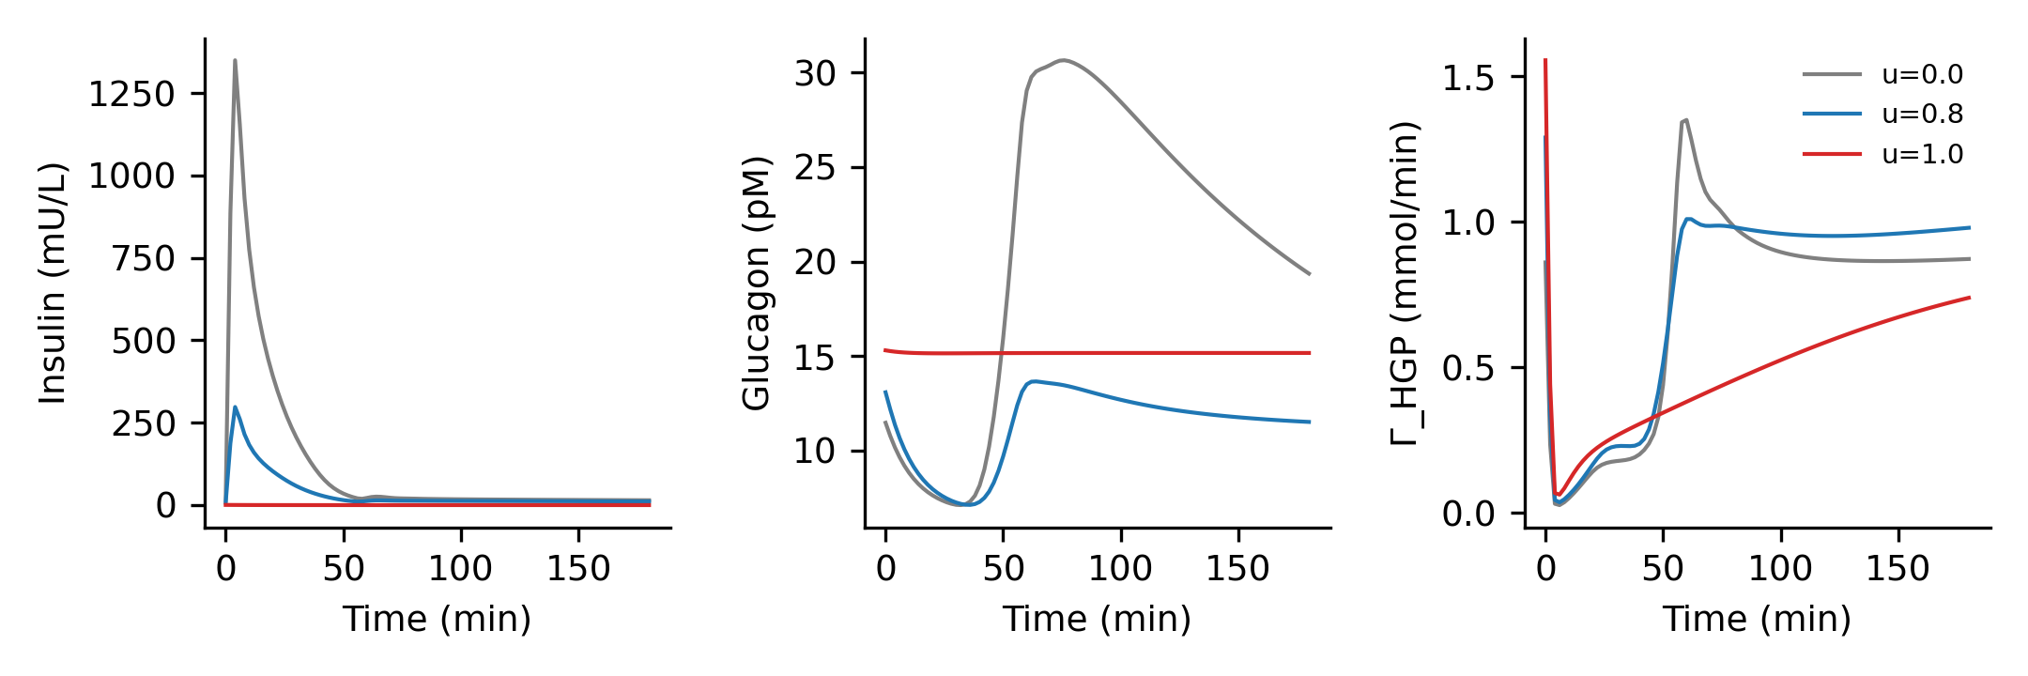

Additional non-IVGTT interior optima
Beyond the insulin IVGTT cases, interior optima appear under continuous-infusion and disease contexts: CIVII insulin-secretion potentiation (u* = 0.51; Figure 4D), OGTT glucagon-secretion suppression (shallow, endpoint-dependent; u* = 0.88), and the disease-state analogues below — i.e. the phenomenon is not confined to one hormone, one direction of modulation, or a single challenge, though its depth and position are context-specific.

Robustness and endpoint dependence
Optimality is necessarily endpoint-dependent; the relevant question is whether interior optima remain detectable under multiple reasonable definitions of homeostatic performance. Grid and solver checks confirmed classification stability — refined optima differed from coarse-grid estimates by ≤ 0.05 and tolerances rtol 1e-5/1e-7 did not change labels. Weight dependence was explicit. For each Type II case probed, 11 of 12 weight perturbations (92 %) preserved Type II/II* classification. Pooled across all 6 probed cases, 33 of 72 perturbations (46 %) preserved Type II/II*; the 12 perturbations per case comprised four loss-term families, each scaled by ×0.5, ×2 or 0. Classification reverted when the glucose-band terms themselves were removed (removing the phenotype by construction) or when the optimum was shallow and the classification threshold was raised to 5 % (Figure 7). Cases whose optimum is driven by variability revert to Type 0 when variability terms are removed — these are endpoint-dependent and are labelled as such in Table 3.
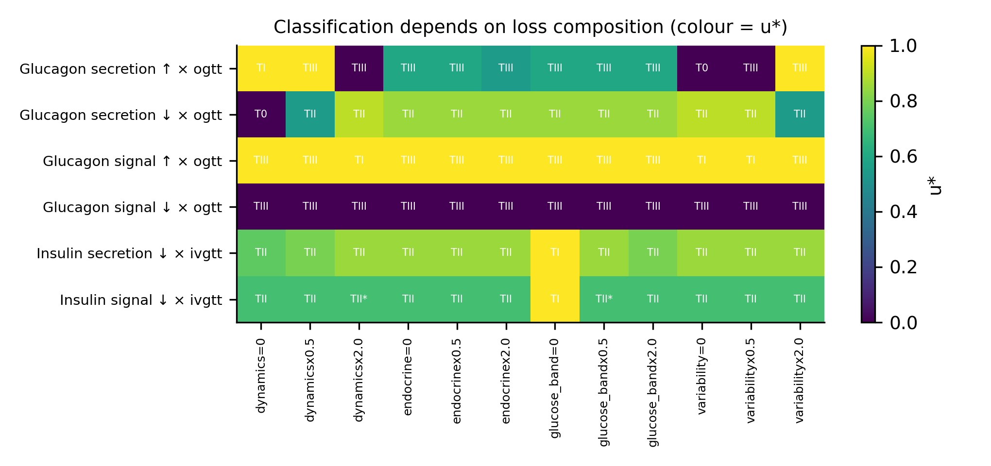

Disease-state extensions
Under a T2DM-like state (insulin action halved; OGTT baseline loss rose from 7.49 to 11.98), interior optima persisted and shifted: potentiating insulin secretion became optimal at u* = 0.55 rather than at maximum, and glucagon secretion suppression retained a strong optimum (u* = 0.90). Under a T1DM-like state (endogenous insulin secretion abolished), suppressing glucagon secretion showed a Type II optimum at u* = 0.80 for fasting (L 56.06 → 6.34), i.e. partial — not total — glucagon suppression is optimal when insulin is absent (Figure 8).
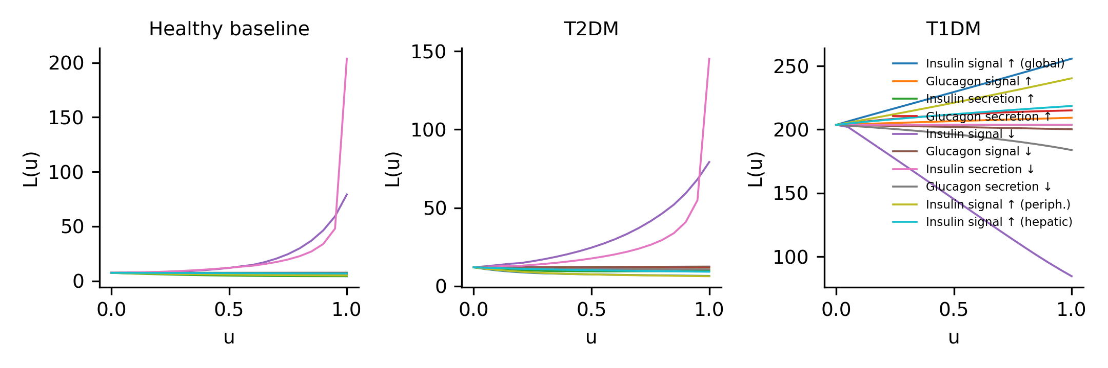

Exploratory HPT extension
An exploratory 3-ODE HPT-axis model (minimal, not fitted to clinical data) showed a qualitatively similar interior optimum for thyroid-output inhibition under a T4 infusion challenge (u* = 0.45; details in Supplementary Information). We regard this as cross-axis, hypothesis-generating corroboration only — exploratory evidence that the phenomenon may not be unique to glucose regulation.

Discussion
What was shown: in a previously validated whole-body glucose–insulin–glucagon model, a subset (4 of 50) of intervention–challenge pairs exhibits true interior optima — partial modulation outperforms both the unperturbed baseline and maximal modulation — spanning insulin secretion, insulin signalling and glucagon secretion, both directions of modulation, multiple challenges, and insulin-resistant/-deficient contexts.
Why it happens: local endocrine action can improve one failure mode while worsening the countervailing one through feedback. A larger insulin excursion clears glucose faster but drives deeper reactive hypoglycaemia; suppressing the loop harder over-commits the system, so an interior point balances the two — a Braess-like tension between local action and global performance [13,14]. The interior optimum is the empirical result; the Braess-like regime is our interpretation.
Why it matters: local efficacy and whole-system homeostatic utility can be non-monotonically related. This complements earlier optimality arguments that glucose control must trade rapid clearance against insulin sparing [15]: rather than optimality forcing a discrete (bistable) control regime, our results show it can also place the optimum at an intermediate modulation strength within a continuous efficacy convention. Maximum hormonal action is not always equivalent to optimal homeostasis; systems tuned near an interior optimum will respond to up-modulation with worsening in at least one direction, a testable prediction for other axes and for patient-level models.
Why an interior optimum is physiologically plausible: glucose regulation defends two opposite failures, and the defences are recruited at different thresholds. Counter-regulatory hormone secretion (glucagon, epinephrine) activates near 68–69 mg/dL — well above the symptomatic threshold [16] — so a stronger insulin excursion buys faster clearance at the price of driving glucose into the counter-regulatory zone, where the system's own corrective machinery generates overshoot and delayed recovery. The reciprocal islet design [3,4,5] makes the trade explicit: modulating secretion on one side of the α/β loop reshapes the other, so response speed and overshoot cannot be optimised independently. The interior minimum is the point where the marginal benefit of faster clearance equals the marginal cost of deeper counter-regulation.
This is not simply another hormetic dose–response. Classic hormesis and the non-monotonic dose responses catalogued for endocrine-active agents describe the response of a target to increasing exogenous exposure [11,12]. Here the intervention variable is monotonic by construction — increasing u scales a single efficacy channel smoothly in one direction — and the U-shape emerges at system level because u shifts the balance between two failure modes through feedback. The locus of non-monotonicity is the closed loop, not the dose–response of any isolated target; a local-intervention monotonicity is converted, not postulated, into system non-monotonicity.
Context dependence is part of the finding, not only a caveat. The position of u* shifted between challenges (IVGTT vs OGTT vs CIVII) and between the healthy, T2DM-like and T1DM-like parameterisations, and one optimum (OGTT) was endpoint-dependent even though it remained no worse than maximal action. This is what should be expected of a real feedback-driven optimum: the "best" modulation strength is an emergent property of where the system sits and which homeostatic failure mode is closest, consistent with optimality arguments that effective control depends on the operating point [15].
Several limitations qualify the finding. The model is parameterised on a single reference subject; the IVGTT reactive hypoglycaemia it produces (nadir ≈ 40 mg/dL) exceeds the transient, subject-dependent counter-regulatory dips described for insulin-modified FSIGT protocols [17], so the absolute position of u* for IVGTT is model-dependent even though the existence of an interior optimum is not. The composite loss encodes a particular set of homeostatic priorities (hypoglycaemia weighted heaviest): classification is accordingly weight-dependent (pooled 46 % preserved Type II/II*; per-case 92 % for the probed Type II cases), the OGTT optimum is endpoint-dependent rather than Pareto-supported, and we report both honestly via the weight-independent analysis. The HPT extension is exploratory and unfitted — richer HPT feedback models exist [18] and the stylised model here serves only to test whether the same interior-optimum pattern can arise on a second axis. We claim no clinical dose inference, no universal Braess behaviour, no general superiority of partial agonists or partial modulation — the results are mechanistic and hypothesis-generating.

Declarations
Data and code availability. All code, frozen upstream model files (SHA-256 ledger), results, figures and this pipeline are public at github.com/bougtoir/endocrine-maximum-not-optimum; the full analysis regenerates with `python scripts/run_all.py`.
AI disclosure. An AI assistant (Devin, Cognition AI) was used for code implementation, simulation orchestration and drafting support; the human author directed the work and takes full responsibility for content. No AI is an author.
Author contributions, funding, competing interests. T.O.: conception, analysis, writing. Funding: none declared. The author declares no competing interests.

References
1. Cannon WB. Organization for physiological homeostasis. Physiol Rev 1929;9:399–431. 2. Kitano H. Biological robustness. Nat Rev Genet 2004;5:826–837. 3. Garzilli I, Itzkovitz S. Design principles of the paradoxical feedback between pancreatic alpha and beta cells. Sci Rep 2018;8:11334. 4. Kawamori D, Kurpad AJ, Hu J, et al. Insulin signaling in α cells modulates glucagon secretion in vivo. Cell Metab 2009;9:350–361. 5. Capozzi ME, Svendsen B, Encisco SE, et al. β Cell tone is defined by proglucagon peptides through cAMP signaling. JCI Insight 2019;4:e126742. 6. Bergman RN, Ider YZ, Bowden CR, Cobelli C. Quantitative estimation of insulin sensitivity. Am J Physiol 1979;236:E667–E677. 7. Bergman RN. Origins and history of the minimal model of glucose regulation. Front Endocrinol (Lausanne) 2021;11:583016. 8. Sorensen JT. A physiologic model of glucose metabolism in man and its use to design and assess improved insulin therapies for diabetes. PhD thesis, MIT, 1985. 9. Panunzi S, Pompa M, Borri A, Piemonte V, De Gaetano A. A revised Sorensen model: simulating glycemic and insulinemic response to oral and intravenous glucose loads. PLoS ONE 2020;15:e0237215. 10. Dalla Man C, Micheletto F, Lv D, Breton M, Kovatchev B, Cobelli C. The UVA/PADOVA type 1 diabetes simulator: new features. J Diabetes Sci Technol 2014;8:26–34. 11. Calabrese EJ, Baldwin LA. Hormesis: U-shaped dose responses and their centrality in toxicology. Trends Pharmacol Sci 2001;22:285–291. 12. Vandenberg LN, Colborn T, Hayes TB, et al. Hormones and endocrine-disrupting chemicals: low-dose effects and nonmonotonic dose responses. Endocr Rev 2012;33:378–455. 13. Braess D. Über ein Paradoxon aus der Verkehrsplanung. Unternehmensforschung 1968;12:258–268. 14. Donovan GM. Biological version of Braess' paradox arising from perturbed homeostasis. Phys Rev E 2018;98:062406. 15. Wang G. Optimal homeostasis necessitates bistable control. J R Soc Interface 2012;9:2723–2734. 16. Schwartz NS, Clutter WE, Shah SD, Cryer PE. Glycemic thresholds for activation of glucose counterregulatory systems are higher than the threshold for symptoms. J Clin Invest 1987;79:777–781. 17. Thomaseth K, Brehm A, Pavan A, Pacini G, Roden M. Modeling glucose and free fatty acid kinetics during insulin-modified intravenous glucose tolerance test in healthy humans: role of counterregulatory response. Am J Physiol Regul Integr Comp Physiol 2014;307:R321–R331. 18. Pandiyan B, Merrill SJ, Benvenga S. A patient-specific model of the negative-feedback control of the hypothalamus–pituitary–thyroid (HPT) axis in autoimmune (Hashimoto's) thyroiditis. Math Med Biol 2014;31:226–258.

Table 1. Interventions and modulation convention
Intervention | Label | Mode | f(u=1) | Description
insulin_signal_global | Insulin signalling (global) | potentiation | 3.0 | Scales insulin action at all sites simultaneously.
glucagon_signal_hepatic | Glucagon signalling (hepatic HGP) | potentiation | 3.0 | Scales the glucagon signal driving hepatic glucose production.
insulin_secretion | Beta-cell insulin secretion capacity | potentiation | 3.0 | Scales pancreatic insulin release rate.
glucagon_secretion | Alpha-cell glucagon secretion capacity | potentiation | 3.0 | Scales pancreatic glucagon release rate.
insulin_signal_global_inhibition | Insulin signalling inhibition | inhibition | 0.0 | Scales insulin action downward; u=1 is complete insulin resistance.
glucagon_signal_inhibition | Glucagon signalling inhibition | inhibition | 0.0 | u=1 abolishes glucagon stimulation of HGP.
insulin_secretion_inhibition | Beta-cell secretion impairment | inhibition | 0.0 | u=1 abolishes endogenous insulin secretion (T1DM limit).
glucagon_secretion_inhibition | Glucagon secretion suppression | inhibition | 0.0 | u=1 abolishes endogenous glucagon secretion.
insulin_signal_peripheral | Insulin signalling (peripheral uptake) | potentiation | 3.0 | Scales the insulin signal driving peripheral glucose uptake (MIPGU).
insulin_signal_hepatic | Insulin signalling (hepatic: HGP + HGU) | potentiation | 3.0 | Scales insulin action on hepatic glucose production and uptake.

Table 2. Response classification across challenges (refined u*)
Intervention | Challenge | Class | u* | L(0) | L(u*) | L(1) | G0 | G1
Insulin signalling (global) | fasting | TypeIII | 0.00 | 0.02 | 0.02 | 0.02 | nan | nan
Glucagon signalling (hepatic HGP) | fasting | TypeIII | 0.70 | 0.02 | 0.02 | 0.02 | nan | nan
Insulin secretion (potentiation) | fasting | Type0 | 0.00 | 0.02 | 0.02 | 3.56 | nan | nan
Glucagon secretion (potentiation) | fasting | Type0 | 0.00 | 0.02 | 0.02 | 2.83 | nan | nan
Insulin signalling (inhibition) | fasting | TypeIII | 0.95 | 0.02 | 0.02 | 0.02 | nan | nan
Glucagon signalling (inhibition) | fasting | TypeIII | 0.15 | 0.02 | 0.02 | 0.02 | nan | nan
Insulin secretion (impairment) | fasting | Type0 | 0.00 | 0.02 | 0.02 | 56.06 | nan | nan
Glucagon secretion (suppression) | fasting | Type0 | 0.00 | 0.02 | 0.02 | 47.51 | nan | nan
Insulin signalling (peripheral uptake) | fasting | Type0 | 0.00 | 0.02 | 0.02 | 0.02 | nan | nan
Insulin signalling (hepatic) | fasting | TypeIII | 0.75 | 0.02 | 0.02 | 0.02 | nan | nan
Insulin signalling (global) | ivgtt | Type0 | 0.00 | 234.42 | 234.42 | 331.14 | nan | nan
Glucagon signalling (hepatic HGP) | ivgtt | TypeI | 1.00 | 234.42 | 198.74 | 198.74 | nan | nan
Insulin secretion (potentiation) | ivgtt | Type0 | 0.00 | 234.42 | 234.42 | 396.77 | nan | nan
Glucagon secretion (potentiation) | ivgtt | TypeI | 0.99 | 234.42 | 217.08 | 217.15 | 0.00 | 0.00
Insulin signalling (inhibition) | ivgtt | TypeII | 0.71 | 234.42 | 60.68 | 66.84 | 173.73 | 6.15
Glucagon signalling (inhibition) | ivgtt | Type0 | 0.00 | 234.42 | 234.42 | 281.17 | nan | nan
Insulin secretion (impairment) | ivgtt | TypeII | 0.83 | 234.42 | 55.89 | 94.84 | 178.52 | 38.95
Glucagon secretion (suppression) | ivgtt | Type0 | 0.00 | 234.42 | 234.42 | 426.92 | nan | nan
Insulin signalling (peripheral uptake) | ivgtt | Type0 | 0.00 | 234.42 | 234.42 | 323.57 | nan | nan
Insulin signalling (hepatic) | ivgtt | Type0 | 0.00 | 234.42 | 234.42 | 255.54 | nan | nan
Insulin signalling (global) | ogtt | TypeI | 1.00 | 7.49 | 5.05 | 5.05 | nan | nan
Glucagon signalling (hepatic HGP) | ogtt | TypeIII | 1.00 | 7.49 | 7.34 | 7.34 | nan | nan
Insulin secretion (potentiation) | ogtt | TypeI | 1.00 | 7.49 | 4.39 | 4.39 | nan | nan
Glucagon secretion (potentiation) | ogtt | TypeIII | 0.60 | 7.49 | 7.44 | 7.46 | nan | nan
Insulin signalling (inhibition) | ogtt | Type0 | 0.00 | 7.49 | 7.49 | 79.26 | nan | nan
Glucagon signalling (inhibition) | ogtt | TypeIII | 0.00 | 7.49 | 7.49 | 7.59 | nan | nan
Insulin secretion (impairment) | ogtt | Type0 | 0.00 | 7.49 | 7.49 | 203.68 | nan | nan
Glucagon secretion (suppression) | ogtt | TypeII | 0.88 | 7.49 | 6.57 | 6.76 | 0.92 | 0.19
Insulin signalling (peripheral uptake) | ogtt | TypeI | 1.00 | 7.49 | 5.06 | 5.06 | nan | nan
Insulin signalling (hepatic) | ogtt | TypeI | 1.00 | 7.49 | 6.91 | 6.91 | nan | nan
Insulin signalling (global) | ivitt | Type0 | 0.00 | 68.88 | 68.88 | 150.83 | nan | nan
Glucagon signalling (hepatic HGP) | ivitt | TypeI | 1.00 | 68.88 | 56.36 | 56.36 | nan | nan
Insulin secretion (potentiation) | ivitt | Type0 | 0.00 | 68.88 | 68.88 | 174.47 | nan | nan
Glucagon secretion (potentiation) | ivitt | TypeI | 1.00 | 68.88 | 54.55 | 54.55 | nan | nan
Insulin signalling (inhibition) | ivitt | TypeI | 1.00 | 68.88 | 1.35 | 1.35 | nan | nan
Glucagon signalling (inhibition) | ivitt | Type0 | 0.00 | 68.88 | 68.88 | 91.96 | nan | nan
Insulin secretion (impairment) | ivitt | TypeI | 0.95 | 68.88 | 21.71 | 22.93 | 0.00 | 0.00
Glucagon secretion (suppression) | ivitt | Type0 | 0.00 | 68.88 | 68.88 | 411.85 | nan | nan
Insulin signalling (peripheral uptake) | ivitt | Type0 | 0.00 | 68.88 | 68.88 | 148.51 | nan | nan
Insulin signalling (hepatic) | ivitt | Type0 | 0.00 | 68.88 | 68.88 | 74.16 | nan | nan
Insulin signalling (global) | civii | Type0 | 0.00 | 5.07 | 5.07 | 9.83 | nan | nan
Glucagon signalling (hepatic HGP) | civii | TypeI | 1.00 | 5.07 | 4.94 | 4.94 | nan | nan
Insulin secretion (potentiation) | civii | TypeII | 0.51 | 5.07 | 4.13 | 28.06 | 0.93 | 23.93
Glucagon secretion (potentiation) | civii | TypeI | 1.00 | 5.07 | 4.61 | 4.61 | nan | nan
Insulin signalling (inhibition) | civii | TypeI | 1.00 | 5.07 | 2.89 | 2.89 | nan | nan
Glucagon signalling (inhibition) | civii | Type0 | 0.00 | 5.07 | 5.07 | 5.23 | nan | nan
Insulin secretion (impairment) | civii | Type0 | 0.00 | 5.07 | 5.07 | 15.46 | nan | nan
Glucagon secretion (suppression) | civii | Type0 | 0.45 | 5.07 | 5.00 | 247.07 | nan | nan
Insulin signalling (peripheral uptake) | civii | Type0 | 0.00 | 5.07 | 5.07 | 5.84 | nan | nan
Insulin signalling (hepatic) | civii | Type0 | 0.00 | 5.07 | 5.07 | 5.67 | nan | nan

Table 3. Evidence summary for all strict Type II cases
intervention | challenge | u_star | loss_u0 | loss_ustar | loss_u1 | hypo_u0 | hypo_ustar | hypo_u1 | hyper_u0 | hyper_ustar | hyper_u1 | pareto_status | weight_sensitivity
insulin_signal_global_inhibition | ivgtt | 0.71 | 234.42 | 60.68 | 66.84 | 1760.3 | 0.0 | 0.0 | 2155.8 | 3793.6 | 7019.0 | dominates u=1; on frontier | 92% keep TypeII/II*
insulin_secretion_inhibition | ivgtt | 0.83 | 234.42 | 55.89 | 94.84 | 1760.3 | 0.0 | 0.0 | 2155.8 | 2809.7 | 20966.9 | dominates u=1; dominated (endpoint-dependent) | 92% keep TypeII/II*
glucagon_secretion_inhibition | ogtt | 0.88 | 7.49 | 6.57 | 6.76 | 0.0 | 0.0 | 0.0 | 0.0 | 0.0 | 0.0 | equal on glycaemic axes; dominated (endpoint-dependent) | 92% keep TypeII/II*
insulin_secretion | civii | 0.51 | 5.07 | 4.13 | 28.06 | 0.0 | 0.0 | 241.0 | 0.0 | 0.0 | 0.0 | dominates u=1; on frontier | not covered
Pareto-status definitions: 'dominates u=0/u=1' (strict dominance) = u* equal or lower on both glycaemic axes and strictly lower on ≥1; 'trade-off' = improves on at least one endpoint while worsening another (weak/non-dominating); 'on frontier' = no other u value dominates u* on all three glycaemic axes (hypo, hyper, SD); 'dominated' = some other u dominates it, so the optimum is endpoint-dependent. Weight sensitivity is per-case: 11/12 perturbations (92%) preserved Type II/II* for each probed Type II case; pooled across all six probed cases the fraction was 46% (33/72). Grid/solver/disease columns and mechanism notes are in results/tables/table3_typeII_evidence.csv.

Figure captions
Figure 1. Model validation: simulated (lines) vs upstream reference data (points) for glucose, insulin and insulin release under 100 g OGTT.
Figure 2. Intervention convention. (A) Modulation factor f(u): potentiation 1+2u, inhibition 1−u. (B) Action-efficacy semantics: effective multiplier M_eff = 1 + s(M−1).
Figure 3. Composite homeostatic loss L(u) for all interventions across the five challenges.
Figure 4. Glucose trajectories at baseline (u=0), interior optimum (u*) and maximum (u=1) for the four strict Type II cases.
Figure 5. Weight-independent support: Pareto fronts of hypoglycaemic vs hyperglycaemic burden; labels give u. u* is no worse than u=1 on the glycaemic axes for all Type II cases; 2/4 lie on the frontier.
Figure 6. Mechanism of the IVGTT interior optimum: insulin, glucagon and hepatic glucose production at u=0, u* and u=1.
Figure 7. Dependence of the optimal modulation u* and classification on loss-function composition (colour bar = u*; cell labels = class).
Figure 8. Loss curves under healthy, T2DM-like (insulin signalling halved) and T1DM-like (no endogenous insulin secretion) states for OGTT.

