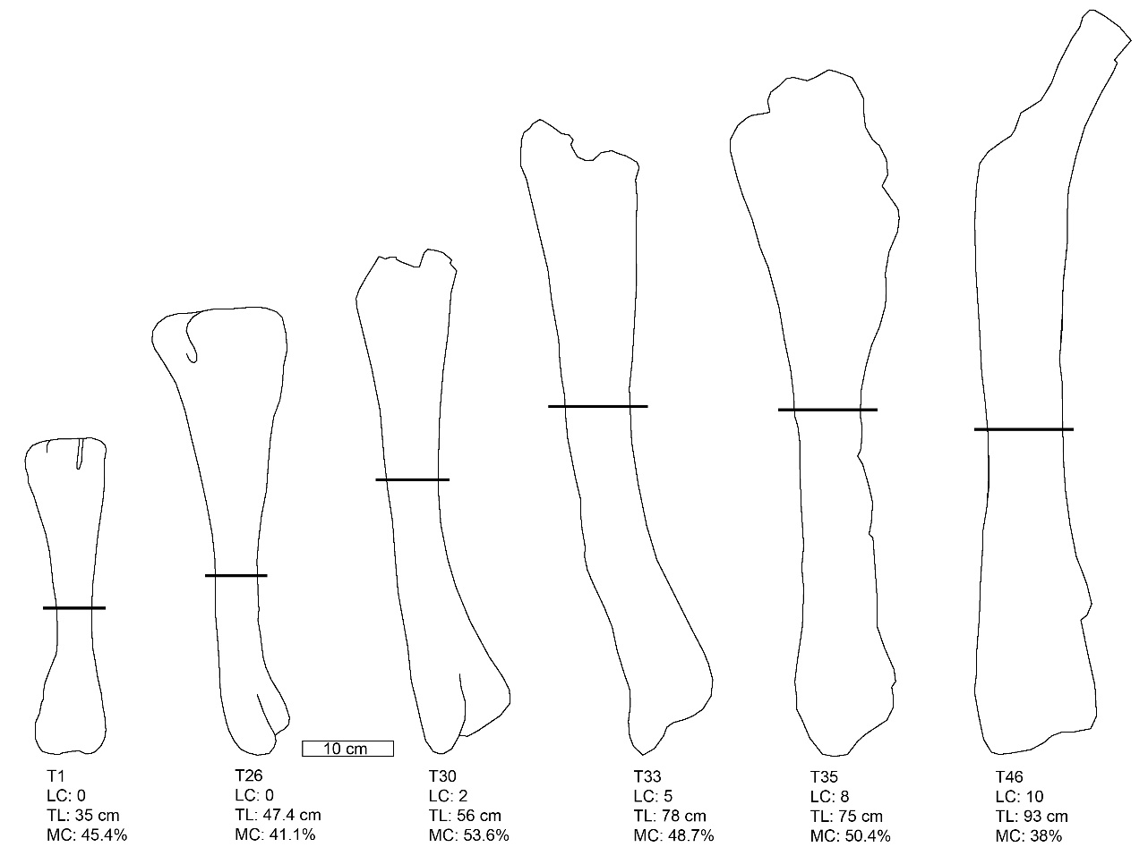

Supplementary Figure 1. Line drawings of Maiasaura tibiae from the sample representing an ontogenetic progression from less than one year of age (T1) to skeletal maturity (T46). The proximal ends of T30, T33, T35, and T46 are partially broken, but enough original surface remains for reasonable tibia length estimates. Horizontal black lines represent the location of the minimum (least) diaphyseal circumference measurement for each tibia. LC = LAG count; TL = Tibia length; MC = the distance from the tip of the lateral malleolus to the minimum diaphyseal circumference express as a percentage of total tibia length. Regardless of ontogenetic status, MC was found to vary individually (mean MC = 48.12%, σ = 6.31%, n = 43).

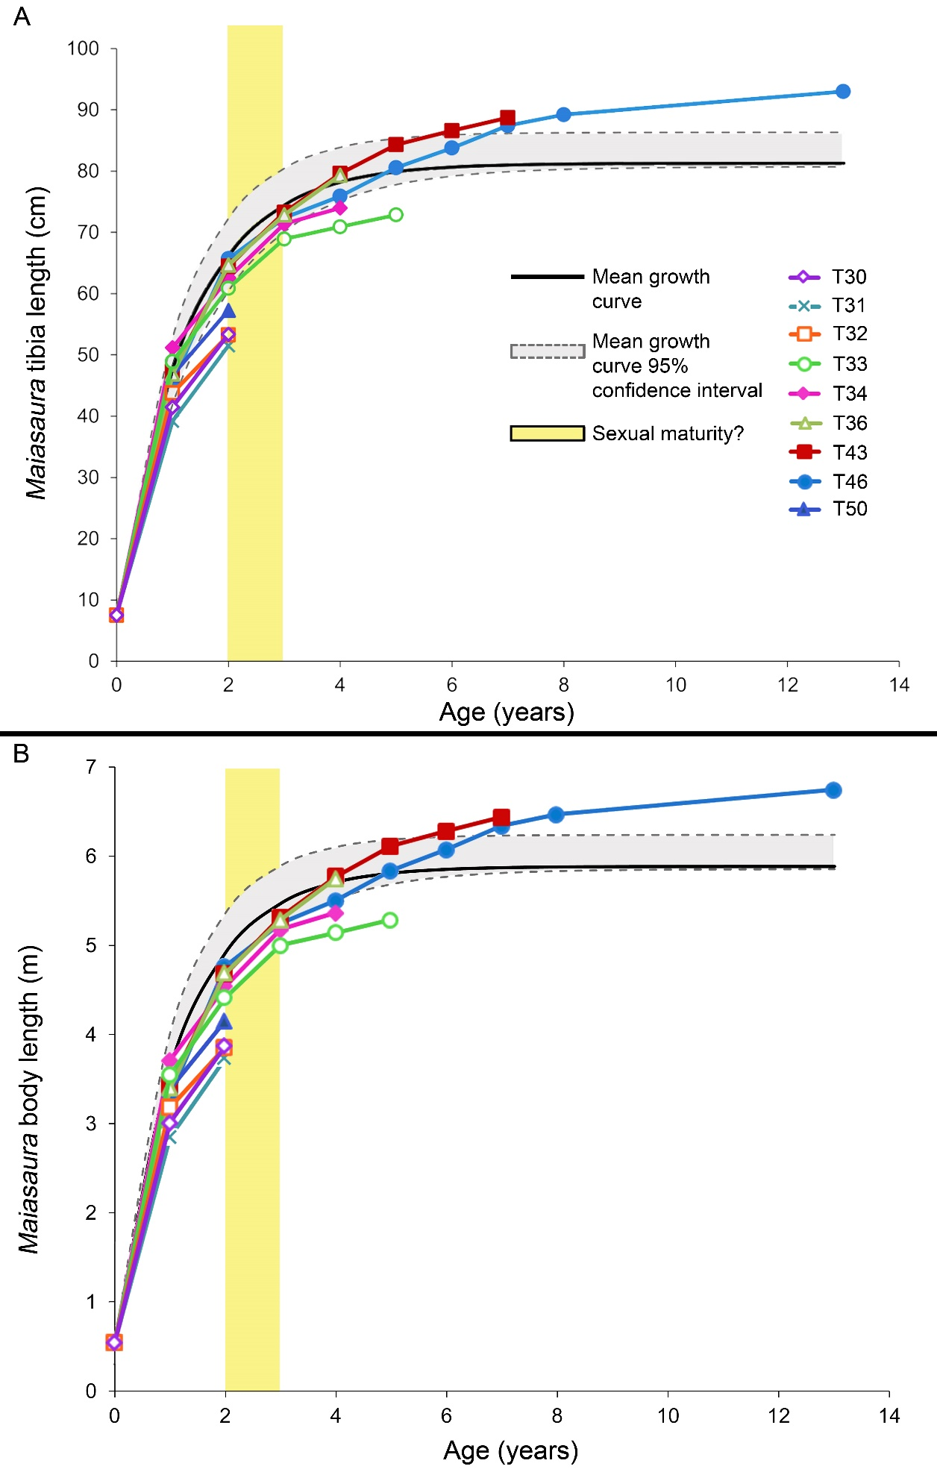
Supplementary Figure 2. Growth curves for Maiasaura peeblesorum. Age in years (determined by the number of LAGs) is plotted against size: A) body length, B) tibia length. The monomolecular model was used to plot body length as well as tibia length. Mean curves were fitted based on the five largest tibiae included in the graph; the four smaller tibiae with only two LAGs did not have enough data points to fit the models. The 95% confidence intervals are based on mean residual standard error around the mean curve, not the individual curves. Yellow bar indicates hypothesized age at which individuals would become sexually mature.

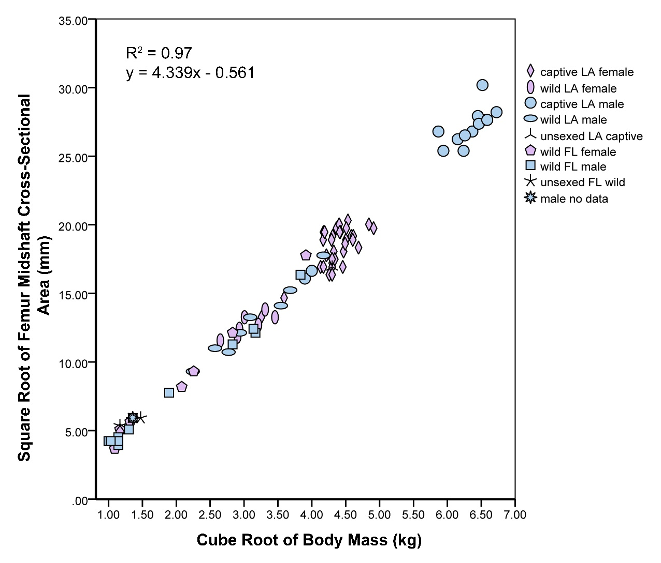
Supplementary Figure 3. A plot comparing the cube root of Alligator mississippiensis body mass (kg) to the square root of Alligator mississippiensis femur midshaft cross-sectional area (mm), obtained from the dataset used in Farlow et al., 2005. The sample includes 54 individuals and results in a strong linear correlation (R² = 0.97; $y=4.339x-0.561$). LA, Louisiana; FL, Florida.

Literature Cited:
Farlow, J. O., G. R. Hurlburt, R. M. Elsey, A. R. C. Britton, and W. Langston Jr. 2005. Femoral dimensions and body size of Alligator mississippiensis: estimating the size of extinct mesoeucrocodylians. Journal of Vertebrate Paleontology 25(2):354-369.

Supplementary Table 1. Raw data measurements, LAG count, and EFS LAG count (if applicable) obtained for Maiasaura tibiae used in this population histology analysis, as well as calculations of associated femur length. Femur length is determined from tibia measurements and then by using the fibula to femur length ratio (using fibula length as a proxy for tibia length) from the Royal Ontario Museum Maiasaura specimen ROM 44770. Asterisks ( * ) in the table indicate circumference measurement estimates from tibiae with somewhat damaged cortex or eroded periosteal surface, and carats ( ^ ) denote tibiae with broken proximal or distal epiphyses but for which length estimates were made. A square superscript ( □ ) indicates tibiae used to perform the analyses in Table 1. Tibiae not used in constructing diaphyseal circumference and cortical area regressions are indicated with a diamond superscript ( ◊ ).
Maiasaura Tibia Code | Tibia Length (cm) | Minimum Diaphyseal Circumference (cm) | Calculated Femur Length (cm) | LAG Count | LAGs within EFS
T01 | 35.0 | 13.0 | 36.2 | 0
T02 | 41.5 | 14.3 | 43.0 | 0
T03 | 33.8 | 14.4 | 35.0 | 0
T04 | 39.7 | 14.4 | 41.1 | 0
T05 | 39.4 | 14.9 | 40.8 | 0
T06 | 46.0 | 15.0 | 47.6 | 0
T07^ | 37.2 | 14.4 | 38.5 | 0
T08^ | 36.2 | 15.1 | 37.5 | 0
T09 | 38.4 | 13.6 | 39.8 | 0
T10 | 42.1 | 14.9 | 43.6 | 0
T11 | 43.5 | 15.2 | 45.0 | 0
T12 | 41.2 | 15.5 | 42.7 | 0
T13 | 43.1 | 16.2 | 44.6 | 0
T14 | 44.3 | 15.7 | 45.9 | 0
T15 | 46.4 | 16.7 | 48.0 | 0
T16 | 44.0 | 15.4 | 45.6 | 0
T17 | 45.2 | 14.9 | 46.8 | 0
T18 | 43.3 | 17.2 | 44.8 | 0
T19 | 43.8 | 17.0 | 45.4 | 0
T20 | 43.4 | 15.4 | 44.9 | 0
T21 | 46.4 | 16.4 | 48.0 | 0
T22 | 48.5 | 15.9 | 50.2 | 0
T23 | 45.4 | 17.2 | 47.0 | 0
T24 | 48.8 | 18.3 | 50.5 | 0
T25 | 48.1 | 16.7 | 49.8 | 0
T26 | 47.4 | 16.8 | 49.1 | 0
T27 | 48.0 | 16.6 | 49.7 | 0
T28 | 47.2 | 16.6 | 48.9 | 0
T29 | 48.5 | 17.0 | 50.2 | 0
T30^□ | 56.0 | 21.4 | 58.0 | 2
T31^□ | 63.0 | 21.4 | 65.2 | 2
T32^□ | 69.0 | 21.3 | 71.5 | 2
T33^□ | 78.0 | 28.0 | 80.8 | 5
T34^□◊ | 75.0 | Substantial periosteal surface missing | 77.7 | 7
T35^◊ | 75.0 | Substantial periosteal surface missing | 77.7 | 8 | 3
T36□ | 88.0 | 30.3 | 91.1 | 5
T37*^◊ | 83.0 | 33.2* | 85.9 | 8
T38*^◊ | 90.0 | 33.5* | 93.2 | 10
T39^ | 83.0 | 31.6 | 85.9 | 9
T40 | 87.5 | 32.9 | 90.6 | 7 | 8
T41◊ | 95.0 | Substantial periosteal surface missing | 98.4 | 9
T42*◊ | 90.5 | 34.4* | 93.7 | 4
T43^□ | 88.0 | 32.9 | 91.1 | 9
T44^ | 87.5 | 38.2 | 90.6 | 8 | 2
T45 | 99.7 | 35.3 | 103.2 | Poor internal preservation | 3
T46□ | 93.0 | 33.2 | 96.3 | 10 | 3
T47◊ | 32.0 | Circumference not measured |  | 0
T48◊ | 69.5 | Circumference not measured | 72.0 | 2
T49◊ | Incomplete | 23.3 |  | 0
T50□◊ | Incomplete | 23.4 |  | 2

Supplementary Table 2. Annual Maiasaura LAG circumference measurements, total area measurements, calculated tibia length, calculated femur length, and body mass estimates (obtained using the developmental mass extrapolation method [DME; Erickson and Tumanova, 2000*]) for Maiasaura tibiae possessing at least one LAG. Perinate tibia circumference and body mass reported for each specimen was obtained from Maiasaura tibia YPM-PU 22432.
Maiasaura Tibia Code | Location Within The Cortex | Total Area (cm²) | Circumference (cm) | Calculated Tibia Length (cm) | Calculated Femur Length (cm) | Mass Estimate Using DME* (kg)
T30 | Medullary Cavity | 4.2 | 7.8
 | Perinate Tibia | 0.5 | 2.5 | 7.5 | 7.8 | 2
 | LAG 1 | 15.9 | 15.0 | 41.5 | 43.0 | 286
 | LAG 2 | 26.4 | 19.4 | 53.4 | 55.3 | 610
 | Periosteal Surface | 32.0 | 21.4 | 56.0 | 58.0 | 704
T31 | Medullary Cavity | 3.7 | 11.2
 | Perinate Tibia | 0.5 | 2.5 | 7.5 | 7.8 | 2
 | LAG 1 | 13.6 | 14.2 | 39.2 | 40.6 | 241
 | LAG 2 | 23.9 | 18.7 | 51.5 | 53.3 | 548
 | Periosteal Surface | 31.7 | 21.4 | 63.0 | 65.2 | 1003
T32 | Medullary Cavity | 1.3 | 4.9
 | Perinate Tibia | 0.5 | 2.5 | 7.5 | 7.8 | 2
 | LAG 1 | 13.2 | 15.9 | 43.8 | 45.3 | 337
 | LAG 2 | 22.2 | 19.4 | 53.3 | 55.1 | 606
 | Periosteal Surface | 29.1 | 21.3 | 69.0 | 71.5 | 1318
T33 | Medullary Cavity | 5.4 | 9.5
 | Perinate Tibia | 0.5 | 2.5 | 7.5 | 7.8 | 2
 | LAG 1 | 21.8 | 17.8 | 48.9 | 50.7 | 469
 | LAG 2 | 34.3 | 22.2 | 60.9 | 63.0 | 904
 | LAG 3 | 44.4 | 25.1 | 68.9 | 71.4 | 1313
 | LAG 4 | 47.0 | 25.9 | 70.9 | 73.4 | 1429
 | LAG 5 | 49.8 | 26.6 | 72.9 | 75.4 | 1551
 | Periosteal Surface | 54.5 | 27.9 | 78.0 | 80.8 | 1903
T34 | Medullary Cavity | 10.6 | 13.0
 | Perinate Tibia | 0.5 | 2.5 | 7.5 | 7.8 | 2
 | LAG 1 | 23.6 | 18.6 | 51.2 | 53.0 | 537
 | LAG 2 | 36.3 | 22.8 | 62.6 | 64.8 | 984
 | LAG 3 | 47.4 | 26.0 | 71.4 | 73.9 | 1459
 | LAG 4 | 51.2 | 27.0 | 74.0 | 76.6 | 1625
 | LAG 5 | Incomplete | Incomplete
 | LAG 6 | Incomplete | Incomplete
 | LAG 7 | Incomplete | Incomplete
 | Periosteal Surface | Incomplete | Incomplete
T36 | Medullary Cavity | 7.0 | 11.6
 | Perinate Tibia | 0.5 | 2.5 | 7.5 | 7.8 | 2
 | LAG 1 | 18.5 | 17.0 | 46.9 | 48.5 | 413
 | LAG 2 | 35.7 | 23.6 | 64.7 | 67.0 | 1085
 | LAG 3 | 47.7 | 26.6 | 72.9 | 75.4 | 1551
 | LAG 4 | 56.5 | 29.0 | 79.3 | 82.1 | 2001
 | LAG 5 | Incomplete | Incomplete
 | Periosteal Surface | 60.5 | 30.3 | 88.0 | 91.1 | 2733
T43 | Medullary Cavity | 6.2 | 10.9
 | Perinate Tibia | 0.5 | 2.5 | 7.5 | 7.8 | 2
 | LAG 1 | 19.9 | 17.2 | 47.4 | 49.1 | 426
 | LAG 2 | 37.9 | 23.5 | 64.4 | 66.7 | 1073
 | LAG 3 | 50.1 | 26.7 | 73.3 | 75.9 | 1577
 | LAG 4 | 59.0 | 29.1 | 79.6 | 82.4 | 2023
 | LAG 5 | 66.9 | 30.8 | 84.3 | 87.3 | 2405
 | LAG 6 | 70.7 | 31.7 | 86.6 | 89.7 | 2606
 | LAG 7 | 74.1 | 32.4 | 88.7 | 91.9 | 2801
 | LAG 8 | Incomplete | Incomplete
 | LAG 9 | Incomplete | Incomplete
 | Periosteal Surface | 76.3 | 32.9 | 88.0 | 91.1 | 2733
T46 | Medullary Cavity | 17.4 | 16.8
 | Perinate Tibia | 0.5 | 2.5 | 7.5 | 7.8 | 2
 | LAG 1 | 19.1 | 16.5 | 45.6 | 47.2 | 380
 | LAG 2 | 39.9 | 24.0 | 65.7 | 68.0 | 1138
 | LAG 3 | 48.6 | 26.4 | 72.4 | 74.9 | 1520
 | LAG 4 | 53.5 | 27.7 | 75.9 | 78.6 | 1753
 | LAG 5 | 60.4 | 29.4 | 80.6 | 83.4 | 2097
 | LAG 6 | 65.4 | 30.6 | 83.8 | 86.7 | 2357
 | LAG 7 | 71.4 | 32.0 | 87.4 | 90.5 | 2680
 | LAG 8 | 74.2 | 32.6 | 89.2 | 92.4 | 2848
 | LAG 9 | Incomplete; start of EFS | Incomplete; start of EFS
 | Periosteal Surface | 77.0 | 33.2 | 93.0 | 96.3 | 3226
T50 | Medullary Cavity | 5.7 | 9.1
 | Perinate Tibia | 0.5 | 2.5 | 7.5 | 7.8 | 2
 | 1 | 20.2 | 16.9 | 46.7 | 48.3 | 408
 | 2 | 30.5 | 20.8 | 57.3 | 59.3 | 754
 | Periosteal Surface | 38.2 | 23.4 | 64.1 | 66.4 | 1057
*Erickson, G. M., and T. A. Tumanova. 2000. Growth curve of Psittacosaurus mongoliensis Osborn (Ceratopsia: Psittacosauridae) inferred from long bone histology. Zoological Journal of the Linnean Society 130:551-566.

Supplementary Table 3. Maiasaura tibia cortical thicknesses measured from the geometric center to consecutive LAGs or periosteal surface along maximum and minimum axes. Some axis measurements were omitted in T34 due to cortical erosion. Only tibiae from the sample with considerably intact (uncrushed) cortical bone were used in cortical thickness measurements.
Maiasaura Tibia Code | LAG Number | Major Axis1 (anterior) (mm) | Major Axis2 (posterior) (mm) | Minor Axis1 (lateral) (mm) | Minor Axis2 (medial) (mm) | Average Total Thickness (mm) | Zone Thickness (mm)
PU 22432 | surface | 4.0 | 3.5 | 3.6 | 3.6 | 3.7 | 3.6
T1 | surface | 21.6 | 20.2 | 16.2 | 17.0 | 18.8 | 18.8
T3 | surface | 23.1 | 22.0 | 16.9 | 18.6 | 20.1 | 20.1
T4 | surface | 23.5 | 22.2 | 20.6 | 20.3 | 21.6 | 21.6
T5 | surface | 24.6 | 25.3 | 18.6 | 15.8 | 21.1 | 21.1
T6 | surface | 21.9 | 25.2 | 21.3 | 19.9 | 22.1 | 22.1
T7 | surface | 22.3 | 21.3 | 20.2 | 21.2 | 21.2 | 21.2
T9 | surface | 23.1 | 21.4 | 18.2 | 18.2 | 20.2 | 20.2
T10 | surface | 25.2 | 24.1 | 20.6 | 20.6 | 22.6 | 22.6
T13 | surface | 24.5 | 25.7 | 20.3 | 21.7 | 23.1 | 23.1
T14 | surface | 24.1 | 25.5 | 21.4 | 22.7 | 23.4 | 23.4
T15 | surface | 27.9 | 27.3 | 19.9 | 22.2 | 24.3 | 24.3
T16 | surface | 22.8 | 25.4 | 21.2 | 20.8 | 22.5 | 22.5
T18 | surface | 23.1 | 23.8 | 27.2 | 24.4 | 24.6 | 24.6
T20 | surface | 25.0 | 26.2 | 20.7 | 22.0 | 23.4 | 23.4
T22 | surface | 26.2 | 25.4 | 20.8 | 23.5 | 24.0 | 24.0
T25 | surface | 24.2 | 26.2 | 21.9 | 24.0 | 24.1 | 24.1
T28 | surface | 27.7 | 24.9 | 22.7 | 20.9 | 24.1 | 24.1
T30 | 1 | 24.8 | 22.1 | 23.9 | 18.6 | 22.4 | 22.4
 | 2 | 32.1 | 30.7 | 27.6 | 26.8 | 29.3 | 6.9
T31 | 1 | 23.9 | 21.4 | 21.0 | 17.6 | 21.0 | 21.0
 | 2 | 30.7 | 21.4 | 27.5 | 24.4 | 26.0 | 5.0
T32 | 1 | 24.3 | 26.7 | 15.3 | 18.3 | 21.2 | 21.2
 | 2 | 32.4 | 31.7 | 21.5 | 22.2 | 26.9 | 5.8
T33 | 1 | 27.3 | 28.6 | 27.8 | 22.7 | 26.6 | 26.6
 | 2 | 34.5 | 36.8 | 33.6 | 30.3 | 33.8 | 7.2
 | 3 | 39.4 | 40.9 | 37.4 | 36.1 | 38.4 | 4.6
 | 4 | 40.7 | 41.7 | 38.1 | 37.7 | 39.5 | 1.1
 | 5 | 41.9 | 42.2 | 38.9 | 39.1 | 40.5 | 1.0
T34 | 1 | 35.5 | 21.9 | 30.9 | 22.7 | 27.7 | 27.7
 | 2 | 41.8 | 31.5 | 35.9 | 29.4 | 34.6 | 6.9
 | 3 | 46.3 | 40.3 | 39.1 | 37.3 | 40.7 | 6.1
 | 4 |  | 43.0 |  | 37.4 | 40.2 | -0.6
 | 5 |  | 45.0 |  | 39.2 | 42.1 | 1.9
 | 6 |  | 46.0 |  | 40.4 | 43.2 | 1.1
 | 7 |  |  |  | 41.5 | 41.5 | -1.7
T36 | 1 | 29.0 | 24.1 | 16.0 | 23.1 | 23.0 | 23.0
 | 2 | 35.3 | 35.7 | 28.7 | 31.4 | 32.8 | 9.7
 | 3 | 39.3 | 41.8 | 33.4 | 36.8 | 37.8 | 5.1
 | 4 | 42.0 | 46.2 | 36.9 | 39.8 | 41.2 | 3.4
T43 | 1 | 24.3 | 26.4 | 31.3 | 12.1 | 23.5 | 23.5
 | 2 | 36.1 | 38.6 | 24.9 | 36.5 | 34.0 | 10.5
 | 3 | 41.5 | 45.0 | 40.0 | 31.2 | 39.4 | 5.4
 | 4 | 45.8 | 48.7 | 35.9 | 41.8 | 43.0 | 3.6
 | 5 | 49.4 | 51.4 | 39.6 | 43.7 | 46.0 | 3.0
 | 6 | 50.5 | 51.4 | 39.6 | 43.7 | 46.3 | 0.3
 | 7 | 51.8 | 53.9 | 43.2 | 44.9 | 48.4 | 2.1
T46 | 1 | 23.6 | 25.8 | 13.7 | 31.2 | 23.6 | 23.6
 | 2 | 40.0 | 36.6 | 26.9 | 38.9 | 35.6 | 12.0
 | 3 | 44.6 | 39.8 | 31.8 | 41.5 | 39.4 | 3.8
 | 4 | 46.6 | 41.7 | 34.6 | 42.9 | 41.4 | 2.0
 | 5 | 49.1 | 44.6 | 38.1 | 44.5 | 44.1 | 2.6
 | 6 | 50.6 | 46.5 | 40.6 | 45.7 | 45.9 | 1.8
 | 7 | 52.6 | 48.7 | 43.3 | 47.0 | 47.9 | 2.1
 | 8 | 53.2 | 49.9 | 44.8 | 47.4 | 48.8 | 0.9
 | 9 | 53.4 | 50.4 | 45.5 |  | 49.8 | 1.0
T50 | 1 | 28.5 | 25.4 | 26.7 | 21.6 | 25.5 | 24.8
 | 2 | 34.6 | 33.3 | 30.4 | 28.4 | 31.6 | 6.1

Supplementary Table 4. Data for Maiasaura tibiae used in this study to construct a linear regression (below) between tibia length and minimum (least) diaphyseal circumference. n = 40.
Maiasaura Tibia Code | Diaphyseal Circumference of Thin Section (cm) | Tibia Length (cm)
T01 | 13.0 | 35.0
T02 | 14.3 | 41.5
T03 | 14.4 | 33.8
T04 | 14.4 | 39.7
T05 | 14.9 | 39.4
T06 | 15.0 | 46.0
T07 | 14.4 | 37.2
T08 | 15.1 | 36.2
T09 | 13.6 | 38.4
T10 | 14.9 | 42.1
T11 | 15.2 | 43.5
T12 | 15.5 | 41.2
T13 | 16.2 | 43.1
T14 | 15.7 | 44.3
T15 | 16.7 | 46.4
T16 | 15.4 | 44.0
T17 | 14.9 | 45.2
T18 | 17.2 | 43.3
T19 | 17.0 | 43.8
T20 | 15.4 | 43.4
T21 | 16.4 | 46.4
T22 | 15.9 | 48.5
T23 | 17.2 | 45.4
T24 | 18.3 | 48.8
T25 | 16.7 | 48.1
T26 | 16.8 | 47.4
T27 | 16.6 | 48.0
T28 | 16.6 | 47.2
T29 | 17.0 | 48.5
T30 | 21.4 | 56.0
T31 | 21.4 | 63.0
T32 | 21.3 | 69.0
T33 | 28.0 | 78.0
T36 | 30.3 | 88.0
T39 | 31.6 | 83.0
T40 | 32.9 | 87.5
T43 | 32.9 | 88.0
T44 | 38.2 | 87.5
T45 | 35.3 | 99.7
T46 | 33.2 | 93.0

Supplementary Table 5. Data for Maiasaura tibiae used in this study to construct a second order polynomial regression (below) between tibia length and medullary cavity circumference. n = 29.
Maiasaura Tibia Code | Tibia Length (cm) | Circumference of Medullary Cavity (cm)
T01 | 35.0 | 4.57
T03 | 33.8 | 3.3
T04 | 39.7 | 6.02
T05 | 39.4 | 3.7
T06 | 46.0 | 3.15
T07 | 37.2 | 4.06
T09 | 38.4 | 5.52
T10 | 42.1 | 7.86
T13 | 43.1 | 5.71
T14 | 44.3 | 6.49
T15 | 46.4 | 4.78
T16 | 44.0 | 4.41
T18 | 43.3 | 5.77
T20 | 43.4 | 6.09
T22 | 48.5 | 5.04
T25 | 48.1 | 5.8
T27 | 48.0 | 6.27
T30 | 56.0 | 7.77
T31 | 63.0 | 11.22
T32 | 69.0 | 4.88
T33 | 78.0 | 9.49
T34 | 75.0 | 12.98
T36 | 88.0 | 11.59
T39 | 83.0 | 11.39
T40 | 87.5 | 10.17
T41 | 95.0 | 13.96
T43 | 88.0 | 10.94
T45 | 99.7 | 13.25
T46 | 93.0 | 16.25

Supplementary Table 6. Data for Maiasaura tibiae used in this study to construct a power regression (below) between tibia length and medullary cavity area. n = 29.
Maiasaura Tibia Code | Tibia Length (cm) | Medullary Cavity Area (cm²)
T01 | 35.0 | 1.0
T03 | 33.8 | 0.5
T04 | 39.7 | 2.2
T05 | 39.4 | 0.6
T06 | 46.0 | 0.6
T07 | 37.2 | 1.1
T09 | 38.4 | 0.9
T10 | 42.1 | 1.9
T13 | 43.1 | 1.6
T14 | 44.3 | 2.6
T15 | 46.4 | 1.3
T16 | 44.0 | 1.0
T18 | 43.3 | 1.8
T20 | 43.4 | 2.3
T22 | 48.5 | 1.5
T25 | 48.1 | 1.7
T27 | 48.0 | 2.2
T30 | 56.0 | 4.2
T31 | 63.0 | 3.7
T32 | 69.0 | 1.3
T33 | 78.0 | 5.4
T34 | 75.0 | 10.6
T36 | 88.0 | 7.0
T39 | 83.0 | 7.0
T40 | 87.5 | 6.6
T41 | 95.0 | 13.3
T43 | 88.0 | 6.2
T45 | 99.7 | 10.6
T46 | 93.0 | 17.4

Supplementary Table 7. Data for Maiasaura tibiae used in this study to construct an exponential regression (below) between tibia length and cortical area. n = 40.
Maiasaura Tibia Code | Cortical Area (cm²) | Tibia Length (cm)
T01 | 11.4 | 35.0
T02 | 11.6 | 41.5
T03 | 13.3 | 33.8
T04 | 14.2 | 39.7
T05 | 14.1 | 39.4
T06 | 14.6 | 46.0
T07 | 14.2 | 37.2
T08 | 13.4 | 36.2
T09 | 12.6 | 38.4
T10 | 14.7 | 42.1
T11 | 12.9 | 43.5
T12 | 15.7 | 41.2
T13 | 14.9 | 43.1
T14 | 16.8 | 44.3
T15 | 17.6 | 46.4
T16 | 16.0 | 44.0
T17 | 13.3 | 45.2
T18 | 18.1 | 43.3
T19 | 15.5 | 43.8
T20 | 16.1 | 43.4
T21 | 14.6 | 46.4
T22 | 17.6 | 48.5
T23 | 17.0 | 45.4
T24 | 17.2 | 48.8
T25 | 18.0 | 48.1
T26 | 17.5 | 47.4
T27 | 19.0 | 48.0
T28 | 16.4 | 47.2
T29 | 15.6 | 48.5
T30 | 32.0 | 56.0
T31 | 31.7 | 63.0
T32 | 29.1 | 69.0
T33 | 54.5 | 78.0
T36 | 60.3 | 88.0
T39 | 62.2 | 83.0
T40 | 67.7 | 87.5
T43 | 76.3 | 88.0
T44 | 90.2 | 87.5
T45 | 86.8 | 99.7
T46 | 77.0 | 93.0

