Beyond the oldest known individual: sample-size-aware reconstruction of mortality in extinct taxa
A generative framework for latent mortality inference from sparse and biased fossil age-at-death evidence, with a simulation-validated recoverability map.
Manuscript prepared for submission. Author list TBD.

Abstract
Palaeontologists infer the demography of extinct species from fossil age-at-death evidence: histologically aged individuals, life tables, and "oldest known specimen" reports. These are three different observation types of a single latent mortality process, but they are routinely treated as interchangeable — and the observed age structure is routinely equated with the mortality schedule. We specify a generative framework that separates four processes: the latent hazard, the assemblage-formation mechanism (attritional death assemblage vs catastrophic standing crop), age-dependent preservation and recovery q(a), and age-estimation error. We show that the latent mortality distribution and q(a) are not jointly identifiable, that standing-crop assemblages cannot identify mortality without independent information on population growth, and that a maximum report is an order statistic whose evidential content depends on the sample behind it. We validate the framework by degrading 45 extant mammal life tables into fossil-like samples under a grid of sample sizes, age resolutions, observation scenarios, report types, and assemblage mechanisms, and we classify each mortality summary as robustly recoverable, conditionally recoverable, weakly identified, or unidentifiable. Mean age at death and the standardized expected maximum E[M_n] are the most robust quantities; the median is surprisingly fragile when mortality is infant-dominated; maximum-only reports cannot support mortality estimates. Applying the framework to four fossil datasets (Maiasaura, Psittacosaurus, Albertosaurus, and two mammaliaform cementum series), we report only recoverable quantities and show that reasonable analytic choices move the Maiasaura median age-at-death estimate across 0.0–6.6 years. We propose standardized reporting (E[M_50], E[M_100]) as a replacement for bare "oldest specimen" claims.

1. Introduction
How long did extinct animals live? The evidence is always indirect: histological age estimates on a handful of specimens ^{1–3}, life tables assembled from such samples ^{2,3}, and press-ready statements about the "oldest known" individual of a taxon. Three different kinds of numbers — individual ages, grouped tallies, and sample maxima — are produced by the same underlying mortality process, yet the literature treats them largely as interchangeable evidence for "the lifespan" of a species.
Two complications are well recognized but rarely modelled together. First, a fossil assemblage is not necessarily a record of deaths: a catastrophically killed standing crop samples the *living* age structure, and interpreting it as a death distribution confounds mortality with population growth ^{4,5}. Second, preservation, recovery and collection are age-dependent: juveniles are systematically under-represented in many assemblages, so the observed age distribution is a filtered version of the latent one ⁴. Steinsaltz and Orzack showed how strongly these filters can reshape apparent survivorship; what has been missing is a generative treatment in which all of these processes are explicit and their identifiability is measured rather than asserted.
Here we build that framework and then subject it to a controlled test. The latent mortality hazard, the assemblage mechanism, the observation process q(a), the age-measurement model, and the report type are each specified separately, so the likelihood of heterogeneous evidence — individual ages, grouped life tables, and maximum-only reports — can be written down without double counting. We then degrade 45 empirically known extant mammal life tables ⁶ into fossil-like samples under a systematic grid of information loss, and ask which mortality summaries survive. The result is a recoverability map: not a claim that a particular dinosaur lived a particular number of years, but a map of what the fossil record can defensibly tell us, and where it cannot.
The framework deliberately withholds what it cannot support. Where an estimand is only weakly identified we report it as such, and where the fossil data cannot separate mortality from preservation or population structure, the paper says so. "The mean lifespan of this taxon cannot be recovered from these data" is, in our view, a publishable answer.

2. The generative framework
Fossil age evidence is modelled as a five-stage generative chain (Figure 1): a latent mortality schedule produces ages at death or ages in a living population; assemblage formation selects between attritional and catastrophic (standing-crop) mechanisms; the observation process q(a) distorts the age distribution; age estimation adds noise or interval censoring; and the reporting scheme determines whether individual ages, grouped counts or only a maximum are available. Each stage is defined below; inference conditions on the whole chain.
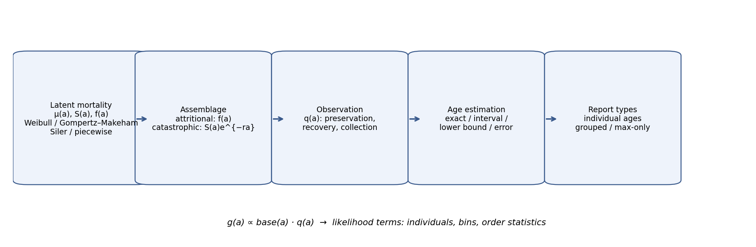
Figure 1. The generative chain from a latent mortality schedule μ(t) to reported fossil age evidence. Dashed nodes mark processes external to the population that must be modelled, not assumed away.

2.1 Latent mortality
Let T be the latent age at death with hazard μ(t), cumulative hazard H(t), survival S(t), and density f(t):
$$S(t) = exp(−H(t)), H(t) = \int_{0}^{t}{μ(u) du}, f(t) = μ(t) S(t)$$
Four parametric families are compared throughout: Weibull μ(t) = (k/λ)(t/λ)
$$μ(t) = \frac{k}{λ} (\frac{t}{λ})^{k−1} (Weibull)$$
$$μ(t) = c + a e^{bt} (Gompertz–Makeham)$$
$$μ(t) = {a₁e}^{−b₁t} + a₂ + {a₃e}^{b₃t} (Siler [7])$$
plus a piecewise-constant hazard as a flexible benchmark. No family is privileged: model choice is itself a sensitivity axis.

2.2 Assemblage formation
An attritional assemblage records deaths, so its base density is the death-age density f(a). A catastrophic or standing-crop assemblage samples the living structure, which under a stable population with growth rate r is
$$n(a) ∝ S(a) e^{−ra}$$
For r = 0 this reduces to n(a) ∝ S(a). Where the taphonomic literature disputes the mechanism (e.g. the Maiasaura bonebed), results are reported under both mechanisms rather than silently classifying the assemblage.

2.3 The observation process
Let q_j(a) be the probability that an individual of age a in study j is preserved, recovered, collected and measurable. The observed density is
$$g_j(a) = base_j(a) q_j(a) / \int_{0}^{∞}{base_j(u) q_j(u) du}$$
We use parametric families for q (constant, logistic monotone increase, juvenile deficit with a ramp, saturating, non-monotone peaked recovery). Because F and q enter g only through their product, they cannot both be unconstrained (Section 3). q is therefore treated as a scenario/uncertainty dimension, not a free estimand — except where we deliberately fit a constrained q to measure the cost of misspecification.

2.4 Age-estimation error and report types
Reported ages enter as exact values, intervals [lo, hi), or lower bounds (e.g. "at least x annuli"), with likelihood contributions g(a) da, G(hi) − G(lo), and 1 − G(lo) respectively. Grouped life-table counts contribute multinomial terms over bins. Observer disagreement is carried as per-specimen interval widths (mammaliaform cementum counts below).

2.5 The maximum as an order statistic
A maximum-only report (M, n) — "the oldest known of n specimens" — has density under the *observed* distribution g:
$$p(M) = n g(M) {G(M)}^{n−1}$$
with expected value
$$E[M^{n}] = \int_{0}^{∞}{(1 − }{G(a)}^{n} da)$$
Two consequences follow. First, M_5 and M_100 are different statistics, not estimates of the same quantity; comparing "oldest" specimens across samples of different size is comparing different estimators. Second, a maximum tells us about g, not directly about f: its information on latent mortality passes entirely through the assumed observation process. We propose standardized reporting of E[M_n*] at fixed n* (we use 50 and 100) as the comparable quantity, and we never reuse a maximum computed from an individual-level dataset as an additional likelihood term — it is already contained in the data and serves only as a posterior-predictive check.

3. What can be identified
Three structural non-identifiabilities bound what fossil age evidence can say, demonstrated empirically in Fig. 2 and quantified in Table 1.
(i) F and q are entangled. An observed sample of n = 50 ages generated under Weibull mortality with a juvenile-recovery deficit below age 6 is matched almost exactly (max |Δg| = 0.012) by a different Weibull mortality under constant q; the two explanations score essentially identical likelihoods (-139.6 vs -139.5). No likelihood can separate them; only assumptions can.
(ii) Catastrophic samples cannot identify mortality alone. For an 80-specimen standing-crop sample drawn from a Siler schedule with growth r = −0.05, the estimated mean age at death sweeps 5.3–20.7 yr as the assumed r varies over ±0.2 (Table S1); the likelihood surface is nearly flat over a broad r range and the best-fitting r is not the true one. Mortality and demography are inseparable in standing-crop data without independent r or fertility information ⁵.
(iii) Maximum-only evidence is weak. A single (M, n) report constrains mainly scale and leaves shape essentially free (Fig. 2C). As a consequence, targets are classified into four recoverability classes (Table 1): A robustly recoverable; B conditionally recoverable under stated scenarios; C weakly identified — report ranges, not points; D not identifiable without external information.
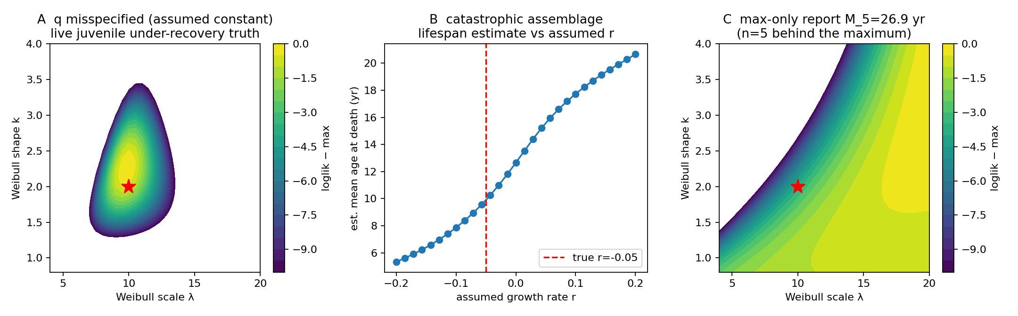
Figure 2. Identifiability exhibits. (A) Likelihood surface over Weibull (λ, k) when a juvenile-deficit truth is fitted under a wrong constant-q assumption. (B) Estimated mean age at death from a standing-crop sample as a function of the assumed population growth rate r; the estimate is a dial on r, not a property of the data. (C) Likelihood surface from a single maximum-only report.
Table 1. Recoverability classes for mortality summary quantities, assigned from the degradation experiment (Section 5) and the structural arguments above.
Class | Targets
A — robust | mean age at death (most scenarios); E[M_50] latent
B — conditional | q90, q95, prime-age hazard, median (continuous-hazard taxa, n ≥ ~30)
C — weak | median when mortality is infant-dominated; juvenile hazard; late-life hazard slope; hazard-minimum age; "onset of senescence"
D — not identifiable | joint (F, q); mortality from catastrophic data without independent r; any quantity from max-only data without known n and constrained q

4. Validation: degrading extant demography into fossil evidence
Because fossil truth is unknowable, we invert the problem: take known extant demographic schedules and destroy information the way the fossil record does. We use 45 published mammalian life tables from the malddaba database [6], each converted to a latent death-age distribution and standing-crop age structure. Samples are drawn as: (a) attritional deaths from the life-table death distribution, or (b) standing-crop ages from S(a)e^(−ra) at r ∈ {−0.05, 0, +0.05}; rejected with probability 1 − q(a) under five observation scenarios (constant; moderate and severe juvenile deficits; monotone logistic; non-monotone peaked recovery); measured at four resolutions (exact, integer-rounded, 2-year interval, ±10% lognormal noise); and reported as all individuals, grouped bins, max+n only, or mixed. Sample sizes span n = 5–100. Two analysts are applied to every sample: a "naive" analyst who assumes an attritional assemblage, constant q and exact ages, and an "informed" analyst who knows the true mechanism class, q family and age model. The informed analyst is an oracle — an upper bound on recoverability; the naive analyst is a lower bound that ignores observation structure entirely. Real-world inference lies between them, and no claim below rests on oracle knowledge alone. Each cell is replicated 30–40 times; the full map comprises 10,380 fits. Metrics: bias, relative bias, RMSE, estimator failure frequency, and the A–D classes of Table 1.

5. Results

5.1 The recoverability map
Fig. 3 summarizes median-age bias for the informed analyst over the three focal populations (a meerkat-sized short-lived, a red-deer mid-lived, and an elephant long-lived schedule). Three patterns dominate.
Observation process: with a severe juvenile-recovery deficit, the naive analyst overestimates the median age at death by 7.2 yr on average; the informed analyst reduces this to 2.3 yr, with the residual reflecting parametric misspecification rather than ignorance of q.
Assemblage: misreading a standing crop as a death assemblage produces biases of several years in either direction depending on r — dwarfing sampling error at any n.
Report type: grouped life tables lose almost nothing relative to individual ages, but max-only reports are unusable for estimating mortality summaries (mean median bias 20.7 yr; every max-only cell classifies D). Mixed reporting adds a legitimate independent maximum term at negligible cost.
Class fractions across all informed-analyst scenarios are shown in Fig. 4. Mean age at death classifies A in a majority of cells; the median is notably less robust — its D-cells are concentrated where the true schedule is infant-dominated (most wild mammal tables), because smooth parametric families cannot express a mortality spike at age 0 and spread the mass upward. Where senescence-relevant summaries (q90, q95, E[M_50]) sit in A/B under honest scenarios, they collapse under max-only reporting or mechanism misread.
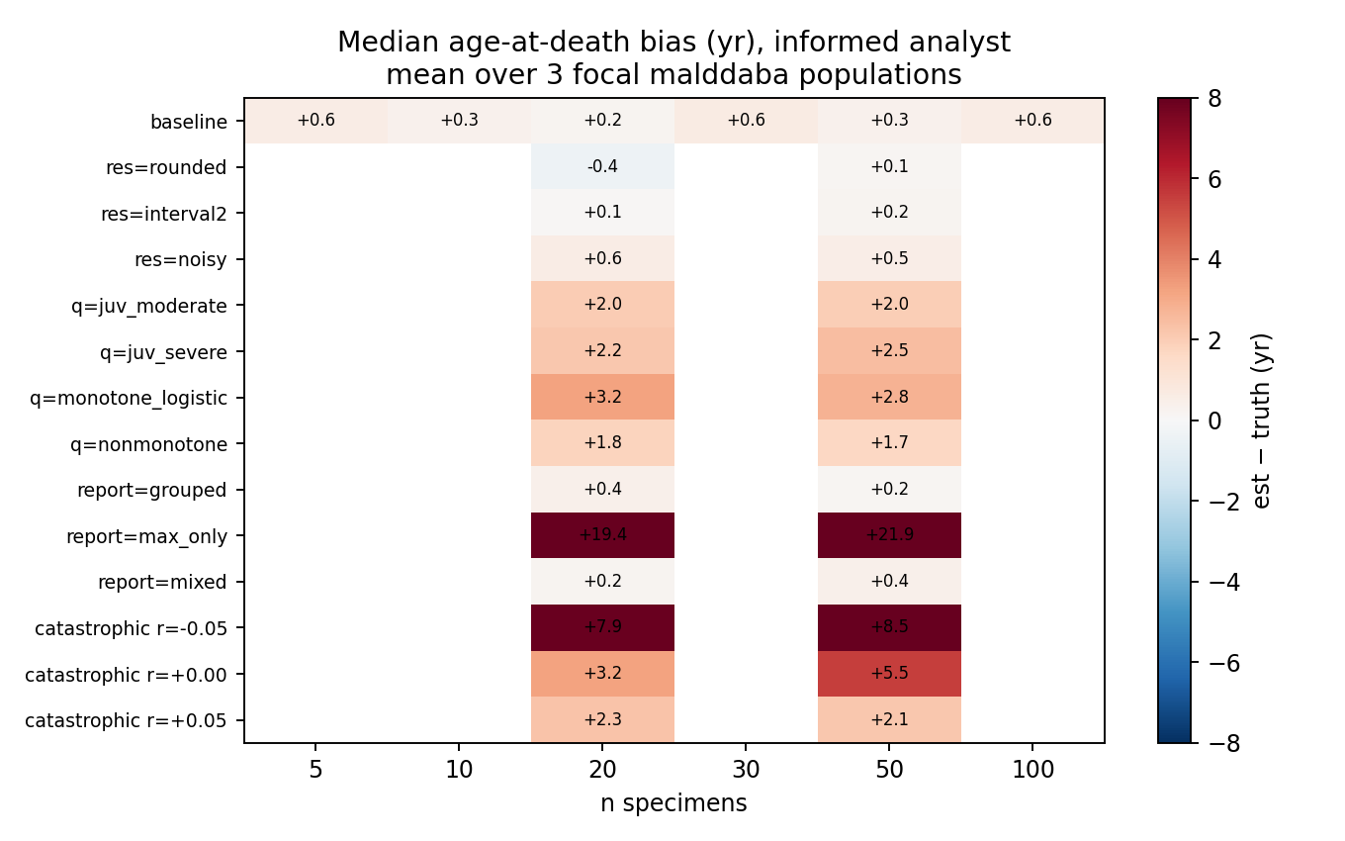
Figure 3. Recoverability map: mean bias of estimated median age at death (informed analyst) across fossilization scenarios and sample sizes, pooled over three focal extant schedules. Positive values mean overestimated lifespan.
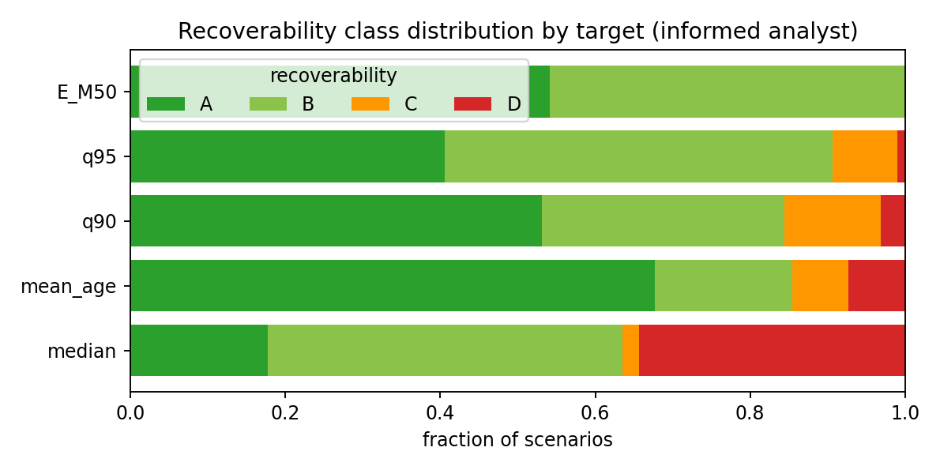
Figure 4. Fraction of informed-analyst scenarios classified A (robust), B (conditional), C (weak), D (not identifiable) for each mortality summary.

5.2 The maximum is a sample-size statistic
Under a single latent Weibull truth, the expected observed maximum climbs from E[M_5] = 14.6 yr to E[M_100] = 22.6 yr (Fig. 5). A 'record oldest individual' therefore says at least as much about collecting effort as about longevity. In simulation, an evidence model using 40 individual ages recovers the median unbiasedly; the same sample's maximum used as a sole datum returns a median biased high by ~12 yr on average; and adding the dataset's own maximum as a second independent likelihood term is illegitimate double counting whose apparent added precision is spurious (Table 2).
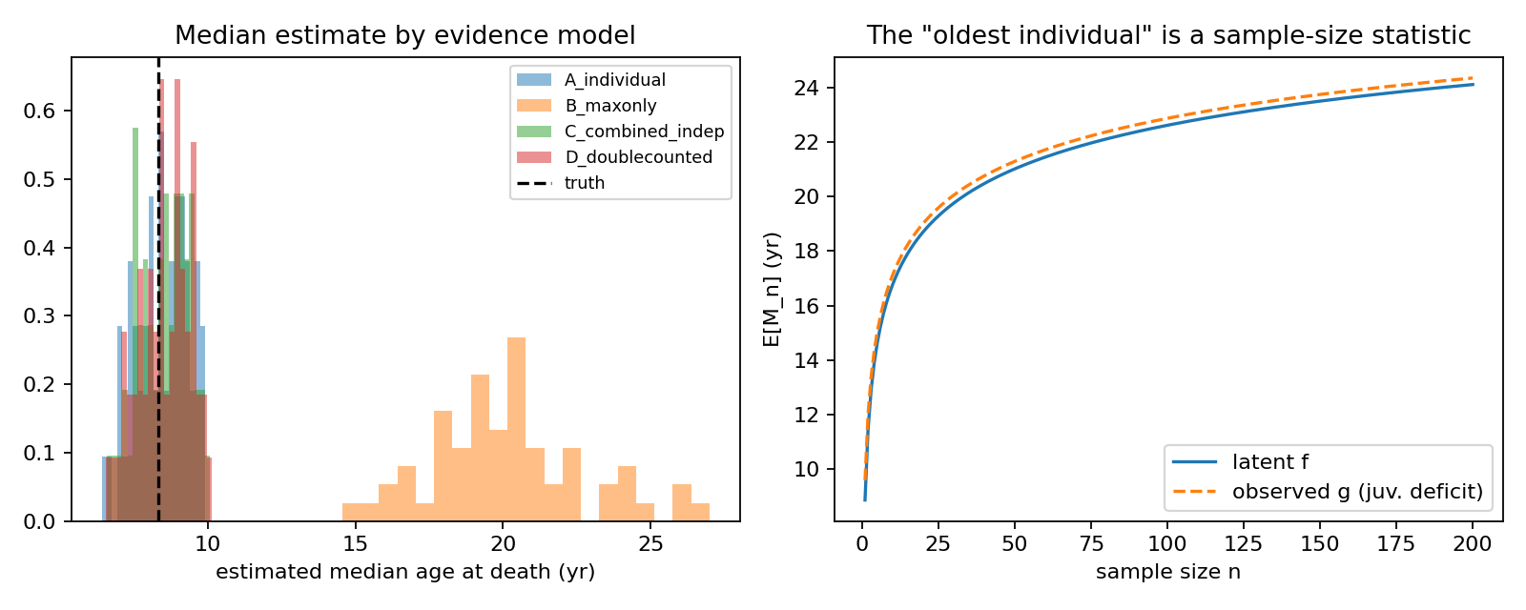
Figure 5. Left: estimated median distributions under four evidence models (A individual ages; B max-only; C individuals + independent max; D individuals + same-data max, the double-counting error). Right: E[M_n] under latent f vs an observed g with juvenile under-recovery — the statistic museums record.
Table 2. Estimated median age at death (yr; true 8.33) under four evidence models, 60 replicates.
evidence model | median mean | median sd
A_individual | 8.45 | 0.88
B_maxonly | 20.19 | 2.65
C_combined_indep | 8.49 | 0.83
D_doublecounted | 8.53 | 0.88

5.3 Fossil demonstrations
Four fossil datasets demonstrate the framework (Table 3; details in Supplement). These are methodological demonstrations on lawfully accessible data, not new estimates of any taxon's natural lifespan.
Maiasaura peeblesorum (n = 49 tibiae with LAG counts; Woodward et al. 2015 ¹). Under an attritional + complete-recovery reading, every family returns a heavily infant-dominated latent mortality — the assemblage is mostly 0-LAG juveniles — with fitted medians of 0.3–1.9 yr across families. The sensitivity analysis (Fig. 6) shows this is the dominant fragility: excluding the age-0 class alone moves the median to ~6.5 yr, and the standing-crop reading redistributes estimates across ±0.10 of assumed r. Across the analysis grid the median spans 0.0–6.6 yr: for this assemblage the median is a class-C quantity, and we report it as such.
Bayesian posteriors (Fig. 7) quantify the same fragility: Weibull median 0.28 yr [95% CrI 0.01–1.11], Siler 0.22 yr [0.02–1.31]. A posterior-predictive check on the dataset maximum (10 LAGs) shows the observed maximum sits in the lower tail of what the fitted models expect for n = 49 (p = 0.99 Weibull; 0.92 Siler): the oldest observed specimen is younger than the fitted latent tails predict — consistent with juvenile-dominated recovery or with a standing-crop mechanism.
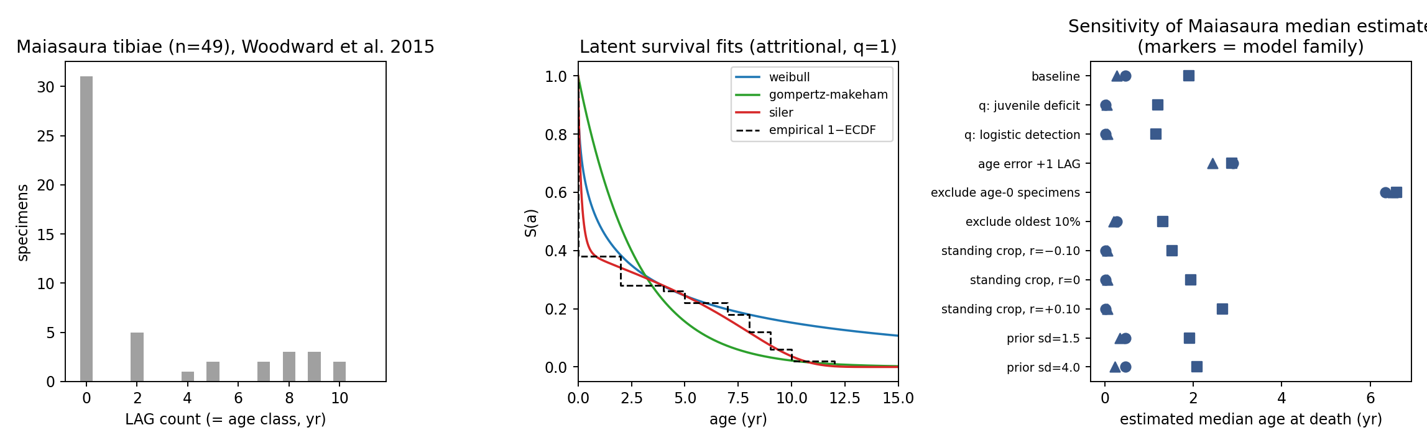
Figure 6. Maiasaura demonstration. Left: LAG-count distribution. Middle: latent survival fits by family (attritional, q = 1). Right: sensitivity of the estimated median to analysis choices; markers denote model family.
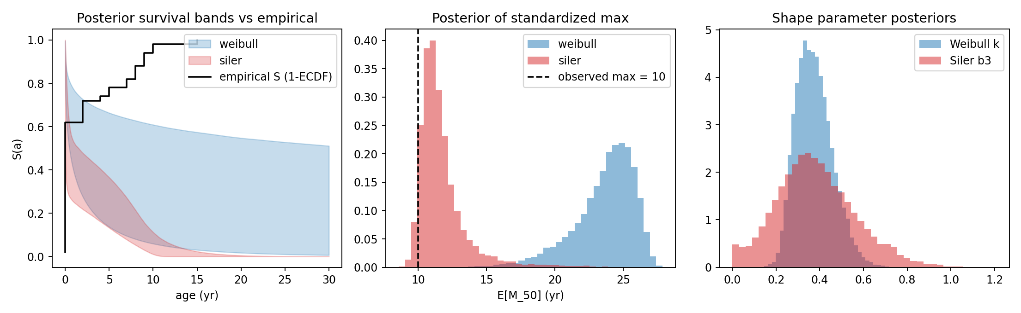
Figure 7. Bayesian demonstration on Maiasaura. Left: posterior survival bands vs empirical curve. Middle: posterior for standardized E[M_50] with the observed dataset maximum. Right: shape-parameter posteriors.
Psittacosaurus lujiatunensis (n = 15 aged specimens from Zhao et al. 2013 ⁸). The assemblage mixes hatchling and ~2-yr clusters with isolated individuals and its taphonomic status is contested; fitted means range ~4–11 yr purely as a function of assumed mechanism and r — the demographic spread dominates the fit. It cannot be read as a death age distribution, and we report the scenario range instead of an estimate.
Albertosaurus sarcophagus (grouped lx, per-1000 survivorship to age 28 from Erickson via the Griebeler Dryad transcription ⁵). Treated as grouped counts (n_eff = 22), fits reproduce the well-known convex survivorship; the recoverable quantities (q90 ≈ 21–26 yr across families) are reported, while the 22-specimen basis makes the median a class-C quantity under exclusion tests (small-sample stress test in the spirit of ⁴).
Mammaliaform cementum series (Morganucodon n = 35, Kuehneotherium n = 27; Newham et al. 2020 ⁹). Used here to demonstrate interval observation models from observer disagreement (three counts per specimen) rather than as demographic assemblages — they are fissure-fill samples, not death records. Attritional-model fits give compact estimates (medians ~4.5–5.2 yr) as an order-statistic/measurement demonstration only.
Table 3. Fossil demonstrations: range of fitted median and q90 (yr) across model families per assemblage/q scenario. Ranges, not point estimates, are the deliverable.
dataset · scenario | families fitted | median min | median max | q90 min | q90 max
Kuehneotherium|attritional | 3 | 5.13 | 5.21 | 7.64 | 7.77
Kuehneotherium|standing|r0 | 3 | 7.10 | 8.53 | 10.03 | 10.29
Maiasaura|attritional|q_const | 3 | 0.26 | 1.90 | 6.17 | 8.43
Maiasaura|attritional|q_juvdef | 3 | 0.01 | 1.20 | 0.02 | 3.95
Maiasaura|attritional|q_juvdef_sq | 3 | 0.01 | 0.90 | 0.01 | 2.96
Maiasaura|standing|r+0.05 | 3 | 0.01 | 2.24 | 0.11 | 7.26
Maiasaura|standing|r-0.05 | 3 | 0.01 | 1.71 | 0.22 | 5.57
Maiasaura|standing|r0 | 3 | 0.01 | 1.94 | 0.14 | 6.31
Morganucodon|attritional | 3 | 4.48 | 4.84 | 8.40 | 9.09
Morganucodon|standing|r0 | 3 | 6.28 | 7.95 | 11.89 | 12.08
Psittacosaurus|attritional | 3 | 3.44 | 3.73 | 8.63 | 8.72
Psittacosaurus|standing|r+0.10 | 3 | 5.44 | 10.96 | 12.60 | 13.46
Psittacosaurus|standing|r-0.10 | 3 | 2.74 | 4.57 | 8.47 | 9.22
Psittacosaurus|standing|r0 | 3 | 3.86 | 6.53 | 10.49 | 11.53

5.4 Sensitivity
The Maiasaura sensitivity grid (Fig. 6, right) ranks the material assumptions: specimen inclusion (age-0 class) and the observation/assemblage model dominate; age-measurement error (±1 retrocalculated LAG), prior strength, and oldest-specimen exclusion are secondary. Identifiability warnings (Table 1) correspond to exactly these fragile directions.

6. Discussion
What this framework changes. Prior work fitted survival curves to observed fossil age distributions ^{2,3,10}; Steinsaltz and Orzack quantified small-sample uncertainty and one fossilization bias ⁴; Griebeler showed that assemblages need not be stationary populations ⁵. The contribution here is to make every link in the inferential chain a separate object — latent hazard, mechanism, q, measurement, report — so that identifiability becomes a computed property rather than an assumption, and heterogeneous evidence combines without double counting.
The recoverability map is the practical output. It says: mean age at death, upper quantiles, and standardized maxima are the defensible deliverables at n ≥ ~30–50 under honest scenarios; the median is fragile where mortality is infant-dominated; juvenile and late-life hazard components are class-C everywhere we tested; and max-only reports are class-D for mortality inference — their only legitimate uses are as weak additional likelihood terms or posterior-predictive checks.
On "oldest individuals". E[M_n] has two virtues as a reporting standard: it is honest about sampling (n is explicit), and it is computable under any fitted model including the observation process. We recommend journals and authors report E[M_50] and E[M_100] alongside any "oldest known specimen" claim, with the sample n behind the maximum stated. A maximum without n is not a statistic.
Limitations. The map is generated under parametric families on life-table smooths of real demography; it can overstate recoverability where malddaba tables are already model-smoothed. The q scenarios are plausible, not measured — no dataset identifies q jointly with F, so field calibration (e.g. capture–recapture-informed preservation estimates) is the real fix and is flagged as future work. Age measurement is treated as a bounded interval, not a full calibration density for histological error, which remains poorly quantified in skeletochronology ^{8,9}. Finally, our fossil demonstrations are deliberately conservative: we report ranges over scenarios, and we expect future datasets (larger assemblages, better taphonomic control) to collapse some of them rather than all.
Positioning. Latent-age observation models are established in human skeletal paleodemography ¹¹; sampling-effort treatments of reported maxima exist in zoological longevity records ¹²; the order-statistic machinery itself is classical ¹³ but has not been wired into palaeodemographic likelihoods; and mechanistic fossil-occurrence simulators serve phylogenetic inference ¹⁴, not within-assemblage demography. This is not the first survival analysis of dinosaurs, the first Weibull fit in palaeontology, or the first paper to say taphonomy biases age structure. Its claim is narrower and new: a joint generative likelihood over heterogeneous fossil age evidence, an explicit non-identifiability treatment of (F, q), an order-statistic accounting of fossil maxima, and a validated map of what survives fossilization.

7. Conclusions
Fossil age-at-death evidence can support mortality inference — but only some quantities, under stated assumptions, reported with their scenario ranges. The framework and recoverability map provided here make those statements checkable dataset by dataset. Where they cannot be made, the honest output is the impossibility result itself.

Data and code availability
All raw inputs (data/raw/ with provenance ledger), processed datasets, analysis scripts (scripts/), generated result tables (output/tables/) and figures (output/figures/) accompany this manuscript; every reported number is regenerated by the scripts in README_REPRODUCIBILITY.md. Third-party datasets remain under their stated licenses; publisher-blocked sources are declared in data_inventory.csv.

References
1. Woodward HN, Freedman Fowler EA, Farlow JO, Horner JR. Maiasaura, a model organism for extinct vertebrate population biology: a large sample statistical assessment of growth dynamics and survivorship. Paleobiology. 2015;41(4):503–527.
2. Erickson GM, Currie PJ, Inouye BD, Winn AA. Tyrannosaur life tables: an example of nonavian dinosaur population biology. Science. 2006;313(5787):213–217.
3. Erickson GM, Makovicky PJ, Inouye BD, Zhou CF, Gao KQ. A life table for Psittacosaurus lujiatunensis: initial insights into ornithischian dinosaur population biology. Anat Rec. 2009;292(9):1514–1521.
4. Steinsaltz D, Orzack SH. Evaluating statistical approaches to quantifying juvenile survival in deep time. Paleobiology. 2011;37(1):113–125.
5. Griebeler EM. Dinosaurian survivorship schedules revisited: new insights from an age-structured population model. Palaeontology. 2021;64(6):839–854. doi:10.1111/pala.12576.
6. Ronget V, Lemaitre JF, Spataro B, Humblot L, Gaillard JM. malddaba: an open-access database of age-specific mammalian demography for comparative analyses in evolutionary biology and demography. bioRxiv. 2025:2025.07.01.662579. doi:10.1101/2025.07.01.662579.
7. Siler W. A competing-risk model for animal mortality. Ecology. 1979;60(4):750–757.
8. Zhao Q, Benton MJ, Sullivan C, Sander PM, Xu X. Histology and postural change during the growth of the ceratopsian dinosaur Psittacosaurus lujiatunensis. Nat Commun. 2013;4:2079.
9. Newham E, Gill PG, Brewer P, Benton MJ, Fernandez V, Gostling NJ, et al. Reptile-like physiology in Early Jurassic stem-mammals. Nat Commun. 2020;11:5121.
10. Ricklefs RE. Tyrannosaur ageing. Biol Lett. 2007;3(2):214–217.
11. Bocquet-Appel JP, Masset C. Farewell to paleodemography. J Hum Evol. 1982;11(4):321–333.
12. Moorad JA, Promislow DEL, Flesness N, Miller RA. A comparative assessment of univariate longevity measures using zoological animal records. Aging Cell. 2012;11(6):940–950.
13. David HA, Nagaraja HN. Order Statistics. 3rd ed. Wiley; 2003.
14. Barido-Sottani J, Pett W, O'Reilly JE, Warnock RCM. FossilSim: an R package for simulating fossil occurrence data under mechanistic models of preservation and sampling. Methods Ecol Evol. 2019;10(6):835–840.

