Beyond the oldest known individual: reconstructing mortality distributions from fossil age-at-death evidence
Tatsuki Onishi
RRH: RECONSTRUCTING FOSSIL MORTALITY
LRH: TATSUKI ONISHI
Abstract.—Palaeontologists infer the demography of extinct species from fossil age-at-death evidence — histologically aged individuals, life tables, and "oldest known specimen" reports — but these are different observation types of one latent mortality process and do not directly identify a population mortality distribution. We specify a generative framework that separates the latent hazard, the assemblage-formation mechanism (attritional death assemblage versus catastrophic standing crop), age-dependent preservation and recovery q(a), age-estimation error, and the reporting scheme, with maximum-only evidence treated as a sample-size-conditioned order statistic. We validate the framework by degrading 45 extant mammal life tables into fossil-like samples under a grid of sample sizes, age resolutions, observation scenarios, report types, and assemblage mechanisms, and classify each mortality summary as robustly, conditionally, or not recoverable. Mean age at death and sample-size-standardized expected maxima E[M_n] were among the more recoverable summaries under realistic sample sizes and observation bias; the median was fragile where mortality is infant-dominated, and maximum-only reports could not support mortality estimates. Application to four fossil assemblages (Maiasaura, Psittacosaurus, Albertosaurus, and two mammaliaform cementum series) demonstrates scenario-range reporting: analytic choices move the Maiasaura median age-at-death estimate across 0.0–6.6 yr. An "oldest known individual" must be interpreted conditional on sample size, and fossil mortality inference should report its recoverability limits.
Tatsuki Onishi. [affiliation, postal address and e-mail to be completed at submission]
Introduction
How long did extinct animals live? The evidence is always indirect: histological age estimates on a handful of specimens (Erickson et al. 2006, 2009; Woodward et al. 2015), life tables assembled from such samples (Erickson et al. 2006, 2009), and press-ready statements about the "oldest known" individual of a taxon. Three different kinds of numbers — individual ages, grouped tallies, and sample maxima — are produced by the same underlying mortality process, yet the literature treats them largely as interchangeable evidence for "the lifespan" of a species.
Two complications are well recognized but rarely modelled together. First, a fossil assemblage is not necessarily a record of deaths: a catastrophically killed standing crop samples the living age structure, and interpreting it as a death distribution confounds mortality with population growth (Steinsaltz and Orzack 2011; Griebeler 2021). Second, preservation, recovery and collection are age-dependent: juveniles are systematically under-represented in many assemblages, so the observed age distribution is a filtered version of the latent one (Steinsaltz and Orzack 2011). Steinsaltz and Orzack showed how strongly these filters can reshape apparent survivorship; what has been missing is a generative treatment in which all of these processes are explicit and their identifiability is measured rather than asserted.
Here we build that framework and then subject it to a controlled test. The latent mortality hazard, the assemblage mechanism, the observation process q(a), the age-measurement model, and the report type are each specified separately, so the likelihood of heterogeneous evidence — individual ages, grouped life tables, and maximum-only reports — can be written down without double counting. We then degrade 45 empirically known extant mammal life tables (Ronget et al. 2026) into fossil-like samples under a systematic grid of information loss, and ask which mortality summaries survive. The result is a recoverability map: not a claim that a particular dinosaur lived a particular number of years, but a map of what the fossil record can defensibly tell us, and where it cannot.
The framework deliberately withholds what it cannot support. Where an estimand is only weakly identified we report it as such, and where the fossil data cannot separate mortality from preservation or population structure, the paper says so. "The mean age at death of this taxon cannot be recovered from these data" is, in our view, a publishable answer.
The Generative Framework
Fossil age evidence is modelled as a five-stage generative chain (Fig. 1): a latent mortality schedule produces ages at death or ages in a living population; assemblage formation selects between attritional and catastrophic (standing-crop) mechanisms; the observation process q(a) distorts the age distribution; age estimation adds noise or interval censoring; and the reporting scheme determines whether individual ages, grouped counts or only a maximum are available. Each stage is defined below; inference conditions on the whole chain.
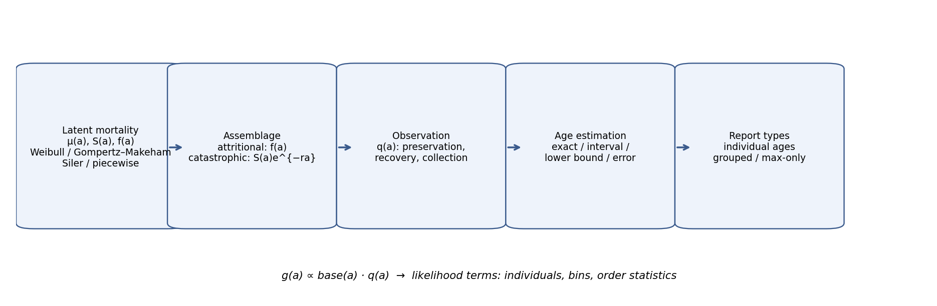
Figure 1. The generative chain from a latent mortality schedule μ(t) to reported fossil age evidence. Dashed nodes mark processes external to the population that must be modelled, not assumed away.
Latent Mortality
Let T be the latent age at death with hazard μ(t), cumulative hazard H(t), survival S(t), and density f(t):
$$S(t) = exp(−H(t)), H(t) = \int_{0}^{t}{μ(u) du}, f(t) = μ(t) S(t)$$ (1)
Four parametric families are compared throughout:
$$μ(t) = \frac{k}{λ} (\frac{t}{λ})^{k−1} (Weibull)$$ (2)
$$μ(t) = c + a e^{bt} (Gompertz–Makeham)$$ (3)
$$μ(t) = {a₁e}^{−b₁t} + a₂ + {a₃e}^{b₃t} (Siler 1979)$$ (4)
plus a piecewise-constant hazard as a flexible benchmark. No family is privileged: model choice is itself a sensitivity axis.
Assemblage Formation
An attritional assemblage records deaths, so its base density is the death-age density f(a). A catastrophic or standing-crop assemblage samples the living structure, which under a stable population with growth rate r is
$$n(a) ∝ S(a) e^{−ra}$$ (5)
For r = 0 this reduces to n(a) ∝ S(a). Where the taphonomic literature disputes the mechanism (e.g. the Maiasaura bonebed), results are reported under both mechanisms rather than silently classifying the assemblage.
The Observation Process
Let q_j(a) be the probability that an individual of age a in study j is preserved, recovered, collected and measurable. The observed density is
$$g_j(a) = base_j(a) q_j(a) / \int_{0}^{∞}{base_j(u) q_j(u) du}$$ (6)
We use parametric families for q (constant, logistic monotone increase, juvenile deficit with a ramp, saturating, non-monotone peaked recovery). Because F and q enter g only through their product, they cannot both be unconstrained (What Can Be Identified). q is therefore treated as a scenario/uncertainty dimension, not a free estimand — except where we deliberately fit a constrained q to measure the cost of misspecification.
Age-Estimation Error and Report Types
Reported ages enter as exact values, intervals [lo, hi), or lower bounds (e.g. "at least x annuli"), with likelihood contributions g(a) da, G(hi) − G(lo), and 1 − G(lo) respectively. Grouped life-table counts contribute multinomial terms over bins. Observer disagreement is carried as per-specimen interval widths (mammaliaform cementum counts below).
The Maximum as an Order Statistic
A maximum-only report (M, n) — "the oldest known of n specimens" — has density under the observed distribution g:
$$p(M) = n g(M) {G(M)}^{n−1}$$ (7)
with expected value
$$E[M^{n}] = \int_{0}^{∞}{(1 − }{G(a)}^{n} da)$$ (8)
Two consequences follow. First, M_5 and M_100 are different statistics, not estimates of the same quantity; comparing "oldest" specimens across samples of different size is comparing different estimators. Second, a maximum tells us about g, not directly about f: its information on latent mortality passes entirely through the assumed observation process. We propose standardized reporting of E[M_n*] at fixed n* (we use 50 and 100) as the comparable quantity, and we never reuse a maximum computed from an individual-level dataset as an additional likelihood term — it is already contained in the data and serves only as a posterior-predictive check.
What Can Be Identified
Three structural non-identifiabilities bound what fossil age evidence can say, demonstrated empirically in Fig. 2 and quantified in Table 1.
(1) F and q are entangled. An observed sample of n = 50 ages generated under Weibull mortality with a juvenile-recovery deficit below age 6 is matched almost exactly (max |Δg| = 0.012) by a different Weibull mortality under constant q; the two explanations score essentially identical likelihoods (-139.6 vs -139.5). No likelihood can separate them; only assumptions can.
(2) Catastrophic samples cannot identify mortality alone. For an 80-specimen standing-crop sample drawn from a Siler schedule with growth r = −0.05, the estimated mean age at death sweeps 5.3–20.7 yr as the assumed r varies over ±0.2 (Supplementary Table 1); the likelihood surface is nearly flat over a broad r range and the best-fitting r is not the true one. Mortality and demography are inseparable in standing-crop data without independent r or fertility information (Griebeler 2021).
(3) Maximum-only evidence is weak. A single (M, n) report constrains mainly scale and leaves shape essentially free (Fig. 2C). As a consequence, targets are classified into four recoverability classes (Table 1): A, robustly recoverable; B, conditionally recoverable under stated scenarios; C, weakly identified (report ranges, not points); D, not identifiable without external information.
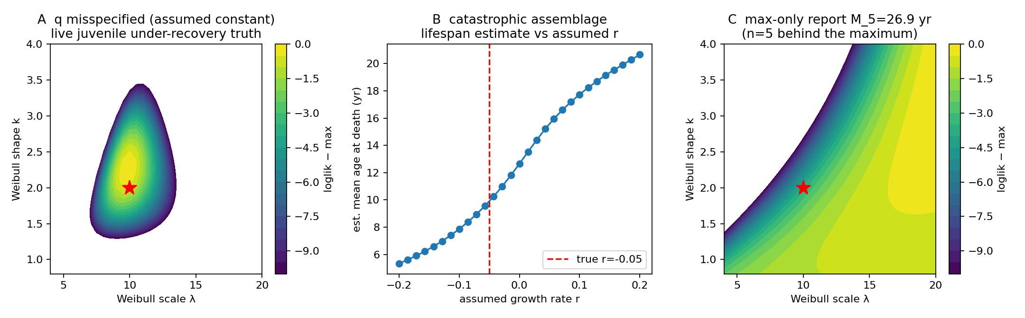
Figure 2. Identifiability exhibits. A, Likelihood surface over Weibull (λ, k) when a juvenile-deficit truth is fitted under a wrong constant-q assumption. B, Estimated mean age at death from a standing-crop sample as a function of the assumed population growth rate r; the estimate is a dial on r, not a property of the data. C, Likelihood surface from a single maximum-only report.
Table 1. Recoverability classes for mortality summary quantities, assigned from the degradation experiment and the structural arguments above.
Class | Targets
A — robust | mean age at death (most scenarios); E[M_50] latent
B — conditional | q90, q95, prime-age hazard, median (continuous-hazard taxa, n ≥ ~30)
C — weak | median when mortality is infant-dominated; juvenile hazard; late-life hazard slope; hazard-minimum age
D — not identifiable | joint (F, q); mortality from catastrophic data without independent r; any quantity from maximum-only data without known n and constrained q
Validation: Degrading Extant Demography into Fossil Evidence
Because fossil truth is unknowable, we invert the problem: take known extant demographic schedules and destroy information the way the fossil record does. We use 45 published mammalian life tables from the malddaba database (Ronget et al. 2026), each converted to a latent death-age distribution and standing-crop age structure. Samples are drawn as attritional deaths from the life-table death distribution, or standing-crop ages from S(a)e^(−ra) at r ∈ {−0.05, 0, +0.05}; rejected with probability 1 − q(a) under five observation scenarios (constant; moderate and severe juvenile deficits; monotone logistic; non-monotone peaked recovery); measured at four resolutions (exact, integer-rounded, 2-yr interval, ±10% lognormal noise); and reported as all individuals, grouped bins, max+n only, or mixed. Sample sizes span n = 5–100. Two analysts are applied to every sample: a "naive" analyst who assumes an attritional assemblage, constant q and exact ages, and an "informed" analyst who knows the true mechanism class, q family and age model. The informed analyst is an oracle — an upper bound on recoverability; the naive analyst is a lower bound that ignores observation structure entirely. Real-world inference lies between them, and no claim below rests on oracle knowledge alone. Each cell is replicated 30–40 times; the full map comprises 10,380 fits. Metrics: bias, relative bias, RMSE, estimator failure frequency, and the A–D classes of Table 1. Analysis code was generated with the assistance of Devin (Cognition AI) and reviewed line by line by the author.
Results
The Recoverability Map
Figure 3 summarizes median-age bias for the informed analyst over the three focal populations (a meerkat-sized short-lived, a red-deer mid-lived, and an elephant long-lived schedule). Three patterns dominate.
Observation process: with a severe juvenile-recovery deficit, the naive analyst overestimates the median age at death by 7.2 yr on average; the informed analyst reduces this to 2.3 yr, with the residual reflecting parametric misspecification rather than ignorance of q.
Assemblage: misreading a standing crop as a death assemblage produces biases of several years in either direction depending on r — dwarfing sampling error at any n.
Report type: grouped life tables lose almost nothing relative to individual ages, but maximum-only reports are unusable for estimating mortality summaries (mean median bias 20.7 yr; every maximum-only cell classifies D). Mixed reporting adds a legitimate independent maximum term at negligible cost.
Class fractions across all informed-analyst scenarios are shown in Fig. 4. Mean age at death classifies A in a majority of cells; the median is notably less robust — its D cells are concentrated where the true schedule is infant-dominated (most wild mammal tables), because smooth parametric families cannot express a mortality spike at age 0 and spread the mass upward. Late-life summaries (q90, q95, E[M_50]) sit in A/B under honest scenarios but collapse under maximum-only reporting or mechanism misread.
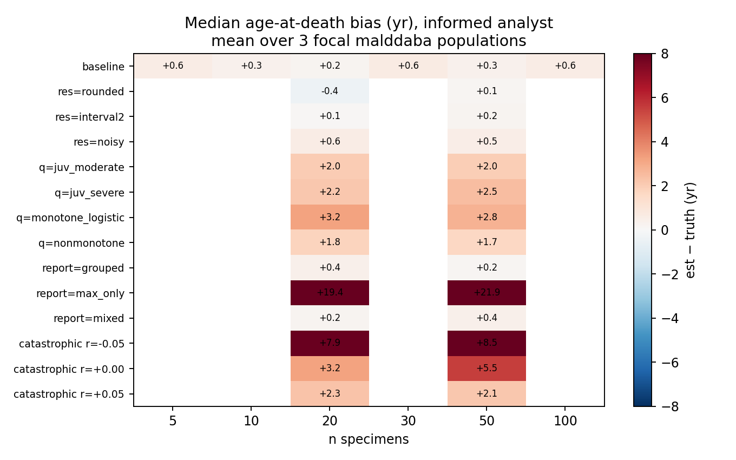
Figure 3. Recoverability map: mean bias of estimated median age at death (informed analyst) across fossilization scenarios and sample sizes, pooled over three focal extant schedules. Positive values indicate overestimation of the median.
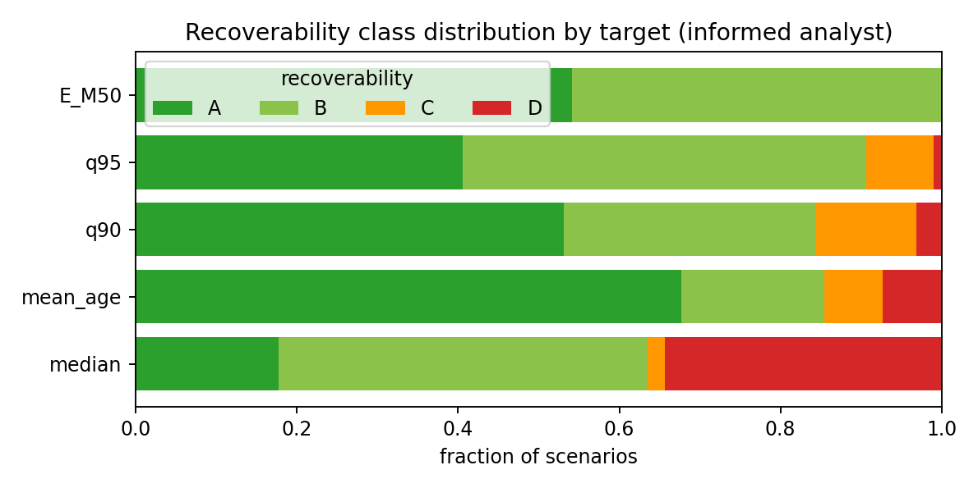
Figure 4. Fraction of informed-analyst scenarios classified A (robust), B (conditional), C (weak), D (not identifiable) for each mortality summary.
The Maximum Is a Sample-Size Statistic
Under a single latent Weibull truth, the expected observed maximum climbs from E[M_5] = 14.6 yr to E[M_100] = 22.6 yr (Fig. 5). A 'record oldest individual' therefore says at least as much about collecting effort as about the underlying mortality schedule. In simulation, an evidence model using 40 individual ages recovers the median unbiasedly; the same sample's maximum used as a sole datum returns a median biased high by ~12 yr on average; and adding the dataset's own maximum as a second independent likelihood term is illegitimate double counting whose apparent added precision is spurious (Table 2).
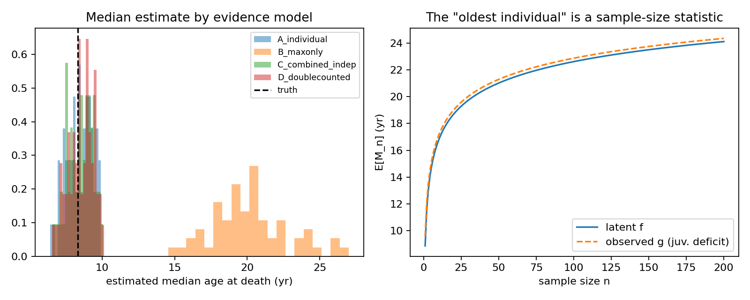
Figure 5. Left, estimated median distributions under four evidence models (A, individual ages; B, maximum-only; C, individuals plus independent maximum; D, individuals plus same-data maximum, the double-counting error). Right, E[M_n] under the latent f versus an observed g with juvenile under-recovery — the statistic museums record.
Table 2. Estimated median age at death (yr; true 8.33) under four evidence models, 60 replicates.
evidence model | median mean | median sd
A_individual | 8.45 | 0.88
B_maxonly | 20.19 | 2.65
C_combined_indep | 8.49 | 0.83
D_doublecounted | 8.53 | 0.88
Fossil Demonstrations
Four fossil datasets demonstrate the framework (Table 3; details in Supplementary Material). These are methodological demonstrations on lawfully accessible data, not new estimates of any taxon’s mortality schedule or longevity.
Maiasaura peeblesorum (n = 49 tibiae with LAG counts; Woodward et al. 2015). Under an attritional + complete-recovery reading, every family returns a heavily infant-dominated latent mortality — the assemblage is mostly 0-LAG juveniles — with fitted medians of 0.3–1.9 yr across families. The sensitivity analysis (Fig. 6) shows this is the dominant fragility: excluding the age-0 class alone moves the median to ~6.5 yr, and the standing-crop reading redistributes estimates across ±0.10 of assumed r. Across the analysis grid the median spans 0.0–6.6 yr: for this assemblage the median is a class-C quantity, and we report it as such.
Bayesian posteriors (Fig. 7) quantify the same fragility: Weibull median 0.28 yr [95% CrI 0.01–1.11]; Siler 0.22 yr [0.02–1.31]. A posterior-predictive check on the dataset maximum (10 LAGs) shows the observed maximum sits in the lower tail of what the fitted models expect for n = 49 (p = 0.99 Weibull; 0.92 Siler): the oldest observed specimen is younger than the fitted latent tails predict — consistent with juvenile-dominated recovery or with a standing-crop mechanism.
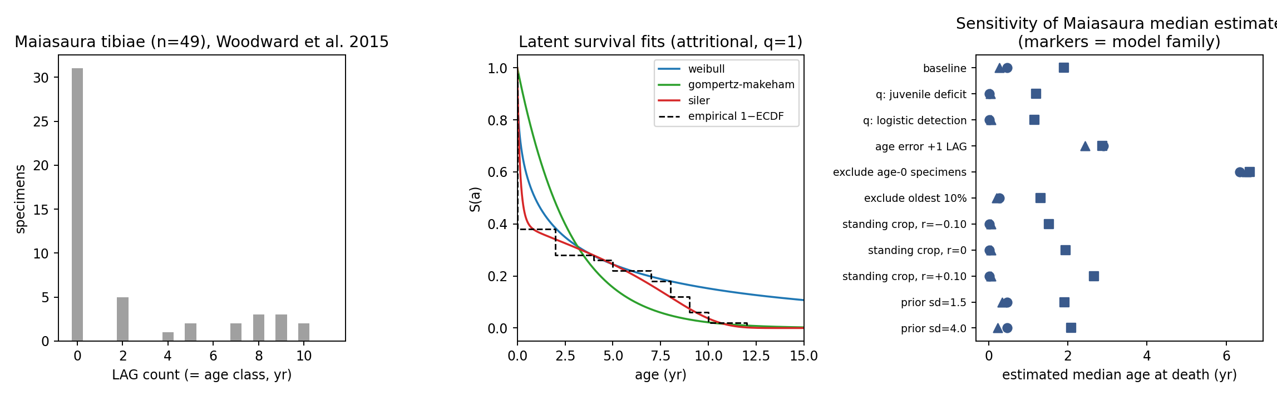
Figure 6. Maiasaura demonstration. Left, LAG-count distribution. Middle, latent survival fits by family (attritional, q = 1). Right, sensitivity of the estimated median to analysis choices; marker shape denotes model family.
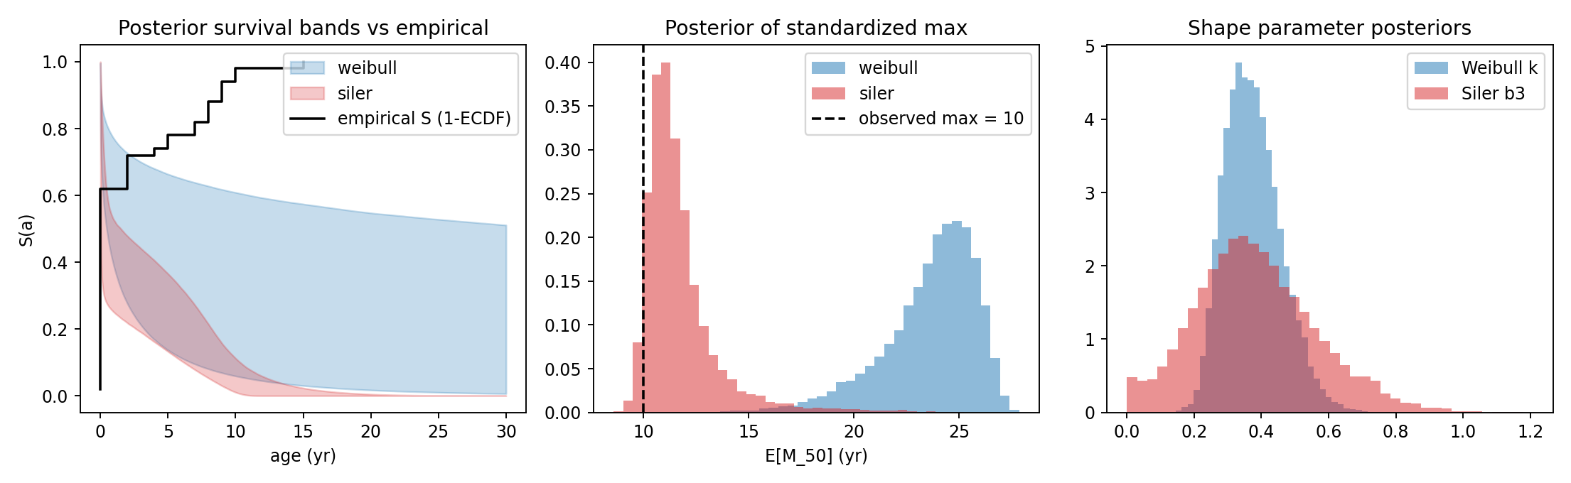
Figure 7. Bayesian demonstration on Maiasaura. Left, posterior survival bands versus the empirical curve. Middle, posterior for standardized E[M_50] with the observed dataset maximum. Right, shape-parameter posteriors.
Psittacosaurus lujiatunensis (n = 15 aged specimens from Zhao et al. 2013). The assemblage mixes hatchling and ~2-yr clusters with isolated individuals and its taphonomic status is contested; fitted means range ~4–11 yr purely as a function of assumed mechanism and r — the demographic spread dominates the fit. It cannot be read as a death-age distribution, and we report the scenario range instead of an estimate.
Albertosaurus sarcophagus (grouped lx, per-1000 survivorship to age 28 from Erickson via the Griebeler Dryad transcription; Griebeler 2021). Treated as grouped counts (n_eff = 22), fits reproduce the well-known convex survivorship; the recoverable quantities (q90 ≈ 21–26 yr across families) are reported, while the 22-specimen basis makes the median a class-C quantity under exclusion tests (a small-sample stress test in the spirit of Steinsaltz and Orzack 2011).
Mammaliaform cementum series (Morganucodon n = 35, Kuehneotherium n = 27; Newham et al. 2020). Used here to demonstrate interval observation models from observer disagreement (three counts per specimen) rather than as demographic assemblages — they are fissure-fill samples, not death records. Attritional-model fits give compact estimates (medians ~4.5–5.2 yr) as an order-statistic/measurement demonstration only.
Table 3. Fossil demonstrations: range of fitted median and q90 (yr) across model families per assemblage/q scenario. Ranges, not point estimates, are the deliverable.
dataset · scenario | families fitted | median min | median max | q90 min | q90 max
Kuehneotherium|attritional | 3 | 5.13 | 5.21 | 7.64 | 7.77
Kuehneotherium|standing|r0 | 3 | 7.10 | 8.53 | 10.03 | 10.29
Maiasaura|attritional|q_const | 3 | 0.26 | 1.90 | 6.17 | 8.43
Maiasaura|attritional|q_juvdef | 3 | 0.01 | 1.20 | 0.02 | 3.95
Maiasaura|attritional|q_juvdef_sq | 3 | 0.01 | 0.90 | 0.01 | 2.96
Maiasaura|standing|r+0.05 | 3 | 0.01 | 2.24 | 0.11 | 7.26
Maiasaura|standing|r-0.05 | 3 | 0.01 | 1.71 | 0.22 | 5.57
Maiasaura|standing|r0 | 3 | 0.01 | 1.94 | 0.14 | 6.31
Morganucodon|attritional | 3 | 4.48 | 4.84 | 8.40 | 9.09
Morganucodon|standing|r0 | 3 | 6.28 | 7.95 | 11.89 | 12.08
Psittacosaurus|attritional | 3 | 3.44 | 3.73 | 8.63 | 8.72
Psittacosaurus|standing|r+0.10 | 3 | 5.44 | 10.96 | 12.60 | 13.46
Psittacosaurus|standing|r-0.10 | 3 | 2.74 | 4.57 | 8.47 | 9.22
Psittacosaurus|standing|r0 | 3 | 3.86 | 6.53 | 10.49 | 11.53
Sensitivity
The Maiasaura sensitivity grid (Fig. 6, right) ranks the material assumptions: specimen inclusion (the age-0 class) and the observation/assemblage model dominate; age-measurement error (±1 retrocalculated LAG), prior strength, and oldest-specimen exclusion are secondary. Identifiability warnings (Table 1) correspond to exactly these fragile directions.
Discussion
What this framework changes. Prior work fitted survival curves to observed fossil age distributions (Erickson et al. 2006, 2009; Ricklefs 2007); Steinsaltz and Orzack (2011) quantified small-sample uncertainty and one fossilization bias; Griebeler (2021) showed that assemblages need not be stationary populations. The contribution here is to make every link in the inferential chain a separate object — latent hazard, mechanism, q, measurement, report — so that identifiability becomes a computed property rather than an assumption, and heterogeneous evidence combines without double counting.
What can be recovered — and what cannot. The recoverability map says: mean age at death, upper quantiles, and standardized expected maxima are the defensible deliverables at n ≥ ~30–50 under honest scenarios; the median is fragile where mortality is infant-dominated; juvenile and late-life hazard components are class-C everywhere we tested; and maximum-only reports are class-D for mortality inference — their only legitimate uses are as weak additional likelihood terms or posterior-predictive checks.
Why sample size changes the meaning of "oldest". E[M_n] has two virtues as a reporting standard: it is honest about sampling (n is explicit), and it is computable under any fitted model including the observation process. We recommend authors report E[M_50] and E[M_100] alongside any "oldest known specimen" claim, with the sample n behind the maximum stated. A maximum without n is not a statistic.
What to report. Future fossil age-demography studies should ideally report: (1) every individual age estimate, with its uncertainty interval, where possible; (2) the total eligible sample size and the number successfully aged; (3) the observed maximum age and the n behind it; (4) the assemblage interpretation (death assemblage versus standing crop); (5) any age- or size-dependent recovery concerns; and (6) whether the reported maximum comes from the same individual-level sample. This metadata is what separates usable evidence from anecdote.
Positioning. Latent-age observation models are established in human skeletal paleodemography (Bocquet-Appel and Masset 1982); sampling-effort treatments of reported maxima exist in zoological longevity records (Moorad et al. 2012); the order-statistic machinery itself is classical (David and Nagaraja 2003) but has not been wired into palaeodemographic likelihoods; and mechanistic fossil-occurrence simulators serve phylogenetic inference (Barido-Sottani et al. 2019), not within-assemblage demography. This framework integrates these pieces: individual age-at-death evidence, independent maximum-only evidence as sample-size-conditioned order statistics, the assemblage-generating mechanism, age-dependent observation, age-estimation uncertainty, and extant-to-fossil validation — into one likelihood whose identifiability limits are reported, not hidden. It is not the first survival analysis of dinosaurs, the first Weibull fit in palaeontology, or the first paper to say taphonomy biases age structure.
Limitations. Latent mortality and unrestricted q(a) are not jointly identifiable from a single sparse assemblage; our map is generated under parametric families on life-table smooths of real demography and can overstate recoverability where malddaba tables are already model-smoothed. The q scenarios are plausible, not measured — no dataset identifies q jointly with F, so field calibration is the real fix and is flagged as future work. Preservation, recovery, collection, publication and museum curation may impose different selection mechanisms than the q families tested. Catastrophic analyses assume a stable or stationary population — where that fails, results shift with r as shown. Fossil age estimates may themselves be systematically biased: we treat age measurement as a bounded interval, not a full calibration density for histological error, which remains poorly quantified in skeletochronology (Zhao et al. 2013; Newham et al. 2020). Validation across 45 mammalian schedules does not guarantee identical fossilization processes in any extinct taxon. The standardized expected maximum E[M_n*] is a model-based comparative statistic, not a biological maximum lifespan. And our fossil demonstrations are stress tests and proofs of concept, not definitive population reconstructions: we expect future datasets to collapse some scenario ranges rather than all.
Conclusions
Fossil age-at-death evidence can support mortality inference — but only some quantities, under stated assumptions, reported with their scenario ranges. The framework and recoverability map provided here make those statements checkable dataset by dataset. Where they cannot be made, the honest output is the impossibility result itself.
Acknowledgments
We thank the authors and journals whose published supplementary materials made this analysis possible. Devin (Cognition AI; devin.ai), accessed September 2026, was used for analysis-code generation and manuscript drafting; all code, results and text were reviewed and verified by the human author.
Author Contributions
T.O. designed the study, verified all analyses, and approved the final manuscript.
Funding
[Funding statement to be completed at submission.]
Competing Interests
The authors declare none.
Data Availability Statement
The complete data-and-code bundle — raw inputs with a provenance ledger, processed datasets, all analysis scripts, and generated result tables and figures — accompanies this submission for review. The same bundle will be deposited in Dryad on acceptance (Paleobiology covers repository costs). Third-party datasets remain under their stated licences; publisher-blocked sources are declared in data_inventory.csv.
Literature Cited
Barido-Sottani, J., W. Pett, J. E. O’Reilly, and R. C. M. Warnock. 2019. FossilSim: an R package for simulating fossil occurrence data under mechanistic models of preservation and sampling. Methods in Ecology and Evolution 10:835–840.
Bocquet-Appel, J.-P., and C. Masset. 1982. Farewell to paleodemography. Journal of Human Evolution 11:321–333.
David, H. A., and H. N. Nagaraja. 2003. Order statistics. Third edition. Wiley, Hoboken, NJ.
Erickson, G. M., P. J. Currie, B. D. Inouye, and A. A. Winn. 2006. Tyrannosaur life tables: an example of nonavian dinosaur population biology. Science 313:213–217.
Erickson, G. M., P. J. Makovicky, B. D. Inouye, C.-F. Zhou, and K.-Q. Gao. 2009. A life table for Psittacosaurus lujiatunensis: initial insights into ornithischian dinosaur population biology. Anatomical Record 292:1514–1521.
Griebeler, E. M. 2021. Dinosaurian survivorship schedules revisited: new insights from an age-structured population model. Palaeontology 64:839–854.
Moorad, J. A., D. E. L. Promislow, N. Flesness, and R. A. Miller. 2012. A comparative assessment of univariate longevity measures using zoological animal records. Aging Cell 11:940–948.
Newham, E., P. G. Gill, P. Brewer, M. J. Benton, V. Fernandez, N. J. Gostling, D. Haberthür, J. Jernvall, T. Kankaanpää, A. Kallonen, C. Navarro, A. Pacureanu, K. Richards, K. Robson Brown, P. Schneider, H. Suhonen, P. Tafforeau, K. A. Williams, B. Zeller-Plumhoff, and I. J. Corfe. 2020. Reptile-like physiology in Early Jurassic stem-mammals. Nature Communications 11:5121.
Ricklefs, R. E. 2007. Tyrannosaur ageing. Biology Letters 3:214–217.
Ronget, V., J.-F. Lemaître, B. Spataro, L. Humblot, and J.-M. Gaillard. 2026. malddaba: an open-access database of age-specific mammalian demography for comparative analyses in evolutionary biology and demography. Journal of Animal Ecology. doi:10.1111/1365-2656.70276.
Siler, W. 1979. A competing-risk model for animal mortality. Ecology 60:750–757.
Steinsaltz, D., and S. H. Orzack. 2011. Statistical methods for paleodemography on fossil assemblages having small numbers of specimens: an investigation of dinosaur survival rates. Paleobiology 37:113–125.
Woodward, H. N., E. A. Freedman Fowler, J. O. Farlow, and J. R. Horner. 2015. Maiasaura, a model organism for extinct vertebrate population biology: a large sample statistical assessment of growth dynamics and survivorship. Paleobiology 41:503–527.
Zhao, Q., M. J. Benton, C. Sullivan, P. M. Sander, and X. Xu. 2013. Histology and postural change during the growth of the ceratopsian dinosaur Psittacosaurus lujiatunensis. Nature Communications 4:2079.

