Flurbiprofen Axetil Before Protamine to Prevent Clinically Important Hypotension in Adult Non-CABG On-Pump Cardiac Surgery: Protocol for the Multicentre, Randomised, Double-Blind, Placebo-Controlled IF-U-PLEASE II Trial

Abstract
Background and Aims: Protamine reversal after cardiopulmonary bypass can cause abrupt hypotension. A retrospective association between pre-protamine intravenous flurbiprofen axetil (FPA) and less haemodynamic decline is hypothesis-generating. This trial will test whether FPA reduces clinically important peri-protamine hypotension.
Methods: IF-U-PLEASE II is a multicentre, parallel-group, randomised, double-blind, placebo-controlled superiority trial. 800 adults undergoing elective non-coronary-artery-bypass cardiac surgery with cardiopulmonary bypass will receive FPA 50 mg/5 mL or saline placebo over 5 minutes, completed 15 ± 5 minutes before protamine. The primary endpoint is at least one artefact-free rolling 60-second epoch during 0–30 minutes after protamine start with median mean arterial pressure ≤80% of a stabilised pre-protamine baseline. Continuous arterial pressure and time-stamped vasoactive treatment will be captured.
Planned Statistical Analysis: The intention-to-treat treatment-policy analysis will estimate an adjusted marginal risk difference with a 95% stratified-bootstrap confidence interval. Supportive analyses include risk ratio, absolute MAP <65 mmHg, hypotension burden, rescue-treatment composites, continuous MAP outcomes, and safety outcomes. The design has 90% power for planning risks of 12.9% versus 6.0% with 5% non-evaluable allowance; target enrolment is 800.
Discussion: Prospective randomisation, concealed allocation, high-resolution haemodynamic acquisition, prespecified artifact rules, and complete rescue-treatment timestamps address the main limitations of the retrospective study. FPA prophylaxis is investigational/off-label; renal, bleeding, hypersensitivity, and cardiovascular safety will be independently monitored.
Trial Status: Not yet recruiting; registration and ethics identifiers are pending.
Keywords: cardiopulmonary bypass; flurbiprofen axetil; hypotension; protamine; randomised controlled trial; study protocol

Introduction
This protocol was motivated by a retrospective association between pre-protamine FPA and attenuated MAP decline [1]. Protamine neutralises unfractionated heparin after cardiopulmonary bypass (CPB) but can produce systemic hypotension, pulmonary vasoconstriction, allergy, and dose-related anticoagulant effects [2]. Prospective and observational evidence confirms that clinically important reactions occur in cardiac surgery [3,4], and the duration and magnitude of haemodynamic disturbance after protamine are associated with mortality [5]. Protamine-containing insulin and allergy histories identify higher-risk patients [6,7].
Preventive evidence is limited. A randomised antihistamine trial demonstrated the feasibility of serial haemodynamic assessment but did not establish a general preventive strategy [8]. In animals, cyclooxygenase inhibition attenuated protamine-associated haemodynamic responses [9], consistent with involvement of arachidonic-acid mediators [10].
The hypothesis for this protocol arose from a retrospective cohort in which pre-protamine intravenous flurbiprofen axetil (FPA) was associated with an approximately 4.09-mmHg attenuation of mean arterial pressure (MAP) decline in the small on-pump subgroup [1]. Treatment was selected by clinicians, propensity overlap was limited, records were historical and partly paper-based, MAP windows were broad, and vasoactive timestamps were incomplete. The observation is therefore hypothesis-generating and cannot establish efficacy.
FPA is an intravenous non-steroidal anti-inflammatory drug available in Japan [11], with perioperative analgesic experience [12]. Renal and bleeding risks remain material after CPB; observational perioperative renal-safety findings do not substitute for randomised cardiac-surgery safety data [13]. International systemic NSAID labels also carry cardiovascular, gastrointestinal, and CABG warnings [14].
The objective is to determine whether assignment to FPA before protamine reduces clinically important peri-protamine hypotension compared with saline placebo while characterising haemodynamic rescue and safety.

Methods
Design and setting: IF-U-PLEASE II is a multicentre, parallel-group, 1:1, randomised, double-blind, placebo-controlled superiority trial in Japanese cardiac-surgery centres. The protocol version is 1.0 dated 2026-09-25. Planned site count, sponsor, ethics approval, and registration identifiers remain to be finalised before enrolment. The assessment schedule and planned participant flow appear in Table 1 and Figure 1.
Table 1. Schedule of enrolment, interventions, and assessments
Procedure | Screening | Pre-protamine | 0–30 min | ICU/POD1 | POD2–7/discharge | Day 30
Eligibility/consent | X
Randomisation |  | X
FPA/placebo |  | Complete 15 ± 5 min before t=0
Protamine/heparin/ACT capture |  | X | X
Continuous MAP and vasoactive drugs |  | Baseline | X
Bleeding/transfusion/reoperation |  |  |  | X | X
AKI and serious adverse events |  |  |  | X | X
Vital status |  |  |  |  |  | X

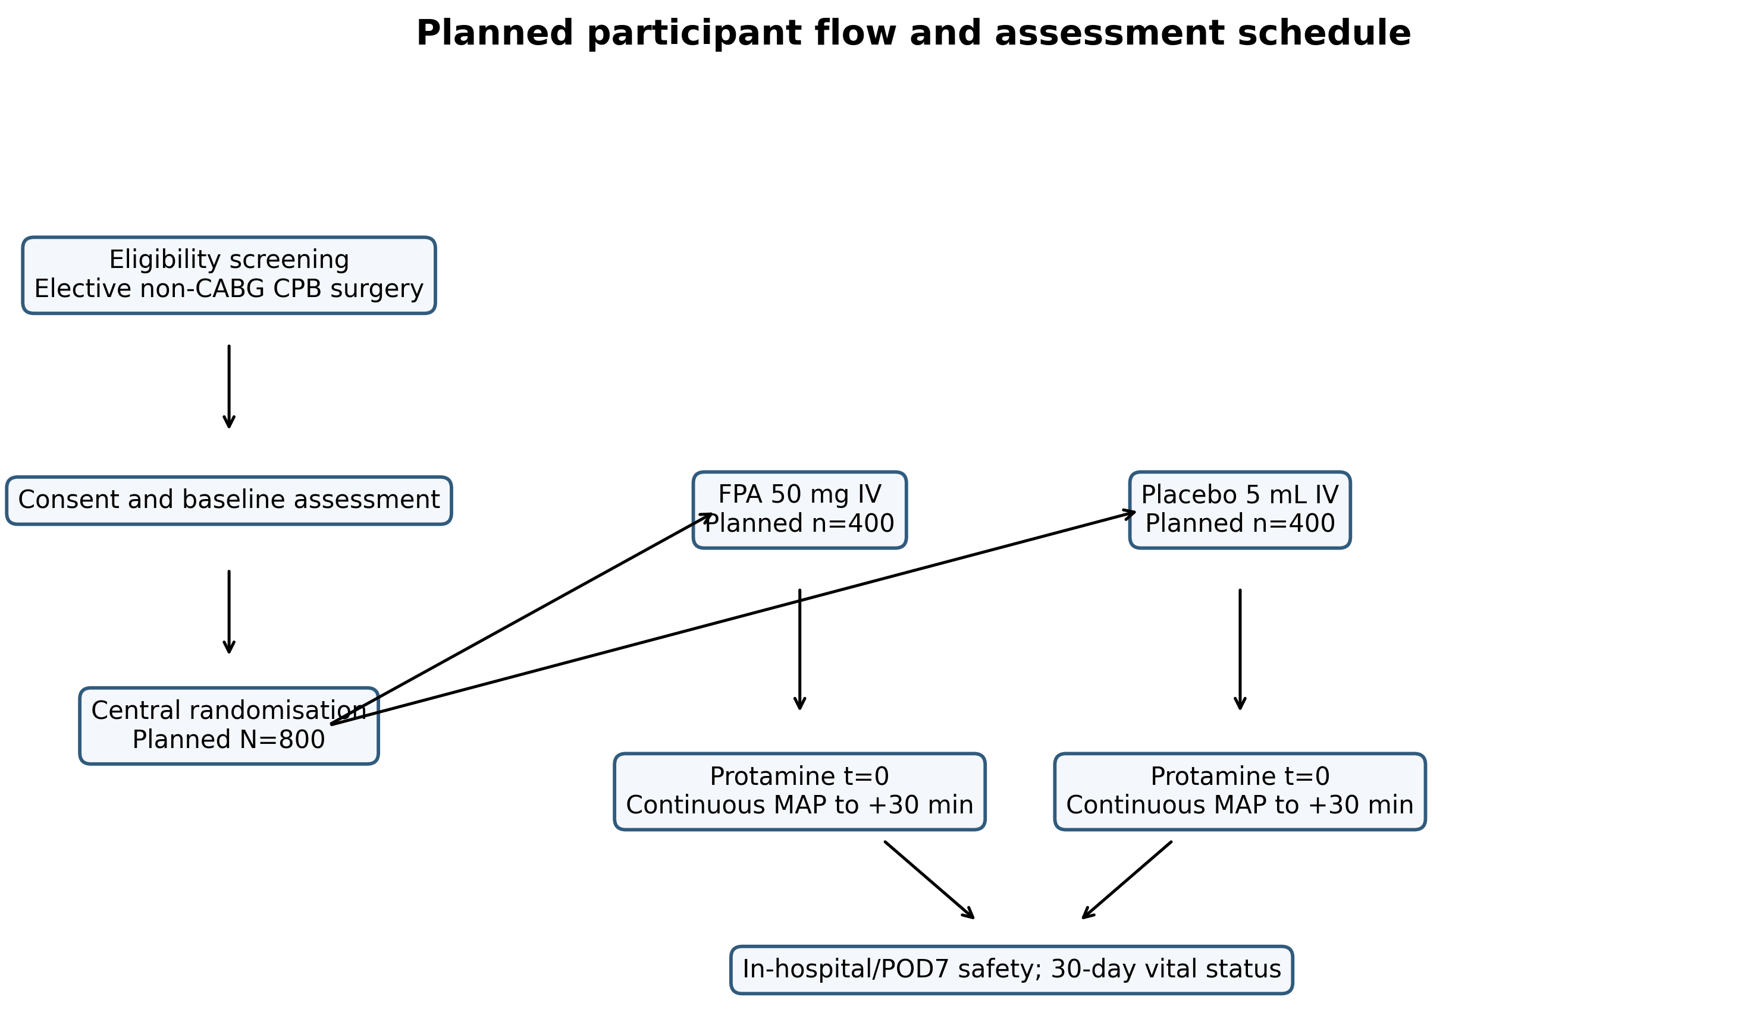
Figure 1. Planned participant flow and assessment schedule. Planned flow for the IF-U-PLEASE II trial. Counts are design targets and do not represent enrolment. CPB, cardiopulmonary bypass; FPA, flurbiprofen axetil; MAP, mean arterial pressure; POD, postoperative day.
Participants: Adults aged ≥18 years scheduled for elective non-CABG cardiac surgery requiring CPB, systemic unfractionated heparinisation, planned protamine reversal, and digital arterial-line acquisition are eligible after written consent. Planned CABG, emergency/salvage surgery, active bleeding or important coagulopathy, active peptic ulcer, severe renal/hepatic disease, decompensated heart failure/cardiogenic shock, severe uncontrolled hypertension, pregnancy, FPA/NSAID hypersensitivity, aspirin-exacerbated respiratory disease, prior severe protamine reaction, and prohibited interacting medicines are exclusions (Table 2). Organ-dysfunction thresholds will be approved against the current Japanese label before activation. Prior protamine or protamine-insulin exposure is a stratification factor unless associated with a severe reaction.
Table 2. Key eligibility criteria
Include | Exclude
Age ≥18 years; written informed consent | Emergency or salvage operation
Elective non-CABG cardiac surgery requiring CPB | Planned CABG or another procedure for which systemic NSAID exposure is prohibited locally
Systemic unfractionated heparin and planned protamine reversal | FPA/NSAID hypersensitivity, aspirin-exacerbated respiratory disease, or prior severe protamine reaction
Arterial catheter suitable for digital waveform capture | Active bleeding, clinically important coagulopathy, or contraindicated antiplatelet/anticoagulant context
Randomisation feasible before study-drug preparation | Active peptic ulcer, severe renal/hepatic disease, decompensated heart failure/cardiogenic shock, severe uncontrolled hypertension, pregnancy, or interacting prohibited medicine under the Japanese label

Interventions: Independent unblinded preparation staff will prepare FPA 50 mg/5 mL or 5 mL 0.9% saline in opaque syringe and tubing. Infusion will last 5 minutes and be completed 15 ± 5 minutes before t=0. The dose reflects the Japanese marketed single ampoule; prophylaxis of protamine hypotension is off-label/investigational [11]. Study drug is withheld for a new contraindication, urgent surgery, or inability to meet the timing window. Clinical rescue is never delayed.
Protamine regimen: t=0 is the start of the first protamine infusion. Sites will preferentially use residual-heparin-guided dosing [15], which can reduce excess protamine and improve haemostatic parameters [16]. Where unavailable, dose will follow the local approved label and documented heparin exposure; ratio must remain below 2.6 mg/100 U. Each 50-mg portion will be diluted and infused over at least 10 minutes consistent with the Japanese label [17]. Heparin, ACT, residual heparin, protamine dose/rate/route, interruptions, additional doses, and deviations are recorded.
Randomisation and masking: A validated central system will use randomly permuted blocks of 4, 6, and 8, stratified by site and prior protamine/protamine-insulin exposure. Allocation is concealed until assignment. Participants, clinical teams, outcome assessors, central waveform reviewers, and statisticians remain masked. Emergency unblinding requires documented clinical necessity.
Outcomes and haemodynamic measurement: Baseline MAP is the median of valid observations from −5 to −1 minutes. The primary endpoint is at least one artefact-free rolling 60-second epoch from t=0 to +30 minutes with median MAP ≤80% of baseline and ≥45 valid seconds. A relative threshold preserves the retrospective hypothesis without calling it universally validated shock. Hypotension definitions vary across perioperative literature [18], while organ risk is also related to absolute pressure and duration [19]; therefore MAP <65 mmHg and burden below 65 mmHg are supportive outcomes (Table 3).
Table 3. Outcome definitions
Outcome | Prospective definition | Analysis
Primary | ≥1 artefact-free rolling 60-s epoch from t=0 to +30 min with median MAP ≤80% of stabilised baseline; ≥45 valid seconds required | Treatment-policy ITT; adjusted marginal risk difference with 95% stratified-bootstrap CI
Absolute hypotension | Any valid 60-s epoch with median MAP <65 mmHg | Risk difference and risk ratio
Hypotension burden | Time-weighted average and area under MAP 65 mmHg | Adjusted linear model; transformed/robust analysis if needed
Rescue treatment | Protocol-defined vasopressor bolus, infusion escalation, or rescue mechanical support | Components and composite with the primary MAP criterion
Safety | KDIGO AKI; chest-tube drainage; transfusion; reoperation; GI bleeding; bronchospasm/anaphylaxis; MI; stroke; SAE; death | Prespecified descriptive estimates with 95% CIs; no efficacy multiplicity claim

Waveform and rescue capture: MAP will be sampled at ≥1 Hz. Flush, calibration, disconnection, and nonphysiologic damping intervals are excluded under prespecified blinded rules; isolated beats cannot define an event. Exact time, dose, and route of every vasopressor/inotrope change, fluid bolus, pacing, cardioversion, return to CPB, and mechanical support are recorded. Observed post-rescue MAP remains in the primary treatment-policy analysis; a rescue composite is supportive (Figure 2).
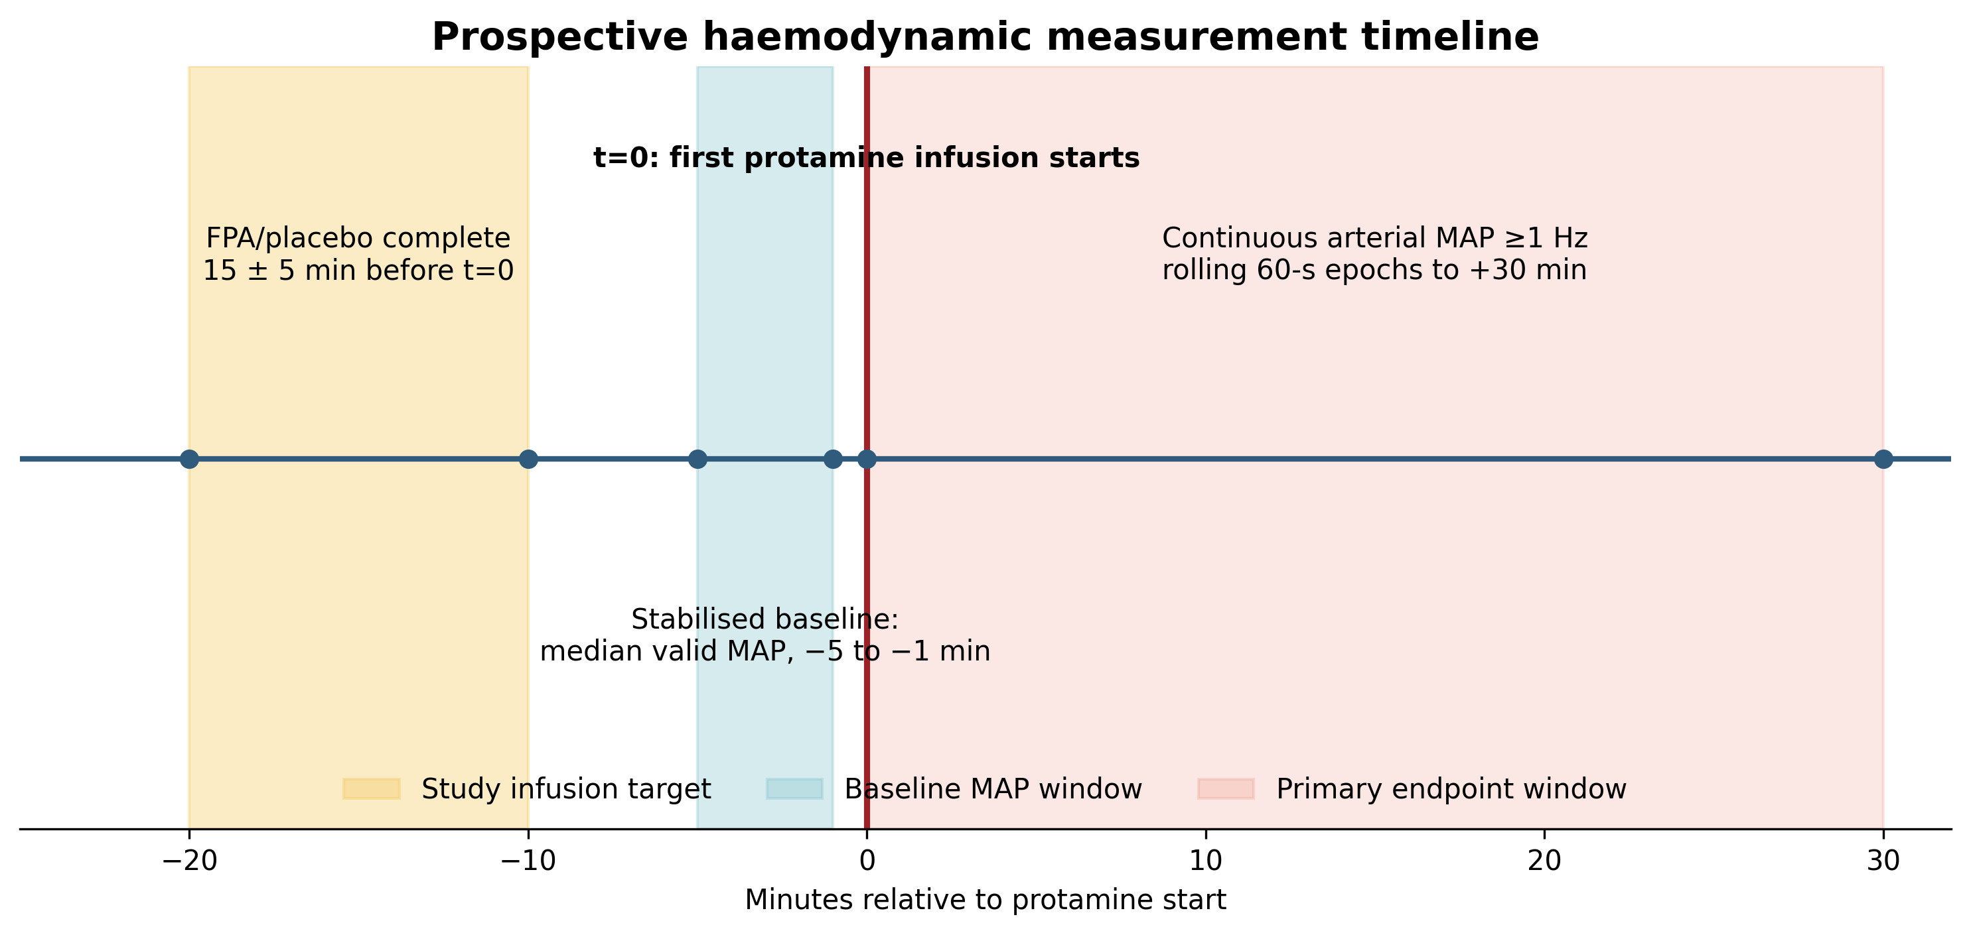
Figure 2. Prospective haemodynamic measurement timeline. Study-drug administration, stabilised baseline, protamine time zero, and the 30-minute primary endpoint window. FPA, flurbiprofen axetil; MAP, mean arterial pressure.
Safety outcomes: Kidney Disease: Improving Global Outcomes (KDIGO) acute kidney injury through postoperative day 7/discharge [20], chest-tube drainage, transfusion, reoperation, gastrointestinal bleeding, bronchospasm/anaphylaxis, myocardial infarction, stroke, serious adverse events, and death will be recorded. An independent DSMB reviews safety after 100 participants and unmasked data after 300 and 600, with ad hoc review for suspected unexpected serious adverse reactions.
Sample size: Executable two-group calculations use placebo risk 12.9%, FPA risk 6.0%, two-sided alpha 0.05, 90% power, and 5% non-evaluable allowance. The minimum is 792; operational enrolment is 800 (400/group). The 12.9% anchor came from a broader adverse-event definition [4] and is not endpoint validation. A blinded reassessment after 300 may increase but not reduce enrolment.
Statistical analysis: The ITT primary analysis will fit logistic regression with treatment, site stratum, prior protamine/protamine-insulin exposure, and baseline MAP, then standardise risks over the trial population. The primary contrast is marginal risk difference with a 95% CI from 2,000 stratified bootstrap samples; risk ratio and odds ratio are supportive. Firth logistic and exact methods address separation. Continuous outcomes use adjusted linear models; minute-level MAP uses a supportive mixed model. Secondary and subgroup analyses are exploratory. Missing endpoint rules, multiple imputation, crossover, protocol deviations, and per-protocol analysis are prespecified in the SAP.
Data quality and reporting: Electronic case-report forms, audit trails, clock synchronisation, raw-waveform retention, blinded derivation, central monitoring, and targeted source verification are required. The protocol follows SPIRIT 2025 [21], with planned results reporting under CONSORT 2025 [22].

Discussion
This trial converts a retrospective signal into a prospective causal test. Randomisation removes clinician-driven treatment selection; multicentre recruitment improves transportability; digital MAP acquisition replaces broad lowest-value windows; and time-stamped rescue capture makes haemodynamic interpretation explicit. The primary endpoint retains the clinically intuitive 20% relative decline while requiring sustained, artefact-controlled evidence. Absolute MAP and burden outcomes address the limitation that a relative threshold may not indicate organ hypoperfusion in every participant.
The selected population deliberately excludes planned CABG and severe label-defined risk states. This improves safety but limits generalisability to emergency surgery, CABG, severe organ dysfunction, and patients with established high protamine risk. FPA’s mechanism remains uncertain, the planning event rates are indirect, and rescue treatments may attenuate observed pressure differences. Treatment-policy and rescue-composite estimands address, but cannot eliminate, this complexity.
The sample size is substantially larger than the historical protocol because a realistic external control risk and conservative treatment risk replace the retrospective zero-event observation. The blinded reassessment protects power against an incorrect pooled event-rate assumption without exposing treatment effects. The trial is designed to estimate both clinical benefit and harms; no preventive use should occur outside approved care or the research protocol on the basis of the retrospective study alone.

Trial status
Protocol version 1.0, 25 September 2026. The trial is not yet registered, ethically approved, or recruiting. Recruitment dates, sponsor, participating sites, registry identifiers, and ethics identifiers will be inserted only after formal confirmation.

Declarations
Ethics approval and consent to participate: Pending. Written informed consent will be obtained before randomisation.
Consent for publication: Not applicable; no participant data are reported.
Availability of data and materials: Protocol code and synthetic validation data are supplied. No prospective clinical data exist. Deidentified trial data-sharing conditions will be defined in the approved protocol and consent.
Competing interests: [Each author must complete before submission.]
Funding: [Sponsor and funding source must be confirmed before submission.]
Authors’ contributions: [Use CRediT roles and confirm all authors before submission.]
Acknowledgements: Generative AI (Devin, Cognition AI) assisted literature organisation, drafting, code generation, document production, and consistency checks. The authors reviewed the sources, analyses, and text and retain full responsibility for accuracy, integrity, and submission decisions.
Patient and public involvement: [Describe involvement or explicitly state none, with rationale, before submission.]

References
1. Onishi T, Ikenoue T. Association between intravenous flurbiprofen axetil pre-administration and attenuation of protamine-induced hypotension in cardiovascular surgery: a retrospective cohort study. J Jpn Soc Clin Anesth. 2026;46(5):413-427.
2. Boer C, Meesters M, Veerhoek D, Vonk A. Anticoagulant and side-effects of protamine in cardiac surgery: a narrative review. British Journal of Anaesthesia. 2018;120(5):914-927. doi:10.1016/j.bja.2018.01.023.
3. Weiler JM, Gellhaus MA, Carter JG, Meng RL, Benson PM, Hottel RA, et al. A prospective study of the risk of an immediate adverse reaction to protamine sulfate during cardiopulmonary bypass surgery. Journal of Allergy and Clinical Immunology. 1990;85(4):713-719. doi:10.1016/0091-6749(90)90189-b.
4. Kimmel SE, Sekeres MA, Berlin JA, Goldberg LR, Strom BL. Adverse Events after Protamine Administration in Patients Undergoing Cardiopulmonary Bypass: Risks and Predictors of Under-Reporting. Journal of Clinical Epidemiology. 1998;51(1):1-10. doi:10.1016/s0895-4356(97)00241-2.
5. Welsby IJ, Newman MF, Phillips-Bute B, Messier RH, Kakkis ED, Stafford-Smith M. Hemodynamic Changes after Protamine Administration. Anesthesiology. 2005;102(2):308-314. doi:10.1097/00000542-200502000-00011.
6. Kimmel SE, Sekeres MA, Berlin JA, Ellison N, DiSesa VJ, Strom BL. Risk factors for clinically important adverse events after protamine administration following cardiopulmonary bypass. Journal of the American College of Cardiology. 1998;32(7):1916-1922. doi:10.1016/s0735-1097(98)00484-7.
7. Weiss ME, Nyhan D, Peng Z, Horrow JC, Lowenstein E, Hirshman C, et al. Association of Protamine IgE and IgG Antibodies with Life-Threatening Reactions to Intravenous Protamine. New England Journal of Medicine. 1989;320(14):886-892. doi:10.1056/nejm198904063201402.
8. Suksompong S, Wongsripuemtet P, Srinoulprasert Y, Khamtuikrua C, Chaikittisilpa N. H1 and H2 antihistamines pretreatment for attenuation of protamine reactions after cardiopulmonary bypass: a randomized-controlled study. Annals of Palliative Medicine. 2023;12(1):47-59. doi:10.21037/apm-22-714.
9. Hobbhahn J, Conzen PF, Zenker B, Goetz AE, Peter K, Brendel W. Beneficial Effect of Cyclooxygenase Inhibition on Adverse Hemodynamic Responses after Protamine. Anesth Analg. 1988;67(3):253-260. doi:10.1213/00000539-198803000-00008.
10. Wang B, Wu L, Chen J, Dong L, Chen C, Wen Z, et al. Metabolism pathways of arachidonic acids: mechanisms and potential therapeutic targets. Signal Transduction and Targeted Therapy. 2021;6(1):94. doi:10.1038/s41392-020-00443-w.
11. Kaken Pharmaceutical Co Ltd. Ropion intravenous 50 mg: Japanese package insert. 2024. Available from: https://pins.japic.or.jp/pdf/newPINS/00054017.pdf.
12. Yamashita K, Fukusaki M, Ando Y, Fujinaga A, Tanabe T, Terao Y, et al. Preoperative administration of intravenous flurbiprofen axetil reduces postoperative pain for spinal fusion surgery. Journal of Anesthesia. 2006;20(2):92-95. doi:10.1007/s00540-006-0389-6.
13. Liu Y, Li B, Hang L, Zhang L. Association between perioperative flurbiprofen administration and acute kidney injury (AKI) in spine surgery: a retrospective cohort study. Perioperative Medicine. 2024;13(1):59. doi:10.1186/s13741-024-00419-2.
14. US Food and Drug Administration. Diclofenac sodium (Cambia) prescribing information: boxed warning for cardiovascular, gastrointestinal, and CABG risks. 2024. Available from: https://www.accessdata.fda.gov/drugsatfda_docs/label/2024/022165s016lbl.pdf.
15. Shore-Lesserson L, Baker RA, Ferraris VA, Greilich PE, Fitzgerald D, Roman P, et al. The Society of Thoracic Surgeons, The Society of Cardiovascular Anesthesiologists, and The American Society of ExtraCorporeal Technology: Clinical Practice Guidelines —Anticoagulation During Cardiopulmonary Bypass. The Annals of Thoracic Surgery. 2018;105(2):650-662. doi:10.1016/j.athoracsur.2017.09.061.
16. Vonk AB, Veerhoek D, van den Brom CE, van Barneveld LJ, Boer C. Individualized Heparin and Protamine Management Improves Rotational Thromboelastometric Parameters and Postoperative Hemostasis in Valve Surgery. Journal of Cardiothoracic and Vascular Anesthesia. 2014;28(2):235-241. doi:10.1053/j.jvca.2013.09.007.
17. Mochida Pharmaceutical Co Ltd. Protamine sulfate intravenous 100 mg: Japanese package insert. 2023. Available from: https://pins.japic.or.jp/pdf/newPINS/00063579.pdf.
18. Wesselink E, Kappen T, Torn H, Slooter A, van Klei W. Intraoperative hypotension and the risk of postoperative adverse outcomes: a systematic review. British Journal of Anaesthesia. 2018;121(4):706-721. doi:10.1016/j.bja.2018.04.036.
19. Sessler DI, Bloomstone JA, Aronson S, Berry C, Gan TJ, Kellum JA, et al. Perioperative Quality Initiative consensus statement on intraoperative blood pressure, risk and outcomes for elective surgery. British Journal of Anaesthesia. 2019;122(5):563-574. doi:10.1016/j.bja.2019.01.013.
20. Kidney Disease: Improving Global Outcomes Acute Kidney Injury Work Group. KDIGO clinical practice guideline for acute kidney injury. Kidney Int Suppl. 2012;2(1):1-138. Available from: https://kdigo.org/guidelines/acute-kidney-injury/.
21. Chan AW, Boutron I, Hopewell S, Moher D, Schulz KF, Collins GS, et al. SPIRIT 2025 statement: updated guideline for protocols of randomised trials. BMJ. 2025;389:e081477. doi:10.1136/bmj-2024-081477.
22. Hopewell S, Chan AW, Collins GS, Hróbjartsson A, Moher D, Schulz KF, et al. CONSORT 2025 statement: updated guideline for reporting randomised trials. BMJ. 2025;389:e081123. doi:10.1136/bmj-2024-081123.

