Functionally graded roofs for passive snow management: nominal trade-off expansion limited by constructability and timestep sensitivity
Tatsuki Onishi*
REQUIRED
Corresponding author: Tatsuki Onishi, REQUIRED, bougtoir@gmail.com

Abstract
Passive roof-snow strategies trade retained modeled snow mass against discrete eave-release mass. We tested whether spatial variation in slope, friction, and adhesion changed that trade-off relative to an exhaustively mapped uniform design space. A unit-width, cell-based threshold-release model was evaluated under synthetic weather, with Japanese Meteorological Agency daily observations used only as supplementary forcing. Multi-seed NSGA-II generated geometry-only, surface-only, and joint heterogeneous sets. The uniform set contained 2 unique objective pairs, whereas the joint set contained 6, including the uniform endpoints and additional intermediate trade-offs. Under the common audit reference, their normalized hypervolumes were 0.701 and 0.762; joint additive epsilon versus uniform was 0.000. The joint set had 4 intermediate objective pairs unavailable to the uniform set under the same objective caps. 6 candidates tied the minimum robustness score. Mapping the continuous joint knee to rule-compliant generic segments changed modeled retained mass by -98.28% and release mass by +537.47%, shifting the selected point toward the low-retention, high-release shedding regime. A targeted 0.25-h sensitivity failed the four-metric tolerance for 3 of 3 selected designs relative to the 0.5-h production results. Spatial grading produced nominal intermediate trade-offs absent from the exhaustive uniform grid, but constructability and interval sensitivity substantially limit interpretation; no front-wide superiority, structural safety, or validated roof performance is established.
Keywords: roof snow; passive snow management; multiobjective optimization; spatial heterogeneity; snow shedding; reduced-order model

1. Introduction
Roof snow is spatially variable, evolves with weather, and can either remain on the roof or leave in discrete releases. Roof-scale experiments and deposition studies show that geometry, wind, and scale influence snow distributions, while validation remains essential for computational models (Giever and Sack, 1990; Sun et al., 2018; Thiis and Gjessing, 1999; Tominaga, 2018; Zhang et al., 2021; Zhou et al., 2016). Adjacent photovoltaic, membrane-roof, meteorological, and field studies further motivate explicit sensitivity analysis and independent validation (Fasani et al., 2026; Pawluk et al., 2021; Tominaga et al., 2025; Zhang et al., 2022; Zhou et al., 2023; Zou et al., 2023).
Japanese technical and administrative sources distinguish retention, shedding, melting, and load-resisting strategies and document the importance of surface condition, aging, snow guards, drainage, cornices, and site context (Asano and Iwai, 1995; Chiba et al., 2021; Hokkaido Research Organization and Hokkaido Building Guidance Center, 2017; Ito et al., 1997; Kimura, 1989; Niigata Prefecture, 2006; Sapporo City, 2025; Takakura et al., 2003; Tomabechi et al., 1996; Watanabe and Takita, 1997). Retention can reduce required snow-fall space at dense sites, whereas shedding requires a suitable receiving zone; retained snow instead imposes long-duration load and drainage obligations. These sources do not establish universal material coefficients, safety thresholds, or one preferable strategy. They motivate a conditional comparison of generic uniform and graded design spaces.
The research question was frozen before production analysis: under identical modeled environmental conditions, how does allowing spatial variation in roof geometry and snow-surface interaction change the achievable trade-off between retained modeled snow mass and discrete shedding events compared with optimized uniform roofs? The hypothesis that heterogeneity expands the attainable design space was tested without assuming superiority.

2. Methods

2.1 Reduced-order roof-snow model
An 8 m long, 1 m wide roof was represented by 24 ridge-to-eave cells. Each cell carried slope, static friction, kinetic friction, adhesion, snow mass, mass-weighted age, volume, and density. Snowfall was added before each within-step maximum was recorded. Melt removed mass, volume, and age moment proportionally. Compaction changed volume and diagnostic depth. Density converted observed snowfall depth to mass but was not asserted to change basal sliding at fixed mass.
A cell became mobile when downslope gravity exceeded static friction plus area-scaled adhesion. Kinetic friction controlled transport after release. Mass, age moment, and volume moved together. Snow leaving the final cell was an eave-shedding event. The kinetic-energy metric was a roof-wide specific-energy proxy, not an impact or injury model.
$$F_g = m g sin(theta)$$
$$F_r = mu_s m g cos(theta) + A tau_a$$

2.2 Outcomes and comparison sets
The locked primary outcomes were Lmax, the maximum modeled roof snow mass per metre width immediately after snowfall and before same-step melt or release, and Smax, the maximum eave-release mass in one timestep per metre width. Secondary outcomes included total shed mass, event count, event-mass summaries, Snow Shedding Concentration Index (SSCI), kinetic-energy proxy, intervention-threshold time, manual triggers, residual mass, maximum modeled snow depth, total variation, transition count, and discretization loss.
$$SSCI = sum_j (m_j / M_total)^2$$
Comparators were retention-oriented, shedding-oriented, and intermediate uniform baselines; the complete optimized uniform frontier; and geometry-only, surface-only, and joint heterogeneous frontiers. Figure 1 summarizes the model and optimization workflow; Figure 2 summarizes synthetic and observed weather contexts; Figures 3-5 show the primary frontier, selected profile, and ablation frontiers. Tables 1-3 report frontier metrics, the selected profile, and continuous-to-discrete mapping.
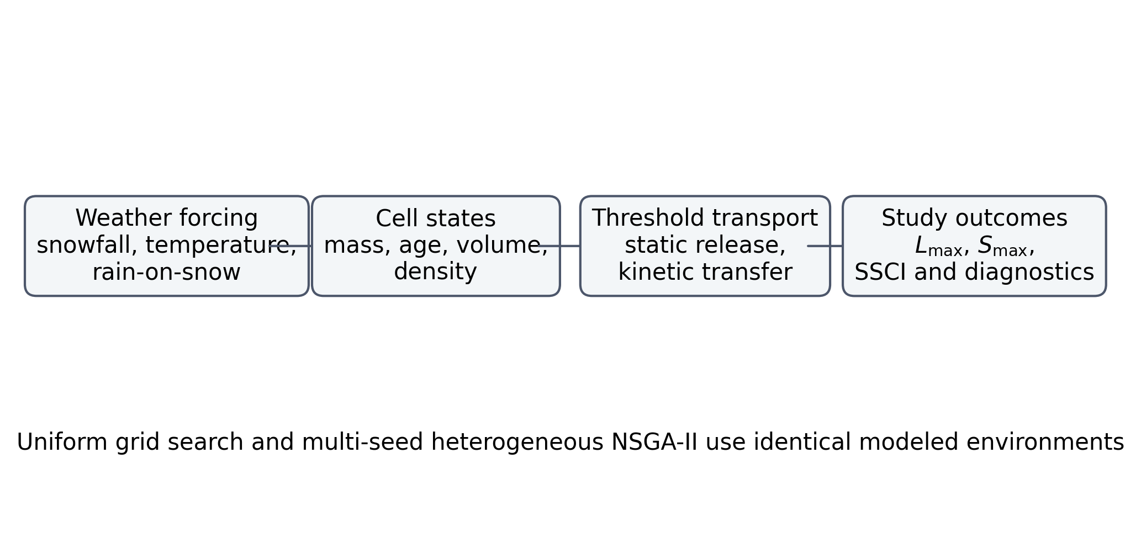
Figure 1. Reduced-order model and comparative optimization workflow.
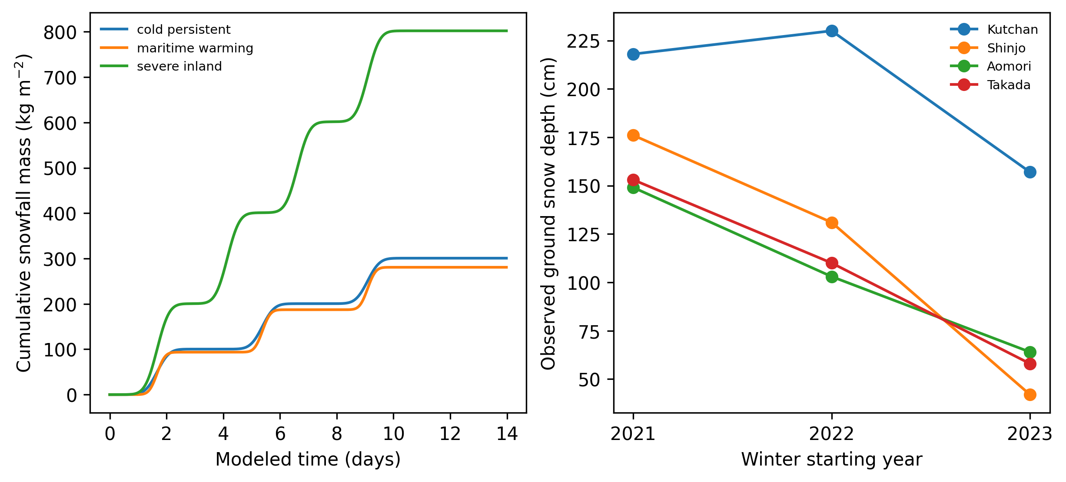
Figure 2. Synthetic snowfall scenarios and JMA ground-snow contexts.
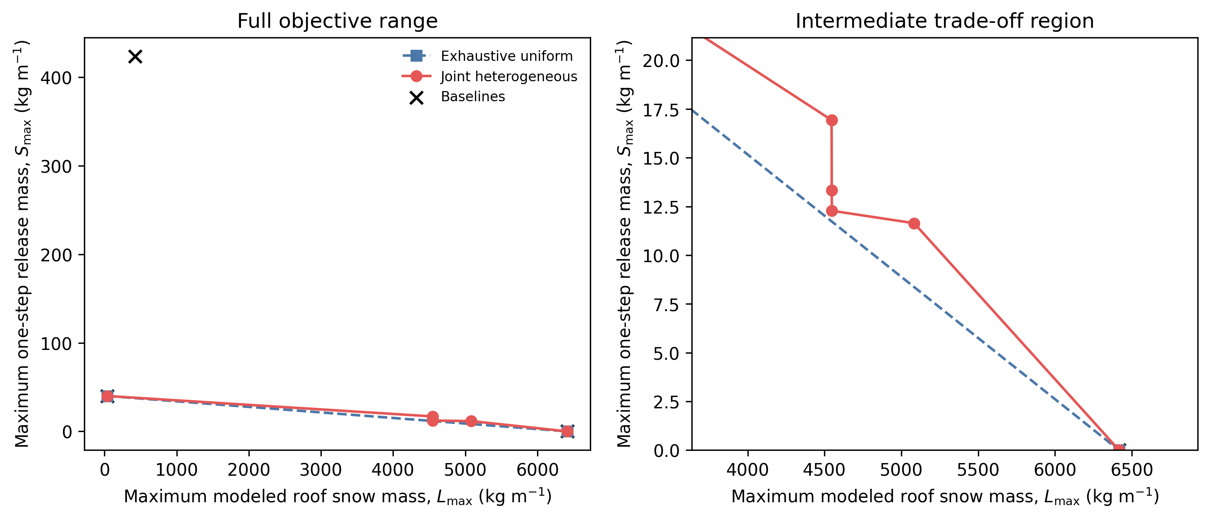
Figure 3. Unique objective pairs for the exhaustive uniform and heuristic joint sets, shown over the full range and the intermediate trade-off region.
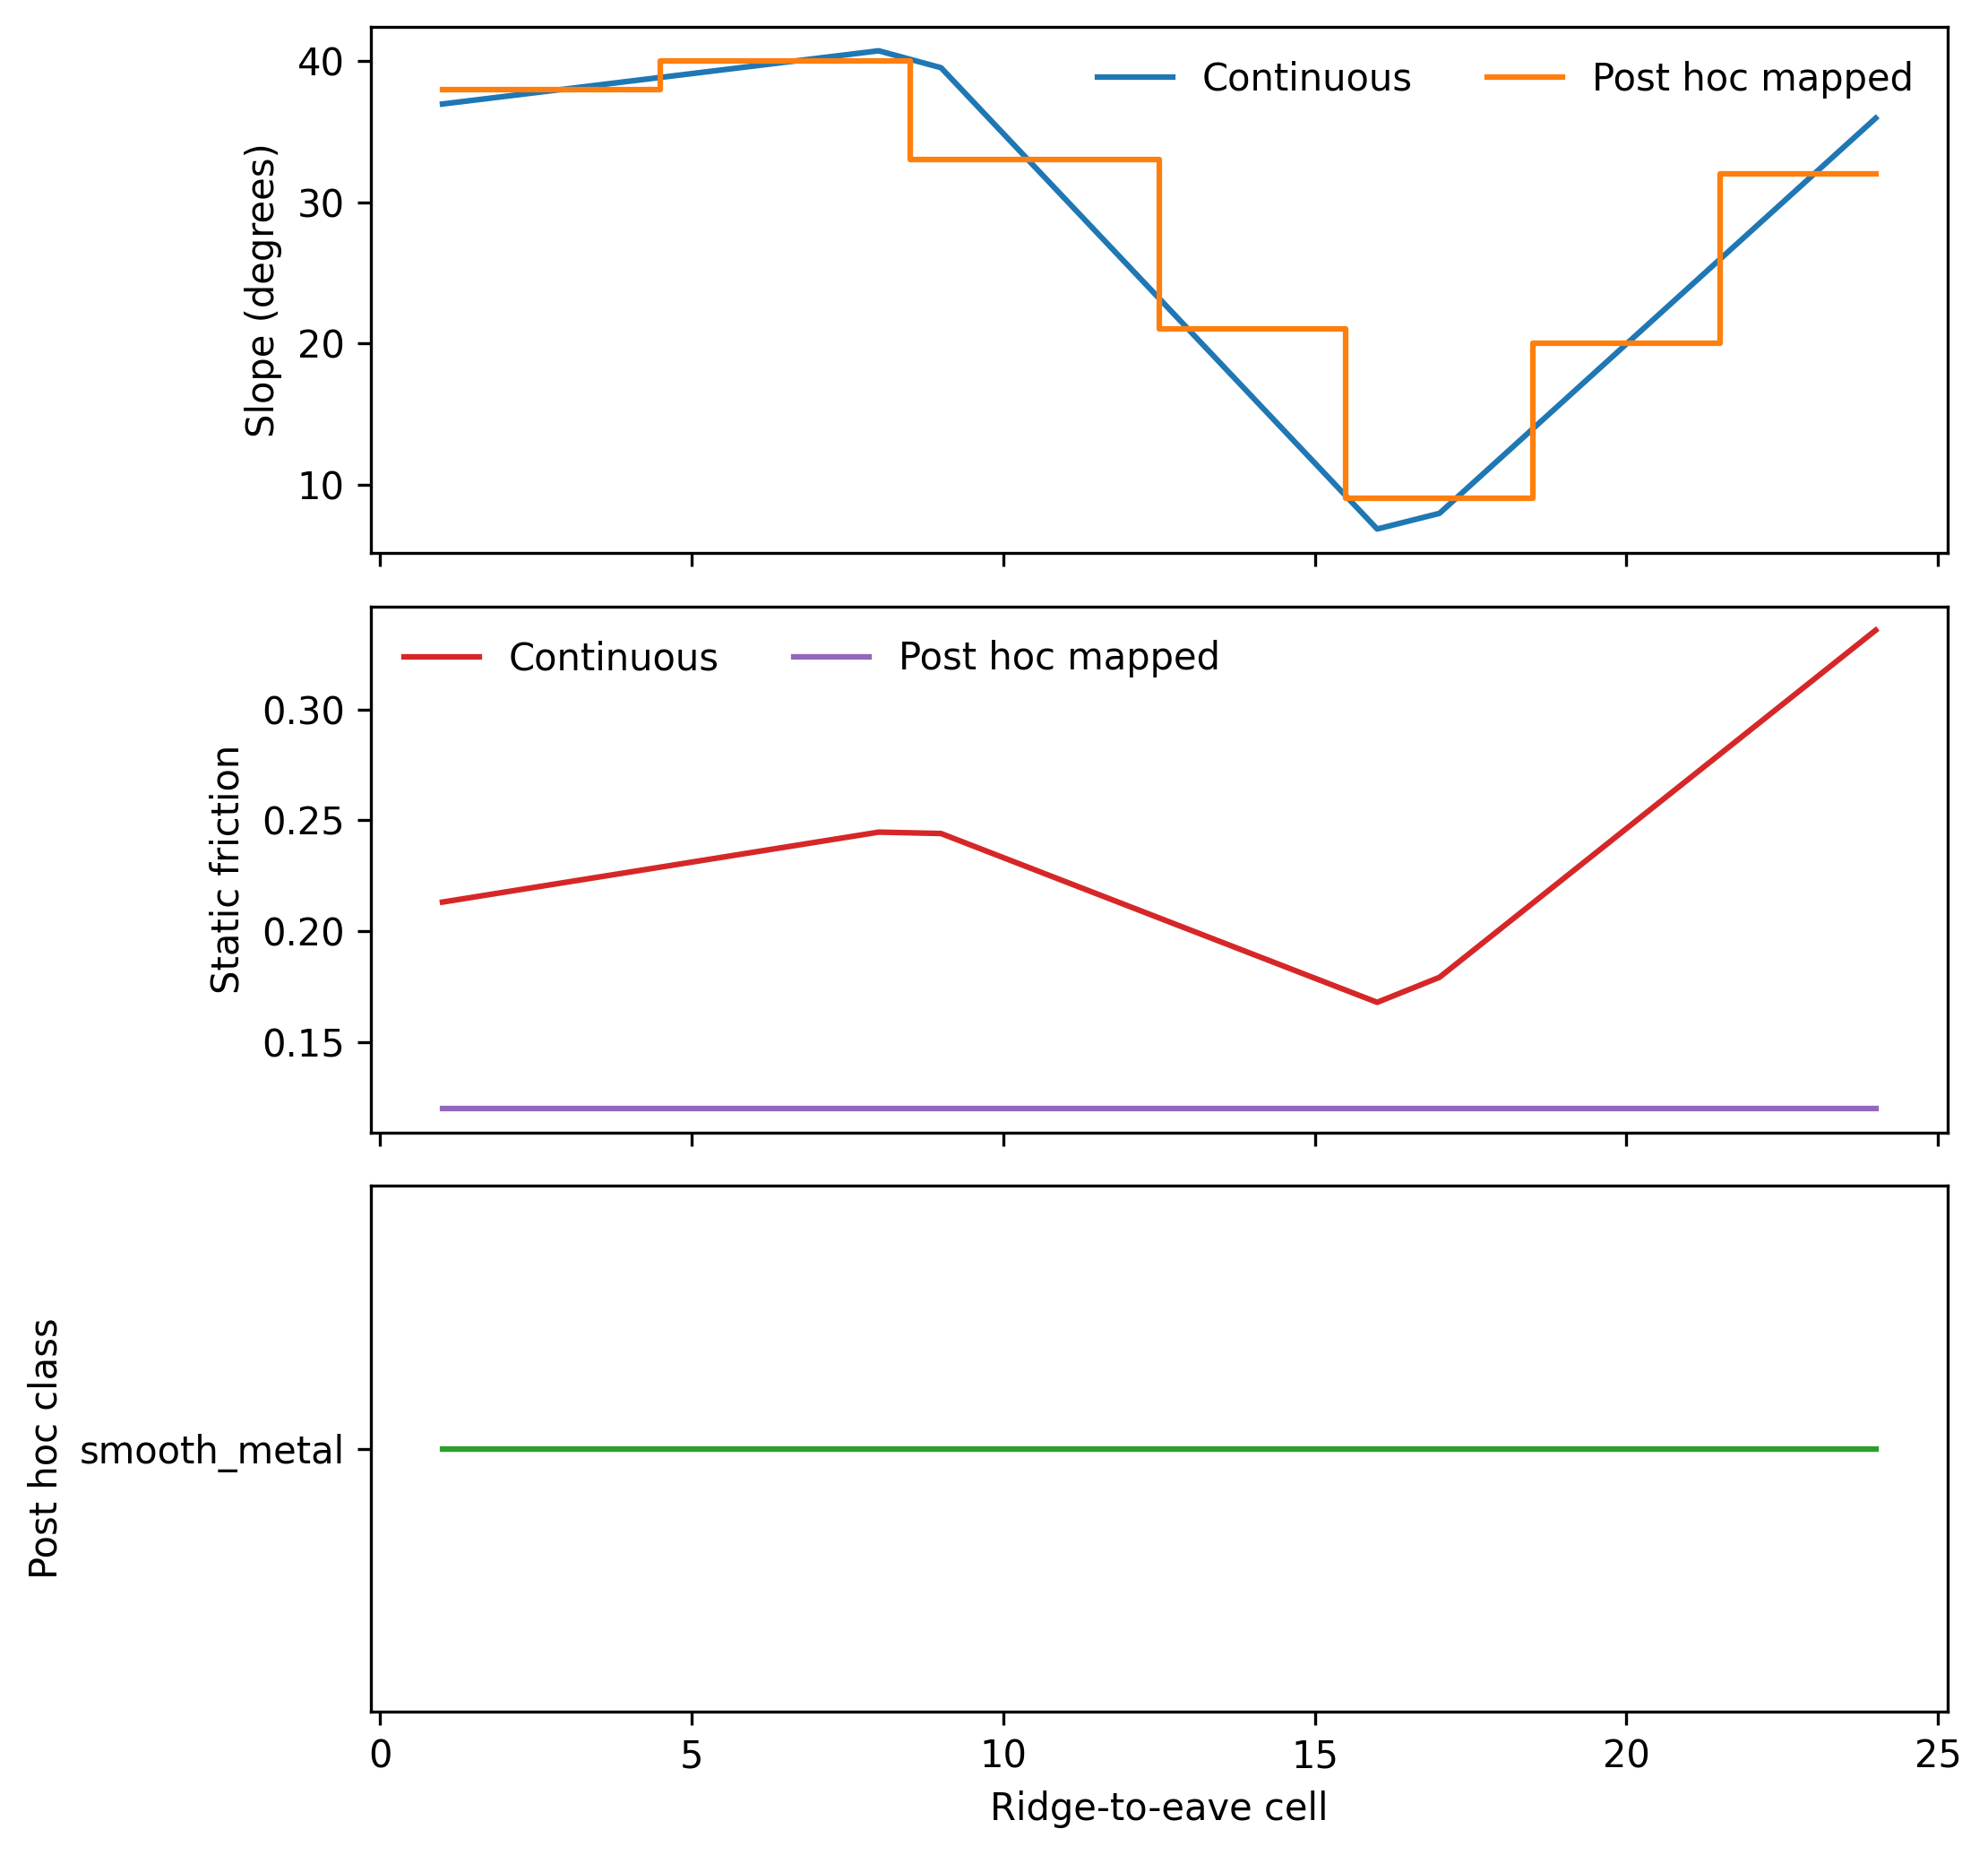
Figure 4. Continuous joint-knee slope and friction profiles compared with the post hoc rule-compliant segmented, generic-class mapping; the mapped profile is not a constrained optimum.
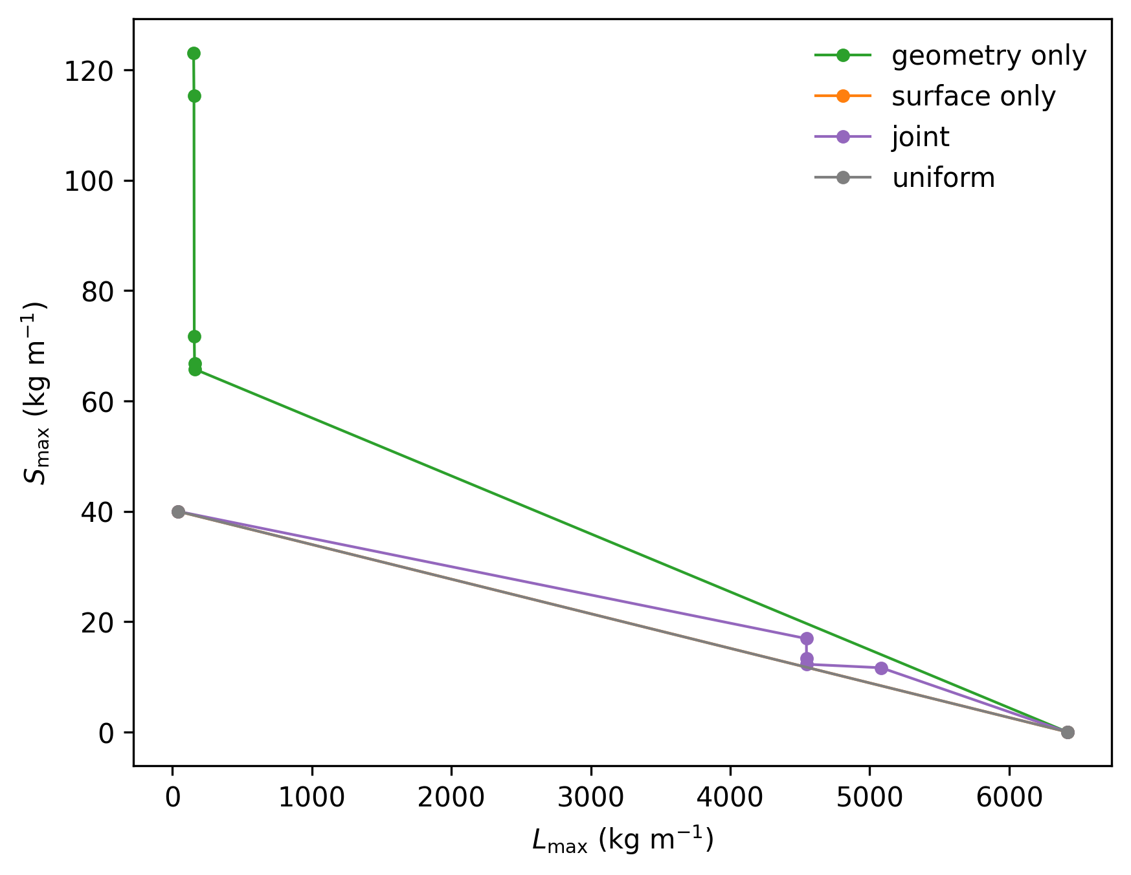
Figure 5. Unique objective pairs for the uniform, geometry-only, surface-only, and joint sets.

Table 1. Audited objective-set summary.
Class | Design rows | Objective pairs | Descriptive knee Lmax | Descriptive knee Smax | Norm. HV | Epsilon vs uniform
uniform | 2910 | 2 | 40.00 | 40.00 | 0.701 | 0.000
geometry | 155 | 6 | 160.0 | 65.77 | 0.504 | 0.209
surface | 270 | 2 | 40.00 | 40.00 | 0.701 | 0.000
joint | 1341 | 6 | 4547.4 | 12.28 | 0.762 | 0.000

Table 2. Selected joint-profile cell properties.
Cell | Continuous slope | Discrete slope | Continuous friction | Continuous adhesion | Generic class
1 | 36.96 | 38.00 | 0.213 | 20.94 | smooth_metal
2 | 37.50 | 38.00 | 0.218 | 22.33 | smooth_metal
3 | 38.04 | 38.00 | 0.222 | 23.72 | smooth_metal
4 | 38.58 | 38.00 | 0.227 | 25.11 | smooth_metal
5 | 39.11 | 40.00 | 0.231 | 26.50 | smooth_metal
6 | 39.65 | 40.00 | 0.236 | 27.89 | smooth_metal
7 | 40.19 | 40.00 | 0.240 | 29.28 | smooth_metal
8 | 40.73 | 40.00 | 0.245 | 30.67 | smooth_metal
9 | 39.53 | 33.00 | 0.244 | 30.23 | smooth_metal
10 | 34.86 | 33.00 | 0.233 | 26.14 | smooth_metal
11 | 30.19 | 33.00 | 0.222 | 22.05 | smooth_metal
12 | 25.52 | 33.00 | 0.211 | 17.95 | smooth_metal
13 | 20.86 | 21.00 | 0.201 | 13.86 | smooth_metal
14 | 16.19 | 21.00 | 0.190 | 9.767 | smooth_metal
15 | 11.52 | 21.00 | 0.179 | 5.673 | smooth_metal
16 | 6.848 | 9.000 | 0.168 | 1.580 | smooth_metal
17 | 7.958 | 9.000 | 0.179 | 0.306 | smooth_metal
18 | 11.96 | 9.000 | 0.202 | 0.441 | smooth_metal
19 | 15.96 | 20.00 | 0.224 | 0.576 | smooth_metal
20 | 19.96 | 20.00 | 0.246 | 0.711 | smooth_metal
21 | 23.96 | 20.00 | 0.269 | 0.846 | smooth_metal
22 | 27.96 | 32.00 | 0.291 | 0.981 | smooth_metal
23 | 31.96 | 32.00 | 0.313 | 1.117 | smooth_metal
24 | 35.96 | 32.00 | 0.336 | 1.252 | smooth_metal

Table 3. Post hoc continuous-to-discrete objective-space movement.
Mapping | Lmax | Smax | Mean SSCI | Event count | Slope transitions | Surface transitions | Lmax change (kg m⁻¹) | Lmax change (%) | Smax change (kg m⁻¹) | Smax change (%)
continuous | 4547.4 | 12.28 | 0.007 | 248.0 | 23 | 23 | 0.000 | 0.000 | 0.000 | 0.000
discrete_generic | 78.28 | 78.28 | 0.017 | 74.33 | 6 | 0 | -4469.1 | -98.28 | 66.00 | 537.5

2.3 Weather forcing
Primary optimization used 3 deterministic synthetic winters spanning cold persistent, maritime warming, and severe inland conditions, including repeated snowfall and configured rain-on-snow periods. JMA daily mean temperature, precipitation, snowfall depth, and ground snow depth were downloaded as immutable official HTML snapshots for 4 stations and 3 winters. Original value strings and parsed numeric fields were retained. JMA ground observations were used only as scenario forcing and were not treated as direct roof-load measurements.

2.4 Optimization and analysis
A full 30 x 30 x 7 uniform slope-friction-adhesion map preceded heterogeneous optimization. Geometry-only, surface-only, and joint profiles were parameterized by 4 control points interpolated across the roof. Checkpointed NSGA-II used a population of 48, 45 generations, and seeds 1701, 2903, 4517. All feasible evaluations from every seed were combined and filtered to approximate nondominated heterogeneous sets; only the uniform grid was exhaustively enumerated. Objective pairs were deduplicated at six decimal places for frontier metrics while design rows remained available for robustness and constructability analyses. Normalized hypervolume used common bounds and a reference at 105% of the joint objective maxima. Additive epsilon versus uniform, combined-set dominance, matched-objective constraints, and reference-point sensitivity were calculated. A normalized-distance knee was reported only as a within-front descriptive selection; common and front-specific normalizations were audited separately. Per-seed metrics summarized optimizer stochasticity in a machine-readable supplement. Production used a 0.5-h timestep, the finest resolution in the frozen grid. A targeted 0.25-h reevaluation of selected designs was reported as post-freeze numerical sensitivity rather than a second optimization. Figure 6 reports the numerical-resolution comparison; Figure 7 reports prespecified one-at-a-time sensitivity.
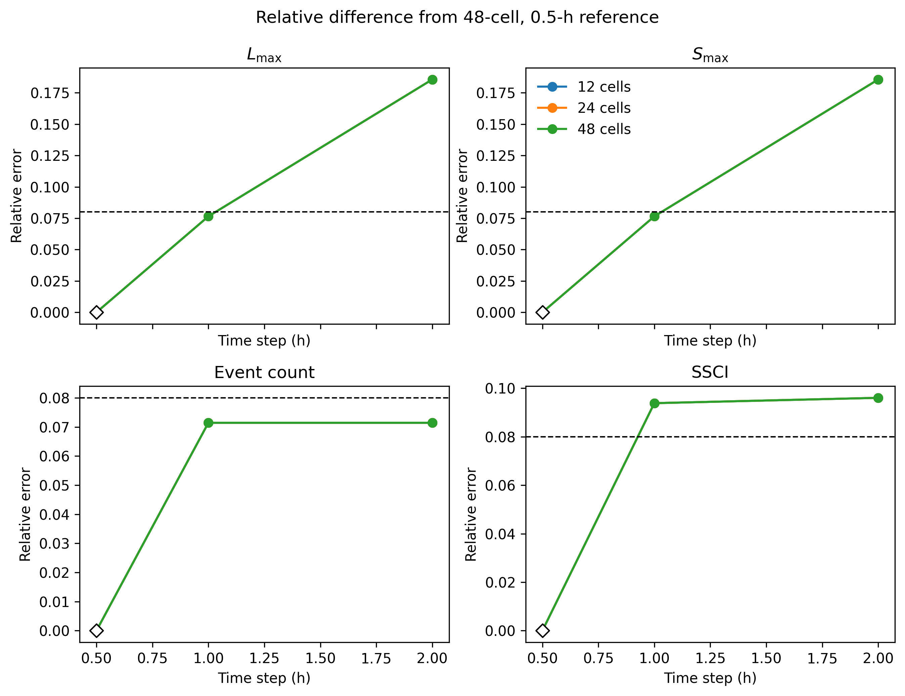
Figure 6. Four-metric numerical-resolution comparison relative to the 48-cell, 0.5-h reference; the dashed line is the frozen relative-error tolerance.
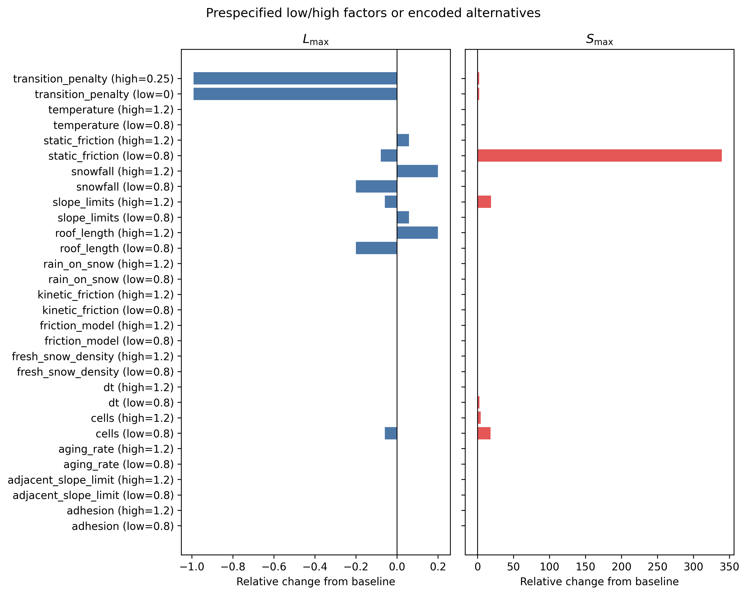
Figure 7. Prespecified one-at-a-time sensitivity. Labels state each low/high factor or encoded alternative; bars are relative changes from baseline.
Monte Carlo robustness used 250 deterministic draws perturbing friction, adhesion, fresh-snow density, snowfall, and temperature for prespecified candidates sampled across the uniform and joint fronts. Every candidate received the same factor vector within each draw, permitting paired comparisons; Monte Carlo quantiles were not interpreted as empirical confidence intervals. Continuous optimization enforced only maximum adjacent slope change. Minimum segment length, maximum transition count, and generic surface classes were audited after optimization. Continuous joint profiles were mapped to 3 generic surface classes and piecewise roof segments of at least 3 cells, with at most 6 transitions, without claiming that the mapped design was a constrained optimum or represented proprietary material performance. Frozen manual-intervention weights generated low, medium, and high labor-scarcity choices across configured snowfall, shedding-penalty, and allowable-release scenarios. Figures 8-9 and Tables 4-8 summarize these analyses.
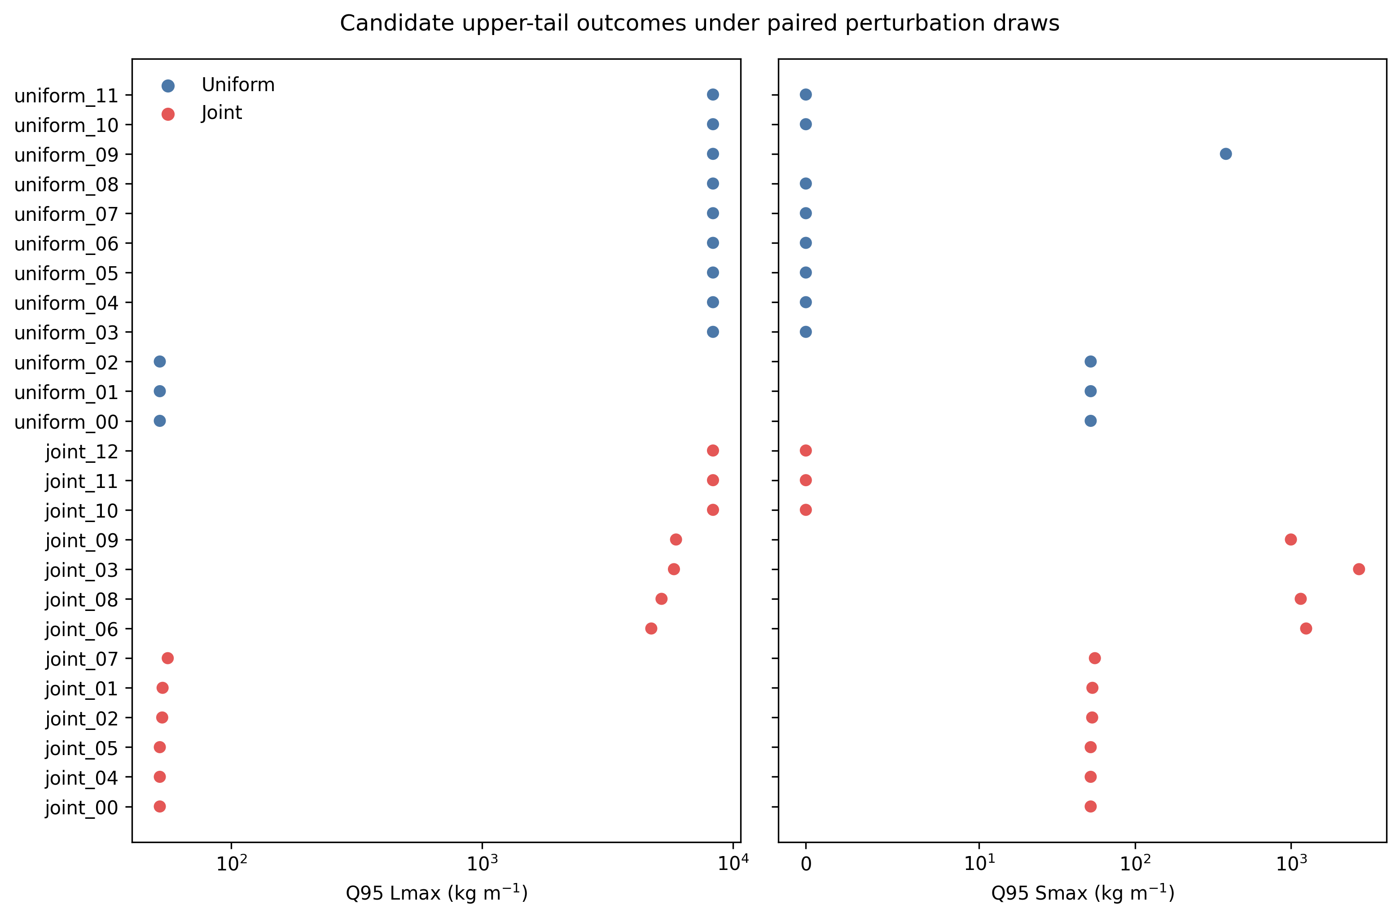
Figure 8. Candidate-specific Q95 retained-mass and release-mass outcomes under 250 paired perturbation draws. Symmetric-log axes include zero outcomes.
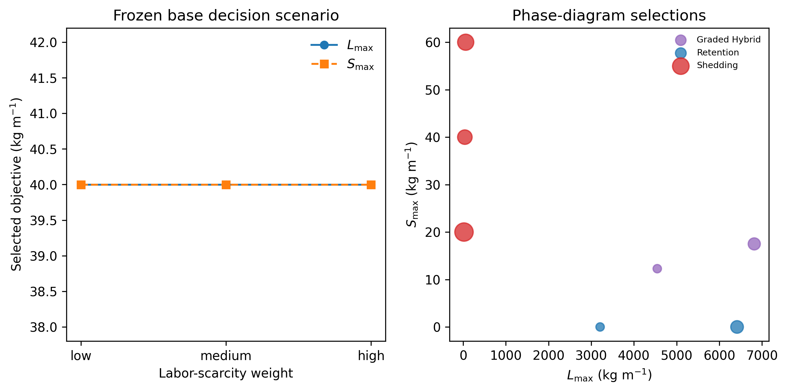
Figure 9. Frozen labor-scarcity selections in the base decision scenario and phase-diagram objective pairs; bubble area reflects selection frequency.

Table 4. Strategy phase-diagram classifications (selected columns; the complete table is supplied as CSV).
Snowfall factor | Shed penalty | Labor scarcity | Allowable shed | Feasible | Class | Strategy | Manual triggers
0.500 | 0.250 | low | 20.00 | True | uniform | SHEDDING | 0.000
0.500 | 0.250 | low | 80.00 | True | uniform | SHEDDING | 0.000
0.500 | 0.250 | low | 200.0 | True | uniform | SHEDDING | 0.000
0.500 | 0.250 | medium | 20.00 | True | uniform | SHEDDING | 0.000
0.500 | 0.250 | medium | 80.00 | True | uniform | SHEDDING | 0.000
0.500 | 0.250 | medium | 200.0 | True | uniform | SHEDDING | 0.000
0.500 | 0.250 | high | 20.00 | True | uniform | SHEDDING | 0.000
0.500 | 0.250 | high | 80.00 | True | uniform | SHEDDING | 0.000
0.500 | 0.250 | high | 200.0 | True | uniform | SHEDDING | 0.000
0.500 | 1.000 | low | 20.00 | True | uniform | SHEDDING | 0.000
0.500 | 1.000 | low | 80.00 | True | uniform | SHEDDING | 0.000
0.500 | 1.000 | low | 200.0 | True | uniform | SHEDDING | 0.000
0.500 | 1.000 | medium | 20.00 | True | uniform | SHEDDING | 0.000
0.500 | 1.000 | medium | 80.00 | True | uniform | SHEDDING | 0.000
0.500 | 1.000 | medium | 200.0 | True | uniform | SHEDDING | 0.000
0.500 | 1.000 | high | 20.00 | True | uniform | SHEDDING | 0.000
0.500 | 1.000 | high | 80.00 | True | uniform | SHEDDING | 0.000
0.500 | 1.000 | high | 200.0 | True | uniform | SHEDDING | 0.000
0.500 | 4.000 | low | 20.00 | True | joint | RETENTION | 1.000
0.500 | 4.000 | low | 80.00 | True | joint | RETENTION | 1.000
0.500 | 4.000 | low | 200.0 | True | joint | RETENTION | 1.000
0.500 | 4.000 | medium | 20.00 | True | uniform | SHEDDING | 0.000
0.500 | 4.000 | medium | 80.00 | True | uniform | SHEDDING | 0.000
0.500 | 4.000 | medium | 200.0 | True | uniform | SHEDDING | 0.000
0.500 | 4.000 | high | 20.00 | True | uniform | SHEDDING | 0.000
0.500 | 4.000 | high | 80.00 | True | uniform | SHEDDING | 0.000
0.500 | 4.000 | high | 200.0 | True | uniform | SHEDDING | 0.000
1.000 | 0.250 | low | 20.00 | True | joint | GRADED_HYBRID | 1.000
1.000 | 0.250 | low | 80.00 | True | uniform | SHEDDING | 0.000
1.000 | 0.250 | low | 200.0 | True | uniform | SHEDDING | 0.000
1.000 | 0.250 | medium | 20.00 | True | joint | GRADED_HYBRID | 1.000
1.000 | 0.250 | medium | 80.00 | True | uniform | SHEDDING | 0.000
1.000 | 0.250 | medium | 200.0 | True | uniform | SHEDDING | 0.000
1.000 | 0.250 | high | 20.00 | True | joint | GRADED_HYBRID | 1.000
1.000 | 0.250 | high | 80.00 | True | uniform | SHEDDING | 0.000
1.000 | 0.250 | high | 200.0 | True | uniform | SHEDDING | 0.000
1.000 | 1.000 | low | 20.00 | True | joint | RETENTION | 1.000
1.000 | 1.000 | low | 80.00 | True | uniform | SHEDDING | 0.000
1.000 | 1.000 | low | 200.0 | True | uniform | SHEDDING | 0.000
1.000 | 1.000 | medium | 20.00 | True | joint | RETENTION | 1.000
1.000 | 1.000 | medium | 80.00 | True | uniform | SHEDDING | 0.000
1.000 | 1.000 | medium | 200.0 | True | uniform | SHEDDING | 0.000
1.000 | 1.000 | high | 20.00 | True | joint | RETENTION | 1.000
1.000 | 1.000 | high | 80.00 | True | uniform | SHEDDING | 0.000
1.000 | 1.000 | high | 200.0 | True | uniform | SHEDDING | 0.000
1.000 | 4.000 | low | 20.00 | True | joint | RETENTION | 1.000
1.000 | 4.000 | low | 80.00 | True | joint | RETENTION | 1.000
1.000 | 4.000 | low | 200.0 | True | joint | RETENTION | 1.000
1.000 | 4.000 | medium | 20.00 | True | joint | RETENTION | 1.000
1.000 | 4.000 | medium | 80.00 | True | joint | RETENTION | 1.000
1.000 | 4.000 | medium | 200.0 | True | joint | RETENTION | 1.000
1.000 | 4.000 | high | 20.00 | True | joint | RETENTION | 1.000
1.000 | 4.000 | high | 80.00 | True | uniform | SHEDDING | 0.000
1.000 | 4.000 | high | 200.0 | True | uniform | SHEDDING | 0.000
1.500 | 0.250 | low | 20.00 | True | joint | GRADED_HYBRID | 1.000
1.500 | 0.250 | low | 80.00 | True | uniform | SHEDDING | 0.000
1.500 | 0.250 | low | 200.0 | True | uniform | SHEDDING | 0.000
1.500 | 0.250 | medium | 20.00 | True | joint | GRADED_HYBRID | 1.000
1.500 | 0.250 | medium | 80.00 | True | uniform | SHEDDING | 0.000
1.500 | 0.250 | medium | 200.0 | True | uniform | SHEDDING | 0.000
1.500 | 0.250 | high | 20.00 | True | joint | GRADED_HYBRID | 1.000
1.500 | 0.250 | high | 80.00 | True | uniform | SHEDDING | 0.000
1.500 | 0.250 | high | 200.0 | True | uniform | SHEDDING | 0.000
1.500 | 1.000 | low | 20.00 | True | joint | GRADED_HYBRID | 1.000
1.500 | 1.000 | low | 80.00 | True | uniform | SHEDDING | 0.000
1.500 | 1.000 | low | 200.0 | True | uniform | SHEDDING | 0.000
1.500 | 1.000 | medium | 20.00 | True | joint | GRADED_HYBRID | 1.000
1.500 | 1.000 | medium | 80.00 | True | uniform | SHEDDING | 0.000
1.500 | 1.000 | medium | 200.0 | True | uniform | SHEDDING | 0.000
1.500 | 1.000 | high | 20.00 | True | joint | GRADED_HYBRID | 1.000
1.500 | 1.000 | high | 80.00 | True | uniform | SHEDDING | 0.000
1.500 | 1.000 | high | 200.0 | True | uniform | SHEDDING | 0.000
1.500 | 4.000 | low | 20.00 | True | joint | GRADED_HYBRID | 1.000
1.500 | 4.000 | low | 80.00 | True | uniform | SHEDDING | 0.000
1.500 | 4.000 | low | 200.0 | True | uniform | SHEDDING | 0.000
1.500 | 4.000 | medium | 20.00 | True | joint | GRADED_HYBRID | 1.000
1.500 | 4.000 | medium | 80.00 | True | uniform | SHEDDING | 0.000
1.500 | 4.000 | medium | 200.0 | True | uniform | SHEDDING | 0.000
1.500 | 4.000 | high | 20.00 | True | joint | GRADED_HYBRID | 1.000
1.500 | 4.000 | high | 80.00 | True | uniform | SHEDDING | 0.000
1.500 | 4.000 | high | 200.0 | True | uniform | SHEDDING | 0.000

Table 5. Frozen labor-scarcity decision choices.
Labor scarcity | Design class | Strategy | Lmax | Smax | Manual triggers
low | uniform | SHEDDING | 40.00 | 40.00 | 0.000
medium | uniform | SHEDDING | 40.00 | 40.00 | 0.000
high | uniform | SHEDDING | 40.00 | 40.00 | 0.000

Table 6. Complexity metrics for selected frontier rows.
Class | Lmax | Smax | Max slope change | Transitions | Min segment cells | Min segment met | Transition limit met
uniform | 40.00 | 40.00 | 0.000 | 0 | 24 | True | True
uniform | 6417.0 | 0.000 | 0.000 | 0 | 24 | True | True
uniform | 6417.0 | 0.000 | 0.000 | 0 | 24 | True | True
geometry | 152.4 | 123.1 | 2.089 | 17 | 1 | False | False
geometry | 155.1 | 115.3 | 2.089 | 16 | 1 | False | False
geometry | 6417.0 | 0.000 | 5.119 | 18 | 1 | False | False
surface | 40.00 | 40.00 | 0.000 | 1 | 3 | True | True
surface | 6417.0 | 0.000 | 0.000 | 1 | 6 | True | True
surface | 6417.0 | 0.000 | 0.000 | 1 | 6 | True | True
joint | 40.00 | 40.00 | 2.008 | 23 | 1 | False | False
joint | 40.00 | 40.00 | 1.976 | 22 | 1 | False | False
joint | 6417.0 | 0.000 | 3.819 | 18 | 1 | False | False

Table 7. Complexity-penalty selections.
Penalty | Class | Lmax | Smax | Transitions | Score
0.000 | uniform | 40.00 | 40.00 | 0 | 0.325
0.100 | uniform | 40.00 | 40.00 | 0 | 0.325
0.250 | uniform | 40.00 | 40.00 | 0 | 0.325

Table 8. Monte Carlo robustness summary for candidate designs.
Candidate | Class | Nominal Lmax | Nominal Smax | Q95 Lmax | Q95 Smax | P(manual) | Robust selected | Minimum-score tie
joint_00 | joint | 40.00 | 40.00 | 51.89 | 51.89 | 0.000 | True | True
joint_01 | joint | 40.00 | 40.00 | 53.23 | 53.23 | 0.000 | False | False
joint_02 | joint | 40.00 | 40.00 | 53.05 | 53.05 | 0.000 | False | False
joint_03 | joint | 40.00 | 40.00 | 5816.7 | 2726.6 | 0.216 | False | False
joint_04 | joint | 40.00 | 40.00 | 51.89 | 51.89 | 0.000 | False | True
joint_05 | joint | 40.00 | 40.00 | 51.89 | 51.89 | 0.000 | False | True
joint_06 | joint | 40.00 | 40.00 | 4723.9 | 1248.8 | 0.140 | False | False
joint_07 | joint | 40.00 | 40.00 | 55.82 | 55.21 | 0.000 | False | False
joint_08 | joint | 40.00 | 40.00 | 5190.1 | 1152.8 | 0.164 | False | False
joint_09 | joint | 4547.4 | 12.28 | 5929.2 | 997.2 | 0.972 | False | False
joint_10 | joint | 6417.0 | 0.000 | 8324.5 | 0.000 | 1.000 | False | False
joint_11 | joint | 6417.0 | 0.000 | 8324.5 | 0.000 | 1.000 | False | False
joint_12 | joint | 6417.0 | 0.000 | 8324.5 | 0.000 | 1.000 | False | False
uniform_00 | uniform | 40.00 | 40.00 | 51.89 | 51.89 | 0.000 | False | True
uniform_01 | uniform | 40.00 | 40.00 | 51.89 | 51.89 | 0.000 | False | True
uniform_02 | uniform | 40.00 | 40.00 | 51.89 | 51.89 | 0.000 | False | True
uniform_03 | uniform | 6417.0 | 0.000 | 8324.5 | 0.000 | 1.000 | False | False
uniform_04 | uniform | 6417.0 | 0.000 | 8324.5 | 0.000 | 1.000 | False | False
uniform_05 | uniform | 6417.0 | 0.000 | 8324.5 | 0.000 | 1.000 | False | False
uniform_06 | uniform | 6417.0 | 0.000 | 8324.5 | 0.000 | 1.000 | False | False
uniform_07 | uniform | 6417.0 | 0.000 | 8324.5 | 0.000 | 1.000 | False | False
uniform_08 | uniform | 6417.0 | 0.000 | 8324.5 | 0.000 | 1.000 | False | False
uniform_09 | uniform | 6417.0 | 0.000 | 8324.5 | 382.1 | 0.992 | False | False
uniform_10 | uniform | 6417.0 | 0.000 | 8324.5 | 0.000 | 1.000 | False | False
uniform_11 | uniform | 6417.0 | 0.000 | 8324.5 | 0.000 | 1.000 | False | False

3. Results

3.1 Baselines and numerical resolution
Across the synthetic scenarios, the retention baseline produced Lmax=6417.0 kg m⁻¹ and Smax=0.000 kg m⁻¹, whereas the shedding baseline produced Lmax=40.00 kg m⁻¹ and Smax=40.00 kg m⁻¹. These are modeled unit-width masses, not structural loads. The frozen 8% four-metric convergence tolerance was met by 3 of 9 tested resolution combinations. The 0.5-h interval was the frozen numerical reference and production resolution. At 1 h, 3 of 3 selected uniform, continuous-joint, and mapped-joint designs failed the same composite criterion relative to 0.5 h. Comparing the 0.5-h production outcomes against targeted 0.25-h reevaluations, 3 of 3 selected designs failed the frozen four-metric tolerance. Accordingly, 0.5 h is described as the production reference resolution, not as demonstrated convergence beyond that interval. Smax is release mass in one model interval and therefore must be interpreted with the stated timestep.

3.2 Optimized uniform reference
The exhaustive uniform grid produced 2910 nondominated design rows but only 2 objective pairs: 40.00/40.00 kg m⁻¹ and 6417.0/0.000 kg m⁻¹ for Lmax/Smax. The multiplicity reflects objective-equivalent profiles rather than a dense uniform trade-off curve. Surface-only optimization reproduced the same two objective pairs.

3.3 Heterogeneous Pareto comparisons
The uniform set contained 2 unique objective pairs, whereas the joint set contained 6, including the uniform endpoints and additional intermediate trade-offs. Under the common audit reference, their normalized hypervolumes were 0.701 and 0.762; joint additive epsilon versus uniform was 0.000.
The complete frontier summary was uniform: 2 objective pairs, normalized hypervolume 0.701, additive epsilon versus uniform 0.000; geometry: 6 objective pairs, normalized hypervolume 0.504, additive epsilon versus uniform 0.209; surface: 2 objective pairs, normalized hypervolume 0.701, additive epsilon versus uniform 0.000; joint: 6 objective pairs, normalized hypervolume 0.762, additive epsilon versus uniform 0.000. Joint hypervolume exceeded uniform because the joint set included the uniform objective pairs and 4 additional intermediate pairs. Joint additive epsilon versus uniform was nevertheless zero because every uniform reference point was weakly matched; this does not imply front-wide superiority. Hypervolume ordering was unchanged under the audited origin and reference-margin choices.
The front-specific joint knee was 4547.4/12.28 kg m⁻¹, whereas common normalization selected 40.00/40.00 kg m⁻¹. The normalization dependence precludes a cross-front percentage headline. At the strictest prespecified Smax limit of 20 kg m⁻¹, the minimum observed Lmax was 4545.9 kg m⁻¹ for joint and 6417.0 kg m⁻¹ for uniform.

3.4 Robustness
Among 12 candidates with the nominal 40.00/40.00 kg m⁻¹ objective pair, Q95 Lmax ranged from 51.89 to 5816.7 kg m⁻¹, Q95 Smax ranged from 51.89 to 2726.6 kg m⁻¹, and manual-intervention probability ranged from 0.000 to 0.216. The minimum scalar robustness score was shared by 6 candidates, so the retained selected flag is only a deterministic row-order tie-break. Monte Carlo quantiles describe the configured perturbation model, not empirical confidence intervals.

3.5 Constructability and decision scenarios
No joint design row among the 1341 nondominated rows met all post hoc constructability checks. The selected continuous joint knee had 23 slope and 23 surface transitions and minimum segment length 1 cell. Generic mapping reduced these to 6 and 0 transitions; Lmax changed by -4469.09 kg m⁻¹ (-98.28%) and Smax by +66.00 kg m⁻¹ (+537.47%). The mapped profile is a post hoc rule-compliant translation, not a constrained optimum. Every frozen transition-penalty setting selected a uniform design. Labor-scarcity and phase-diagram classifications remain illustrative decision weights, not community or building-code recommendations.

3.6 JMA station-winter scenarios
Daily forcing covered 4 stations and 12 station-winters without missing temperature or snowfall days. Joint-to-uniform Lmax ratios ranged from 2.84 to 16.68, while Smax reductions ranged from 67.01% to 70.83%. These paired modeled trade-offs were strongly station-winter dependent. Table 9 gives the paired station-winter results. Daily ground observations are supplementary forcing, not roof-scale validation, and daily Smax is not directly comparable with subdaily synthetic Smax.

Table 9. Supplementary paired JMA station-winter evaluation.
Station | Winter | Name | Uniform Lmax | Joint Lmax | Lmax ratio | Uniform Smax | Joint Smax | Smax reduction (%)
s47433 | 2021 | Kutchan | 345.6 | 5612.9 | 16.24 | 345.6 | 114.0 | 67.01
s47433 | 2022 | Kutchan | 336.0 | 5603.9 | 16.68 | 336.0 | 106.0 | 68.45
s47433 | 2023 | Kutchan | 307.2 | 5064.1 | 16.48 | 307.2 | 97.60 | 68.23
s47520 | 2021 | Shinjo | 316.8 | 4278.4 | 13.50 | 316.8 | 92.40 | 70.83
s47520 | 2022 | Shinjo | 451.2 | 3682.3 | 8.161 | 451.2 | 131.6 | 70.83
s47520 | 2023 | Shinjo | 278.4 | 1729.7 | 6.213 | 278.4 | 81.60 | 70.69
s47575 | 2021 | Aomori | 499.2 | 3701.6 | 7.415 | 499.2 | 145.6 | 70.83
s47575 | 2022 | Aomori | 278.4 | 3372.6 | 12.11 | 278.4 | 81.20 | 70.83
s47575 | 2023 | Aomori | 278.4 | 2376.7 | 8.537 | 278.4 | 81.20 | 70.83
s47612 | 2021 | Takada | 384.0 | 2319.6 | 6.041 | 384.0 | 112.0 | 70.83
s47612 | 2022 | Takada | 451.2 | 1349.8 | 2.992 | 448.9 | 130.9 | 70.83
s47612 | 2023 | Takada | 364.8 | 1037.3 | 2.843 | 357.9 | 104.4 | 70.83

4. Discussion
The frozen research question can be answered narrowly: under identical modeled forcing, spatial variation retained the 2 uniform objective regimes and introduced 4 observed intermediate Lmax-Smax combinations that the exhaustive uniform grid did not attain under the same objective caps. This is an expansion of the modeled trade-off set, not universal superiority. The joint front's larger hypervolume and zero additive epsilon are compatible because it contains the uniform endpoints while filling intermediate regions.
Knee selection is unsuitable as the primary cross-front claim: front-specific normalization and common normalization selected different joint designs. Matched objective caps provide a clearer interpretation. Robustness also cannot be inferred from nominal objectives, because nominally equivalent profiles had widely different upper-tail outcomes and the best scalar score was tied.
Constructability materially changes the interpretation. The intermediate joint trade-offs were found in continuous profiles that did not directly satisfy all segment and transition limits. Post hoc mapping changed the selected knee's Lmax by -98.28% and Smax by +537.47%, moving the point toward the low-retention, high-release shedding regime; every frozen transition penalty selected a uniform regime. Thus, the selected continuous-profile location in objective space was not preserved by the rule-compliant post hoc mapping. Graded concepts require constrained reoptimization and physical testing before practical comparison.
Retention, shedding, active melting, manual removal, and hybrid systems solve different site problems. Retention can limit routine eave release and reduce snow-fall-space demand, but requires verified structural capacity, drainage, waterproofing, inspection, and maintenance. Shedding can reduce retained mass but requires a controlled receiving area and falling-snow measures. The model does not invalidate either strategy, and Japanese guidance cannot be generalized to other climates, building traditions, or regulatory systems without local evidence (Asano and Iwai, 1995; Chiba et al., 2021; Hokkaido Research Organization and Hokkaido Building Guidance Center, 2017; Ito et al., 1997; Kimura, 1989; Niigata Prefecture, 2006; Sapporo City, 2025; Takakura et al., 2003; Tomabechi et al., 1996; Watanabe and Takita, 1997).

4.1 Limitations
The model has not been calibrated or validated against roof-scale shedding measurements. It omits wind redistribution, three-dimensional flow, snow fracture and slab mechanics, cornices, local roof details, heat transfer through the assembly, impact trajectories, drainage blockage, structural response, and pedestrian exposure. Friction, adhesion, compaction, melt, and aging parameters include explicit assumptions. The 0.5-h production interval is the finest frozen-grid reference rather than proof of convergence beyond 0.5 h. The 1-h and targeted 0.25-h comparisons showed that event mass, event count, and SSCI were particularly interval sensitive. The heterogeneous sets are multi-seed heuristic results rather than guaranteed complete fronts. Daily JMA observations do not resolve subdaily events, and ground snowfall or snow depth is not roof snow mass. Accordingly, the study does not establish structural safety, pedestrian safety, code compliance, injury reduction, lifecycle cost, or universal effectiveness.

4.2 Future validation
Future work should calibrate interface parameters across temperature, liquid-water content, roughness, aging, and load; validate mass and release timing against instrumented roofs; add wind redistribution and three-dimensional edge effects; define an interval-invariant release-rate outcome if cross-timestep comparison is required; optimize explicitly constrained segments and surface classes; and predefine external-validation metrics before fitting.

5. Conclusions
An exhaustive uniform reference had 2 modeled objective regimes. Heuristic joint spatial grading preserved those regimes and added 4 intermediate trade-off combinations. However, no joint row directly passed all frozen constructability checks, post hoc mapping shifted the selected point toward the low-retention, high-release shedding regime, nominal objectives did not determine robustness, and the targeted 0.25-h check confirmed interval sensitivity. Constructability and numerical resolution therefore substantially limit interpretation of the nominal trade-off expansion. The findings are reproducible design-space hypotheses for constrained reoptimization and roof-scale validation, not design approval or safety certification.

Declarations
Funding: REQUIRED
Declaration of competing interests: REQUIRED
Data and code availability: Source code, immutable quantitative inputs and redistributable public-data snapshots, acquisition metadata, generated result tables, and reproduction instructions are available at https://github.com/bougtoir/functionally-graded-roof-snow-management.

Declaration of generative AI and AI-assisted technologies in the manuscript preparation process
During the preparation of this work, the author used Devin (Cognition AI) to support coding, public-data acquisition, analysis scripting, and drafting. Before submission, the author must review and edit the content as needed and replace this sentence with confirmation that the author takes full responsibility for the content of the published article.
CRediT authorship contribution statement: REQUIRED-author confirmation of roles before submission.

References
Asano, Y., Iwai, K., 1995. Experimental Study on the Snow Removal on the Roof by Snow-Melting System in Northern Area of Nagano Prefecture. Journal of Architecture Planning and Environmental Engineering 60(476), 57-65. https://doi.org/10.3130/aija.60.57_3.
Chiba, T., et al., 2021. Fundamental study for elucidating snow cornice formation mechanism of flat roofs based on wind tunnel test using natural snow. Snow and Ice 83(3), 249-258. https://doi.org/10.5331/seppyo.83.3_249.
Fasani, D., Cernuschi, F., Wolfsperger, F., Balordi, M., Colombo, L.P.M., 2026. Shear and tensile adhesion of dry and wet snow on metallic surfaces. Cold Regions Science and Technology 249, 104971. https://doi.org/10.1016/j.coldregions.2026.104971.
Giever, P.M., Sack, R.L., 1990. Similitude considerations for roof snow loads. Cold Regions Science and Technology 19(1), 59-71. https://doi.org/10.1016/0165-232X(90)90018-R.
Hokkaido Research Organization, Hokkaido Building Guidance Center, 2017. Planning roof-snow treatment for detached houses. Official technical guide. Available at: https://www.hro.or.jp/upload/51707/yanenoyukishori.pdf.
Ito, T., Tomabechi, T., Mitsuhashi, H., 1997. Evaluation and Maintenance of Snow Sliding Performance of Coated Steel Roofing Used for Sloped Roof. Journal of Snow Engineering of Japan 13(3), 244-252. https://doi.org/10.4106/jsse.13.244.
Kimura, T., 1989. Change of removing technique of snow on roof and recent situation of its technical development. Snow and Ice 51(2), 111-117. https://doi.org/10.5331/seppyo.51.111.
Niigata Prefecture, 2006. Technical material on characteristics and design ideas for roof-snow treatment. Official prefectural technical material. Available at: https://www.pref.niigata.lg.jp/uploaded/attachment/135532.pdf.
Pawluk, R.E., Rezvanpour, M., Chen, Y., She, Y., 2021. A sensitivity analysis on effective parameters for sliding/melting prediction of snow cover on solar photovoltaic panels. Cold Regions Science and Technology 185, 103262. https://doi.org/10.1016/j.coldregions.2021.103262.
Sapporo City, 2025. Measures to prevent hazards caused by falling ice and snow. Municipal administrative guidance. Available at: https://www.city.sapporo.jp/toshi/k-shido/kakuninn/yukidome/yukidome.html.
Sun, X., He, R., Wu, Y., 2018. Numerical simulation of snowdrift on a membrane roof and the mechanical performance under snow loads. Cold Regions Science and Technology 150, 15-24. https://doi.org/10.1016/j.coldregions.2017.09.007.
Takakura, M., Ito, T., Tomabechi, T., 2003. Assessment of the effectiveness of snow guards on a sloped roof. AIJ Journal of Technology and Design 9(17), 67-70. https://doi.org/10.3130/aijt.9.67_1.
Thiis, T.K., Gjessing, Y., 1999. Large-scale measurements of snowdrifts around flat-roofed and single-pitch-roofed buildings. Cold Regions Science and Technology 30(1-3), 175-181. https://doi.org/10.1016/S0165-232X(99)00021-X.
Tomabechi, T., Takakura, M., Ito, T., 1996. Influence of the surface roughness of roofing materials on snow sliding. Journal of Snow Engineering of Japan 12(3), 205-211. https://doi.org/10.4106/jsse.12.205.
Tominaga, Y., 2018. Computational fluid dynamics simulation of snowdrift around buildings: Past achievements and future perspectives. Cold Regions Science and Technology 150, 2-14. https://doi.org/10.1016/j.coldregions.2017.05.004.
Tominaga, Y., Igarashi, K., Wakui, M., Motoyoshi, H., Ito, Y., 2025. Measurement and estimation of temporal variations of roof snow load on semi-full-scale building model. Cold Regions Science and Technology 232, 104445. https://doi.org/10.1016/j.coldregions.2025.104445.
Watanabe, M., Takita, M., 1997. Fundamental Study on Control of Roof Snow Sliding. Journal of Snow Engineering of Japan 13(1), 3-12. https://doi.org/10.4106/jsse.13.3.
Zhang, B., Zhang, Q., Mo, H., Fan, F., Lehning, M., 2022. Considering snow depositions and transport mechanisms in meteorological analysis of predicting snow loads on buildings. Cold Regions Science and Technology 201, 103614. https://doi.org/10.1016/j.coldregions.2022.103614.
Zhang, G., Zhang, Q., Fan, F., Shen, S., 2021. Numerical simulations of development of snowdrifts on long-span spherical roofs. Cold Regions Science and Technology 182, 103211. https://doi.org/10.1016/j.coldregions.2020.103211.
Zhou, X., Kang, L., Yuan, X., Gu, M., 2016. Wind tunnel test of snow redistribution on flat roofs. Cold Regions Science and Technology 127, 49-56. https://doi.org/10.1016/j.coldregions.2016.04.006.
Zhou, X., Zhang, T., Liu, Z., Gu, M., 2023. A study of snow drifting on monoslope roofs during snowfall: Wind tunnel test and numerical simulation. Cold Regions Science and Technology 206, 103731. https://doi.org/10.1016/j.coldregions.2022.103731.
Zou, J., Sun, X., Zhou, H., 2023. Sensitivity analysis and practical application of an automatic snow-melting membrane roof. Cold Regions Science and Technology 206, 103754. https://doi.org/10.1016/j.coldregions.2022.103754.

