Spatially graded roofs for passive snow management in heavy-snowfall regions: constructable intermediate retention-release trade-offs under a physical event metric
Tatsuki Onishi*
REQUIRED
*Corresponding author: Tatsuki Onishi, REQUIRED, bougtoir@gmail.com

Abstract
Roofs in heavy-snowfall regions either retain snow, which raises structural load and the need for manual clearing, or shed it, which creates eave-release hazards. We asked whether spatial grading of slope and surface class along a constructable roof creates retention-release trade-offs that uniform roofs cannot provide. A reduced-order ridge-to-eave model with Coulomb-adhesion failure, exact threshold-crossing times and work-energy runout was forced by three synthetic winters. Release hazard was quantified by a pre-specified physical event metric, the largest integrated eave-release mass per event (S_{event,max}), replacing a per-timestep metric that halved whenever the timestep halved. Numerical convergence was tested on 543 design-winter pairs; every tested timestep met the pre-specified criterion. Constructability (segments of at least 3 cells, at most 6 transitions, integer slopes, three discrete surface classes) was enforced inside NSGA-II by a feasible encoding, and graded searches were compared with all 132 constructable uniform roofs. Uniform roofs either shed nearly all snow (maximum retained mass L_{max} 91.9 kg m⁻¹) or retained all of it (6,417 kg m⁻¹). Graded roofs added 26 nondominated intermediate combinations (S_{event,max} 11.5-91.8 kg m⁻¹), found in all 15 optimisation runs, but changed normalised hypervolume only from 0.982 to 0.988. Under parameter and forcing uncertainty these intermediate options persisted, but their 95th-percentile releases were an order of magnitude larger than nominal. Spatial grading is therefore a configurable means of intermediate retention rather than a general improvement; the model is verified numerically but not validated against roof observations.
Keywords: roof snow; snow shedding; snow retention; heavy-snowfall areas; constructability; multiobjective optimisation; reduced-order model

1. Introduction
Heavy snowfall shapes building practice across much of Japan. Under the Act on Special Measures for Heavy Snowfall Areas [1], 532 of 1719 municipalities are designated heavy-snowfall areas, covering 50.8% of the national land and 18.2 million people, about 14.5% of the national population [2]. Snow-related deaths numbered 22 in the FY2023 winter; over the preceding decade about about 90% occurred during snow removal and about about 90% of those victims were aged 65 or older, with falls from roofs and falling roof snow among the dominant accident types [3]. Annual snowfall normals reach 479 cm in Sapporo and 567 cm in Aomori [4]. Reducing the need to climb roofs and the hazard of uncontrolled releases is therefore both a structural and a public-safety problem.
The legal framework sets loads, not roof-snow strategies. Article 86 of the Order for Enforcement of the Building Standards Act [5] defines the snow load from unit snow weight, horizontal projected area and design snow depth; it allows a slope-dependent shape coefficient for roofs that shed snow, withholds this reduction where snow guards prevent sliding, requires consideration of uneven snow, and permits a reduced design depth only where roof clearing is customary and its conditions are posted. Retention, shedding, melting and load-resisting roofs are thus design choices described in regional technical guidance [6,7] and historical practice [8,9], not in binding rules. The model in this paper does not compute code snow loads and makes no compliance claim.
Roof-snow research has concentrated on drift and deposition [10,11,12,13,14,15,16,17,18] and on load monitoring [19]. Sliding depends on surface roughness, water content, ageing and adhesion [20,21,22], snow guards change retention [23], and melting systems trade energy for clearance [24,25]; sliding models for inclined photovoltaic panels show the sensitivity of release to interface parameters [26]. Municipal guidance highlights the hazard of falling roof snow and ice [27]. Whether varying slope and surface along a single roof can place it between the retention and shedding extremes has not, to our knowledge, been examined under explicit constructability limits.
The question tested here was whether spatial grading produces physically interpretable, numerically stable, robust and constructable retention-release trade-offs that uniform roofs cannot provide. A negative or limited answer was admissible. Compared with the originally submitted analysis, the release metric, the transport scheme, the treatment of constructability and the number of optimisation seeds were revised; all changes are listed in Section 2.8 and the original outputs are retained.

2. Methods

2.1 Reduced-order roof-snow model
A 8 m ridge-to-eave strip of unit width was divided into 24 cells, each with slope, static and kinetic friction and adhesion. Snowfall was added as mass, compacted with age, melted by a degree-hour factor plus a rain-heat term, and assigned a dynamic friction that increased with age and decreased near melting (parameters in Supplementary Table S1). A cell with mass m per unit area failed when gravity exceeded the Coulomb-adhesion resistance:
$$m g \sin{θ} ≥ μ_{s} m g \cos{θ} + c (1)$$
where θ is slope, μ_{s} static friction and c adhesion. Because snowfall within a step is integrated exactly, the failure time is found as the exact crossing of the threshold mass m* = c/[g(sin θ − μ_{s} cos θ)] within the step rather than at step end. A released slab travels downslope with kinetic friction μ_{k}; its speed follows the work-energy balance
$${v_{j+1}}^{2} = {v_{j}}^{2} + 2 g Δx (\sin{θ_{j}} − μ_{k,j} \cos{θ_{j}}) (2)$$
and it stops where the speed reaches zero or leaves at the eave. Mass resting in cells it crosses that are themselves at or above threshold is entrained inelastically. Cells that cannot hold any snow (sin θ > μ_{s} cos θ and c = 0) route incoming snowfall continuously to the eave or to the first retaining cell. Mass balance (input = eave release + melt + residual) was checked in every run.

2.2 Outcomes
L_{max} is the maximum retained roof mass per metre width over the winter. The primary release outcome is the largest physical event mass
$$S_{event,max} = \max_{e} M_{e}, M_{e} = \sum_{i∈e}{m_{i}} + \int_{t_{e,0}}^{t_{e,1}}{q(t) dt} (3)$$
where m_{i} are slab masses leaving the eave at their exact times and q(t) is continuous eave outflow. An event starts when a slab leaves or q exceeds 1.0 kg m⁻¹ h⁻¹, and ends when no such activity occurs for 1 h. The definition, tie rules and secondary fixed-window metrics (largest release in any 10 min, 1 h and 3 h window) were specified before any revised result was generated (Fig. 1b). The submitted per-timestep maximum is reported only as a diagnostic. Both objectives were taken as the worst case over the three winters.
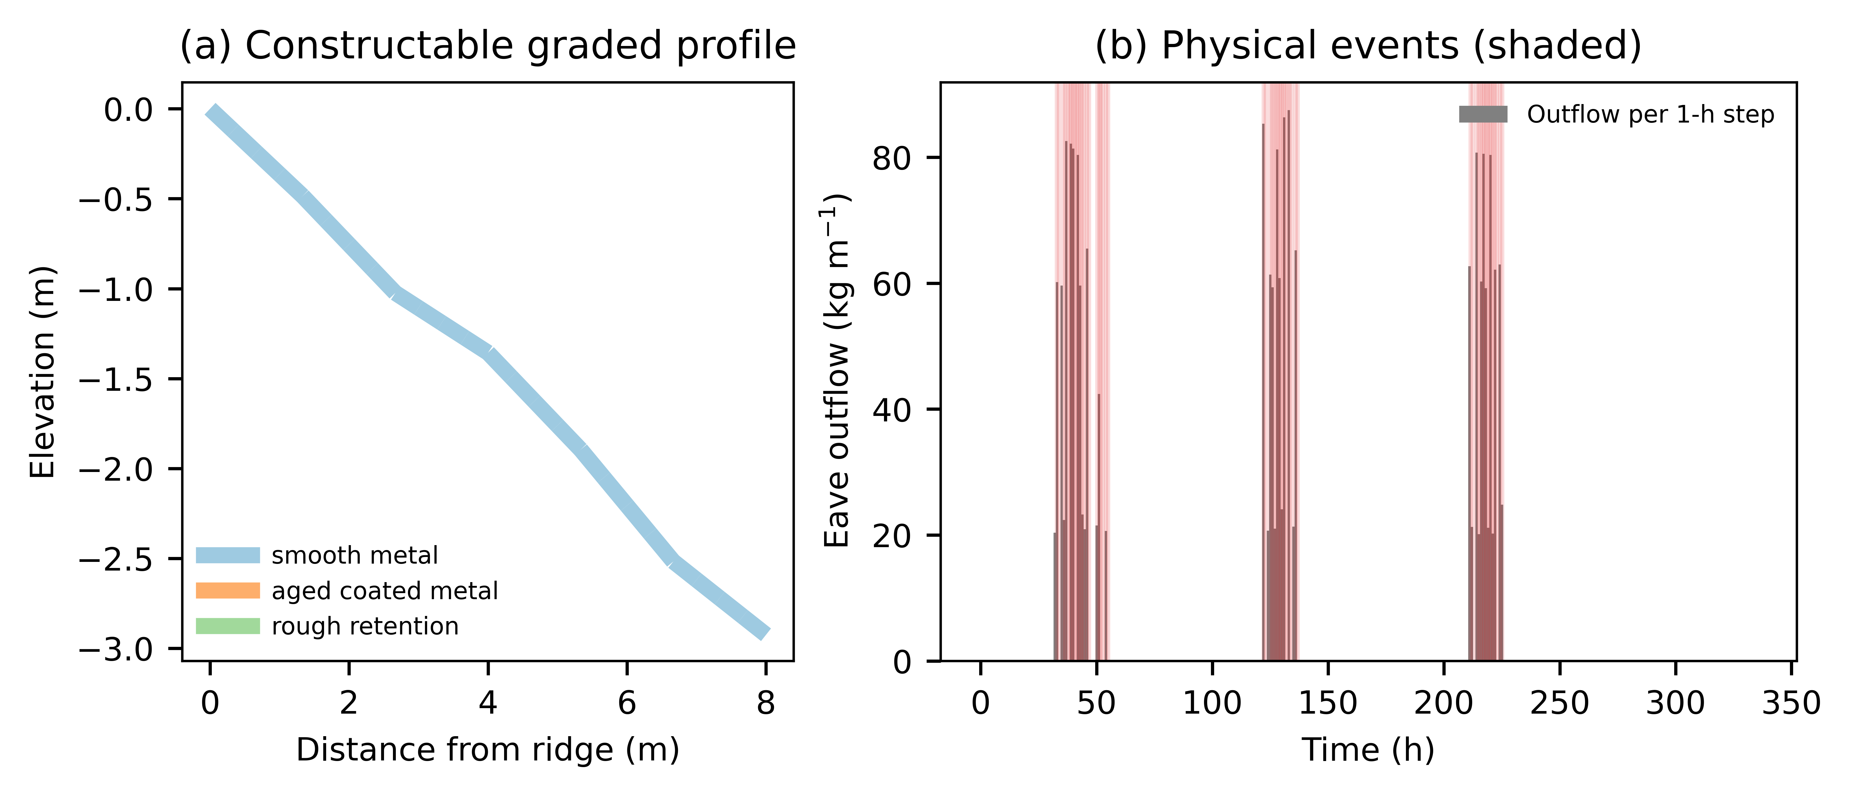
Figure 1. (a) Example constructable graded profile coloured by surface class. (b) Eave outflow per 1-h step in the maritime warming winter with physical events shaded.

2.3 Weather forcing
Three deterministic 336-h synthetic winters (cold persistent, maritime warming, severe inland) were defined in continuous time: Gaussian snowfall pulses, linear warming with a diurnal cycle, and terminal rain-on-snow. Step totals are exact integrals, so every timestep sees the same storm (water-equivalent snowfall 281-802 kg m⁻²; Fig. 2). Observed JMA daily records for 4 stations and 12 station-winters [28] were used only as supplementary scenarios, spreading daily totals uniformly over 24 h. These ground observations are not roof-snow validation data.
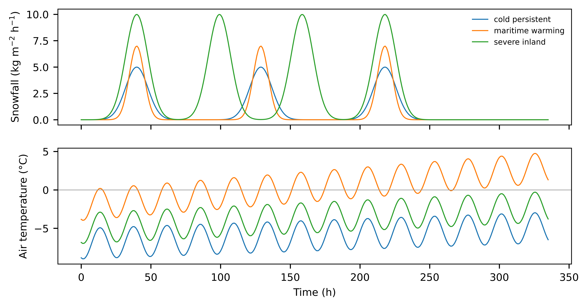
Figure 2. Synthetic forcing: snowfall rate and air temperature for the three winters.

2.4 Numerical verification
Before optimisation, all constructable uniform roofs and 60 random constructable graded roofs were simulated at dt = 1, 0.5, 0.25, 0.125 and 0.0625 h (reference) with 24 cells, and at 48 and 96 cells. A timestep was acceptable if at least 95% of pairs agreed with the reference within max(2%, 1 kg m⁻¹) for L_{max}, S_{event,max}, S_{1h,max} and total release, at least 90% had event counts within one, and mass-balance error was below 10⁻⁶ kg m⁻¹; the coarsest acceptable step was used. All final nondominated designs were then re-evaluated at 0.0625 h and at 48 cells.

2.5 Constructable optimisation
Candidates were decoded from a unit hypercube into piecewise-constant segments that satisfy every rule by construction: segments of at least 3 cells, at most 6 transitions, integer slopes 2.0-45.0 degrees, adjacent slope changes of at most 12.0 degrees, and one of three surface classes (smooth metal, aged coated metal, rough retention surface). Geometry-only (single class), surface-only (single slope) and joint searches each used NSGA-II with population 48, 45 generations and 5 seeds. The uniform reference was the exhaustive set of constructable uniform roofs; a 6,300-design continuous uniform grid was evaluated as a sensitivity.

2.6 Frontier comparison
Fronts were compared by normalised hypervolume (reference point 1.1 times the largest observed objectives, with 1.05 and 1.5 as sensitivities), additive epsilon in both directions, matched-objective improvement, unique objective pairs, per-seed variability and hypervolume after 15, 30 and 45 generations. The number of graded pairs lying inside the L_{max} gap of the uniform front is reported as a descriptive summary defined after the fronts were inspected.

2.7 Robustness and event-definition sensitivity
Every nondominated design was simulated under 250 common random draws (seed 7021) of lognormal multipliers on friction (CV 0.15), adhesion (0.25), fresh-snow density (0.15) and snowfall (0.2), and a normal temperature offset (SD 1.5 degrees C); the 95th percentiles (Q95) are reported. The event definition was varied (separation 10 min and 3 h; activity threshold 0.1 and 10 kg m⁻¹ h⁻¹) and entrainment was switched off.

2.8 Changes from the submitted analysis and reproducibility
The submitted analysis moved snow one cell per step and defined events per timestep, so its release endpoint depended on dt; it also applied constructability only after optimisation. The revision replaced transport, the release metric and the constraint handling, increased seeds from three to five, and selected dt by the rule above. Code, configuration, raw public-data snapshots with checksums, and every table and figure source are in the project repository; the submitted state is preserved under a fixed tag.

3. Results

3.1 Numerical convergence
For a smooth 40-degree uniform roof in the severe inland winter, the submitted per-step metric was 111.1, 74.1, 37.1 kg m⁻¹ at dt = 1, 0.5, 0.25 h, whereas S_{event,max} was 1,325.1, 1,325.0, 1,324.9 kg m⁻¹ (Fig. 3a). At dt = 1 h, 95.9% of pairs met the S_{event,max} tolerance and 98.2% met the L_{max} tolerance; all steps passed (Fig. 3b, Table 1), so dt = 1 h was used. The largest deviations (up to 1,333 kg m⁻¹) occurred for designs near a failure threshold. Spatial refinement to 48 and 96 cells changed S_{event,max} by a 95th-percentile relative amount of 0.29%. Mass-balance error was below 10⁻⁶ kg m⁻¹ in every run.
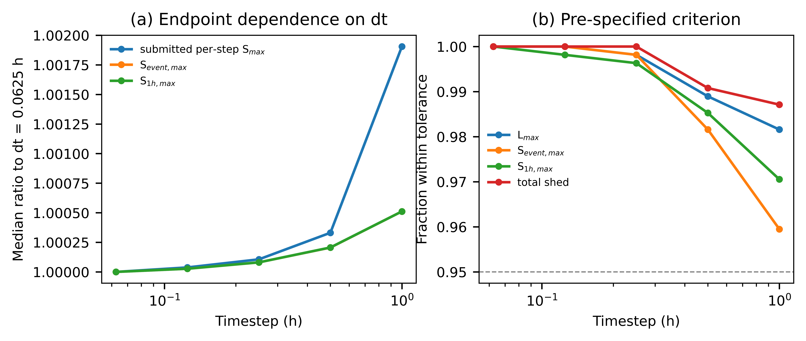
Figure 3. (a) Median ratio of release endpoints to the dt = 0.0625 h reference. (b) Fraction of design-winter pairs within the pre-specified tolerance; dashed line is the 95% criterion.

Table 1. Fraction of design-winter pairs within tolerance of the dt = 0.0625 h, 24-cell reference.
dt (h) | L_{max} | S_{event,max} | S_{1h,max} | Total release | Event count +/-1 | P95 rel. diff. S_{event,max} | Acceptable
1.0 | 0.982 | 0.959 | 0.971 | 0.987 | 0.996 | 2.94% | True
0.5 | 0.989 | 0.982 | 0.985 | 0.991 | 0.998 | 0.63% | True
0.25 | 0.998 | 0.998 | 0.996 | 1.000 | 1.000 | 0.25% | True
0.125 | 1.000 | 1.000 | 0.998 | 1.000 | 0.998 | 0.10% | True
0.0625 | 1.000 | 1.000 | 1.000 | 1.000 | 1.000 | 0.00% | True

3.2 Uniform reference
The constructable uniform front had 26 unique objective pairs (Fig. 4). Smooth roofs of 0-20 degrees traded L_{max} from 33.0 to 91.9 kg m⁻¹ against S_{event,max} from 1,374 to 91.9 kg m⁻¹; steep smooth roofs shed frequently, and closely spaced small releases merge into long events. The next uniform option was full retention (L_{max} 6,417 kg m⁻¹, no release). No constructable uniform roof lay between these regimes. The continuous uniform grid, which allows non-catalogue friction and adhesion, also had no design between 83.7 and 6,417 kg m⁻¹ on its front.
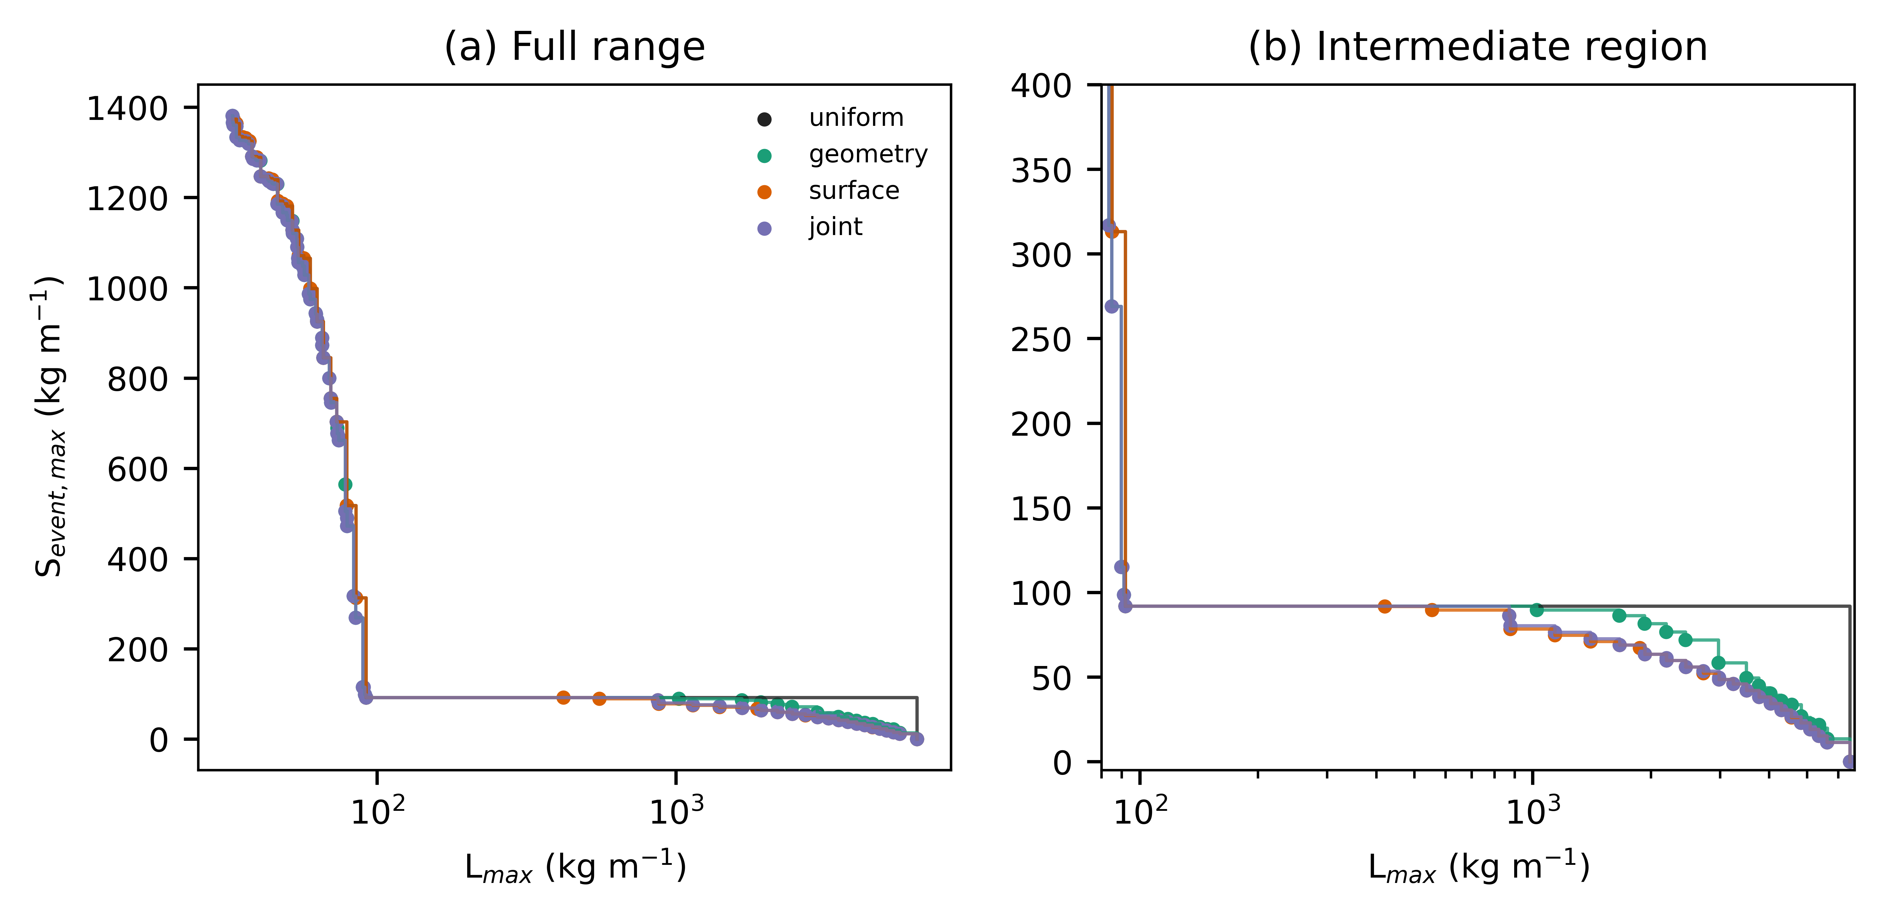
Figure 4. Constructable Pareto fronts for uniform, geometry-only, surface-only and joint sets: (a) full range, (b) intermediate region between the uniform shedding and retention regimes.

3.3 Graded fronts
All 15 runs produced only constructable designs, simulating 1,012-1,874 unique designs each. The geometry, surface and joint fronts had 89, 49 and 86 unique pairs. Hypervolume was 0.9822 for the uniform set and 0.9869, 0.9879 and 0.9880 for the graded sets, with the same ordering under both alternative reference points (Table 2). No graded front was dominated anywhere by the uniform front (epsilon 0), and the uniform front needed a normalised shift of 0.0129 to cover the joint front. Matched-objective improvements were small: median 0.5% in S_{event,max} at equal L_{max} (maximum 14.1%).

Table 2. Constructable front comparison (5 seeds pooled for graded sets).
Set | Unique pairs | Nondominated designs | HV (1.05) | HV (1.1) | HV (1.5) | Epsilon uniform to set | Median matched S gain | Graded pairs
uniform | 26 | 69 | 0.9807 | 0.9822 | 0.9895 | 0.0000 | 0.0000 | 0
geometry | 89 | 1344 | 0.9858 | 0.9869 | 0.9920 | 0.0126 | 0.0049 | 82
surface | 49 | 2482 | 0.9870 | 0.9879 | 0.9926 | 0.0129 | 0.0000 | 24
joint | 86 | 1070 | 0.9870 | 0.9880 | 0.9926 | 0.0129 | 0.0049 | 80
The substantive difference lay in the uniform gap. The combined graded fronts contained 26 pairs with L_{max} between 91.9 and 6,417 kg m⁻¹ and S_{event,max} of 11.5-91.8 kg m⁻¹; every one of the 15 runs found such pairs (8-23 per run). These designs combine steep or smooth shedding segments with a low-slope or rough retaining segment, so that snow released upslope stops on the roof while a short eave-side zone sheds small amounts (Fig. 5). Final-generation hypervolume varied across seeds by at most 0.0018, and the change from 30 to 45 generations was at most 0.0005 (Fig. 6).
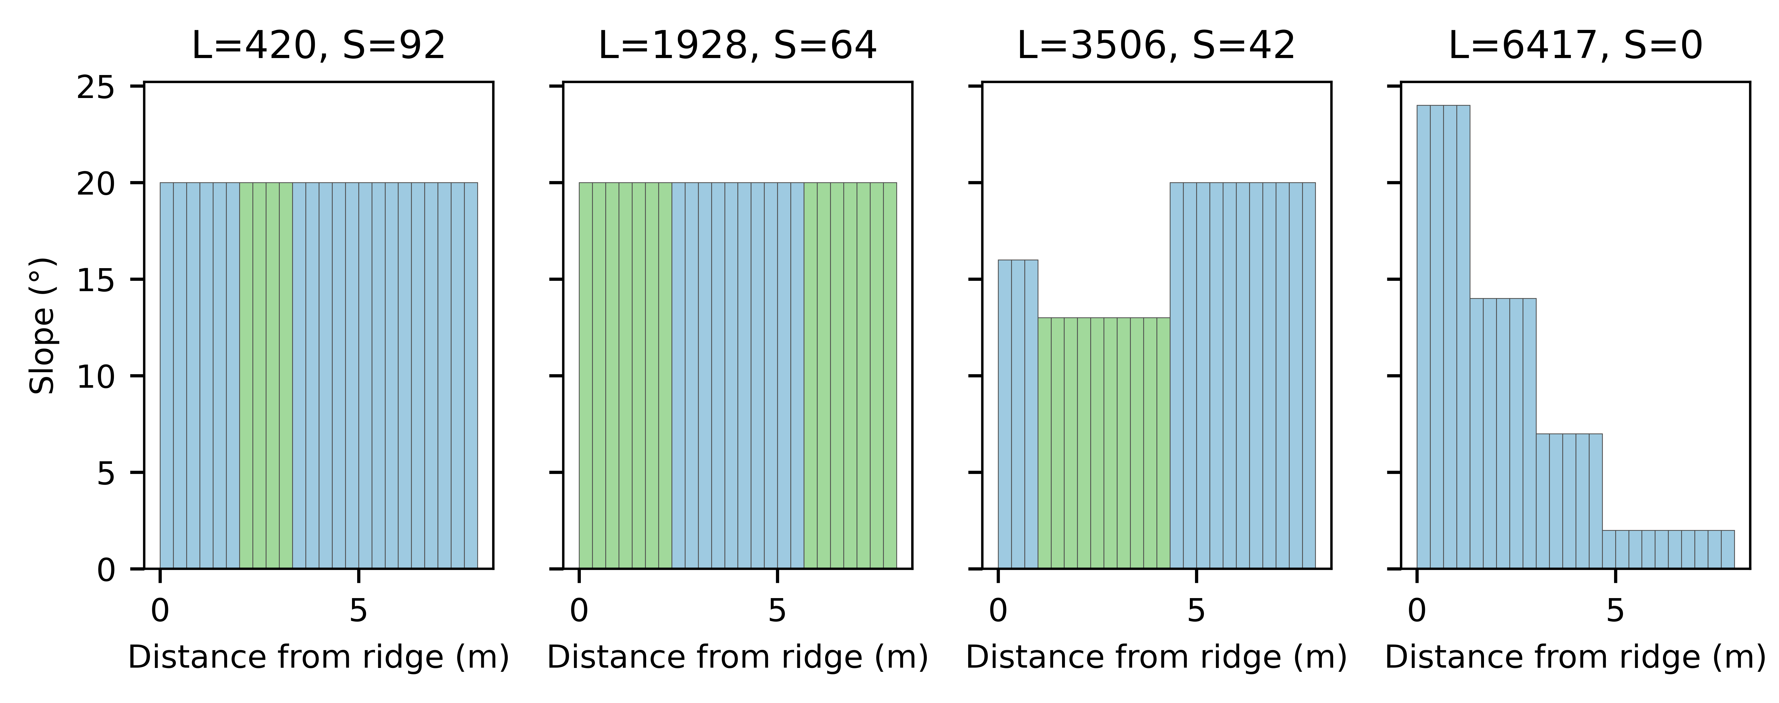
Figure 5. Slope profiles of representative intermediate graded designs; bar colours denote surface class.
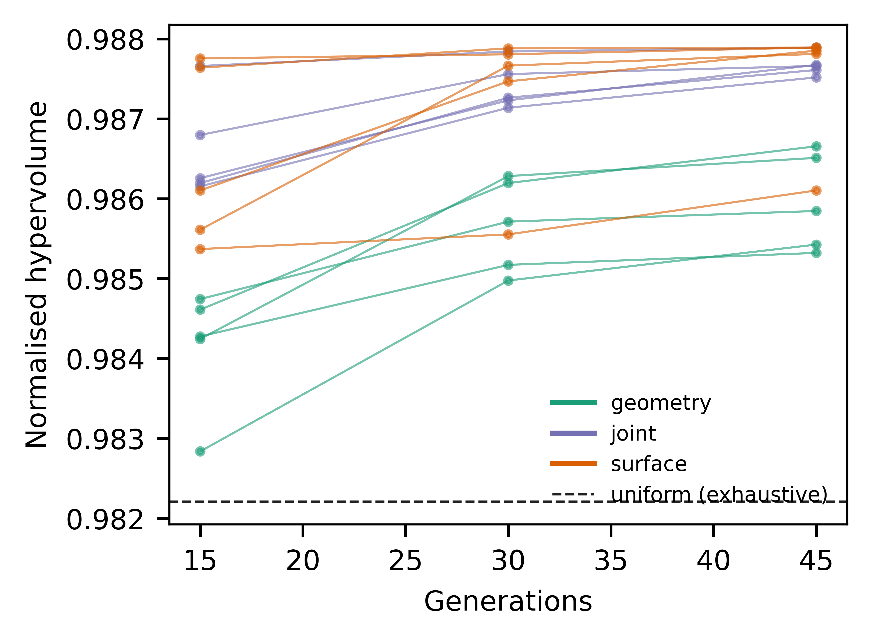
Figure 6. Normalised hypervolume after 15, 30 and 45 generations for each seed; dashed line is the exhaustive uniform set.

3.4 Fine-resolution re-check
Re-evaluating all 211 nondominated designs at dt = 0.0625 h changed S_{event,max} by a median 0.03% (95th percentile 5.9%) and L_{max} by a median 0.03%; refinement to 48 cells changed S_{event,max} by a median 0.03%. With fine-resolution objectives, hypervolume was 0.9822 (uniform) and 0.9880 (joint).

3.5 Event-definition sensitivity
The activity threshold (0.1 or 10 kg m⁻¹ h⁻¹) did not change any front. The separation time did (Table 3). With 10 min separation, closely spaced releases from steep smooth roofs counted as separate events, the uniform front shrank to 2 pairs and the uniform gap began at 33.0 kg m⁻¹; with 3 h separation it began at 292.9 kg m⁻¹. Graded pairs inside the uniform gap numbered 26 (base), 6 (10 min) and 4 (3 h), and 18 without entrainment. The existence of intermediate graded options was therefore insensitive to these choices, whereas the release magnitude attributed to shedding roofs depended strongly on how closely spaced releases are grouped.

Table 3. Sensitivity to event-definition and entrainment choices.
Variant | Uniform front pairs | Combined front pairs | Uniform gap starts at L_{max} (kg m⁻¹) | Graded pairs in gap | Largest S_{event,max} in gap (kg m⁻¹) | Epsilon uniform to combined (kg m⁻¹)
base | 26 | 97 | 91.9 | 26 | 91.8 | 80.4
no_entrainment | 26 | 44 | 91.9 | 18 | 86.3 | 80.4
q_min_0.1 | 26 | 97 | 91.9 | 26 | 91.8 | 80.4
q_min_10 | 26 | 97 | 91.9 | 26 | 91.8 | 80.4
tau_sep_10min | 2 | 8 | 33.0 | 6 | 27.8 | 21.6
tau_sep_3h | 22 | 30 | 292.9 | 4 | 250.7 | 114.5

3.6 Robustness
Uncertainty degraded the intermediate designs strongly (Fig. 7). For the 68 graded designs inside the nominal uniform gap, Q95 S_{event,max} ranged from 0 to 4,340 kg m⁻¹ (median 771), against nominal values of at most 91.8 kg m⁻¹; in a median 48% of draws their release exceeded 91.9 kg m⁻¹. Uniform shedding roofs were similarly sensitive at the retentive end (Q95 S_{event,max} 1,273-1,888 kg m⁻¹). In Q95 space the gap persisted: uniform roofs gave Q95 L_{max} of at most 145 kg m⁻¹ or full retention (8,472 kg m⁻¹), whereas 24 graded designs formed the Q95 front between 1,149 and 8,472 kg m⁻¹ with Q95 S_{event,max} of 0-1,037 kg m⁻¹, below every uniform shedding roof. Mass-balance error remained below 2e-11 kg m⁻¹.
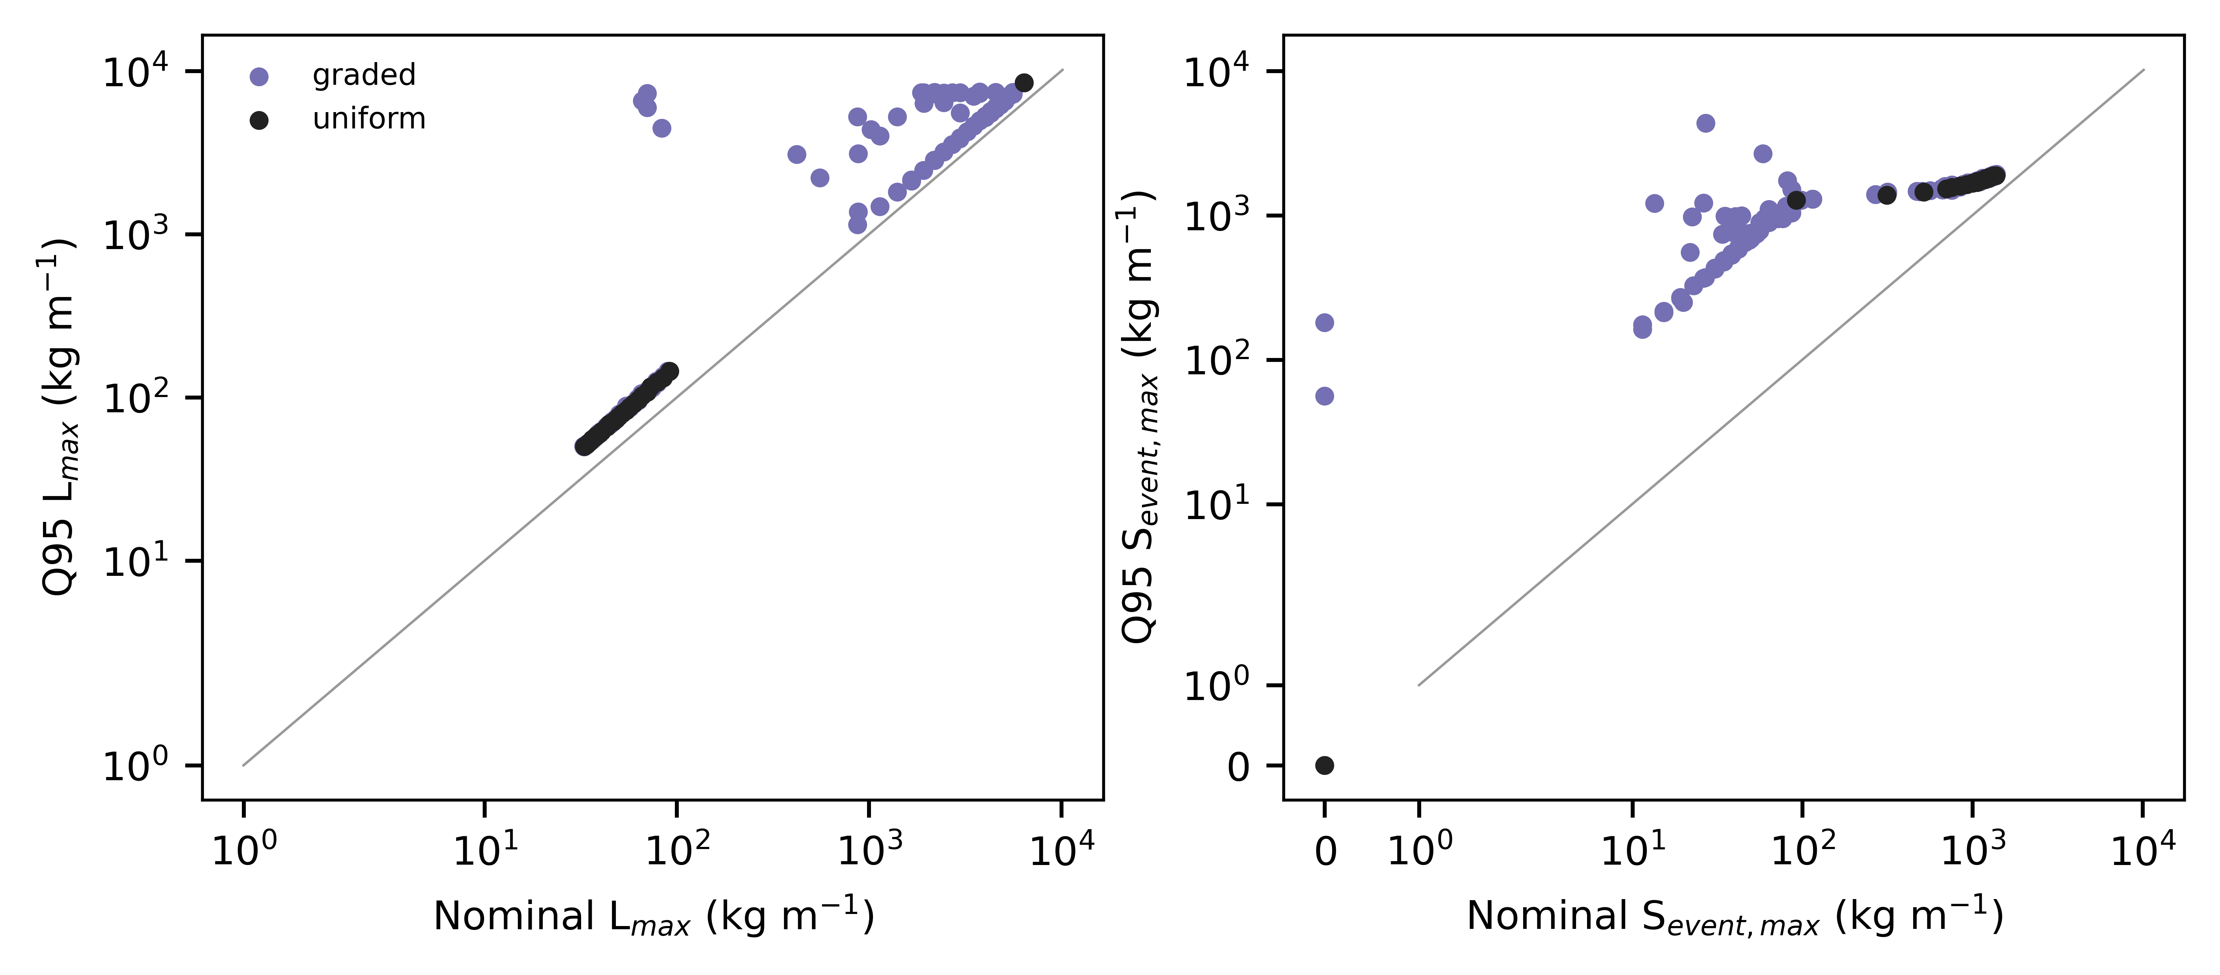
Figure 7. Nominal versus Q95 outcomes under 250 common uncertainty draws for all nondominated designs.

3.7 JMA station-winter scenarios
Under the 12 observed station-winters (snowfall water equivalent 340-1,043 kg m⁻², rain 152-1,316 mm), the same designs were re-simulated without re-optimisation (Fig. 8). Because daily snowfall was spread uniformly, steep smooth roofs shed as near-continuous streams and the uniform front reduced to 2 pairs in every station-winter: a shedding roof with L_{max} of 32.6-33.0 kg m⁻¹, or full retention. In every station-winter, 6-10 graded pairs lay between these options, with S_{event,max} of 10.8-32.5 kg m⁻¹. These scenario results extend the comparison to longer, observed forcing but do not validate roof behaviour.
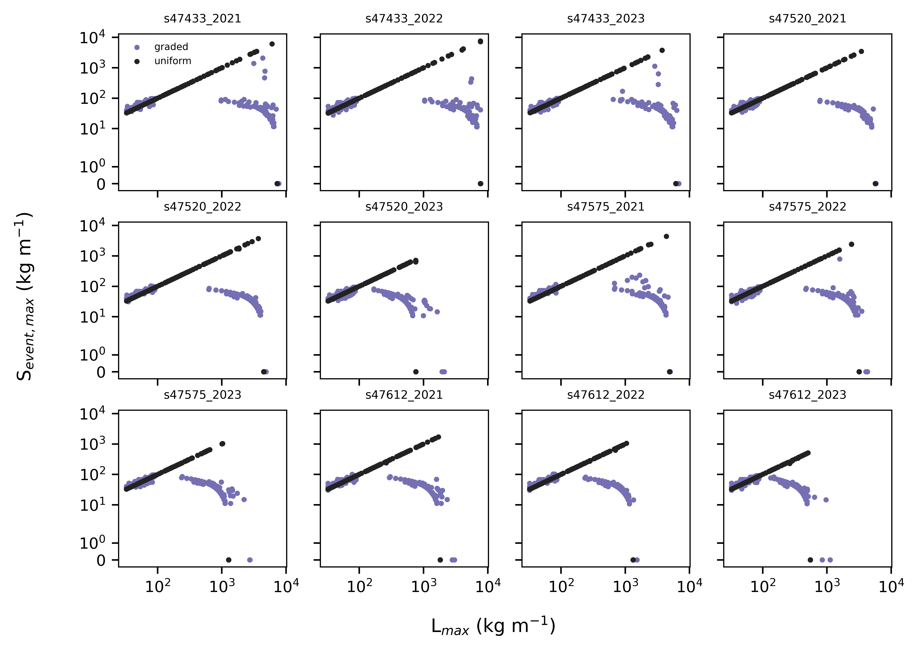
Figure 8. Objective pairs of uniform and nondominated graded designs under observed JMA station-winters (daily totals spread uniformly over 24 h).

4. Discussion
Within this model, spatial grading did not produce a generally better roof: hypervolume, epsilon and matched-objective gains over the exhaustive constructable uniform set were small. What grading did provide, reproducibly across seeds, was access to intermediate states between near-complete shedding and full retention, where a roof holds most of its snow and releases less than any shedding uniform roof. The nominal smallness of those releases was not robust: it depends on a retaining segment holding close to its failure threshold, and modest changes in friction, adhesion or snowfall convert it into releases of several hundred kg m⁻¹. Uniform roofs reach these states only through non-catalogue surface properties, if at all. In practice this corresponds to a retention zone combined with a short controlled-shedding eave zone, a configuration related to snow guards and retention roofs in regional guidance [6,7,23]; the mechanism is physically interpretable (upslope releases stop on a retaining segment).
The revised metric changes the interpretation of shedding roofs. Steep smooth roofs release often, and when releases are closely spaced they form long continuous events with large integrated mass; per-step metrics hid this by dividing each release among timesteps. Whether a series of small releases is less hazardous than one large release depends on occupancy below the eave, and the fixed-window metrics are supplied for that reason.
For Japanese practice the result is a design option, not a compliance route. Retaining designs carry the full design snow load, and Article 86 withholds the slope reduction where sliding is prevented [5]. A graded roof that retains most snow should therefore be designed as a retention roof structurally, while its potential benefit is fewer clearing operations and smaller, more predictable eave releases.

4.1 Limitations
The model has not been calibrated or validated against roof-scale release measurements; friction, adhesion, ageing and near-melt laws are assumptions informed only qualitatively by interface studies. Slabs are rigid blocks; fracture, cornices, creep and glide, eave overhang, wind redistribution and three-dimensional flow are omitted. Meltwater and rain leave the roof immediately: liquid-water retention, refreezing, ice dams, runoff routing, drainage capacity and hydrologically triggered wet-snow releases are not represented, so rain-on-snow effects are limited to a melt-energy term and a near-melt friction reduction. Synthetic winters are stylised, and daily JMA data cannot resolve sub-daily timing. Optimisation is heuristic and limited to a 2D strip with three surface classes.

4.2 Future validation
Product-specific inclined-plane friction and adhesion tests across temperature and liquid-water content, instrumented roof panels with load cells and time-lapse imaging such as the semi-full-scale setup of Tominaga et al. [19], and eave-catchment measurements of release mass and timing are needed before graded designs can be recommended.

5. Conclusions
With a timestep-independent event metric and constructability enforced inside the search, constructable uniform roofs either shed nearly all snow or retained all of it. Spatially graded roofs reproducibly filled this gap with intermediate retention-release combinations, which persisted under uncertainty with substantially larger releases, but did not materially improve the overall frontier. Spatial grading is best viewed as a configurable retention strategy whose physical benefit remains to be demonstrated experimentally.

Declarations
Funding: REQUIRED
Declaration of competing interests: REQUIRED
Data and code availability: Code, configuration, raw public-data snapshots, acquisition ledger with SHA-256 checksums, and all result tables are available in the project repository.
Declaration of generative AI and AI-assisted technologies in the manuscript preparation process: During the preparation of this work, the author used Devin (Cognition AI) to support coding, data acquisition, analysis scripting and drafting. The author reviewed and edited the content and takes full responsibility for the publication.
CRediT authorship contribution statement: REQUIRED - author confirmation of roles.

References
[1] Government of Japan, 1962. Act on Special Measures for Heavy Snowfall Areas (Act No. 73 of 1962). e-Gov Law Search. Available at: https://laws.e-gov.go.jp/law/337AC1000000073.
[2] Ministry of Land Infrastructure Transport and Tourism, 2026. Overview of designated heavy snowfall areas and special heavy snowfall areas. MLIT. Available at: https://www.mlit.go.jp/kokudoseisaku/chisei/content/001881217.pdf.
[3] Ministry of Land Infrastructure Transport and Tourism, 2025. Implementation status of measures in heavy snowfall areas. MLIT. Available at: https://www.mlit.go.jp/kokudoseisaku/chisei/content/001881218.pdf.
[4] Japan Meteorological Agency, 2026. Climatological normals 1991-2020 (Sapporo 47412 Aomori 47575 Niigata 47604). JMA. Available at: https://www.data.jma.go.jp/stats/etrn/index.php.
[5] Government of Japan, 1950. Order for Enforcement of the Building Standards Act (Cabinet Order No. 338 of 1950) Article 86. e-Gov Law Search. Available at: https://laws.e-gov.go.jp/law/325CO0000000338.
[6] Hokkaido Research Organization, Hokkaido Building Guidance Center, 2017. Planning roof-snow treatment for detached houses. Official technical guide. Available at: https://www.hro.or.jp/upload/51707/yanenoyukishori.pdf.
[7] Niigata Prefecture, 2006. Technical material on characteristics and design ideas for roof-snow treatment. Official prefectural technical material. Available at: https://www.pref.niigata.lg.jp/uploaded/attachment/135532.pdf.
[8] Kimura, T., 1989. Change of removing technique of snow on roof and recent situation of its technical development. Snow and Ice. https://doi.org/10.5331/seppyo.51.111.
[9] Watanabe, M., Takita, M., 1997. Fundamental Study on Control of Roof Snow Sliding. Journal of Snow Engineering of Japan. https://doi.org/10.4106/jsse.13.3.
[10] Giever, P.M., Sack, R.L., 1990. Similitude considerations for roof snow loads. Cold Regions Science and Technology. https://doi.org/10.1016/0165-232X(90)90018-R.
[11] Thiis, T.K., Gjessing, Y., 1999. Large-scale measurements of snowdrifts around flat-roofed and single-pitch-roofed buildings. Cold Regions Science and Technology. https://doi.org/10.1016/S0165-232X(99)00021-X.
[12] Zhou, X., Kang, L., Yuan, X., Gu, M., 2016. Wind tunnel test of snow redistribution on flat roofs. Cold Regions Science and Technology. https://doi.org/10.1016/j.coldregions.2016.04.006.
[13] Tominaga, Y., 2018. Computational fluid dynamics simulation of snowdrift around buildings: Past achievements and future perspectives. Cold Regions Science and Technology. https://doi.org/10.1016/j.coldregions.2017.05.004.
[14] Sun, X., He, R., Wu, Y., 2018. Numerical simulation of snowdrift on a membrane roof and the mechanical performance under snow loads. Cold Regions Science and Technology. https://doi.org/10.1016/j.coldregions.2017.09.007.
[15] Zhang, G., Zhang, Q., Fan, F., Shen, S., 2021. Numerical simulations of development of snowdrifts on long-span spherical roofs. Cold Regions Science and Technology. https://doi.org/10.1016/j.coldregions.2020.103211.
[16] Zhang, B., Zhang, Q., Mo, H., Fan, F., Lehning, M., 2022. Considering snow depositions and transport mechanisms in meteorological analysis of predicting snow loads on buildings. Cold Regions Science and Technology. https://doi.org/10.1016/j.coldregions.2022.103614.
[17] Zhou, X., Zhang, T., Liu, Z., Gu, M., 2023. A study of snow drifting on monoslope roofs during snowfall: Wind tunnel test and numerical simulation. Cold Regions Science and Technology. https://doi.org/10.1016/j.coldregions.2022.103731.
[18] Chiba, T., et al., 2021. Fundamental study for elucidating snow cornice formation mechanism of flat roofs based on wind tunnel test using natural snow. Snow and Ice. https://doi.org/10.5331/seppyo.83.3_249.
[19] Tominaga, Y., Igarashi, K., Wakui, M., Motoyoshi, H., Ito, Y., 2025. Measurement and estimation of temporal variations of roof snow load on semi-full-scale building model. Cold Regions Science and Technology. https://doi.org/10.1016/j.coldregions.2025.104445.
[20] Tomabechi, T., Takakura, M., Ito, T., 1996. Influence of the surface roughness of roofing materials on snow sliding. Journal of Snow Engineering of Japan. https://doi.org/10.4106/jsse.12.205.
[21] Ito, T., Tomabechi, T., Mitsuhashi, H., 1997. Evaluation and Maintenance of Snow Sliding Performance of Coated Steel Roofing Used for Sloped Roof. Journal of Snow Engineering of Japan. https://doi.org/10.4106/jsse.13.244.
[22] Fasani, D., Cernuschi, F., Wolfsperger, F., Balordi, M., Colombo, L.P.M., 2026. Shear and tensile adhesion of dry and wet snow on metallic surfaces. Cold Regions Science and Technology. https://doi.org/10.1016/j.coldregions.2026.104971.
[23] Takakura, M., Ito, T., Tomabechi, T., 2003. Assessment of the effectiveness of snow guards on a sloped roof. AIJ Journal of Technology and Design. https://doi.org/10.3130/aijt.9.67_1.
[24] Asano, Y., Iwai, K., 1995. Experimental Study on the Snow Removal on the Roof by Snow-Melting System in Northern Area of Nagano Prefecture. Journal of Architecture Planning and Environmental Engineering. https://doi.org/10.3130/aija.60.57_3.
[25] Zou, J., Sun, X., Zhou, H., 2023. Sensitivity analysis and practical application of an automatic snow-melting membrane roof. Cold Regions Science and Technology. https://doi.org/10.1016/j.coldregions.2022.103754.
[26] Pawluk, R.E., Rezvanpour, M., Chen, Y., She, Y., 2021. A sensitivity analysis on effective parameters for sliding/melting prediction of snow cover on solar photovoltaic panels. Cold Regions Science and Technology. https://doi.org/10.1016/j.coldregions.2021.103262.
[27] Sapporo City, 2025. Measures to prevent hazards caused by falling ice and snow. Municipal administrative guidance. Available at: https://www.city.sapporo.jp/toshi/k-shido/kakuninn/yukidome/yukidome.html.
[28] Japan Meteorological Agency, 2026. Historical daily weather data (Kutchan Aomori Shinjo Takada). JMA. Available at: https://www.data.jma.go.jp/stats/etrn/index.php.

Figure captions
Figure 1. (a) Example constructable graded profile coloured by surface class. (b) Eave outflow per 1-h step in the maritime warming winter with physical events shaded.
Figure 2. Synthetic forcing: snowfall rate and air temperature for the three winters.
Figure 3. (a) Median ratio of release endpoints to the dt = 0.0625 h reference. (b) Fraction of design-winter pairs within the pre-specified tolerance; dashed line is the 95% criterion.
Figure 4. Constructable Pareto fronts for uniform, geometry-only, surface-only and joint sets: (a) full range, (b) intermediate region between the uniform shedding and retention regimes.
Figure 5. Slope profiles of representative intermediate graded designs; bar colours denote surface class.
Figure 6. Normalised hypervolume after 15, 30 and 45 generations for each seed; dashed line is the exhaustive uniform set.
Figure 7. Nominal versus Q95 outcomes under 250 common uncertainty draws for all nondominated designs.
Figure 8. Objective pairs of uniform and nondominated graded designs under observed JMA station-winters (daily totals spread uniformly over 24 h).

