Functionally graded roofs for passive snow management: nominal trade-off expansion limited by constructability and timestep sensitivity

Spatially graded roofs for passive snow management in heavy-snowfall regions: constructable intermediate retention-release trade-offs under a physical event metric
Tatsuki Onishi*
REQUIRED
Corresponding *Corresponding author: Tatsuki Onishi, REQUIRED, bougtoir@gmail.com

Abstract
Roofs in heavy-snowfall regions either retain snow, which raises structural load and the need for manual clearing, or shed it, which creates eave-release hazards. We asked whether spatial grading of slope and surface class along a constructable roof creates retention-release trade-offs that uniform roofs cannot provide. A reduced-order ridge-to-eave model with Coulomb-adhesion failure, exact threshold-crossing times and work-energy runout was forced by three synthetic winters. Release hazard was quantified by a pre-specified physical event metric, the largest integrated eave-release mass per event (S_{event,max}), replacing a per-timestep metric that halved whenever the timestep halved. Numerical convergence was tested on 543 design-winter pairs; every tested timestep met the pre-specified criterion. Constructability (segments of at least 3 cells, at most 6 transitions, integer slopes, three discrete surface classes) was enforced inside NSGA-II by a feasible encoding, and graded searches were compared with all 132 constructable uniform roofs. Uniform roofs either shed nearly all snow (maximum retained mass L_{max} 91.9 kg m⁻¹) or retained all of it (6,417 kg m⁻¹). Graded roofs added 26 nondominated intermediate combinations (S_{event,max} 11.5-91.8 kg m⁻¹), found in all 15 optimisation runs, but changed normalised hypervolume only from 0.982 to 0.988. Under parameter and forcing uncertainty these intermediate options persisted, but their 95th-percentile releases were an order of magnitude larger than nominal. Spatial grading is therefore a configurable means of intermediate retention rather than a general improvement; the model is verified numerically but not validated against roof observations.
Keywords: roof snow; passive snow management; multiobjective optimization; spatial heterogeneity; snow shedding; reduced-order model
Keywords: roof snow; snow shedding; snow retention; heavy-snowfall areas; constructability; multiobjective optimisation; reduced-order model
Passive roof-snow strategies trade retained modeled snow mass against discrete eave-release mass. We tested whether spatial variation in slope, friction, and adhesion changed that trade-off relative to an exhaustively mapped uniform design space. A unit-width, cell-based threshold-release model was evaluated under synthetic weather, with Japanese Meteorological Agency daily observations used only as supplementary forcing. Multi-seed NSGA-II generated geometry-only, surface-only, and joint heterogeneous sets. The uniform set contained 2 unique objective pairs, whereas the joint set contained 6, including the uniform endpoints and additional intermediate trade-offs. Under the common audit reference, their normalized hypervolumes were 0.701 and 0.762; joint additive epsilon versus uniform was 0.000. The joint set had 4 intermediate objective pairs unavailable to the uniform set under the same objective caps. 6 candidates tied the minimum robustness score. Mapping the continuous joint knee to rule-compliant generic segments changed modeled retained mass by -98.28% and release mass by +537.47%, shifting the selected point toward the low-retention, high-release shedding regime. A targeted 0.25-h sensitivity failed the four-metric tolerance for 3 of 3 selected designs relative to the 0.5-h production results. Spatial grading produced nominal intermediate trade-offs absent from the exhaustive uniform grid, but constructability and interval sensitivity substantially limit interpretation; no front-wide superiority, structural safety, or validated roof performance is established.

1. Introduction
Heavy snowfall shapes building practice across much of Japan. Under the Act on Special Measures for Heavy Snowfall Areas [1], 532 of 1719 municipalities are designated heavy-snowfall areas, covering 50.8% of the national land and 18.2 million people, about 14.5% of the national population [2]. Snow-related deaths numbered 22 in the FY2023 winter; over the preceding decade about about 90% occurred during snow removal and about about 90% of those victims were aged 65 or older, with falls from roofs and falling roof snow among the dominant accident types [3]. Annual snowfall normals reach 479 cm in Sapporo and 567 cm in Aomori [4]. Reducing the need to climb roofs and the hazard of uncontrolled releases is therefore both a structural and a public-safety problem.
The legal framework sets loads, not roof-snow strategies. Article 86 of the Order for Enforcement of the Building Standards Act [5] defines the snow load from unit snow weight, horizontal projected area and design snow depth; it allows a slope-dependent shape coefficient for roofs that shed snow, withholds this reduction where snow guards prevent sliding, requires consideration of uneven snow, and permits a reduced design depth only where roof clearing is customary and its conditions are posted. Retention, shedding, melting and load-resisting roofs are thus design choices described in regional technical guidance [6,7] and historical practice [8,9], not in binding rules. The model in this paper does not compute code snow loads and makes no compliance claim.
Roof-snow research has concentrated on drift and deposition [10,11,12,13,14,15,16,17,18] and on load monitoring [19]. Sliding depends on surface roughness, water content, ageing and adhesion [20,21,22], snow guards change retention [23], and melting systems trade energy for clearance [24,25]; sliding models for inclined photovoltaic panels show the sensitivity of release to interface parameters [26]. Municipal guidance highlights the hazard of falling roof snow and ice [27]. Whether varying slope and surface along a single roof can place it between the retention and shedding extremes has not, to our knowledge, been examined under explicit constructability limits.
The question tested here was whether spatial grading produces physically interpretable, numerically stable, robust and constructable retention-release trade-offs that uniform roofs cannot provide. A negative or limited answer was admissible. Compared with the originally submitted analysis, the release metric, the transport scheme, the treatment of constructability and the number of optimisation seeds were revised; all changes are listed in Section 2.8 and the original outputs are retained.
Roof snow is spatially variable, evolves with weather, and can either remain on the roof or leave in discrete releases. Roof-scale experiments and deposition studies show that geometry, wind, and scale influence snow distributions, while validation remains essential for computational models (Giever and Sack, 1990; Sun et al., 2018; Thiis and Gjessing, 1999; Tominaga, 2018; Zhang et al., 2021; Zhou et al., 2016). Adjacent photovoltaic, membrane-roof, meteorological, and field studies further motivate explicit sensitivity analysis and independent validation (Fasani et al., 2026; Pawluk et al., 2021; Tominaga et al., 2025; Zhang et al., 2022; Zhou et al., 2023; Zou et al., 2023).
Japanese technical and administrative sources distinguish retention, shedding, melting, and load-resisting strategies and document the importance of surface condition, aging, snow guards, drainage, cornices, and site context (Asano and Iwai, 1995; Chiba et al., 2021; Hokkaido Research Organization and Hokkaido Building Guidance Center, 2017; Ito et al., 1997; Kimura, 1989; Niigata Prefecture, 2006; Sapporo City, 2025; Takakura et al., 2003; Tomabechi et al., 1996; Watanabe and Takita, 1997). Retention can reduce required snow-fall space at dense sites, whereas shedding requires a suitable receiving zone; retained snow instead imposes long-duration load and drainage obligations. These sources do not establish universal material coefficients, safety thresholds, or one preferable strategy. They motivate a conditional comparison of generic uniform and graded design spaces.
The research question was frozen before production analysis: under identical modeled environmental conditions, how does allowing spatial variation in roof geometry and snow-surface interaction change the achievable trade-off between retained modeled snow mass and discrete shedding events compared with optimized uniform roofs? The hypothesis that heterogeneity expands the attainable design space was tested without assuming superiority.

2. Methods

2.1 Reduced-order roof-snow model
A 8 m ridge-to-eave strip of unit width was divided into 24 cells, each with slope, static and kinetic friction and adhesion. Snowfall was added as mass, compacted with age, melted by a degree-hour factor plus a rain-heat term, and assigned a dynamic friction that increased with age and decreased near melting (parameters in Supplementary Table S1). A cell with mass m per unit area failed when gravity exceeded the Coulomb-adhesion resistance:
$$m g \sin{θ} ≥ μ_{s} m g \cos{θ} + c (1)$$
where θ is slope, μ_{s} static friction and c adhesion. Because snowfall within a step is integrated exactly, the failure time is found as the exact crossing of the threshold mass m* = c/[g(sin θ − μ_{s} cos θ)] within the step rather than at step end. A released slab travels downslope with kinetic friction μ_{k}; its speed follows the work-energy balance
$${v_{j+1}}^{2} = {v_{j}}^{2} + 2 g Δx (\sin{θ_{j}} − μ_{k,j} \cos{θ_{j}}) (2)$$
and it stops where the speed reaches zero or leaves at the eave. Mass resting in cells it crosses that are themselves at or above threshold is entrained inelastically. Cells that cannot hold any snow (sin θ > μ_{s} cos θ and c = 0) route incoming snowfall continuously to the eave or to the first retaining cell. Mass balance (input = eave release + melt + residual) was checked in every run.
2.2 Outcomes and comparison sets

2.2 Outcomes
L_{max} is the maximum retained roof mass per metre width over the winter. The primary release outcome is the largest physical event mass
$$S_{event,max} = \max_{e} M_{e}, M_{e} = \sum_{i∈e}{m_{i}} + \int_{t_{e,0}}^{t_{e,1}}{q(t) dt} (3)$$
where m_{i} are slab masses leaving the eave at their exact times and q(t) is continuous eave outflow. An event starts when a slab leaves or q exceeds 1.0 kg m⁻¹ h⁻¹, and ends when no such activity occurs for 1 h. The definition, tie rules and secondary fixed-window metrics (largest release in any 10 min, 1 h and 3 h window) were specified before any revised result was generated (Fig. 1b). The submitted per-timestep maximum is reported only as a diagnostic. Both objectives were taken as the worst case over the three winters.
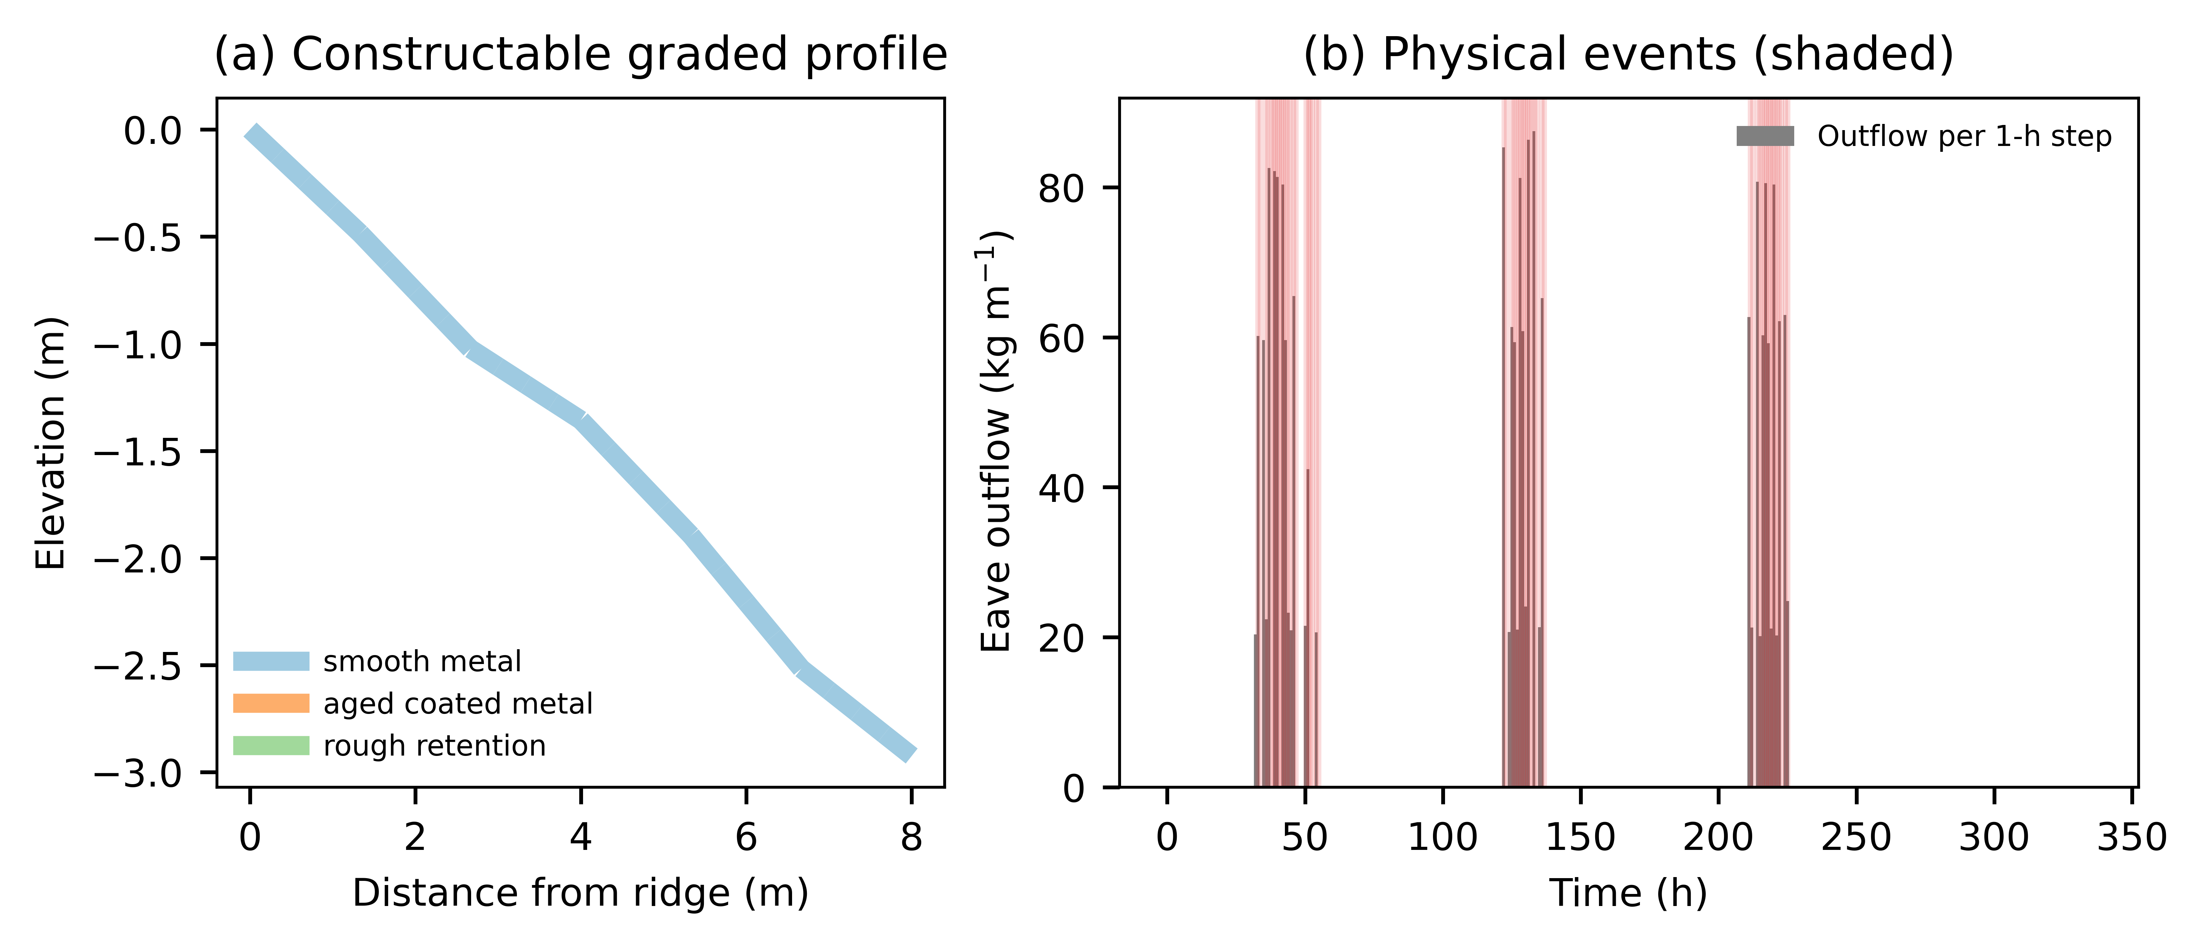
Figure 1. (a) Example constructable graded profile coloured by surface class. (b) Eave outflow per 1-h step in the maritime warming winter with physical events shaded.
An 8 m long, 1 m wide roof was represented by 24 ridge-to-eave cells. Each cell carried slope, static friction, kinetic friction, adhesion, snow mass, mass-weighted age, volume, and density. Snowfall was added before each within-step maximum was recorded. Melt removed mass, volume, and age moment proportionally. Compaction changed volume and diagnostic depth. Density converted observed snowfall depth to mass but was not asserted to change basal sliding at fixed mass.
A cell became mobile when downslope gravity exceeded static friction plus area-scaled adhesion. Kinetic friction controlled transport after release. Mass, age moment, and volume moved together. Snow leaving the final cell was an eave-shedding event. The kinetic-energy metric was a roof-wide specific-energy proxy, not an impact or injury model.
The locked primary outcomes were Lmax, the maximum modeled roof snow mass per metre width immediately after snowfall and before same-step melt or release, and Smax, the maximum eave-release mass in one timestep per metre width. Secondary outcomes included total shed mass, event count, event-mass summaries, Snow Shedding Concentration Index (SSCI), kinetic-energy proxy, intervention-threshold time, manual triggers, residual mass, maximum modeled snow depth, total variation, transition count, and discretization loss.
Comparators were retention-oriented, shedding-oriented, and intermediate uniform baselines; the complete optimized uniform frontier; and geometry-only, surface-only, and joint heterogeneous frontiers. Figure 1 summarizes the model and optimization workflow; Figure 2 summarizes synthetic and observed weather contexts; Figures 3-5 show the primary frontier, selected profile, and ablation frontiers. Tables 1-3 report frontier metrics, the selected profile, and continuous-to-discrete mapping.

2.3 Weather forcing
Three deterministic 336-h synthetic winters (cold persistent, maritime warming, severe inland) were defined in continuous time: Gaussian snowfall pulses, linear warming with a diurnal cycle, and terminal rain-on-snow. Step totals are exact integrals, so every timestep sees the same storm (water-equivalent snowfall 281-802 kg m⁻²; Fig. 2). Observed JMA daily records for 4 stations and 12 station-winters [28] were used only as supplementary scenarios, spreading daily totals uniformly over 24 h. These ground observations are not roof-snow validation data.
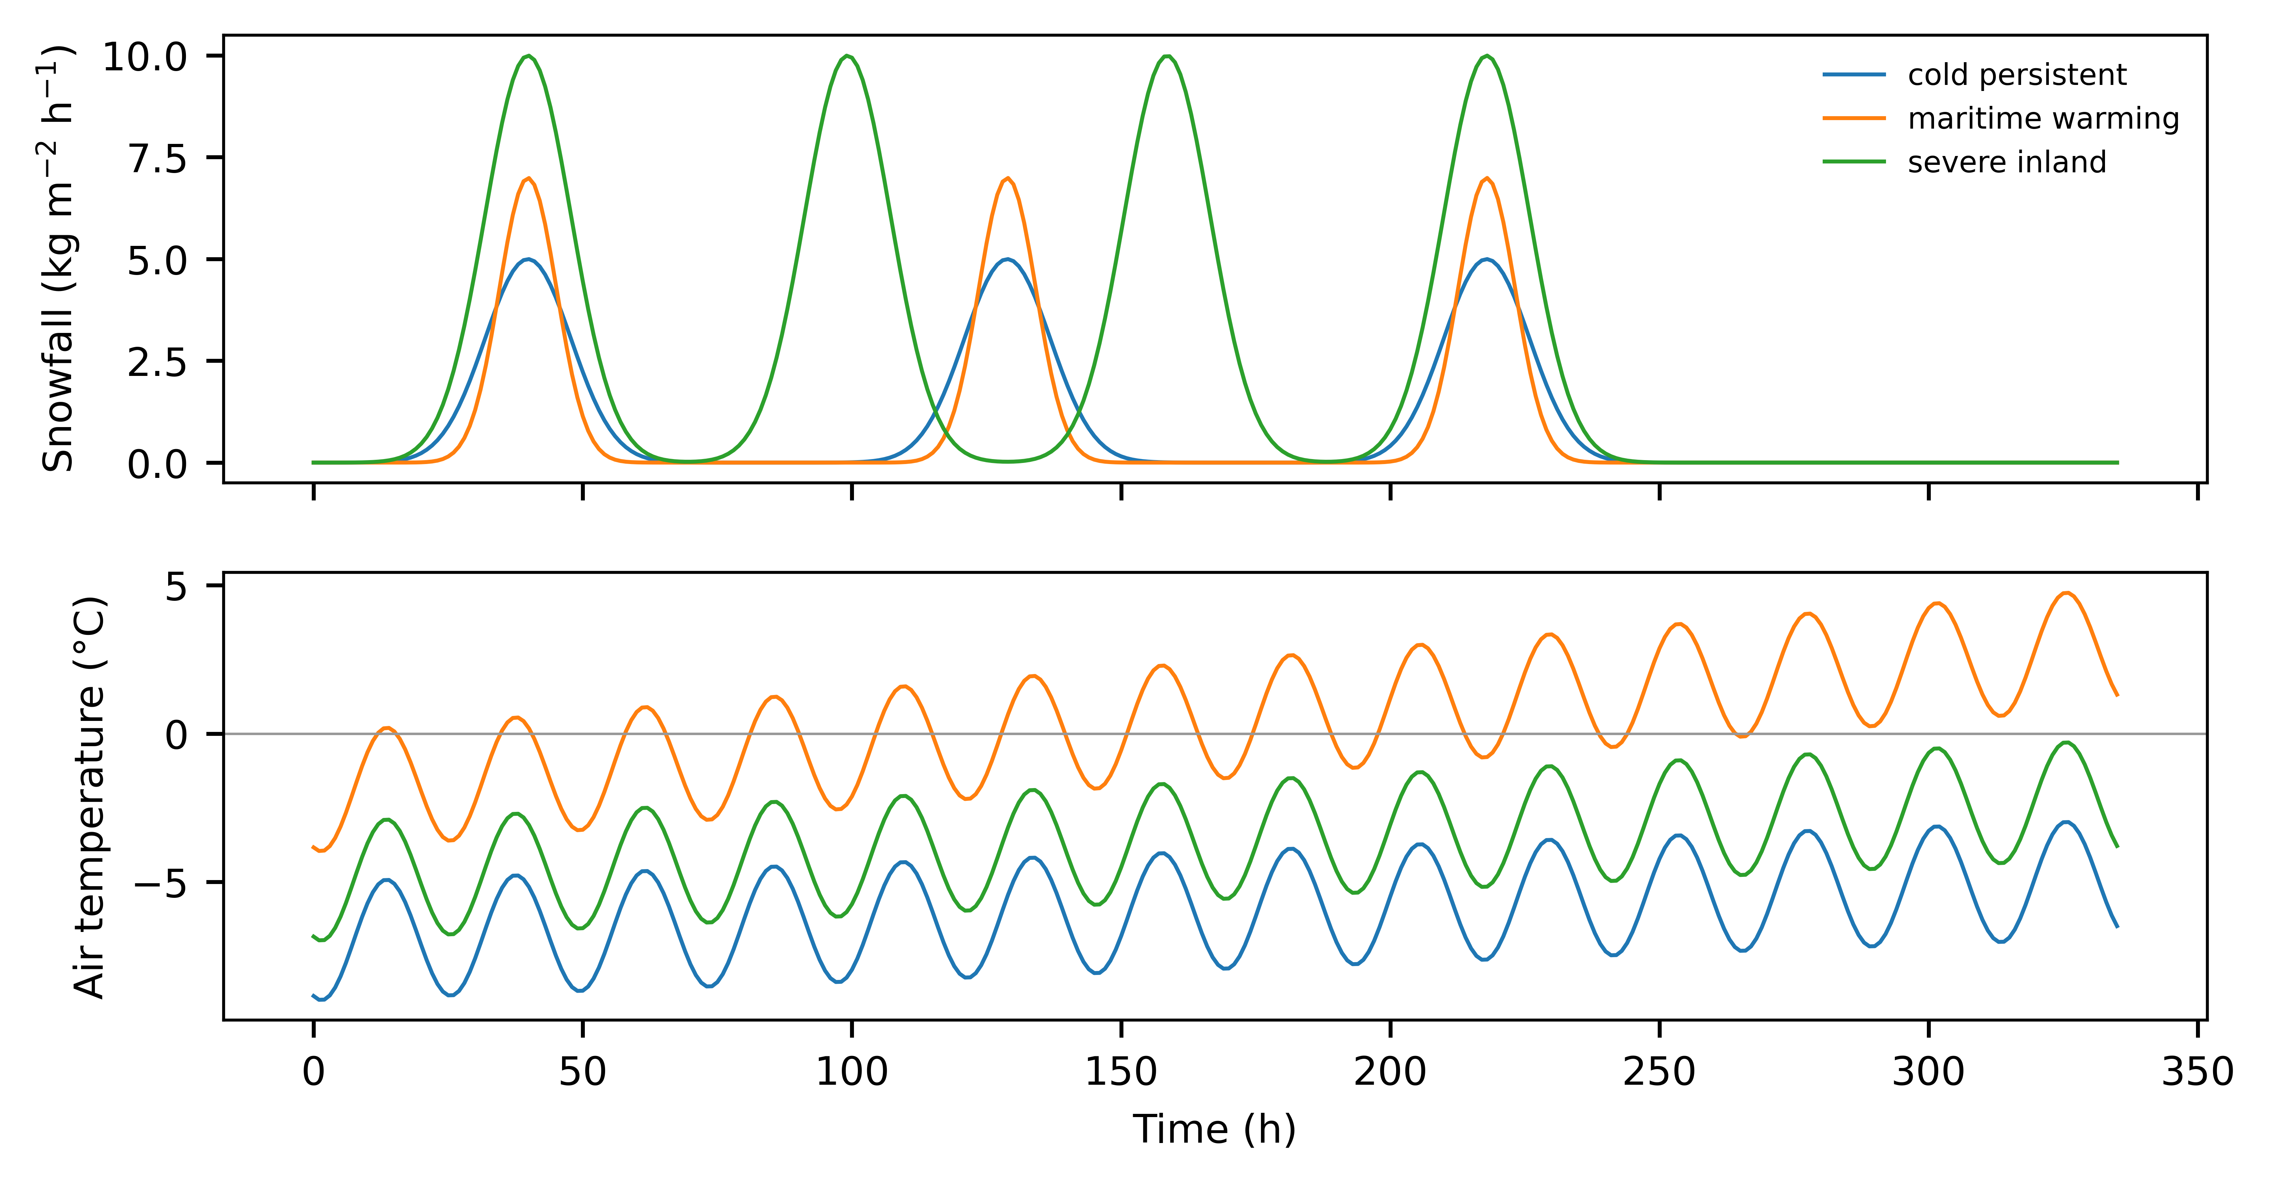
Figure 2. Synthetic forcing: snowfall rate and air temperature for the three winters.

2.4 Numerical verification
Before optimisation, all constructable uniform roofs and 60 random constructable graded roofs were simulated at dt = 1, 0.5, 0.25, 0.125 and 0.0625 h (reference) with 24 cells, and at 48 and 96 cells. A timestep was acceptable if at least 95% of pairs agreed with the reference within max(2%, 1 kg m⁻¹) for L_{max}, S_{event,max}, S_{1h,max} and total release, at least 90% had event counts within one, and mass-balance error was below 10⁻⁶ kg m⁻¹; the coarsest acceptable step was used. All final nondominated designs were then re-evaluated at 0.0625 h and at 48 cells.

2.5 Constructable optimisation
Candidates were decoded from a unit hypercube into piecewise-constant segments that satisfy every rule by construction: segments of at least 3 cells, at most 6 transitions, integer slopes 2.0-45.0 degrees, adjacent slope changes of at most 12.0 degrees, and one of three surface classes (smooth metal, aged coated metal, rough retention surface). Geometry-only (single class), surface-only (single slope) and joint searches each used NSGA-II with population 48, 45 generations and 5 seeds. The uniform reference was the exhaustive set of constructable uniform roofs; a 6,300-design continuous uniform grid was evaluated as a sensitivity.

2.6 Frontier comparison
Fronts were compared by normalised hypervolume (reference point 1.1 times the largest observed objectives, with 1.05 and 1.5 as sensitivities), additive epsilon in both directions, matched-objective improvement, unique objective pairs, per-seed variability and hypervolume after 15, 30 and 45 generations. The number of graded pairs lying inside the L_{max} gap of the uniform front is reported as a descriptive summary defined after the fronts were inspected.

2.7 Robustness and event-definition sensitivity
Every nondominated design was simulated under 250 common random draws (seed 7021) of lognormal multipliers on friction (CV 0.15), adhesion (0.25), fresh-snow density (0.15) and snowfall (0.2), and a normal temperature offset (SD 1.5 degrees C); the 95th percentiles (Q95) are reported. The event definition was varied (separation 10 min and 3 h; activity threshold 0.1 and 10 kg m⁻¹ h⁻¹) and entrainment was switched off.

2.8 Changes from the submitted analysis and reproducibility
The submitted analysis moved snow one cell per step and defined events per timestep, so its release endpoint depended on dt; it also applied constructability only after optimisation. The revision replaced transport, the release metric and the constraint handling, increased seeds from three to five, and selected dt by the rule above. Code, configuration, raw public-data snapshots with checksums, and every table and figure source are in the project repository; the submitted state is preserved under a fixed tag.
Primary optimization used 3 deterministic synthetic winters spanning cold persistent, maritime warming, and severe inland conditions, including repeated snowfall and configured rain-on-snow periods. JMA daily mean temperature, precipitation, snowfall depth, and ground snow depth were downloaded as immutable official HTML snapshots for 4 stations and 3 winters. Original value strings and parsed numeric fields were retained. JMA ground observations were used only as scenario forcing and were not treated as direct roof-load measurements.
2.4 Optimization and analysis
A full 30 x 30 x 7 uniform slope-friction-adhesion map preceded heterogeneous optimization. Geometry-only, surface-only, and joint profiles were parameterized by 4 control points interpolated across the roof. Checkpointed NSGA-II used a population of 48, 45 generations, and seeds 1701, 2903, 4517. All feasible evaluations from every seed were combined and filtered to approximate nondominated heterogeneous sets; only the uniform grid was exhaustively enumerated. Objective pairs were deduplicated at six decimal places for frontier metrics while design rows remained available for robustness and constructability analyses. Normalized hypervolume used common bounds and a reference at 105% of the joint objective maxima. Additive epsilon versus uniform, combined-set dominance, matched-objective constraints, and reference-point sensitivity were calculated. A normalized-distance knee was reported only as a within-front descriptive selection; common and front-specific normalizations were audited separately. Per-seed metrics summarized optimizer stochasticity in a machine-readable supplement. Production used a 0.5-h timestep, the finest resolution in the frozen grid. A targeted 0.25-h reevaluation of selected designs was reported as post-freeze numerical sensitivity rather than a second optimization. Figure 6 reports the numerical-resolution comparison; Figure 7 reports prespecified one-at-a-time sensitivity.
Monte Carlo robustness used 250 deterministic draws perturbing friction, adhesion, fresh-snow density, snowfall, and temperature for prespecified candidates sampled across the uniform and joint fronts. Every candidate received the same factor vector within each draw, permitting paired comparisons; Monte Carlo quantiles were not interpreted as empirical confidence intervals. Continuous optimization enforced only maximum adjacent slope change. Minimum segment length, maximum transition count, and generic surface classes were audited after optimization. Continuous joint profiles were mapped to 3 generic surface classes and piecewise roof segments of at least 3 cells, with at most 6 transitions, without claiming that the mapped design was a constrained optimum or represented proprietary material performance. Frozen manual-intervention weights generated low, medium, and high labor-scarcity choices across configured snowfall, shedding-penalty, and allowable-release scenarios. Figures 8-9 and Tables 4-8 summarize these analyses.

3. Results

3.1 Numerical convergence
For a smooth 40-degree uniform roof in the severe inland winter, the submitted per-step metric was 111.1, 74.1, 37.1 kg m⁻¹ at dt = 1, 0.5, 0.25 h, whereas S_{event,max} was 1,325.1, 1,325.0, 1,324.9 kg m⁻¹ (Fig. 3a). At dt = 1 h, 95.9% of pairs met the S_{event,max} tolerance and 98.2% met the L_{max} tolerance; all steps passed (Fig. 3b, Table 1), so dt = 1 h was used. The largest deviations (up to 1,333 kg m⁻¹) occurred for designs near a failure threshold. Spatial refinement to 48 and 96 cells changed S_{event,max} by a 95th-percentile relative amount of 0.29%. Mass-balance error was below 10⁻⁶ kg m⁻¹ in every run.
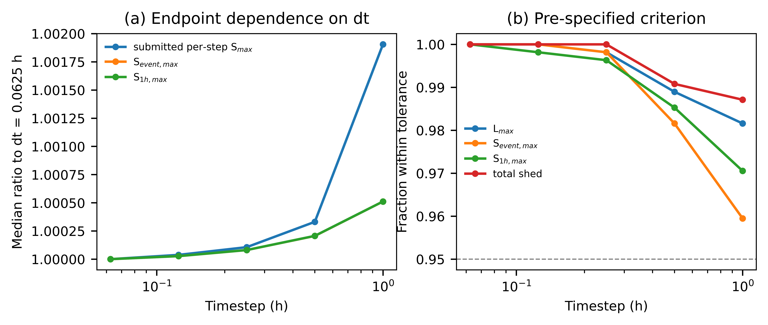
Figure 3. (a) Median ratio of release endpoints to the dt = 0.0625 h reference. (b) Fraction of design-winter pairs within the pre-specified tolerance; dashed line is the 95% criterion.

Table 1. Fraction of design-winter pairs within tolerance of the dt = 0.0625 h, 24-cell reference.
dt (h) | L_{max} | S_{event,max} | S_{1h,max} | Total release | Event count +/-1 | P95 rel. diff. S_{event,max} | Acceptable
1.0 | 0.982 | 0.959 | 0.971 | 0.987 | 0.996 | 2.94% | True
0.5 | 0.989 | 0.982 | 0.985 | 0.991 | 0.998 | 0.63% | True
0.25 | 0.998 | 0.998 | 0.996 | 1.000 | 1.000 | 0.25% | True
0.125 | 1.000 | 1.000 | 0.998 | 1.000 | 0.998 | 0.10% | True
0.0625 | 1.000 | 1.000 | 1.000 | 1.000 | 1.000 | 0.00% | True
3.2 Optimized uniform reference

3.2 Uniform reference
The constructable uniform front had 26 unique objective pairs (Fig. 4). Smooth roofs of 0-20 degrees traded L_{max} from 33.0 to 91.9 kg m⁻¹ against S_{event,max} from 1,374 to 91.9 kg m⁻¹; steep smooth roofs shed frequently, and closely spaced small releases merge into long events. The next uniform option was full retention (L_{max} 6,417 kg m⁻¹, no release). No constructable uniform roof lay between these regimes. The continuous uniform grid, which allows non-catalogue friction and adhesion, also had no design between 83.7 and 6,417 kg m⁻¹ on its front.
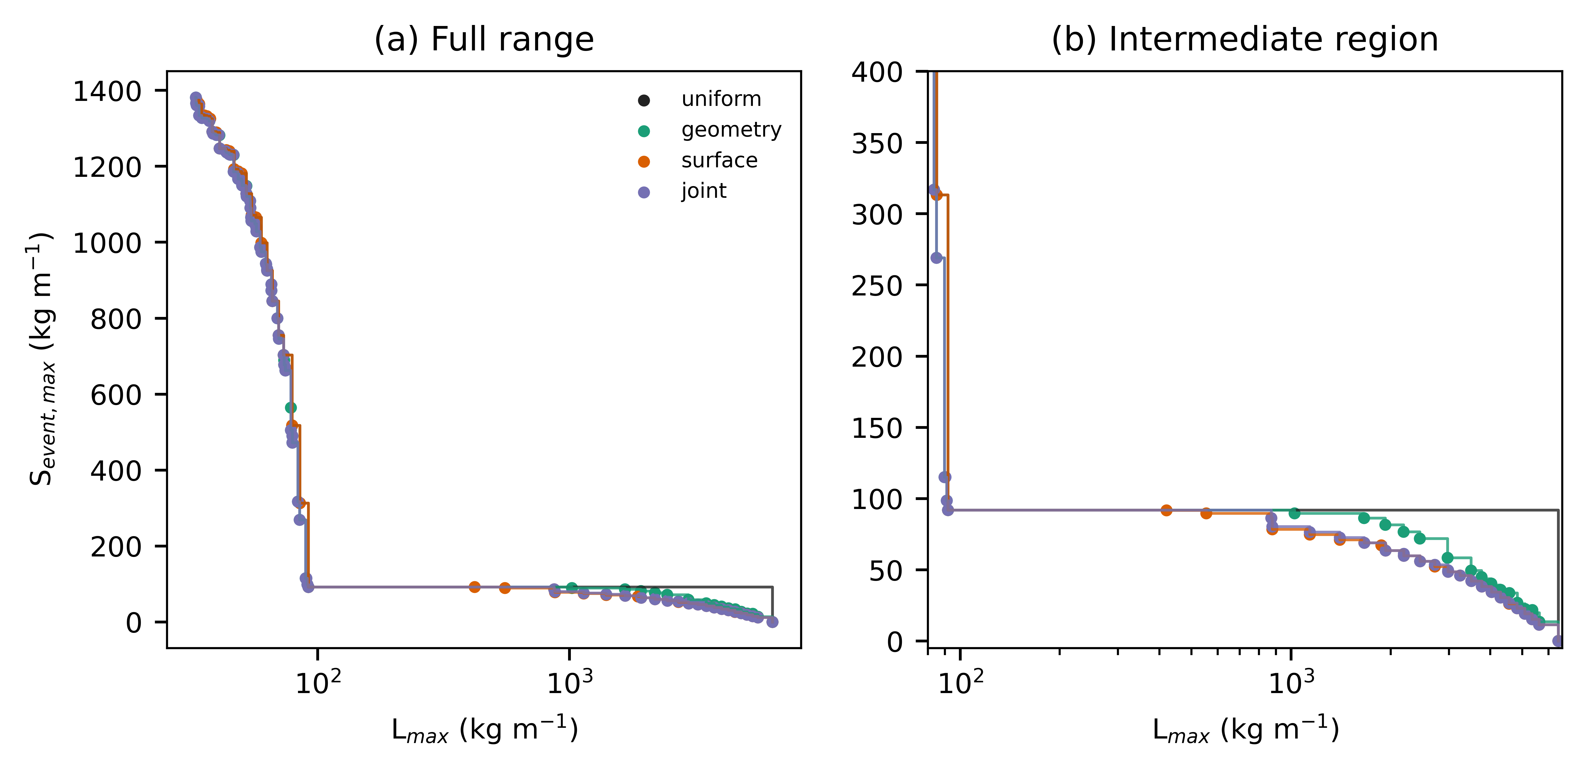
Figure 4. Constructable Pareto fronts for uniform, geometry-only, surface-only and joint sets: (a) full range, (b) intermediate region between the uniform shedding and retention regimes.

3.3 Graded fronts
All 15 runs produced only constructable designs, simulating 1,012-1,874 unique designs each. The geometry, surface and joint fronts had 89, 49 and 86 unique pairs. Hypervolume was 0.9822 for the uniform set and 0.9869, 0.9879 and 0.9880 for the graded sets, with the same ordering under both alternative reference points (Table 2). No graded front was dominated anywhere by the uniform front (epsilon 0), and the uniform front needed a normalised shift of 0.0129 to cover the joint front. Matched-objective improvements were small: median 0.5% in S_{event,max} at equal L_{max} (maximum 14.1%).

Table 2. Constructable front comparison (5 seeds pooled for graded sets).
Set | Unique pairs | Nondominated designs | HV (1.05) | HV (1.1) | HV (1.5) | Epsilon uniform to set | Median matched S gain | Graded pairs
uniform | 26 | 69 | 0.9807 | 0.9822 | 0.9895 | 0.0000 | 0.0000 | 0
geometry | 89 | 1344 | 0.9858 | 0.9869 | 0.9920 | 0.0126 | 0.0049 | 82
surface | 49 | 2482 | 0.9870 | 0.9879 | 0.9926 | 0.0129 | 0.0000 | 24
joint | 86 | 1070 | 0.9870 | 0.9880 | 0.9926 | 0.0129 | 0.0049 | 80
The substantive difference lay in the uniform gap. The combined graded fronts contained 26 pairs with L_{max} between 91.9 and 6,417 kg m⁻¹ and S_{event,max} of 11.5-91.8 kg m⁻¹; every one of the 15 runs found such pairs (8-23 per run). These designs combine steep or smooth shedding segments with a low-slope or rough retaining segment, so that snow released upslope stops on the roof while a short eave-side zone sheds small amounts (Fig. 5). Final-generation hypervolume varied across seeds by at most 0.0018, and the change from 30 to 45 generations was at most 0.0005 (Fig. 6).
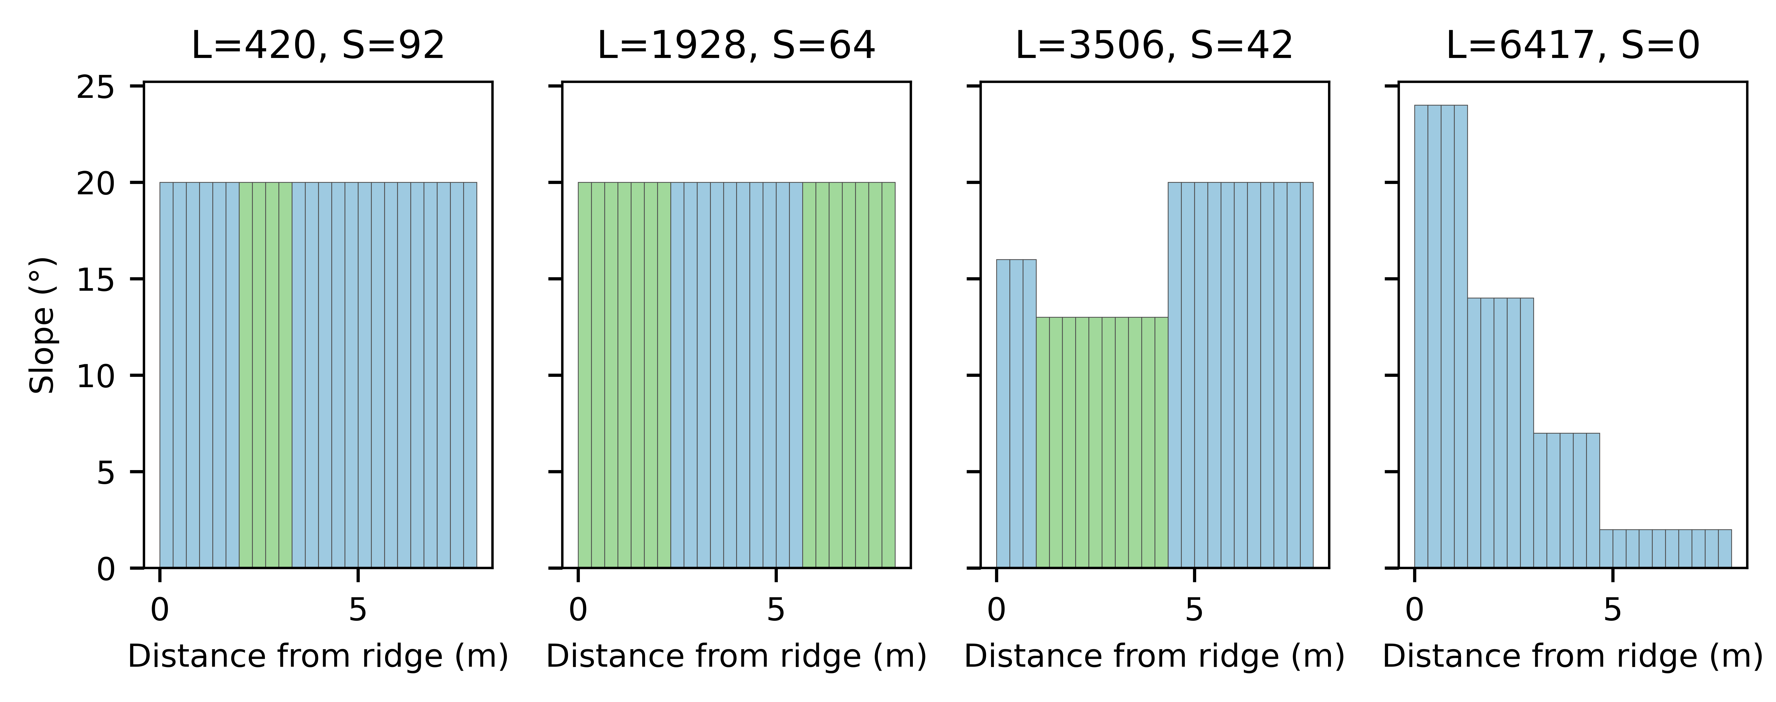
Figure 5. Slope profiles of representative intermediate graded designs; bar colours denote surface class.
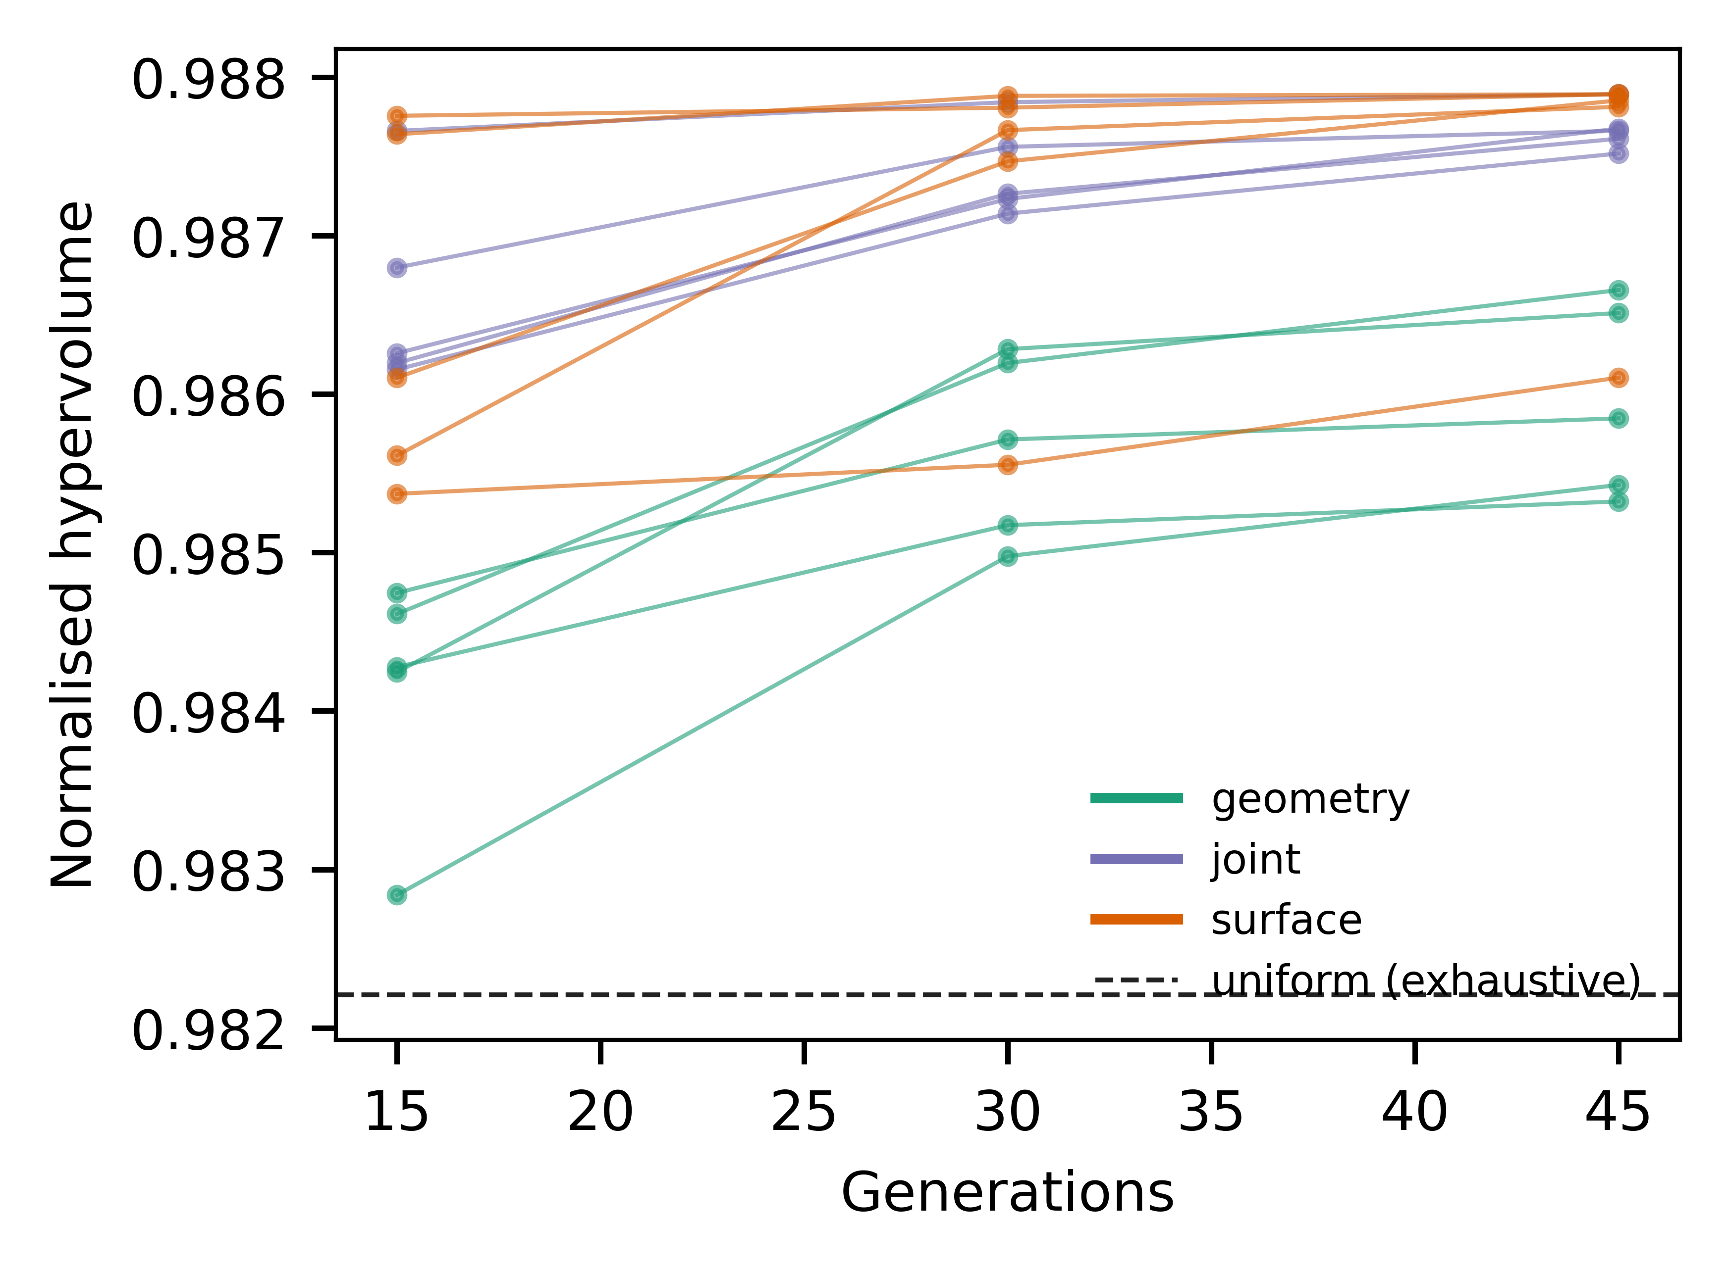
Figure 6. Normalised hypervolume after 15, 30 and 45 generations for each seed; dashed line is the exhaustive uniform set.

3.4 Fine-resolution re-check
Re-evaluating all 211 nondominated designs at dt = 0.0625 h changed S_{event,max} by a median 0.03% (95th percentile 5.9%) and L_{max} by a median 0.03%; refinement to 48 cells changed S_{event,max} by a median 0.03%. With fine-resolution objectives, hypervolume was 0.9822 (uniform) and 0.9880 (joint).

3.5 Event-definition sensitivity
The activity threshold (0.1 or 10 kg m⁻¹ h⁻¹) did not change any front. The separation time did (Table 3). With 10 min separation, closely spaced releases from steep smooth roofs counted as separate events, the uniform front shrank to 2 pairs and the uniform gap began at 33.0 kg m⁻¹; with 3 h separation it began at 292.9 kg m⁻¹. Graded pairs inside the uniform gap numbered 26 (base), 6 (10 min) and 4 (3 h), and 18 without entrainment. The existence of intermediate graded options was therefore insensitive to these choices, whereas the release magnitude attributed to shedding roofs depended strongly on how closely spaced releases are grouped.

Table 3. Sensitivity to event-definition and entrainment choices.
Variant | Uniform front pairs | Combined front pairs | Uniform gap starts at L_{max} (kg m⁻¹) | Graded pairs in gap | Largest S_{event,max} in gap (kg m⁻¹) | Epsilon uniform to combined (kg m⁻¹)
base | 26 | 97 | 91.9 | 26 | 91.8 | 80.4
no_entrainment | 26 | 44 | 91.9 | 18 | 86.3 | 80.4
q_min_0.1 | 26 | 97 | 91.9 | 26 | 91.8 | 80.4
q_min_10 | 26 | 97 | 91.9 | 26 | 91.8 | 80.4
tau_sep_10min | 2 | 8 | 33.0 | 6 | 27.8 | 21.6
tau_sep_3h | 22 | 30 | 292.9 | 4 | 250.7 | 114.5

3.4 3.6 Robustness
Uncertainty degraded the intermediate designs strongly (Fig. 7). For the 68 graded designs inside the nominal uniform gap, Q95 S_{event,max} ranged from 0 to 4,340 kg m⁻¹ (median 771), against nominal values of at most 91.8 kg m⁻¹; in a median 48% of draws their release exceeded 91.9 kg m⁻¹. Uniform shedding roofs were similarly sensitive at the retentive end (Q95 S_{event,max} 1,273-1,888 kg m⁻¹). In Q95 space the gap persisted: uniform roofs gave Q95 L_{max} of at most 145 kg m⁻¹ or full retention (8,472 kg m⁻¹), whereas 24 graded designs formed the Q95 front between 1,149 and 8,472 kg m⁻¹ with Q95 S_{event,max} of 0-1,037 kg m⁻¹, below every uniform shedding roof. Mass-balance error remained below 2e-11 kg m⁻¹.
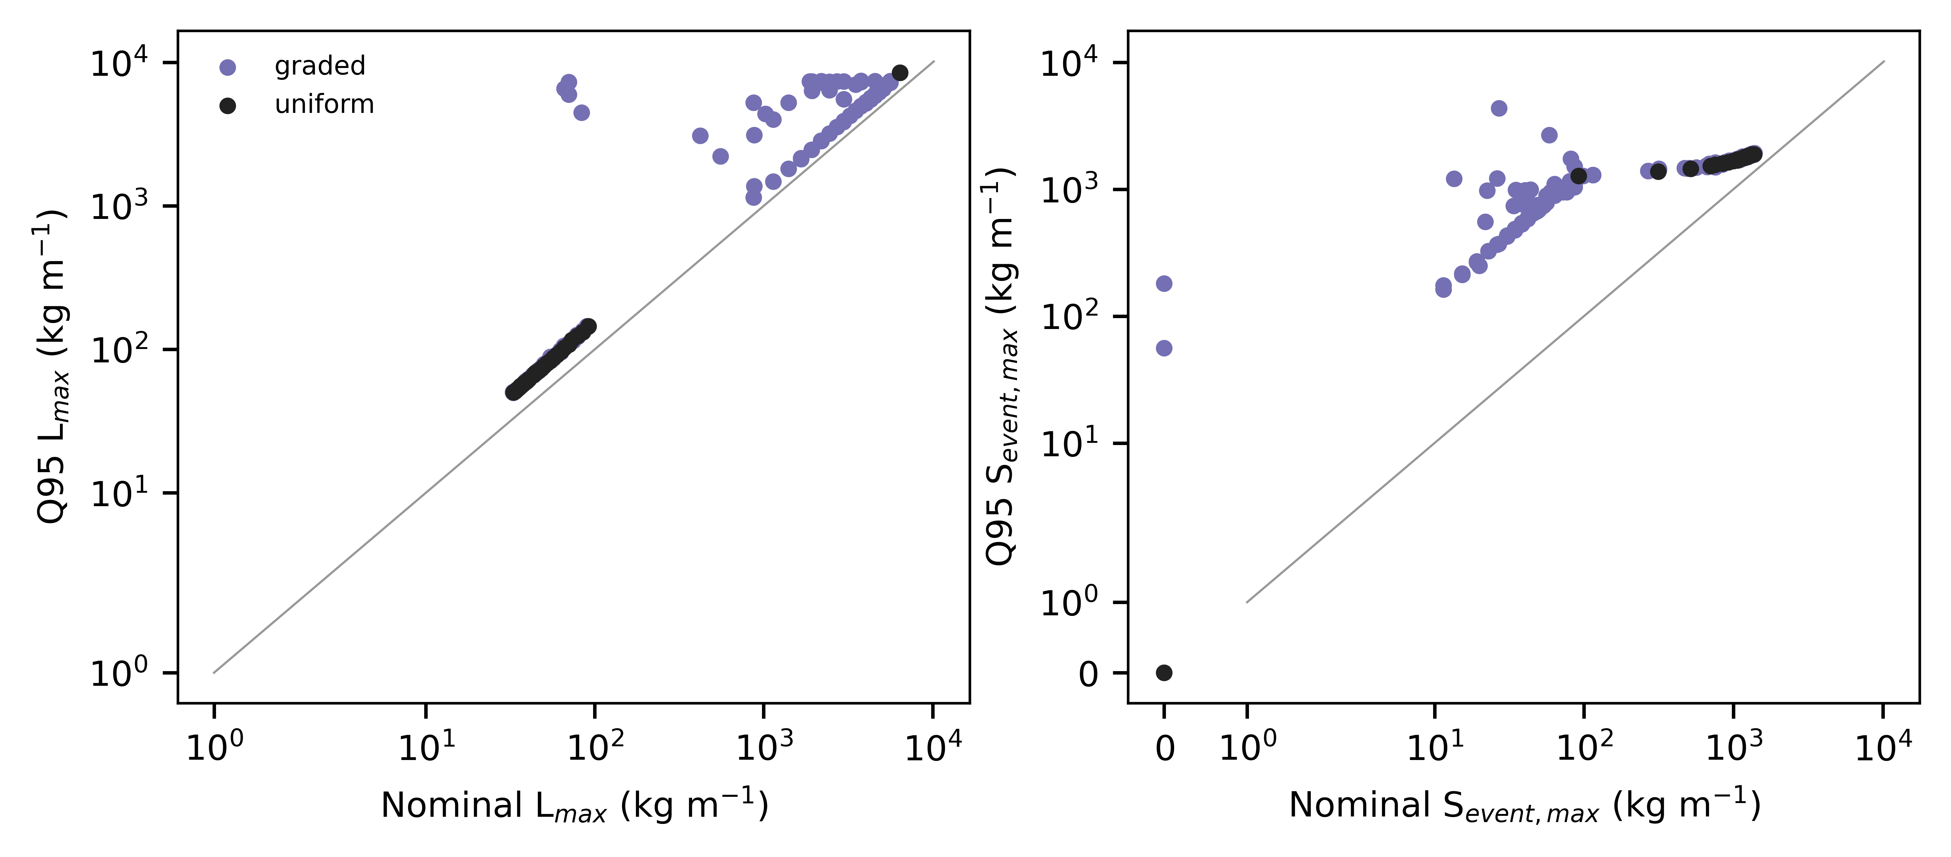
Figure 7. Nominal versus Q95 outcomes under 250 common uncertainty draws for all nondominated designs.

3.6 3.7 JMA station-winter scenarios
Under the 12 observed station-winters (snowfall water equivalent 340-1,043 kg m⁻², rain 152-1,316 mm), the same designs were re-simulated without re-optimisation (Fig. 8). Because daily snowfall was spread uniformly, steep smooth roofs shed as near-continuous streams and the uniform front reduced to 2 pairs in every station-winter: a shedding roof with L_{max} of 32.6-33.0 kg m⁻¹, or full retention. In every station-winter, 6-10 graded pairs lay between these options, with S_{event,max} of 10.8-32.5 kg m⁻¹. These scenario results extend the comparison to longer, observed forcing but do not validate roof behaviour.
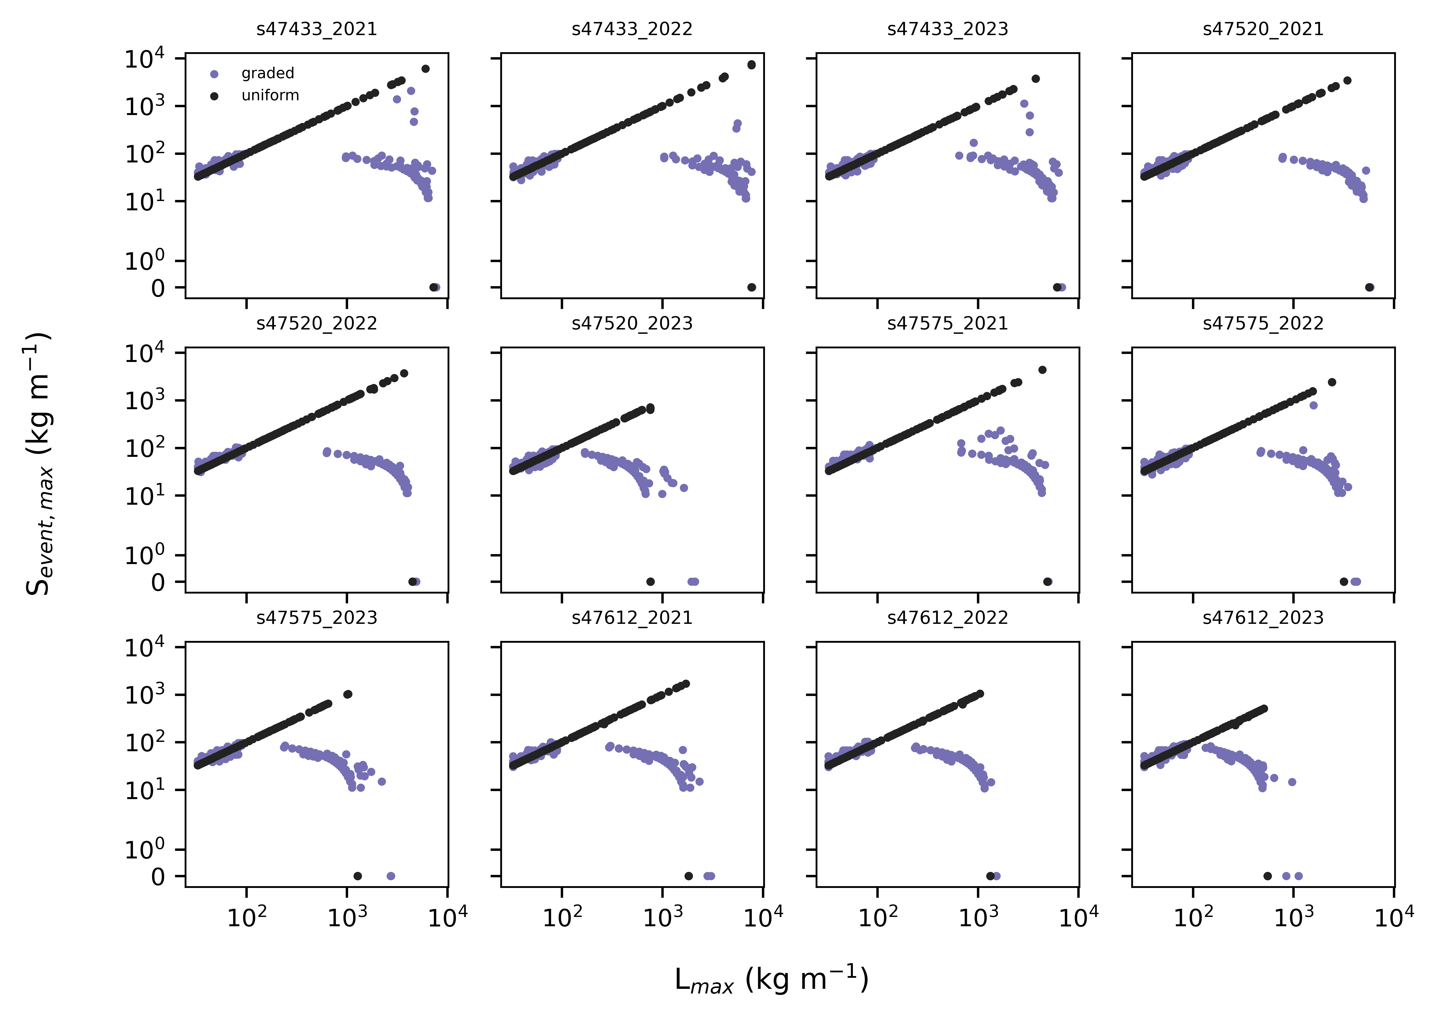
Figure 8. Objective pairs of uniform and nondominated graded designs under observed JMA station-winters (daily totals spread uniformly over 24 h).
3.1 Baselines and numerical resolution
Across the synthetic scenarios, the retention baseline produced Lmax=6417.0 kg m−1 and Smax=0.000 kg m−1, whereas the shedding baseline produced Lmax=40.00 kg m−1 and Smax=40.00 kg m−1. These are modeled unit-width masses, not structural loads. The frozen 8% four-metric convergence tolerance was met by 3 of 9 tested resolution combinations. The 0.5-h interval was the frozen numerical reference and production resolution. At 1 h, 3 of 3 selected uniform, continuous-joint, and mapped-joint designs failed the same composite criterion relative to 0.5 h. Comparing the 0.5-h production outcomes against targeted 0.25-h reevaluations, 3 of 3 selected designs failed the frozen four-metric tolerance. Accordingly, 0.5 h is described as the production reference resolution, not as demonstrated convergence beyond that interval. Smax is release mass in one model interval and therefore must be interpreted with the stated timestep.
The exhaustive uniform grid produced 2910 nondominated design rows but only 2 objective pairs: 40.00/40.00 kg m−1 and 6417.0/0.000 kg m−1 for Lmax/Smax. The multiplicity reflects objective-equivalent profiles rather than a dense uniform trade-off curve. Surface-only optimization reproduced the same two objective pairs.
3.3 Heterogeneous Pareto comparisons
The uniform set contained 2 unique objective pairs, whereas the joint set contained 6, including the uniform endpoints and additional intermediate trade-offs. Under the common audit reference, their normalized hypervolumes were 0.701 and 0.762; joint additive epsilon versus uniform was 0.000.
The complete frontier summary was uniform: 2 objective pairs, normalized hypervolume 0.701, additive epsilon versus uniform 0.000; geometry: 6 objective pairs, normalized hypervolume 0.504, additive epsilon versus uniform 0.209; surface: 2 objective pairs, normalized hypervolume 0.701, additive epsilon versus uniform 0.000; joint: 6 objective pairs, normalized hypervolume 0.762, additive epsilon versus uniform 0.000. Joint hypervolume exceeded uniform because the joint set included the uniform objective pairs and 4 additional intermediate pairs. Joint additive epsilon versus uniform was nevertheless zero because every uniform reference point was weakly matched; this does not imply front-wide superiority. Hypervolume ordering was unchanged under the audited origin and reference-margin choices.
The front-specific joint knee was 4547.4/12.28 kg m−1, whereas common normalization selected 40.00/40.00 kg m−1. The normalization dependence precludes a cross-front percentage headline. At the strictest prespecified Smax limit of 20 kg m−1, the minimum observed Lmax was 4545.9 kg m−1 for joint and 6417.0 kg m−1 for uniform.
Among 12 candidates with the nominal 40.00/40.00 kg m−1 objective pair, Q95 Lmax ranged from 51.89 to 5816.7 kg m−1, Q95 Smax ranged from 51.89 to 2726.6 kg m−1, and manual-intervention probability ranged from 0.000 to 0.216. The minimum scalar robustness score was shared by 6 candidates, so the retained selected flag is only a deterministic row-order tie-break. Monte Carlo quantiles describe the configured perturbation model, not empirical confidence intervals.
3.5 Constructability and decision scenarios
No joint design row among the 1341 nondominated rows met all post hoc constructability checks. The selected continuous joint knee had 23 slope and 23 surface transitions and minimum segment length 1 cell. Generic mapping reduced these to 6 and 0 transitions; Lmax changed by -4469.09 kg m−1 (-98.28%) and Smax by +66.00 kg m−1 (+537.47%). The mapped profile is a post hoc rule-compliant translation, not a constrained optimum. Every frozen transition-penalty setting selected a uniform design. Labor-scarcity and phase-diagram classifications remain illustrative decision weights, not community or building-code recommendations.
Daily forcing covered 4 stations and 12 station-winters without missing temperature or snowfall days. Joint-to-uniform Lmax ratios ranged from 2.84 to 16.68, while Smax reductions ranged from 67.01% to 70.83%. These paired modeled trade-offs were strongly station-winter dependent. Table 9 gives the paired station-winter results. Daily ground observations are supplementary forcing, not roof-scale validation, and daily Smax is not directly comparable with subdaily synthetic Smax.

4. Discussion
Within this model, spatial grading did not produce a generally better roof: hypervolume, epsilon and matched-objective gains over the exhaustive constructable uniform set were small. What grading did provide, reproducibly across seeds, was access to intermediate states between near-complete shedding and full retention, where a roof holds most of its snow and releases less than any shedding uniform roof. The nominal smallness of those releases was not robust: it depends on a retaining segment holding close to its failure threshold, and modest changes in friction, adhesion or snowfall convert it into releases of several hundred kg m⁻¹. Uniform roofs reach these states only through non-catalogue surface properties, if at all. In practice this corresponds to a retention zone combined with a short controlled-shedding eave zone, a configuration related to snow guards and retention roofs in regional guidance [6,7,23]; the mechanism is physically interpretable (upslope releases stop on a retaining segment).
The revised metric changes the interpretation of shedding roofs. Steep smooth roofs release often, and when releases are closely spaced they form long continuous events with large integrated mass; per-step metrics hid this by dividing each release among timesteps. Whether a series of small releases is less hazardous than one large release depends on occupancy below the eave, and the fixed-window metrics are supplied for that reason.
For Japanese practice the result is a design option, not a compliance route. Retaining designs carry the full design snow load, and Article 86 withholds the slope reduction where sliding is prevented [5]. A graded roof that retains most snow should therefore be designed as a retention roof structurally, while its potential benefit is fewer clearing operations and smaller, more predictable eave releases.
The frozen research question can be answered narrowly: under identical modeled forcing, spatial variation retained the 2 uniform objective regimes and introduced 4 observed intermediate Lmax-Smax combinations that the exhaustive uniform grid did not attain under the same objective caps. This is an expansion of the modeled trade-off set, not universal superiority. The joint front's larger hypervolume and zero additive epsilon are compatible because it contains the uniform endpoints while filling intermediate regions.
Knee selection is unsuitable as the primary cross-front claim: front-specific normalization and common normalization selected different joint designs. Matched objective caps provide a clearer interpretation. Robustness also cannot be inferred from nominal objectives, because nominally equivalent profiles had widely different upper-tail outcomes and the best scalar score was tied.
Constructability materially changes the interpretation. The intermediate joint trade-offs were found in continuous profiles that did not directly satisfy all segment and transition limits. Post hoc mapping changed the selected knee's Lmax by -98.28% and Smax by +537.47%, moving the point toward the low-retention, high-release shedding regime; every frozen transition penalty selected a uniform regime. Thus, the selected continuous-profile location in objective space was not preserved by the rule-compliant post hoc mapping. Graded concepts require constrained reoptimization and physical testing before practical comparison.
Retention, shedding, active melting, manual removal, and hybrid systems solve different site problems. Retention can limit routine eave release and reduce snow-fall-space demand, but requires verified structural capacity, drainage, waterproofing, inspection, and maintenance. Shedding can reduce retained mass but requires a controlled receiving area and falling-snow measures. The model does not invalidate either strategy, and Japanese guidance cannot be generalized to other climates, building traditions, or regulatory systems without local evidence (Asano and Iwai, 1995; Chiba et al., 2021; Hokkaido Research Organization and Hokkaido Building Guidance Center, 2017; Ito et al., 1997; Kimura, 1989; Niigata Prefecture, 2006; Sapporo City, 2025; Takakura et al., 2003; Tomabechi et al., 1996; Watanabe and Takita, 1997).

4.1 Limitations
The model has not been calibrated or validated against roof-scale release measurements; friction, adhesion, ageing and near-melt laws are assumptions informed only qualitatively by interface studies. Slabs are rigid blocks; fracture, cornices, creep and glide, eave overhang, wind redistribution and three-dimensional flow are omitted. Meltwater and rain leave the roof immediately: liquid-water retention, refreezing, ice dams, runoff routing, drainage capacity and hydrologically triggered wet-snow releases are not represented, so rain-on-snow effects are limited to a melt-energy term and a near-melt friction reduction. Synthetic winters are stylised, and daily JMA data cannot resolve sub-daily timing. Optimisation is heuristic and limited to a 2D strip with three surface classes.
The model has not been calibrated or validated against roof-scale shedding measurements. It omits wind redistribution, three-dimensional flow, snow fracture and slab mechanics, cornices, local roof details, heat transfer through the assembly, impact trajectories, drainage blockage, structural response, and pedestrian exposure. Friction, adhesion, compaction, melt, and aging parameters include explicit assumptions. The 0.5-h production interval is the finest frozen-grid reference rather than proof of convergence beyond 0.5 h. The 1-h and targeted 0.25-h comparisons showed that event mass, event count, and SSCI were particularly interval sensitive. The heterogeneous sets are multi-seed heuristic results rather than guaranteed complete fronts. Daily JMA observations do not resolve subdaily events, and ground snowfall or snow depth is not roof snow mass. Accordingly, the study does not establish structural safety, pedestrian safety, code compliance, injury reduction, lifecycle cost, or universal effectiveness.

4.2 Future validation
Product-specific inclined-plane friction and adhesion tests across temperature and liquid-water content, instrumented roof panels with load cells and time-lapse imaging such as the semi-full-scale setup of Tominaga et al. [19], and eave-catchment measurements of release mass and timing are needed before graded designs can be recommended.
Future work should calibrate interface parameters across temperature, liquid-water content, roughness, aging, and load; validate mass and release timing against instrumented roofs; add wind redistribution and three-dimensional edge effects; define an interval-invariant release-rate outcome if cross-timestep comparison is required; optimize explicitly constrained segments and surface classes; and predefine external-validation metrics before fitting.

5. Conclusions
With a timestep-independent event metric and constructability enforced inside the search, constructable uniform roofs either shed nearly all snow or retained all of it. Spatially graded roofs reproducibly filled this gap with intermediate retention-release combinations, which persisted under uncertainty with substantially larger releases, but did not materially improve the overall frontier. Spatial grading is best viewed as a configurable retention strategy whose physical benefit remains to be demonstrated experimentally.
An exhaustive uniform reference had 2 modeled objective regimes. Heuristic joint spatial grading preserved those regimes and added 4 intermediate trade-off combinations. However, no joint row directly passed all frozen constructability checks, post hoc mapping shifted the selected point toward the low-retention, high-release shedding regime, nominal objectives did not determine robustness, and the targeted 0.25-h check confirmed interval sensitivity. Constructability and numerical resolution therefore substantially limit interpretation of the nominal trade-off expansion. The findings are reproducible design-space hypotheses for constrained reoptimization and roof-scale validation, not design approval or safety certification.

Declarations
Funding: REQUIRED
Declaration of competing interests: REQUIRED
Data and code availability: Source code, immutable quantitative inputs and redistributable public-data snapshots, acquisition metadata, generated result tables, and reproduction instructions are available at https://github.com/bougtoir/functionally-graded-roof-snow-management.
Data and code availability: Code, configuration, raw public-data snapshots, acquisition ledger with SHA-256 checksums, and all result tables are available in the project repository.
During the preparation of this work, the author used Devin (Cognition AI) to support coding, public-data acquisition, analysis scripting, and drafting. Before submission, the author must review and edit the content as needed and replace this sentence with confirmation that the author takes full responsibility for the content of the published article.
Declaration of generative AI and AI-assisted technologies in the manuscript preparation process: During the preparation of this work, the author used Devin (Cognition AI) to support coding, data acquisition, analysis scripting and drafting. The author reviewed and edited the content and takes full responsibility for the publication.
CRediT authorship contribution statement: REQUIRED-author REQUIRED - author confirmation of roles before submission.roles.
Declaration of generative AI and AI-assisted technologies in the manuscript preparation process
Figure 1. Reduced-order model and comparative optimization workflow.
Figure 3. Unique objective pairs for the exhaustive uniform and heuristic joint sets, shown over the full range and the intermediate trade-off region.
Figure 4. Continuous joint-knee slope and friction profiles compared with the post hoc rule-compliant segmented, generic-class mapping; the mapped profile is not a constrained optimum.
Figure 6. Four-metric numerical-resolution comparison relative to the 48-cell, 0.5-h reference; the dashed line is the frozen relative-error tolerance.
Figure 7. Prespecified one-at-a-time sensitivity. Labels state each low/high factor or encoded alternative; bars are relative changes from baseline.
Figure 8. Candidate-specific Q95 retained-mass and release-mass outcomes under 250 paired perturbation draws. Symmetric-log axes include zero outcomes.
Figure 9. Frozen labor-scarcity selections in the base decision scenario and phase-diagram objective pairs; bubble area reflects selection frequency.
Tables of the submitted version (deleted)
Class | Design rows | Objective pairs | Descriptive knee Lmax | Descriptive knee Smax | Norm. HV | Epsilon vs uniform
uniform | 2910 | 2 | 40.00 | 40.00 | 0.701 | 0.000
geometry | 155 | 6 | 160.0 | 65.77 | 0.504 | 0.209
surface | 270 | 2 | 40.00 | 40.00 | 0.701 | 0.000
joint | 1341 | 6 | 4547.4 | 12.28 | 0.762 | 0.000
Cell | Continuous slope | Discrete slope | Continuous friction | Continuous adhesion | Generic class
1 | 36.96 | 38.00 | 0.213 | 20.94 | smooth_metal
2 | 37.50 | 38.00 | 0.218 | 22.33 | smooth_metal
3 | 38.04 | 38.00 | 0.222 | 23.72 | smooth_metal
4 | 38.58 | 38.00 | 0.227 | 25.11 | smooth_metal
5 | 39.11 | 40.00 | 0.231 | 26.50 | smooth_metal
6 | 39.65 | 40.00 | 0.236 | 27.89 | smooth_metal
7 | 40.19 | 40.00 | 0.240 | 29.28 | smooth_metal
8 | 40.73 | 40.00 | 0.245 | 30.67 | smooth_metal
9 | 39.53 | 33.00 | 0.244 | 30.23 | smooth_metal
10 | 34.86 | 33.00 | 0.233 | 26.14 | smooth_metal
11 | 30.19 | 33.00 | 0.222 | 22.05 | smooth_metal
12 | 25.52 | 33.00 | 0.211 | 17.95 | smooth_metal
13 | 20.86 | 21.00 | 0.201 | 13.86 | smooth_metal
14 | 16.19 | 21.00 | 0.190 | 9.767 | smooth_metal
15 | 11.52 | 21.00 | 0.179 | 5.673 | smooth_metal
16 | 6.848 | 9.000 | 0.168 | 1.580 | smooth_metal
17 | 7.958 | 9.000 | 0.179 | 0.306 | smooth_metal
18 | 11.96 | 9.000 | 0.202 | 0.441 | smooth_metal
19 | 15.96 | 20.00 | 0.224 | 0.576 | smooth_metal
20 | 19.96 | 20.00 | 0.246 | 0.711 | smooth_metal
21 | 23.96 | 20.00 | 0.269 | 0.846 | smooth_metal
22 | 27.96 | 32.00 | 0.291 | 0.981 | smooth_metal
23 | 31.96 | 32.00 | 0.313 | 1.117 | smooth_metal
24 | 35.96 | 32.00 | 0.336 | 1.252 | smooth_metal
Mapping | Lmax | Smax | Mean SSCI | Event count | Slope transitions | Surface transitions | Lmax change (kg m−1) | Lmax change (%) | Smax change (kg m−1) | Smax change (%)
continuous | 4547.4 | 12.28 | 0.007 | 248.0 | 23 | 23 | 0.000 | 0.000 | 0.000 | 0.000
discrete_generic | 78.28 | 78.28 | 0.017 | 74.33 | 6 | 0 | -4469.1 | -98.28 | 66.00 | 537.5
Labor scarcity | Design class | Strategy | Lmax | Smax | Manual triggers
low | uniform | SHEDDING | 40.00 | 40.00 | 0.000
medium | uniform | SHEDDING | 40.00 | 40.00 | 0.000
high | uniform | SHEDDING | 40.00 | 40.00 | 0.000
Class | Lmax | Smax | Max slope change | Transitions | Min segment cells | Min segment met | Transition limit met
uniform | 40.00 | 40.00 | 0.000 | 0 | 24 | True | True
uniform | 6417.0 | 0.000 | 0.000 | 0 | 24 | True | True
uniform | 6417.0 | 0.000 | 0.000 | 0 | 24 | True | True
geometry | 152.4 | 123.1 | 2.089 | 17 | 1 | False | False
geometry | 155.1 | 115.3 | 2.089 | 16 | 1 | False | False
geometry | 6417.0 | 0.000 | 5.119 | 18 | 1 | False | False
surface | 40.00 | 40.00 | 0.000 | 1 | 3 | True | True
surface | 6417.0 | 0.000 | 0.000 | 1 | 6 | True | True
surface | 6417.0 | 0.000 | 0.000 | 1 | 6 | True | True
joint | 40.00 | 40.00 | 2.008 | 23 | 1 | False | False
joint | 40.00 | 40.00 | 1.976 | 22 | 1 | False | False
joint | 6417.0 | 0.000 | 3.819 | 18 | 1 | False | False
Penalty | Class | Lmax | Smax | Transitions | Score
0.000 | uniform | 40.00 | 40.00 | 0 | 0.325
0.100 | uniform | 40.00 | 40.00 | 0 | 0.325
0.250 | uniform | 40.00 | 40.00 | 0 | 0.325
Candidate | Class | Nominal Lmax | Nominal Smax | Q95 Lmax | Q95 Smax | P(manual) | Robust selected | Minimum-score tie
joint_00 | joint | 40.00 | 40.00 | 51.89 | 51.89 | 0.000 | True | True
joint_01 | joint | 40.00 | 40.00 | 53.23 | 53.23 | 0.000 | False | False
joint_02 | joint | 40.00 | 40.00 | 53.05 | 53.05 | 0.000 | False | False
joint_03 | joint | 40.00 | 40.00 | 5816.7 | 2726.6 | 0.216 | False | False
joint_04 | joint | 40.00 | 40.00 | 51.89 | 51.89 | 0.000 | False | True
joint_05 | joint | 40.00 | 40.00 | 51.89 | 51.89 | 0.000 | False | True
joint_06 | joint | 40.00 | 40.00 | 4723.9 | 1248.8 | 0.140 | False | False
joint_07 | joint | 40.00 | 40.00 | 55.82 | 55.21 | 0.000 | False | False
joint_08 | joint | 40.00 | 40.00 | 5190.1 | 1152.8 | 0.164 | False | False
joint_09 | joint | 4547.4 | 12.28 | 5929.2 | 997.2 | 0.972 | False | False
joint_10 | joint | 6417.0 | 0.000 | 8324.5 | 0.000 | 1.000 | False | False
joint_11 | joint | 6417.0 | 0.000 | 8324.5 | 0.000 | 1.000 | False | False
joint_12 | joint | 6417.0 | 0.000 | 8324.5 | 0.000 | 1.000 | False | False
uniform_00 | uniform | 40.00 | 40.00 | 51.89 | 51.89 | 0.000 | False | True
uniform_01 | uniform | 40.00 | 40.00 | 51.89 | 51.89 | 0.000 | False | True
uniform_02 | uniform | 40.00 | 40.00 | 51.89 | 51.89 | 0.000 | False | True
uniform_03 | uniform | 6417.0 | 0.000 | 8324.5 | 0.000 | 1.000 | False | False
uniform_04 | uniform | 6417.0 | 0.000 | 8324.5 | 0.000 | 1.000 | False | False
uniform_05 | uniform | 6417.0 | 0.000 | 8324.5 | 0.000 | 1.000 | False | False
uniform_06 | uniform | 6417.0 | 0.000 | 8324.5 | 0.000 | 1.000 | False | False
uniform_07 | uniform | 6417.0 | 0.000 | 8324.5 | 0.000 | 1.000 | False | False
uniform_08 | uniform | 6417.0 | 0.000 | 8324.5 | 0.000 | 1.000 | False | False
uniform_09 | uniform | 6417.0 | 0.000 | 8324.5 | 382.1 | 0.992 | False | False
uniform_10 | uniform | 6417.0 | 0.000 | 8324.5 | 0.000 | 1.000 | False | False
uniform_11 | uniform | 6417.0 | 0.000 | 8324.5 | 0.000 | 1.000 | False | False
Station | Winter | Name | Uniform Lmax | Joint Lmax | Lmax ratio | Uniform Smax | Joint Smax | Smax reduction (%)
s47433 | 2021 | Kutchan | 345.6 | 5612.9 | 16.24 | 345.6 | 114.0 | 67.01
s47433 | 2022 | Kutchan | 336.0 | 5603.9 | 16.68 | 336.0 | 106.0 | 68.45
s47433 | 2023 | Kutchan | 307.2 | 5064.1 | 16.48 | 307.2 | 97.60 | 68.23
s47520 | 2021 | Shinjo | 316.8 | 4278.4 | 13.50 | 316.8 | 92.40 | 70.83
s47520 | 2022 | Shinjo | 451.2 | 3682.3 | 8.161 | 451.2 | 131.6 | 70.83
s47520 | 2023 | Shinjo | 278.4 | 1729.7 | 6.213 | 278.4 | 81.60 | 70.69
s47575 | 2021 | Aomori | 499.2 | 3701.6 | 7.415 | 499.2 | 145.6 | 70.83
s47575 | 2022 | Aomori | 278.4 | 3372.6 | 12.11 | 278.4 | 81.20 | 70.83
s47575 | 2023 | Aomori | 278.4 | 2376.7 | 8.537 | 278.4 | 81.20 | 70.83
s47612 | 2021 | Takada | 384.0 | 2319.6 | 6.041 | 384.0 | 112.0 | 70.83
s47612 | 2022 | Takada | 451.2 | 1349.8 | 2.992 | 448.9 | 130.9 | 70.83
s47612 | 2023 | Takada | 364.8 | 1037.3 | 2.843 | 357.9 | 104.4 | 70.83

References
[1] Government of Japan, 1962. Act on Special Measures for Heavy Snowfall Areas (Act No. 73 of 1962). e-Gov Law Search. Available at: https://laws.e-gov.go.jp/law/337AC1000000073.
[2] Ministry of Land Infrastructure Transport and Tourism, 2026. Overview of designated heavy snowfall areas and special heavy snowfall areas. MLIT. Available at: https://www.mlit.go.jp/kokudoseisaku/chisei/content/001881217.pdf.
[3] Ministry of Land Infrastructure Transport and Tourism, 2025. Implementation status of measures in heavy snowfall areas. MLIT. Available at: https://www.mlit.go.jp/kokudoseisaku/chisei/content/001881218.pdf.
[4] Japan Meteorological Agency, 2026. Climatological normals 1991-2020 (Sapporo 47412 Aomori 47575 Niigata 47604). JMA. Available at: https://www.data.jma.go.jp/stats/etrn/index.php.
[5] Government of Japan, 1950. Order for Enforcement of the Building Standards Act (Cabinet Order No. 338 of 1950) Article 86. e-Gov Law Search. Available at: https://laws.e-gov.go.jp/law/325CO0000000338.
[6] Hokkaido Research Organization, Hokkaido Building Guidance Center, 2017. Planning roof-snow treatment for detached houses. Official technical guide. Available at: https://www.hro.or.jp/upload/51707/yanenoyukishori.pdf.
[7] Niigata Prefecture, 2006. Technical material on characteristics and design ideas for roof-snow treatment. Official prefectural technical material. Available at: https://www.pref.niigata.lg.jp/uploaded/attachment/135532.pdf.
[8] Kimura, T., 1989. Change of removing technique of snow on roof and recent situation of its technical development. Snow and Ice 51(2), 111-117. Ice. https://doi.org/10.5331/seppyo.51.111.
[9] Watanabe, M., Takita, M., 1997. Fundamental Study on Control of Roof Snow Sliding. Journal of Snow Engineering of Japan 13(1), 3-12. Japan. https://doi.org/10.4106/jsse.13.3.
[10] Giever, P.M., Sack, R.L., 1990. Similitude considerations for roof snow loads. Cold Regions Science and Technology 19(1), 59-71. Technology. https://doi.org/10.1016/0165-232X(90)90018-R.
[11] Thiis, T.K., Gjessing, Y., 1999. Large-scale measurements of snowdrifts around flat-roofed and single-pitch-roofed buildings. Cold Regions Science and Technology 30(1-3), 175-181. Technology. https://doi.org/10.1016/S0165-232X(99)00021-X.
[12] Zhou, X., Kang, L., Yuan, X., Gu, M., 2016. Wind tunnel test of snow redistribution on flat roofs. Cold Regions Science and Technology 127, 49-56. Technology. https://doi.org/10.1016/j.coldregions.2016.04.006.
[13] Tominaga, Y., 2018. Computational fluid dynamics simulation of snowdrift around buildings: Past achievements and future perspectives. Cold Regions Science and Technology 150, 2-14. Technology. https://doi.org/10.1016/j.coldregions.2017.05.004.
[14] Sun, X., He, R., Wu, Y., 2018. Numerical simulation of snowdrift on a membrane roof and the mechanical performance under snow loads. Cold Regions Science and Technology 150, 15-24. Technology. https://doi.org/10.1016/j.coldregions.2017.09.007.
[15] Zhang, G., Zhang, Q., Fan, F., Shen, S., 2021. Numerical simulations of development of snowdrifts on long-span spherical roofs. Cold Regions Science and Technology 182, 103211. Technology. https://doi.org/10.1016/j.coldregions.2020.103211.
[16] Zhang, B., Zhang, Q., Mo, H., Fan, F., Lehning, M., 2022. Considering snow depositions and transport mechanisms in meteorological analysis of predicting snow loads on buildings. Cold Regions Science and Technology 201, 103614. Technology. https://doi.org/10.1016/j.coldregions.2022.103614.
[17] Zhou, X., Zhang, T., Liu, Z., Gu, M., 2023. A study of snow drifting on monoslope roofs during snowfall: Wind tunnel test and numerical simulation. Cold Regions Science and Technology 206, 103731. Technology. https://doi.org/10.1016/j.coldregions.2022.103731.
[18] Chiba, T., et al., 2021. Fundamental study for elucidating snow cornice formation mechanism of flat roofs based on wind tunnel test using natural snow. Snow and Ice 83(3), 249-258. Ice. https://doi.org/10.5331/seppyo.83.3_249.
[19] Tominaga, Y., Igarashi, K., Wakui, M., Motoyoshi, H., Ito, Y., 2025. Measurement and estimation of temporal variations of roof snow load on semi-full-scale building model. Cold Regions Science and Technology 232, 104445. Technology. https://doi.org/10.1016/j.coldregions.2025.104445.
[20] Tomabechi, T., Takakura, M., Ito, T., 1996. Influence of the surface roughness of roofing materials on snow sliding. Journal of Snow Engineering of Japan 12(3), 205-211. Japan. https://doi.org/10.4106/jsse.12.205.
[21] Ito, T., Tomabechi, T., Mitsuhashi, H., 1997. Evaluation and Maintenance of Snow Sliding Performance of Coated Steel Roofing Used for Sloped Roof. Journal of Snow Engineering of Japan 13(3), 244-252. Japan. https://doi.org/10.4106/jsse.13.244.
[22] Fasani, D., Cernuschi, F., Wolfsperger, F., Balordi, M., Colombo, L.P.M., 2026. Shear and tensile adhesion of dry and wet snow on metallic surfaces. Cold Regions Science and Technology 249, 104971. Technology. https://doi.org/10.1016/j.coldregions.2026.104971.
[23] Takakura, M., Ito, T., Tomabechi, T., 2003. Assessment of the effectiveness of snow guards on a sloped roof. AIJ Journal of Technology and Design 9(17), 67-70. Design. https://doi.org/10.3130/aijt.9.67_1.
[24] Asano, Y., Iwai, K., 1995. Experimental Study on the Snow Removal on the Roof by Snow-Melting System in Northern Area of Nagano Prefecture. Journal of Architecture Planning and Environmental Engineering 60(476), 57-65. Engineering. https://doi.org/10.3130/aija.60.57_3.
[25] Zou, J., Sun, X., Zhou, H., 2023. Sensitivity analysis and practical application of an automatic snow-melting membrane roof. Cold Regions Science and Technology 206, 103754. Technology. https://doi.org/10.1016/j.coldregions.2022.103754.
[26] Pawluk, R.E., Rezvanpour, M., Chen, Y., She, Y., 2021. A sensitivity analysis on effective parameters for sliding/melting prediction of snow cover on solar photovoltaic panels. Cold Regions Science and Technology 185, 103262. Technology. https://doi.org/10.1016/j.coldregions.2021.103262.
[27] Sapporo City, 2025. Measures to prevent hazards caused by falling ice and snow. Municipal administrative guidance. Available at: https://www.city.sapporo.jp/toshi/k-shido/kakuninn/yukidome/yukidome.html.
[28] Japan Meteorological Agency, 2026. Historical daily weather data (Kutchan Aomori Shinjo Takada). JMA. Available at: https://www.data.jma.go.jp/stats/etrn/index.php.
Editable tables
Table 1. Audited objective-set summary.
Table 2. Selected joint-profile cell properties.
Table 3. Post hoc continuous-to-discrete objective-space movement.
Table 4 (strategy phase-diagram classifications) is supplied separately as an editable CSV because the complete table is too large for useful display in the manuscript.
Table 5. Frozen labor-scarcity decision choices.
Table 6. Complexity metrics for selected frontier rows.
Table 7. Complexity-penalty selections.
Table 8. Monte Carlo robustness summary for candidate designs.
Table 9. Supplementary paired JMA station-winter evaluation.

Figure captions
Figure 1. (a) Example constructable graded profile coloured by surface class. (b) Eave outflow per 1-h step in the maritime warming winter with physical events shaded.
Figure 2. Synthetic snowfall scenarios and JMA ground-snow contexts.
Figure 2. Synthetic forcing: snowfall rate and air temperature for the three winters.
Figure 3. (a) Median ratio of release endpoints to the dt = 0.0625 h reference. (b) Fraction of design-winter pairs within the pre-specified tolerance; dashed line is the 95% criterion.
Figure 5. Unique objective pairs for the uniform, geometry-only, surface-only, and joint sets.
Figure 4. Constructable Pareto fronts for uniform, geometry-only, surface-only and joint sets: (a) full range, (b) intermediate region between the uniform shedding and retention regimes.
Figure 5. Slope profiles of representative intermediate graded designs; bar colours denote surface class.
Figure 6. Normalised hypervolume after 15, 30 and 45 generations for each seed; dashed line is the exhaustive uniform set.
Figure 7. Nominal versus Q95 outcomes under 250 common uncertainty draws for all nondominated designs.
Figure 8. Objective pairs of uniform and nondominated graded designs under observed JMA station-winters (daily totals spread uniformly over 24 h).

