DRAFT—NOT FOR SUBMISSION UNTIL THE SCIENTIFIC AND ADMINISTRATIVE GATES IN THE CHECKLIST ARE RESOLVED

From global heat-allocation bounds to a real waste-heat pathway: a two-scale constraint analysis
Tatsuki Onishi
[Affiliation to be confirmed before submission]
Corresponding author: Tatsuki Onishi; bougtoir@gmail.com

Abstract
The value of moving or storing heat depends on where and when it is released, but a theoretical allocation optimum need not survive engineering and environmental constraints. We connect two scales: a global conserved-heat marginal screening model and an auditable waste-heat case based on measured Frontier supercomputer data and documented Oak Ridge National Laboratory heating-demand bounds. The global model combines six-hourly reanalysis, gridded population, a convex Humidex burden, exact memory-bounded spatial search, and same-location temporal storage. The matched-event land and non-cryosphere spatial bound was 777.8 burden units/GJ; an 18-hour delay retained 53.9% of that value. The spatial solution contained 422 exactly co-optimal sink cells, and the largest tested transfer was infeasible under the local temperature cap. The real case contained 75,573.6 MWh-th across 49,869 valid 10-minute intervals, with 2,691 unavailable intervals. We then applied environmental, geographic, pathway, technology, storage, demand, and finite-dispatch gates. Receiving demand was available only as measured summary bounds; route hydraulics, capture efficiency, incremental auxiliaries, storage design, complete installed cost, lifecycle emissions, and new-discharge clearance remained unresolved. Consequently, none of the 6 evaluated practical modes was evidence-supported; all remained conditional. The principal result is therefore a reproducible constraint-attrition framework that separates global burden-space potential from physically delivered heat and identifies exactly where practical claims fail.
Keywords: waste-heat recovery; thermal storage; heat stress; constraint waterfall; finite dispatch; evidence audit

1. Introduction
Anthropogenic and industrial heat is small in the global mean energy balance but can be spatially concentrated enough to alter regional atmospheric conditions.^{1,2} This mismatch between a small global mean and large local fluxes motivates a question that is usually left implicit: if one unit of thermal energy must remain in the Earth system, where and when does it impose the least human thermal-stress burden?
Energy-systems research already treats heat as a spatial and temporal resource. Transportation formulations allocate thermal resources within district systems,³ thermal storage supplies short- and long-duration flexibility,⁴ and low-temperature networks integrate distributed sources and stores.⁵ These applications operate at engineered network scales. A global analysis therefore cannot be interpreted as evidence that low-grade heat is practically transportable across continents. Its defensible role is to establish a conditional screening bound within a prescribed atmospheric slab and identify which constraints cause that bound to collapse.
Optimal transport supplies a mathematical language for conserved allocation,⁶ and Earth-system studies have used related Wasserstein methods for oceanographic fields, sea ice, and climate-model evaluation.⁷⁻⁹ However, a diagnostic distance between fields is not a physical heat-transfer design, and the calculation implemented here is a one-unit marginal pair search rather than a finite-mass optimal-transport plan. The source, sink, travel distance, storage lag, capacity, and environmental exclusions must remain explicit.
Human heat-stress indices differ materially in their physical content and empirical domains.¹⁰ Global reanalysis products support consistent gridded thermal indices,¹¹ while observed humid-heat extremes and population exposure establish the importance of compound temperature and humidity.^{12,13} We therefore use a transparent convex thermal-stress burden rather than a mortality endpoint and test alternative metrics and parameters.
A persistent gap is the link between such theoretical allocation value and a real low-grade thermal-energy pathway. Source heat, temperature grade, coincident demand, route hydraulics, losses, auxiliary electricity, storage, cost, and environmental admissibility are often incomplete or reported at incompatible resolutions. Treating missing inputs as favorable assumptions would make the apparent practical value irreproducible.
This study therefore makes a two-scale contribution. First, it compares same-time spatial relocation, same-location temporal storage, and joint spatiotemporal allocation within one conserved-energy screening objective. Second, it audits an empirical waste-heat source and a documented receiving pathway without inventing missing engineering inputs. Third, it uses a constraint waterfall and mode-decision analysis to identify how much theoretical value can be translated into a supported physical-energy claim. The central question is not whether a mathematical sink exists, but where the global-to-real evidence chain survives or fails (Fig. 1).
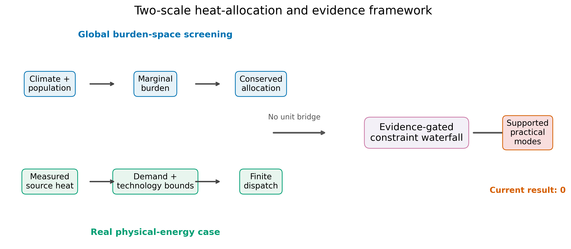
Figure 1. Two-scale heat-allocation and evidence framework. The global burden-space screening branch and the real physical-energy branch enter a common evidence-gated constraint waterfall without an assumed unit conversion.

2. Methods

2.1 Data and harmonization
The meteorological baseline used the NCEP/NCAR Reanalysis 1 architecture described by Kalnay et al.¹⁴ We acquired complete 2023 annual files for two-metre air temperature and specific humidity, surface pressure, 10-m winds, surface radiative fluxes, sea-ice fraction, snow water equivalent, and the land-sea mask. The common Gaussian grid contained 94 latitudes, 192 longitudes, and 1460 six-hourly observations.
Population was taken from the WorldPop 2020 unconstrained global grid, a high-resolution gridded population product consistent with published WorldPop methods.¹⁵ It was conservatively aggregated to the climate grid; the resulting total was 7.970 billion. Natural Earth 1:110m Admin-0 boundaries supplied country labels. Every raw snapshot was stored locally with its source URL, retrieval time, file size, SHA-256 checksum, license terms, and completeness status. The public inputs are summarized in Table 1.
Table 1. Public datasets used in the global analysis.
Product | Role | Version | Completion
Admin 0 countries | country_boundaries | 5.1.2, 1:110m | complete
NCEP/NCAR Reanalysis 1 | downward_longwave_flux | 2023 annual file | complete
NCEP/NCAR Reanalysis 1 | downward_shortwave_flux | 2023 annual file | complete
NCEP/NCAR Reanalysis 1 | eastward_wind_10m | 2023 annual file | complete
NCEP/NCAR Reanalysis 1 | land_fraction | invariant Gaussian grid | complete
NCEP/NCAR Reanalysis 1 | near_surface_air_temperature | 2023 annual file | complete
NCEP/NCAR Reanalysis 1 | near_surface_specific_humidity | 2023 annual file | complete
NCEP/NCAR Reanalysis 1 | northward_wind_10m | 2023 annual file | complete
NCEP/NCAR Reanalysis 1 | sea_ice_fraction | 2023 annual file | complete
NCEP/NCAR Reanalysis 1 | snow_water_equivalent | 2023 annual file | complete
NCEP/NCAR Reanalysis 1 | surface_pressure | 2023 annual file | complete
NCEP/NCAR Reanalysis 1 | upward_longwave_flux | 2023 annual file | complete
NCEP/NCAR Reanalysis 1 | upward_shortwave_flux | 2023 annual file | complete
Unconstrained global population mosaic at 30 arc seconds | population_count | 2020 | complete

2.2 Thermal-stress burden
Specific humidity q and pressure p define vapour pressure as e = qp/(0.622 + 0.378q). Humidex is H = T_C + (5/9)(e_hPa - 10). For reference level H0 and curvature γ, the stress excess is s = max(H - H0, 0), and cell-time burden is B = P s^γ, where P is population. The primary configuration used H0 = 26 and γ = 2. Air temperature and a validity-masked Stull wet-bulb proxy were sensitivity metrics; wet-bulb estimates were not extrapolated outside their documented temperature and relative-humidity domain.¹⁶ Wet-bulb marginal burdens used a centered numerical temperature derivative with specific humidity and pressure held fixed.
For grid-cell area A, mixing height h, air density ρ, and specific heat c_p, atmospheric heat capacity is C = Ahρc_p. A heat increment Q changes temperature by ΔT = Q/C. At γ = 2, the marginal burden per GJ is m = Pγs^(γ-1)10^9/C. This derivative is a burden index, not a monetary value, mortality estimate, or measure of total planetary heat.

2.3 Conserved allocation problem
A decision removes Q from source cell-time (i,t) and releases the same Q at sink cell-time (j,t′). Transport and storage appear as objective penalties rather than fictitious energy losses. For a one-GJ perturbation, the evaluated value is V = m_source - m_sink - c_d d - c_s(t′ - t), where d is great-circle distance, c_d is the transport penalty, and c_s is the storage penalty per six-hour step. No-relocation has value zero; negative feasible optima are retained rather than clipped. These coefficients are abstract conditional penalties, not calibrated costs, losses, emissions, or technology efficiencies.
Spatial allocation used same-time source and sink states. Temporal allocation used the same cell at a later time. Joint allocation allowed both changes. A spherical cKDTree enumerated only cells within the maximum distance and evaluated exact great-circle distances for candidates, avoiding an infeasible global dense pairwise matrix. The canonical primary sink mask required land fraction ≥0.5 and excluded cryosphere cells, defined by sea-ice fraction ≥0.15 or snow water equivalent ≥1 kg m^-2. Unrestricted masks were retained as diagnostics. Canonical assumptions are summarized in Table 2.
Table 2. Canonical model assumptions.
Assumption | Value | Unit
Canonical transferred energy | 1 | GJ
Atmospheric mixing height | 100 | m
Air density | 1.23 | kg m-3
Air heat capacity | 1e+03 | J kg-1 K-1
Humidex reference | 26 | degrees C equivalent
Burden curvature | 2 | dimensionless
Maximum transfer distance | 5e+03 | km
Local heat-load cap | 1e+06 | GJ
Maximum local temperature perturbation | 0.1 | K

2.4 Robustness, finite energy, and diagnostics
The Humidex sensitivity crossed three reference levels, three curvatures, and three prescribed mixing heights. Air temperature and wet-bulb sensitivities each varied three reference levels at fixed curvature and mixing height. Progressive mask ablation added distance, cryosphere, and ocean exclusions. Finite-energy tests recomputed exact quadratic burden changes for 1, 10^3, 10^5, and 10^6 GJ and enforced both an energy cap and a maximum local temperature perturbation. Seasonal marginal quantiles used all eligible populated land source cell-times in each local day/night group; total burden summed all grid cells and times in that group.
A reduced-order seven-day trajectory advected the selected release point using six-hourly 10-m winds and recorded a diffusion-radius diagnostic. It did not calculate plume concentration or thermal response and was used only to flag downstream classification changes. Surface longwave fields were retained as descriptive context. Observed radiation products such as CERES EBAF characterize the radiation budget but do not identify the incremental radiative response to added surface heat,¹⁷ whereas engineered radiative cooling depends on device-specific spectral properties.¹⁸ We therefore made no causal radiative-disposal claim.

2.5 Auditable real thermal-energy case
The practical audit used the public 2023 Frontier high-performance-computing facility workbook as the measured source. Ten-minute waste heat, coolant supply and return temperature, flow, compute power, accessory power, and total power were retained without filling missing timestamps. The receiving pathway used the ORNL waste-heat-recovery report and official metadata, campus-map, and environmental records. Figure 13 of the report supplied measured annual average and maximum space-heating demand summaries for the selected buildings, but not a synchronized hourly demand trace.
Each required case input was classified as FOUND_MEASURED, FOUND_DERIVABLE, FOUND_BOUND_ONLY, or NOT_FOUND. Practical pathways were separately classified as SUPPORTED, CONDITIONAL, or EXCLUDED. Measured facility accessory electricity was not substituted for incremental heat-recovery auxiliaries, existing steam-line distance and loss were not assigned to a new hot-water route, and generic storage or cost parameters were not presented as case design values (Table 4).
Table 4. Case-specific evidence status.
Evidence Domain | Status | Supported Statement
Source heat | Measured | 75,573.6 MWh-th; 49,869 valid intervals
Receiving demand | Summary bounds only | Case A 0.76–2.09 MW; no synchronized profile
Heat pump | Bounded | COP 3.08; 3.0 MW-th
Capture, route, auxiliaries | Not calibrated | No recovery efficiency, hydraulic design, or incremental load
Storage | Not designed | No case-specific tank volume or operating temperature range
Cost and lifecycle CO2e | Incomplete | No complete installed cost or case-specific lifecycle inventory
Environmental clearance | Not established | No route clearance or authorization for a new thermal discharge

2.6 Constraint waterfall, finite dispatch, and mode decision
The global-to-real waterfall retained burden-space and physical-energy quantities as separate domains. It evaluated the global theoretical bound, environmental admissibility, geographic locality, pathway eligibility, technology evidence, storage and capacity, demand evidence, finite dispatch, and the supported practical endpoint. No conversion factor was used between the thermal-stress burden index and delivered MWh.
Finite dispatch used the measured 10-minute source series, explicit unavailable intervals, a report-derived heat-pump COP and capacity, constant lower and upper demand bounds, and no, formula-sized, or generic-reference storage. The dispatch preserved thermal balance at every interval. The mode analysis compared useful heat delivered, demand served, residual source rejection, heat-pump electricity, storage capacity, and storage losses. Cost and lifecycle CO2e were excluded from practical mode selection because case-specific evidence was incomplete.

3. Results

3.1 Global marginal-burden field
The annual peak field was concentrated in densely populated humid regions (Supplementary Fig. S4). Upper-tail marginal burden varied seasonally but remained non-zero by both local day and night (Supplementary Table S1 and Fig. S5). The JJA daytime 95th percentile was 63.5 burden units per GJ.
The maximum canonical source occurred in Bangladesh at 23.81°N, 90.00°E, with marginal benefit 777.8 per GJ. Bangladesh was selected in all 33 scenarios in the canonical parameter sweep (Supplementary Table S2 and Fig. S1). Across 9 prespecified structural scenarios, source country labels included Bangladesh, India; theoretical value persisted while selected source and sink coordinates shifted (Supplementary Table S6).

3.2 Spatial, temporal, and joint bounds
With the land requirement and cryosphere exclusion but no transport penalty, the spatial solution moved one GJ from Bangladesh to a representative co-optimal grid cell labeled Russia over 4666 km and reduced marginal burden by 777.8 units per GJ. At a transport penalty of 10^-5 per GJ-km, the sink moved to Bhutan at 424 km with negligible loss of objective value (Fig. 2).
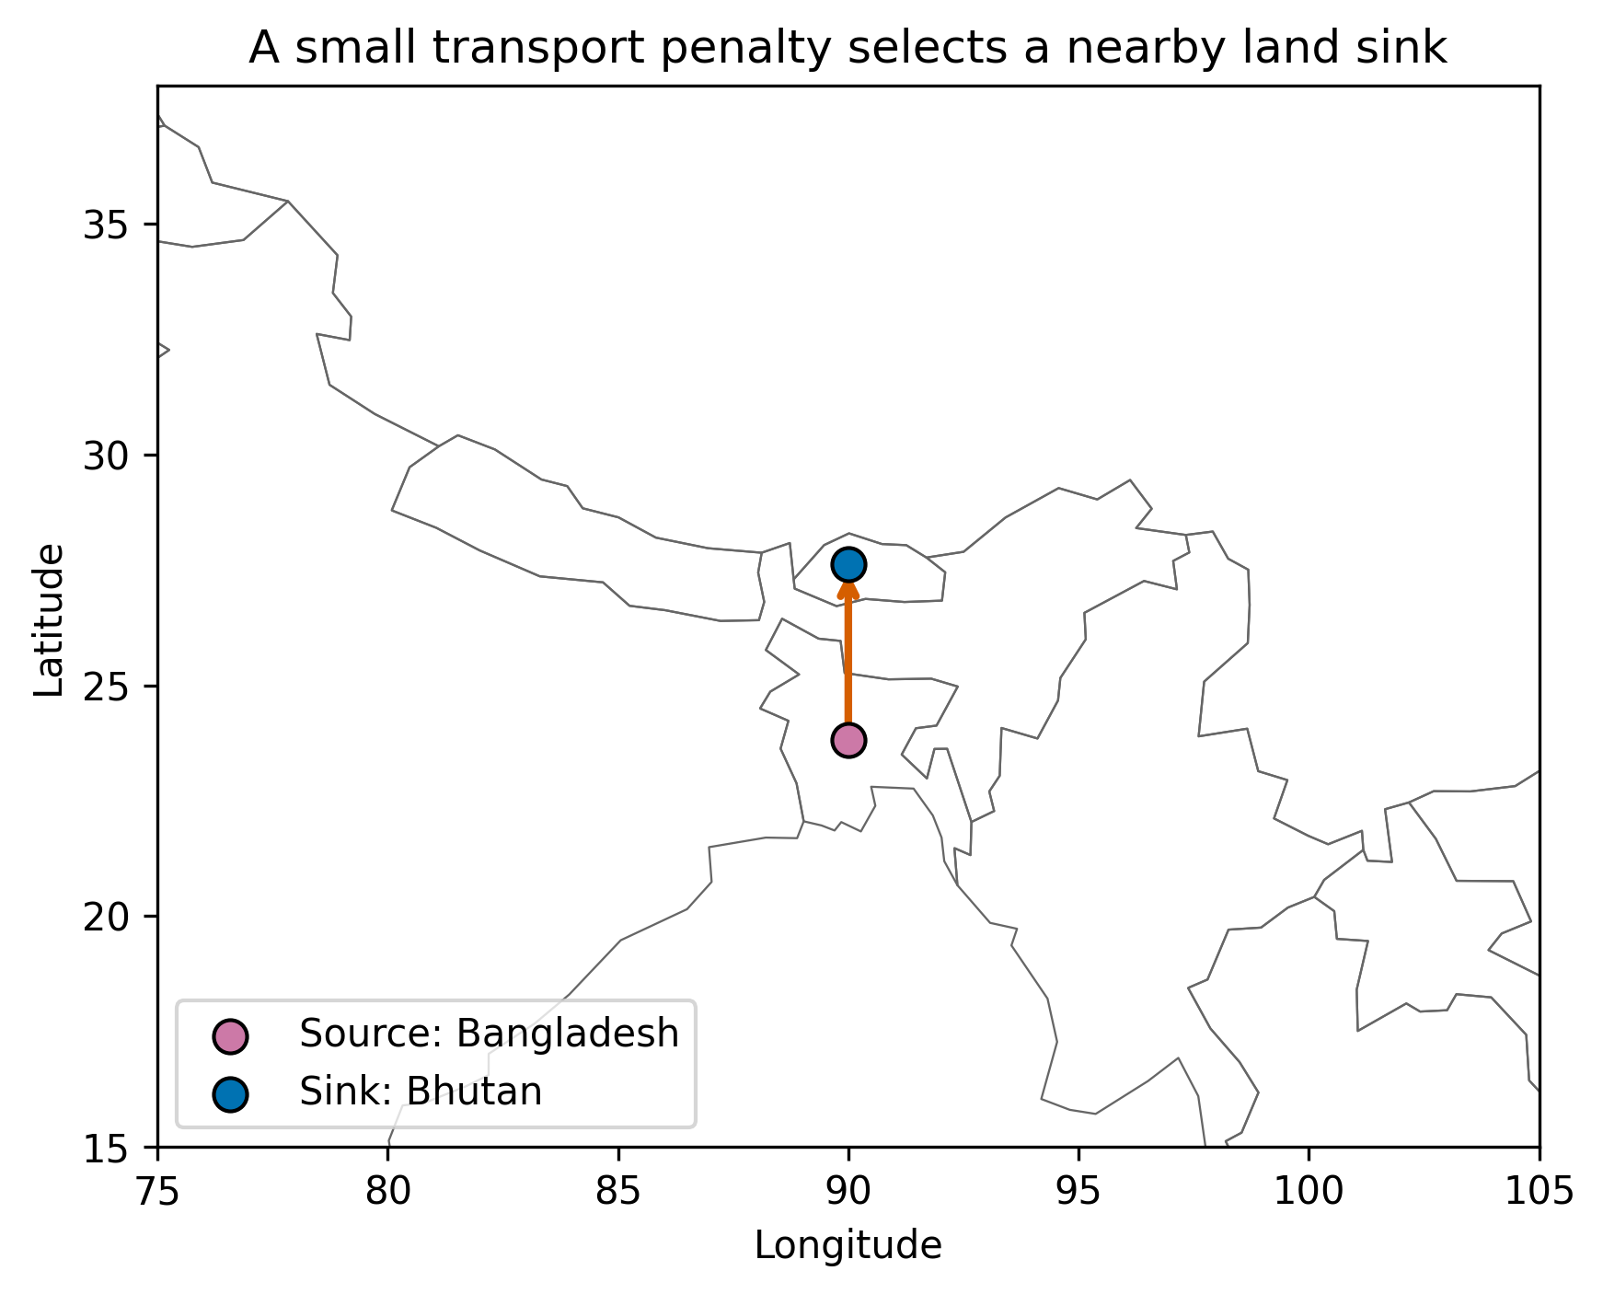
Figure 2. Primary spatial one-GJ transfer under a small transport penalty of 10^-5 burden units per GJ-km, a 5,000-km limit, and land/non-cryosphere sink constraints.
For the same peak source cell-time used by the spatial result, a 18-hour delay at the source location produced 419.3 units per GJ, or 53.9% of the simultaneous spatial bound (Table 3; Fig. 3). With zero penalties, matched-event joint allocation selected the immediate spatial sink.
Table 3. Matched-event spatial, temporal, and joint allocation results.
Analysis | Source Country | Sink Country | Lag Steps | Distance Km | Net Benefit | Fraction Of Matched Spatial | Cooptimal Candidate Count | Near Optimal Candidate Count
spatial | Bangladesh | Russia | 0 | 4.67e+03 | 778 | 1 | 422 | 808
temporal | Bangladesh | Bangladesh | 3 | 0 | 419 | 0.539 | 1 | 1
joint | Bangladesh | Russia | 0 | 4.67e+03 | 778 | 1 | nan | nan
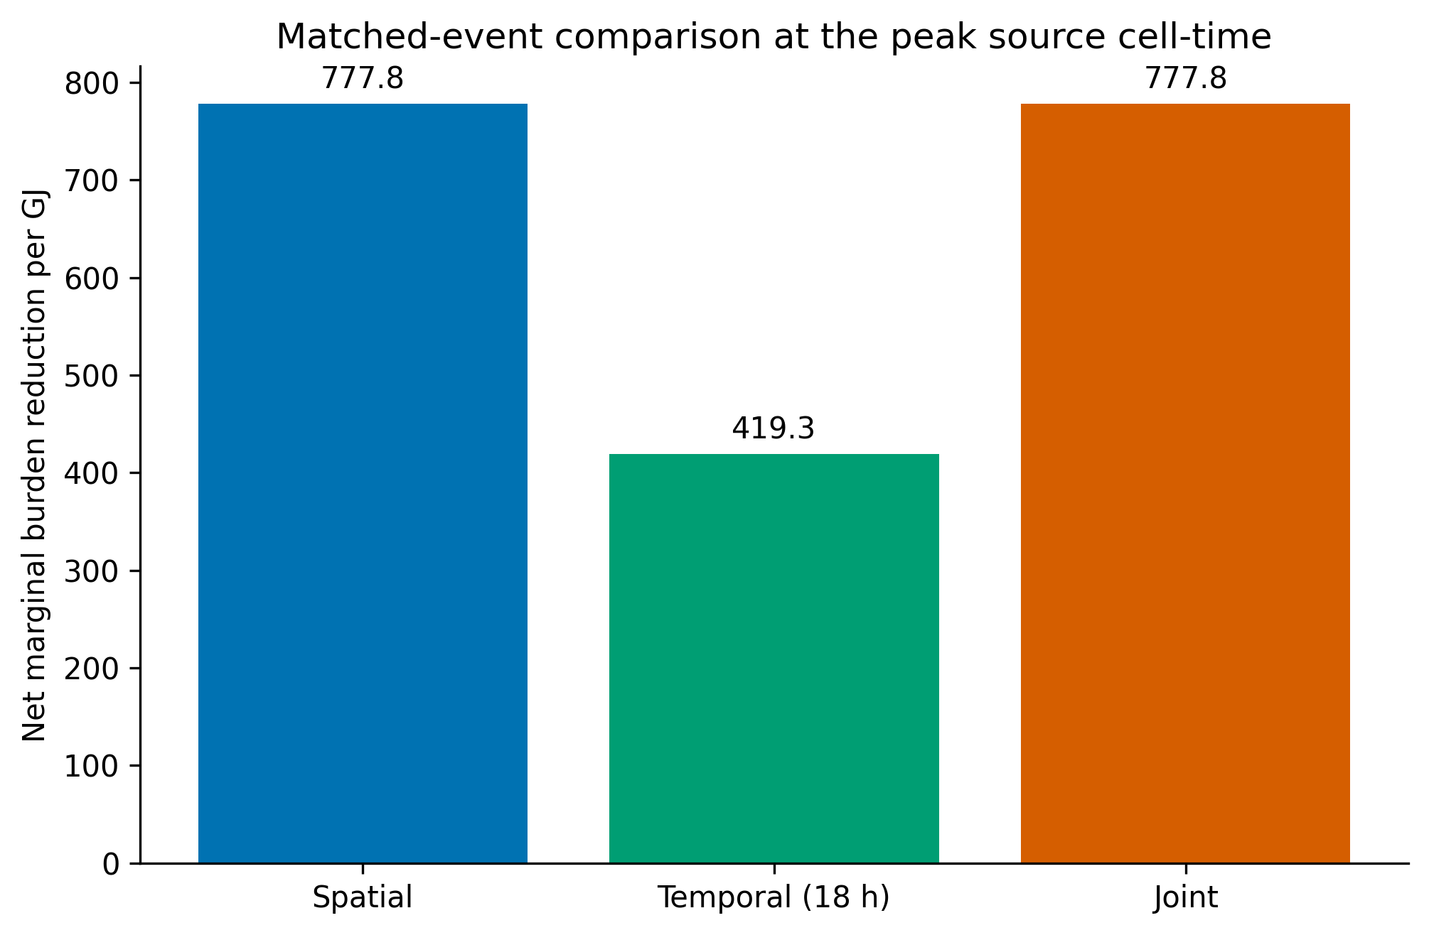
Figure 3. Net marginal burden reduction for zero-penalty spatial, temporal, and joint modes using the same peak source cell-time; the temporal candidate uses a 18-hour lag.

3.3 Exclusion masks, penalty sensitivity, and finite-energy behavior
3 of the 5 progressive mask scenarios selected representative ocean sinks. Cryosphere exclusion alone did not eliminate the selected ocean cell because it was not classified as cryosphere. Ocean exclusion changed the representative co-optimal sink geography to land (Supplementary Table S3 and Fig. S6). The identical zero-burden objective values reveal substantial sink non-uniqueness and show why zero population cannot serve as an environmental criterion.
At a transport penalty of 5 per GJ-km, the best spatial-only objective was -265.7, so no-relocation dominated. The joint model instead selected same-location temporal transfer and retained 524.0 units per GJ. Across the full penalty grid, the selected mathematical candidate shifted from spatial transfer toward temporal transfer (Supplementary Fig. S7). Because the coefficients are uncalibrated, this is a conditional mode map rather than evidence for an engineering tradeoff.
Transfers through 100000 GJ were feasible and showed a small decline in benefit per GJ because finite cooling reduced the average source benefit; sink burden remained zero in the reported feasible cases. The 1,000,000-GJ case was infeasible under the 0.1-K local temperature cap (Supplementary Table S4 and Fig. S2). Thus, the one-unit result is a marginal bound and cannot be scaled indefinitely.
The reduced-order wind trajectory entered cryosphere-classified nearest cells after 24, 72 h (Supplementary Table S5 and Fig. S3). This point-trajectory encounter is only a flag for follow-up; it is not a heat-plume simulation or evidence of downstream impact.

3.4 Measured source and receiving-demand evidence
The Frontier source record contained 49,869 valid 10-minute intervals and 2,691 unavailable intervals. Observed valid-interval waste heat totaled 75,573.6 MWh-th. The measured distribution had median 8.5857 MW, 95th percentile 14.7011 MW, and maximum 26.3353 MW. Median supply and return temperatures were 20.5 °C and 31.803 °C, respectively (Fig. 4).
The ORNL report documented average and maximum space-heating demand of 0.76 and 2.09 MW-th for the 5600-5700-5800 complex. The selected larger building set had 1.31 MW-th average and 3.61 MW-th maximum demand. These summaries bounded demand magnitude but did not reconstruct coincidence with the source series. Of 16 required evidence items, 7 were not found and 5 were available only as bounds.
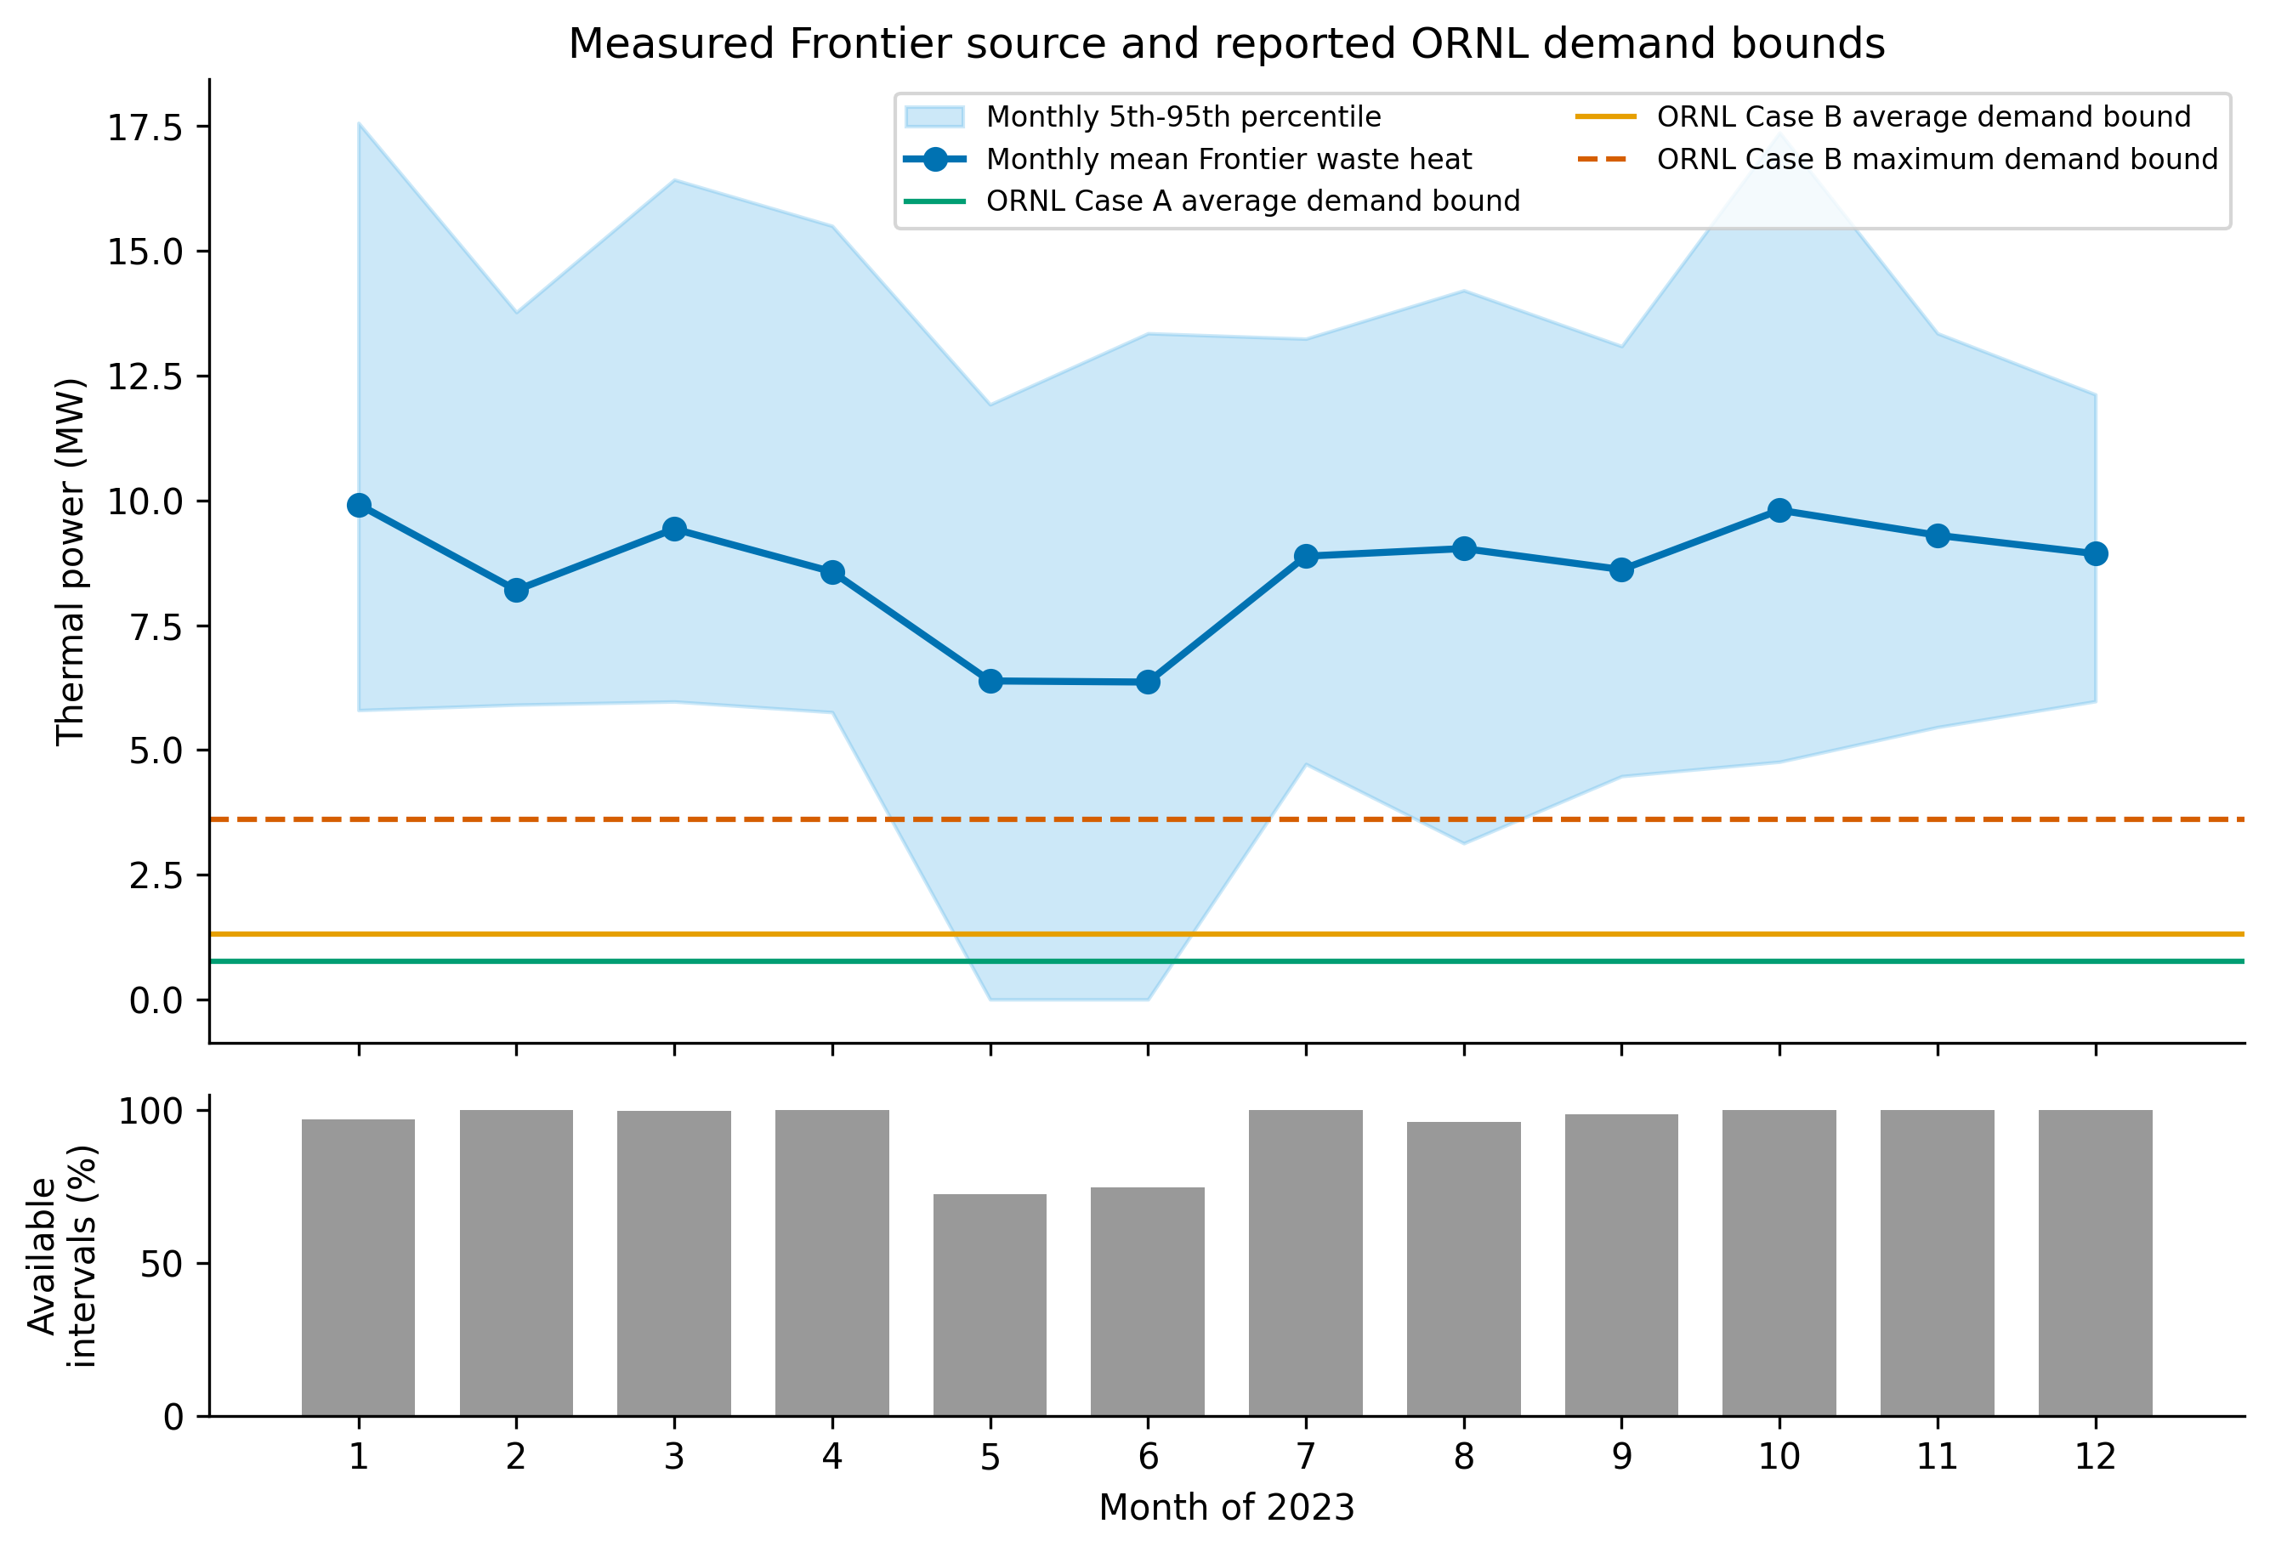
Figure 4. Measured Frontier waste-heat power and reported ORNL receiving-demand bounds. Monthly source summaries retain unavailable 10-minute intervals rather than imputing them; horizontal lines are annual demand-summary bounds, not a synchronized demand profile.

3.5 Global-to-real constraint attrition
The burden-space branch retained the global marginal screening values but could not assign a practical environmental or technology conversion to them. The physical-energy branch began with the measured source and documented demand bounds, then failed to close route, capture, auxiliary, storage-design, complete-cost, lifecycle-emissions, and external-discharge gates (Fig. 5 and Table 5). The terminal supported endpoint was therefore zero practical modes rather than an attenuated numerical fraction of the global burden-space optimum.
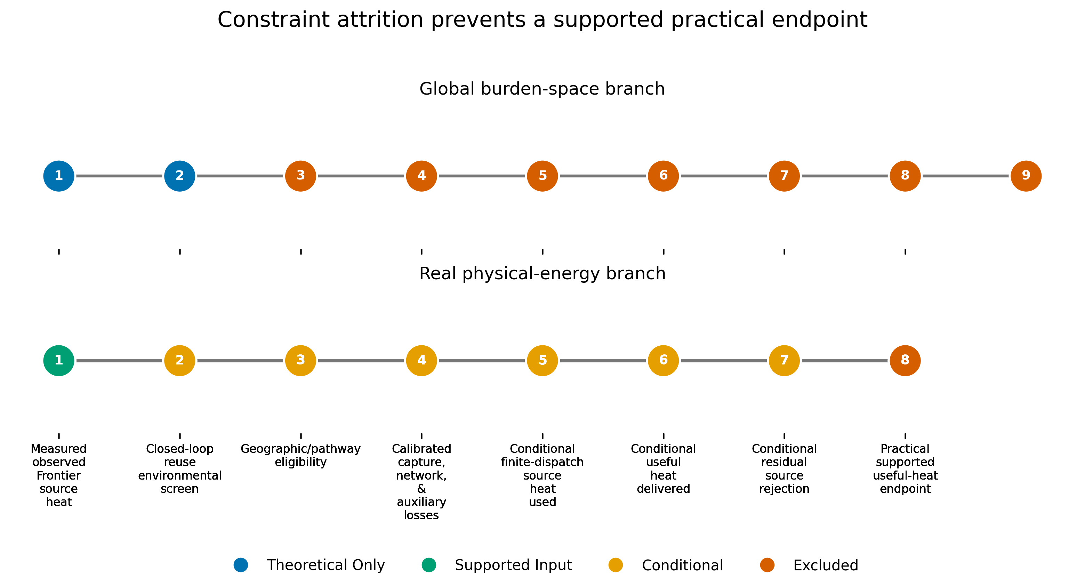
Figure 5. Global-to-real constraint waterfall. Burden-space and physical-energy branches remain separate because no supported unit bridge exists. The real pathway retains conditional inputs but reaches no supported practical endpoint.
Table 5. Global-to-real constraint summary.
Quantity | Value | Eligibility | Claim Limit
Global spatial bound | 777.7645 burden units/GJ | Theoretical only | No conversion to delivered heat
Global temporal bound | 419.3294 burden units/GJ | Theoretical only | Same-event marginal screening
Observed Frontier source | 75,573.6 MWh-th | Supported input | Missing intervals retained
ORNL demand | 0.76–3.61 MW | Summary bounds | No synchronized demand trace
Conditional finite dispatch | 94.4121%–100.0000% demand served | Conditional | Six sensitivity modes
Supported practical endpoint | 0 | Excluded | Required evidence gates remain open

3.6 Conditional finite dispatch and mode decision
Across the nonzero-demand dispatch sensitivities, served fraction ranged from 94.4121% to 100.0000%. Residual source rejection ranged from 63,501.3 to 75,573.6 MWh-th. The maximum absolute timestep thermal-balance error was 1.137e-13 MWh-th. These results demonstrate numerical dispatch closure but not calibrated annual operation.
All six compared reuse and storage modes were Pareto efficient within at least one demand basis because useful heat, residual rejection, electricity, storage capacity, and losses traded off. Direct local reuse was the least-assumption mode within each demand bound; storage increased demand served but introduced an unsupported case-design requirement. Every mode remained CONDITIONAL, and none was selected as a supported practical endpoint (Fig. 6 and Table 6).
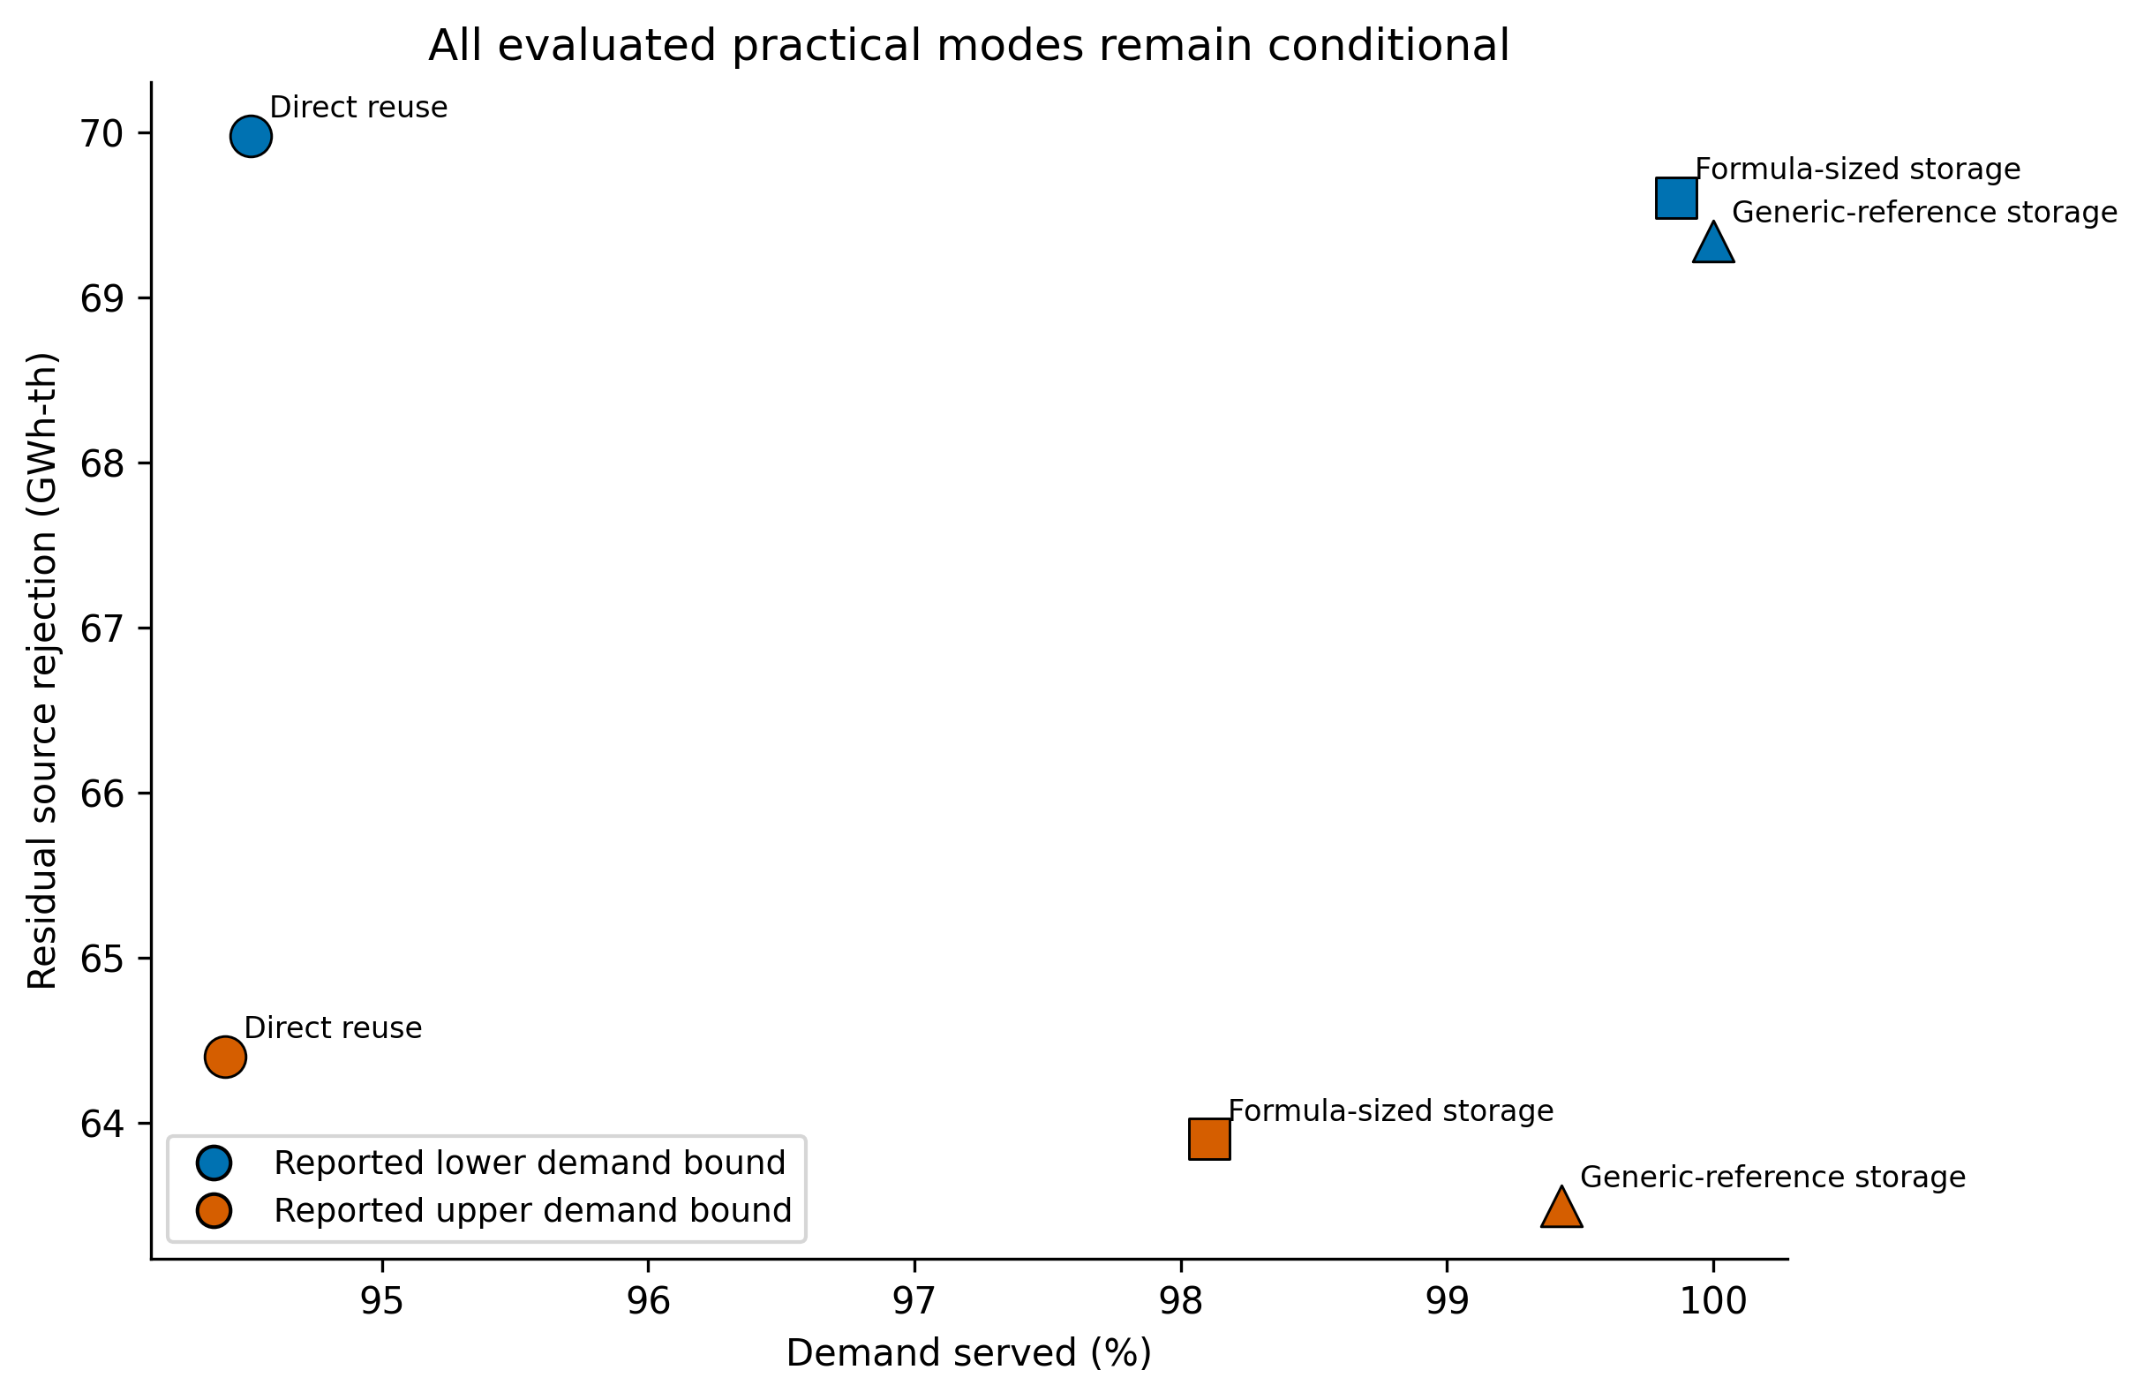
Figure 6. Conditional practical mode results under reported lower and upper demand bounds. All modes are sensitivity cases; storage labels do not imply a case-specific installed design.
Table 6. Conditional practical mode-decision results.
Mode | Demand | Useful Heat (Mwh) | Demand Served | Residual Heat (Mwh) | Eligibility
Direct | Lower bound | 8,278.8 | 94.5% | 69,982.7 | Conditional
Formula storage | Lower bound | 8,747.8 | 99.9% | 69,604.8 | Conditional
Generic storage | Lower bound | 8,760.0 | 100.0% | 69,346.2 | Conditional
Direct | Upper bound | 16,541.0 | 94.4% | 64,403.0 | Conditional
Formula storage | Upper bound | 17,188.5 | 98.1% | 63,903.4 | Conditional
Generic storage | Upper bound | 17,420.1 | 99.4% | 63,501.3 | Conditional

4. Discussion

4.1 Energy-system interpretation
The global result establishes the opportunity created by spatiotemporal heterogeneity. For the peak source cell-time, an 18-hour delay yielded 54% of the simultaneous spatial bound. This comparison makes temporal management commensurable with spatial allocation inside the screening model, but it remains a burden-space result rather than a heat-delivery efficiency.
The real-case audit shows why a large theoretical opportunity does not automatically become a supported system result. Source heat and temperature grade were measured, demand magnitude and heat-pump performance were documented, and repeated dispatch was numerically feasible under explicit bounds. Yet the absence of a coincident demand trace and integrated route, auxiliary, storage, cost, lifecycle, and environmental design prevented selection of a supported mode. This negative constraint result is itself the applied finding: evidence attrition, not optimizer performance, determined practical claim eligibility.

4.2 Environmental interpretation
The unconstrained optimizer repeatedly preferred unpopulated ocean or polar cells because the objective measured human burden. This is a diagnostic failure mode, not a recommendation. Ocean, cryosphere, ecosystem, and Earth-system consequences require independent constraints. The trajectory experiment further shows that a stationary release-cell mask cannot guarantee that downstream heat remains outside sensitive environments.
Likewise, the study reallocates heat rather than destroying it. No result should be interpreted as planetary cooling. A separate radiative-loss analysis would require a causal response model for added heat, not an observed longwave climatology. Device-scale radiative cooling literature does not by itself justify a planetary surface-flux derivative.

4.3 Limitations and next steps
The atmospheric control volume uses a prescribed mixing height and instantaneous linear temperature response. It does not resolve boundary-layer dynamics, land or ocean heat uptake, cloud feedbacks, precipitation, or circulation responses. Humidex is only one stress metric; the robustness and structural replication analyses reduce but do not remove metric dependence. The replication matrix spans multiple years, two related NCEP reanalysis products, two population surfaces, factor-two grid aggregation, and three thermal metrics. NCEP-DOE Reanalysis 2 shares lineage and resolution with NCEP/NCAR Reanalysis 1, so this is not an independent modern high-resolution replication. Population is static, and the burden function is not a health-impact function.
The case study is limited by public evidence rather than by an attempt to estimate favorable missing values. A practical follow-up requires synchronized receiving demand, a surveyed route and hydraulic design, measured or guaranteed capture and auxiliary performance, storage sizing where applicable, complete installed cost with price year, lifecycle inventory, equipment availability, and route-specific environmental review. Until those inputs exist, dispatch, economics, emissions, and mode selection remain sensitivity analyses.
The closest literatures already cover district-energy resource allocation, thermal storage, low-temperature networks, anthropogenic heat, heat-stress mapping, and conserved-allocation methods. The novelty claimed here is narrower: a reproducible two-scale chain that preserves conserved-energy accounting, diagnoses pathological global optima, and refuses to translate a theoretical bound into practical performance when required evidence is absent.

5. Conclusions
A heterogeneous thermal-stress field creates a large marginal screening value for moving heat, and short temporal delay preserves part of the matched spatial bound. The empirical Frontier-ORNL pathway confirms substantial measured low-grade source heat and documented receiving-demand bounds, but the constraint waterfall leaves no supported practical mode because critical coincident, engineering, economic, lifecycle, and environmental evidence is missing. Global burden-space value and physical-energy delivery must therefore remain separate. The main contribution is a reproducible method for showing how much of a theoretical heat-allocation opportunity survives real evidence gates—and for reporting zero when the gates do not close.

Data and code availability
All analysis code, configurations, processed result tables, checksums, and figure-generation scripts are available at https://github.com/bougtoir/global-heat-allocation. Large public raw files are not bundled with the manuscript archive; immutable source URLs, retrieval conditions, sizes, SHA-256 checksums, and acquisition scripts are provided so that they can be independently retrieved and verified. The repository must be archived and its permanent identifier inserted before submission.

Funding
[To be completed and verified by the author before submission.]

Declaration of competing interest
[To be completed and verified by the author before submission.]

Declaration of generative AI and AI-assisted technologies
During preparation of this work, the author used Devin (Cognition AI) to assist with code generation, analysis workflow development, and language drafting. The author reviewed and edited all outputs, verified the underlying data and citations, and takes full responsibility for the content.

References
1. Flanner MG. Integrating anthropogenic heat flux with global climate models. Geophysical Research Letters. 2009;36(2). https://doi.org/10.1029/2008gl036465
2. Block A, Keuler K, Schaller E. Impacts of anthropogenic heat on regional climate patterns. Geophysical Research Letters. 2004;31(12). https://doi.org/10.1029/2004gl019852
3. Li X, Walch A, Yilmaz S, Patel M, Chambers J. Optimal spatial resource allocation in networks: Application to district heating and cooling. Computers &amp; Industrial Engineering. 2022;171:108448. https://doi.org/10.1016/j.cie.2022.108448
4. Guelpa E, Verda V. Thermal energy storage in district heating and cooling systems: A review. Applied Energy. 2019;252:113474. https://doi.org/10.1016/j.apenergy.2019.113474
5. Lund H, Werner S, Wiltshire R, Svendsen S, Thorsen JE, Hvelplund F, et al.. 4th Generation District Heating (4GDH). Energy. 2014;68:1-11. https://doi.org/10.1016/j.energy.2014.02.089
6. Peyré G, Cuturi M. Computational Optimal Transport with Applications to Data Sciences. Foundations and Trends® in Machine Learning. 2019;11(5-6):355-607. https://doi.org/10.1561/2200000073
7. Hyun S, Mishra A, Follett CL, Jonsson B, Kulk G, Forget G, et al.. Ocean mover’s distance: using optimal transport for analysing oceanographic data. Proceedings of the Royal Society A: Mathematical, Physical and Engineering Sciences. 2022;478(2262). https://doi.org/10.1098/rspa.2021.0875
8. Parno MD, West BA, Song AJ, Hodgdon TS, O'Connor DT. Remote Measurement of Sea Ice Dynamics With Regularized Optimal Transport. Geophysical Research Letters. 2019;46(10):5341-5350. https://doi.org/10.1029/2019gl083037
9. Vissio G, Lembo V, Lucarini V, Ghil M. Evaluating the Performance of Climate Models Based on Wasserstein Distance. Geophysical Research Letters. 2020;47(21). https://doi.org/10.1029/2020gl089385
10. Buzan JR, Oleson K, Huber M. Implementation and comparison of a suite of heat stress metrics within the Community Land Model version 4.5. Geoscientific Model Development. 2015;8(2):151-170. https://doi.org/10.5194/gmd-8-151-2015
11. Di Napoli C, Barnard C, Prudhomme C, Cloke HL, Pappenberger F. ERA5‐HEAT: A global gridded historical dataset of human thermal comfort indices from climate reanalysis. Geoscience Data Journal. 2020;8(1):2-10. https://doi.org/10.1002/gdj3.102
12. Raymond C, Matthews T, Horton RM. The emergence of heat and humidity too severe for human tolerance. Science Advances. 2020;6(19). https://doi.org/10.1126/sciadv.aaw1838
13. Mora C, Dousset B, Caldwell IR, Powell FE, Geronimo RC, Bielecki CR, et al.. Global risk of deadly heat. Nature Climate Change. 2017;7(7):501-506. https://doi.org/10.1038/nclimate3322
14. Kalnay E, Kanamitsu M, Kistler R, Collins W, Deaven D, Gandin L, et al.. The NCEP/NCAR 40-Year Reanalysis Project. Bulletin of the American Meteorological Society. 1996;77(3):437-471. https://doi.org/10.1175/1520-0477(1996)077<0437:tnyrp>2.0.co;2
15. Lloyd CT, Sorichetta A, Tatem AJ. High resolution global gridded data for use in population studies. Scientific Data. 2017;4(1). https://doi.org/10.1038/sdata.2017.1
16. Stull R. Wet-Bulb Temperature from Relative Humidity and Air Temperature. Journal of Applied Meteorology and Climatology. 2011;50(11):2267-2269. https://doi.org/10.1175/jamc-d-11-0143.1
17. Loeb NG, Doelling DR, Wang H, Su W, Nguyen C, Corbett JG, et al.. Clouds and the Earth’s Radiant Energy System (CERES) Energy Balanced and Filled (EBAF) Top-of-Atmosphere (TOA) Edition-4.0 Data Product. Journal of Climate. 2018;31(2):895-918. https://doi.org/10.1175/jcli-d-17-0208.1
18. Raman AP, Anoma MA, Zhu L, Rephaeli E, Fan S. Passive radiative cooling below ambient air temperature under direct sunlight. Nature. 2014;515(7528):540-544. https://doi.org/10.1038/nature13883

